IIRS Daily Space Digest Wednesday, 06/05/2026

1. Rain lashes Delhi-NCR, AQI drops to lowest of the year
Delhi | The Indian Express
Read more


Palam recorded 9.8 mm of rainfall between 8:30 am and 5:30 pm, followed by Ayanagar at 1.4 mm, while Safdarjung recorded only trace rainfall and Lodi Road and Ridge reported none during this period. Delhi breathed its cleanest air of the year so far on Tuesday after rainfall lashed the city, leading to a sharp drop in temperature after a period marked by scorching heat. At 86, the AQI remained in the 'satisfactory' category for the second consecutive day on Tuesday. "Delhi records its lowest daily average AQI of the current year today with average AQI clocking 86 at 4:00 PM," the Commission for Air Quality Management (CAQM) said in a post on X. Hailstorm, thunderstorm and lightning were witnessed at isolated places including ITO, Akshardham, Nehru Stadium, Dilshad Garden, Seemapuri, Shahdara, Vivek Vihar in Delhi; and Loni Dehat, Hindon Air Force Station, Ghaziabad, Bagpat, Khekra in the Capital's neighbouring regions.

2. ISRO completes preliminary design review of Venus Orbiter Mission - MSN
"ISRO OR NRSC OR IIRS after:2026-05-05" - Google News
Read more

ISRO completes preliminary design review of Venus Orbiter Mission MSN

3. RPCAU, ISRO set to develop climate-smart farming model - The Times of India
"ISRO OR NRSC OR IIRS after:2026-05-05" - Google News
Read more


RPCAU, ISRO set to develop climate-smart farming model The Times of India

4. Two unauthorised drones spotted flying in ISRO no flying zone campus case registered probe on - Country and Politics
"ISRO OR NRSC OR IIRS after:2026-05-05" - Google News
Read more

Two unauthorised drones spotted flying in ISRO no flying zone campus case registered probe on Country and Politics

5. Probe launched after drone spotted over ISRO's ISITE campus in Bengaluru - Dailyhunt
"ISRO OR NRSC OR IIRS after:2026-05-05" - Google News
Read more

According to a police complaint, a sub-inspector from the Central Industrial Security Force (CISF) spotted the drone flying around 80-100 feet above the campus for about 10-12 seconds before it disappeared at around 8.16 am. The ISITE campus is a highly sensitive area and has been officially classified as a restricted no-drone zone. Any unauthorised aerial activity in such zones poses a serious threat to security and safety, the complaint added. Police have registered a case against unknown persons for operating the drone in the prohibited area without permission. Though no clues have emerged yet, efforts are under way to trace the suspect, police said.

6. Unauthorized Drone Intrusion Raises Alarm at ISRO Campus - Devdiscourse
"ISRO OR NRSC OR IIRS after:2026-05-05" - Google News
Read more


A potential security breach rattled the ISRO campus this week, as an unauthorized drone was reportedly seen hovering over the ISITE premises in Bengaluru. This area, strictly designated as a 'No Drone Zone', encountered the incursion at around 8:16 AM on May 2, raising immediate alarm. In response, law enforcement registered a case against anonymous operators, citing criminal trespass and illegal drone activity under the Aircraft Act, prompting a thorough investigation. (With inputs from agencies.)

7. India aims to land astronauts on the Moon by 2040: Former ISRO chief - MSN
"ISRO OR NRSC OR IIRS after:2026-05-05" - Google News
Read more

India aims to land astronauts on the Moon by 2040: Former ISRO chief MSN

8. NASA eClips and GLOBE Educators Strengthen a Regional STEM Ecosystem in Coastal Virginia
NASA
Read more
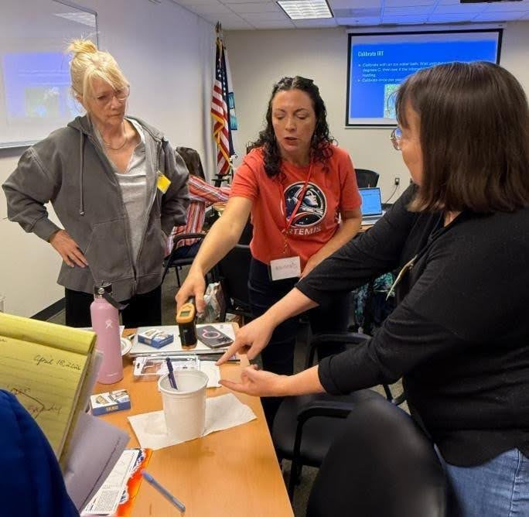

Jessica Taylor, Physical Scientist at NASA Langley Research Center and Principle Investigator for GLOBE Clouds and the My NASA Data project, explains calibration of an infrared thermometer. Thirty-eight science educators representing seven school districts across Virginia's Tidewater region joined forces with community organizations, such as the Elizabeth River Project, to deepen their instructional practice through a dynamic collaboration between NASA eClips and the GLOBE (Global Learning and Observation to Benefit the Environment) Program. Together, these groups are cultivating a regional STEM ecosystem that connects classrooms, community science, and NASA resources in meaningful and lasting ways. As part of NASA's Science Activation Program, NASA eClips engages educators and learners with standards-aligned resources grounded in authentic NASA science. Complementing this work, the GLOBE Program empowers participants to contribute to citizen science through environmental data collection and analysis. The partnership between these two programs creates a powerful bridge between content knowledge and real-world application - bringing Earth Systems science to life for both educators and learners. Educators gathered for a three-hour professional learning experience on March 7 or April 18, 2026 at the National Institute of Aerospace in Hampton, Virginia. Through hands-on investigations, participants explored how land cover influences surface temperature, how clouds impact atmospheric conditions, and how soil plays a critical role in environmental systems. These experiences were anchored in NASA eClips resources and GLOBE protocols, offering practical strategies for teaching key Virginia Science Standards of Learning related to weather, climate, land covering, and Earth's energy budget. Participants calibrated and used scientific instruments such as infrared thermometers and multi-day minimum/maximum thermometers, gaining confidence in collecting accurate environmental data. They examined the urban heat island effect, engaged in interactive activities including an energetic cloud dance and a cloud opacity demonstration, and learned how to contribute observations through practice of using the GLOBE Observer app. These immersive experiences not only strengthened content knowledge but also modeled how authentic science practices can be integrated into classroom instruction. This initiative builds on two years of intentional collaboration among the NASA eClips Educators from the National Institute of Aerospace's Center for Integrative STEM Education (NIA-CISE); GLOBE scientists from NASA Langley Research Center; and regional school divisions and community organizations that laid the foundation for a sustainable regional STEM ecosystem. Support from the Coastal Virginia STEM Hub, funded through the Virginia General Assembly, has been instrumental in expanding access to these opportunities. Grant funding provided educator stipends and enabled the purchase of essential equipment, including weather instrument shelters and soil kits. In a powerful example of cross-sector collaboration, the instrument shelters were constructed by Career and Technical Education (CTE) students in Hampton City Schools and Norfolk Public Schools using GLOBE specifications, further connecting students to the scientific process while supporting their peers' learning. As participating school divisions and community organizations integrate NASA eClips and GLOBE resources into their curricula and outreach efforts, they are ensuring that all learners have access to authentic, data-driven science experiences. Together, this network of educators, students, and partners is not only enhancing science education, but also building a connected, collaborative STEM ecosystem where learning extends beyond the classroom and into the community. NASA eClips, led by NIA-CISE, is supported by NASA under cooperative agreement award number NNX16AB91A and is part of NASA's Science Activation Portfolio. Learn more about how Science Activation connects NASA science experts, real content, and experiences with community leaders to do science in ways that activate minds and promote deeper understanding of our world and beyond: https://science.nasa.gov/learn/about-science-activation/

9. NASA's Perseverance Mars Rover Surveys 'Crocodile Bridge'
NASA
Read more
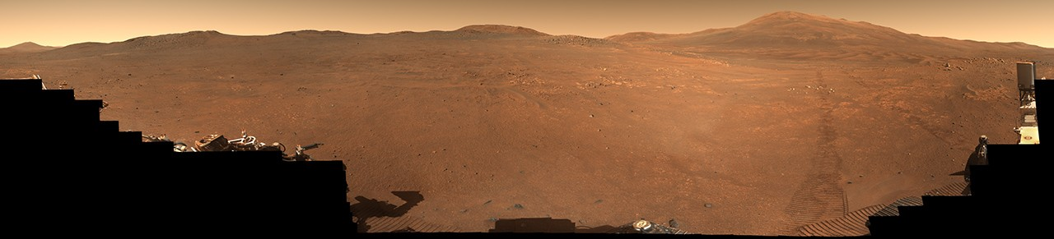

Description NASA's Perseverance Mars rover used its Mastcam-Z camera system to capture this 360-degree panorama of a region nicknamed "Crocodile Bridge" on Jezero Crater's rim. The panorama is made up of 980 images, 971 of which were taken on Dec. 18, 2025, the 1,717th Martian day, or sol, of the mission. An additional nine were taken on Jan. 25, 2026, Sol 1,754. This natural-color view has been processed to show the landscape as the human eye would see it. Jezero Crater's rim and the regions around it hold some of the oldest rocks anywhere in the solar system; they serve as time capsules of the Red Planet's early history, when its crust and atmosphere were still forming. No terrain this ancient exists on Earth, where tectonic plates constantly recycle the surface. (Mars lacks tectonic plates, allowing some of this very old material to be preserved.) "Crocodile Bridge" represents a transition into an area nicknamed "Lac de Charmes," which Perseverance will explore for several months later this year. [Full-resolution image versions of figures A through E can be downloaded at the bottom of this page.] Figure A (low resolution) Figure A is the natural-color view panorama. Figure B (low resolution) Figure B is the same panorama in an enhanced-color view, which brings out subtle details. Figure C (low resolution) Figure C is an anaglyph (3D) version of the natural-color view of the panorama. Figure D (low resolution) Figure D is an anaglyph red-color view of the enhanced version of the panorama. Figure E (low resolution) Figure E is an anaglyph blue-color view of the enhanced version of the panorama. Managed for NASA by Caltech, NASA's Jet Propulsion Laboratory in Southern California built and manages operations of the Perseverance rover on behalf of the agency's Science Mission Directorate as part of NASA's Mars Exploration Program portfolio. Arizona State University leads the operations of the Mastcam-Z instrument, working in collaboration with Malin Space Science Systems in San Diego, on the design, fabrication, testing, and operation of the cameras, and in collaboration with the Niels Bohr Institute of the University of Copenhagen on the design, fabrication, and testing of the calibration targets. To learn more about Perseverance, visit: science.nasa.gov/mission/mars-2020-perseverance

10. 650 NASA Volunteers Have Co-Authored Scientific Papers
NASA
Read more
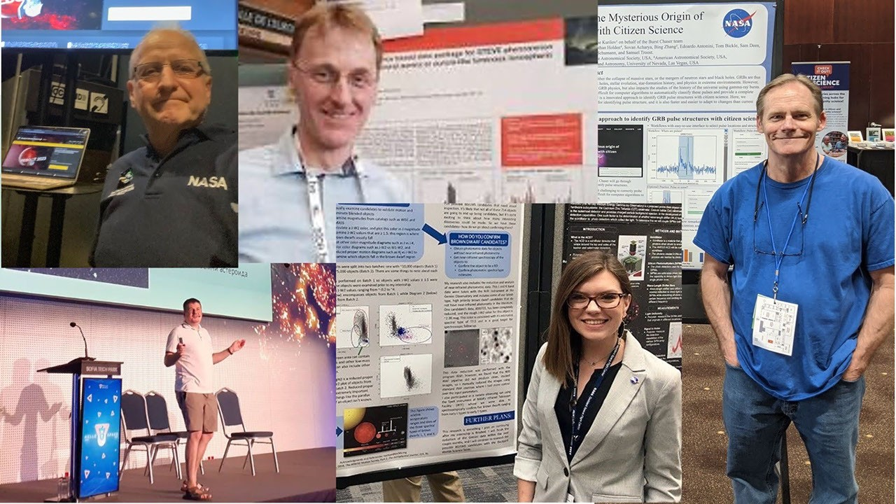

After a recent count, NASA Citizen Science is proud to report that more than 650 people who have volunteered to participate in NASA citizen science projects have co-authored peer-reviewed research papers with scientists on those project teams. These volunteers made incredible contributions like: And all of them saw their passion and dedication translated into lasting contributions to the scientific literature that will inform generations of researchers to come. Explore these frequently asked questions and discover how you, too, can be a part of scientific discovery and become a co-author. Why do peer-reviewed research papers matter? When scientists make a discovery, they write up the details of their research and its results in a manuscript and submit it to a scientific journal. The journal's editors subject the manuscript to the 'peer-review' process, in which they invite other scientists to verify and validate the methods used and the novelty and importance of the results. Peer-reviewed research papers are the primary way scientists document what they discover or learn and share it with each other and the world. Once a paper passes the peer-review process, it is published where other scientists can read it, criticize it, and build on it. Contributing to published scientific literature is an important and celebrated part of a scientific career - for PhD scientists and citizen scientists alike. A list of published papers is the core of any scientist's resume, and any budding scientist's first publication is widely considered a milestone worth celebrating. Three cheers for each and every one of the 650 published citizen science project volunteers! How can I get involved in writing a scientific paper through NASA citizen science? Sometimes, volunteers get lucky - they're simply notified by the project science team that their contributions have made it into a scientific paper. However, if you are determined to become a published author, it helps to choose your project carefully and then to take initiative. First, find a project that interests you. In the words of citizen scientist Michael Primm, "pick one or more [projects that] appeal to you, and try them out for size. If you don't like them, try other ones." Once you have a project you like, do the task frequently enough to get comfortable and confident. Read all the project material you can, including any frequently asked questions and blog posts the team may have written. Many of the extraordinary breakthroughs in these projects come from participants noticing patterns in the data that are unusual - you can't do this unless you've developed a good sense of what's "normal." "Find a project where you can communicate directly with the scientists involved," said Marc Kuchner, citizen science officer, NASA Headquarters in Washington. "That way, you can get the coaching and mentorship you need to learn the paper-writing process." A good place to start is with the projects listed on the publications by NASA citizen scientists webpage, since these projects have track records of involving volunteers in papers. "After you've followed the instructions and participated in a project, it's all about asking questions!" said Kuchner. "Ask other participants first, and read the project's FAQ and Research pages. Dig into scientific journal articles, if you can. Before long, you'll find yourself with a novel and meaningful question nobody knows the answer to. Then you'll have an excellent reason to start a conversation with the science team." Second, look for ways to interact with project scientists and teams and stay informed and involved. Many NASA citizen science project teams have regular calls or meetings with participants. They also sometimes give participants the option to sign up for an email list, through which they share additional opportunities to interact with the scientists leading the projects. "Don't be afraid to ask for help, either from your fellow citizen scientists or even the pros of the project you're working on," said citizen scientist Les Hamlet, co-author of three papers and counting. NASA partner SciStarter also hosts a series of Do NASA Science Live virtual events, which offer another way to meet scientists. These virtual events, held roughly once a month, feature experts from NASA citizen science projects who are eager to interact with volunteers. You can see the schedule and sign up here for the next Do NASA Science Live event. Many projects have virtual bulletin boards, like the "TALK" boards of Zooniverse-hosted projects, which can facilitate discussions with the science team. Or you can reach out by email to the science team by looking them up on the project's team page. Just remember these science teams are busy, so do your homework first by reading all the project materials before you reach out. NASA volunteer Michiharu Hyogo offered some tips to help others get started on the journey toward becoming a published author. There are also numerous online resources and guides for anyone new to writing scientific papers. What if I'm still a student? Can I get involved in writing a paper? Yes, the same advice above applies to students. There's no better way to explore whether or not you'd like to pursue a career in science or a new scientific field of study than to do the work of a scientist and get involved in the process of publishing your findings. If you become a published co-author, you'll also have the added advantage of listing your publication on your resume for internship, undergraduate, or graduate school applications. Several high school students and many undergraduate or graduate students have written papers with NASA citizen science project teams, including Matteo Kimura, Emily Burns-Kaurin, Darcy Wenn, and Michaela B. Allen. A few NASA citizen scientists who have co-authored scientific papers present their findings. Clockwise from the upper left: Peter Jalowiczor, Michael Hunnekul, Danny Roylance, Michaela Allen, and Svetoslav Alexandrov. Ride the rollercoaster! Science can be unpredictable, which can make writing papers feel like a roller-coaster ride at times. "Don't give up if your first try was not successful," said published citizen scientist Michael Hunnekuhl. Most projects take years to produce results. Sometimes, nature doesn't cooperate, and a science team must change directions instead of writing the paper they initially imagined. But with 42 citizen science projects online, NASA has plenty of room for your science ambitions. Go to https://science.nasa.gov/citizen-science/, pick a project, and start your science journey today.

11. NASA's Curiosity Rover Frees Its Drill From a Rock
NASA
Read more
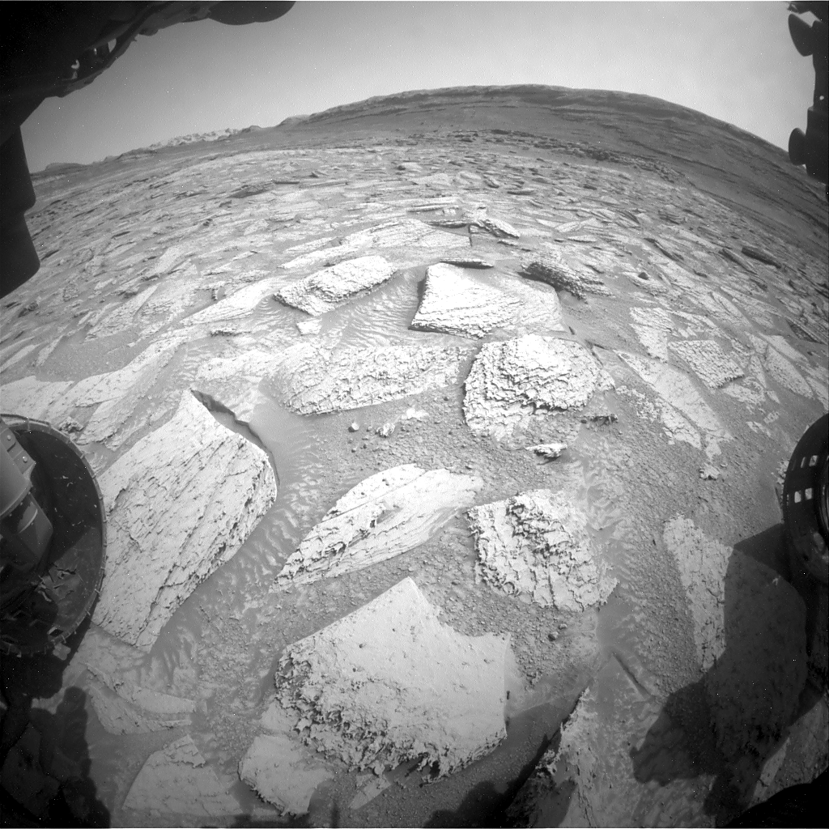

Description This series of images shows NASA's Curiosity Mars rover as it got a rock stuck to the drill on the end of its robotic arm and, after waving the arm and running the drill a few times, finally detached the rock. The imagery showing the entire process was captured by the black-and-white hazard cameras on the front of Curiosity's chassis and by navigation cameras on its mast, or head. On April 25, 2026, Curiosity drilled a sample from a rock nicknamed "Atacama," which is an estimated 1.5 feet in diameter at its base, 6 inches thick and weighs roughly 28.6 pounds (13 kilograms). When the rover retracted its arm, the entire rock lifted out of the ground, suspended by the fixed sleeve that surrounds the rotating drill bit. Drilling has fractured or separated the upper layers of rocks in the past, but a rock has never remained attached to the drill sleeve. The team initially tried vibrating the drill to shake off the rock, but saw no change. Then, on April 29, they tried reorienting Curiosity's robotic arm and vibrating the drill again. Imagery in the GIF shows sand falling from Atacama, but the rock stayed attached to the rover. Finally, on May 1, Curiosity's team tried again, tilting the drill more, rotating and vibrating the drill, and spinning the drill bit. The team planned to perform these actions multiple times but the rock came off on the first round, fracturing as it hit the ground. Figure A Figure A is the same GIF with yellow time stamps added in the upper left corner. Figure B Figure B is an alternate view of the same activities from the navigation cameras on Curiosity's mast, or head. Curiosity was built by NASA's Jet Propulsion Laboratory, which is managed by Caltech in Pasadena, California. JPL leads the mission on behalf of NASA's Science Mission Directorate in Washington as part of NASA's Mars Exploration Program portfolio. To learn more about Curiosity, visit: science.nasa.gov/mission/msl-curiosity

12. NASA Astronaut to Answer Questions from Students in Florida
NASA
Read more
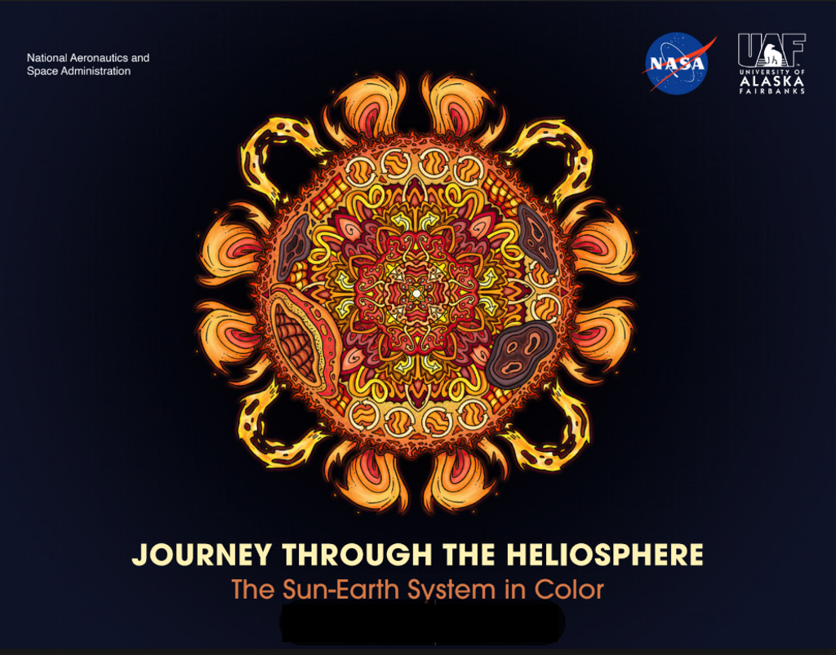

NASA astronaut Chris Williams calls down to mission controllers during Crew Medical Officer training while inside the International Space Station's Destiny laboratory module. Credit: NASA/Jessica Meir Students in Florida will hear from NASA astronaut Chris Williams as he answers prerecorded science, technology, engineering, and mathematics (STEM) questions while aboard the International Space Station. The Earth-to-space call will begin at 11 a.m. EDT Friday, May 8, and will stream live on the agency's Learn With NASA YouTube channel. This event is hosted by the Aurelia M. Cole Academy in Clermont, Florida, for students in grades K-12 and members of the community. This unique opportunity aims to deepen understanding of space exploration and enhance awareness of STEM careers. Media interested in covering the event must RSVP by 5 p.m., Thursday, May 7, to Sherri Owens at: 352-253-6522 or owenss@lake.k12.fl.us. For more than 25 years, astronauts have continuously lived and worked aboard the space station, testing technologies, performing science, and developing skills needed to explore farther from Earth. Astronauts communicate with NASA's Mission Control Center in Houston 24 hours a day through SCaN's (Space Communications and Navigation) Near Space Network. Research and technology investigations taking place aboard the space station benefit people on Earth and support other agency work, including missions at the Moon. As part of NASA's Artemis program, the agency will send astronauts to the Moon to prepare for future human exploration of Mars, inspiring the world through discovery in a new Golden Age of innovation and exploration. See more information on NASA in-flight calls at: https://www.nasa.gov/stemonstation

13. NASA'S Juno Misson Captures Jupiter Moon Thebe
NASA
Read more
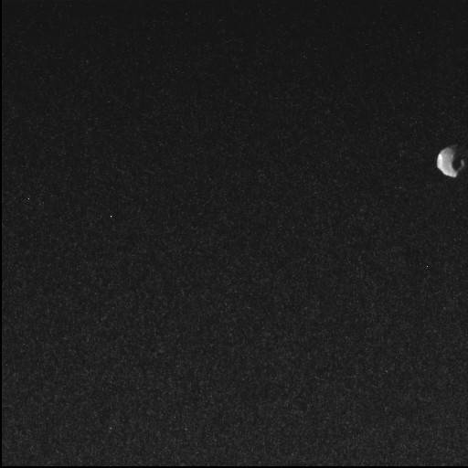

Description NASA's Juno spacecraft captured this view of Thebe, the second largest of Jupiter's inner moons, during a close pass on May 1, 2026. The spacecraft's Stellar Reference Unit (SRU) captured this image from a distance of approximately 3,100 miles (5,000 kilometers) at a resolution of about 1.9 miles (3 kilometers) per pixel. Thebe resides at the outer edge of Jupiter's faint ring system and is believed to play a role in the formation of the planet's "gossamer" ring through the shedding of dust. While the SRU's primary function is to image star fields for navigation, its high sensitivity in low-light conditions makes it a powerful secondary science instrument. The SRU has previously been used to discover "shallow lightning" in Jupiter's atmosphere and to image the planet's ring system. A division of Caltech in Pasadena, California, JPL manages the Juno mission for the principal investigator, Scott J. Bolton, of the Southwest Research Institute in San Antonio. Juno is part of NASA's New Frontiers Program, which is managed at NASA's Marshall Space Flight Center in Huntsville, Alabama, for the agency's Science Mission Directorate in Washington. For more information about Juno, visit: https://www.nasa.gov/juno

14. Mexico City is sinking up to 14 inches per year, satellite images show
Latest from Space.com
Read more
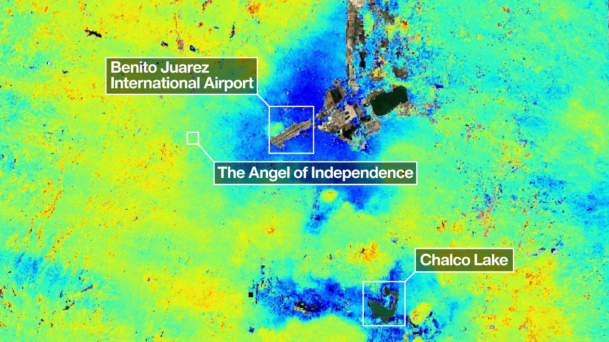

Click for next article Mexico City is sinking, and a powerful new orbiting satellite that's monitoring changes in land levels all across the globe has discovered how quickly this is happening. It's all thanks to the mission's innovative dual-frequency band radar. NISAR, the NASA-ISRO Synthetic Aperture Radar satellite, launched on July 30, 2025 as a joint partnership between NASA and the Indian Space Research Organisation (ISRO). Its mission is to track in real-time surface changes on Earth, from ground subsidence and the retreat of glaciers to and the movement of tectonic plates and the spread of wildfires - all to a precision of within a centimeter. "Mexico City is a well-known hot spot when it comes to subsidence, and images like this are just the beginning for NISAR," said David Bekaert, of the Flemish Institute for Technological Research in Belgium and the NISAR science team, in a statement . It has been known since 1925 that much of the city, home to 20 million people, is sinking at a rate of up to 14 inches (35 centimeters) per year. This is the result of the city being built above an aquifer, or an underground layer of permeable rock and sand, left behind by an ancient lakebed - and the resulting groundwater pumping and the weight of its urban sprawl is compressing those sedimentary layers. The result is damage to buildings and infrastructure, such as the Mexico City Metro system. "NISAR's long-wavelength L-band radar will make it possible to detect and track land subsidence in more challenging and densely vegetated regions such as coastal communities where they may have the compounding effect of both land subsidence and sea level rise," said Craig Ferguson, who is NISAR's deputy manager at NASA Headquarters in Washington, D.C. NISAR is one of the most powerful radars ever launched into space. L-band refers to the microwave frequency of 1-2 gigahertz (GHz), but the satellite also carries an S-band radar that operates at longer frequencies of 2-4 GHz. NASA built the L-band radar that is sensitive to changes in bedrock and ice, and which was utilized in this study of Mexico City, while ISRO built the S-band radar that is sensitive to changes in vegetation. A visualization of the NISAR satellite above Earth. (Image credit: NASA/JPL-Caltech) Both L- and S-band radars are synthetic aperture radars. As the spacecraft moves in orbit around Earth , covering the entire surface every 12 days, its motion results in it scanning a much larger area on the ground than the size of its true aperture. Hence it has a "synthetic" aperture and blurring of the resulting radar image is avoided by firing thousands of radar pulses per second. NISAR is the first mission to carry both an L-band and an S-band synthetic aperture. The radar reflections are captured by NISAR's 39-foot (12-meter) drum-shaped collector, the largest radar antenna reflector NASA has ever built. "We're going to see an influx of new discoveries from all over the world, given the unique sensing capabilities of NISAR and its consistent global coverage," said Bekaert. The radar image of Mexico City looks like a contradictory splash of blue and yellow paint. These colors are false, designed to highlight shifts in the ground. Dark blue represents parts of the city that have subsided by more than 0.5 inches (2 cm) during the period between October 2025 and January 2026, which is Mexico's dry season. Yellow and green areas are residual noise. This would be expected to decrease as NISAR makes more passes over Mexico and the signal-to-noise ratio improves. "Images like this confirm that NISAR's measurements align with expectations," said Ferguson. As one of the quickest subsiding capitals in the world, Mexico City is therefore the perfect opportunity for NISAR to test its skills. To place its rate of subsidence into context, the towering Angel of Independence - a 118-foot-tall (36-meter-tall) spire with a golden statue of an angel perched atop that commemorates Mexico earning its independence - on the Paseo de la Reforma in the heart of Mexico City has required 14 new steps to be added to it since its construction in 1910.

15. NASA just released 12,000 photos from Artemis 2. Here are our top picks
Latest from Space.com
Read more
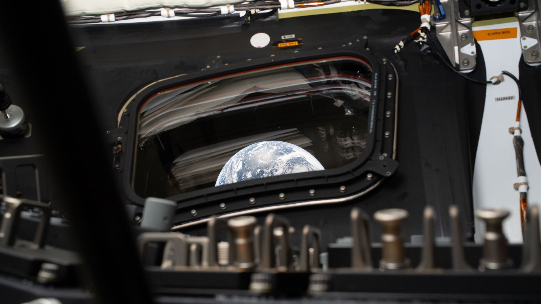

Click for next article You can now browse through more than 12,000 photos taken by the Artemis 2 astronauts during their mission around the moon. The images range from stunning views of Earth to shots of the astronauts inside their Orion capsule to breathtaking images of the moon and the crew's unique perspective from beyond its far side. They're the first pictures taken by astronauts traveling beyond low Earth orbit in more than 50 years, and they show our home planet and its celestial neighbor in brand new, incredible ways. The 10-day Artemis 2 mission launched on April 1 , flying NASA astronauts Reid Wiseman, Victor Glover and Christina Koch, as well as Canadian Space Agency astronaut Jeremy Hansen, on a journey around the moon aboard the Orion space capsule "Integrity". The crew managed to transmit a few photos during their mission, but due to data limits, NASA was forced to wait for the physical SD cards to return to Earth before recovering the bulk of the data. Since their successful splashdown in the Pacific Ocean on April 10 , NASA has been poring through all the photos they took - and now you can, too. Many photos were released in the weeks following the mission's end, but now NASA has released a whopping 12,217. You can scroll through them yourself on the agency's public archive of astronaut photographs. Here are some of our top picks. (Image credit: NASA) The two images above show Earth mostly in the dark. They were shot on April 3, as Orion was on its way to lunar space. This is a six-second exposure of the stars seen outside Intregrity's window. To get a photo like this on Earth, you need several minutes of exposures for the star trails to start becoming clear. Orion, however, spent its journey to the moon rotating to distribute the heat buildup from the sun, a spin captured by the above photograph. This picture shows the moon with a brown, almost rust-colored region on its face. During their trip around the moon, the Artemis 2 astronauts described seeing browns, greens and other subtle colors on the lunar surface. This image of the moon's surface features two small craters named by the Artemis 2 crew. One they named "Integrity," after the spacecraft that kept them safe throughout their mission. The other they named "Carroll," after Wiseman's late wife, who died of cancer in 2020. From the far side of the moon , the astronauts snapped this photo through one of Orion's windows. It shows a quarter moon in the foreground, with a bright but tiny Earth behind. During their lunar flyby on April 6 , the Artemis 2 crew witnessed a solar eclipse from beyond the far side, when the sun dipped behind the planetary body's disk. For the astronauts, the sun's corona , or outer atmosphere, shone brightly, providing a rare perspective of the moon.

