IIRS Daily Space Digest Sunday, 10/05/2026

1. Students excelling in science exhibitions to earn NASA, ISRO visits | Hindustan Times - Hindustan Times
"ISRO OR NRSC OR IIRS after:2026-05-09" - Google News
Read more


Pune: The Maharashtra government has launched the "Chief Minister Students' Science Tour" initiative under the school education and sports department. Maharashtra government has launched the "Chief Minister Students' Science Tour" initiative under the school education and sports department. Students excelling in science exhibitions will be given exposure visits to ISRO and NASA. ((PIC FOR REPRESENTATION)) According to the government resolution (GR) issued on May 6, students excelling in science exhibitions will be given exposure visits to leading science institutions, including science centres in Maharashtra, the Indian Space Research Organisation (ISRO) in Bengaluru, and the National Aeronautics and Space Administration (NASA) in the United States. The programme has been designed in line with the National Education Policy (NEP) 2020, which emphasises experiential learning, innovation, scientific inquiry, artificial intelligence and computational thinking. The government has announced that six students from each taluka-level science exhibition will be selected for educational visits to nearby science centres. A total of 2,148 students along with 20 science teachers and supervisors will participate in these tours. The state government has sanctioned expenditure of up to ₹20,000 per participant for these visits through district planning and development council (DPDC) funds. At the district level, 180 outstanding students from primary and secondary categories, including general, tribal and disabled groups, will be selected for an educational visit to ISRO, with the government approving expenditure up to ₹35,000 per participant. Selection committees headed by chief executive officers of zilla parishads will oversee the process at the district level. The Maharashtra government has approved ₹3.30 crore for the NASA tour, with a ceiling of ₹6 lakh per participant. The State Council of Educational Research and Training (SCERT), Pune, and the State Science Education Institute, Nagpur, will coordinate implementation of the programme.

2. ISRO Gaganyatris outline India's New Space Vision - MSN
"ISRO OR NRSC OR IIRS after:2026-05-09" - Google News
Read more

ISRO Gaganyatris outline India's New Space Vision MSN

3. RPCAU, ISRO set to develop climate-smart farming model - MSN
"ISRO OR NRSC OR IIRS after:2026-05-09" - Google News
Read more

RPCAU, ISRO set to develop climate-smart farming model MSN

4. When will Isro launch humans to space? Indian astronaut answers - MSN
"ISRO OR NRSC OR IIRS after:2026-05-09" - Google News
Read more

When will Isro launch humans to space? Indian astronaut answers MSN

5. ISRO advances talks with Russia for semi-cryogenic engines for next-gen rockets - MSN
"ISRO OR NRSC OR IIRS after:2026-05-09" - Google News
Read more

ISRO advances talks with Russia for semi-cryogenic engines for next-gen rockets MSN

6. It was not rain that caused the Dharali flood. ISRO has found the real culprit - MSN
"ISRO OR NRSC OR IIRS after:2026-05-09" - Google News
Read more

It was not rain that caused the Dharali flood. ISRO has found the real culprit MSN

7. This Week In Space podcast: Episode 209 - Astronauts for America
Latest from Space.com
Read more


Click for next article Astronauts for America - The Best of the Best Speak Out - YouTube Watch On On Episode 209 of This Week In Space, Rod Pyle and Tariq Malik talk with Garrett Reisman and Steve Lindsey, the leaders of the new organization Astronauts for America. Many of us grew up idolizing astronauts as the best of the best that America - and other nations - have to offer. After leaving NASA, many of them go on to relatively routine careers in business or academia, but some stay "on mission" and continue striving to improve the human condition. The 100-plus astronauts behind Astronauts for America, led by Reisman and Lindsey - a Democrat and Republican - have decided to speak out about their concerns for our democracy. As the nonprofit's website says, "Astronauts For America is a nonpartisan organization of former NASA astronauts who have sworn to defend the Constitution of the United States. We are committed to science, evidence-based decision-making, public service, and the rule of law." Latest Videos From View more Download or subscribe to this show at: https://twit.tv/shows/this-week-in-space. Get episodes ad-free with Club TWiT at https://twit.tv/clubtwit Space news of the week Model Falcon 9! TOP TELESCOPE PICK: (Image credit: Celestron) Looking for a telescope to see planets and comets? We recommend the Celestron Astro Fi 102 as the top pick in our best beginner's telescope guide. Finally, did you know you can launch your own SpaceX rocket? Model rocket maker Estes' stunning scale model of a Falcon 9 rocket that you can pick up now. The launchable model is a detailed recreation of the Falcon 9 and retails for $149.99. You can save 10% by using the code IN-COLLECTSPACE at checkout, courtesy of our partners collectSPACE.com. About This Week In Space This Week in Space covers the new space age. Every Friday we take a deep dive into a fascinating topic. What's happening with the new race to the moon and other planets? When will SpaceX really send people to Mars? Join Rod Pyle and Tariq Malik from Space.com as they tackle those questions and more each week on Friday afternoons. You can subscribe today on your favorite podcatcher. Host of This Week In Space on TWiT Host of This Week In Space on TWiT Rod Pyle Social Links Navigation Space author and historian Rod Pyle is an author, journalist, television producer and Editor-in-Chief of Ad Astra magazine. He has written 18 books on space history, exploration, and development, including Space 2.0, Innovation the NASA Way, Interplanetary Robots, Blueprint for a Battlestar, Amazing Stories of the Space Age, First On the Moon, and Destination Mars In a previous life, Rod produced numerous documentaries and short films for The History Channel, Discovery Communications, and Disney. He also worked in visual effects on Star Trek: Deep Space Nine and the Battlestar Galactica reboot, as well as various sci-fi TV pilots. His most recent TV credit was with the NatGeo documentary on Tom Wolfe's iconic book The Right Stuff.

8. NASA's twin Voyager spacecraft are very low on power after nearly 50 years. How long can they keep going?
Latest from Space.com
Read more
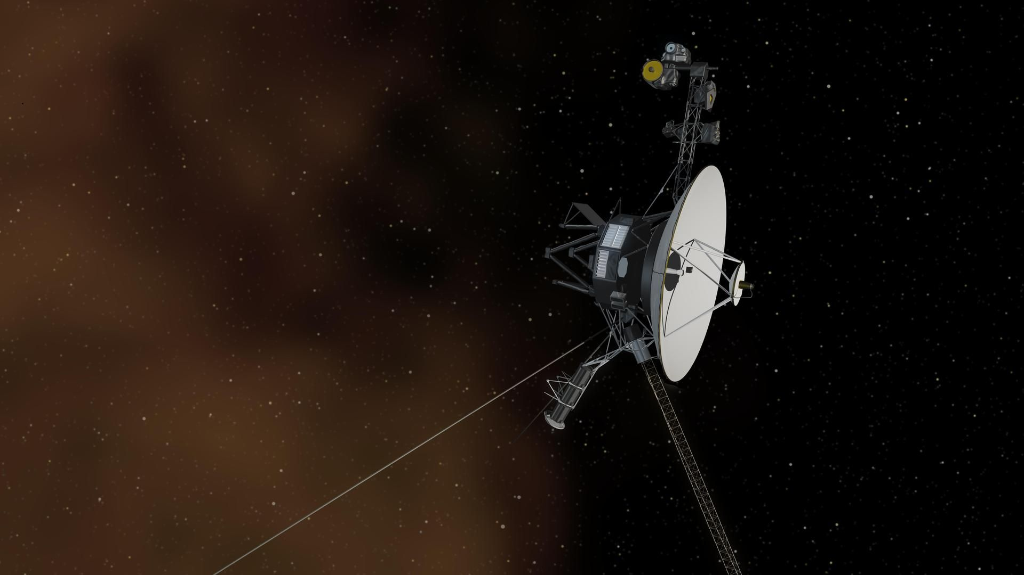

Click for next article The pioneering Voyager probes might only have a few years left to explore interstellar space, and that's assuming a planned, risky maneuver in 2026 goes well. NASA's twin Voyager 1 and Voyager 2 spacecraft, both running on nuclear power, now have access to just a portion of the 470 watts of energy that they generated immediately after their 1977 launches. Originally tasked with exploring the giant planets in our solar system, the pair have long passed their expected lifespans and are still transmitting data, far from home. Voyager 1 crossed into interstellar space in 2012, and Voyager 2 followed suit six years later. For years, NASA has been turning off the probes' instruments one at a time as their power supplies dwindled. They still lose about four watts of power a year. But NASA's Jet Propulsion Laboratory (JPL) in Southern California has an idea, which will be tested out soon, to give them a little more time. What's running? What's not? Both Voyager probes launched with the same 10 operational instruments. Voyager 1 turned off its subsystem to look at cosmic rays (high-energy particles) in February, then did the same with its Low-Energy Charged Particles (LECP) instrument in April . Only two of Voyager 1's instruments appear to be on at the moment, according to a JPL list : a magnetometer to look at magnetic fields, and a gas examination via its plasma wave subsystem instrument. Voyager 2 has three instruments running: the cosmic ray subsystem, the magnetometer, and the plasma wave subsystem. JPL's list suggests that the other spacecraft instruments are off, or at least partially turned off, because of power requirements. The active instruments' days are numbered, but a spokesperson told Space.com that the mission team aims to extend their operational lives soon. "An upcoming engineering activity - nicknamed the 'Big Bang' - on NASA's twin Voyager spacecraft will continue the agency's efforts to maximize the science output of the mission," the spokesperson said in an email. "Voyager engineers will turn off three devices on the spacecraft that have been used to keep the thruster fuel lines from freezing - and turn on three other devices that will keep the fuel lines warm, but use a total of almost 10 watts less power," the spokesperson continued. "If successful, this could delay the need to turn off a science instrument aboard each spacecraft by at least one year. The engineering team will test and implement the program on Voyager 2 in May and June. Based on the outcome, the mission plans to do the same on Voyager 1 sometime this summer." JPL did not respond to follow-up questions about the possible impact on instruments that are partially shut off, the current wattage levels on both spacecraft, and how long each Voyager is expected to keep operating, among other power-related queries. How long could Voyager keep going? Each Voyager is so far away from Earth that it takes nearly a day to send a signal to the faraway spacecraft. Power continues to dwindle as the spacecraft approach their 50th anniversary in space next year, but it sounds like mission managers are expecting things to continue for a while. "We don't know how long the mission will continue, but we can be sure that the spacecraft will provide even more scientific surprises as they travel farther away from the Earth," Suzanne Dodd, project manager for Voyager at JPL, said in a 2022 statement from the lab. That same year, Dodd told Space.com that there were only five to six watts of power margin available on each spacecraft. Some of the basic equipment is also power-hungry: "It takes about 200 watts, approximately, to run the transmitter on the spacecraft, to be able to send signals back to Earth," she said. Dodd added that she was impressed by how well the remaining instruments are performing in the cold of interstellar space. "If we got really lucky, maybe doing some operating below some thresholds, we might be able to go out to the 2030s," she said. Alan Cummings, a co-investigator on Voyager, told an audience in October 2024 that, technically, the probes' power will never run out because nuclear energy always has a half-life. But in terms of power to operate the spacecraft, he said it's dwindling: The spacecraft might only have about 230 watts apiece to use, much of it gobbled up by the transmitting equipment. "It's interesting because the Voyager is coming to an end in kind of a graceful way, in a sense, because there's different things trying to kill it off," he mused at a recorded event at the California Institute of Technology, where he is a senior scientist. The Voyagers' thruster lines are close to freezing and getting clogged, he noted. Their telescopes, which already were "blasted" by radiation when flying near Jupiter 's volcanic moon Io in the 1970s, continue to degrade as deep-space particles hit them. The computers have backups, but the backups are also aging. Cummings paid tribute to the original mission team for allowing the Voyagers to keep going for so long: "There is so much redundancy on these spacecraft. It is amazing, and they built that into it." In August 2022, Dodd was asked during a JPL livestream how far she thought the Voyagers would go. She predicted each spacecraft would "definitely" make it to the 50th anniversary in 2027 - which still seems to be possible from the perspective of today - but added she has a "stretch goal" assuming that gets accomplished. Ideally, Dodd said she would love to see the spacecraft reach 200 astronomical units (AU; Earth-sun distances) from our planet, which would happen in about 2035. (At the moment, Voyager 1 is about 169.8 AU from Earth, and Voyager 2 is roughly 143.1 AU away.) "That's going to take a lot of good luck and good fortune and good engineering," she said. "But nobody would have thought that Voyager would last for 45 years [to 2022]. So what's another 15?"

9. NASA's Artemis 2 commander and astrophotographer team up to capture breathtaking, never-before-seen shots of the moon's far side
Latest from Space.com
Read more
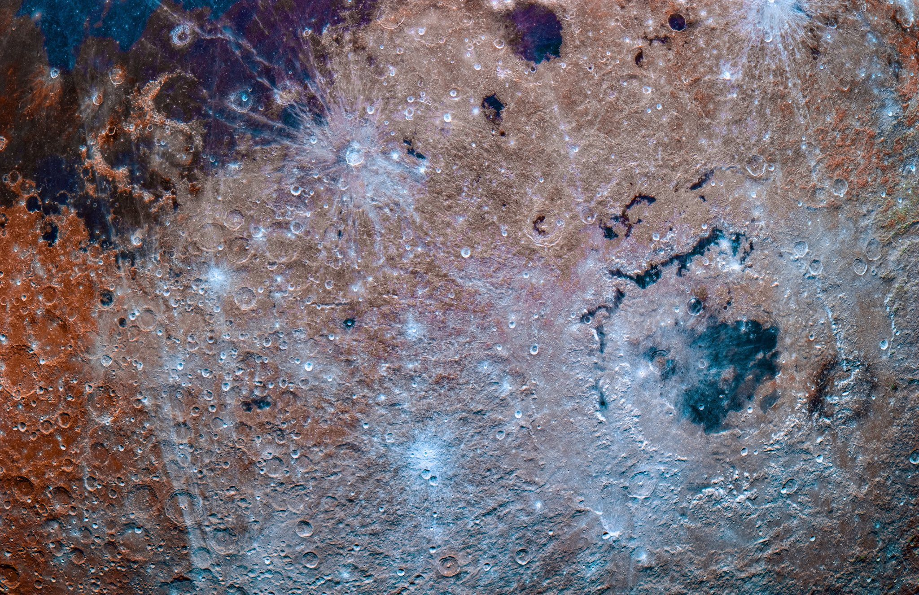

Click for next article Just weeks before the first Artemis 2 launch window, astrophotographer Andrew McCarthy had a last-minute idea: What if he could get the Artemis 2 astronauts to shoot the moon the same way he shoots the moon? So McCarthy slid into the DMs (direct messages) of Artemis 2 commander and NASA astronaut Reid Wiseman . He knew getting a response at such a late date was a long shot, but he couldn't pass up the chance for a once-in-a-lifetime collaboration. And the long shot came through. "He was immediately onboard," McCarthy told Space.com in an interview. "It was a dream come true, obviously, for me, but I saw it as this very unique opportunity." NASA's Artemis 2 mission launched on April 1 , flying four astronauts on a 10-day journey around the far side of the moon that captivated people across the world. The astronauts snapped breathtaking photos of the moon, which showed beautifully haunting views of the lunar far side that Artemis 2 crew member Christina Koch of NASA described as "the most ominous thing I've ever loved." On Earth , McCarthy combines hundreds to thousands of photos of the moon to bring out details you can't see in a single image. The results are colorful landscapes that look more like paintings than the gray orb we're used to seeing hang in the night sky , but the diversity he presents in his images come down to lunar spectroscopy rather than artistic interpretation. "It's very true life in a sense that everything you're seeing is real features on the surface that your eyes just simply don't have the color sensitivity to make out on their own," McCarthy said. He explained that his approach to astrophotography is all about showing you the things your eyes can't see. "I don't want to show you something the way your eyes see it. I want to show you something as if you had superhuman vision … I want to show you the moon as if you had cyborg eyes, because your cyborg eyes can actually pick out the color differences," McCarthy said. "The camera becomes cyborg eyes for our vision." "The color is naturally there, just much more subtle to your eyes," he added. Some color differences on the moon are possible to see with your eyes, using binoculars or a telescope, and there are ways to trick your eyes into noticing more of the contrast than you realize. A single frame of the moon, Artemis 2 photo ART002-E-9680. (Image credit: NASA) "If you take a normal photo of the moon with a DSLR and just completely desaturate it, you can tell the difference," McCarthy explained. "When you return it to regular saturation, it suddenly seems a little more colorful." For his collaboration with Wiseman , McCarthy wanted to see if he could get the same colorful results with a camera from the lunar far side. "Usually you can't get very high-fidelity color data from the far side of the moon," McCarthy said. "We've got LRO [NASA's Lunar Reconnaissance Orbiter ], which has some color data, but … it's too low fidelity to do the kind of saturation pumps that show the really granular geological differences in the regolith." McCarthy outlined a plan with Wiseman and NASA's lunar photography team, which was responsible for teaching the Artemis 2 crew how to use the cameras they brought aboard the Orion capsule during their mission. "They worked it in where he would shoot bursts in different exposures and different times, depending on where they were during the flyby," McCarthy explained. Stacking is the key to McCarthy's lunar imagery, enabling him to turn the subtle variations of color in an image of the moon into the rich browns and blues seen in his edits. The technique isn't a new one in the astrophotography world, but no one had ever tried it before using photos from the far side of the moon. A stacked photo compilation of the far side of the moon. (Image credit: Andrew McCarthy/ cosmicbackground.io The colors themselves indicate the diverse distribution of different minerals across the moon's surface and reveal key information about chemical composition of the soil and rocks. Titanium-rich basalts, for example, take on a bluish hue, while iron-rich or older, weathered material can appear in shades of brown and red. "You can do it with a single photo, but it's really, really low resolution from a noise standpoint," McCarthy said. "What's different about those different photos is the noise, because noise, by definition, is random. So, when I'm stacking those photos together, I'm able to average out that noise, and then that noise vanishes … That's why you hear astrophotographers talk about the signal-to-noise ratio, because when you stack, the signal stays the same, but the noise diminishes." NASA has published its own "mineral moon" photos in the past, like the one shot using the Jupiter-bound Galileo spacecraft as it swung by Earth for a gravity assist in 1992, but McCarthy said the quality of images from space probes can't match the dynamics of a human with a good camera. Mosaic of 53 images was recorded by the Jupiter-bound Galileo spacecraft as it passed near our own large natural satellite in 1992. The pictures were recorded through three spectral filters and combined in an exaggerated false-color scheme. (Image credit: NASA) "With the really, really high-fidelity image stacks from the stuff that Reid got, I'm able to bring out that saturation," McCarthy said. McCarthy also noticed a huge difference in the quality of Wiseman's individual photos compared to those McCarthy takes on the ground, pointing to the lack of a lunar atmosphere as a contributing factor. "On Earth, you're dealing with atmosphere in the way, and atmosphere actually adds a color cast to the moon," he said. "I'm often shooting 150 to 200 photos just to barely be able to get out the color .... It's way more than that if I'm doing it with a mosaic - sometimes thousands of photos." Comparatively, McCarthy found he needed to stack far fewer of the images Wiseman took from the lunar far side. "I was able to cut down the number of exposures used," he said. "Maybe [Wiseman] shot 50 exposures. I only ended up using 10 to 15." A stack of about 20 images from the photo collaboration. (Image credit: Andrew McCarthy/ cosmicbackground.io "It's been quite fun working this data, not only because of the features I've never seen before, but also, the data is just so clean," McCarthy said. "It is phenomenally clean. It's the best data I've ever worked." Since Artemis 2's April 10 splashdown, NASA has released more than 12,000 images taken by the astronauts during their flight around the moon. McCarthy says he's only scratched the surface of how he wants to use the wealth of material, and he expects to release more edits in the future. "I'm just going to keep working the data. There are some close-up shots I haven't worked or published yet. Nothing too crazy. I'm going to go into the highlands a little deeper," McCarthy said.

10. A close brush with Mars will reshape NASA's Psyche journey in a way few missions attempt
Space News - Space, Astronomy, Space Exploration
Read more


NASA's Psyche spacecraft will get a boost from Mars on Friday, May 15, passing just 2,800 miles (4,500 kilometers) from the planet's surface at some 12,333 mph (19,848 kph). The spacecraft will harness the planet's gravitational pull to speed up and adjust its trajectory toward the metal-rich asteroid Psyche, one of the more unusual objects in our solar system.

