IIRS Daily Space Digest Sunday, 07/06/2026

1. NASA places ISS astronauts on alert during Russian module leak investigation
Science | The Indian Express
Read more
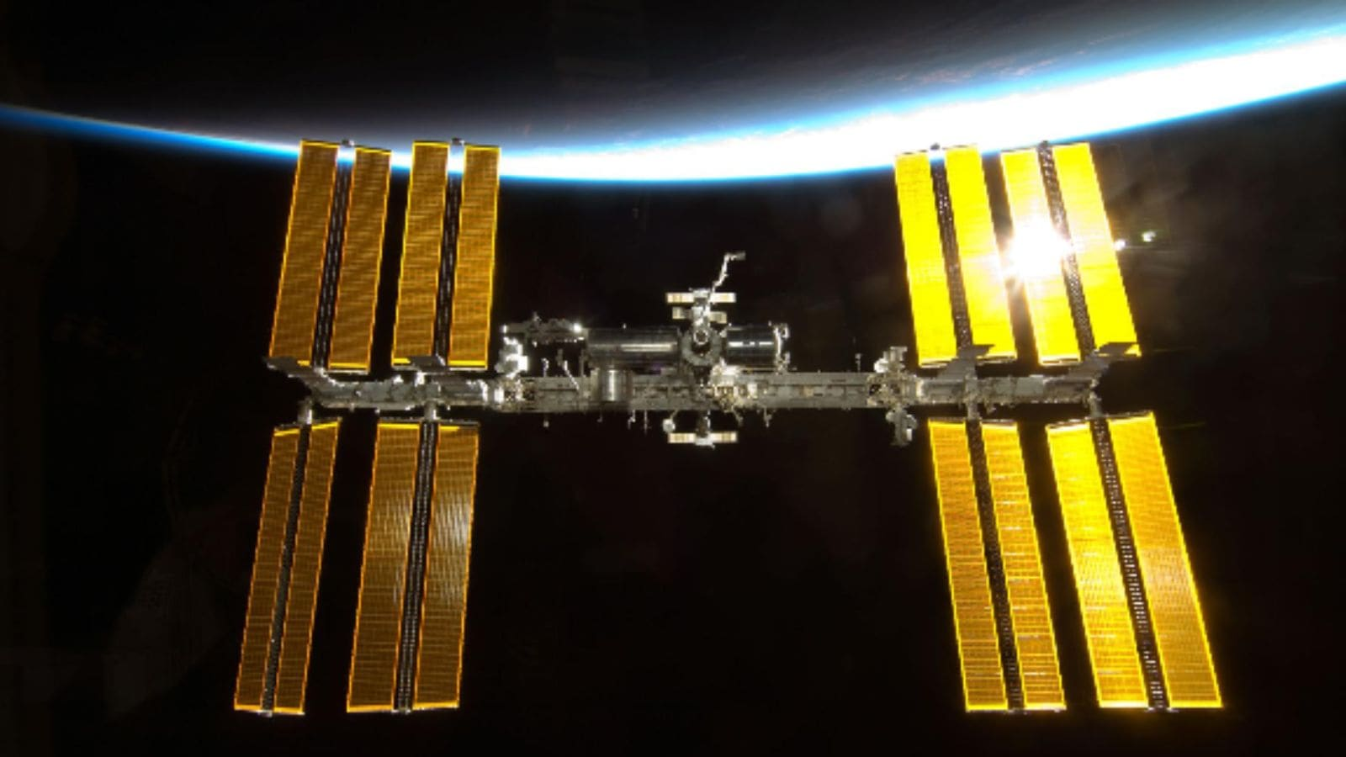

The International Space Station orbits roughly 250 miles above the Earth's surface and has been continuously inhabited since 2000. (Photo Credit: NASA) NASA, on Friday, June 5, directed astronauts aboard the International Space Station (ISS) to take shelter inside a docked spacecraft as Russian engineers prepared to investigate an air leak in the Russian segment of the orbiting laboratory. The precautionary directive came after Russia's space agency said that it was considering carrying out repair work on a section of the ISS that has been a source of air leaks for several years. NASA said the proposed repair involved cutting a bracket to gain better access to a suspected leak location, a step that could have posed additional structural risks. As a result, NASA instructed astronauts to board a SpaceX Crew Dragon spacecraft and prepare for a potential emergency evacuation if necessary.

2. ISRO's Vision 2047 Takes Centre Stage at NESAC's Meghalaya meet Pathri Rajasekhar - Deccan Chronicle
"ISRO OR NRSC OR IIRS after:2026-06-06" - Google News
Read more
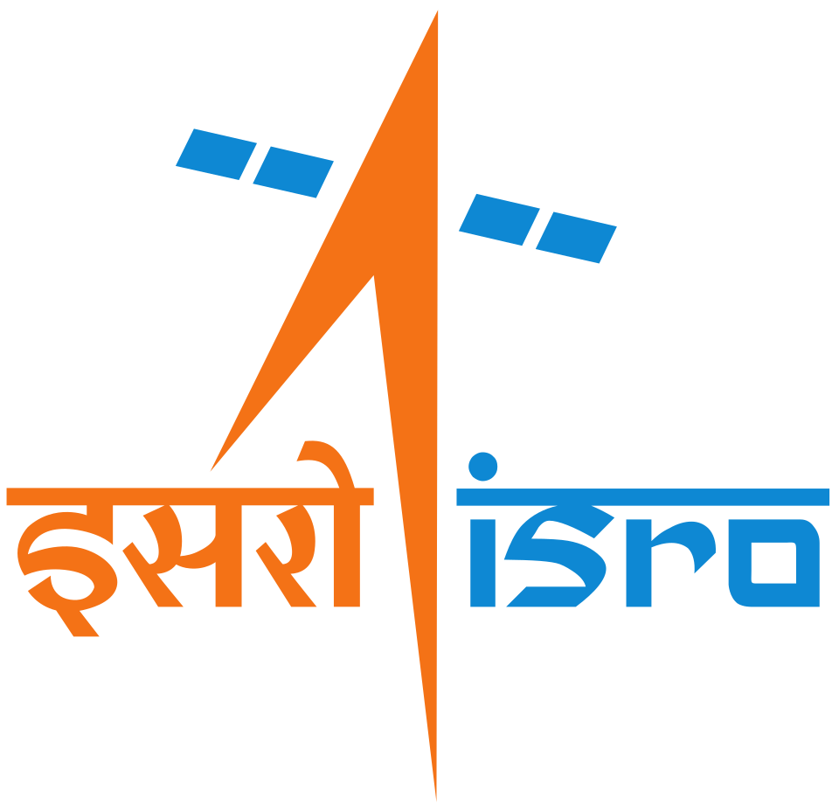

NELLORE: India's ambitious Space Vision 2047, which envisages next-generation launch vehicles, successive Gaganyaan and Chandrayaan missions, establishment of the Bharatiya Antariksh Station by 2035, and a crewed Indian Moon landing by 2040, has taken centre stage at the 13th Annual General Meeting of the North Eastern Space Applications Centre (NESAC) Society organised in Shillong, Meghalaya. Addressing the gathering, NESAC director Dr V. Narayanan outlined how the country's expanding space programme would support the vision of a developed India under Viksit Bharat 2047. He described space technology as a critical enabler of national development and highlighted Isro's roadmap for the coming decades, including advanced launch capabilities and human spaceflight missions. Union communications and development of north eastern region minister Jyotiraditya M. Scindia chaired the meeting attended by Meghalaya Chief Minister Conrad K. Sangma, senior officials from the Government of India, and representatives of all the eight northeastern states. Dr Narayanan noted that NESAC has prepared a comprehensive action plan to harness space technology for governance, planning, and public service delivery across the Northeast. As part of its outreach efforts, NESAC has completed 110 projects across the region and, through the NE-SPARKS programme, enabled 786 students from northeastern states to visit Isro facilities in Bengaluru. Presenting NESAC's progress, its director Dr S.P. Aggarwal said the centre has completed 50 projects since its previous annual meeting, while another 78 projects are currently underway across various geospatial themes. Praising NESAC's role, Jyotiraditya Scindia said the organisation has evolved into a cornerstone institution for the northeast over the past 26 years, using space technology to drive development and transformation. He highlighted the region's vast economic potential, particularly in agriculture, and called for greater use of geospatial mapping and traceability systems to create value chains for farmers and entrepreneurs. The union minister advocated a Future-Ready Space-Enabled Development Strategy for the Northeast, stressing the use of satellite imagery, GIS, and climate-smart regional planning. He said advanced geospatial technologies could help policymakers make informed decisions on infrastructure, resource management, and grassroots development across the northeastern region.

3. ISRO Scientist Nandini Harinath's Mars Mission Saree Lands At US Space Museum - NDTV
"ISRO OR NRSC OR IIRS after:2026-06-06" - Google News
Read more

ISRO Scientist Nandini Harinath's Mars Mission Saree Lands At US Space Museum NDTV

4. Union Minister congratulates ISRO on successful CE20 engine test at 22-tonne thrust - The News Mill
"ISRO OR NRSC OR IIRS after:2026-06-06" - Google News
Read more


Union Minister Jitendra Singh congratulated ISRO on the successful test of the CE20 cryogenic engine at 22-tonne thrust in Tamil Nadu. In a post on X, he stated: "Congratulations to #ISRO on the successful sea-level hot test of the CE20 Cryogenic Engine at 22-tonne thrust at the ISRO Propulsion Complex, Mahendragiri, Tamil Nadu. The successful test featuring the nozzle protection system and multi-element igniter marks another important step in strengthening India's advanced cryogenic propulsion capabilities and further enhancing the reliability of the LVM3 programme." ISRO conducted the sea-level hot test of the CE20 engine with 22-tonne thrust using a nozzle protection system and multi-element igniter on March 10 at the ISRO Propulsion Complex, Mahendragiri. Previously, sea-level tests using the nozzle protection system were performed at a 19-tonne thrust level. The CE20 engine powers the upper cryogenic stage of the LVM3 launch vehicle. To enhance the payload capacity of LVM3, future missions are planned to use an uprated C32 stage with 22-tonne thrust for the CE20 engine, according to ISRO. Consequently, flight acceptance tests of the CE20 engine also need to be conducted at the 22-tonne thrust level. The recent test qualified the sea-level testing of the engine with a duration of 165 seconds at 22-tonne thrust using the Nozzle Protection System (NPS). The performance of both the engine and the test facility met expectations throughout the test. Testing the CE20 engine at sea level poses significant challenges, primarily due to the high area ratio nozzle, which has an exit pressure of approximately 50 millibar. A main concern during sea-level testing is flow separation inside the nozzle, which can cause severe vibrations and thermal issues at the flow separation plane, potentially leading to mechanical damage of the nozzle.

5. Axiom Mission 4 launch delayed again, NASA to announce new date soon - News On AIR
"ISRO OR NRSC OR IIRS after:2026-06-06" - Google News
Read more

Indian astronaut Shubhanshu Shukla's Axiom-4 mission to the International Space Station has again been postponed. The mission was earlier expected to be launched on the 22nd of June. In a statement today, NASA said that the space agency needs additional time to continue evaluating International Space Station operations after recent repair work in the aft-most segment of the orbital laboratory's Zvezda service module. Because of the space station's interconnected and interdependent systems, NASA wants to ensure the station is ready for additional crew members, and the agency is taking the time necessary to review data. Meanwhile, the crew remains in quarantine in Florida, and the astronauts stand ready to launch when the station is ready to receive them. Moreover, SpaceX's Falcon 9 rocket and Dragon spacecraft remain healthy on the launch pad at Launch Complex 39A at NASA's Kennedy Space Centre in Florida. Peggy Whitson, former NASA astronaut and director of human spaceflight at Axiom Space, will command the commercial mission, while ISRO astronaut Shubhanshu Shukla will serve as pilot. The two mission specialists are European Space Agency (ESA) project astronaut Sławosz Uznański-Wiśniewski of Poland and Tibor Kapu of Hungary.

6. ISRO's new milestone: Space farming and Recycled rockets | Tap to know more | Inshorts - Inshorts
"ISRO OR NRSC OR IIRS after:2026-06-06" - Google News
Read more
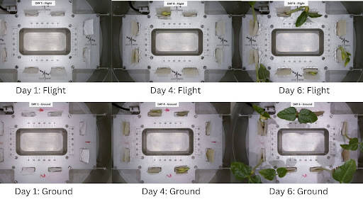

- - - ISRO's new milestone: Space farming and Recycled rockets - - - - - - - - inshorts ISRO's new milestone: Space farming and Recycled rockets Scientists at ISRO have successfully grown India's first plants in space, sprouting black-eyed peas. Grown in a recycled rocket stage in Low Earth Orbit, the autonomous CROPS module germinated 5 out of 8 seeds to the two-leaf stage. This provides hope for the viability of unmanned cosmic greenhouses for future life support on long-duration missions. tap for more at Research Matters yesterday Tap to know more Tap to deep dive! Share Load More

7. SpaceX launches 2 Starshield satellites during Saturday night Starlink mission
Spaceflight Now
Read more

Update June 7, 12:50 a.m. EDT (0450 UTC): SpaceX landed the booster on the drone ship. SpaceX launched a combination of 21 Starlink and two Starshield satellites on Saturday night from Vandenberg Space Force Base. Starshield is an alternate version of the Starlink satellite architecture the government. SpaceX hasn't announced which U.S. government agency ordered these two satellites or if they are for a foreign government. Liftoff of the Falcon 9 rocket on the Starlink 17-43 mission from Space Launch Complex 4 East happened at 9:24:30 p.m. PDT on Saturday, June 6 (12:24:30 a.m. EDT / 0424:30 UTC on Sunday, June 7). <span data-mce-type="bookmark" style="display: inline-block; width: 0px; overflow: hidden; line-height: 0;" class="mce_SELRES_start"></span> SpaceX flew the mission using the Falcon 9 first stage booster with the tail number B1097. This was its tenth flight after launching NROL-172, the Twilight rideshare, and seven batches of Starlink satellites. A little more than eight minutes after liftoff, B1097 landed on the drone ship, 'Of Course I Still Love You.' This was the 201st landing on this vessel and the 620th booster landing to date. While never publicly declared by the National Reconnaissance Office, the 13 launches supporting its "multi-phenomenology proliferated architecture" satellite constellation are believed to consist of Starshield satellites. In April 2024, Reuters reported that Northrop Grumman "is providing sensors for some of the SpaceX satellites." In 2025, SpaceX launched two missions, Starlink 13-1 and Starlink 13-4, which reportedly included two Starshield satellites each as well, similar to the upcoming Starlink 17-43 mission. Those satellites, logged by the U.S. Space Force as USA 485, 486, 549, and 550, have also not been publicly connected to a specific part of the U.S. government.

8. SpaceX signs pre-IPO deal to provide AI computing to Google
Space News - Space, Astronomy, Space Exploration
Read more
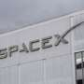

SpaceX on Friday signed a blockbuster cloud computing agreement under which Google will pay the Elon Musk-founded rocket company $920 million per month for access to a massive cluster of AI chips, according to a disclosure in its initial public offering filing.

9. SpaceX denied fast track to S&P 500 after IPO
Space News - Space, Astronomy, Space Exploration
Read more


SpaceX has been denied a fast track into the S&P 500 when the rocket and satellite company goes public, in a ruling that cuts off quick access to one of the biggest pools of Wall Street money.

10. Astronauts briefly take shelter during repair to fix leak on the International Space Station
Space News - Space, Astronomy, Space Exploration
Read more
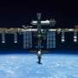

NASA on Friday temporarily ordered astronauts to take shelter during repairs to fix a fresh leak aboard the International Space Station.

