 |  | 

🌌 अंतरिक्ष समाचार | Space News
शनिवार, ०७/११/२०२६ | Saturday, 07/11/2026

1. Odisha CM Majhi launches ₹1,292-crore projects in Keonjhar, lays foundation for 630 model schools
Read more

- Governance - 1 min Read Chief Minister Mohan Charan Majhi inaugurated 198 projects and laid foundation stones for 132 others in Keonjhar. The total investment for these development projects is ₹1,292 crore. - TIMESOFINDIA.COM - Published On Nov 07, 2026 at 11:47 AM IST - Set ETGovernment as your preferred source on Google - Share Icon Copy Link Share on Whatsapp Share on Linkedin Share on X Share on Telegram Share on Facebook - Bookmark - Comment Odisha chief minister Mohan Charan Majhi. Chief minister Mohan Charan Majhi on Friday inaugurated and laid foundation stones for 330 development projects worth ₹1,292 crore in Keonjhar, spanning education, healthcare, technology, roads and civic infrastructure. The projects included the launch of the third phase of the Godabarish Mishra Model Primary School Scheme covering 630 schools across Odisha, inauguration of Dharanidhar University's south campus and the state's first indigenous technology-based preventive cancer screening centre and the foundation-laying for a ₹237-crore tech business park. Of the 330 projects, the CM inaugurated 198 worth around ₹412 crore and laid foundation stones for 132 projects valued at over ₹880 crore. Under the third phase of the model primary school scheme, 630 schools, including 35 in Keonjhar district, will be developed at an estimated cost of nearly ₹4,000 crore. Comments What are your thoughts?

2. NASA invites ISRO to join its ambitious Moon Base programme - DD News
Read more
NASA invites ISRO to join its ambitious Moon Base programme DD News

3. ISRO Chairman Narayanan meets Tamil Nadu CM Vijay - The Hindu
Read more
ISRO Chairman Narayanan meets Tamil Nadu CM Vijay The Hindu

4. 'Russia stood by India': ISRO chief V Narayanan recalls Moscow's role in space journey - Business Today
Read more
'Russia stood by India': ISRO chief V Narayanan recalls Moscow's role in space journey Business Today

5. ISRO chief Narayanan calls on TN CM Vijay - ThePrint
Read more
ISRO chief Narayanan calls on TN CM Vijay ThePrint

6. Former ISRO scientist's space debris startup Cosmoserve raises $6 million, opens Base 1 in Hyderabad - Indian Startup News
Read more
Former ISRO scientist's space debris startup Cosmoserve raises $6 million, opens Base 1 in Hyderabad Indian Startup News

7. SpaceX launches mystery mission for US Space Force in gorgeous sunset liftoff from California (photos)
Read more
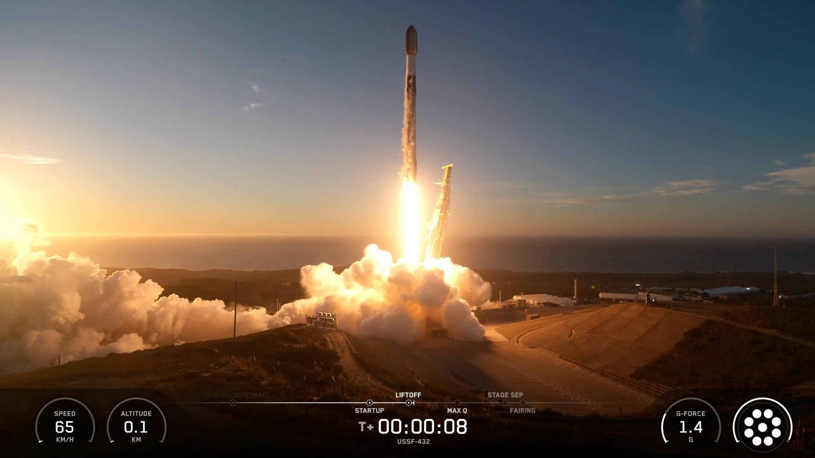
Click for next article A SpaceX Falcon 9 rocket launches the USSF-432 mission for the U.S. Space Force from Vandenberg Space Force Base on Nov. 6, 2026. SpaceX just launched a classified mission for the U.S. military. A Falcon 9 rocket lifted off from California's Vandenberg Space Force Base this evening (Nov. 6) at 7:48 p.m. EST (4:48 p.m. local California time; 0048 GMT on Nov. 7), rising into the sky as the sun sank toward the Pacific. The launch kicked off the USSF-432 mission for the U.S. Space Force , which we know little about. Neither SpaceX nor the Space Force told us much about USSF-432 beforehand, and we learned tonight; SpaceX cut its webcast off about 10 minutes into the flight, shortly after the Falcon 9's first stage came back to Earth for a landing. The Falcon 9's first stage after its landing on Nov. 6, 2026. (Image credit: SpaceX) That touchdown occurred aboard the SpaceX droneship "Of Course I Still Love You," which was stationed downrange in the Pacific Ocean. It wrapped up the eighth flight for this particular booster, which is designated 1095. The Falcon 9's upper stage, meanwhile, continued carrying its mystery payload skyward. It could be headed to low Earth orbit , outside observers speculate. "It is possibly a batch of classified LEO satellites for the USSF's Space Based Sensing and Targeting (SBST) portfolio based on SpaceX's Starshield satellite bus, based on locations of rocket stage drop zones being exact fits with previous Starlink Group 15 launches," NextSpaceflight.com wrote in a mission description . Starlink is SpaceX's LEO broadband megaconstellation, which consists of more than 11,000 active satellites. Starshield is a similar system designed to provide services to the U.S. military and its allies. Starshield satellites are believed to be based heavily on the Starlink spacecraft bus. Previous Booster 1095 missions GPS-III 8 | 6 Starlink missions USSF-432 was the 119th Falcon 9 launch of 2026, and the 14th national-security flight of the rocket so far this year. The vast majority of Falcon 9 missions in 2026 - more than 70% - have been devoted to building out the Starlink megaconstellation.

8. AST SpaceMobile announces new 'Blacklift' rocket, targets 2028 launch debut
Read more
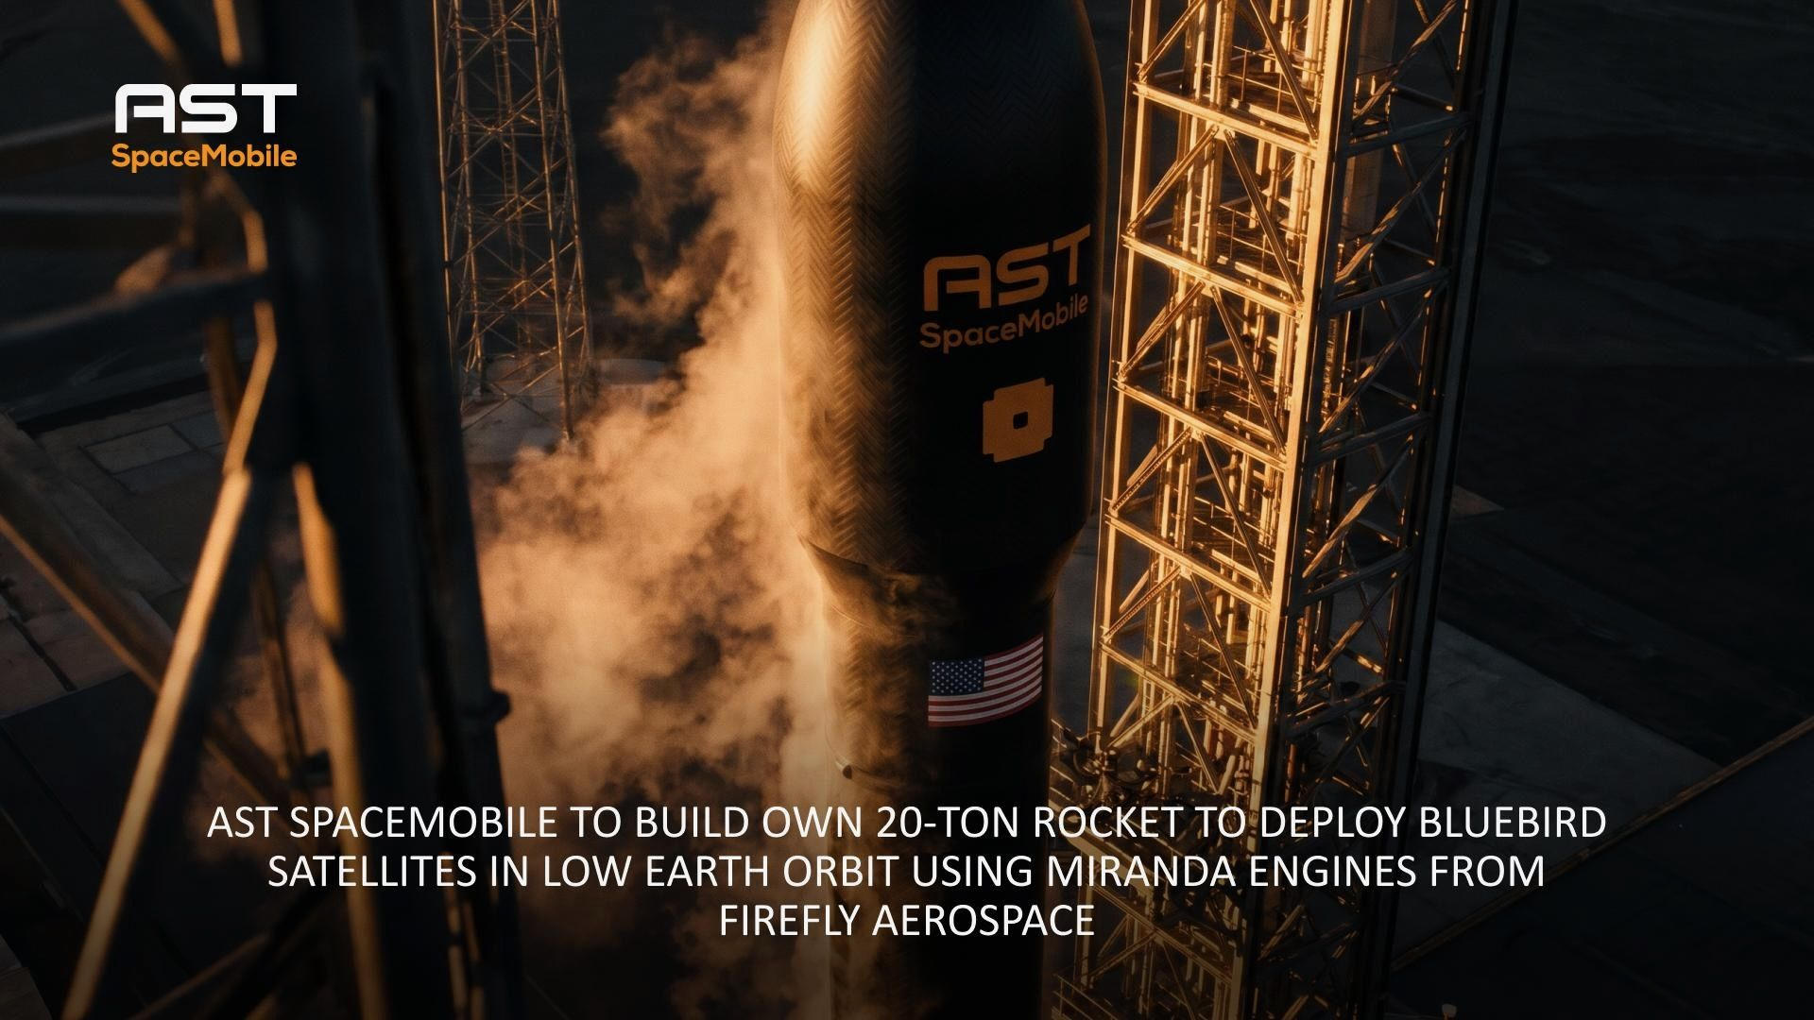
Click for next article AST SpaceMobile announced on Nov. 6, 2026, that it's developing a new rocket called Blacklift. First flight of the vehicle is targeted for 2028. Another new private rocket is in the works. AST SpaceMobile announced today (Nov. 6) that it's building a reusable rocket called Blacklift to launch its broadband satellites to low Earth orbit (LEO), with first flight targeted in 2028. The news comes just 10 days after Cowboy Space unveiled Big Iron , a rocket designed to launch its constellation of 20,000 AI data centers . Cowboy Space is also targeting 2028 for its first liftoff. "The Blacklift rocket is the springboard to significantly expand our total addressable market, providing AST SpaceMobile with regular unconstrained access to orbit and providing for most favorable owners' economics in the industry," Abel Avellan, the company's founder, chairman and CEO, said in a statement today . "This will accelerate our mission to build a new layer of global connectivity, extending connectivity beyond terrestrial networks and helping to bring AI-enabled services wherever people live, work and travel," Avellan added. Texas-based AST SpaceMobile is building a LEO constellation composed of its BlueBird satellites , which beam internet service directly to cell phones. The company has launched 13 BlueBirds to date, including eight "Block 2" variants. The antennas on each of these next-gen spacecraft cover a whopping 2,400 square feet (223 square m) - the largest ever deployed in LEO by a commercial satellite. BlueBirds have flown atop three different rockets to date - SpaceX's Falcon 9 , Blue Origin's New Glenn and India's Launch Vehicle Mark-3. But AST SpaceMobile wants to get more vertically integrated, which explains the push to develop Blacklift. The company won't be starting from scratch. It has signed a deal with another Texas-based outfit, Firefly Aerospace , to provide the engines (and associated engineering services) for the first three Blacklift launches. After that, AST SpaceMobile will build the engines itself, under a licensing agreement with Firefly. Those engines are Miranda, which will power Blacklift's booster, and Vira, which will power the upper stage. Neither engine has flight experience. (Firefly's currently operational rocket, Alpha, uses Reavers in its booster and Lightnings in its upper stage.) But Miranda has been tested extensively on the ground, firing for more than 4,200 seconds over the course of 175 hot fires, according to AST SpaceMobile. "The Miranda engine will allow us to leapfrog the traditional five-to-10-year development cycle as we build Blacklift," AST SpaceMobile President Scott Wisniewski said in the same statement. The "supply and services" agreement for the first three launches is worth $500 million. The licensing agreement cost AST SpaceMobile about $800 million, with half of that paid in cash and half in stock, according to the statement. Blacklift will be able to haul 20 tons to LEO. Each launch will therefore be able to loft up to five BlueBird satellites, according to today's announcement. (For perspective: The Falcon 9's LEO lift capacity is about 25 tons.) BlueBirds will continue going up while AST SpaceMobile gets Blacklift ready to fly: The company already holds contracts with other providers to launch more than 100 of the satellites over the course of 2027 and 2028. The launch landscape will likely be very different when Blacklift, Big Iron and other new rockets come online. SpaceX has said that it plans to phase out the Falcon 9, as well as its Falcon Heavy heavy lifter, after its Starship megarocket gets up and running.

9. Giant exoplanet emerges from the dark when the James Webb Space Telescope turns out the starlight
Read more

Click for next article An illustration of exoplanet 51 ERI b in the glare of its parent star (main); JWST/NIRCam observation of star 51 Eridani A with new technique blocking star light (top left); the same observation of the system without this filter and the predicted appearance of ERI b based upon that image (bottom). Sometimes science can seem really counter-intuitive. For example, occasionally in astronomy, you can see more with less light. Case in point: the emergence of a giant planet in observations made by the James Webb Space Telescope (JWST), when astronomers found a way to block out light from the planet's parent star. The extrasolar planet, or exoplanet , in question is 51 Eridani b (51 ERI b), a gas giant with the same mass as around 11 Jupiters that orbits a star located around 97 light-years away. 51 ERI b was discovered back in 2015 by ground-based telescopes, but the planet was missing from observations of the system made by the JWST. That wasn't a failing of the JWST itself; no one is doubting the observing capabilities of the most powerful telescope humanity has ever hoisted into orbit around Earth. Instead, it was a result of starlight from the star 51 ERI A obscuring this intimidatingly massive world. The brightest planets are 100,000 times fainter than their host stars, meaning spotting them is like observing a firefly hovering around a lighthouse. Even using a tool called a coronagraph to block the star isn't enough to reveal the planet, as that doesn't stop all the starlight. The only solution to this glaring problem is a computer program to wipe out the starlight. "For the past 20 years, astronomers have tackled this problem by observing a different star and using its image as a reference," Jason Wang of Northwestern University explained in a statement . "Then, they subtract that reference image from the original observation to remove the unwanted glare to reveal faint planets that otherwise might be hidden." There is a problem with this process, however. Even the most stable telescopes "wobble." For instance, the JWST requires cryocoolers to keep its NIRCam instrument super cold, and those coolers have little motors that can cause the mirrors to vibrate. This movement, however slight, causes a scatter in starlight. The result is enough glare remaining to obscure a planet, but Wang and colleagues developed a new approach to this problem. Telescopes their more stable digital twins The new approach taken by the team is dubbed Physics-based Learning for Imaging Planets (FLIP), and it involves creating a digital "twin" of a telescope. Essentially a virtual replica that simulates how starlight travels through the telescope's mirrors and reaches its detectors. This twin is then fine-tuned to account for millions of tiny imperfections in the original telescope. The digital twin is then tweaked until it aligns with observations from the actual telescope. Astronomers can then remove the simulated glare from the original image. To assess the validity of the technique, the researchers took a second look at JWST observations of two star systems with known exoplanets, HIP 65426 and 51 Eridani , and one system, TYC 5899, with no known planets. Subtracting starlight finds hidden planet - YouTube Watch On The researchers found that, in terms of detecting faint exoplanets, FLIP outperformed conventional image-processing techniques two to 15 times. This led to ERI b emerging from data collected by the JWST two years ago. "We showed that we can actually recover a planet that people previously couldn't see," Wang said. "This is real data in a real scenario. It was science left on the table because we didn't have the right tools to analyze the data in the most optimal way." Left: JWST/NIRCam observation of star 51 Eridani A (51 Eri) in the F430M filter, using standard method KLIP to subtract the glare of the star. Middle: The same observation, but using new method FLIP to subtract the glare of the star. Right: Simulated image of 51 Eri b (Image credit: Rodrigo Ferrer-Chavez.) The team hopes that FLIP can now be adopted by other astronomers in a bid to recover hitherto undiscovered exoplanets that have been hidden by the glare of their stars. This could be a major boon for NASA's proposed Habitable Worlds Observatory , which aims to directly photograph Earth-like planets orbiting distant sun-like stars. "We know of no planets around other stars that are like those in our own solar system," team leader Rodrigo Ferrer-Chavez of Northwestern University said. "It's not that they don't exist. It's that we cannot see them. "Every time we improve our techniques, we discover new types of planets. By finding more planets, we can better understand how planetary systems form and evolve, and ultimately how typical our own solar system truly is."

10. How to watch 'Musk' online - stream the SpaceX billionaire biography from anywhere
Read more

Click for next article As of 2026, Elon Musk is the world's richest man and CEO of SpaceX , Tesla, and xAI. Not only that, but he is also one of the most polarizing figures in popular culture. Some laud him as a new Magellan; the eccentric billionaire set on colonizing Mars. Others believe he should keep his eyes on the stars and stop meddling in politics. Whatever you think about Elon Musk , it has to be said that you do think about him. Perhaps that's precisely the reason that he is the subject of Alex Gibney's 4-hour documentary, detailing the astronomical rise of Musk and his metamorphosis into the polarizing figure he is today. Below, we explain how to stream "Musk" online and from anywhere with this VPN . Stream securely from anywhere with Nord VPN (75% off) "Musk" premiered in theaters on Oct. 9 and is available to buy digitally in North America from Nov. 6 at 12 a.m. ET, which is 9 p.m. PT on Nov. 5. The documentary boasts a mammoth runtime of 3 hours and 55 minutes, combining archive footage with first-person interviews. Here's how to watch "Musk" from anywhere with a VPN . How To Watch "Musk" Elon Musk poses in front of SpaceX shuttle. (Image credit: Getty Images) "Musk" is available to buy digitally in North America on Amazon Prime Video starting November 6 for $19.99. The documentary will also be available for purchase on Apple TV and Fandango at Home , also costing $19.99 Watch "Musk" on Amazon Prime: The 4-hour documentary is available to order from Amazon Prime right now. It will be available to view - after the $19.99 purchase - from November 6. If you want to stream "Musk" or any of Prime's other great films, TV shows and live sports while you're abroad, Nord VPN will let you access your subscription from anywhere in the world. Exclusive Deal 🟩 NordVPN - get the world's best VPN Not having a VPN is like leaving your front door wide open in a busy city - anyone can walk right in and take a peek. TechRadar regularly reviews all the biggest and best VPN providers and NordVPN is our #1 choice ✅ Up to 75% Off Today ✅ 3 Extra Months Free Get NordVPN and stream "Musk" from wherever you are. "Musk" trailer MUSK | Official Trailer HD - YouTube Watch On Who are the "Musk" cast and creators? Director Alex Gibney attending the screening of his documentary film, "MUSK" (Image credit: Getty Images) The documentary was created by Alex Gibney. the film features insights from Musk's ex-wife Justine Musk, Ashley St. Clair, Kara Swisher, Zoë Schiffer, Martin Eberhard, and Geoffrey Hinton. More from Space.com

11. Falcon 9 launches from California on classified mission for U.S. Space Force
Read more
Liftoff from pad 4E at Vandenberg Space Force Base occurred at 4:48 p.m. PST (7:48 p.m. EST / 0048 UTC). The mission is thought to be carrying satellites based on SpaceX's Starshield platform.

12. SpaceX launches classified US military mission, Falcon 9 booster nails eighth landing
Read more
Analysts suspect the mission could involve satellites linked to the Space Based Sensing and Targeting program. The U.S. Space Force has not disclosed the payload's identity, satellite count or operational capabilities. SpaceX has completed another national security launch for the U.S. military, sending its Falcon 9 rocket into orbit with the classified USSF-432 payload. The mission lifted off from Space Launch Complex 4E at Vandenberg Space Force Base in California on November 7. Its first-stage booster subsequently returned to Earth and landed on the Of Course I Still Love You droneship in the Pacific Ocean. Designated USSF-432 and R-4, the mission adds another classified payload to the U.S. Space Force's growing orbital operations. Officials have not disclosed the spacecraft's identity, capabilities, or exact mission objectives. However, its suspected connection to a military satellite program offers some clues about the technology involved. Inside the classified mission USSF-432 is part of a series of national security launches associated with the Space Force. Analysts have linked the R-series missions to the military's Space Based Sensing and Targeting portfolio. The program aims to strengthen the military's ability to gather information and support operations from orbit. The suspected payload could include satellites based on SpaceX's Starshield platform. SpaceX developed Starshield specifically for government and national security customers. Its architecture draws on technology from the company's commercial Starlink network. However, Starshield supports more specialized requirements, including secure communications and Earth observation. Liftoff! pic.twitter.com/v8mmRp00fG - SpaceX (@SpaceX) November 7, 2026 Neither SpaceX nor the Space Force has confirmed the payload's composition. Its satellite count and individual capabilities also remain undisclosed. Any connection to Starshield therefore remains an assessment rather than an established mission detail. Falcon 9 booster returns The launch marked the eighth flight for Falcon 9's first-stage booster, identified as B1095. Its previous assignments included the GPS III-8 navigation satellite mission. The booster also supported six Starlink flights before taking on USSF-432. Falcon 9 separates its two stages during powered flight. The upper stage continues toward orbit with the payload. Meanwhile, the first stage begins its controlled return toward a designated recovery zone. Falcon 9's first stage lands on the Of Course I Still Love You droneship pic.twitter.com/u5WQblzJlB - SpaceX (@SpaceX) November 7, 2026 For this mission, B1095 targeted SpaceX's Of Course I Still Love You droneship. The autonomous recovery vessel waited in the Pacific Ocean. After completing its descent sequence, the booster touched down on the platform. SpaceX can inspect and refurbish recovered boosters before assigning them to future missions. Reusing the first stage reduces the need to manufacture an entirely new booster for every launch. It also allows the company to maintain a high launch cadence.

13. Elon Musk teases SpaceX's orbital supercomputers, says it will 'blow people's minds'
Read more
Musk says StarMind's full capabilities will become clearer when SpaceX reveals more details in 2027. NVIDIA is co-designing the first StarMind systems around its Vera Rubin NVL72 computing platform. SpaceX plans to begin launching its StarMind orbital computing systems in Q3 2027, with deployment expected to accelerate in 2028 and 2029. Elon Musk is preparing to take high-performance computing beyond Earth's atmosphere. SpaceX plans to begin launching its StarMind SI computing systems into orbit in the third quarter of 2027. The company expects deployment to accelerate through 2028 and 2029. He says the project could reshape how engineers approach large-scale computing infrastructure. Speaking with investor Ron Baron at the 33rd Annual Baron Investment Conference in New York, Musk teased more details about the project. "When we unveil the details of the StarMind computer next year, it will blow people's minds," he said. SpaceX is developing its first orbital computing systems alongside NVIDIA. The initial hardware will center on NVIDIA's Vera Rubin NVL72 platform. The partnership brings advanced computing hardware into a project designed for operation beyond traditional terrestrial data centers. Supercomputing moves into orbit Space-based computing could offer advantages beyond freeing data centers from land constraints. Musk also sees orbital infrastructure as an opportunity to rethink global data transmission. He discussed SpaceX's upcoming Starlink Version 4 satellites during the interview. The next generation could deliver 10 times the capacity of Version 3. Musk said Version 3 already offers 10 times the capability of Version 2. When we unveil the details of the Starmind computer next year, it will blow people's minds - Elon Musk (@elonmusk) November 6, 2026 Laser communication will play a major role in that upgrade. SpaceX plans to equip each satellite with 10 next-generation laser links. Each link could deliver data transmission speeds exceeding 10 terabits per second. Musk also outlined a more ambitious possibility involving more than 100,000 satellites. He suggested that roughly 100 laser links per satellite could eventually challenge traditional undersea communications cables. His argument centers on transmission physics and network geometry. Light travels approximately 40% faster through space than through fiber-optic cables. Orbital connections can also follow more direct paths between distant destinations. Memphis becomes computing hub Musk also discussed SpaceX's massive computing infrastructure project in Memphis, Tennessee. He described an unusually hands-on approach to developing the facility. The billionaire said he lives in an Airstream trailer beside its power plant. SpaceX built the facility's power infrastructure in approximately one year. Elon Musk claimed the process typically takes around five years. The power plant now produces more than one gigawatt, according to the SpaceX chief. He also described personally handling electrical and networking work across the site. ~100 lasers per satellite, each operating above 10 Tb/s, with over 100k satellites should be able to outcompete undersea cables. Speed of light in space is ~40% faster than cable and the path is direct, instead of following the outline of land masses. https://t.co/l7aqDUoTAK - Elon Musk (@elonmusk) November 6, 2026 "I've pulled power cables the size of an anaconda," Musk said. He added that he has worked on fiber-optic connections and network switches. Musk said he walks the facility up to five times daily. He wants direct exposure to the engineering challenges facing employees. His approach, he explained, helps him understand the difficulties workers encounter. He also defended the economic impact of large data centers. Musk argued that Memphis businesses have benefited from SpaceX's presence. He cited stronger restaurant and hotel activity, higher wages, and additional local tax revenue. Tesla targets faster chip development The interview also touched on Tesla's expanding semiconductor ambitions. Musk revealed that Tesla is developing a research chip fabrication facility at Gigafactory Texas. The facility aims to shorten semiconductor development cycles dramatically. His target involves reducing processes that traditionally take approximately one year. He wants engineers to complete comparable development cycles in roughly one month. Tesla also plans to establish Terafab in Grimes County, Texas. The two facilities will serve different purposes. The Austin research operation will experiment with chip designs and manufacturing techniques. Terafab will focus on scaling successful developments into high-volume production. Tesla wants to bring multiple stages of semiconductor development under one roof. These include logic fabrication, memory production, lithography, and advanced packaging. The setup will also support chip testing.

