 |  | 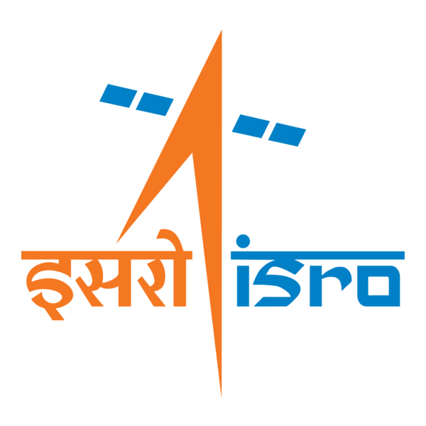

🌌 अंतरिक्ष समाचार | Space News
मंगलवार, २२/०९/२०२६ | Tuesday, 22/09/2026

1. ISRO successfully conducts 2nd integrated air drop test for Gaganyaan mission - News On AIR
Read more
ISRO successfully conducts 2nd integrated air drop test for Gaganyaan mission News On AIR

2. ISRO-ESA broaden co-operation agreement to include human and robotic exploration - The Hindu
Read more
ISRO-ESA broaden co-operation agreement to include human and robotic exploration The Hindu

3. Isro and European Space Agency extend space cooperation agreement until 2032 - India Today
Read more
Isro and European Space Agency extend space cooperation agreement until 2032 India Today

4. Japanese lawmakers visit IISc, ISRO and BEL in Bengaluru - DD News
Read more
Japanese lawmakers visit IISc, ISRO and BEL in Bengaluru DD News

5. ISRO, European Space Agency to focus on space weather, human & robotic exploration - WION
Read more
ISRO, European Space Agency to focus on space weather, human & robotic exploration WION

6. Student-led missions deploy free-flying light sails from CubeSats in low Earth orbit
Read more
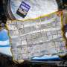
Students in Cornell's Space Systems Design Studio (SSDS) have released mission results for two unique light-sail experiments. These sails are slightly larger than a pizza box and harness momentum from photons to accelerate to high velocities. With ChipSats onboard-gram-scale spacecraft that fit in the palm of your hand-the sails can become free-flyers. They origami-fold into Cu...

7. Solar Orbiter catches the sun's missing high-speed vibrations
Read more
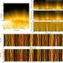
The sun's magnetic fields are a twisty, curvy, ever-changing mess. In particular, our star's polar regions host areas called polar coronal holes, which contain invisible magnetic highways that stretch into interplanetary space. But there's a lot we don't know about how those highways actually work, particularly how they give the particles that form the fast solar wind an extra ...

