संकलन
SANKALAN
31st August 2026 to 06th September 2026
ई-न्यूज़लेटर | e-Newsletter

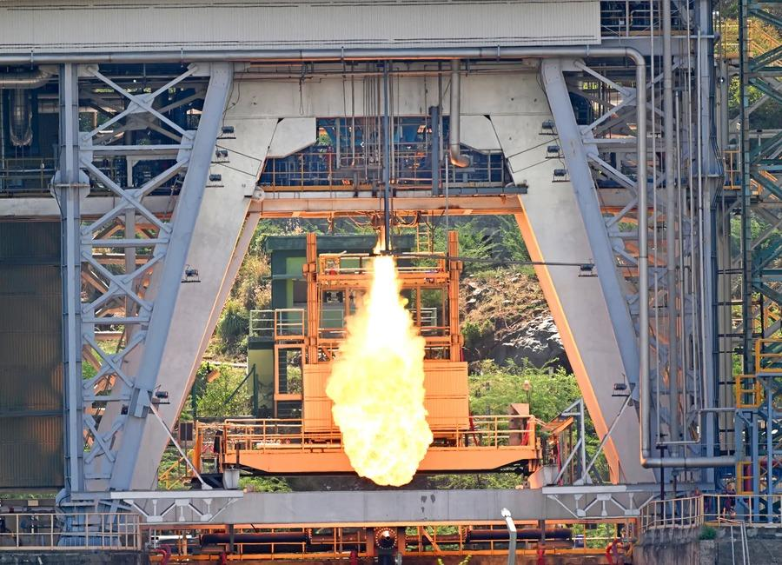 | 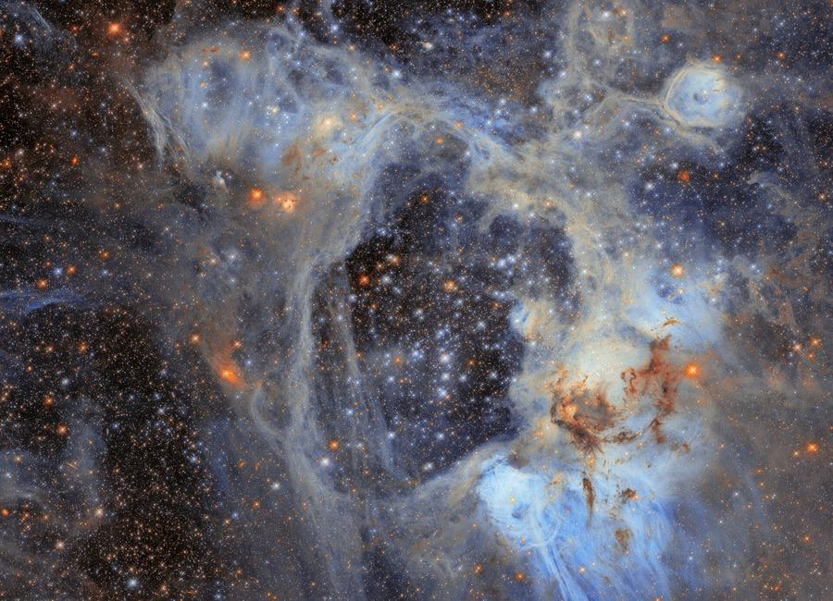 | 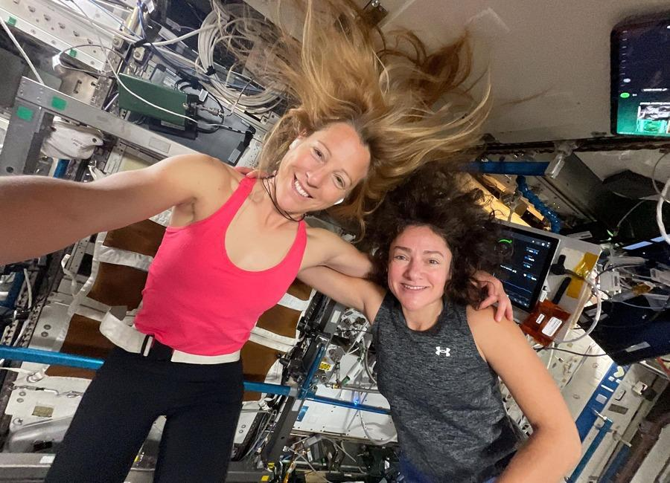
 | 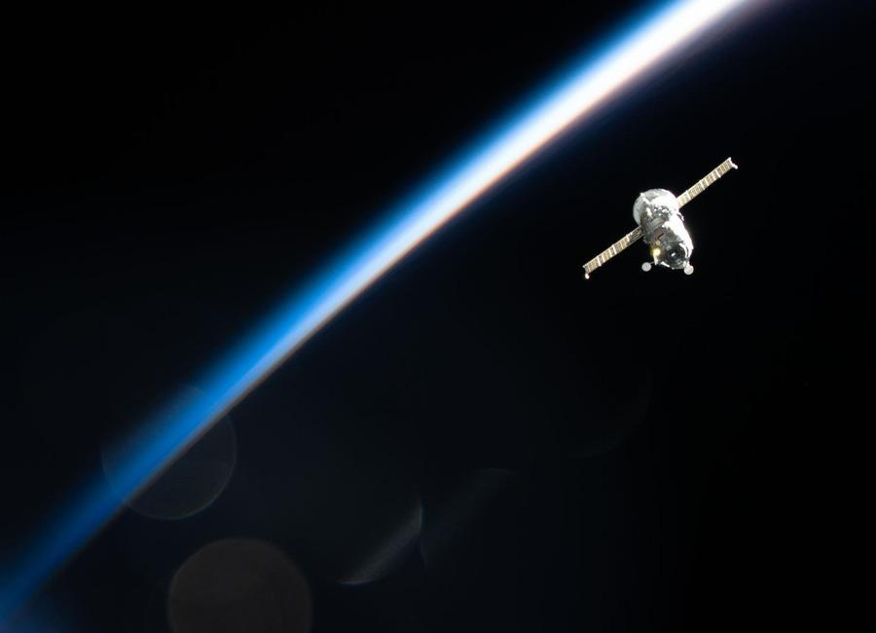 | 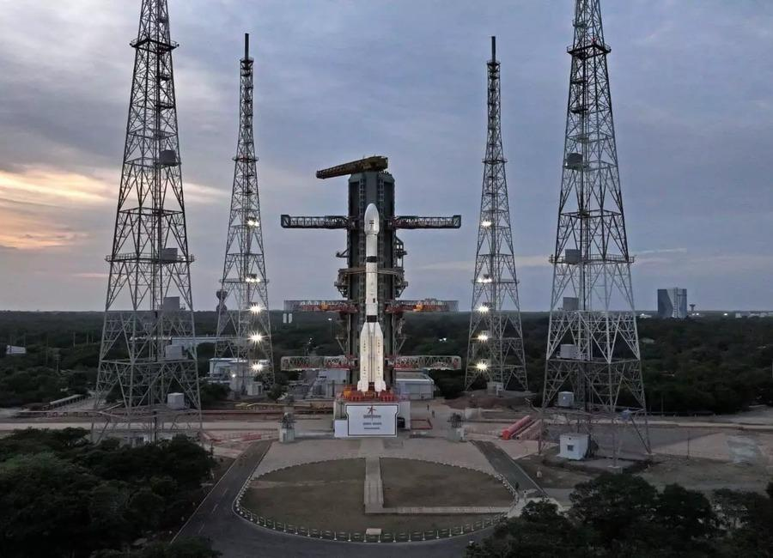
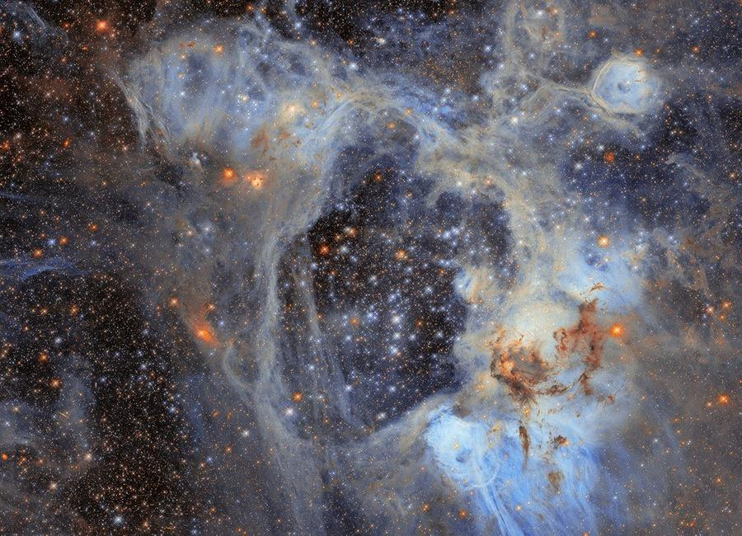 | 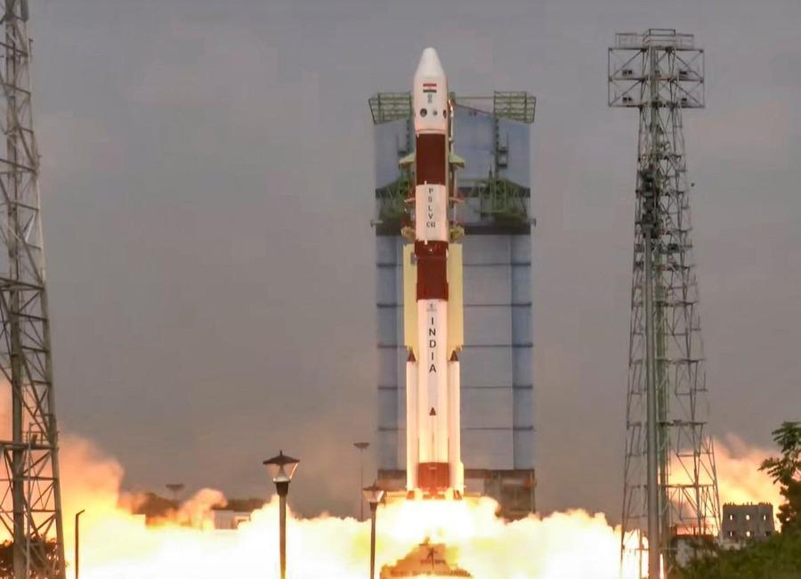 | 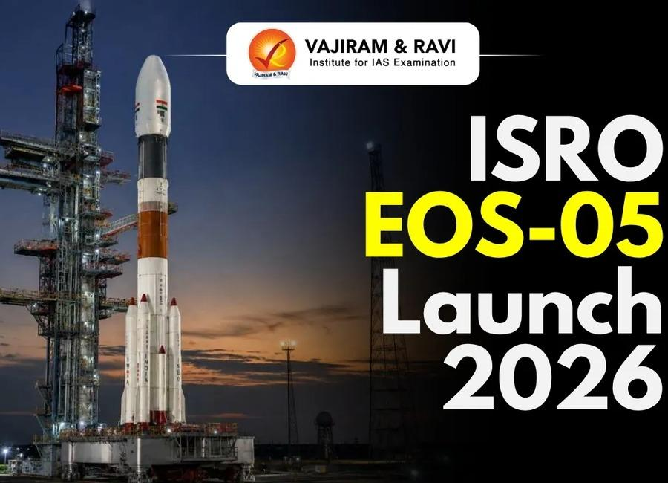

Indian Institute of Remote Sensing (ISRO), Dehradun
Collection of recent developments in the realms of Space Technology

Table of Contents
S. No. | Title
1 | Trump calls in to NASA press conference to celebrate launch of Roman Space Telescope, a mission he tried to cancel
2 | 'What a glorious dawn launch': Why the Roman Space Telescope's picture-perfect liftoff beyond Earth is such a big deal
3 | Liftoff! NASA's Roman Space Telescope soars to the stars on a SpaceX Falcon Heavy rocket in spectacular launch (video)
4 | NASA's newest Roman space telescope launches on a quest to explore the hidden universe
5 | NASA's Roman telescope set to launch on cosmic mapping mission
6 | What is GISAT-1? India's new eyes in space that Isro will launch on September 4 - India Today
7 | Onam Week celebrations: Forest dept., ISRO among winners - The Hindu
8 | After seven-month hiatus, ISRO to launch key satellite on September 4 - The Indian Express
9 | Meet GISAT-1A: ISRO's new "Eye In Space" that will watch India from 36,000 km above Earth - Moneycontrol.com
10 | Meet the ISRO Chief Who Led India to Mars While Keeping His Love for Kathakali Alive - The Better India
11 | NASA Welcomes Türkiye as Newest Artemis Accords Signatory
12 | September 2026 Satellite Puzzler
13 | Roman Commissioning
14 | Watch 2 astronauts take 6th-ever all-female spacewalk today
15 | NASA's doomed Swift space telescope restarts science work after rescue mission fails
16 | 'No guts, no glory': How I captured NASA's Roman Space Telescope cross the sun on a picture-perfect SpaceX Falcon Heavy launch
17 | What's next for Roman Space Telescope? Here's how NASA's flagship observatory will open up the universe
18 | SpaceX, NASA delay next astronaut launch to ISS due to leak on Dragon spacecraft
19 | With Rocket Model, ISRO Chief Prays At Tirumala Temple Ahead Of Crucial Launch - NDTV
20 | ISRO EOS-05 Mission | India's New Eye in Space Launches on September 4 - Kanak News Odisha
21 | GSLV-F17 carrying EOS-05 was moved from the Vehicle Assembly Building (VAB) to the Umbilical Tower (UT) on 28th August 2026 at Satish Dhawan Space Centre, SHAR, Sriharikota, as preparations continue for the scheduled launch on: 🗓️ 04 Sept 2026 | - x.com
22 | ISRO chairman Narayanan visits Tirumala; presents models of GSLV-F17, EOS-05 satellite to deity - newsmeter.in
23 | Two astronauts replace ISS camera and docking aid on 6th-ever all-female spacewalk (video)
24 | Nonprofit wants to launch 80,000-year mission to Alpha Centauri in 2029 (video)
25 | NASA's Roman Space Telescope is just one of a few missions named after real-life women
26 | Repairing the ISS 250 miles above Earth | Space photo of the day for Sept. 1, 2026
27 | 'Orbitals' is a co-op sci-fi adventure that recaptures the magic of Saturday morning cartoons
28 | SpaceX to launch Starlink mission from West Coast
29 | Many space missions are searching for life beyond Earth, but are we prepared for the fallout if they succeed?
30 | AI tool detects unusual satellite behavior to improve space safety
31 | ISRO to launch Earth observation satellite EOS-05 from Sriharikota tomorrow - News On AIR
32 | Today News Headlines for School Assembly, September 3, 2026: ISRO all set to launch satellite EOS-05 - The Indian Express
33 | ISRO GSLV-F17 EOS-05 Mission On September 4: How To Watch Rocket Launch At Sriharikota - News18
34 | 2 spacecraft headed to Mercury are about to begin their long-awaited arrival for Europe and Japan - watch it live on Sept. 3
35 | Blue Origin wins $700 million contract to build NASA's next Mars orbiter
36 | On this day in space! Sept. 2, 2016: Rosetta spacecraft finds long-lost Philae lander on Comet 67P after 2-year search
37 | Health Dept raids clinics in Kichha, 5 found unregistered
38 | How ISRO's 'Naughty Boy' Rocket Delivered A Big Win For India - NDTV
39 | After seven-month hiatus, ISRO to launch key satellite on September 4 - The Indian Express
40 | PM lauds ISRO for successful launch of GSLV-F17 carrying EOS-05 - PM India
41 | ISRO successfully launches Earth observation satellite EOS-05 - The Hindu
42 | PM Narendra Modi, Defence Minister Rajnath Singh laud successful launch of ISRO's EOS-05 - News On AIR
43 | Isro's GSLV-F17 successfully places EOS-05 Earth observation satellite in geosynchronous orbit - The Times of India
44 | Hubble's superbubble scene
45 | NASA to Cover Progress 96 Spacecraft Launch, Docking
46 | NASA's Hubble Spies Superbubble Scene
47 | 2 spacecraft will soon reach Mercury after 8 years in space. Here's what BepiColombo can do
48 | 'A new mission starting today': 8 years after launch, BepiColombo begins Mercury arrival
49 | On this day in space! Sept. 3, 2006: Europe's SMART-1 spacecraft crashes into the moon in lunar death dive
50 | India sends Earth-imaging satellite toward geosynchronous orbit in milestone launch (video)
51 | Perseverance rover watches Earth vanish behind Martian moon
52 | GeoSARAL targets wider GIS adoption across government with Linux-based, low-cost platform
53 | ISRO Successfully Launches EOS-05 Earth Observation Satellite - Vajiram & Ravi
54 | After seven-month hiatus, ISRO to launch key satellite on September 4 - The Indian Express
55 | ISRO successfully launches Earth observation satellite EOS-05 - manoramayearbook.in
56 | The Success of EOS-05 Says the Seven-Month Launch Hiatus for ISRO Is Over - TheWire.in
57 | NASA Hosts Virtual Artemis Webinar for Blind, Low-Vision Community
58 | Hubble Telescope sees spectacular 'superbubble' | Space photo of the day for Sept. 4, 2026
59 | How did the infant sun form? Scientists get surprising new insights from 4.6-billion-year-old space dust
60 | Rescue satellite gets close to NASA's doomed telescope, even if it can't save it
61 | All-civilian US workforce completes historic overhaul of 15,000-mph nuclear missile
62 | US' new fighter jet that can integrate 12 AMRAAM missiles, 30,000-lb payload leaves Boeing facility
63 | PWD plans drone survey to identify vulnerable slopes amid rising landslides
64 | Climate disaster report highlights gaps in Uttarakhand's preparedness
65 | ISRO successfully conducts hot test of Semicryogenic Engine Power Head Test Article at full thrust level - ISRO
66 | ISRO to launch two satellites tonight from its spaceport in Sriharikota to demonstrate docking and undocking of spacecraft in orbit | Akashvani News - News On AIR
67 | 9 ISRO employee bodies write to chairman, seek clarity on space privatisation plans - The Federal
68 | ISRO employees seek 'written clarity' over privatisation of space sector: Report - Deccan Herald
69 | ISRO employee associations seek clarification on privatisation plans - The News Mill
70 | Gaganyaan mission reaches advanced stage as ISRO completes key systems, infrastructure - DD News
71 | On this day in space! Sept. 5, 1977: NASA launches Voyager 1 on epic journey across the solar system
72 | This NASA-funded 'Slingshot' spacecraft idea could map minerals on planets and moons across our solar system
73 | Live coverage: SpaceX to launch 80th Starlink mission of 2026
74 | Spacecraft bound for Mercury begins 'tricky' arrival
75 | 11-foot robot boat that can conduct surveillance missions to boost US military power

 |  | 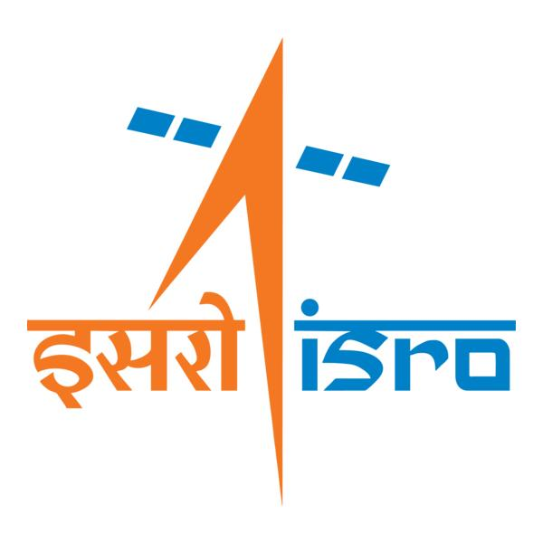

🌌 अंतरिक्ष समाचार | Space News
सोमवार, ३१/०८/२०२६ | Monday, 31/08/2026

1. Trump calls in to NASA press conference to celebrate launch of Roman Space Telescope, a mission he tried to cancel
Read more
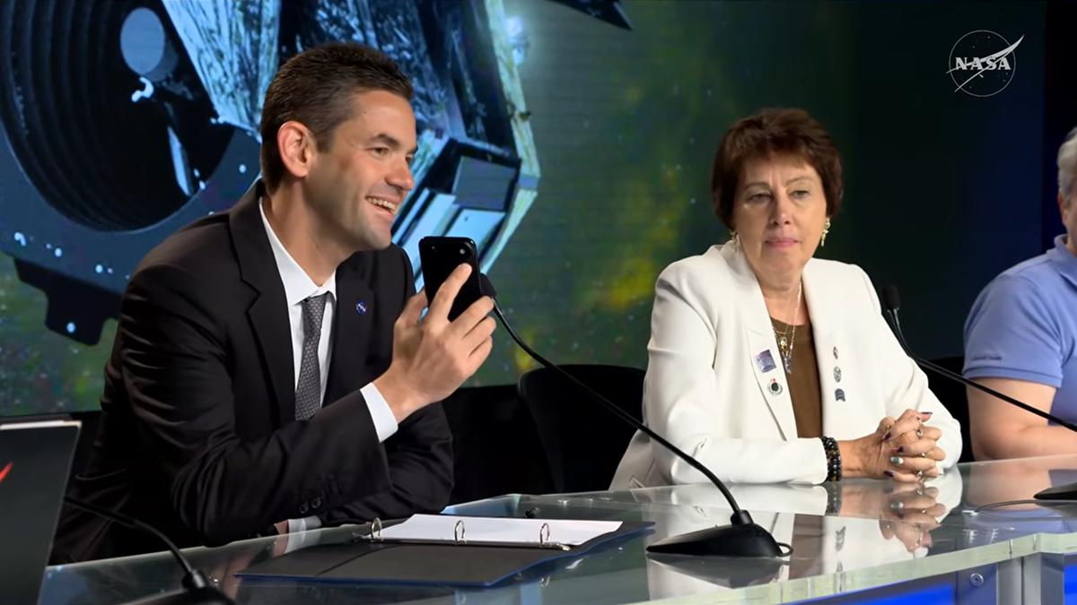
Click for next article CAPE CANAVERAL, Fla. -President Trump interrupted a NASA press conference today (Aug. 30) to congratulate the Nancy Grace Roman Space Telescope team on a successful launch. Just a few years ago, however, the president tried to cancel this very mission. In today's briefing, mission leadership was going through the specifics of Roman's successful launch and the science the observatory is expected to deliver when NASA Administrator Jared Isaacman got a phone call. It was the president. The room fell silent, though I could hear Nicky Fox, NASA associate administrator for the Science Mission Directorate, say, "He's not kidding." "Hello, sir," Isaacman said. He got up to take the call outside the room but came came back in a few moments later. "The president of the United States would like to address and congratulate everyone on this mission," he said. "You're live, Mr. President." Jared Isaacman takes a surprise phone call from President Trump during the post-launch briefing following the launch of the Nancy Grace Roman Space Telescope on Aug. 30, 2026. (Image credit: NASA) "I just want to thank everybody and congratulate you," Trump said on the phone, which Isaacman held up to the microphone and clearly displayed Trump's name. "Boy, it looked beautiful on television ... You are doing a fantastic job, and I'm supplying you all that money." The president spoke for more than a minute while Isaacman smiled, holding the phone up to a microphone for everyone to hear, and the crowd of journalists listened intently. The call was mostly congratulatory, but Trump did go on a brief tangent, claiming that he has taken NASA to new heights. Near the beginning of his first term in 2016, Trump said, he visited NASA's Kennedy Space Center (KSC) in Florida and saw that "grass was growing through the cracks in the runways, and there were a lot of cracks. And I looked; that place was closed ... It was just literally closed. And now, again, like we are with the country itself, we're the hottest there is. We're the hottest. You're the hottest in space, and we have the hottest country anywhere in the world." (To clarify, KSC was only closed for two days in 2016, and that was because of Hurricane Matthew .) President Trump's relationship with the Roman mission is more complicated than today's congratulatory call might suggest, however. Under the Trump administration, the White House has repeatedly tried to cancel or restrict funding for this mission . Between 2019 and 2021, for example, the president proposed canceling Roman (then called WFIRST) three separate times in three different budget requests. Congress rejected those proposals and kept the mission funded. But then, in April 2025, reports emerged about initial "passback" budget documents that proposed slashing NASA science funding by about 50%. The proposed cuts were deep enough, experts suggested , that the Roman mission would end if they were passed. That didn't happen either, of course; Congress ended up passing a $24.4 billion NASA budget for fiscal year 2026, keeping the agency's funding relatively flat. As Trump made his call today to a room packed with science journalists, this bit of recent budget history did not go unnoticed. Image 1 of 2 Jared Isaacman takes a phone call from President Trump to congratulate the Nancy Grace Roman Space Telescope mission team. (Image credit: NASA) Donald Trump's name glows on Jared Isaacman's phone as he holds the phone up to a microphone during a surprise call during a post-launch briefing. (Image credit: NASA) Image 1 of 2 View Original Image 2 of 2 View Original A direct question "Question for the administrator," SpaceNews reporter Jeff Foust asked Isaacman today following Trump's call. "It's great to hear the president call in and show us excitement about the Roman launch. I know the administration in past years, in its first term, proposed zeroing out Roman and also proposed a serious cut in Roman's budget just last year. What did you tell the administration, and the president, to change his mind and make him so excited about a mission that he once proposed to cancel?" Isaacman did not directly address the question, focusing instead on the current climate, which he said is very positive. "I'm incredibly grateful for his support, the space policy, the resources," Isaacman responded. "Sounds like from that call, maybe even more resources, which is also a great thing for more missions of science and discovery."

2. 'What a glorious dawn launch': Why the Roman Space Telescope's picture-perfect liftoff beyond Earth is such a big deal
Read more
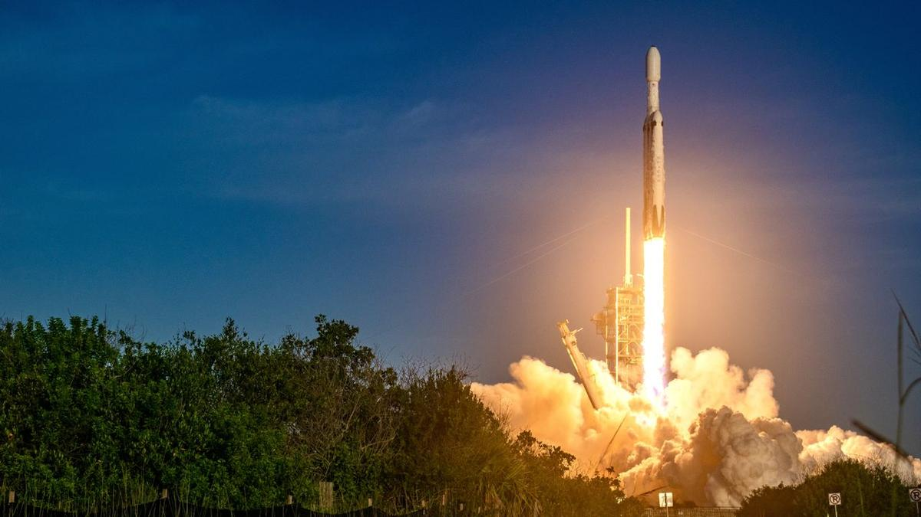
Click for next article CAPE CANAVAREL, Fla. - It was a bright and sunny morning here in Florida when the Nancy Grace Roman Space Telescope lifted off planet Earth against a magical blue sky. "What a glorious dawn launch," Jackie Townsend, the Roman Space Telescope 's project manager, said during a post-launch press conference on Sunday (Aug. 30). "The ride was magnificent - it put us right where we wanted to be. All of the deployments went great." Roman lifted off on a SpaceX Falcon Heavy rocket right on cue at 7:26 a.m. EDT (1126 GMT), beginning its journey to revolutionize the way we see the universe. It will be able to do this thanks to the two stars of its toolkit, the Wide Field Instrument (WFI) and the Coronagraph Instrument. The former is meant to image extremely wide sections of the cosmos to capture tons of fleeting phenomena that are hard to catch - things like supernovas, fast radio bursts and maybe even colliding neutron stars . Its uniquely wide view will also help scientists decode the intricacies of dark matter and dark energy while perhaps clearing up some contradictions about our universe that scientists have been scratching their heads over for decades. What's the source of the puzzling " Hubble tension ?" Why exactly is the universe expanding the way it is? Are we alone? Meanwhile, the coronagraph will take direct images of exoplanets and bring us a gallery of "Pale Brown Dots" from beyond our solar system akin to the Voyager spacecraft's priceless "Pale Blue Dot" portrait of Earth . The Roman Space Telescope lifts off. (Image credit: Chelsea Gohd) What happens now? Now that it has lifted off, the Roman Space Telescope will undergo a 90-day commissioning period while traveling to its station in space at the sun-Earth Lagrange Point 2, or L2. This is a gravitationally stable point in space on the side of Earth always opposite the sun; it's a popular location to send telescopes because the orientation allows spacecraft to remain safe from heat while still getting a great view of the universe. Notably, the powerful James Webb Space Telescope (JWST) is also located here. "Roman will travel nearly 1 million miles away from Earth to Lagrange Point L2 and begin transmitting imagery and data back home that will contribute to world-changing science along with captivating imagery like we see from Hubble and James Webb," NASA administrator Jared Isaacman said during today's press conference. "I have no doubt that Roman will become a household name alongside those great instruments of discovery." Right after getting off the ground and successfully separating from the spacecraft, Roman started undergoing several typical post-launch procedures - for example, outgassing, referring to the spacecraft releasing any trapped gases once exposed to the vacuum of space, getting "power positive" and plunging to the really cold temperature levels necessary to keep its instruments safe. A visualization showing what the Roman Space Telescope looks like from the side. (Image credit: NASA Goddard Space Flight Center Scientific Visualization Studio) The picture-perfect launch today adds to Roman's glowing record of efficiency and performance. This telescope has been in development for over a decade and has an estimated total cost of about $4 billion - but while this may sound like lots of time and money, it's pretty good for a space mission. The JWST, for instance, cost about $10 billion. Roman, in fact, was completed under budget and ahead of schedule. And now, it turns out that even the famously fickle Florida weather couldn't stop this space explorer in its tracks. "The weather got the memo that Roman is always early," Townsend said. The Roman Space Telescope's solar arrays. (Image credit: NASA/Jolearra Tshiteya) What exactly will Roman do? The Roman Space Telescope is a huge deal for astronomers. First of all, with its WFI, it's meant to process a tremendous amount of data in relatively short periods of time in order to survey gigantic zones of our cosmos. For context, the Hubble Space Telescope has generated about 400 terabytes of data across its 35 or so years of service, while Roman will be generating about 500 terabytes every single year. "Our main survey will take over a year and be really huge," Julie McEnery, Roman's senior project scientist at NASA's Goddard Space Flight Center in Greenbelt, Maryland, said during a prelaunch conference on Saturday (Aug. 29). "We would need over half a million 4K TVs to fully display the single Roman image on our largest survey." Roman will also view the universe in the infrared region of the electromagnetic spectrum like the JWST, but with a wide-field, shallow view rather than the JWST's super narrow but deep view. This is a big deal because infrared observations are key for astronomers; they allow us to view objects hidden behind interstellar dust and gas as well as objects in the very (very) distant universe emitting light wavelengths that stretch out from bluer, tight ones into redder, longer ones. And second of all, Roman's coronagraph is state-of-the-art. It's the first "active" coronagraph to be flown in space, which means it's able to actively adjust itself to enhance its observations. The concept is basically like a solar eclipse; a coronagraph blocks out the glare of a star such that anything around that star can come into focus. And that means exoplanets - specifically large ones for Roman's capabilities. NASA will be using Roman foremost to find Jupiter -like worlds around other stars in the universe. "If you try to imagine seeing an exoplanet next to a star, it's going to be very challenging," Vanessa Bailey, Roman's coronagraph instrument scientist, said during the prelaunch briefing. "The starlight is going to be overwhelmingly bright. It's like trying to see a firefly next to a lighthouse hundreds of miles away. We can use a technology called a coronagraph inside of our camera to block that lighthouse and see the firefly." People watch on as the Falcon Heavy's booster returns to Earth. (Image credit: Chelsea Gohd) But what's special about an active coronagraph like this one is that it can change its hardware to increase the amount of targets it can study. Shawn Domagal-Goldman, the head of NASA's Astrophysics Division, offered an analogy about going to see an optometrist: "They measured my eyes, they measured my vision, and then they gave me a prescription, which I then mailed in, designed lenses to basically impart the opposite area that my eyes impart," he explained. "What the coronagraph does is, it's basically doing that measurement and then reshaping with deformable mirrors in a fast cadence to correct the vision that the telescope is imparting." "In 1990 when we launched Hubble, we didn't even know there were exoplanets," Nicky Fox, the associate administrator for NASA's Science Mission Directorate, said during today's briefing. "There will be maybe 100,000 [known ones] at the end of Roman." 'The edge of a precipice' McEnery described today's launch as a transition point, and said it feels like Roman's technical team is on the "edge of a precipice." Launch experts will now hand the baton to scientists, who will start using the machine they worked so very hard to get to space safely. "We're just about to set foot off into the unknown," she said. "I'm looking forward to the next few months when we turn things on, figure out how well things work, and actually get to use this observatory, this telescope, these instruments in space, in the environment that it's designed for." Soon, the science is going to come rolling in, she said: "You know, I have no real good words because it's just so exciting." Another bit of excitement during today's conference came from U.S. President Donald Trump, who called Isaacman right when Fox was beautifully describing what it's like to say goodbye to Roman, a machine that has without a doubt become a member of her team. "There is that moment where you think, 'I'm never going to see that spacecraft again,' and get that feeling of 'You know, it's never coming back,"' she said. "I liken it to sending your kids to college. They're going to have great adventures." When Trump called, Isaacman left the room briefly before returning and putting his phone toward the speaker. "I just want to thank everybody and congratulate you," Trump said. "Boy, it looked beautiful on television." "I just called Jared to find out: 'Is there anything negative that I should know about? Like, it will never be able to return? Little things like that,'" Trump continued. "He said 'No, it's looking great. It couldn't be better and it was another great successful launch.' Jared's doing a fantastic job. You are doing a fantastic job, and I'm supplying you all that money." During his first term, however, Trump tried to cancel the Roman Space Telescope. Jared Isaacman speaking to President Donald Trump during the conference. (Image credit: NASA) From team Earth to team space It will be a treat to see the first results that come in from Roman, whether it be a "fuzzy little smudge" of an exoplanet, as Bailey once told me we can expect from the coronagraph, or a sweeping panorama of millions of galaxies that can help us decode the truth about dark matter and dark energy. On that note, the dark universe is a huge point of interest for the Roman team, because the way we're able to study this elusive yet ubiquitous aspect of our cosmos is by watching how dark matter and dark energy affect galaxies across vast spaces. It's therefore important to monitor as many galaxies as we can simultaneously. But as the Roman team has consistently repeated one particular role Roman will have in space: to be a team member to other space telescopes just the way it's always felt like a part of Fox's team. NASA's Nancy Grace Roman Space Telescope is encapsulated in the payload fairing of its SpaceX Falcon Heavy rocket. (Image credit: SpaceX) While Roman has a very wide field of view - far wider than that of the Hubble Space Telescope and James Webb Space Telescope - it doesn't have the same resolution as Hubble or the ability to heavily zoom in on objects in infrared like the JWST can. The goal is to have a fleet of telescopes that can work together to show us the universe in as much detail as possible. Roman will work with Hubble, Webb, and even Europe's Euclid space telescope , the ground-based Rubin Observatory and more. In fact, Euclid's field of view is even bigger than Roman's - but it isn't doing the same surveys that Roman will. Rubin will create a new 3,200-megapixel image of the southern night sky every 40 seconds for 10 years during its observing time - but it's on the ground in Chile, so its view is somewhat compromised by Earth's atmosphere. "Roman, Rubin and Euclid, they're siblings. They were all proposed and prioritized at the same time, so the design of each of those observatories has been in the knowledge of knowing what the other ones were doing," McEnery said. "There is a reason that most of Roman's observations are in the Southern Hemisphere, and that's to maximize the overlap with Rubin. We're not competitors. We're stronger together, and we both need each other." "It's kind of like layering paint on a canvas," Fox said. "You layer the data, and it just really unlocks the secrets of the universe."

3. Liftoff! NASA's Roman Space Telescope soars to the stars on a SpaceX Falcon Heavy rocket in spectacular launch (video)
Read more
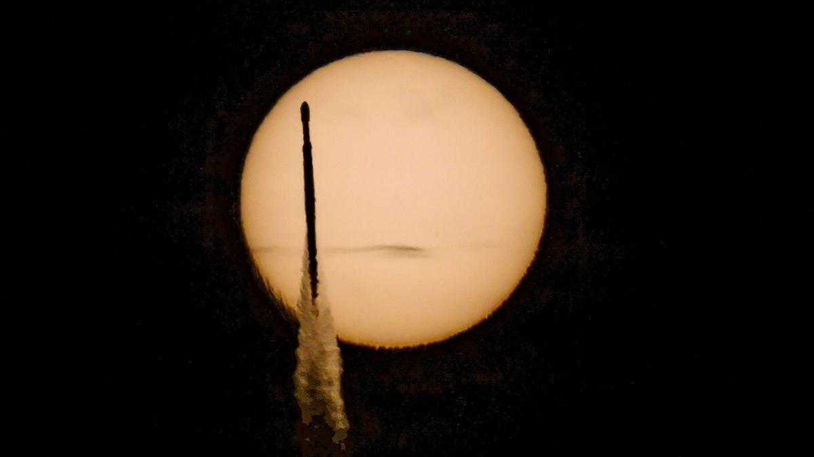
Click for next article CAPE CANAVERAL, Fla. - A new era of astronomy is about to begin after NASA's newest flagship observatory leaped from the terrestrial bounds of Earth into the vastness of space this morning. NASA's Nancy Grace Roman Space Telescope launched today (Aug. 30) on a SpaceX Falcon Heavy rocket from the Kennedy Space Center here in Florida. Liftoff occurred at 7:26 a.m. EDT (1126 GMT) at Launch Complex-39A (LC-39A). Roman is NASA's newest orbital observatory designed to add to the wealth of research and discoveries we've received from the Hubble Space Telescope and James Webb Space Telescope . "The scope is extraordinary," Roman senior scientist Julie McEnery said during live commentary. "We will do a survey of our own Milky Way galaxy and find 20 billion stars. That would make it the largest catalog of astronomical objects that's ever been produced." Image 1 of 3 A SpaceX Falcon Heavy rocket carrying NASA's Roman Space Telescope crosses the sun during launch from Pad 39A of NASA's Kennedy Space Center, Florida on Aug. 30, 2026. (Image credit: Space.com / Josh Dinner) A SpaceX Falcon Heavy rocket launches with NASA'S Nancy Grace Roman Space Telescope onboard from Launch Complex 39 on Aug. 30, 2026, at NASA's Kennedy Space Center in Florida. (Image credit: Space.com / Josh Dinner) A SpaceX Falcon Heavy rocket launches with NASA'S Nancy Grace Roman Space Telescope onboard from Launch Complex 39 on Aug. 30, 2026, at NASA's Kennedy Space Center in Florida. (Image credit: NASA/Joel Kowsky) Image 1 of 3 View Original Image 2 of 3 View Original Image 3 of 3 View Original While Hubble and the JWST are built to get close looks at distant phenomena in the universe, Roman will study the bigger picture of our cosmos . Its main instrument, known as the Wide Field Instrument (WFI), will take extremely wide images of the universe, capturing ultra-high definition views across broad swaths of the sky. It's also equipped with the first active coronagraph to be used in space, which will revolutionize exoplanet studies. The Roman Space Telescope is named after NASA's first chief astronomer Nancy Grace Roman , the first woman in an executive leadership role at the space agency. It was Roman who advocated for a telescope in space, leading to the Hubble Space Telescope. Roman, who died in 2018, earned the nickname "Mother of Hubble" as a result. "It was Nancy in the old days, before the internet and before Google and email and all that stuff, who really helped to sell the Hubble Space Telescope, organize the astronomers, who eventually convinced Congress to fund it," Ed Weiler, Roman's successor as Hubble's chief scientist, told the Voice of America in 2011. At liftoff, Falcon Heavy blazed off the pad at LC-39A, roaring with the thunder of 21 Merlin 1D engines on the business end of the SpaceX triple-booster launch vehicle. About 2.5 minutes into flight, the rocket's two side boosters cut off their engines for a nominal separation and began trajectory burns to return for a landing back here on the Space Coast. The rocket's core booster then continued onward to deliver Falcon Heavy's second stage equipped with Roman into space. Main engine cut off (MECO) and separation of Falcon Heavy's main stage took place about four minutes after liftoff, with fairing separation about 15 seconds later. Falcon Heavy's side boosters, meanwhile, executed boostback burns for landings at SpaceX's Launch Complex-40 and Landing Zone-2 at Cape Canaveral Space Force Base, a few miles downrange from LC-39A. A view of on e of the two SpaceX Falcon Heavy side booster as it lands at Cape Canveral Space Force Station following the Roman Space Telescope launch. (Image credit: NASA) Roman's delivery to space caps more than a decade and $4 billion of development for the space telescope, which was made possible, in part, by i ncorporating elements of an unused spy satellite . With its coronagraph and WFI, the telescope is designed to make groundbreaking strides in the fields of dark matter and dark energy , exoplanet discoveries, and will be capable of capturing views 100 times wider than those of its Hubble predecessor. "The smallest Roman images will be a billion pixels," Dominic Benford, progam scientist for the Roman Space Telescope, said during live commentary. "When we take a billion-pixel image, there isn't a screen on Earth large enough to display all the pixels." NASA's Roman Space Telescope flies free from its SpaceX Falcon Heavy rocket after a successful launch on Aug. 30, 2026. The large dish visible on the spacecraft is its high-gain antenna, which will beam its trillion-pixel photos back to Earth. (Image credit: NASA) The coronagraph works by blocking out the light of distant stars in such a way that scientists can examine minute details around those stars - meaning they can map out exoplanets orbiting in the systems. Once active, Roman's Wide Field Instrument (WFI) will capture more than a terabyte of data daily; its largest survey will take over a year to complete and is expected to fill more than half a million 4K TVs. How big will the largest Roman image be? "A trillion pixels," Benford said. You can actually adopt one of those Roman Space Telescope pixels yourself with NASA's new "Adopt a Pixel" program , which the agency announced during the Roman launch. Roman's Falcon Heavy launch vehicle released the telescope to fly on its own a short 31 minutes after liftoff. NASA cheered the success, and even got a bit of a nod from celebrities in the form of a record message from singer Jewel. "As you may know, I make artwork using astrophysical data, and there would be no data more fascinating than dark energy and dark matter," Jewel said in a recorded video. "And so, it is with this great wish of great success and Godspeed that I wish the Nancy Grace Roman Space Telescope so excited. Now, the telescope is headed to sun-Earth Lagrange point 2 (L2), a relatively stationary orbital location beyond the orbit of the moon that allows the spacecraft to remain persistently on Earth's night side, with the sun on the opposite side of the planet. The locale places the sun to Roman's backside and points its sensitive instruments away from the intrusion of light reflected off the Earth and moon. Roman's journey to L2 will take about 90 days. The first 40 or so of those days will be spent turning on the telescope's instruments and performing status checks as the spacecraft slowly configures itself for operation. Science commissioning will begin after about 45 days, its completion corresponding with when Roman arrives at L2. "I very much hope, and in fact, expect that the most exciting science of Roman will be a surprise - something we couldn't predict and that will set the stage for the next, deeper set of questions for future missions to progress," McEnery told reporters a day before launch. The telescope's first images are expected in the beginning months of 2027.

4. NASA's newest Roman space telescope launches on a quest to explore the hidden universe
Read more
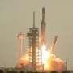
NASA's newest crown jewel blasted off Sunday to hunt for planets around other stars, explore secret dark energy and survey the cosmos like never before.

5. NASA's Roman telescope set to launch on cosmic mapping mission
Read more
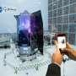
NASA is preparing to launch its new flagship space telescope on Sunday, embarking on a multiyear mission to create an unprecedented map of the cosmos and shed light on some of the biggest mysteries in physics.
6. What is GISAT-1? India's new eyes in space that Isro will launch on September 4 - India Today
Read more
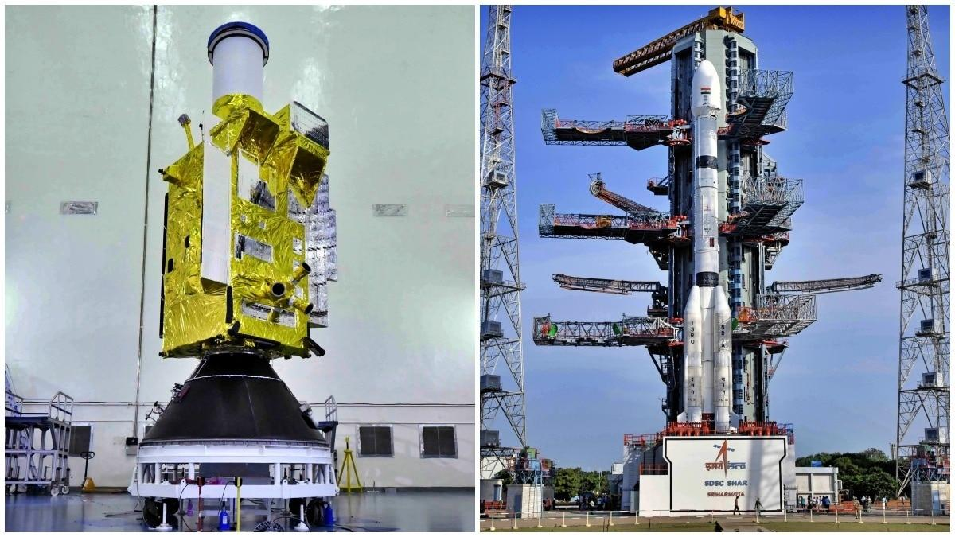
The Indian Space Research Organisation (Isro) is preparing to launch EOS-05, an advanced Earth observation satellite that represents a renewed push to establish continuous imaging capabilities from geostationary orbit. The mission, scheduled for launch on September 4, is particularly significant because EOS-05 is the successor to Isro's earlier GISAT-1 mission, which was lost during a launch attempt in 2021. The satellite will launch aboard the GSLV-F17 mission from the Second Launch Pad (SLP) at Satish Dhawan Space Centre in Sriharikota. WHAT IS INDIA'S GISAT-1? GISAT, short for Geo Imaging Satellite, was designed to give India a unique view of the Earth. Unlike conventional Earth observation satellites that circle the planet in low-Earth orbit and observe a location only when they pass overhead, a satellite positioned in geostationary orbit can continuously watch the same large region. EOS-05 is designed to operate from an orbit about 36,000 kilometres above the equator. At this altitude, the satellite orbits Earth at the same rate at which the planet rotates, allowing it to remain in a nearly fixed position relative to the Earth's surface. This capability is expected to allow EOS-05 to repeatedly image the Indian subcontinent and surrounding regions. According to the planned mission profile, the satellite will be capable of providing near-real-time imagery at intervals of around 30 minutes. For priority targets, the revisit time could be as short as five minutes. Such rapid imaging could prove valuable during fast-changing events. WHY ARE EARTH OBSERVATION SATELLITES IMPORTANT FOR INDIA? Earth observation satellites are used to monitor clouds and weather systems, assess agricultural conditions, track changes in land and water, and support disaster management. Rapid and repeated observations could help agencies monitor developing cyclones, floods, forest fires and other events where conditions can change within minutes. The satellite could also support security and strategic observation by providing persistent monitoring of areas of interest. Geostationary satellites are commonly used for communication and weather monitoring, but imaging Earth's surface from such a great distance presents major technological challenges. From nearly 36,000 kilometres away, the satellite must collect detailed imagery of a vast region while maintaining precise pointing and stable operations. That makes the EOS-05 mission an important technological step for India's Earth observation programme. The September 4 launch will also carry emotional and strategic significance for Isro. The original GISAT-1 mission failed to reach orbit after a problem during the GSLV-F10 launch in August 2021. Five years later, the return of the GISAT concept in the form of EOS-05 offers Isro another opportunity to demonstrate continuous Earth imaging from geostationary orbit. If successful, EOS-05 could give India a powerful new eye in space, one capable of watching the Indian subcontinent almost continuously. - Ends Published By: Sibu Kumar Tripathi Published On: Sep 1, 2026 10:45 IST

7. Onam Week celebrations: Forest dept., ISRO among winners - The Hindu
Read more

The Tourism department has announced the winners of various events of the 'Onam Tourism Week 2026' celebrations, including the cultural procession that marked the finale of the festival. Among State government departments that featured floats in the cultural procession, the Kerala Forest and Wildlife department emerged victorious, followed by the Excise department. The Indian Space Research Organisation (ISRO) won the first prize followed by Southern Railway among the Central government institutions. Among public-sector institutions, the Livestock Development Board secured the top position. The second prize was shared by the Kerala Tourism Development Corporation (KTDC) and the National Ayurveda Mission. While the Thiruvananthapuram Corporation emerged victorious in the local self-government institutions category, the Thiruvananthapuram District Panchayat secured the second prize. NABARD emerged as the winner in the banking sector, while Krupalayam Old-Age Home was given a consolation prize. Agasthya Siddha Marma Kalari Sanghom won the first prize in Kalari in the Visual Art Forms category. Hussein Kollayil won second prize in Arabanamutt. Vignesh (Panchari Melam) won first prize while Kaurava Kalasamiti (Shinkarimelam) won second prize. For illuminations, Keltron won first prize in the public-sector category, followed by Jalabhavan. The State Legislative Assembly complex won first prize among the State departments, followed by Thiruvananthapuram Corporation. In the private sector, Kalyan Silks won the first prize, and Anna Bhavan Restaurant won second prize.

8. After seven-month hiatus, ISRO to launch key satellite on September 4 - The Indian Express
Read more
After seven-month hiatus, ISRO to launch key satellite on September 4 The Indian Express

9. Meet GISAT-1A: ISRO's new "Eye In Space" that will watch India from 36,000 km above Earth - Moneycontrol.com
Read more
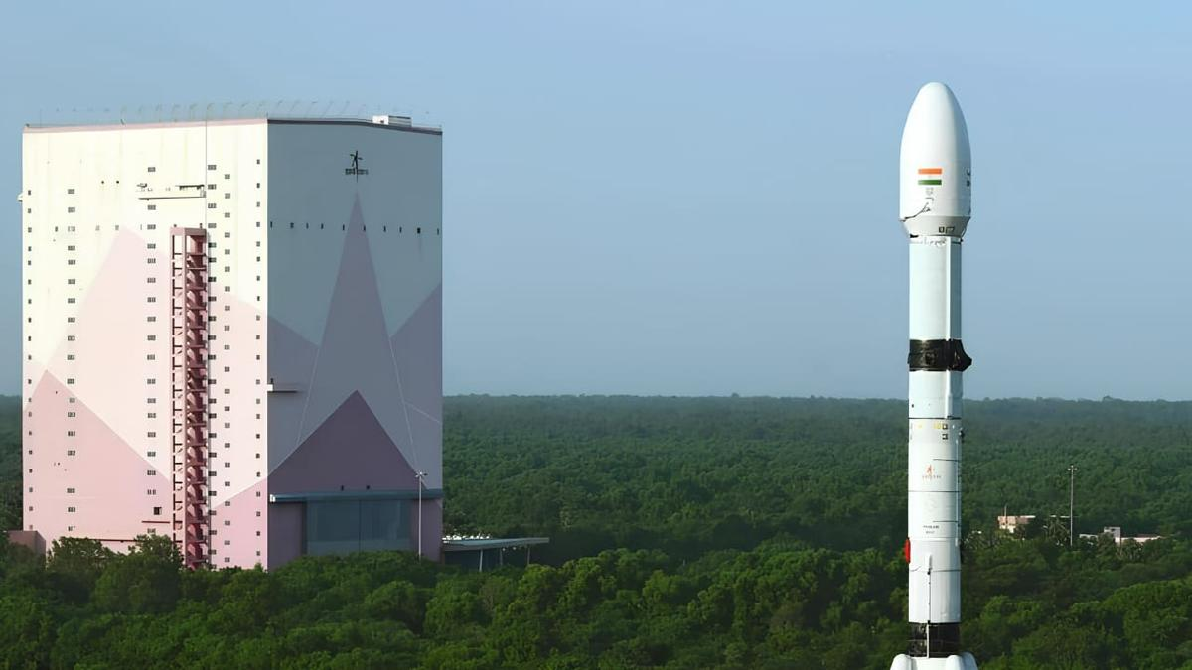
ISRO will launch EOS-05, or GISAT-1A, on September 4, 2026, at 2:55 am IST on Friday at Satish Dhawan Space Centre in Sriharikota. Here's how the satellite will monitor India from geosynchronous orbit. ISRO's EOS-05 will watch India from 36,000 km above Earth. (Image: ISRO) ISRO to launch EOS-05 (GISAT-1A) satellite. Launch set for Sept 4, 2026, from Sriharikota. Satellite for continuous Earth observation & disaster monitoring. Did our AI summary help? Market Mastery Webinar by Vishal Malkan Find the weak links in your portfolio by Vishal Malkan Register for FREE Webinar Register for FREE India is preparing to put a powerful new Earth-observation satellite into space. ISRO will launch EOS-05, also known as GISAT-1A, aboard the GSLV-F17 rocket on September 4, 2026. The launch is planned from the Second Launch Pad at Satish Dhawan Space Centre in Sriharikota. If successful, the mission will give India a new capability. The satellite is designed to observe the Indian subcontinent from a geosynchronous orbit. India is getting a new 'Eye In Space' EOS-05 is designed for near-continuous Earth imaging. Unlike satellites that repeatedly pass over the same location, a geosynchronous spacecraft can keep watching a broad region for long periods. This makes it valuable for monitoring rapidly changing events. When GISAT-1A launch happening? ISRO is targeting September 4, 2026, from Sriharikota. The GSLV-F17 will carry the 2,367-kilogram EOS-05 spacecraft into space. If the mission succeeds, India will gain a powerful new tool for watching its territory from space. During a disaster this constant view could become especially valuable. The launch will take place at 2:55 am IST on Friday at Satish Dhawan Space Centre in Sriharikota. What will EOS-05 do in space? The satellite is designed to provide frequent images of large areas. Its observations could support disaster monitoring, weather analysis, agriculture and environmental studies. It could be particularly useful during cyclones, floods and other fast-moving events. The GISAT concept was developed to provide rapid imaging, including targeted observations at frequent intervals. Is the orbit important here, but why? EOS-05 will first be placed into a Sub-Geosynchronous Transfer Orbit by the GSLV-F17. The spacecraft is then intended to operate from the geosynchronous region. The orbit is roughly 36,000 kilometres above Earth. From there, the satellite can maintain a persistent view of the Indian region. A Second Chance After 2021 The mission also carries history. EOS-05 is the successor to GISAT-1, which failed to reach orbit during the GSLV-F10 launch in August 2021. The new spacecraft represents another attempt to establish India's geostationary imaging capability.

10. Meet the ISRO Chief Who Led India to Mars While Keeping His Love for Kathakali Alive - The Better India
Read more
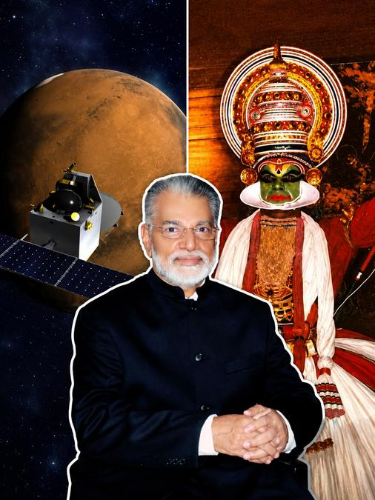
Meet the ISRO Chief Who Led India to Mars While Keeping His Love for Kathakali Alive The Better India

11. NASA Welcomes Türkiye as Newest Artemis Accords Signatory
Read more
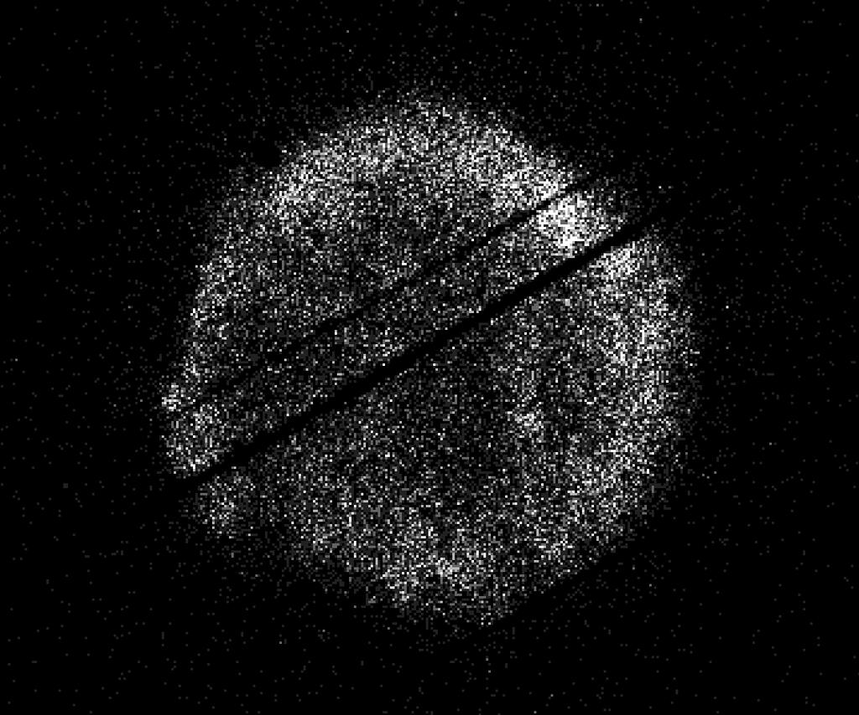
Turkish Minister of Industry and Technology, Mehmet Fatih Kacır, 3rd from left, signs the Artemis Accords for the Republic of Türkiye as NASA Administrator Jared Isaacman, left, U.S. Deputy Assistant Secretary of State for Space and Environment Connor Tomlinson, and Turkish Space Agency President, Yusuf Kıraç, right, look on, Monday, August 31, 2026, at the Mary W. Jackson NASA Headquarters building in Washington. NASA/Bill Ingalls During a ceremony hosted by NASA Administrator Jared Isaacman at the agency's headquarters in Washington on Monday, the Republic of Türkiye signed the Artemis Accords, joining the growing international coalition of like-minded nations dedicated to peaceful, transparent space exploration. "It is my privilege to welcome the Republic of Türkiye as the 71st signatory of the Artemis Accords," said Isaacman. "Last year, President Trump directed NASA to accelerate its return to the lunar surface and establish humanity's first enduring presence on another world, a Moon Base, as well as lay the foundation for the manned exploration of Mars. NASA never undertakes these grand endeavors alone. On the Moon Base, we're taking the Artemis Accords principles and putting them into practice on the lunar surface. NASA has invited every signatory to take part in this endeavor, creating opportunities for nations to contribute major pieces of hardware, scientific payloads, technology demonstrations, CubeSats, and other capabilities to future Artemis missions." Turkish Minister of Industry and Technology Mehmet Fatih Kacır signed on behalf of Türkiye. The President of the Turkish Space Agency Yusuf Kıraç, and the U.S. Deputy Assistant Secretary of State for Space and Environment Connor Tomlinson, also participated in the event. Türkiye's recent achievements in human spaceflight underscore its commitment to space exploration. In 2024, the country's first astronaut, Alper Gezervaci, traveled to the International Space Station on Axiom Mission 3 and conducted scientific research alongside NASA astronauts. That same year, a second Turkish astronaut, Tuva Atasever, flew on Virgin Galactic 07 suborbital mission, conducting experiments and physiology research. Türkiye will soon launch its first lunar mission, AYAP-1, joining the small but growing group of countries building and launching their own satellites to the Moon. The country's signing also comes as the country prepares to host the International Astronautical Congress in Antalya this October. Dozens of Artemis Accords signatories are expected to attend to discuss the future of peaceful and transparent space exploration. In 2020, NASA and the State Department joined with seven other founding nations to establish the Artemis Accords, responding to the growing interest in lunar activities by both governments and private companies. They introduced the first set of practical principles aimed at enhancing the safety and coordination between nations as they explore the Moon, Mars, and beyond, committing nations to: explore peaceably and transparently render aid to those in need enable access to scientific data ensure activities do not interfere with those of others preserve historically significant sites and artifacts by developing best practices By signing the Artemis Accords, nations open the door to opportunities for future lunar exploration with NASA, advancing humanity's return to the Moon, and shaping the Golden Age of space exploration and innovation. Learn more about the Artemis Accords at: https://www.nasa.gov/artemis-accords -end-

12. September 2026 Satellite Puzzler
Read more
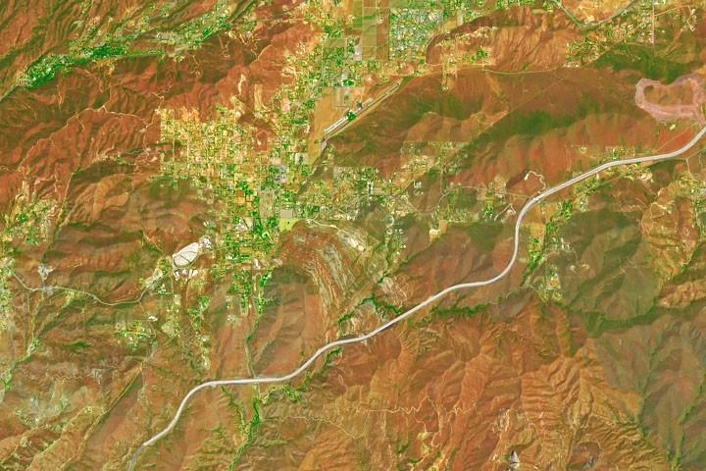
Every month, NASA Earth Observatory features a puzzling satellite image. The September 2026 puzzler appears above. Your Challenge Identify the location shown in this satellite image. Share what clues you see, where you think it is, and what makes this place interesting or unique to you. How to Answer Submit your response using this form and select "Puzzler Answer" as the topic. Please include your preferred name or alias. You can keep it simple and just guess the location. Want to impress us? Tell us which satellite and instrument captured the image, which spectral bands were used, or point out a subtle detail about the geology or history of the area. If something catches your eye, or if this is your home or means something to you, we'd love to hear about it. The Prize We can't offer prize money or a trip to space to see Earth like satellites and astronauts do. But we can offer something almost as rewarding: puzzler bragging rights. About a week after the challenge, we'll post the answer at the top of this page, along with a link to an Earth Observatory Image of the Day story that explains the image in more detail. We'll recognize the first person who correctly guesses the location, and we may also highlight readers who share especially thoughtful or interesting answers. By submitting a response, you acknowledge that your comments may be edited, excerpted, and published on this page. Until then, zoom in, look closely, and enjoy the challenge. See you at the reveal!

13. Roman Commissioning
Read more
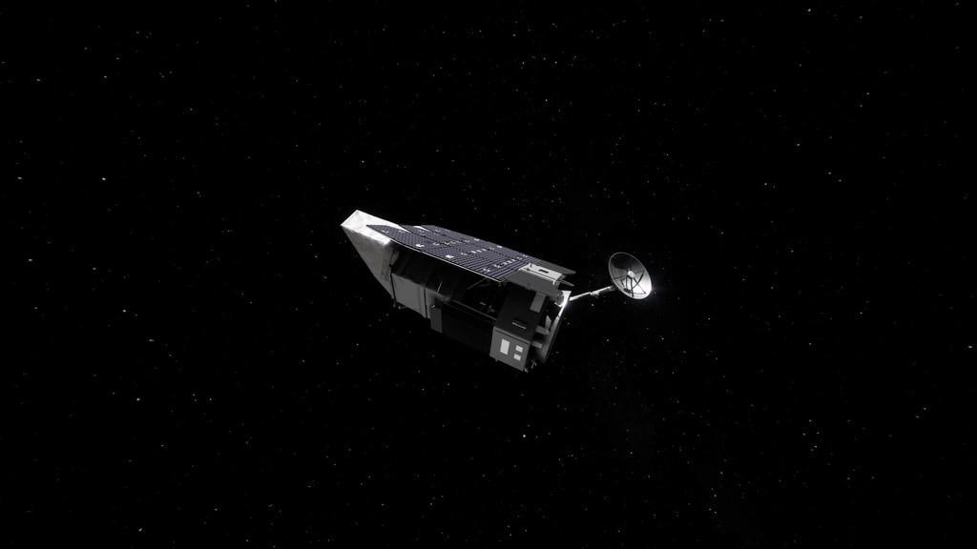
2 Min Read Roman Commissioning Beauty pass of Roman, coming around from behind with high-gain antenna rotating. Credits: NASA's Goddard Space Flight Center/Conceptual Image Lab Contents Where is Roman? Deployments Roman's Orbit Explore the Roman Systems 3D View Where is Roman? Roman is making its three-month journey from Earth to Sun-Earth Lagrange Point 2, or L2. Along the way, Roman is undergoing a process called commissioning, where systems are turned on, adjusted, calibrated, and prepared for science operations. Commissioning is the time for scientists and engineers to make sure that Roman is performing as expected. The schedule is subject to change as the team assesses and adjusts as needed. Visit the Roman Blog To view this video please enable JavaScript, and consider upgrading to a web browser that supports HTML5 video An hour and 23 minutes after launch, Roman began to emerge from the tight configuration that allowed it to fit in the rocket fairing. The solar panels and sunshade deployed, shading the rest of the observatory and providing power to the systems. Within the upcoming days, the antenna will swing out and the visor-like deployable aperture cover will move into place to permanently reveal and shade the primary mirror. This visualization shows the stable, halo orbit that Roman will have around L2. At this location, the gravity of the Sun and Earth, together with an object's motion around the Sun, let it stay lined up with Earth as they orbit, allowing Roman to have a relatively steady orbit without using much fuel. This location also offers exceptionally stable optical performance and a constant, unobstructed view of a wide swath of the sky; Earth won't block much of Roman's view since it will be so distant. And at L2, heat from Earth, the Sun, and the Moon have less effect on infrared telescopes, which "see" heat. Unable to render the provided source Learn more about the systems that are getting turned on, tested and calibrated. 3D View

14. Watch 2 astronauts take 6th-ever all-female spacewalk today
Read more
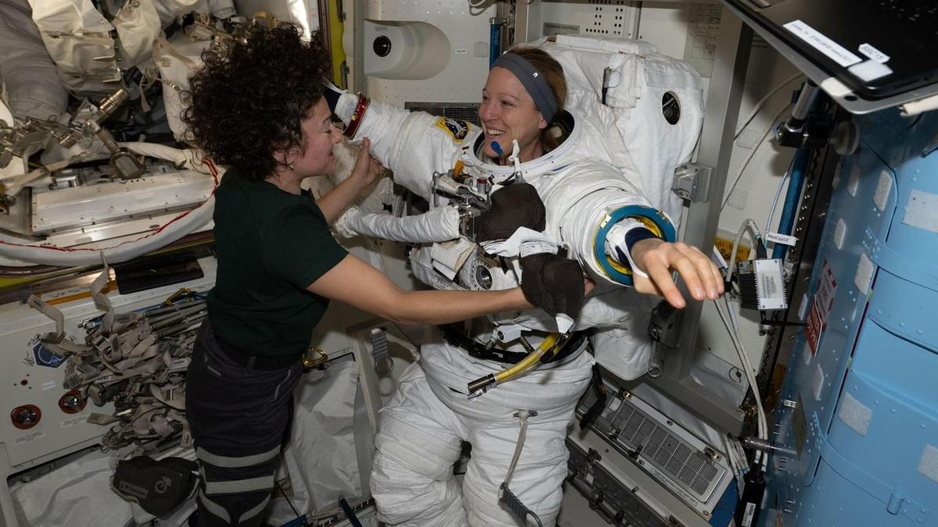
Click for next article U.S. Spacewalk 99 - YouTube Watch On Two astronauts will conduct history's sixth all-female spacewalk today (Sept. 1), and you can watch it live. NASA's Jessica Meir and Sophie Adenot of the European Space Agency will venture outside the International Space Station (ISS) at around 8:30 a.m. EDT (1230 GMT) on an excursion expected to last about 6.5 hours. You can watch it here at Space.com, courtesy of NASA, or directly via the agency . Coverage will start at 7:00 a.m. EDT (1100 GMT). NASA astronaut Jessica Meir and the European Space Agency's Sophie Adenot work together inside the International Space Station's Quest airlock during spacesuit fit and leak checks. (Image credit: NASA) During today's spacewalk , Meir and Adenot "will replace a retroreflector on the forward port of the space station's Harmony module to support spacecraft navigation during rendezvous and docking operations," NASA officials said in a media advisory . "After installing the reflector, the crew will work to install jumper cables for the data-relay systems, prepare the Alpha Magnetic Spectrometer's radiator for future maintenance, and replace a high-definition camera on the station's truss," they added. (The Alpha Magnetic Spectrometer is a $2 billion particle physics experiment mounted to the exterior of the ISS that studies cosmic rays and hunts for mysterious dark matter , among other tasks.) Adenot will be "crew member 1" on today's spacewalk and will wear a suit with red stripes, NASA officials said. Meir will wear an unmarked suit and serve as "crew member 2." It will be the third spacewalk for Adenot, who two weeks ago became the first French woman ever to perform an extravehicular activity (EVA). It will be the seventh for Meir, which will put her third among female NASA astronauts behind Peggy Whitson (10 EVAs) and Suni Williams (nine).

15. NASA's doomed Swift space telescope restarts science work after rescue mission fails
Read more
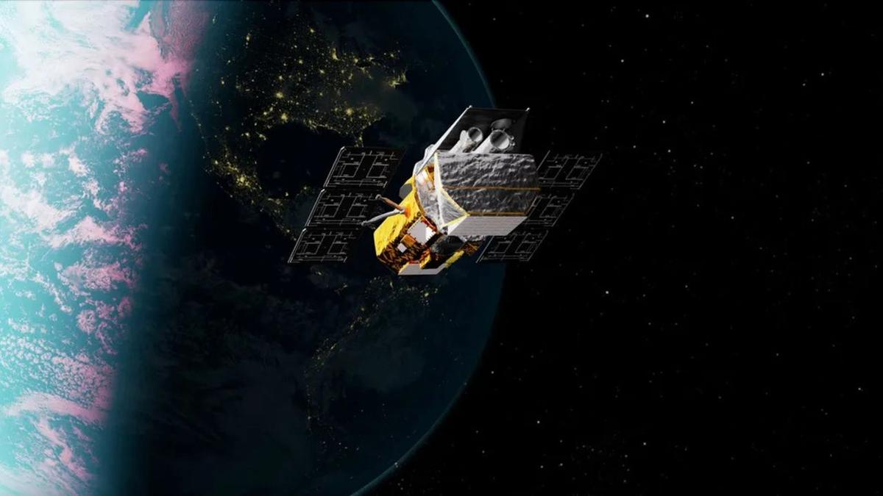
Click for next article Artist's illlustration of NASA's Neil Gehrels Swift Observatory, which launched to Earth orbit in November 2004 and will soon fall out of space. NASA's Neil Gehrels Swift Observatory is back to studying the universe after spending months in a low-drag configuration while awaiting an orbital rescue mission that ultimately fell short. Mission controllers restarted two of Swift's three science instruments - its X-ray Telescope (XRT) and Ultraviolet/Optical Telescope (UVOT) - on Aug. 26. Both instruments had been shut down in February as part of an effort to minimize atmospheric drag and keep the aging spacecraft in orbit long enough for another spacecraft to reach and boost it to a higher altitude, according to an Aug. 28 statement from NASA. Swift's third instrument, the Burst Alert Telescope (BAT), remains offline. Operations of the BAT were halted in April to conserve power, allowing controllers to position Swift's solar panels in a way that further reduced drag from its interaction with Earth's atmosphere . NASA says the mission team hopes to resume data collection with the instrument within the next few weeks. "Over the last 21 years, Swift has been NASA's multitool for studying the cosmos ," NASA officials said in the statement. "It observes a wide range of light, rapidly points at short-lived outbursts, and sends alerts to other facilities in space and on the ground to help coordinate follow-up observations." The return to science follows NASA's decision to abandon plans to boost Swift's orbit using LINK, a robotic servicing spacecraft built by the Arizona company Katalyst Space. LINK launched July 3 aboard a Northrop Grumman Pegasus XL rocket with the ambitious goal of rendezvousing with Swift, grabbing the observatory and raising its orbit. However, the rescue mission encountered trouble in late July when LINK developed attitude-control problems that caused it to spin and disrupted communications. Two of the spacecraft's three reaction wheels were found to be inoperable, while its cold-gas thruster system also experienced some loss of functionality. Although engineers managed to reduce LINK's spin and regain attitude control, NASA and Katalyst announced Aug. 19 that the spacecraft would no longer attempt to capture and boost Swift. Instead, LINK is expected to rendezvous with Swift and perform proximity operations, providing an opportunity to demonstrate technologies that could be used for future in-space satellite servicing missions - leaving Swift without the orbital boost intended to extend its life and its future increasingly uncertain. Launched in 2004, Swift was originally designed for a two-year mission studying gamma-ray bursts , the most powerful explosions in the universe. More than two decades later, the observatory continues to detect and rapidly follow up on fleeting cosmic events in gamma-ray, X-ray , ultraviolet and visible light, while alerting other observatories so they can turn their attention to the same targets. Unlike some spacecraft in low Earth orbit , Swift doesn't have a propulsion system capable of counteracting atmospheric drag. Increased solar activity has heated and expanded Earth's upper atmosphere, increasing the drag on Swift and causing its orbit to decay faster than previously expected. NASA's low-drag operations had been expected to keep Swift above an altitude of about 185 miles (300 kilometers) until October. Below that threshold, operating the observatory becomes increasingly difficult and its descent accelerates, NASA officials said in the statement. Now that science operations have resumed - and the planned orbital boost is off the table - NASA expects Swift to reach that critical altitude within the next one to two months. Without intervention, the observatory is likely to crash back to Earth later this year, mostly burning up as it reenters the atmosphere, according to the space agency. For now, the veteran space telescope is making the most of the time it has left - and once again scanning the universe.

16. 'No guts, no glory': How I captured NASA's Roman Space Telescope cross the sun on a picture-perfect SpaceX Falcon Heavy launch
Read more

Click for next article The SpaceX Falcon Heavy carrying NASA's Roman Space Telescope crosses the face o the sun as it launches to space from Pad 39A of the Kennedy Space Center in Florida in this photo taken by Space.com's Josh Dinner from a Titusville Hobby Lobby parking lot. Here's how he did it. (Image credit: Space.com / Josh Dinner) CAPE CANAVERAL, Fla. - Standing in the parking lot of the Titusville Hobby Lobby was maybe something I should have planned on before traveling to Florida for the launch of NASA's Nancy Roman Grace Space Telescope, but it was not where I expected to be until I was speeding there in my car. Rocket enthusiasts and locals around Florida's Space Coast gathered Sunday morning (Aug. 30) to watch SpaceX's latest Falcon Heavy launch. The triple-booster rocket launched NASA's newest flagship observatory , the Nancy Grace Roman Space Telescope, which is now on its way to an orbital sweet spot nearly 1 million miles from Earth to image the widest views of the universe ever captured, map planets around alien stars and usher in a new wave of discovery into phenomena like dark matter and dark energy . Liftoff occurred at 07:26:49 a.m. EDT (11:26:49 GMT), from Launch Complex-39A at NASA's Kennedy Space Center (KSC). Specifying those 49 seconds was very important. Roman's launch opportunity is known as an "instantaneous" launch window because its proper orbital delivery was dependent on getting the time right down to the very second. And the seconds mattered for those watching the launch, too. Any fewer, and the clouds from viewing the location of dozens of photographers at Hobby Lobby, myself included, wouldn't have cleared in time. Any more and the sun would have moved too high in the sky to capture what me and all those photographers were hoping to capture. Josh Dinner Spaceflight Writer Josh Dinner is a Spaceflight Writer for Space.com. He also photographs rockets. Sometimes, from a Hobby Lobby parking lot... The early morning launch got off the ground a little more than 20 minutes after sunrise, while the bright glowing orb was still relatively low in the sky. The Space Coast's eastward shores on the Atlantic Ocean, coincidentally, sometimes offer the rare alignment with one of the missions launching from KSC for a rocket to fly right in front of the sun on its way to space, but only from specific vantage points. Plotting and predicting the trajectories of a launch vehicle is no easy task, but it is made incredibly simpler using certain softwares like the popular FlightClub.io , which is used by many photographers to help line up shots that would be nearly impossible without a rocket's flight trajectory info before launch. That, and apps like PhotoPills or The Photographer's Ephemeris are incredibly useful for planning rocket launch photos ahead of time. It's rare for a launch to line up just right, and even more rare for a launch vehicle like Falcon Heavy, which flies far less often than SpaceX 's workhorse Falcon 9 rocket , to line up for a solar transit the way Roman's launch did. The sun rises in a slightly different spot on the horizon each day, and even a few minutes delay in a launch can be enough for the sun to move out of alignment of where the rocket is going to fly. And the alignment for Roman's launch happened to be in the parking lot of Hobby Lobby. A SpaceX Falcon Heavy rocket launches with NASA'S Nancy Grace Roman Space Telescope onboard from Launch Complex 39 on Aug. 30, 2026, at NASA's Kennedy Space Center in Florida. Space.com's Josh Dinner used a remote camera to capture this view. (Image credit: Space.com / Josh Dinner) I hadn't checked FlightClub.io, and was so focused on other parts of launch coverage for Roman's mission , I didn't think to check if a transit was in the cards for Sunday morning. But as the excitement for launch built, and the days until Roman's launch dwindled, excitement over the possibility of a solar transit spread among the photojournalists at KSC. Shooting the transit, though, meant leaving KSC during launch, which meant sacrificing literal front row seats to one of the world's most powerful rockets . The KSC press site sits just three miles (4.8 km) LC-39A. Hobby Lobby in Titusville, on the other hand, is about 12 miles away (19 km). And there were some concerns about clouds, too. Weather during Saturday's prelaunch mission briefing forecasted only a 50% of favorable weather conditions for Sunday, and when the morning of launch arrived, clouds on the horizon weren't showing obvious signs of clearing in time for liftoff. I was torn. I didn't want to sacrifice getting a shot of the launch by leaving KSC if the clouds were going to persist, but if it worked, this would be my first ever solar transit rocket launch photo. About an hour before launch, Space Scout's David Diebold popped into the KSC press site, and told me when I asked him that of course he was going to try for the shot. "No guts, no glory," he said. He was on his way out the door as he said it. David also offered to lend me one of his solar filters for my camera, which was another very influential factor in my decision. It takes about 25 minutes to get from the press site at KSC to the strip in Titusville where Hobby Lobby sits, and the launch was about 45 minutes away. Checking the clouds one more time, I decided to take the chance. "No guts, no glory," I told my fellow Space.com reporters, who were able to manage things from the press site in my absence. A post shared by Space.com (@spacedotcom) A photo posted by on I jumped in my car and headed to Hobby Lobby. Everyone else who tried for this shot was already there when I arrived, and so were hundreds of other launch spectators across the street, lining the stretch of spots along the Banana River where several launchpads stand in view. Thankfully, I was able to squeeze in between fellow launch photographers Andrew McCarthy from Consider the Cosmos , and NASA Space Flight's Max Evans, both of whom generously offered me some last-minute advice for my camera settings. I shot on a Canon R5 Mark II , an absolute unit of photography engineering and one of Canon's newest full-frame mirrorless cameras , with an RF100-400mm F5.6-8. With my lens zoomed all the way up to 400 and my solar filter from David on the end, I cranked the R5's exposure down to 1/20000 and set aperture to F16 and waited with just a few minutes until liftoff. It wasn't until those last minutes that the clouds finally did clear. Someone listening to SpaceX's live stream began a countdown from 5 seconds, and everyone went silent and hands and eyes moved to cameras and viewfinders. "Liftoff." One more view of SpaceX's Falcon Heavy rocket launching NASA's Roman Space Telescope from one of Dinner's remote cameras. (Image credit: Space.com / Josh Dinner) I didn't even look up to try to see if I could make out the rocket on the horizon. I just waited for a moment seconds later when Falcon Heavy flew across the face of the sun. It happened in a split second. I just held my finger down on the shutter button and hoped. Rocket launches are inherently risky endeavors. Millions of dollars go into designing and building the unique satellites sent to orbit, and millions more on the launch vehicles that get them there. But launches don't always go as planned, and the nature of rockets means that if something goes wrong, often things go very wrong. They are, after all, vehicles channeling controlled explosions through Earth's turbulent atmosphere into the unforgiving vacuum of space. But we do it anyway. We send the amazing things into the cosmos to expand humanity's understanding of the universe. Like the new era of discovery about to be ushered in as Roman journeys to its final destination in orbit, we take the risks because the payoffs are so tremendous. And when we do, it makes getting the shot that much better. No guts, no glory.

17. What's next for Roman Space Telescope? Here's how NASA's flagship observatory will open up the universe
Read more
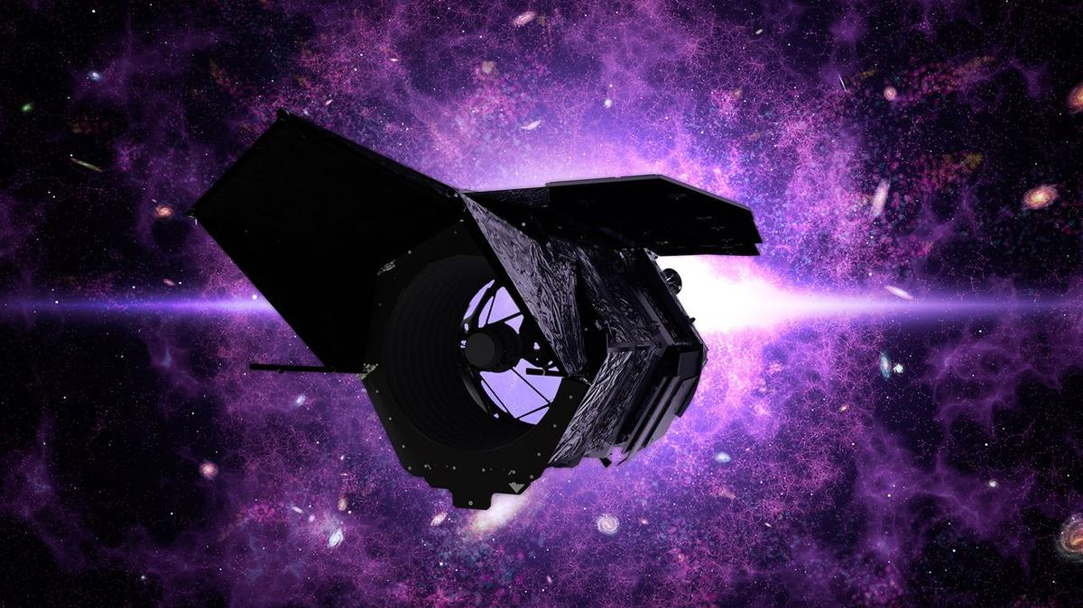
Click for next article The Nancy Grace Roman Space Telescope separates from its SpaceX Falcon Heavy rocket about 30 minutes after launch on Aug. 30, 2026. NASA's next big space telescope has left Earth, but it's not ready to start observing the heavens just yet. The Nancy Grace Roman Space Telescope launched yesterday (Aug. 30), riding a SpaceX Falcon Heavy rocket into the heavens . Astronomers are very excited about Roman, for it's expected to discover thousands of new exoplanets and shed light on mysterious dark energy and dark matter, among other accomplishments. Such science work is a few months off, however. Here's a brief rundown of the next steps for the Roman team. A diagram showing Roman at Lagrange point 2, between Earth and Mars. (Image credit: NASA SVS) A long journey The first order of business is getting Roman to its destination. The 42-foot-long (12.7 meters) scope isn't staying in Earth orbit; it's headed to the sun-Earth Lagrange Point 2 (L2), which lies about 930,000 miles (1.5 million kilometers) from our planet in the Marsward direction. There are multiple reasons to target L2, which also hosts NASA's James Webb Space Telescope (JWST) and Europe's Euclid probe. "At this special place in space," NASA officials wrote in a Roman explainer , "gravitational forces balance to keep objects in steady orbits with very little assistance." "Roman's barrel-like shape will help block out unwanted light from the sun, Earth and moon, and the spacecraft's distant location will help keep the instruments cool," they added. "The thermal stability of an observatory at L2 will provide a ten-fold improvement beyond Hubble in much of the data Roman will gather." And don't worry about Roman and JWST bumping heads; though their cosmic addresses will be the same, they won't actually share space. "Like Webb, Roman will trace out a large orbit around the actual L2 point - much larger than the moon's orbit around Earth - and the two will easily be kept far apart," NASA wrote in a different Roman piece . It'll take Roman about 30 days to fly out to L2 and settle into its looping orbit there. A new round of work will then begin for the Roman team. Checking Roman out That work is "commissioning" - making sure that all of Roman's systems and subsystems are working properly, as is its science gear, which consists of the Wide Field Instrument (WFI) and the Coronagraph Instrument (CGI). WFI "is a 300-megapixel infrared camera that will allow scientists to look very far back in time," NASA officials wrote in the explainer. "Seeing the universe in its early stages will help unravel how it has expanded throughout its history, which will hint at how it may continue to evolve." CGI is a technology demonstration that will block the light of distant stars, allowing Roman to spot a wealth of previously unknown alien worlds. "It will be far more powerful than any other coronagraph ever flown, seeing planets that are almost a billion times fainter than their host star," NASA officials wrote. Roman should be ready to begin its science work in early 2027, according to the nonprofit Planetary Society. Its science life is slated to last five years, but astronomers are doubtless hoping for more. And there's precedent for such optimism; after all, NASA's Hubble Space Telescope is still going strong today, more than 36 years after its launch.

18. SpaceX, NASA delay next astronaut launch to ISS due to leak on Dragon spacecraft
Read more
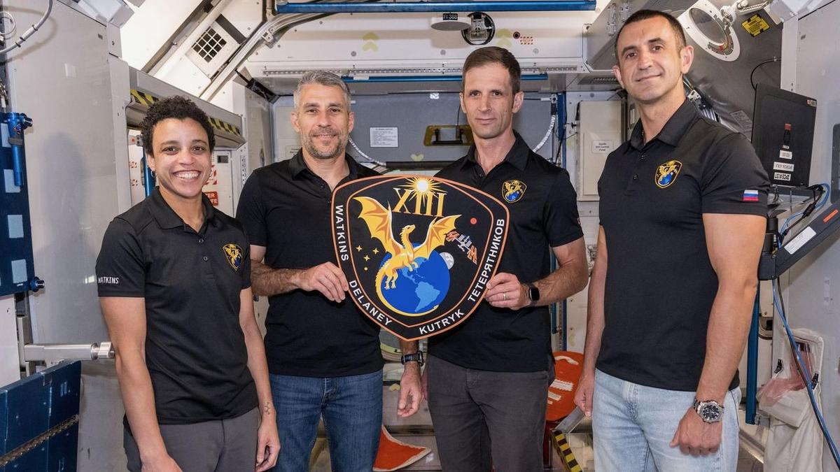
Click for next article The four members of NASA's SpaceX Crew-13 mission to the International Space Station display their mission plaque inside a training mockup of a space station module. From left: Commander Jessica Watkins and Pilot Luke Delaney, both from NASA, and Mission Specialists Joshua Kutryk of the Canadian Space Agency and Sergey Teteryatnikov of Roscosmos. SpaceX's next astronaut mission to the International Space Station won't launch on Sept. 12 after all. That flight, known as Crew-13 , has been delayed due to an oxidizer leak in the propulsion system of SpaceX's Dragon spacecraft, NASA announced on Saturday (Aug. 29). "Joint NASA and SpaceX teams are performing additional tests and data review and will complete any necessary rework prior to launch," NASA officials wrote in an update on Saturday . "A new target date will be announced once available." Crew-13 will launch atop a Falcon 9 rocket from Cape Canaveral Space Force Station. As its name suggests, it will be the 13th operational astronaut mission SpaceX flies to the International Space Station (ISS) for NASA. (The company also conducted a crewed test flight to the orbiting lab, called Demo-2 , which launched in May 2020.) Crew-13 will send NASA astronauts Jessica Watkins and Luke Delaney of NASA, the Canadian Space Agency 's Josh Kutryk, and Sergey Teteryatnikov of Russia's federal space corporation Roscosmos to the ISS for a seven-month stay. "We expect a very busy mission with lots of station maintenance, both internal and external, with a few EVAs [extravehicular activities, or spacewalks ] on the docket," Watkins said during an Aug. 3 press conference. There will also be "visiting vehicle capture and stowage operations, lots of science - very interesting science experiments that will be flying with us as well - and plenty of outreach," she added. SpaceX just launched a high-profile mission for NASA, sending the agency's Nancy Grace Roman Space Telescope into the final frontier on Sunday (Aug. 30) atop a Falcon Heavy rocket .
19. With Rocket Model, ISRO Chief Prays At Tirumala Temple Ahead Of Crucial Launch - NDTV
Read more
With Rocket Model, ISRO Chief Prays At Tirumala Temple Ahead Of Crucial Launch NDTV

20. ISRO EOS-05 Mission | India's New Eye in Space Launches on September 4 - Kanak News Odisha
Read more

ISRO EOS-05 Mission is set to mark another major step in India's Earth observation capabilities, with the GSLV-F17 mission scheduled to launch EOS-05 on September 4, 2026, at 2:55 AM IST. ISRO says EOS-05 is a state-of-the-art Earth observation spacecraft and India's first imaging satellite from geosynchronous orbit. The mission is designed to provide valuable Earth observation data, with potential applications across disaster management, agriculture, environmental monitoring and other strategic areas. The satellite will be placed into a sub-geosynchronous transfer orbit by GSLV-F17 before reaching its intended geosynchronous orbit. The upcoming launch highlights India's growing space-based observation capabilities and the expanding role of satellite imagery in national applications. Watch the full report for the latest ISRO EOS-05 launch updates. Like, Share & Subscribe for more India space and science news. Advertisment #ISRO#EOS05#GSLVF17#ISROMission#SpaceMission#IndiaInSpace#EarthObservation#SpaceNews Kanak News is Odisha's leading 24x7 news and current affairs TV channel from Eastern Media Limited. Odisha's largest media house that also publishes the daily 'Sambad'. Get the latest updates on news, politics, sports, business, current affairs, entertainment, technology and health updates from Kanak News. Breaking News, Live news updates, Odia News Live, Live Odia News, odisha news, latest odisha news, odisha news today, odisha politics, odisha latest updates Join us on WhatsApp to get the latest updates: https://whatsapp.com/channel/0029Va9qLIDAYlUKjL5iF90c For the latest Odisha News, follow us: Website: https://kanaknews.com/ Instagram: https://www.instagram.com/kanaknewsofficial/ LinkedIn: https://www.linkedin.com/company/kanak-news Facebook: https://www.facebook.com/KanakNews App Kanak :- https://play.google.com/store/apps/details?id=com.kanak__news.app&hl=en Twitter: https://twitter.com/kanak_news Telegram: https://t.me/kanaknewsofficial WhatsApp: https://whatsapp.com/channel/0029Va9qLIDAYlUKjL5iF90c

21. GSLV-F17 carrying EOS-05 was moved from the Vehicle Assembly Building (VAB) to the Umbilical Tower (UT) on 28th August 2026 at Satish Dhawan Space Centre, SHAR, Sriharikota, as preparations continue for the scheduled launch on: 🗓️ 04 Sept 2026 | - x.com
Read more
ISRO @isro GSLV-F17 carrying EOS-05 was moved from the Vehicle Assembly Building (VAB) to the Umbilical Tower (UT) on 28th August 2026 at Satish Dhawan Space Centre, SHAR, Sriharikota, as preparations continue for the scheduled launch on: 🗓️ 04 Sept 2026 | ⏰ 02:55 AM IST Livestreaming starting from 02:25 AM IST onwards: youtube.com/live/Q9OdYc3Kp… For more information: isro.gov.in/Mission_GSLVF1… #GSLVF17 #EOS05 #ISRO 00:00 4:29 PM · Sep 1, 2026 254.5K Views 465 3.2K

22. ISRO chairman Narayanan visits Tirumala; presents models of GSLV-F17, EOS-05 satellite to deity - newsmeter.in
Read more
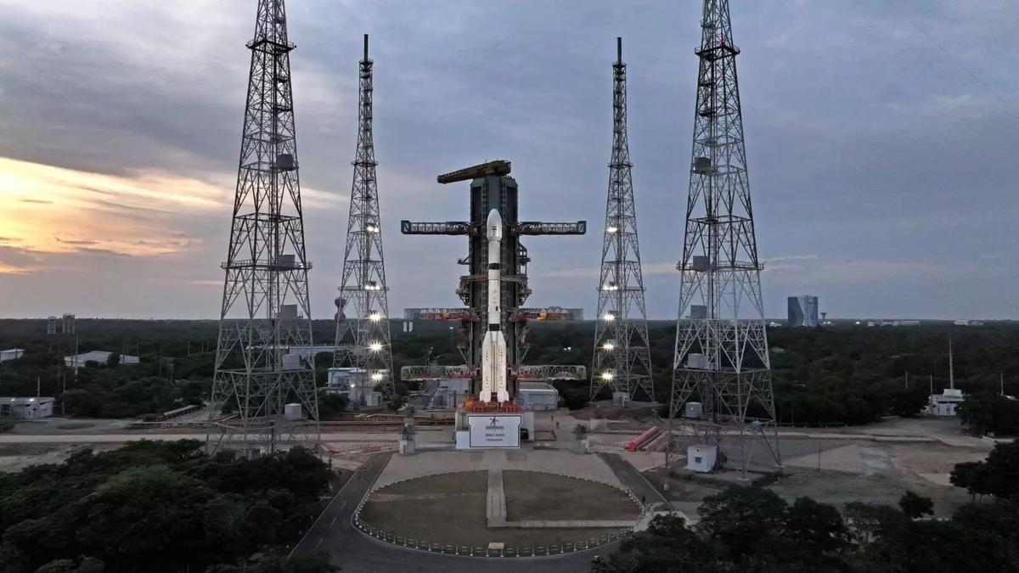
Tirumala: ISRO Chairman V. Narayanan visited the Tirumala temple on Wednesday and offered prayers to Lord Venkateswara along with his team during the VIP break darshan. Narayanan reached Ananda Nilayam through the Vaikuntha Q Complex and placed miniature models of the GSLV-F17 launch vehicle and EOS-05 satellite at the feet of the deity as part of the traditional prayers. The models symbolically represented the upcoming mission and were presented at the sanctum sanctorum, seeking the Lord's blessings for its successful launch. The GSLV-F17 model is a miniature representation of ISRO's Geosynchronous Satellite Launch Vehicle, a three-stage heavy-lift rocket designed to place satellites into geostationary transfer orbit. The mission's EOS-05 satellite model represents the Earth observation spacecraft that the rocket is scheduled to carry. Following the darshan, temple priests blessed Narayanan and the ISRO team at the Ranganayakula Mandapam and presented them with theertha prasadam and Lord Venkateswara's offerings.

23. Two astronauts replace ISS camera and docking aid on 6th-ever all-female spacewalk (video)
Read more
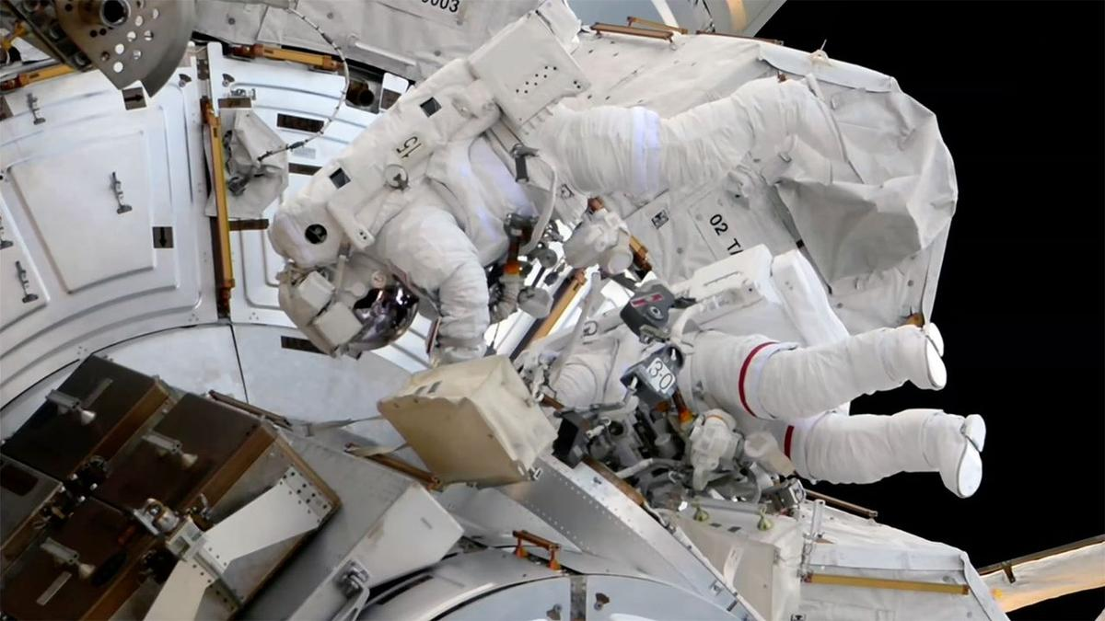
Click for next article Two astronauts replaced a spacecraft docking aid and a video camera during a successful spacewalk outside of the International Space Station on Tuesday (Sept. 1). NASA astronaut Jessica Meir and ESA ( European Space Agency ) astronaut Sophie Adenot got through most of the tasks set out for them even in light of Adenot's spacesuit developing a mobility issue late in the extravehicular activity (EVA), which lasted six hours and 49 minutes. After beginning the spacewalk from the U.S. Quest airlock at 8:40 a.m. EDT (1240 GMT), Meir and Adenot set about the first and most important activity of the outing: replacing the planar deflector on the forward port of the station's Harmony Node 2. The retroreflector is used to support navigation during rendezvous and docking operations by visiting spacecraft. The older reflector that they replaced had become coated in thruster residue from earlier spacecraft arrivals and departures. NASA astronaut Jessica Meir (at left) and ESA astronaut Sophie Adenot (in spacesuit with red stripes) are seen outside the Quest airlock during a spacewalk at the International Space Station on Tuesday, Sept. 1, 2026. (Image credit: NASA) They also replaced the Camera Port 3 (CP3) high-definition (HD) camera on the station's truss. "And it's off!" reported Meir after freeing the spent camera assembly that was swapped out for spare. Her words were met by applause in Mission Control at NASA's Johnson Space Center in Houston. "That worked, great!" she said. From there, Adenot headed off to continue an ongoing scientific study by swabbing areas on the exterior of the airlock and her gloves for possible microorganisms. Meir, meanwhile, rode one end of the Canadarm2 robotic arm to a site near the Alpha Magnetic Spectrometer (AMS), torquing 46 bolts in preparation for future maintenance of the particle physics detector. Get the Space.com Newsletter Breaking space news, the latest updates on rocket launches, skywatching events and more! Contact me with news and offers from other Future brands Receive email from us on behalf of our trusted partners or sponsors Meir also relocated power and thermal jumper cables and an articulating portable foot restraint for use on a later spacewalk. There were some other tasks planned, time permitting, but toward the end of the EVA, Adenot reported losing mobility in her left shoulder joint. Erring on the side of caution, Mission Control called for Adenot to wait where she was until Meir could follow her back to the airlock. Once there, Meir was able to unzip a portion of Adenot's extravehicular mobility unit's (EMU's) upper arm assembly to inspect what was happening. In doing so, she freed the kink that had limited Adenot's motion. "I think it was where the cable got caught in between the shoulder MLI [multi-layer insulation] and the rotation [joint]. I don't think it was held up by anything but some friction," said Meir. The two Expedition 75 crewmates then proceeded back into the airlock to complete the EVA at 4:29 p.m (2029 GMT). In a view from her helmet-mounted camera, NASA astronaut Jessica Meir holds a spent HD video camera before installing its replacement outside of the International Space Station on Tuesday, Sept. 1, 2026. (Image credit: NASA) Tuesday's spacewalk was Meir's seventh and Adenot's third. Meir, who has a total of 49 hours and 22 minutes on EVA, now ranks third among all women astronauts at NASA for total number of spacewalks. She trails only Peggy Whitson with 10 and Suni Williams at 9. Adenot now has spent 19 hours and 42 minutes working in the vacuum of space.

24. Nonprofit wants to launch 80,000-year mission to Alpha Centauri in 2029 (video)
Read more
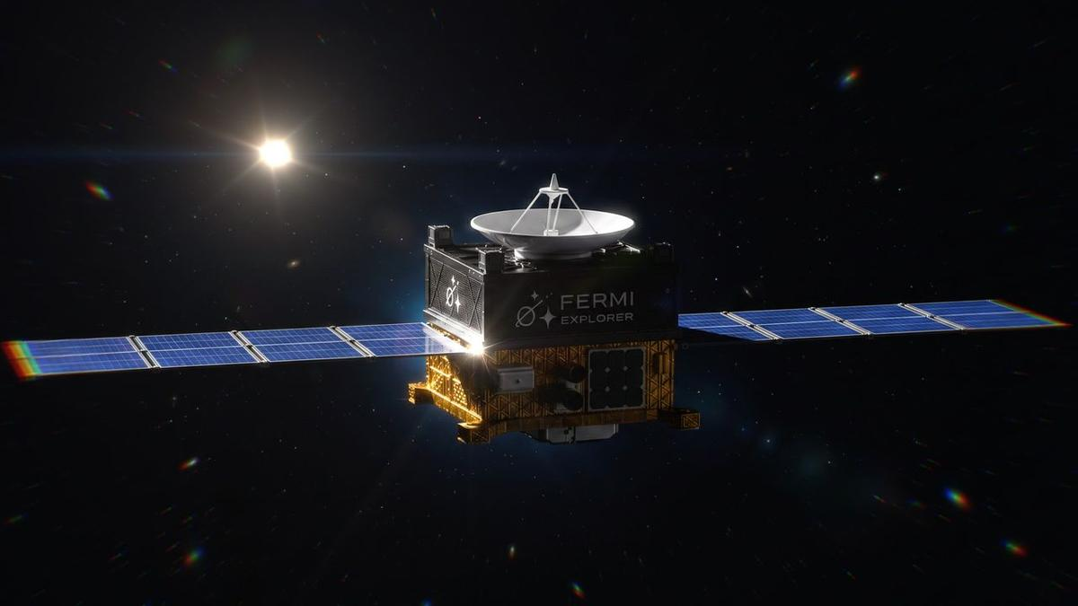
Click for next article The first dedicated mission to another star will launch before the end of the decade, if all goes according to plan. A nonprofit called the Fermi Explorer Mission announced today (Sept. 1) that it plans to send a small probe toward Alpha Centauri by 2029. But none of us will live to see the interstellar spacecraft 's historic arrival; its journey is expected to take about 80,000 years. "We hope to be both the first to leave and the last to arrive at Alpha Centauri," Philip Johnston, co-founder and president of the Fermi Explorer Mission, said in a statement today. "None of us will be here when this journey ends, and that is the point. It's about taking the first achievable step and inspiring future generations to keep pushing beyond the limits we inherited." Artist's impression of the planned Fermi Explorer Mission spacecraft, which is targeted to launch toward Alpha Centauri by 2029. (Image credit: Fermi Explorer Mission) Johnston is also co-founder and CEO of Starcloud, a company that plans to operate data centers in space . He started the Fermi Explorer Mission with fellow Starcloud co-founders Ezra Feilden and Adi Oldean. Former U.S. Air Force officer Garrett Jamison leads day-to-day execution of the project. Some big names in the spaceflight world have signed on as advisors, including former Blue Origin president Rob Meyerson and Matt Gialich, co-founder and CEO of the asteroid-mining company AstroForge . The Fermi Explorer project is ambitious but achievable, according to Johnston and his colleagues. They want to launch a spacecraft to the three-star Alpha Centauri system - the sun's nearest stellar neighbor, at about 4.4 light-years away - by 2029. This directed trajectory will be a first. Though NASA's Voyager 1 and Voyager 2 spacecraft are in interstellar space , they're not headed toward any particular star; rather, they're journeying outward on the path they took to complete their "grand tour" of Jupiter , Saturn, Uranus and Neptune. The Fermi Explorer spacecraft will carry at least 2.2 pounds (1 kilogram) of payload, and its entire mission will cost less than $15 million, according to the team. If all goes to plan, the returns on that investment will be considerable. Get the Space.com Newsletter Breaking space news, the latest updates on rocket launches, skywatching events and more! Contact me with news and offers from other Future brands Receive email from us on behalf of our trusted partners or sponsors "The mission is intended to make the idea of interstellar travel real, and to encourage more people to confront one of humanity's biggest unanswered questions when we look beyond our planet: 'Where is everybody?' (the Fermi Paradox)," the Fermi Explorer team said via X today. The proposed path of the Fermi Explorer Mission spacecraft. (Image credit: Fermi Explorer Mission) The Fermi Paradox takes its name from the famed physicist Enrico Fermi, who posited the "Where is everybody?" question in 1950. It has taken on greater significance in the past decade or so, as scientists have realized how common exoplanets - potential abodes for life - are throughout our Milky Way galaxy. There are just three possible explanations for the paradox, according to the Fermi Explorer team: Human-like intelligence is rare throughout the universe It's not rare, but intelligent species don't survive for long It's common and long-lasting, but intelligent aliens generally don't make themselves known to their cosmic colleagues (either by choice or by circumstance) Launching a directed interstellar mission won't solve the paradox, but it will give us some data that we didn't have before. "After the Fermi Explorer Mission, we will have more confidence both that is possible for intelligent species to leave for their nearest star in a way that isn't resource prohibitive, and that there are least some species that try to do it (namely us!)," team members wrote in an FAQ about the mission . "This has the effect of throwing the Fermi Paradox into even greater focus." The Fermi Explorer Mission wants its spacecraft to be the first ever launched to Alpha Centauri, and the last to arrive. (Image credit: Fermi Explorer Mission) The team says it envisions a small spacecraft, one that weighs just 220 to 440 pounds (100 to 200 kilograms) here on Earth. It will also likely employ electric propulsion , which is more efficient than traditional chemical thrusters. Electric propulsion is also a proven system, meaning the Fermi Explorer team isn't relying on futuristic tech to travel to the stars. This has been a stumbling block for other interstellar projects, such as the apparently defunct Breakthrough Starshot , which wanted to blast tiny sailcraft to Proxima Centauri - part of the Alpha Centauri system - using powerful lasers. (That futuristic tech would be great if it worked, however; Breakthrough Starshot aimed to accelerate its nanoprobes to about 20% the speed of light, which equates to a roughly 20-year trip to Proxima Centauri.) The details - who will build the spacecraft, for example, and what payloads it will carry - will be nailed down in the coming months. The project says it already has a proposal from one major satellite manufacturer that comes in under the $15 million cap.

25. NASA's Roman Space Telescope is just one of a few missions named after real-life women
Read more
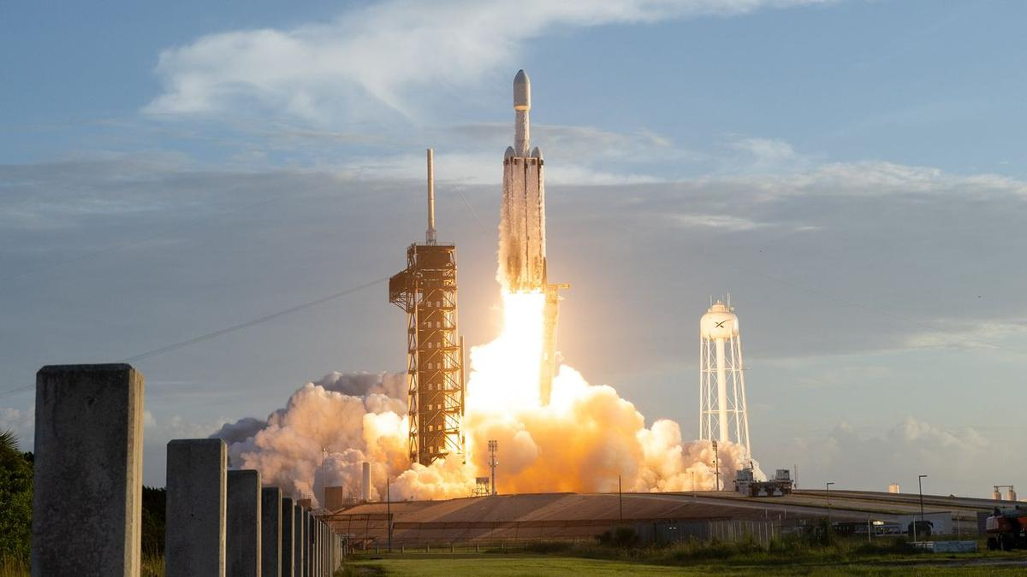
Click for next article NASA's next big space telescope is not only meant to unlock some of the mysteries of dark energy. It also is a pioneer in the naming of missions. Scientific American recently said that the observatory, which launched on Aug. 30 , is the first ever space telescope ever named after a real-life woman: American astronomer Nancy Grace Roman , who supported development of the iconic Hubble Space Telescope and was NASA's first head of astronomy in the 1960s. The story is very different when it comes to men. For example, NASA's "Great Observatories," which launched between 1990 and 2003, were all named after famous U.S. male astronomers or physicists: the Hubble Space Telescope (Edwin Hubble), the Compton Gamma-Ray Observatory (Arthur Compton), the Chandra X-ray Observatory (Subrahmanyan Chandrasekhar) and the Spitzer Space Telescope (Lyman Spitzer). Nancy Grace Roman briefs Edwin (Buzz) Aldrin on celestial objects in Washington, D.C. in 1965. Aldrin would go on to complete three spacewalks and become the second person to walk on the moon. (Image credit: NASA) Indeed, relatively few spacecraft of any kind have borne female names over the years - and most of the ones that did were not honoring actual, real-life people. For instance, a number of missions with female names took them from mythology (e.g., NASA's Europa Clipper and China's Chang'e moon probes ). Others used female names not attached to particular individuals (such as NASA's Clementine moon mission, and the European Space Agency 's LISA, which is an acronym for "Laser Intraferometer Space Antenna.") A notable exception is Sojourner , the mini-rover on NASA's Mars Pathfinder lander mission that was made famous again by the 2015 film "The Martian;" it's named after Sojourner Truth , a Civil War-era abolitionist. Sojourner's name was selected in 1995 from a worldwide naming contest for students and suggested by 12-year-old Valerie Ambroise of Bridgeport, Connecticut. Some other notable examples of missions honoring real-life women include: ESA's long-delayed ExoMars rover Rosalind Franklin , which is now set to launch to Mars in 2028. It's named after a British scientist who contributed to discovering the structure of DNA. (Part of the rover's mission is to analyze potential biosignatures on the Red Planet's surface.) rover , which is now set to launch to Mars in 2028. It's named after a British scientist who contributed to discovering the structure of DNA. (Part of the rover's mission is to analyze on the Red Planet's surface.) The Cygnus International Space Station (ISS) resupply program, which is managed by Northrop Grumman. Multiple Cygnus freighters have been named after female NASA astronauts, including Janice E. Voss, Sally Ride and Kalpana Chawla, and one of them honored the American mathematician and "hidden figure" Katherine Johnson . (ISS) resupply program, which is managed by Northrop Grumman. Multiple Cygnus freighters have been named after female NASA astronauts, including Janice E. Voss, and Kalpana Chawla, and one of them honored the American mathematician and "hidden figure" . Satellogic's ÑuSat/NewSat series. It has commonly named satellites after female historical figures in science, such as Black American chemist Alice Ball, Polish physicist-chemist Marie Curie and Australian radio astronomer Ruby Payne-Scott. after female historical figures in science, such as Black American chemist Alice Ball, Polish physicist-chemist Marie Curie and Australian radio astronomer Ruby Payne-Scott. Canada's GHGSat has a program in which employees name the company's Earth-orbiting satellites after family members, which has generated names from real-life people like Eleonore and Penny . and . The U.S. Space Force nicknamed its GPS III Space Vehicle-08 "Ms. Creola Katherine Johnson," another nod to the mathematician What this means Throughout history, the names of ocean-going ships - ships on the water, not spaceships - often have associations with women. The U.K.'s Imperial War Museums (IWM) suggests that women's names are used due to two traditions. The first is that, very generally speaking, the word "boat" is a "female" word in some languages that use gendered nouns, but that is by far not universal, even among the imperial sailing powers of the 1400s to 1600s. The second association, which seems more likely, is the notion of a mother, goddess or similar "female figure" guiding a crew, which we see in theaters right now with "The Odyssey:" Athena helps Odysseus, reflecting the ancient Greek epic story. (For example, figureheads - sculptures on sailing ship prows - were often, although not always, carved in the likeness of women, Royal Museums Greenwich states .) There are famous sailing ships with female names that many Americans can cite, such as the nicknames for the three Spanish ships - the Niña, Pinta and Santa María - used by Christopher Columbus during his famed first voyage to the New World in 1492. "There's always been a tradition to name ships - and oftentimes after women," Valerie Neal, emerita curator in the Smithsonian National Air and Space Museum's department of space history, told Space.com. Neal's research includes extensive work on female astronauts . The U.S. space program has historically leaned upon mythological names of both genders for its missions, she noted, citing the Mercury , Gemini and Apollo human spaceflight programs as examples of male monikers. These days, Neal added, the education system is less tilted toward introducing children to old Greek or Roman myths, which may explain why it's now more common to name missions after real-life individuals. In the 1970s and 1980s, for example, "there was a big debate at the time of the space shuttle naming whether to name the space shuttles after historic figures, or after concepts," Neal said. "One idea was even after Native American tribes." (For example, Tafuna High School in American Samoa recommended the name "Hōkūle'a" for shuttle, as noted in NASA's 1991 monograph "From Ship to Shuttle: NASA Orbiter-Naming Program") The Cygnus spacecraft " USS Janice Voss ," which flew to the ISS in 2014, was the first U.S. orbital mission known to Neal to be named after a woman. "She had had an affiliation with the Orbital Sciences Corporation, and so they wanted to honor her," said Neal, referring to a previous company that managed the Cygnus program. The flock of Cygnuses named after women - at least six of them, according to Neal - is "a good sign that people are starting to think of contemporary figures, or more contemporary, [and] naming spacecraft as a tribute to them, and to their contributions in science and exploration and discovery." Naming a flagship space telescope after Nancy Grace Roman is another good sign, of course. And choosing her for this honor makes sense; she was in "a class by herself - because her name is so directly associated with astronomy and large space telescopes" like Hubble, Neal said. "It is recognizing her significance in the history of space exploration as a leader who made so much possible, through her own work as an astronomer, but then as an administrator and manager at NASA made possible the orbiting solar observatories, the orbiting astronomical observatories - and then Hubble and the other great observatories that followed." Roman's name on the telescope, she added, is "elevated" because "her name coincides exactly with the spacecraft and its purpose, whereas the names of the astronauts that are attached to the [ISS] resupply missions … not all of them had any connection to the International Space Station. Several did, but not all." Neal said she's hopeful that more women will see their names attached to space missions, including both those historical astronomers who saw "their bosses were getting all the credit" as well as the numerous non-male scientists making impacts in the field today. "I think it's entirely possible that, in time, there will be another major observatory named for a woman," Neal added. She noted that recommendations from the science community every 10 years form the basis of new space missions, and that the next such " decadal survey " in astrophysics is expected to wrap up around 2030. In the nearer term, NASA is considering ideas such as an ultraviolet telescope, an advanced X-ray imaging satellite, and the Habitable Worlds Observatory for launch in the 2030s or early 2040s, presenting more opportunities to attach female names to flagship space missions. Artist's illustration of Europe's ExoMars rover, named Rosalind Franklin, on the surface of the Red Planet. (Image credit: ESA/ATG medialab) Sidebar: Female mission names With thousands of flown or planned missions to space, and numerous parts making up each spacecraft, it is difficult to compile a comprehensive list of probes or instruments that have had female names. The following is therefore a partial list, though an extensive one. In no particular order, it includes: Telescopes/observatories: NASA's Roman, ESA's Gaia, NASA's Pandora, the British-American Ariel V telescope, ESA's NewAthena, ESA's Ariel, ESA's LISA, NASA's TESS (Transiting Exoplanet Survey Satellite). NASA's Roman, ESA's Gaia, NASA's Pandora, the British-American Ariel V telescope, ESA's NewAthena, ESA's Ariel, ESA's LISA, NASA's (Transiting Exoplanet Survey Satellite). Human spacecraft: Mercury Aurora 7, SpaceX 's Crew Dragon Grace. Mercury Aurora 7, 's Crew Dragon Grace. Satellites/ISS missions: ESRO-1A and 1B's nicknames of Aurora and Boreas, multiple Cygnus ISS resupply spacecraft, much of the Satellogic NuSat/NewSat constellation, several GHGSat spacecraft, Space Force 's GPS III Space Vehicle-08 (nicknamed Ms. Creola Katherine Johnson), and the Russian Resurs-DK1 satellite's multinational cosmic-ray module PAMELA (Payload for Antimatter Matter Exploration and Light-nuclei Astrophysics). ESRO-1A and 1B's nicknames of Aurora and Boreas, multiple Cygnus ISS resupply spacecraft, much of the Satellogic NuSat/NewSat constellation, several GHGSat spacecraft, 's GPS III Space Vehicle-08 (nicknamed Ms. Creola Katherine Johnson), and the Russian Resurs-DK1 satellite's multinational cosmic-ray module PAMELA (Payload for Antimatter Matter Exploration and Light-nuclei Astrophysics). Moon: China's Chang'e series, the Soviet Union's Luna series, NASA's Artemis program and missions, Intuitive Machines' IM-2 lander Athena, JAXA's Selene/Kaguya, NASA's Clementine, the NASA ARTEMIS moon-orbiting probe. China's Chang'e series, the Soviet Union's Luna series, NASA's and missions, Intuitive Machines' IM-2 lander Athena, JAXA's Selene/Kaguya, NASA's Clementine, the NASA ARTEMIS moon-orbiting probe. Venus: ESA's Venus Express, the Soviet Union's Venera series. ESA's Venus Express, the Soviet Union's Venera series. Mars: ESA's Rosalind Franklin rover, NASA's Sojourner rover, JAXA's failed Nozomi orbiter. ESA's Rosalind Franklin rover, NASA's Sojourner rover, JAXA's failed Nozomi orbiter. Jupiter/moons: NASA's Juno , NASA's Europa Clipper. NASA's , NASA's Europa Clipper. Asteroids: NASA's Lucy, ESA's Hera. NASA's Lucy, ESA's Hera. Other hardware: Some spacecraft/rocket parts have female names (e.g. the US military's Juno II rocket, Firefly Aerospace's Miranda engine, ESA's Europa and Ariane rockets). The following at first glance appear to have female names, but either were not confirmed before this story's deadline or were confirmed to have other origins:

26. Repairing the ISS 250 miles above Earth | Space photo of the day for Sept. 1, 2026
Read more
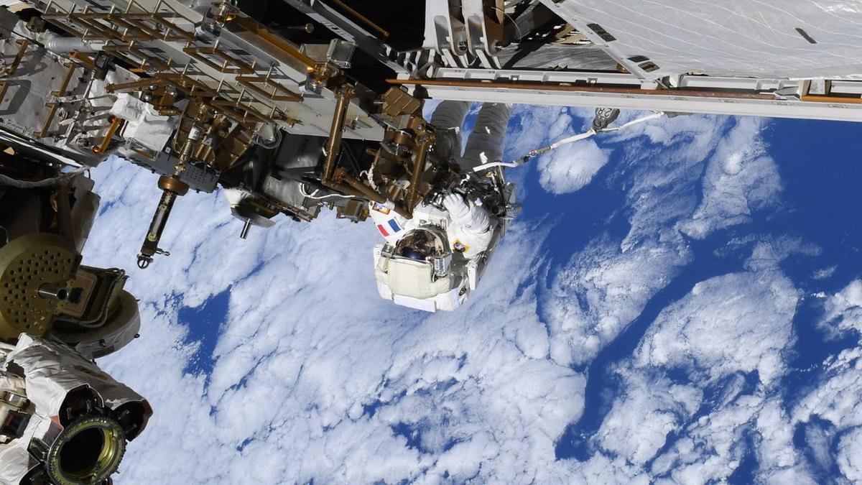
Click for next article ESA astronaut Sophie Adenot on the outside of the International Space Station during an extravehicular activity on Aug. 25, 2026. (Image credit: ESA/NASA) Repairing an engineering marvel like the International Space Station is no easy feat by itself, but it's even more impressive when it's done 250 miles (400 kilometers) up. What is it? In this photograph, European Space Agency (ESA) astronaut Sophie Adenot works on the exterior of the International Space Station on Aug. 25, 2026. The photo was taken while Adenot and NASA astronaut Anil Menon were conducting a 6.5-hour spacewalk, or extravehicular activity (EVA), to replace one of two Space-to-Ground antennas on the outside of the ISS. This was the second EVA that Adenot and Menon performed to replace the antenna. During a previous spacewalk a week earlier, the pair ran out of time before the new antenna could be installed. With that first spacewalk, Adenot became the first woman from France to ever conduct an EVA. Why is it incredible? It can be hard to conceptualize just how high up the ISS orbits until you see a photo like this one; few people on Earth have ever flown as high as 250 miles (400 km), so that altitude can feel a bit abstract. Seeing an astronaut like Adenot clinging to the space station with the clouds and blue oceans of Earth below puts things into perspective. At that height, the ISS orbits at quite a high rate of speed. The orbital laboratory zips around Earth at 17,500 mph (28,000 kph), meaning it circles the planet 16 times a day. This photo was taken on day 194, or orbit 3010, of Adenot's mission, which began in February when she launched to the ISS as part of NASA's Crew-12 mission.

27. 'Orbitals' is a co-op sci-fi adventure that recaptures the magic of Saturday morning cartoons
Read more

Click for next article Growing up, the best Saturday morning cartoons were the ones we re-enacted with our friends on the playground. Whether it was screaming at the top of our lungs to go Super Saiyan like in Dragon Ball Z, or sleuthing around the school as Darkwing Duck. In the years since our childhood, we've often bonded with both strangers and friends over memories of Saturday morning cartoons, remembering the quaint stories and characters that influenced our lives in surprisingly profound ways. Those stories have a unifying power, and that's at the heart of developer Shapefarm's debut, Orbitals, which seeks to combine that rich heart with the gameplay style of Hazelight Studios' co-op games like It Takes Two and Split Fiction. Will Orbitals be looked back on quite as fondly as those cartoons years down the road? Probably not, but this Switch 2 exclusive is a no-frills co-op smorgasbord that's delightful from start to finish. Disclaimer Editor's Note: Since Orbitals requires two players to complete, this feature is co-authored by George Yang and Hayes Madsen. Name a more iconic duo. You play as Maki and Omura, two space explorers tasked with finding power cores to power up their home ship and prevent it from being destroyed by a cosmic storm. Orbitals is very similar to co-op games like It Takes Two and Split Fiction, both from Hazelight Studios. Strictly a two-player game, you and a friend have to work together to solve environmental puzzles while communicating with each other. This dynamic complements the friendly camaraderie between Maki and Omura, the former of whom is a bubbly girl and the latter a more laidback, blue-skinned male humanoid with horns. Perhaps what's most remarkable about Orbitals is its sense of lightness. This is a game laser-focused on fun, evoking that through smart puzzle design, cooperation, collectibles that are all tied to fun little minigames, and more. Experiencing Orbitals was just like marathoning an entire season worth of anime. The 80s and 90s anime art direction emphasizes thick lines and simple shading, as opposed to modern standards of meticulous detail and cinematic lighting. This retro aesthetic permeates every facet of Orbitals. The splash screen that appears when loading up Orbitals, showing Shapefarm and publisher Kepler Interactive's logos, is soaked in retro-futuristic bright neon like Apple's back in the 80s. The amazing opening song, " Accelerating Destiny ," is sung by legendary 80s anime vocalist Mami Ayukawa. Each decision feels intentional, like a love letter to this era. Orbitals - Main Theme "Accelerating Destiny" Official Music Video - Nintendo Switch 2 - YouTube Watch On It's an absolutely gorgeous journey through space that lasts a brisk 5 hours. There are 12 chapters lasting around 20-25 minutes, with each feeling like a separate TV episode, and we know what you're thinking; that seems like a short game. And it is. Compared to Split Fiction, which lasted way too long, Orbitals finds itself on the other end of the spectrum. The pacing quickly picks up into the finale, making it feel a bit rushed. There's a middle ground that both games missed, which is a shame. Despite that, although hastily, Orbitals wraps itself up in a satisfying way. Shows like Cowboy Bebop had a ragtag team of underdogs exploring the solar system, instilling lessons about loneliness and existentialism. Mobile Suit Gundam Wing had heavier ethical themes about war. These ideas flew over our heads as kids, and we were mostly occupied by the pretty lights and awesome fight scenes. But rewatching them as adults allowed us to grasp them better. Orbitals follows in these classics' footsteps, tackling subjects like agency of choice and forgiveness. Orbitals has its fair share of battles, with one player controlling the guns while the other steers the ship to take down turrets and incoming asteroids. It's not too difficult, since each of you only has to focus on one task, but the real challenge comes from communicating. In a few boss fights, the battles can suddenly change into a completely different format. In one instance, the pilot had to dodge enemy projectiles like a bullet-hell game, while the other player's perspective shifted inside the ship, with them putting out fires before heading back to the guns. It's these unexpected moments that make Orbitals a blast to play. As the designated pilot of the duo, Hayes quickly felt the burden of protection weigh upon his shoulders. He didn't just have to get us from point A to point B, but also had to dodge enemy attacks in frenetic battles, pilot through the sudden bullet-hell segment, use a microwave to possess creatures and shift the stage, and so much more. George, on the other hand, had to quickly dispatch enemies before they depleted the ship's HP, while also frantically navigating through lava while Hayes cooled it from underneath, creating a path to the other side of the level. Despite a runtime that feels like it ends when the game is really picking up, Orbitals is an incredibly smartly designed little game. One that consistently weaves different gameplay styles and genres together into something effortlessly distinct, even though it clearly is trying to emulate the magic of It Takes Two and Split Fiction. The good news is that it largely succeeds at what it does. The story is breezy, but punctuated by shockingly good performances and that whimsical Saturday morning cartoon feel. The main duo instantly feel like lifelong friends, with the game knowing it doesn't need to take the time to lay out that backstory. Equally, gameplay mechanics are briefly explained but then further explored through experimentation and context clues, rather than lengthy tutorials. Those two aspects combine into a game that, ultimately, makes every hour feel distinctly different, just like a Saturday morning cartoon. It's those differences that make Orbitals more than the sum of its parts, alongside how much the experience of the game's two players actually differs. While the game likely felt more like a shooter for George, Orbitals was essentially a platformer and vehicular exploration game. That inherently adds a bit of a different tinge to each experience, even in how Orbitals relates to those Saturday morning cartoons it tries to evoke. For Hayes' part, it transported him back to his favorite shows like Gundam and Code Lyoko. This also adds some much-needed replay value, as you can swap roles and dive back in once the credits have rolled. Orbitals may be short, but there's a lot to love. The kind of dessert that satisfies your craving, but doesn't taste too sickly sweet. Orbitals launches on September 3 exclusively for Nintendo Switch 2.

28. SpaceX to launch Starlink mission from West Coast
Read more
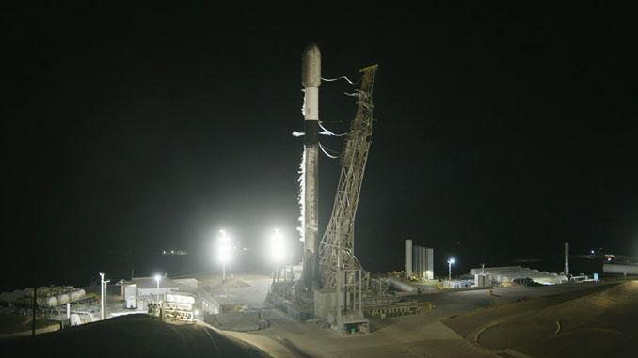
A SpaceX Falcon 9 will liftoff from the company's West Coast launch facility early Wednesday morning to add another batch of satellites to SpaceX's Starlink constellation. Liftoff from Vandenberg Space Force Base in California is scheduled for 1:42 a.m. PDT (4:42 a.m. EDT / 0842 UTC). Spaceflight Now will have live coverage starting 30 minutes prior to launch. The Falcon 9 first stage booster, B1063, making its 35th flight, will take a south-easterly trajectory on departure from Space Launch Complex 4-East. After second stage separation, the booster will target a landing on the drone ship 'Of Course I Still Love You' stationed in the Pacific Ocean off the coast of Baja California. If all goes according to plan, 27 Starlink V2 Mini satellites will be deployed from the Falcon 9 upper stage just over an hour into flight. SpaceX is now basing its Starlink launch operations on the West Coast as it focuses efforts at Cape Canaveral on preparing for the East Coast debut of its Starship vehicle.

29. Many space missions are searching for life beyond Earth, but are we prepared for the fallout if they succeed?
Read more
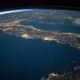
Microbes from space have fueled the plots of science fiction mainstays like "Project Hail Mary" and "The Andromeda Strain." But with more space missions launching each year, finding extraterrestrial life in a microbial form is becoming more plausible. What will the response be back here on Earth if-or when-scientists discover extraterrestrial microbes? Will the international po...

30. AI tool detects unusual satellite behavior to improve space safety
Read more
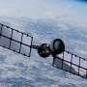
A new AI model can monitor satellites and spot anomalies in their behavior, reducing the risk of in-orbit collisions, according to new research published in the journal Expert Systems.
31. ISRO to launch Earth observation satellite EOS-05 from Sriharikota tomorrow - News On AIR
Read more
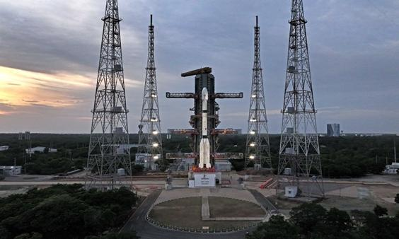
ISRO Chairman V. Narayanan has said that the EOS-05 Earth observation satellite will be launched tomorrow. The satellite is scheduled to lift off at 2:55 AM aboard the GSLV-F17 rocket from the Satish Dhawan Space Centre at Sriharikota. Mr Narayanan said EOS-05 is a state-of-the-art Earth observation spacecraft and India's first imaging satellite to be placed in a geosynchronous orbit. He said the mission will further strengthen India's Earth observation capabilities and improve the delivery of Earth observation services. The ISRO Chairman was speaking to the media after offering prayers at the Sri Venkateswara Swamy Temple in Tirumala yesterday. Before offering prayers, Mr Narayanan placed models of the GSLV-F17 rocket at the feet of Lord Venkateswara. He said all arrangements for the launch have been completed at the Satish Dhawan Space Centre in Sriharikota.

32. Today News Headlines for School Assembly, September 3, 2026: ISRO all set to launch satellite EOS-05 - The Indian Express
Read more
Today News Headlines for School Assembly, September 3, 2026: ISRO all set to launch satellite EOS-05 The Indian Express

33. ISRO GSLV-F17 EOS-05 Mission On September 4: How To Watch Rocket Launch At Sriharikota - News18
Read more
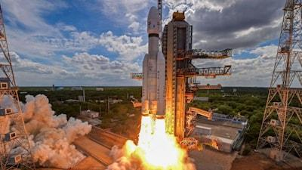
ISRO GSLV-F17 EOS-05 Mission On September 4: How To Watch Rocket Launch At Sriharikota News18

34. 2 spacecraft headed to Mercury are about to begin their long-awaited arrival for Europe and Japan - watch it live on Sept. 3
Read more
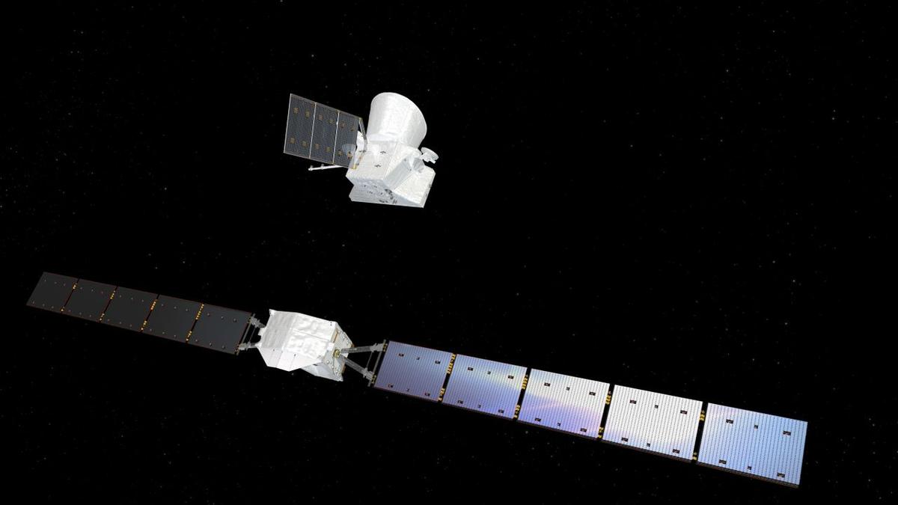
Click for next article BepiColombo's Mercury arrival begins (Official ESA broadcast) - YouTube Watch On The BepiColombo mission is finally getting ready to arrive at its exotic destination. BepiColombo launched in October 2018 and took a long, looping and highly circuitous route toward Mercury our solar system's innermost planet. That journey is now nearly over, and the mission is gearing up for arrival. BepiColombo's two science orbiters - one run by the European Space Agency (ESA) and the other by the Japan Aerospace Exploration Agency (JAXA) - will separate from their power and propulsion module on Thursday (Sept. 3) at around 8 a.m. EDT (1200 GMT). You can watch that milestone live here at Space.com, courtesy of ESA, starting at 7:45 a.m. EDT (1145 GMT). Artist's impression showing the Mercury Transfer Module (at bottom) separate from the BepiColombo Mercury Planetary Orbiter (MPO) and Mercury Magnetospheric Orbiter (MMO) composite spacecraft. (Image credit: ESA/ATG medialab) ESA will pause the webcast at 8:30 a.m. EDT (1230 GMT), then resume it an hour later to cover the mission teams' acquisition of signals from the newly free-flying orbiters. Those communications links are expected to be established no earlier than 9:53 a.m. EDT (1353 GMT), according to ESA officials. The webcast will chronicle that activity, as well as some spacecraft status checks, before ending between 10:15 and 10:45 a.m. EDT (1415 to 1445 GMT). Diagram showing the key moments in the BepiColombo mission's arrival at Mercury. (Image credit: ESA) The separation is just the beginning of BepiColombo's Mercury-arrival phase. For example, the two science orbiters - ESA's Mercury Planetary Orbiter (MPO) and JAXA's Mercury Magnetospheric Orbiter (MMO, or Mio) - won't be captured by the planet's gravity until Nov. 21. The duo will still be linked up on that date. If all goes according to plan, MPO will release Mio into its final orbit - a highly elliptical one that gets as close as 367 miles (590 kilometers) to Mercury and as far away as 7,233 miles (11,640 km) - on Dec. 9 or Dec. 10, then start moving toward its own designated path a week later. MPO is scheduled to reach its final orbit - an ellipse with altitude extremes of 298 miles and 932 miles (480 by 1,500 km) on March 10, 2027. The science phase of the BepiColombo mission (which is named after Italian mathematician and engineer Giuseppe "Bepi" Colombo) will begin on April 6. That science work - performed over the course of at least one Earth year - should be intriguing and rewarding. MPO will map Mercury and Mio will study its magnetosphere, working together to shed light on "the least explored planet in the inner solar system," ESA officials wrote in a BepiColombo mission description . "Among several investigations, BepiColombo will make a complete map of Mercury at different wavelengths," they added. "It will chart the planet's mineralogy and elemental composition, determine whether the interior of the planet is molten or not, and investigate the extent and origin of Mercury's magnetic field."

35. Blue Origin wins $700 million contract to build NASA's next Mars orbiter
Read more
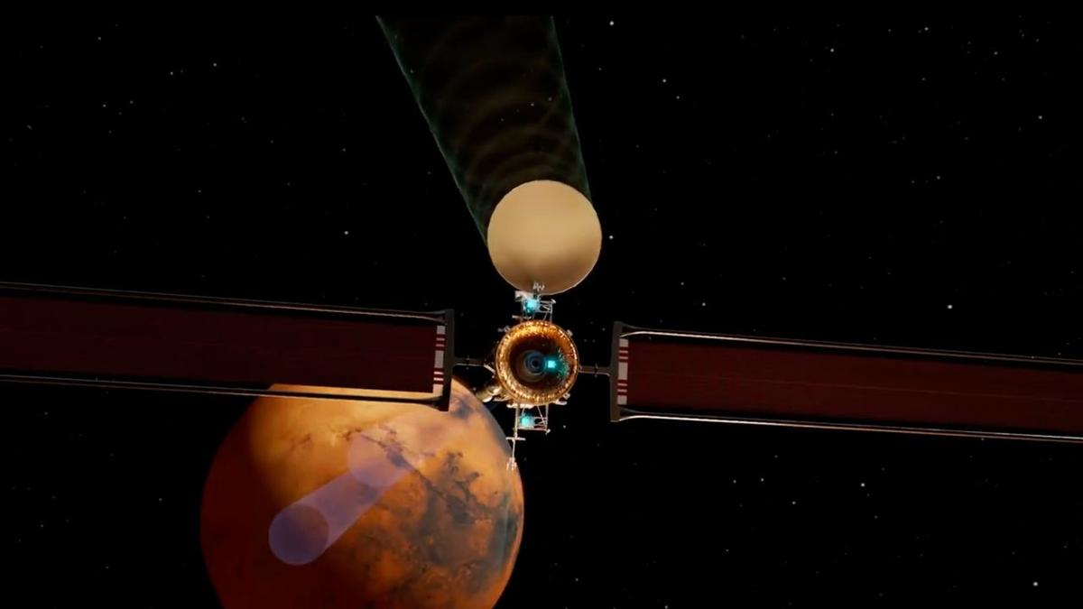
Click for next article Still from a Blue Origin animation showing its Mars Telecommunications Network orbiter at the Red Planet. Blue Origin will build NASA's next Mars orbiter. The agency announced on Tuesday (Sept. 1) that it has selected Jeff Bezos ' spaceflight company to develop the $700 million Mars Telecommunications Network (MTN), which is expected to be up and running at the Red Planet by 2030. "The award marks a milestone in NASA's strategy to expand communications and navigation services beyond Earth and the moon , establishing the foundation for sustained exploration of Mars in the coming decades," NASA officials said in a statement on Tuesday . As its name suggests, the MTN - previously known as the Mars Telecommunications Orbiter - will primarily serve to aid NASA science missions rather than gather data of its own. The MTN is "a next-generation communications system that will enable reliable, high-bandwidth communications and navigation services for current and future Mars missions," NASA officials said in the statement. The need for such a data-relay craft is expected to become acute in the coming years as NASA's fleet of current Mars orbiters ages and the agency works to prepare the Red Planet ground for crewed missions in the late 2030s or early 2040s. At the moment, just two NASA orbiters relay data and commands between the agency's Curiosity and Perseverance Mars rovers and their handlers on Earth - Mars Odyssey and the Mars Reconnaissance Orbiter , which launched in 2001 and 2005, respectively. The European Space Agency's Mars Express and Trace Gas Orbiter spacecraft help out as well. All four of these orbiters are gathering science data of their own, however. The MTN will not have a split focus; it will be a dedicated communications craft. Our Mars Telecommunications Orbiter, built upon the Blue Ring platform, will strengthen the communications backbone at the Red Planet while creating new pathways for science. Capable of delivering multiple payloads to the surface and orbits of Mars, it drives discovery today and… pic.twitter.com/nCN8zMAWCkMarch 5, 2026 NASA got $700 million for a Mars telecom orbiter in July 2025, when Congress passed a budget reconciliation bill. The agency laid out requirements for the spacecraft in February of this year, then issued a request for proposals in May . Blue Origin and Rocket Lab were viewed as the front-runners for the contract, and both pushed hard for it, touting their bona fides and expertise. Blue Origin won out in the end, however. The company will base MTN on its Blue Ring spacecraft platform, which it describes as "an all-in-one, high-powered hybrid solar electric and chemical propelled spacecraft that provides unmatched mission maneuverability, versatility, and capacity at dramatically lower profile costs." Blue Ring has not flown a mission yet, but a prototype version of it went to space on the first-ever launch of Blue Origin's powerful New Glenn rocket in January 2025. Though Blue Ring can fly on other rockets as well, MTN will presumably launch on a New Glenn; the newly announced NASA contract calls for Blue Origin to "design, develop, integrate, launch and operate" the Mars telecom mission. The contract calls for Blue Origin to deliver the spacecraft to NASA no later than Dec. 31, 2028.

36. On this day in space! Sept. 2, 2016: Rosetta spacecraft finds long-lost Philae lander on Comet 67P after 2-year search
Read more
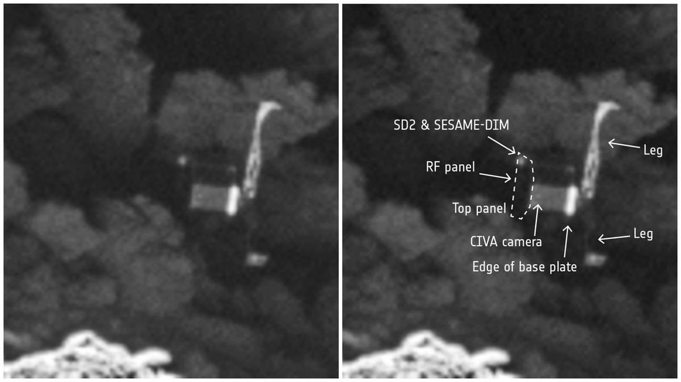
Click for next article On Sept. 2, 2016, the European Space Agency finally located Philae, its long-lost comet lander. Philae was a spacecraft about the size of a washing machine, and it was dropped off at Comet 67P by another spacecraft named Rosetta in November 2014. But when Philae's landing harpoons failed to deploy, it bounced all over the comet before tumbling into a shady place where its solar panels couldn't collect enough light. Philae did transmit some data to Rosetta while using the last of its batteries after the landing, and it occasionally made contact for months after the crash. Rosetta kept looking for Philae by flying around Comet 67P and taking photos. It took Rosetta almost two years to find Philae. A photo taken on Sept. 2, 2016 showed little Philae lying on its side in a dark, rocky crevice. Why it mattered These side-by-side images of the Philae lander show it tilted on its side on the comet 67P/C-G after its landing from its Rosetta spacecraft on Nov. 12, 2014. It took nearly 2 years for Rosetta to spot the lander after the landing. (Image credit: ESA/Rosetta/MPS for OSIRIS Team MPS/UPD/LAM/IAA/SSO/INTA/UPM/DASP/IDA) Locating Philae's grave finally gave the European Space Agency some closure less than a month before Rosetta's mission came to an end with an epic crash landing on Comet 67/P . The European Space Agency's Rosetta mission was an ambitious project. It was the first mission ever to successfully land a probe on the surface of a comet to understand how the icy objects change as they travel through the solar system (although, NASA's Deep Impact mission did intentionally crash into a comet on July 4, 2005, it did not make soft, controlled landing). The moment of truth occured on Nov. 12, 2014, when Philae touched down on the surface of Comet 67P/Churyumov-Gerasimenko (we'll call it 67P for short) after a day-long descent that some scientists had dubbed the "seven hours of terror." This series of images shows the comet 67P with red indicators showing the location of the Philae lander on its surface from the Rosetta spacecraft. (Image credit: ESA/Rosetta/MPS for OSIRIS Team MPS/UPD/LAM/IAA/SSO/INTA/UPM/DASP/IDA) While Philae succeeded in its attempt to make the first-ever soft landing on a comet (Philae actually landed 3 times after bouncing twice ), and even snapped photos of the surface, its exact location was unknown. Philae failed to fire a set of harpoons to anchor it into the surface of Comet 67P, and while Rosetta did manage to track the lander after its first bounce, it lost track shortly thereafter. Philae was a solar-powered lander, equipped with a suite of 10 instruments (and even a drill ) to study comet 67P up close. But because it ultimated ended up in a shadowy crevasse on its side, it couldn't generate the power needed for prolonged science observations. Its onboard batteries ran out after just 60 hours. But despite that truncated lifetime, Philae made several key discoveries - including detecting organics on 67P , mission scientists said. Fortunately, the Rosetta mission team had plenty of time to search for Philae. Rosetta circled comet 67P for another 22 months, snapping more than 80,000 images in all as it studied the icy object while also searching for Philae. By luck, Rosetta managed to find Philae just weeks before its mission ended with its own landing on the comet on Sept. 30, 2014. Want more space history? Check out our full On This Day In Space Story archive and watch our On This Day In Space videos on YouTube .
37. Health Dept raids clinics in Kichha, 5 found unregistered
Read more
PIONEER EDGE NEWS SERVICE/Rudrapur The Health department conducted a surprise inspection in Kichha, in which five clinics were found operating without proper registration. This inspection was carried out on the instructions of the chief medical officer, Dr Sanjeev Kumar Goswami. According to the officials, a team from the Health department, led by the nodal officer, Dr Sudhir Gupta, examined the clinics in the Kichha area. The action was taken under the Clinical Establishments Act, Gupta said. Officials further stated that providing medical services without registration is against the rules. The CMO Goswami emphasised that the campaign against clinics operating sans registration and failing to meet prescribed standards would continue in the district. "Compromising people's health will not be tolerated under any circumstances," he noted and added that appropriate actions are being taken against all five clinics in accordance with the regulations.

38. How ISRO's 'Naughty Boy' Rocket Delivered A Big Win For India - NDTV
Read more
How ISRO's 'Naughty Boy' Rocket Delivered A Big Win For India NDTV

39. After seven-month hiatus, ISRO to launch key satellite on September 4 - The Indian Express
Read more
After seven-month hiatus, ISRO to launch key satellite on September 4 The Indian Express

40. PM lauds ISRO for successful launch of GSLV-F17 carrying EOS-05 - PM India
Read more
Prime Minister Shri Narendra Modi today hailed yet another outstanding achievement by ISRO, calling it a proud moment for the nation. The Prime Minister stated that the successful launch of GSLV-F17 carrying EOS-05, India's first-ever imaging satellite from Geosynchronous orbit, is a reflection of the excellence, innovation, and growing capabilities that define India's space sector. Shri Modi further noted that the growing partnership between ISRO and the Indian industry is adding new strength and scale to the space programme, expanding India's capabilities across the entire space ecosystem. In a post on X, the Prime Minister shared: "Yet another outstanding achievement by ISRO and a proud moment for our nation. The successful launch of GSLV-F17 carrying EOS-05, India's first-ever imaging satellite from Geosynchronous orbit is a reflection of the excellence, innovation and growing capabilities that define India's space sector. The growing partnership between ISRO and Indian industry is adding new strength and scale to our space programme and expanding India's capabilities across the entire space ecosystem."

41. ISRO successfully launches Earth observation satellite EOS-05 - The Hindu
Read more
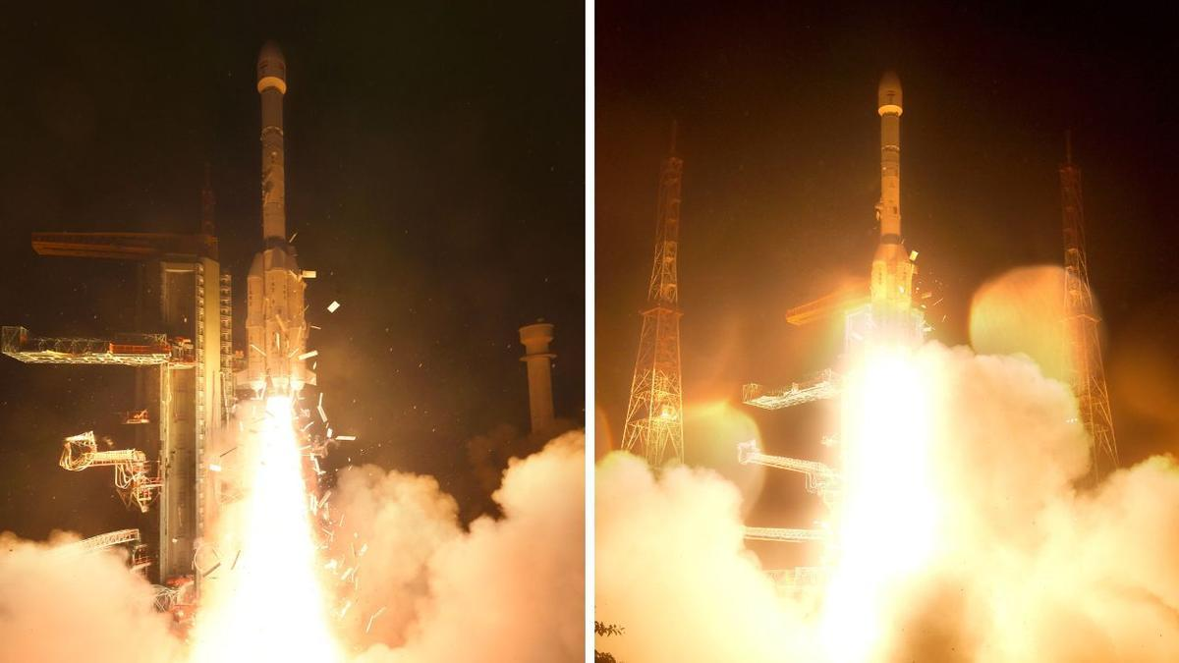
The Indian Space Research Organisation (ISRO), which has had a quiet year so far, is back to winning ways with the successful launch of the state-of-the-art Earth observation spacecraft, EOS-05. Graphics | India's space journey The Geosynchronous Satellite Launch Vehicle (GSLV) on its 19th flight placed the EOS-05 into the intended Sub-Geosynchronous Transfer Orbit 18 minutes after it lifted off from the second launch pad of the Satish Dhawan Space Centre in Sriharikota at 2.55 a.m. on Thursday (September 4, 2026). The EOS-05 is India's first ever imaging satellite to monitor from Geosynchronous orbit about 36,000 km above the Earth. "I am very happy to announce that the GSLV-F17 vehicle has successfully and precisely injected the advanced Earth observation satellite EOS-05 in the intended and required orbit," ISRO Chairman Dr. V. Narayanan said. He added that this was the 107th launch from the spaceport in Sriharikota and the 19th mission of the GSLV. "The first launch of the GSLV-D1 was done with a payload of 1536 kg. From that, gradually we have improved the performance of this vehicle by optimising the structural mass and improving the propulsion systems, and today we have injected the heaviest satellite, a 2367 kg satellite, using this launch vehicle," he added. The ISRO Chairman said that once the Earth observation satellite, EOS-05, is operationalised in orbit, it will become India's first dedicated imaging satellite from the Geo Orbit, providing important strategic data for our country. "From the satellite data we confirm all the valves are operating perfectly, the solar panel is deployed and the health of the satellite is perfectly alright. In the coming days we will raise the orbit and take it to the required orbit and place the satellite in the Geo platform for national activities," the ISRO Chairman said. Prime Minister Narendra Modi on Friday (September 4, 2026) hailed the successful launch of the country's first-ever imaging satellite in geo-orbit and said it was a proud moment for the country. "Yet another outstanding achievement by ISRO and a proud moment for our nation. The successful launch of GSLV-F17 carrying EOS-05, India's first-ever imaging satellite from Geosynchronous orbit is a reflection of the excellence, innovation and growing capabilities that define India's space sector," PM Modi said in a post on X. "The growing partnership between ISRO and Indian industry is adding new strength and scale to our space programme and expanding India's capabilities across the entire space ecosystem," he added. Minister of State in the Department of Space, Jitendra Singh, wrote on X, "Another giant leap for India in Space! Kudos to Team @isro on the successful launch of GSLV-F17/EOS-05. EOS-05 is a state-of-the-art Earth Observation satellite and India's first imaging satellite from Geosynchronous Orbit, enabling advanced imaging across visible, infrared, multi-spectral and hyperspectral bands. With the visionary leadership of PM Shri @narendramodi Ji, India's space capabilities continue to scale new heights, strengthening our position as a global space power." The EOS-05 satellite dubbed 'Eye in the Sky' will provide real-time imagery besides helping agriculture, the environment, disaster management, and others. The successful launch of the EOS-05 comes as a huge relief for ISRO, which has not carried out any launch activities since the failure of the PSLV-C62 mission carrying the EOS-N1 earth observation satellite on January 12, 2026. The space agency, since the back-to-back failures of PSLV-C62 and the PSLV-C61 on May 18, 2025, had taken a cautious approach and refrained from carrying out any launches. Though seven missions, including the GSLV-F17/EOS-05, were scheduled to take place in the first quarter of 2026, ISRO did not launch any satellites. The successful launch of the 2367 kg EOS-05 satellite also puts behind the failure which ISRO had encountered in August 2021 with the GSLV-F10 / EOS-03 mission. Back then, the GSLV-F10 / EOS-03's mission performance was normal during the first and second stages. However, the cryogenic upper-stage ignition did not happen due to a technical anomaly, and the mission remained unsuccessful. The EOS-05 satellite replaces the unsuccessful EOS-03 mission.

42. PM Narendra Modi, Defence Minister Rajnath Singh laud successful launch of ISRO's EOS-05 - News On AIR
Read more
Prime Minister Narendra Modi has commended the successful launch of GSLV-F17 carrying EOS-05, India's first-ever imaging satellite from Geosynchronous orbit. In a social media post, Mr Modi called the successful launch a reflection of the excellence, innovation and growing capabilities that define India's space sector. The Prime Minister said that the growing partnership between ISRO and Indian industry is adding new strength and scale to the country's space programme and expanding India's capabilities across the entire space ecosystem. He also termed it an outstanding achievement by ISRO and a proud moment for the nation. Defence Minister Rajnath Singh has also commended the successful launch of GSLV-F17 carrying EOS-05, India's first-ever imaging satellite from Geosynchronous orbit. In a social media post, Mr Singh said that EOS-05 strengthens India's Earth-observation capabilities and reflects the growing sophistication of its space programme. He added that the expanding partnership between ISRO and Indian industry is giving greater scale to innovation, strengthening indigenous capabilities and opening new frontiers for its space ambitions. The Defence minister further said that under the visionary leadership of Prime Minister Narendra Modi, the country is steadily building a progressive, self-reliant and globally competitive space ecosystem.

43. Isro's GSLV-F17 successfully places EOS-05 Earth observation satellite in geosynchronous orbit - The Times of India
Read more

Isro's GSLV-F17 successfully places EOS-05 Earth observation satellite in geosynchronous orbit The Times of India

44. Hubble's superbubble scene
Read more
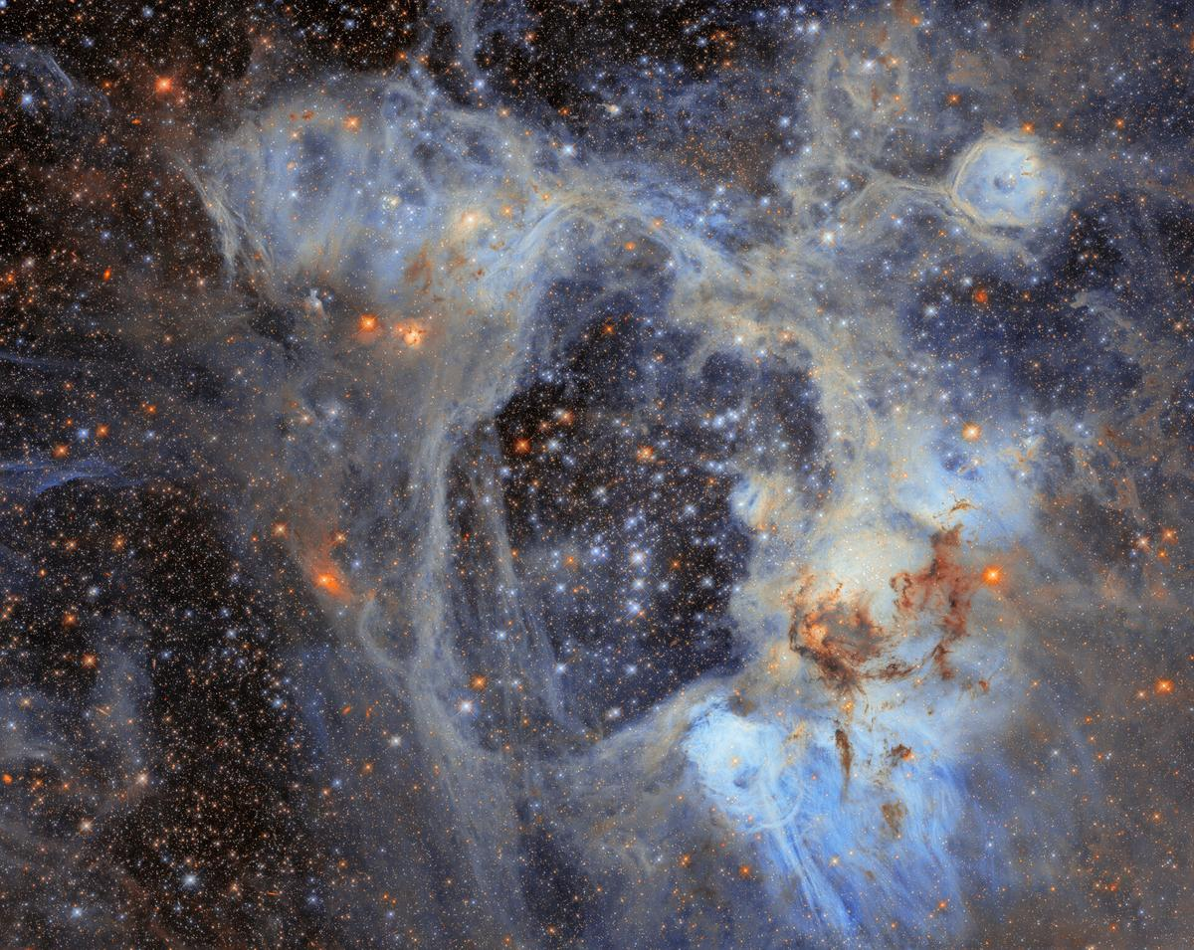
This sprawling cosmic vista and subject of today's ESA/Hubble Picture of the Month comes from the Large Magellanic Cloud (LMC). The LMC is the largest of the small galaxies that orbit our Milky Way galaxy. At just 160 000 light-years away, the LMC offers a close look at highly active stellar birthsites like the nebula shown here. This nebula is named LHA 120-N44, or N44 for short, and it's located in the constellation Dorado. The appearance of this photogenic nebula is dominated by two features: a vast central void and a shell of dense, dusty gas. The central void is a 'superbubble' spanning roughly 210 by 140 light-years. The glittering stars at the centre of the void are responsible for its creation; through their powerful stellar winds and explosive supernovae, these stars have expelled much of the gas from which they were born. When the stars of N44's central star cluster swept away this gas, the expelled gas formed a shell around the superbubble. New stars are forming in this compressed gas shell, making N44 an interesting target for researchers studying the process of star formation. In particular, astronomers have turned to this nebula as an ideal place to time this process from start to finish. Their goal is to understand how long it takes from the collapse of cold gas clouds into dense knots to the moment nuclear fusion ignites in the heart of a newborn star. Researchers used Hubble to survey N44 and take a census of its stars, cataloguing nearly half a million stars within the cluster as well as interlopers drifting in front of it. Of the stars surveyed, nearly 30 000 are what astronomers call pre-main-sequence stars, which have yet to begin fusing hydrogen into helium in their cores. This treasure trove of baby stars was discoverable thanks to the high sensitivity and fine spatial resolution of Hubble's instruments that can pick out faint objects in crowded clusters. The gas shell surrounding the superbubble is energised by ultraviolet radiation from massive stars, causing it to glow and highlighting several distinct features. Each feature within the broader N44 star-forming complex was catalogued by astronomer Karl Henize in the 1950s. One feature is a smaller bubble, catalogued as N44F, that is located near the upper-right corner of this image. N44F is an interstellar bubble blown by the intense stellar winds of a single hot and massive star. As this previously released Hubble closeup shows, the star's furious winds and radiation have sculpted the surrounding bubble and created pillars of dusty gas. The data used to create this image come from an observing programme (#14689; PI: Gouliermis) that aimed to probe stars in the N44 complex that have not yet begun fusing hydrogen into heavier elements in their cores. These data help to determine how long the process of star formation takes, as well as what masses newborn stars typically have. Hubble's sensitive observations of the lowest-mass stars in this region open a new window onto star formation in regions that, like the LMC or the galaxies of the early Universe, are poor in elements heavier than helium. [Image Description: A dense field of stars fills the image, surrounded by wispy clouds of gas and dust. Pale blue and grey nebulosity forms an intricate web across the scene, with darker clouds of dust concentrated towards the lower right. Numerous bright stars appear in shades of blue, white and orange.]

45. NASA to Cover Progress 96 Spacecraft Launch, Docking
Read more
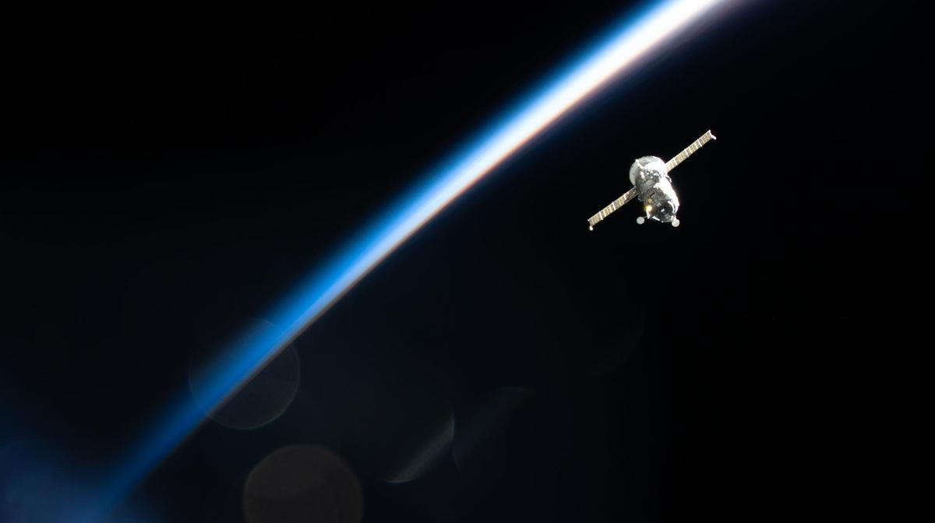
The Roscosmos Progress 92 cargo spacecraft is photographed in March 2026 from the International Space Station as it flies into an orbital sunset 267 miles above Earth's surface. Credit: NASA NASA will provide live coverage of the launch and docking of a Roscosmos cargo spacecraft carrying about three tons of food, fuel, and supplies for the crew aboard the International Space Station. The unpiloted Progress 96 resupply spacecraft is scheduled to launch at 12:15 p.m. EDT (9:15 p.m. Baikonur time), Wednesday, Sept. 9, on a Soyuz rocket from the Baikonur Cosmodrome in Kazakhstan. NASA's live launch coverage will begin at 12 p.m. After a two-day trip to the space station, Progress will dock autonomously to the Poisk module's space-facing port at 2:37 p.m., Friday, Sept. 11. NASA's arrival coverage will begin at 1:45 p.m. NASA will stream these events live through a variety of platforms. Learn where to watch online: https://www.nasa.gov/live The spacecraft will remain docked to the orbiting laboratory for about five months before departing to re-enter Earth's atmosphere, where it will harmlessly burn up over the Pacific Ocean. Before Progress 96 arrives, the Progress 94 spacecraft will undock from the space station at approximately 11:18 a.m., Monday, Sept. 7, for its departure and planned destructive re-entry. NASA will not stream coverage of Progress 94 undocking. For more than 25 years, people have lived and worked continuously aboard the International Space Station, advancing scientific knowledge and making research breakthroughs not possible on Earth. The space station helps NASA understand and overcome the challenges of human spaceflight, expand commercial opportunities in low Earth orbit, and build on the foundation for long-duration missions to the Moon, as part of the Artemis program, and to Mars. Learn more about the International Space Station, its research, and crew, at: https://www.nasa.gov/station -end- Joshua Finch / Jimi Russell Headquarters, Washington 202-358-1100 joshua.a.finch@nasa.gov / james.j.russell@nasa.gov Sandra Jones Johnson Space Center, Houston 281-483-5111 sandra.p.jones@nasa.gov

46. NASA's Hubble Spies Superbubble Scene
Read more
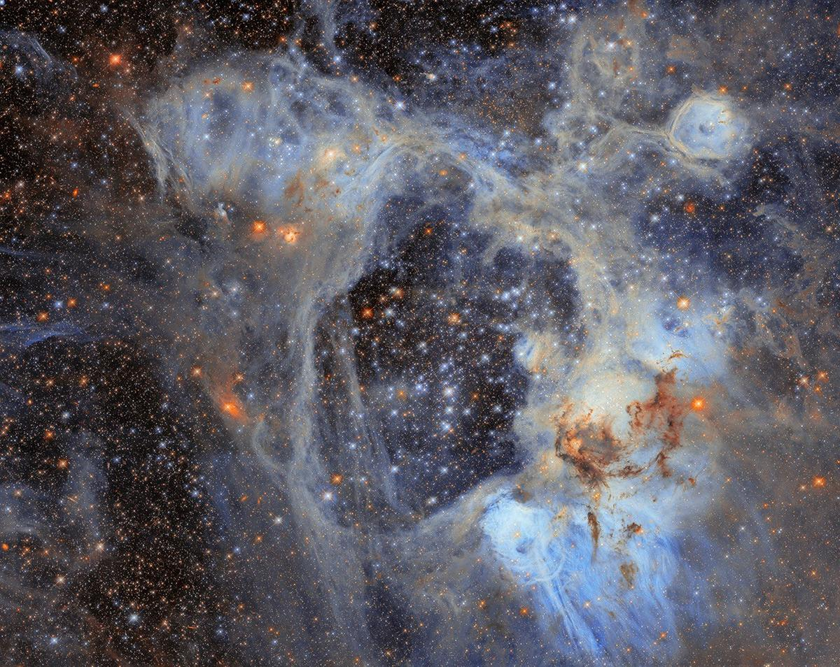
This Hubble Space Telescope image features the picturesque nebula LHA 120-N44, or N44. NASA, ESA/Hubble, D. Gouliermis This NASA/ESA Hubble Space Telescope image features a sprawling cosmic vista in the Large Magellanic Cloud, or LMC, the largest of the small galaxies that orbit our Milky Way galaxy. At just 160,000 light-years away, the LMC offers a close look at highly active star birth sites like the one in this image. This photogenic nebula, named LHA 120-N44, or N44, is in the constellation Dorado. N44 is dominated by two features: a vast central void and a shell of dense, dusty gas. The central void is a 'superbubble' spanning roughly 210 by 140 light-years across. The glittering stars at the center of the void are responsible for its creation; through their powerful stellar winds and explosive supernovae, these stars expelled much of the gas from which they were born. When the stars of N44's central star cluster swept away this gas, the expelled gas compressed and formed a shell around the superbubble. New stars are forming in this compressed gas shell, making N44 an interesting target for astronomers who are using the nebula to study how stars form in this environment. Their goal is to understand how long it takes from the collapse of cold gas clouds into dense knots to the moment nuclear fusion ignites in the heart of a newborn star. The data in this image is from an observing program (#14689; PI: Gouliermis) that used Hubble to survey N44 and take a census of its stars, cataloging nearly half a million stars within the cluster as well as interlopers drifting in front of it. Of the stars surveyed, nearly 30,000 are what astronomers call pre-main-sequence stars, which have yet to begin fusing hydrogen into helium in their cores. Astronomers discovered this treasure trove of baby stars thanks to the high sensitivity and fine spatial resolution of Hubble's instruments that can pick out faint objects in crowded clusters. The gas shell surrounding the superbubble is energized by ultraviolet radiation from massive stars, causing it to glow and highlighting several distinct features. Each feature within the broader N44 star-forming complex was cataloged by astronomer Karl Henize in the 1950s. One feature is a smaller bubble, cataloged as N44F, that is located near the upper-right corner of this image. N44F is an interstellar bubble blown by the intense stellar winds of a single hot and massive star. As this previously released Hubble closeup shows, the star's furious winds and radiation have sculpted the surrounding bubble and created pillars of dusty gas. Hubble's sensitive observations of the lowest-mass stars in this region open a new window onto star formation in regions that, like the LMC or the galaxies in the early universe, are poor in elements heavier than helium. Text Credit: ESA/Hubble Media Contact: Claire Andreoli NASA's Goddard Space Flight Center, Greenbelt, MD claire.andreoli@nasa.gov

47. 2 spacecraft will soon reach Mercury after 8 years in space. Here's what BepiColombo can do
Read more
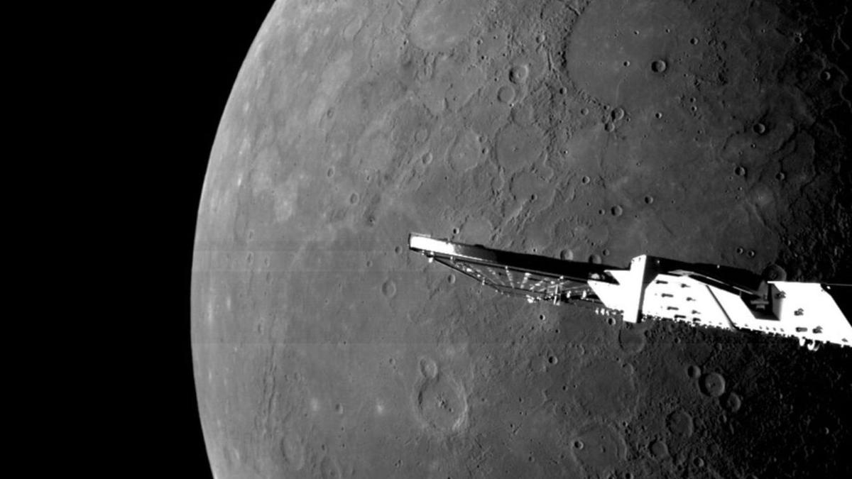
Click for next article This image was taken by the BepiColombo mission on Jan. 8, 2025 as the spacecraft sped by Mercury for its sixth and final gravity assist at the planet. Mercury, the tiniest and least-explored planet in the inner solar system, is hiding mysteries far larger than itself - and finally, scientists will soon be getting not one but two spacecraft designed to decode the strange world. That's thanks to the BepiColombo mission, a joint project of the European Space Agency (ESA) and Japan Aerospace Exploration Agency (JAXA) that launched in October 2018. After a harrowing journey through the inner solar system, the mission is tackling a crucial maneuver on Thursday (Sept. 3) : separating its science equipment from the transport that carried it all that way. By April 2027, scientists hope the mission's two instrument-heavy probes will be gathering a slew of observations that could help solve puzzles about Mercury - and maybe even the solar system we call home. "I think being able to see new data come out about Mercury is going to be so fantastic," Rachel Klima, a planetary geologist at the Johns Hopkins University Applied Physics Laboratory, told Space.com. The planet, she says, is "just so weird and beautiful and interesting." An enigmatic planet For now, Mercury holds the dubious honor of being the least-explored planet in the inner solar system, visited by only two missions to date. NASA's Mariner 10 spacecraft made a trio of zippy flybys in 1974 and 1975, giving scientists their first glimpses of the planet's cracked and cratered surface, as well as confirming the world has both a very tenuous atmosphere and a magnetic field. "It really gave us our first close-up view of Mercury," Sean Solomon, a planetary scientist at Columbia University, told Space.com. "But it left a lot of pages blank." And for decades, that was it. Scientists didn't return to Mercury until 2011, when NASA's MESSENGER spacecraft, with Solomon as its principal investigator, arrived at the tiny world. (Mercury has a radius of 1,516 miles, or 2,440 kilometers, meaning its width is just over a third of Earth's.) The spacecraft was packed with tools tailored to the job, such as spectrometers tuned to gamma-rays, X-rays and neutrons, and instruments to sniff out the atmosphere and measure the magnetic field, and it was there to stay. Four years of observations with MESSENGER showed scientists Mercury's complete surface for the first time, and by late in its mission, the spacecraft was passing just 15.5 miles (24.9 km) above the planet's surface. But even MESSENGER wasn't sophisticated enough to crack Mercury's puzzles or unveil the strange planet's beginnings. "I think the jury's still out on exactly how Mercury got assembled," Solomon said. Flying over Mercury's north pole gave BepiColombo's monitoring camera 1 (M-CAM 1) a unique opportunity to peer down into the shadowy polar craters on Jan. 8, 2025. (Image credit: ESA/BepiColombo/MTM) MESSENGER opened up some smaller mysteries, too. It discovered bright, steep-sided pits that scientists dubbed "hollows." It found a suite of elements - that planetary scientists call "volatiles" for their tendency to slip free of rock - somehow more prevalent in Mercury's surface than Earth's. It calculated that the center of the planet's magnetic field is wildly offset from the planet's core. Plus, MESSENGER's tricky orbit also meant the spacecraft never saw the southern half of the planet as sharply as the northern half, leaving one side shadowed in doubt. The arrival of BepiColombo It's these mysteries that the ambitious BepiColombo mission hopes to tackle. By April, if all goes well, the mission will consist of two separate spacecraft gathering independent but coordinated data about Mercury. Europe's Mercury Planetary Orbiter, or MPO, will focus on the planet proper. It's packed with 11 science instruments that will map the terrain, minerals in the crust, and the gravity field, investigate the hollows and volcanic deposits, and observe how the barrage of charged particles from the sun affects this innermost planet. Japan's Mercury Magnetospheric Orbiter, or Mio, meanwhile, will focus on the planet's surroundings - its magnetosphere and wispy atmosphere, as well as the dust cluttering up its neighborhood. Both spacecraft also carry instruments to measure the planet's magnetic field, offering simultaneous observations of different parts of the field to scientists who typically make do with data gathered from just one location at a time. In fact, some of these instruments have been able to gather observations during BepiColombo's long trek to Mercury and its six quick flybys of the planet so far. But because of how the spacecraft were configured for the journey, most of the instruments have not - and will not - get to work until after MPO and Mio have separated. That is expected to happen in December. The mission's science, then, has begun only in dribbles, while the bulk of its promise still lies ahead. "There is a growing literature of new results that have come from the BepiColombo flybys, but I expect that will explode once they go into orbit," Solomon said. A diagram showing BepiColombo's path to getting near Mercury. (Image credit: ESA) He's especially excited to see the spacecraft's sharp views of the southern hemisphere, and particularly find hidden deposits of water ice across the area. These deposits would exist in deep craters that never feel the sun's heat. In examining this region of the planet, scientists will be able to reduce the northerly bias of MESSENGER's data and better see Mercury's complete picture. Meanwhile, Klima is most eagerly awaiting MPO's work to map elements and minerals in the planet's surface. This work eluded MESSENGER, which used a technique that relied on these rocks being rich in iron and similar materials - but as it turned out, those elements were absent, leaving scientists stymied. MPO carries different technology that will be able to read rocks on the world even without iron, which Klima said could help reveal how Mercury - and our whole solar system, as a matter of fact - formed. Klima says she hopes BepiColombo can get people excited about Mercury, the overlooked terrestrial planet of the solar system: "It certainly doesn't get the love and attention that Mars and Venus and everywhere else gets."

48. 'A new mission starting today': 8 years after launch, BepiColombo begins Mercury arrival
Read more

Click for next article This image was taken by the BepiColombo mission on Jan. 8, 2025 as the spacecraft sped by Mercury for its sixth and final gravity assist at the planet. After nearly eight years traveling through the inner solar system, the trailblazing BepiColombo spacecraft has finally begun its arrival at Mercury. The joint European Space Agency (ESA)-Japanese Aerospace Exploration Agency ( JAXA ) mission reached a major milestone today (Sep. 3), entering its arrival phase at one of our sun's least-studied planets. BepiColombo's Mercury Transfer Module (MTM), the main power and propulsion system that has ferried a dual stack of planetary probes through space for nearly eight years, released its payload to kick off a sequence of operations that will ultimately place the two spacecraft in Mercury's orbit. The separation left ESA's Mercury Planetary Orbiter (MPO) and JAXA's Mercury Magnetospheric Orbiter, known as Mio, together for their final approach, which will take about six more months. "It will basically be a new mission starting today," said Bruno Sousa, ESA's head of operations definition and engineering, during today's mission livestream. BepiColombo launched aboard an Ariane 5 rocket from Europe's Spaceport at the Guiana Space Center in Kourou, French Guiana, on Oct. 19, 2018, beginning a journey that was expected to take about seven years. To assist its plunge sunward, the spacecraft's trajectory has included one flyby of Earth , two of Venus and six of Mercury , as it has shed more and more gravitational energy during to slow its approach to the system's innermost planet. "It's one of the most complicated missions we have ever flown," Sousa said. The mission was made even more complicated in April 2024, when a solar panel issue reduced the available power for MTM's electric thrusters. Engineers devised a lower-thrust trajectory that saved BepiColombo's mission but delayed its Mercury arrival from December 2025 to November 2026. Today's maneuver doesn't place BepiColombo in orbit around Mercury quite yet. MPO and Mio will spend the next several weeks navigating toward the planet ahead of orbital insertion on Nov. 21. "Arriving to Mercury is not as simple as other missions that do a big maneuver and they are there," said Elsa Montagnon, BepiColombo's operations manager. "In our case, it's going to be six months of continuous activities." The Nov. 21 arrival will begin a sequence of 16 maneuvers to progressively lower and reshape BepiColombo's orbit. Mio is scheduled to separate from MPO around Dec. 9 and settle into a highly elliptical polar orbit. MPO will jettison Mio's MOSIF sunshield (Magnetospheric Orbiter Sunshield and Interface Structure) on Dec. 16, then continue lowering its own altitude before reaching its own polar orbit on March 10, 2027. BepiColombo's arrival at Mercury will take about six months. (Image credit: European Space Agency) BepiColombo is scheduled to begin science operations on April 6, 2027, with MPO and Mio studying Mercury simultaneously from complementary orbits. MPO will focus on Mercury's surface composition, geology and planetary interior, while Mio will investigate the planet's magnetic field and its interaction with the solar wind . Today's separation took place at 8:00 a.m. EDT (1200 GMT), but confirmation of that event didn't come for more than an hour following its scheduled execution. Acquisition of signal from BepiColombo came just before 10 a.m. EDT (1400 GMT), followed by a positive telemetry reading indicating the spacecraft was where it was supposed to be. "I'm again extremely relieved," Montagnon said. "That the telemetry comes exactly at the moment we expect it, and that we see in the telemetry that the configuration of the spacecraft is the correct one," she said, "this is the best case scenario."

49. On this day in space! Sept. 3, 2006: Europe's SMART-1 spacecraft crashes into the moon in lunar death dive
Read more
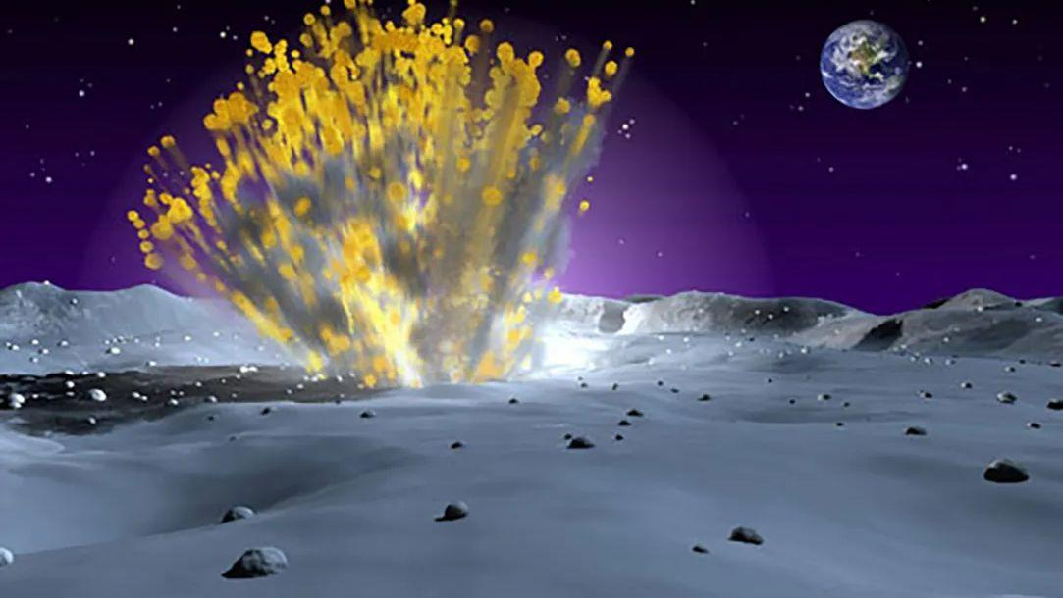
Click for next article On Sept. 3, 2006, a European satellite named SMART-1 crashed into the moon ! This wasn't actually as disastrous as it sounds, because the spacecraft did it on purpose. SMART-1 launched in 2003 and was the first European spacecraft to go to the moon . It was also the first mission of a program called Small Missions for Advanced Research in Technology, which was a series of low-cost spacecraft that the European Space Agency launched to test new spaceflight technologies. SMART-1's primary objective was to test something called Solar Electric Primary Propulsion, or a solar-powered electric engine. While it orbited the moon for almost two years, it looked for water ice and other chemicals on the lunar surface. When SMART-1 slammed into the moon, that was also done for science. Astronomers back on Earth watched the impact with their telescopes, hoping that it would give them some insight into the mechanics of meteor impacts. Why it mattered An illustration of the European Space Agency's SMART-1 probe firing its engine at the moon. (Image credit: ESA, CC BY-SA 3.0 IGO At its core, ESA's SMART-1 moon probe was a technology testbed for spacecraft technologies, that doesn't mean the mission was without science merit. The spacecraft carried a suite of instruments to map the surface of the moon, study the mineral composition of the lunar surface and seek out infrared signatures for signs of water ice. Scientists hoped the probe would help build a geologic history of the moon to better understand its violent origins in a cosmic impact . Image 1 of 2 The moon grave site of ESA's SMART-1 moon orbiter after its crash as seen by NASA's Lunar Reconnaissance Orbiter in 2017. (Image credit: P. Stooke/B. Foing et al 2017/ NASA/GSFC/Arizona State University) (Image credit: P. Stooke/B. Foing et al 2017/ NASA/GSFC/Arizona State University) Image 1 of 2 View Original Image 2 of 2 View Original SMART-1 accomplished all this and more. The mission was expected to last just six months at the moon, but the probe persisted for about three years. ESA initially expected SMART-1 to crash into the moon in September 2005, but mission managers devised a series of engine maneuvers that added a full year onto the mission. An even later maneuver, which completely exhausted SMART-1's xenon supply, extended the probe's life by a few more weeks, ESA officials have said . Greatest moon crashes ever The Greatest Moon Crashes Of All Time! But on Sept. 3, 2006, the moon's gravity pulled SMART-1 out of its lunar orbit. The probe crashed into the moon at a relatively slow 4,473 mph (7,200 kph) -- Leonid meteoroid impacts on the moon are more than of 156,585 mph (252,000 kph), for example -- in a region known as the "Lake of Excellence." No spacecraft in lunar orbit saw its demise, but a telescope on Earth did record the flash from the lunar impact. It would take another 11 years before NASA's Lunar Reconnaisance Orbiter as able to spot the gouge in the lunar surface caused by the SMART-1 impact. That probe's photo showed that SMART-1 created a crater just over 13 feet (4 meters) wide and a gouge over 65 feet (20 m) long when it slammed into the moon. You can see the photo below. Image 1 of 2 The moon grave site of ESA's SMART-1 moon orbiter after its crash as seen by NASA's Lunar Reconnaisance Orbiter in 2017. (Image credit: P. Stooke/B. Foing et al 2017/ NASA/GSFC/Arizona State University) This diagram shows the final resting point in the Lake of Excellence on the moon where the SMART-1 probe crashed. (Image credit: P. Stooke/B. Foing et al 2017/ NASA/GSFC/Arizona State University) Image 1 of 2 View Original Image 2 of 2 View Original Still, demonstrating the solar electric ion engine on SMART-1, which used inert xenon gas as a propellant, was the primary goal of the mission. At the time, SMART-1 was only the second spacecraft to test the solar electric engine (NASA's Deep Space 1 was the first). ESA was hoping the mission could serve lead to a new era of interplanetary exploration by using a lower-cost and more fuel-efficent way of reaching other planets. The mission, ESA said at the time, could pave the way for missions to Mercury , asteroids and more. Today, those hopes have been realized, quite literally. The BepiColombo mission to Mercury, a joint effort by the European Space Agency and Japan to send two orbiters to the planet, is beginning its arrival phase today - Sept. 3, 2026 - by releasing the joined orbiter ahead of orbital entry. The Mercury Transfer Module that carried the two probes toward Mercury is powered by a solar electric xenon propulsion system . NASA's Psyche asteroid spacecraft , Dawn asteroid mission and DART asteroid impact mission also used similar propulsion systems. Want more space history? Check out our full On This Day In Space Story archive and watch our On This Day In Space videos on YouTube .

50. India sends Earth-imaging satellite toward geosynchronous orbit in milestone launch (video)
Read more
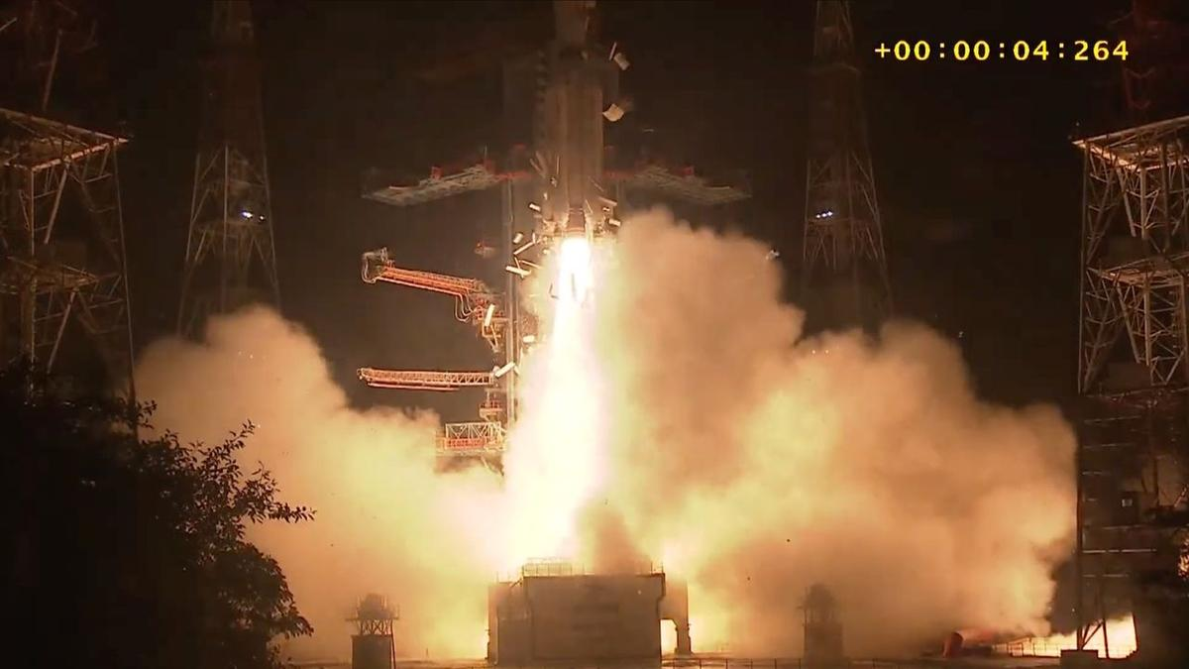
Click for next article India notched a spaceflight milestone today (Sept. 3). A GSLV Mark II rocket launched an Earth-imaging satellite toward geosynchronous orbit from Satish Dhawan Space Centre today at 5:25 p.m. EDT (2:55 a.m. on Sept. 4 India Standard Time). The GSLV deployed the satellite, called EOS-05, into sub-geosynchronous transfer orbit about 18 minutes later as planned. The success marked a first for India, which had never hit that mark with an Earth-observing satellite before. An Indian GSLV Mark II rocket launches the EOS-05 Earth-observing satellite toward geosynchronous orbit on Sept. 3, 2026. (Image credit: ISRO) The GSLV (Geosynchronous Satellite Launch Vehicle) Mark II is a three-stage rocket that stands 170 feet (52 meters) tall. The vehicle debuted in 2010 and now has 13 flights under its belt to date, 11 of them successful. (Its predecessor, the GSLV Mark I, flew six times between 2001 and 2010, with two launch failures.) On today's flight, the GSLV Mark II sent up EOS-05, a 5,218-pound (2367 kilograms) satellite designed to study our planet from a very high perch. "EOS-05 is a state-of-the-art Earth observation spacecraft," Indian Space Research Organisation ( ISRO ) officials wrote in the press kit for today's launch. "It is India's first-ever imaging satellite from geosynchronous orbit." Geosynchronous orbit (GEO) lies 22,236 miles (35,786 kilometers) up, where orbital speed matches Earth's rotational speed. Spacecraft at this altitude can therefore "hover" over a particular patch of our planet, making it a popular destination for weather, communications and spy satellites . EOS-05's "ability to maintain persistent coverage could support monitoring of the Indian subcontinent, including remote border areas, strategic assets, severe weather and environmental events," The Economic Times wrote on Wednesday (Sept. 2). "The satellite is intended for both civilian and military applications." An Indian GSLV Mark II rocket topped with the EOS-05 Earth-observation satellite stands on the pad before its Sept. 3, 2026 launch. (Image credit: ISRO) India tried to get an Earth-observing satellite to GEO once before - in August 2021, when a GSLV Mark II launched the EOS-03 spacecraft. But the rocket experienced an anomaly with its third stage, and the satellite was lost . The rocket bounced back from that failure in May 2023 and is now riding a streak of five consecutive successful launches. Today's liftoff was the third orbital mission for India in 2026. The others were flown by ISRO's Polar Satellite Launch Vehicle, which failed to deliver 16 satellites to orbit in January, and Skyroot Aerospace's Vikram-1 rocket, which aced the nation's first-ever private orbital launch in July . Editor's note: This story was updated at 6:50 p.m. ET on Sept. 3 with news of successful launch and satellite deployment.

51. Perseverance rover watches Earth vanish behind Martian moon
Read more

Earth and the Martian moon Phobos dance together in a series of images recently acquired by NASA's Perseverance Mars rover. Earth appears as a point of light in the Martian sky, disappearing behind the crescent of Phobos, the larger of Mars' two moons.
52. GeoSARAL targets wider GIS adoption across government with Linux-based, low-cost platform
Read more

- Digital India - 7 min read GeoSARAL brings indigenous development, Linux support and data sovereignty to GIS, while AI and digital twins could expand its impact across urban governance and infrastructure. Anoop Verma - ETGovernment - Published On Sep 4, 2026 at 07:12 PM IST Select ETGovernment as Preferred Choice on Google Copy Link Share on WhatsApp Share on Linkedin Share on X Share on Telegram Share on Facebook Esri India Managing Director Agendra Kumar addresses the launch of GeoSARAL, an indigenous GIS Software at Aerocity, in New Delhi. As geospatial technologies become increasingly central to urban planning, infrastructure, agriculture, disaster management and public service delivery, the focus is shifting towards wider access, data sovereignty and locally developed capabilities. Against this backdrop, Agendra Kumar , Managing Director, Esri India , discusses the development of GeoSARAL , a Linux-based desktop GIS platform developed largely in India. In this conversation with Anoop Verma, Kumar argues that while sophisticated foundational GIS technologies are built for global markets and require decades of investment, India can create domestic capabilities by developing solutions on top of such foundational technologies. Kumar identifies urban governance, agriculture and infrastructure as three areas where GIS can have a major impact in India over the next five years. Advt Edited excerpts: Esri India has described GeoSARAL as an indigenous GIS software. What exactly is indigenous about it? Was the core technology developed in India, and how much of the engineering and development resides with Esri India? GeoSARAL has been built using a software development kit, but the entire application development on top of that has taken place in India by Esri India. A sizable amount of code has gone into the GeoSARAL application, so I would say that the Indian content in it is very high. In any GIS software, there is a core engine involving the scientific and mathematical components. That is complicated technology and cannot be developed in a short period of time. There are only a few organisations, companies and communities globally that have been able to create technologies of that nature. But building applications on top of that foundational technology gives us considerable flexibility in terms of adding features and developing new versions. This is the first version of GeoSARAL. We have already given it to some customers to try, and they have been quite happy with what they have seen and used. We will continue adding features over time. The control over the development of GeoSARAL and the addition of new features will reside in India. The Government of India has been emphasising technological self-reliance and reducing dependence on foreign technologies, particularly for critical digital infrastructure. Do you see GeoSARAL as a step towards giving Indian government agencies greater control over their geospatial technology stack? It is definitely a step towards self-reliance. If the coding and application development are being done in India, and we know how the product has been designed, then modifications and the addition of new features remain within the control of the Esri India team. From that perspective, I think it is a major step. Esri India does a significant amount of business with the government, and we always keep national sovereignty in mind. We continue to add features and functionalities specifically for users in India. At the same time, we have to look at the practical aspect of developing foundational technologies. Esri started in 1969 and has created technology that is now used globally by a very large number of organisations and users. Creating a comparable foundational GIS technology specifically for the market of one country would require enormous time, investment and expertise, and may not necessarily be economically viable. That is why many sophisticated technology products are developed by global companies serving global markets. What is certainly possible in India is to use foundational algorithms, scientific libraries and other technologies that are available and build applications locally on top of them. That gives you considerable flexibility regarding how the technology is used, where it is deployed and who uses it. Importantly, the data does not have to go to another country; it can remain here. GeoSARAL, for instance, can operate without an internet connection. It can also work as part of the ArcGIS ecosystem because ArcGIS already has a very large user base in India. We have close to 6,500 organisations using our technology in the country, and about 1.5 million people use ArcGIS in some application every day. We therefore provide both options. GeoSARAL can be used as a standalone application without getting into the ArcGIS ecosystem, while organisations that already use ArcGIS can integrate it with their existing environment. Why did you make Linux central to GeoSARAL? Is the demand coming particularly from government and institutional users? One of the reasons we looked at developing something like GeoSARAL in India was that ArcGIS Pro, our professional desktop GIS technology, is not supported on Linux. Linux has a very large user base in India. The market share of Linux on desktops in India is around 16.2%. That represents a significant user base. If you are unable to provide a Linux-based option, you are not addressing the requirements of a sizable section of users. That is why Linux has been central to GeoSARAL. The core development took place for Linux, although we have also made GeoSARAL available on Windows. Are you also seeking to provide a more affordable alternative for users who do not require sophisticated professional GIS capabilities? GeoSARAL is currently positioned as a low-cost, Linux-based offering for some of the simpler GIS tasks. On the other side, we have ArcGIS Pro, which is designed for professional users who want to run AI algorithms, conduct advanced analytics or undertake sophisticated cartography and other computationally demanding GIS operations. Within an organisation, there may be 30 people who require ArcGIS Pro capabilities and therefore have laptops with GPUs and high-end configurations. But you cannot necessarily provide that level of computing capability to everyone, nor does everyone require it. There are many other users who primarily need mapping, visualisation, editing and querying capabilities. GeoSARAL is designed to address that requirement. Could that make GIS more accessible to institutions with limited budgets, including municipal bodies, panchayats and officials working in the field? A municipal corporation, urban local body, forest department or water resources department, for example, could have a few ArcGIS Pro licences along with an ArcGIS Enterprise setup. At the same time, a much larger number of people who are engaged in fieldwork, data editing or creating maps could use GeoSARAL. This allows organisations to deploy different levels of GIS capability depending on the requirements of individual users. Geospatial data can be highly sensitive, particularly in defence, infrastructure and critical utilities. What security architecture has been incorporated into GeoSARAL? Can organisations deploy it in completely isolated or air-gapped environments? We provide the same level of focus on security that we have in our broader GIS environment. We ensure that security is built into GeoSARAL and that the data is managed appropriately and can remain within the organisation's environment. For ArcGIS Enterprise, we regularly obtain security certifications, including from CERT-In-empanelled agencies. GeoSARAL, as a standalone application, has its own security built into it. If GeoSARAL is connected to ArcGIS Enterprise and the organisation then connects to the internet, the existing ArcGIS Enterprise security architecture comes into play. That is how we have designed the security framework. Esri India's technology is being used by around 6,500 organisations across government, industry, academia and the non-profit sector. From that vantage point, what are the three areas of Indian governance where GIS could produce the biggest measurable improvements over the next five years? The first area is urban living and urban governance. Indian cities face a range of infrastructure challenges. Sometimes roads are not good; in other cases there are problems relating to solid waste management and other municipal services. GIS can help governments address many of these challenges much more effectively. The second area is agriculture. GIS is already making a significant impact in agriculture and can contribute to improving productivity and initiatives aimed at increasing farmers' incomes. The third major area is infrastructure. India is investing significantly in airports, railway modernisation, new highways and other large infrastructure projects. GIS is already playing a role in these sectors, but its contribution can become substantially larger. One important development will be the emergence of living digital twins and the integration of artificial intelligence with geospatial technologies. Digital twins can enable sophisticated designs and simulations in a virtual environment before infrastructure is actually built. A living digital twin of a city, for example, can also help authorities address challenges such as urban flooding and traffic management. I see significant impact coming from the convergence of GIS, AI and digital twins in these areas over the next several years. Anoop Verma , --> - By - See more on: - Agendra Kumar MD Esri GeoSARAL , - GeoSARAL , - Esri India , - Linux-based GIS , - government GIS adoption , - affordable GIS solutions , - Agendra Kumar Managing Director Esri India , - Interview , - agricultural GIS , - data sovereignty in GIS Telegram Facebook Comments What are your thoughts? Comment Now --> Comment Now Read Comment (1) All Comments By commenting, you agree to the Prohibited Content Policy Post Find this Comment Offensive? Choose your reason below and click on the submit button. This will alert our moderators to take actions REASONS FOR REPORTING Foul Language Defamatory Inciting hatred against a certain community Out of Context / Spam Others Report Join the community of 2M+ industry professionals. Subscribe to Newsletter to get latest insights & analysis in your inbox. All about ETGovernment industry right on your smartphone! - Download the ETGovernment App and get the Realtime updates and Save your favourite articles. Scan to download App --> - Home - News - GeoSARAL targets wider GIS adoption across government with Linux-based, low-cost platform

53. ISRO Successfully Launches EOS-05 Earth Observation Satellite - Vajiram & Ravi
Read more
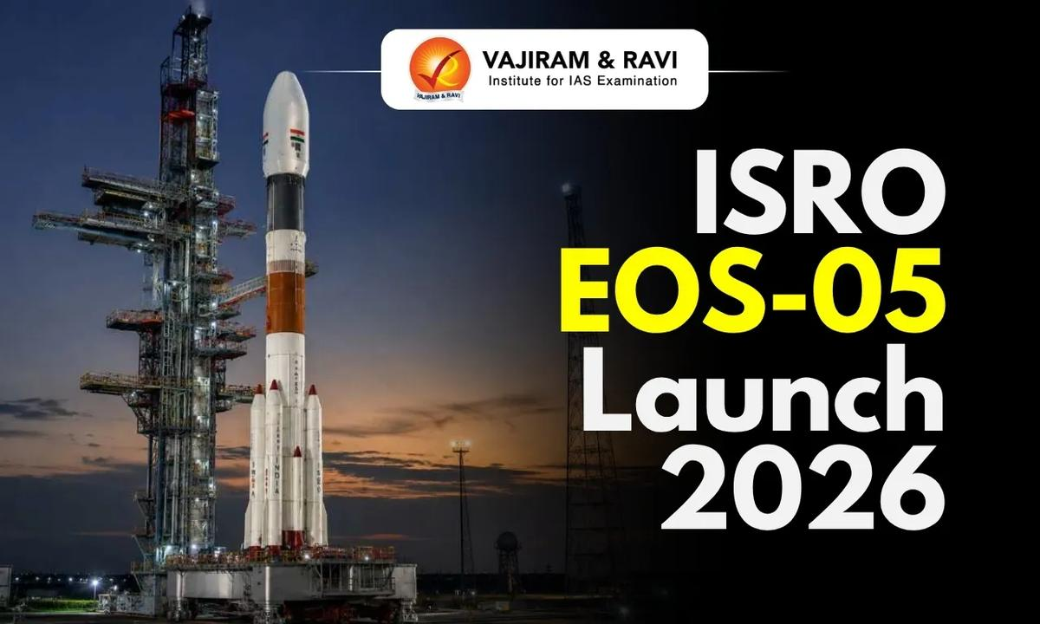
The Indian Space Research Organisation (ISRO) has launched the GSLV-F17/EOS-05 mission on September 4, 2026, at 2:55 AM IST. The mission lift off from the Second Launch Pad (SLP) at Satish Dhawan Space Centre (SDSC-SHAR), Sriharikota. The GSLV-F17 carried EOS-05, an advanced Earth observation satellite, and placed it into a Sub-Geosynchronous Transfer Orbit (Sub-GTO). A major feature of the mission is that EOS-05 is India's first imaging satellite designed for operation from a geosynchronous orbit. What is GSLV-F17? GSLV-F17 is the launch vehicle assigned to place EOS-05 into its designated orbit. It belongs to India's Geosynchronous Satellite Launch Vehicle (GSLV) family, which is designed to launch heavier spacecraft into high-energy orbits. For the GSLV-F17 mission, ISRO is using a 4-metre diameter Ogive composite payload fairing. The fairing protects the satellite from atmospheric conditions during the initial phase of flight. The vehicle will inject EOS-05 into a Sub-Geosynchronous Transfer Orbit (Sub-GTO). From there, the spacecraft can be manoeuvred towards its operational orbit. What is EOS-05? EOS-05 is a state-of-the-art Earth observation spacecraft developed by ISRO. It is particularly significant because it is described by ISRO as India's first-ever imaging satellite from a geosynchronous orbit. Earth observation satellites collect information about the Earth's surface and atmosphere. Their data can support applications such as: Land and resource monitoring Agricultural assessment Disaster management Environmental monitoring Weather and climate-related studies Mapping and planning EOS-05 and Geosynchronous Orbit A key aspect of the mission is the use of a geosynchronous orbit for Earth imaging. A geosynchronous satellite has an orbital period approximately equal to Earth's rotation period. Such an orbit allows a satellite to repeatedly observe a particular region at regular intervals. The use of geosynchronous orbit for Earth observation can be particularly useful for frequent monitoring of large areas. This makes the EOS-05 mission important from the perspective of India's remote sensing and Earth observation capabilities. What is Sub-Geosynchronous Transfer Orbit? The Sub-Geosynchronous Transfer Orbit (Sub-GTO) is the target orbit into which GSLV-F17 will place EOS-05. A transfer orbit is used to move a spacecraft from the launch vehicle's initial injection conditions towards its intended operational orbit. After reaching the transfer orbit, the satellite can undertake additional orbital manoeuvres to reach its final position. The distinction between GTO, Sub-GTO, geosynchronous orbit and geostationary orbit is important while understanding India's space missions. ISRO EOS-05 Launch 2026 Significance GSLV-F17/EOS-05 Mission is significant for strengthening India's Earth observation capabilities and demonstrating the use of a geosynchronous orbit for imaging applications. First geosynchronous imaging satellite: EOS-05 is India's first-ever imaging satellite from a geosynchronous orbit . Strengthens Earth observation: The mission will enhance India's ability to obtain space-based Earth observation data . Advances satellite applications: Earth observation data can support resource monitoring, environmental studies, agriculture and disaster management . Demonstrates GSLV capability: GSLV-F17 marks the 19th flight of the GSLV , adding to India's experience with high-energy orbital missions. Technological advancement: The mission reflects progress in developing advanced spacecraft and launch vehicle technologies . Strategic importance: Improved space-based observation capabilities can contribute to better planning, monitoring and management of natural resources . Expands orbital applications: EOS-05 demonstrates the potential of geosynchronous orbit for Earth imaging , broadening India's remote-sensing capabilities. Importance of Earth Observation Satellites Earth observation satellites are an important part of modern space-based infrastructure. They provide data that can be used by governments, researchers and other organisations for monitoring changes on Earth. Their applications include:

54. After seven-month hiatus, ISRO to launch key satellite on September 4 - The Indian Express
Read more
After seven-month hiatus, ISRO to launch key satellite on September 4 The Indian Express

55. ISRO successfully launches Earth observation satellite EOS-05 - manoramayearbook.in
Read more
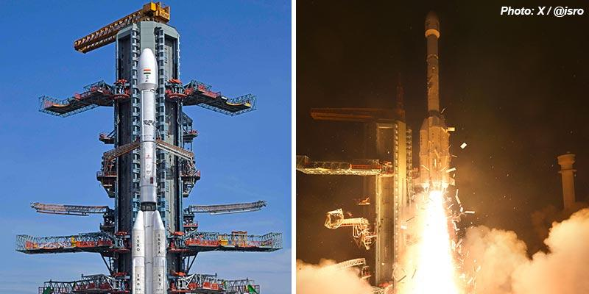
• Indian Space Research Organisation (ISRO) successfully launched the country's first ever imaging satellite in the Geosynchronous orbit on September 4. • A Geosynchronous Satellite Launch Vehicle (GSLV) rocket, carrying Earth observation satellite EOS-05, lifted off from the second launch pad at Satish Dhawan Space Centre in Sriharikota in a pre-dawn mission. • The satellite was successfully placed in the intended sub-geosynchronous transfer orbit, about 18 minutes after it lifted off from the spaceport. • While several earth observation satellites operate from Low Earth Orbit (LEO), the EOS-5 satellite is set to hover at an altitude of roughly 36,000 km above earth, which is the geosynchronous orbit and at that level, the satellite will match Earth's rotational speed. • At over 2,300 kg, this is the heaviest satellite ever to be carried by a GSLV. • This was the 107th launch from Srihariharikota and the 19th mission of GSLV. • Once the EOS-05 is operationalised, it will become India's first dedicated imaging satellite to monitor the Earth from geosynchronous orbit, about 36,000 km above the Earth. (The author is a trainer for Civil Services aspirants.)

56. The Success of EOS-05 Says the Seven-Month Launch Hiatus for ISRO Is Over - TheWire.in
Read more
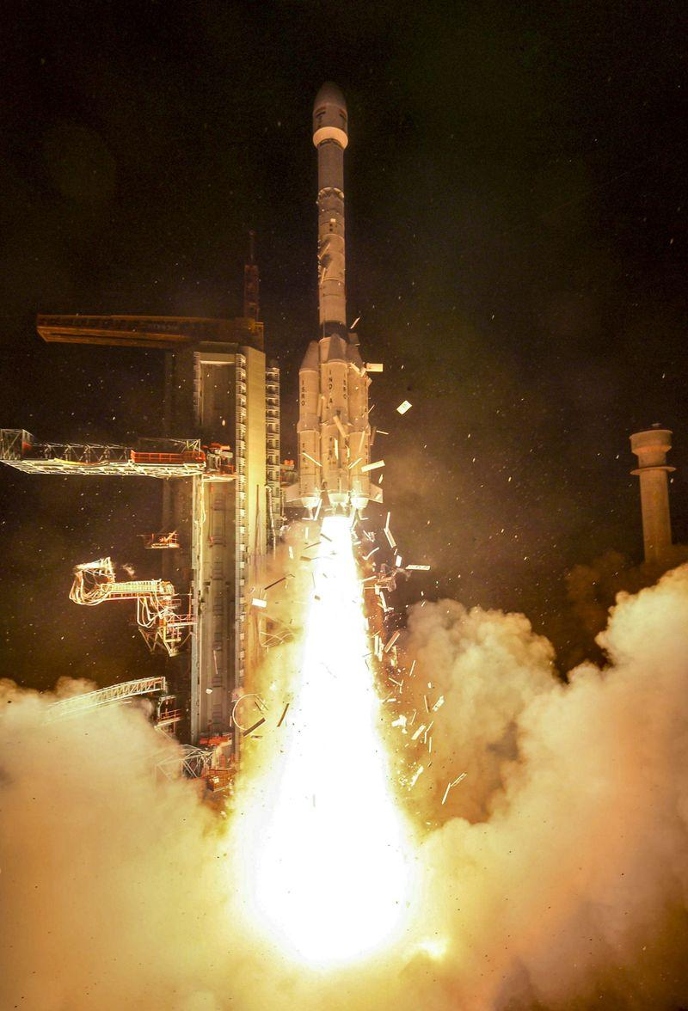
ISRO is best placed to address its manpower shortages, project delays and other organisational challenges. Its track record demonstrates a capacity to overcome various setbacks. On September 4, 2026, the Indian Space Research Organisation (ISRO) successfully launched the GSLV-F17/EOS-05 mission. This success comes in the wake of two consecutive failures of the Polar Satellite Launch Vehicle (PSLV). On May 18, 2025, PSLV-C61 failed following an anomaly during the third stage while carrying the EOS-09 satellite. This was followed by the failure of PSLV-C62 on 12 January 2026, shortly before third-stage separation. Following the January 2026 failure, ISRO remained without a launch for nearly seven months. There could understandably have been some apprehension within the ISRO community about this launch as well, given the historically challenging and unforgiving nature of the Geosynchronous Satellite Launch Vehicle (GSLV) and particularly its cryogenic upper stage. The PSLV, long regarded as ISRO's workhorse launcher, had experienced two consecutive failures in the recent past. On the other hand, the performance of the GSLV has historically been mixed. The GSLV Mk I, which used a Russian cryogenic upper stage and is now retired, undertook six missions, including two outright failures and two partial failures. The GSLV Mk II, equipped with an indigenous cryogenic stage and still in service, had completed 12 missions, with 10 successes before this mission. Promisingly, the GSLV Mk II's success rate has been significantly better than that of the earlier Mk I configuration. Interestingly, ISRO appears to have revised the nomenclature of its GSLV missions, with the earlier GSLV Mk I now being referred to as GSLV Mk II, while the vehicle previously designated GSLV Mk II is now simply referred to as GSLV. Following the failure of the GSLV-F10 mission in 2021, the subsequent four missions of the GSLV have been successful, indicating a period of improved reliability. The previous GSLV mission, GSLV-F16, had successfully launched NISAR (NASA-ISRO Synthetic Aperture Radar) mission, the satellite jointly developed by ISRO and NASA, in July 2025. The Earth Observation Satellite (EOS) series reflects ISRO's effort to establish a dedicated constellation of advanced remote-sensing (also known as earth observation) satellites, with most positioned in low Earth orbit (LEO) and some in geostationary orbit (GEO). At present, four EOS-series satellites are operational in LEO. Two of these carry Synthetic Aperture Radar (SAR) sensors, enabling all-weather imaging for applications such as flood mapping, soil-moisture assessment and hydrology. With EOS-05, ISRO is expanding this capability to GEO, where the satellite is expected to provide continuous, near-real-time observation of the area under coverage, with a spatial resolution of about 42 metres. In comparison, the LEO-based EOS series systems offer resolutions ranging from about 6 to 360 metres. Deploying satellites across different orbits allows ISRO to combine the higher spatial resolution of LEO platforms with the wider and more persistent coverage offered from GEO. Although primarily intended for civilian applications, these satellites have significant dual-use potential and are therefore highly relevant to India's defence requirements. SAR based satellites have major utility for armed forces too. However, India would require a larger and more diverse EOS constellation to adequately meet its growing strategic needs. Notably, EOS-05 is actually a replacement for EOS-03 (GISAT-1), which was lost in a launch failure in 2021. ISRO is planning a few more satellites in this series and a satellite called EOS-10 (Oceansat-3A) could be launched around March 2027. In regards to the use of satellites in disaster management, there could be one important learning from the recent high-altitude collapse of rock and ice triggering a catastrophic flash flood near the Nepal-Tibet border on 26 August 2026. The NISAR satellite operates in a near-polar, sun-synchronous dawn-dusk orbit at an altitude of approximately 747 km. There are views and counterviews in regards to the capabilities highlighted by NASA and ISRO about this satellite at the backdrop of the recent Nepal disaster. It is obvious that NISAR failed to give any early warning of this catastrophic event. Possibly, the disaster was difficult to anticipate because it resulted from the sudden failure of a high-altitude glacier-rock system in a remote and poorly monitored region. It appears that satellites like NISAR are not designed to detect subtle deformation across thousands of glaciers and unstable slopes. This clearly demonstrates that even state-of-the-art single satellites may be not sufficient to monitor and respond to major disasters. NISAR does not pass over the Himalayan region on every orbit. While it completes about 14 orbits a day, its polar, sun-synchronous orbit means that each pass covers a different region as the Earth rotates below it. Normally, only a limited number of passes align with the Himalayan region, restricting the frequency of observations over a specific area. This may partly explain India's efforts to develop a combination of LEO and GEO satellites to minimise data gaps and provide more continuous coverage. Such a multi-orbit satellite architecture would have significant civilian as well as military utility. The success of the GSLV-F17/EOS-05 mission will undoubtedly boost ISRO's confidence. It was unfortunate that a globally recognised space agency such as ISRO went through a nearly seven-month launch hiatus. The current situation suggests that all is not well with ISRO. Shockingly at present India's space programme faces a paradox of budgetary constraints alongside significant under-utilisation of allocated funds. The Parliamentary Standing Committee in its 410th report on Science and Technology (2026-2027) has expressed concern that the Department of Space has not been able to utilise its allocations effectively. There are issues surrounding fluctuating government resource allocation on one hand and the inability to fully convert available budgetary resources into timely programme expenditure on the other. It is also important to note that currently ISRO is facing its worst human power shortages, with nearly 30% of its sanctioned positions remaining vacant while some top scientists are found leaving for the private sector. India's private space sector is found making rapid progress. ISRO has transferred the technology for producing launch vehicles such as the PSLV and SSLV to private and other public-sector agencies. Thus, trained manpower with expertise mainly in such systems is likely to be in high demand in the private sector. Recent launch failures, delays and capacity constraints have raised questions about the organisation's ability to sustain the pace and reliability expected of it. Is ISRO at present undertaking too many projects simultaneously? Is the shift in focus towards the human spaceflight mission (Project Gaganyaan) and the expanding Moon program impacting progress on other strategically important missions? Owing to manpower and other related issues, has the time come for ISRO to reprioritise its agenda and focus more on strategic requirements first, before investing into so-called trendy fields like the human spaceflight program, space station and other planetary missions? ISRO is best placed to address its manpower shortages, project delays and other organisational challenges. Its track record demonstrates a capacity to overcome various setbacks. The successful EOS-05 mission could therefore mark the beginning of a process of renewal and reinvention. Ajey Lele is a researcher and is the author of the book Institutions That Shaped Modern India: ISRO. The Wire is now on WhatsApp. Follow our channel for sharp analysis and opinions on the latest developments.

57. NASA Hosts Virtual Artemis Webinar for Blind, Low-Vision Community
Read more
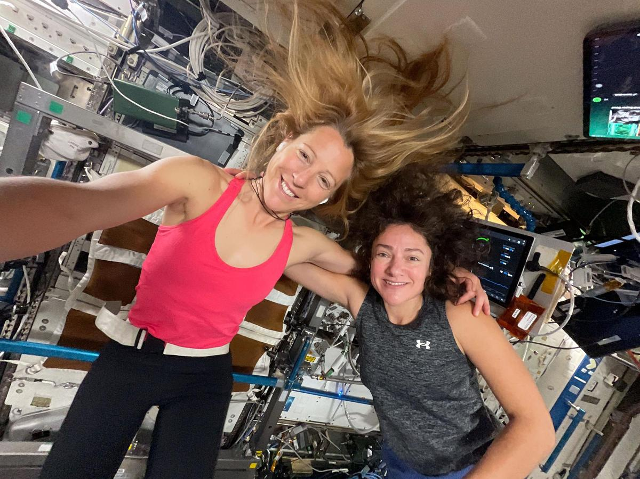
Two technicians at NASA's Michoud Assembly Facility in New Orleans stand around one of the four RS-25 engines for the agency's SLS (Space Launch System) rocket on Sept. 8, 2023. The RS-25 engine looks like a bell-shaped nozzle attached to a network of pipes. The engine is being lifted by the horizontal engine installer so it appears to be lying on its side. The RS-25 engine is about the size of a large pickup truck. The technicians are wearing hard hats and safety harnesses. Credit: NASA/Michael Democker NASA will host a virtual webinar at 2 p.m. EDT on Friday, Oct. 2, titled "The RS-25 Engine and the Future of Artemis Missions: An Accessible Webinar for the Blind and Low-Vision Community." This webinar is open to the public, however it is tailored specifically for a blind and low-vision audience. The webinar will last about two hours and include an audio-described video of an RS-25 engine test, a Q&A session with an Artemis engineer, and a panel about accessibility in space and science. The event will be hosted on the Zoom platform. Participants in the session include: Dr. Kimberly Arcand, visualization scientist, NASA's Chandra X-ray Observatory Josh Greiner, test director, NASA's Stennis Space Center in Bay St. Louis, Mississippi Dr. Craig Moore, materials engineer, NASA's Marshall Space Flight Center in Huntsville, Alabama Dr. Robert Shelton, lead simulation engineer, NASA's Johnson Space Center in Houston Christine Malec, freelance writer and consultant Those interested in attending the webinar must RSVP using this form by Friday, Sept. 25. Any questions can be directed to thalia.k.patrinos@nasa.gov. The details of the webinar will be emailed to registrants in the days leading up to the event. NASA's Artemis program will send astronauts on increasingly difficult missions to explore the Moon and establish a Moon Base on the lunar surface. For additional information on the Artemis missions, visit: https://www.nasa.gov/artemis

58. Hubble Telescope sees spectacular 'superbubble' | Space photo of the day for Sept. 4, 2026
Read more
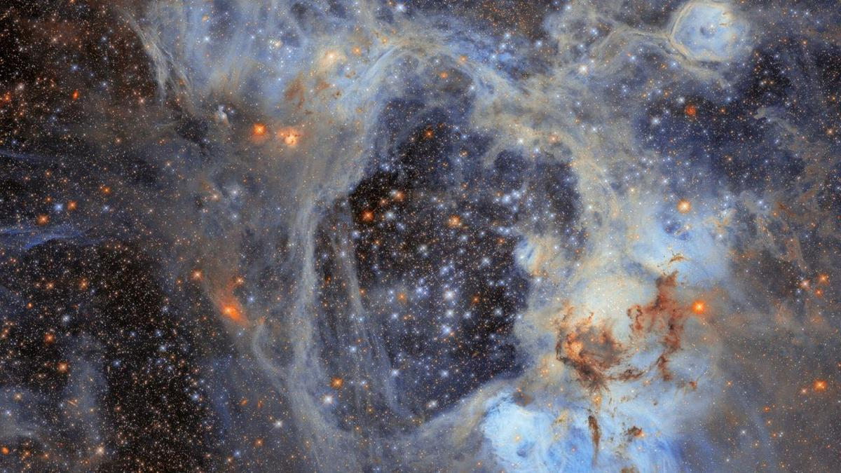
Click for next article This nebula is named LHA 120-N44, or N44 for short, and it's located in the constellation Dorado. (Image credit: ESA/Hubble & NASA, D. Gouliermis) About 160,000 light-years away lies one of our Milky Way's little galactic neighbors: The Large Magellanic Cloud (LMC). And thanks to a new observing program, the Hubble Space Telescope has provided us with an intricate image of a nebula in the LMC. The surprising part? There's a giant void at the center. Scientists call it a "superbubble." What is it? What you're seeing in this image is a nebula within the LMC known as LHA 120-N44, or simply N44. It's located in the constellation of Dorado and, like a classic nebula, is the site of stars being born at a noticeably rapid rate. But of course, what really can't be missed is the huge hole at the center of N44's dusty tendrils - this is the "superbubble," and its dimensions are staggering. NASA says it's about 210 by 140 light-years across - a truly unimaginable size, considering the distance between our sun and Pluto isn't even a single light-year. One light-year , the distance light travels in a year, is about 6 trillion miles (9.7 trillion kilometers). Why is it noteworthy? The superbubble is a bit of a mystery, but one theory of why it exists is that stars at the center of the bubble could have undergone supernova explosions or have released stellar winds that swept away gas in the nebula. This could have resulted in a "void," as NASA calls it, surrounded by a gaseous shell. That would explain away the image we see pretty well, but there will likely be studies dedicated to refining that story. Of note, in that shell around the superbubble, stars continue to form and show themselves as beautiful little specks across the watercolor-like landscape. Something else interesting about this image is that N44 is what's known as an " emission nebula ," meaning the gas you see has been energized by stars in the area. This enhances the luminescent quality of the portrait. This is because the energization process, or ionization to be specific, generates ionized gas that ultimately must cool down. During that cooling, it goes from a higher energy state to a lower energy state and thus releases some energy. This energy loss causes N44 to glow brightly, creating the beautiful scene we see. The reason scientists have used the Hubble Space Telescope to study N44 is this particular nebula offers good conditions to study star formation and evolution. As a matter of fact, Hubble managed to survey nearly half a million stars in and around the cluster, 30,000 of which are in the very early stages of their lives.

59. How did the infant sun form? Scientists get surprising new insights from 4.6-billion-year-old space dust
Read more
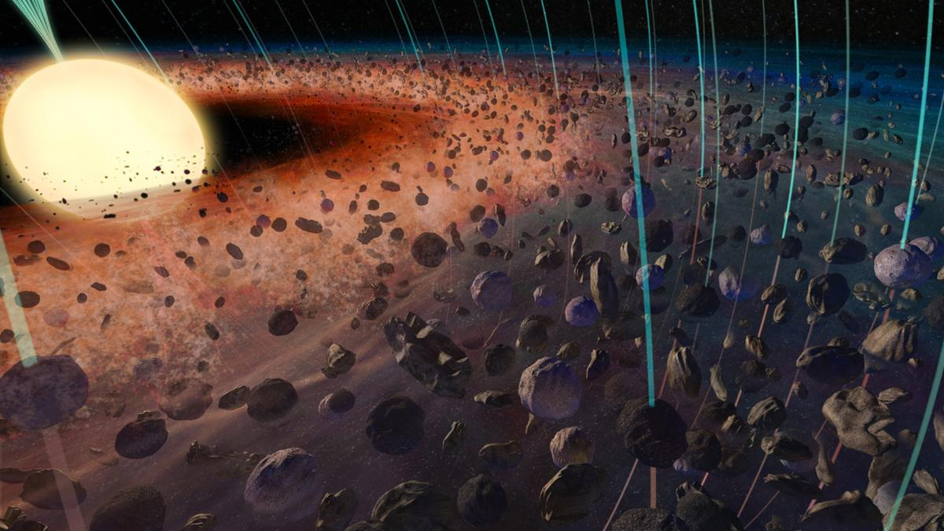
Click for next article New research suggests that dust from meteorites contains a "fossil record" dating back to the formation of the sun. The research reveals that magnetism played a far greater role in the birth of the solar system than had previously been suspected. Around 4.6 billion years ago, the solar system was a cloud of gas and dust, known as a solar nebula. Over the next few million years, this cloud began to flatten, forming a donut-shaped ring or torus with a budding star gathering mass at its core. Eventually, planets would form within this so-called protoplanetary disk. Scientists have always theorized that gravity was the main sculptor during this early era. But the new study suggests that gravity had major assistance from magnetism. The signature of this additional cosmic artist was found within grains of dust sealed in DOM 08006, a meteorite recovered from Antarctica in 2008. The grains found by the team are calcium-aluminum-rich inclusions (CAIs), which are thought to have formed during the first 200,000 years of the solar system. That potentially makes them the oldest samples of solar system material ever seen. "We know they are the oldest things we have of the early solar system," team leader Cauê Borlina of Purdue University said in a statement. "But CAIs are very complex and are not all the same, even within a 1-millimeter piece of the meteorite. So we have to carefully identify what types they are." These CAIs indicated that there was a magnetic field in the proto-solar system even during its solar nebula phase. This magnetic field would have been stronger than Earth's magnetosphere and, as such, would have influenced the flattening of the solar nebula. "This transition, from a spherical cloud to a protoplanetary disk, is one of the most significant events in all of solar system history," team member Benjamin Weiss, of the Massachusetts Institute of Technology (MIT), said in the same statement. "It has long been theorized that gravity caused this, but our measurements show magnetism likely played a role." A new spin on early solar system magnetism In the newly forming solar system, a magnetic field would have been generated when charged particles were sent spinning through the collapsing cloud of gas and dust that birthed the sun . This plasma would then have sustained that field. As such, that magnetism must have affected the material in the solar nebula that would become the solar system. For that reason, the team reasoned that the strength of this field should be "locked in" to materials from the time as remanent magnetization. This matter could make its way to Earth in meteorites. In fact, the same scientists who conducted this research previously found evidence of a magnetic field that existed 2 million years into the formation of the solar system, baked into meteorites. That's an impressive and important find, because this magnetic field would have helped planets like Earth form - but the sun was already around by that point. Thus, the team was after an earlier magnetic field, one that predated our star. "Nowadays, people don't debate whether magnetism is present when planets are forming. But the debate is around the very early solar system, before planets are forming, when there's just a disk," Borlina said. "That's where the debate still resides, and that's where we're operating now." Early solar system material takes shape under the influence of magnetism. (Image credit: Hernan Canellas) DOM 08006 is one of the most unspoiled or "primitive" meteorites ever discovered, retaining and preserving materials, including CAIs, as they were when the sun was forming. "Other meteorites went through many different processes over this 4.5 billion-year history ," said Weiss. "They were formed in the solar nebula, then added to bodies with water, then got destroyed, moved to the asteroid belt , and then landed here. But somehow, DOM has experienced less alteration than any other meteorite." If a magnetic field existed during the earliest stage of the solar system, it should be observable in the matter that makes up DOM 08006. The team was able to isolate and identify a handful of CAIs that contained inherently magnetic minerals such as iron, which they tested to measure any magnetism they had retained. An X-ray image of the Antarctic meteorite DOM 08006, which was discovered in 2008. (Image credit: NASA) Studying these grains, the researchers found evidence of a magnetic field 12 times stronger than that of Earth. They think this magnetic field may have played a crucial role in the evolution of the solar system. "We think these kinds of magnetic fields were helping to move gas from the protoplanetary disk inward toward this central star, the sun," Borlina said. "Gravity is also playing a role. But we are now showing that, if you want to fully understand how the sun and planets formed, you should include magnetic fields in the ingredients that make them."

60. Rescue satellite gets close to NASA's doomed telescope, even if it can't save it
Read more

A private spacecraft that was supposed to supply a lifeline to NASA's Swift Observatory managed to get close to the sinking telescope and even snap photos more than a week after the rescue was abandoned.

61. All-civilian US workforce completes historic overhaul of 15,000-mph nuclear missile
Read more
Air Force maintenance crews have completed an unusual overhaul of a Minuteman III missile component, sending the massive assembly across the country before returning it to its launch facility. The 583rd Missile Maintenance Squadron completed the refurbishment on August 18 near Minot Air Force Base in North Dakota. Crews first removed the suspension system from an underground launch facility earlier this year. They then transported it to Vandenberg Space Force Base in California for depot-level work. After technicians completed the overhaul, the system returned to Minot for reinstallation. The round trip marks the first such operation at Minot, according to the Air Force. It also shows how specialized maintenance teams can tackle major structural work away from an operational missile site. Rare missile overhaul The suspension system plays a crucial role inside a Minuteman III launch facility. It supports the missile and helps maintain the structure around it within the silo. Technicians normally handle preventative maintenance at the launch facility itself. A complete overhaul requires a much larger intervention and rarely occurs across the Minuteman III fleet. Roy Ring, production superintendent for the 583rd Missile Maintenance Squadron, said crews have maintained these systems for decades. Depot Maintenance Teams emerged in the mid-1980s under the name Rivet Mile. The organization later became the 583rd Missile Maintenance Squadron. Technicians have continued inspecting and repairing suspension systems throughout the fleet. The Minot operation took that work a step further by moving an entire system for refurbishment. That approach created a significant logistical challenge. The team had to remove the component, transport it to California, and prepare it for its return to an active launch facility. Civilian specialists The 583rd Missile Maintenance Squadron occupies an unusual position within the Air Force's nuclear mission. It has no active-duty personnel and relies entirely on civilian employees. The squadron has 196 workers spread across five geographically separate units. Those locations include Minot, Malmstrom, and F.E. Warren Air Force Bases. Vandenberg Space Force Base and Hill Air Force Base also host squadron units. Together, the workforce brings more than 250 combined years of Minuteman III experience at each base, according to the Air Force. KyAnn Betz, the squadron's director, said the unit holds authorization for depot-level maintenance at Minuteman III facilities. Its technicians work on both underground and above-ground infrastructure. Each missile wing also has a dedicated maintenance shop for manufacturing and repairs. The team can support field-level maintenance when local crews need additional expertise. Sustaining an aging arsenal The refurbishment matters because Minuteman III remains a central part of America's nuclear deterrent. The missile forms the land-based component of the nation's nuclear triad. Keeping that infrastructure operational requires more than maintaining the missiles themselves. Supporting systems inside launch facilities also need inspection, repair, and occasional major refurbishment.

62. US' new fighter jet that can integrate 12 AMRAAM missiles, 30,000-lb payload leaves Boeing facility
Read more
The U.S. Air Force has taken a significant step toward modernizing its fighter force in the Indo-Pacific. The USAF's first F-15EX Eagle II, which is destined for Kadena Air Base, has departed Boeing's facility in St. Louis for Portland Air National Guard Base, Oregon. The aircraft's departure on August 28 marked an important stage in the transition from the long-serving F-15C/D fleet to the significantly upgraded F-15EX. After reaching Portland, the aircraft is scheduled to undergo additional preparations and updates before eventually making its way to Kadena. The Air Force expects F-15EXs to begin arriving at the Japanese base in fiscal year 2027. The USAF also revealed that the F‑15EX is built to anchor tactical fighter forces today and tomorrow. Drawing on a legacy of air dominance, it features digital fly‑by‑wire controls, an all‑glass cockpit, modern mission systems and software, open mission systems architecture and the ability to carry hypersonic weapons. Advanced AESA radar and the EPAWSS electronic‑warfare suite enable confident operations in highly contested airspace and advanced networking - both line-of-sight and beyond-line-of-sight - enables collaborative operations with manned and unmanned systems. Base provides critical platform for maintaining U.S. air superiority With a payload capacity of 29,500 pounds (13,300 kilograms), it delivers affordable massed effects at extended ranges to counter rapidly evolving threats. Kadena Air Base has long been one of the United States' most important airpower hubs in the Indo-Pacific. Located on Okinawa, the base provides a critical platform for maintaining U.S. air superiority and supporting regional operations. The arrival of the F-15EX will represent a major technological shift for the base. The aircraft is the latest development of the F-15 Eagle family, combining the proven airframe with modern avionics, greater payload capacity and enhanced multi-role capabilities. For the Air Force, the transition is about more than replacing an aging fighter. It is intended to provide Kadena with a more capable and adaptable combat aircraft while sustaining the base's ability to generate ready airpower in a strategically important region. Brig. Gen. John Gallemore, commander of the 18th Wing, described the aircraft's movement to Portland as an important step toward bringing the F-15EX to Kadena and placing the new capability in the hands of the personnel who will operate and maintain it.
63. PWD plans drone survey to identify vulnerable slopes amid rising landslides
Read more
PIONEER EDGE NEWS SERVICE/Dehradun The Public Works Department (PWD) will soon conduct drone surveys along important roads to identify vulnerable slopes, seasonal water streams and erosion-prone areas. An agency will also be engaged to undertake slope treatment and protection works at identified locations. PWD engineer-in-chief Rajesh Chandra Sharma said that a special agency will be hired to assess vulnerable slopes and recommend necessary treatment. The Dehradun chief engineer has been directed to identify a suitable agency specialising in slope stabilisation and protection and initiate work at vulnerable locations. Sharma said that erosion of slopes in downstream areas is a matter of concern, particularly where it threatens important deposits and infrastructure. Several slopes have become loose following earlier landslides, while streams and drains are now flowing through or below these areas, increasing their vulnerability during heavy rainfall. "After a landslide, the newly formed slope is unstable and water starts flowing through the area. During heavy rainfall, this loose slope can get further disturbed. As the slope tries to regain stability and its natural angle of repose, it can collapse under its own weight." he said. Such slope failures can also damage retaining and protection walls downstream, Sharma said. The department has directed officials to identify vulnerable locations and take preventive measures before the onset of heavy rainfall. Priority will be given to locations where a stream or drain flows below a weak or loose slope. Protection and slope-treatment works will be carried out up to the Highest Flood Level (HFL) at such sites to check further erosion and destabilisation. The proposed drone survey will cover important roads and help identify seasonal water channels, unstable slopes and other vulnerable stretches, particularly those falling within HFL areas. Sharma said that the exercise is intended to enable advance identification and treatment of vulnerable slopes, reducing the risk of recurring landslides and associated damage to roads, retaining structures and other infrastructure across the State

64. Climate disaster report highlights gaps in Uttarakhand's preparedness
Read more
PIONEER EDGE NEWS SERVICE/Dehradun A new report by the Social Development for Communities (SDC) Foundation on Saturday raised concerns over significant gaps in Uttarakhand's preparedness for climate-related disasters, warning that glacier retreat, Glacial Lake Outburst Floods (GLOFs), avalanches and extreme weather events are increasing risks across the Himalayan state. Titled "Uttarakhand at a Climate Crossroads-What Four Years of Disaster Reporting Tell Us About Glaciers, GLOFs and Avalanches," the report was released at the Press Club Dehradun by SDC Foundation founder Anoop Nautiyal and Praveen Upreti. Prepared under the Uttarakhand Disaster and Accident Analysis Initiative (UDAAI), the study reviews media reports published between October 2022 and June 2026. It analyses 28 documented updates and compares them with findings from institutions such as ISRO, the National Disaster Management Authority (NDMA), the Wadia Institute of Himalayan Geology, ICIMOD, IITs and several universities. Nautiyal said that disasters in Uttarakhand should not be viewed as isolated incidents but as indicators of rapid environmental changes in the Himalayas that require stronger preparedness, accountability and long-term planning. The report identifies a major gap between hazard assessment and preventive action. While the NDMA listed 13 potentially dangerous glacial lakes in Uttarakhand in 2024, including five in the highest-risk category, monitoring mechanisms and early-warning systems remain incomplete. It cited Vasudhara Lake as an example where a risk assessment had been completed but an early-warning system had reportedly not been installed. The study also highlighted the presence of 219 hanging glaciers in the Alaknanda basin and noted continuing glacier retreat at all four Char Dham sites. It warned that expanding roads, hydropower projects, tourism and settlement growth in fragile mountain regions could further increase disaster vulnerability. Among its recommendations, the report calls for time-bound action plans for high-risk glacial lakes, enhanced monitoring systems, climate-sensitive infrastructure planning and greater involvement of local communities in disaster preparedness and risk management efforts.

65. ISRO successfully conducts hot test of Semicryogenic Engine Power Head Test Article at full thrust level - ISRO
Read more
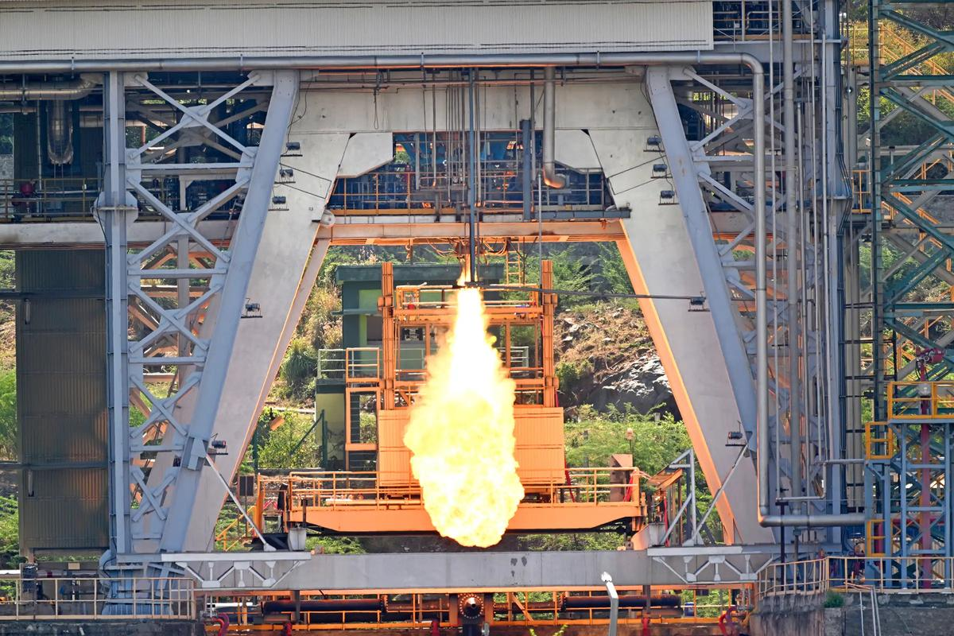
September 05, 2026 Indian Space Research Organisation (ISRO) demonstrated successful hot test of the Semi-Cryogenic Engine Power Head Test Article (PHTA) at full thrust level of 200Tonne at the ISRO Propulsion Research Complex (IPRC), Mahendragiri, Tamil Nadu on September 05, 2026. The Power Head Test Article (PHTA) encompasses all engine systems except thrust chamber. This is the 9th test in a series of hot tests using the PHTA. This is the first time that the PHTA is tested at 100% or full thrust level i.e. 200 tonnes. Previously, the tests were conducted at 47% (94 tonnes), 60% (120 tonnes) and 88% (175 tonnes) thrust levels successfully. The test proceeded as predicted and all the engine parameters were as expected. The test duration was 35 seconds including operation of the engine powerhead at 200 tonne (100%) thrust level for a duration of 5 seconds. The switch over of propellant supply from a low pressure start tank to medium pressure run tank was also validated in order to enable long duration testing of PHTA in subsequent hot tests. The Semi-Cryogenic Propulsion Stage (SC120), powered by the 2000 kN-class SE2000 engine, is being developed to replace the current L110 core stage of the LVM3 launch vehicle. The integration of the Semicryogenic stage along with the uprated cryogenic upper stage (C32) will enhance the LVM3 payload capability.

66. ISRO to launch two satellites tonight from its spaceport in Sriharikota to demonstrate docking and undocking of spacecraft in orbit | Akashvani News - News On AIR
Read more
The Indian Space Research Organisation(ISRO) is all set with its Space Docking experiment known as the SpaDex mission. Its powerhorse rocket PSLV C60 will lift off tonight from spaceport Sriharikota in Andhra Pradesh. Two satellites - SDX01 called also Chaser and SDX02 called Target - will be placed into a 470 km circular orbit at 55-degree inclination with a local time cycle of about 66 days. Both Target and Chaser satellites will be placed in the same orbit at a distance of 10 to 20 km. The SpaDex Space Docking experiment once successful will establish India as the country that can successfully undertake human spaceflight and satellite servicing missions. This is a cost-effective technology demonstrator mission that will enable India to plan a mission to the Moon and build its own Bhartiya Antriksh Station where the satellite can dock and get back to Earth. In space docking technology is essential when multiple rocket launches are required for common mission objectives. This needs precision in inter-satellite separation, velocity and navigation, transfer of electric power between two docked spacecraft, composite spacecraft control, and payload operations after undocking. India will be the fourth country to master docking and undocking technology.

67. 9 ISRO employee bodies write to chairman, seek clarity on space privatisation plans - The Federal
Read more
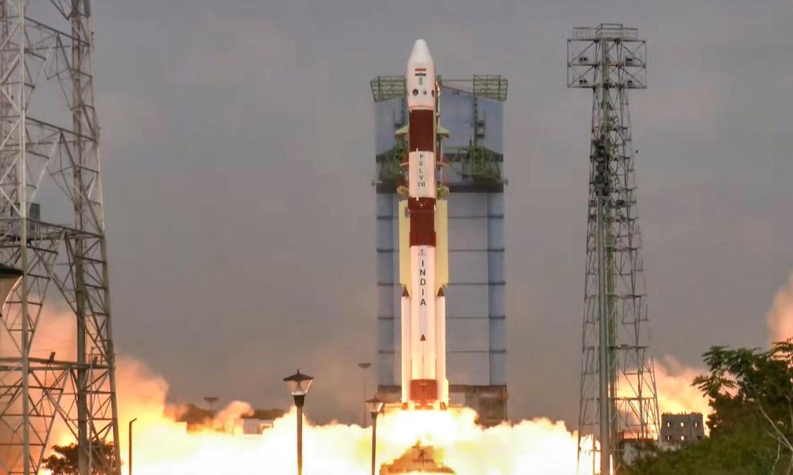
Even though the government's opening of the space sector to private players has had its fair share of criticisms, for the first time, nine employee associations of the Indian Space Research Organisation (ISRO) have raised a formal concern over the transition, asking for a written clarification from the space body's chairperson, V Narayanan, on the same. The associations have also sought clarity on the government's privatisation plan, ISRO's future, and the consequences for current employees and future recruitment. 'ISRO can't be reduced to R&D boutique' The letter reportedly was sent to the ISRO chief just hours after the successful launch of India's earth observation satellite aboard a GSLV rocket on Friday (September 4), multiple reports, including the Times of India and the Indian Express, said. The employee associations are the ISRO Staff Association, SHAR Employees Association, ISAC Employees Association, ISRO Staff Association-LPSC, ISRO Staff Association-BBU, NRSA Employees Union, Space Employees Association-BBU, ISRO Staff Association-IPRC and SAC Employees Welfare Association. Also read: IN-SPACe overreach threatens ISRO's strategic future: G Madhavan Nair The letter reportedly protests the government's alleged bid to reduce ISRO to a "residual R&D boutique" while investing the power to launch vehicles and operate launch infrastructure in private hands. "Private participation in defined commercial activities can coexist with strong, publicly owned ISRO. What cannot be accepted without debate is a policy that reduces ISRO to a residual R&D boutique while the realisation of the nation's launch vehicles and the operation of its launch infrastructure pass out of public hands," TOI quoted the letter as saying. Associations seek clarity on major shifts The letter came after Pawan Goenka, chairman of the Indian National Space Promotion and Authorisation Centre (IN-SPACe), said at a recent event that ISRO will eventually cease manufacturing launch vehicles and shift responsibility to the private sector. The ISRO employees in their letter said the change is already evident in the Small Satellite Launch Vehicle (SSLV) and may extend to the Polar Satellite Launch Vehicle (PSLV) and LVM3. The associations in the letter sought clarity if Goenka's statement was the government's line and whether ISRO would still be responsible for the design, development, realisation, integration, testing and launch of PSLV, LVM3, SSLV and future vehicles. The employee organisations also flagged concerns over the proposed transfer of production of SSLV, PSLV and LVM3 vehicles, the shifting of satellite manufacturing to private facilities, and the opening of new launch infrastructure including the Space Launch Complex at Kulasekarapattinam to private players. Also read: ISRO's strategic satellite delays expose cracks in India's space readiness The letter also raised concerns over the transfer of 120 ISRO technologies to the private sector. "These statements have received wide national publicity. They have not, however, been accompanied by any corresponding official communication from the Department of Space to its employees explaining the approved policy, its legal and administrative basis, its phasing, or its consequences for the existing workforce and for future public recruitment," the letter said. Repercussions of transition In June 2020, the Department of Space (DoS) launched IN-SPACe to facilitate private participation in the space sector. In-SPACe handles authorisation and supervises various space activities of private players, including the launch of vehicles and satellites, providing space-based services, sharing of space infrastructure and premises under the control of DoS/ISRO, and establishment of new space infrastructure and facilities. In their letter, the employee associations said the reports that ISRO may withdraw from manufacturing launch vehicles and satellites are making employees and their families anxious. The letter said the move may "tamper experiments after research, shrink in-house work, freeze or reduce sanctioned, and close promotion and skill-development avenues in technical, scientific, administrative, store, purchase, quality, safety and industrial cadres." Also read: TN rocket port in private hands: Is IN-SPACe becoming Centre's space privatisation arm? "Launch-vehicle design, realisation, integration, testing and launch operations are not merely 'manufacturing contracts'. They are the core competence, institutional memory and strategic capability of the Organisation," the letter said. The organsiations said the transitions may make existing employees surplus, lead to their redeployment or leave them without meaningful work. It also warned that reduced recruitment to Group A, B and C posts deny young people careers in ISRO.

68. ISRO employees seek 'written clarity' over privatisation of space sector: Report - Deccan Herald
Read more
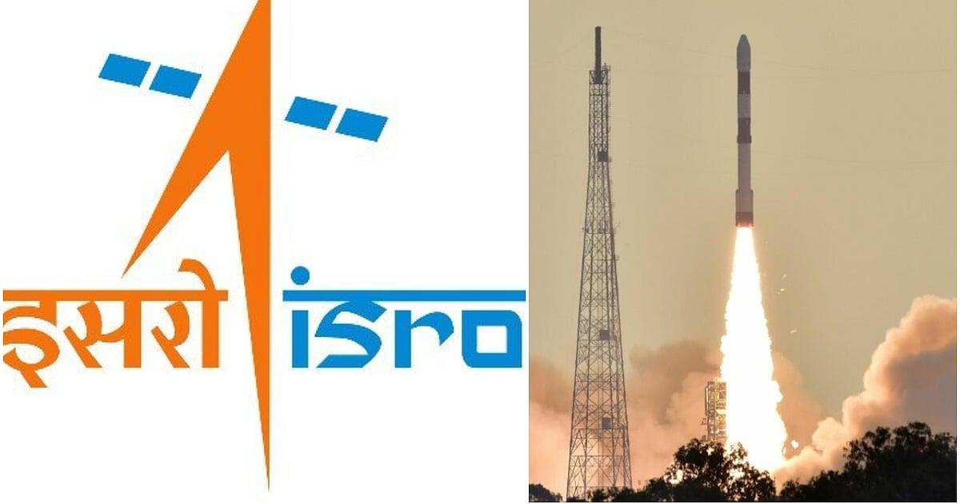
ISRO employees seek 'written clarity' over privatisation of space sector: Report Deccan Herald

69. ISRO employee associations seek clarification on privatisation plans - The News Mill
Read more
ISRO employee associations seek clarification on privatisation plans The News Mill

70. Gaganyaan mission reaches advanced stage as ISRO completes key systems, infrastructure - DD News
Read more
India's ambitious human spaceflight programme, Gaganyaan, has achieved significant milestones, with critical launch systems, spacecraft components and mission infrastructure either completed or nearing readiness ahead of the first uncrewed mission, the government informed Parliament on Wednesday. In a written reply to the Lok Sabha, Minister of State in the Prime Minister's Office, Dr. Jitendra Singh, said preparations for the first uncrewed Gaganyaan mission (G1) are progressing steadily, while the country's first astronaut mission continues to move through its development and testing phase. The government said the Human Rated Launch Vehicle (HLVM3) has completed the development and ground testing of all its propulsion stages and structural systems. The vehicle has been specially designed to safely carry astronauts into space. Significant progress has also been made in the development of the Orbital Module, comprising the Crew Module and Service Module. Propulsion systems for both modules have been developed, tested and qualified, while critical technologies including the Environmental Control and Life Support System (ECLSS) engineering model, thermal protection system, deceleration system, Crew Module uprighting system and end-to-end avionics have also been developed and successfully tested. The Crew Escape System (CES), designed to safely separate astronauts from the launch vehicle in the event of an emergency, has also reached an advanced stage. Five types of escape motors have been developed and successfully undergone static testing, while all associated structures have been realised and qualified. The government informed Parliament that several mission-critical facilities have been established, including the Orbital Module Preparation Facility, Gaganyaan Control Centre, Gaganyaan Control Facility, Crew Training Facility, and modifications to the Second Launch Pad at Satish Dhawan Space Centre (SDSC SHAR) to support future crewed missions. ISRO has also completed several key test campaigns. These include the successful Test Vehicle Demonstration Mission (TV-D1) for in-flight validation of the Crew Escape System, along with Integrated Air Drop Tests (IADT-01 and IADT-02) to validate the Crew Module's deceleration system. Preparations for the TV-D2 mission are currently in an advanced stage. According to the government, the Gaganyatris have completed their generic astronaut training at Glavkosmos in Russia, while mission-specific training is currently underway at the Astronaut Training Facility in Bengaluru. For the upcoming uncrewed G1 mission, all propulsion stages of the HLVM3-HS200, L110 and C32-along with Crew Escape System motors are ready. The Crew Module and Service Module systems have been realised, while assembly, integration and testing are nearing completion. Integrated mission simulations are also being carried out. The government said Gaganyaan missions will be launched from the Second Launch Pad at SDSC SHAR, which has undergone extensive upgrades to meet human spaceflight requirements. These include modifications to the Second Vehicle Assembly Building, enhanced checkout facilities, a Crew Access Arm, bubble lift, and a zip-line emergency evacuation system to ensure astronaut safety during launch operations. The Environmental Control and Life Support System (ECLSS), one of the most critical technologies for human spaceflight, is also being developed indigenously by ISRO. The system is designed to maintain a habitable environment inside the Crew Module by regulating temperature, humidity, air pressure and carbon dioxide levels throughout the mission. It is currently undergoing development tests, and a reduced version of the system will be demonstrated during the upcoming uncrewed Gaganyaan missions.

71. On this day in space! Sept. 5, 1977: NASA launches Voyager 1 on epic journey across the solar system
Read more
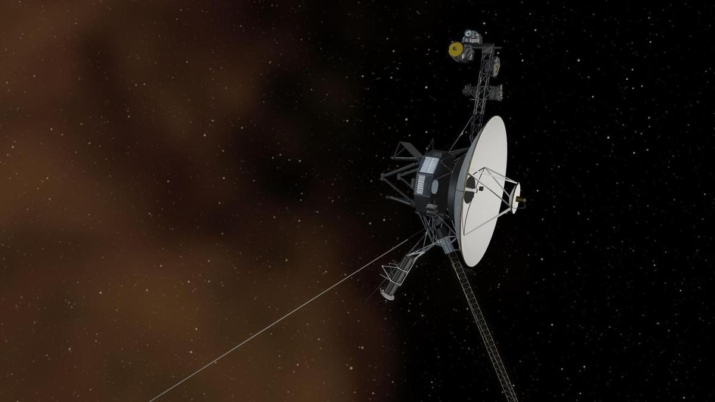
Click for next article On Sept. 5, 1977, Voyager 1 began its epic journey through deep space with a glorious morning launch from Cape Canaveral, Florida. Voyager 1 initially launched on a mission to explore the outer planets. After flying by Jupiter and Saturn in 1979 and 1980, the spacecraft took a sharp turn and started heading straight out of the solar system. Voyager 1 became the f irst spacecraft to reach interstellar space in 2012, although scientists are still debating about exactly where that boundary lies. The spacecraft's next big encounter will take place in about 40,000 years, when it will fly by another star system. And just in case it comes across any intelligent life out in the universe, it's carrying a golden record with sights, sounds and greetings from planet Earth. Why it mattered NASA's Voyager 1 spacecraft launches from NASA's Kennedy Space Center in Florida on Sept. 5, 1977. (Image credit: NASA/KSC) Voyager 1 is a space exploration icon and NASA's ultimate long-lasting mission. The spacecraft was part of a two spacecraft mission ( Voyager 2 launched a few weeks earlier) to explore the outer solar system like never before. While Voyager 2 launched on a four-planet "Grand Tour" of the solar system, a trajectory that included flybys of Jupiter, Saturn, Uranus and Neptune , it wasn't the fastest of missions. Voyager 1 launched on a fast-track to Jupiter. In fact, the probe actually overtook Voyager 2 on the way to Jupiter and arrived their first for a flyby in March 1979. A year later, in November 1980, Voyager 1 passed by Saturn in a flyby that shot it out of the solar system. Voyager 1, launched in September 1977, is currently exploring the farthest edges of the solar system. (Image credit: NASA) By Feb. 17, 1998, Voyager 1 grabbed the record as the farthest human-built object after it flew farther than Pioneer 10 and in 2012, the spacecraft became the first probe ever to enter interstellar space. It remains NASA's farthest flung mission still active today. Today, Voyager 1 is 15.9 billion miles (171.6 astronomical units) from Earth and still flying. Even 49 years after launch, the spacecraft is still collecting some data, but its nuclear radioisotope thermoelectric generator does not produce as much power as it did at launch, so NASA teams have steadily shut down heaters and unneeded instruments over the decades. Earlier this year, on April 17, NASA commanded Voyager 1 to shut down its low-energy charged particles experiment to save power. For nearly 50 years, the instrument has provided constant measurements on the ion, electron and cosmic ray environment in deep space. Want more space history? Check out our full On This Day In Space Story archive and watch our On This Day In Space videos on YouTube .

72. This NASA-funded 'Slingshot' spacecraft idea could map minerals on planets and moons across our solar system
Read more
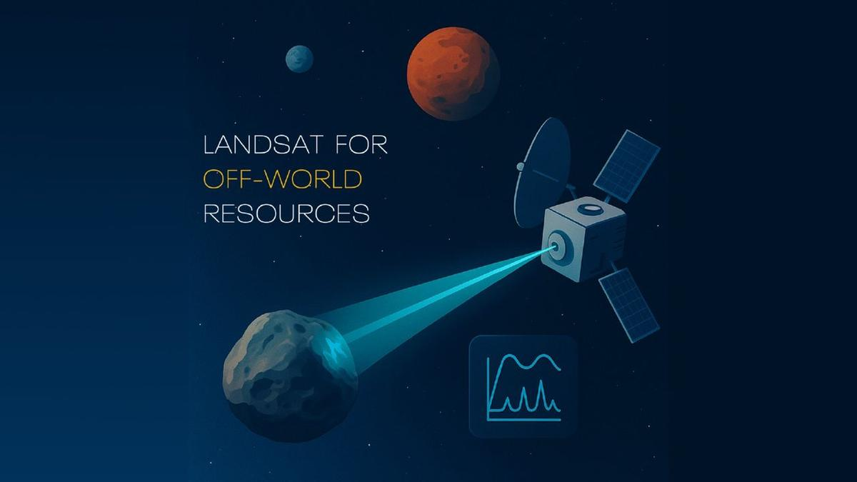
Click for next article Nearby Earth, an iconic series of orbiting U.S. government satellites called Landsat have collectively been charting minerals and climate change for more than 50 years. What if we can do the same thing in space? A new NASA early-stage project, whimsically named "Interworld Slingshot Resource Surveys", aims to bring "Landsat-style mineral intelligence" to other worlds, including the moon. NASA is aiming to put a moon base on the lunar surface in the 2030s that would be staffed by astronauts, as the U.S. tries to secure access to helium-3 and other minerals on the surface ahead of China. Being able to scout for minerals ahead of landing and setting up a base would be a huge boon for the United States' lunar ambitions. The newly funded concept - which doesn't appear to have an official nickname or acronym, so we will call it "Slingshot" for short - isn't meant to address that big task all at once, but to be a Phase 1 study for a far-future Discovery-class (large) mission. The spacecraft could fly from world to world, scanning destinations such as the moon, an asteroid near Earth, or a target like the Mars moon Phobos, said principal investigator Pablo Sobron, a research scientist at the SETI (Search for Extraterrestrial Intelligence) Institute, in a statement . "The thing most likely to stop space mining may be that we cannot afford to prove there is anything worth mining," Sobron said. "Land in the wrong place and you can lose an entire exploration program or a company, and nobody has enough money to keep sending spacecraft and hoping for the best." The overall aim is to not only prove a spacecraft could make it that far, but also to see if Raman spectroscopy - which is commonly used close up to look for minerals or water by NASA's Perseverance mission on Mars, for example - could work from orbit or a flyby. The technique uses reflected light from a laser popped at a target to see the molecular structure of a mineral, which in turn reveals the mineral's composition. "The main challenge for Interworld Slingshot Resource Surveys is the distance involved," SETI stated. "Raman scattering is very faint and hard to detect. The project team says that only about one photon in 10 trillion is Raman-scattered. Sobron's earlier long-distance Raman tests reached about 120 meters [393 feet]. This study is looking at whether useful measurements can be made from much farther away, around 30 to 50 kilometers [19 to 31 miles]." The NASA-funded Interworld Slingshot Resource Surveys study is exploring whether a small spacecraft could survey the moon, a near-Earth asteroid and Phobos during a single mission using a single remote-sensing instrument. (Image credit: Pablo Sobron) Slingshot received a Phase 1 grant from the NASA Innovative Advanced Concepts (NIAC) program, which aims to prove out conceptual ideas into something that could be nudged into further development. NIAC has funded dozens of grants over the years, but illustrating the difficulty of and long development cycles to bring things into space, not much has made it out of the atmosphere yet. A notable NIAC success story was SNAPPY, the Solar Neutrino Astro-Particle Physics CubeSat, which reached space earlier this year aboard SpaceX.

73. Live coverage: SpaceX to launch 80th Starlink mission of 2026
Read more
Update Sept. 5, 6:18 p.m. EDT (2218 UTC): SpaceX updated the launch time. SpaceX is gearing up for a Labor Day weekend launch of its Falcon 9 rocket from Vandenberg Space Force Base. The Sunday morning flight will be the 80th Starlink mission this year. Liftoff of the Starlink 15-24 mission from Space Launch Complex 4 East is scheduled for 7:26 a.m. PDT (10:26 a.m. EDT / 1426 UTC). The rocket will fly on a southeasterly trajectory upon leaving the pad. Spaceflight Now will have live coverage beginning about 30 minutes prior to liftoff. SpaceX will launch the mission using the Falcon 9 first stage booster with the tail number B1088. It's flying for a 19th time after previously flying three national security missions, Transporter-12, NASA's SPHEREx, and 13 batches of Starlink satellites. Nearly 8.5 minutes after liftoff, B1088 will target a landing on the droneship, Of Course I Still Love You, positioned in the Pacific Ocean. If successful, this will be the 223rd landing on this vessel and the 659th Falcon booster landing to date. Shifting priorities The Starlink 15-24 mission is the third Starlink mission since SpaceX announced that it would no longer launch its broadband internet satellites from on Falcon 9 rocket's from Florida. "From here on, Starlink missions out of Florida will fly on Starship," said Kiko Dontchev, Vice President for Launch at SpaceX. Currently, SpaceX is working on three Starship launch towers in the Sunshine State: one at Launch Complex 39A at NASA's Kennedy Space Center and two at Space Launch Complex 37 at Cape Canaveral Space Force Station. The company has said it aims to launch its first Starship mission from Florida before the end of the year. SpaceX is working towards its first orbital launch of the more than 400-foot-tall rocket, which will fly from Starbase, Texas. SpaceX completed single-engine and six-engine static fire tests for Ship 41 and a 33-engine static fire test for Booster 21, both of which will fly on the forthcoming Starship Flight 14. A launch date hasn't been announced, but hazard warnings for aviators and mariners suggest that the mission may fly no earlier than Sept. 15.

74. Spacecraft bound for Mercury begins 'tricky' arrival
Read more
After an eight-year journey, a spacecraft carrying European and Japanese probes began the monthslong, high-risk approach to Mercury on Thursday to study the sun-scorched planet.

75. 11-foot robot boat that can conduct surveillance missions to boost US military power
Read more
New Zealand's Seasats reports it has had a very good month in terms of sales for its proprietary Lightfish unmanned surface vessel (USV). According to a press release, they managed to secure $24 million of actual funded orders in August/early September, including boats for the US Navy and Marine Corps. These orders are for its USV and its robot-as-a-service (RaaS) products. These orders, the company reports, appear to "reflect growing demand for small, long-endurance USVs across a broad base of military users." The star of the show is Lightfish, a roughly 11-foot (3.4-meter) long surface, solar-powered drone boat that stays at sea for extended periods of time. Weighing in at around 360 pounds (163 kg), it is designed primarily for Intelligence, Surveillance, and Reconnaissance (ISR) missions. In this sense, it can be thought of as something of a mobile, autonomous ocean surveillance post. It can carry different sensors depending on the mission: normal cameras, infrared cameras, sonar, or other surveillance equipment. A good month for Seasats Because it's solar-powered and designed for very long endurance, you can scatter a bunch of them over a large maritime area and have them keep watch without constantly sending crewed ships or aircraft out there. Reference Raas is also interesting. Under such a contract, customers (like the Navy) will request Seasat to supply the boats, launch them, maintain them, operate the autonomous system, and presumably provide the sensor/data service. Such agreements are attractive to the military because it doesn't have to establish an entire maintenance, training, and logistics infrastructure around another new platform. Whether a military service buys outright or rents the drones, the ultimate goal is to provide something called "persistent awareness" at sea. What this means in reality is long-term monitoring of things like ports and naval bases, coastlines, shipping lanes, chokepoints, etc without the need for committing manned surface vessels for the task. Such drones can also be used to continuously monitor for things like submarine activity at a location, or act as a watchdog for activities like smuggling. So, rather than deploying a destroyer at hundreds of dollars a day, these solar drones can provide a similar capability at a fraction of the cost. Importantly, larger areas of the ocean can be monitored too using fleets of drones.

द्वारा अभिकल्पित एवं संकलित
DESIGNED & COMPILED BY:
पुस्तकालय एवं सूचना संसाधन प्रभाग
Library & Information Resources Division, IIRS (ISRO), Dehradun
अस्वीकरण | Disclaimer:
सभी लेख / सूचनाएँ सार्वजनिक डोमेन में उपलब्ध हैं तथा केवल सूचना एवं सामान्य जागरूकता के उद्देश्य से
इंटरनेट से संकलित की गई हैं。
All the articles / information are available in public domain and are taken from
Internet for information & general awareness only.

