 |  | 

🌌 अंतरिक्ष समाचार | Space News
मंगलवार, ०३/११/२०२६ | Tuesday, 03/11/2026

1. India's Aditya-L1 Reveals the Hidden Third Dimension of a Solar Eruption - ISRO
Read more
India's Aditya-L1 Reveals the Hidden Third Dimension of a Solar Eruption ISRO

2. ISRO's NavIC Gets New Lease Of Life - Rediff
Read more
ISRO's NavIC Gets New Lease Of Life Rediff

3. ISRO Chairman V. Narayanan is 'Mr Go-Getter' - Whispers in the Corridors
Read more
ISRO Chairman V. Narayanan is 'Mr Go-Getter' Whispers in the Corridors

4. Ananth Technologies supplies avionics for ISRO's GSLV-F18 mission - electronics.economictimes.indiatimes.com
Read more
Ananth Technologies supplies avionics for ISRO's GSLV-F18 mission electronics.economictimes.indiatimes.com

5. Editorial: From setbacks to success - ISRO's desi navigation system gets a boost - Telangana Today
Read more
Editorial: From setbacks to success - ISRO's desi navigation system gets a boost Telangana Today

6. Explainer: How ISRO's NVS-03 Mission Strengthens India's Indigenous Navigation System - DD India
Read more
Explainer: How ISRO's NVS-03 Mission Strengthens India's Indigenous Navigation System DD India

7. James Webb Space Telescope uncovers new clues about the origins of 'interstellar invader' comet 3I/ATLAS
Read more
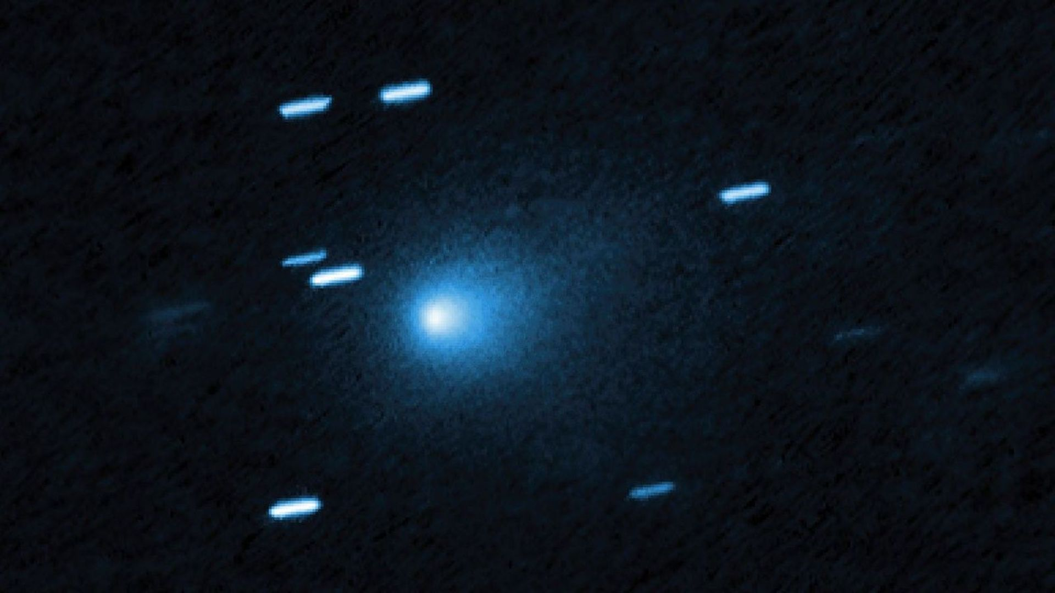
Click for next article Using the James Webb Space Telescope (JWST), scientists have found that the interstellar comet 3I/ATLAS was built from tiny grains of ice mixed with dust that are quite different from the solar system's comets. These ice grains do, however, bear striking similarities to some icy bodies located at the edge of the solar system, beyond the orbit of Neptune, so-called trans-Neptunian objects (TNOs). 3I/ATLAS was discovered entering the solar system in the summer of 2025. It was only the third object found entering the solar system from farther afield in the Milky Way after 1I/'Oumuamua , seen in 2017, and 2I/Borisov , detected in 2019. This meant the interstellar comet offered a rare chance to glimpse the conditions under which such bodies form in other star systems. Thus, the JWST was quickly on the trail of 3I/ATLAS. "We designed [JWST] to be ready the moment an active interstellar comet was found and to follow it over time," Martin Cordiner of NASA's Goddard Space Flight Center and the Catholic University of America said in a statement . Cordiner leads the JWST program to study objects such as 3I/ATLAS, and he is a co-author on a new research paper describing some of the findings. The unclear origins of 3I/ATLAS Researchers know that 3I/ATLAS wasn't born in the solar system, but nobody knows around which star 3I/ATLAS formed. What scientists are more sure of is the fact that this interstellar comet was produced within a planet-forming disk of gas and dust around a young star, possibly as long ago as 10 to 12 billion years . That's over twice the age of our solar system. It was then ejected from its home system somehow and left to wander interstellar space before encountering our solar system. Like the familiar comets in our solar system, 3I/ATLAS is composed of grains of ice less than a micron - a millionth of a meter - in size. When the surface of the comet is warmed by the sun , gas erupts outwards, carrying ice grains into the cloud of ice and dust surrounding the comet, its coma, and its tail, where JWST can detect them. When viewed spectroscopically, the water-ice in comets native to our solar system creates a strong absorption line in a comet's spectrum at a wavelength of three microns, as well as less-prominent absorption lines at 1.5 and two microns. Comparison between ice in the interstellar invader comet 3I/Atlas and icy bodies in our solar system. (Image credit: SwRI/Silvia Protopapa/NASA/ESA/CSA JWST) Yet when the JWST's Near-Infrared spectrograph ( NIRSpec ) instrument viewed 3I/ATLAS three times between August 2025, before its closest approach to the sun, and after closest approach in April 2026, scientists found the 1.5- and two micron absorption lines were missing, though the three-micron line remained strong. "That combination was a puzzle," research lead author Silvia Protopapa of the South-west Research Institute said. "The strong three-micron band points to water-ice in the coma, but the weak or absent shorter-wavelength bands suggest the ice is not in the form we usually see in solar system comets ." The JWST's muddy 3I/ATLAS findings Whenever presented with an unusual observational signature such the JWST delievered for 3I/ATLAS researchers turn to modeling to find the physical characteristics that best fit the spectrum. The modeling suggested to Protopapa's team that 3I/ATLAS was composed of sub-micron grains of dirty water-ice, rich in dust. In comparison, the grains from the solar system's indigenous comets are much cleaner, with almost pure water-ice relatively uncontaminated by dust. "What seems to set [3I/ATLAS' grains] apart is how much dust is mixed into the ice," said Protopapa. "Those grains hold clues to the conditions where the comet was born." The chemical composition of 3I/ATLAS (Image credit: NASA, ESA, CSA, STScI, Martin Cordiner (CUA, NASA-GSFC); Image Processing: Alyssa Pagan (STScI)) Comets are made of primordial material found in the planet-forming disk of gas and dust that surrounds a young star, and therefore the composition of comets can provide a window into the conditions in which planets form. Whereas solar system comets tell us about the birth of Earth , an interstellar comet can tell us about conditions in which planets formed around another star, and how similar or dissimilar those conditions were to the birth of the solar system. Yet comets are not the only icy remnants that date back to such primordial times. There are various families of bodies in the outer solar system, and 3I/ATLAS' spectrum bears a resemblance to the spectrum of some medium-sized TNOs that are rich in carbon-dioxide ice and organic compounds (organic meaning containing carbon atoms). Indeed, in a separate 2025 study led by Cordiner, the JWST found 3I/ATLAS to have one of the greatest abundances of carbon dioxide ever seen in a comet. TNOs are sizable bodies that are located far beyond the orbit of Neptune , The TNOs in question would have formed in a different part of the Sun's protoplanetary disk than most comets and their composition reflects that. Artist's illustration of a planetary disk, a region of dust and gas where planets form. The zoom-in insert displays carbon monoxide molecules in the ice phase. (Image credit: M.Weiss/Center for Astrophysics | Harvard & Smithsonian) On the other hand, the results imply that 3I/ATLAS was formed around its star of origin from similar icy material to that which produced some of the TNOs in our solar system, showing that the building blocks of planets around other stars share a common range of properties with the building blocks that formed our solar system. Indeed, 3I/ATLAS could even be a fragment of a TNO-like body that was shattered in a collision. "At first glance, 3I/ATLAS looks different from the icy comets we know," said Protopapa. "But when we placed it alongside distant icy worlds in our own solar system, it no longer looked out of place. "This suggests that the icy building block of planets, here and around other stars, may share ice in the form of tiny, micron-scale grains, ranging from relatively pure ice to ice mixed with dust, with 3I/ATLAS toward the dusty end." What this tells us is that these sub-micron-sized icy grains must form first in planet-forming disks, to then be incorporated into large bodies such as comets and protoplanets.

8. On this day in space! Nov. 2, 2000: Expedition 1 Arrives at the International Space Station
Read more
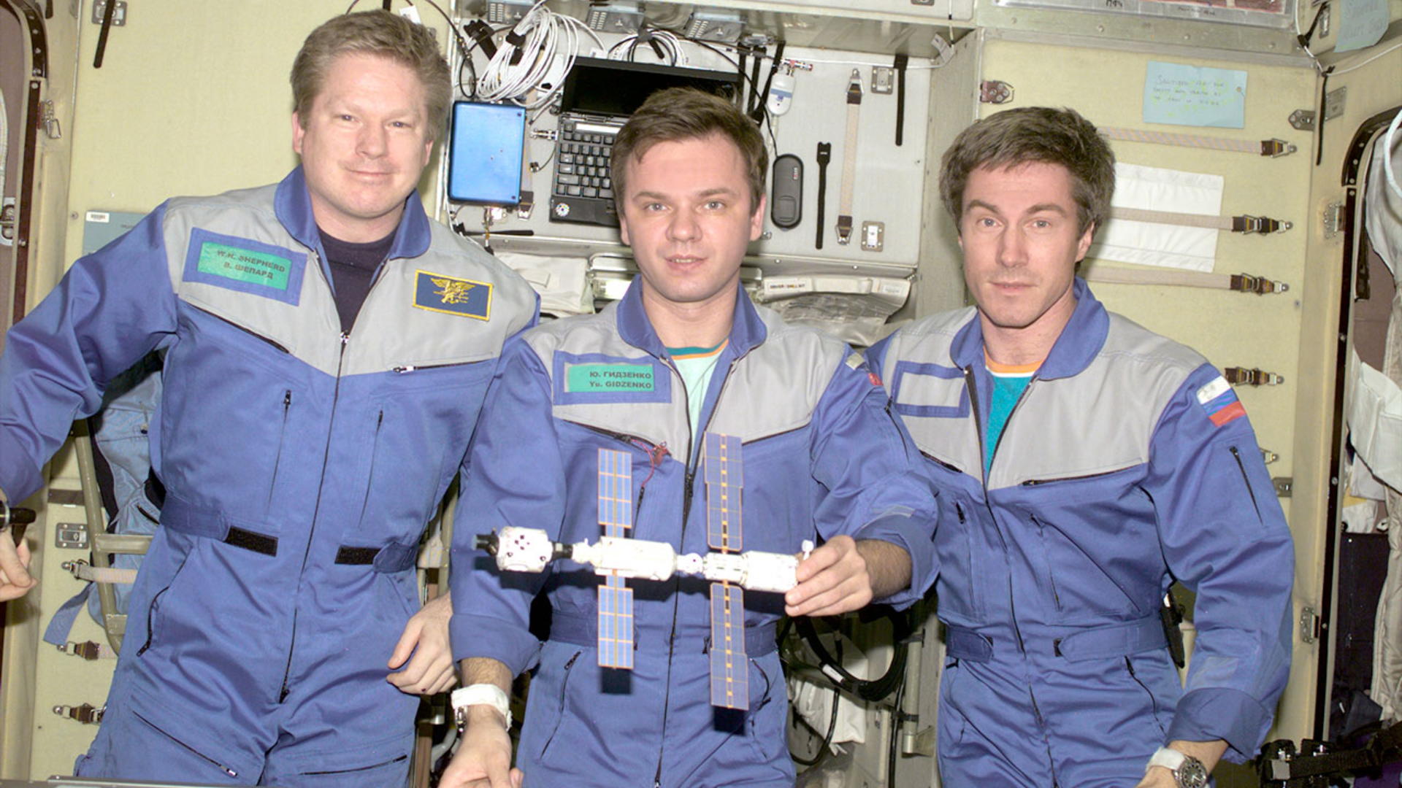
Click for next article On Nov. 2, 2000, the International Space Station welcomed its first long-term residents: NASA astronaut Bill Shepherd and two Russian cosmonauts, Yuri Gidzenko and Sergei Krikalev. The mission was called Expedition 1. Before this expedition, NASA had launched five, one-week-long Space Shuttle missions to help build the space station and bring up supplies. But this time, the crew would be staying for four and a half months, and they weren't taking the shuttle. Instead, they took a Russian Soyuz spacecraft, and this was the first Soyuz to ever dock at the space station. During their stay at the space station, they unpacked supplies and installed new equipment, including the first solar arrays. They left on the space shuttle Discovery, which brought up the Expedition 2 crew that would take their place. Expedition 1 crewmates Bill Shepherd, Yuri Gidzenko and Sergei Krikalev pose with a model of the space station as it appeared in 2000. (Image credit: NASA) Why it mattered As of today, there has been a continuous astronaut presence in space aboard the International Space Station for 26 years. For all of these years, not a day has gone by without someone living in space, orbiting our planet from aboard the space station. While the ISS was not the first space station, it has been the longest-running space statin by far. This first crew were pioneers, showing how humans could actually live and work aboard this station. This exploratory mission proved that the station could successfully support astronaut crews. Since this mission 26 years ago, there have been literally hundreds of astronauts from around the world who have flown to and lived aboard the ISS. While NASA has stated that the station might be decommissioned in the coming years, these accomplishments will remain forever in spaceflight history. Want more space history? Check out our full On This Day In Space Story archive and watch our On This Day In Space videos on YouTube .

9. What is Starshield? A look at SpaceX's military satellite network
Read more
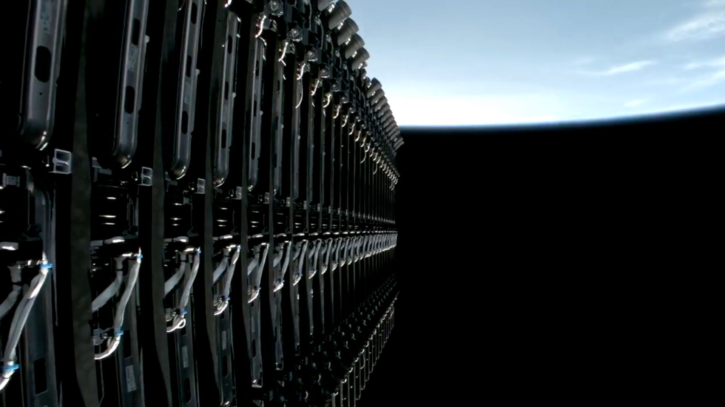
Click for next article A stack of 27 SpaceX Starlink satellites are seen aboard the upper stage of their Falcon 9 rocket before deployment on Aug. 22, 2026. Starshield satellites are believed to be based on the Starlink spacecraft bus. SpaceX is building and operating two satellite networks at the moment, Starlink and Starshield. What's the difference between the two, and who uses them? For more than a week in October 2026, Ukrainian drone operators found their high-speed satellite links shut off. Officials in Kyiv said that terminals for SpaceX 's Starshield network stopped working at speeds of above 160 kilometers per hour (100 miles per hour) from Oct. 14, hampering efforts to conduct defensive operations and intercept Russian drones. Full connectivity was restored on Oct. 24, according to Ukrainian President Volodymyr Zelenskyy. The arguments over who did what continue, but the affair highlighted how little is publicly understood about Starshield - what it is, how it relates to Starlink , and how it is operated. What is Starlink? Starlink is SpaceX's commercial, mass-market satellite internet service. The company says it now has more than 11,000 Starlink broadband and mobile satellites in orbit, operating approximately 342 miles (550 kilometers) above Earth. This follows years of deployment using the company's Falcon 9 rocket.. The network serves consumers, enterprises and government customers across more than 160 countries. It is owned and operated by SpaceX. Anyone from a rural household to an airline can buy a terminal and a service plan. Governments are also customers, with public agencies using Starlink for a range of purposes including connectivity, disaster response and national security, notably in the case of Ukraine in the wake of the invasion by Russia , which began in February 2022 and is ongoing. What is Starshield? Starshield is SpaceX's network for serving national security customers. The company announced the program in December 2022 , stating it would apply Starlink technology and SpaceX's launch capability to government needs, initially in three areas: Earth observation, communications and hosted payloads. "They are using the same satellite buses," says Bleddyn Bowen, associate professor of astropolitics at Durham University in the U.K. "They look the same, but they have a lot more kit on them that allows them to do more things. They provide similar broadband internet, but with more secure hardware and software and hardened systems." The company says it has won multi-billion-dollar, multiyear contracts from the U.S. military in 2026 for Starshield-related services. Some Starshield satellites may also carry sensors for intelligence and surveillance. But much about Starshield is secretive, with its finances not revealed and launches often classified. Starshield makeup Starshield is made up of a range of different assets, including spy satellites, military data satellites, and secure communications for ground users. The spy satellites are sent into orbit in launches for the U.S. National Reconnaissance Office (NRO), for a "proliferated architecture" of spy satellites , including electro-optical, radar and relay spacecraft. The NRO does not use the Starshield name, but said earlier this year that it had launched more than 200 satellites in recent years, many of which are for its proliferated architecture. Then there is the Space Data Network Backbone. The U.S. Space Force awarded SpaceX a $2.29 billion fixed-price contract to build the network, previously known as MILNET, using Starshield satellites. It is meant to move data quickly between missile-warning sensors and interceptors as part of the Trump administration's Golden Dome missile defense plan. A prototype is due by the end of 2027. A Space Force official has described MILNET as government-owned and operated by SpaceX as a contractor, under Space Force oversight. Starshield provides encrypted connectivity for military users through terminals. These can be dedicated Starshield terminals, or Starlink terminals for Starshield services. Crucially, the networks overlap. "Those Starshield satellites are physically separate from Starlink satellites, but the Starshield satellites can use the Starlink network if they need to," Bowen said. That interoperability is available to U.S. national security users, he added, "but not if you're a commercial user of Starlink." Use restrictions differ, too. SpaceX CEO Elon Musk has said that Starlink's terms of service bar its use for offensive drone strikes, while decisions about Starshield use rest with the U.S. government. A SpaceX Falcon 9 rocket launches the NROL-172 mission from California on May 11, 2026. NROL-172 is believed to have launched Starshield satellites for the U.S. government. (Image credit: SpaceX) Who controls Starshield is a question that entered the public consciousness in the wake of the Ukraine Starshield speed limit affair. The U.S. government is the customer, and also in some cases the owner, but SpaceX builds the satellites, operates the underlying Starlink network on which some Starshield services run and, in some arrangements, operates the Starshield satellites themselves. How this command is divided between the government and SpaceX is unclear. Bowen compared it to the U.K.'s Skynet military satellite system, in which contractor Babcock operates the satellites. "The actual button punching is done by the contractors, but the military and government are in the room and are calling the shots," he said. That question matters, because it determines whether SpaceX can act on its own or only with government oversight and approval. What's next? Starshield appears set to become more central to U.S. military space. The Space Data Network Backbone prototype is expected next year, while NRO launches will continue, according to contracts. With SpaceX now a public company, quarterly reports could provide more insight into the system. For now, however, much remains classified.

10. CubeSat achieves challenging laser link to ground
Read more
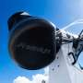
Despite the complexity of the operation, ERMIS-3, an 8U CubeSat developed by the National and Kapodistrian University of Athens, has established a link with an optical ground station, marking an important step in validating optical communications on small satellites. The demonstration, supported by the European Space Agency (ESA) and achieved using optical terminals developed b...

11. US rival tests powerful cluster warhead for cruise missiles with 6-hectare kill zone
Read more
The trial followed a separate test of a tactical ballistic missile cluster warhead, which North Korea claims can affect an area of 12 to 13 hectares. The test also assessed improvements to the missile's terminal maneuverability and its ability to strike targets vertically. North Korea says a dispersal warhead tested for a strategic cruise missile can devastate a target area of 5 to 6 hectares. North Korea has tested a dispersal warhead designed for a strategic cruise missile, claiming it can devastate a target area of up to 6 hectares. The test also assessed the missile's ability to strike targets vertically, as Pyongyang continues to expand its range of weapons systems. The tests were conducted on Monday, November 2, and overseen by Full Gen. Kim Jong-sik, a member of the ruling Workers' Party of Korea's Central Military Commission, according to the Korean Central News Agency (KCNA). North Korea's Warhead Institute, which operates under its Missile Administration, said the medium-sized dispersal warhead could turn an area of 5 to 6 hectares into ashes at what it described as the highest-density power. The country's Cruise Missile System Institute also reported improvements to the missile's terminal maneuverability, saying the changes had established its ability to conduct vertical strikes while accounting for the natural and geographical characteristics of the target area. Cruise missile gains vertical strike capability The reported test involved two assessments: the destructive power of the dispersal warhead and the missile's flight characteristics during a vertical strike. North Korea did not provide details about the missile's range, flight profile or the technical changes behind the claimed improvement. A dispersal warhead is designed to release multiple smaller explosive devices, known as submunitions, over a wider area. Such weapons can threaten several targets within the affected zone rather than concentrating their effects on a single point. The Missile Administration's director described the tests as a demonstration of "practical combat power." The official also said developing different weapon systems was increasingly urgent, arguing that the country's armed forces needed to defend national security and deter external threats. Cluster warheads expand weapons options The cruise missile test followed another weapons trial on Saturday, October 31, when North Korea tested a cluster warhead designed for tactical ballistic missiles. KCNA reported that the standard Type 2 cluster warhead could devastate an area of 12 to 13 hectares at its highest density. That figure is separate from the 5-to-6-hectare area claimed for the dispersal warhead tested on Monday. North Korea's Missile Administration said its cluster warheads fall into four categories, depending on their intended purpose. An official said the country planned to make the different types available to military units by the end of 2026, allowing them to select weapons based on operational requirements and target characteristics.

12. 1,200-mph US Navy Super Hornets to pack four Mach 5+ hypersonic Blackbeard missiles
Read more
The Navy plans to equip each Super Hornet with up to four Blackbeard missiles. Blackbeard is designed to exceed Mach 5 and maneuver during atmospheric flight. The U.S. Navy is advancing integration of Castelion's Blackbeard hypersonic missile with its F/A-18E/F Super Hornet fighters. The U.S. Navy is preparing to add a new class of high-speed strike weapons to its carrier-based fighter fleet. Chief of Naval Operations Adm. Daryl Caudle recently examined Blackbeard, a hypersonic missile developed by defense startup Castelion, during a visit to Naval Air Station Patuxent River in Maryland. The October 28 visit provided a closer look at the weapon's progress toward integration with the F/A-18E/F Super Hornet. The Navy has already conducted an initial flight evaluation, with further testing planned before the missile enters operational service. Caudle inspected the weapon at Air Test and Evaluation Squadron 23 (VX-23), which handles weapons testing at the installation. The visit also included discussions about the Navy's broader approach to developing autonomous aircraft and extending the reach of carrier-based operations. Hypersonic weapon nears testing Blackbeard falls into the hypersonic category, which covers weapons capable of exceeding Mach 5. Its flight profile also allows it to change direction during atmospheric flight. This combination could complicate interception attempts by adversary air defense networks. Integrating the weapon onto the Super Hornet has already produced several testing milestones. A Navy presentation in August showed two Blackbeard test articles mounted beneath the fighter's wings. Engineers took the next step on September 18. A Super Hornet departed Patuxent River carrying two missiles during a developmental flight. The aircraft completed the sortie without releasing either weapon, allowing the Navy to evaluate how the fighter handles their additional weight and external configuration. Coming soon to a theater near you…BLACKBEARD!@USPACOM @CENTCOM @PAEAviation pic.twitter.com/KgBtIqdf8I - NAVAIR (@NAVAIRNews) September 25, 2026 Footage released by the Navy on September 25 documented the flight. The service ultimately wants each Super Hornet to accommodate four Blackbeard missiles, potentially giving individual aircraft a substantial strike payload. Navy increases missile orders Castelion has positioned Blackbeard as a more affordable alternative to existing American hypersonic weapons. The California-based startup was founded by former SpaceX engineers and aims to simplify production to increase manufacturing capacity. The Navy awarded the company a $105 million agreement in April to advance integration with the Super Hornet. The program also includes preparations for live-fire evaluations in the Indo-Pacific. Procurement activity has gathered pace since then. In June, the Navy purchased 50 pre-production missiles for $23.4 million. A September agreement added a production order worth up to $200 million. USNI News reported that the deal covers 444 missiles. @USNavyCNO, meet Blackbeard. pic.twitter.com/xgu5pBVEJJ - Castelion (@Castelion) November 2, 2026 The Pentagon has also outlined much larger ambitions for the weapon. A framework agreement calls for at least 500 missiles annually once testing concludes. The Department of War has also indicated plans to seek funding for more than 12,000 units over five years. Multiple launch platforms planned The Super Hornet represents just one potential application for Blackbeard. Castelion is pursuing compatibility with several other military platforms. The U.S. Army's HIMARS rocket artillery system is among the planned launch platforms. The company has also begun adapting the weapon for the Air Force's F-16 under a research agreement. Naval operations could eventually involve unmanned vessels, too. Castelion intends to demonstrate a launch from Saronic's Marauder unmanned surface vessel in 2027. The Navy is working toward early operational capability, which would allow a limited missile inventory to reach frontline units. Additional developmental flights at Patuxent River will help prepare the weapon for subsequent live-fire evaluations.

