 |  | 

🌌 अंतरिक्ष समाचार | Space News
मंगलवार, ०१/०९/२०२६ | Tuesday, 01/09/2026

1. What is GISAT-1? India's new eyes in space that Isro will launch on September 4 - India Today
Read more
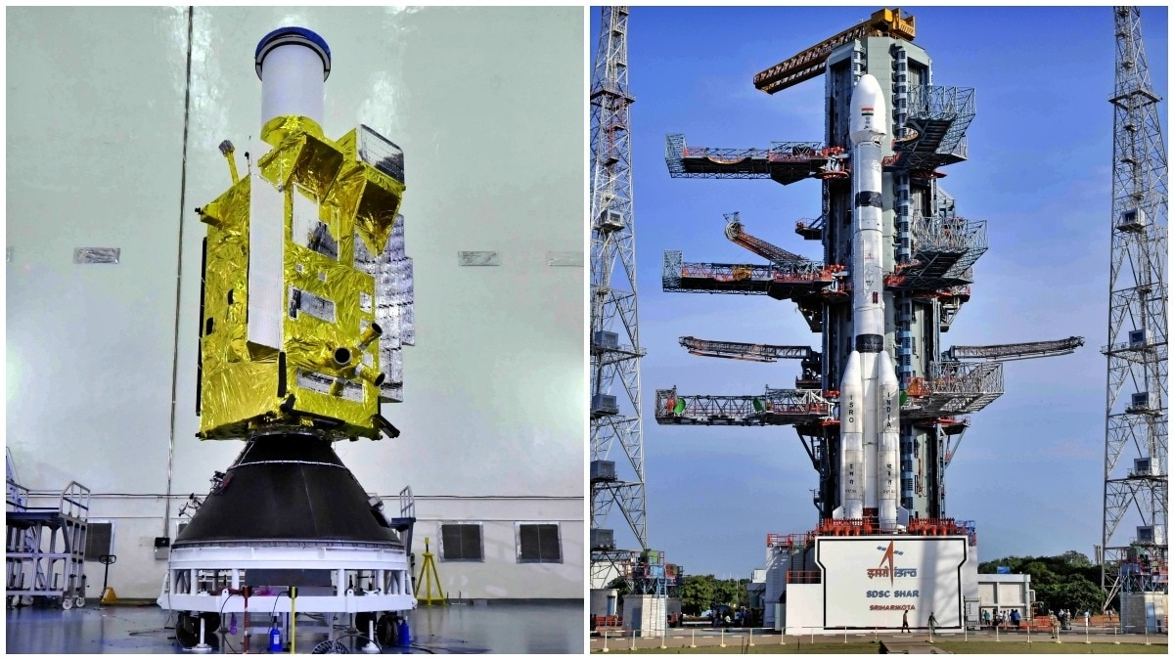
The Indian Space Research Organisation (Isro) is preparing to launch EOS-05, an advanced Earth observation satellite that represents a renewed push to establish continuous imaging capabilities from geostationary orbit. The mission, scheduled for launch on September 4, is particularly significant because EOS-05 is the successor to Isro's earlier GISAT-1 mission, which was lost during a launch attempt in 2021. The satellite will launch aboard the GSLV-F17 mission from the Second Launch Pad (SLP) at Satish Dhawan Space Centre in Sriharikota. WHAT IS INDIA'S GISAT-1? GISAT, short for Geo Imaging Satellite, was designed to give India a unique view of the Earth. Unlike conventional Earth observation satellites that circle the planet in low-Earth orbit and observe a location only when they pass overhead, a satellite positioned in geostationary orbit can continuously watch the same large region. EOS-05 is designed to operate from an orbit about 36,000 kilometres above the equator. At this altitude, the satellite orbits Earth at the same rate at which the planet rotates, allowing it to remain in a nearly fixed position relative to the Earth's surface. This capability is expected to allow EOS-05 to repeatedly image the Indian subcontinent and surrounding regions. According to the planned mission profile, the satellite will be capable of providing near-real-time imagery at intervals of around 30 minutes. For priority targets, the revisit time could be as short as five minutes. Such rapid imaging could prove valuable during fast-changing events. WHY ARE EARTH OBSERVATION SATELLITES IMPORTANT FOR INDIA? Earth observation satellites are used to monitor clouds and weather systems, assess agricultural conditions, track changes in land and water, and support disaster management. Rapid and repeated observations could help agencies monitor developing cyclones, floods, forest fires and other events where conditions can change within minutes. The satellite could also support security and strategic observation by providing persistent monitoring of areas of interest. Geostationary satellites are commonly used for communication and weather monitoring, but imaging Earth's surface from such a great distance presents major technological challenges. From nearly 36,000 kilometres away, the satellite must collect detailed imagery of a vast region while maintaining precise pointing and stable operations. That makes the EOS-05 mission an important technological step for India's Earth observation programme. The September 4 launch will also carry emotional and strategic significance for Isro. The original GISAT-1 mission failed to reach orbit after a problem during the GSLV-F10 launch in August 2021. Five years later, the return of the GISAT concept in the form of EOS-05 offers Isro another opportunity to demonstrate continuous Earth imaging from geostationary orbit. If successful, EOS-05 could give India a powerful new eye in space, one capable of watching the Indian subcontinent almost continuously. - Ends Published By: Sibu Kumar Tripathi Published On: Sep 1, 2026 10:45 IST

2. Onam Week celebrations: Forest dept., ISRO among winners - The Hindu
Read more

The Tourism department has announced the winners of various events of the 'Onam Tourism Week 2026' celebrations, including the cultural procession that marked the finale of the festival. Among State government departments that featured floats in the cultural procession, the Kerala Forest and Wildlife department emerged victorious, followed by the Excise department. The Indian Space Research Organisation (ISRO) won the first prize followed by Southern Railway among the Central government institutions. Among public-sector institutions, the Livestock Development Board secured the top position. The second prize was shared by the Kerala Tourism Development Corporation (KTDC) and the National Ayurveda Mission. While the Thiruvananthapuram Corporation emerged victorious in the local self-government institutions category, the Thiruvananthapuram District Panchayat secured the second prize. NABARD emerged as the winner in the banking sector, while Krupalayam Old-Age Home was given a consolation prize. Agasthya Siddha Marma Kalari Sanghom won the first prize in Kalari in the Visual Art Forms category. Hussein Kollayil won second prize in Arabanamutt. Vignesh (Panchari Melam) won first prize while Kaurava Kalasamiti (Shinkarimelam) won second prize. For illuminations, Keltron won first prize in the public-sector category, followed by Jalabhavan. The State Legislative Assembly complex won first prize among the State departments, followed by Thiruvananthapuram Corporation. In the private sector, Kalyan Silks won the first prize, and Anna Bhavan Restaurant won second prize.

3. After seven-month hiatus, ISRO to launch key satellite on September 4 - The Indian Express
Read more
After seven-month hiatus, ISRO to launch key satellite on September 4 The Indian Express

4. Meet GISAT-1A: ISRO's new "Eye In Space" that will watch India from 36,000 km above Earth - Moneycontrol.com
Read more
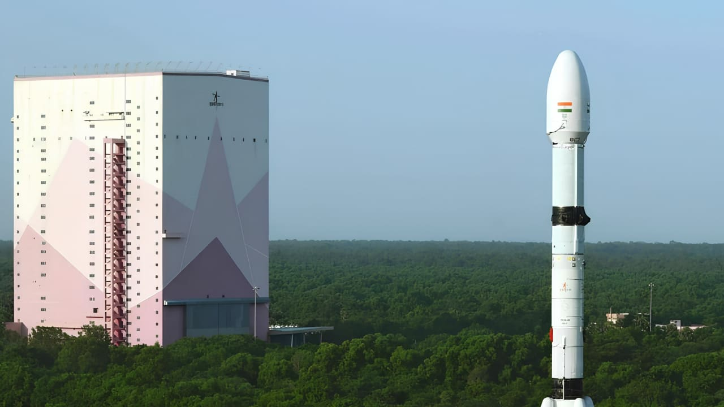
ISRO will launch EOS-05, or GISAT-1A, on September 4, 2026, at 2:55 am IST on Friday at Satish Dhawan Space Centre in Sriharikota. Here's how the satellite will monitor India from geosynchronous orbit. ISRO's EOS-05 will watch India from 36,000 km above Earth. (Image: ISRO) ISRO to launch EOS-05 (GISAT-1A) satellite. Launch set for Sept 4, 2026, from Sriharikota. Satellite for continuous Earth observation & disaster monitoring. Did our AI summary help? Market Mastery Webinar by Vishal Malkan Find the weak links in your portfolio by Vishal Malkan Register for FREE Webinar Register for FREE India is preparing to put a powerful new Earth-observation satellite into space. ISRO will launch EOS-05, also known as GISAT-1A, aboard the GSLV-F17 rocket on September 4, 2026. The launch is planned from the Second Launch Pad at Satish Dhawan Space Centre in Sriharikota. If successful, the mission will give India a new capability. The satellite is designed to observe the Indian subcontinent from a geosynchronous orbit. India is getting a new 'Eye In Space' EOS-05 is designed for near-continuous Earth imaging. Unlike satellites that repeatedly pass over the same location, a geosynchronous spacecraft can keep watching a broad region for long periods. This makes it valuable for monitoring rapidly changing events. When GISAT-1A launch happening? ISRO is targeting September 4, 2026, from Sriharikota. The GSLV-F17 will carry the 2,367-kilogram EOS-05 spacecraft into space. If the mission succeeds, India will gain a powerful new tool for watching its territory from space. During a disaster this constant view could become especially valuable. The launch will take place at 2:55 am IST on Friday at Satish Dhawan Space Centre in Sriharikota. What will EOS-05 do in space? The satellite is designed to provide frequent images of large areas. Its observations could support disaster monitoring, weather analysis, agriculture and environmental studies. It could be particularly useful during cyclones, floods and other fast-moving events. The GISAT concept was developed to provide rapid imaging, including targeted observations at frequent intervals. Is the orbit important here, but why? EOS-05 will first be placed into a Sub-Geosynchronous Transfer Orbit by the GSLV-F17. The spacecraft is then intended to operate from the geosynchronous region. The orbit is roughly 36,000 kilometres above Earth. From there, the satellite can maintain a persistent view of the Indian region. A Second Chance After 2021 The mission also carries history. EOS-05 is the successor to GISAT-1, which failed to reach orbit during the GSLV-F10 launch in August 2021. The new spacecraft represents another attempt to establish India's geostationary imaging capability.

5. Meet the ISRO Chief Who Led India to Mars While Keeping His Love for Kathakali Alive - The Better India
Read more
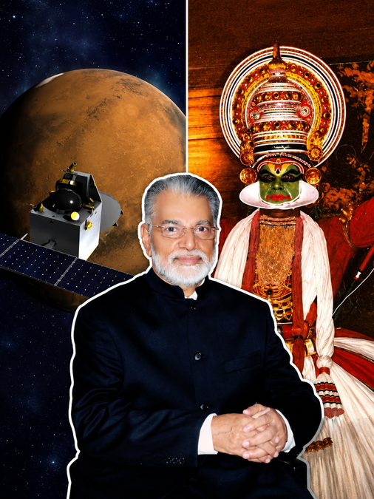
Meet the ISRO Chief Who Led India to Mars While Keeping His Love for Kathakali Alive The Better India

6. NASA Welcomes Türkiye as Newest Artemis Accords Signatory
Read more
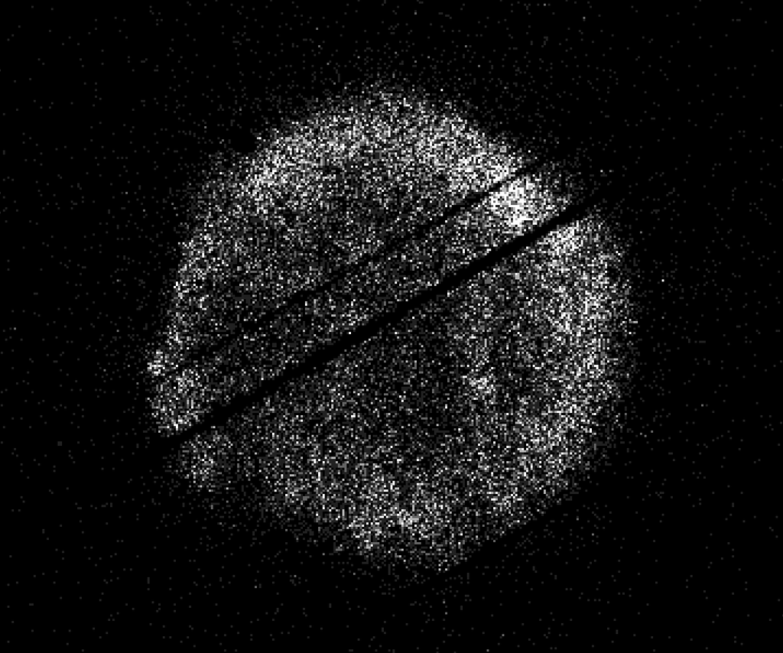
Turkish Minister of Industry and Technology, Mehmet Fatih Kacır, 3rd from left, signs the Artemis Accords for the Republic of Türkiye as NASA Administrator Jared Isaacman, left, U.S. Deputy Assistant Secretary of State for Space and Environment Connor Tomlinson, and Turkish Space Agency President, Yusuf Kıraç, right, look on, Monday, August 31, 2026, at the Mary W. Jackson NASA Headquarters building in Washington. NASA/Bill Ingalls During a ceremony hosted by NASA Administrator Jared Isaacman at the agency's headquarters in Washington on Monday, the Republic of Türkiye signed the Artemis Accords, joining the growing international coalition of like-minded nations dedicated to peaceful, transparent space exploration. "It is my privilege to welcome the Republic of Türkiye as the 71st signatory of the Artemis Accords," said Isaacman. "Last year, President Trump directed NASA to accelerate its return to the lunar surface and establish humanity's first enduring presence on another world, a Moon Base, as well as lay the foundation for the manned exploration of Mars. NASA never undertakes these grand endeavors alone. On the Moon Base, we're taking the Artemis Accords principles and putting them into practice on the lunar surface. NASA has invited every signatory to take part in this endeavor, creating opportunities for nations to contribute major pieces of hardware, scientific payloads, technology demonstrations, CubeSats, and other capabilities to future Artemis missions." Turkish Minister of Industry and Technology Mehmet Fatih Kacır signed on behalf of Türkiye. The President of the Turkish Space Agency Yusuf Kıraç, and the U.S. Deputy Assistant Secretary of State for Space and Environment Connor Tomlinson, also participated in the event. Türkiye's recent achievements in human spaceflight underscore its commitment to space exploration. In 2024, the country's first astronaut, Alper Gezervaci, traveled to the International Space Station on Axiom Mission 3 and conducted scientific research alongside NASA astronauts. That same year, a second Turkish astronaut, Tuva Atasever, flew on Virgin Galactic 07 suborbital mission, conducting experiments and physiology research. Türkiye will soon launch its first lunar mission, AYAP-1, joining the small but growing group of countries building and launching their own satellites to the Moon. The country's signing also comes as the country prepares to host the International Astronautical Congress in Antalya this October. Dozens of Artemis Accords signatories are expected to attend to discuss the future of peaceful and transparent space exploration. In 2020, NASA and the State Department joined with seven other founding nations to establish the Artemis Accords, responding to the growing interest in lunar activities by both governments and private companies. They introduced the first set of practical principles aimed at enhancing the safety and coordination between nations as they explore the Moon, Mars, and beyond, committing nations to: explore peaceably and transparently render aid to those in need enable access to scientific data ensure activities do not interfere with those of others preserve historically significant sites and artifacts by developing best practices By signing the Artemis Accords, nations open the door to opportunities for future lunar exploration with NASA, advancing humanity's return to the Moon, and shaping the Golden Age of space exploration and innovation. Learn more about the Artemis Accords at: https://www.nasa.gov/artemis-accords -end-

7. September 2026 Satellite Puzzler
Read more
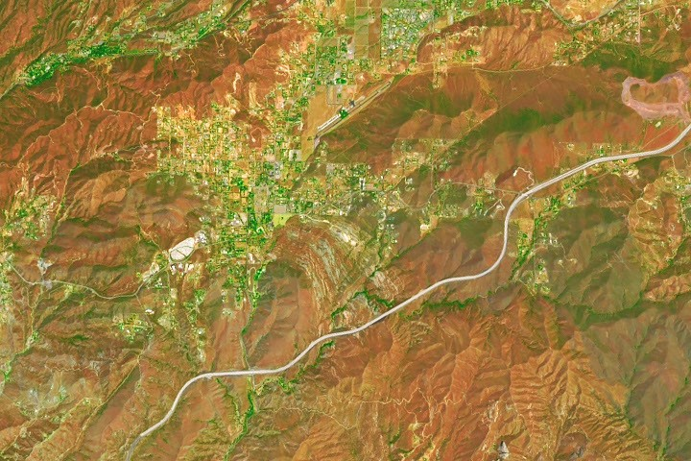
Every month, NASA Earth Observatory features a puzzling satellite image. The September 2026 puzzler appears above. Your Challenge Identify the location shown in this satellite image. Share what clues you see, where you think it is, and what makes this place interesting or unique to you. How to Answer Submit your response using this form and select "Puzzler Answer" as the topic. Please include your preferred name or alias. You can keep it simple and just guess the location. Want to impress us? Tell us which satellite and instrument captured the image, which spectral bands were used, or point out a subtle detail about the geology or history of the area. If something catches your eye, or if this is your home or means something to you, we'd love to hear about it. The Prize We can't offer prize money or a trip to space to see Earth like satellites and astronauts do. But we can offer something almost as rewarding: puzzler bragging rights. About a week after the challenge, we'll post the answer at the top of this page, along with a link to an Earth Observatory Image of the Day story that explains the image in more detail. We'll recognize the first person who correctly guesses the location, and we may also highlight readers who share especially thoughtful or interesting answers. By submitting a response, you acknowledge that your comments may be edited, excerpted, and published on this page. Until then, zoom in, look closely, and enjoy the challenge. See you at the reveal!

8. Roman Commissioning
Read more
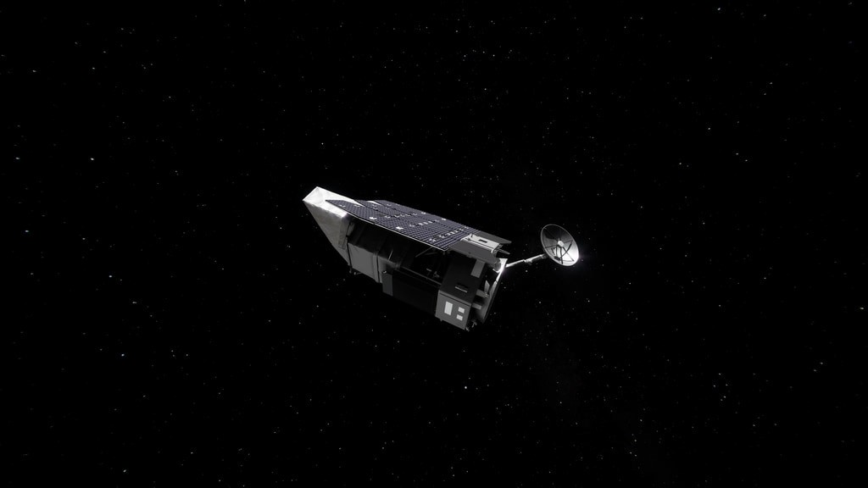
2 Min Read Roman Commissioning Beauty pass of Roman, coming around from behind with high-gain antenna rotating. Credits: NASA's Goddard Space Flight Center/Conceptual Image Lab Contents Where is Roman? Deployments Roman's Orbit Explore the Roman Systems 3D View Where is Roman? Roman is making its three-month journey from Earth to Sun-Earth Lagrange Point 2, or L2. Along the way, Roman is undergoing a process called commissioning, where systems are turned on, adjusted, calibrated, and prepared for science operations. Commissioning is the time for scientists and engineers to make sure that Roman is performing as expected. The schedule is subject to change as the team assesses and adjusts as needed. Visit the Roman Blog To view this video please enable JavaScript, and consider upgrading to a web browser that supports HTML5 video An hour and 23 minutes after launch, Roman began to emerge from the tight configuration that allowed it to fit in the rocket fairing. The solar panels and sunshade deployed, shading the rest of the observatory and providing power to the systems. Within the upcoming days, the antenna will swing out and the visor-like deployable aperture cover will move into place to permanently reveal and shade the primary mirror. This visualization shows the stable, halo orbit that Roman will have around L2. At this location, the gravity of the Sun and Earth, together with an object's motion around the Sun, let it stay lined up with Earth as they orbit, allowing Roman to have a relatively steady orbit without using much fuel. This location also offers exceptionally stable optical performance and a constant, unobstructed view of a wide swath of the sky; Earth won't block much of Roman's view since it will be so distant. And at L2, heat from Earth, the Sun, and the Moon have less effect on infrared telescopes, which "see" heat. Unable to render the provided source Learn more about the systems that are getting turned on, tested and calibrated. 3D View

9. Watch 2 astronauts take 6th-ever all-female spacewalk today
Read more
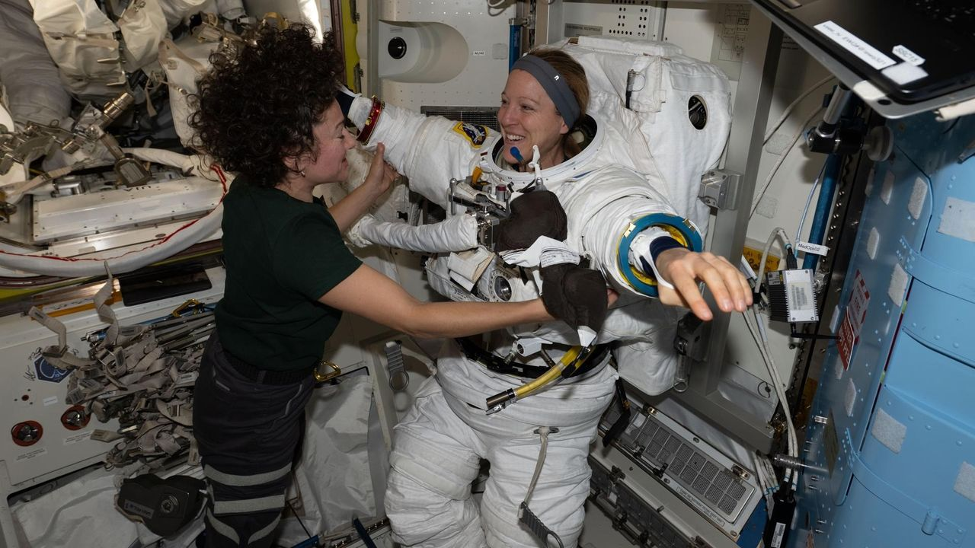
Click for next article U.S. Spacewalk 99 - YouTube Watch On Two astronauts will conduct history's sixth all-female spacewalk today (Sept. 1), and you can watch it live. NASA's Jessica Meir and Sophie Adenot of the European Space Agency will venture outside the International Space Station (ISS) at around 8:30 a.m. EDT (1230 GMT) on an excursion expected to last about 6.5 hours. You can watch it here at Space.com, courtesy of NASA, or directly via the agency . Coverage will start at 7:00 a.m. EDT (1100 GMT). NASA astronaut Jessica Meir and the European Space Agency's Sophie Adenot work together inside the International Space Station's Quest airlock during spacesuit fit and leak checks. (Image credit: NASA) During today's spacewalk , Meir and Adenot "will replace a retroreflector on the forward port of the space station's Harmony module to support spacecraft navigation during rendezvous and docking operations," NASA officials said in a media advisory . "After installing the reflector, the crew will work to install jumper cables for the data-relay systems, prepare the Alpha Magnetic Spectrometer's radiator for future maintenance, and replace a high-definition camera on the station's truss," they added. (The Alpha Magnetic Spectrometer is a $2 billion particle physics experiment mounted to the exterior of the ISS that studies cosmic rays and hunts for mysterious dark matter , among other tasks.) Adenot will be "crew member 1" on today's spacewalk and will wear a suit with red stripes, NASA officials said. Meir will wear an unmarked suit and serve as "crew member 2." It will be the third spacewalk for Adenot, who two weeks ago became the first French woman ever to perform an extravehicular activity (EVA). It will be the seventh for Meir, which will put her third among female NASA astronauts behind Peggy Whitson (10 EVAs) and Suni Williams (nine).

10. NASA's doomed Swift space telescope restarts science work after rescue mission fails
Read more
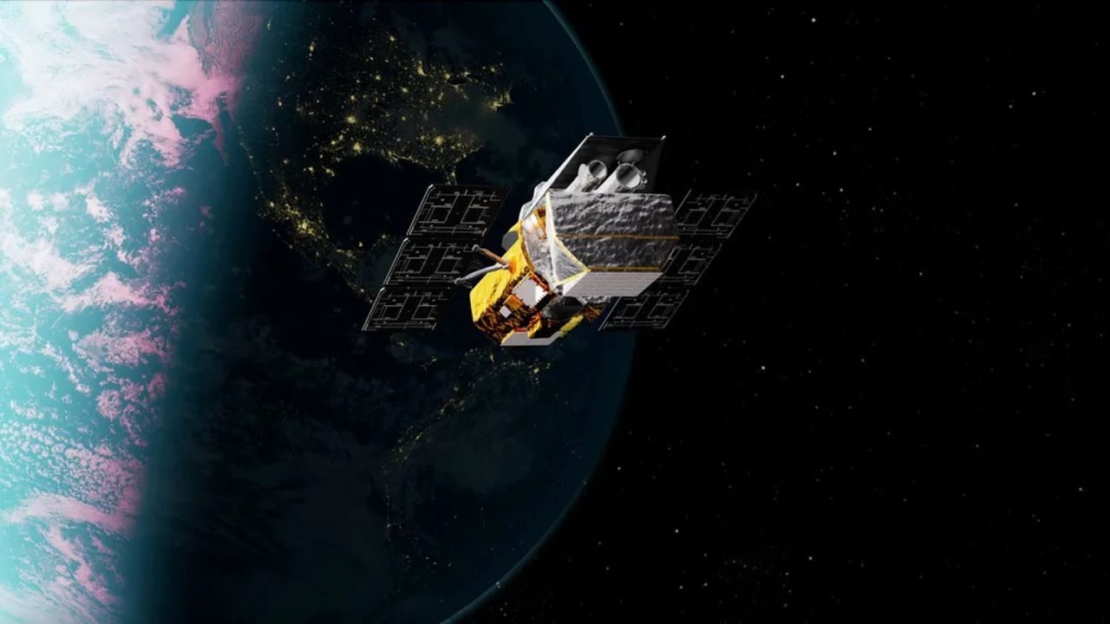
Click for next article Artist's illlustration of NASA's Neil Gehrels Swift Observatory, which launched to Earth orbit in November 2004 and will soon fall out of space. NASA's Neil Gehrels Swift Observatory is back to studying the universe after spending months in a low-drag configuration while awaiting an orbital rescue mission that ultimately fell short. Mission controllers restarted two of Swift's three science instruments - its X-ray Telescope (XRT) and Ultraviolet/Optical Telescope (UVOT) - on Aug. 26. Both instruments had been shut down in February as part of an effort to minimize atmospheric drag and keep the aging spacecraft in orbit long enough for another spacecraft to reach and boost it to a higher altitude, according to an Aug. 28 statement from NASA. Swift's third instrument, the Burst Alert Telescope (BAT), remains offline. Operations of the BAT were halted in April to conserve power, allowing controllers to position Swift's solar panels in a way that further reduced drag from its interaction with Earth's atmosphere . NASA says the mission team hopes to resume data collection with the instrument within the next few weeks. "Over the last 21 years, Swift has been NASA's multitool for studying the cosmos ," NASA officials said in the statement. "It observes a wide range of light, rapidly points at short-lived outbursts, and sends alerts to other facilities in space and on the ground to help coordinate follow-up observations." The return to science follows NASA's decision to abandon plans to boost Swift's orbit using LINK, a robotic servicing spacecraft built by the Arizona company Katalyst Space. LINK launched July 3 aboard a Northrop Grumman Pegasus XL rocket with the ambitious goal of rendezvousing with Swift, grabbing the observatory and raising its orbit. However, the rescue mission encountered trouble in late July when LINK developed attitude-control problems that caused it to spin and disrupted communications. Two of the spacecraft's three reaction wheels were found to be inoperable, while its cold-gas thruster system also experienced some loss of functionality. Although engineers managed to reduce LINK's spin and regain attitude control, NASA and Katalyst announced Aug. 19 that the spacecraft would no longer attempt to capture and boost Swift. Instead, LINK is expected to rendezvous with Swift and perform proximity operations, providing an opportunity to demonstrate technologies that could be used for future in-space satellite servicing missions - leaving Swift without the orbital boost intended to extend its life and its future increasingly uncertain. Launched in 2004, Swift was originally designed for a two-year mission studying gamma-ray bursts , the most powerful explosions in the universe. More than two decades later, the observatory continues to detect and rapidly follow up on fleeting cosmic events in gamma-ray, X-ray , ultraviolet and visible light, while alerting other observatories so they can turn their attention to the same targets. Unlike some spacecraft in low Earth orbit , Swift doesn't have a propulsion system capable of counteracting atmospheric drag. Increased solar activity has heated and expanded Earth's upper atmosphere, increasing the drag on Swift and causing its orbit to decay faster than previously expected. NASA's low-drag operations had been expected to keep Swift above an altitude of about 185 miles (300 kilometers) until October. Below that threshold, operating the observatory becomes increasingly difficult and its descent accelerates, NASA officials said in the statement. Now that science operations have resumed - and the planned orbital boost is off the table - NASA expects Swift to reach that critical altitude within the next one to two months. Without intervention, the observatory is likely to crash back to Earth later this year, mostly burning up as it reenters the atmosphere, according to the space agency. For now, the veteran space telescope is making the most of the time it has left - and once again scanning the universe.

11. 'No guts, no glory': How I captured NASA's Roman Space Telescope cross the sun on a picture-perfect SpaceX Falcon Heavy launch
Read more
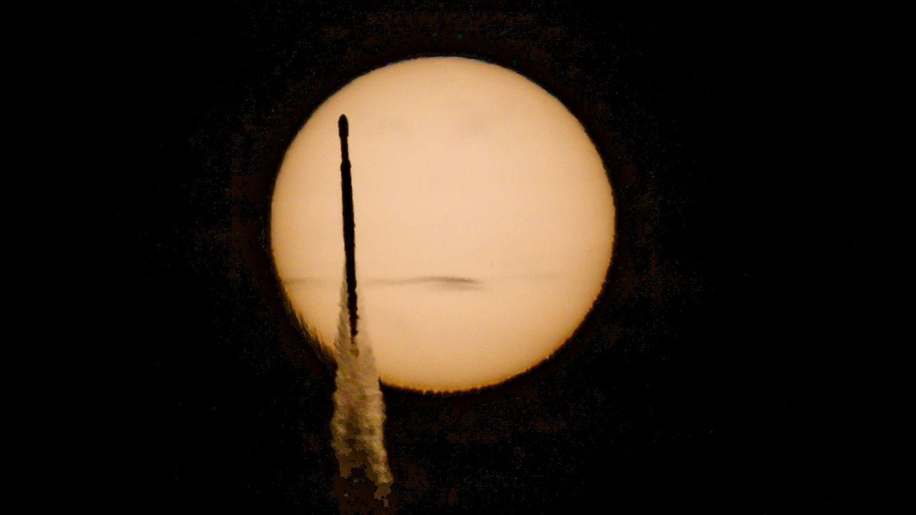
Click for next article The SpaceX Falcon Heavy carrying NASA's Roman Space Telescope crosses the face o the sun as it launches to space from Pad 39A of the Kennedy Space Center in Florida in this photo taken by Space.com's Josh Dinner from a Titusville Hobby Lobby parking lot. Here's how he did it. (Image credit: Space.com / Josh Dinner) CAPE CANAVERAL, Fla. - Standing in the parking lot of the Titusville Hobby Lobby was maybe something I should have planned on before traveling to Florida for the launch of NASA's Nancy Roman Grace Space Telescope, but it was not where I expected to be until I was speeding there in my car. Rocket enthusiasts and locals around Florida's Space Coast gathered Sunday morning (Aug. 30) to watch SpaceX's latest Falcon Heavy launch. The triple-booster rocket launched NASA's newest flagship observatory , the Nancy Grace Roman Space Telescope, which is now on its way to an orbital sweet spot nearly 1 million miles from Earth to image the widest views of the universe ever captured, map planets around alien stars and usher in a new wave of discovery into phenomena like dark matter and dark energy . Liftoff occurred at 07:26:49 a.m. EDT (11:26:49 GMT), from Launch Complex-39A at NASA's Kennedy Space Center (KSC). Specifying those 49 seconds was very important. Roman's launch opportunity is known as an "instantaneous" launch window because its proper orbital delivery was dependent on getting the time right down to the very second. And the seconds mattered for those watching the launch, too. Any fewer, and the clouds from viewing the location of dozens of photographers at Hobby Lobby, myself included, wouldn't have cleared in time. Any more and the sun would have moved too high in the sky to capture what me and all those photographers were hoping to capture. Josh Dinner Spaceflight Writer Josh Dinner is a Spaceflight Writer for Space.com. He also photographs rockets. Sometimes, from a Hobby Lobby parking lot... The early morning launch got off the ground a little more than 20 minutes after sunrise, while the bright glowing orb was still relatively low in the sky. The Space Coast's eastward shores on the Atlantic Ocean, coincidentally, sometimes offer the rare alignment with one of the missions launching from KSC for a rocket to fly right in front of the sun on its way to space, but only from specific vantage points. Plotting and predicting the trajectories of a launch vehicle is no easy task, but it is made incredibly simpler using certain softwares like the popular FlightClub.io , which is used by many photographers to help line up shots that would be nearly impossible without a rocket's flight trajectory info before launch. That, and apps like PhotoPills or The Photographer's Ephemeris are incredibly useful for planning rocket launch photos ahead of time. It's rare for a launch to line up just right, and even more rare for a launch vehicle like Falcon Heavy, which flies far less often than SpaceX 's workhorse Falcon 9 rocket , to line up for a solar transit the way Roman's launch did. The sun rises in a slightly different spot on the horizon each day, and even a few minutes delay in a launch can be enough for the sun to move out of alignment of where the rocket is going to fly. And the alignment for Roman's launch happened to be in the parking lot of Hobby Lobby. A SpaceX Falcon Heavy rocket launches with NASA'S Nancy Grace Roman Space Telescope onboard from Launch Complex 39 on Aug. 30, 2026, at NASA's Kennedy Space Center in Florida. Space.com's Josh Dinner used a remote camera to capture this view. (Image credit: Space.com / Josh Dinner) I hadn't checked FlightClub.io, and was so focused on other parts of launch coverage for Roman's mission , I didn't think to check if a transit was in the cards for Sunday morning. But as the excitement for launch built, and the days until Roman's launch dwindled, excitement over the possibility of a solar transit spread among the photojournalists at KSC. Shooting the transit, though, meant leaving KSC during launch, which meant sacrificing literal front row seats to one of the world's most powerful rockets . The KSC press site sits just three miles (4.8 km) LC-39A. Hobby Lobby in Titusville, on the other hand, is about 12 miles away (19 km). And there were some concerns about clouds, too. Weather during Saturday's prelaunch mission briefing forecasted only a 50% of favorable weather conditions for Sunday, and when the morning of launch arrived, clouds on the horizon weren't showing obvious signs of clearing in time for liftoff. I was torn. I didn't want to sacrifice getting a shot of the launch by leaving KSC if the clouds were going to persist, but if it worked, this would be my first ever solar transit rocket launch photo. About an hour before launch, Space Scout's David Diebold popped into the KSC press site, and told me when I asked him that of course he was going to try for the shot. "No guts, no glory," he said. He was on his way out the door as he said it. David also offered to lend me one of his solar filters for my camera, which was another very influential factor in my decision. It takes about 25 minutes to get from the press site at KSC to the strip in Titusville where Hobby Lobby sits, and the launch was about 45 minutes away. Checking the clouds one more time, I decided to take the chance. "No guts, no glory," I told my fellow Space.com reporters, who were able to manage things from the press site in my absence. A post shared by Space.com (@spacedotcom) A photo posted by on I jumped in my car and headed to Hobby Lobby. Everyone else who tried for this shot was already there when I arrived, and so were hundreds of other launch spectators across the street, lining the stretch of spots along the Banana River where several launchpads stand in view. Thankfully, I was able to squeeze in between fellow launch photographers Andrew McCarthy from Consider the Cosmos , and NASA Space Flight's Max Evans, both of whom generously offered me some last-minute advice for my camera settings. I shot on a Canon R5 Mark II , an absolute unit of photography engineering and one of Canon's newest full-frame mirrorless cameras , with an RF100-400mm F5.6-8. With my lens zoomed all the way up to 400 and my solar filter from David on the end, I cranked the R5's exposure down to 1/20000 and set aperture to F16 and waited with just a few minutes until liftoff. It wasn't until those last minutes that the clouds finally did clear. Someone listening to SpaceX's live stream began a countdown from 5 seconds, and everyone went silent and hands and eyes moved to cameras and viewfinders. "Liftoff." One more view of SpaceX's Falcon Heavy rocket launching NASA's Roman Space Telescope from one of Dinner's remote cameras. (Image credit: Space.com / Josh Dinner) I didn't even look up to try to see if I could make out the rocket on the horizon. I just waited for a moment seconds later when Falcon Heavy flew across the face of the sun. It happened in a split second. I just held my finger down on the shutter button and hoped. Rocket launches are inherently risky endeavors. Millions of dollars go into designing and building the unique satellites sent to orbit, and millions more on the launch vehicles that get them there. But launches don't always go as planned, and the nature of rockets means that if something goes wrong, often things go very wrong. They are, after all, vehicles channeling controlled explosions through Earth's turbulent atmosphere into the unforgiving vacuum of space. But we do it anyway. We send the amazing things into the cosmos to expand humanity's understanding of the universe. Like the new era of discovery about to be ushered in as Roman journeys to its final destination in orbit, we take the risks because the payoffs are so tremendous. And when we do, it makes getting the shot that much better. No guts, no glory.

12. What's next for Roman Space Telescope? Here's how NASA's flagship observatory will open up the universe
Read more
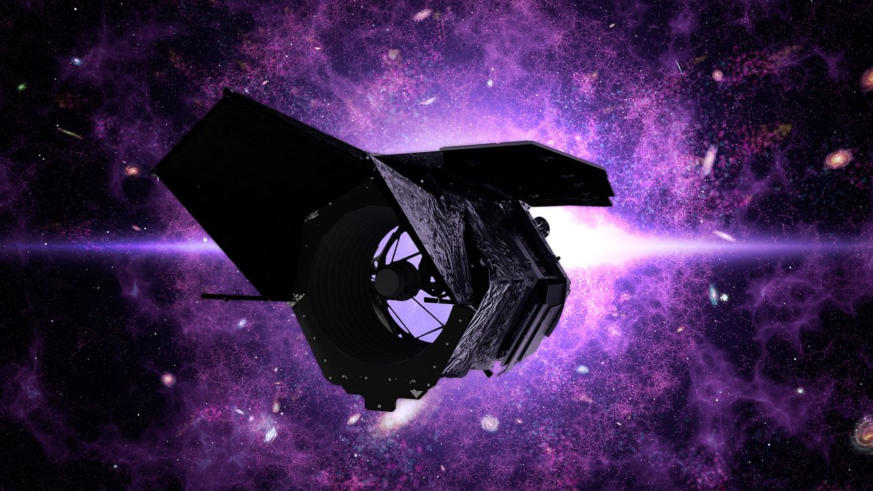
Click for next article The Nancy Grace Roman Space Telescope separates from its SpaceX Falcon Heavy rocket about 30 minutes after launch on Aug. 30, 2026. NASA's next big space telescope has left Earth, but it's not ready to start observing the heavens just yet. The Nancy Grace Roman Space Telescope launched yesterday (Aug. 30), riding a SpaceX Falcon Heavy rocket into the heavens . Astronomers are very excited about Roman, for it's expected to discover thousands of new exoplanets and shed light on mysterious dark energy and dark matter, among other accomplishments. Such science work is a few months off, however. Here's a brief rundown of the next steps for the Roman team. A diagram showing Roman at Lagrange point 2, between Earth and Mars. (Image credit: NASA SVS) A long journey The first order of business is getting Roman to its destination. The 42-foot-long (12.7 meters) scope isn't staying in Earth orbit; it's headed to the sun-Earth Lagrange Point 2 (L2), which lies about 930,000 miles (1.5 million kilometers) from our planet in the Marsward direction. There are multiple reasons to target L2, which also hosts NASA's James Webb Space Telescope (JWST) and Europe's Euclid probe. "At this special place in space," NASA officials wrote in a Roman explainer , "gravitational forces balance to keep objects in steady orbits with very little assistance." "Roman's barrel-like shape will help block out unwanted light from the sun, Earth and moon, and the spacecraft's distant location will help keep the instruments cool," they added. "The thermal stability of an observatory at L2 will provide a ten-fold improvement beyond Hubble in much of the data Roman will gather." And don't worry about Roman and JWST bumping heads; though their cosmic addresses will be the same, they won't actually share space. "Like Webb, Roman will trace out a large orbit around the actual L2 point - much larger than the moon's orbit around Earth - and the two will easily be kept far apart," NASA wrote in a different Roman piece . It'll take Roman about 30 days to fly out to L2 and settle into its looping orbit there. A new round of work will then begin for the Roman team. Checking Roman out That work is "commissioning" - making sure that all of Roman's systems and subsystems are working properly, as is its science gear, which consists of the Wide Field Instrument (WFI) and the Coronagraph Instrument (CGI). WFI "is a 300-megapixel infrared camera that will allow scientists to look very far back in time," NASA officials wrote in the explainer. "Seeing the universe in its early stages will help unravel how it has expanded throughout its history, which will hint at how it may continue to evolve." CGI is a technology demonstration that will block the light of distant stars, allowing Roman to spot a wealth of previously unknown alien worlds. "It will be far more powerful than any other coronagraph ever flown, seeing planets that are almost a billion times fainter than their host star," NASA officials wrote. Roman should be ready to begin its science work in early 2027, according to the nonprofit Planetary Society. Its science life is slated to last five years, but astronomers are doubtless hoping for more. And there's precedent for such optimism; after all, NASA's Hubble Space Telescope is still going strong today, more than 36 years after its launch.

13. SpaceX, NASA delay next astronaut launch to ISS due to leak on Dragon spacecraft
Read more
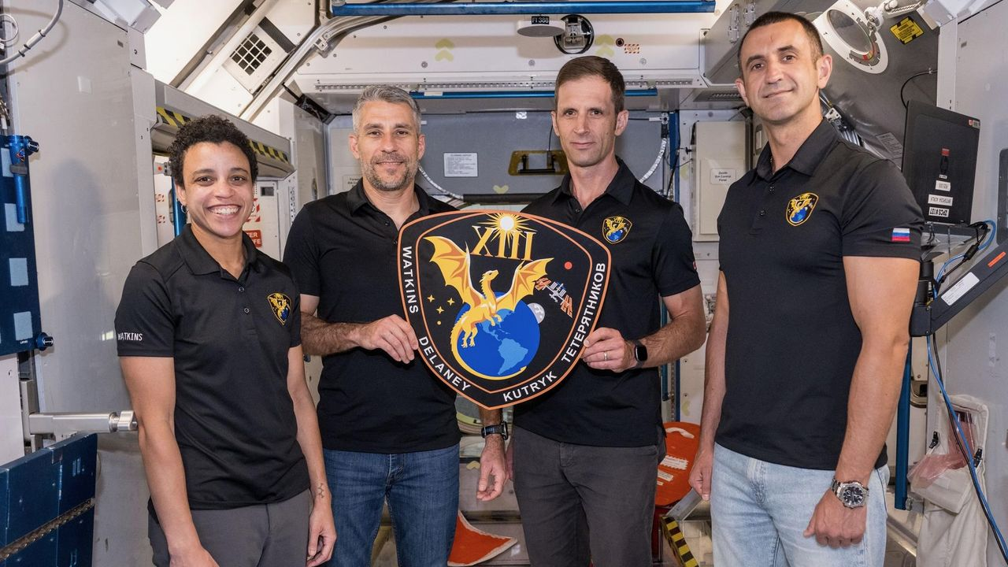
Click for next article The four members of NASA's SpaceX Crew-13 mission to the International Space Station display their mission plaque inside a training mockup of a space station module. From left: Commander Jessica Watkins and Pilot Luke Delaney, both from NASA, and Mission Specialists Joshua Kutryk of the Canadian Space Agency and Sergey Teteryatnikov of Roscosmos. SpaceX's next astronaut mission to the International Space Station won't launch on Sept. 12 after all. That flight, known as Crew-13 , has been delayed due to an oxidizer leak in the propulsion system of SpaceX's Dragon spacecraft, NASA announced on Saturday (Aug. 29). "Joint NASA and SpaceX teams are performing additional tests and data review and will complete any necessary rework prior to launch," NASA officials wrote in an update on Saturday . "A new target date will be announced once available." Crew-13 will launch atop a Falcon 9 rocket from Cape Canaveral Space Force Station. As its name suggests, it will be the 13th operational astronaut mission SpaceX flies to the International Space Station (ISS) for NASA. (The company also conducted a crewed test flight to the orbiting lab, called Demo-2 , which launched in May 2020.) Crew-13 will send NASA astronauts Jessica Watkins and Luke Delaney of NASA, the Canadian Space Agency 's Josh Kutryk, and Sergey Teteryatnikov of Russia's federal space corporation Roscosmos to the ISS for a seven-month stay. "We expect a very busy mission with lots of station maintenance, both internal and external, with a few EVAs [extravehicular activities, or spacewalks ] on the docket," Watkins said during an Aug. 3 press conference. There will also be "visiting vehicle capture and stowage operations, lots of science - very interesting science experiments that will be flying with us as well - and plenty of outreach," she added. SpaceX just launched a high-profile mission for NASA, sending the agency's Nancy Grace Roman Space Telescope into the final frontier on Sunday (Aug. 30) atop a Falcon Heavy rocket .

