 |  | 

🌌 अंतरिक्ष समाचार | Space News
शुक्रवार, १९/०६/२०२६ | Friday, 19/06/2026

1. From doctor to astronaut: Indian-American Anil Menon set for mission aboard ISS
Read more
Nasa astronaut Anil Menon is preparing for his first spaceflight, an eight-month mission aboard the International Space Station. (Image: Nasa) Nasa astronaut Anil Menon, an Indian-American physician, engineer and military officer, is preparing for the biggest mission of his career as he gets ready to spend about 240 days aboard the International Space Station (ISS). Menon will leave on July 14, 2026, aboard the Soyuz MS-29 spacecraft from the Baikonur Cosmodrome in Kazakhstan. He will travel alongside Roscosmos cosmonauts Pyotr Dubrov and Anna Kikina for an eight-month mission in orbit. The crew is expected to return to Earth in the spring of 2027. This mission is his maiden space voyage and is also considered the high point of an illustrious career in science, technology, military operations, and space travel.

2. Govt says ISRO has developed & operationalised wide range of space-based applications to benefit society - Newsonair
Read more
The Government has said that the Indian Space Research Organisation (ISRO) has developed and operationalised a wide range of space-based applications to benefit all sections of society, including the welfare of the Scheduled Caste community. Science and Technology Minister Dr. Jitendra Singh informed this in a written reply in the Lok Sabha today. The Minister said that key space application areas include satellite-based Potential Fishing Zone (PFZ) advisories, crop acreage and production forecasting, agrometeorological advisories for farmers, crop insurance support, geospatial support for flagship government programmes, tele-education, telemedicine, the Vessel Communication and Support System, and disaster management support. Mr. Singh noted that ISRO has established robust awareness and capacity-building programmes to promote the use of space technology for societal, governance, and disaster management purposes, enabling decision-makers to operate effectively at the grassroots level. He added that these initiatives are designed to be inclusive and accessible to targeted beneficiaries across the country. The Minister further said that the benefits of Earth observation, satellite communication, and navigation applications, particularly in terms of improved connectivity and navigation services, are reaching SC farmers, students, and disaster-prone regions within satellite coverage areas. He also highlighted that the Department has undertaken several measures to ensure the inclusive use of space technology, including the implementation of flagship initiatives such as Digital India, the BharatNet Programme, the Vessel Communication and Support System (VCSS) under the Pradhan Mantri Matsya Sampada Yojana (PMMSY), and the PM e-VIDYA scheme for tele-education.

3. ISRO to launch PSLV-C62 mission on January 12 from Sriharikota - The News Mill
Read more
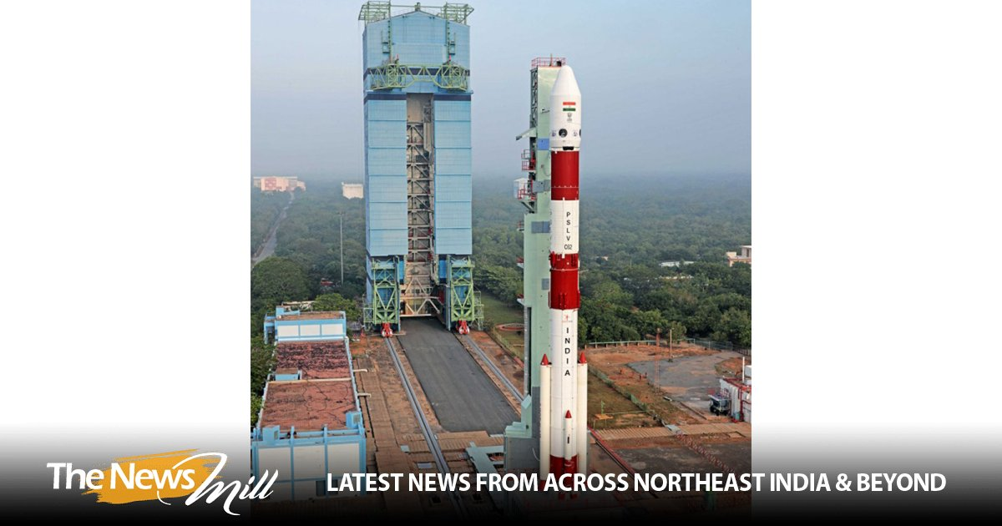
The Indian Space Research Organisation (ISRO) will launch its PSLV-C62 mission on January 12 (Monday) at 10:17 AM IST from the First Launch Pad at Satish Dhawan Space Centre (SDSC), Sriharikota. In a post on X on Tuesday, ISRO shared, "The Launch of PSLV-C62 Mission is scheduled on 12 January 2026 at 10:17 hrs IST from First Launch Pad (FLP), SDSC SHAR, Sriharikota." The Launch of PSLV-C62 Mission is scheduled on 12 January 2026 at 10:17 hrs IST from First Launch Pad (FLP), SDSC SHAR, Sriharikota. Public can witness the launch from Launch View Gallery at SDSC SHAR, Sriharikota by registering through online from the following link… - ISRO (@isro) January 6, 2026 On December 24, ISRO successfully launched the BlueBird Block-2 communication satellite for the United States' AST SpaceMobile. The satellite was successfully placed in orbit, and the mission was declared a success. The launch took place from the Satish Dhawan Space Station in Sriharikota, Andhra Pradesh, at 8:55 AM IST. The mission deployed the next-generation communication satellite designed to provide high-speed cellular broadband directly to smartphones worldwide. The BlueBird Block-2 spacecraft would be the heaviest payload to be launched into Low Earth Orbit in the history of the LVM3 rocket. ISRO stated that the LVM3-M6/BlueBird Block-2 Mission is a dedicated commercial mission onboard the LVM3 launch vehicle, which will launch the BlueBird Block-2 communication satellite of AST SpaceMobile, USA. This mission marks the sixth operational flight of LVM3. In this mission, LVM3-M6 will place the BlueBird Block-2 satellite into Low Earth Orbit, which is the largest commercial communications satellite to be deployed in Low Earth Orbit. It will also be the heaviest payload to be launched by LVM3 from Indian soil. LVM3, developed by ISRO, is a three-stage launch vehicle comprising two solid strap-on motors (S200), a liquid core stage (L110), and a cryogenic upper stage (C25). It has a lift-off mass of 640 tonnes, a height of 43.5 meters, and a payload capability of 4,200 kg to Geosynchronous Transfer Orbit (GTO)

4. In 1981, when ISRO carried its APPLE on bullock cart for just Rs 150, the world laughed; Today, the same s - The Economic Times
Read more

APPLE Satellite Launch Today, India is recognised as a major space power. From missions to the Moon and Mars to launching satellites for countries around the world, the Indian Space Research Organisation (ISRO) has come a long way. But decades before these achievements, India's space scientists were working with limited resources, relying on creativity and determination to achieve ambitious goals. One of the best examples of this spirit came in 1981 with APPLE, India's first experimental communication satellite. The mission not only marked a major milestone in the country's space programme but also produced one of the most memorable images in Indian scientific history, a satellite being transported on a bullock cart. APPLE Satellite Launch: A Turning Point in India's Space Programme On June 19, 1981, the Ariane Passenger PayLoad Experiment (APPLE) was launched aboard the Ariane-1 rocket from Kourou in French Guiana. The mission was a landmark achievement for ISRO. APPLE became India's first three-axis stabilised experimental geostationary communication satellite and played a crucial role in developing the country's future satellite communication capabilities. Although the satellite was experimental, its success laid the foundation for India's later communication satellite programmes and helped strengthen the nation's telecommunications infrastructure. Live Events Why Did ISRO Use a Bullock Cart for APPLE Satellite Testing? The famous bullock cart story emerged during the testing phase of the mission. At the time, ISRO was operating with limited resources. Engineers faced a challenge while conducting antenna tests because they needed a non-magnetic environment to avoid signal interference. Rather than spending large amounts of money on specialised facilities, the team found a practical solution. APPLE was transported on a simple bullock cart to an open field where testing could be carried out under suitable conditions. The cost of the exercise was reportedly around Rs 150. The image of a sophisticated satellite travelling on a traditional bullock cart became a powerful symbol of Indian innovation. It demonstrated how scientists could overcome obstacles through creative thinking rather than expensive equipment. How Scientists Worked Around Resource Constraints The APPLE mission was developed during a period when advanced computing resources were not widely available in India. Engineers and researchers often worked late into the night at institutions such as the Indian Institute of Science (IISc), IIT Madras and the Tata Institute of Fundamental Research (TIFR) to complete critical mission calculations and analyses. The challenges were significant. Tasks that are now performed quickly using modern computers often required extensive manual effort and careful planning. Despite these limitations, the team successfully completed the mission, proving that determination and expertise could compensate for resource shortages. What Made APPLE Satellite Special? APPLE was designed as an experimental communication satellite and served as a test platform for future technologies. The spacecraft weighed approximately 672 kilograms and had a cylindrical structure measuring around 1.2 metres in diameter and 1.2 metres in height. Its payload included two 6/4 GHz transponders connected to a parabolic antenna. The satellite was intended to test communication technologies that would later become essential for India's growing satellite network. On July 16, 1981, APPLE was positioned at 102 degrees East longitude in geostationary orbit. APPLE Satellite's Role in Communication Experiments The satellite was used for several communication experiments that helped India gain valuable experience in space-based telecommunications. Among its key applications were: - Television programme transmission - Radio networking experiments - Satellite communication testing - Development of future communication infrastructure These experiments provided technical knowledge that contributed to the development of later Indian communication satellite systems. Even though one of APPLE's solar panels failed to deploy, the satellite continued to perform its intended functions and delivered important operational experience to ISRO. Who Led the APPLE Mission? The APPLE project was led by R. M. Vasagam, who served as the mission's project director between 1977 and 1983. Under his leadership, the team successfully navigated technical, financial and logistical challenges to deliver one of the most important early achievements in India's space history. The mission showcased the capabilities of Indian scientists and engineers at a time when the country's space programme was still in its early stages. Why the APPLE Satellite Story Still Matters Today More than four decades later, the APPLE mission continues to inspire people across India. The bullock cart photograph is often shared as a reminder that innovation is not always about having the latest technology or the biggest budget. Sometimes it is about finding practical solutions to difficult problems. The mission demonstrated that scientific progress depends on knowledge, persistence and creative thinking. As India celebrates achievements such as Chandrayaan and other major space missions, the story of APPLE serves as a reminder of where that journey began. From a Bullock Cart to Global Space Success The success of APPLE marked an important chapter in India's space journey. It helped establish the technological foundation for future communication satellites and strengthened confidence in the country's growing space capabilities. From engineers working through the night to a satellite transported on a bullock cart, the APPLE mission remains one of the most remarkable examples of Indian ingenuity. Its legacy continues to live on in every major achievement of ISRO, proving that determination and innovation can turn even the most limited resources into historic success. Inputs from agencies Add as a Reliable and Trusted News Source Add Now! (You can now subscribe to our Economic Times WhatsApp channel ) apple satellite isro apple mission bullock cart satellite story india's first communication satellite apple satellite launch 1981 isro history indian space programme ariane passenger payload experiment r m vasagam apple satellite famous isro success stories Prime Exclusives Investment Ideas Stock Report Plus ePaper Wealth Edition - What will the NSE IPO price be? Unlisted market deals offer clues. - She made baking an INR2k crore biz. Now comes the real heat. - Market darling to drawdown: Why momentum stocks are losing steam - Can targeted reforms at home save India from external shocks? - Auditor red flagged Gymkhana land issue long before govt action - Time for long-term investors to look at them again? 9 NBFC stocks with upside potential of up to 22% - 1 - 2 - 3 View all Stories

5. "Together going to launch TRISHNA satellite next year": PM Modi hails India-France multisectoral ties - ANI News
Read more
"Together going to launch TRISHNA satellite next year": PM Modi hails India-France multisectoral ties ANI News

6. This Indian company is reinventing tiffin to carry lunch for Gaganyaan astronauts - India Today
Read more
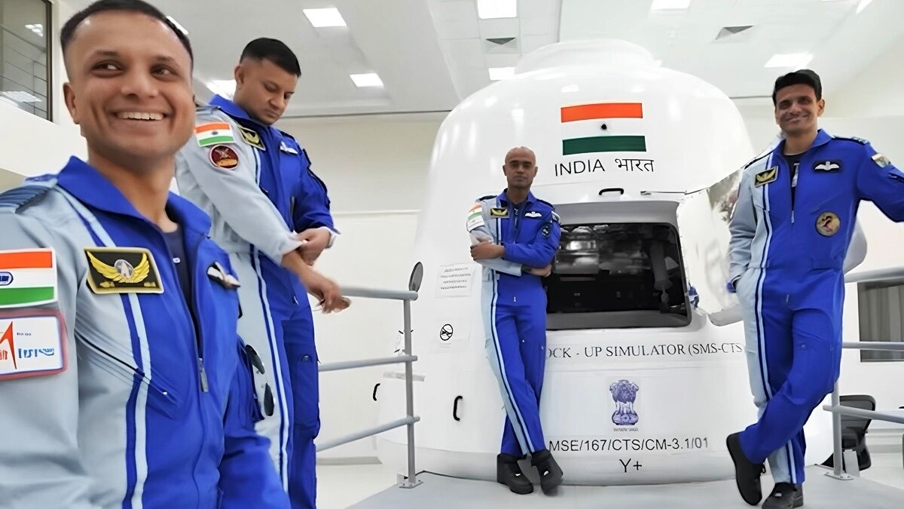
When India sends its first astronauts into orbit on the Gaganyaan mission, their meals may travel in something that sounds oddly familiar. A tiffin box. But this is no ordinary lunchbox. It is a steel container fitted with sensors and electronics, and it is being designed by an Indian company. Ananth Technologies, the Hyderabad firm that has contributed parts to India's space missions for more than two decades, is building the smart food container with the Defence Food Research Laboratory (DFRL) in Mysuru, its chairman and founder, Dr Subba Rao Pavuluri, told IndiaToday.in in an exclusive conversation at the India Space Congress in New Delhi. A SMART STEEL BOX, NOT A LUNCHBOX The container is made of steel and carries small sensors and electronics inside it. These sensors do something a normal lunchbox cannot. They send information back to the ground, Dr Pavuluri said, so the team on Earth can keep a close watch on the food the crew is carrying. In a mission where the safety of the astronauts comes first, he described the food system as one of the most important parts of the journey. The Gaganyaan Crew Module. In microgravity, even a floating crumb can damage equipment, so space food must be sealed and secured. (Photo: Isro) The food itself is being developed by the DFRL, the defence laboratory in Mysuru that prepares meals for India's armed forces. Ananth is working with the laboratory to build a container that will hold and protect those meals in space. WHY FEEDING ASTRONAUTS IS SO HARD Eating in space is far harder than it looks. In orbit, there is almost no gravity to hold things down. Scientists call this microgravity, a state where everything floats freely, including crumbs and tiny drops of liquid. A stray crumb is not just messy. It can drift into an astronaut's eye, or float into delicate equipment and damage it. Ananth Technologies is also building the onboard computing and navigation for India's crew capsule. (Photo: Isro) That is why food for astronauts must be carefully sealed, secured and tracked. A steel container fitted with sensors adds a layer of safety, keeping the meals protected and monitored from launch until they are eaten in orbit. The sensors act like a tiny health monitor for the food, sending readings to engineers on the ground. A PRIVATE FIRM IN INDIA'S ASTRONAUT STORY The container is only one part of Ananth's role in India's human spaceflight programme. The company is also building the onboard computing and navigation systems for the crew capsule, the electronics that help run the spacecraft and find its way. Gaganyaan is India's first attempt to send its own astronauts into space aboard an Indian spacecraft. If the food container works as planned, a humble tiffin box, rebuilt in steel and wired with sensors, will help keep India's first astronauts fed and safe far above the Earth. - Ends

7. NASA Mission to Study Space Weather Impacts of Earth's Atmosphere
Read more
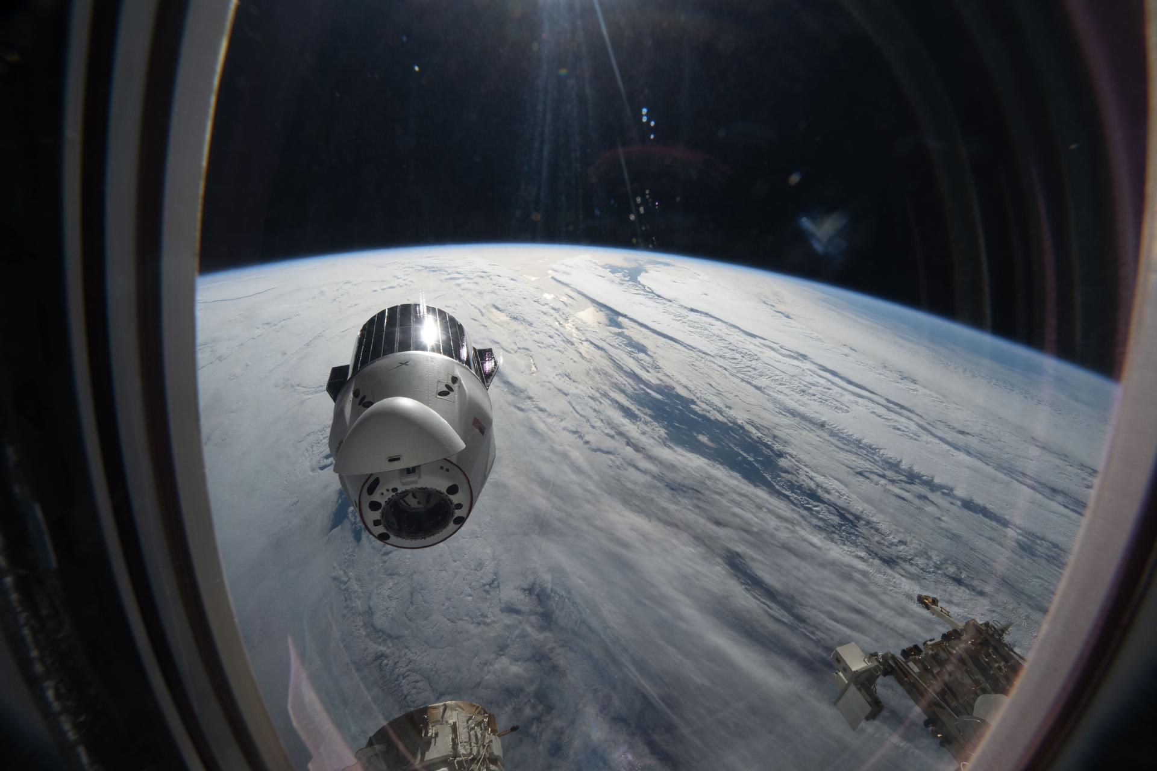
Artist's rendition of the DAPHNE (Dynamic Atmosphere-Ionosphere Explorer) mission concept. The coloring represents auroras and atmospheric waves in Earth's atmosphere. Credit: Laboratory for Atmospheric and Space Physics/Mary Tostanoski NASA selected a mission concept to research how space weather and dynamics within Earth's atmosphere influence the space environment and help improve prediction capabilities for impacts on crucial technology, such as GPS and low Earth orbit satellites, as well as astronauts in space. The DAPHNE (Dynamic Atmosphere-Ionosphere Explorer) mission will enter Phase B of development, which includes planning and design for flight and mission operations. It will use identical twin satellites to study how changes in Earth's lower atmosphere influence our planet's upper atmosphere, where space weather is manifested. "NASA is advancing the United States' leadership as a space weather-ready nation, and by providing new insights into Earth's atmosphere we can better predict and prepare for impacts in our daily lives on Earth and in space," said Nicky Fox, associate administrator, Science Mission Directorate, NASA Headquarters in Washington. "As NASA sends astronauts beyond Earth's magnetic protection to the Moon, Mars, and beyond, DAPHNE will join the NASA science fleet strategically located across the solar system to provide data that will help mission planners predict and mitigate the effects of space weather for the benefit of all." The DAPHNE mission's low-risk high-return concept will provide coordinated, multi-point measurements of neutral winds, temperature, and composition in the thermosphere. The ionosphere and thermosphere regions are where Earth's neutral atmosphere transitions into the ionized plasma of space. In this thin shell that surrounds the planet, the atmosphere is in constant motion, shaped by the influence of solar activity and changes in the lower atmosphere and in near-Earth space. Fundamental observations and physical insights from the DAPHNE mission will incorporate lower-atmospheric energy data to advance space weather predictive capabilities. The mission is led by Aimee Merkel from the Laboratory for Atmospheric and Space Physics at the University of Colorado, Boulder. The mission will be subject to a confirmation review in 2027, which will assess the progress of the mission and the availability of funds. If confirmed, the total estimated cost of the mission, excluding launch, will not exceed $250 million in fiscal year 2023 dollars, with a mission launch date of no earlier than 2029. The DAPHNE mission was proposed as a concept study in response to the DYNAMIC (Dynamical Neutral Atmosphere-Ionosphere Coupling) mission announcement of opportunity. Funding and management oversight for this mission is provided by the Solar Terrestrial Probes program at NASA's Goddard Space Flight Center in Greenbelt, Maryland. For more information on NASA's heliophysics missions, visit: https://science.nasa.gov/heliophysics -end- Abbey Interrante / Karen Fox Headquarters, Washington 202-358-1600 abbey.a.interrante@nasa.gov / karen.c.fox@nasa.gov

8. NASA Awards Contract for Commercial Satellite Data Acquisition
Read more

Credit: NASA NASA has selected eight new companies and will acquire new data products from six existing Commercial Satellite Data Acquisition contract holders to expand the range of commercial satellite data available to researchers, civil agencies, and decision-makers. Such measurements supplement NASA's Earth satellites by contributing high-resolution and frequent observations to enhance the agency's set of data. Leveraging commercial data demonstrates NASA's commitment to strong public-private partnerships, allowing the agency to expand scientific insight while reducing costs and accelerating the delivery of data to researchers and decision-makers. Collectively, NASA and commercial Earth observations provide insight into our home planet - benefitting Americans, providing environmental intelligence, strengthening disaster response, and improving public safety. The Commercial Satellite Data Acquisition Program On-Ramp 2 Multiple Award contract is a firm-fixed-price, indefinite-delivery/indefinite-quantity multiple-award contract. The original maximum contract value was $476 million, with a performance period that began in 2023 and continues through Nov. 15, 2028. Contract awardees are: Airbus DS Geo Inc. GHGSat Inc. Hydrosat Inc. ICEYE US Inc. ImageSat International Kuva US Inc. Muon Space Inc. Orbital Sidekick Inc. OroraTech USA Inc. Planet Labs Federal Inc. Space Sciences and Engineering LLC, doing business as PlanetiQ SATLANTIS US Tomorrow Companies Inc., doing business as Tomorrow.io Wyvern Inc. The agency's Commercial Satellite Data Acquisition mission works to execute a cost-effective way to augment and complement the suite of Earth observations captured by NASA and its partners by identifying, evaluating, and acquiring commercial satellite data. For more information about NASA's Commercial Satellite Acquisition program, visit: https://science.nasa.gov/earth-science/csda -end- Liz Vlock Headquarters, Washington 202-358-1600 elizabeth.a.vlock@nasa.gov

9. From Suriname to Space: Rohit Goeptar Shares His Journey to NASA
Read more
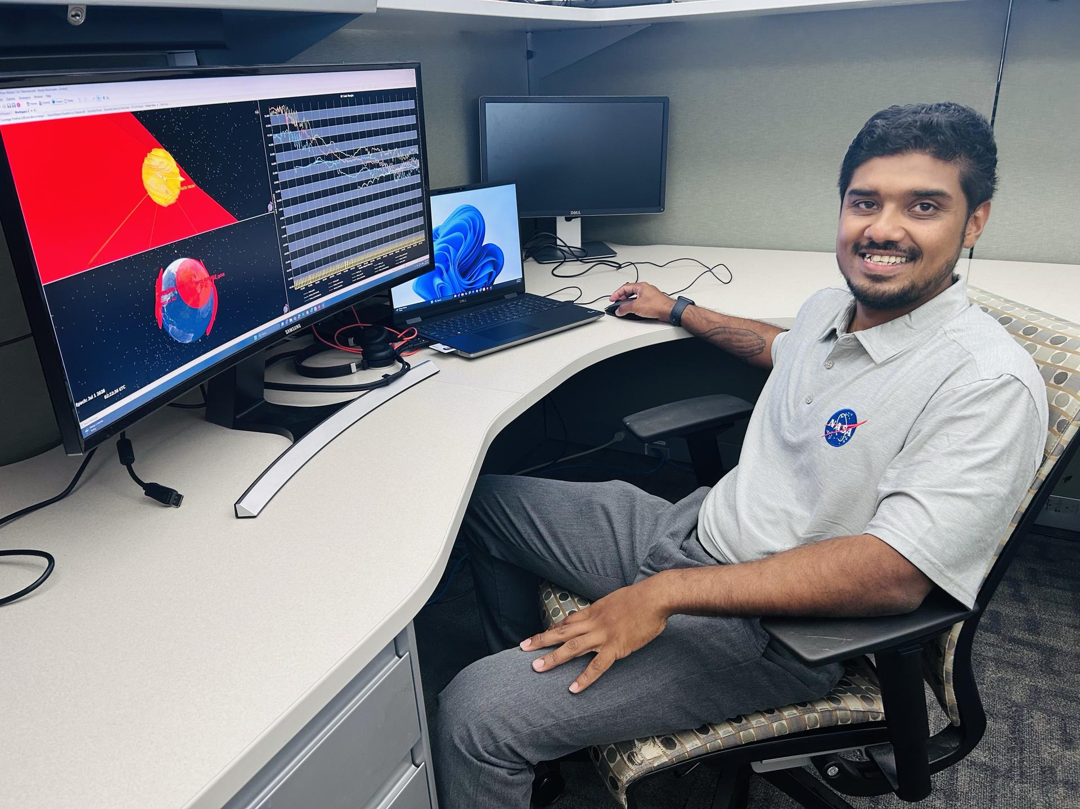
Rohit Goeptar, an electromagnetic/radio frequency analyst with NASA's Launch Services Program at the agency's Kennedy Space Center in Florida, reviews a radio frequency link budget analysis for NASA's Nancy Grace Roman Space Telescope from his office. Goeptar is among the engineers and technicians sworn in as new NASA civil servants as part of NASA Administrator Jared Isaacman's workforce directive to restore technical core competencies within the civil servants ranks. NASA/Amanda Griffin Rohit Goeptar was born into a poor family in Suriname, South America, the kind where both parents work three jobs and they still can only provide food and shelter for their family. At around age six, his family moved to California to start a new life. Only two years later, he moved back to South America with his father while his mother stayed in the United States and remarried. When he was 13, he became a U.S. citizen and he and his brothers returned to live with their mother in California. At 19, Goeptar joined the U.S. Marine Corps where he spent six years as a technical operator. During one deployment to the Philippines, Goeptar helped set up communication systems for individuals who needed to contact their loved ones after a typhoon ripped through entire towns. "I was lost, the Marine Corps gave me an opportunity," Goeptar recalled. While the Marines taught him useful skills, his life had not been the easiest. He lost not one, but two, fathers to suicide, and a short first marriage ended with him being unhoused on the streets of Kissimmee, Florida, for six months. But Goeptar eventually found his way. As with most underdog stories, there was another person in the shadows behind his rise to success. "Your brain works in mysterious ways," his now wife told him a short while after they met. She then filled out college applications for him, and he eventually applied to NASA's Kennedy Space Center in Florida. While raising three kids, going to school full-time pursuing a computer engineering and electrical engineering degree simultaneously, Goeptar got the call that changed his life. "In spring 2025, I was driving to pick my son up from school when a gentleman from Kennedy calls, telling me he's seen my resume and do I have time for a quick interview," Goeptar recounted. He pulled on the side of the road and took part in an impromptu job interview. Two weeks later, he had an in-person interview with others from Kennedy and two weeks after that, he had a contractor badge at America's premier spaceport. After starting as an intern under the Expendable Launch Vehicle Integrated Support, or ELVIS, contract, then moving to part-time until he graduated from the University of Central Florida (UCF) in Orlando, then full-time at the beginning of 2026, Goeptar was one of the ELVIS contractors who applied and were picked up to become civil servants recently. Rohit Goeptar, an electromagnetic/radio frequency analyst with NASA's Launch Services Program at the agency's Kennedy Space Center in Florida, reviews a radio frequency link budget analysis for NASA's Nancy Grace Roman Space Telescope with a colleague. NASA/Amanda Griffin Now an employee of NASA's Launch Services Program, Goeptar works with electromagnetic interference, electromagnetic compatibility, and radio frequency. It is his job throughout the entirety of the mission to analyze and ensure avionic boxes or anything electrically powered doesn't interfere with any other systems. He also ensures independent systems are compatible when brought together. And finally, he conducts model radio frequency link analysis for different rockets and science demonstrations payloads. These may belong to NASA or commercial partners, and he is responsible for ensuring uninterrupted communication with the ground. In his short time at Kennedy, Goeptar has worked on Sentinel-6B, JPSS-4 (Joint Polar Satellite System), and IMAP (Interstellar Mapping and Acceleration Probe) missions. And as far as his wife's assessment that his brain works differently, he proved that within a year at Kennedy when he noticed an analytical issue his team wasn't tracking. Once a rocket launches, it does a pitch, yaw, and roll. The analysis the team had been conducting didn't account for this movement, which meant it wasn't as accurate as it could be. He presented his solution to the team lead, and it now enables NASA data and partner data to be much more in sync. "There is no greater feeling, being able to serve. It's more than serving the public, it's serving our country. It's serving the future of our country," Goeptar said with tears brimming in his eyes. "Being able to give back to that same government that gave me an opportunity to be where I'm at today. There's no greater feeling than that." Meanwhile, Goeptar's 11-year-old takes most of the credit for his landing at the space center, a NASA enthusiast, his son believes he spoke it into existence. Rohit Goeptar, an electromagnetic/radio frequency analyst with NASA's Launch Services Program at the agency's Kennedy Space Center in Florida, poses for a photograph with his children. NASA/Rohit Goeptar "One day he wants to become an astronaut," Goeptar said with joy on his face. "And I told him I will guide him until the day that I die. Maybe my last mission could be the one my son flies on. I'm not going to stop until that day happens." Rohit's positive streak continues as he recently was accepted into electrical engineering master's programs at both Johns Hopkins University, and UCF. Learn more about NASA's missions online: https://www.nasa.gov

10. Desert Field Test With NASA Advanced Rover Prototype
Read more
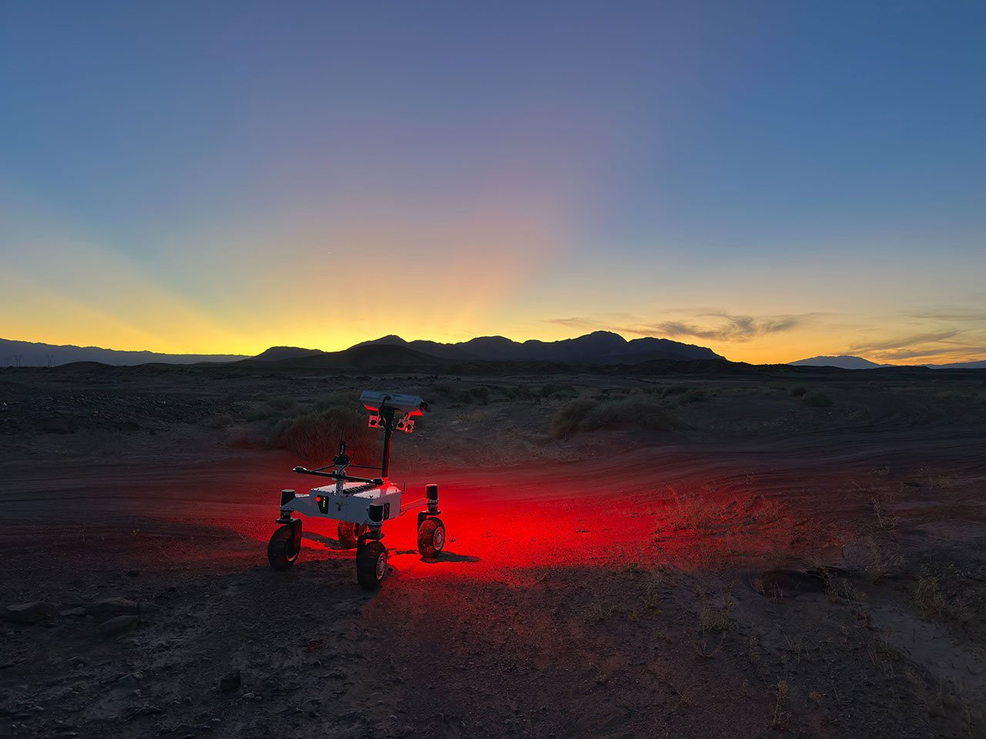
Description A prototype four-wheel rover developed at NASA's Jet Propulsion Laboratory with advanced mobility and robotic autonomy capabilities trundled across the Colorado Desert near Plaster City, California, during a field test in March 2026. Called ERNEST (Exploration Rover for Navigating Extreme Sloped Terrain), the rover served here as a testbed for autonomy software developed for a potential lunar mission requiring higher speeds and much greater mileage than can be achieved with current planetary rovers. ERNEST was trailed by engineers as it traveled about 16 miles over the course of 37 hours of drive time. That's more than 10 times the speed at which NASA's Perseverance rover can navigate on Mars. The team also tested how well the rover traveled at dusk, dawn, and nighttime to simulate the experience of large terrain shadows in polar regions on the Moon. Figure A Figure A shows the rover traveling toward its shadow. Figure B Figure B shows two team members setting up illuminators on the rover at night. Figure C Figure C shows three team members observing the rover during its long-range traverse. Figure D Figure D shows the rover with one wheel up on a rock. Work on ERNEST began in 2022 and was initially supported by JPL internal research and development funds. It is currently funded by NASA's Mars Exploration Program and the agency's Exploration Science Strategy Integration Office under its Science Mission Directorate in Washington. Caltech in Pasadena, California, manages JPL for NASA.

11. NASA Testing Advanced Capabilities for Moon, Mars Rovers
Read more

Developed at NASA's Jet Propulsion Laboratory, ERNEST (Exploration Rover for Navigating Extreme Sloped Terrain) is used in a desert field test to help refine mobility hardware and autonomy software that could be used for a potential future long-range lunar rover mission. During the field test, which took place in March 2026 in the Colorado Desert of Southern California, the JPL team deployed ERNEST at all times of the day - including dusk, dawn, and nighttime, when lighting conditions create long shadows like those seen on the Moon's polar regions. On a bleak stretch of the Colorado Desert in Southern California, a compact four-wheeled rover recently trundled about 16 miles (26 kilometers) with minimal intervention from the team of engineers trailing it. Called ERNEST (Exploration Rover for Navigating Extreme Sloped Terrain), this prototype is being used by NASA to advance both robotic autonomy and the ability to traverse challenging landscapes. Developed at NASA's Jet Propulsion Laboratory in Southern California, ERNEST is 4 feet (1.2 meters) long. Not only can it lift each of its mesh wheels to get past obstacles that would stymie Curiosity and Perseverance, NASA's six-wheeled Mars rovers, but the prototype also has enhanced independent decision-making capabilities. These mobility and autonomy advances could be infused into future missions that will venture to previously inaccessible areas of the Red Planet or the Moon. ERNEST serves as a testbed for a potential future lunar rover mission requiring high speeds and extreme distances. In a recent field test, the prototype traveled 16 miles over the course of 37 hours, going an order of magnitude above the top speed at which NASA's current Mars rovers can navigate. Credit: NASA/JPL-Caltech In the field, ERNEST served as a testbed for a potential future lunar mission requiring higher speeds and much greater mileage than can be accomplished by current rovers. This technology could be used to inform future designs for exploration efforts on the Moon and beyond. "This testing is helping us refine the mobility hardware and autonomy software to navigate extreme distances across a wide range of terrain and lighting conditions anticipated on the Moon," said Issa Nesnas, a principal technologist at JPL who led the recent testing as head of autonomy for a NASA mission concept for a potential future long-range lunar rover. Engineers from JPL set up illuminators after transporting ERNEST for a pre-sunrise test during a seven-day desert field campaign. NASA/JPL-Caltech Nesnas' team is using ERNEST to demonstrate it is possible to build a rover that's twice as big as the prototype and capable of a long-distance Moon mission. During the recent campaign, ERNEST traveled at speeds up to 0.6 mph (1 kph) over 37 hours of driving, across seven days of intermittent testing. That's an order of magnitude above the top speed Perseverance and Curiosity can navigate. "You could do a science road trip across the Moon - or Mars - with this vehicle," said James Keane, a JPL planetary scientist working on lunar missions. The initial goal of the team that developed ERNEST was mechanical: to design a relatively simple, low-cost rover that advances the trusted rocker-bogie suspension system featured on every Mars rover since NASA's Sojourner. This passive system keeps relatively constant weight on all six wheels, thanks to pivot points and struts that enable each one to adapt to the changing surface. The mobility and autonomy advances developed at JPL for the ERNEST prototype rover could be infused into future NASA missions to previously inaccessible areas of the Red Planet or the Moon. Credit: NASA/JPL-Caltech On ERNEST, the active suspension lets the rover manage weight distribution among its wheels. Two powered joints in front articulate a gimbal that allows the rover to drive using different gaits like squirming, wheel-walking, and obstacle-climbing. With a clutch mechanism, it can switch between active and passive suspension, which is less terrain capable but more energy efficient. With four steerable wheels, it can drive in any direction, including sideways. "We started by postulating that we could do better in designing a planetary surface robotic mobility system," said Hari Nayar, a JPL principal technologist leading the ERNEST team. "While the rocker-bogie system has been very successful over the past 30 years, there's been a lot of research in that time on mobility and understanding terrain interaction." Before arriving at today's version of ERNEST, the team built two earlier prototypes, each about 2 feet (0.6 meters) long, to test 11 active suspension configurations. In a trailer filled with lunar regolith simulant, they ran experiments at different slope angles over several months before landing on a final design. Then the team scaled up, including adding a rectangular head mounted on a 4.5-foot-tall (1.4-meter-tall) mast. The hardware was completed in September 2024, but the rover still needed a human operator to joystick it, sending commands to instruct the rover on how to move over obstacles. In order to train the rover to think on its own, the ERNEST team turned to reinforcement learning, a type of artificial intelligence where the robot learns by interacting with its environment. The Dynamics and Real-Time Simulation Laboratory at JPL developed a high-fidelity virtual testing environment that replicates the rover's behavior. The team fed the simulator data collected by engineers who documented the response of the actual rover hardware to a variety of terrain types. On a high-performance computing cluster, the team ran many simulations at once, sometimes completing thousands of hours of tests over a single weekend. After months of virtual training, the ERNEST team was ready to see if the rover could use its new autonomous algorithms to figure out how to drive over terrain features that would halt a passive-suspension rover. They set up an obstacle course with sand ripples, rubble piles, steps, and steep slopes in JPL's Mars Yard, an outdoor terrain proving ground. Then they watched as the rover maneuvered the terrain on its own. Since then, ERNEST has completed many such courses. Nayar's team is starting a new autonomy project which involves integrating the rover's ability to determine when and how to use its active suspension with longer-range intelligent navigation. The goal is to enable ERNEST to plan an efficient path so that it can tackle surmountable obstacles and circumnavigate hazardous ones. These capabilities could contribute to potential future rover missions encountering formidable landscapes on Mars or more rugged areas of the Moon. Work on ERNEST began in 2022 was initially supported by JPL internal research and development funds. It is currently funded by NASA's Mars Exploration Program and the agency's Exploration Science Strategy and Integration Office in its Science Mission Directorate at NASA Headquarters in Washington. Caltech in Pasadena, California, manages JPL for NASA. Media Contacts Karen Fox / Molly Wasser NASA Headquarters, Washington 240-285-5155 / 240-419-1732 karen.c.fox@nasa.gov / molly.l.wasser@nasa.gov Melissa Pamer Jet Propulsion Laboratory, Pasadena, Calif. 626-314-4928 melissa.pamer@jpl.nasa.gov 2026-040

12. NASA's Lucy Reveals Wobbling, Peanut-Shaped Asteroid
Read more
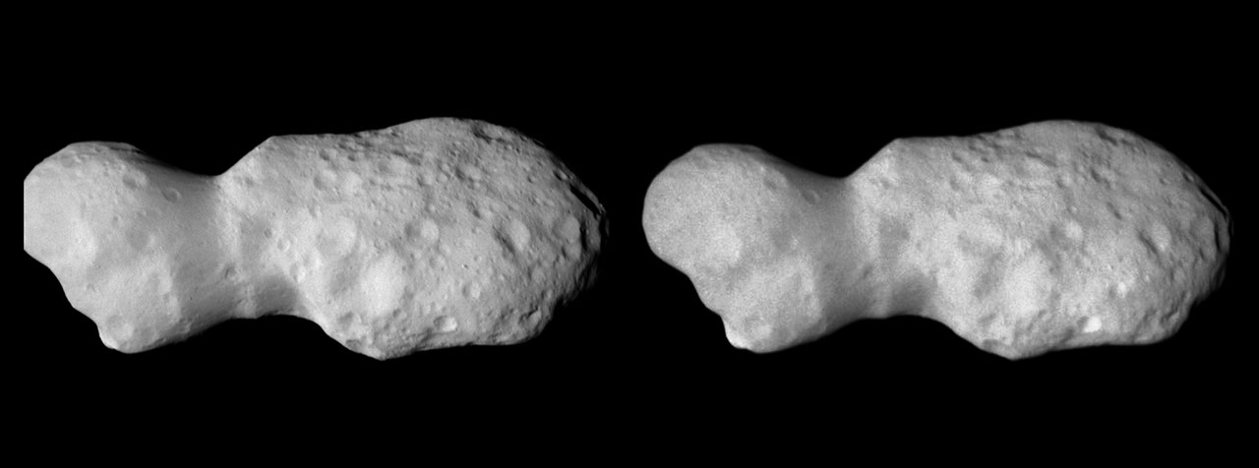
Even small asteroids lead complex lives. During its flyby of the asteroid Donaldjohanson last year, NASA's Lucy spacecraft revealed the asteroid to be a wobbly, peanut-shaped body that has undergone a lot of activity in its relatively short history. Formed as fragments coalesced after a violent collision 155 million years ago, the asteroid was transformed by the small but inexorable force of the Sun's radiation, all while retaining signs of the brief presence of liquid water in its distant past. Zooming through the main asteroid belt toward one of the Jupiter Trojan asteroid groups, the Lucy spacecraft collected the first close-up images and other data at Donaldjohanson on April 20, 2025, as it passed 650 miles away from the asteroid. The data revealed that, instead of spinning simply around one axis like most other asteroids and planets, Donaldjohanson has a more complicated two-axis rotation. Scientists also saw Donaldjohanson's peanut shape and the craters and ridges on its surface. To view this video please enable JavaScript, and consider upgrading to a web browser that supports HTML5 video A timelapse video made from images taken by NASA's Lucy spacecraft as it approached the asteroid Donaldjohanson on April 20, 2025. The L'LORRI (Lucy Long Range Reconnaissance Imager) instrument, the spacecraft's high-resolution black-and-white imager, collected these images over two hours as the spacecraft rapidly closed in on the asteroid from an initial separation of more than 58,000 miles (93,000 km), until the spacecraft passed a mere 650 miles (1000 km) from the 5-mile- (8 km-) wide asteroid. NASA/Goddard/SwRI/JHU-APL Lucy's encounter with the asteroid was planned as a dress rehearsal for the spacecraft and mission team before its primary asteroid encounters, which begin with Lucy's flyby of the Trojan asteroid Eurybates on Aug. 12, 2027. The instruments performed as expected, and, as a bonus, scientists got a rare opportunity to study a previously unexplored asteroid up close and to compare it to two asteroids with similar compositions but different histories: Bennu, the target of NASA's OSIRIS-REx sample-return mission, and Ryugu, the site of JAXA's (Japan Aerospace Exploration Agency) Hayabusa2 sample-return mission. Here's what Lucy's science team has learned so far from Lucy's encounter with Donaldjohanson, as reported on June 18 in the journal Science. Wobbling rotation With Earth-based telescopes, observers saw fluctuations in the light Donaldjohanson reflects, regular patterns of peaks and valleys, typical of an elongated object rotating once every 10.5 Earth days. But Lucy's data revealed another pattern: Donaldjohanson appears to be rotating like a wobbly top. Paper authors reported that the asteroid rotates end-over-end once every 10.5 Earth days, and wobbles back and forth around its long axis once every 26.5 days. To view this video please enable JavaScript, and consider upgrading to a web browser that supports HTML5 video The asteroid Donaldjohanson is shown slowly rotating in a tumbling, non-principal axis motion, with its angular momentum vector and rotation axes indicated. The surface is colored by gravity slope, which measures the angle between the local surface and the direction of gravity. Higher values (warmer colors) indicate steeper terrain relative to the local gravitational pull. Regions with limited stereo image coverage have been masked out where the shape model is less well constrained. Kel Elkins/NASA's Science Visualization Studio/DLR Peanut shape While the Earth-based observations hinted at Donaldjohanson's elongated shape, the Lucy flyby revealed a "bilobate" structure: two lobes connected by a neck, like a peanut. These lobes are likely two fragments from an asteroid collision that gently came together afterward by their mutual gravity. Donaldjohanson likely rotated at least 10 times faster when it formed, having slowed to its current rate in the last 20 to 60 million years, the team estimates. As it slowed, the balance between the centrifugal force pushing things apart and gravity pulling things together changed and loose rocky material slid down slopes creating the worn-down appearance of many craters, as the flyby images showed. The paper's authors say that the asteroid's slowing rotation is likely caused by a subtle consequence of solar heating known as the YORP effect. Each part of the asteroid's Sun-warmed surface radiates heat away as infrared light, and that radiation imparts a tiny recoil force to the surface. Because the asteroid's shape isn't symmetric, this results in a net torque, or twist, that can change the asteroid's rotation. Thus, YORP can slow asteroid spins down or speed them up, as in the case of Bennu (once every four hours) and Ryugu (once about every seven hours), which both likely used to rotate much slower than they do today. Fleeting water As it passed by Donaldjohanson at 30,000 mph, Lucy recorded the signatures of iron-rich clay minerals on the surface. These clays must have formed in the distant past with the help of liquid water. However, the exposure must have been brief, Lucy scientists concluded, because iron in clays tends to be replaced with other elements, such as magnesium, as water lingers. Indeed, scientists saw magnesium-rich clays at Bennu and Ryugu, which suggested prolonged water exposure, perhaps lasting millions of years, when they were still part of larger asteroids. This difference in water exposure history, and other characteristics, may mean that the parent bodies of these asteroids formed at different times or in different regions of the solar system before relocating to the main belt. Compare, contrast Donaldjohanson is thought to be made from rocky remnants of a larger, carbon- and water-rich asteroid that collided with another object in the main asteroid belt. Bennu and Ryugu are thought to have formed in the same way and in the same region. But Donaldjohanson is different. At 155 million years old, it is much younger than Bennu and Ryugu, which formed 1 to 2 billion years ago. Donaldjohanson also has remained in the asteroid belt since birth, while its wandering cousins migrated into orbits around the Sun that bring them close to Earth's orbit about once a year (which made them perfect close targets for sample return missions). During its April 20, 2025, encounter with the main-belt asteroid Donaldjohanson, NASA's Lucy spacecraft discovered evidence for iron-rich clays on the surface using its infrared spectrometer. These clays, which are similar to those found in carbon-rich meteorites such as QUE 97990, indicate that water was briefly present in the asteroid during the distant past. NASA/Goddard/SwRI/Dan Gallagher "It's helpful for scientists to compare Donaldjohanson with asteroids like Bennu and Ryugu, which are seemingly similar asteroids, because every subtle difference is another clue to our origin story," said Simone Marchi, Lucy deputy principal investigator and lead author of the study at the Boulder, Colorado, office of the Southwest Research Institute. "Once we start learning more about the Trojans, a completely different population of space rocks with very different histories, our understanding of solar system formation is destined to be challenged," said Marchi. Named after a fossilized skeleton of a human ancestor discovered in Ethiopia in 1974, NASA's Lucy will be the first mission to explore Jupiter's Trojan asteroids, a population of well-preserved space rocks that formed early in our solar system's history and could help scientists understand how the planets formed and moved around before settling in their current configuration. Download story graphics from NASA's Scientific Visualization Studio. About Lucy: Lucy's principal investigator is based out of the Boulder, Colorado, branch of Southwest Research Institute, headquartered in San Antonio. NASA's Goddard Space Flight Center in Greenbelt, Maryland, provides overall mission management, systems engineering, and safety and mission assurance. Lockheed Martin Space in Littleton, Colorado, built the spacecraft. Lucy is the 13th mission in NASA's Discovery Program. NASA's Marshall Space Flight Center in Huntsville, Alabama, manages the Discovery Program for the agency's Science Mission Directorate in Washington. For more information on NASA's Lucy mission, visit: By Lonnie Shekhtman NASA's Goddard Space Flight Center, Greenbelt, Md. and Katherine Kretke Southwest Research Institute, Boulder, Colo. Media Contacts: Karen Fox / Molly Wasser Headquarters, Washington 240-285-5155 / 240-419-1732 karen.c.fox@nasa.gov / molly.l.wasser@nasa.gov Sarah Frazier 202-853-7191 sarah.frazier@nasa.gov

13. Hubble Glimpses Merging Galaxy Clusters
Read more
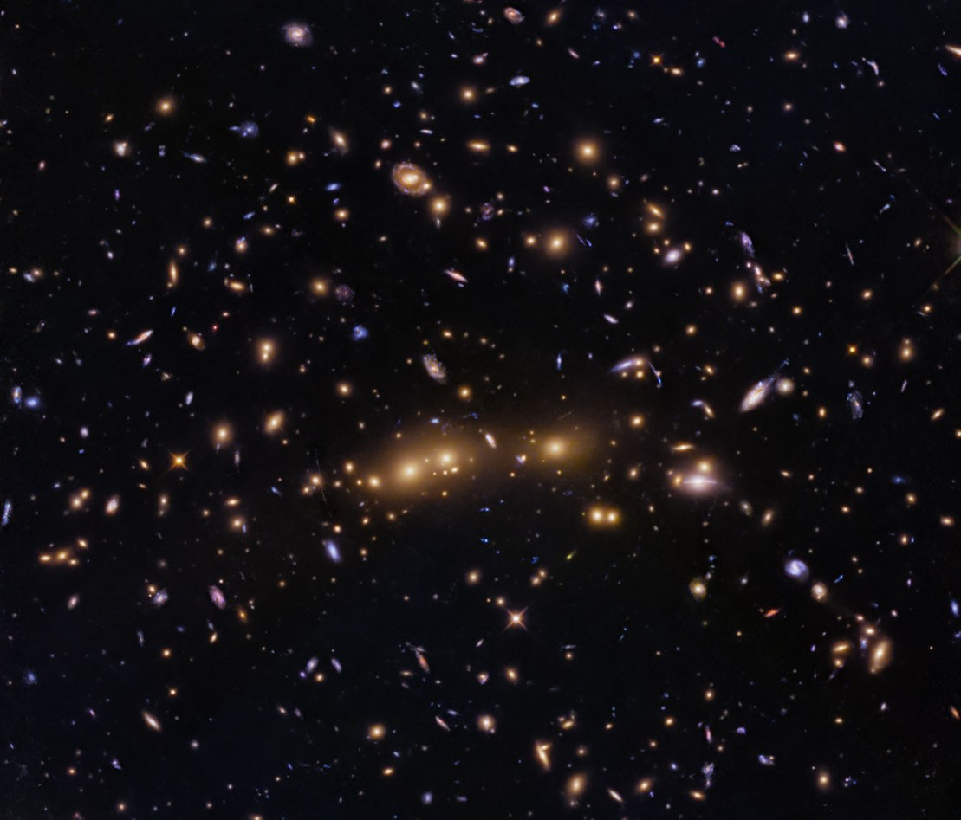
This NASA Hubble Space Telescope image features a swarm of galaxies in the galaxy cluster called CL0016+1609 or MACS J0018.5+1626. NASA, ESA, H. Ebeling (University of Hawaii), D. Coe (STScI, ESA, JWST); Image Processing: G. Kober (NASA/Catholic University of America) This NASA Hubble Space Telescope image features a galaxy cluster, called CL0016+1609 or MACS J0018.5+1626, that is very bright at X-ray wavelengths and is one of the most extensively studied clusters at X-ray and radio wavelengths. The X-ray observations of this cluster revealed that it is two clusters merging along our line of sight. Researchers requested time to observe CL0016+1609 with Hubble's Advanced Camera for Surveys because that data would help them accurately measure the cluster's dark-matter distribution, which helps them study the merger and the role of CL0016+1609 in the large-scale structure of the universe. Hubble can't directly see dark matter, but its infrared and visible light observations can detect dark matter's gravitational lensing effects on the normal matter Hubble observes. The data in this image also includes observations with Hubble's Wide Field Camera 3 taken as part of an observing program that obtained the first Hubble infrared images of 46 massive galaxy clusters and looked for distant galaxies gravitationally lensed by these clusters. Called RELICS (Reionization Lensing Cluster Survey), this survey found some 300 high-redshift candidate galaxies lensed by these clusters. You can see the faint vertical arc of one of these distant galaxies in the image above. Look for it just to the left of the large elliptical galaxies in the center of the image. Another brighter, though shorter arc is visible just above and to the right of the large elliptical galaxies in the center of the image. Media Contact: Claire Andreoli NASA's Goddard Space Flight Center, Greenbelt, MD claire.andreoli@nasa.gov

14. James Webb Space Telescope finds a salty surprise on famous 'Pink Planet'
Read more
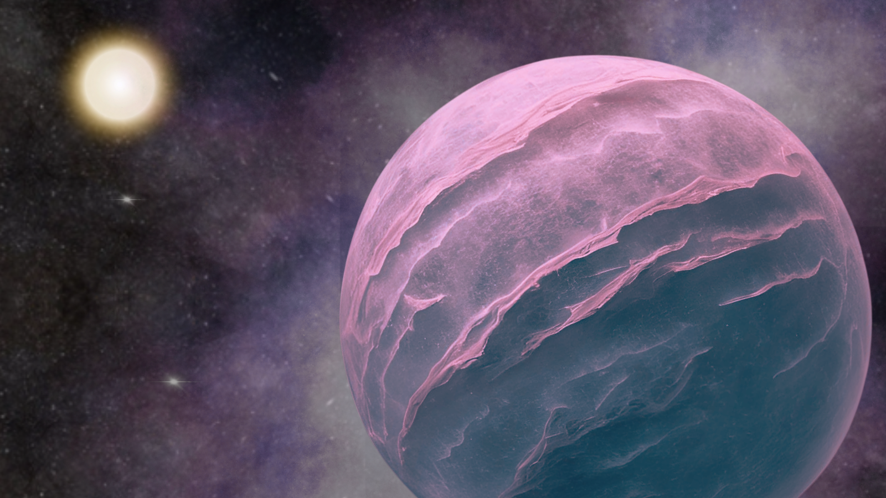
Click for next article Using the James Webb Space Telescope, astronomers have discovered that the well-known "Pink Planet" harbors a salty surprise and an exotic atmospheric chemistry. The discovery marks an advancement in the study of cold objects beyond the solar system. Initially discovered in 2013, GJ504b orbits a sun-like star located around 57 light-years from Earth. With a mass around 25 times that of Jupiter , this Pink Planet may not be a planet at all despite its moniker. It may instead be a brown dwarf , a failed star that formed like a star but was unable to gather enough mass to achieve the nuclear fusion of hydrogen to helium in its core. Thus, astronomers refer to it as a "planetary-mass companion," which means a planet-size object orbiting a parent star. GJ504b remains one of the coldest planetary-mass companions discovered using ground-based telescopes, with a temperature of around 550 degrees Fahrenheit (290 degrees Celsius). Although, that still makes it hot enough to bake bread. Now, James Webb Space Telescope (JWST) data reveals it has a key ingredient for bread making too: salt located in its atmospheric clouds, unlike anything astronomers have seen before. "The Pink Planet is the coldest companion ever discovered using ground-based instruments," team leader Aneesh Baburaj of Northwestern University said in a statement . "Many teams all around the world performed follow-up observations to study its light, but it was too faint for ground-based instruments. That made it a perfect target for JWST. "When we finally obtained its spectrum, it immediately looked interesting. But once we started digging deeper into the data, we realized it was not like anything we have analyzed before." The Pink Planet is cold and old The team studied this planetary companion by measuring its faint electromagnetic radiation emissions and filtering out the bright glare of its parent star. They found the relative coolness of the Pink Planet is a result of the planet's age. Both gas giant planets and brown dwarfs are born blisteringly hot but cool off as they get older. This new research estimated that GJ504b is between 2.5 billion and 4 billion years old. Breaking down light from the Pink Planet into individual wavelengths , the team was also able to determine its chemical composition. This is possible because elements absorb and emit light at characteristic wavelengths, meaning they leave "fingerprints" on light passing through their atmospheres. "In the past, other astronomers observed the companion for an entire night with some of the biggest telescopes in the world to obtain a spectrum," Baburaj said. "And they could not see the object. With JWST, our entire observation took around two hours, and we were successful." The JWST data revealed a rich cocktail of chemicals in the atmosphere of the Pink Planet that included water, carbon dioxide, methane, and ammonia. However, these observations didn't match modeling of the planetary companion's atmosphere until the team factored in something completely unexpected: clouds of salt deep in the atmosphere. An illustration of the JWST which has become a vital tool in the investigation of exoplanets and brown dwarfs. (Image credit: ESA) "We ran simulations with clouds, and the results aligned with what we know about cold planets," Baburaj said. "We tried three different types of clouds, and salt clouds fit best. When we accounted for salt clouds, it subdued the signature of molecules hidden deeper in the companion's atmosphere. Then, the results became physically possible. "This is the first time we've found that salt clouds are critical to explaining the spectrum of an object. It's a good reminder to account for clouds in our models." Though this mystery may be solved, there are still questions surrounding GJ504b that will only be solved with further investigation. The Pink Planet seems to be unusually rich in elements heavier than hydrogen and helium, which astronomers call metals. This means the team still can't pin down the origin of the Pink Planet; did it form like a planet, or like a star? That means they aren't quite ready to determine if GJ504b is a gas giant planet or a brown dwarf... or should that be Pink Dwarf? The team's research was published on Thursday (June 18) in The Astronomical Journal.

