 |  | 

🌌 अंतरिक्ष समाचार | Space News
सोमवार, २२/०६/२०२६ | Monday, 22/06/2026

1. ISRO successfully conducts 2nd integrated air drop test for Gaganyaan mission | Akashvani News - Newsonair
Read more
The Indian Space Research Organisation (ISRO) has successfully conducted the second integrated air drop test (IADT-02) for the upcoming Gaganyaan mission at Sriharikota in Andhra Pradesh. The system is essential to ensure safe recovery of the crew module - the capsule in which astronauts sit during a human flight. After the module's release, a parachute system, comprising 10 parachutes, was deployed, helping the capsule decelerate to a safe splashdown speed. The IADT-02 follows the successful completion of the first IADT, which took place on August 24, 2025, at the Satish Dhawan Space Centre in Sriharikota. In the first IADT, a 4.8-tonne dummy crew module was dropped from a height of three km by a Chinook helicopter. Air drop tests recreate the last leg of a spacecraft's return to the Earth. An aircraft or helicopter drops the spacecraft from a height to test various systems under different scenarios. These are the deployment of the parachute system in case the mission is aborted mid-flight, system performance when one parachute fails to open, and the spacecraft's orientation and safety during splashdown. Union Minister Jitendra Singh congratulated the ISRO for successfully conducting the test. India's first human spaceflight will be launched from Sriharikota in 2027.

2. ISRO Telemetry Tracking and Command Network - researchmatters.in
Read more
ISRO Telemetry Tracking and Command Network researchmatters.in

3. ISRO Invites Indian Astronomers To Explore XPoSAT Data For New Cosmic Discoveries - News18
Read more
ISRO Invites Indian Astronomers To Explore XPoSAT Data For New Cosmic Discoveries News18

4. Researchers create a mathematical tool to measure the Sun's atmosphere using spacecraft radio signals - researchmatters.in
Read more
Researchers create a mathematical tool to measure the Sun's atmosphere using spacecraft radio signals researchmatters.in

5. Govt says ISRO has developed & operationalised wide range of space-based applications to benefit society - Newsonair
Read more
The Government has said that the Indian Space Research Organisation (ISRO) has developed and operationalised a wide range of space-based applications to benefit all sections of society, including the welfare of the Scheduled Caste community. Science and Technology Minister Dr. Jitendra Singh informed this in a written reply in the Lok Sabha today. The Minister said that key space application areas include satellite-based Potential Fishing Zone (PFZ) advisories, crop acreage and production forecasting, agrometeorological advisories for farmers, crop insurance support, geospatial support for flagship government programmes, tele-education, telemedicine, the Vessel Communication and Support System, and disaster management support. Mr. Singh noted that ISRO has established robust awareness and capacity-building programmes to promote the use of space technology for societal, governance, and disaster management purposes, enabling decision-makers to operate effectively at the grassroots level. He added that these initiatives are designed to be inclusive and accessible to targeted beneficiaries across the country. The Minister further said that the benefits of Earth observation, satellite communication, and navigation applications, particularly in terms of improved connectivity and navigation services, are reaching SC farmers, students, and disaster-prone regions within satellite coverage areas. He also highlighted that the Department has undertaken several measures to ensure the inclusive use of space technology, including the implementation of flagship initiatives such as Digital India, the BharatNet Programme, the Vessel Communication and Support System (VCSS) under the Pradhan Mantri Matsya Sampada Yojana (PMMSY), and the PM e-VIDYA scheme for tele-education.

6. SpaceX Falcon 9 rocket launches 24 Starlink satellites into low Earth orbit from California (video)
Read more
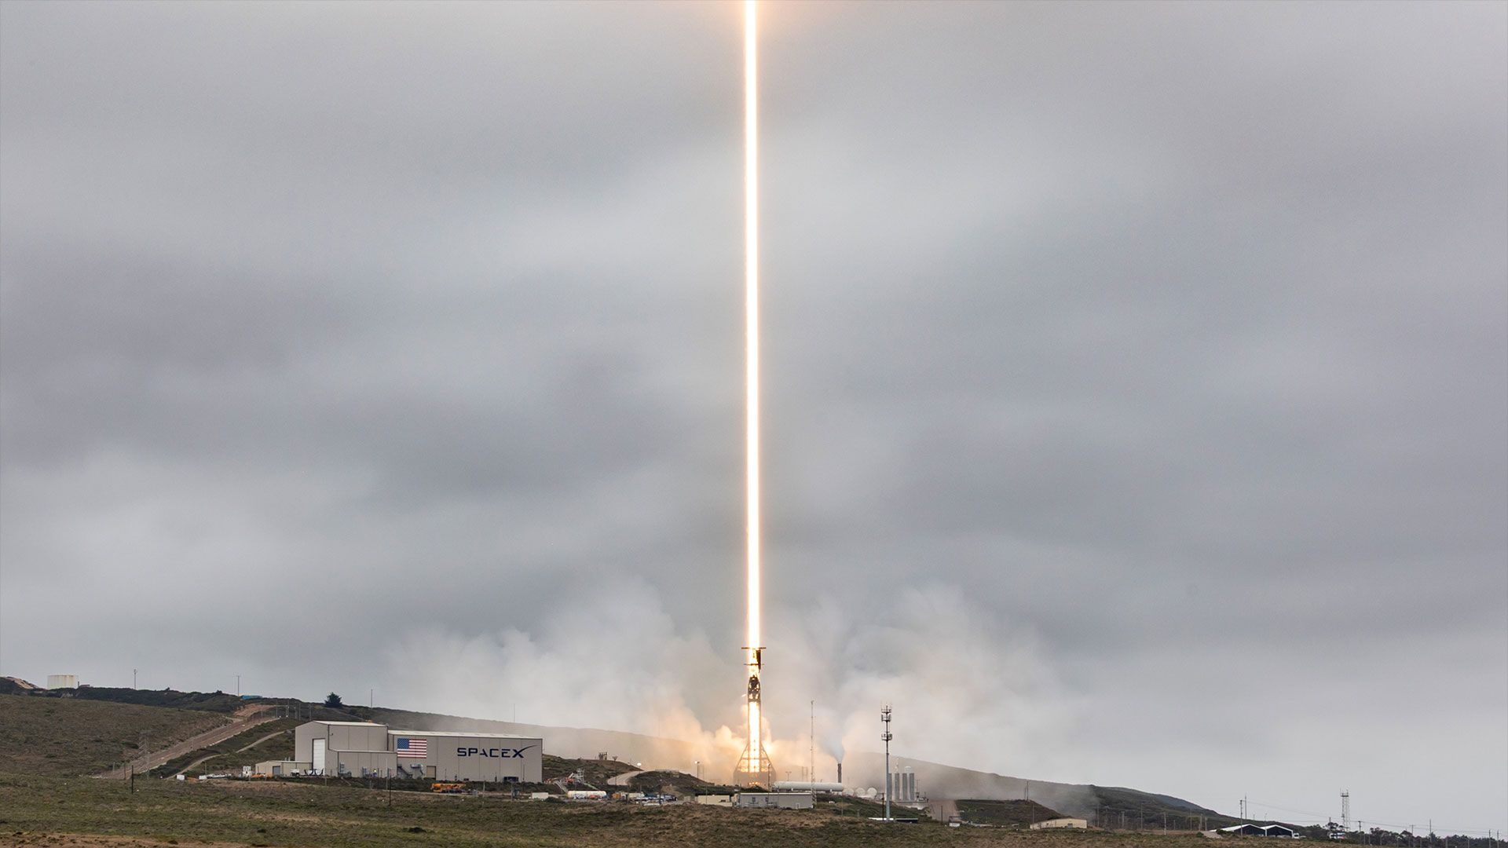
Click for next article SpaceX added 24 satellites to its Starlink megaconstellation on Sunday (June 21) with a launch from California. A Falcon 9 rocket lifted off at 12:39 p.m. EDT (1639 GMT or 9:39 a.m. PDT local time) from Space Launch Complex 4 East at Vandenberg Space Force Base. SpaceX confirmed deployment of the Starlink batch (Group 17-28) about an hour after their launch. The Falcon 9 rocket's first stage (Booster 1063) completed its 33rd launch by landing on the autonomous droneship "Of Course I Still Love You" stationed in the Pacific Ocean. The stage is just two flights shy of the current Falcon 9 reuse record of 35 launches. A SpaceX Falcon 9 rocket carrying 24 Starlink satellites lifted off from Vandenberg Space Force Base in California on Sunday, June 21, 2026. (Image credit: SpaceX) The Starlink network now has more than 10,600 active satellites, according to tracker Jonathan McDowell. The service provides worldwide internet access, as well as inflight wifi and direct to cell connections for select providers. Sunday;s launch was SpaceX's 72nd Falcon 9 mission of the year out of a total history 655 missions.

7. NASA's Nancy Grace Roman Space Telescope arrives in Florida
Read more
NASA's next great observatory, the Nancy Grace Roman Space Telescope, arrived at the Kennedy Space Center aboard the agency's massive Pegasus barge late Sunday morning. The spacecraft was nestled inside its protective case, which NASA nicknamed the "Chariot" in keeping with the "Roman" theme. That said, telescope is named not for the ancient empire, but instead for NASA's first Chief of Astronomy, Nancy Grace Roman. "She was a key person in our exploration of space. She understood that in order to better understand the universe, you have to go in space," said Lucas Paganini, the program executive for Roman. "That's why she's called the 'Mother of Hubble' because she made Hubble possible." The 43-foot-tall observatory disembarked from the barge shortly after 7 p.m. EDT (2300 UTC), following a stream of thunderstorms that delayed its departure by about an hour. The spacecraft will travel to the south end of the KSC campus to a building called the Payload Hazardous Servicing Facility. There it will undergo a roughly 70-day prelaunch campaign involving checkouts, fueling, and finally the encapsulation inside the payload fairing of a Falcon Heavy rocket. The observatory is set to launch from Launch Complex 39A no earlier than August 30, moved up from the original September launch date. "A lot of credit to this great team. They've been able to accommodate schedules, to accelerate to be able to launch earlier," Paganini said. "There's a lot of things going on at the Cape and of course the team has been amazing." <span data-mce-type="bookmark" style="display: inline-block; width: 0px; overflow: hidden; line-height: 0;" class="mce_SELRES_start"></span> This was the second trip to Florida for the Pegasus barge this year after it dropped off the propellant tank section of the core stage for the Artemis 3 Space Launch System rocket back in late April. While the spacecraft arrived safely, Neil Patel, the Roman mechanical engineer who traveled with the observatory, said it wasn't entirely smooth sailing after leaving from Massachusetts. "We do have a tight temperature tolerance on the observatory. We need to stay below 74 degrees. We have two cooling units: we had a primary and a redundant unit and they just weren't getting the job done down here, so we had to make a stop, add additional rental units," Patel said. "Again, it was an amazing effort to have a team come down on an emergency basis. Basically, a MacGyver crew came in and we added additional units and those units did maintain the temperature quite well." Roman is designed to operate near a fixed point in space called Lagrange Point 2, about 1.5 million km away from the Earth on the side opposite the Sun. It's designed to operate there for a minimum of five years, but Paganini said with the propellant onboard, it will likely last for 10 years or more. The telescope is+ equipped with a 300 megapixel camera called the Wide Field Instrument, which features 18 detectors. It was developed by BAE Systems (formerly Ball Aerospace). "It's going to allow us to observe at least 100 times wider field of view than what we can do with Hubble. Same resolution, but a wider area, 1000 times faster," Paganini said. "So what takes Roman a year to observe, it would take Hubble thousands of years. So it's definitely much more efficient." The observatory also features a chronograph instrument, developed by the Jet Propulsion Laboratory, which will allow Roman to observe the faint light of exoplanets near their stars. Paganini said Roman will also help scientists better understand dark matter and dark energy, the combination of which he calls the "dark universe". "100 years ago, we discovered that the universe was expanding. 25 years ago, we discovered that it was expanding at an accelerated pace and that's what led to a Nobel Prize," Paganini said. "What we don't quite know yet is if that acceleration is changing in ways. We don't know if it's actually dark energy, what is producing it, or is it simply that we don't understand gravity at all. "So eventually, we'll see if the laws of physics that we use these days are the right ones for what we are observing. But at the end is, we're trying to understand a very human question, which is where do we come from and where are wea heading in this universe that is our neighborhood?"

8. NASA testing advanced capabilities for moon, Mars rovers
Read more
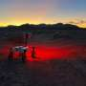
On a bleak stretch of the Colorado Desert in Southern California, a compact four-wheeled rover recently trundled 16 miles (26 kilometers) with minimal intervention from the team of engineers trailing it. Called ERNEST (Exploration Rover for Navigating Extreme Sloped Terrain), this prototype is being used by NASA to advance both robotic autonomy and the ability to traverse chall...

