 |  | 

🌌 अंतरिक्ष समाचार | Space News
शुक्रवार, ३१/०७/२०२६ | Friday, 31/07/2026

1. Medical Lab Technologists Association to march to CM residence today
Read more
PIONEER EDGE NEWS SERVICE/Dehradun With their longstanding demands remaining unmet, the Medical Laboratory Technologists Association of Uttarakhand has decided to march to the chief minister's residence on July 31. The general secretary of the association, Mayank Rana, informed that they have been peacefully staging a sit-in at Ekta Vihar, Dehradun, for the past 73 days, pressing for the fulfillment of their four legitimate demands. Their demands include the creation of Medical Laboratory Technologist posts in accordance with Indian Public Health Standards (IPHS), framing of service rules and ensuring regular annual merit-based recruitment for B Sc Medical Laboratory Technology (B Sc MLT) graduates. They are demanding a one-time age relaxation for eligible candidates who have exceeded the upper age limit due to prolonged delays in recruitment as well as an end to the privatisation and outsourcing of government laboratory services, with regular appointments to sanctioned government posts, he said. Rana further stated that despite receiving support from several organisations, healthcare professionals and social groups, the government is dithering. "No officials have cared to visit us for the past few days and so no dialogue has been held to break the impasse," he said. Warning of indefinite sit-in, he said that they were all set to march to the CM's residence on Friday. "Medical Laboratory Technologists, B Sc MLT graduates and students from across Uttarakhand are expected to participate in large numbers to submit our legitimate demands to the government," he said, adding that they would gather at Gandhi Park around 10: 30AM and commence the march from there. "Earlier also we staged a march towards the CM's residence and made numerous attempts to secure appointments to meet him, but we were unsuccessful," he added.

2. Free ISRO from bureaucratic control. The public-private space model needs it - theprint.in
Read more
Before looking at how India can build on this momentum, it is worth revisiting the country's space journey over the past several decades. This milestone signals a new chapter in India's space programme, based on the foundation laid by ISRO but with fewer bureaucratic constraints and more room for private enterprise. As Prime Minister Narendra Modi said earlier this month, the successful orbital launch of Vikram-1, India's first privately developed launch vehicle, is "a historic new frontier for India's space journey". Also Read: Why foreign universities alone won't fix India's higher education crisis ISRO's pioneering groundwork What began as the Indian National Committee for Space Research (INCOSPAR), founded by Dr Vikram Sarabhai in 1962, evolved over time into the Indian Space Research Organisation (ISRO) in 1969. India's first step into outer space was the launch of the Aryabhata satellite in 1975. Three decades later, Chandrayaan-1 added value to lunar exploration by discovering water molecules on the Moon. In 2014, India became the first country to reach Mars on its maiden attempt with the Mars Orbiter Mission, Mangalyaan. ISRO further solidified its scientific prowess with Chandrayaan-3, Aditya-L1 and the SPADEX space docking experiment. Behind many of these recent successes was ISRO's long effort to develop its own launch capabilities. ISRO began developing the solid-fuelled Satellite Launch Vehicle-3 (SLV-3) in 1973 under its then project director, and later President of India, Dr APJ Abdul Kalam. In 1980, it launched the 40 kg remote sensing satellite Rohini, making India the seventh country to demonstrate the capability to launch a satellite and place it in orbit. The development of the Augmented Satellite Launch Vehicle (ASLV) in the late 1980s and the launch of the Polar Satellite Launch Vehicle (PSLV) in October 1994-which placed the 870 kg Indian Remote Sensing (IRS) P2 satellite into Low Earth Orbit (LEO) at an altitude of 825 km-were ample proof of India's self-reliance. The Indian space agency also developed the technological capability for outer space exploration through the Geosynchronous Satellite Launch Vehicle (GSLV), designed to place heavier payloads into Geosynchronous Transfer Orbit using cryogenic rocket engines. Desperately in need of this technology, India signed a USD 120 million deal with Glavkosmos of the Soviet Union in January 1991 for the supply of two KVD-1 cryogenic engines and the transfer of technology. As the India-Russia agreement was being put in place, the US, in July 1993, arm-twisted both countries by imposing sanctions on ISRO and Glavkosmos, stalling the engine supply on the grounds that it violated the Missile Technology Control Regime (MTCR). ISRO responded by launching its ambitious indigenous Cryogenic Upper Stage (CUS) project in 1995 and eventually mastered the ultra-low-temperature technology. Giant leaps & systemic setbacks Due to the untiring efforts and monumental research of ISRO's scientists, and the vision of successive governments, India's space programme over the decades has leapt forward on three major fronts: technological capacity building, strengthening self-reliance, and laying the foundations for public-private partnerships in space-related commercial ventures through R&D and innovation. ISRO's space-based innovations, projects, launches and applications are now supporting governance, commercial payment systems and banking, healthcare, education, disaster management and livelihoods in India, while also providing support to countries in the region. GSAT-9, conceived as the SAARC satellite and launched as the South Asia Satellite in 2017 after Pakistan opted out, is a Rs 450 crore geostationary communication satellite equipped with 12 Ku-band transponders. It provides Fixed Satellite Services (FSS), including television broadcasting, DTH, VSAT connectivity, tele-education, telemedicine, as well as delivering critical communication links and real-time coordination during natural disasters such as cyclones, earthquakes and floods. Against this backdrop, it is sad and frustrating that the government's premier institution for pioneering research in outer space should experience a massive talent exodus. The reasons for this are not far to seek: lack of vision, bureaucratic rigidity and organisational inertia. While nothing prevents ISRO from commercialising and monetising its capabilities and investment in research, the government also made the wise choice of allowing private investors to tap into the agency's expertise, as is the method followed by American institutions and industries. Also Read: Skyroot's Vikram-1 success shows it's time for ISRO to redefine its role India's next space odyssey On 18 July, Skyroot Aerospace Private Limited, founded in 2018 by former ISRO engineers Pawan Kumar Chandana and Naga Bharath Daka, successfully executed the Aagaman mission, launching Vikram-1 from Sriharikota. It thereby announced India's entry into the private orbital launch market. Incidentally, just a few days before the launch, Brian Babin, chairman of the US House Committee on Science, Space and Technology, was eulogising America's "innovative commercial sector". He also sounded a warning: "As other nations, particularly China under the Chinese Communist Party, seek to overtake us in space, we must ensure that American innovators are competing against our adversaries-not against unnecessary government bureaucracy." ISRO was experiencing precisely this - being stifled by bureaucracy. The US presents a different model. Mike Haridopolos, chairman of the Space and Aeronautics Subcommittee, speaking about the thriving commercial space sector, said that the American aerospace industry now supports nearly 150,000 private sector jobs, more than five times the roughly 30,000 jobs it sustained just 15 years ago. The number of launches in the US, he added, had grown from 54 in 2021 to 199 in 2025. Now, ISRO and India's private sector can jointly position the country as a leader in astronautical and aeronautical research and commercial projects. Commercial ventures must be incubated in research projects from the beginning to reduce risk and improve their viability. However, research, innovation and commercial space ventures require huge investments, robust supply and value-chain mechanisms, strong legal and security systems, and government facilitation to discharge international obligations. Prime Minister Narendra Modi should personally intervene and initiate a massive reform process. This should include reducing bureaucratic control, giving greater autonomy to ISRO's top management, allowing scientists to participate in industry and university projects without quitting ISRO, and strengthening the NewSpace India Limited (NSIL) and Indian National Space Promotion and Authorisation Centre (IN-SPACe). Even the sky is not the limit for India's space odyssey. Seshadri Chari is the former editor of 'Organiser'. Views are personal. (Edited by Asavari Singh)

3. ISRO Apprentice Recruitment 2026 Notification Out: Apply Online Till August 29 - NDTV
Read more
ISRO Apprentice Recruitment 2026 Notification Out: Apply Online Till August 29 NDTV

4. ISRO Apprentice recruitment 2026 opens for over 400 posts at URSC; apply by August 28 - The Times of India
Read more

The Indian Space Research Organisation (ISRO) has launched its Apprentice Recruitment 2026 drive for 410 positions at the U.R. Rao Satellite Centre in Bengaluru. Aspirants can apply through the NATS portal until August 28, 2026. The recruitment covers graduate, technician and commercial apprentice roles, with candidates to be shortlisted on the basis of their academic performance.

5. ISRO's NavIC system can no longer provide navigation data independently: Government - The Indian Express
Read more
The reply also stated: "Next NavIC satellite NVS-03 is ready for launch and two more satellites NVS-04 and NVS-05 are in advanced stage of realisation." For the first time since positioning data from one of its satellites was lost in March, the government has accepted in the parliament that the seven-satellite navigation constellation (NavIC) can no longer independently aid people in navigation. The Indian Space Research Organisation (ISRO) earlier this year informed that IRNSS-1F satellite, which was launched in March 2016, completed its designed mission life of 10 years and the on-board atomic clock stopped functioning. "…presently the NavIC constellation has three satellites for providing PNT (Positioning, Navigation, Timing) services - IRNSS-1B, IRNSS-1I and NVS-01. To provide basic positioning service, minimum four operational satellites are required in orbit. Hence, the NavIC constellation cannot provide standalone positioning service, however timing service is functional," union minister of state for space Dr Jitendra Singh replied in a written answer in Parliament.

6. From ISRO to Inspiring a Greener India | Pankti Pandey's Story - adityabirla.com
Read more
Pankti Pandey spent the early years of her career at ISRO, building the future through science. But some of the values that shaped her life came much earlier, from her grandmother, who taught her that every resource has value. Years later, as she prepared to become a mother, those lessons returned with a new purpose. Wondering what kind of world she would leave behind for her daughter, Pankti began making small changes at home. She started composting kitchen waste, carrying cloth bags to the market, recycling whatever she could, and reducing plastic in her daily life. While many questioned these choices, Pankti believed that lasting change begins with everyday habits. As she puts it, "People often choose convenience because that's what the world encourages... But change doesn't come overnight. It starts with one small habit." Those small habits soon inspired others. Neighbours began adopting similar practices, and what started in one home gradually grew into a community movement. In 2021, Pankti founded Zero Waste Adda, a platform that makes sustainable living simple and practical. Today, it has reached over 4.5 lakh Indians. In her own community, 100 families compost every day, over 80% of homes generate their own solar electricity, and more than 16,000 kg of plastic has been diverted from landfills over the last four years. For Pankti, the journey has always been about starting where you are. "I strongly believe that change always begins at home. So if we want to change the world, we have to change ourselves first. And if we want a better future for our kids, we have to change our habits today." Aditya Birla Group is proud to partner with The Better India to amplify stories of individuals who are changing lives by choosing to be #AForceForGood.

7. The US government wants to bypass environmental laws for commercial launches and spacecraft reentries
Read more
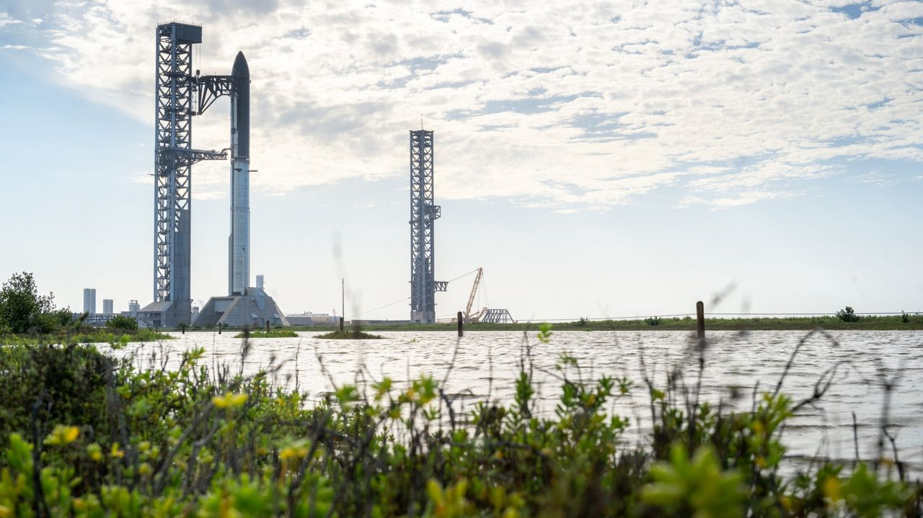
Click for next article A SpaceX Starship V3 rocket stands upright on a launch pad at the company's Starbase facility on May 22, 2026 in Boca Chica Beach, Texas A new Federal Aviation Administration (FAA) proposal says the agency wants to speed up commercial space licensing for rocket launches and spacecraft re-entries by removing "unnecessary" environmental regulations. The proposed FAA rule, released yesterday (July 29), has a 30-day period for comment and if approved, would apply to rocket launches, re-entering spacecraft, and the sites at which launches and re-entries take place. The FAA proposes to "waive requirements of laws of the U.S. for a license or permit, after consultation with the head of the appropriate executive agency, when the requirement is not necessary to protect the public health and safety, safety of property, and national security and foreign policy interests of the United States," the text of the proposal reads, in part. The Department of Transportation stated that the proposal, if implemented, would allow the agency to waive what it calls "unnecessary environmental laws and regulations" that it claims are "slowing American innovation." However, the proposal will still require the FAA to ensure that launches do not impede on public health and safety, or U.S. national security or foreign policy. To do so, the FAA plans to remove 13 federal laws from applying to "certain commercial space licenses and permits", with examples including the National Environmental Policy Act, the Endangered Species Act, parts of the Clean Water Act, the Clean Air Act, and the National Historic Preservation Act. The proposal takes place as the United States is seeing unprecedented demand on its limited spaceports for commercial launches, fueled by broadband satellite constellations like SpaceX Starlink , as well as emergent orbital data centers. Earlier this month, the U.S. government proposed moving some launch operations offshore to ease the demand backlog. More rocket launches, according to peer-reviewed research, could cause environmental issues . The proposal also appears to build on two recent Trump administration executive orders. The first, from December 2025, saw the administration aim to redirect a wide swath of space policy - including boosting the number of rocket launches and landings . (These already were at unprecedented levels last year, mostly on the back of SpaceX .) The second one, in August, focused on streamlining launch licensing and accelerating spaceport construction. A portion of the Lower Rio Grande Valley National Wildlife Refuge. SpaceX and the U.S. government are currently negotiating a land swap for a portion of the refuge. (Image credit: US Fish and Wildlife Service) Meanwhile, SpaceX is trying to procure a federal land swap in south Texas, mostly for Starship operations, but its proposal prompted an emergency injunction last week filed by a coalition of conservation and tribal groups.

8. Satellites spy penguin poop on Danger Islands | Space photo of the day for July 30, 2026
Read more
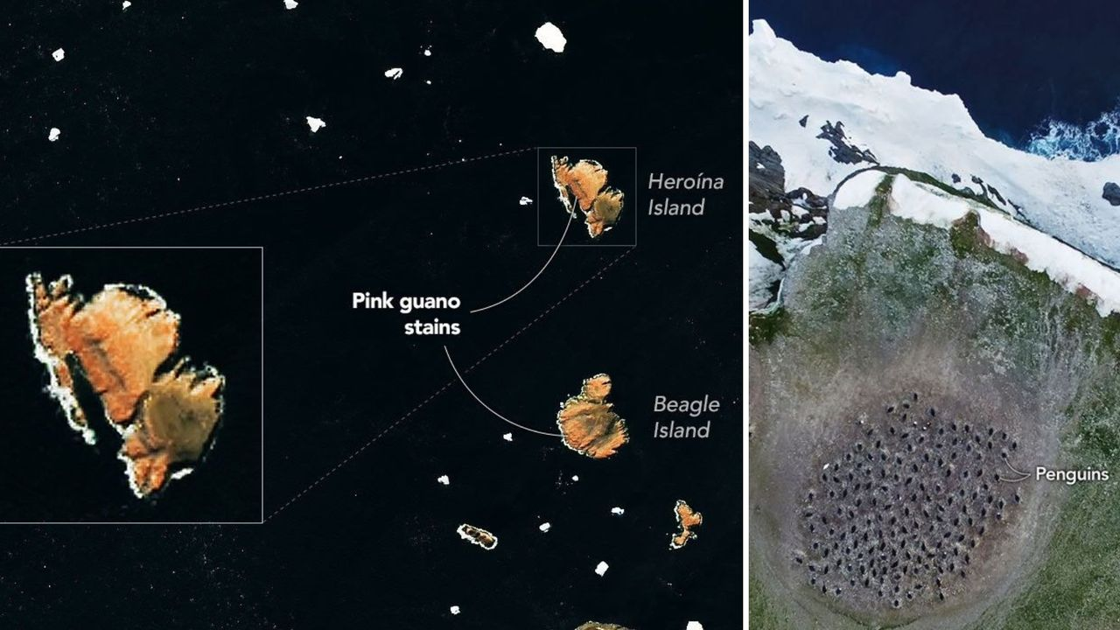
Click for next article Pieces of sea ice drift near Antarctica's Danger Islands in this image, acquired on Jan. 22, 2023, by the Landsat 8 satellite. Several of the islands are stained pink by guano from Adélie penguins with a krill-rich diet. (Image credit: NASA Earth Observatory/Michala Garrison) The diets of penguins on Antarctica's Danger Islands can be seen from space. At least indirectly. Using satellite images captured by the Landsat 8 spacecraft operated by NASA and the United States Geological Survey, scientists can track changes in Adélie penguins' diets based on the color of their guano, or droppings. What is it? The image above shows pinkish-orange guano staining large sections of some of the Danger Islands, Heroína Island and Beagle Island. The penguins that live there eat a diet rich in krill, small marine crustaceans that are bright pink in color due to a specific type of algae upon which they feed. A group of Adelie penguins jumping from ice pebble to ice pebble on a beach of Paulet Island on the tip of the Antarctic Peninsula. (Image credit: Wolfgang Kaehler/LightRocket via Getty Images) The bright pink color of the penguins' droppings stands out in satellite imagery, allowing researchers to monitor the birds' populations from space. But scientists wanted a closer look, and collected drone imagery as well, as seen in the image below. A colony of Adélie penguins is visible in this image captured by a drone during a research expedition to the Danger Islands. (Image credit: Thomas Sayre-McCord/WHOI/MIT) Why is it incredible? It's pretty amazing that the diet of a specific population of birds can be monitored from 438 miles (705 kilometers) above Earth's surface. The imagery collected by Landsat-8 helped scientists locate where the penguin colonies might be, allowing them to find them in-person and collect guano samples. Those samples contained evidence of what the penguins were eating over time. Researchers are using those satellite images and samples to track how the penguins' diet might be affected by changes in sea ice conditions, according to a NASA statement . "Sea ice is such a hugely important factor in the Antarctic marine environment," said Clemson University biologist Casey Youngflesh who led a study comparing the penguins' diet and sea ice conditions. "The structure of the region's food web is changing in response."

9. A SpaceX rocket will crash into the moon next week, and scientists aren't sure what to expect
Read more
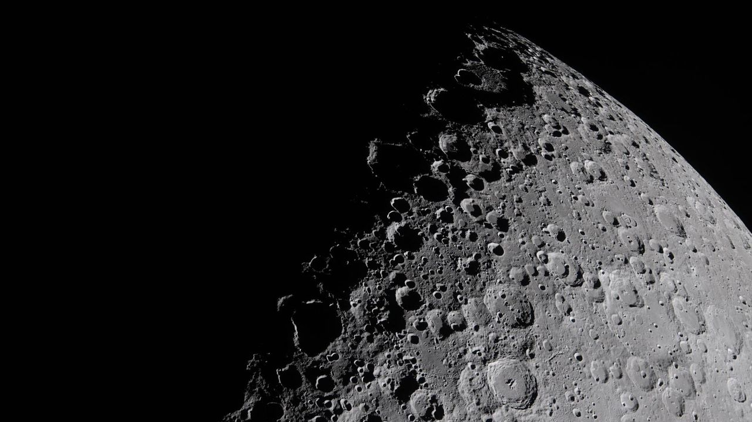
Click for next article A portion of the moon captured by the Artemis II crew during their ten-day mission in April 2026. On Aug. 5, Earth's moon is due for a human-made, high-speed impact from an identified flying object: a spent SpaceX Falcon 9 upper stage. The event will lead to a literal "dust up" on the lunar landscape. That Falcon 9 upper stage is a leftover from the launch that sent Firefly's Blue Ghost-1 lander to the moon on Jan. 15, 2025. Onboard the same flight was the Hakuto-R Mission 2 , called Resilience, a robotic lunar lander developed by the Japanese company ispace. And according to a new study by an international team published on the open-source arXiv server, the resulting impact plume may briefly be bright enough to see against the dark sky near the moon's edge. That means it might be visible to moongazers with sufficiently sensitive telescopes. This head-on collision of the errant stage is expected to occur near the Einstein and Bell craters near the western lunar limb. It may well be visible to ground and space-based assets. Indeed, putting aside all the unknowns and modeling uncertainties, some specialists suggest if you've got the time and observational prowess, it might be worth a look. Visible ejecta spike Using special physics simulations to model the impact, William Jo, a graduate research assistant at the University of Texas, Austin and colleagues predict the debris plume from the impact will have the central ejecta spike reaching roughly 47 miles to over 60 miles (75 kilometers to 100 kilometers) altitude. "Our calculations suggest the plume should be several orders of magnitude brighter than the dark-sky background for the first few minutes after impact," Jo told Space.com. "So the plume should be visible, though I'd stress this is a single nominal case. The real one will look different, and the numbers are on the optimistic side. But the point worth making is that the flash isn't really the story here." Jo emphasized that there's great slam-dunk science to be had. "Watching this one gives us a rare chance to open up ejecta-plume science and calibrate those models against a real event, which matters for every future thing we deliver to the moon," Jo said. An animation predicting the evolution of the target ejecta column density, rendered on the lunar surface at the predicted impact site near Einstein crater by William Jo et al. (Image credit: William Jo/UT Austin) Implications for future moon missions According to new research led by Benjamin Fernando of the Los Alamos National Laboratory in New Mexico, the impact flash and resultant ejecta plume are "potentially observable" from ground- and space-based observational facilities. "This event provides an opportunity to attempt the recording of an artificial impact in real-time; although many of the properties of the event (such as visual magnitude) are imprecisely predicted at present," Fernando and colleagues report. Moreover, this rocket stage meets moon occasion yields an opportunity to test a pipeline for localizing impacts on the lunar surface for future seismic experiments, investigating the dust and plume dynamics from impact events on the moon, and considering hazards from artificial space debris impacts that future astronauts on the lunar surface might have to avoid, Fernando and team members point out. "The maximum ballistic range of resolved particles is found to be slightly under 1,000 km, which is far enough to be significant from the perspective of presenting a hazard to future astronauts or infrastructure across much of the lunar surface," Fernando et al wrote in the study. A SpaceX photo of one of the company's Falcon 9 second stages, taken in 2022. A similar second stage is expected to impact the moon in August 2026. (Image credit: SpaceX) Before and after Brent Garry is a project scientist for NASA's Lunar Reconnaissance Orbiter (LRO) at Goddard Space Flight Center in Greenbelt, Maryland. LRO will be passing over the projected rocket stage crash site about seven days prior to the impact and about seven days after the impact, Garry explains. "After the impact we might have a little bit more knowledge of where it is. We can do some additional targeting about a week after the impact and get some targeting over where the site is," said Garry, as noted in earlier Space.com reporting . Meanwhile, Jo at the University of Texas, Austin underscores the fact that a spent rocket stage is a hollow, spacecraft-like body, and there are very few impact models for human-made objects like it. They seem to produce very different plumes than natural impactors, like asteroids or comets do. But Jo stresses that the real scientific contributions will come by studying the moments after the impact. "My concern is that most observers will stop at the sub-second flash and never track down the ejecta, which is the part that should actually be visible, and where the science is."

10. Scientists advance space agriculture for future moon and Mars missions
Read more
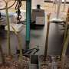
Space isn't known for rich soil or ideal agricultural conditions anywhere in the solar system. Yet amid extreme temperatures and vast distances, multidisciplinary teams at USF's Aerospace: Science, Technology, Research and Applications Center (ASTRA) are collaborating on sustainable space agriculture projects with potential applications back on Earth.

11. Tracking satellites and space debris using radio antennae
Read more

Every year, thousands of satellites are launched into orbit around our planet. The result is an increasingly congested "space" above Earth populated by equipment that provides services to the surface. At the same time, these satellites affect ground-based astronomy and create the potential for damage when they eventually fall through Earth's atmosphere to the surface. In additi...

12. Mission-ready Moon excavation system targets 2028 for NASA's lunar base construction
Read more
Before permanent lunar bases become possible, someone has to level the ground. Preparing the Moon for a sustained human presence will require far more than rockets and habitats. Future missions will also depend on heavy machinery capable of clearing terrain, stabilizing landing areas, and performing construction work without constant human control. That challenge is driving a deeper partnership between lunar resources company Interlune and industrial equipment manufacturer Vermeer Corporation. The companies have expanded their collaboration to develop construction systems for future Moon Base missions, with a mission-ready lunar site-preparation tool now targeted for 2028. The effort aligns with NASA's long-term plans to establish permanent infrastructure on the Moon. It also reflects growing commercial interest in building the equipment needed before large-scale exploration and resource extraction can begin. Heavy equipment heads Moonward Interlune and Vermeer will develop an autonomous tool designed to prepare the lunar surface for construction activities. Engineers plan to integrate the system with a lunar rover before testing it on Earth and later demonstrating it on the Moon. The Interlune-Vermeer excavator prototype unveiled in 2025. Credit - Interlune Unlike traditional construction equipment, the machine must operate in an environment covered with abrasive dust, exposed to extreme temperature swings, and separated from Earth by communication delays. Those conditions demand highly autonomous systems that can perform excavation and site preparation with limited human input. The companies first worked together on a full-scale prototype lunar excavator unveiled in May 2025. That project served as an engineering proof of concept. Their expanded partnership now shifts attention toward hardware intended for operational missions. Interlune co-founder and CEO Rob Meyerson said dependable excavation and autonomous mobility will form the backbone of permanent lunar infrastructure. He added that the companies are now focused on scalable systems capable of supporting future Moon Base construction and harvesting lunar resources. Engineering beyond Earth Vermeer has spent nearly eight decades developing industrial equipment for demanding construction sites. Interlune specializes in robotic systems, space infrastructure and operations in the lunar environment, giving the partnership expertise across both terrestrial engineering and space technology. Engineers expect the equipment to perform some of the earliest construction work on the Moon. Preparing stable surfaces for landing pads, transport routes and future facilities will become increasingly important as mission activity grows. Vermeer President and CEO Jason Andringa said the company views the Moon as its most demanding job site yet. He said Vermeer plans to work with Interlune, NASA and other partners to help supply the infrastructure required for future lunar settlements. Foundation for future missions The partners expect to deliver a mission-ready site-preparation system by 2028, matching NASA's broader Moon Base timeline. Success could influence how future missions approach extraterrestrial construction. Equipment developed for the Moon may eventually support resource extraction, infrastructure projects, and exploration efforts on Mars and other destinations. As governments and private companies increase their lunar ambitions, autonomous construction equipment is emerging as a critical piece of the broader space economy. The ability to reshape the lunar surface before astronauts arrive could determine how quickly permanent outposts become reality.

