 |  | 

🌌 अंतरिक्ष समाचार | Space News
रविवार, १६/०८/२०२६ | Sunday, 16/08/2026

1. ISRO Scientist Recruitment 2026: Apply for 92 Posts - Education Today
Read more
ISRO Scientist Recruitment 2026: Applications Open for 92 Posts, Check Eligibility and Selection Process Leave a Comment / Daily News Table of Contents - 92 Scientist and Engineer Vacancies Announced - Academic Eligibility for Applicants - Age Limit and Application Fee - Selection Based on GATE Score and Interview - How Candidates Can Apply - Why the Recruitment Matters for Engineering Graduates - Engineering Skills Meet Space Technology - A Career Opportunity Within India's Space Programme The Indian Space Research Organisation (ISRO) has opened applications for 92 Scientist/Engineer 'SC' positions across multiple engineering disciplines, offering qualified candidates an opportunity to build a career with India's premier space research organisation. The recruitment is being conducted through the ISRO Centralised Recruitment Board (ICRB), with candidates required to hold a valid GATE score in the relevant discipline. The recruitment comes at a time when opportunities in space science, engineering and advanced technology are expanding alongside India's growing space programme. For engineering graduates with the required academic qualifications and GATE scores, the vacancies provide an opportunity to enter a highly specialised technical environment. Candidates interested in the posts must complete the online application process by 17th August 2026. Applicants are advised to verify their eligibility and submit their forms well before the deadline rather than waiting until the final day. 92 Scientist and Engineer Vacancies Announced The vacancies have been distributed across several engineering disciplines. Electronics has the highest number of positions, followed by Mechanical and Computer Science. The discipline-wise distribution is: - Electronics: 34 vacancies - Mechanical: 26 vacancies - Computer Science: 13 vacancies - Civil: 10 vacancies - Electrical: 4 vacancies - Refrigeration and Air Conditioning: 2 vacancies - Architecture: 2 vacancies - Civil at PRL: 1 vacancy - Total: 92 vacancies The distribution highlights the range of technical expertise required across ISRO's operations. Engineers from conventional disciplines as well as specialised areas can therefore find opportunities within the recruitment process. Academic Eligibility for Applicants Candidates applying for the Scientist/Engineer 'SC' positions must possess a BE, BTech or equivalent degree in the relevant engineering discipline. Applicants are required to have secured at least 65% aggregate marks or a CGPA of 6.84 on a 10-point scale. Another important requirement is the GATE score. Candidates must have a valid score from either GATE 2025 or GATE 2026 in the corresponding paper. This requirement makes the recruitment particularly relevant for engineering graduates who have recently appeared for the national-level examination. The eligibility criteria are designed to ensure that applicants possess both the required academic foundation and a recognised national-level assessment score before moving to the next stage of recruitment. Age Limit and Application Fee Age is another important criterion that applicants must consider before submitting their forms. Candidates must be 28 years of age or below as on 17th August 2026, subject to the applicable provisions and relaxations specified by ISRO. Candidates belonging to the unreserved category are required to pay an application fee of ₹250. Applicants should carefully review the official notification for applicable provisions before completing the payment and final submission. Since recruitment applications involve document verification at later stages, candidates should ensure that the information entered in the application form matches their educational records and other supporting documents. Selection Based on GATE Score and Interview The selection process combines the candidate's performance in GATE with an interview. According to the recruitment notification, the final merit list will be based on the interview and GATE score. This makes the recruitment particularly important for candidates who have already invested significant preparation in the GATE examination. A strong GATE performance can provide the academic foundation for progressing through the recruitment process, while the interview offers ISRO an opportunity to assess candidates beyond their examination performance. The combination of a national-level examination score and a specialised interview also reflects the technical nature of the positions. Successful candidates are expected to contribute to highly specialised engineering and scientific work within the organisation. How Candidates Can Apply Eligible candidates can complete their applications through the official ISRO recruitment portal. The application process involves several stages, and applicants should carefully follow the instructions provided in the notification. The broad application process includes: - Visiting the official ISRO website and accessing the Careers section - Opening the relevant Scientist/Engineer recruitment notification - Registering with an email ID and mobile number - Entering personal and educational details - Uploading the required documents - Paying the applicable application fee - Submitting the completed application form - Downloading and retaining a copy of the submitted form for future reference Candidates should check every detail before final submission, particularly their educational qualifications, GATE information and personal particulars. Why the Recruitment Matters for Engineering Graduates A Scientist/Engineer position at ISRO represents more than a conventional engineering career. The organisation works across areas involving spacecraft, launch vehicles, satellite systems, electronics, communication, propulsion, remote sensing and other advanced technologies. The recruitment therefore provides qualified engineers with an opportunity to work in an environment where engineering knowledge is applied to complex national space missions. The diversity of disciplines in the latest vacancies also demonstrates that India's space programme requires expertise extending well beyond aerospace engineering alone. For engineering students and recent graduates, the recruitment can also underline the importance of building strong fundamentals alongside preparation for examinations such as GATE. Click below to watch the video. Engineering Skills Meet Space Technology Engineering careers are increasingly extending into specialised sectors such as space technology, satellite systems and advanced research. EducationToday views the ISRO recruitment drive as a notable example of how strong engineering fundamentals, combined with national-level examinations such as GATE, can open pathways into highly specialised careers. The opportunity is particularly relevant for graduates who want to apply their technical knowledge to projects with national significance. It also highlights the growing importance of interdisciplinary engineering capabilities as India's space programme expands into increasingly sophisticated areas of research and technology. For aspiring engineers, such recruitment drives can serve as a reminder that career opportunities are not limited to conventional corporate roles. Public-sector research and technology institutions can also offer pathways into specialised technical work. A Career Opportunity Within India's Space Programme The 92 vacancies offer engineering graduates an opportunity to enter a demanding technical environment and contribute to India's space programme. With recruitment spanning Electronics, Mechanical, Computer Science, Civil, Electrical and other disciplines, the drive reflects the broad engineering expertise required to support complex space missions. For eligible candidates, the immediate priority is to focus on the application deadline. With 17th August 2026 approaching, applicants should verify the eligibility requirements, keep the necessary documents ready, and complete the online registration carefully. The selection process also requires candidates to prepare beyond the application stage. Since the final merit list takes into account both GATE performance and the interview, applicants should be prepared to demonstrate not only academic knowledge but also their understanding of engineering concepts and their suitability for specialised work. The latest recruitment drive provides a significant opportunity for qualified engineering graduates seeking a technically challenging career within India's space sector. Candidates who meet the prescribed requirements should make use of the application window and approach the selection process with careful preparation. 1. How many vacancies are available in ISRO Scientist Recruitment 2026? ISRO has announced 92 vacancies for Scientist/Engineer posts under the 2026 recruitment drive. 2. Who is eligible for ISRO Scientist Recruitment 2026? Eligibility depends on the post and discipline. Candidates generally need the prescribed engineering or relevant technical qualification with the required academic performance specified in the official recruitment notification. 3. What is the age limit for ISRO Scientist/Engineer Recruitment 2026? The age limit varies according to the recruitment notification and applicable category-based relaxations. Candidates should check the official notification before applying. 4. How can candidates apply for ISRO Scientist Recruitment 2026? Eligible candidates can submit their applications online through the official ISRO recruitment portal by completing the form, uploading required documents, and paying the applicable fee, if required. 5. What is the selection process for ISRO Scientist Recruitment 2026? The selection process generally involves shortlisting based on the prescribed criteria, followed by the relevant written test and/or interview, depending on the post and recruitment notification. Post Views: 553 UP Board's Derecognition of 465 Non-Functional Schools Signals a Strong Push for Educational Accountability Daily News

2. Skyroot Aerospace: How Two ISRO Engineers Built India's Space-Tech Unicorn | Independence Day 2026 - news18.com
Read more
Skyroot Aerospace: How Two ISRO Engineers Built India's Space-Tech Unicorn | Independence Day 2026 news18.com

3. 80 years of Independence: From Mangalyaan to Chandrayaan-3, India's rise as a space power - WION
Read more
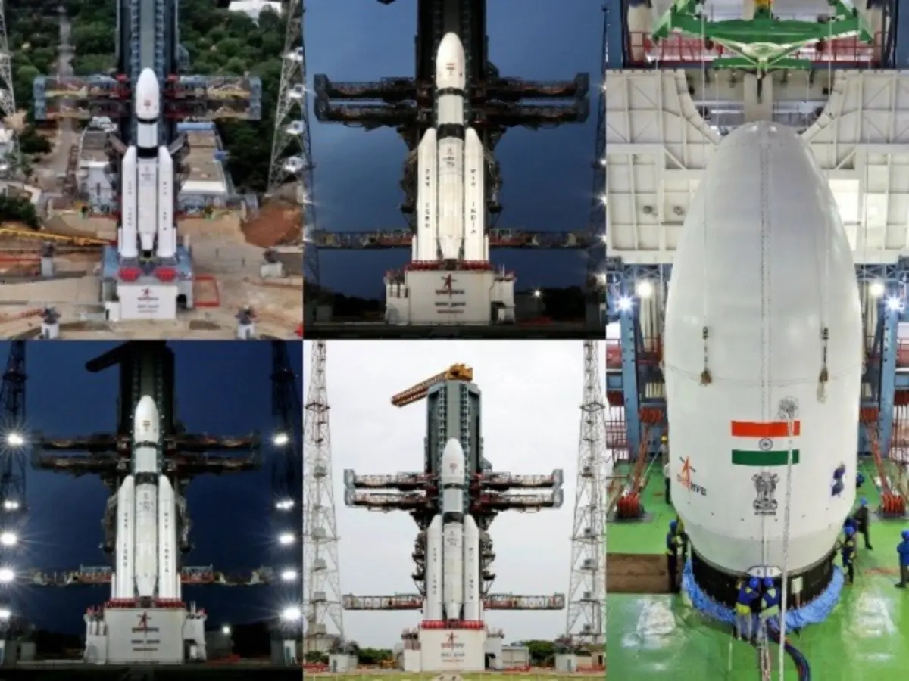
India is amongst the fastest growing economies in the world. In fact it is the sixth-largest economy by nominal GDP, with an estimated size of around $4.15 trillion. When measured by Purchasing Power Parity (PPP), India stands much higher at the third place globally, trailing only the United States and China. Similarly, India has grown by leaps and bounds in the field of science and technology since gaining Independence on August 15, 1947 from the British rule. According to the global ranking, India stands 3rd in scientific publications and ranks 38th in the Global Innovation Index. The country has rapidly scaled its research output, patent filings, and high-impact contributions across global science, technology, and innovation frameworks. Add WION as a Preferred Source One of India's most visible scientific achievements has been its space programme, led by Indian Space Research Organisation (ISRO). Here we take a look at some of the developments and achievements made in Space Science in last two decades made by India. From 2006 to 2026, India has shown exceptional growth like undertaking lunar, Martian, solar, astronomical and deep-space missions and demonstrating advanced technologies such as autonomous satellite docking. Chandrayaan-1: India Reaches the Moon - 2008 A major turning point for India to prove its capabilities in Space Science came on 22 October 2008, when it launched Chandrayaan-1, India's first mission to the Moon, carried 11 scientific instruments from India and international partners. Other than mapping Moon's chemical, mineralogical and geological characteristics, Chandrayaan-1 detected evidence of hydration/water-related signatures on the lunar surface and near-surface environment. The mission demonstrated that India could conduct sophisticated planetary science too and that its capabilities are not limited to merely launching communication and Earth-observation satellites. Mars Orbiter Mission - 2013 On 5 November 2013, ISRO launched the Mars Orbiter Mission or Mangalyaan and became the fourth space agency to successfully place a spacecraft in Mars orbit. The mission was designed for six months but completed seven years in Mars orbit. During its mission the spacecraft studied aspects of the Martian surface, atmosphere, morphology, mineralogy and the Martian exosphere. Also its Mars Colour Camera produced more than 1,100 images for study. Multi-Wavelength Astronomy - 2015 On 28 September 2015 India launched Astrostat, an astronomical observatory designed to study celestial objects in multiple wavelengths. It has helped Indian scientists to investigate phenomena involving stars; galaxies; X-ray sources; black holes; neutron stars and high-energy astronomical events. Chandrayaan-2 in 2019 India launched Chandrayaan-2 on 22 July 2019. The mission consisted of an orbiter, lander and rover. Although the lander did not achieve a successful soft landing, the orbiter continued operating and producing valuable scientific data. Chandrayaan-3: Historic Lunar Landing - 2023 On 23 August 2023, Chandrayaan-3 successfully soft-landed on the Moon. With this India became the first country to land in the Moon's southern high-latitude region and only the fourth country to achieve a soft landing on the Moon.

4. Live coverage: SpaceX to launch satellite replenishment mission for Globalstar from Cape Canaveral
Read more
Globalstar is getting ready to replenish its low Earth orbit satellite constellation with a Saturday night launch onboard a SpaceX Falcon 9 rocket. The mission, dubbed Globalstar 2R Launch 1, will send a batch of eight satellites into orbit with a deployment sequence beginning more than 56 minutes after liftoff and lasting less than 10 minutes. SpaceX's Falcon 9 rocket will take off from Space Launch Complex 40 at Cape Canaveral Space Force Station. Liftoff is scheduled for 9:12 p.m. EDT (0112 UTC), less than 40 minutes prior to another planned Falcon 9 launch from Vandenberg Space Force Base. Spaceflight Now will have live coverage beginning about an hour prior to liftoff. <span data-mce-type="bookmark" style="display: inline-block; width: 0px; overflow: hidden; line-height: 0;" class="mce_SELRES_start"></span> The 45th Weather Squadron forecast a 90 percent chance for favorable weather at liftoff. Meteorologists said there's a chance for interference from cumulus and anvil clouds. "Weak flow at the surface and high pressure over the Gulf will allow afternoon sea breeze formation to push isolated showers and thunderstorms inland through the evening hours," launch weather officers wrote. "Lingering anvil and cumulus clouds will remain low risks throughout both launch opportunities." SpaceX will launch the mission using the Falcon 9 first stage booster with the tail number B1090. This will be its 14th flight. Less than eight minutes after liftoff, B1090 will target a landing back at Landing Zone 40, adjacent to the launch pad. If successful, this will be the fifth landing at this site and the 649th Falcon booster landing for SpaceX. The mission Saturday night was publicly announced by Globalstar in the springtime. It said the launch was scheduled to happen on Sunday, May 17, but the flight was pulled to "allow more time for Globalstar teams to prepare the satellites for launch." The flight announcement came about a month after Amazon announced its intention to acquire Globalstar, which would allow the Amazon Leo to add direct-to-device capabilities to its constellation and compete with companies, like SpaceX and AST SpaceMobile in that domain. "This launch represents another important step in sustaining and strengthening the infrastructure our customers rely on every day," said Dr. Paul E. Jacobs, Chief Executive Officer, Globalstar, in a May 12 press release. "As we continue executing our long-term strategy, replenishing our existing constellation remains a critical part of delivering resilient satellite services around the world." In its latest earnings statement published Aug. 6, Globalstar said it would not be holding any further earnings calls or updates to its forward-looking guidance while the Amazon acquisition is pending. That deal is expected to close sometime in 2027.

