 |  | 

🌌 अंतरिक्ष समाचार | Space News
शनिवार, ०३/१०/२०२६ | Saturday, 03/10/2026

1. ISRO sets up space tracking facility near Guwahati | Tap to know more | Inshorts - Inshorts
Read more
ISRO sets up space tracking facility near Guwahati | Tap to know more | Inshorts Inshorts

2. ISRO Starts Work On Advance Radar Research Facility Near Guwahati Under For Satellite And Debris Tracking - Swarajya
Read more
ISRO Starts Work On Advance Radar Research Facility Near Guwahati Under For Satellite And Debris Tracking Swarajya

3. Gaganyaan Mission advances towards 2027 crewed flight; Bharatiya Antariksh Station targeted for 2035: Jitendra Singh - DD News
Read more
Gaganyaan Mission advances towards 2027 crewed flight; Bharatiya Antariksh Station targeted for 2035: Jitendra Singh DD News

4. World Space Week 2026: How Rocket Revolution is reshaping exploration - The Federal
Read more
World Space Week 2026: How Rocket Revolution is reshaping exploration The Federal

5. EXCLUSIVE: Mike Rogers and NRSC launch coordinated seven-figure ad buy targeting Abdul El-Sayed's ties to "radical Islam" - washingtonreporter.news
Read more
EXCLUSIVE: Mike Rogers and NRSC launch coordinated seven-figure ad buy targeting Abdul El-Sayed's ties to "radical Islam" washingtonreporter.news

6. ICYMI: Adam Hamilton accused of shielding 'child predator' who worked for his church in mid-2000s - NRSC.org
Read more
ICYMI: Adam Hamilton accused of shielding 'child predator' who worked for his church in mid-2000s NRSC.org

7. NASA Astronaut Christina Koch to Join NFL Fans in Philadelphia
Read more
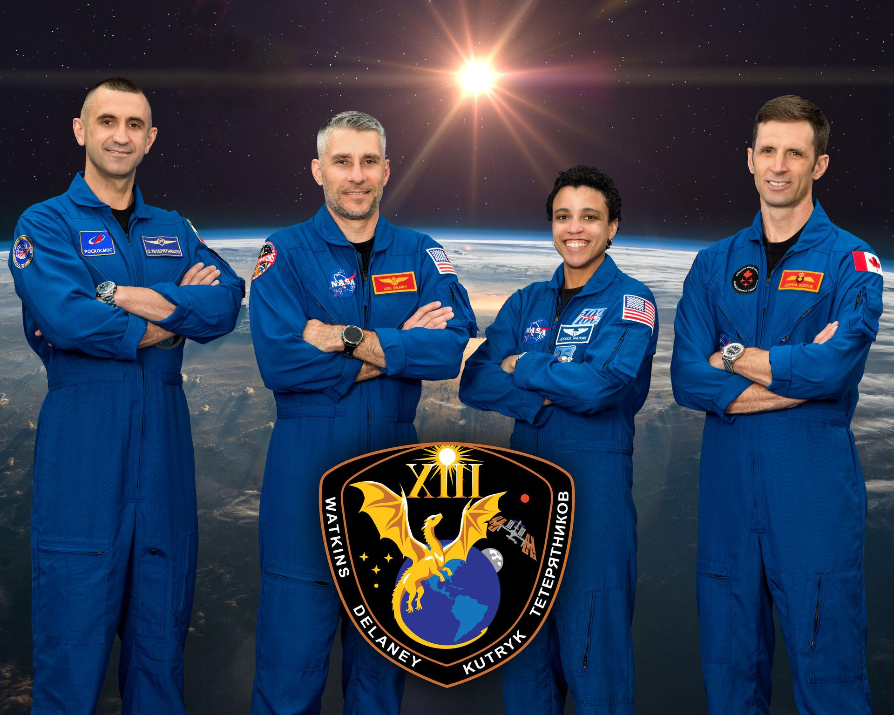
NASA astronaut Christina Koch is seen during an event to award the Congressional Space Medal of Honor to the Artemis II crew, Friday, Aug. 28, 2026, at the agency's Johnson Space Center in Houston. Credit: NASA/John Kraus As part of NASA's ongoing Inspiration Tour, NASA astronaut Christina Koch will highlight America's strengths in space exploration and aeronautics innovation at the Philadelphia Eagles vs. Los Angeles Rams game in Philadelphia on Sunday, Oct. 4. A self-proclaimed Philadelphia sports fan, Koch is an explorer and engineer who spent a total of 338 days in space across two missions, including serving as a mission specialist for the agency's Artemis II mission earlier this year. On April 1, Koch launched from NASA's Kennedy Space Center in Florida aboard the Orion spacecraft on top of the agency's SLS (Space Launch System) rocket as part of Artemis II. Koch and her fellow crew members completed a historic lunar flyby, marking humanity's return to the vicinity of the Moon for the first time in more than 50 years. NASA team members will engage with fans at the agency's Experience Zone, located outside the stadium from 10 a.m. to 1 p.m. before the game. Fans can learn more about NASA's return to the Moon through the agency's Artemis program, enjoy interactive games, and capture photos at a selfie station and with a large, inflatable NASA logo. With stops across the nation, NASA's Inspiration Tour convenes academic, industry, and public sector stakeholders to connect the agency with the people, technologies, and organizations that drive American leadership in space. The tour will culminate in MAX POWER, a public exposition of American air and space innovation, Saturday, Nov. 7, and Sunday, Nov. 8, on and near the agency's Kennedy Space Center in Florida. Held in honor of America's historic 250th anniversary, the multi-day, family-friendly event will showcase the next-generation aircraft, spacecraft, autonomous vehicles, and technologies that will help define the future of transportation in air and space. For more information about MAX POWER and the agency's missions, visit: https://www.nasa.gov/maxpower -end- Camille Gallo / Jessica Taveau Headquarters, Washington 202-358-1600 camille.m.gallo@nasa.gov / jessica.c.taveau@nasa.gov

8. Heading Home: NASA's SpaceX Crew-12 Concludes Station Science Mission
Read more
NASA's SpaceX Crew-12 mission is ending, with the crew scheduled to return in early October. NASA astronauts Jessica Meir and Jack Hathaway, ESA (European Space Agency) astronaut Sophie Adenot, and Roscosmos cosmonaut Andrey Fedyaev will head home from the International Space Station after supporting research that benefits life on Earth and prepares humans for missions into deep space. Here's a look back at some of their accomplishments: Orbital transit The crew members look out the window of a Dragon spacecraft during their journey to the space station, a destination that offers a unique vantage point to observe both Earth and the cosmos. Research in microgravity allows the scientific community to experiment through a new perspective, from changes in how cells behave to how materials take shape, space offers new paths to scientific discovery. Learn more about research in microgravity. Crystalline clues NASA/Jessica Meir Hathaway floats alongside hardware used for crystal growth experiments aboard the orbiting laboratory. Microgravity reveals new details about crystal structures, helping researchers improve the quality and stability of pharmaceuticals. Here, cancer-targeting treatments are crystallized to better understand their properties and help advance cancer therapies on Earth. Learn more about the Pharmaceutical In-space Laboratory (ADSEP-PIL-15). Boosting quantum science NASA/Jack Hathaway Meir works with cables that deliver light used to cool, trap, and study atoms inside the Cold Atom Lab. In microgravity, ultracold atoms can be observed for longer periods, giving scientists a window to peer into the quantum realm. A recent upgrade to the facility increases the number of atoms produced, providing more data to advance quantum technologies such as solar cells and the components that power cell phones and computers. Learn more about the Cold Atom Lab. Branching beyond bone loss ESA/Sophie Adenot Adenot holds a small container that houses a bone scaffold made from wood, designed to mimic the structure of real bones and support the growth of bone cells. Since microgravity can accelerate bone loss, it offers a unique opportunity to test how well the scaffold promotes bone regeneration. Insights from this study could protect future space explorers and provide new treatment options for patients with osteoporosis, a disease that affects more than 200 million people globally. Learn more about Green Bone. In-space suspension NASA Meir sets up hardware for an investigation that studies soft materials made from tiny particles suspended in water. In microgravity, scientists can study how these particles interact and assemble into structures differently than they do on Earth. Understanding these interactions could help scientists fine-tune the texture, stability, and performance of materials used for growing plants, 3D printing, and producing pharmaceuticals. Learn more about Colloidal Solids. Decoding microbial secrets Hathaway holds equipment to test for antibiotic-resistant bacteria aboard the space station. Some bacteria can withstand antibiotics, starvation, and disinfection, making them a concern in closed environments like spacecraft. Sequencing DNA in microgravity can reveal how resilient microbes adapt to space, helping scientists identify countermeasures to manage antibiotic‑resistant bacteria during exploration missions while also advancing efforts to combat resistance on Earth. Learn more about CS-05A: Genomic Enumeration of Antibiotic Resistance in Space (GEARS). Fresh delivery NASA/Chris Williams Expedition 74 crew members smile among fresh produce delivered aboard NASA's Northrop Grumman Commercial Resupply Services 24 mission. Cargo flights bring critical supplies, fresh food, sweet treats, and new science to the space station. The Cygnus XL spacecraft also delivered many research projects, including an instrument that could improve space-weather modeling and a project that could help protect gut-microbiome stability on future exploration missions. Reshaping cartilage Meir works on an investigation that studies how engineered cartilage tissue develops in microgravity, which may help scientists produce medical implants that more closely resemble natural cartilage. For millions of people with cartilage injuries, space-grown tissue could offer treatment options that don't require transplanting cartilage from another part of the body. Learn more about Biomimetic Tissue Engineering in Microgravity for Cartilage using Aggregate Rejuvenation, Tension, and Self-Assembly (BEM-CARTS). Printing meets metal Adenot installs the Metal 3D Printer aboard the orbital complex. Several small metal parts have already been 3D printed in microgravity and returned to Earth, where their quality is evaluated against those made on the ground. Producing metal parts on demand in space could give future crews the ability to make or replace what they need far from Earth, reducing reliance on spare parts and resupply missions. Learn more about Metal 3D Printer. Vital fluids Adenot works to produce intravenous (IV) fluid on demand in microgravity. Commercial IV fluids expire after about 16 months and carrying them on long-duration missions adds weight and takes up valuable space. This system could provide a critical medical resource when resupply is limited and improve access in remote areas or during emergencies on Earth. Learn more about Intravenous Fluid Generation - Mini (IVGEN Mini). Multiplying stem cells Hathaway takes a selfie as Meir conducts a stem cell investigation in space. Microgravity can help produce larger numbers of clinical-grade stem cells that retain their ability to transform into other cells. Cells used in this experiment could help rebuild blood and immune systems after chemotherapy, advancing care for leukemia and other blood diseases on Earth. Learn more about the Hematopoietic Stem Cell Expansion in Space: Pathfinder Investigation (InSPA-StemCellEX-H2). Training bone cells Hathaway holds an experiment container that uses bone marrow cells to study how microgravity affects bone and muscle. The research uses structures that mimic parts of bone marrow, and some samples are exposed to vibrations that simulate exercise. Tracking changes in these cells could reveal new ways to combat bone and muscle loss during spaceflight and support bone health on Earth. Learn more about 3D Bone Marrow Analog.

9. NASA's DAVINCI Probe Can Stand the Heat
Read more
An engineering model of NASA's DAVINCI (Deep Atmosphere Venus Investigation of Noble gases, Chemistry, and Imaging) descent probe passed a key test that ran from Aug. 28 to Sept. 10, showing it can survive the extreme temperatures of Venus. NASA/Mike Guinto The engineering development unit for NASA's DAVINCI (Deep Atmosphere Venus Investigation of Noble gases, Chemistry, and Imaging) probe is photographed prior to a major thermal evaluation. The DAVINCI team put the yoga ball-sized vessel into a ceramic-lined chamber with heat-scorched walls and ratcheted up the temperature to 869 F, or 465 C, over the course of about an hour - the same pace the probe will heat up during its descent to the surface of Venus. DAVINCI will study the origin, evolution, and present state of Venus in unprecedented detail to help determine whether it was once wet and habitable, like Earth. Image credit: NASA/Mike Guinto

10. La NASA abre solicitudes para próxima promoción de directores de vuelo
Read more
3 min read María José Viñas Oct 02, 2026 RELEASE 26-082 NASA Headquarters El equipo de control de vuelo de Artemis II, en la Sala Blanca de Control de Vuelo del centro de control de misiones del Centro Espacial Johnson de la NASA, en Houston, el 10 de abril de 2026, durante el amerizaje y la recuperación de la misión Artemis II. Crédito: NASA/Robert Markowitz Lee esta nota de prensa en inglés aquí . La NASA busca líderes para uno de los puestos más prestigiosos de la Tierra en el ámbito de los vuelos espaciales tripulados: director de vuelo en el control de misión del Centro Espacial Johnson de la agencia, en Houston. Esta función es fundamental para reforzar el liderazgo estadounidense en la exploración espacial, a medida que la NASA allana el camino hacia una presencia humana sostenida en la Luna. El plazo para presentar solicitudes está abierto desde ahora hasta el lunes 12 de octubre. Los ciudadanos estadounidenses pueden presentar su solicitud en (información en inglés): https://www.usajobs.gov/GetJob/ViewDetails/886788000 Las personas seleccionadas como directores de vuelo de la NASA dirigirán misiones tripuladas a la Estación Espacial Internacional, misiones Artemis a la Luna y, más adelante, las primeras misiones tripuladas a Marte. Los directores de vuelo dirigen equipos de controladores de vuelo, astronautas y socios comerciales e internacionales en la ejecución de misiones en tiempo real y en la gestión de riesgos. Durante los preparativos de una misión, los directores de vuelo colaboran con los equipos de ingeniería, seguridad y programas para garantizar que los planes operativos se ajusten a las capacidades de la nave espacial y a los objetivos de la misión. "Estamos en un momento apasionante y decisivo, ya que seguimos dando soporte a las operaciones en la Estación Espacial Internacional mientras construimos la próxima etapa de los vuelos espaciales tripulados con las misiones de Artemis y Base Lunar, y nos preparamos para llegar más lejos que nunca", dijo Emily Nelson, jefa de directores de vuelo en el centro Johnson. "Alcanzar estos ambiciosos objetivos requiere directores de vuelo que sean expertos en integración, capaces de reunir una amplia variedad de equipos y disciplinas en un esfuerzo de misión claro y unificado. Esta función esencial representa lo mejor de la innovación y el trabajo en equipo". Para ser considerados, los candidatos a director de vuelo deben ser ciudadanos estadounidenses y contar con una licenciatura de una institución acreditada en ingeniería, ciencias biológicas, ciencias físicas, informática o matemáticas. También necesitarán una amplia experiencia profesional afín y de responsabilidad creciente, que incluya la toma de decisiones críticas en entornos de alta presión y alto riesgo. Aunque muchos directores de vuelo de la NASA han sido antes controladores de vuelo en el control de misión, no es un requisito para presentar la solicitud. La NASA prevé anunciar las selecciones antes de que termine el año. Los nuevos directores de vuelo recibirán una amplia formación en control de vuelo y sistemas de naves espaciales, así como en liderazgo operativo y gestión de riesgos. Obtén más información sobre los directores de vuelo de la NASA y el proceso de solicitud en (información en inglés): go.nasa.gov/BeAFlightDirector -fin- Rachel Kraft / María José Viñas Sede central, Washington 202-358-1100 rachel.h.kraft@nasa.gov / maria-jose.vinasgarcia@nasa.gov Anna Schneider / Mary Pfister Centro Espacial Johnson, Houston 281-483-5111 anna.c.schneider@nasa.gov / mary.m.pfister@nasa.gov Share Details Last Updated Location Related Terms - NASA en español

11. NASA Opens Applications for Next Class of Flight Directors
Read more
The Artemis II flight control team is pictured in the White Flight Control Room in mission control at NASA's Johnson Space Center in Houston on April 10, 2026, for the splashdown and recovery of the Artemis II mission. Credit: NASA/Robert Markowitz NASA is seeking leaders for one of the most esteemed positions on Earth for human spaceflight: flight director in mission control at the agency's Johnson Space Center in Houston. This role is critical to advancing American leadership in space exploration, as NASA paves the way for a sustained human presence on the Moon. Applications for new flight directors are open now through Monday, Oct. 12. U.S. citizens can apply at: https://www.usajobs.gov/GetJob/ViewDetails/886788000 Those chosen as NASA flight directors will lead human spaceflight missions to the International Space Station, Artemis missions to the Moon, and, eventually, the first human missions to Mars. Flight directors lead teams of flight controllers, astronauts, and commercial and international partners in real-time mission execution and risk management. In preparation for a mission, flight directors collaborate with engineering, safety, and program partners to ensure operational plans align with spacecraft capabilities and mission objectives. "We are working in an exciting, pivotal time as we continue supporting operations to the International Space Station while building the next phase of human spaceflight with Artemis and Moon Base missions, preparing to go farther than ever before," said Emily Nelson, chief flight director at Johnson. "Accomplishing these ambitious goals requires flight directors who are expert integrators, bringing together a broad range of teams and disciplines into a clear, unified mission effort. This integral role exemplifies the best of innovation and teamwork." To be considered, flight director candidates must be U.S. citizens with a bachelor's degree from an accredited institution in engineering, biological science, physical science, computer science, or mathematics. They also will need substantial related, progressively responsible professional experience, including time-critical decision-making experience in high-stress, high-risk environments. Although many NASA flight directors have previously been flight controllers working in mission control, it is not a prerequisite to apply. NASA plans to announce selections by the end of the year. The new flight directors will receive extensive training in flight control and spacecraft systems, as well as operational leadership and risk management. Learn more about NASA flight directors and the application process at: go.nasa.gov/BeAFlightDirector -end- Rachel Kraft Headquarters, Washington 202-358-1100 rachel.h.kraft@nasa.gov Anna Schneider / Mary Pfister Johnson Space Center, Houston 281-483-5111 anna.c.schneider@nasa.gov / mary.m.pfister@nasa.gov

12. Team selected for NASA program to explore potential lunar cave
Read more
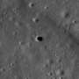
NASA has selected a Planetary Science Institute-led proposal to investigate whether a potentially large underground cave extends beyond the opening of a lunar pit. Such a cave may one day provide a safe haven for astronauts to escape the radiation and extreme temperature swings present at the lunar surface.

13. Tiny 33-pound satellites track greenhouse gas emissions from 310 miles above Earth
Read more
Two tiny satellites have joined an orbital fleet designed to measure greenhouse gas emissions from hundreds of miles above Earth. The 33-pound spacecraft launched Oct. 1 aboard SpaceX's Transporter-18 mission from Vandenberg Space Force Base in California. Their arrival brings the number of satellites developed for GHGSat to 13. The spacecraft carry sensors that can measure emissions from specific facilities on the ground. Precise attitude control keeps those instruments pointed at their targets as the satellites race around Earth. Precision packed into 33 pounds The satellites use the NEMO spacecraft platform, which has supported 11 earlier GHGSat missions. Its compact design puts significant emphasis on accurate pointing without adding substantial mass. The spacecraft operate about 310 miles above Earth. At that altitude, even small changes in orientation can affect where an instrument looks on the ground. SFL Missions CEO Robert E. Zee said the company's small satellites can deliver the attitude stability and pointing performance required for the mission. That capability has been central to the partnership since the 2016 GHGSat Pathfinder mission. Engineers needed the spacecraft to track specific targets with enough precision for reliable emissions measurements. The design also leaves additional capacity across several spacecraft systems. Power generation, data storage, and communications all include built-in margins. Those reserves can support longer missions and allow the spacecraft to collect more data. Earlier satellites using the platform have reportedly exceeded their expected collection capacity. Thirteen satellites and counting The latest launch also shows how a common spacecraft architecture can support a growing constellation. GHGSat has worked with SFL Missions for more than a decade. The two new satellites underwent integration and testing at SFL's facility in Vaughan, Ontario. Stephane Germain, CEO of GHGSat, said the new spacecraft represent another step in expanding the company's emissions-monitoring network. "Our ability to scale as quickly as we have is a direct reflection of the caliber of partners like SFL," Germain said. The production pipeline extends well beyond the latest launch. SFL currently has 32 additional spacecraft under development at the Ontario facility. Hunting emissions from orbit Space-based emissions monitoring depends on accurate targeting as much as sensitive detection hardware. The satellites can observe individual facilities from orbit and gather measurements that help identify greenhouse gas sources. Those observations can support monitoring across industries with significant emissions.

