 |  | 

🌌 अंतरिक्ष समाचार | Space News
मंगलवार, ०७/०७/२०२६ | Tuesday, 07/07/2026

1. Over 1 L registered for Patanjali Civil Services Academy
Read more
PIONEER EDGE NEWS SERVICE/ Haridwar Patanjali Civil Services Academy has so far admitted 1,000 students from across the country. Besides, over one lakh candidates have registered. Candidates from 16 states across the country, including Uttarakhand , Himachal Pradesh , Delhi , Uttar Pradesh , Rajasthan , Madhya Pradesh , Maharashtra, Bihar and Haryana, have also registered. Students in the second year of their BA are also eligible to apply, Patanjali sources said, adding that it will provide high-level preparation for both the UPSC and PCS exams. The unique feature of this registration is that for the first time, about 50 students from Patanjali Yogpeeth have been selected, Patanjali sources informed. Yoga guru Swami Ramdev said that those, who have passed the Prelims and Mains examination of UPSC or PCS on the basis of their hard work and talent but could not get success in the interview even after at least two attempts and want to prepare again, can also apply online. "Patanjali itself will bear the expenses of the candidates eligible for the interview, from accommodation to complete training," Baba Ramdev said, adding that along with this, accommodation, food and other necessary arrangements will be completely free for all candidates participating in the training workshop and interviews until July-end. "Patanjali Yogpeeth will cover all expenses for this period," Baba Ramdev announced.

2. ISRO successfully conducts 2nd integrated air drop test for Gaganyaan mission - News On AIR
Read more
The Indian Space Research Organisation (ISRO) has successfully conducted the second integrated air drop test (IADT-02) for the upcoming Gaganyaan mission at Sriharikota in Andhra Pradesh. The system is essential to ensure safe recovery of the crew module - the capsule in which astronauts sit during a human flight. After the module's release, a parachute system, comprising 10 parachutes, was deployed, helping the capsule decelerate to a safe splashdown speed. The IADT-02 follows the successful completion of the first IADT, which took place on August 24, 2025, at the Satish Dhawan Space Centre in Sriharikota. In the first IADT, a 4.8-tonne dummy crew module was dropped from a height of three km by a Chinook helicopter. Air drop tests recreate the last leg of a spacecraft's return to the Earth. An aircraft or helicopter drops the spacecraft from a height to test various systems under different scenarios. These are the deployment of the parachute system in case the mission is aborted mid-flight, system performance when one parachute fails to open, and the spacecraft's orientation and safety during splashdown. Union Minister Jitendra Singh congratulated the ISRO for successfully conducting the test. India's first human spaceflight will be launched from Sriharikota in 2027.

3. ISRO headquarters in Bengaluru gets third bomb threat mail - The New Indian Express
Read more

BENGALURU: The Indian Space Research Organisation (ISRO) Headquarters on New BEL Road in the city received yet another bomb threat email around 9 pm on Sunday. This is the third bomb threat email that the ISRO has received over the last four days. ISRO staff noticed the email around 10.30 am on Monday. The accused, who had written the mail in English, claimed that the bombs would go off around 2 pm. The staff alerted the police, and the Bomb Detection and Disposal Squad (BDDS), dog squad, the Central Industrial Security Police (CISF) and the jurisdictional Sanjaynagar police personnel arrived and checked the entire campus thoroughly, including Antariksh Bhavan. The search went on till afternoon before concluding the mail as a hoax. The police also reportedly checked the ISRO Telemetry Tracking and Command Network (ISTRAC) in Peenya Industrial Area Phase II. On July 3, 36-year-old Nishant Tyagi from Sanyog Nagar in Ghaziabad of Uttar Pradesh was arrested for sending a similar threat mail to the office of ISRO Chairman Dr V Narayanan the previous day. The second threat mail was sent on the email ID of Dr Narayanan around 10.30 am on Friday. That email was in Tamil and did not come from the same email ID sent by Tyagi. The police checked the campus again with the bomb squad. The search went on for two hours and was confirmed as a hoax. "Tyagi had no role in the second and the third threat emails. All the three email IDs are different. This is the third threat email in the last four days. After all the three threat emails, thorough checks were conducted before declaring the threat a hoax," DCP North BS Nemagoud said. The Sanjaynagar police have registered three separate cases and are investigating.

4. Terror Alert at ISRO Headquarters! Bomb Threat E-mail Sparks Massive Evacuation - Kanak News Odisha
Read more

High alert at India's space command! A terrifying bomb threat email targeting the ISRO Headquarters in Bengaluru triggered an immediate emergency response and mass evacuation. #ISROBombThreat #BengaluruAlert #ISROHeadquarters #BreakingNewsIndia #SpaceCommandScare #BengaluruPolice #CyberSecurityIndia #HoaxCallAlert #SanjayNagarPolice #IndianSpaceAgency #SecurityBreachNews #KanakNewsImpact #TrendingNewsIndia #MassiveEvacuation #SecurityAlert Kanak News is Odisha's leading 24x7 news and current affairs TV channel from Eastern Media Limited. Odisha's largest media house that also publishes the daily 'Sambad'. Get the latest updates on news, politics, sports, business, current affairs, entertainment, technology and health updates from Kanak News. Breaking News, Live news updates, Odia News Live, Live Odia News, odisha news, latest odisha news, odisha news today, odisha politics, odisha latest updates Join us on WhatsApp to get the latest updates: https://whatsapp.com/channel/0029Va9qLIDAYlUKjL5iF90c For the latest Odisha News, follow us: Website: https://kanaknews.com/ Instagram: https://www.instagram.com/kanaknewsofficial/ LinkedIn: https://www.linkedin.com/company/kanak-news Facebook: https://www.facebook.com/KanakNews App Kanak :- https://play.google.com/store/apps/details?id=com.kanak__news.app&hl=en Twitter: https://twitter.com/kanak_news Telegram: https://t.me/kanaknewsofficial WhatsApp: https://whatsapp.com/channel/0029Va9qLIDAYlUKjL5iF90c

5. ISRO PRT TGT Vacancy 2026 Notification Out, Check Apply Online Dates - Adda247
Read more
Today (07 July 2026) is the Last Date for ISRO PRT TGT Recruitment Registration. ISRO PRT TGT Vacancy 2026 Notification Out The organisation released the notification on 16 June 2026. Posts are temporary in nature but are likely to continue. Applicants must fulfil the eligibility criteria on the last date of receipt of applications. Separate applications must be submitted for each post along with separate fee payment. A candidate cannot submit more than one application for the same post. ISRO PRT TGT 2026: Overview The overview table gives a quick summary of ISRO PRT TGT recruitment cycle so that candidates can understand the basic details at a glance. Candidates should refer to this table before checking the detailed sections further in the article. ISRO PRT TGT Vacancy 2026 SDSC SHAR has notified a total of 10 posts across five post codes. These ISRO PRT TGT vacancies are spread across Trained Graduate Teacher posts in Maths, Science, Work Experience, and Telugu, along with Primary Teacher posts. Reservation details for each post are also mentioned in the notification. Post Code Post Name Vacancies 01 TGT (Maths) UR-01 02 TGT (Science) SC-01 03 TGT (Work Experience Teacher) UR-01 04 TGT (Telugu) ST-01 05 Primary Teacher UR-03, EWS-01, OBC-02 ISRO PRT TGT Eligibility Criteria Every ISRO post under this notification carries a different qualification requirement based on the subject to be taught. Candidates must also qualify CTET or the relevant state TET along with the required degree. The table below gives subject-wise qualification details for each post. Post Educational Qualification TGT (Maths) Four-year integrated degree with Maths and Physics, or Graduation with Maths combination plus B.Ed, along with CTET Paper-II TGT (Science) Four-year integrated degree with Chemistry and Biology, or Graduation with Chemistry combination plus B.Ed, along with CTET Paper-II TGT (WET) Bachelor's Degree in Electrical/Electronics/Electronics & Communication Engineering plus B.Ed TGT (Telugu) Graduation with Telugu as main subject plus B.Ed with Telugu methodology, along with State TET/CTET Paper-II Primary Teacher Senior Secondary (10+2) with 2-year Diploma in Elementary Education, or 4-year B.El.Ed, along with CTET Paper-I Apply Link of ISRO PRT TGT Recruitment 2026 Candidates can apply for ISRO PRT TGT recruitment only through the online link available on the official SDSC SHAR website. The direct registration link is active and candidates must complete the process before the closing date. It is advisable to keep all documents ready before starting the form to avoid last minute issues. How to Apply for ISRO PRT TGT Recruitment 2026 Applicants need to follow a step by step process to complete their ISRO PRT TGT online application successfully. Before applying, candidates should scan and keep their photograph, signature, and certificates ready in the required format. The steps for applying are given below. Visit the official website www.shar.gov.in and find the recruitment link. Register with basic details and create login credentials. Fill in the application form with personal, academic, and category details. Upload photograph, signature, and required documents in the prescribed format and size. Pay the application fee online through the available payment mode. Submit the form and download the registration confirmation for future reference. ISRO PRT TGT Application Fees Every candidate needs to pay a combined application and processing fee while submitting the form. The processing fee is refundable to candidates who appear for the written test, while the application fee is not refundable except for exempted categories. Fee details are listed below for ISRO PRT TGT. Particulars Fee Application Fee Rs 250 Processing Fee Rs 500 Total Fee Payable Rs 750 Refund for Women/SC/ST/PwBD/Ex-Servicemen (after appearing in written test) Rs 750 (full refund) Refund for Other candidates (after appearing in written test) Rs 500 ISRO PRT TGT Age Limit and Relaxation Age limit for these posts is calculated as on 7 July 2026 and varies between TGT and Primary Teacher posts. Reserved category candidates and women get age relaxation as per government rules. Details are given in the table below. Category Age Limit / Relaxation TGT posts (Post Code 01 to 04) 18 to 35 years Primary Teacher (Post Code 05) 18 to 30 years SC/ST candidates 5 years relaxation OBC candidates 3 years relaxation Women candidates (all categories) 10 years relaxation PwBD candidates 10 years (15 years for ST, 13 years for OBC, 10 years for General/EWS) Ex-Servicemen and Central Government employees Relaxation as per Government of India orders ISRO PRT TGT Exam Scheme The written test pattern is different for ISRO Telugu TGT compared to other TGT and Primary Teacher posts. Each part of the exam checks a different skill area of the candidate, and the subject specific part carries the highest weightage. The exam scheme for both patterns is given in the table below. For Primary Teacher, TGT (Maths), TGT (Science), and TGT (WET): Section Marks General English 10 General Hindi 10 General Awareness and Current Affairs 10 Reasoning Ability 5 Computer Literacy 5 Understanding the Learner 10 Understanding Teaching Learning 15 Creating Conducive Learning Environment 6 School Organisation and Leadership 6 Perspectives in Education 3 Subject Specific 100 Total 180 For TGT (Telugu): Part Area Marks I General English, General Awareness, Reasoning & Computer Proficiency 20 II Perspectives in Education and Classroom Implications of Educational Psychology 20 III Pedagogy of Concerned Subject 40 IV Telugu Language and Literature 100 Total 180 ISRO PRT TGT Salary Selected candidates get pay as per the 7th Pay Commission levels along with other government benefits. The ISRO PRT TGT pay level differs based on the post applied for. Salary details are given in the table below. Post Pay Level Pay Scale TGT posts (Post Code 01 to 04) Level 7 Rs 44,900 to Rs 1,42,400 Primary Teacher (Post Code 05) Level 6 Rs 35,400 to Rs 1,12,400 ISRO PRT TGT Qualifying Marks Candidates need to clear a minimum cut-off in each subject as well as an overall aggregate to qualify the written test. These marks apply mainly to the TGT Maths and TGT Science posts, where more than one subject is tested.

6. Another bomb threat email to Isro HQ sparks security scare in Bengaluru - The Times of India
Read more

Another bomb threat email to Isro HQ sparks security scare in Bengaluru The Times of India

7. Fresh bomb threat email to ISRO headquarters declared hoax - The Hindu
Read more

The headquarters of the Indian Space Research Organisation (ISRO) at Antariksha Bhavan on New BEL Road was once again placed on high alert on Monday after receiving a fresh bomb threat email, barely days after the police arrested a man from Uttar Pradesh for sending a similar hoax threat. According to the police, the email was received on Sunday around 9 p.m., but it came to the attention of the ISRO officials only on Monday morning when staff reported for duty and checked the official email account. The email claimed that bombs had been planted inside the premises and would explode by 2 p.m. The ISRO officials immediately alerted senior authorities and informed the police. Following the alert, personnel from the Sanjay Nagar Police Station, along with the Bomb Detection and Disposal Squad (BDDS), anti-sabotage teams and sniffer dog squads, rushed to the ISRO headquarters and carried out a comprehensive search of the premises as per the Standard Operating Procedure (SOP). After an extensive sweep, the police found no explosives or suspicious objects and declared the threat a hoax. A case has been registered at the Sanjay Nagar Police Station, and investigators have launched a probe to identify and trace the sender of the email. The latest threat comes just days after the police arrested Nishant Tyagi, a resident of Ghaziabad, Uttar Pradesh, for allegedly sending a similar bomb threat email to the ISRO headquarters on July 2. During the investigation, the police seized electronic devices allegedly used to send the email. Investigators had stated that Tyagi appeared to be suffering from a mental illness.

8. SpaceX launches 81 satellites to orbit from California, lands rocket on ship at sea
Read more
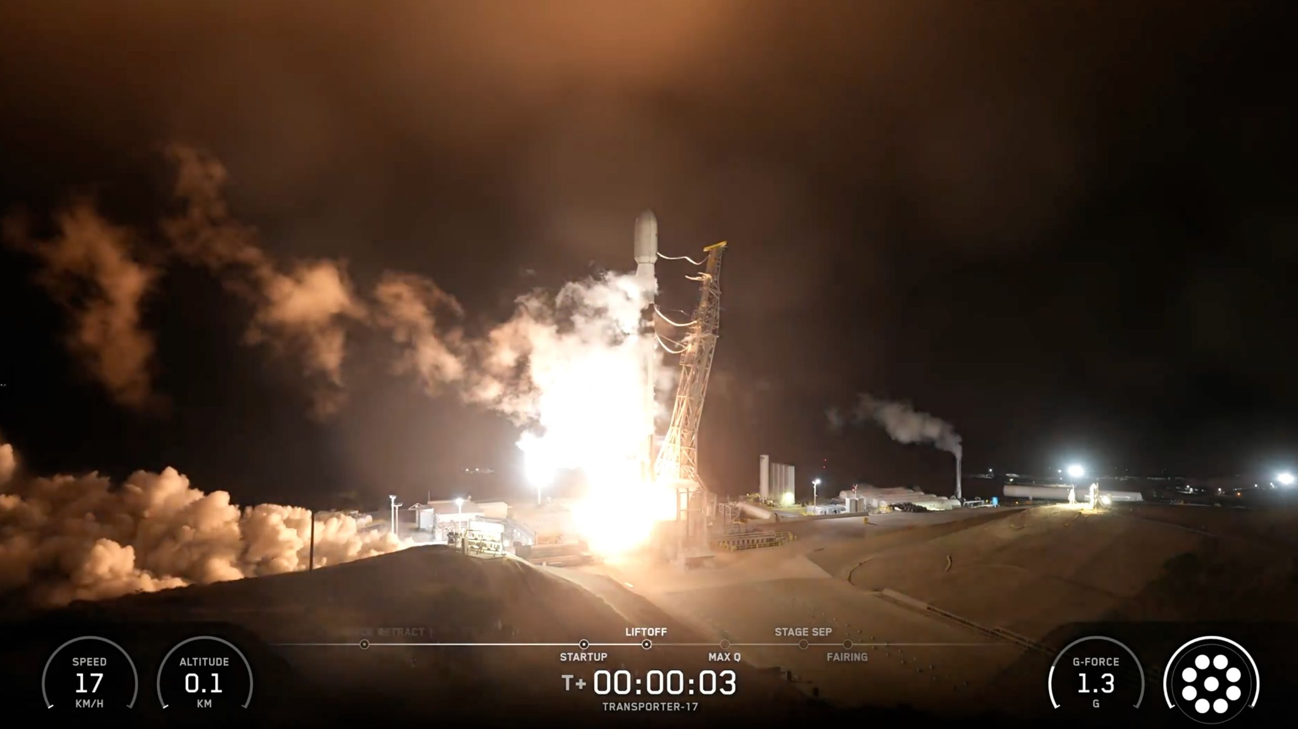
Click for next article A SpaceX Falcon 9 rocket launches the Transporter-17 rideshare mission from Vandenberg Space Force Base in California on July 7, 2026. SpaceX launched a passel of satellites to orbit early Tuesday morning (July 7). A Falcon 9 rocket carrying 81 payloads lifted off from California's Vandenberg Space Force Base on Tuesday at 3:12 a.m. EDT (0712 GMT; 12:12 a.m. local California time), kicking off a mission SpaceX called Transporter-17. As that name suggests, Transporter-17 was the 17th flight of SpaceX 's Transporter rideshare program. The company operates another rideshare series as well, called Bandwagon, which has launched four missions to date . The 20 Transporter and Bandwagon missions that flew before Transporter-17 sent more than 1,800 payloads to Earth orbit. Transporter-1 lofted 143 of those back in January 2021 , which remains the global single-launch record. The 81 payloads that went up on Transporter-17 included " cubesats , microsats, hosted payloads and orbital transfer vehicles carrying eight of those payloads to be deployed at a later time," SpaceX wrote in a mission description . Perhaps the biggest satellite riding the Falcon 9 on Tuesday was CAS500-4, a South Korean Earth-observation craft that tips the scales at about 1,100 pounds (500 kilograms). The satellite, whose name is short for "Compact Advanced Satellite 500-4," is the fourth member of a planned five-satellite CAS500 fleet in low Earth orbit (LEO). CAS500-4 will help the South Korean government monitor crops and forests , among other tasks. The first stage of a SpaceX Falcon 9 rocket rests on the deck of a drone ship shortly after launching the Transporter-17 rideshare mission from Vandenberg Space Force Base in California on July 7, 2026. (Image credit: SpaceX) The first stage of the Transporter-17 Falcon 9 landed about 8.5 minutes after launch on the SpaceX droneship "Of Course I Still Love You," which was stationed in the Pacific Ocean. It was the 11th flight for this particular booster, according to the company's Transporter-17 mission description. The Falcon 9's upper stage, meanwhile, continued hauling the 81 payloads to LEO, where they'll be deployed starting about 50.5 minutes after launch. CAS500-4 won't be released until nearly 2.5 hours after liftoff. Transporter-17 was the 79th Falcon 9 launch of 2026. Nearly 80% of this year's missions have been devoted to building out Starlink , SpaceX's giant broadband constellation in LEO. Editor's note: This story was updated at 3:25 a.m. ET on July 7 with news of successful launch and rocket landing.

9. NASA just found a planet 'hiding' in TESS spacecraft data, all thanks to Einstein
Read more

Click for next article NASA's exoplanet-hunting spacecraft TESS (Transiting Exoplanet Survey Satellite) has a new method for detecting worlds beyond the solar system. The technique relies on a phenomenon introduced by Einstein in his 1915 theory of gravity, general relativity, called gravitational microlensing. The exoplanet in question is called Gaia23bra b. The first hints of this exoplanet were found in 2023 by the now-retired Gaia space telescope via the slight brightening of a star caused by a microlensing event. TESS usually spots planets by the tiny drop in the light output from their parent star as they cross, or transit, its face. This technique is most effective for very large gas giants that orbit close to their star, so it most likely wouldn't work for Gaia23bra b, which has 1.6 times Jupiter's mass but orbits its star at a similar distance to Jupiter's orbit around the sun. Additionally, the transit method employed by TESS usually has a search radius of around 150 light-years. Gaia23bra b, however, orbits an orange dwarf star about 80 percent the size of the sun that is located 40,000 light-years away. Thus, to confirm the existence of this world, TESS had to learn a new trick. "When TESS launched, no one expected it to ever be capable of finding this kind of planet," team member Diana Dragomir of the University of New Mexico said in a statement . "The discovery implies that there are probably other so-called microlensing planets hiding in TESS's data that we hadn't previously thought to look for." Microlensing and the hunt for exoplanets To understand what microlensing is, first we have to consider what general relativity says about the effect of objects with mass on space itself. Mass causes the very fabric of space and time, united as 4-dimensional spacetime, to warp. Gravity arises from that curvature. The greater the mass, the more extreme the warping and thus the greater the force of gravity. Here is the cool part: light usually travels in a straight line, but when the very fabric of spacetime is curved, it has to follow that path. So when light from a background object passes a foreground object, the light bends around it. The bigger the mass and the closer to that mass the light passes, the more its path is curved. That means light from the same source can reach our telescopes at different times. This causes an amplification of the background source. This phenomenon of gravitational lensing has been used to great effect to study ancient galaxies that would usually be too distant and faint to see when they are gravitationally lensed by foreground galaxy clusters. A diagram shows an exaggerated microlensing situation (Image credit: NASA's Goddard Space Flight Center/CI Lab) Obviously, planets have a heck of a lot less mass than clusters of galaxies, but they can still cause a slight gravitational lensing effect. That is micro-lensing, and it can be used to hunt planets. Of the around 6,000 known exoplanets , only around 5 percent have thus far been discovered using microlensing. That is compared to around 75% found using the transit method TESS usually depends upon. Gaia23bra b was first hinted at when it acted as a gravitational lens, passing between Earth and a background star, causing the ever-so-slight brightening of that star. The exciting thing about TESS successfully using microlensing is that this offers a complementary technique of exoplanet detection capable of detecting planets that the transit method might miss. "With microlensing, we can find smaller planets with greater orbital distances, including worlds in the habitable zone of their star and even farther away," team member Mallory Harris of the University of New Mexico said. "Microlensing events happen once, and they're gone - they don't repeat. I like to joke that we'll probably find the first Earth analog with microlensing, and then wave at it as it goes by because we'll never see it again. A diagram showing the search areas of three planet-hunting missions: NASA's upcoming Nancy Grace Roman Space Telescope, the retired Kepler Space Telescope, and NASA's TESS (Image credit: NASA's Goddard Space Flight Center)

10. Unidentified metal spheres found on Australian beach are 'debris from a foreign rocket body', space agency says
Read more
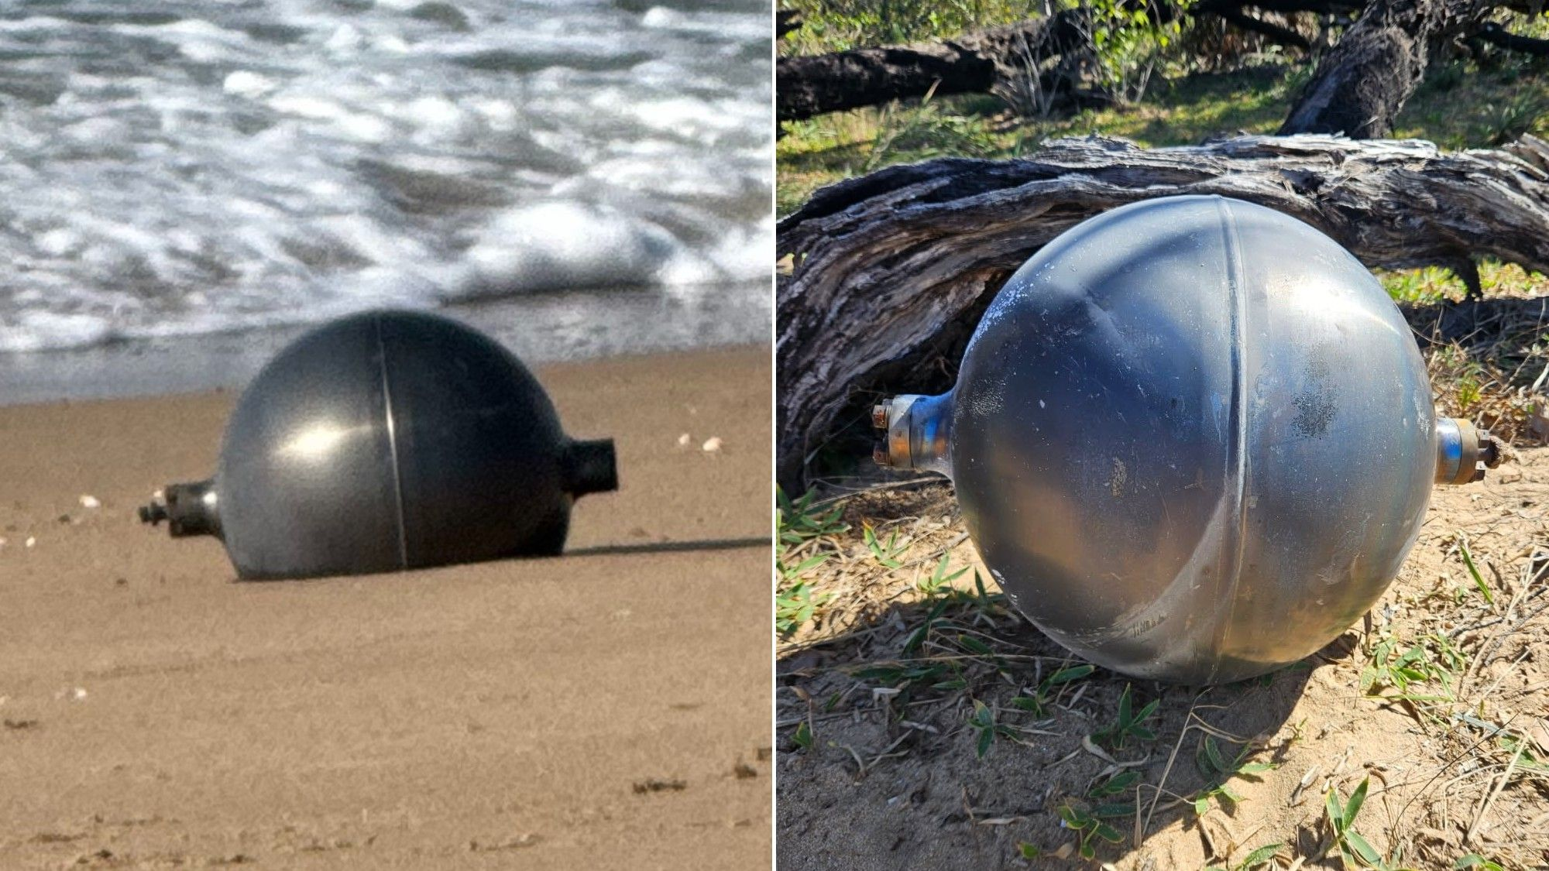
Click for next article Images of metallic spheres found on Forrest Beach in Queensland, Australia. The Australian Space Agency has said the objects are "consistent with debris from a foreign rocket body." Mysterious metallic-looking spheres have appeared on a northeastern Australian beach, prompting the Australian Space Agency to warn residents to be on the lookout for what they state is likely space debris. Australia is investigating the possible space debris incident in conjunction with authorities in Queensland as well as the National Emergency Management Agency, the country's space agency wrote on X late on Sunday (July 5). "The recovered objects appear to be pressure vessels from a space launch vehicle. The agency has identified the likely source," the statement read in part. "The objects' location and characteristics are consistent with debris from a foreign rocket body that recently re-entered the atmosphere from orbit." The agency advised residents not to touch the pieces, which might be hazardous, and to report them immediately if found. "The agency is continuing to engage with international authorities to formally confirm the launch vehicle and launching state," the statement added. The Australian Space Agency is advising Queensland authorities and the National Emergency Management Agency following the discovery of several unidentified objects at Forrest Beach. pic.twitter.com/43BeUNBCWKJuly 6, 2026 The objects washed up in Forrest Beach, which is in Queensland - the northeastern state of Australia facing the Coral Sea, and somewhat near Papua New Guinea. So far, there has been no public analysis of these pieces by companies or individuals who track space debris, nor any public acknowledgement by a foreign space agency or group. Based only on proximity, there are a few weekend launch possibilities from China, although the orbits and timings would have to be checked. China launched a Long March 6 rocket with satellites on Saturday (July 4), as well as a Long March 8A with another satellite group on Sunday (July 5). China also test-fired a submarine missile in the Pacific Ocean on Monday (July 6), Reuters reported , although the timing of that appears to fall after the debris was found.

11. Artemis moon astronauts visit Capitol Hill | Space photo of the day for July 6, 2026
Read more
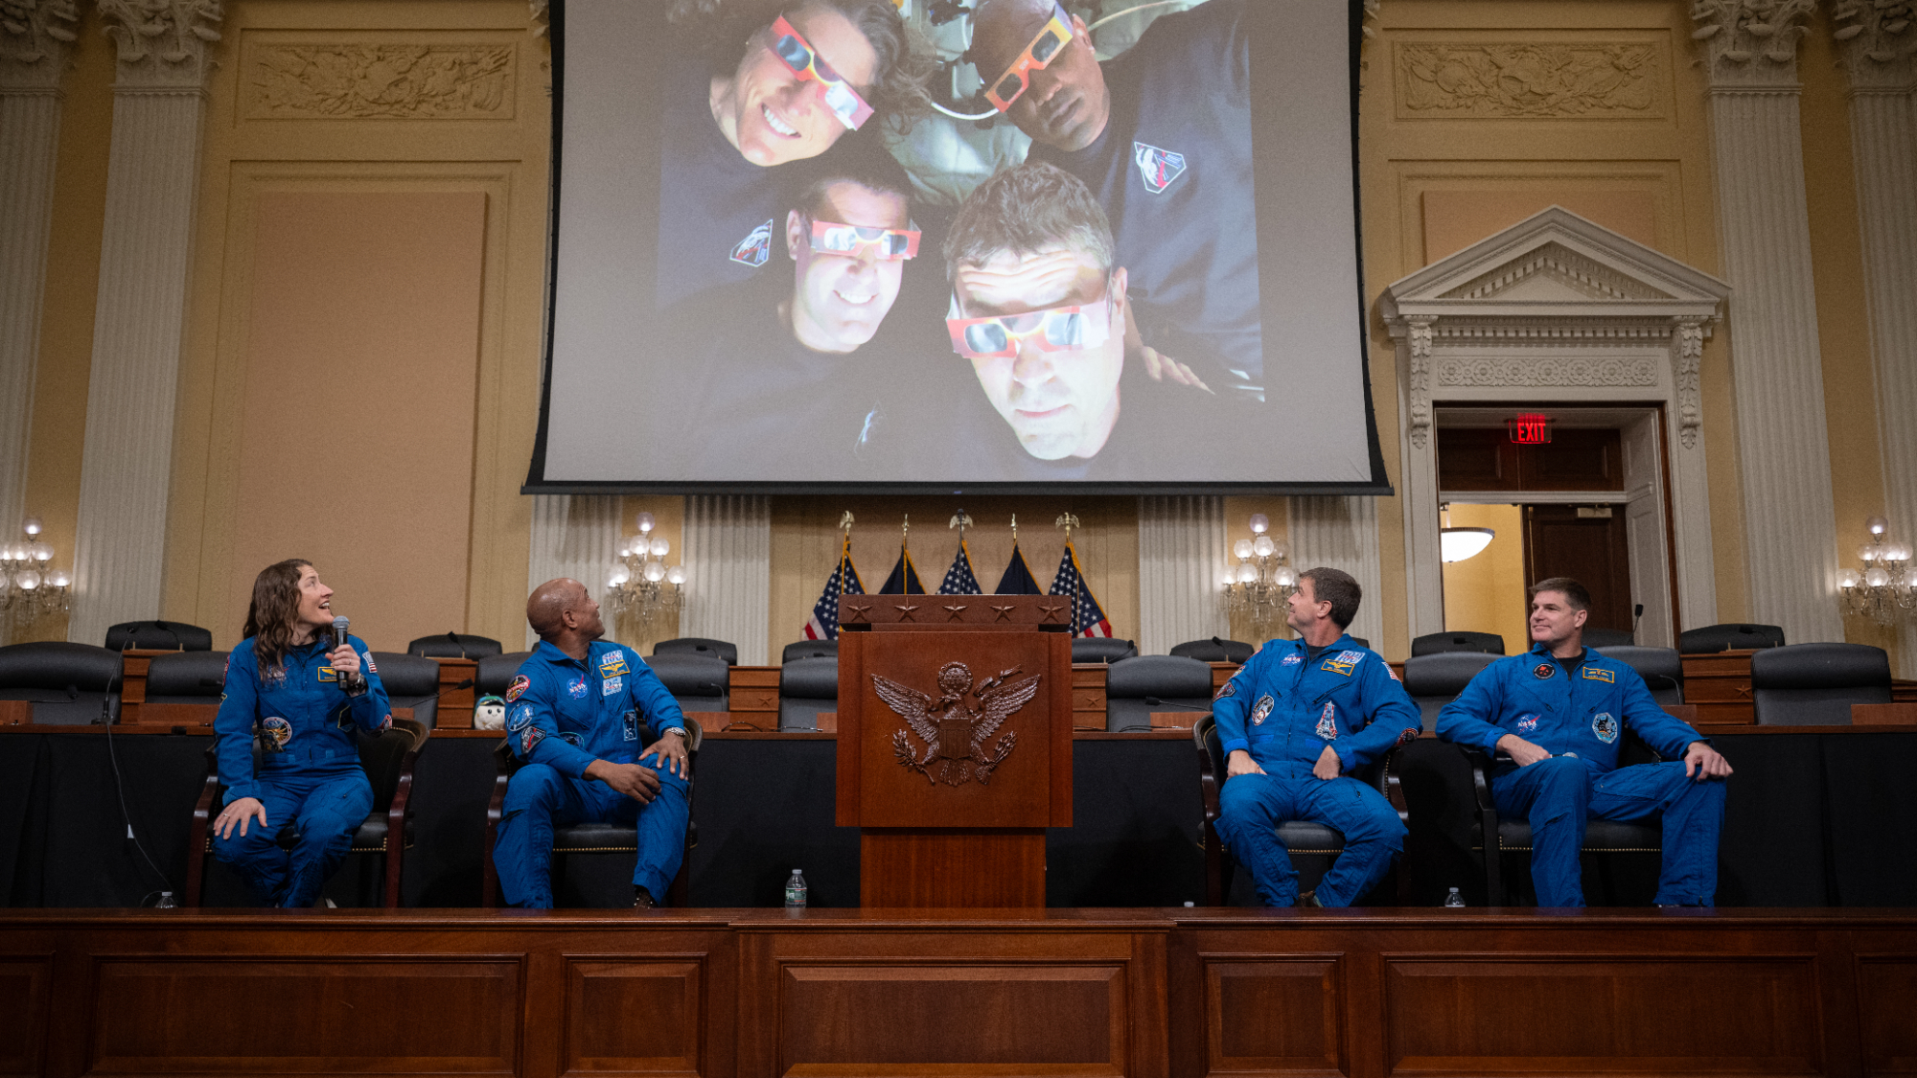
Click for next article The Artemis 2 astronauts look up at footage from their flight during a visit to Capitol Hill. (Image credit: NASA/Joel Kowsky) As we reflect on this past July 4 weekend, and America's 250th birthday, we look to NASA's Artemis II astronauts, who recently reflected on their historic mission during a visit to Capitol Hill. What is it? Following their return to Earth from a 10-day journey around the moon in April, NASA's Artemis II astronauts headed to Capitol Hill. This photograph, captured on May 12, shows the crew - from left to right, NASA astronauts Christina Koch (mission specialist), Victor Glover (mission pilot), Reid Wiseman (mission commander) and Canadian Space Agency astronaut Jeremy Hansen (mission specialist) - showing off a photo from their mission to congressional staff at the Cannon House Office Building in Washington, D.C. In the photo, the four astronauts are wearing what look like eclipse glasses in the Orion capsule that they rode to space and back. The presentation was part of a larger visit by the astronauts, who went to Capitol Hill to speak with U.S. politicians and staff about their mission. Why is it incredible? NASA's Artemis II mission had a profound impact on the public. The first crewed mission of NASA's Artemis program , and the first mission to the moon since the Apollo program ended over 50 years ago, Artemis II was a big step forward in human spaceflight. But its success went well beyond the mission itself. The public really connected with the astronauts, and this mission seemed to ignite a fresh, new excitement about space overall. In going to Capitol Hill and speaking with policymakers, the astronauts were able to share some of the experiences that the public connected to so deeply. For federal funding and support of science and spaceflight activities to continue, it's important for policymakers to understand what happens in space, and on these missions, and the many benefits that can come from even a single flight.

12. NASA will have to find a way to service its new alien-hunting space telescope
Read more
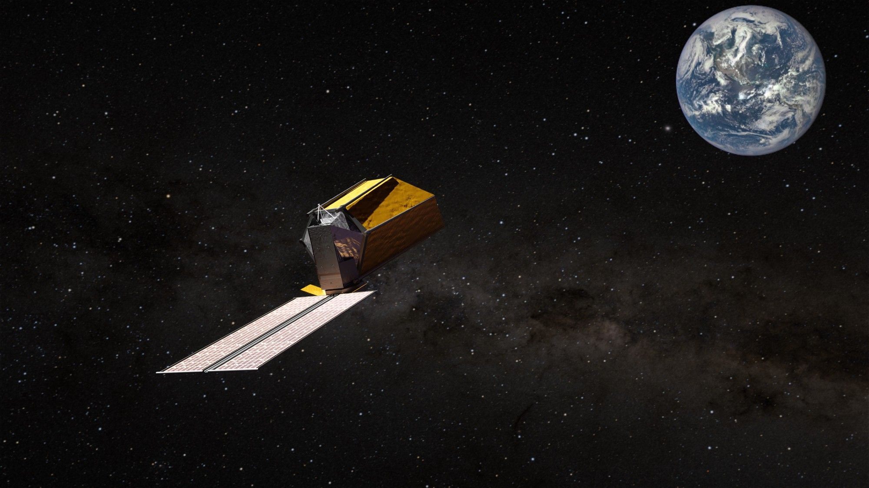
Click for next article PASADENA, California - NASA's new alien-hunting telescope, the Habitable Worlds Observatory (HWO), will be serviceable out in space (and it will have gamma-ray detectors, to boot). Do you remember seeing NASA's space shuttle astronauts working on the Hubble Space Telescope out in space? Well, it will likely be robots this time around, but NASA is planning for HWO to be serviceable, which means that they will need to figure out a way to work on, repair, and maintain the observatory while it operates roughly a million miles (1.5 million kilometers) away. "HWO will have to be serviceable to some extent," NASA's astrophysics division director Shawn Domagal-Goldman told Space.com during a session at the American Astronomical Society's (AAS) 248th meeting in Pasadena, California. From Hubble to HWO The Habitable Worlds Observatory (HWO) is NASA's next planned flagship space telescope. But what separates it from previous space telescopes like Hubble or the James Webb Space Telescope (JWST) is its purpose: to look for and study rocky, Earth-like planets orbiting sun-like stars. In other words, to find planets that could hold life. The mission won't just hunt for aliens, but rather explore these habitable planets and their atmospheres, expanding our understanding of other worlds while also being used for a variety of astronomical purposes. And by making it serviceable, NASA will not just extend HWO's life, but it will also open the door for future technologies that can be used to enhance the observatory. Hubble was a unique case. As the space telescope came about at roughly the same time as NASA's Space Shuttle program, and the telescope was designed to function in low-Earth orbit, it was a natural fit that astronauts go out to assemble, repair and maintain the observatory. "There were decisions made early on that the avionics would be modular in a way that astronauts could take the computer out and put a new computer in, or take a gyroscope out and put a new gyroscope in," former NASA astronaut and former NASA Chief Scientist John Grunsfeld, who today works independently as a consultant in the space industry, told Space.com. However, HWO won't be so close to us. Instead, it will be located nearby L2, or the Sun-Earth Lagrange point 2, a point out in space roughly one million miles (1.5 million kilometers) away where the gravitational pull of the sun and Earth combine to keep objects in the same orbital period as Earth. This position, which is also home for the JWST, allows space telescopes to stay in sync with Earth, making communication easier. It also makes an astronaut mission quite difficult, if not nearly impossible with the technology we have today. While the JWST was sent out to this distant vantage point without plans for servicing the telescope, HWO will "have to" be serviceable, according to Domagal-Goldman and further confirmed with NASA's press office. Servicing the observatory could look like anything from instrument swaps to regular maintenance or as-needed repairs, but it could also entail assembling the observatory itself. "If the telescope is too large to launch [fully assembled]," Domagal-Goldman added, it might need to be "assembled in space." When the JWST went to L2, the mission team realized the problem with micrometeorites was a bit bigger than they anticipated. "We've learned that there's more micrometeorites and they're larger than we expected," said Grunsfeld, "and so you might be able to want to put a patch over a sunshield or a patch on a barrel to patch a hole - and, in principle, robotics could do that." NASA has yet to confirm details about exactly how they plan to service the new observatory, which makes sense as the design of HWO itself is still in flux. But with L2 being so far away, it's logical to assume that it will need to be supported robotically, instead of with astronauts working out in space like with Hubble. We don't know what these future space telescope robot mechanics might look like, but they will have to be very capable to work on such a powerful observatory all the way out at L2. "This will be by far the most challenging observatory that we've ever built," Grunsfeld said. "It's just remarkable that we are so bold as to think we can do it, and to be really close to showing that we can … so since we're just getting started, this is the time to have the discussion about should it be serviceable or not." Image 1 of 3 (Image credit: NASA's Goddard Space Flight Center Conceptual Image Lab) An artist's concept of NASA's Habitable Worlds Observatory in space. (Image credit: NASA's Goddard Space Flight Center Conceptual Image Lab) An artist's concept of NASA's Habitable Worlds Observatory in space. (Image credit: NASA) An artist's concept of NASA's Habitable Worlds Observatory in space. Science is the driving force In addition to extending HWO's longevity by building it in a way that will allow it to be repaired out in space, making the observatory serviceable will also stretch its science capabilities in ways we can't yet imagine. If we look at Hubble's history, its instruments have been swapped out for newer, better versions over time that have not just allowed the telescope to continue functioning, it has allowed the telescope to evolve with changing technologies. From Hubble's gyroscopes to the Wide-Field Camera 3 swapped out in 2009, the telescope has benefitted from many technological upgrades. With servicing capabilities, the same could be true for HWO. HWO is still fairly early in its development, and many years from launch (estimated for the 2040s). But NASA is laying the groundwork for this mission with the upcoming flagship mission the Nancy Grace Roman Space Telescope. This mission carries with it a technology demonstration called the Roman Coronagraph Instrument. Essentially an "exoplanet camera," this instrument will block the glare of far-off stars, getting a direct look at the planets in their orbit. Roman will provide a proving ground for this next-gen coronagraph technology. But even if HWO launches with an advanced version of this coronagraph five , 10 or even 15 years following launch there could be even better planet-spotting technology available. "I'm sure we will be highly motivated if we see a little rocky planet around a nearby star that kind of looks like Earth," Grunsfeld said, "we're going to be highly motivated to send a higher resolution spectrograph, or some different type of detector … up there as fast as we can. So that's the primary driver of servicing, is to be able to put in new scientific instruments." By making HWO serviceable, NASA will enable the use of future technologies without having to launch entirely new space telescopes to support them. This is a cost-effective method, but it might also enable the deployment of future technologies that might otherwise not have a place to operate out in space. "Imagine 20 years from now, or 25 years from now, that there'll be a robust space industry doing servicing, such that we could have a commercial servicer deliver new scientific instruments to habitable worlds," Grunsfeld said. They would simply "slide the old ones out, [and slide] the new ones in." Speaking of future technologies, this decision to make HWO serviceable wasn't all that NASA revealed at AAS. Domagal-Goldman also shared that HWO will be equipped with Gamma-ray detectors. The specific details of these detectors and what they will be used for is also to-be-determined, but with HWO being serviceable, these detectors could continue to evolve with the observatory over time, enabling future astronomy that we can't even imagine today.

13. Canadian Artemis II crew member to retire from space agency
Read more

The Canadian astronaut who was part of the historic Artemis II crew that successfully voyaged around the moon earlier this year is retiring from the nation's space agency, officials said Monday.

14. How interceptor missiles work: The technology behind stopping missiles in mid-air
Read more
Intercepting a missile sounds straightforward. Launch another missile at it before it reaches its target. In reality, it is one of the most technically demanding challenges of defense. Unlike offensive missiles, interceptor missiles must detect, track, calculate, and collide with a target that may be traveling several times the speed of sound, often within a matter of minutes. Some even destroy their targets without carrying an explosive warhead, relying instead on the sheer force of impact. Here's how interceptor missiles work. It starts with detection An interceptor missile is only as effective as the network supporting it. Long before an interceptor launches, satellites equipped with infrared sensors detect the intense heat generated by a missile launch. Ground- and sea-based radars then begin tracking the missile's trajectory, calculating where it is likely to travel and, more importantly, where it can be intercepted. This information is continuously shared across a command-and-control network that decides whether an engagement is necessary, selects the most suitable interceptor, and determines the optimal launch time. Predicting where a missile will be One of the biggest misconceptions is that interceptor missiles simply "chase" incoming threats. Instead, fire-control computers predict the future position of the target based on its speed, altitude, direction, and expected flight path. The interceptor is launched toward that predicted intercept point rather than directly at the missile's current location. As both missiles continue moving, onboard guidance systems receive updated tracking data and constantly adjust the interceptor's course until it reaches the target. The entire process, from detection to interception, may take only a few minutes for short-range ballistic missiles. Three opportunities to intercept Ballistic missiles travel through three distinct flight phases, each offering different interception opportunities. The boost phase begins immediately after launch while the rocket motors are still burning. During this stage, the missile is highly visible due to its intense infrared signature, but interception is extremely difficult because defensive systems must already be positioned near the launch site. Terminal High Altitude Area Defense interceptor missile launch. Credit - U.S. Department of War The midcourse phase is the longest portion of flight, when the warhead travels through space after booster separation. Systems such as the Aegis Ballistic Missile Defense using SM-3 interceptors and the U.S. Ground-based Midcourse Defense are designed to engage threats during this stage. Finally comes the terminal phase, when the warhead re-enters the atmosphere and descends toward its target. Systems such as THAAD and Patriot PAC-3 operate in this phase, providing the final opportunity to stop an incoming missile before impact. Hit-to-kill versus explosive interception Not every interceptor destroys its target in the same way. Many older interceptor missiles use blast-fragmentation warheads, detonating near the incoming missile and destroying it with high-speed metal fragments. Modern systems increasingly rely on hit-to-kill technology. Rather than exploding nearby, these interceptors collide directly with the incoming missile at extremely high speed. The enormous kinetic energy generated by the impact is sufficient to destroy or disable the target without carrying a large explosive payload. Systems including THAAD, SM-3, and Patriot PAC-3 employ hit-to-kill interception for many ballistic missile defense missions. Why is interception so difficult? Intercepting a missile is often compared to "hitting a bullet with another bullet," but the reality is even more challenging. Incoming ballistic missiles can travel at several kilometers per second, leaving defenders with only a narrow engagement window. Modern missiles may also deploy decoys, maneuver during flight, or fly at lower altitudes to complicate tracking. Weather, electronic warfare, radar coverage, and terrain can further reduce the time available to detect and engage a threat. For this reason, countries increasingly rely on layered missile defense, where multiple interceptor systems operate at different ranges and altitudes. If one layer fails, another still has an opportunity to intercept the incoming missile. Examples of interceptor missiles Different interceptor missiles are optimized for different threats. The Patriot PAC-3 focuses on defending military bases and cities against ballistic missiles, cruise missiles, and aircraft during the terminal phase. THAAD (Terminal High Altitude Area Defense) intercepts short- and intermediate-range ballistic missiles at much higher altitudes, including outside Earth's atmosphere. The naval SM-3 interceptor protects ships and allied territories by engaging ballistic missiles during their midcourse phase, while SM-6 provides additional terminal defense against aircraft, cruise missiles, and some ballistic threats. Other countries operate systems such as Israel's Arrow-3, David's Sling, and Iron Dome, each designed for different ranges and threat types. The future of missile interception As hypersonic glide vehicles and maneuverable ballistic missiles become more common, traditional interception methods are becoming increasingly challenging. Future systems are expected to combine more capable sensors, artificial intelligence-assisted tracking, and new interceptors, such as the Glide Phase Interceptor (GPI), currently under development, to engage hypersonic threats before they begin their final descent. While no missile defense system offers perfect protection, modern layered architectures have significantly improved the ability to detect, track, and intercept increasingly sophisticated threats. Success ultimately depends not on a single interceptor missile but on the seamless integration of satellites, radars, command networks, and multiple defensive layers that work together within seconds.

