 |  | 

🌌 अंतरिक्ष समाचार | Space News
सोमवार, १०/०८/२०२६ | Monday, 10/08/2026

1. Gangotri Dham registers footfalls of more than 60K Kanwadiyas
Read more
PIONEER EDGE NEWS SERVICE/Uttarkashi With the Kanwad Yatra at its peak, more than 60,000 Kanwadiyas have so far collected Ganga water from Gangotri Dham. The number of Kanwadiyas arriving here this year is about 35 per cent more than the previous year. Considering the rising number of visitors, Uttarkashi superintendent of police Kamlesh Upadhyay is monitoring the arrangements at the ground level. She is camping in Gangotri Dham to regulate safety, traffic and crowd management efforts. The SP inspected the Kanwad route and reached Gangotri Dham on Saturday night to check arrangements at the ground level. She assured the arriving pilgrims that the police are committed to their safety and convenience. The Kanwadiyas were also told to follow the traffic, parking and barrier systems, observe additional care in vulnerable locations and maintain patience and discipline during crowding. Upadhyay said that additional police force has been deployed in the subsidence affected Papadgad and Bhatwadi areas. The police have been deployed to ensure effective crowd management, traffic diversion and other aspects related to the pilgrimage. CCTV cameras and drones are being used to monitor the Yatra routes, parking places and vulnerable locations, the SP added.

2. Arunachal Govt, CM launch 'Har Ghar Tiranga' campaign
Read more

- Governance - 1 min read The event was attended by Arunachal Pradesh Legislative Assembly Speaker Tesam Pongte, cabinet ministers, lawmakers, and senior civil and police officials. - PTI - Published On Aug 9, 2026 at 04:21 PM IST Select ETGovernment as Preferred Choice on Google Copy Link Share on WhatsApp Share on Linkedin Share on X Share on Telegram Share on Facebook Kolkata: People take part in the Har Ghar Tiranga rally, at Bhawanipur, in Kolkata. (PTI Photo/Swapan Mahapatra)(PTI08_07_2026_000325A) Itanagar, Arunachal Pradesh Governor Lt Gen K T Parnaik (Retd) and Chief Minister Pema Khandu on Sunday launched the statewide 'Har Ghar Tiranga' campaign at the Golden Jubilee State Banquet Hall here, coinciding with August Kranti Diwas . Launching the drive along with Deputy Chief Minister Chowna Mein, the governor handed over national flags to youth and joined participants in singing the national song, Vande Mataram. In his address, Parnaik called upon every citizen to proudly hoist the National Flag, describing the campaign as a people's movement that rekindles patriotism and strengthens emotional integration. Advt He emphasised that as the nation moves toward 'Viksit Bharat@2047', patriotism must extend to responsible civic actions, including constitutional respect, environmental stewardship, and civic duty. Recalling Mahatma Gandhi's 1942 Quit India Movement launch on this day, Parnaik said the Tricolour remains a living symbol of India's unity, sacrifice, and democratic values. Describing Arunachal Pradesh as the sentinel of the nation's eastern frontier, he encouraged young citizens to embrace 'Jai Hind' as a daily greeting and promoted the use of Hindi alongside local languages to foster national integration. Khandu said the campaign goes beyond a flag-hoisting exercise to deepen citizens' bond with foundational national values and honour freedom fighters. Mein paid tribute to the state's unsung freedom heroes, affirming that national pride is deeply embedded in every Arunachali heart. On the occasion, the governor and chief minister felicitated ex-servicemen and gaon buras (village headmen) for their contributions to society. The Har Ghar Tiranga campaign was also launched in Khonsa (Tirap district), Namsai (Namsai district), and Yingkiong (Upper Siang district). - See more on: - Har Ghar Tiranga campaign , - Arunachal Pradesh , - K T Parnaik , - Pema Khandu , - August Kranti Diwas Telegram Facebook Comments What are your thoughts? Comment Now --> Comment Now Read Comment (1) All Comments By commenting, you agree to the Prohibited Content Policy Post Find this Comment Offensive? Choose your reason below and click on the submit button. This will alert our moderators to take actions REASONS FOR REPORTING Foul Language Defamatory Inciting hatred against a certain community Out of Context / Spam Others Report Join the community of 2M+ industry professionals. Subscribe to Newsletter to get latest insights & analysis in your inbox. --> All about ETGovernment industry right on your smartphone! - Download the ETGovernment App and get the Realtime updates and Save your favourite articles. Scan to download App -->

3. Isro eyes 300 satellites in six years, space station by 2035: Chairman - Business Standard
Read more
Isro eyes 300 satellites in six years, space station by 2035: Chairman Business Standard

4. IN-SPACe moves to hand over Isro's new Rs 986 crore small rocket launch complex to private sector - The Economic Times
Read more

ETtech IN-SPACe seeks private partners to manage ISRO's new launch complex. This facility will support small rocket launches and enhance launch efficiency. Private entities will handle end-to-end operations and maintenance of the complex Space regulator and promoter IN-SPACe has begun the process of handing over the operations and management of Isro 's Rs 986-crore Small Satellite Launch Complex (SLC) at Kulasekarapattinam in Tamil Nadu to the private sector, Times of India reported, in another step towards opening up the country's launch infrastructure to industry. IN-SPACe has invited expressions of interest from eligible Indian entities to operate and manage the new launch complex, which is being developed primarily to support small rocket launches . Also Read: IN-SPACe re-entry rules expose insurance crunch The SLC is part of the new spaceport being built by Isro at Kulasekarapattinam, India's second launch site. Spread across about 2,233 acres, the spaceport is expected to handle launches of Isro's Small Satellite Launch Vehicle (SSLV) as well as equivalent launch vehicles developed by private companies. Under the government's initial plans, launches from the facility were to be carried out by private launch vehicle operators after the spaceport was commissioned. IN-SPACe's latest move takes the private-sector role further by seeking an industry partner to take charge of the complex's operations and maintenance. Live Events The selected entity will be responsible for the end-to-end management of the facility, including launch campaign operations, maintenance of infrastructure and systems, safety and security, mission readiness, asset management, logistics and coordination with Isro, IN-SPACe and launch customers. Isro will initially provide technical and operational support to help the private operator build the required capabilities. "To facilitate a smooth transition and capability development, Isro will provide the selected party with the necessary technical guidance, operational support, training, and handholding assistance for a defined period up to the completion of three launch services provided by the selected party to launch vehicle operators, or one year, whichever is earlier," as per IN-SPACe. Also Read: India plans safe space for local satellite communications players Located on the Tamil Nadu coast, about 55 km from Thoothukudi, the Kulasekarapattinam site has been designed with small satellite launches in mind and offers a more efficient trajectory for missions to polar and Sun-synchronous orbits. Unlike launches from Sriharikota, rockets launched from Kulasekarapattinam can head directly south over the Indian Ocean without having to undertake a dog-leg manoeuvre to avoid flying over Sri Lanka. The more direct trajectory can improve payload capacity and reduce fuel requirements, making launches more efficient, particularly for the SSLV. The facility is also designed to support a higher launch cadence, with shorter turnaround times between missions. This complements the SSLV, which was developed by Isro for on-demand launches of small satellites and requires fewer personnel and shorter integration times than larger launch vehicles. Together, the SSLV and the new launch complex are expected to support the growing demand in India and overseas for dedicated small satellite launches. The move is part of a broader effort by IN-SPACe to transfer Isro-developed technologies and infrastructure to private industry. In recent months, the agency has invited industry participation for the transfer of technologies related to Isro's PSLV and LVM-3 launch vehicles. Technology for the SSLV has already been procured by defence public sector undertaking Hindustan Aeronautics Ltd (HAL) for Rs 511 crore. IN-SPACe is also opening up access to Isro's ground infrastructure. In June, it invited private companies to establish and operate ground stations within the National Remote Sensing Centre (NRSC) campus at Shadnagar on the outskirts of Hyderabad. The agency plans to select up to three Indian companies for the facility. The regulator is also preparing new schemes aimed at supporting private space companies and other non-government entities, including subsidies ranging from 30% to 100% for areas such as launch services, technology transfer, satellite data and access to Isro facilities. The push reflects the government's broader strategy of shifting more space activities and infrastructure towards private operators, while retaining Isro's role in providing technical expertise and supporting the development of India's commercial space ecosystem. (With inputs from Times of India) Add as a Reliable and Trusted News Source Add Now! (You can now subscribe to our Economic Times WhatsApp channel ) ISRO Small Satellite Launch Complex Kulasekarapattinam small rocket launches Private sector involvement in space Commercial space ecosystem in India Prime Exclusives Investment Ideas Stock Report Plus ePaper Wealth Edition - The umbrella seller as economic forecaster - Bigger or Better: Tata Power - the hard part is done. Will the paying part start? Part 3 - ET Prime special series: Bigger or Better ? FY13 to FY26. Not years, but evidence: Tata Power - Part 1 - Did dollar bail out yen or vice-versa? - How Future Consumer insolvency professional selection slipped from SBI's control - More troubles brewing, is SpiceJet flying too close to the sun? - 1 - 2 - 3 View all Stories

5. Gaganyaan Mission Achieves Critical Milestones Ahead of Uncrewed Launch - nktv.in
Read more
India's maiden human spaceflight program, Gaganyaan, has completed major technological validations across its human-rating systems, launch infrastructure, and emergency escape mechanisms. Updating the Rajya Sabha, Union Minister of State for Space Dr. Jitendra Singh confirmed that ISRO is on track for its first uncrewed experimental mission featuring the half-humanoid "Vyommitra" in late 2026, paving the way for full human spaceflight by 2027. Technical Progress & Validation Highlights Launch & Module Propulsion: Ground testing and development are complete for all propulsion stages of the Human Rated Launch Vehicle (HLVM3), alongside propulsion systems for the Crew and Service Modules. Ground testing and development are complete for all propulsion stages of the Human Rated Launch Vehicle (HLVM3), alongside propulsion systems for the Crew and Service Modules. Life Support & Safety: Development and qualification have wrapped up for critical subsystems, including the Environmental Control and Life Support System (ECLSS) Engineering Model, Thermal Protection System, and all five static-tested Crew Escape System (CES) motor types. Development and qualification have wrapped up for critical subsystems, including the Environmental Control and Life Support System (ECLSS) Engineering Model, Thermal Protection System, and all five static-tested Crew Escape System (CES) motor types. Flight Testing: Successful completions include the TV-D1 Test Vehicle Mission for in-flight escape validation, alongside Integrated Air Drop Tests (IADT-01 and 02) for the deceleration system. Preparations for the TV-D2 mission are currently underway. Successful completions include the TV-D1 Test Vehicle Mission for in-flight escape validation, alongside Integrated Air Drop Tests (IADT-01 and 02) for the deceleration system. Preparations for the TV-D2 mission are currently underway. Infrastructure & Tracking: Specialized facilities-including the Orbital Module Preparation Facility, Gaganyaan Control Centre, and modified Second Launch Pad-are fully operational. Communication networks (IDRSS-1 feeder stations) and recovery protocols are established. Mission Roadmap & Long-Term Space Station Vision The Cabinet approved a ₹20,193 crore allocation in September 2024 to support eight missions under the Human Spaceflight Programme. Timeline Target Milestone / Objective Q4 2026 First uncrewed experimental flight carrying humanoid Vyommitra By 2027 Two additional uncrewed flights to fully validate crew-flight configuration Post-2027 Maiden indigenous crewed orbital spaceflight 2035 Operational target for the 5-module Bharatiya Antariksh Station (BAS) (BAS-01 module development approved) Global Partnerships ISRO is leveraging international expertise to strengthen mission operations:

6. On this day in space! Aug. 9, 1976: Soviet Luna 24 sample return probe launches to the moon
Read more
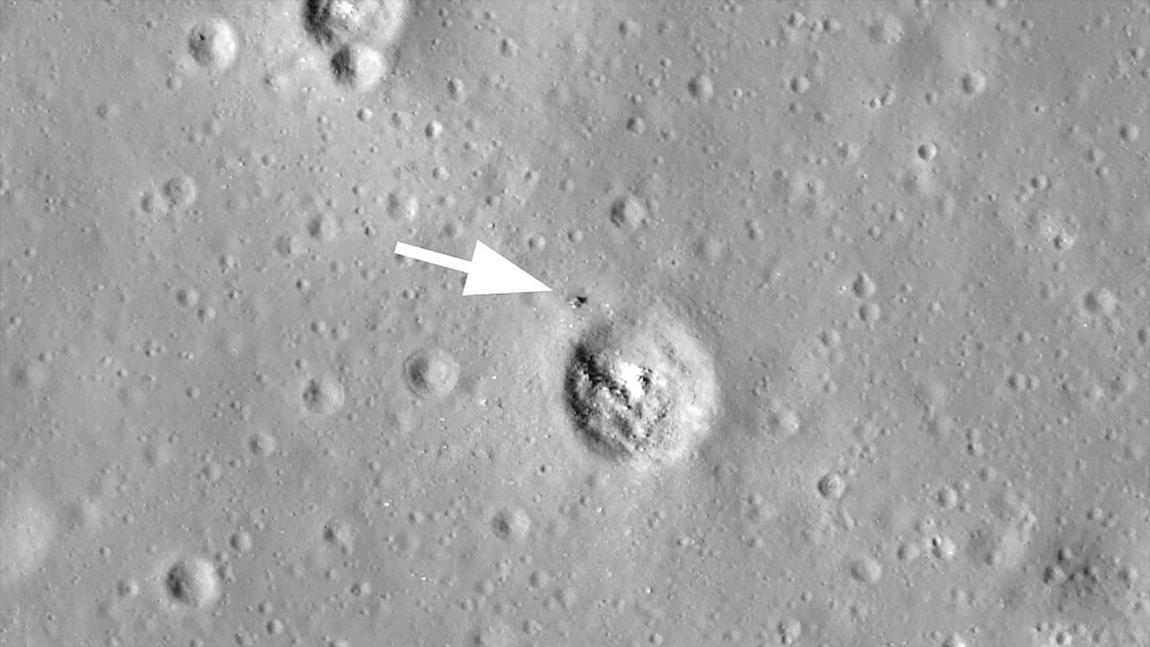
Click for next article On Aug. 9, 1976, the Soviet space program launched its last moon mission. Luna 24 was a robotic sample return mission and the third of its kind. It lifted off on a Proton-K rocket from the Baikonur Cosmodrome in Kazakhstan and safely landed on the lunar surface nine days later. The probe landed in a dark plain of the moon known as Mare Crisium, or the "Sea of Crises" and collected 6 ounces (170.1 grams) of soil samples, which it brought back to Earth on Aug. 22, 1976. Scientists then found that the samples from Luna 24 contained tiny traces of water - about 0.1% by mass. This photo, taken by NASA's Lunar Reconnaissance Orbiter, shows the location of the Soviet Luna 24 moon lander on Mare Crisium near a crater. (Image credit: NASA/GSFC/Arizona State University) Why it mattered The Soviet Union lost the Space Race to land the first humans on the moon, but its Luna program of robotic probes was prolific. The country's Luna 2 was the first spacecraft ever to land on the moon (it slammed into the lunar surface in 1959), with the more advanced Luna 9 making the first-ever soft-landing on the moon in February 1966, beating NASA's Surveyor 1 by about 4 months. By 1976, 12 NASA astronauts had walked on the moon, the last two on Apollo 17 in 1973 and the Space Race was over. But the Soviet moon program was not, with Luna probes and Lunakhod rovers . A Roscosmos illustration of the Luna 24 lunar sample return capsule launching from its lander to return pieces of the moon to Earth in August 1976. (Image credit: Roscosmos) The Luna sample return missions consisted of a lander equipped with a descent stage, ascent stage and Earth return capsule. The probes could collect samples of the moon, place them in the return capsule on the ascent stage, then rocket it from the moon for the trip back to Earth. NASA's Lunar Reconnaissance Orbiter has captured photos of the descent stages of Luna 16, Luna 20 and Luna 24 still on the moon. The Luna 23 spacecraft remained on the moon entirely, as it was damaged during landing and wasn't able to return a sample. NASA's LRO images later revealed Luna 23 likely fell on its side . But Luna 24, the last of the series, worked as planned, landing on Mare Crisium on Aug. 16, 1976, collecting a sample of the lunar regolith and launching back into space less than 24 hours later. While Luna 24 was the last Soviet moon sample return mission, it was not the last for Russia. In August 2023, Russia's Roscosmos space agency launched the Luna 25 mission , its first in 47 years, toward the lunar south pole. Luna 25 was planned to be the first in a new fleet of moon probes, but ultimately crashed into the moon after an orbital maneuver went wrong.

7. Exploring 'very low Earth orbit': The world's 1st air-breathing satellite thruster could soon get a test run
Read more
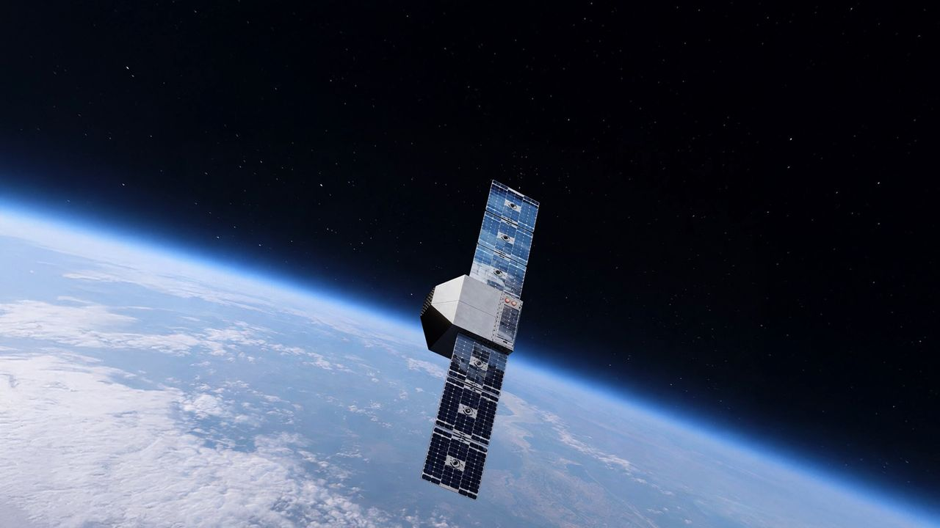
Click for next article Artist's illustration of a satellite operating in very low Earth orbit. Kreios Space is partnering with Kongsberg NanoAvionics to develop such a satellite mission. A new way to move around Earth's outer atmosphere could soon get a field test. The Spanish company Kreios Space plans to launch into orbit the world's first satellite that uses scooped-up air to push it forward, the company announced on Tuesday (Aug. 4). The technology Kreios Space has been developing is called air-breathing electric propulsion (ABEP). It relies on air sourced from Earth's atmosphere, which is then heated up, ionized and expelled to generate thrust. Diagram showing the different types of orbit around Earth. (Image credit: ESA) This method will allow satellites in very low Earth orbit (VLEO) - the region from roughly 60 miles to 250 miles (100 to 400 kilometers) above our planet - to counteract atmospheric drag without the aid of liquid fuel. "Kreios is building the satellites that make sustained operations in very low Earth orbit possible," Kreios Space CEO Adrián Senar said in the Aug. 4 announcement. "By enabling satellites to fly lower, longer and more efficiently, we are enabling higher-resolution Earth observation, much better satellite communications, more responsive and accurate missions and a more sustainable orbital infrastructure," he continued. Kreios Space chose Lithuanian-based Kongsberg NanoAvionics to provide the satellite bus that will carry the ABEP system into orbit for the test run. "Kreios is tackling one of the most demanding operating environments in space, and this mission joins a very short list of European VLEO initiatives," Kongsberg NanoAvionics CEO Atle Wøllo said in the same statement. "Our engineering team has worked closely with Kreios to configure the MP42 satellite bus to the mission's specific requirements and support the integration of Kreios' technology," he added. Kreios Space did not give a target launch date for the mission in Tuesday's statement, saying that the company will launch it "at a time when interest in and development of VLEO technologies has accelerated." But the company's website identifies 2027 as a notional target for its first space mission. A new, very low frontier Satellites in low Earth orbit (LEO) - altitudes of roughly 100 miles to 1,200 miles (160 to 2,000 km) - generally don't need constant propulsion. Usually, a small boost from traditional thrusters here and there is enough to keep a LEO satellite on the right track. To power the thrusters, these satellites usually have some form of fuel built in. VLEO works differently. It's low enough that there's still some atmosphere present, which generates drag on spacecraft. If you want a satellite to move around VLEO, it'll need to employ propulsion most or all of the time to counteract that drag. Any fuel that the satellite brings with it therefore won't last long. So, if satellites are going to operate in VLEO, it would be very helpful to have a method of propulsion that doesn't require traditional fuel - a method like ABEP. Satellites in VLEO have a few advantages over those operating in LEO, like sharper imagery thanks to the closer vantage point. One of the biggest advantages is that VLEO is much less crowded. There are thousands of satellites in LEO - most of them SpaceX's Starlink broadband spacecraft - and the number is growing all the time. But VLEO has plenty of room. If ABEP technology works and companies start outfitting satellites with this new propulsion method, then we might start seeing satellites operate quite close to Earth, zooming through the atmosphere and using the air around it to stay on course.

