 |  | 

🌌 अंतरिक्ष समाचार | Space News
शनिवार, ०१/०८/२०२६ | Saturday, 01/08/2026

1. Youth can take India to zenith of space research: Group captain Shukla
Read more
PIONEER EDGE NEWS SERVICE/ Dehradun Group captain Shubhanshu Shukla known for the 'Gaganyan mission' has said that India's youth have the potential to take the country to new heights in global space research. He was interacting with the students at the All India Institute of Medical Sciences (AIIMS) Rishikesh on Friday. Shukla motivated the students to pursue careers in space science, innovation and other challenging fields, he emphasised that even the most difficult goals can be achieved through determination, a positive mind-set and persistent effort. Shukla narrated his journey from his school days to becoming an Indian Air Force officer and eventually an astronaut. Through a video presentation, he explained the astronaut selection process, training for gravity and microgravity, physical and mental preparation, medical emergency training, mission launch procedures, medical care in space and the safe return to Earth. He explained that prolonged stays in space affect muscles, bones and the body's balance system. Therefore, after returning to Earth, astronauts undergo rehabilitation to retrain their muscles and restore balance and coordination. Sharing his experience of travelling hundreds of kilometres above Earth to the International Space Station (ISS), he said that science is a field driven by curiosity, discipline and dedication. During the interactive session, he also answered questions from students representing different schools and colleges. Welcoming Group Captain Shukla, executive director of AIIMS Rishikesh Meenu Singh described him as a true national hero. She said that by representing India in space, he has made the entire nation proud.

2. Gujarat launches ₹25 crore marketing support scheme to connect Sakhi mandal products to e-commerce platforms
Read more

Advt Join the community of 2M+ industry professionals. Subscribe to Newsletter to get latest insights & analysis in your inbox. All about ETGovernment industry right on your smartphone! Download the ETGovernment App and get the Realtime updates and Save your favourite articles. To make rural women associated with Sakhi Mandals financially Atmanirbhar and increase their income, the Gujarat Livelihood Promotion Company Limited (GLPC) has launched the 'Marketing Support Scheme'.Under the scheme, ₹25 crore will be provided during 2026-27 to help Sakhi Mandals connect their products to e-commerce platforms, giving them access to national and international markets.Implemented under the leadership of Chief Minister Bhupendra Patel and guided by Rural Development Minister Kunvarji Bavaliya and Minister of State Sanjaysinh Mahida, the scheme will help rural women sell their locally made products online and connect them directly with global markets.Until now, products made by Self-Help Groups were mainly sold at local fairs and exhibitions. Under the new scheme, women will receive financial assistance to complete the required formalities for registering on e-commerce platforms. This includes GST registration up to ₹15,000, FSSAI licence up to ₹10,000, and PAN Card registration up to ₹2,000.Additionally, an online sales incentive of ₹20 per order will be provided, with lifetime assistance of up to Rs 5 lakh for each Sakhi Mandal.This initiative will help rural women earn from home and become 'Lakhpati Didis', while giving a strong boost to the rural economy.Rekhaben of Dhoraji earned ₹10.96 lakh annually through her spice business. The success story of the President of the Osam Sakhi Mandal in Patanvav village of Dhoraji taluka, Rajkot district, is inspiring many rural women. After joining a Self-Help Group in 2016, she received food processing training from RSETI and started a traditional spices business.With a bank loan of ₹1.5 lakh, she expanded her business and created employment opportunities for other local women. Today, her spice unit earns an annual income of over ₹10.96 lakh. Under the Government's new 'Marketing Support Scheme', many Sakhi Mandals like Rekhaben's will now be able to sell their products through e-commerce platforms and reach customers in national and international markets.

3. ISRO successfully conducts Integrated Main Parachute Air Drop Test (IMAT) for Gaganyaan Programme - ISRO
Read more
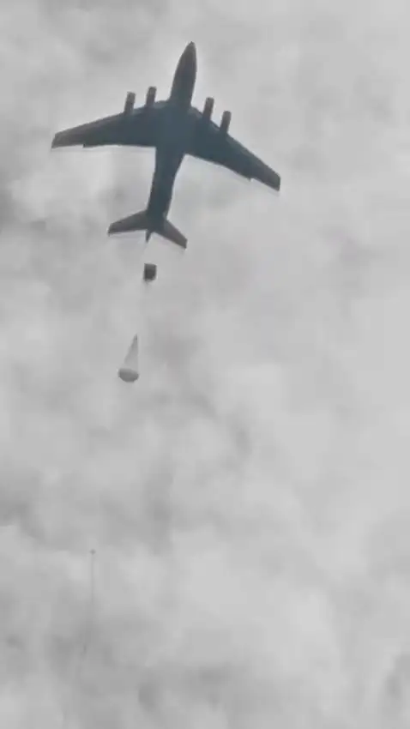
July 08, 2026 Indian Space Research Organisation (ISRO) has successfully conducted a critical Integrated Main parachute Airdrop Test (IMAT) for the Gaganyaan Missions on July 07, 2026 at the Aerial Delivery Research and Development Establishment (ADRDE) drop zone in Sheopur, Madhya Pradesh. The deceleration system of Gaganyaan Crew Module comprises of a total of 10 parachutes of 4 types. The descent sequence begins with two Apex Cover Separation parachutes that remove the protective cover of the parachute compartment, followed by two Drogue Parachutes that stabilize and decelerate the module. Upon release of the drogues, three Pilot Parachutes are deployed to extract three Main Parachutes, which further slows down the Crew Module to ensure a safe splashdown in the sea. The objective of this test was to qualify the Main Parachute for its structural integrity & design margins under the maximum expected load conditions in the first uncrewed Gaganyaan G1 mission. A simulated assembly of single main parachute and a dummy mass was dropped from an altitude of 2.5 km using an Indian Air Force IL-76 aircraft. The complex descent sequence began with an extractor parachute that deployed a Drogue parachute to stabilize oscillations. Upon achieving the requisite conditions, the main parachute was deployed which slowed the payload to a safe terminal speed. This is the 5th test in a series of Integrated Main parachute Airdrop Tests (IMAT) to qualify the critical Main Parachute for the Gaganyaan Mission. The successful completion of IMAT-05 provides necessary confidence in the performance and reliability of the Main Parachute System for the first Uncrewed Gaganyaan Mission (G1). This successful test is a joint effort of ISRO, DRDO, Indian Air Force and Indian Army.

4. ISRO aims for space station by 2035, Moon Mission by 2040 - The New Indian Express
Read more

He opined research should move beyond publications and result in technologies, patents and products that benefit society. He opined research should move beyond publications and result in technologies, patents and products that benefit society. Photo | Express VISAKHAPATNAM: "ISRO is working towards establishing India's own space station by 2035 and sending an Indian to the Moon aboard an Indian rocket by 2040," ISRO Chairman V Narayanan said on Friday. He was addressing the inaugural session of the 'ISRO Academia Connect @ AU' programme, organised by Andhra University, through virtual mode. Narayanan said India's progress towards becoming a developed nation by 2047 would require stronger collaboration among educational institutions, firms and research organisations. He opined research should move beyond publications and result in technologies, patents and products that benefit society. Highlighting ISRO's contributions, he stated that the organisation's satellites support more than 50 sectors, including telecommunications, weather forecasting, disaster management, agriculture, fisheries, water resources and border security. He added that satellite-based advisories to fishermen have helped improve their incomes.

5. ISRO calls for stronger academia-industry partnership to power future space missions - The Hindu
Read more
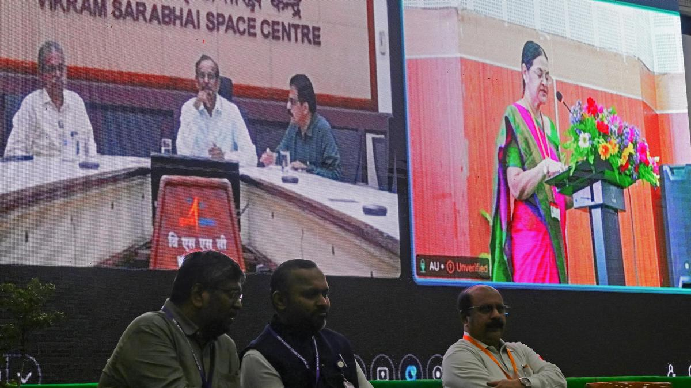
ISRO Chairman and Secretary, Department of Space, V. Narayanan, on Friday called for closer collaboration between academia, industry and research institutions to help realise India's ambitious space programme, including plans to establish an indigenous space station by 2035 and land Indians on the Moon by 2040. Delivering the keynote address virtually at ISRO Academia Connect @ AU, organised by the Capacity Building Programme Office (CBPO), ISRO, in association with Andhra University College of Engineering (A), Mr. Narayanan said the century-old Andhra University had made significant contributions to the nation by producing scientists, academicians and administrators, making it an ideal partner for advancing research and innovation. Highlighting India's achievements in space, he said the country had become the first to achieve a successful soft landing near the Moon's south pole through Chandrayaan-3 and added that work was under way on Chandrayaan-4 and Chandrayaan-5. "There should not be any gap between space and the common man of this country," he said, noting that ISRO's satellites were supporting more than 50 sectors, including telecommunications, weather forecasting, disaster management, agriculture, fisheries, water resources and border security. He said India had also developed indigenous cryogenic technology after being denied access to it by other countries. Calling for application-oriented research, Mr. Narayanan urged universities to move beyond academic publications and develop patents, technologies and products that benefit society. He expressed confidence that the collaboration between ISRO and Andhra University would create greater opportunities for research and internships while contributing to the country's space programme. ISRO Scientific Secretary M. Ganesh Pillai said the event at Andhra University was the fifth edition of ISRO's nationwide Academic Connect initiative. "Every successful space mission is built upon decades of research, innovation and academic excellence," he said, urging universities to undertake mission-oriented research leading to technologies, prototypes and products for future space missions.

6. What's Up: August 2026 Skywatching Tips from NASA
Read more
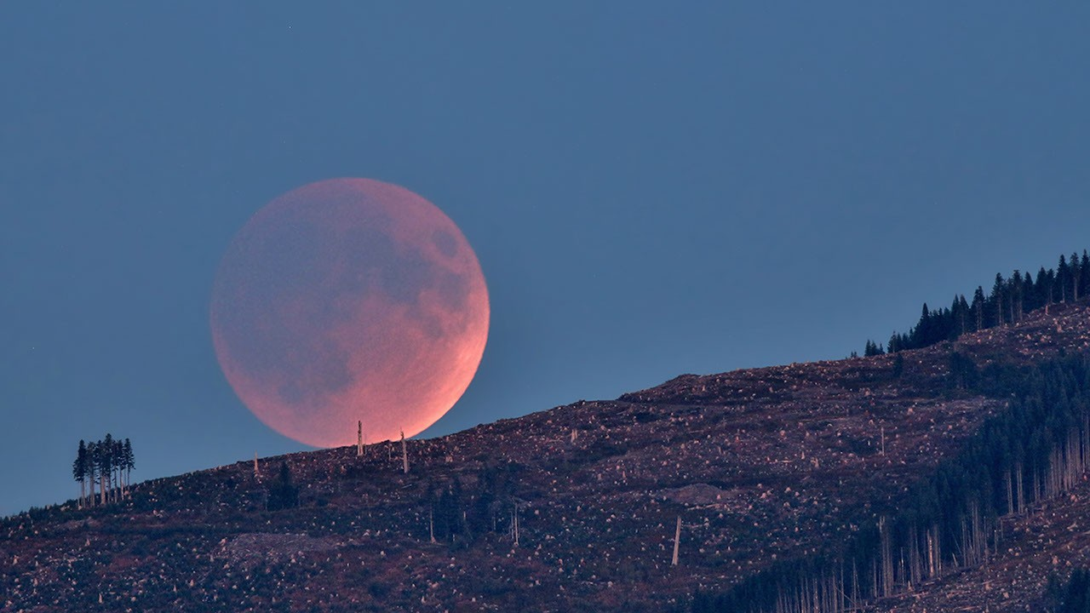
A solar eclipse, the Perseids, bright Venus after sunset, and a deep partial lunar eclipse highlight August's skywatching. Skywatching Highlights Aug. 5: Last Quarter Moon Last Quarter Moon Aug. 12: Total solar eclipse across northern Russia, Greenland, Iceland, northern Spain, and part of Portugal; partial eclipse in parts of the U.S.; New Moon Total solar eclipse across northern Russia, Greenland, Iceland, northern Spain, and part of Portugal; partial eclipse in parts of the U.S.; New Moon Aug. 12-13: Perseid meteor shower peak under dark skies Perseid meteor shower peak under dark skies Aug. 14-16: Venus reaches greatest eastern elongation and shines low in the west after sunset Venus reaches greatest eastern elongation and shines low in the west after sunset Aug. 27-28: Partial lunar eclipse visible from much of North and South America and parts of Europe and Africa Transcript A solar eclipse, one of the year's best meteor showers, Venus at its brightest in the evening sky, and a lunar eclipse to close out the month. That's "What's Up" for August. On Aug. 12, a total solar eclipse crosses northern Russia, Greenland, Iceland, and northern Spain, with a small corner of Portugal inside the path of totality. In parts of the United States, from Alaska to North Carolina, the eclipse is partial. The Moon will take only a small bite out of the Sun, and the amount of coverage will vary with location. A map showing viewing areas of the August 2026 total solar eclipse. NASA/JPL-Caltech Remember to watch safely. Use certified eclipse glasses or a safe solar viewer any time any part of the Sun is visible. Regular sunglasses are not safe. And never use binoculars, a telescope, or a camera without a solar filter made for the front of the optics. Later that same night, the Perseid meteor shower will light up the sky, peaking the evening of Aug. 12 into the early morning hours of the 13th. And with a New Moon arriving on the 12th, the skies will be ideally dark. The Perseids happen every year when Earth passes through a debris stream left behind by Comet Swift-Tuttle. As those tiny bits of comet dust hit our atmosphere at high speed, they burn up as bright streaks of light. To view this meteor shower, look toward the northeast once it's fully dark and watch for the constellation Perseus to clear the horizon. This is where the meteors originate, but let your eyes wander, because they can flash across any part of the sky. For the best view, stay out late as the stars climb higher, find a dark open spot, and give your eyes 30 minutes to adjust. This illustration shows where in the night sky to look for the Perseid meteor shower. NASA/JPL-Caltech Aug. 14-16, Venus reaches its greatest eastern elongation, which is its widest apparent separation from the Sun during this evening appearance. Look low in the western sky shortly after sunset for the bright object that will outshine every star around it. Through a telescope after sunset, Venus will look close to half lit, like a tiny lunar phase. This illustration shows where to observe Venus after sunset in August. NASA/JPL-Caltech On the night of Aug. 27, continuing into Aug. 28 for some time zones, the Full Moon slips through Earth's shadow, resulting in a partial lunar eclipse. It will be visible from much of North and South America and parts of Europe and Africa. Viewing areas for the August 2026 lunar eclipse. NASA/JPL-Caltech At maximum eclipse, about 93% of the Moon's diameter will be inside Earth's dark central shadow, called the umbra. The Moon will not be completely covered, but it can look dramatically darkened, with a rusty, coppery tint along the covered edge. Unlike a solar eclipse, a lunar eclipse is safe to watch with just your eyes. Binoculars or a small telescope can give you a closer view of Earth's curved shadow moving across the Moon. Here are the phases of the Moon for August. You can stay up to date on all of NASA's missions exploring the solar system and beyond at science.nasa.gov. I'm Raquel Villanueva from NASA's Jet Propulsion Laboratory, and that's What's Up for this month.

7. NASA to Host Florida Event Celebrating American Air, Space Leadership
Read more
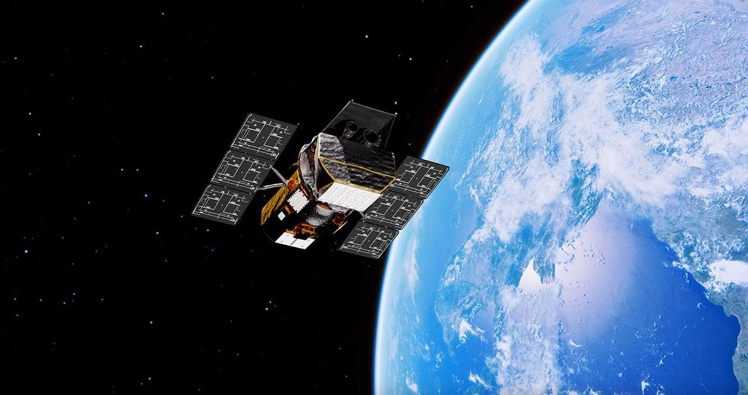
An American flag is seen in front of NASA's SLS (Space Launch System) rocket and Orion spacecraft at NASA's Kennedy Space Center in Florida on Jan. 17, 2026, ahead of the historic Artemis II test flight. NASA will host a news conference at NASA Kennedy on Friday, Aug. 14, to highlight American leadership in space and aviation. Credit: NASA/Joel Kowsky NASA will hold a news conference at 2:30 p.m. EDT, Friday, Aug. 14, live from the agency's Kennedy Space Center in Florida, and media and digital creators are invited to attend in person. The announcement, held in the XLV Hangar at the Shuttle Landing Facility, will preview a new event at NASA Kennedy later this year tied to America's 250th anniversary, showcasing American leadership in aviation, space exploration, and emerging technologies while bringing together the public, industry leaders, innovators, and the next generation of explorers. Participants include: NASA Administrator Jared Isaacman NASA leadership Members of Congress The agency will stream this news conference live through a variety of platforms: https://www.nasa.gov/live This event is open to U.S. media and digital creators. The request to attend must be received no later than 12 p.m. on Thursday, Aug. 6, to the Kennedy newsroom at: https://media.ksc.nasa.gov. NASA's media accreditation policy is available online. For more information about NASA's missions, visit: https://www.nasa.gov -end- George Alderman / Cheryl Warner Headquarters, Washington 202-358-1600 george.a.alderman@nasa.gov / cheryl.m.warner@nasa.gov Danielle Sempsrott Kennedy Space Center, Fla. 321-298-8990 danielle.c.sempsrott@nasa.gov

8. NASA, SpaceX Advance Wind Tunnel Tests for Starship Rocket
Read more
NASA and its industry partners are preparing for next year's Artemis III demonstration mission by completing new wind tunnel tests on SpaceX's Super Heavy Version 3 rocket booster. The tests, conducted at NASA's Ames Research Center in California's Silicon Valley, focused on better understanding the extreme aerodynamic forces the rocket can experience during re-entry. The recent test series builds on previous testing completed at NASA Ames in 2024. NASA is working with SpaceX to develop the company's Starship Human Landing System (HLS) to safely carry astronauts from lunar orbit to the Moon's surface and back. The upgraded Super Heavy rocket booster is part of SpaceX's Starship launch system. Version 3 of Starship and Super Heavy is expected to be the basis for the Starship HLS for Artemis III in 2027 and a later crewed lunar landing in 2028. Engineers at NASA Ames conduct transonic and supersonic wind testing on a 1.2% scale model of the Super Heavy Version 3 rocket that will launch the Starship human landing system. NASA Engineers at NASA Ames conduct transonic and supersonic wind testing on a 1.2% scale model of the Super Heavy Version 3 rocket that will launch the Starship human landing system. NASA Engineers at NASA Ames conduct transonic and supersonic wind testing on a 1.2% scale model of the Super Heavy Version 3 rocket that will launch the Starship human landing system. NASA Engineers at NASA Ames conduct transonic and supersonic wind testing on a 1.2% scale model of the Super Heavy Version 3 rocket that will launch the Starship human landing system. NASA Although Starship HLS is a lunar lander designed and built by SpaceX, NASA collaborates with commercial companies to provide access to specialized testing facilities, like the wind tunnels at NASA Ames, and technical expertise, such as the team that set up the wind tunnel testing and helped analyze the results. "NASA has a lot of experience with unsteady aerodynamics," said Manish Mehta, discipline lead engineer for the HLS Plume and Aero Environments team, NASA's Marshall Space Flight Center in Huntsville, Alabama. "We used the agency's broad experience base of conducting wind tunnel tests for the space shuttle, the SLS (Space Launch System) rocket, and Orion spacecraft to efficiently set up and analyze the wind tunnel testing for the Super Heavy Version 3. In fact, similar testing at the Ames Unitary Plan Wind Tunnel resulted in adding strakes to SLS for Artemis II, so what we learned for Artemis II is helping us get to Artemis III and beyond." Testing SpaceX's Starship consists of a 33-engine first-stage Super Heavy rocket, or booster, and the second-stage Starship. Version 3 of Super Heavy incorporates many new and upgraded systems, including: New propulsion systems and new Raptor 3 rocket engines No engine section skirt, individual engine shrouds, or integrated large-scale base heat shield Three gridfins on the Super Heavy booster instead of four, with each fin now 50% larger An integrated hot stage replacing the previous single-use protective interstage With significant changes to Super Heavy, NASA and SpaceX engineers wanted more information about the steady and unsteady aerodynamic forces the rocket will experience during atmospheric re-entry as it returns to the launch site for refurbishment and re-use. "When a rocket, or an airplane, flies through air at high speed, it's subjected to steady aerodynamic forces and moments, and unsteady aerodynamic forces and moments," explained Jayanta Panda, unsteady aerodynamics subject matter expert at NASA Ames and part of the Human Landing System Plume and Aero Environments team. "An example of a steady aerodynamic force would be when air smoothly flows over the surface of the rocket as it ascends. An unsteady aerodynamic force would be air 'buffeting,' or hitting, certain areas the rocket at less predictable times and potentially causing vibrations." Wind tunnels NASA and SpaceX used a 1.2% scale model of the Super Heavy Version 3 in the transonic wind tunnel and the supersonic wind tunnel at NASA Ames for testing. The transonic tunnel blasts scale models of rockets or aircraft with air at speeds ranging from Mach 0.2 to Mach 1.4 (Mach 1 is the speed of sound, or about 761 miles per hour). The smaller supersonic tunnel fires winds at higher speeds, from Mach 1.55 to Mach 2.5. The wind tunnel tests on Super Heavy Version 3, conducted in late 2025, used both tunnels to measure steady and unsteady air flows on the surfaces of Super Heavy. "Resulting wind tunnel data on steady forces and moments helps predict how the rocket will react to forces in the atmosphere during re-entry so the flight software can effectively guide the rocket during flight," Mehta said. "The unsteady pressure data helps engineers understand the environment around the rocket as it re-enters Earth's atmosphere. Engineers use that information as one input into software that analyzes loads on the rocket." Through the Artemis program, NASA is returning humans to the Moon for scientific discovery, economic opportunity, to establish an enduring human presence on the lunar surface, and build the foundation for the first crewed missions to Mars - for the benefit of all. To learn more about Artemis, visit: https://www.nasa.gov/artemis

9. NASA Opens New Flight Dynamics Research Facility in Virginia
Read more
From left to right: Casey Swails, NASA deputy associate administrator; Mike Waller, vice president of BL Harbert International Federal Division; Edward C. Forst, administrator of the U.S. General Services Administration; NASA Administrator Jared Isaacman; Dr. Trina Dyal, director of NASA's Langley Research Center; Rep. Robert "Bobby" Scott (D-Va.); Virginia Lt. Gov. Ghazala F. Hashmi; Jimmy Gray, mayor, City of Hampton; and Amit Kshatriya, NASA associate administrator, pose for a photo before cutting the ribbon to open the Flight Dynamics Research Facility, NASA's newest wind tunnel, Friday, July 31, 2026, at NASA's Langley Research Center in Hampton, Virginia. Credit: NASA/Keegan Barber NASA opened its newest wind tunnel, the Flight Dynamics Research Facility, Friday, providing a critical resource for the agency and its partners to test the safety and performance of future generations of aircraft, rockets, and space exploration vehicles. Located at NASA's Langley Research Center in Hampton, Virginia, the Flight Dynamics Research Facility will support advances in aircraft safety, X‑plane development, drone research, and spacecraft technology. The facility will enable both free‑flight and mounted testing of a wide range of scale-model vehicles designed to travel through an atmosphere, from airplanes to space capsules returning to Earth. "The Flight Dynamics Research Facility is NASA's first major new wind tunnel in more than 40 years and gives us a powerful new platform to test the ideas and technologies that will shape the future of aviation and exploration," said NASA Administrator Jared Isaacman. "America has led in air and space because we were willing to take on hard problems, challenge assumptions, and build what didn't exist before. This facility gives the talented team at Langley, and our partners across government, industry, and universities, the tools to keep pushing the boundaries of what's possible and ensure America remains the world leader in air and space." A ribbon-cutting ceremony at NASA Langley marked the start of a new chapter in flight research. Agency leaders, partners, and Virginia officials emphasized how the Flight Dynamics Research Facility's state-of-the-art capabilities will shape the future of flight and exploration. "The opening of the Flight Dynamics Research Facility represents a significant advancement for NASA and for the nation," said Dr. Trina Dyal, NASA Langley center director. "By bringing modernized testing capabilities under one roof, we are enabling transformative research that will ensure the United States remains at the forefront of aeronautics and exploration." Built through a partnership with the U.S. General Services Administration (GSA), the facility replaces aging infrastructure with an energy-efficient facility that reduces maintenance costs and provides the flexibility needed for future research. The Flight Dynamics Research Facility is part of a broader, long-term collaboration between the agencies, representing the fourth new building GSA has delivered to NASA under Langley's 20-year campus revitalization plan. "GSA is proud to partner with NASA in delivering the Flight Dynamics Research Facility, a state-of-the-art asset that will power the next generation of American dominance in aeronautics and space exploration," said Edward C. Forst, GSA administrator. "This facility reflects what we do best: provide the advanced, expertly designed installations that federal agencies need to carry out their missions. With these new capabilities, NASA will be better equipped to test bold ideas, validate new designs, and advance technologies that will serve the nation for decades to come." The Flight Dynamics Research Facility combines and improves upon the capabilities of two historic NASA Langley wind tunnels - the 20-Foot Vertical Spin Tunnel and the 12-Foot Low-Speed Tunnel. The 25,000-square-foot building features a vertical wind tunnel with improved airflow, modern digital systems, and flexible testing capabilities that will allow researchers to study how aircraft, spacecraft, parachutes, and other vehicles behave during flight. The facility's 20-foot diameter test chamber is much larger than those of its NASA Langley predecessors, allowing for more air to pass around test models and improving data accuracy. Its increased size also allows for the use of larger, more detailed models during testing. The Flight Dynamics Research Facility's top airspeed of 117 miles per hour is twice as fast as the old facilities, enabling free-flight tests of heavier scale models. This will allow simulations of full-scale vehicles flying at higher altitudes - a critical capability for operations such as studying the stability of aircraft or reentry capsules coming back from space. The facility's wind power comes from four 750-horsepower motors, each with an integrated, 14-foot diameter, eight-bladed fan. The fan blades are made of lightweight carbon fiber, enabling rapid, precise airspeed adjustments during free‑flight tests. The Flight Dynamics Research Facility illustrates the powerful synergy between NASA's aeronautics and space exploration efforts, with each driving innovation in the other. The facility will drive experimental research across a wide range of flight systems, advancing the development of autonomous flight vehicles, drones, commercial and military aircraft, and X‑planes. As NASA prepares for a sustained human presence on the lunar surface through the Artemis program and the development of a Moon Base, the facility will play a key role in testing vehicle designs for entry, descent, and landing that will help reduce mission risk and support the safe return of crews to Earth. NASA also will be able to use the wind tunnel to help design aircraft for Mars and other destinations in our solar system where atmospheric flight is possible. With the Flight Dynamics Research Facility now open, NASA is entering a new era in flight research - one that will shape the aircraft and spacecraft of tomorrow, strengthen industry partnerships, and extend the agency's legacy of pioneering aerospace leadership. The facility is managed under the Aerosciences Evaluation and Test Capabilities portfolio in the Aeronautics Division of NASA's Research and Technology Mission Directorate. Learn more about the Flight Dynamics Research Facility at: https://go.nasa.gov/4yzKEGQ -end- Camille Gallo / Rob Margetta Headquarters, Washington 202-358-1600 camille.m.gallo@nasa.gov / robert.j.margetta@nasa.gov Kimiko Booker / Brittny McGraw NASA Langley, Hampton, Virginia 757-506-5939 / 757-769-3763 kimiko.s.booker@nasa.gov / brittny.v.mcgraw@nasa.gov

10. NASA's Roman Telescope to Carry 1.35 Million Names to Deep Space
Read more
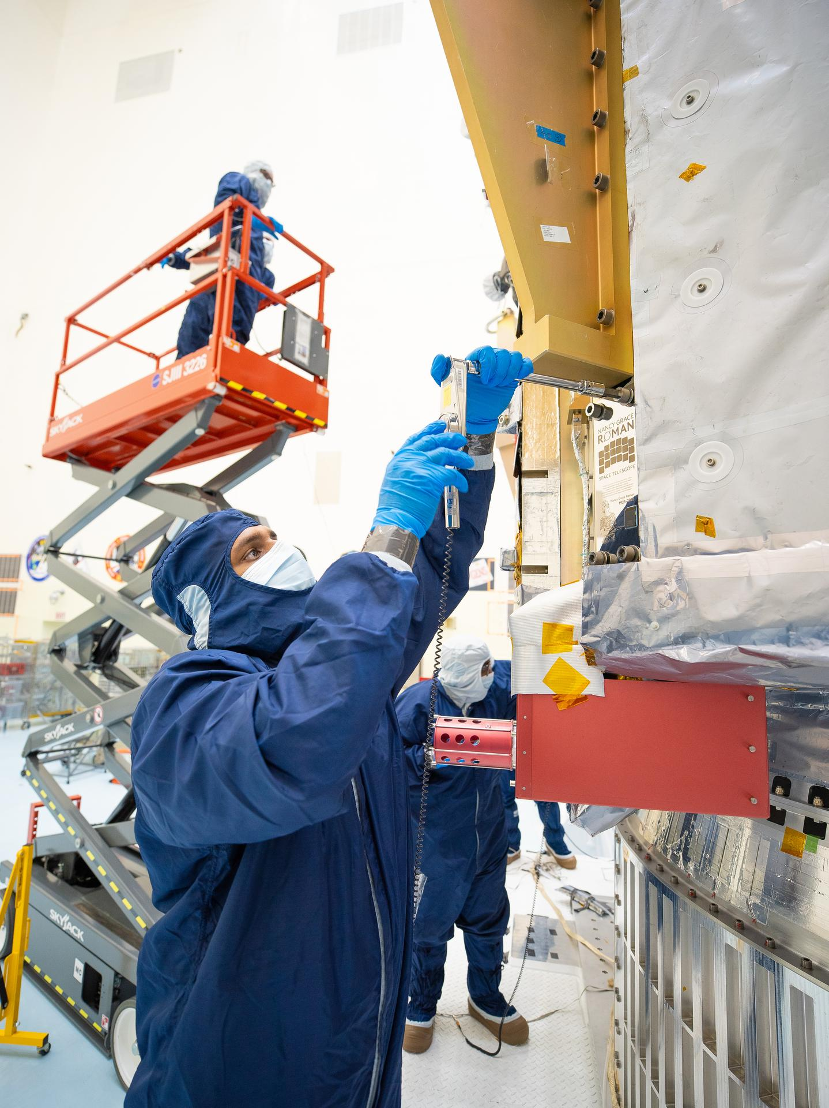
On July 27, technicians at NASA's Kennedy Space Center in Florida installed a memory card containing 1,350,144 names as part of a commemorative plaque on the Nancy Grace Roman Space Telescope. The names were submitted by people globally, including astronauts from Artemis II and Artemis III. The memory card will travel with the Roman observatory to the Sun-Earth Lagrange point 2, or L2, about one million miles from Earth, where the Sun's and Earth's gravity balance out. Roman is named after Dr. Nancy Grace Roman, NASA's first chief astronomer and one of the architects of the agency's modern science program. Roman championed space-based observatories that could study the universe from above Earth's hazy atmosphere while making their data broadly available to the scientific community. NASA and SpaceX are targeting launch for no earlier than 7:26 a.m. EDT Sunday, Aug. 30 aboard a SpaceX Falcon Heavy from Launch Complex 39A at Kennedy. To learn more about the Roman mission, visit: https://www.nasa.gov/roman Image credit: NASA/Jolearra Tshiteya

11. SpaceX's Starship seen in space by next-gen Starlink satellite (video)
Read more
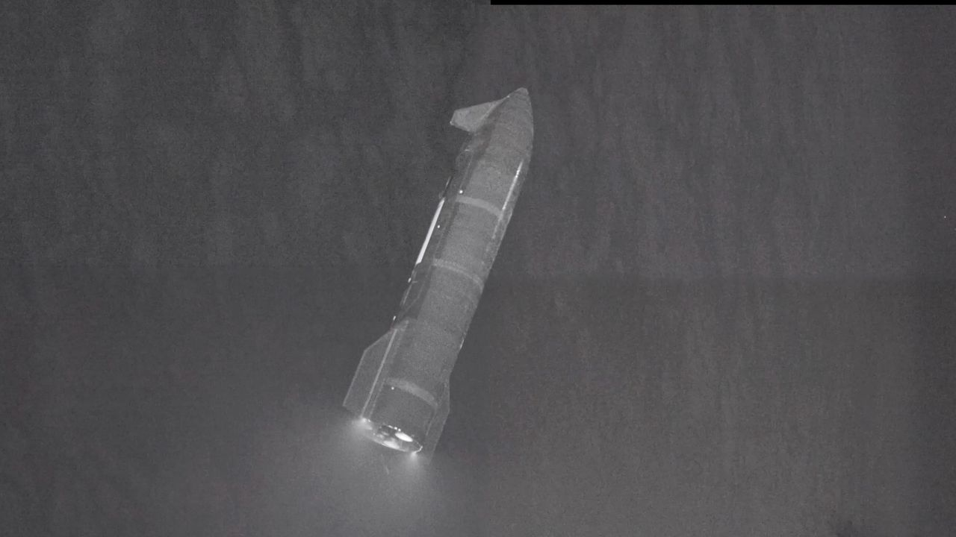
Click for next article The upper stage of SpaceX's Starship megarocket, seen on July 24 during the vehicle's 13th test flight by one of the company's Starlink V3 satellites. We just got an amazing new view of SpaceX's Starship vehicle, thanks to one of the company's next-gen Starlink satellites. Starship , the biggest and most powerful rocket ever built, launched on its 13th test flight from South Texas last Friday (July 24). The suborbital jaunt was similar in many respects to past Starship test missions, with one big exception: This time, the vehicle deployed a batch of functional, next-gen Starlink internet satellites into space. Six of those "Starlink V3" spacecraft carried cameras, so that SpaceX could get good views of the heat shield on Starship's upper stage, which is known as Starship, or simply Ship. The satellites did that job and more, capturing amazing views of Ship as it cruised away from them high above Earth . View of Starship in space from a Starlink V3 satellite on Flight 13.This composite is made of imagery from four separate cameras on a single satellite. Six of the satellites were equipped with cameras to scan Starship's heat shield and transmit imagery down to operators to… pic.twitter.com/sNTHHz5vLrJuly 31, 2026 SpaceX shared one such view on X Friday evening (July 31) - a 65-second video that stitches together imagery taken by four different cameras on a single Starlink V3 satellite. The video starts with an up-close view of the shiny, 171-foot-tall (52 meters) Ship. We see more of the vehicle as the footage rolls and the two spacecraft get farther and farther apart. Toward the end, we see Ship in its entirety, and we get a sense of its activity; three of its six Raptor engines are firing, and small puffs of white vapor indicate that the vehicle is engaging its fine-tuning reaction control thrusters. Like all Starship test missions to date, Flight 13 targeted a suborbital trajectory. So the 20 Starlink V3 satellites, the first ever to reach space, did not stay up for long; they came back down to Earth about 20 minutes after deploying into the final frontier. Their successors will get higher - and there will be many of them. According to a filing with the U.S. Federal Communications Commission, SpaceX wants to operate a megaconstellation of 100,000 Starlink V3 satellites . Starship will be key to building and maintaining this constellation, which will require many launches of the brawny, fully reusable rocket. (SpaceX currently operates a constellation of nearly 11,000 Starlink satellites, but those V2 craft are considerably smaller than the 4,400-pound V3 iteration.) SpaceX's Starship upper stage splashes down in the Indian Ocean to wrap up its 13th test flight on July 24, 2026. (Image credit: SpaceX) Ship seems to have checked all of its boxes on Flight 13. After deploying the satellites and successfully reigniting one of its Raptors in space, it splashed down on target in the Indian Ocean off the coast of Western Australia about 65 minutes after liftoff. The vehicle survived its harrowing return trip through Earth's atmosphere in one piece and remains intact today, as far as we know; SpaceX recently shared a photo of the vehicle bobbing in the Indian Ocean five days after splashdown. But Starship's giant first-stage booster, known as Super Heavy, had a few issues on Flight 13. Its landing burn employed only five of a planned 13 Raptor engines, for example, and the booster hit the waters of the Gulf of Mexico at a higher velocity than intended. (Super Heavy has a total of 33 Raptors, all of which fire at liftoff.)

12. NASA is sending 2 probes to the moon to test complex 'three-body orbits'
Read more
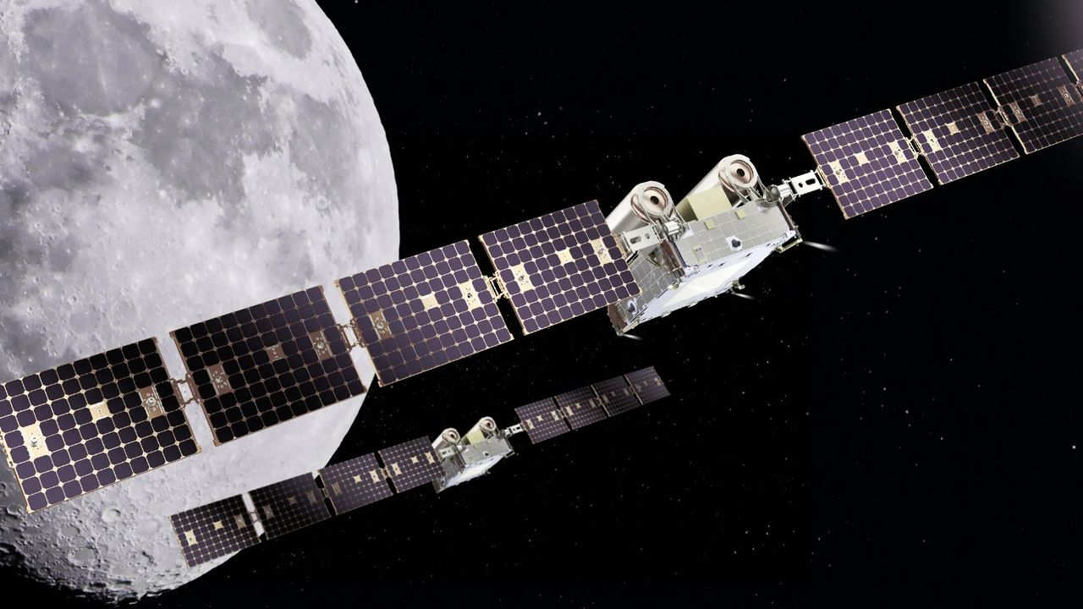
Click for next article NASA is planning to send two maneuverable probes to lunar orbit in order to learn how spacecraft are affected by the complex gravitational environment near the moon. The mission, known as CAPSTONE 02, is currently aiming to launch in 2027. It will see the two probes maneuver in close proximity to one another and fly in "formation" so mission operators can better understand the gravitational effects spacecraft experience in cislunar space . This area of space is under the influence of both Earth's gravity and the moon's, meaning spacecraft operating there will have to navigate what are known as "three-body orbits." While testing spacecraft maneuverability in these complex orbits, CAPSTONE 02 will also study communication and navigation systems that will be used in NASA's planned Artemis missions of lunar exploration and moon base construction . "This mission represents an important step in the maturation of cislunar capabilities," said NASA's Sean Fuller, Moon Base CAPSTONE manager, in an agency statement . "CAPSTONE 02 lays the foundation for lunar infrastructure and commercial services that support Artemis, Moon Base, and future missions to deep space." The two CAPSTONE 02 probes are being built by Terran Orbital Systems, Inc. Once in space, they will alternate jobs while flying in formation, switching between what NASA calls "chaser" and "target" roles. The spacecraft pair will use celestial navigation, optical sensors and data collected by telescopes on the ground during these maneuvers. This is similar to how NASA will use a variety of data to help its Orion spacecraft meet up with a lunar lander en route to the moon. On the upcoming Artemis III mission, currently scheduled for 2027, NASA will test some of these techniques as Orion will rendezvous with both Blue Origin's Blue Moon lander and SpaceX's Starship, if all goes according to plan. "Transporting crew to the lunar surface from cislunar orbit depends on knowing how well navigation systems will perform during these operations. Since these conditions can't be fully recreated on Earth, they must be tested in space," NASA wrote in its statement outlining the CAPSTONE 02 mission. An artist's rendering of NASA's Orion spacecraft meeting up with SpaceX's Starship on the planned Artemis III mission. (Image credit: SpaceX) As its name implies, this will be the second mission under NASA's CAPSTONE program, or Cislunar Autonomous Positioning System Technology Operations and Navigation Experiment. The first CAPSTONE probe launched in 2022 and operated for four years before NASA officially concluded its mission in June 2026. That microwave-oven-sized CAPSTONE spacecraft tested communications tech and became the first spacecraft to test three-body orbits around the moon, according to a NASA statement .

13. Watch SpaceX's Starship land at sea in these stunning new videos
Read more
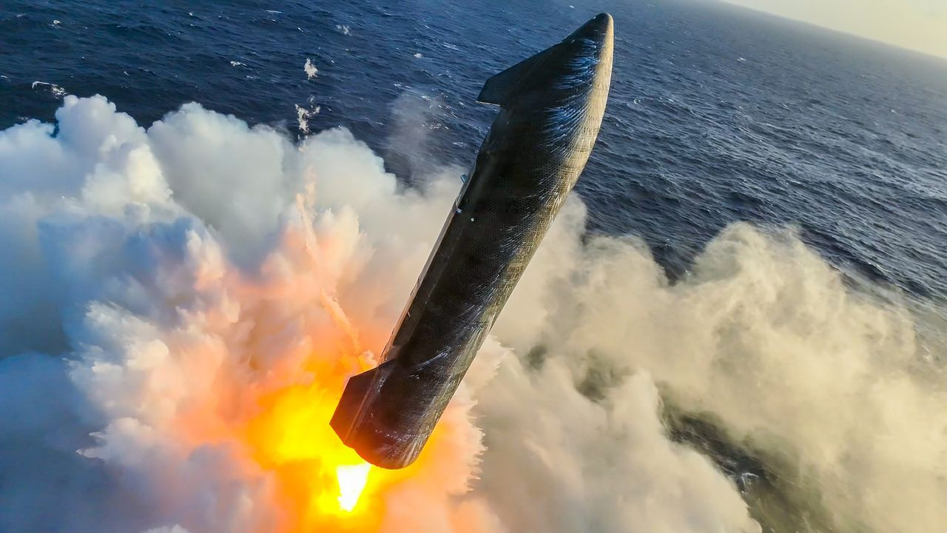
Click for next article It was Lucky 13 for SpaceX, as new videos show just how much work came into getting the latest flight of Starship's upper stage softly down into the ocean. After Starship made its 13th launch on Friday (July 24) from SpaceX's Starbase site in South Texas, the upper stage achieved all major milestones: putting 20 next-gen Starlink satellites aloft to watch it go, reigniting a Raptor engine in space, and then the soft splashdown off the coast of Western Australia. While the lower stage of Starship faced engine issues, fresh video shows some incredible views of the successful upper stage. Starlink satellites, ferrying signal from a buoy in the Indian Ocean, helped create a video on X showing the 171-foot (52-meter) upper stage roaring above the water, then generating steam as the engines swiveled to make a gentle splashdown. SpaceX's Starship upper stage fires its engines to slow down before splashing down on the Indian Ocean after its 13th test flight on July 24, 2026. (Image credit: SpaceX) Getting down that way was no easy feat, as SpaceX posted another video on Tuesday (July 28) showing Starship swaying dramatically in midair to achieve a near-vertical orientation above the water. If you don't mind a bit of vertigo, SpaceX also provided an on-ship view of the splashdown, complete with dramatic swings and ocean steam. The upper stage's ocean arrival was so soft, in fact, that days after launch on July 28 the 171-foot (52-meter) stage was reported as still afloat in the Indian Ocean, SpaceX said on X , adding that its Starship recovery team is continuing to gather imagery of the vehicle at sea. SpaceX's Starship Recovery Team poses for a portrait in front of the company's Starship V3 rocket afloat in the Indian Ocean on July 28, 2026. (Image credit: SpaceX) Starship's Version 3 (which flew on Friday) is a 408-foot-tall stacked system including the Super Heavy booster and the upper stage, also known as Starship (or Ship). SpaceX aims to make this system rapidly reusable for applications ranging from astronaut moon missions to launching even more powerful and larger Starlinks. That said, SpaceX still needs to notch some goals ahead of its expected participation for docking during the Artemis III astronaut mission scheduled for next year, and to possibly bring astronauts to the moon's surface during Artemis IV.

