IIRS Daily Space Digest Tuesday, 19/05/2026

1. SpaceX set to launch Starship test flight on May 20: Here's all you need to know
Science | The Indian Express
Read more
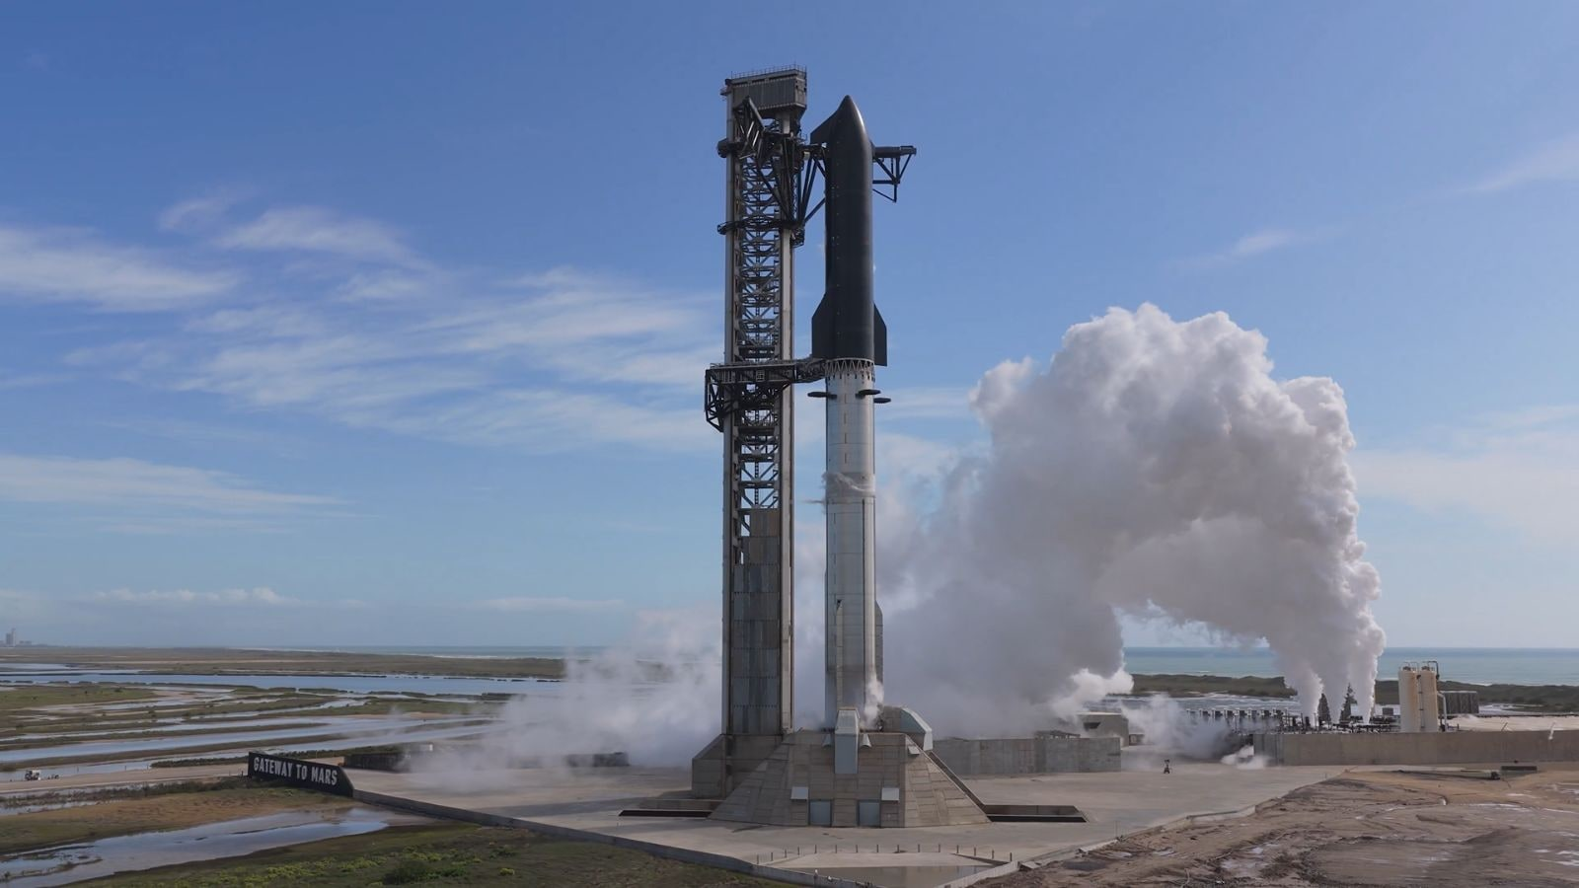

SpaceX has said that the flight test is being conducted to test both pieces of the hardware in a simulated flight environment. (Image: SpaceX) 2026 could potentially be a big year for SpaceX as it looks to go public even as the commercial spaceflight company founded by Elon Musk in 2022 gears up for the launch of its gargantuan rocket called Starship, with a test flight scheduled for Wednesday, May 20. This would mark the 12th overall launch of the world's largest rocket since April 2023, and the first since October 2025. Starship is currently parked on the launchpad of SpaceX's headquarters in South Texas, United States. The upcoming launch is crucial as SpaceX is looking to have a lunar lander configuration of Starship ready for astronaut moon landings under NASA's Artemis campaign.

2. Rajasthan CM launches statewide water conservation campaign from May 25 to June 5
Government News | Latest news on eGovernance, Digital India, Smart Cities | ET Government : ETGovernment.com
Read more


- Governance - 1 min read The Chief Minister chaired a high-level meeting at the CM's residence to review preparations for the campaign, along with the "Jal Sanchay Jan Bhagidari 2.0" and "Karmabhoomi Se Matrubhoomi" initiatives. ETGovernment Desk - ETGovernment - Published On May 18, 2026 at 05:16 PM IST Copy Link Share on WhatsApp Share on Linkedin Share on X Share on Telegram Share on Facebook Rajasthan Chief Minister Bhajan Lal Sharma Rajasthan Chief Minister Bhajan Lal Sharma has directed officials to implement the "Vande Ganga Jal Sanrakshan Jan Abhiyan" across the state from May 25, coinciding with Ganga Dussehra , to June 5, World Environment Day . The campaign will focus on water conservation, public participation, and restoration of traditional water bodies. During the meeting, Sharma instructed departments to ensure participation from both urban and rural communities and to involve administrative bodies, social organisations, and volunteers in the campaign. Advt Under the campaign, activities including worship and restoration of wells, ponds, and stepwells will be organised across the state. Plantation drives will also be carried out on the embankments of water bodies. The Chief Minister said awareness programmes should be conducted to inform people about the religious, environmental, and social significance of Ganga Dussehra and the importance of water conservation. He also directed officials to promote rainwater harvesting systems in houses and buildings and to encourage the construction and development of water conservation structures to improve groundwater levels. The meeting also reviewed the progress of the Jal Sanchay Jan Bhagidari 2.0 and Karmabhoomi Se Matrubhoomi campaigns. Sharma instructed all departments to work in coordination for implementation of the initiatives. Chief Secretary V. Srinivas and senior officials from related departments were present at the meeting. ETGovernment Desk , --> - By - See more on: - water conservation campaign , - Rajasthan CM , - Vande Ganga Jal Sanrakshan Jan Abhiyan , - Bhajan Lal Sharma , - Ganga Dussehra , - World Environment Day , - Jal Sanchay Jan Bhagidari 2.0 , - rainwater harvesting , - Karmabhoomi Se Matrubhoomi Telegram Facebook Comments What are your thoughts? Comment Now --> Comment Now Read Comment (1) All Comments By commenting, you agree to the Prohibited Content Policy Post Find this Comment Offensive? Choose your reason below and click on the submit button. This will alert our moderators to take actions REASONS FOR REPORTING Foul Language Defamatory Inciting hatred against a certain community Out of Context / Spam Others Report Join the community of 2M+ industry professionals. Subscribe to Newsletter to get latest insights & analysis in your inbox. All about ETGovernment industry right on your smartphone! - Download the ETGovernment App and get the Realtime updates and Save your favourite articles. Scan to download App -->

3. PM Modi announces ISRO-Norway space pact in Oslo; focus on climate change, fragile ecosystems - The Economic Times
"ISRO OR NRSC OR IIRS after:2026-05-18" - Google News
Read more

(ET Online) PM Modi announces ISRO-Norway space pact in Oslo; focus on climate change, fragile ecosystems 03:45 Min | May 19, 2026, 1:16 PM IST India and Norway signed multiple agreements during Prime Minister Narendra Modi's visit, including a key MoU between ISRO and the Norwegian Space Agency to strengthen cooperation in the space sector, Arctic research, climate studies, digital public infrastructure, and high-tech health solutions. Modi said the partnership will deepen scientific collaboration and support efforts to protect fragile ecosystems and address climate change challenges.

4. Smithsonian Displays ISRO Scientist Nandini Harinath's Saree From Mangalyaan Mission - The Better India
"ISRO OR NRSC OR IIRS after:2026-05-18" - Google News
Read more


Inside the vast galleries of the Smithsonian National Air and Space Museum in Washington, D.C., where objects tied to humanity's greatest journeys through air and space are carefully preserved, an unexpected exhibit from India has found its place - a saree. Advertisment The red-and-blue draped garment once worn by ISRO scientist Nandini Harinath during a defining moment of India's Mars Orbiter Mission, or Mangalyaan, is now part of the museum's collection. Advertisment Add The Better India As A Trusted Source The inclusion marks more than a personal milestone for the scientist, often referred to as India's "rocket woman". It also reflects how India's entry into the global space race carried not only engineering ambition, but cultural identity as well. The museum described the garment as "a vibrant red and blue sari with intricate patterns", sharing images of a mannequin draped in the outfit alongside archival visuals from the mission. For many Indians, the image feels familiar. Years before the saree entered a Washington exhibit, photographs of women scientists in bright sarees inside ISRO control rooms had already travelled across the world. Nandini Harinath wore this saree during one of the most celebrated moments in India's space journey: the success of the Mars Orbiter Mission in 2014. Photograph: (Conde Nast Traveller India) They stood in front of giant screens tracking spacecraft trajectories, celebrating successful launches, or monitoring data streams from millions of kilometres away. At a time when global depictions of scientists were still dominated by lab coats and sterile aesthetics, these images quietly disrupted expectations. And Mangalyaan changed everything. The mission that placed India on Mars When the Indian Space Research Organisation launched the Mars Orbiter Mission in 2013, the odds were steep. Deep-space missions are notoriously difficult, with many nations failing multiple times before successfully reaching Mars. India reached the planet on its very first attempt. In doing so, it became the first Asian nation to enter Martian orbit and only the fourth space agency in the world to achieve the feat. The spacecraft was initially designed to function for six to ten months. Instead, it remained operational for nearly eight years, studying Mars' surface and atmosphere long after expectations had ended. The images of women scientists in sarees celebrating Mangalyaan's success challenged stereotypes about who scientists are. Now, Nandini Harinath's saree at the Smithsonian stands as a symbol of women's growing visibility in space science and engineering. Photograph: (Rediff) At the centre of mission planning and operations was Nandini Harinath, who served as the deputy operations director of the mission. In a social media post announcing the display, the Smithsonian noted that Harinath had been "integral to mission planning and operations". The museum also highlighted how the sarees worn by the mission's women leaders came to symbolise both India's success in space and their national identity. A scientist shaped by stories of space Long before she became associated with one of India's most defining scientific achievements, Harinath was a child watching science fiction at home with her family. Born and raised in India, she grew up in an academically inclined household. Her mother taught mathematics; her father worked as an engineer. She later pursued undergraduate and postgraduate studies in engineering before joining ISRO, where she would go on to contribute to more than 14 missions over a career spanning two decades. But equations and propulsion systems were only part of the story. Harinath's love for space exploration In a 2025 conversation at the ET Enterprise AI Making AI Work Summit in Bengaluru, Harinath recalled how television and cinema first shaped her fascination with space exploration. "There was this very popular serial on TV called Star Trek," she said. "My entire family were absolute fans, we wouldn't miss a single episode. Another film I loved watching again and again was Apollo 13. Those stories of exploration and teamwork stayed with me." That sense of collective effort would later define Mangalyaan itself. More than a garment Museums often preserve objects because they capture turning points in human history. The Smithsonian's decision to preserve Harinath's saree is not about fabric alone. It is about what it represented during one of India's most closely watched scientific moments. Before becoming one of ISRO's key scientists, Nandini Harinath was a child inspired by Star Trek and Apollo 13. Raised in a family of educators and engineers, she went on to contribute to more than 14 space missions over two decades at ISRO. Photograph: (Instagram@airandspacemuseum) For decades, space exploration has been defined by machines - rockets, modules, helmets, and engines. This exhibit tells a different story: one where science and culture are not separated, but coexist. For young girls in India, especially those who saw themselves reflected in ISRO's women scientists during the Mangalyaan years, the saree carries another meaning too. It stands as a reminder that scientific ambition does not need to conform to a single visual identity to be globally respected. And now, in one of the world's most recognised museums of aviation and space history, that story has been formally preserved. Source: 'Saree, Nandini Harinath, Indian Mars Orbiter Mission (MOM)': By Smithsonian National Air and Space Museum

5. Air Force school student secures ISRO internship - Daily Excelsior
"ISRO OR NRSC OR IIRS after:2026-05-18" - Google News
Read more

Excelsior Correspondent JAMMU, May 18: Arjunveer Singh, a Class 11 student of Air Force School Jammu, has brought laurels to the Union Territory of Jammu and Kashmir by securing the prestigious Srijan internship with Indian Space Research Organisation (ISRO) and Defence Research and Development Organisation (DRDO), to be conducted at IISER Bhopal. Arjunveer earned the internship after securing 2nd rank in the North Zone at the Vidyarthi Vigyan Manthan (VVM) National Level Camp, held at IIT Gandhinagar, Gujarat. More than 5 lakh students from across the country participated in the first regional round of Vidyarthi Vigyan Manthan (VVM) held earlier this year. Of these, only the top 500 qualified for the final round held at IIT Gandhinagar, Gujarat. Arjunveer Singh clinched the 2nd rank in the North Zone to bag the prestigious Srijan internship. The Srijan internship - a coveted opportunity for high-performing VVM - will provide Arjunveer chance to work alongside eminent researchers at premier national institutions. Principal, Air Force School Jammu, congratulated Arjunveer, saying his achievement will inspire other students in J&K to pursue excellence in science and innovation.

6. ISRO expanding student participation in space missions, 11 student satellites already launched: Jitendra Singh - DD News
"ISRO OR NRSC OR IIRS after:2026-05-18" - Google News
Read more

Union Minister of State for Science and Technology Dr. Jitendra Singh on Thursday said the Indian Space Research Organisation (ISRO) is expanding student participation in space missions through structured programmes that allow young researchers to design satellites, develop payloads and participate in real mission experiments. Replying to an unstarred question by Sumitra Balmik in the Rajya Sabha, Singh said the government is committed to widening access to space technology so that students from institutions across the country, including those in tier-2 and tier-3 cities, can contribute to India's growing space ecosystem. The minister said ISRO has launched several initiatives aimed at providing hands-on exposure to space technology for students and researchers. Student satellite programme gaining momentum Singh said that ISRO's Student Satellite Programme, led by the U R Rao Satellite Centre, encourages academic institutions to design and develop satellites with technical mentorship from ISRO scientists. The organisation also supports integration and launch opportunities for these satellites through its missions. So far, the Indian National Space Promotion and Authorisation Centre (IN-SPACe) has authorised 17 student satellites and payloads, of which 11 have already been successfully launched, the minister informed. These projects have involved several academic institutions including the Indian Institute of Astrophysics, Indian Institute of Space Science and Technology, RV College of Engineering, Amity University Maharashtra, MIT World Peace University, Assam Don Bosco University and CV Raman Global University, reflecting growing national participation in student-led space missions. Competitions and innovation initiatives Singh said student engagement is also being promoted through national competitions organised by IN-SPACe. These include satellite and model rocketry competitions in which 97 student teams comprising nearly 850 students have participated. One such event - the Model Rocketry and CanSat India Student Competition - was organised jointly by IN-SPACe, ISRO and the Astronautical Society of India in October 2025 at Kushinagar in Uttar Pradesh. The event saw 67 teams with nearly 500 students design, fabricate and launch model rockets carrying CanSat payloads to an altitude of about one kilometre. Internship and research support The minister said students are also benefiting from internship and project trainee programmes that provide research exposure at ISRO centres for undergraduate, postgraduate and doctoral students. To strengthen collaboration between universities and ISRO scientists, the government has established Space Technology Incubation Centres (STICs) across various regions. These centres support students in developing indigenous space technologies under expert mentorship. In addition, Regional Academic Centres for Space (RAC-S) have been created to help students from smaller towns and institutions access ISRO programmes and research opportunities. Strengthening space education ecosystem Singh also highlighted the role of ISRO's RESPOND Programme, which provides financial and technical support to universities undertaking research in space science, technology and applications. He said the All India Council for Technical Education has approved a Space Technology Minor Course, while a national committee has been formed to promote adoption of space technology education in line with the Indian Space Policy 2023. The government has also earmarked around ₹10 crore annually for educational outreach activities in space science and technology. Singh said IN-SPACe is further supporting the next generation of space entrepreneurs through mentorship from domain experts, pre-incubation programmes and co-working facilities at its technical centres. "These initiatives are part of the government's broader vision to build a vibrant and inclusive space ecosystem in India, where students, startups, academic institutions and industry all contribute to the country's expanding role in the global space sector," the minister said.

7. Smile launch highlights
ESA Space Science
Read more
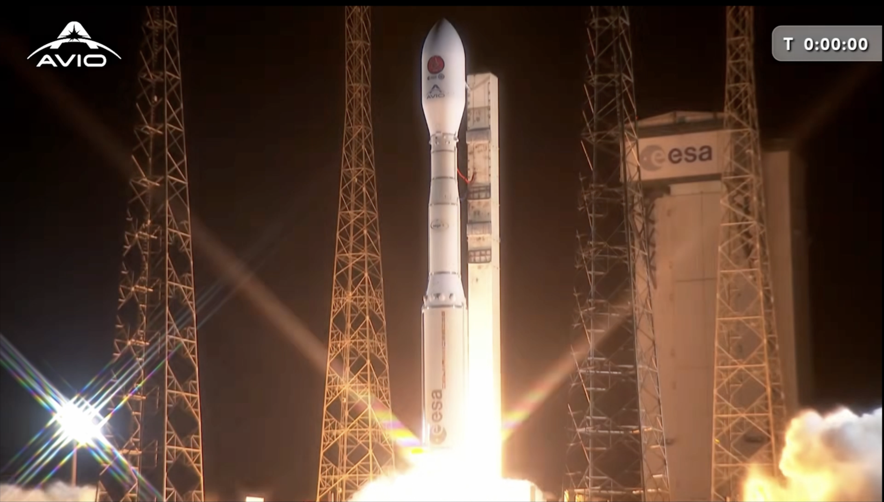

ESA's Smile satellite launched aboard a Vega-C rocket from Europe's Spaceport in French Guiana. The rocket lifted off on at 04:52 BST / 05:52 CEST (00:52 local time) on 19 May 2026. Smile flew to space on Vega-C flight VV29. At 35 m tall, a Vega-C weighs 210 tonnes on the launch pad and the rocket used three solid-propellant-powered stages to take Smile to orbit before the fourth liquid-propellant stage took over for a precise drop-off around Earth.Smile (the Solar wind Magnetosphere Ionosphere Link Explorer) is a joint mission between the European Space Agency (ESA) and the Chinese Academy of Sciences (CAS). Smile will use four science instruments to study how Earth responds to the solar wind from the Sun. In doing so, Smile will improve our understanding of solar storms, geomagnetic storms and the science of space weather.

8. Vega C rocket launches European-Chinese space weather satellite to orbit
Latest from Space.com
Read more
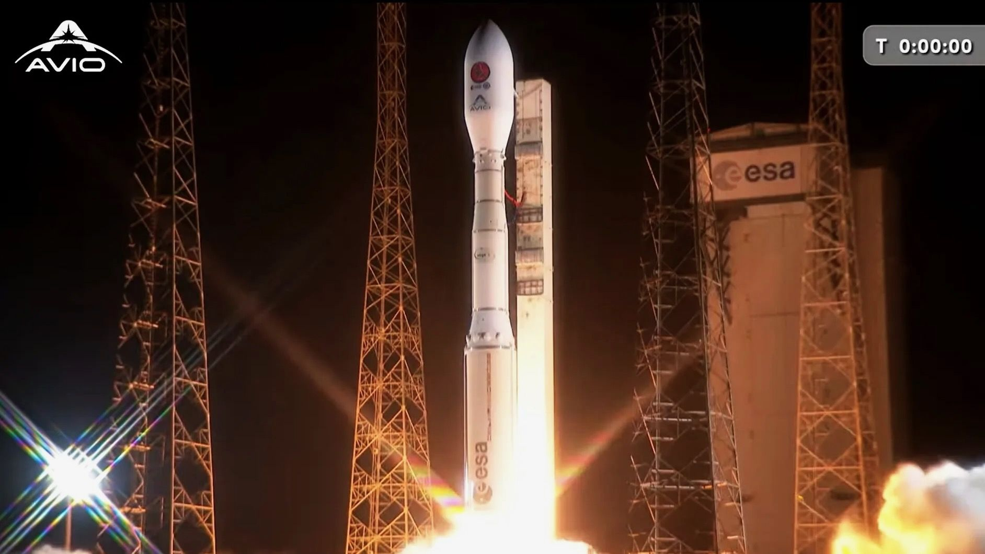

Click for next article A Vega C rocket launches the SMILE space weather mission from Kourou, French Guiana on May 18, 2026. A European-Chinese space weather mission launched to orbit on Monday night (May 18). The SMILE spacecraft lifted off atop a Vega C rocket from Europe's Spaceport in Kourou, French Guiana Monday at 11:52 p.m. EDT (0352 GMT and 5:52 a.m. local Kourou time on May 19). Everything went according to plan: The three-stage Vega C deployed SMILE in a circular orbit 439 miles (707 kilometers) above Earth about 56 minutes after liftoff. SMILE (short for Solar wind Magnetosphere Ionosphere Link Explorer) will use four science instruments to study how Earth is affected by the solar wind , the flow of charged particles streaming constantly from the sun . "In doing so, SMILE will improve our understanding of solar storms , geomagnetic storms and the science of space weather ," European Space Agency (ESA) officials wrote in a mission description. The Chinese Academy of Sciences is responsible for SMILE's satellite platform, spacecraft operations and three of the four science instruments - the Ultraviolet Imager (UVI), the Light Ion Analyser (LIA) and the Magnetometer (MAG). ESA provided SMILE's payload module, the other science instrument (the Soft X-ray Imager, or SXI), the rocket and assembly and testing integration and services. The agency also contributed to the UVI instrument and will help with operations in orbit, according to ESA's mission description. Artist's illustration of the European-Chinese SMILE space weather satellite attached to its Vega C rocket in space. (Image credit: ESA/ATG Europe) SMILE can't start doing its science work just yet. It will conduct 11 engine burns over the next 25 days, changing its orbit to a highly elliptical one that takes it 75,185 miles (121,000 km) above the North Pole and 3,107 miles (5,000 km) above the South Pole. After that, the mission team will perform a number of checkouts to make sure SMILE and its instruments are working properly. "About three months after launch, the team will receive the first X-ray and ultraviolet images, and then finally begin the science that SMILE is designed to do. The planned mission lifetime is three years," ESA officials wrote in the mission description. The 115-foot-tall (35 meters) Vega C , which was developed by ESA, debuted in July 2022. It now has seven flights under its belt to date, six of them successful. Monday's launch was the first Vega C mission operated by the Italian company Avio; the others were managed by France-based Arianespace. Editor's note: This story was updated at 12:45 a.m. ET on May 19 with news of successful launch, then again at 12:55 a.m. ET with news of satellite deployment.

9. This amazing NASA video shows the exact moment the Artemis 2 Orion capsule broke free of its service module, and we can't stop watching it
Latest from Space.com
Read more
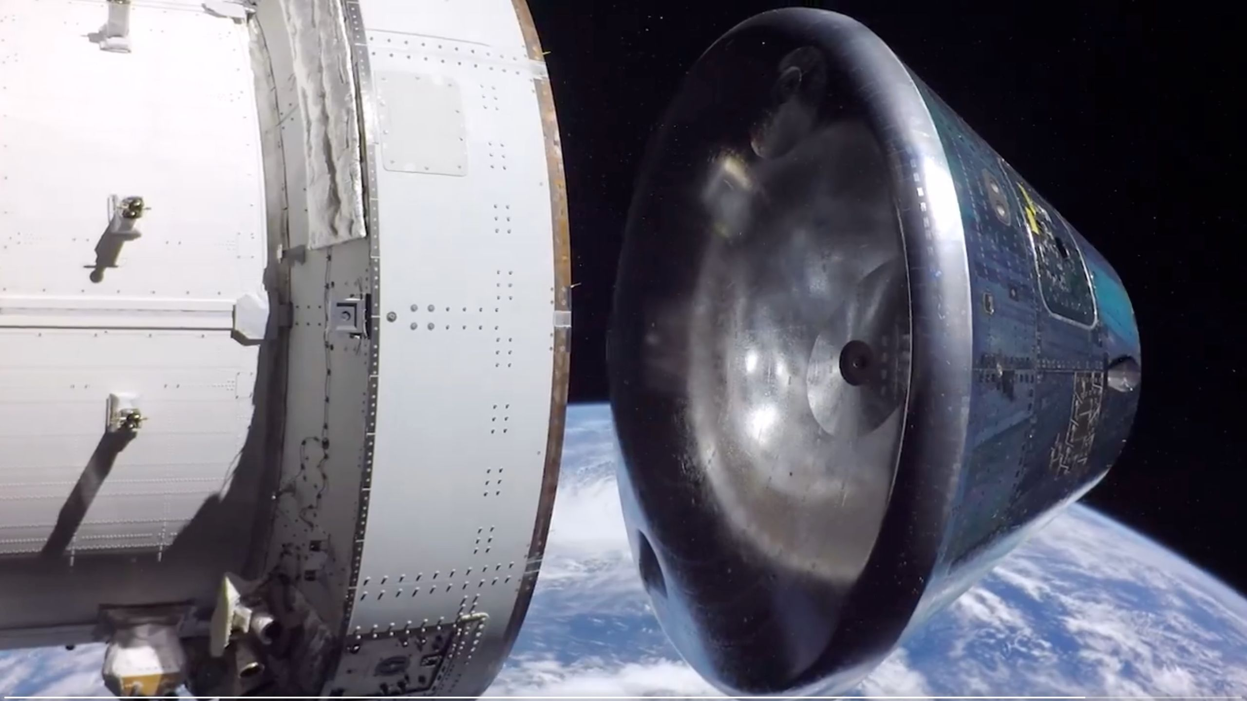

Click for next article The Orion capsule's heat shield was a big topic of discussion during the Artemis 2 moon mission, and for good reason: It was the key component of the spacecraft that kept the crew safe when they reentered Earth's atmosphere. The trajectory the Artemis 2 astronauts flew when Orion returned was different from the path taken by the uncrewed Artemis 1 mission's Orion spacecraft in late 2022. Unexpectedly high degrees of charring on Orion's heat shield during that mission led engineers to alter the spacecraft's course to prevent a recurrence on Artemis 2, but, as is anything untested in space, there is always risk involved. So, when the Artemis 2 livestream transmitted a pixelated view of Orion's separation from its European service module on April 10 and put the spacecraft's heat shield on full display, people marveled at the surprisingly reflective surface mated to the capsule's broad side. NASA's Artemis 2 Orion capsule separates from its service module shortly before reentering Earth's atmosphere on April 10, 2026. (Image credit: NASA) And everything worked out just fine: The Artemis 2 Orion and crew safely splashed down in the Pacific Ocean just over a half hour later, and now NASA has released the high definition footage from their stage separation. "POV: You're coming home after a journey around the moon," NASA officials said via the Artemis program 's X account in a May 15 post . The post included a video that shows two angles of the Artemis 2 Orion stage separation with its service module, highlighting the mission milestone in vivid detail. As Orion drifts away, the service module can be seen reflected in the capsule's mirror-like heat shield. Intricate details of both spacecraft stages, down to some individual rivets, can be seen along the spacecraft hulls, while Earth hangs humbly in the background on the bottom half of the frame. Artemis 2 launched on April 1 , sending four astronauts on a 10-flight around the moon . Their mission captured the attention of people across the world, and NASA has been releasing media from the mission since the crew's return, including a gallery of more than 12,000 images the astronauts took during their journey. NASA's Artemis program aims to establish a consistent and sustainable human presence on and around the moon. Artemis 2 was the program's first crewed mission, and the first Orion flight with astronauts aboard.

10. SpaceX Starship Flight 12 launch updates: 1st-ever Starship V3 test gets new launch date
Latest from Space.com
Read more
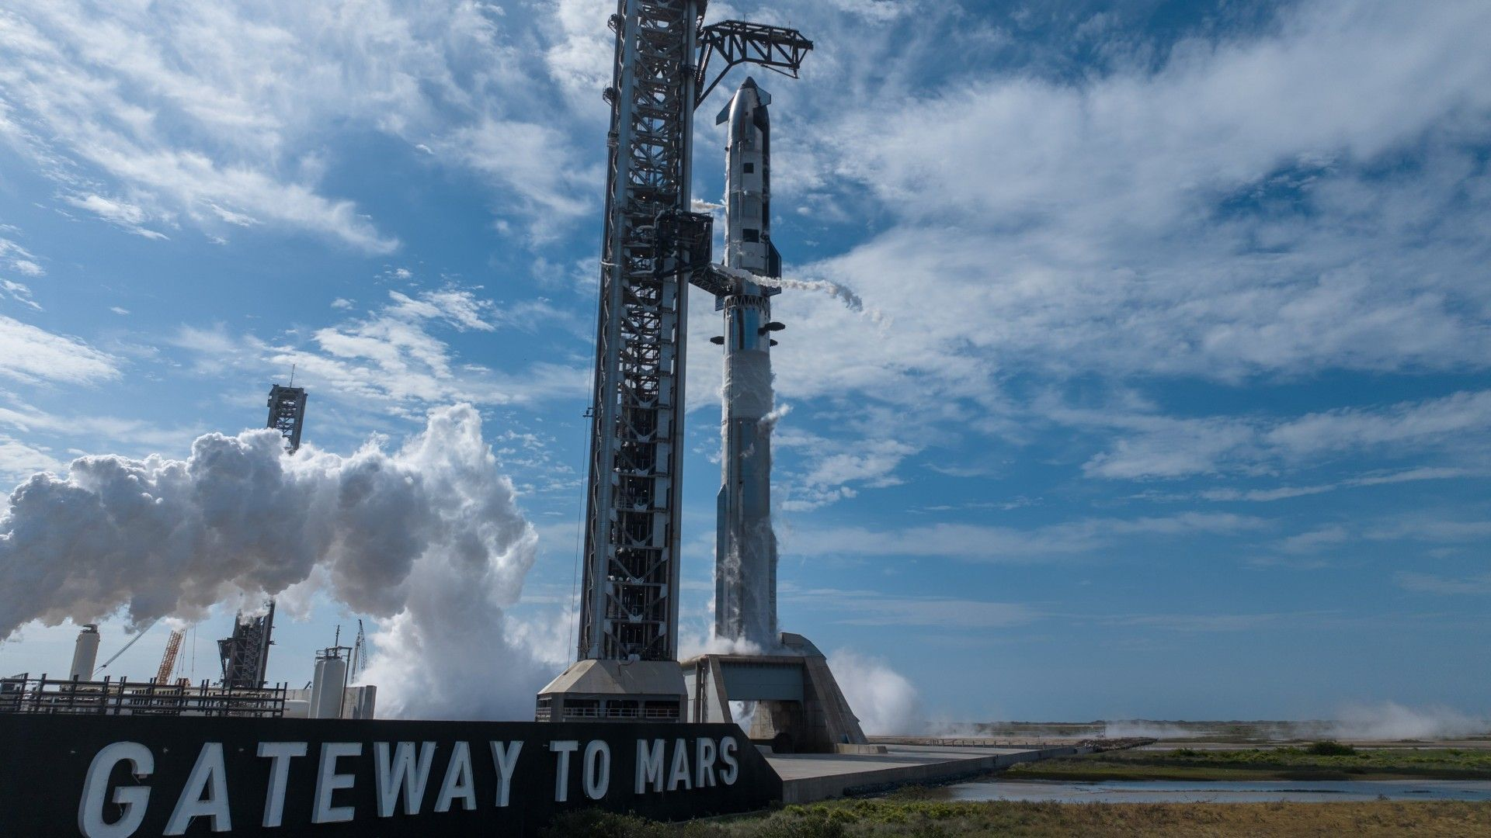

Refresh Get notified of updates SpaceX Starship Flight 12 will now launch on May 21 The 12th test flight of SpaceX's Starship megarocket has slipped yet again, to Thursday evening (May 21). That's the second delay in the past two days; SpaceX had originally targeted Tuesday (May 19) for the launch but pushed it to Wednesday (May 20). And now Wednesday is off the table as well . Starship Flight 12 is currently targeted to lift off from SpaceX 's Starbase site in South Texas on Thursday, during a 90-minute window that opens at 6:30 p.m. EDT (2230 GMT; 5:30 local time in Texas). You can watch it here at Space.com when the time comes. The test flight will send Starship's upper stage on a suborbital trajectory partway around the world, with splashdown coming in the Indian Ocean off Western Australia about 65 minutes after liftoff. Starship's Super Heavy first stage will make a controlled splashdown of its own in the Gulf of Mexico about seven minutes after launch. Flight 12 will mark the debut of Starship Version 3 (V3), the biggest and most powerful iteration of the rocket to date. It features many upgrades over its predecessors, which helps explain the long gap in Starship flights. The megarocket last took to the sky in October 2025 . What time is Starship V3 launch? Road closure clues SpaceX conducts a launch rehearsal with its first Starship V3 megarocket at its Starbase site in South Texas on May 11, 2026. (Image credit: SpaceX) With SpaceX's Starship V3 test flight just a few days away, I thought it might be helpful to make a guide to the timing of the mission. In my latest story - helpfully titled " What time is SpaceX's Starship V3 launch on May 20? (Starship Flight 12 timeline) " - I've laid out a what has become a fairly standard timeline for SpaceX's Starship launches. Based on the information we have now, it is a pretty good idea of what to expect. Here's the basics: On Wednesday, May 20, SpaceX will attempt to launch its Starship V3 at 6:30 p.m. EDT (2230 GMT). It will actually be 5:30 p.m. local time at SpaceX's Starbase, Texas launch site. SpaceX's livestream of the launch will begin about 45 minutes BEFORE liftoff, so you'll want to tune in around 5:45 p.m. EDT (2145 GMT). HOWEVER! SpaceX has said the launch window opens at 6:30 p.m. EDT, so there is wiggle room and the exact time could change. In the past, Starship launch windows have varied from 30 minutes to 2 hours. So it's possible the launch time will be later what SpaceX has said. The launch day could change as well. In fact it already has. As I say in my piece, SpaceX initially aimed for a May 19 launch , but pushed the Starship flight back 24 hours without explanation (probably for more preflight checks). But TODAY, we received a new road closure alert from Starbase, Texas officials. That alert states that the town is closing off public access to the roads around SpaceX's Starbase test site (which is near a public beach), from May 19 through the end of May 21, which suggests a potential back up launch day of at least May 21 is available. Tariq Malik Editor-in-Chief, Space.com

11. Artemis 2 moon astronauts snap gorgeous shot of swirling stars | Space photo of the day for May 18, 2026
Latest from Space.com
Read more

Click for next article The view out the window of the Orion capsule "Integrity" during NASA's Artemis 2 mission around the moon. (Image credit: NASA) NASA's Artemis 2 astronauts had quite the view on their "roadtrip" to the moon. In this image, captured by the astronauts onboard the mission's Orion capsule "Integrity," you can see the swirling stars of space from the window as the crew journeyed from our home planet to the moon . What is it? This past April, four astronauts - commander Reid Wiseman, pilot Victor Glover and mission specialist Christina Koch of NASA and Canadian Space Agency mission specialist Jeremy Hansen - blasted off on a 10-day journey around the moon and back as part of NASA's Artemis 2 mission. Latest Videos From View more The quartet flew in an Orion capsule that they named "Integrity." This spacecraft came equipped with four windows, enough for each astronaut to have his or her own view. And you can see in this image that through these windows, the astronauts could watch the stars swirling by on their cosmic journey. The crew successfully splashed down back on Earth in the Pacific Ocean on April 10 . If all goes to plan, Artemis 2 will be followed by the Artemis 3 docking test in Earth orbit in 2027 before Artemis 4 lands humans on the moon in late 2028. Why is it incredible? On roadtrips on Earth, it's always fun to look out the window and watch the world pass you by. But on this journey, the view out the window was out of this world - literally. This roadtrip snapshot also signifies something bigger: a big step forward in the journey back to the moon with Artemis. NASA's Artemis program aims to return humans to the lunar surface for the first time in over 50 years, since the agency's final Apollo mission in 1972. But the plan isn't just to go back for a singular, celebratory landing on the lunar surface. Instead, NASA is aiming for a longer-term presence on the moon. Who knows? Future astronauts could soon be looking out their windows at the view on their way to stay at a moon base.

12. SpaceX Starlink and other satellite megaconstellations are creating an 'unregulated geoengineering experiment', scientists say
Latest from Space.com
Read more
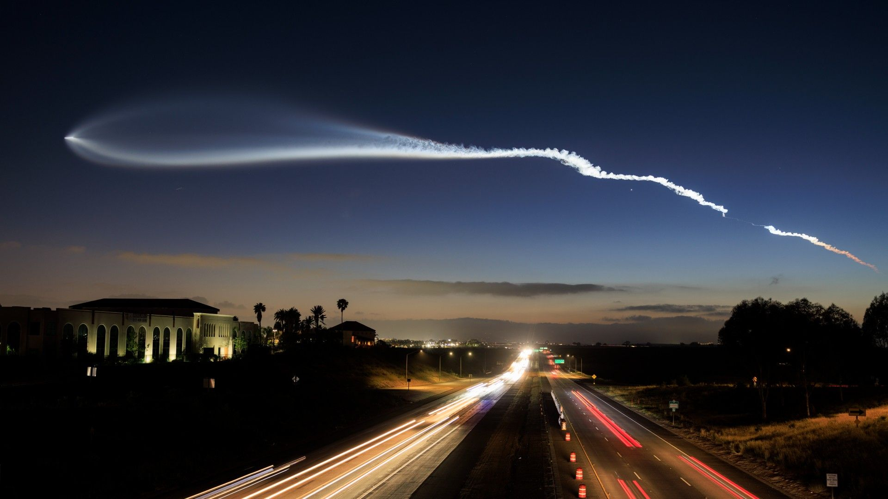

Click for next article A SpaceX Falcon 9 rocket carrying a payload of 25 Starlink internet satellites soars into space after launching from Vandenberg Space Force Base on a clear spring night on April 6, 2026 as seen from San Diego, California. Space industry aficionados have big plans. They talk about the not so distant future when hundreds of thousands or even millions of satellites orbit planet Earth, beaming the internet to the unconnected, processing data in orbital computer centers, generating solar power and more. But this ambitious vision, which many in the sector think will become reality sooner or later, worries atmospheric researchers. Studies show that since the beginning of the mega-constellation era in 2020, concentrations of potentially dangerous high-altitude air pollution stemming from satellite launches and re-entries has significantly increased. Based on estimates described by researchers as "conservative", the global space sector will have released by 2030 more climate-altering chemicals into the atmosphere than the entire United Kingdom. If the growth envisioned by the space industry leaders comes to pass, this air pollution, mostly concentrated in higher layers of the atmosphere , will at some point begin altering Earth's climate, Eloise Marais, a professor of atmospheric chemistry and air quality at University College London, told Space.com. "The space industry pollution is like a small-scale, unregulated geoengineering experiment that could have many unintended and serious environmental consequences," she said. Geoengineering is a term describing a number of possible interventions that could reverse the rise in global temperatures caused by the increasing concentrations of greenhouse gases in the atmosphere. One of the most commonly discussed geoengineering methods is the Stratospheric Aerosol Injection, which entails releasing large amounts of light-reflecting particles into the stratosphere, the second layer of Earth's atmosphere, to reduce the amount of heat reaching the planet. The idea is being studied by scientists, who warn that impacts may be unpredictable, including changes in rain patterns, draughts and unforeseen weather changes. Marais is one of those scientists, leading a team that is studying the effects of satellite-related air pollution. Their latest study found that by 2029, air pollution from megaconstellation satellite launches - such as Starlink, Amazon Leo or Chinese projects Guowang and Quianfan - will account for more than 40 percent of all pollution generated by the space sector. Megaconstellations - most commonly used to beam internet to users in remote areas from near Earth space - are a quickly growing trend. They rely on satellites with limited life-spans which get replaced about every five years with more modern and powerful technology. The frequent replacements mean a more frequent launching and a more frequent deorbiting compared to old-school missions designed with longer missions in mind. That in turn, means more air pollution inserted into the otherwise pristine upper layers of Earth's atmosphere . "Most mega-constellation launches today are burning kerosine fuel, because they usually rely on Falcon 9 rockets, which are producing black carbon," Marais said. "This black carbon is being released into the higher layers of the atmosphere where it stays for 2.5 to 3 years. Because of that, that black carbon has about 540 times bigger climate effect than black carbon that's released from surface sources like ships, cars and power plants." The researchers estimate the impact of air pollution from rocket launches by calculating the amounts of pollution likely to arise from expected satellite launches and re-entries in a given period. While satellite launches mostly produce black carbon, which has a potential to warm the upper atmosphere, satellite re-entries generate aluminum oxides, which can damage the ozone layer. The team then runs climate models that show the expected impact of the pollutants on the planet. "The model can very nicely tell us how much ozone is going to be destroyed from this pollution and how much the climate is going to be altered from this pollution," said Marais. Marais added the latest modelling was based on "conservative" numbers as the actual growth in satellite numbers has been consistently outstripping the researchers expectations. Currently, over 15,000 operational satellites orbit the planet, according to the European Space Agency . That is three times more than circled Earth in 2020 . The increase is mostly down to SpaceX's Starlink megaconstellation , which currently consists of more than 10,000 satellites. New contenders, including Amazon LEO and Chinese operators Guawang and Qianfan, are in the process of building up their own fleets. By 2030, some 100,000 satellites may orbit the planet, with further steep growth expected in the coming decades. Marais warns about an unregulated growth in satellite launches. The particles released into the upper layers of Earth's are at some point likely to reach concentrations, which will have an effect on Earth's climate. Screenshot from a video captured by a SpaceX Starlink satellite shortly after its deployment into space on May 1, 2026. (Image credit: SpaceX/Starlink/Michael Nicolls) Marais said that although by 2029 concentrations of pollutants from satellite launches and re-entries will amount to only about one hundredth of the quantity required for geoengineering interventions, the continued accumulation of the pollutant resulting from increased satellite deployments raises concerns. "We need to be taking it far more seriously in terms of regulating the pollution that's coming from launches and reentries," said Marais. "There also needs to be far more funding funneled into research to study this because we can't keep up with the space industry."

13. Hubble reveals rare galaxy 100 million light-years away caught in transition
Space News - Space, Astronomy, Space Exploration
Read more


This NASA Hubble Space Telescope image reveals an enigmatic galaxy with a bright center and a face that hints at spiral structure, yet it holds no obvious spiral arms. Reddish-brown clumps and filaments of dust partially obscure the galaxy's full face, while red, blue, and orange light from distant galaxies shines through its diffuse outer regions and dots the inky-black backgr...

14. Images: NASA's Perseverance captures panorama at 'Arbot'
Space News - Space, Astronomy, Space Exploration
Read more
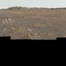

NASA's Perseverance Mars rover used its Mastcam-Z camera to capture this panorama of an area nicknamed "Arbot" on April 5, 2026, the 1,882nd Martian day (sol) of the mission, during the rover's deepest push west beyond Jezero Crater.

