संकलन
SANKALAN
24th August 2026 to 30th August 2026
ई-न्यूज़लेटर | e-Newsletter

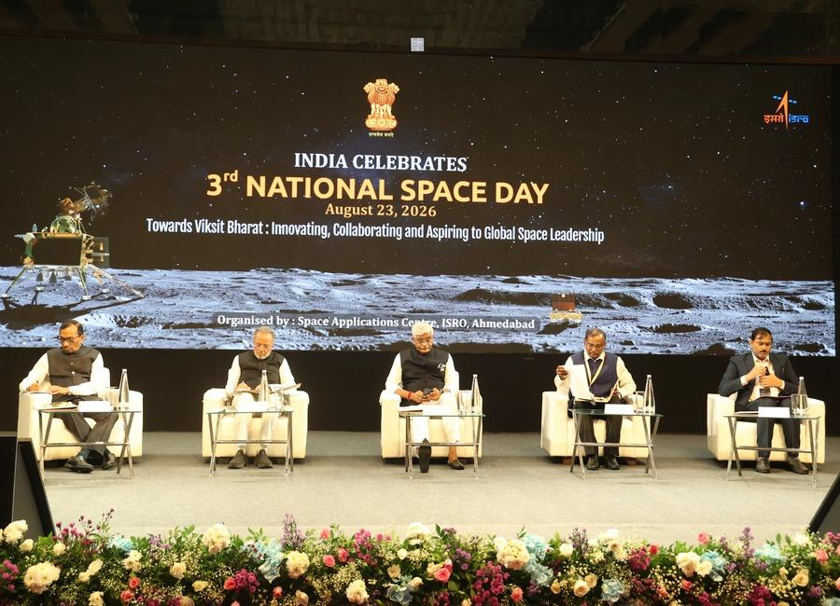 | 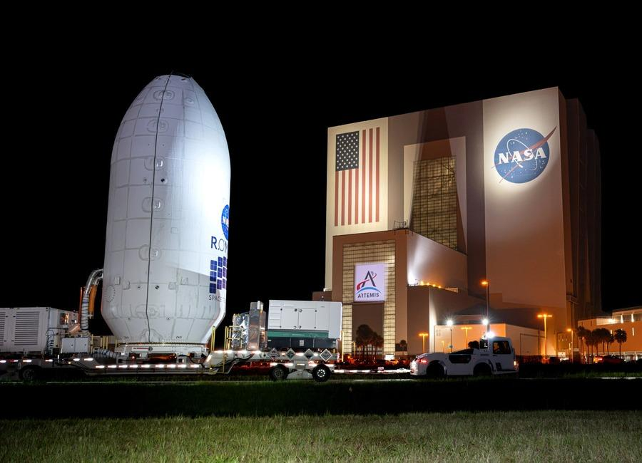 | 
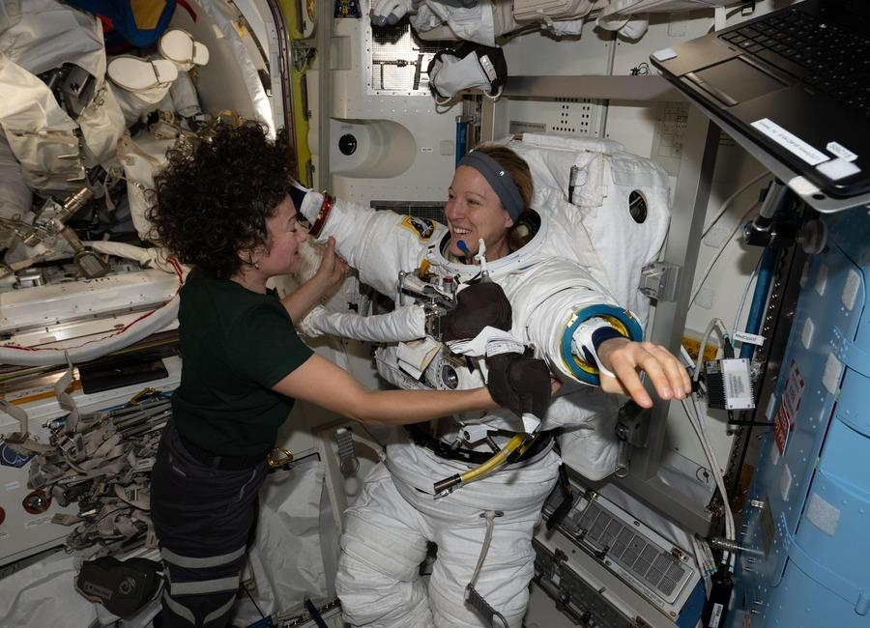 | 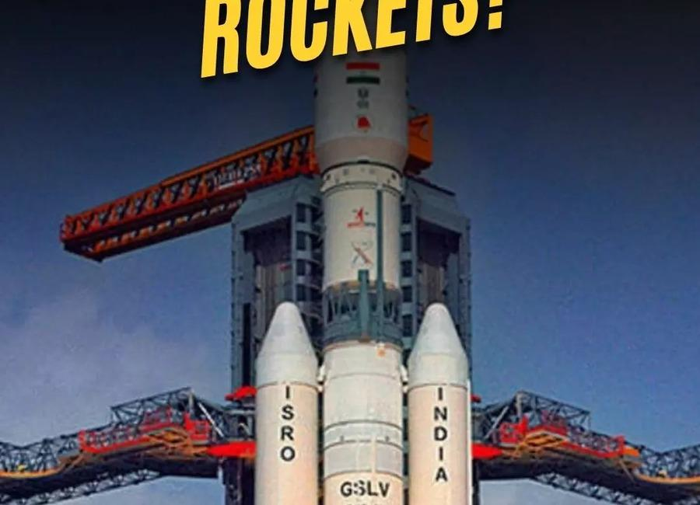 | 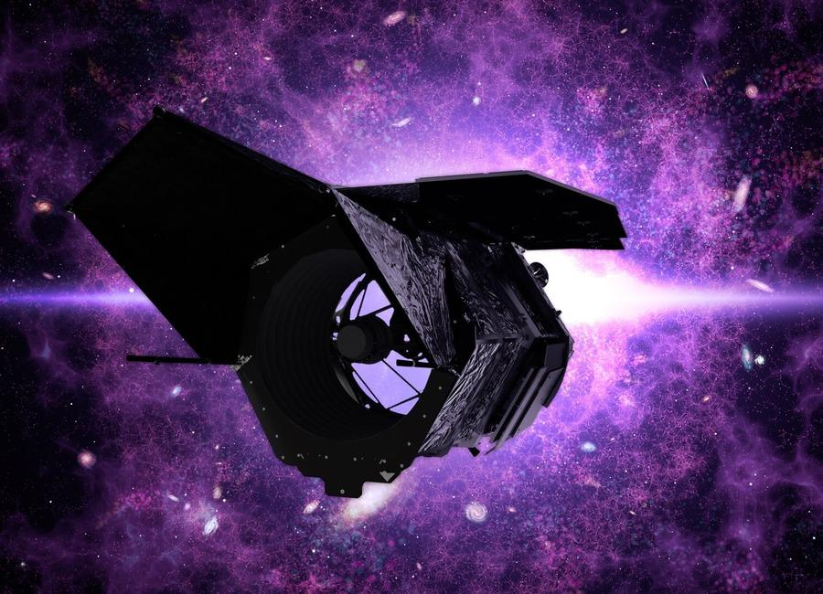
 | 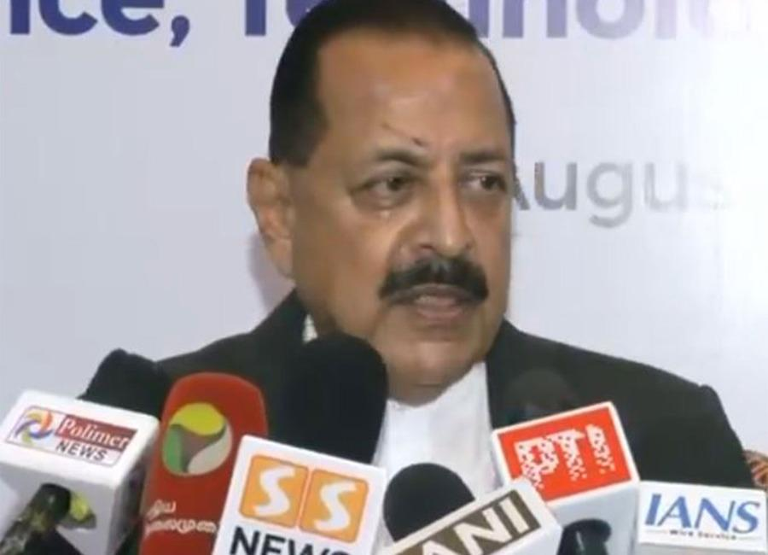 | 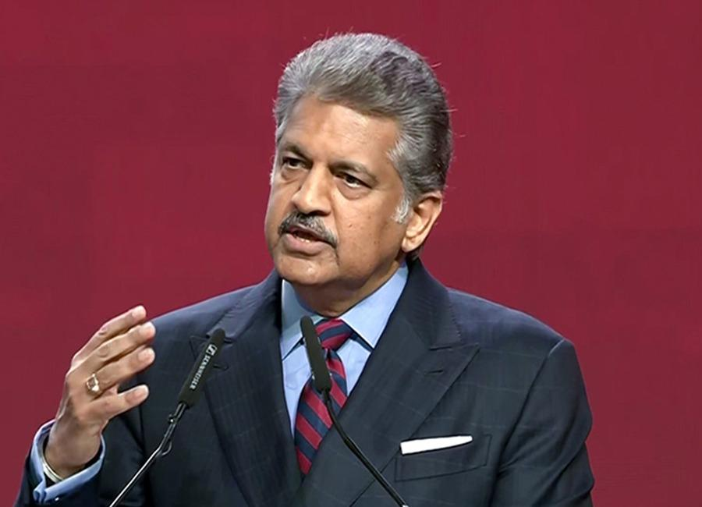

Indian Institute of Remote Sensing (ISRO), Dehradun
Collection of recent developments in the realms of Space Technology

Table of Contents
S. No. | Title
1 | ISRO to privatise launch vehicle production, ex-chief Madhavan Nair questions viability - The News Minute
2 | "Celebrating National Space Day would create more awareness", says ISRO's mission patch designer Manish Tripathi - ANI News
3 | Govt re-appoints Anand Mahindra to RBI Board; inducts former ISRO chief S. Somnath also - Whispers in the Corridors
4 | On National Space Day, PM Modi hails Gen Z for building new tech; Isro chief says plan to launch 8 vehicl - The Times of India
5 | Parliamentary panel reviews space and science projects at ISRO, other facilities in Bengaluru - The Hindu
6 | How a huge fleet of 17 spacecraft discovered something surprising about solar eruptions
7 | Bad weather delays launch of China's historic Chang'e 7 mission to moon's south pole
8 | Launching 10,000 tiny 'femtosats' to Saturn? NASA funds 18 futuristic spaceflight ideas
9 | China abruptly postpones ambitious Chang'e-7 lunar mission launch
10 | 3rd National Space Day 2026 celebrated at Ahmedabad - ISRO
11 | India to have its own space station by 2035, says ISRO chairman - ThePrint
12 | Why strangulate ISRO with privatisation push: Congress - The Economic Times
13 | "India's space sector has taken global trajectory under PM Modi, ISRO's legacy bearing fruit": Jitendra Singh hits back at Jairam Ramesh - ANI News
14 | Goodbye, Falcon 9: SpaceX planning to retire workhorse launcher when Starship is up and running
15 | SpaceX will set rocket-reuse record on 100th Falcon 9 launch of the year early Aug. 25: Watch it live
16 | Satellite sees Greenland's most significant floating ice loss in over a decade | Space photo of the day for Aug. 24, 2026
17 | Nancy Grace Roman Telescope live updates: NASA readies Roman for launch
18 | Live coverage: SpaceX to launch Starlink mission on a Falcon booster's record-breaking 37th flight
19 | NASA starshade would enable astronomers to directly image rocky exoworlds
20 | China says unmanned moon mission delayed over 'launch conditions'
21 | ISRO changes tack on launch vehicle manufacture - Developing Telecoms
22 | After Centre rejig, Anand Mahindra and former ISRO chair appointed to RBI board - ANI News
23 | Private Players Might Take Over ISRO's Rockets - The Federal
24 | Cutting-edge infrared space telescope Roman set to launch
25 | 'You just saved the video dish': Two astronauts complete spacewalk to replace ISS antenna
26 | Starbase Louisiana: SpaceX announces enormous $100 billion Starbase launch site
27 | NASA's Roman Space Telescope will reveal the universe in a way the JWST and Hubble cannot
28 | Astronauts make history repairing the ISS | Space photo of the day for Aug. 25, 2026
29 | On this day in space! Aug. 25, 1997: NASA launches Advanced Composition Explorer to track solar wind and so much more
30 | Polish startup Ares Shield hired to protect data center satellites with high-power microwave weapons
31 | NASA satellites ace world's 1st 'lost-in-space' GPS-free navigation experiment
32 | Earthquake May Have Triggered Glacier Collapse, Flash Floods In Nepal: ISRO - NDTV
33 | 2/3rd of glacier detached, collapsed: ISRO satellite images reveal what triggered Nepal floods - WION
34 | Nepal floods: ISRO images capture glacier collapse, swollen rivers and debris surge - Moneycontrol.com
35 | Roman Space Telescope Travels to SpaceX Hangar
36 | NASA Johnson Pilots Chase Moon's Shadow for Eclipse Science
37 | NASA Sets Spacewalk for Station Maintenance, Live Coverage Planned
38 | NASA Begins Moon Mission Plume-Surface Interaction Tests
39 | Contractor to Civil Servant: NASA Welcomes Jeret Howard
40 | From spy satellite to space telescope: The unlikely origins of NASA's Roman Space Telescope
41 | Chance gaze at old Hubble Telescope image leads to discovery that could reveal dark matter's secrets
42 | SpaceX's final Falcon 9 Starlink launch from Florida creates gorgeous 'jellyfish' over New York City (video)
43 | Uttarakhand sets up helplines after Nepal disaster
44 | Isro to return to launchpad with Gisat-1A; lift-off likely on Sept 4 - The Times of India
45 | Space Beyond ISRO - Daily Excelsior
46 | Public base, private launchpad - The New Indian Express
47 | James Webb Space Telescope observes 72 stars and finds planet formation is a race against time
48 | Astronaut Jonny Kim leaves NASA, will return to active military duty
49 | After failure of private rescue mission, NASA's Swift space telescope will crash back to Earth. But when and where?
50 | Starship is coming home! SpaceX loads floating spacecraft onto huge ship in the Indian Ocean (photos)
51 | Trump tried to scrap NASA's Roman Space Telescope last year. Now it's ready to launch
52 | Powerful Ariane 6 rocket launches European weather satellite to orbit (video)
53 | NASA Johnson pilots chase moon's shadow for eclipse science
54 | NASA's Webb telescope rules out two new Dyson sphere candidates
55 | Yogi Adityanath directs officials to fast-track UP development projects
56 | ISRO Seeks To Make Comeback With Hawkeye Satellite Launch On September 4 - NDTV
57 | ISRO announces recruitment for Scientist, Engineer 'SC' posts: Vacancy details, selection process - The Indian Express
58 | ISRO Scientist, Engineer SC recruitment 2026: 176 vacancies announced, check eligibility, selection proce - The Times of India
59 | What time will SpaceX launch NASA's Roman Space Telscope on Aug. 30? (Full mission timeline)
60 | The night we nearly saw a 'blood moon' (and why I love near-misses in astronomy)
61 | SpaceX Falcon Heavy rocket launching NASA's Roman Space Telescope on Aug. 30: How to watch it live
62 | On this day in space! Aug. 28, 1993: Galileo spacecraft flies by asteroid Ida on the way to Jupiter only to find a tiny moon!
63 | President Trump gives Artemis II moon astronauts the Congressional Space Medal of Honor
64 | SpaceX recovers Starship from the Indian Ocean a month after launch and is shipping it back to Texas
65 | NASA telescope honors Nancy Grace Roman, architect of space-based astronomy
66 | Phase-change material powers smart thermal management for modern missile seekers
67 | ISRO Scientist Resignations Put Space Privatisation in Focus - Frontline Magazine
68 | ISRO's EOS-05 Launch to take place on September 4, 2026; Check time, location and how to watch it live - Moneycontrol.com
69 | ISRO in final preparations phase for GSLV-F17 mission - DT Next
70 | Isro is hiring for Scientist, Engineer 'SC' posts, apply for 176 vacancies by Sept 16 - India Today
71 | NASA's Roman Space Telescope is ready for launch aboard SpaceX Falcon Heavy rocket
72 | On this day in space! Aug. 29, 1965: NASA's Gemini 5 breaks spaceflight duration record after 2 astronauts spent '8 days in a garbage can'
73 | Meeting Nancy Grace Roman: What was the 'mother of Hubble' really like?
74 | Who was Nancy Grace Roman? NASA's next big space telescope is named after the 'Mother of Hubble'
75 | Roman Space Telescope, NASA's next 'great observatory,' poised for Sunday launch

 |  | 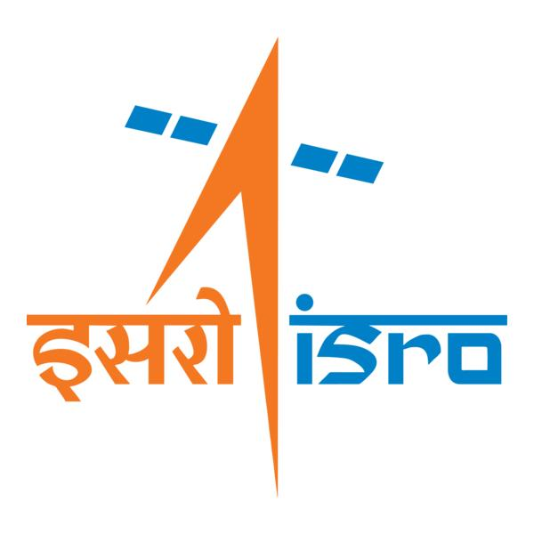

🌌 अंतरिक्ष समाचार | Space News
सोमवार, २४/०८/२०२६ | Monday, 24/08/2026

1. ISRO to privatise launch vehicle production, ex-chief Madhavan Nair questions viability - The News Minute
Read more
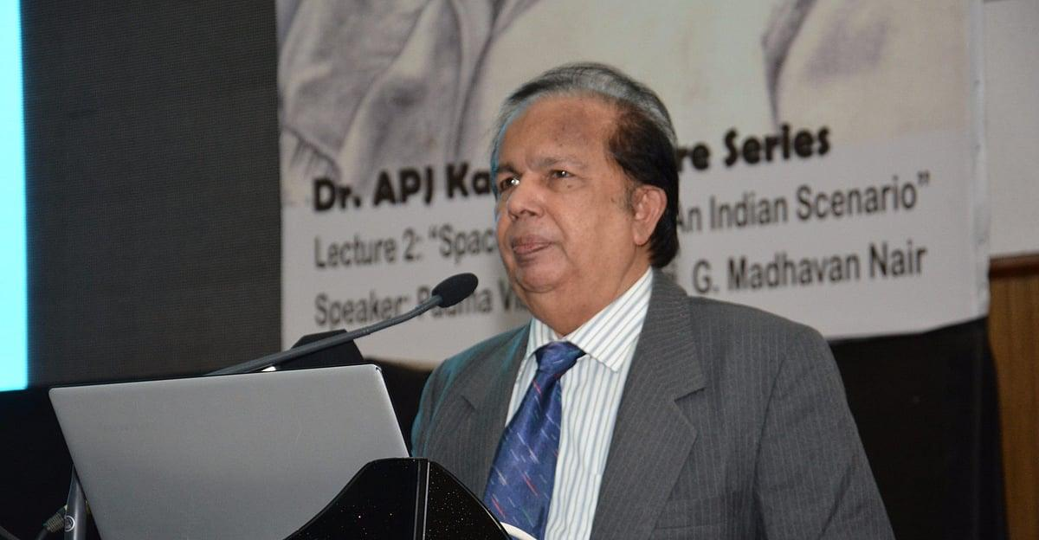
Former ISRO chairman G Madhavan Nair has questioned the viability of the Union government's move to have private companies and public sector undertakings (PSUs) take over the manufacture of launch vehicles, arguing that industry already handles much of the manufacturing for ISRO, while the space agency continues to carry out critical operations such as final assembly, integration, testing, and launching. Madhavan Nair's comments to TNM come after Indian National Space Promotion and Authorisation Centre (IN-SPACe) Chairman Pawan Goenka said ISRO would stop manufacturing launch vehicles, with their production to be taken up by the private sector or PSUs. "ISRO will not make any launch vehicles and will not manufacture any launch vehicles. That will all be done by the private sector or PSU," Goenka said while speaking at Business Today's India @ 100 Economy Summit. According to Madhavan Nair, industry has already been involved in the manufacture of launch vehicles for decades, and "around 90% of the work" on rockets such as the Polar Satellite Launch Vehicle (PSLV) and Geosynchronous Satellite Launch Vehicle (GSLV) is currently done by industry. "The final assembly, integration, testing, and launching is done by ISRO. So that's the critical operation, and we cannot leave it to an industry who is not experienced or who does not have the expertise in the field," he told TNM. Madhavan Nair questioned whether private companies would be willing to make the investment required to independently undertake such operations. "If you want to create an establishment similar to ISRO, today it will cost something like 50,000 crores. And the income from that will be hardly a few thousand crores," he said. "So which industry will come forward in making such a large investment with a very miniscule return? So that's a big question mark," he added. According to Madhavan Nair, the more lucrative opportunities in the space sector lie in applications based on space technology rather than the manufacture of launch vehicles and satellites. "The contribution of the global business in space is only 20% from the hardware industry, whereas 80% is coming from the application program," he said, pointing to services based on communication satellites and earth observation as examples. ISRO's shift to industry The proposed shift is part of the Union government's broader effort to increase private-sector participation in the space sector, with ISRO expected to increasingly focus on research, scientific missions, and advanced technologies rather than routine production. Speculation over the move had intensified after IN-SPACe recently invited Indian companies to operate and maintain ISRO's upcoming Rs 1,000-crore Small Satellite Launch Complex (SLC) in Kulasekarapattinam in Tamil Nadu's Thoothukudi district. According to India Today, the first major step has already been taken with the Small Satellite Launch Vehicle (SSLV). Its technology and production rights have been transferred to Hindustan Aeronautics Limited (HAL) following a bidding process. The government is now looking at similar arrangements for the PSLV and Launch Vehicle Mark-3 (LVM3), India's most powerful operational rocket. Madhavan Nair said attempts to transfer the production of launch vehicles to industry have been underway for years. "After the launch of PSLV, we announced that we want the industry to take on this. Even today that is not fructified," he said. He said the latest arrangement involves NewSpace India Limited (NSIL), the commercial arm of ISRO, working with Larsen & Toubro and HAL to produce the PSLV, while critical technology continues to be held by ISRO. "After nearly 20 years of effort, there is a stage which we have reached here now," he added. ISRO has historically developed technologies, manufactured rockets and satellites, and conducted launches, while also pursuing scientific research. However, industry has long been involved in manufacturing components and hardware for ISRO missions. "We have already transferred 120 technologies from ISRO to the private sector," Goenka said. The proposed shift would see private companies and PSUs take on a larger share of routine manufacturing and established technologies, while ISRO focuses more on research, advanced technologies, and complex scientific missions. According to the report, the government is also planning to hand over the operations of a new launch centre to private industry. Goenka said the operator could be finalised within the next four or five months. What are PSLV, GSLV, LVM3 and SSLV? The PSLV is ISRO's workhorse rocket and has been used since the 1990s to launch satellites for earth observation, navigation, scientific research, and other applications. It is a four-stage launch vehicle capable of placing satellites into different orbits and has also launched satellites for several other countries. The GSLV is a heavier launch vehicle designed primarily to place communication and other satellites into geosynchronous transfer orbit. Its more powerful successor, the Launch Vehicle Mark-3 (LVM3), is currently India's most powerful operational rocket. LVM3 has been used for major missions including Chandrayaan-3 and has also been selected as the launch vehicle for India's Gaganyaan human spaceflight programme. The Small Satellite Launch Vehicle (SSLV), meanwhile, was developed for launching smaller satellites, particularly into low Earth orbit. It is designed to provide a quicker and more flexible launch option for small satellites and can carry payloads of up to 500 kg. The transfer of launch vehicle production is part of the Union government's broader push to expand the role of non-government entities in the space sector. Under the proposed model, established technologies and routine manufacturing would increasingly be handled by industry, while ISRO would focus on developing new technologies, scientific missions, and more complex capabilities.

2. "Celebrating National Space Day would create more awareness", says ISRO's mission patch designer Manish Tripathi - ANI News
Read more

"Celebrating National Space Day would create more awareness", says ISRO's mission patch designer Manish Tripathi ANI News

3. Govt re-appoints Anand Mahindra to RBI Board; inducts former ISRO chief S. Somnath also - Whispers in the Corridors
Read more

The Govt of India has re-appointed industrialist Anand Mahindra as part-time Non-official Director on the Central Board of Reserve Bank of India. Former chief of ISRO Dr. S. Somnath has also been inducted to the RBI board as a part-time Non-official Director on the Board of Reserve Bank of India. Both the appointments are for a period of four years with effect from August 20, 2026.

4. On National Space Day, PM Modi hails Gen Z for building new tech; Isro chief says plan to launch 8 vehicl - The Times of India
Read more

PM Modi interacting with CEOs of 20 space startups in New Delhi on Friday Join conversation View All Comments → Share your thoughts in the comments Insightful Agree Disagree Skeptical Concerning Promising Worth Reading Big Development Post Comment Be respectful · TOI community guidelines NEW DELHI: On the 3rd National Space Day, PM Narendra Modi on Sunday hailed India's global rise in the space sector and praised Gen Z for building new technologies, saying this rise has made India a "magnet" for global investors.Sharing a video of his speeches, PM Modi said, "I said in Ayodhya that this is the beginning of a new cycle of change. In this new cycle, India is steadily expanding its space presence in the global order, and this is clearly reflected in our space programme. Together, we have resolved to make India a developed nation by 2047, and the space sector plays a vital role in achieving this goal."Praising the youth of the nation, the PM said, "Today, these Gen Z engineers, designers, coders and scientists are building new technologies. Be it propulsion systems, composite materials, rocket stages or satellite platforms, India's youth is working in areas that were not even imagined some time ago." He also hailed the private space sector saying, "India's private space talent is making its own identity in the world. "Just two days ago, the PM interacted with CEOs and founders of 20 space startups on Friday and highlighted India's cost-competitiveness in launching space ventures.He emphasised that the country's vast talent pool and high risk-taking capacity would allow India to rapidly establish a dominant position in the global space sector, according to the transcript of the interaction, which was released on Sunday. One of the CEOs told the PM that after India opened the space industry for private players, a very positive trend was observed and many Indian citizens living in the US and Europe now want to return and work in the country. In response, Modi said: "We need to connect with many people â€" people who went abroad are now returning. I believe we should create an aura where people worldwide feel that if they want to make a career, they should go to India." He said such people from across the globe should feel that they should connect with a startup in India, connect with a space agency in India.Praising Isro, he said, "Seeing the success of Isro, many children think that when they grow up, they too will become scientists."Speaking at the 3rd National Space Day celebrations in Ahmedabad, Isro chairman V Narayanan said India's space programme is heading into a crucial phase, with the agency planning eight launch vehicle missions and 12 satellite missions during the current financial year. Among the most closely watched missions is the first uncrewed flight under the Gaganyaan programme, which Isro expects to undertake within the next four months, he said. Narayanan said the Gaganyaan programme had completed about 8,000 tests and was now approaching its final stage. "We are in the final leg," he said.Space minister Jitendra Singh said on X, "On National Space Day, we remember the historic success of Chandrayaan-3, a moment that placed India among the world's leading spacefaring nations. Remarkable achievement of our scientists, backed by the progressive vision of PM.PM Shri Narendra Modi continues to inspire generations. Celebrating our scientists, innovators and the unstoppable spirit of ViksitBharat. "With the historic milestone of 100 launches and 548 satellites placed in orbit, including around 460 in the last decade alone, India's space sector is reaching new horizons, petroleum and natural gas minister Hardeep Singh Puri said on Sunday.

5. Parliamentary panel reviews space and science projects at ISRO, other facilities in Bengaluru - The Hindu
Read more
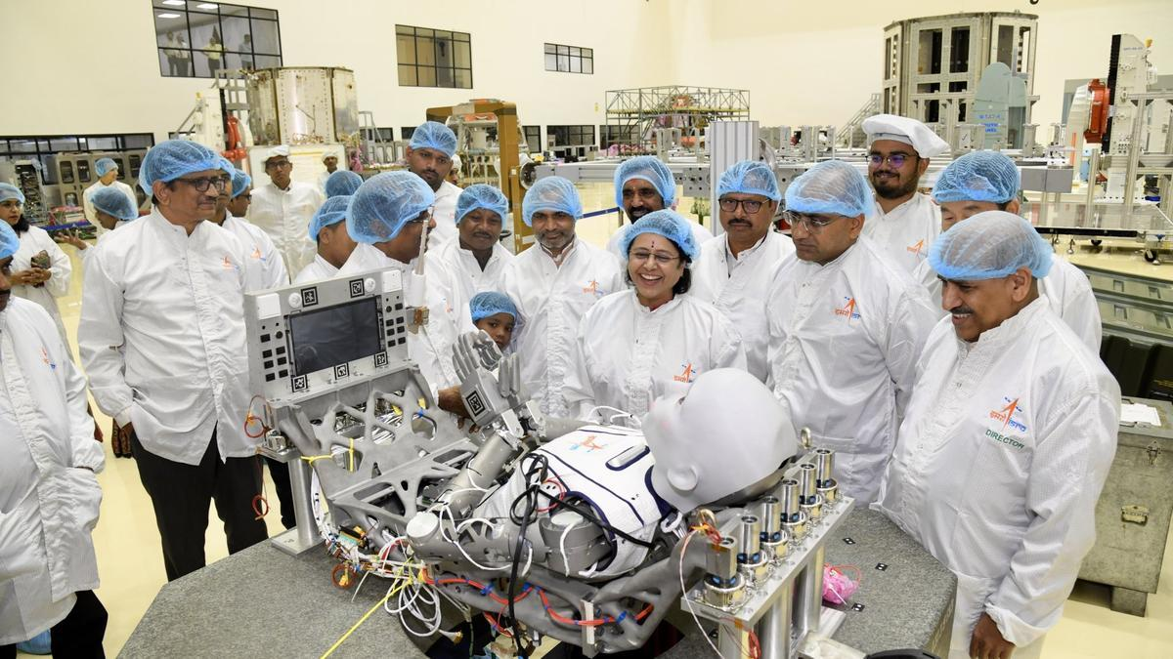
The Parliamentary Standing Committee on Science and Technology, Environment, Forests and Climate Change visited scientific facilities in Bengaluru - including the Indian Space Research Organisation (ISRO) - and reviewed the progress of various projects. Space, AI and other tech integration to shape a nation's geopolitical future: Minister Shekhawat The committee led by Chairperson and Rajya Sabha MP Dr. Medha Vishram Kulkarni, who arrived in Bengaluru on August 20, visited the Indian Institute of Astrophysics (IIA), National Aerospace Laboratories (NAL), and the National Institute of Data Science and AI (CSIR-NIDSA) facilities over the last few days. The committee, in a visit to the ISRO headquarters - Human Space Flight Centre (HSFC), reviewed the current status of India's first human spaceflight mission, Gaganyaan. They also interacted with the ISRO Chairman Dr. V. Narayanan and other senior scientists and engineers besides reviewing the planning and preparedness for ISRO's upcoming missions at the UR Rao Satellite Centre. At IIA, Dr. Kulkarni chaired a review meeting and held discussions on India's progress in astronomy, astrophysics, solar physics, and upcoming telescope projects. "We also explored ways to strengthen research infrastructure and ensure policy support, empowering our scientists with the resources needed to lead global space missions," Dr. Kulkarni said. At NAL, the committee reviewed the ongoing work and progress in India's civil aircraft development programmes and were briefed on the capabilities of HANSA-NG and the ongoing development of indigenous passenger aircraft for regional connectivity. At NIDSA, the committee reiwed the progress in high-performance computing, the National Data Grid, and practical AI applications. "Had a very productive discussion with senior officials from DSIR and the scientific team at the institute. We went through their progress in high-performance computing, the National Data Grid and practical AI applications, especially how data modeling can help with early weather alerts, stronger cybersecurity and simpler citizen services," she said.

6. How a huge fleet of 17 spacecraft discovered something surprising about solar eruptions
Read more
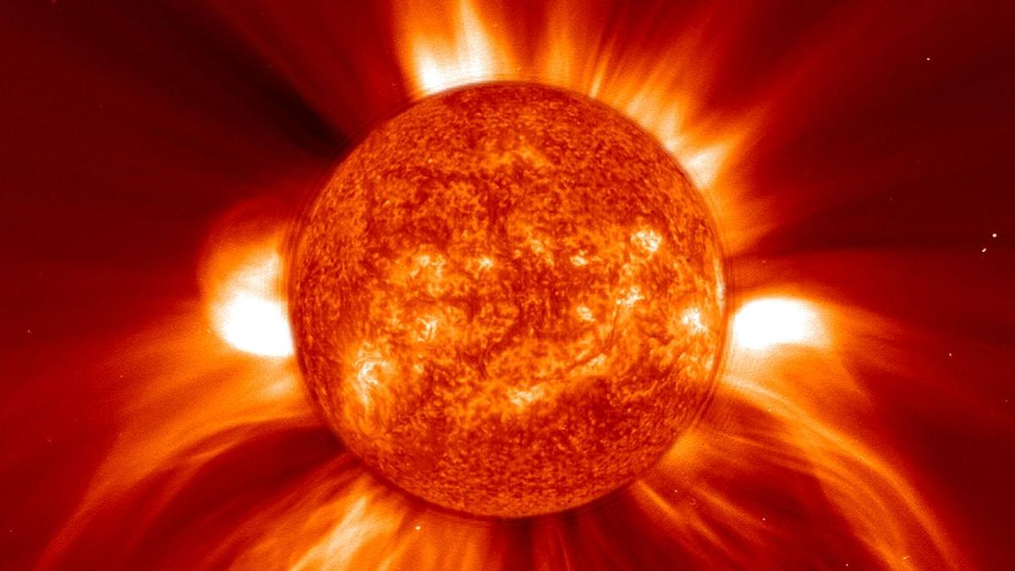
Click for next article A misbehaving coronal mass ejection (CME) that blew out a hidden cloud of charged particles aimed at Earth has been tracked by a record 17 spacecraft spread throughout the solar system, revealing the CME to be surprisingly lopsided. CMEs are "burps" from the sun - huge clouds of magnetized plasma belched out from the sun's hot outer atmosphere , the corona, by the energy resulting from a solar flare . The magnetized CME cloud then expands out into the solar system , and the charged particles that the cloud contains are a significant radiation hazard to astronauts, spacecraft and even passengers on jet liners, but they also have a beautiful side as they can trigger the beautiful lights of the aurora when they intercept Earth . CMEs occur on a regular basis, but one that erupted from the sun at 00:48 UT (7:48 p.m. ET) on Dec. 15, 2024 proved to be rather special. "We used observations from 17 spacecraft to track and characterize this CME," Adrienn Luspay-Kuti of Johns Hopkins University Applied Physics Laboratory, who led the research that drew all the observations together, told Space.com. "This was a record number of spacecraft for tracking and characterizing a single CME, and gave us an exceptionally detailed view of how the CME evolved." The previous record had been 10 spacecraft, but they had mostly been in a rough line from the sun through to the Earth and beyond, meaning that their measurements were somewhat one-dimensional. This time, for the December 2024 CME, the spacecraft were spread far and wide, not just at different distances from the sun, but also substantially wide of the Earth-sun line. They revealed that the CME had two asymmetric lobes, one moving faster than the other. One of those lobes, which headed for Earth and Mars , would have gone unseen, obscured by the larger but slower lobe that left the sun at a tangent, were it not for the wide spread of the spacecraft. "Our observations showed a fast lobe propagating through the Earth-Mars sector and a much slower lobe farther west toward STEREO-A ," said Luspay-Kuti. STEREO-A is one half of NASA's two-spacecraft space weather monitoring system known as the Solar Terrestrial Relations Observatory. The onset of the CME was seen by the joint NASA-ESA Solar and Heliospheric Observer (SOHO), which has been constantly monitoring the sun for more than 30 years . Yet it only saw the slower lobe that erupted at an angle to Earth; the faster lobe heading for our planet was missed, obscured by the slower, larger lobe. A schematic of the CME has its two lobes progressing through the solar system and encountered various spacecraft and satellites. (Image credit: Johns Hopkins Applied Physics Lab) The CME was next detected at a distance from the sun of 0.35 astronomical units (AU; 1 AU is the distance of Earth from the sun) on Dec. 16 moving through space near Mercury and the European Space Agency's BepiColombo mission (which finally arrives into orbit around the innermost planet in November 2026). The next detection, on Dec. 17, was of the "hidden" component arriving at Earth, where a multitude of spacecraft picked it up. The CME was not strong enough to produce significant aurorae. Intriguingly Europe's Solar Orbiter mission, on an elongated orbit around the sun and at the time 0.94 AU from the sun and just 10 degrees off the Earth-sun line, did not detect the CME. This non-detection was actually vital since it helped to constrain the shape of the CME. Then on Dec. 18, the slower moving lobe reached NASA's STEREO-A spacecraft, which orbits the sun at the same distance as Earth - 1 AU -- but substantially ahead of Earth in its orbit. The lobe that intersected the Earth had an average velocity of 522 miles (840 kilometers) per second, but the other lobe dragged its feet, moving at an average of 332 miles (534 km) per second from the sun and past BepiColombo and STEREO-A. In fact, by the time it reached STEREO-A, it had slowed to about 248.5 miles (400 km) per second. Both lobes decelerated as a result of friction with the regular solar wind that the CME was overtaking, and the range of velocities measured in the CME told researchers that the solar eruption was not traveling as a single, unified front. Beyond Earth NASA's Europa Clipper mission, on which Luspay-Kuti is the Principal Investigator for the spacecraft's Plasma Instrument for Magnetic Sounding (PIMS) experiment, detected the faster moving lobe at 1.19 AU as the spacecraft was cruising to Mars for a gravity assist to help it on its journey to Jupiter . At the red planet, the now-defunct MAVEN mission also detected the CME on Dec. 19 to Dec. 20. To have not only so many spacecraft follow the progress of a CME but also enough spacecraft off the Earth-sun line to measure the shape of the CME, at least in two dimensions, is a significant step forward in understanding and forecasting the propagation of CMEs. The CME seen by the Solar Dynamics Observatory (top left), SOHO (top right) and STEREO-A (bottom left and right). The fast moving Earth-directed lobe was obscured by the southward-directed slower lobe. (Image credit: Luspay-Kuti et al.) "This matters for future human exploration because a missed CME can mean losing valuable warning time," said Luspay-Kuti. "Fast CMEs can drive shocks that accelerate high-energy particles, which can pose a radiation hazard to astronauts outside Earth's protective magnetic field. This is why observations from multiple viewpoints, including spacecraft away from the sun-Earth line and planetary missions operating during their cruise phase, will become increasingly important for space-weather forecasting as human exploration moves further from Earth." The asymmetrical double-lobed structure of this particular CME was certainly a surprise. The cause of the asymmetry remains unclear at present, though Luspay-Kuti told Space.com that researchers are investigating. The main question is, how frequent are asymmetric CMEs? "In the context of previous observations, this event is at the most extreme end of observed CME variability," said Luspay-Kuti. "Are highly asymmetric CMEs actually fairly common but we fail to recognize them because we don't have enough observational coverage, or are they genuinely rare?" The 17 spacecraft that detected or imaged the CME across some or all of its various stages - the bow shock and turbulent sheath ahead of the magnetic cloud, the CME itself and the turbulent wake left in the solar wind after its passing - were the following: SOHO (initial imaging), BepiColombo, NASA's Solar Dynamics Observatory , STEREO-A, the four spacecraft of the Magnetospheric Multiscale (MMS) mission, the two spacecraft of the ARTEMIS (Acceleration, Reconnection, Turbulence, and Electrodynamics of the Moon's Interaction with the sun) mission, NASA's Wind, ACE (Advanced Composition Explorer), GOES (Geostationary Operational Environmental Satellite) and DSCOVR (Deep Space Climate Observatory) missions, Europa Clipper, MAVEN and Solar Orbiter, the latter of which made measurements but did not detect the CME. In the future, these missions will be joined by the European Space Agency's Vigil mission that will watch for space weather when it launches in 2031 for the sun-Earth L5 Lagrange point , 60 degrees behind Earth in its orbit and therefore providing additional off-axis monitoring.

7. Bad weather delays launch of China's historic Chang'e 7 mission to moon's south pole
Read more
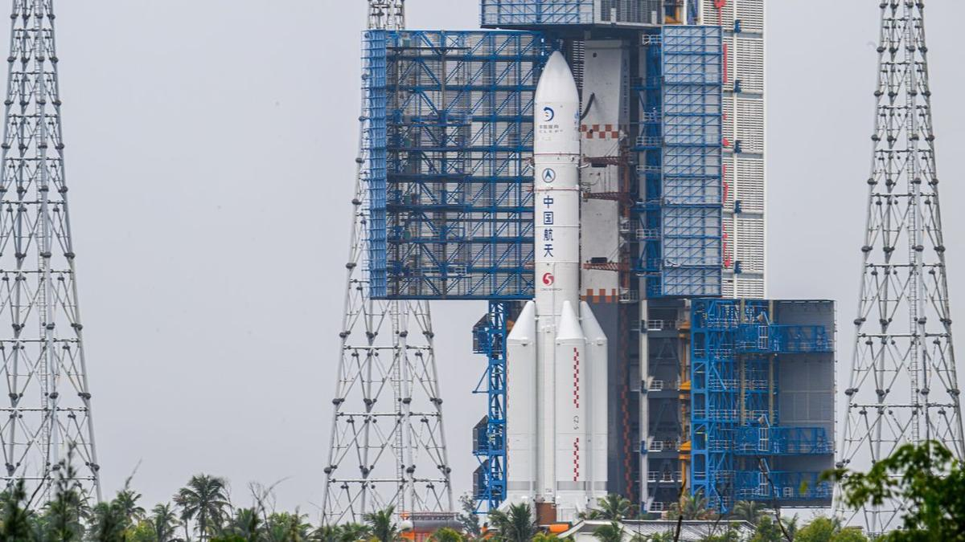
Click for next article China's Chang'e 7 lunar probe and its Long March 5 rocket are transferred to their pad at the Wenchang Spacecraft Launch Site on Aug. 19, 2026 in Wenchang, Hainan Province. Poor weather has delayed the launch of China's latest moon mission. According to reports, the growth of Tropical Depression Narra in the Gulf of Tonkin has prompted China's space agency to delay the liftoff of Chang'e 7 significantly - possibly until 2027. "China's Chang'e 7 lunar probe does not meet launch conditions, and its launch therefore cannot take place during the planned window this year," the state-run Xinhua news agency reported today (Aug. 23), citing the China Manned Space Agency. Chang'e 7 had originally been scheduled to launch today from the Wenchang Space Launch Site on the island of Hainan. But then Narra started brewing in the Gulf of Tonkin, just to the island's west. Launching a rocket into a howling gale is less than ideal. Chinese space officials initially pushed the launch back a day, to Monday (Aug. 24), before concluding that the new target was unattainable as well. It's now unclear when Chang'e 7 might lift off; messaging on the topic has been characteristically murky. (China is fairly tight-lipped about its space activities, revealing far less publicly than, say, NASA or the European Space Agency does. For example, China announces who's flying on its crewed missions just one day before liftoff .) The Chang'e 7 launch requires a certain lineup of Earth and the moon , so it cannot simply occur as soon as the skies around Wenchang clear. Some online reports suggest that Chang'e 7 could lift off as soon as September , while others - including today's Xinua story - have it launching sometime in 2027. Artist's illustration of China's Chang'e 7 mission orbiting the moon. (Image credit: China Media Group) Whenever it occurs, the liftoff will draw a lot of attention. Chang'e 7 is an ambitious and exciting mission, and it could have serious implications for lunar exploration down the road. Chang'e 7 consists of an orbiter and a lander, which will likely touch down on the rim of Shackleton Crater , near the moon's south pole (though China has not announced an official landing site). This region is thought to harbor lots of water ice, most of it on crater floors that have not seen the sun for billions of years. Chang'e 7's lander will deploy a rover and a hopping robot to hunt for this precious resource, which could help support human settlements in the area.

8. Launching 10,000 tiny 'femtosats' to Saturn? NASA funds 18 futuristic spaceflight ideas
Read more
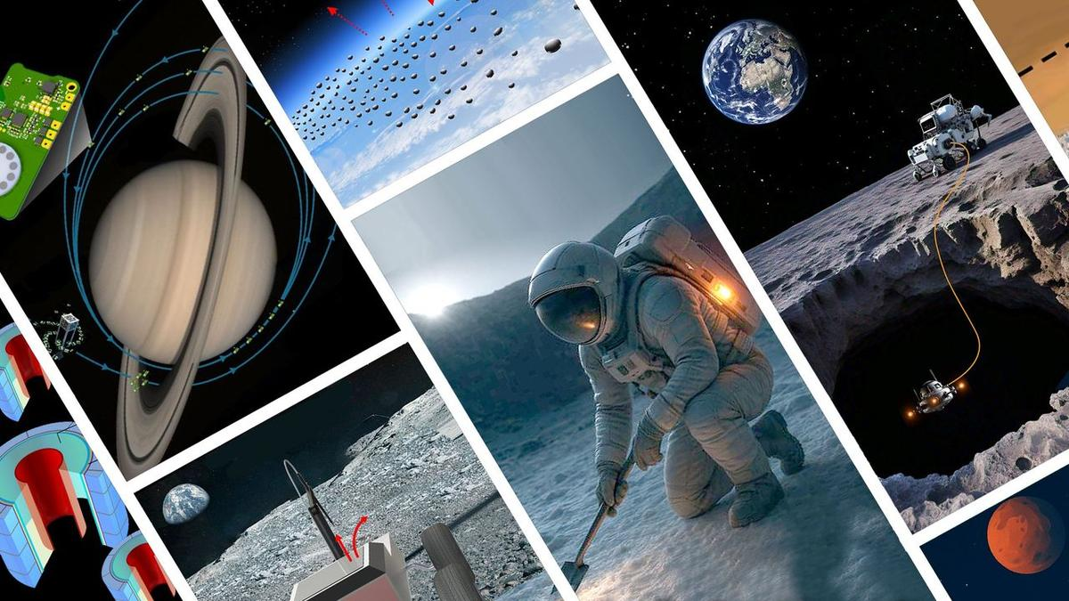
Click for next article NASA is giving a financial boost to nearly 20 technology investigations to help fuel the incubation of tomorrow's spaceflight research capabilities. The NASA Innovative Advanced Concepts ( NIAC ) program has selected 18 projects for this year's Phase I awards, which will each split a total of $3.2 million in development funding. NIAC is designed to bolster technology breakthroughs that NASA could use on future space missions. This year's awards include an array of mission concepts and research proposals NASA views as having "transformative potential," according to a July 29 announcement of winners . Among them are ideas for hardening spacecraft to explore and withstand the harsh conditions of Venus , radioisotope-heated lunar spacesuits and using space dust to partially block out the sun to reduce solar radiation. The selected projects aren't actual NASA missions, but serve as a sampling of technologies the agency sees as potentially contributing to projects like establishing a moon base as part of the Artemis program . "Achieving that will require more than incremental technological advancement. It means we need great leaps," Greg Stover, director of the Advanced Research and Technology division in NASA's Research and Technology Mission Directorate, said in the awards announcement. "These awards are the kinds of innovation the world needs NASA to help foster." Each of the 18 award winners will receive up to $175,000 to complete a nine-month investigation of their proposals to determine their feasibility and determine the next steps in maturing their technologies. Graphic depiction of the LUX concept. (Image credit: Stone Aerospace, Inc.) As NASA's plans for long-term lunar habitation evolve, underground dwellings that are naturally shielded from the harsh solar radiation are a serious consideration for habitation spaces. One of the NIAC winning ideas includes the Lunar Underground eXplorer (LUX), from Gilly Elor, at Texas-based Stone Aerospace, Inc. LUX would send hovering robots to map the potentially miles-long lava tubes beneath the moon 's Mare Tranquilitatitis. These drones, obscured from sunlight in the depths of these lunar labyrinths, would each be tethered by an extra lightweight fiber-optic cable spooled out from a lander or rover on the moon's surface, which would shoot the line with a laser to supply the cave-diving probe's power and communications link. Another NIAC winner aims to map the continents of Earth -like exoplanets orbiting nearby stars . Today, we can determine the size and makeup of exoplanets, but discerning their physical features isn't something that's been attempted on a large scale. Paul Stankus, from Brookhaven Science Associates in New York, proposes designing a new type of "nulling interferometer," which uses data from different telescopes to cancel out a star's light, via a technique called "dynamic hierarchical nulling." His idea would merge data from a pair of "nuller" space telescopes positioned about 60 miles (100 kilometers) apart to achieve a resolution fine enough to detect the contrast of surface features on exoplanets 10 billion times dimmer than their star. Another award-winning concept comes from Michael Rubenstein and Northwestern University. They propose exploring Saturn 's rings by throwing thousands of "femtosats" (small satellite probes weighing less than 100 grams) into the gas giant 's orbit. According to the project's page on NASA's website, "Conducting in-situ surveys of Saturn's rings with a single flagship mission, such as Cassini, would carry an unacceptably high risk of mission failure due to particle collisions." Instead, the femtosat fleet proposal suggests flying 10,000 spacecraft into Saturn's rings, knowing a significant portion could be lost. "The distributed nature of the proposed mission means it can accept a risk that could destroy many of [the] femtosats in the constellation, making in-situ survey of the ring possible." "Every innovation, every leap in technology, starts with a seed of an idea," Phillip Williams, NIAC's acting program executive, said in NASA's statement. "The NIAC program allows NASA to germinate those seeds and determine if there's something that could be grown to benefit future space missions and our nation's aerospace economy."

9. China abruptly postpones ambitious Chang'e-7 lunar mission launch
Read more

China said on Sunday it was postponing its planned ambitious Chang'e-7 lunar mission, which was set to carry out explorations including searching for water ice on the moon.
10. 3rd National Space Day 2026 celebrated at Ahmedabad - ISRO
Read more
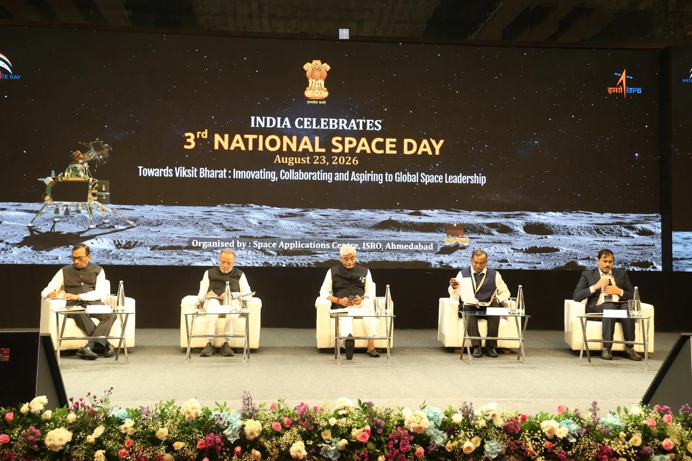
August 24, 2026 The inaugural event of 3rd National Space Day (NSPD) 2026 was held at Ahmedabad on August 23, 2026. This year's theme is "Towards Viksit Bharat: Innovating, Collaborating and Aspiring to Global Space Leadership". Hon'ble Union Minister Shri Gajendra Singh Shekhawat, Union Minister of Culture and Tourism, was the chief guest and Hon'ble Shri Arjunbhai Devabhai Modhwadia, Minister for Forests and Environment, Climate Change and Science and Technology Govt. of Gujarat was the Guest of Honour. Dr V. Narayanan, Secretary DoS / Chairman ISRO presided over the function, Dr Pawan Kumar Goenka, Chairman IN-SPACe and Dr Ch V. N. Rao, Director SAC, participated in the function. The event was inaugurated with invocation, lighting of lamp and formal welcome address by Director SAC. Hon'ble Union Minister Shri Gajendra Singh Shekhawat while addressing emphasised about the theme reflecting three key pillars of India's development journey-innovation as the strength of a new India, collaboration as an expression of India's culture, thought and wisdom, and global leadership as a national aspiration, and stated that the center of these aspirations is India's youth. He conveyed the important message to the gathering that the success of space missions would be determined by how these missions have changed the lives of common man and further reasserted that space reform is not the privatisation but it is the democratisation of space opportunity. He concluded by stating that India stands at the threshold of immense possibilities and is moving forward with enthusiasm and resolve under the leadership of the Hon'ble Prime Minister. Emphasizing that every stakeholder has a role and responsibility in a period of transformation, he noted that greater capacity and capabilities bring greater responsibility, particularly for those working in the fields of science and space. He called upon all stakeholders to recognize this responsibility and fulfil their respective roles in developing India, so that future generations can take pride in the contribution of the present generation towards Viksit Bharat. He urged everyone to make full use of this opportunity and work with collective resolve for the country's development. In his address, Guest of Honor Shri Arjunbhai Devabhai Modhwadia mentioned that today's youth is not job seekers but they are job givers. He invited start-up and industries to establish their manufacturing facilities at Gujarat Space Park. The Secretary, Department of Space / Chairman, ISRO, highlighted that, in recognition of the historic soft landing of Chandrayaan-3's Vikram lander near the lunar south polar region on August 23, 2023, Hon'ble Prime Minister Shri Narendra Modi declared August 23 as 'National Space Day'. To celebrate this landmark achievement in India's space journey the 3rd National Space Day was celebrated on 23 August 2026, in Ahmedabad, which was aptly chosen considering the presence of Space Applications Centre and start-up ecosystem growing rapidly in and around Ahmedabad. He recalled ISRO's humble beginnings in the 1960s, from launching small sounding rockets to demonstrating the capability to launch international commercial satellites in the 6-ton class. He congratulated M/s Skyroot Aerospace team for successful launch of the first orbital flight 'Vikram-1' in the very first attempt. He also mentioned that ISRO team whole heartedly supported the private launch activities as ISRO's own activity. He added that space sector reforms were rolled out by Govt. of India in 2020, and now it has resulted in growth of more than 440 space start-ups in the country. He reaffirmed that we would contribute towards Viksit Bharat 2047 as per the vision of the Hon'ble Prime Minister. Addressing the gathering, Dr. Pawan Kumar Goenka, Chairman, IN-SPACe, underscored the pivotal role of ISRO in nurturing India's rapidly expanding space ecosystem. He highlighted that the country's growing space industry has been built on ISRO's decades of technological excellence, institutional support, and knowledge-sharing. Emphasising the strength of public-private collaboration, he said that the growth of private space sector in India can happen only with the support of ISRO, and the partnership between ISRO and industry will accelerate innovation, strengthen India's global competitiveness, and help achieve the nation's ambitious space goals. He reiterated that 'without ISRO there is no space industry in India'. Subsequently, M/s Skyroot Aerospace team was felicitated by Secretary, DOS / Chairman ISRO. Awards to winners of various competitions and quiz organized during national space day celebration across India were also distributed.

11. India to have its own space station by 2035, says ISRO chairman - ThePrint
Read more
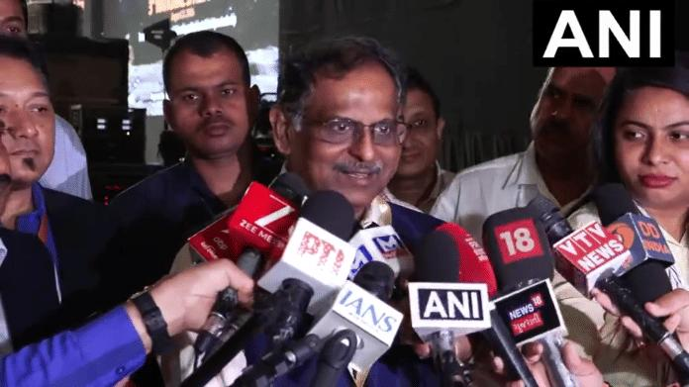
"India started its space programme 64 years ago, and today we are serving the common man in more than 50 areas, including Earth observation, remote sensing, telecommunications, television broadcasting, tele-education, disaster warning and mitigation, ensuring the safety and security of every citizen, navigation, real-time monitoring and tracking," the ISRO chief said. Narayanan also outlined some of the country's major upcoming space programmes, including the Gaganyaan human spaceflight mission and the development of India's own space station. "Today, we are celebrating the third National Space Day. The theme is very important: innovation, collaboration, and aspiring for global leadership in the space sector," Narayanan said. He said India has been steadily expanding its capabilities since launching its space programme 64 years ago. Ahmedabad: India is working towards establishing its own space station by 2035, with the first module of the proposed Bharatiya Antariksha Station already approved, ISRO Chairman Dr V Narayanan said on Sunday. Speaking at the third National Space Day celebrations in Ahmedabad, Narayanan highlighted India's growing capabilities in space technology and said the country is now using space-based applications across more than 50 areas directly serving citizens. "Under the visionary leadership of Prime Minister Narendra Modi, many programmes are in the pipeline. We are working on the Gaganyaan programme. We are also working towards establishing our own space station, the Bharatiya Antariksha Station," he said. "The first module has already been approved, and we aim to establish the space station by 2035," Narayanan added. The ISRO chief's remarks came during celebrations marking India's achievements in space exploration and the third National Space Day. Union Minister Gajendra Singh Shekhawat, who also addressed the event, recalled the significance of Chandrayaan-3's historic landing near the Moon's south polar region. He said National Space Day was announced following the successful Chandrayaan mission and India's achievement of reaching the lunar south pole at the location named Shiv Shakti Point. "Following the success of the Chandrayaan mission and the announcement by the Prime Minister, India will observe the day it set foot on the Moon's south pole-at the 'Shiv Shakti Point'-as National Space Day," Shekhawat said. He said the third National Space Day was being celebrated in Ahmedabad under the aegis of the Space Applications Centre and highlighted the government's efforts to expand participation in the space sector. "Under the Prime Minister's leadership, the privatisation of the space science sector has opened doors to immense possibilities for India," Shekhawat said. He said the expansion of private participation had created new opportunities for India's space industry while also complementing the work being undertaken by ISRO. "ISRO's workload has not decreased; rather, its operational capacity has expanded manifold," the Union Minister said. Shekhawat further noted that the time taken for several space-related activities, including developing applications, manufacturing satellites, creating payloads and launching satellites, had been substantially reduced. "These processes are now being executed with far greater proficiency," he said. India's space programme has expanded significantly from its early focus on developing basic satellite and launch capabilities to missions involving lunar exploration, human spaceflight, advanced Earth observation and satellite-based applications. The Chandrayaan-3 mission, which successfully landed on the Moon on August 23, 2023, became a landmark achievement for the country's space programme and is commemorated annually through National Space Day. With Gaganyaan and the proposed Bharatiya Antariksha Station, India is now looking beyond lunar exploration towards sustained human activity in space and a larger role in the global space ecosystem. This report is auto-generated from ANI news service. ThePrint holds no responsibility for its content.

12. Why strangulate ISRO with privatisation push: Congress - The Economic Times
Read more
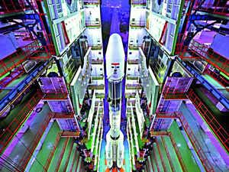
Synopsis Congress accuses the government of aggressive privatization of India's space program. This agenda will limit the Indian Space Research Organisation's rocket development and manufacturing. The party questions why ISRO is being strangulated and emasculated by this policy. Much of ISRO's satellite assets may transfer to private companies under this plan.

13. "India's space sector has taken global trajectory under PM Modi, ISRO's legacy bearing fruit": Jitendra Singh hits back at Jairam Ramesh - ANI News
Read more
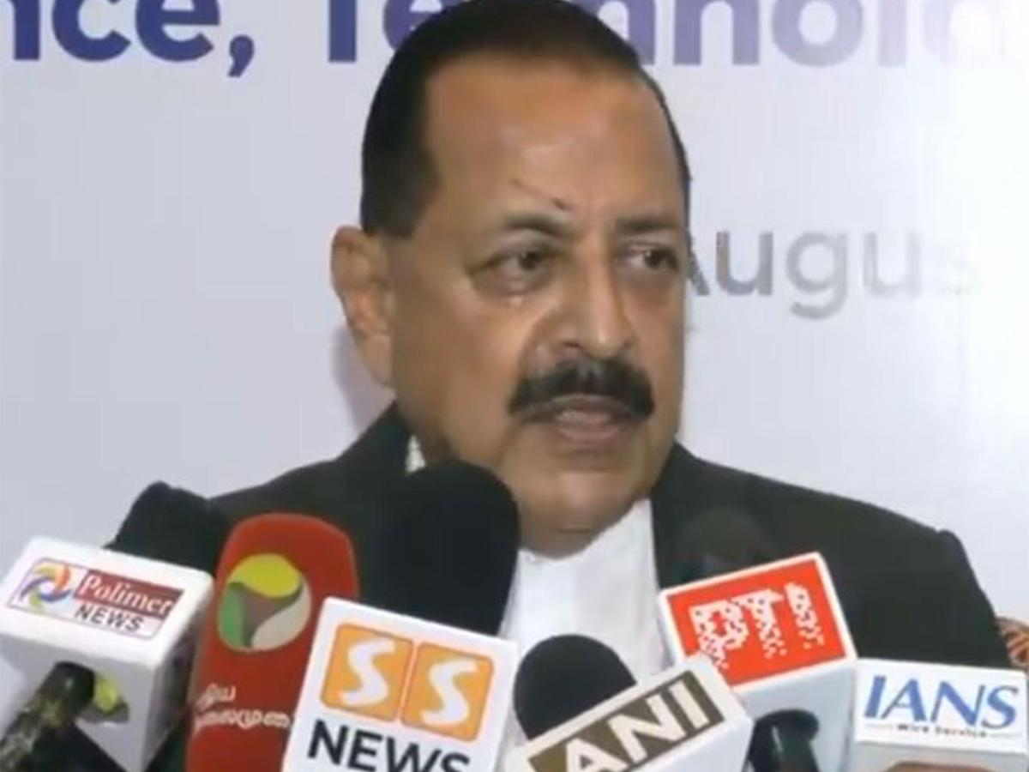
"India's space sector has taken global trajectory under PM Modi, ISRO's legacy bearing fruit": Jitendra Singh hits back at Jairam Ramesh ANI News

14. Goodbye, Falcon 9: SpaceX planning to retire workhorse launcher when Starship is up and running
Read more
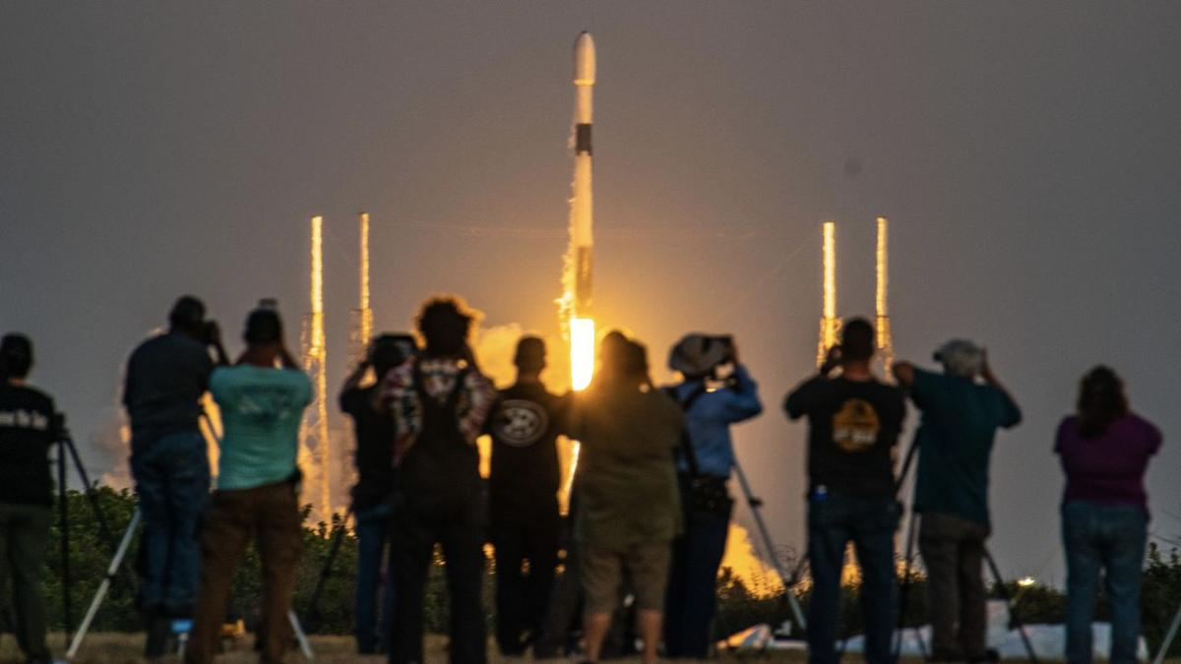
Click for next article The rumors are true. SpaceX plans to retire its workhorse Falcon 9 rocket once the company's giant next-generation Starship begins regular operational flights. SpaceX launched the Falcon 9 for the first time in 2010, and the rocket soon chiselled itself a place in spaceflight history. The Falcon 9 has lifted off nearly 700 times to date, and it's the first orbital rocket ever to land and refly its first-stage booster. Russia's Soyuz rocket , which has been in operation since 1957, is the only launch vehicle with more missions under its belt, but the Falcon 9 is on track to pass it next year. However, "winding down Falcon" - both Falcon 9 and Falcon Heavy, a triple-booster variant that has flown 12 times to date - is inevitable, SpaceX founder and CEO Elon Musk said in an Aug. 22 post on X . "Once Starship is flying reliably several times per week, it makes sense to shift … production resources to Starship to get launch rate to several times per day," he wrote. The impact of Falcon 9's absence from the launch market can't yet be known, but industry reports suggest that SpaceX may discontinue all but a few Falcon 9 missions beginning in 2028. The ones that remain will likely include crew and resupply missions for NASA to the International Space Station (ISS), which is expected to continue flying until at least 2030, meaning that commercial operators will have to start looking to Starship to deliver their satellites to space. When exactly SpaceX will begin to wind down Falcon 9 will depend on the continuing development of Starship. Unlike its predecessor, Starship is built for full reusability, with the rocket's Super Heavy booster and Ship upper stage both designed to return to Earth for recovery and reflight. (Falcon 9 and Falcon Heavy upper stages are expendable.) And Starship is bigger than Falcon 9, too. The current Version 3 (V3) Starship stands 408 feet (124.4 meters) tall, towering over the 230-foot tall (70 m) Falcon 9, and is capable of launching substantially heavier payloads to space . Starship is expected to be able to deliver more than 100 tons to low Earth orbit (LEO). By comparison, Falcon 9 and Falcon Heavy can carry about 25 tons and 63 tons to LEO, respectively. The majority of Falcon 9 missions over the past few years have been dedicated to SpaceX's Starlink satellite internet network, with more than 300 launches since 2023 adding to the growing constellation of over 11,000 spacecraft. The more powerful next generation of Starlink satellites , however, are bigger, and designed to fit in Starship's payload bay, not atop the Falcon 9. And once Starship is launching reliably (and even before then), SpaceX plans to begin upgrading its Starlink network with the newer satellite version. A Falcon 9 rocketl launches the Crew-7 mission for NASA on Aug. 26, 2023 (Image credit: Space.com/ Josh Dinner) That will likely kick off an exponential upward trend for Starship launches. This happened with the Falcon 9, after all. SpaceX launched the rocket just 11 times in 2019, the year the company began assembling its Starlink constellation. In 2025, Falcon 9 flew a whopping 165 missions, and 122 of them were Starlink flights. NASA has also contracted SpaceX to design a version of Starship for use as a lunar landing vehicle for the space agency's Artemis missions. A Starship V3 is in line to launch on the Artemis III mission next year, which will practice docking operability in LEO with NASA's Orion spacecraft . Starship has also been slated to deliver astronauts to the surface of the moon on Artemis IV in 2028. That's also when SpaceX has told NASA that it plans to end commercial Falcon 9 launches, according to Ars Technica . One thing Starship has not yet been contracted or designed for is docking with the ISS. NASA is positioned to continue purchasing flights of SpaceX's cargo and Crew Dragon spacecraft to deliver astronauts and supplies to the space station through 2030, and would be hard pressed to shift those tasks to Starship. Cost and contract logistics aside, the mere size of Starship poses significant engineering risks outside the station's safety margins . Regardless of the timeline for the ISS, SpaceX's planned sundowning of Falcon 9 also hinges on Starship's success. The launch vehicle has flown 13 suborbital test flights to date. Another is poised to lift off within the next month, and may be the rocket's first attempt at fully reaching orbit. But that's just one of many milestones that Starship must hit before it can begin "flying reliably several times per week," as Musk stipulated in his post. That kind of turnaround time has already been achieved by Falcon 9, but building up Starship's infrastructure is a much bigger enterprise than the dozen or so successful test flights the vehicle has under its belt. And how quickly SpaceX can scale Starship to match Falcon 9's reliability will ultimately determine how soon the legacy rocket is largely phased out of commission.

15. SpaceX will set rocket-reuse record on 100th Falcon 9 launch of the year early Aug. 25: Watch it live
Read more
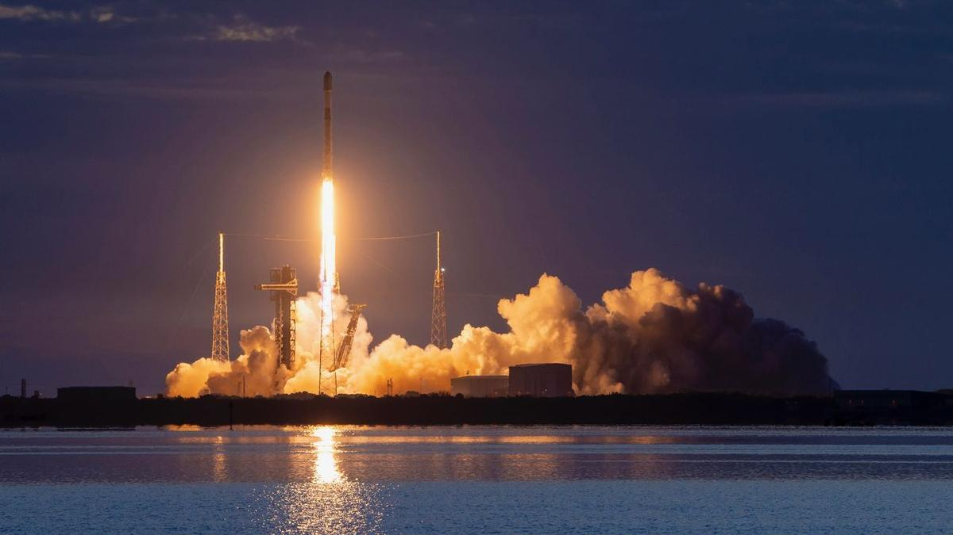
Click for next article Starlink launches may have become commonplace, but this one's definitely worth staying up for. A SpaceX Falcon 9 rocket topped with 29 Starlink internet satellites is scheduled to lift off from Florida's Cape Canaveral Space Force Station on Tuesday (Aug. 25), during a four-hour window that opens at 1:49 a.m. EDT (0549 GMT). It will be the 100th Falcon 9 flight of 2026 and the record-breaking 37th mission for this rocket's first stage, a booster designated B1067. You can watch the action live via SpaceX , starting about 10 minutes before launch. The Falcon 9 is by far the busiest rocket in operation today. Last year, it flew 165 missions - more than all of the world's other orbital rockets combined . And all 165 of those flights were fully successful. Extensive first-stage reuse is the Falcon 9's secret sauce, making it cheaper and more efficient to fly than its competitors. Those competitors are racing to catch up, however, and some are making strides. In the past six weeks, for example, two different Chinese rockets aced landings during orbital missions . But neither one of those newcomers has made it back to the pad for a second flight. SpaceX , meanwhile, has six Falcon 9 boosters with at least 30 flights under their belts, led by B1067's 36. (The others are B1077 and B1078 with 30, B1069 with 32, B1063 with 34 and B1071 with 35). And SpaceX plans to take reuse to even higher levels. The company's next-gen megarocket, Starship , is designed to be completely and rapidly reusable, with each vehicle capable of flying multiple times per day, according to SpaceX founder and CEO Elon Musk . (The Falcon 9 and its cousin the Falcon Heavy are only partially reusable; they have expendable upper stages.) If all goes according to plan on Tuesday morning, the Falcon 9 will return to Earth for recovery and yet more reuse. About 8.5 minutes after liftoff, the booster will land on the drone ship "A Shortfall of Gravitas," which will be stationed in the Atlantic Ocean. The rocket's upper stage, meanwhile, will haul the 29 Starlink satellites to low Earth orbit , deploying them there 61.5 minutes after launch. Tuesday's liftoff will be the 77th of 2026 devoted to building out Starlink, by far the largest satellite constellation ever assembled. It currently consists of more than 11,000 operational spacecraft, and that number is growing all the time.

16. Satellite sees Greenland's most significant floating ice loss in over a decade | Space photo of the day for Aug. 24, 2026
Read more

Click for next article ESA's Sentinel-1 mission captured remarkable imagery showing significant ice loss and calving at the Petermann Glacier. (Image credit: ESA) The massive glaciers of Greenland are disappearing right before our very eyes in new satellite imagery. What is it? Petermann Glacier in northwest Greenland connects the Greenland ice sheet to the Arctic ocean. Petermann's "ice tongue" has previously measured 43 miles (70 kilometers) long and 9 miles (15 km) wide. But new satellite imagery has revealed the glacier's floating "ice tongue" has broken apart in the glacier's most dramatic loss of floating ice since 2012. On August 4, 2026, the European Space Agency's Copernicus Sentinel-1 mission captured imagery of the glacier that revealed that a 29 square mile (76 square km) section of the ice tongue has broken away. This is the most significant ice calving event (where ice breaks off of a glacier) seen in the Arctic since 2020. "Satellite missions such as Sentinel-1 provide the systematic, long-term observations needed to track these changes, helping scientists better understand the processes driving calving and the wider impacts on the polar environment, and ultimately the Earth system as a whole," ESA Earth scientist Martin Wearing said in a statement. A moving image showing the ice calving in the Petermann glacier in August 2026. (Image credit: ESA) Why is it incredible? It is no secret that worsening climate change is contributing to significant ice loss. Antarctica has lost 5,000 square miles (12,950 square km) of grounded ice over the last three decades. Warming oceans are consistently eroding the arctic ice we have left which, when melted, contributes to rising sea levels. But knowledge is power, and by studying Earth from the vantage point of space, Earth scientists can gather critical information about our changing planet. "By studying Arctic ice islands, we will gain knowledge that can be transferred across polar regions. This is critical for understanding how the calving and deterioration of ice islands impact glacier dynamics, sea-level rise and the ocean environment," Anna Crawford, a glaciologist at the University of Stirling, said in the same statement.

17. Nancy Grace Roman Telescope live updates: NASA readies Roman for launch
Read more
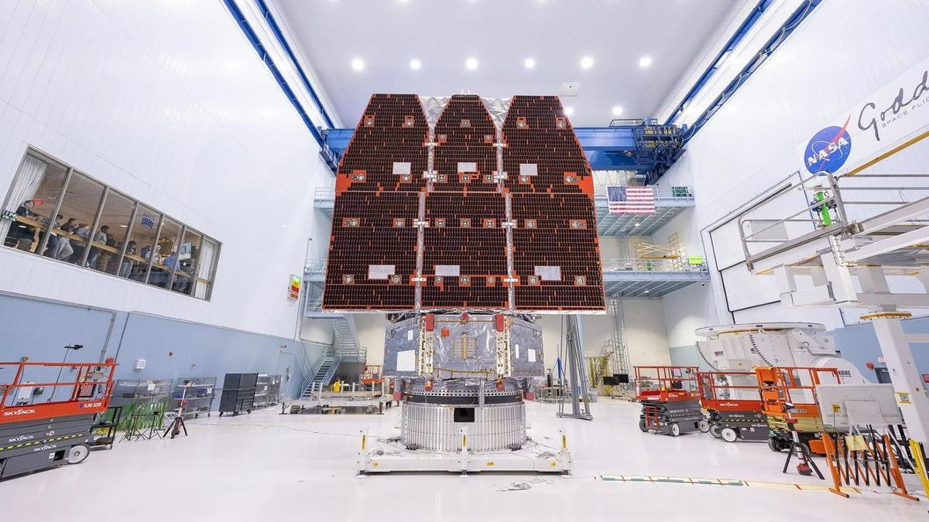
The Nancy Grace Roman Space Telescope is NASA's next great observatory poised to lead humanity's next generation of astronomical discoveries. The Roman Space Telescope will research the mysteries of dark energy, search for exoplanets and investigate the physics of distant stars. SpaceX will launch Roman on a Falcon Heavy rocket from NASA's Kennedy Space Center (KSC) in Florida. Liftoff is scheduled for no earlier than 7:26 a.m. EDT (1126 GMT) on Sunday, Aug. 30. from Launch Complex-39A (LC-39A). Follow this blog for live updates as Roman is prepped for launch and delievered to space for a brand new mission of discovery.

18. Live coverage: SpaceX to launch Starlink mission on a Falcon booster's record-breaking 37th flight
Read more
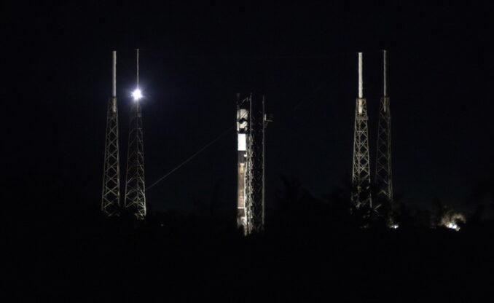
SpaceX will launch a Falcon 9 rocket from Florida early Tuesday morning, using a first-stage booster making a record-breaking 37th flight. The Starlink 10-49 mission will add another 29 broadband internet satellites to the company's low Earth orbit constellation consisting of more than 11,000 spacecraft. It could be the last Starlink flight from Cape Canaveral for a while, with no further missions for the company's internet service appearing on the near-term schedule. So far this year, SpaceX has launched 44 out of 76 Starlink missions from its West Coast launch site at Vandenberg Space Force Base in California. The company's Cape Canaveral workforce has been refocused on Starship preparations. Liftoff from Space Launch Complex 40 at Cape Canaveral Space Force Station is scheduled for 5:33 a.m. EDT (0933 UTC). The rocket will head off on a north-easterly trajectory upon leaving the pad. Spaceflight Now will have live coverage beginning about an hour prior to liftoff. <span data-mce-type="bookmark" style="display: inline-block; width: 0px; overflow: hidden; line-height: 0;" class="mce_SELRES_start"></span> The 45th Weather Squadron forecast a 90 percent chance for favorable weather during the launch window. Launch weather officers said they're watching for a small possibility of interference from cumulus and anvil clouds. SpaceX's flight-leading booster, tail number B1067, will make its 37th mission after entering service in June 2021. Nearly 8.5 minutes after liftoff, B1067 will target a landing on the droneship, A Shortfall of Gravitas, positioned in the Atlantic Ocean. If successful, this will be 165th landing on this vessel and the 654th Falcon booster landing to date.

19. NASA starshade would enable astronomers to directly image rocky exoworlds
Read more
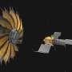
A NASA-led team hopes to take a shortcut to direct imaging of extrasolar Earth-like planets. The idea is to use what they call a hybrid telescope composed of an orbital starshade coupled with the next-generation extremely large ground-based optical telescopes.

20. China says unmanned moon mission delayed over 'launch conditions'
Read more
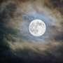
China's manned space agency said Sunday it is delaying a research moon mission that is part of Beijing's efforts to land a crew there by 2030, less than two weeks after a rare launch failure.
21. ISRO changes tack on launch vehicle manufacture - Developing Telecoms
Read more

The Indian Space Research Organisation (ISRO) has reportedly announced a change of policy that means it will cease direct manufacturing of commercial launch vehicles, though this may boost its other businesses. ISRO, whose main focus is the development and application of space technology for various national needs, plans to transfer end-to-end rocket assembly and operational manufacturing to private industrial consortia while refocusing its internal resources on advanced space exploration research, technology development, and deep-space missions. The operational transition transfers production lines for ISRO's operational launch fleet to domestic private aerospace contractors, which will assume responsibility for serial production, component sourcing, and launch vehicle integration. The launch fleet includes the Polar Satellite Launch Vehicle (PSLV), Launch Vehicle Mark-3 (LVM3), and the Small Satellite Launch Vehicle (SSLV). Commercial operations and mission procurement will continue through NewSpace India Limited (NSIL), the commercial arm of ISRO, while regulatory authorisations will still be managed by the Indian National Space Promotion and Authorisation Centre (IN-SPACe). According to the SatNews website, this industrial policy shift accelerates ISRO's initiatives to expand spacecraft and launch throughput while adapting to competitive pressures from global commercial launch providers, where ISRO continues coordinating international rideshare manifests. It explains that by shifting routine hardware fabrication to private industry, the Indian government aims to expand the nation's domestic space economy from approximately US$8 billion to US$44 billion by 2033 - an estimated 8% of the global space market. Commercialising launch vehicle production is designed to establish an export-oriented aerospace supply chain, positioning Indian prime contractors to supply launch services and satellite buses to international commercial customers.

22. After Centre rejig, Anand Mahindra and former ISRO chair appointed to RBI board - ANI News
Read more
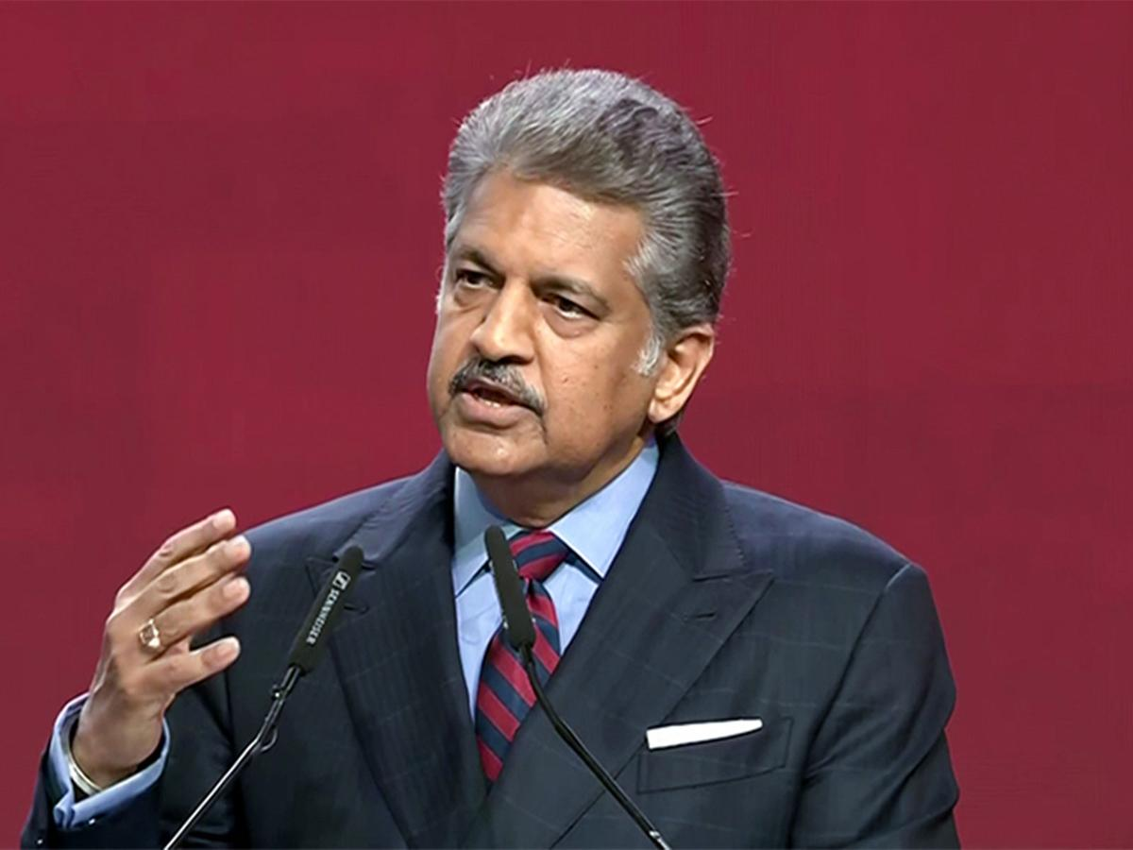
After Centre rejig, Anand Mahindra and former ISRO chair appointed to RBI board ANI News

23. Private Players Might Take Over ISRO's Rockets - The Federal
Read more
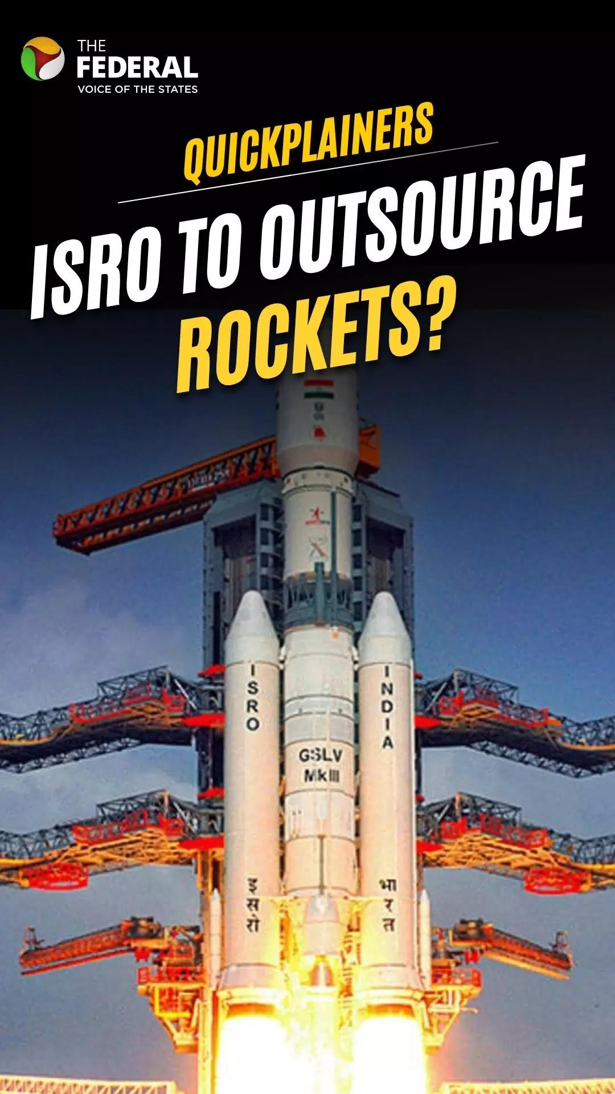
Private Players Might Take Over ISRO's Rockets The Federal

24. Cutting-edge infrared space telescope Roman set to launch
Read more
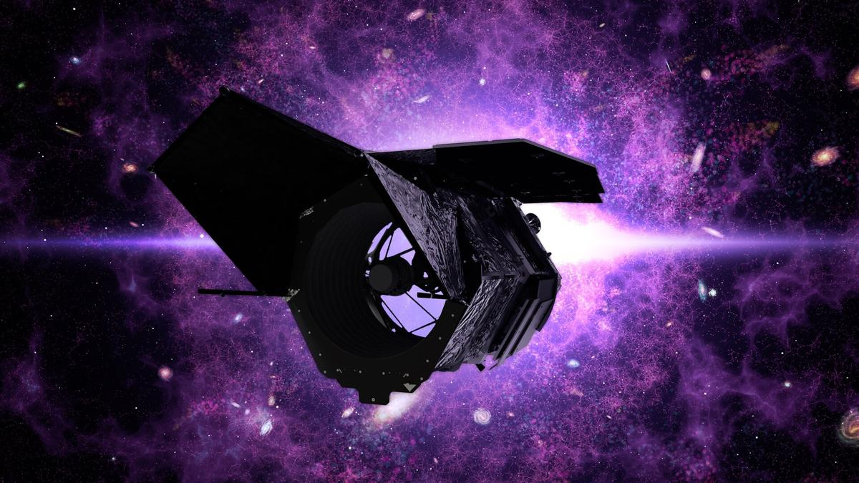
Science & Exploration Cutting-edge infrared space telescope Roman set to launch 25/08/2026 524 views 8 likes The NASA-led Nancy Grace Roman Space Telescope is set to launch on 30 August 2026 at 07:26 EDT / 12:26 BST / 13:26 CEST from NASA's Kennedy Space Center in Florida, USA. With its wide field of view and advanced optical design, the Roman telescope will conduct detailed scans of the sky in visible to near-infrared light. In doing so, Roman will help reveal the nature of dark energy and dark matter and find new exoplanets. "ESA is contributing essential hardware to Roman, including the spacecraft's star trackers, batteries, detectors for the coronagraph instrument, and communications support through its deep-space ground station network," says Bethan James, ESA's Roman Project Scientist. "Through the Mission of Opportunity programme, Europe contributes scientific expertise, helping guide and maximise the mission's scientific return." ESA will also enable data download from Roman using the new 35-metre antenna in New Norcia, Australia. Looking back at the early Universe Roman will conduct fast, detailed scans of the sky in infrared light. This will reveal a lot about the early Universe and how it expanded over time. "It will combine Hubble-quality imaging with a field of view more than 200 times larger, allowing it to study billions of stars, millions of galaxies, thousands of exoplanets, and vast regions of previously unexplored space," explains Bethan. "This will enable astronomers to address some of the biggest open questions in astrophysics, from the nature of dark energy to the abundance of planets throughout our Milky Way galaxy." Dark matter and dark energy Roman will join ESA's Euclid in uncovering the mysteries of the dark Universe About 25% of the Universe appears to be made up of invisible dark matter. The presence of dark matter can only be 'seen' by how it affects the apparent shape of galaxies. Light from a distant galaxy is bent and distorted due to the presence of clumps of dark matter, making the galaxy look slightly warped. This effect is called weak gravitational lensing. One of Roman's main tasks will be to scan about 12% of the sky high above our galactic plane to look for the lensing effect in millions of distant galaxies. By studying tiny changes in the shapes of galaxies, Roman will help astronomers accurately map the distribution of ordinary and dark matter across the history of the Universe and trace how galaxies evolved. Roman will investigate how the Universe has expanded over time. The expansion appears to be speeding up, and dark energy seems to be the culprit. Scientists think that dark energy makes up about 70% of the Universe and yet its nature remains a mystery. Like ESA's Euclid, Roman will use multiple methods to help us understand what dark energy is and how it has evolved over time. In one method, Roman will look for exploding stars known as supernovas, in distant galaxies, especially type Ia supernovas. Because these explosions peak at a predictable brightness, astronomers can use them to measure cosmic distances, which in turn provide insights into how fast the Universe is expanding. In another method, Roman will map how galaxies cluster together in time and space to test the effect of dark energy on them. Roman will study baryonic acoustic oscillations - imprints of sound waves that once rippled through the very early Universe. Like ESA's Euclid, Roman will use the method of baryonic acoustic oscillations to trace the expansion of the Universe As the Universe cooled, these ripples froze in place. Over time clusters of galaxies formed along the frozen ripples. Eventually, as the Universe expanded, the ripples stretched, and the distance between the surrounding galaxies increased. By looking at how galaxies are distributed across cosmic distances, astronomers can study how the Universe expanded over time. This will further shine a light on the nature of dark energy. Exoplanets Another task of Roman will be to look for exoplanets including planetary systems like our own. Using its deep and wide field of view, Roman will peer into the heart of our own galaxy. By doing so, it will track the amount of light coming from millions of stars and study how the intensity of light changes over time. Roman will keep an eye on microlensing events that may reveal over 1200 new worlds. At the same time, the telescope is expected to reveal more than 100 000 transiting planets that dim the light of their host stars when the planets cross in front of them. Roman's advanced coronagraph instrument will allow astronomers to directly image some of the exoplanets in detail by blocking the host stars' light, even when the planet is over 100 million times fainter than its host star. Extreme cosmic objects Roman is so sensitive that it will also detect extreme events, such as the birth of black holes when neutron stars merge, and tidal disruption events. The mission will also observe active galaxies hosting extremely bright quasars at their centres and several faint faraway quasars from the period of reionisation. Wide-eyed telescope in space Roman Wide Field Instrument detector plane The Roman Telescope is equipped with a primary mirror of 2.4 m in diameter. The telescope has two main instruments: the Wide Field Instrument (WFI) and a Coronagraph Instrument. The WFI is a 300-megapixel multi-band visible and near-infrared camera capable of obtaining extremely crisp images and very sensitive spectroscopic data. The Coronagraph Instrument is a high-performance technology demonstrator that blocks out starlight to look for faint planets around them. The instrument could be capable of directly imaging reflected starlight from Jupiter-sized exoplanets in Jupiter-like orbits around their host stars. "Whenever astronomy opens a new window on the Universe, history has shown that some of the most important discoveries are the ones we never anticipated," remarks Bethan. "With its unprecedented combination of depth, area and image quality, Roman has every opportunity to surprise us." Follow the launch live here Roman is scheduled to launch on a SpaceX Falcon Heavy rocket from NASA's Kennedy Space Center in Florida, USA on 30 August 2026 at 07:26 EDT /12:26 BST / 13:26 CEST. Watch the launch live via NASA's YouTube channel. Follow NASA for updates. For more information, please contact: ESA Media Relations Email: media@esa.int

25. 'You just saved the video dish': Two astronauts complete spacewalk to replace ISS antenna
Read more
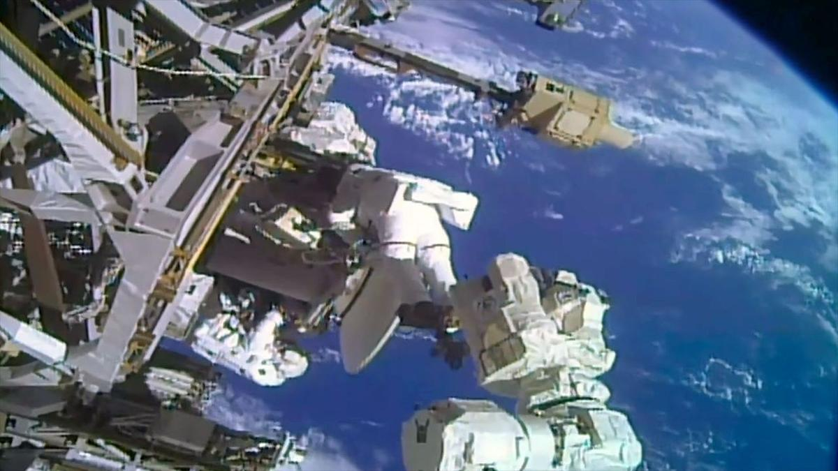
Click for next article Astronauts Anil Menon and Sophie Adenot conduct a spacewalk to install a replacement Space-to-Ground antenna on the outside of the International Space Station on Tuesday, Aug. 25, 2026. "Houston, we have a working comm link again." Thanks to the efforts of two astronauts, such a call is possible again using one of two Space-to-Ground antennas outside the International Space Station (ISS). The pair finished the replacement of a faulty dish assembly during a spacewalk on Tuesday (Aug. 25). Anil Menon of NASA and Sophie Adenot of the European Space Agency (ESA), who previously removed a faulty dish during a spacewalk on Aug. 18, installed a spare in its place and moved the broken assembly from a temporary to more permanent storage location along the station's backbone truss. As seen from a camera mounted on ESA astronaut Sophie Adenot's helmet, fellow Expedition 75 crew member Anil Menon of NASA works to mount a replacement Space-to-Ground antenna during a spacewalk outside of the International Space Station on Tuesday, Aug. 25, 2026. (Image credit: NASA) With Menon positioned at the end of the Canadarm2 robotic arm and Adenot traversing by handrails to join him, the two Expedition 75 crewmates first retrieved a spare Space-to-Ground Antenna (SGANT) from an external stowage position. Menon and the spare dish were then maneuvered to the Z-1 truss, where it was mounted and connected to the station's power and data systems. Menon and Adenot then retrieved the faulty antenna, which they had stowed on the Z-1 truss during the prior spacewalk. Menon (on the arm) moved it to external stowage platform-3 (ESP-3) on the starboard side of the truss. The replacement work became necessary after the SGANT ceased being able to track NASA's data and relay satellites , rendering it unusable, beginning last November. A second antenna has been in use since, continuing the transmission of voice and critical data, but this repair re-established redundancy to the system. "On behalf of CAPCOM and I, we're going to count down like a bolt: '3, 2, 1… You just saved the video dish, you just saved the video dish,'" sang astronaut Anne McClain from Mission Control at NASA's Johnson Space Center in Houston, parodying the The Buggles' 1979 hit "Video Killed the Radio Star." "Oh my god, it is hard to top that," replied Menon, who could be heard laughing along with Adenot. "I want to thank the entire team on executing this complex, time-critical operation successfully." Tuesday's spacewalk began at 8:27 a.m. EDT (1227 GMT) and was completed exactly 6.5 hours later, at 2:57 p.m. EDT (1857 GMT). The extravehicular activity (EVA) was the 283rd in support of ISS assembly, maintenance and upgrades. It was Menon's third EVA, increasing his total spacewalking time to 19 hours and 20 minutes. It was the second time that Adenot worked in the vacuum of space, raising her time on EVA to 12 hours and 53 minutes after becoming the first woman and fifth citizen of France to perform a spacewalk. This was the sixth outing from the International Space Station this year, the second EVA for Expedition 75 and the 98th spacewalk using U.S. extravehicular mobility unit (EMU) spacesuits at the station.

26. Starbase Louisiana: SpaceX announces enormous $100 billion Starbase launch site
Read more

Click for next article Illustration of SpaceX's planned Starbase Louisiana site, which the company says will support thousands of Starship launches per year. A new spaceport will bring 10 launch pads to Louisiana's Gulf Coast and support thousands of Starship launches per year. SpaceX and Louisiana Governor Jeff Landry announced Tuesday (Aug. 25) a $100 billion investment in the state's Vermilion Parish to build "Starbase Louisiana," a sprawling new manufacturing and launch facility for SpaceX's massive Starship rocket. It will be one of the biggest projects in the state's history, and serve as SpaceX's largest center for spaceflight operations. Once complete, the new site will feature five complexes that feature two Starship towers each, for a total of 10 launch pads across the facility, each with its own propellant farm. That fuel will also be produced onsite as well. "We're planning to build a self-sustaining spaceport with its own propellant production, power generation, deep water shipping capabilities, vehicle processing facilities, and probably an airport," SpaceX President Gwynn Shotwell said during the announcement event. "And thanks to the abundant resources here in Louisiana, we have ready access to the natural gas that fuels these rockets to get to orbit." SpaceX and Louisiana officials say the site will eventually support thousands of launches per year and will be central to SpaceX's effort to dramatically increase Starship's flight rate. SpaceX founder and CEO Elon Musk recently estimated that Starship will be launching more than 30 times per day by 2030, which equates to more than 10,000 flights per year. Landry framed the project in historic terms, saying."This will be the place [from] which America reaches farther than it has ever reached before. In 1803, Louisiana gave America a continent. Today, Louisiana and SpaceX will give America the stars ." Starship is SpaceX's next-generation, fully reusable launch vehicle. The giant rocket is still under development, but the company is quickly making strides to mature the rocket to operational status. SpaceX is preparing for Starship's 14th test flight in September, and is on a tight timeline to qualify the rocket for operational missions. Shotwell said SpaceX's existing infrastructure can't support the number or cadence of Starship launches the company anticipates reaching, and tied Starbase Louisiana to SpaceX's long-term goal of using Starship to make human life interplanetary. In the nearer term, Starship is also tasked with returning astronauts to the surface of the moon . NASA has contracted SpaceX to design a lunar lander version of Starship for the agency's Artemis program . Artemis III is scheduled for mid-2027, and will launch NASA's Orion spacecraft to Earth orbit to practice rendezvous and docking maneuvers with one of SpaceX's current "Version 3" Starship test vehicles. The first moon landing of the program is planned for Artemis IV in 2028, giving SpaceX a fast-approaching deadline to mature Starship from test article to crew-certified lunar lander. Render of Starship and Orion docked on Artemis III, scheduled for mid-2027. (Image credit: SpaceX) For the Artemis IV Starship to carry out its mission of landing astronauts on the surface of the moon and then launching them back to lunar orbit to rendezvous with Orion, and for any Starship mission beyond low Earth orbit, the spacecraft requires refueling launches of additional "tanker" Starships. Artemis IV's Starship may need up to a dozen such refueling flights. But Starbase Louisiana's 10 launch pads will be for more than propellant delivery. SpaceX plans to launch its next-generation Starlink internet satellite constellation aboard Starship. To date, SpaceX has launched more than 300 Starlink missions aboard its workhorse Falcon 9 rocket, which has delivered more than 11,000 of the satellites to orbit. Already preparing for the transition to Starship, SpaceX just launched its last Falcon 9 Starlink mission from Florida , and plans to fly the remaining Falcon 9 Starlink launches from Vandenberg Space Force Base in California. SpaceX intends to retire Falcon 9 entirely once Starship is fully operational. The company is also planning for Starship to launch its huge artificial intelligence network and build out an orbital infrastructure to "move supercomputing to space," Shotwell said, as artificial intelligence drives greater demand for resources. Illustration of SpaceX's planned Starbase Louisiana site, which the company says will support thousands of Starship launches per year. (Image credit: SpaceX) "Put all of this together, and these tasks will require thousands of launches," Shotwell said. "Starbase Louisiana is being designed from day one to support this dramatic increase in launch cadence." Construction on the new Starbase is expected to begin in 2027, with the first launch from the site targeted for 2029, SpaceX said. According to an outline of the plan from Louisiana Economic Development, the state agency overseeing the project's economic development efforts, the project is expected to create 3,000 direct jobs over the next decade, and thousands of additional jobs indirectly tied to its development. Already having gone through the processes in Texas and Florida, SpaceX has also already begun working with Louisiana wildlife and coastal agencies to assess the impacts of such a large industrial complex along the Gulf Coast. "We are committed to doing our part to ensure that this land doesn't disappear," Shotwell said, viewing the area as a unique opportunity to fly the world's most powerful rocket, while supporting Louisiana's coastal resilience. "SpaceX is partnering with state and federal agencies to expand Louisiana's coastal master plan, including shoreline protection, marsh restoration, and wildlife conservation," she said. Starbase Louisiana will be SpaceX's biggest undertaking ever, and likely the eventual hub of the company's launch operations. "This will be a project like no other," Shotwell said, "another piece of science fiction transported into reality."

27. NASA's Roman Space Telescope will reveal the universe in a way the JWST and Hubble cannot
Read more
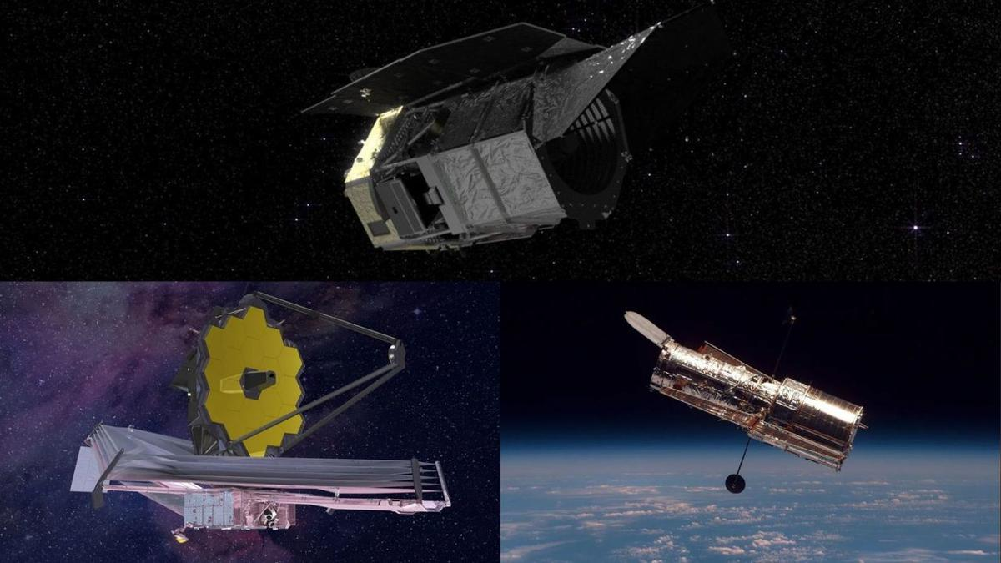
Click for next article The Roman Space Telescope on top, the James Webb Space Telescope on the bottom left and the Hubble Space Telescope on the bottom right. Even if you aren't the kind of person who often looks up the latest space images, it's hard to navigate life (especially on the internet) without running into a few. Try choosing a new iPhone background and you'll have your pick of sharp, gray moon portraits. Watch an old "Star Trek" episode and you may not realize how many of those translucent nebulas outside the spaceship's windows were based on real, hard data. When it comes to space, we're spoiled. Mind-bending objects light-years away from us have managed to become integrated into our everyday lives - and though we're still a ways away from understanding the true nature of the universe, we're also the closest we've ever been. It's in large part thanks to how impeccable our fleet of space telescopes is. In seconds, you can find a Hubble Space Telescope Deep Field with luminescent galaxies warped along the curvature of spacetime and James Webb Space Telescope images of strange hazy red objects from just after the dawn of time. Moreover, what's tremendously exciting is this fleet is constantly growing. Indeed, very soon, a new space telescope will launch from NASA's Kennedy Space Center in Florida. It's called the Nancy Grace Roman Space Telescope , and it should be able to unlock a new level in the astronomy layer of our lives. It will show us new types of images, reveal new types of data and lead us in directions we may not yet know are possible. What is Roman? To put it succinctly, the Nancy Grace Roman Space Telescope is an approximately 42-foot-long (12.7-meter-long), cylindrical metal observatory scheduled to lift off from our planet on Aug. 30 aboard a SpaceX Falcon Heavy rocket. Across a five-year-long mission (a 10-year-long one if everything goes well), Roman is meant to use two powerful instruments - the Wide-Field Instrument (WFI) and Coronagraph Instrument - to image huge swaths of the cosmos and tackle some crucial questions. It will help scientists probe the mysteries of dark matter and dark energy , directly image exoplanets near and far, witness an extensive amount of stars exploding in colossal supernovas and more. But whether or not it's a fair thought, it's hard not to want to compare the specifications of this space telescope to some of the others that have brought the cosmos down into our daily lives. This is particularly true for two of the major players right now: the James Webb Space Telescope and the Hubble Space Telescope. What can Roman do that these two cannot? The multiple-image effect seen in this Hubble picture is produced by a process called gravitational lensing, a quirk of warped spacetime in which the gravitational field of a massive object bends and amplifies light from a background object. (Image credit: ESA, NASA, K. Sharon (Tel Aviv University) and E. Ofek (Caltech)) Roman vs. Hubble To start, one of the biggest benefits of Roman over Hubble is its processing power. By numbers, that means Hubble has managed to gather about 400 terabytes of data over its approximately 35 years of service so far. Roman is expected to be able to create 500 terabytes of data every single year. "Its surveying capabilities are over 1,000 times faster than Hubble, and can chart 200 times more sky in a single image," NASA administrator Jared Isaacman said during a press conference about Roman in April . "What would take Hubble 2,000 years to process, Roman can do in a year - the images it captures will be so large there is not a screen in existence large enough to show them." Roman's primary mirror is about 7.9 feet (2.4 meters) wide, which is actually the same as Hubble's. Primary mirrors are arguably the most important aspect of a space telescope, because it's how an observatory manages to gather light coming from the universe. Bigger mirrors can collect more light, which allows them to see dimmer or more distant objects. Interestingly, Roman's primary mirror is also about 80% lighter than Hubble's. Roman has a secondary mirror as well; it's just under 2 feet (0.5 meters) wide. Hubble's secondary mirror is very similar at exactly 12.2 inches (0.3 m) in width. On the left, the Roman Space Telescope. On the right, Hubble. (Image credit: NASA's Goddard Space Flight Center) Yet even though Roman's mirrors are so comparable to Hubble's, because of Roman's processing power as well as the capabilities of its WFI, it will be able to image a far wider stretch of sky than Hubble can. Though Roman does have some visible light capabilities like Hubble, WFI specializes in infrared light - actually the kind of light the JWST works with, but we'll get to that telescope comparison shortly - so we should compare it to Hubble's infrared instrument. The WFI's field of view is about 100 times greater than the Hubble infrared instrument's field of view. According to NASA, this view will allow Roman to measure light emanating from a billion galaxies and billions more cosmic phenomena over its years of service. "Both observatories will perform spectroscopy," NASA explains, "which involves splitting light into individual colors to study patterns that reveal detailed information. But Roman's spectral studies will have lower resolution over a large area, while Hubble's has higher resolution over a small area." This concept really sums up the difference between the two telescopes, and in fact foreshadows what we'll soon discuss about the JWST. NASA's Nancy Grace Roman Space Telescope is encapsulated in the payload fairing of its SpaceX Falcon Heavy rocket. (Image credit: SpaceX) Roman vs. the JWST The main similarity between the Roman Space Telescope and the JWST is those infrared light goggles. Infrared light, unlike visible light, is invisible to human eyes. You can think of it more like a heat signature. Firefighters, for instance, use infrared trackers on burning buildings from the outside to see where the source of the fire might lie within. And when it comes to astronomy, infrared light is priceless - that's why the JWST's strong infrared capabilities give it an advantage over Hubble. Infrared light's role in astronomy observations has to do with the way light moves throughout the universe. As light from a distant region of space moves toward us - through a continuously expanding universe, no less - those light wavelengths stretch out from tight, bluer ones into long, redder ones. Eventually, the wavelengths stretch out into the infrared region of the electromagnetic spectrum , which is the part of the spectrum we cannot see with our own eyes. Plus, any objects in our line of sight that are hidden behind dense clouds of interstellar dust or gas can only be seen via their infrared emissions. What this means is that very, very distant objects as well as concealed objects in space are pretty much invisible to us, hiding in the infrared part of the spectrum. We therefore need infrared decoders, like the JWST's suite of tools or Hubble's infrared instrument, to reveal them. The JWST has already made absolute strides in this regard, revealing to us peculiar objects from the early years of the universe, consistently breaking its own record while finding the most distant galaxies we've ever seen and revamping Hubble portraits like the spectacular Pillars of Creation with its infrared filter. It's even reintroduced us to our own solar system with crisp views of Neptune 's frail, oft-forgotten rings and Saturn 's big, bright ones. The JWST's view of Neptune and its rings. The world looks so small when seen this way. (Image credit: ESA/NASA) When it comes to mirrors, the JWST's iconic golden primary mirror made of 18 hexagonal segments is a beautiful 21 feet and 4 inches (6.5 meters) across, which is much larger than Roman's. This means the JWST can collect tons more light than Roman can, which makes a lot of sense because it was built to see as deep into the ancient universe as possible. But where the JWST lacks is, you guessed it, its field of view. This is on purpose. The whole point of JWST is to pierce into the universe with a highly narrow view in order to get great resolution on whatever it's looking at. Roman definitely won't be getting that same resolution, as its images will be shallower than the JWST's, but its WFI will see a region 50 times wider than what the JWST can see. A view of the James Webb Space Telescope's giant mirror. (Image credit: NASA) The Roman Space Telescope's mirror. (Image credit: NASA/Sydney Rohde) To be clear, there are indeed other survey telescopes that are able to image huge amounts of the sky at once, but Roman's version of doing this is expected to be with higher clarity. For example, the ground-based Rubin Observatory is revolutionary for the vast amounts of data it's able to collect while scanning a new section of the sky every 40 seconds. However, Rubin is on the ground. A space telescope sits above Earth's atmosphere, and therefore has less atmospheric interference to sift through. This makes the observations way better. Okay, you've probably figured out the moral of the story at this point: Roman's reach is shallower than Hubble's and the JWST's, but extremely wide. So, what's the benefit of this enormity? Simulated views of what a section of space would look like from the Rubin Observatory and the Roman Space Telescope. Because it has to peer through Earth's atmosphere, Rubin's images won't always be sharp enough to distinguish multiple, close sources as separate objects. (Image credit: J. Chiang (SLAC), C. Hirata (OSU), and NASA's Goddard Space Flight Center) The promise of Roman Imaging huge amounts of the universe in one go is of foremost importance because things in the universe happen simultaneously. A supernova on one end might be worth checking out, but a fleeting fast radio burst buzzing on the other end of the cosmos could be just as vital to study. Yet, with a narrow field of view, you'd have to select which target to zoom in on. And if you aren't sure which targets are even options, while perusing an ancient black hole with immense resolution you will most definitely miss an even older one that lurks 50 frames or so away. With Roman, scientists won't have to be as selective about which parts of the sky they scan. Roman is designed to be able to capture the supernovas, fast radio bursts, black hole emissions and warped galaxy candidates all at once. For example, NASA explains how Roman will be able to spot colliding neutron stars - stellar corpses so dense a tablespoon of one is equal to the weight of Mount Everest - with its infrared view. The JWST would likely never even come across such an event due to its tunnel vision. Of course, Roman won't be able to image these objects with as much depth as the JWST or Hubble - or several other telescopes for that matter, like maybe SPHEREx or Euclid - but it will be able to notice that these objects exist. The next step would be to have one of those other telescopes follow up on the targets. You can think of Roman as creating the Google Maps of hotspot locations in the universe that the JWST, Hubble or another telescope may want to examine someday. Big field of view means big science Furthermore, capturing information from billions of objects in such a short period of time will enable specific kinds of research, such as the hunt for the truth about dark matter and dark energy. Despite collectively making up about 95% of the universe's contents, dark matter and dark energy aren't visible to us. However, we know dark energy exists because it appears to be applying a force that accelerates the expansion of our universe and we know dark matter exists because it seems to be the glue around galaxies that prevents them from falling apart like horses on a merry-go-round spinning too fast. What this means is imaging tons of galaxies at once could allow scientists to have a better picture of how those interactions between the dark universe and our regular universe play out. Roman will also be able to create time-lapse "movies" of the universe in three dimensions and offer scientists the chance to see how other observations fit into that picture. It would also be remiss not to mention what Roman's other instrument can do: the coronagraph. The telescope's coronagraph is actually one-of-a-kind. You can think of it like a special artificial eclipse that brings objects into view that would otherwise be obscured by bright starlight. No other space observatory in service right now has the ability to directly image exoplanets like Roman will be able to using that coronagraph. It would take an entire other article to explain the awesome complexities of this instrument - an article that you can definitely expect soon - but to go through the basics, this tool will block out the glare of distant stars and then measure the polarization of light around them in order to help scientists tease out exoplanets orbiting those stars. A side by side view of the Hubble Telescope's view of the Pillars creation and the JWST's. (Image credit: NASA, ESA, CSA, STScI, Hubble Heritage Project (STScI, AURA), Joseph DePasquale (STScI), Anton M. Koekemoer (STScI), Alyssa Pagan (STScI)) According to NASA, Roman's coronagraph will be able to detect planets 100 million times fainter than their stars. That capability is about 100 to 1,000 times better than existing space-based coronagraphs. This will give scientists the opportunity to study planets beyond our solar system that are dimmer, colder, farther and more elusive than what we're currently able to see. With all this in mind, there is an important concept to remember. When the JWST first entered service in the year 2022, everyone (including me) started comparing it to Hubble and thinking of it as Hubble's upgrade. It's hard not to, especially when the images rolling out of a shiny new telescope are so utterly gorgeous. But "upgrade" couldn't be farther from reality . The JWST is just different. Impressive, sure, but different. The goal is for all of these telescopes to work together, each one giving us a new sheet of the universe to explore. Stack up all the sheets, and you'll get the full picture. Roman will simply be offering us one breathtaking new sheet.

28. Astronauts make history repairing the ISS | Space photo of the day for Aug. 25, 2026
Read more
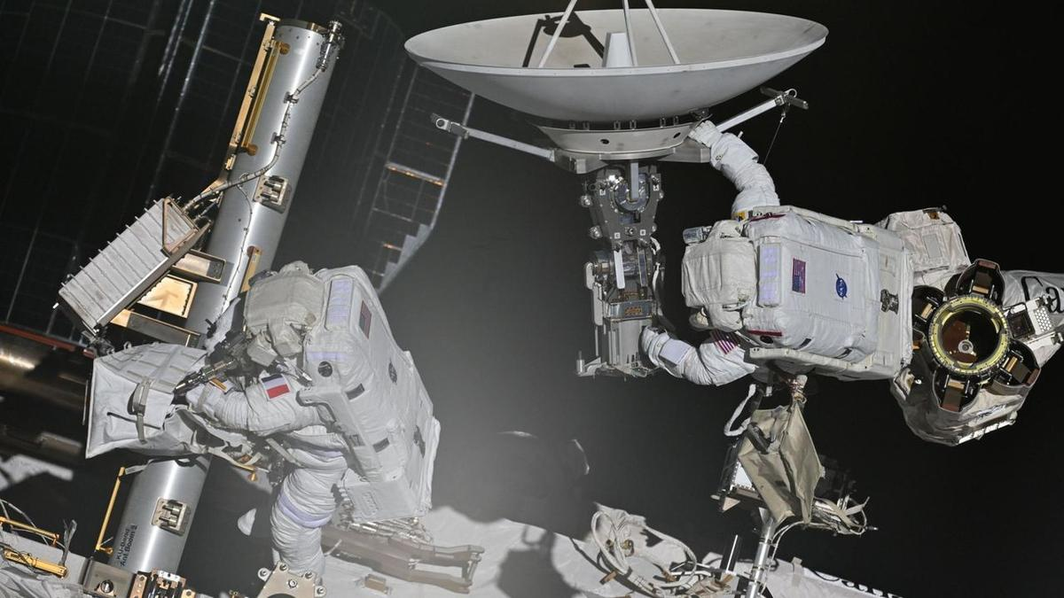
Click for next article ESA astronaut Sophie Adenot and NASA astronaut Anil Menon complete a spacewalk on Aug. 18, 2026. (Image credit: Roscosmos/Anna Kikina) Intensely focused and tethered to a floating laboratory in the vacuum of space, two astronauts spent over 6 hours working on the International Space Station during a historic spacewalk. What is it? Two astronauts aboard the ISS set out on a spacewalk recently (Aug. 18). European Space Agency astronaut Sophie Adenot and NASA astronaut Anil Menon set out recently a historic spacewalk. This was Adenot's first spacewalk and, in journeying out into the darkness of space she became the first French woman to conduct a spacewalk (or, formally, an extravehicular activity, or EVA). In this snapshot from the space station, you can see Adenot on the left and Menon on the right, both hard at work on their mission. On this spacewalk , which took the pair 6 hours and 23 minutes, the astronauts were tasked with removing a failed antenna from the space station. However, while it was a successful outing, the pair didn't have enough time to replace the old antenna with a new, working one. Why is it incredible? Getting to space is hard enough. And then once you're there, venturing out of an orbiting laboratory into the darkness of space to do a physically demanding but technically complex repair job on that laboratory is certainly no picnic. But these two astronauts pushed through almost six-and-a-half hours of grueling space work to remove the broken antenna before running out of time. And this big step forward in this fix is critical, as these antennae help to connect the space station to Earth, which is of the utmost importance. The antenna, a "Space-to-Ground" antenna, started malfunctioning months ago and a second antenna has temporarily taken over. But this solution was temporary and a more permanent replacement was needed as this antenna ensures that astronauts on the space station can quickly transmit critical information back down to Mission Control back on Earth.

29. On this day in space! Aug. 25, 1997: NASA launches Advanced Composition Explorer to track solar wind and so much more
Read more
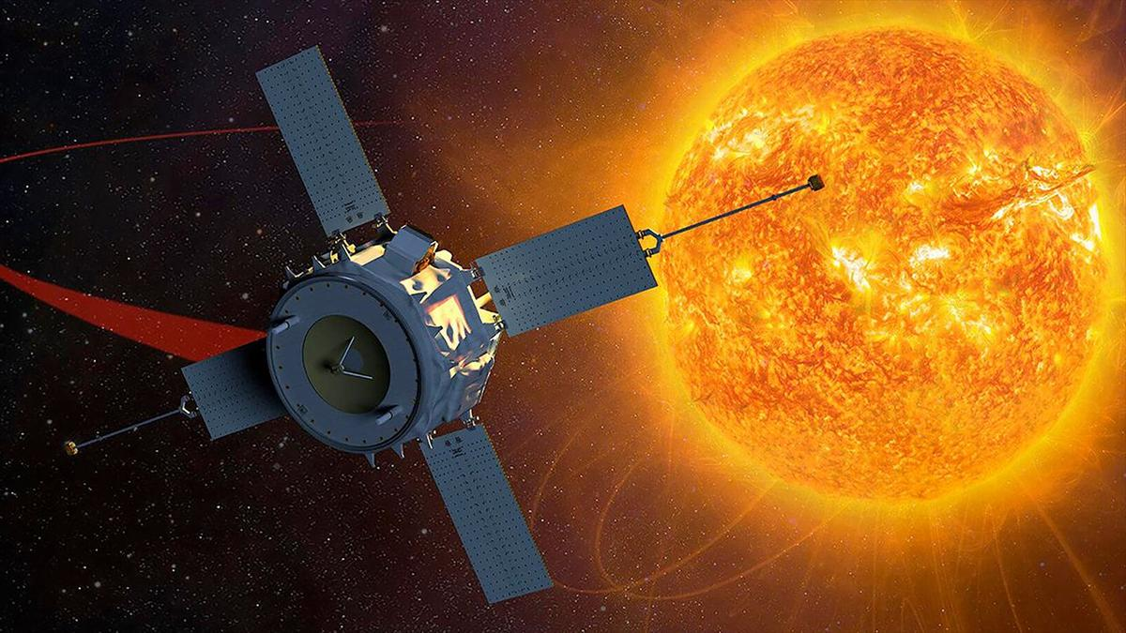
Click for next article On Aug. 25, 1997, NASA launched the Advanced Composition Explorer, or ACE satellite to study energetic particles traveling through space. It lifted off from Kennedy Space Center in Florida on a Delta II rocket and spent the next three and a half months making its way to its orbital post near the L1 Lagrangian point , a point of gravitational equilibrium between Earth and the sun. There, the spacecraft is monitoring the stream of accelerated particles coming from the sun known as the solar wind . ACE provides 24/7 continuous coverage of the solar wind, which lets scientists know when to expect geomagnetic storms that can disrupt communication satellites and power grids on Earth. Why it mattered A Boeing Delta II rocket launches NASA's Advanced Composition Explorer satellite from Launch Complex 17A at the Cape Canaveral Air Force Station in Florida on Aug. 25, 1997. (Image credit: NASA) The ACE satellite is a NASA sentinel survivor. When it launched in 1997, NASA hoped the ACE satellite mission would last up to five years as it monitored solar wind speeds and conditions, as well as the flow of other critical charged particles through space, such as galactic cosmic rays , as well as interplanetary and interstellar particles. As of today, ACE has been hard at work for 29 years and shows no signs of stopping. It's one of NASA's oldest still-operating sun-monitoring spacecraft (the Solar and Heliospheric Observatory , or SOHO, is two years older, as it launched in 1995). ACE serves as a core part of NASA's early-warning system for incoming space weather. It's nine primary instruments were between 10 and 10,000 times better than any sensors flown in space when the satellite launched in 1997. In 2005, one of those instruments - the Solar Energetic Particle Ionic Charge Analyzer - stopped sending data, but it is the only instrument to be lost during ACE's lifetime, NASA has said . Want more space history? Check out our full On This Day In Space Story archive and watch our On This Day In Space videos on YouTube .

30. Polish startup Ares Shield hired to protect data center satellites with high-power microwave weapons
Read more
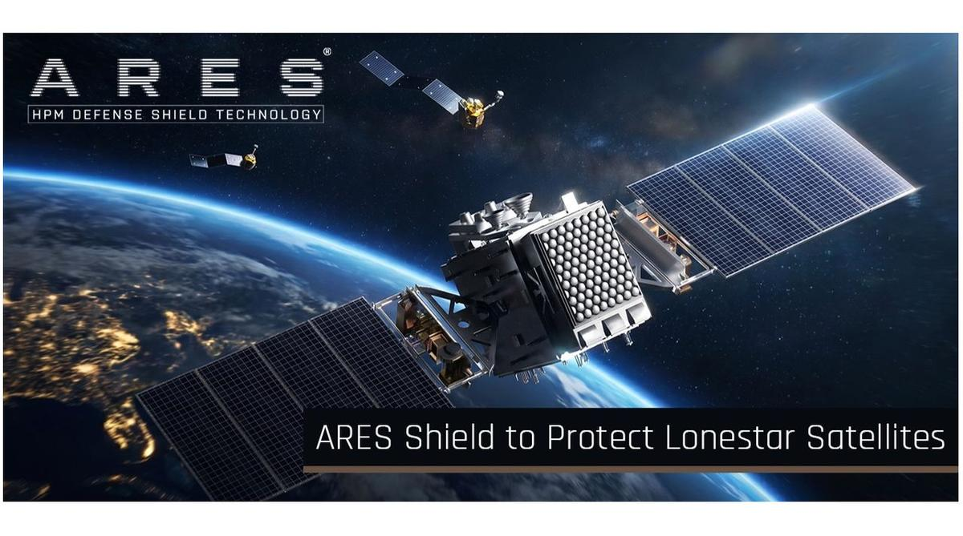
Click for next article Ares Shield just signed a deal to provide protection for some of Lonestar Data Holding's satellites. The final frontier is getting more and more contested, so satellite companies are investing in some self-defense. At least one of them is, anyway. Florida-based Lonestar Data Holdings announced today (Aug. 25) that it has contracted Polish startup Ares Shield to provide protection for its off-Earth data centers , in a deal worth up to $6 million. "Our clients entrust us with mission-critical data, which is why we treat the security of our orbital infrastructure as the foundation of our entire service," Lonestar CEO Stephen Eisele said in a statement today. "Ares Shield technology offers a unique solution that allows us to further protect our satellites without the risk of generating space debris. For a company whose product is data security, it is a compelling option." Lonestar has already tested its data-storage tech on four space missions, including two that went to the moon . For example, one of the company's devices hit the gray dirt aboard Intuitive Machines ' Athena lander in March 2025. Athena toppled over shortly after touchdown, but Lonestar's mini data center achieved its desired milestones regardless , according to the company. Such work has helped inform the development of Lonestar's first commercial space-based offering - a platform called StarVault, which will store customer data at a healthy remove from natural disasters and other issues that could crop up here on terra firma. "StarVault combines Lonestar's advanced cryptographic key escrow capabilities with space-based data storage infrastructure, creating a new class of digital resilience - extending secure data beyond Earth," the company said in a statement in April. The first StarVault payload is currently scheduled to fly aboard Sidus Space's LizzieSat-4, which is manifested on SpaceX 's Transporter 18 rideshare mission. That flight is expected to launch from California's Vandenberg Space Force Base in late October. Other StarVault missions will follow, as Lonestar builds a data-storage network in low Earth orbit and, perhaps, more far-flung locales. 🛰️Russian satellites multi-object proximity event in LEORadar tracking data via @LeoLabs_Space, processed through COMSPOC SSA Suite.This week we observed a complex proximity event involving Russian satellites: COSMOS 2581, 2582, 2583, and Object F (a subsatellite released by… pic.twitter.com/3nDkcOmTuDMay 1, 2026 Multiple satellites in that network will be protected by Ares Shield technology, if all goes according to plan. That tech is a combination of sensors, AI-driven analytics and a high-power microwave (HPM) emitter, which are integrated into a module that attaches to the client satellite. Ares Shield's system will be able to detect and classify potential threats, such as approaching "inspector" satellites that may have designs on stealing the client's data. And the defense module can neutralize them via electronics-frying HPM emissions, knocking satellites out without creating a cloud of space debris . But shooting to kill will likely not be the first option, said Ares Shield CEO Grzegorz Zwolinski. "The defense system can show the opponent that we can create malfunctions in their hardware, jam them, or do like small-energy attacks," Zwolinski, who previously co-founded the Polish aerospace company SatRev, told Space.com. "Then they will realize that it's not worth losing their system on this particular infrastructure, which we are protecting." Ares Shield plans to deliver its first defense systems for Lonestar in 2028 or 2029, he added. The newly announced agreement calls for three satellites to be protected initially, with Ares providing modules for more spacecraft in the constellation over time. And there could be other customers in the near future as well. "We are discussing another delivery for other operators," Zwolinski said. "So, we are seeing more and more interest." Such interest is not surprising, given the rise of in-space surveillance and the continuing development of satellites capable of rendezvous and proximity operations (RPO) - the ability to meet up, and potentially interfere, with other satellites in orbit. These threats have increased dramatically in the past few years, according to Zwolinski. When he co-founded SatRev back in 2016, "there were mostly peaceful actions, but during the the war in Ukraine, more hostile actions started to appear on orbit," Zwolinski said, referring to Russian's ongoing invasion, which began in February 2022. "The inspector robots and RPO attacks started to be more frequent," he added. "Russia is is trying to exercise those attacks more and more often . China is doing a lot of RPO attacks on NATO satellites. There are more and more actors which are producing the inspector robots. "So, it appears to me that we should have something to answer for those problems," he continued. "I think in the future, most satellites will need our protection." That need will only increase as more and more data centers reach orbit. And that's expected to happen relatively soon. For example, Elon Musk has said that SpaceX plans to operate one million of its " Starmind " AI satellites in Earth orbit - and that it aims to launch the first prototype spacecraft early next year. Ares Shield plans to protect infrastructure here on Earth as well. The company is currently building HPM systems that can take out drones - which have become key weapons on the modern battlefield - at a distance of 330 feet (100 meters), according to Zwolinski. "The plan is that, in the next five months, we want to increase the distance where we are shooting the drones, and the most wanted is 2 kilometers," he said.

31. NASA satellites ace world's 1st 'lost-in-space' GPS-free navigation experiment
Read more
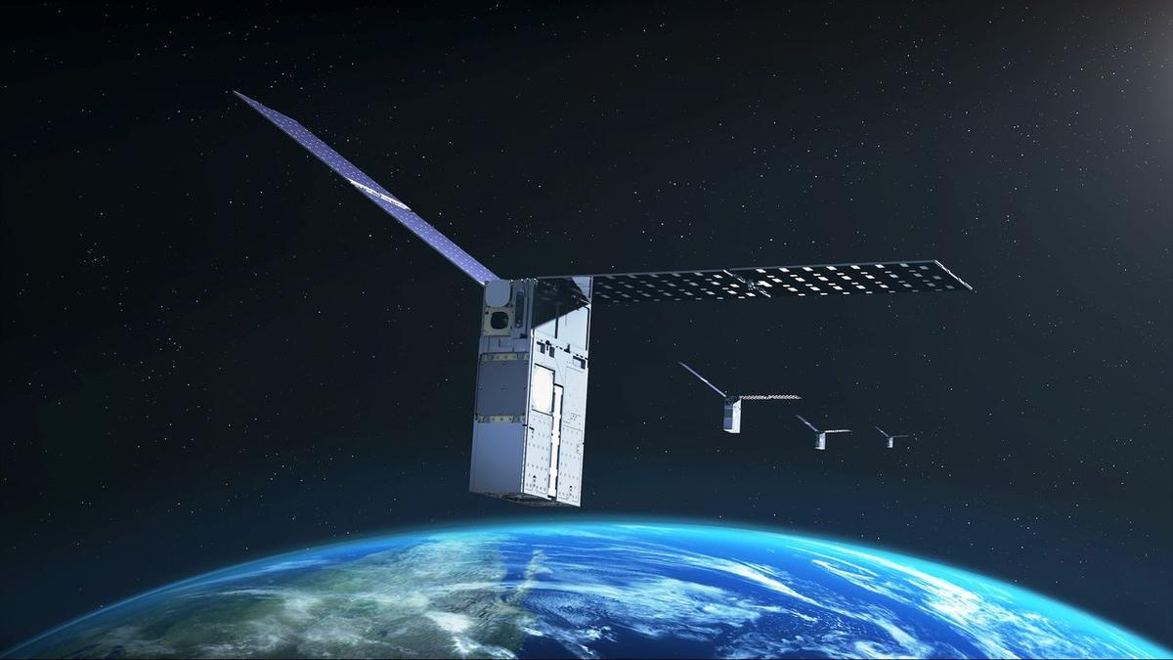
Click for next article No GPS available in space? A satellite experiment may have a solution for that. NASA's Starling mission - made up of a swarm of four cubesats in low Earth orbit (LEO) - is testing out navigation by using other satellites as moving landmarks. The hope is that this tech will allow future missions to navigate if GPS is not available. The three-year-old tech demo will be extended beyond its previous expiration date this year until at least 2028, NASA announced on Monday (Aug. 17). The aim is to get the most out of the onboard experiment, a collaboration with industry partner EraDrive called FALCON (short for "Fast Autonomous Lost-in-space Catalog-based Optical Navigation"). "As NASA prepares for more missions beyond Earth's orbit, technologies like FALCON can support lunar satellite swarms, distributed science missions and human exploration," NASA officials said in Monday's statement. While NASA's applications are civilian, alternative GPS solutions are also being investigated by the U.S. Department of Defense (DoD) out of concern that the limited number of GPS satellites could be vulnerable to adversaries. Earlier this year, for example, Space Force entities SpaceWERX and Space Systems Command jointly launched an initiative aiming for new ideas for "positioning, navigation and timing" (PNT) capabilities in space. The aim of FALCON, however, is to deal with sheer distance. While satellites in Earth orbit have ample access to purpose-built navigational markers such as GPS, that access rapidly thins out as missions go farther afield. And this isn't just an abstract concern; NASA aims to send astronauts to the surface of the moon again as soon as 2028 on the Artemis IV mission, as part of a larger effort to build a moon base . Industry and the military are also very interested in the moon and the area around it, known as cislunar space - and how best to navigate in the new environment. The moon's orbit also introduces complications to navigation; in 2025, for example, Canada's Outer Space Institute reported that "mass concentrations," or mascons , pull down on orbiting satellites and may affect their pathway, in some cases even inducing crashes into the lunar surface. But before testing at the moon, NASA wants to learn more closer to home. It partnered with EraDrive, an autonomous spacecraft navigation company that originated with a group at Stanford University, which provided flight software and algorithms for FALCON. The experiment uses data from Starling's cameras, as well as a catalog on the spacecraft that charts thousands of known satellites and space objects around it. The mission not only is trying out "GPS-independent navigation" but is also showcasing space situational awareness, or SSA - that is, the ability to understand the environment around the spacecraft (including other satellites). Some other spacecraft, like SpaceX's Starlink broadband satellites, use SSA to automatically dodge threats of space debris in LEO. Starling's team is hoping to bring even more capabilities for navigation and SSA. "The results from FALCON can have far-reaching implications for on-orbit space-traffic monitoring, collision avoidance and alternative navigation," Roger Hunter, program manager for NASA's small spacecraft and distributed systems program, said in the statement. NASA plans a to build a permanent base on the moon over the next decade or so, via a step-by-step approach. (Image credit: NASA) FALCON notched two major milestones in its first three years. For PNT, the spacecraft used its cameras to observe other satellites and objects - and to match their information with the onboard database, which includes roughly 20,000 objects from publicly available DoD records. "FALCON then used the observed and verified objects as reference points to determine Starling's orbit," NASA stated. FALCON's in-orbit observations also helped mission managers better understand the pathways of 200 individual objects, beyond the orbital estimates in the DoD catalog. The estimating work was performed over just three days and autonomously, meaning ground operators did not participate. "The self-orbit determination capability made possible through FALCON is a first for spacecraft using optical cameras, to navigate by their relative position to other objects in space," NASA stated. "Separately, the catalog-update experiments produced better object position predictions onboard Starling than those provided by ground stations." Starling's four spacecraft operate at an altitude of about 350 miles (565 km), which is about 6 miles (10 km) higher than originally planned. That's because SpaceX advised mission managers that Starling's mission plan put it at risk of coming close to Starlink satellites already operating in an orbital shell at 340 miles (555 km), according to Space News . By comparison, the International Space Station typically orbits slightly lower than Starling or Starlink, at 250 miles (400 km).
32. Earthquake May Have Triggered Glacier Collapse, Flash Floods In Nepal: ISRO - NDTV
Read more
Earthquake May Have Triggered Glacier Collapse, Flash Floods In Nepal: ISRO NDTV

33. 2/3rd of glacier detached, collapsed: ISRO satellite images reveal what triggered Nepal floods - WION
Read more

In its satellite imagery-based preliminary analysis of the deadly flash floods that struck Tibet and Nepal on Wednesday(26th August), Indian Space agency ISRO has revealed that almost two-third of the glacier's body detached and collapsed. This massive collapse led to large debris and ice mass flow downslope and downstream, further causing rapid melting and inundation. The analysis carried out by ISRO's National Remote Sensing Centre(NRSC) points out that the worst affected areas are Rasuwa, Rasuwagadhi, Timure, and Trishuli River. ISRO reiterated that this is a preliminary analysis and that a detailed assessment will be carried out. ISRO's Hyderabad-based NRSC is responsible for establishing ground stations that receive satellite data, generating data products, dissemination to users, and development of remote sensing applications including disaster management support, geospatial services for governance, and capacity building. How satellite images were compared and analysed Add WION as a Preferred Source NRSC's Disaster Management Support Group carried out the preliminary analysis based on comparison of images captured by multiple satellites including ISRO's Resourcesat-2A, NASA's LANDSAT-9 and European Space Agency's SENTINEL-2. By juxtaposing SENTINEL-2 satellite imagery from 24thAugust(two days prior to disaster) and 26thAugust(post-disaster), ISRO's analysis pin points the zone of glacier breakage and collapse, the Ice-rock avalanche. The overall disaster event is described as a 'sudden flash flood and heavy debris surge along the Trishuli river system causing rapid inundation'. Further, ISRO juxtaposes imagery captured by its Resourcesat-2A satellite on 4thApril 2026(four months prior to disaster) and imagery captured by LANDSAT-9 on 26thAugust(post-disaster). Comparing the two, the analysis depicts the massively swelled up Bhote Koshi river and the resultant flood inundation in the Rasuwa district of Nepal. The disaster that unfolded in Tibet and Nepal The massive flash floods originating in Tibet swept through Central Nepal on Wednesday, devastating several towns and villages, washing away bridges and buildings, damaging several hydropower projects and crippling power generation capacity. Estimates say that over 160 lives have been lost and over a thousand people are missing across Tibet and Nepal. The United States Geological Survey(USGS) states that this event was initially reported as a magnitude 4.4 earthquake. However, additional analysis of long period seismic waves indicate that the seismic energy was instead generated by a glacial collapse and debris flow.

34. Nepal floods: ISRO images capture glacier collapse, swollen rivers and debris surge - Moneycontrol.com
Read more

Satellite images captured show a wide area of disturbance in the high-altitude terrain near a glacier adjacent to the Trishuli river, along with a swollen Bhote Koshi river and extensive flooding downstream The post-disaster images were acquired by ISRO's Resourcesat-2A AWiFS sensor at around 10.30 am IST on August 26 ISRO: Glacier collapse caused Nepal flash floods. Flash floods in Nepal's Rasuwa district. Satellite images show glacier breakage, swollen river. Did our AI summary help? Market Mastery Webinar by Vishal Malkan Find the weak links in your portfolio by Vishal Malkan Register for FREE Webinar Register for FREE A preliminary analysis by ISRO's National Remote Sensing Centre (NRSC) indicates that a major glacier collapse in the upstream Himalayan region may have triggered the massive flash floods in Nepal's Rasuwa district near the Nepal-Tibet border. Satellite images captured on August 26 show a wide area of disturbance in the high-altitude terrain near a glacier adjacent to the Trishuli river, along with a swollen Bhote Koshi river and extensive flooding downstream. The post-disaster images were acquired by ISRO's Resourcesat-2A AWiFS sensor at around 10.30 am IST on August 26. NRSC compared the images with pre-event satellite data to identify changes in the terrain and river system. What happened upstream? According to NRSC's preliminary assessment, the disaster appears to have begun with an ice-rock avalanche or landslide in the glacier and mountain terrain. The collapse sent a large mass of ice and debris downslope and may have temporarily blocked the river. The subsequent release of the impounded water, along with ice and debris, appears to have produced a sudden flash flood and heavy debris surge along the Trishuli river system. NRSC estimates that almost two-thirds of the glacier's body detached and collapsed. A post-disaster Landsat-9 image from August 26 marks the area as the "zone of glacier breakage and collapse". A pre-disaster Sentinel-2 image from August 24 had identified the same high-altitude area as a glacier, while the post-event imagery shows the disturbed section as an "ice rock avalanche". River swells after collapse The before-and-after satellite images show a significant widening of the Bhote Koshi river following the event. NRSC has identified swollen sections of the river and flood inundation extending beyond the normal channel into adjoining valley areas. The affected stretch includes areas around Rasuwagadhi and Timure in Rasuwa district, near the Nepal-Tibet border, as well as the Trishuli river system. The satellite imagery also shows a broad disturbed tract extending from the glacier and ice-covered mountain terrain towards the river drainage. Debris surge downstream NRSC described the event as a sudden flash flood accompanied by a heavy debris surge along the Trishuli river system. Its preliminary cause sequence suggests that the glacier or ice-rock collapse may have temporarily blocked the river, allowing water to accumulate before a sudden release carried water, ice and debris downstream. However, the satellite assessment does not quantify the total inundated area, volume of debris, river discharge or damage to infrastructure. Cloud cover has also obscured parts of the affected region, limiting the extent of the visible assessment. NRSC has stressed that the findings are preliminary and that a detailed assessment will follow. The analysis was carried out by the National Remote Sensing Centre, ISRO, Department of Space.

35. Roman Space Telescope Travels to SpaceX Hangar
Read more
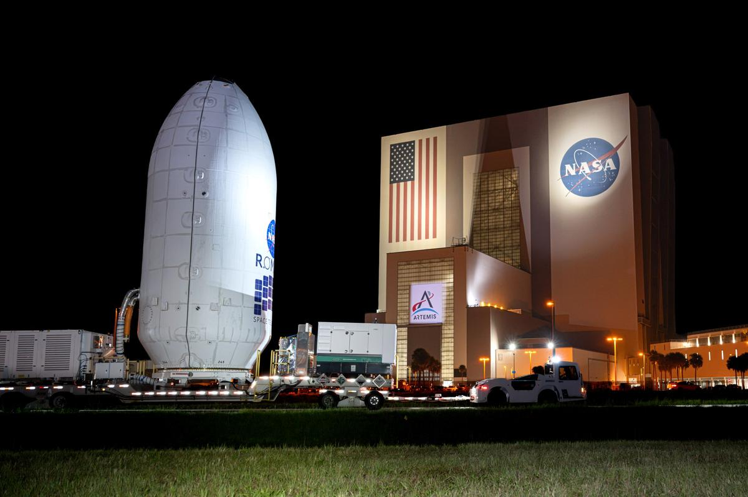
NASA/Sydney Rohde (Rocz) NASA's Nancy Grace Roman Space Telescope, encapsulated in its payload fairing, travels from the Payload Hazardous Servicing Facility to the SpaceX hangar at Launch Complex 39A at NASA's Kennedy Space Center on Tuesday, Aug. 25, 2026, ahead of mating to a SpaceX Falcon Heavy rocket. Roman's science instruments are designed to help researchers understand dark energy, the mysterious force accelerating the universe's expansion. The observatory also will map how galaxies form, cluster, and evolve by tracing the influence of dark matter. Liftoff from NASA Kennedy is targeted no earlier than Sunday, Aug. 30, 2026. Image credit: NASA/Sydney Rohde (Rocz)

36. NASA Johnson Pilots Chase Moon's Shadow for Eclipse Science
Read more
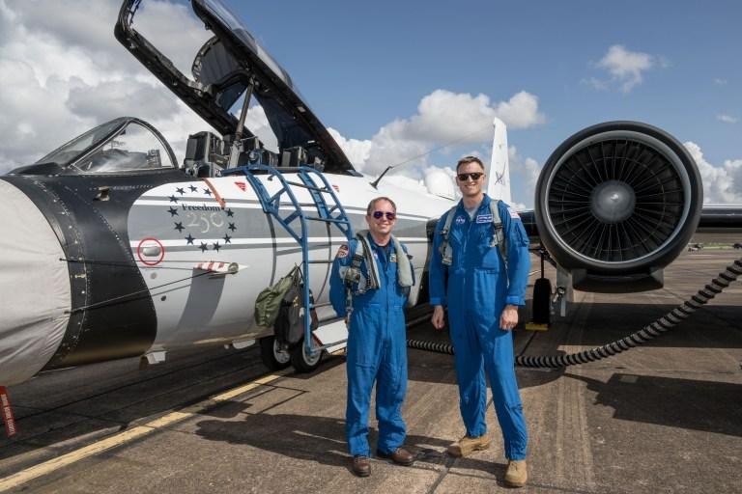
NASA's WB-57F aircraft prepares for takeoff from Ellington Field in Houston ahead of its mission to observe the Aug. 12, 2026, total solar eclipse from Iceland. From left are John Gustine, NASA WB-57F pilot, and Cary Klemm, sensor equipment operator for NASA's WB-57F. NASA/Robert Markowitz During the Aug. 12 total solar eclipse over Europe, scientists aimed to study a long-standing mystery: why the Sun's outer atmosphere, the corona, is far hotter than its visible surface. Capturing the data they needed meant being in exactly the right place at the right time. Pilots from NASA's Johnson Space Center flew the WB-57F high altitude research aircraft from Ellington Field in Houston to Iceland, their base for flying through the path of totality to give scientists a clearer view of the Sun's corona. A total solar eclipse provides a unique opportunity to examine the corona because the Moon temporarily blocks the Sun's bright surface, revealing its fainter outer atmosphere. Observations collected during this brief window can help scientists better understand how energy and material move through the corona and away from the Sun, improving our understanding of space weather. John Gustine, NASA WB-57F pilot, prepares for flight at Ellington Field in Houston ahead of the aircraft's departure for Iceland to support the Aug. 12 total solar eclipse. NASA/Robert Markowitz At about 50,000 feet, the WB-57F flew above most clouds, dust, and water vapor that can interfere with observations from the ground. The altitude reduced atmospheric interference while also allowing the science instruments to observe infrared wavelengths that are largely absorbed lower in Earth's atmosphere. Capturing those observations required careful coordination between scientists and the flight crew. Before the mission, teams calculated where the aircraft needed to be as the Moon's shadow moved across the North Atlantic. "Going into a mission like this takes a huge team. It starts with the science team establishing the requirements, and then we work closely with them for months leading up to the mission," said Tom Parent, NASA WB-57F pilot. "We rely heavily on our maintenance team to get the instruments serviced, prepared, loaded onto the aircraft, and flight tested. It's a huge team effort to get an aircraft like this up there to image and achieve these objectives." NASA's WB-57F aircraft takes off from Ellington Field in Houston ahead of its mission supporting the Aug. 12 total solar eclipse from Iceland. NASA/Robert Markowitz During totality, NASA WB-57F pilot John Gustine positioned the aircraft along the eclipse path to maximize time in the Moon's shadow and give scientists as much opportunity as possible to collect data. From the back seat, Cary Klemm, sensor equipment operator for NASA's WB-57F, controlled the camera systems, adjusting focus and exposure times while tracking features of interest throughout totality. With the cameras capturing observations throughout the brief window, every second mattered. "Every image is another piece of data that could reveal something new about the Sun," Klemm said. What scientists can learn from those observations reaches far beyond the eclipse itself. The Sun's corona is made of plasma shaped by magnetic fields, and many of the same physical processes occur elsewhere in the universe. "The NASA WB-57F's unique capabilities of high-altitude flight were truly crucial in providing access to these valuable wavelengths during an eclipse whose path crossed mostly over the ocean in an area where clouds are common," said Amir Caspi, principal investigator for the study at Southwest Research Institute in Boulder, Colorado. "We could not have achieved this success without this platform, and all of the efforts of the many intrepid ground, air, and science crew members." Members of NASA's WB-57F eclipse mission team gather at Ellington Field in Houston ahead of the aircraft's departure for Iceland. NASA/Robert Markowitz The data gathered during the flight will give scientists another opportunity to investigate the Sun and the processes that influence the space environment around Earth. View images and videos from NASA's eclipse mission.

37. NASA Sets Spacewalk for Station Maintenance, Live Coverage Planned
Read more
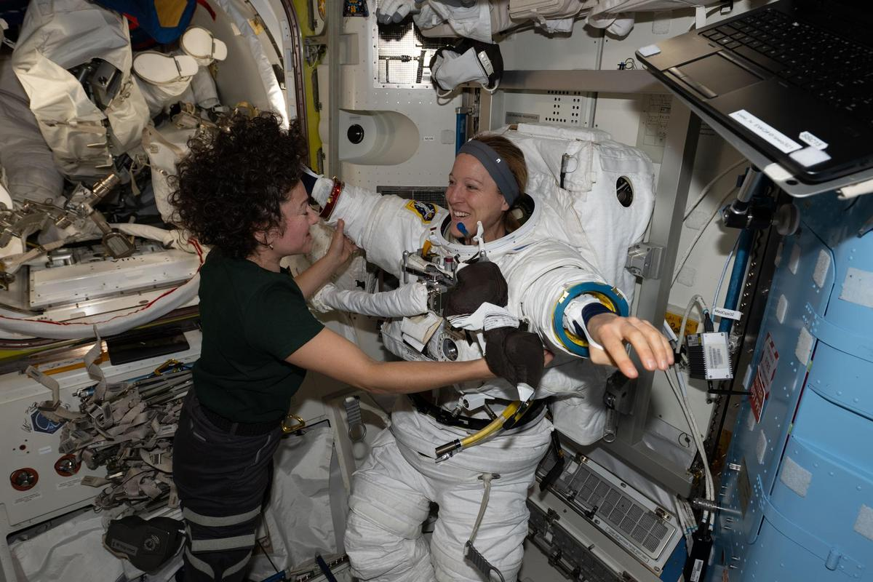
NASA astronaut Jessica Meir and ESA (European Space Agency) astronaut Sophie Adenot work together inside the International Space Station's Quest airlock during spacesuit fit and leak checks. Credit: NASA NASA will provide coverage as two astronauts step outside the International Space Station on Tuesday, Sept. 1, to replace a spacecraft navigational aid and complete several maintenance tasks in support of space station operations. Watch live coverage beginning at 7 a.m. EDT. The spacewalk is expected to start at approximately 8:30 a.m. and last about six and a half hours. NASA's spacewalk coverage will stream through a variety of platforms. Learn where to watch online: https://nasa.gov/live During U.S. spacewalk 99, NASA astronaut Jessica Meir and ESA (European Space Agency) astronaut Sophie Adenot will replace a retroreflector on the forward port of the space station's Harmony module to support spacecraft navigation during rendezvous and docking operations. After installing the reflector, the crew will work to install jumper cables for the data-relay systems, prepare the Alpha Magnetic Spectrometer's radiator for future maintenance, and replace a high-definition camera on the station's truss. Adenot will serve as spacewalk crew member 1 and will wear a suit with red stripes. Meir will serve as crew member 2 and will wear an unmarked suit. This will be Meir's seventh spacewalk and Adenot's third. Meir will move into third all-time for total spacewalks among women at NASA, trailing Peggy Whitson (10) and Suni Williams (9). The excursion also marks the 284th spacewalk supporting space station assembly, maintenance, and upgrades. To learn more about International Space Station research, operations, and its crews, visit: https://www.nasa.gov/station -end- Jimi Russell Headquarters, Washington 202-358-1100 james.j.russell@nasa.gov Sandra Jones / Anna Schneider Johnson Space Center, Houston 281-483-5111 sandra.p.jones@nasa.gov / anna.c.schneider@nasa.gov

38. NASA Begins Moon Mission Plume-Surface Interaction Tests
Read more
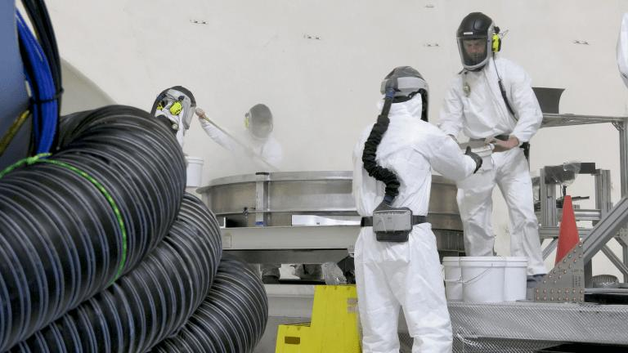
EDITOR'S NOTE: This story, originally published in December, was revised Aug. 26, 2026 with an update on a new phase of testing, including video from a recent test run and new images. To help NASA and commercial partners better understand the science of lunar landings, specifically the hazards that may occur when a lander's engine plumes blast away at lunar dust, soil, and rocks, a team at NASA's Langley Research Center in Hampton, Virginia, has initiated a series of plume-surface interaction tests inside a massive 60-foot spherical vacuum chamber. As NASA works to return humans to the Moon starting with Artemis IV in 2028 and develop a Moon Base, the tests will provide a trove of data for researchers to use to improve predictive models and influence the design of space hardware. "This plume-surface interaction ground test is the most complex test of its kind to be undertaken in a vacuum chamber," said Ashley Korzun, testing lead at NASA Langley. "If I'm in a spacecraft and I'm going to move all that regolith while landing, some of that's going to hit my lander. Some of it's going to go out toward other things - payloads, science experiments, eventually rovers and other assets. Understanding those physics is pivotal to ensuring crew safety and mission success." The campaign involves multiple NASA centers, academic institutions, and commercial entities both small and large. Korzun' s team will test two types of propulsion systems in the vacuum sphere. For the first round of tests, they are using an ethane plume simulation system designed by NASA's Stennis Space Center near Bay St. Louis, Mississippi, and built and operated by Purdue University. The ethane system generates a maximum of about 100 pounds of thrust - imagine the force necessary to lift or support a 100-pound person. It heats up but doesn't burn. The team recently began firing the system into a roughly six-and-a-half-foot diameter, one-foot-deep bin of simulated lunar regolith, called Black Point-1, that has jagged, cohesive properties similar to actual lunar regolith. A number of different instruments, including a version of the Stereo Cameras for Lunar Plume Surface Studies system that imaged the plume-surface interaction when Firefly's Blue Ghost Mission-1 landed on the Moon in 2025, are capturing data and imagery from the tests, which will only last about six seconds each. The instruments are measuring things such as crater formation, angle and height of the ejecta sheet, spatial distribution of solid ejecta, and the speed of the regolith particles as they get blasted out of the bin. A crew loads simulated lunar dirt into the test bin in the 60′ vacuum sphere. NASA/Rob Lorkiewicz Later this year, a second round of tests will involve a 14-inch, 3D-printed hybrid rocket motor developed at Utah State University in Logan, Utah, and tested at NASA's Marshall Space Flight Center in Huntsville, Alabama. It produces around 35 pounds of thrust, igniting both solid propellant and a stream of gaseous oxygen to create a hot, powerful stream of rocket exhaust, simulating a real rocket engine but at smaller scale for this test series. Researchers will test both propulsion systems at various heights. "It gives us a huge range of test conditions," Korzun said, "to be able to talk about spacecraft of all different kinds going to the Moon, and for us to understand what they're going to do as they land or try to take back off from the surface." Korzun sees this test campaign as more than a one-shot, Moon-specific thing. The entire operation is modular by design and also can prepare NASA for missions to Mars. The lunar regolith simulant can be replaced with a Mars simulant that's more like sand. Pieces of hardware and instrumentation can be unbolted and replaced to represent future Mars landers. Rather than take the vacuum sphere down to really low pressure like on the Moon, it can be adjusted to a pressure that simulates the atmosphere on the Red Planet. "Mars has always been in our road maps," Korzun said. But for now, the Moon looms large. Clockwise from left: Wesley Chambers, deputy principal investigator for the PSI tests from Marshall's Space Flight Center in Huntsville, Alabama; Ashley Korzun, test lead and principal investigator; Dave Lehotay, project manager; and Tylor Takahashi and Olivia Tyrrell, both from the SCALPSS instrument team, watch test footage in the control room. NASA/Rob Lorkiewicz "This test campaign is one of the most flight-relevant and highly instrumented plume-surface interaction test series NASA has ever conducted," said Daniel Stubbs, an engineer with the Human Landing Systems plume and aero environments team at NASA Marshall. "The data from these tests at NASA Langley will be critical in developing and validating models to predict the effects of plume-surface interaction for landing on the Moon and even Mars, ensuring mission success for the human landing systems and the safety of our astronauts." Through the Artemis program, NASA will send astronauts on increasingly complex missions to explore the Moon for scientific discovery, economic benefits, establish an enduring human presence on the lunar surface, and to build on our foundation for the first crewed missions to Mars. For more information about Artemis, visit: https://www.nasa.gov/artemis

39. Contractor to Civil Servant: NASA Welcomes Jeret Howard
Read more
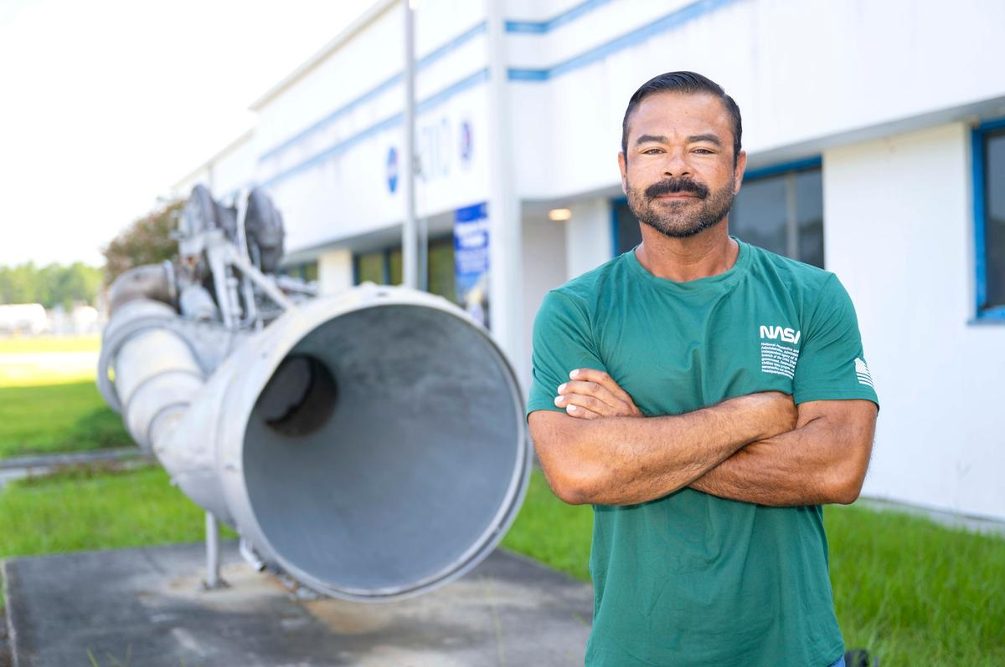
Jeret Howard, logistics management specialist at NASA's Stennis Space Center near Bay St. Louis, Mississippi, poses for a photograph on July 27, 2026. Howard is now a NASA civil servant at Stennis as part of the administrator's directive to strengthen technical core competencies within the civil service workforce. NASA/Danny Nowlin At 17, Jeret Howard raised his right hand to serve his country as a United States Army combat medic in Iraq. This past summer, he raised his right hand again at NASA's Stennis Space Center near Bay St. Louis, Mississippi. Hired as a civil servant under the agency's workforce directive to restore core competencies by converting contractors to civil service, Howard's transition from long-time contractor to logistics management specialist represents a continuation of a life dedicated to national service. He has worked for more than 15 years at America's largest rocket propulsion test site as a mechanical technician, turning wrenches and building test stand infrastructure as a contractor. Now, he steps into a NASA role that carries deep personal meaning. "It is absolutely a continuation of service," said Howard. "It is a point of pride to go from being a 17-year-old just wanting to serve your country to coming full circle like this, hoping to one day retire from NASA." As a logistics management specialist, Howard's job is to secure necessary hardware and components for propulsion testing. He relies on years of technical experience to anticipate the needs of the engineering team. As he secures essential materials, Howard ensures taxpayer dollars are wisely spent. Howard's expertise is not confined to a desk as he actively works alongside new technicians and supports testing across multiple areas, including the build up to support Blue Origin's testing at NASA Stennis. "Mechanical work is a challenge," said Howard. "Everything is a puzzle. Even when it seems like it is going to be monotonous, there is always something new that comes up. It is a skill, and once you do it so much over the years and get really good at it, you do not want to waste it." Howard's motivation for public service is rooted in his home. A resident of Kiln, Mississippi, Howard views his career as a chance to lead by example and make his family proud. "My little girl can look at me, be proud, and know she can do anything," said Howard. This resonates just as strongly with his teenage son, who dreams of one day becoming a NASA engineer. Even as his son navigates physical challenges, the family's focus is entirely on his limitless potential. "We push him to not think about what he cannot do, but to focus on how much he can do," said Howard. The family balances drive with a "work hard, play hard" lifestyle by spending their free time riding dirt bikes and taking their boat out on the water. The hard work is paying off at a time in history when NASA is returning humans to the Moon through the Artemis program and building a Moon Base as humanity's first lunar outpost where astronauts will live, work, and explore near the Moon's South Pole. The future of spaceflight is a shared family passion for the Howards. When the Artemis II mission launched last April, the family set up a large tablet outside next to their boat, using its heavy-duty sound system to amplify the broadcast. "My daughter could feel the bass of the launch," said Howard. "I got chills." As Howard's work supports NASA and the commercial companies conducting propulsion test work at Stennis, the family is already anticipating the launch of Artemis III, a mission intended to demonstrate integrated operations before Artemis IV returns astronauts to the lunar surface. Howard's transition to a civil servant means he has a direct role with NASA. His work contributes to securing American leadership in space today, while inspiring the next generation of engineers, such as his son, into the future. For more information about NASA's Stennis Space Center, visit: www.nasa.gov/stennis

40. From spy satellite to space telescope: The unlikely origins of NASA's Roman Space Telescope
Read more
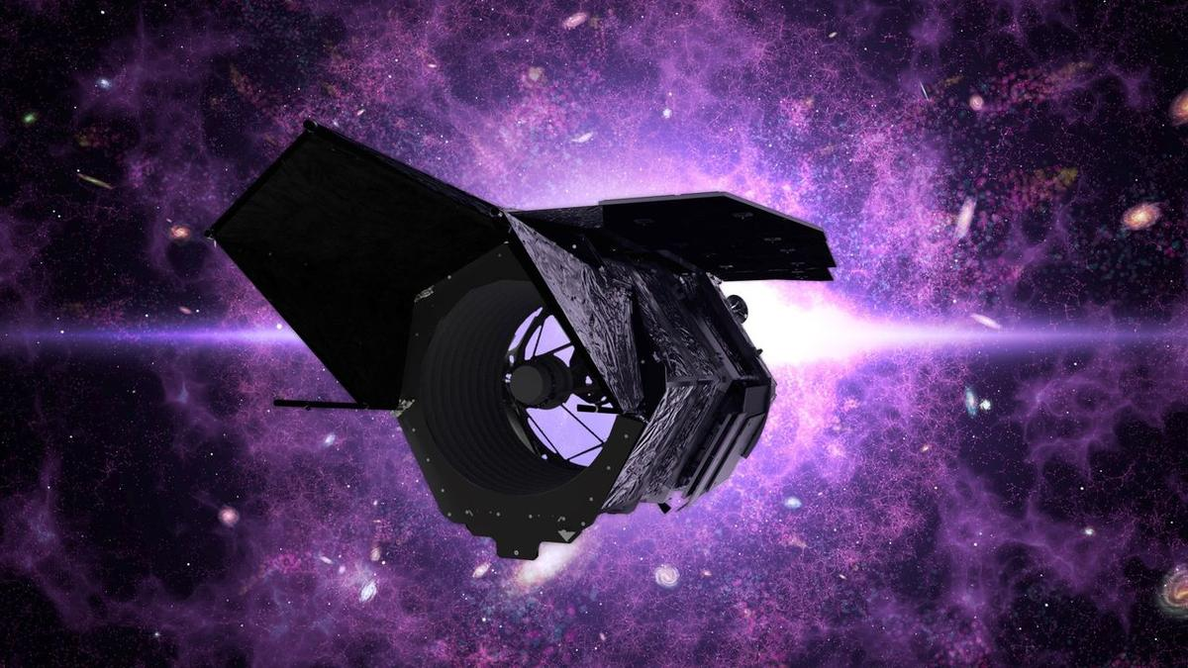
Click for next article NASA took the guts out of old spy satellites to build the groundbreaking Nancy Grace Roman Space Telescope - but how? And why? Years of hard work and anticipation are culminating as we sit on the verge of NASA's launch of its next-generation space telescope. Set to lift off this upcoming Sunday (Aug. 30) aboard a SpaceX Falcon Heavy rocket, the Roman Space Telescope will push astronomy into the future, exploring the mysteries of dark energy , studying far-off worlds and expanding our understanding of the universe around us. But to get to this point, NASA used some … unexpected technology. At the core of the observatory lies the Optical Telescope Assembly. This houses the telescope's primary mirror, its main mechanism through which it surveys the cosmos, nine additional mirrors, supporting structures and various sorts of electronics. But where did all of this tech come from? The National Reconnaissance Office (NRO), which builds spy equipment for U.S. agencies like the CIA. That's where. In 1999, the NRO stood up the multibillion-dollar "Future Imagery Architecture" program, which contracted out new spy satellites . The NRO contracted Boeing for the project, having the company design a whole suite of new optical and radar imaging reconnaissance satellites. They're basically spy satellites. In 2001, in a post-9/11 America, this effort continued to ramp up with national security concerns at an all-time-high. However, this flurry of spy satellite development was short-lived. And with billions of dollars in overrun costs from Boeing, the project closed in 2005. At the time, the New York Times called the program "perhaps the most spectacular and expensive failure in the 50-year history of American spy satellite projects." But one program's spectacular failure is another program's free space tech treasure. Years later, in 2012, the NRO donated two unused space telescopes from this program to NASA. With optics said to be similar to the Hubble Space Telescope 's, two free telescopes presented the agency with a tantalizing opportunity. This donation happened just a couple of years after Roman (then known as WFIRST) was originally proposed - and even though it would cost money to rework the hardware and build the rest of the space telescope out, this provided the possibility of a serious cost alleviation to the mission. After considering the possibility, the team decided it was the right call. And in 2011, years before Roman (WFIRST) was even formally designated as a mission by NASA, the agency announced that they would be reusing this spy satellite technology . This decision followed the 2010 National Academy of Science Astronomy and Astrophysics Decadal Survey, which pointed to Roman as its highest priority. While this donated spy satellite part came with top-tier optics , it was also free. The most recent space telescope to launch was the James Webb Space Telescope (JWST), which lifted off in 2018 but was in development since the mid-1990s. The JWST garnered significant public attention and scrutiny for being both well behind schedule and way over budget, ultimately costing a whopping $10 billion. Scientists working on the Roman Space Telescope. (Image credit: NASA/Sophia Roberts) As the JWST was grappling with these budget issues, Roman was already in development. So, it's not a shock that when a high-tech space telescope landed on their doorstep, NASA took full advantage of the opportunity, though the Roman team would still have to replace the electronics in the telescopes that the NRO removed. Thus, in the end, did the NRO telescopes actually save NASA money? It's not clear. Each donated telescope was said to be worth at least $250 million , but experts at the time of development were torn in their estimates for whether repurposing this old hardware would actually save or eat up costs in the end. A few quirks also came with the free hardware. In addition to having to replace the electronics and rework a telescope someone else built, the Roman team had to learn about the telescope with some, well, restrictions. When the details about the telescopes were given to the mission team, there were large chunks of information fully blacked out, the Washington Post reported at the time. But while the Roman team was handed something quite strange to work with, the mission has remained about as on schedule and on budget as we've seen with a space telescope of this magnitude. NASA still has the second telescope from the NRO, though the agency has not said what they might do with the equipment. However strange and unexpected this series of events may have been, it did result in a completed space telescope that now sits at the launch site, ready to uncover the mysteries of the universe. Join us this upcoming Sunday (Aug. 30) to see a telescope made with spy satellite tech travel beyond our planet.

41. Chance gaze at old Hubble Telescope image leads to discovery that could reveal dark matter's secrets
Read more
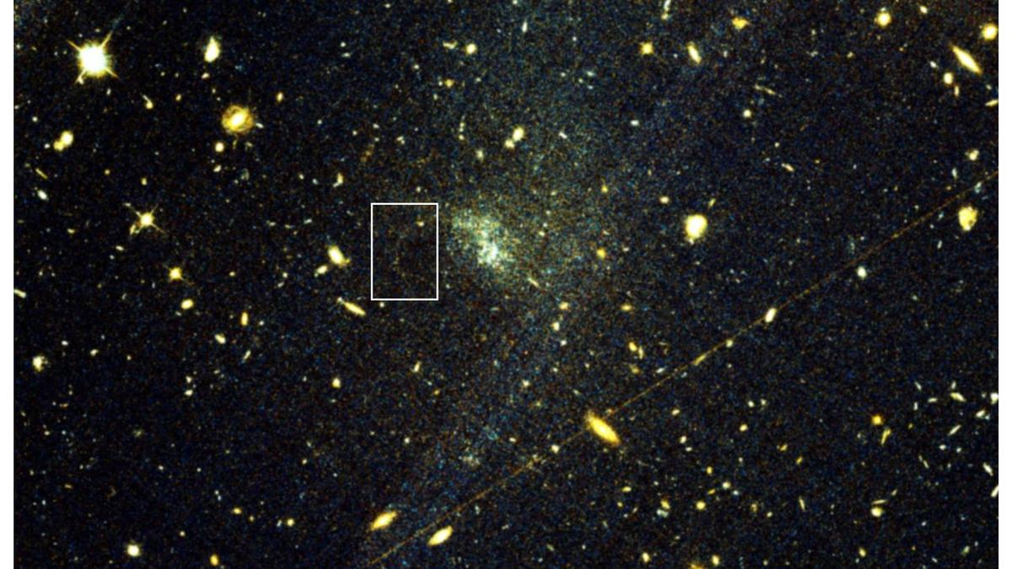
Click for next article In late June 2023, on a morning train commuting to work in New York City, David Hendel was scrolling through a recent astronomy paper on his phone when a half-page image caught his eye. The image, captured a year earlier by the Hubble Space Telescope , showed UGC 9050-Dw1, a dwarf galaxy some 115 million light-years from Earth . It appeared as little more than a faint, diffuse smudge of bluish-white light that astronomers call an ultra-diffuse galaxy - a type of galaxy so sparsely populated with stars that most of its mass is thought to be dark matter , the invisible substance that makes up more than 80% of the matter in the universe but has yet to be directly detected. What made Hendel pause was not the galaxy itself but a thin, fragile ribbon of stars trailing off from it, so dim it nearly disappeared among the other smudges of light crowding the frame. Hendel, a former astronomer who had studied thousands of similar structures, immediately recognized the subtle interplay of the arc's features, including the shared color of the stars and their curved trajectory pointing toward a tiny, matching bright knot along its track. Together, those clues matched a stellar stream tearing from a tight ball of stars called a globular cluster, pulled apart by the gravity of UGC 9050-Dw1. If Hendel's reading was correct, it would be the first such stream ever found outside the Milky Way . "It almost seemed too good to be true," Hendel told Space.com. "At this point I felt the excitement of a discovery to such a degree that I recall looking up and around the train for someone to tell!" This discovery would give researchers a pristine new laboratory for probing dark matter, and one far less contaminated by competing astrophysical forces that muddy similar searches within our own galaxy . Hendel, who now works in finance but still follows research from his former field, ran a quick literature search to see whether anyone had already documented the feature. No one had. The right person to tell was not on the train, of course. Before reaching his stop, Hendel took a screenshot, sketched a rough circle around the arc and sent it to Sarah Pearson, an associate professor of astrophysics at Technical University of Denmark's DTU Space, and his friend since their graduate school days at Columbia University. That message kicked off the collaborative effort that would ultimately confirm the find, led by Pearson and Julie Kiel Holm, a Ph.D. student at the Niels Bohr Institute at Denmark's University of Copenhagen. The team's paper gives the stream the name Oyashio (pronounced "oh-yah-shee-oh"), Japanese for a cold Pacific current, following a tradition of naming these faint stellar trails after bodies of water in Indigenous languages to honor cultures worldwide with long astronomical traditions, including in Australia, Chile and India. An image of the Hubble Space Telescope. (Image credit: NASA) Within the Milky Way, astronomers have so far identified roughly 100 stellar stream candidates shed by globular clusters, but finding one around another galaxy is extraordinarily rare. Streams that form when a whole dwarf galaxy is torn apart are relatively easy to spot, since they emerge in the sparse outskirts of a larger galaxy. But globular cluster streams form deep inside their host galaxy, where they are washed out by brighter, more crowded starlight. Oyashio's detection was possible in part because UGC 9050-Dw1's already-sparse stellar population meant a dimmer backdrop gave the stream just enough contrast to be seen, Holm told Space.com. Oyashio's discovery is "a very exciting step forward," Emily Cunningham, an assistant professor at Boston University who studies stellar streams and dark matter halos and was not involved in the new study, told Space.com. "Using techniques like those described in this paper, we will detect many more streams around other galaxies with upcoming observations from facilities such as the Vera Rubin Observatory and the Nancy Grace Roman Space Telescope." A sufficiently large catalog of such streams in different galactic environments would allow them to tease out the subtler perturbations that dark matter is predicted to cause at the smallest scales, the researchers say. "This is one of the most promising avenues for new astrophysical constraints on dark matter's nature," said Hendel. No Eureka! moment UGC 9050-Dw1 was first identified in 2017 in images taken by the Canada-France-Hawaii Telescope atop Mauna Kea in Hawaii, as part of a survey for diffuse dwarf galaxies. A follow-up study in 2023, drawing on the same Hubble images in which Hendel later spotted Oyashio, catalogued an "exceptionally high" population of globular clusters near the galaxy. Its authors concluded that UGC 9050-Dw1 likely formed from the merger of two comparably sized galaxies roughly 10 billion years ago, one gentle enough that gas from both survived and ignited a burst of star formation, which would also explain the clusters' uniform color. That 2023 study did not flag Oyashio. In the new study, Holm and her colleagues recovered Oyashio independently in archival data from both Hubble and the Canada-France-Hawaii Telescope, ruling out the possibility that it was an artifact of telescope imaging or subsequent data processing. The team then ran thousands of simulations, testing which combinations of globular cluster properties and dark matter distributions could reproduce the stream's observed brightness and shape. The best-fitting models produced new estimates of the UGC 9050-Dw1's total mass and how that mass is spread throughout it, suggesting the galaxy harbors far more dark matter than its sparse stellar population would imply, consistent with expectations for such a diffuse galaxy. A ring of dark matter (seen by the Hubble Space Telescope in false color), its location inferred from its gravity, around the galaxy cluster ZwCl0024+1652, which is 5 billion light-years away. (Image credit: NASA/ESA/M. Jee and H. Ford (Johns Hopkins University).) In the study, the team also weighs a range of alternative explanations and lays out why none quite fit the evidence. The arc could be, for instance, a chance alignment of unrelated stars, the product of gravitational lensing from a background galaxy, or a dusty region that happens to mimic a stream's shape. None of those scenarios, the team says, accounts on its own for the key pieces of evidence, chiefly the stars' consistent color, their alignment along a single curved track and that track's connection to what appears to be the globular cluster progenitor. "It was an interesting process in the sense that there wasn't a specific moment where we're like, 'Okay, now we know what it is,'" Holm told Space.com. "We started with the assumption that just by looking at it, it looks like it could be something. How many different ways can we try to prove that it can't be?" Still, in the interest of rigor, the team acknowledges it cannot fully exclude every alternative explanation. "There's still the possibility that some stars just randomly fall in this pattern," said Holm, "But again ... for all these things to line up as nicely as they do would require a lot of coincidence." Dark matter clues The payoff of that caution lies in what Oyashio can reveal about the universe's invisible scaffolding. As a globular cluster is shredded over billions of years, the stars it sheds fan out along its former orbit rather than scattering randomly, preserving, in effect, a pristine record of the gravitational forces that shaped them. If a clump of dark matter too small to host stars of its own - a "subhalo," in the language of cold dark matter theory - passes through that stream, its gravity can tug stream stars off course and carve out a gap. "Streams that form from globular clusters are particularly sensitive to these perturbations," said Cunningham. The challenge lies in isolating the cause, and one stream is not enough to draw firm conclusions about the astrophysical process responsible. Inside the Milky Way, any disturbance in a stream of stars could just as easily come from the galaxy's central bar of stars or from nearby dwarf galaxies falling into the Milky Way, like the Magellanic Clouds. UGC 9050-Dw1 has none of those features, so any gap found in Oyashio would stand as a more confident signature of dark matter at work, Holm said. "If a gap is observed in a single stream, it is very difficult to say for certain which astrophysical process is responsible," said Cunningham. "However, if we can build up a sufficiently large sample of streams in different galactic environments, we can start to disentangle these effects." "To do this, we need to look beyond the Milky Way," she added. New instruments coming online could help do just that. Astronomers are particularly excited for the launch of the Nancy Grace Roman Space Telescope , scheduled for launch Aug. 30 from the Kennedy Space Center in Florida, which has a field of view at least 100 times larger than Hubble's. In its five-year primary mission, with a possible five-year extension, Roman is expected to measure light from a billion galaxies, according to NASA . "You would be able to do this kind of research in different galaxies at once with the same exposure, basically," said Holm. She hopes Roman, along with the European Space Agency's Euclid space telescope, which launched in 2023, will turn up more galaxies like Oyashio, "so we can start to put together a more generalized image of how these things work and what they can tell us." Some of those discoveries could even come to light the way Oyashio did, as a product of pure scientific curiosity applied to data already sitting in an archive. Hendel said he read the 2023 paper mostly because he was intrigued by the team's conclusion that UGC 9050-Dw1 likely formed through a dwarf galaxy merger. "I had no aim when opening it except to satisfy my curiosity," he said. That he was able to spot a rare feature hiding inside an image collected for a completely different research project speaks to the value of the scientific community's long-standing practice of making data publicly available, Holm said. "Anyone can come along with another idea and actually find something also interesting with the same data that you didn't know was hiding in it," said Holm. "I think that's also a really cool part of this."

42. SpaceX's final Falcon 9 Starlink launch from Florida creates gorgeous 'jellyfish' over New York City (video)
Read more

Click for next article SpaceX's launch from Florida early this morning (Aug. 25) was memorable in more ways than one. The mission, which sent 29 Starlink internet satellites skyward from Cape Canaveral Space Force Station at 5:33 a.m. EDT (0933 GMT), was the 100th flight of 2026 for SpaceX's workhorse Falcon 9 rocket. It was also the 37th flight for this particular vehicle's first stage, setting a new reuse record for the company. And we learned a few hours after liftoff that it was also the last-ever Falcon 9 Starlink mission to fly from the Sunshine State. A SpaceX Falcon 9 rocket on the Starlink Group 10-49 mission passes by lower Manhattan and One World Trade Center just before dawn in New York City after launching from Cape Canaveral, Florida on Aug. 25, 2026, as seen from Hoboken, New Jersey. (Image credit: Getty Images) "From here on, Starlink missions out of Florida will fly on Starship . The West Coast team will continue regularly launching Starlink from Vandenberg [Space Force Base in California]," Kiko Dontchev, SpaceX vice president of launch, said via X this morning. "In the last seven years, Falcon has flown ~260 Starlink missions from the Cape … can't wait until we launch that and many more with Starship!" he added. Starship, which stands more than 400 feet (122 meters) tall, is the biggest and most powerful rocket ever built, and it's designed to be fully and rapidly reusable. Starship remains in the testing phase; SpaceX has conducted 13 test flights with the vehicle to date, all of them suborbital. Starship currently launches only from SpaceX's Starbase site in South Texas. But the company is already building pads for the giant rocket in Florida, and it announced today that it plans to break ground next year on Starbase Louisiana, which it says will be able to support thousands of Starship liftoffs per year. SpaceX thinks Starship will revolutionize spaceflight when it comes online. The company plans to phase out the Falcon 9 and its heavy-lift cousin, the Falcon Heavy , after that happens, so the final Falcon 9 Starlink launch from the West Coast may be coming relatively soon as well. The SpaceX Falcon 9 rocket launched from Florida with a batch of Starlink satellite onboard, passing by above New York City at 5:38 am ET. pic.twitter.com/Y8kYykAQK8August 25, 2026 The Falcon 9 made quite an impression on skywatchers during this morning's Starlink swan song from the Space Coast, creating a "jellyfish" in the sky visible to folks as far away as New York City. Indeed, some people in the Big Apple posted video of the Falcon 9 cruising over the city's famous skyline . The jellyfish effect is a regular feature of Falcon 9 missions that launch shortly before dawn or not long after dusk. During these windows, sunlight illuminates the rocket's expanding exhaust plume while the sky itself remains mostly dark. The buildout of the Starlink megaconstellation has driven Falcon 9's launch cadence to record highs over the past few years. In 2024 and 2025, for example, the rocket lifted off a total of 297 times, and 211 of those were Starlink flights. Seventy-seven of the 100 Falcon 9 launches this year have been Starlink missions.
43. Uttarakhand sets up helplines after Nepal disaster
Read more

PIONEER EDGE NEWS SERVICE / Dehradun The Uttarakhand government has issued 24×7 helpline numbers for people in Dehradun and other parts of the State after a devastating flood reportedly killed hundreds of people in the nation bordering the State. The flood in Nepal's Rasuwa and Nuwakot districts supposedly after a glacial lake burst affected normal life and tourism activities in the border areas. The helplines have been issued to provide information and assistance to citizens, district administration said. The flood situation was reported in the Bhotekoshi and Trishuli rivers in Nepal on the morning of August 26. The incident took place in areas close to the Uttarakhand region, raising concerns among people who may have relatives, contacts or travel plans in the affected areas. Based on what is known so far, many Indian nationals are reported missing, especially those undertaking the pilgrimage to Kailash Mansarovar from the Nepal route. Apart from this, many from Uttarakhand frequently travel to Nepal and even Tibet from travel, trade and other activities. The status of those from Uttarakhand who may have been affected by this disaster is yet to be ascertained officially by the State government. The Uttarakhand government has issued five helpline numbers for information and assistance. People can contact 0135-2710334, 0135-2710335, 0135-2664314, 0135-2664315 and 0135-2664316. A mobile number, 8218877005, and toll-free number 1070 have also been issued. For Dehradun district, residents can contact 0135-2726066 and 0135-2626066. The district administration has also provided mobile number 7534826066 and toll-free number 1077.

44. Isro to return to launchpad with Gisat-1A; lift-off likely on Sept 4 - The Times of India
Read more
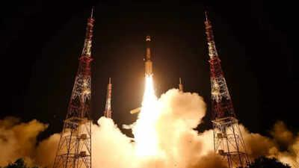
Isro to return to launchpad with Gisat-1A; lift-off likely on Sept 4 The Times of India

45. Space Beyond ISRO - Daily Excelsior
Read more
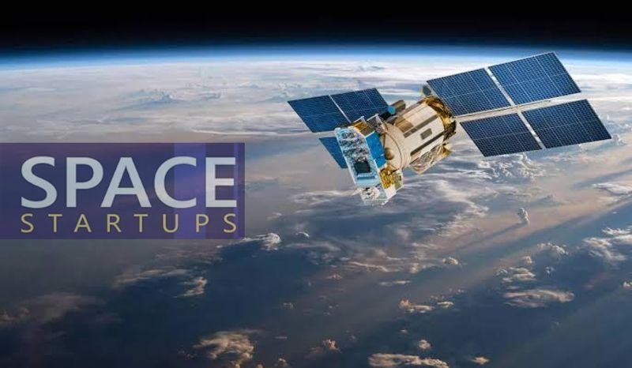
The global space race is being rewritten at a pace few could have imagined a decade ago. Space exploration is no longer the exclusive preserve of Governments and national agencies; it is being reshaped by private enterprise, commercial capital and... The global space race is being rewritten at a pace few could have imagined a decade ago. Space exploration is no longer the exclusive preserve of Governments and national agencies; it is being reshaped by private enterprise, commercial capital and rapid technological innovation. Prime Minister Narendra Modi's call, made during his interaction with the founders of 20 space startups on National Space Day, for India to build a global "aura" around its private space sector, comes at precisely the right moment. The next phase of India's space journey must rest not merely on national prestige but on a genuine commercial space ecosystem capable of taking on the world's best. Nowhere is this transformation more visible than in the United States, where NASA no longer holds anything resembling a monopoly over access to space. Private companies have become dominant forces in launch technology, satellite systems, reusable rockets and space-based communications. Elon Musk's SpaceX has redefined what private enterprise can achieve beyond the atmosphere. The lesson is unambiguous: the future of space will belong as much to nimble companies as to traditional state agencies. This matters because space technology is quietly becoming the backbone of everyday life. Satellites already underpin navigation, broadcasting, disaster response, weather forecasting and strategic communication. The next major leap is wireless, satellite-delivered connectivity that reduces reliance on the vast physical cabling networks stretching across lakhs of kilometres today. Starlink has demonstrated that high-speed connectivity can be beamed from orbit, particularly to remote or difficult terrain where laying conventional infrastructure is costly or simply impractical. The applications reach well beyond communication. Agriculture, arguably India's most vital sector, stands to gain enormously. Satellite imagery and weather data can help farmers track crop health, assess soil and moisture conditions, and anticipate adverse weather before it strikes. Better forecasting of rainfall and extreme weather events can sharpen agricultural planning and cut losses, while space-based data can equally support livestock and dairy management, environmental monitoring, water conservation and disaster preparedness - a point Modi himself urged the startup founders to explore further. India embarks on this new era with a solid foundation of strength. ISRO has repeatedly shown that extraordinary achievement does not require extravagant spending; its reputation for delivering ambitious missions at remarkably low cost has earned global respect. Chandrayaan-3's successful lunar landing, commemorated each year on National Space Day, proved beyond doubt India's technological maturity and its capacity for missions of global significance. But Government achievement alone cannot sustain leadership in an increasingly commercial space economy. ISRO has laid the foundation; the logical next step is to hand a substantial part of the baton to private enterprise - not by diminishing ISRO's role, which must continue to anchor frontier research and strategic missions, but by allowing private players to bring the speed, capital, commercial discipline and appetite for risk that Government institutions cannot always match. The early signs are genuinely encouraging. Skyroot Aerospace, India's first space-tech unicorn, has already flown the country's first privately built rocket into orbit, and its founders speak of scaling from one launch a month to one a week and eventually several a day. Alongside it, a growing cluster of firms - spanning launch services, satellites, earth observation and space situational awareness - is beginning to attract serious investment and international contracts, one startup reportedly securing eight launch contracts within a month of its debut flight. India's deepest asset remains its scientific and engineering talent, and there is now a real opportunity to draw back Indian-origin professionals who built careers abroad. Unlike the more structured recruitment pathways of public institutions, private companies can hire laterally, reward niche expertise and assemble multidisciplinary teams quickly - a flexibility that could prove decisive in the global contest for talent. None of this works, however, without policy stability. Investors committing large sums to rockets and satellites need confidence that rules will not shift arbitrarily, and the Prime Minister's own emphasis on consistency and trust is well placed. A predictable regulatory environment and reliable access to infrastructure will do more to unlock entrepreneurial risk-taking than any amount of rhetoric. India has proven scientific capability, cost competitiveness, deep talent and a maturing entrepreneurial culture. The space juggernaut has begun to move.

46. Public base, private launchpad - The New Indian Express
Read more
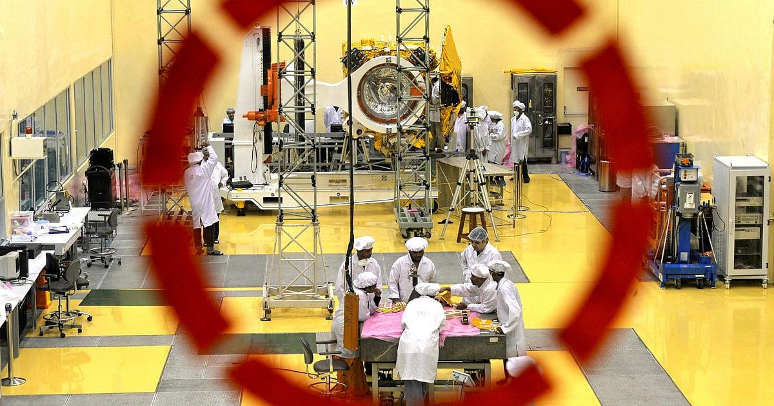
On August 23, Prime Minister Narendra Modi celebrated India's third National Space Day, observed to mark the landing of Chandrayaan-3 near the lunar south pole, during an interaction in New Delhi with the CEOs and founders of 20 Indian space startups. Calling for a private-sector environment to magnetise global talent, investments and companies, he challenged private companies to create thousands of startups within the next five years and increase launch capacity from less than 10 a year at present to 50 rockets from 2029 onwards. The 2026 celebrations were held under the theme 'Towards Viksit Bharat: Innovating, Collaborating and Aspiring to Global Space Leadership'. What seems grandiose is not the ambition-the Modi government has never lacked in esprit-but that the PM said it not at the beating heart of India's space programme, the Indian Space Research Organisation headquartered at Bengaluru, but in front of major private-sector honchos and startup founders in the country's capital, where policy decisions are made. What remained unuttered was the Indian government's latest decision to relegate Isro to a role highlighted in its name: research and research alone. As I had hazarded might happen in my previous column, Isro has been divested of all rocket production and launches, which have been handed over to the private sector. It has begun transferring the production rights and technology of rockets-beginning with the SSLV (small satellite launch vehicle) to Hindustan Aeronautics, and the PSLV (polar satellite launch vehicle) and LVM3 (launch vehicle mark-3)-the erstwhile geosynchronous satellite launch vehicle mark III, India's most powerful operational heavy-lift vehicle-to private domestic industry. Equally to the point, unlike with the SSLV process, public sector units will not be allowed-please note the finality-to participate in the transfer process, leaving the private sector entirely in charge. The 'private domestic industry' bit appears to be for public consumption. For the government announced that it has "liberalised" the "foreign direct investment policy for the space sector" in order "to make it more investor-friendly". How friendly is the pointer to the level of domestication: the government has updated its FDI guidelines to allow up to 49 percent through the automatic route in launch vehicles and spaceports, 74 percent in satellite manufacturing, and 100 percent in component manufacturing.

47. James Webb Space Telescope observes 72 stars and finds planet formation is a race against time
Read more
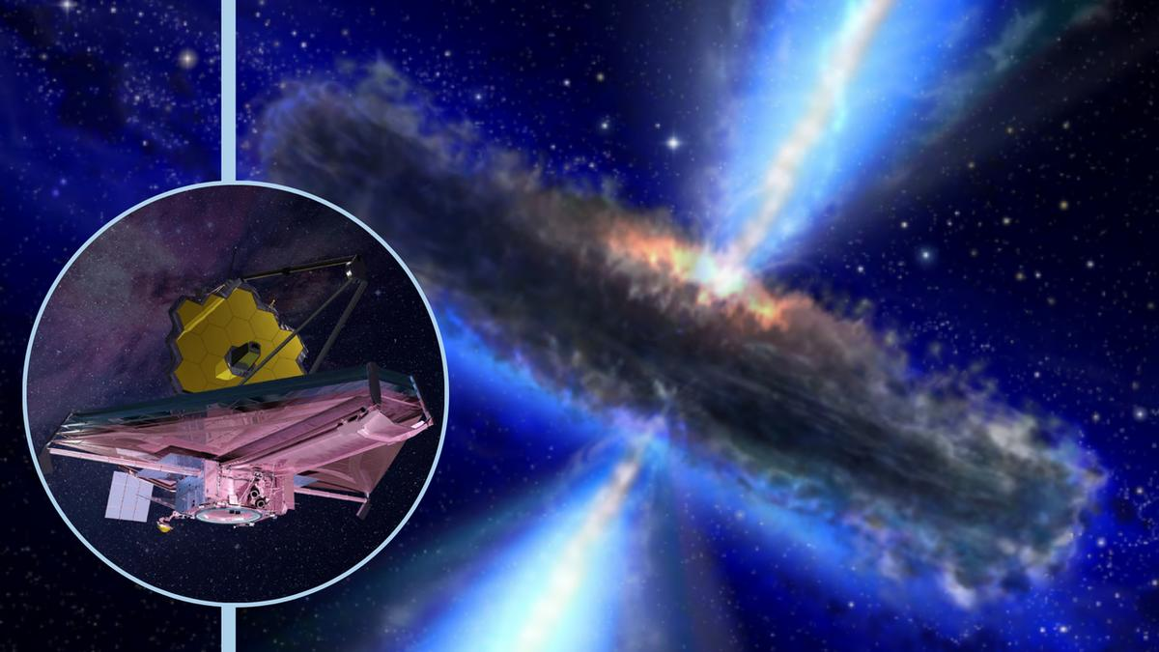
Click for next article Using the James Webb Space Telescope (JWST), astronomers have studied 72 young, sun-like stars. As a result, they found that forming planets is a real race against time. This is because the material that serves as the building blocks for planets is constantly escaping the swirling platters of gas and dust, or protoplanetary disks , that wrap around infant stars. Some types of planets may find their formation window closing sooner than others. The team's research represents the most in-depth investigation yet into how matter escapes these protoplanetary disks and how this escape gives rise to different stages of planet formation around sun-like stars. All in all, the study helps paint a better picture of how and why our solar system took the shape it did around the infant sun around 4.6 billion years ago. "Gas giants like Jupiter must assemble their massive atmospheres while the disk is still substantial enough to supply them, before winds and jets carry that raw material away into space," team leader Naman Bajaj from the University of Arizona said in a statement . An ill wind blows around infant stars The team conducted its research using data collected by the JWST's Mid-Infrared Instrument (MIRI) . The scientists tracked matter loss by following the movements of molecular hydrogen, one of the most common molecules in protoplanetary disks. Each of the stars involved in the investigation represented a different stage in the early life of a star system. That meant putting these snapshots together allowed the researchers to create a "movie" detailing the early life of a planetary system. One of the most important findings of this approach is the mechanisms for material loss from protoplanetary disks seem to evolve and switch dominance as an infant star ages. This is important because gas giants like Jupiter and Saturn have vast atmospheres. They thus require more raw material to form than smaller rocky worlds like Earth do. Understanding matter loss allows scientists to determine at what stages of protoplanetary disk evolution gas giants can form. "What is exciting about this study is that we can now see, across a large sample of young systems, how the mechanisms that remove gas from planet-forming disks change with time," team member Uma Gorti from the SETI Institute said in the statement. "Disk dispersal sets a fundamental clock for planet formation: once the gas is gone, the opportunity to build gas-rich planets is essentially over." An illustration of an evolved protoplanetary disk in which material close to the infant star has been dispersed (Image credit: NASA/ JPL-Caltech/ T. Pyle (SSC)) The researchers found that early in the evolution of protoplanetary disks, powerful, magnetically driven jets and winds dominate mass loss. These jets and winds are powered by magnetic fields that weave through protoplanetary disks. Later, as the disk thins and starlight can pass through it more easily, these winds and jets weaken, and magnetic processes are dominated by high-energy radiation from the infant star ionizing gas and blowing it into space. The latter process is called photoevaporation . All this reveals there is no one single process responsible for stripping planet-forming material from around infant stars. The research also demonstrates the JWST is more than capable of studying the dispersal of gas and dust around individual infant stars. The next step for the team is to discover just how much material these different mechanisms shift. The scientists could also look into the areas of the disks in which the mechanisms studied operate. Down the line, this will help develop a model to reveal just how rapidly planet-formation is shut off - and in which regions of a protoplanetary disk different types of planets are most likely to form.

48. Astronaut Jonny Kim leaves NASA, will return to active military duty
Read more
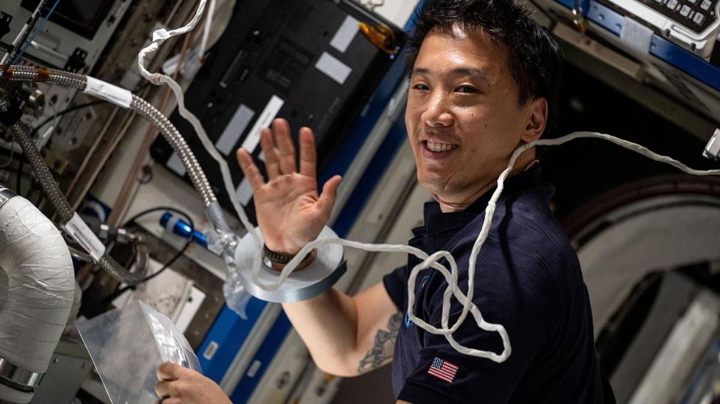
Click for next article Former NASA astronaut and Expedition 73 Flight Engineer Jonny Kim services an experimental carbon dioxide removal device aboard the International Space Station in May 2025. Jonny Kim is leaving NASA to continue his military career. The 42-year-old astronaut, who has one of the most jaw-dropping resumes of any person alive, is departing today (Aug. 27) after nine years with the agency. He has one mission under his belt, a long-duration flight to the International Space Station (ISS). "Jonny has been an integral part of the agency, and his immeasurable impact will be felt for generations to come," Vanessa Wyche, director of NASA's Johnson Space Center (JSC) in Houston, said in a statement today . "From advancing groundbreaking science to inspiring the next generation, Jonny has been an incredible source of inspiration to our nation. His exceptional talent, determination, and grit will leave a lasting legacy at NASA." NASA picked Kim as part of its 2017 astronaut class, the 22nd in the agency's history. He and his 11 fellow selectees nicknamed themselves "The Turtles." Kim was already incredibly accomplished before he got the NASA nod. He's a physician with a medical degree from Harvard. He served in the U.S. military, as a dual-designated naval aviator and flight surgeon as well as a Navy SEAL - a commando trained to conduct special operations on sea, air and land (hence the acronymic name). "Over the course of more than 100 combat operations, he served as a medic, sniper, navigator and point man, earning the Silver Star, Bronze Star with Combat 'V,' and numerous additional commendations," NASA officials said in the same statement. After completing his mandatory two years of NASA astronaut training, Kim served as a CAPCOM ("capsule communicator") at JSC, relaying information between Mission Control and crewmembers on the ISS. "Kim also contributed to Artemis program development through his work in the astronaut exploration branch, leading the astronaut crew operations branch, and serving as increment lead for Expedition 65," NASA officials said in the same statement. "His experiences as a Navy SEAL, physician and naval aviator provided unique perspectives in mission operations and crew support." In April 2025, Kim got the chance to go to space himself. He launched to the ISS aboard a Russian Soyuz spacecraft along with Russian cosmonauts Sergey Ryzhikov and Alexey Zubritsky. The trio lived and worked in space for 245 days, circling Earth 3,920 times and traveling a total of nearly 104 million miles (167 million kilometers), according to NASA. During that time, Kim conducted a variety of scientific experiments that could advance technological development and aid space exploration down the road. Kim, Ryzhikov and Zubritsky returned to Earth in December , touching down in their Soyuz on the steppe of Kazakhstan . Kim isn't walking off into the sunset now. Far from it: He's going back to active duty, "to finish out the remainder of his military career within naval aviation training," according to NASA. "Contributing to space exploration and serving NASA has been the honor of a lifetime," Kim said in the same NASA statement. "Throughout my career, I've learned that beyond the missions, the training, and the hardware, success always comes down to the people," he added. "They are our greatest asset, and leading with love and empathy is how we achieve the impossible. I look forward to carrying my commitment to service, my enduring love for space and technology, and the hard-earned lessons of this past decade into my next chapter to make a meaningful impact on humanity's future."

49. After failure of private rescue mission, NASA's Swift space telescope will crash back to Earth. But when and where?
Read more
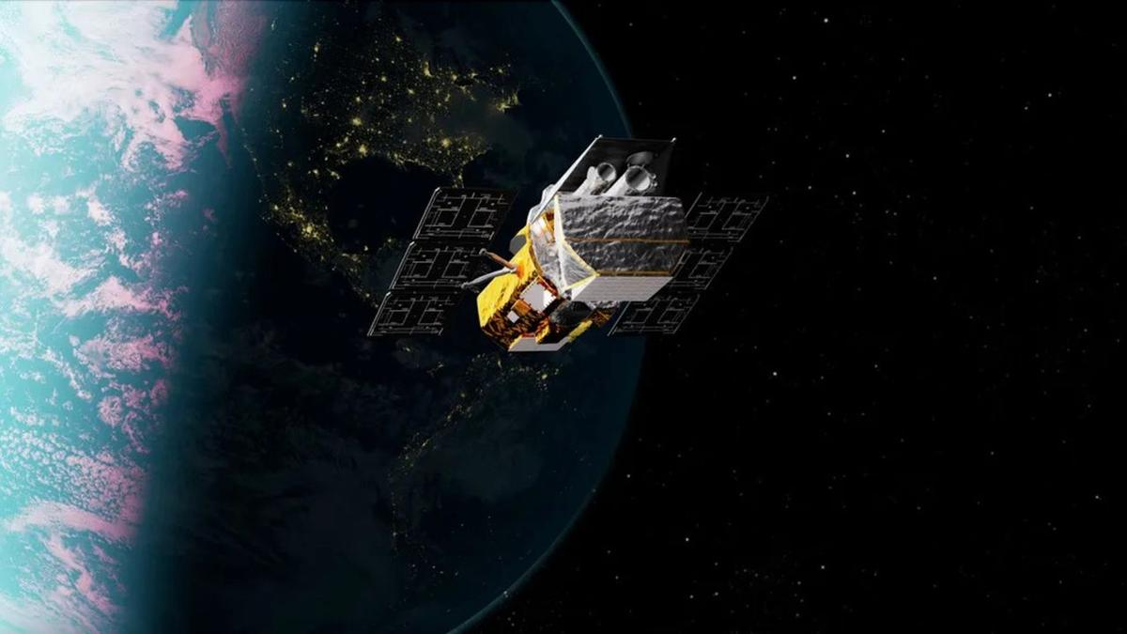
Click for next article Artist's illlustration of NASA's Neil Gehrels Swift Observatory, which launched to Earth orbit in November 2004 and will soon fall out of space. A private spacecraft failed to rescue NASA's Swift space telescope, meaning the big observatory will come crashing back to Earth in the near future. The Neil Gehrels Swift Observatory launched to Earth orbit in November 2004. Over the past two decades, it studied gamma-ray bursts - the most powerful explosions in the universe - and other cosmic objects and events using a trio of telescopes. But Swift's science work is now done, and its days in orbit are numbered. Call to action In September 2025, NASA put out a call to action to save Swift, whose orbit was decaying quickly due to high solar activity. The bottom line: The observatory needed a boost to a higher orbit soon, or it would be dragged down to its death in Earth's atmosphere . The Arizona-based company Katalyst Space Technologies answered that call, and won a $30 million NASA contract to perform the re-boost. In hurry-and-scurry mode, Katalyst built a robotic spacecraft called LINK, which launched on July 3 to meet up with Swift and haul it to a higher orbit. But LINK suffered attitude-control issues after launch, causing NASA and Katalyst to wave off the rescue attempt . Artist's illustration of Katalyst Space Technologies' LINK spacecraft meeting up with NASA's Swift space telescope in orbit. This did not happen, however; LINK suffered issues after launch and was unable to pull of the rendezvous. (Image credit: NASA) Timeline troubles Ghonhee Lee is the CEO of Katalyst Space Technologies. Speaking to CNN News Central on Aug. 24, Lee said: "You know, this is not the outcome that we wanted, but I think it's very important to recognize the unprecedented scale. This was an ambitious, high-risk, high-reward mission where we designed, built and launched a space robot within nine months." Lee said that the timeline worked against the group. "I think if we had had 12 months even - just three more months - it would have made a tremendous difference," he told CNN's Kate Bolduan. Swift is now coming back down to Earth , but it's unclear when and where. A pre-launch photo showing technicians working on NASA's Swift space telescope. (Image credit: NASA/GSFC) Uncontrolled reentry "Yes, Swift will have an uncontrolled reentry ," said Alise Fisher, public affairs specialist in astrophysics within the Office of Communications at NASA Headquarters in Washington, D.C. The spacecraft's specific timing for reentry will depend on a number of factors, Fisher told Space.com. "Swift is not likely to reenter sooner than October. NASA will share more information as reentry approaches, following established interagency procedures for such notifications." NASA expects most of the Swift spacecraft to burn up as it travels through the atmosphere, Fisher said, "but some components are expected to survive reentry. The risk of harm coming to anyone on Earth is unlikely." Diagram depicting the Swift observatory. (Image credit: NASA/GSFC) Survivability analysis Swift's dry mass is 613 kilograms (1,351 pounds). The spacecraft's science gear includes a Burst Alert Telescope, an Ultraviolet/Optical Telescope and an X-Ray Telescope. So what might make it to Earth during Swift's speedy fall through the atmosphere? The observatory's "dry mass and instruments are such that it will likely disintegrate sufficiently upon reentry to not pose a ground casualty hazard," said Darren McKnight, a senior technical fellow at LeoLabs, a company that keeps a persistent eye on what's going on in Earth orbit. "However, it has both an X-ray telescope and optical telescope, so the internal workings of those devices might survive," McKnight told Space.com. He said that optical lenses, along with titanium tanks, are components that might make it to the ground . "I am sure that they have done the analysis but have seen no public reporting on the survivability analysis," he said. A sign of things to come? Swift is unlikely to burn up entirely upon reentry, given its mass, said Ewan Wright, a Ph.D. student in interdisciplinary studies at the University of British Columbia in Vancouver and a junior fellow at the university's Outer Space Institute. We also don't know where it will come down, he noted. "It has an orbital inclination of 21 degrees, so could reenter anywhere in any latitude from 21 North to 21 South," Wright told Space.com. "The most likely outcome is that any surviving debris will land in the sea, but there is a chance it could impact a built-up area and cause a casualty."

50. Starship is coming home! SpaceX loads floating spacecraft onto huge ship in the Indian Ocean (photos)
Read more

Click for next article SpaceX loads the upper stage that flew on Starship's 13th test flight onto a "semi-submersible" ship off Christmas Island. The company posted this photo on X on Aug. 27, 2026. More than a month after its epic spaceflight, Starship is finally headed home. SpaceX announced today (Aug. 27) that it has loaded Starship 's 171-foot-tall (52 meters) upper stage - known as Starship, or simply Ship - onto a huge "semi-submersible" ship in the Indian Ocean, off the coast of Christmas Island. Ship had been in the water since July 24, when it splashed down to bring an end to the Starship program's 13th test flight . The vehicle will now head back to SpaceX's Starbase site in South Texas, a journey expected to take several months, according to the company . The semi-submersible's deck rises with Ship on board. (Image credit: SpaceX) Starship Flight 13 lifted off from Starbase, sending Ship on an hour-long suborbital jaunt that went quite well. The vehicle deployed its payloads - 20 of SpaceX's big, next-gen Starlink "Version 3" satellites - into space as planned and also managed to relight one of its six Raptor engines in the final frontier as well. Ship then splashed down softly in the Indian Ocean off the coast of Western Australia - so softly, in fact, that it survived the ordeal intact . This was unprecedented; on every previous Starship flight, the upper stage had either broken apart during reentry to Earth's atmosphere or exploded shortly after splashdown, when it toppled sideways into the waves. (Starship's first-stage booster, known as Super Heavy, attempted a soft splashdown in the Gulf of Mexico during Flight 13 but suffered engine problems and hit the water hard.) SpaceX determined to take advantage of this unexpected development. Getting an up-close look at Ship, the company said, would shed light on how its heat shield held up during the flight - key information that could advance the development of Starship, which is designed to be fully and rapidly reusable. SpaceX engineers inspect Flight 13's Ship as it floats off the coast of Christmas Island. (Image credit: SpaceX) So the company began towing the Flight 13 Ship to shore - an endeavor that initially seemed doomed to failure . "Unfortunately, ship recovery is not looking good right now," SpaceX founder and CEO Elon Musk said in an Aug. 7 post on X , the social media platform he bought in 2022. He was responding to a SpaceX post that same day, which cited "challenging conditions and increasingly rough seas." Ship is now on its its way back to Texas. (Image credit: SpaceX) SpaceX persevered, however, and managed to tow Ship to Christmas Island, an Australian territory that lies about 1,200 miles (1,900 kilometers) northwest of the city of Broome. Once there, company engineers inspected the vehicle for several days as it bobbed in the waves, gathering valuable data, according to SpaceX. "They collected heatshield samples and gained vital insight into how the vehicle handled reentry with improvements now planned on future vehicles," SpaceX said today in an X post that shared several photos of the operation. Further analysis doubtless awaits, after the semi-submersible hauler vessel - so called because its deck goes underwater beneath heavy floating payloads, then rises up with them on board - arrives in Texas.

51. Trump tried to scrap NASA's Roman Space Telescope last year. Now it's ready to launch
Read more
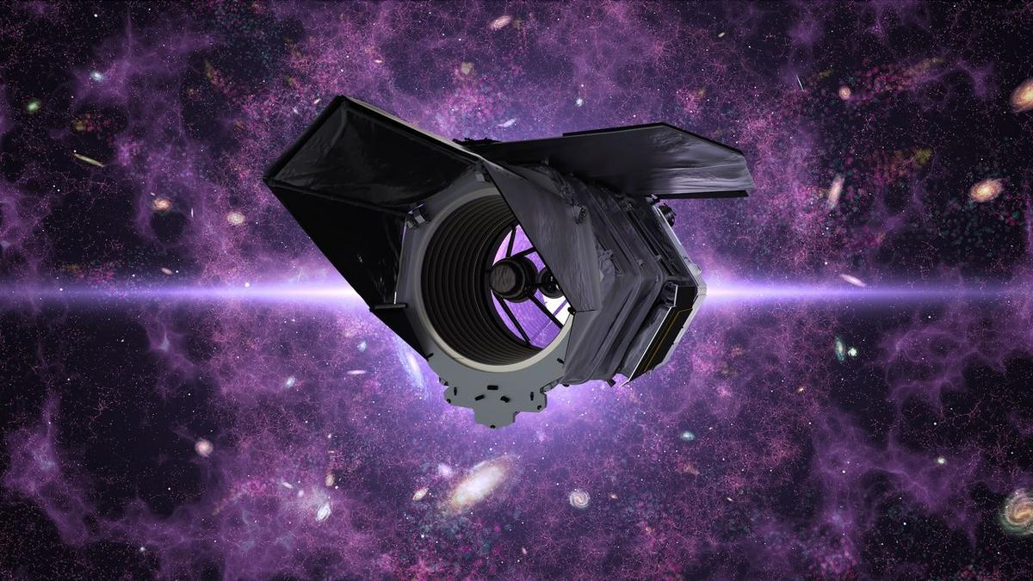
Click for next article The hours are counting down to the launch of NASA's newest flagship orbital observatory. The spacecraft recently got its last glimpse of terrestrial light before being encapsulated in its rocket's protective payload fairing last week and is imminently bound for liftoff. The Nancy Grace Roman Space Telescope is NASA's next-generation research satellite , and it's currently slated to launch on Sunday (Aug. 30). Roman will lift off atop a SpaceX Falcon Heavy rocket at 7:27 a.m. EDT (1127 GMT) from NASA's Kennedy Space Center in Florida. The scope will then head to sun-Earth Lagrange Point 2 (L2), an orbital sweet spot about 930,000 miles (1.5 million km) away that will park the spacecraft on the side of Earth opposite the sun. Roman's upcoming launch will cap nearly two decades and $4 billion of development and usher in a new wave of astronomical research into dark matter and dark energy , exoplanet discoveries and the ability to capture visible-to-near-infrared images of the universe that are 50 times wider than the field of view on the James Webb Space Telescope (JWST). But last year, as Roman's assembly and testing neared completion, President Trump's leaked budget proposal for fiscal year 2026 (FY26) stoked fears that the entire mission could be canceled. In April 2025, reporting about initial "passback" budget documents outlined a proposal for the largest cut in NASA's history - a 24% overall reduction in funding, with a 50% loss to science programs. The document detailed continued support for missions like Hubble and JWST but allocated "no funding … for other telescopes." The news shocked scientists and engineers across NASA missions, who were suddenly dealt a dose of uncertainty as their job security teetered in political limbo. For Roman's team, the prospect of abandoning the telescope just before the finish line hit hard. Lisa, an engineer who worked on Roman's team at NASA's Goddard Space Flight Center in Maryland and wished to be identified by an alias, was left confounded at the time. "We're 95% there. If it gets canceled, it would be really ridiculous, and I don't know how I would handle it," she told Space.com in an interview. "This is basically my life's work." Others working on Roman took the news in stride. Jamie Dunn has worked at Goddard since 1991. He served as Roman's project manager from 2018 until he was appointed director of the center this past June. During a question-and-answer session with a committee of the National Academies of Sciences, Engineering, and Medicine on Aug. 10 - part of a congressionally mandated assessment prompted in part by reporting from Space.com about accelerated facility closures and consolidations at Goddard last year - Dunn described a calmer reaction to Roman's potential cancellation. "Out of the eight years I [worked on Roman]," he told the committee, "we were zeroed out in the president's budget … in at least half of them. Not to be casual about it, but that happens." When the president's official "skinny budget" proposal was published a few weeks after the April leak last year, Roman's prospects shifted from dire to just worrisome. Instead of cancelling the mission outright, the administration's budget request allocated just $156.6 million to Roman's continued development in FY26 - less than half of what the project received in FY25. Scientists working on the Roman Space Telescope. (Image credit: NASA/Sophia Roberts) Goddard personnel began working around the clock at a time when government agencies, including NASA, were initiating reductions in force and encouraging civil servants to accept a " deferred resignation " option. Of three skilled technicians working in one department of Roman's team, two left, according to Lisa, which put further strain on the telescope's ongoing qualification testing at the time. "We're pushing forward to get as far as we can while we have our current funding, and we'll see what happens," Lisa told Space.com last summer. "That amount of funding obviously will make it impossible, in my opinion, to keep schedule, because we can't keep running two shifts with half the people." On the management side, Dunn tried to keep his team from getting distracted by politics. "Sometimes you've just got to keep coloring," he told the National Academies committee. "We kept working, and I [told the Roman team that] the best thing we can do is deliver on our commitments. And if delivering on our commitments isn't good enough, then what else can we do?" Lisa said that Roman's mission leadership mitigated the team's panic. "[They] actually did a really good job of telling us, 'We're just going to proceed as we were before … Just focus on the work,' and, 'The best way to make sure we don't get cut is to continue delivering and continue to stay on schedule,'" she said. Many of the engineers and technicians working on Roman "just put on blinders, put our heads down and kept working," Lisa said. "People were giving up their weekends, and at the same time, there was this compartmentalized knowledge that it could all get cut." Rather than merely stay on schedule, though, the Roman mission team was pushed to accelerate it. Congress ultimately rejected the steep cuts to NASA in the president's budget request and restored the agency's funding to the previous year's levels. Not wanting to go through a repeat of uncertainty for FY27, Roman mission management began eyeing faster routes to the launch pad. "They just kept pulling it earlier and earlier, because I think they were pushing to get it off the ground and in space before it could get cut," Lisa said. Eventually, Roman's target launch date moved up to September, and then to the end of August "so that it could happen within this fiscal year." "In order to stay on schedule at the time, the Roman teams were running two shifts every day and working every Saturday, sometimes on Sundays," Lisa said. The strain took a toll on morale, but their hard work paid off. NASA announced the Roman Space Telescope's completion in April, eight months ahead of schedule, and under budget. "Lo and behold, it turns out delivering on your commitments means something," Dunn said. Now, all eyes are turning to watch Roman leave Earth . Having passed all its political hurdles leading up to launch day, Roman has one more major milestone: Launching to space to begin its mission. Rocket rides to orbit aren't known for being particularly smooth, and after so much time spent worrying about budgets and schedules, Lisa said the part that makes her and her colleagues most nervous now is that it's out of their hands. "The launch vehicle … that's what we kind of don't have control over," Lisa said. "I'm really nervous, because it's just so many people's effort and years of work and sacrifice." It'll take the telescope 30 days to reach its L2 destination, and there are a few benchmarks it has to meet along the way. Roman will have to perform a few trajectory adjustments, including the mid-course "correction 1" maneuver about 24 hours after launch, which Lisa described as one of Roman's most consequential in reaching its designated orbit. After nearly two decades of development - and a final year spent wondering whether the telescope would make it to the launch pad at all - the team's focus has finally shifted to Roman's actual in-space operation as it awaits delivery to its new home in the final frontier.

52. Powerful Ariane 6 rocket launches European weather satellite to orbit (video)
Read more
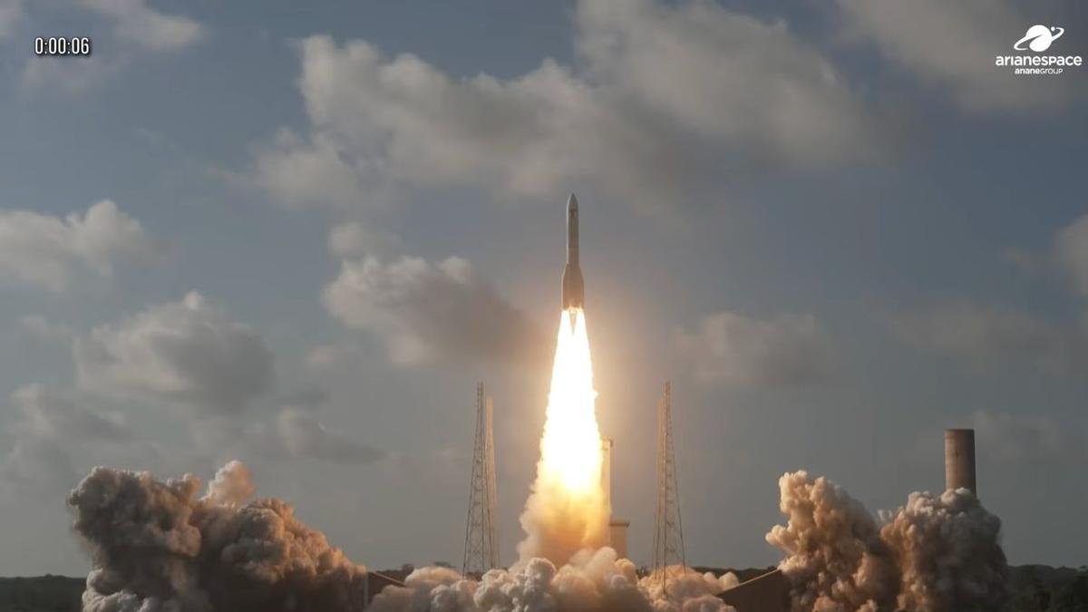
Click for next article Europe's most powerful rocket flew again today (Aug. 27). An Ariane 6 launched the MTG-I2 weather satellite from Europe's Spaceport in Kourou, French Guiana today (Aug. 27) at 4:10 p.m. EDT (2010 GMT; 5:10 p.m. local time in Kourou), right at the beginning of a 2.5-hour window. Everything went according to plan today: The Ariane 6 released MTG-I2 into geostationary transfer orbit (GTO) 36 minutes after liftoff. An Ariane 6 rocket launches the MTG-I2 weather satellite from Kourou, French Guiana on Aug. 27, 2026. (Image credit: Arianespace) The 8,400-pound (3,800 kilograms) MTG-I2 is the second imaging satellite in the Meteosat Third Generation network (hence the name). It will complete the three-spacecraft constellation in geostationary orbit , which lies 22,236 miles (35,786 kilometers) above Earth. Its companions, MTG-I1 and MTS-S1, launched in December 2022 and July 2025 , respectively. MTG-I1 is an imaging craft and MTS-S1 is a "sounder," using an infrared instrument to probe different layers of Earth's atmosphere . The MTG satellites are operated by the European Organisation for the Exploitation of Meteorological Satellites ( EUMETSAT ), an international group based in Germany. And they're very capable, according to Arianespace. "The MTG system is part of a new generation of geostationary satellites providing imagery for the early detection of fast-developing severe storms, weather forecasting and climate monitoring," the company wrote in the MTG-I2 press kit, which you can find here . Arianespace went on to describe MTG as "the most complex and innovative meteorological geostationary system ever built," citing its potential to improve the prediction and early detection of severe weather events. "The data gathered will have a wide range of uses, from enabling aircraft to avoid storms and for earlier alerts of flooding, through to more precise monitoring of fires and fog," the company wrote. Today's launch was the ninth to date for the Ariane 6, which can deliver up to 12.7 tons (11.5 metric tons) to GTO in its burliest configuration. For comparison, SpaceX's workhorse Falcon 9 rocket has a GTO payload capacity of 9.15 tons (8.3 metric tons). The Ariane 6 debuted in July 2024. Before today, the rocket last flew this past June , when it successfully sent 36 of Amazon's broadband satellites to low Earth orbit . Editor's note: This story was updated at 4:20 p.m. ET on Aug. 27 with news of successful liftoff, then again at 4:50 p.m. ET with news of satellite deployment.

53. NASA Johnson pilots chase moon's shadow for eclipse science
Read more

During the Aug. 12 total solar eclipse over Europe, scientists aimed to study a long-standing mystery: why the sun's outer atmosphere, the corona, is far hotter than its visible surface. Capturing the data they needed meant being in exactly the right place at the right time.

54. NASA's Webb telescope rules out two new Dyson sphere candidates
Read more

The latest Swedish-led search for technosignatures in the form of Dyson spheres has again come up empty-handed. The two latest stellar candidates in the hunt for such hypothetical extraterrestrial technology have been eliminated as Dyson spheres.
55. Yogi Adityanath directs officials to fast-track UP development projects
Read more

- Smart Infra - 3 min read CM asks departments to resolve land acquisition, tendering and coordination bottlenecks, and ensure projects are completed on schedule. - PTI - Published On Aug 28, 2026 at 04:04 PM IST Select ETGovernment as Preferred Choice on Google Copy Link Share on WhatsApp Share on Linkedin Share on X Share on Telegram Share on Facebook Uttar Pradesh Chief Minister Yogi Adityanath reviews major development projects and welfare schemes at a meeting of the State Transformation Commission. Uttar Pradesh Chief Minister Yogi Adityanath on Thursday said delays in development projects would not be tolerated, and directed officials to resolve bottlenecks related to land acquisition , tendering and inter-departmental coordination immediately. "The government's priority is not limited to announcing and approving projects. Every project must be brought on the ground within the stipulated time and its actual benefits must reach the people," Adityanath said while reviewing major development projects and welfare schemes at a meeting of the State Transformation Commission. Advt He said expressways should not be viewed merely as transport projects but as corridors driving industry, investment, employment and regional economies. The meeting was informed that the Chitrakoot Link Expressway tender was published on August 6, while land acquisition for the Farrukhabad Link Expressway was 91.28 per cent complete, Agra-Lucknow-Purvanchal Link 80.43 per cent, Jhansi Link 84.82 per cent and Jewar Link 79.27 per cent. He directed officials to expedite land acquisition for these projects. Verification for the Meerut-Haridwar, Vindhya and Vindhya-Purvanchal Spur expressways has been completed and he directed officials to speed up land acquisition for them. Reviewing the Greater Noida Multi-Modal Logistics Hub, the chief minister said logistics projects should be accelerated so that Uttar Pradesh becomes a major supply-chain hub. He also directed speedy action on the Aqua Business Project in Unnao, according to the statement. The 40 MLD sewage treatment plant at Bingawan, Kanpur, for supplying treated water to the Panki power plant has been completed. Adityanath also stressed capacity-building of engineers to ensure quality in project planning, execution and maintenance. On fire safety in hospitals, health institutions, hotels and guest houses, he said, "Negligence at any level in matters related to public safety cannot be accepted." He directed creation of a digital database of fire NOCs and renewal of licences before their expiry, according to the statement. Reviewing electricity supply, Adityanath directed officials to identify the reasons for high line losses and strengthen action against power theft while improving billing and recovery. "Accountability should also be fixed for responsible discom officials in areas with excessive line losses," he said. He directed that digital libraries in gram panchayats be developed as centres for studies, competitive examinations and digital learning and ordered that all related work be completed by September 30. Reviewing the Zero Poverty campaign, he said, "Every identified eligible family should get housing." Families left out of the Pradhan Mantri Awas Yojana should be covered under the Mukhyamantri Awas Yojana, while eligible families should receive ration, Ayushman cards, toilets and other benefits. He also directed efforts to link at least one family member with skill training and employment . Of 12.50 lakh identified families, nine lakh were found eligible for housing, including 4.50 lakh under the PMAY list and about five lakh to be covered by the state housing scheme. Some 6.67 lakh families did not have Ayushman cards, the meeting was told. The chief minister directed that labour points be surveyed and equipped with drinking water, toilets, sanitation, bathing, medical care and food. Special drives should be conducted for labour and Ayushman cards, with medical mobile units and mobile canteens in every municipal corporation area. Reviewing the Gorakhpur international cricket stadium and Major Dhyan Chand Sports University in Meerut, he directed that construction be completed on schedule without compromising quality. The 30,000-capacity Gorakhpur stadium, whose construction began in December 2025, is scheduled for completion by December 2027. He also directed timely release of approved financial incentives to investors, according to the statement. On revenue matters, the chief minister said inheritance and land measurement cases directly concern citizens' rights and property and must be resolved transparently and within a fixed time frame. He ordered an inquiry into 13,386 cancelled undisputed inheritance applications in Prayagraj, the highest in the state, and directed that cancellations be examined on merit. He also ordered priority disposal of old measurement cases and regular review of revenue officials to ensure land disputes do not remain pending unnecessarily. - See more on: - Uttar Pradesh development projects , - Yogi Adityanath , - land acquisition , - transport projects , - skill training and employment Telegram Facebook Comments What are your thoughts? Comment Now --> Comment Now Read Comment (1) All Comments By commenting, you agree to the Prohibited Content Policy Post Find this Comment Offensive? Choose your reason below and click on the submit button. This will alert our moderators to take actions REASONS FOR REPORTING Foul Language Defamatory Inciting hatred against a certain community Out of Context / Spam Others Report Join the community of 2M+ industry professionals. Subscribe to Newsletter to get latest insights & analysis in your inbox. --> All about ETGovernment industry right on your smartphone! - Download the ETGovernment App and get the Realtime updates and Save your favourite articles. Scan to download App --> - Home - News - Yogi Adityanath directs officials to fast-track UP development projects

56. ISRO Seeks To Make Comeback With Hawkeye Satellite Launch On September 4 - NDTV
Read more
ISRO Seeks To Make Comeback With Hawkeye Satellite Launch On September 4 NDTV

57. ISRO announces recruitment for Scientist, Engineer 'SC' posts: Vacancy details, selection process - The Indian Express
Read more
ISRO announces recruitment for Scientist, Engineer 'SC' posts: Vacancy details, selection process The Indian Express

58. ISRO Scientist, Engineer SC recruitment 2026: 176 vacancies announced, check eligibility, selection proce - The Times of India
Read more

(Image credit: Isro) ISRO Scientist, Engineer recruitment 2026: Vacancy details Discipline ISRO Centres PRL Total Electronics 99 1 100 Mechanical 52 1 53 Computer Science 21 1 22 ISRO Scientist, Engineer eligibility criteria ISRO Scientist, Engineer recruitment application fee ISRO Scientist, Engineer posts: Steps to apply Go to the official ISRO recruitment portal, isro.gov.in. Open the recruitment notification for Scientist and Engineer 'SC' posts. Read the eligibility conditions and other instructions carefully. Register on the portal using the required personal details. Log in and select the relevant engineering discipline and post. Enter educational qualifications, personal information, and other required details. Upload the photograph, certificates, and other documents in the prescribed format. Pay the applicable processing/application fee through the available online payment mode. Review the complete application form carefully before final submission. Submit the application and download or print a copy of the confirmation page for future reference. ISRO Scientist, Engineer selection process Interview to assess technical and communication skills The Indian Space Research Organisation (ISRO) has opened recruitment for Scientist, Engineer 'SC' positions in Electronics, Mechanical, and Computer Science. The recruitment drive offers 176 vacancies across various ISRO Centres and the Physical Research Laboratory (PRL).Eligible engineering graduates can submit their applications through the official recruitment portal until September 16, 2026, by 11:55 pm. Candidates should carefully check the eligibility conditions and application requirements before submitting the form, as applications through any other mode will not be accepted.The 176 posts have been distributed across three engineering disciplines. Electronics has the highest number of vacancies, followed by Mechanical and Computer Science.The posts are classified as Group 'A' positions and carry Level 10 pay in the Pay Matrix, making the recruitment an important opportunity for engineering graduates seeking a career in the country's space research and technology establishment.Candidates must hold a BE, BTech or equivalent qualification in the relevant engineering discipline from a recognised institution.For Electronics posts, applicants should possess the required qualification in Electronics and Communication Engineering.Candidates applying for Mechanical and Computer Science vacancies must have the corresponding engineering degree.Applicants are required to have secured at least 65% marks in aggregate or a CGPA of 6.84 on a 10-point scale in their qualifying degree.The upper age limit is 28 years as of September 16, 2026. Relaxation in the maximum age will be available to eligible categories, including Central Government employees, ex-servicemen, and Persons with Benchmark Disabilities (PwBD), in accordance with the applicable recruitment rules.Candidates applying for the posts will have to complete the online application process and pay the applicable charges by the deadline.An application fee of Rs 250 is applicable. Candidates are initially required to pay a processing fee of Rs 750, subject to the refund provisions specified in the recruitment notification.Applicants should ensure that their payment is completed successfully before the application deadline. A partially completed form or an application submitted without the required payment may not be considered.Eligible candidates can follow these steps to complete the application:Candidates should ensure that all information entered in the form matches their official documents. Any discrepancy in personal or academic details could create problems during subsequent stages of recruitment.The selection process will consist of a written test followed by a personal interview. The final selection will give equal importance to both stages, with 50% weightage assigned to the written test and 50% to the interview.The written examination will be conducted as a computer-based test in 37 cities across India. It will carry a total of 100 marks and will be divided into two parts.Part A will contain 80 discipline-specific multiple-choice questions, to be attempted in 90 minutes. The section will have negative marking, with one-third of a mark deducted for every incorrect answer.Part B will assess aptitude and ability. It will comprise a maximum of 15 questions carrying 20 marks and will have a duration of 30 minutes. There will be no negative marking in Part B.Candidates will be shortlisted for the interview based on their written-test performance in a 1:5 ratio.The personal interview will carry 100 marks. Besides technical knowledge, candidates will be assessed on areas such as general awareness, communication skills, comprehension, and academic achievements.For unreserved candidates, the prescribed qualifying requirement includes at least 50% marks in the interview and 60% aggregate marks.With the application window open until September 16, eligible candidates should avoid waiting until the final day. Apart from ensuring timely submission, early application gives candidates an opportunity to rectify any technical or document-related issues before the deadline.

59. What time will SpaceX launch NASA's Roman Space Telscope on Aug. 30? (Full mission timeline)
Read more
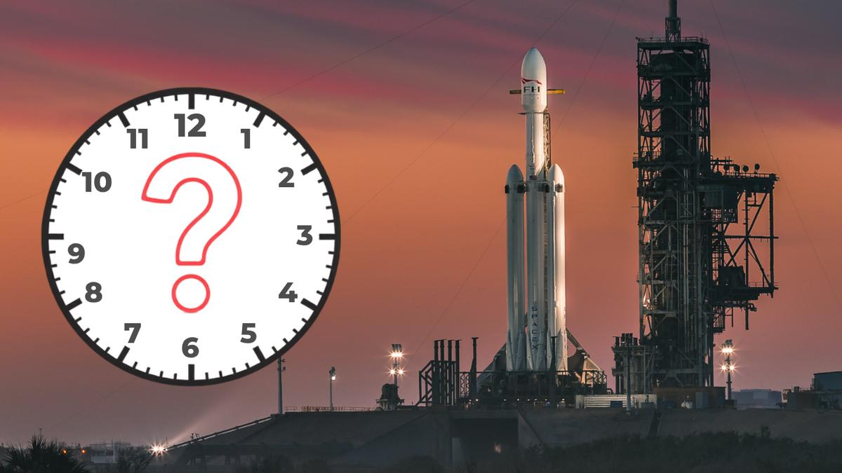
Click for next article A huge SpaceX rocket is just days away from launching NASA's next great observatory into space: the Roman Space Telescope. But if you're hoping to watch it live online, you'll have to get up pretty early on Sunday (Aug. 30) or you'll miss it. NASA's Roman Space Telescope , named after the late NASA astronomer Nancy Grace Roman , will launch no earlier than Sunday on a mission to map the galaxy like never before. Liftoff is set for 7:26 a.m. EDT (1126 GMT) from a NASA pad in Cape Canaveral, Florida. You can follow the mission in real time with our Roman Space Telescope live updates . " Roman's deep, sweeping surveys will help investigate dark energy and dark matter, discover and characterize planets beyond our solar system, map billions of galaxies, study black holes and share enormous amounts of data with both scientists and the public," NASA said in an update Friday (Aug. 28), after clearing Roman for launch. Here's a look at what time NASA's Roman Space Telescope will launch atop a SpaceX Falcon Heavy rocket , as well as how to watch online. What time is SpaceX's Roman Space Telescope launch? NASA's Nancy Grace Roman Space Telescope is encapsulated in the payload fairing of its SpaceX Falcon Heavy rocket. (Image credit: SpaceX) SpaceX is currently targeting the launch of NASA's Roman Space Telescope for no earlier than 7:26 a.m. EDT (1126 GMT) on Sunday, Aug. 30. The company will launch Roman into space atop a Falcon Heavy rocket from Launch Complex 39A at NASA's Kennedy Space Center in Florida. A launch livestream will begin about one hour before liftoff. While SpaceX hopes to launch Roman on time, the company can try again on Monday, Aug. 31, if needed. A launch on that day would lift off a few minutes earlier, at 7:22 a.m. EDT (1122 GMT), SpaceX has said. $39.99 at Amazon Starship Die Cast Rocket Model Was $47.99 Now $39.99 on Amazon. Even if you can't see SpaceX's Starship in person, you can score a model of your own. Standing at 13.77 inches (35 cm), this is a 1:375 ratio of SpaceX's Starship as a desktop model. The materials here are alloy steel and it weighs just 225g. Can I watch SpaceX's Roman Space Telescope launch? LIVE: Roman Space Telescope launches aboard SpaceX Falcon Heavy - YouTube Watch On Yes, of course, you'll be able to watch SpaceX launch the Roman Space Telescope , and you have some options regarding where to tune in. NASA will provide a launch webcast early Sunday morning. That livestream begins Aug. 30 at 6:20 a.m. EDT (1020 GMT) and will run through the launch and a post-launch briefing. That livestream can be found on the NASA website here , as well as all of NASA Social channels ( Facebook , Instagram , X ), and streaming channels like Twitch , Discovery+ , Amazon Prime , NASA+, and of course YouTube . Our Space.com livestream can be found on our VideoFromSpace YouTube channel , and will feature NASA's livestream simulcast. SpaceX will also host its own launch livestream via its X account , which will begin about an hour before liftoff. As mentioned above, SpaceX aims to launch Roman for NASA at 7:26 a.m. EDT (1126 GMT), with the flight lasting about 31 minutes and 31 seconds - the time post-liftoff at which Roman is expected to deploy into space. A post-launch press conference is scheduled for 9:30 a.m. EDT (1330 GMT) and will include comments from the experts listed below. NASA Administrator Jared Isaacman Nicky Fox, associate administrator, Science Mission Directorate, NASA Headquarters Jackie Townsend, Roman telescope project manager, NASA Goddard Julie McEnery, Roman telescope senior project scientist, NASA Goddard Denton Gibson, launch director, NASA's Launch Services Program, NASA Kennedy How long is SpaceX's Roman Space Telescope launch? A diagram showing SpaceX's Roman Space Telescope launch profile on a Falcon Heavy rocket. The flight should last about 31.5 minutes. (Image credit: SpaceX) SpaceX's Roman Space Telescope launch for NASA will last just over 31 minutes (31 minutes and 31 seconds, to be exact), in order to send Roman on its way into deep space. After liftoff, the Falcon Heavy rocket's core booster and twin side boosters will fire for just under 2.5 minutes, after which the side boosters will separate and return to Earth. If all goes well, they should land about 7 minutes, 23 seconds after liftoff. "This is the first and third flight for the two first stage side boosters supporting this mission, which previously launched the GOES-U and Viasat-3 F3 missions," SpaceX wrote in a mission overview . "Following stage separation, Falcon Heavy's two side boosters will land on SpaceX's Landing Zones 2 and 40 (LZ-2 and LZ-40) at Cape Canaveral Space Force Station in Florida." SpaceX does not appear to be planning a core first-stage landing off shore for this flight. The three first-stage boosters of the Falcon Heavy rocket that will launch NASA's Nancy Grace Roman Space Telescope on Aug. 30, 2026. SpaceX shared this photo via X on Aug. 26. (Image credit: SpaceX) Here's a look at the launch and flight timeline from SpaceX. Swipe to scroll horizontally SpaceX Roman Space Telescope Launch Timeline TIME (Hr:Min:Sec) EVENT T-0:53:00 Flight director polls for fueling T-0:50:00 1st stage RP-1 (rocket grade kerosene) loading begins T-0:45:00 1st stage liquid oxygen loading begins T-0:35:00 2nd stage RP-1 fuel loading begins T-0:18:30 2nd stage liquid oxygen loading begins T-0:07:00 Falcon Heavy engine chilldown begins T-00:00:59 Flight computer commanded to begin final prelaunch checks T-00:00:45 Launch Director GO for launch poll T-00:0:20 Propellant tanks pressurized for flight T-00:00:06 Engine controller commands engine ignition sequence start T-00:00:00 Liftoff Swipe to scroll horizontally SpaceX Roman Space Telescope Post-Launch Timeline TIME (Hr:Min:Sec) FLIGHT EVENT T+00:00:00 Liftoff! T+00:01:08 "Max Q" T+00:02:24 Side boosters' engines shut down T+00:02:27 Side boosters separate T+00:02:32 Side boosters flip T+00:02:43 Side boosters' boostback burn begins T+00:03:48 Side boosters' boostback burn ends T+00:03:51 1st stage main engine cutoff T+00:03:54 1st stage separation from upper stage T+00:04:00 2nd stage engine ignition T+00:04:15 Payload fairing separation T+00:06:19 Side boosters' entry burn begins T+00:06:29 Side boosters' entry burn ends T+00:07:23 Side boosters' landing burn begins T+00:07:40 TOUCHDOWN! Side boosters land T+00:08:28 2nd stage engine cutoff (SECO-1) T+00:24:33 2nd stage engine restart (SES-2) T+00:26:33 2nd stage engine cutoff (SECO-2) T+00:31:31 Roman Space Telescope deploys The upper stage of the Falcon Heavy will continue firing its engine through the 8-minutes-and-28-seconds mark, when it will shut down for a 16-minute cruise period. Just over 24 minutes into the flight, the second stage will reignite its single Merlin engine for about three minutes before shutting down for good. The Roman Space Telescope will then deploy from its carrier at the 31:31 minute mark. It is expected to deploy its solar panels and sunshade shortly after liftoff, then spend the next few days unfolding its antenna and aperture cover, while also performing a mid-course correction burn on its way to its final destination: a stable point in space called Lagrange Point 2 , about 1 million miles (1.5 million kilometers) from Earth, opposite the sun. "The Roman team will complete a carefully orchestrated series of deployments, calibrations, and tests in the three months following launch before the observatory reaches its final orbit," NASA has said of the steps that will follow. What if the Roman Space Telescope can't launch? If SpaceX can't launch the Roman Space Telescope on Aug. 30, the company and NASA have at least one backup day to try again. A second launch window is available on Monday, Aug. 31, at 7:22 a.m. EDT (1122 GMT), according to SpaceX. Both SpaceX and NASA are watching the weather closely to determine if Roman can fly on Aug. 30. "Meteorologists with the U.S. Space Force's Space Launch Delta 45 Weather Squadron are predicting a 60% chance of favorable weather conditions for launch, which is targeted for 7:26 a.m. EDT on Sunday, Aug. 30 from Launch Complex 39A at Kennedy," NASA wrote in an update Friday (Aug. 28).

60. The night we nearly saw a 'blood moon' (and why I love near-misses in astronomy)
Read more
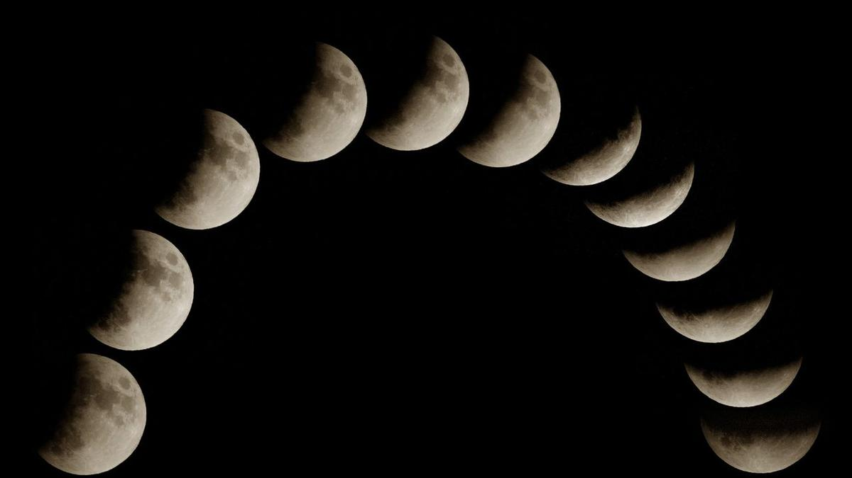
Click for next article Stargazers have trigger words - total, bright, peak, maximum, best. But observing the sky is often more interesting when something seems neither one thing nor the other. A case in point was the almost-total partial lunar eclipse we just witnessed. From where I watched, early on Aug. 28, Earth's shadow reached its maximum across the lunar surface, covering 96.2% of it, as the moon began to sink in the west. A thin part of the lunar surface remained outside the darkest part of Earth's shadow, and the surface never did quite go red. At maximum eclipse, the moon looked like a sliver - totally unlike a crescent moon, and something very odd to behold - and came within a fingernail of becoming a totally eclipsed " blood moon ." Astronomy and stargazing are full of this sort of near-miss. A comet that nearly becomes bright enough to tell your neighbors about, but ultimately becomes nothing more than a smudge in binoculars that few can even find, let alone be impressed by. A meteor shower that's hyped as the strongest for years that doesn't live up to expectations. Or the worst kind - a cloud deck that clears a few minutes after a total solar eclipse comes to an end. We pretend these moments are failures because they do not match the headline version of the sky. But it's often the "almost" part that keeps the imagination alive. Beyond the headline act A total lunar eclipse happens only when the entire moon passes into Earth's dark umbral shadow. On Aug. 27-28, the deep partial eclipse missed totality, but the bright uneclipsed sliver made the shadow easier to see and appreciate. Its almostness gave the event an unusual tension. During a total lunar eclipse - also called a "blood moon," which gets headline writers very excited - the red color comes from sunlight filtering through Earth's atmosphere . Shorter blue wavelengths scatter more efficiently, while longer red and orange wavelengths are bent into the shadow and onto the moon. In other words, the totally eclipsed moon is lit by the combined glow of sunrise and sunset around the rim of Earth . That sounds like a poetic exaggeration, but it's just physics. A partial lunar eclipse is equally just physics. With the headline act of totality not on the agenda, I watched Earth's curved shadow creep across the lunar surface, almost reach across the entire orb, then gradually retreat. You could see the geometry working. You could see the moon move through a circular shadow - our planet's shadow. A lunar eclipse always gives you time to think because it unfolds slowly, but this gave me a chance to focus on the one thing we all ignore when we obsess over the "blood moon" moment - the moon moving through Earth's giant shadow in space. Almost, but not quite - near-totality during a deep partial lunar eclipse. (Image credit: Giovanni Bortolani via Getty Images) Grazing occultations and weird eclipses Near-misses in astronomy occur when things do not perfectly align as seen from Earth. A good example is a grazing occultation, in which the moon almost crosses a bright star or planet, but not quite. Instead of seeing it disappear and re-emerge, the planet or star winks as it's skimmed by the mountains on the rugged edge of the moon. Spectacular examples include July 10, 2018 , when red giant star Aldebaran blinked along the lunar limb, as seen from North America, and Aug. 24, 2023, when Antares played hide-and-seek behind the moon. It's proof that the moon has no atmosphere , though it's location-specific because the moon's apparent position in the sky varies by about two degrees depending on where you are. There are some good occultations (which all have grazing zones) coming up: Sept. 8: lunar occultation of Jupiter ( visible across the U.S.) across the U.S.) Sept. 14: lunar occultation of Venus ( visible across Europe and the Middle East) across Europe and the Middle East) Sept. 17: lunar occultation of Antares ( visible in southwest Australia) Mars being grazed by the moon. (Image credit: (c) 2010 Luis Argerich via Getty Images) However, my favorite type of celestial near-miss is a solar eclipse , which comes in so many shapes and sizes that it's tough not to start collecting observations of them once you've started. If you like big partial eclipses - when the central shadow of the moon, the umbra, passes just above the planet, but never quite makes land to cause totality - get Jan. 14, 2029 and Dec. 5, 2029 in your calendar. An extremely similar event, celestially speaking, but with a vastly different effect, will occur on April 9, 2043 . On that day, a total solar eclipse will be seen from almost nowhere on the planet. Instead of a long, narrow path of totality across the globe, the cone of the moon's dark shadow just grazes Earth's edge. Most of the shadow misses the planet and falls into space. What does touch Earth will create an ellipse of totality over the far north of Russia. That makes it the 21st century's sole non-central total solar eclipse. How many eclipse chasers will be in Tymlat, on the east coast of Kamchatka, for 59 seconds of totality just minutes after watching a partially eclipsed sunrise? Most will miss it for a much simpler reason - it's not a place you can easily travel to, if at all. Near-misses and oddities are, of course, not rare nor unusual; they're just abnormal from our point of view during a human lifetime. Astronomy is often about being close to seeing extraordinary things without fully experiencing them, and very often it's clouds that are to blame. If that sounds frustrating, it shouldn't - most of life works the same way. Stargazer's corner: Aug. 28-Sept. 3, 2026 Saturn through a 14-inch Schmidt-Cassegrain telescope. (Image credit: Jamie Cooper/SSPL/Getty Images) With the moon just past full, it remains bright for much of the night all week, so we'll struggle to see galaxies, nebulae and the Milky Way. However, Saturn, rising in the east, is now becoming more convenient in the late evening sky and is worth a look through binoculars - and particularly a small telescope if you have one. It will be in conjunction with the moon on Aug. 30. Venus remains bright just after sunset, low toward the west, though horizon haze can make it less crisp than its brightness suggests. Constellation of the week: Capricornus Capricornus, the "Sea Goat," is now visible in the south after dark. (Image credit: E. Slawik/NOIRLab/NSF/AURA/M. Zamani) Autumn is coming to the night sky. One of the telltale signs is the presence of Capricornus, a constellation that looks more convincing on a chart than in the sky. From the northern hemisphere, it sits low in the south on late summer evenings, east of Sagittarius and south of bright star Altair, the lowest star in the iconic Summer Triangle. Its stars are modestly bright, so suburban observers will need patience and a clear southern horizon. As Capricornus emerges into the evening sky, the bright center of the summer Milky Way is on the wane, beginning to lean west, and autumn is approaching.

61. SpaceX Falcon Heavy rocket launching NASA's Roman Space Telescope on Aug. 30: How to watch it live
Read more
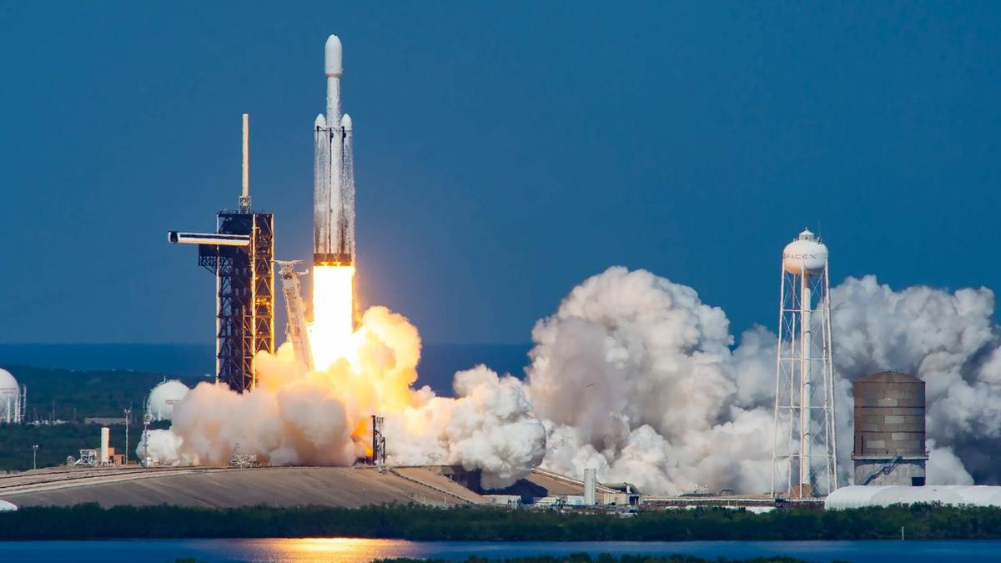
Click for next article LIVE: Roman Space Telescope launches aboard SpaceX Falcon Heavy - YouTube Watch On NASA's next great space observatory is about to lift off, and you can watch it live. The Nancy Grace Roman Space Telescope is scheduled to launch atop a SpaceX Falcon Heavy rocket from NASA's Kennedy Space Center in Florida on Sunday (Aug. 30) at 7:26 a.m. EDT (1126 GMT). You can watch it live here at Space.com, courtesy of NASA, beginning at 6:20 a.m. EDT (1020 GMT). You don't have to wait that long for a Roman fix, actually; there's stuff to watch on Saturday (Aug. 29) as well. Here's a rundown of this weekend's Roman action. SpaceX's Falcon Heavy rocket launches NASA's Europa Clipper mission from Florida on Oct. 14, 2024. (Image credit: SpaceX) Saturday: Prelaunch briefings Things kick off at on Saturday at 9 a.m. EDT (1300 GMT) with NASA's Roman Space Telescope mission science briefing. This should be quite eventful, for Roman's science goals are ambitious; it will likely discover thousands of exoplanets , for example, and reveal intriguing new information about mysterious dark matter and dark energy . Participants are: Shawn Domagal-Goldman, director, Astrophysics Division, NASA Headquarters Julie McEnery, Roman telescope senior project scientist, NASA Goddard Space Flight Center Vanessa Bailey, Roman Coronagraph Instrument scientist, NASA Jet Propulsion Laboratory Kristen McQuinn, Roman Science Operations Center lead, Space Telescope Science Institute Lee Armus, Roman Science Support Center lead, Caltech/IPAC Next up is the prelaunch press conference, which will discuss the mission's launch readiness. It will start at 10:30 a.m. EDT (1430 GMT) and feature the following folks: Nicky Fox, associate administrator, Science Mission Directorate, NASA Headquarters Lucas Paganini, Roman telescope program executive, NASA Headquarters Jackie Townsend, Roman telescope project manager, NASA Goddard Denton Gibson, launch director, NASA's Launch Services Program, NASA Kennedy Julianna Scheiman, director, NASA Science and Dragon Programs, SpaceX Justin McReynolds, launch weather officer, 45th Weather Squadron, U.S. Space Force Then, at 11:45 a.m. EDT (1545 GMT), NASA Administrator Jared Isaacman, an accomplished pilot and private astronaut, will put on a mini air show of sorts. Isaacman "is expected to fly past the Nancy Grace Roman Space Telescope and Falcon Heavy rocket on the launch pad in his jet," NASA wrote in an Aug. 24 media advisory. "The flyby will be shown live on the same stream as the prelaunch news conference, with a view of the launch pad during the transition. The flyby is subject to weather and operational considerations." Sunday: Launch day And there's more to watch on Sunday than the launch itself. At 9:30 a.m. EDT (1330 GMT), NASA will hold a post-launch briefing featuring Isaacman, Fox, Townsend, McEnery and Gibson. They'll likely discuss the next steps for Roman, which include a 30-day journey to its deep-space home, the sun-Earth Lagrange Point 2 . This spot lies about 930,000 miles (1.5 million kilometers) from Earth in the direction of Mars . It's gravitationally stable, meaning Roman will be able to stay put without expending much fuel. Mission team members will spend the next few months checking out the observatory's systems and science gear. It should be ready to begin its five-year science mission in early 2027.

62. On this day in space! Aug. 28, 1993: Galileo spacecraft flies by asteroid Ida on the way to Jupiter only to find a tiny moon!
Read more
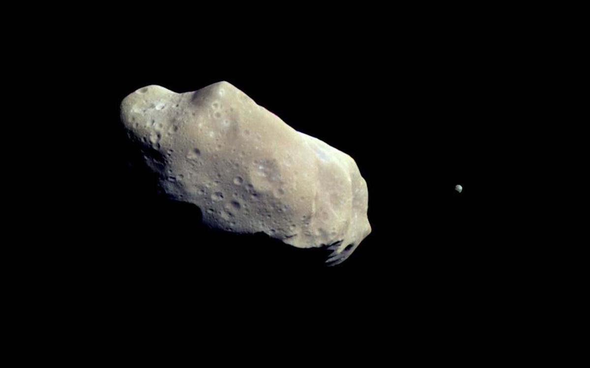
Click for next article On Aug. 28, 1993, NASA's Galileo spacecraft flew by the asteroid Ida while on its way to Jupiter. Galileo was the first spacecraft to fly by an asteroid in the asteroid belt . Ida was actually the second one it visited after another flyby of the asteroid Gaspra in 1991. Galileo whizzed by asteroid Ida going almost 28,000 mph and came within 1,500 miles of the asteroid's surface. During the encounter, Galileo actually discovered a tiny moon orbiting Ida! This was the first confirmed satellite of an asteroid . The International Astronomical Union named the moon Dactyl after a group of mythological beings who lived on a sacred mountain called Mount Ida. Why it mattered The Galileo spacecraft, on its way to the Jupiter system, captured this mind-blowing image of asteroid 243 Ida and its moon, Dactyl. (Image credit: NASA/JPL) Asteroid 243 Ida was actually the second asteroid ever to be visited by a spacecraft (Galileo previously flew by the asteroid Gaspra in October 1991), but this flyby clinched the theory that asteroids could have moons . Until the Galileo spacecraft photographed Ida and Dactyl, astronomers suspected some asteroids could have their own moons, but Galileo proved it once and for all. During the flyby, Galileo approached within 1,500 miles (2,400 kilometers) of Ida as it made its way to Jupiter . "It was previously thought that natural satellites of asteroids could form, but they probably weren't common," Torrence Johnson, Galileo's project scientist, once said of the flyby in a NASA statement . "Having found one fairly quickly, we can say that they're probably more common than previously thought." Ida is an S-type asteroid made mostly of silicate rock and sits in the main asteroid belt. Astronomers suspect it is what's known as a Koronis asteroid, leftover debris from an ancient crash of two much larger objects, according to NASA. It was discovered on Sept. 29, 1884 by Austrian astronomer Johann Palisa at the Vienna Observatory. Galileo imaging team member Ann Harch actually discovered Ida's moon Dactyl on Feb. 17, 1994, months after the flyby, while reviewing data, NASA said. Galileo did not stop to study Ida and Dactyl. As with its Gaspra flyby, the probe zoomed by to continue its trip to Jupiter. NASA launched the Galileo mission on Oct. 18, 1989 and it arrived at Jupiter on Dec. 7, 1995, orbiting the giant planet for nearly 8 years. The mission ended on Sept. 21, 2003, when Galileo intentionally crashed into Jupiter . Want more space history? Check out our full On This Day In Space Story archive and watch our On This Day In Space videos on YouTube .

63. President Trump gives Artemis II moon astronauts the Congressional Space Medal of Honor
Read more
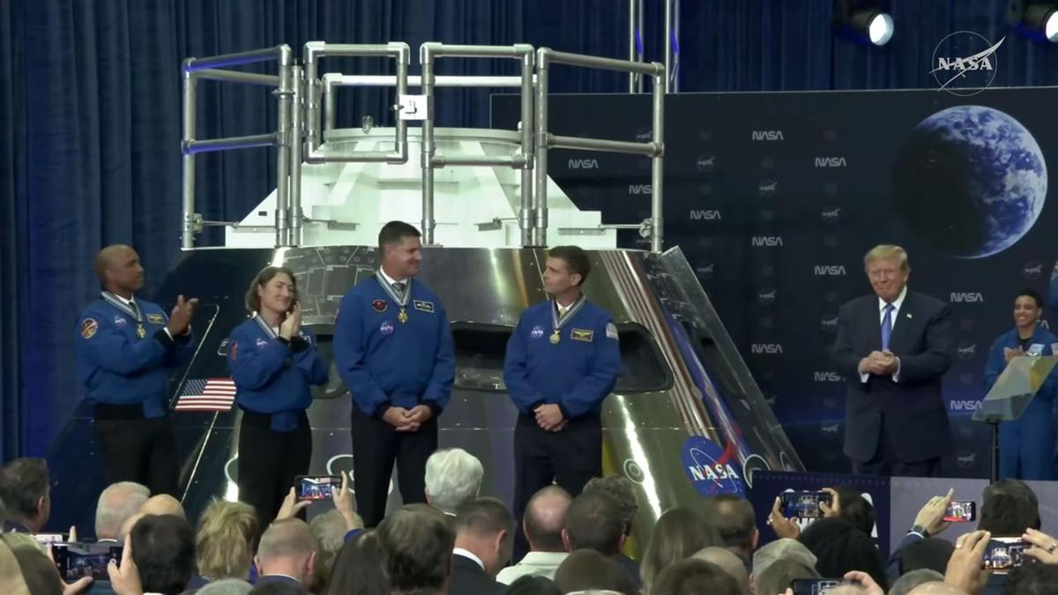
Click for next article President Donald Trump awarded the four astronauts of NASA's Artemis II moon mission the Congressional Space Medal of Honor on Aug. 28, 2026. Four astronauts just received the United States' highest space honor. President Donald Trump gave the astronauts of NASA's Artemis II moon mission the Congressional Space Medal of Honor today (Aug. 28) during a ceremony at Johnson Space Center in Houston. "This is a very rare thing. It's for courageous people, brilliant people, bestowed on astronauts who have distinguished themselves with exceptional service to the nation and all of mankind," Trump said during the event. Artemis II Congressional Space Medal of Honor Ceremony - YouTube Watch On Artemis II launched on April 1 and came back to Earth nine days later. It was the first crewed mission of NASA's Artemis program , which aims to establish a long-term base near the moon's south pole in the coming years. The flight sent four people - NASA's Reid Wiseman, Victor Glover and Christina Koch, as well as Canadian Space Agency astronaut Jeremy Hansen - on a looping journey around the lunar far side. It was the first crewed trip beyond low Earth orbit since Apollo 17 in 1972, and its astronauts got farther from their home planet than any people ever had before. Artemis II engaged folks around the world thanks to its importance, its historic nature and the charisma of its astronauts. And some fortuitous orbital dynamics didn't hurt, either: The Artemis II crew were lucky enough to observe a total solar eclipse from beyond the moon , something human eyes had never seen firsthand before. The Congressional Space Medal of Honor is awarded "to any astronaut who in the performance of his duties has distinguished himself by exceptionalIy meritorious efforts and contributions to the welfare of the Nation and of mankind," NASA wrote in a description of the award , citing Congress' stated criteria. Though the president gives out the medal, he does so on the recommendation of the NASA administrator, the agency added. Before today, just 30 people had received the award, and most of them are pretty big names. Past honorees include Apollo 11 astronaut Neil Armstrong ; Alan Shepard and John Glenn, who were the first Americans to reach space and orbit Earth, respectively; Gemini astronaut Ed White, the first American to perform a spacewalk; and Apollo 13 commander Jim Lovell. The award was also given to each of the 14 astronauts who died in the space shuttle Challenger and Columbia disasters. Hansen therefore wasn't the first non-American to receive the medal. Ilan Ramon, one of the seven people who perished when Columbia broke apart upon reentry to Earth's atmosphere on Feb. 1, 2003, was from Israel. The Artemis II astronauts gave President Trump a special flight jacket on Aug. 28, 2026. (Image credit: NASA TV) During his speech at today's ceremony, Trump said that the United States is entering a golden age of spaceflight and exploration. And he thanked the Artemis II astronauts for being a guiding light. "Thanks to the crew of Artemis II, those dreams are closer than ever before," the president said. "We're on the cusp of an adventure and something that's so special, people have really not imagined anything. It's really, civilization is into the stars. The stars are up there and they're beautiful, and you're right next to them. You have the courage to be right next to them. Few people do, but you're leading the way. It's great, great bravery." The astronauts reciprocated the warmth. For example, they gave the president a blue flight jacket commemorating the mission. And Wiseman, Artemis II's commander, thanked Trump for calling the crew during their mission. "The one thing that really sticks out to us is, you said how proud you are and how proud our nation is of the job that we have just accomplished," Wiseman said during the ceremony. "And for us, that is what we set out to do. We wanted to inspire this nation and inspire the world, and for us, that showed us we were on the right track. So, thank you for that call." Editor's note: This story was updated at 1:30 p.m. ET on Aug. 28 with quotes and information from the medal ceremony.

64. SpaceX recovers Starship from the Indian Ocean a month after launch and is shipping it back to Texas
Read more

SpaceX has pulled off its biggest salvage operation yet, recovering its most recently launched Starship from the Indian Ocean.

65. NASA telescope honors Nancy Grace Roman, architect of space-based astronomy
Read more

The Nancy Grace Roman Space Telescope is set to launch this weekend aboard a SpaceX rocket from Kennedy Space Center in Florida. When it becomes operational early next year, it will transform our view of the universe.

66. Phase-change material powers smart thermal management for modern missile seekers
Read more
Modern military sensors are pushing more computing power into smaller packages. That creates a stubborn engineering problem: all that power produces heat, but compact platforms leave little room for cooling hardware. The challenge becomes sharper inside seekers and other small sensors. Conventional liquid cooling needs pumps, tubing, and reservoirs, which can consume space and add weight. Lyntris is taking a different approach. The defense technology company has completed a phase-change material production line at its Jessup, Maryland, facility. The new capability is aimed at producing passive thermal hardware for U.S. defense programs at higher rates. Phase-change materials absorb heat Phase-change heat sinks use an engineered material that melts as temperatures rise. During that transition, the material absorbs heat generated by electronics inside the system. The approach can provide thermal protection without pumps or circulating coolant. That makes it particularly suited to systems with short operating windows, including compact seekers and sensors. Lyntris describes the technology as a thermal battery. The heat sink absorbs energy during operation, keeping electronics within their required temperature range for the mission. That matters as defense electronics become more capable. Higher power densities can increase thermal loads, creating another constraint for engineers trying to fit advanced sensors into smaller platforms. Active cooling remains useful for larger systems with enough room for supporting equipment. Small, attritable platforms face a different set of constraints. Lyntris expects its phase-change capability to first support seeker and sensor programs. The company is also discussing other applications with defense prime contractors and government program offices. New line targets production scale The Maryland facility goes beyond making individual thermal components. Lyntris built the production line to handle several stages of the manufacturing process at one location. The operation includes precision machining of heat sink structures and vacuum brazing. It also handles controlled filling of the phase-change material, thermal testing, and final assembly. That integration addresses an important problem in defense manufacturing. A thermal design can work well during development but still prove difficult to reproduce at production volumes. Lyntris expects its technology to support programs that could require thousands of units. Keeping more manufacturing steps together can also reduce the number of supplier handoffs involved in producing each component. Production capacity became available in the third quarter of 2026. Lyntris spent several years investing in the capability before reaching that stage.
67. ISRO Scientist Resignations Put Space Privatisation in Focus - Frontline Magazine
Read more
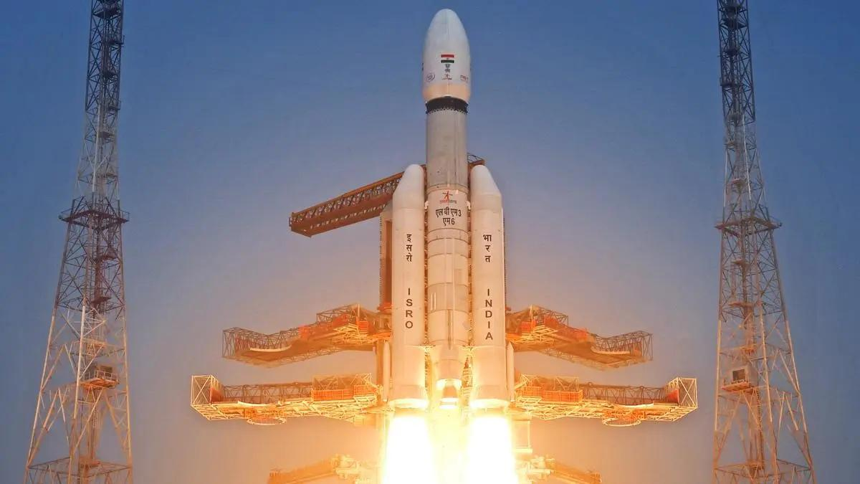
Published : Aug 29, 2026 21:02 IST - 8 MINS READ The government is asking ISRO to focus on its hardest missions while allowing the infrastructure and expertise needed for those missions to move out of its control. In August 2026, the Indian National Space Promotion and Authorization Center (IN-SPACe) invited private firms to take over the operation and management of the Rs.986-crore Small Satellite Launch Complex at Kulasekarapattinam, a spaceport ISRO itself designed. According to IN-SPACe's Expression of Interest (EoI), the winning operator will run launch campaigns, handle safety and security, and manage mission readiness across the 2,233-acre site. ISRO's role during the transition is limited to technical guidance-for up to a year or three launch campaigns, whichever comes first, per the EoI's terms. A few weeks earlier, the Department of Space had issued a memorandum, dated July 14, pulling back a 2020 reform, after ISRO centres had been approving resignations from scientists on mission-critical projects as a matter of routine. It would be wrong to call these two decisions part of one coordinated policy. Nothing in the public record shows they were planned together, and this piece is not claiming that. But they came from the same government within weeks of each other. Put side by side, they show ISRO giving up infrastructure it built while it loses the people who built it. Union Minister of State (Independent Charge) for Science and Technology Jitendra Singh, who holds charge of the Department of Space, has addressed the resignations directly. In July, he told reporters the exits were for "administrative reasons, so that the decision can be taken at a much more mature level." He said ISRO's workforce was large enough that "many have gone, many have come," and that there was "no controversy" in the matter. ISRO Chairman V. Narayanan made much the same case, calling attrition "part of every organisation". That framing does not hold up well against who actually left. The departures named in reporting include Victor Joseph, LVM3 project director; the SpaDeX project director at the U R Rao Satellite Centre; and Aditya Rallapalli, the Chandrayaan-3 scientist who led the simulation team that validated the spacecraft's lunar landing sequence. Calling this routine turnover means treating decades of mission-specific technical judgement as interchangeable with any other exit. The memorandum itself does not sit well with "no controversy" either. It exists because centre directors were approving resignations, including from staff linked to Gaganyaan, fast enough that the Department of Space decided to take that approval power back for itself. Retired ISRO officials have questioned what the Kulasekarapattinam handover actually asks of a private operator. Official language describes launch as facility upkeep and logistics. But one senior former ISRO official told The Federal that "launch is a professional activity where safety is paramount and must be a state activity". The same report raised a pointed question. Does IN-SPACe, a regulator set up to authorise and promote private space activity, actually have the power to transfer ISRO-built assets and technology to a private company? Or has it started acting as an asset-divestment channel instead? Neither the Department of Space secretary nor the IN-SPACe chairman responded when The Federal put that question to them. On a facility built with close to Rs.1,000 crore of public money, that question still has no answer on record. ISRO's launch record rests on a chain of command that answers to Parliament, not shareholders. A private operator's incentives run toward turnaround time and contract renewal, not the slower, costlier caution that the record depends on. What that trade costs, in risk or in money, has not been quantified by the government in anything made public so far. There is a second problem, separate from safety. Once a private company runs the pad, it is not bound in the same way that ISRO is to answer Parliament questions or face a CAG audit. If something goes wrong under a private operator, working out who is responsible and getting a straight answer about it gets harder than it is today. That is how oversight tends to work once an activity moves out of a government department and into a company. Cost of the exodus According to figures reported across national media and attributed to ISRO sources, between 100 and 120 scientists resigned from ISRO in the months before the July memorandum. Close to 80 left the U R Rao Satellite Centre in Bengaluru, and at least 20 left the Vikram Sarabhai Space Centre in Thiruvananthapuram. Parliament has been told that more than 650 scientific and technical staff have left ISRO over the past five years, and that the organisation is currently short of more than 1,600 sanctioned posts. Across the wider Department of Space, according to the department's workforce data reported in July 2026, staff strength stands at 14,637 against a sanctioned 20,269-a fill rate of about 72 per cent, the lowest in twenty-five years. The 2023 Indian Space Policy narrowed ISRO's mandate toward research, deep-space work, and human spaceflight, and pushed routine manufacturing and commercial launch outward. It came with no measure on compensation parity or retention. The scientists who left were not doing the routine work the policy meant to hand off. They were leading the docking mission, the human-rated launch vehicle programme, the Chandrayaan landing simulations. Two of the named departures this year were attached to Gaganyaan-adjacent work. According to ISRO's own public statements, ISRO is targeting the uncrewed Gaganyaan G1 flight, carrying the Vyommitra half-humanoid, by the end of 2026, after the mission slipped repeatedly from an original 2020 target. Every slip since 2020 has lined up with the years India's private space policy moved fastest. Nobody has proven cause and effect there. But the timing lines up, and the government has not addressed it while calling the resignations routine. According to the Union Budget 2026-27, India's Department of Space budget is Rs.13,705.63 crore. Within it, NewSpace India Limited's (the commercial arm of ISRO) allocation rose from Rs.1,030 crore to Rs.1,403 crore. That money went toward the commercial arm, not toward retention for ISRO's core scientific staff. Whether it should have gone differently is a fair question. It is just not one the numbers alone can settle. This is where the government's own numbers work against it. Jitendra Singh, the same minister who calls the resignations routine, has also said India's space economy is expected to grow from $8.4 billion to $44 billion by 2033, largely on the back of private companies. Most of those private companies are staffed by people who trained at ISRO first. If ISRO keeps losing its senior engineers, the same pool the private sector draws from gets shallower too. The government cannot treat the resignations as a footnote and also expect the private sector to carry a five-fold jump in the space economy on the strength of people ISRO trained and is now losing. NASA's Commercial Orbital Transportation Services programme, which ran from 2006 to 2013, is the usual comparison. Private industry delivered two launch vehicles and two cargo spacecraft for about $800 million, against the $12 billion NASA spent developing Orion. NASA kept its safety-certification authority and its systems-engineering bench throughout, using milestone-based partnerships instead of simply handing capacity over. As the EoI cited above makes clear, ISRO's involvement doesn't end at signing: the department is to provide technical guidance and training for up to a year or three launch campaigns, whichever comes first. But that support is a transition window, not a certification regime. There is no certification authority written into the handover, no retention package for ISRO's scientific staff, and no public word on where liability sits if a privately managed pad has an accident. That is what the Commercial Off-The-Shelf (COTS) comparison actually shows. India has not copied a flawed model so much as it has not yet published the safeguards that model relied on. The government's case is that ISRO doing less clears room for it to do the hardest work better: Gaganyaan, deep space, human-rating. The resignation and vacancy numbers point the other way. The roles ISRO has lost are concentrated in exactly the work its narrower mandate was supposed to protect. Jitendra Singh's "no controversy" line answers whether there is a scandal. It does not answer whether the institution can still do what its mandate says it should, or whether the private sector he is counting on can grow the way he says it will without the people ISRO just let walk out the door. Amit Kumar is a data analyst based in Bangalore who writes on policy, politics, and technology. Also Read | Space flights, nuclear power and a missile shield Also Read | The mega AI bubble

68. ISRO's EOS-05 Launch to take place on September 4, 2026; Check time, location and how to watch it live - Moneycontrol.com
Read more
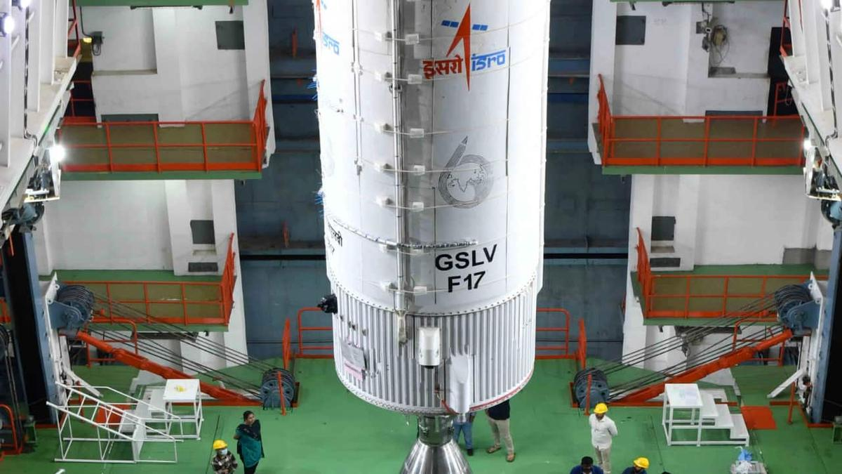
ISRO is preparing to launch EOS-05, also known as GISAT-1A, aboard GSLV-F17 on September 4, 2026. (Image: ISRO) ISRO to launch EOS-05 (GISAT-1A) Earth Observation satellite. Satellite for high-resolution imaging & disaster monitoring. Launch scheduled for Sept 4, 2026, via GSLV-F17. Did our AI summary help? Market Mastery Webinar by Vishal Malkan Find the weak links in your portfolio by Vishal Malkan Register for FREE Webinar Register for FREE India is preparing for another significant Earth Observation mission with the launch of EOS-05 (GISAT-1A) scheduled by Indian Space Research Organisation (ISRO). The satellite is meant for high resolution imaging of the Indian subcontinent and could be very useful in monitoring cyclones, floods and forest fires. Now, the mission is in a critical condition with the rocket GSLV-F17 shifted from the Vehicle Integration Centre (VIC) to the Second Launch Pad at Sriharikota ahead of its take-off. What is ISRO planning? ISRO is readying itself for the launch of the 2,367-kilogram EOS-05 satellite on board the 51.7-metre GSLV-F17 rocket. The satellite is an earth observation satellite able to collect high-resolution images. ISRO eyes major comeback: EOS-5 'Hawk's Eye' satellite set for September 4 launch to watch over Indi... Gurpreet Singh

69. ISRO in final preparations phase for GSLV-F17 mission - DT Next
Read more
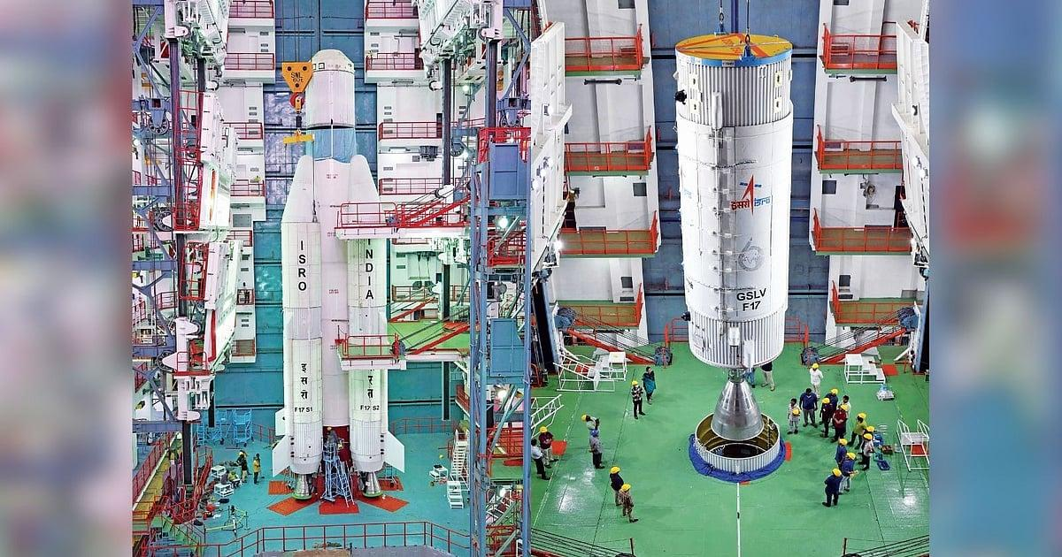
The GSLV-F17 was moved to the Second Launch Pad (SLP) around 8 pm. The mission is scheduled for launch on September 4 and will place the 2,367-kg EOS-05, also known as GISAT-1A, into a Sub-Geosynchronous Transfer Orbit (SubGTO). The orbit will have a perigee (closest point to Earth from satellite) of 170 km and an apogee (highest point from the satellite) of 28,934 km. EOS-05 is a civilian and strategic Earth observation satellite designed to provide frequent, near-real-time imagery of large areas of the country. It is being launched as a replacement for EOS-03, also known as GISAT-1, which was lost during the failed GSLV-F10 mission on August 12, 2021. The GSLV-F10 mission failed because of a technical anomaly in its cryogenic upper stage. While the first and second stages performed normally after lift-off, the cryogenic engine in the third stage failed to ignite, resulting in the loss of the EOS-03 satellite.

70. Isro is hiring for Scientist, Engineer 'SC' posts, apply for 176 vacancies by Sept 16 - India Today
Read more
The Indian Space Research Organisation (ISRO) has announced recruitment for 176 Scientist/Engineer 'SC' posts across its centres and the Physical Research Laboratory (PRL). Eligible engineering graduates can apply online through the official ISRO recruitment website, isro.gov.in, until September 16, 2026, by 11:55 pm. The recruitment drive is aimed at young engineering professionals looking to build a career in India's space and research programmes. The posts are classified under Group 'A' and carry Level 10 pay in the pay matrix. VACANCY DETAILS Of the 176 vacancies announced, Electronics accounts for the highest number with 100 posts, including 99 positions across ISRO centres and one at the Physical Research Laboratory (PRL). This is followed by 53 vacancies in Mechanical, with 52 posts in ISRO centres and one in PRL, while Computer Science has 23 posts, including 21 in ISRO centres and one in PRL. The recruitment offers engineering graduates an opportunity to work on a range of programmes, projects and research initiatives undertaken by ISRO and its associated establishments. ELIGIBILITY CRITERIA Candidates applying for the ISRO Scientist/Engineer 'SC' posts must hold a BE, BTech or equivalent degree in the relevant engineering discipline. Applicants for Electronics positions should have a degree in Electronics and Communication Engineering, while those applying for Mechanical and Computer Science posts must have the corresponding engineering qualification. Candidates must also have secured at least 65% marks or a CGPA of 6.84 on a 10-point scale. The upper age limit is 28 years as on September 16, 2026, with age relaxation applicable to eligible reserved-category candidates, ex-servicemen, Central Government employees and PwBD applicants as per the rules. DIRECT LINK TO CHECK OFFICIAL NOTICE SELECTION PROCESS The ISRO Scientist/Engineer 'SC' selection process will consist of a computer-based written test followed by a personal interview. The written exam, to be held in 37 cities across India, will carry 100 marks and comprise two parts. Part A will include 80 discipline-specific objective questions to be attempted in 90 minutes, with one-third mark deducted for each wrong answer. Part B will consist of up to 15 aptitude-based questions carrying 20 marks, with 30 minutes allotted and no negative marking. Candidates will be shortlisted for the interview in a 1:5 ratio based on their written-test performance. The interview will carry another 100 marks and assess technical knowledge, communication skills, general awareness and academic background. Unreserved candidates must secure at least 50 percent marks in the interview and 60 percent overall. The final merit list will be prepared by giving equal 50 percent weightage to the written test and interview. Engineering graduates who meet the eligibility requirements should complete their applications before the September 16, 2026 deadline at 11:55 pm. Candidates are advised to carefully check the official recruitment notification for discipline-wise requirements, age relaxations, fee-refund provisions and other conditions before submitting the form. A CHANCE TO JOIN INDIA'S SPACE PROGRAMME With 176 Scientist/Engineer 'SC' vacancies across Electronics, Mechanical and Computer Science, the recruitment drive offers eligible engineering graduates a significant opportunity to enter one of India's premier scientific organisations. Candidates who clear both stages of the selection process can look forward to a career contributing to ISRO's space, engineering and research missions. - Ends

71. NASA's Roman Space Telescope is ready for launch aboard SpaceX Falcon Heavy rocket
Read more
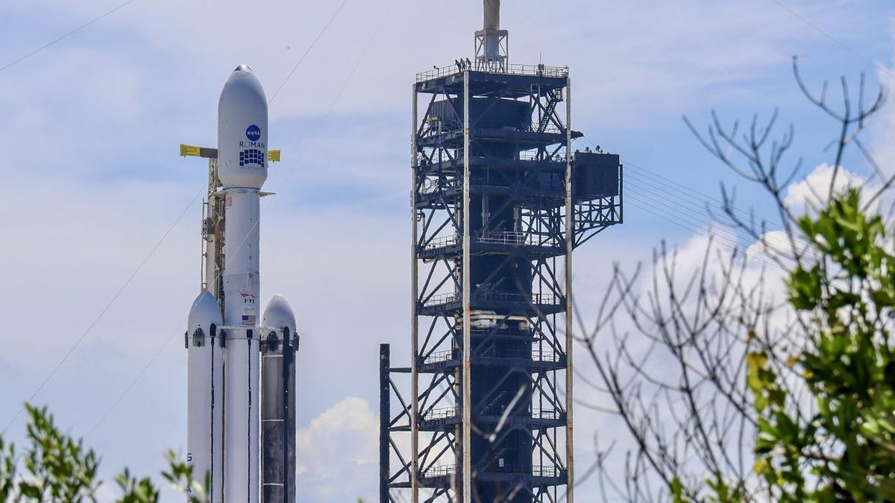
Click for next article A new flagship observatory is about to launch to space and join the ranks of its powerful predecessors, like the Hubble and James Webb space telescopes. NASA's groundbreaking new Nancy Roman Grace Space Telescope is ready to lift off aboard a SpaceX Falcon Heavy rocket. It's scheduled to depart from Launch Complex-39A at NASA's Kennedy Space Center in Florida, bound for a gravitationally stable spot in space called Lagrange Point 2, or L2, nearly 1 million miles (1.6 million km) from Earth . The spacecraft's first window for launch is tomorrow (Aug 30) at 7:26 a.m. EDT (1126 GMT). Mission managers and launch administrators held a prelaunch briefing on Saturday (Aug. 29), confirming NASA and SpaceX's "go" to proceed toward tomorrow's lift off. Weather tomorrow currently poses a 50% chance of favorable launch conditions, according to launch weather officer Justin McReynolds of the Space Force 's 45th Weather Squadron. Roman's final L2 destination will place the spacecraft in a persistent position on the opposite side of Earth from the sun . "That means that we have a wide open view of the sky that really exceeds anything in low Earth orbit like Hubble could achieve," Jackie Townsend, Roman's project manager, said during the press conference. Once in space and operational, Roman will begin completing wide surveys of the entire universe, taking thousands of images every day. The telescope will also allow for new research into dark matter and dark energy , and it will directly image exoplanets around distant stars . "Nancy Grace Space Telescope will blow your mind. It is the size of a tour bus, and it weighs the same as a T-Rex," Nicky Fox, associate administrator for the Science Mission Directorate at NASA, said during the press conference. "To put it into perspective, it will be as if Hubble and James Webb kind of peer through a keyhole at the universe , while Nancy Grace Roman will kick the door down." Fox also put Roman's scientific potential in further context, saying its enormous datasets could help researchers tackle some of astronomy 's biggest questions. "Roman's data will help bring us closer than ever to answering humanity's most profound questions," Fox said, including whether "there are other solar systems like ours" and, ultimately, "are we alone in the universe?" Before any of that science begins, however, Roman first has to get off the ground - and weather remains the biggest uncertainty for Sunday morning. McReynolds said forecasters are primarily watching offshore cumulus clouds , and the possibility of those producing showers or thunderstorms. Conditions improve for the backup opportunities Monday and Tuesday, McReynolds said. The tropical disturbance influencing Sunday's forecast is expected to move west, dropping the probability of weather violating launch criteria to about 30% - offering a 70% chance of acceptable conditions. Once in space, Roman will spend roughly three months going through instrument deployments, calibrations and checkout activities as it travels toward its operational orbit around L2. NASA expects the observatory's first science images to be released in early 2027.

72. On this day in space! Aug. 29, 1965: NASA's Gemini 5 breaks spaceflight duration record after 2 astronauts spent '8 days in a garbage can'
Read more

Click for next article On Aug. 29, 1965, two NASA astronauts returned from their record-breaking Gemini 5 mission . Astronauts Gordon Cooper and Pete Conrad spent eight days in Earth orbit, and for the first time, the United States set a world record for the duration of a crewed spaceflight. The Gemini 5 mission launched on Aug. 21, 1965 atop a Titan II rocket from what was then the Cape Canaveral Air Force Station (now the Cape Canaveral Space Force Station ) in Florida. While in orbit, the astronauts were supposed to test rendezvous capabilities and maneuvers using a pod that deployed from their spacecraft. But due to an electrical problem, they had to cancel those plans along with several science experiments. Pete Conrad later called the mission "eight days in a garbage can," referring to the cramped quarters of the Gemini spacecraft . Why it mattered NASA Astronauts Gordon Cooper and Pete Conrad exit their spacecraft after splashdown of the Gemini 5 spacecraft on Aug. 29, 19. They are photographed boarding a life raft with the help of Navy divers. (Image credit: NASA) Human spaceflight was still pretty new in 1965 when NASA's Gemini program was in full swing. The first crewed launch was just four years earlier, when Soviet cosmonaut Yuri Gagarin orbited Earth for just 108 minutes on Vostok 1. By 1965, NASA's longest mission had run just 4 days, but the space agency needed missions at least twice as long if it was to send astronauts to the moon and back under Project Apollo . Astronauts Gordon Cooper (left) and Charles Conrad are seen in the Gemini 5 spacecraft just before launching on their 8 Days or Bust mission in 1965. The crew was also the first to design and wear a mission patch, as shown. (Image credit: NASA/Museum of Flight/collectSPACE.com) That brings us to the Gemini 5 mission, which NASA envisioned as an endurance test to prove that astronauts could survive for eight days on a long trip to the moon and back. Cooper commanded the flight with Conrad as pilot. (Their backup crew included future Apollo 11 moonwalker Neil Armstrong and Elliott See, both rookies at the time.) It was Cooper who designed the Gemini 5 mission patch , which featured a Conestoga wagon and the words "8 Days Or Bust," to celebrate the flight's endurance run. It was a cramped flight, but the astronauts proved the human body could live and work in space for an extended time, setting the stage for even longer flights to follow. Gemini 5 pilot Pete Conrad takes pictures of predetermined land areas during visual acuity experiments over Laredo, Texas while in orbit on the record-setting mission in 1965. (Image credit: NASA) It was a fuel cell oxygen tank pressure issue that forced the crew to scrap their planned rendezvous demonstration, NASA has said . While the rendezvous target was deployed as planned and tracked by radar, Mission Control called the demo off when the pressure glitch occurred because the fuel cells were key to power Gemini 5 for its full 8-day mission. Cooper and Conrad powered down non-essential systems to conserve power on the flight. They also weathered some thruster failures on the fifth day of the mission, but a "drift-and-correct" workaround allowed the mission to continue. They also performed Earth observatoin and medical experiments during the flight. Amazing photos from NASA's Gemini 5 mission Amazing photos from NASA's Gemini 5 mission When the Gemini 5 crew splashed down in the Atlantic Ocean on Aug. 29, they broke the previous space endurance record set by Vostok 5 cosmonaut Valery Bykovsky, who spent nearly 5 days in space in 1963. "Although both had lost weight, they were in good physical condition after their record-breaking eight days in space," NASA wrote of the crew's condition. Today, an 8-day mission may seem quaint, given that astronauts and cosmonauts have spent over a year in space . The longest single spaceflight lasted 437 days and was set between 1994 and 1995 by Russian cosmonaut Valeri Polyakov on the Mir space station . You can see the Gemini 5 space capsule today at the Space Center Houston near NASA's Johnson Space Center in Houston. Want more space history? Check out our full On This Day In Space Story archive and watch our On This Day In Space videos on YouTube .

73. Meeting Nancy Grace Roman: What was the 'mother of Hubble' really like?
Read more

Click for next article Nearly a decade ago, I found myself laughing alongside one of the most iconic women in astronomy. This week, a telescope bearing her name launches to the stars . So let's travel back in time and meet Nancy Grace Roman together. Standing under a tent in Washington D.C. at the 2017 inaugural "March for Science," a hodgepodge of scientists and reporters crowd together as the rain pours down outside. "That's Nancy Roman," I hear Bill Nye whisper to me as we stood on the outskirts of the tent. And as I struggled to keep my cool next to one of my childhood heroes, here he is pointing out another. Looking across the room, I see her. There, in the corner of the tent, a woman with white hair wearing a "science not silence" pin sits by herself, soaking in the scenery. I hadn't noticed her before as, with the noise and crowd, it was tough to notice much of anything. But Bill was right. There she was, the "mother of Hubble." The woman who pioneered astronomy at NASA and pushed space science into the future. A quick catch-up If you're not too familiar with Nancy, let's speed run a little bit of information about the woman whose name was chosen to represent NASA's latest space telescope. Nancy Grace Roman, born in 1925, was a pioneering astronomer and the first chief of astronomy at NASA. In creating and leading NASA's astronomy program, she was also the first woman in an executive position at the agency. She earned the nickname "mother of Hubble," because of the critical role that she played in realizing the Hubble Space Telescope. She spent all 93 of her years exploring the universe. Portrait of American astronomer Nancy Grace Roman at NASA's Goddard Space Flight Center in Greenbelt, Maryland in the early 1970s. (Image credit: NASA/Interim Archives/Getty Images) Meeting Nancy Grace Roman Now, in this moment I'm already overwhelmed meeting Bill Nye for the first time. Unsurprisingly, I was a science-obsessed 90s kid who would wait my turn at the computer just to explore the lab in the Bill Nye CD-ROM game. But now, all of a sudden I'm also made aware that this woman who paved the way for modern astronomy is just sitting right there, mere feet away from me across the tent. And I knew I had to say hello. So, walking over, I introduced myself. "Hi, it's so nice to meet you," I offer, reaching out my hand to shake hers, unsure of what else to say. "I'm a bit starstruck." And without missing a beat, she responds: "You know, I have a thing for stars," delivering the quip with a small laugh and a bright sparkle in her eye. She holds my hand for a moment and we smile and giggle together. It's so brief, maybe just a few seconds, but for that moment I shared a cheeky inside joke with one of history's most important astronomers. But just as the moment passes, I once again see Bill Nye, this time accompanied by NASA astronaut Leland Melvin, walking up to greet Nancy. Image 1 of 3 Bill Nye whispers something to Nancy Grace Roman. (Image credit: Chelsea Gohd/Space.com) Leland Melvin shakes Nancy Grace Roman's hand while Bill Nye stands nearby. (Image credit: Chelsea Gohd/Space.com) Bill Nye with Space.com's Chelsea Gohd. (Image credit: Chelsea Gohd/Space.com) Image 1 of 3 View Original Image 2 of 3 View Original Image 3 of 3 View Original The pair are both incredibly accomplished icons in their own right. But in approaching Nancy, it was clear that I wasn't the only one starstruck. One by one, Bill and Leland leaned down and shared their own personal moments with Nancy, holding her hands just as I did and speaking with her in hushed tones as their eyes lit up with the same delight that I felt in mine. Time seemed to stand still as the two spoke to Nancy; two legends in space and science meeting their own science hero. And just standing nearby, I felt the love and admiration for Nancy, whose impact on astronomy will be felt for many years still to come. This entire meeting took place over the course of mere minutes. But still, 9 years later it sticks in my memory. About one year after this event, Nancy passed away at the age of 93. And today, her legacy lives on in Hubble, in the trail she blazed forward in astronomy and for women in science and now in the space telescope bearing her name.

74. Who was Nancy Grace Roman? NASA's next big space telescope is named after the 'Mother of Hubble'
Read more
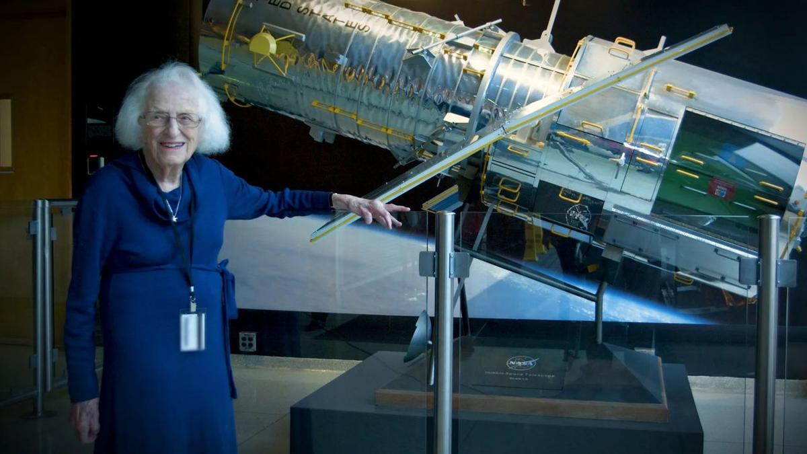
Click for next article Nancy Grace Roman stands next to a scale model of the Hubble Space Telescope outside the Hubble control center at NASA's Goddard Space Flight Center in Maryland. Roman is known as the "Mother of Hubble." The Nancy Grace Roman Space Telescope is about to launch on an incredible adventure to help scientists explore the great mysteries of the universe. But who was Nancy Grace Roman? You might have heard about the upcoming launch on Sunday morning (Aug. 30), which will send NASA's next flagship space telescope up to investigate everything from dark matter and dark energy to far-off worlds beyond our solar system. But do you know who the telescope is named for? This observatory will be an absolute powerhouse for astronomy, and its namesake is perfectly fitting. Nancy Grace Roman was the first-ever chief astronomer at NASA and the agency's first female executive. She created NASA's space astronomy program in 1959, just one year after the agency was created. She laid the groundwork for modern astronomy and played a critical role in making missions like the Hubble Space Telescope happen, a feat that earned her the nickname the "mother of Hubble." In short, Nancy Grace Roman was a trailblazing scientist and leader whose work has made modern space science possible. But let's dig a little deeper. Roman's early years Roman was born on May 16, 1925. Her mother was a music teacher and her father was a geophysicist. Over the years, Roman would often attribute her early interest in science to influence from her parents. "I teasingly have blamed my mother for getting me interested in astronomy, because I can remember up in Michigan she used to take me out at night and show me the constellations and the aurora and things like that. But she also showed me birds and trees and animals and plants and that sort of thing, so it wasn't just astronomy," Roman said in a 1980 interview with David DeVorkin. That conversation took place just a few years after Hubble formally began development and a decade before the space telescope would launch (though at this time, Hubble was still called the "Large Space Telescope"). Roman's passion for astronomy grew, and, at age 11, she started an astronomy club with classmates. In addition to getting her friends involved in her astronomical interests, she spent her time checking out books from her local library in a quest to learn as much as she could. As she put it, she "read everything I could get my hands on." And by junior high, Roman had already decided to become an astronomer. "I can remember thinking, probably in junior high school or early high school days, that I wanted to go into astronomy," she said, adding that her parents were supportive of her early decision to study the stars . At that time, not all colleges even allowed women to apply, so Roman had to look for a school that both accepted women and had a solid astronomy program. She eventually ended up choosing Swarthmore College in Pennsylvania, which she attended through the end of World War II. Roman would go on to graduate school at the University of Chicago, where she studied astronomy and worked at the Yerkes Observatory, where she was the first woman on the academic staff. Nancy Grace Roman briefs Edwin (Buzz) Aldrin on celestial objects in Washington, D.C. in 1965. Aldrin would go on to complete three spacewalks and become the second person to walk on the moon. (Image credit: NASA) Trailblazing at NASA After spending her early-career years at academic institutions, Roman moved on to conduct astronomy research at the U.S. Naval Research Laboratory (NRL). She was building her career observing stars and galactic structure, bouncing radar off the moon , studying orbital mechanics and so much more. Then, in 1959, a new opportunity arose. With her expertise and experience across astronomy, and with NASA just getting up and running, Roman was asked to join the new agency and create its first astronomy program. In stepping into this role, Roman became NASA's first-ever chief astronomer, as well as the agency's first female executive. "The idea of coming in with an absolutely clean slate to set up a program that I thought was likely to influence astronomy for 50 years was just a challenge that I couldn't turn down," Roman told DeVorkin. She added that, when she started NASA's astronomy program, she spent a great deal of time visiting astronomy departments across the country, not just to communicate what NASA was doing but also to understand what astronomers wanted to accomplish with the agency. And it was at the 1959 American Astronomical Society meeting that Roman announced NASA's brand-new astronomy program. While Roman had been heavily involved in research prior to joining NASA, her role expanded considerably when she began heading the agency's astronomy program. In addition to continuing her astronomy research outside of NASA, she was now leading NASA's early space missions. From finding astronomers to join NASA to working alongside engineers to proposing mission budgets and navigating the many convoluted channels of a government agency to make these missions happen, Roman worked across many areas of the field to lead astronomy at the agency. A decade after she joined NASA, Apollo 11 landed the first humans on the moon. So, as Roman pushed for progress in science, crewed spaceflight missions were taking center stage. But Roman and her colleagues fought to continue astronomy at the agency alongside crewed spaceflight. This role required her not only to be an exceptional astronomer but also to understand the political landscape both within and surrounding NASA. Roman realized "the importance of the politics in the scientific community," she said. "We do have to deal with it, even though we would like to make all of our decisions in a vacuum strictly on scientific and technical grounds." 'Mother of Hubble' Roman had a hand in many missions, projects and research fields, and some of the work she did helped change humanity's understanding of the cosmos . The most notable example may be the Hubble Space Telescope. The idea for a "Large Space Telescope" (an early name for Hubble) had been around since the 1940s. But there was heavy skepticism about how feasible it would be - and also how much it would cost. Leading astronomy at NASA, Roman really had to sell the importance of this telescope to Congress to receive the funding necessary to make it happen. She pitched the project, coordinating efforts across NASA to make sure that the message landed on Capitol Hill. "It was Nancy in the old days, before the internet and before Google and email and all that stuff, who really helped to sell the Hubble Space Telescope, organize the astronomers, who eventually convinced Congress to fund it," Edward J. Weiler, Roman's successor as chief scientist for Hubble, told the Voice of America in 2011. Hubble opened our eyes to the cosmos, completely changing astronomy as we know it. The space telescope hasn't just collected incredible data; its images have also given the general public a new appreciation for the beauty and wonder of space. And so, in making Hubble happen, Roman didn't just advance scientific progress in astronomy; she also built an enduring bridge between the public and astronomy that continues to this day. Roman won't get to see her namesake telescope launch into the heavens; she died on Dec. 25, 2018 at the age of 93. But its work will continue the legacy of NASA space science that she worked so hard establish and develop.

75. Roman Space Telescope, NASA's next 'great observatory,' poised for Sunday launch
Read more
Using a donated Hubble-class mirror originally built for a spy satellite, NASA's Roman Space Telescope is poised for launch Sunday on a $4.3 billion mission to open a new window on the universe, taking wide-angle, ultra-sharp images that would require a half million 4K TVs to show in full. Put another way, officials say a single full-resolution image from Roman's 300-megapixel wide-field camera would cover 45 city blocks or the entirety of El Capitan in Yosemite National Park. And it will collect that data faster than any previous NASA spacecraft. The Hubble Space Telescope has beamed back about 172 terabytes of data over 30 years while Roman will downlink a staggering 2,500 terabytes over its five-year primary mission. Put yet another way, Roman's sensitive wide field camera and advanced detectors will scan broad swaths of the cosmos 1,000 times faster than Hubble, collecting as much data in one month as its older cousin could manage in a century. The flood of data is expected to shed new light on the nature of "dark matter, dark energy and the structure of the universe itself and accelerate the … discovery of potentially habitable planets outside our solar system," said NASA Administrator Jared Isaacman. "Roman will give the Earth a new atlas of the universe." Said NASA science chief Niki Fox: "The Nancy Grace Roman Space Telescope is a sheer powerhouse. It is literally a speed machine. The speed at which we'll be scanning the sky, delivering vast amounts of data and returning results will be at an unprecedented rate, never done before." The 42-foot-long 18,000-pound telescope is named for the late Nancy Grace Roman, NASA's first chief astronomer who championed the value of space telescopes throughout her career and was instrumental in the development of the Hubble Space Telescope. As such, she is often referred to as "the mother of Hubble." Spaceflight Now's will live coverage starts about two hours prior to launch. The the new telescope is scheduled for launch atop a triple-core SpaceX Falcon Heavy rocket at the Kennedy Space Center at 7:26 a.m. EDT Sunday. It is bound for Lagrange Point No. 2, a gravitational eddy of sorts about a million miles on the opposite side of Earth from the sun where it will remain in place with a minimal use of fuel. The James Webb Space Telescope is stationed in the same region for the same reason. From the vantage point of L2, Roman will study the effects of dark matter, the mysterious substance that pervades the universe, holds galaxies together and accounts for most of the mass in the cosmos, acting as a brake on the expansion of space itself, which is carrying galaxies farther and farther apart. At the same time, Roman will work to gain statistically significant insights into the nature of the equally mysterious dark energy, a repulsive force presumably present since the Big Bang that became dominant about five billion years ago as the universe expanded and thinned out. Ever since, the expansion of the cosmos has been speeding up. Roman may help resolve a conflict between the strength of dark energy in the very early universe, as measured by probes studying the remnant three-degree glow of the Big Bang's immediate aftermath, compared to Hubble observations of a specific type of supernova that indicate a slightly different value. When the Hubble Space Telescope was launched in 1990, estimates for the age of the universe, from its Big Bang birth to the present, ranged from 10 billion years or so to 20 billion years. Hubble was able to determine the speed of that expansion - the Hubble Constant - and thus the time that has passed since the Big Bang to an accuracy within 1 percent: 13.8 billion years. But detailed studies by researchers using spacecraft studying the afterglow of the bang - the 3-degree cosmic background radiation - came up with a different number. The mismatch - known as "the Hubble Tension" - suggests some critical element is missing in the current understanding of the universe and the forces driving its evolution. "We're seeing evidence that the Hubble constant, as inferred from very early times, is not consistent with the Hubble constant that we measure closer to now, which is telling us that the model that connects those two things might not be quite right," said Project Scientist Julie McEnery. "We have a slight tension in our expectations for how structure should grow and evolve." That "slight tension" indicates a potentially serious flaw in the standard model of cosmology, the current understanding of how the universe, and everything in it, has evolved over time. It might even indicate dark energy is not the constant force it is thought to be, but might somehow change over time. "We're probably not going to confirm the standard model of how the universe works," McEnery said. "We're very likely to demonstrate that our standard model is wrong, and to set ourselves on a path to figuring out how does our universe really work. It's hard to get (a better question than) the fundamental nature of your universe!" Roman's wide-field camera is one of two instruments aboard the spacecraft. The other is an advanced coronagraph equipped with deformable mirrors that can block out the glare of a star to detect the vastly dimmer light reflected from the atmosphere of an orbiting planet. Roman's coronagraph is expected to detect Jupiter-size planets orbiting Earth-like stars. By analyzing that reflected light, researchers may be able to tease out the elemental composition of those atmospheres. "We think that we will be capable of detecting exoplanets that are about 100 million times fainter than their stars, and with that capability, we are hoping to see … a Jupiter twin around a nearby star using visible light reflected from its cloud tops for the first time," said Vanessa Bailey, the Roman coronagraph instrument scientist at the Jet Propulsion Laboratory. "Then, we can use that light to study the composition of its atmosphere." About 6,200 exoplanets have been discovered to date using smaller instruments like NASA's Kepler Space Telescope. Roman is expected to discover more than 100,000 exoplanets over 18 months of observations. It will take three to four months to "commission" the spacecraft, calibrating is instruments and testing its myriad subsystems before science operations can begin in earnest. The solar-powered Roman is built around a 7.9-foot-wide 410-pound primary mirror, one of two that were donated to NASA by the National Reconnaissance Office, the secretive agency that manages many of the nation's high-end spy satellites. The mirrors, the same size as Hubble's, were built for a classified project that later was canceled. But both were ground to near-perfect prescriptions, allowing them to look down and focus on Earth, not out into deep space. NASA has no plans or funding to utilize the second mirror, focusing instead on building a single "flagship" observatory. The donated mirror's curvature, smoothness and polish had to be modified to ensure the desired astronomical prescription and the telescope's trusses and other components had to be altered to enable them to withstand the ultra-low temperatures at Lagrange Point 2. "I think our engineering team thinks of it as we received a set of well tested parts that included highly calibrated optical systems," said Project Manager Jackie Townsend. "But we really had to sort of start over and make it our own to work at our operating temperatures." In the end, the project came in ahead of schedule and under budget. But even with an effectively "free" primary mirror, the telescope will still cost taxpayers some $4.3 billion to build, launch and operate for its five-year primary mission. Three "core" surveys are planned over the course of Roman's planned five-year mission. The High-Latitude Wide-Area Survey will focus on a huge swath of the sky looking out of the plane of the Milky Way - 12 percent of the entire sky - avoiding obscuring star clouds and dust marking the galactic disk. The goal is to catalog the distribution of a billion or more galaxies. Those data, collected over 520 days, will help researchers better understand how dark matter and energy have combined over cosmic time to drive the evolution of structure in the universe. The High-Latitude Time-Domain Survey will require 180 days of observations over two years. The telescope will repeatedly image the same regions in an area of 90 full moons to make movies capturing short-duration events ranging from supernova blasts to the radiation emitted when stars fall into black holes. McEnery described such transient events as "things that go bump in the night." The Galactic Bulge Time-Domain Survey will focus on the core of the Milky Way, the central bulge of stars, gas and dust where a supermassive black hole affects the trajectories of nearby stars. Imaging across an area spanning 8.5 fill moons, Roman is expected to find tens of thousands of exoplanets by watching hundreds of millions of stars and looking for signs of "microlensing," a phenomenon in which the light of a background star is enhanced, or magnified, by the gravity of an intervening object. Mission managers have also left room for "general astrophysics" topics not covered in Roman's three core surveys. The first such program, known as the Galactic Plane Survey, will monitor the disk of the Milky Way from one side to the other covering an area of 3,455 full moons. Some 20 billion stars will be mapped along the way, providing the most complete portrait of the galaxy and its structure ever captured. "What makes me most excited about Roman is the discovery potential," McEnery said. "With two billion galaxies, we'll have two thousand objects that are one in a million. We'll be exploring patches of sky as a function of time with exquisite sensitivity. We'll find new things that go bump in the night. "I very much hope, and in fact expect, that the most exciting science from Roman will be a surprise, something we couldn't predict. And that will set the stage for the next deeper set of questions for future missions to address."

द्वारा अभिकल्पित एवं संकलित
DESIGNED & COMPILED BY:
पुस्तकालय एवं सूचना संसाधन प्रभाग
Library & Information Resources Division, IIRS (ISRO), Dehradun
अस्वीकरण | Disclaimer:
सभी लेख / सूचनाएँ सार्वजनिक डोमेन में उपलब्ध हैं तथा केवल सूचना एवं सामान्य जागरूकता के उद्देश्य से
इंटरनेट से संकलित की गई हैं。
All the articles / information are available in public domain and are taken from
Internet for information & general awareness only.

