 |  | 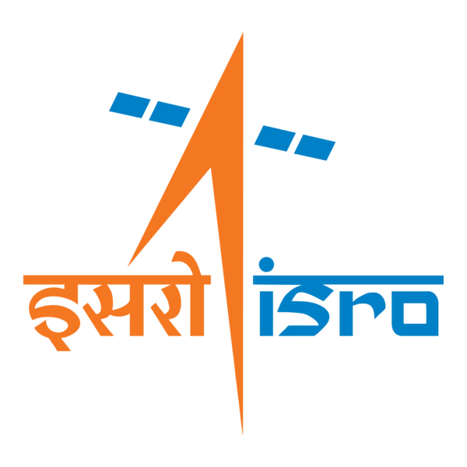

🌌 अंतरिक्ष समाचार | Space News
गुरुवार, २९/१०/२०२६ | Thursday, 29/10/2026

1. GSLV-F18/NVS-03 MISSION - ISRO
Read more
GSLV-F18/NVS-03 MISSION ISRO

2. Isro to launch NVS-03 on Oct 30, but NavIC has a long way to go - The Times of India
Read more
Isro to launch NVS-03 on Oct 30, but NavIC has a long way to go The Times of India

3. ISRO to launch NVS-03 navigation satellite aboard GSLV rocket on October 30; how to watch live - Starlust.org
Read more
ISRO to launch NVS-03 navigation satellite aboard GSLV rocket on October 30; how to watch live Starlust.org

4. Isro to launch NVS-03: What it means for India's NavIC navigation system - Business Standard
Read more
Isro to launch NVS-03: What it means for India's NavIC navigation system Business Standard

5. Aishwarya Rajinikanth visits Tirumala; ISRO announces satellite launch - The News Mill
Read more
Aishwarya Rajinikanth visits Tirumala; ISRO announces satellite launch The News Mill

6. ISRO to launch NVS-03 satellite on October 30 - The Hindu
Read more
ISRO to launch NVS-03 satellite on October 30 The Hindu

7. Caltech Names Artemis II Commander Reid Wiseman as NASA JPL Deputy
Read more
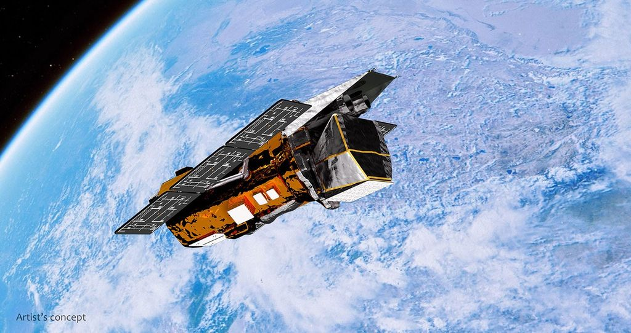
Former NASA astronaut and Artemis II Commander Reid Wiseman joins Caltech and NASA JPL as Caltech associate vice president and JPL deputy director on Nov. 30. Photo Credit: NASA Artemis II Commander Reid Wiseman has been named Caltech associate vice president and deputy director of NASA's Jet Propulsion Laboratory in Southern California. The emeritus astronaut and retired U.S. Navy captain begins his new role at NASA's center of excellence for robotics and deep space exploration and at Caltech, which manages JPL for NASA, on Nov. 30, 2026. "Reid has spent his career at the edge of what is possible, and he has the technical judgment, operational experience, and leadership to help push that edge farther," said NASA Administrator Jared Isaacman. "As commander of Artemis II, he helped carry America back around the Moon, and now, as an emeritus astronaut, he will continue giving back to NASA from a new vantage point at JPL. Reid is joining a storied laboratory that has made an enormous amount of history, and there is a lot more ahead. I am excited to see what he and the JPL team accomplish in the years to come." During the Artemis II test flight, Wiseman, Victor Glover, Christina Koch, and Jeremy Hansen journeyed 695,081 miles on a lunar flyby that took them farther than any humans have ever traveled before. "It feels fitting for Reid, who with the Artemis II crew traveled farther from Earth than any human in history, to join Caltech and JPL - institutions that for nearly 90 years have sent spacecraft into the far reaches of our solar system and beyond," said Dave Gallagher, JPL director and Caltech vice president. "Reid shares our drive for discovery, knows what it takes to lead teams through high-stakes missions, and has a remarkable ability to inspire people everywhere. He adds incredible bench strength to our leadership team as we build on the lab's legacy and shape its future together." After joining NASA's astronaut corps in 2009, Wiseman went on to serve as flight engineer aboard the International Space Station for the 165-day Expedition 41 mission in 2014 and was a commander of NASA's 21st Extreme Environment Mission Operations expedition, during which he lived for eight days in a habitat on the ocean floor in 2016. As the agency's chief astronaut from December 2020 to November 2022, Wiseman led NASA's astronaut corps, overseeing crew flight readiness and crew safety for all NASA human spaceflight missions. During his years of service at the agency, he has conducted hundreds of scientific experiments. "I've explored the furthest reaches of what a human can explore at NASA - and there were truly no words in the English vocabulary to describe seeing the Sun disappear behind the Moon from deep space. But that experience was really the jumping off point to go do the impossible things that Caltech and JPL dream, dare together, and do for NASA and the nation," Wiseman said. "What an awesome time in my career to join this team and to try and push humanity and push our understanding of the solar system and the universe." Wiseman joins JPL, NASA's only federally funded research and development center, as the lab approaches its 90th anniversary since being founded by Caltech. In his role as Caltech's associate vice president and JPL deputy director, Wiseman will be responsible for the strategic leadership, stewardship and continuous improvement of laboratory operations, including close partnership with Caltech on institutional planning, management and compliance. Serving as Center Management Authority for JPL mission execution, Wiseman will ensure operational excellence across mission support functions in accordance with NASA requirements and applicable federal and state regulations. In addition, he will be JPL's primary interface for national security programs. "Reid brings to Caltech and JPL a truly unprecedented view of what humanity can achieve when ingenuity and determination are matched with the courage to pursue the furthest frontiers," said Caltech president Ray Jayawardhana. "His pioneering spirit coupled with unbounded curiosity make him a natural fit for Caltech and JPL, a force-multiplier for a community whose daring continues to push the limits of humanity's reach. I look forward to working closely with Dave and Reid as we chart our next era of exploration in partnership with NASA, elevating America's space ambitions to breathtaking new heights." After receiving a bachelor's degree in computer and systems engineering from Rensselaer Polytechnic Institute, Wiseman joined the Navy, going on to fly combat missions and serve as a test pilot. He also has a master's degree in systems engineering from Johns Hopkins University in his hometown of Baltimore. -end- Media Contact Matthew Segal Jet Propulsion Laboratory, Pasadena, Calif. 818-354-8307 matthew.j.segal@jpl.nasa.gov 2026-077

8. NASA Welcomes Vietnam as Newest Artemis Accords Signatory
Read more
Credit: NASA The Socialist Republic of Vietnam became the 78th nation to sign the Artemis Accords, joining a growing coalition of like-minded nations committed to the peaceful, transparent, and responsible exploration of space. "Vietnam is joining at an important point in the development of its own space program," said NASA Deputy Administrator Matt Anderson in recorded remarks for the ceremony. "NASA and the Vietnam National Space Center have built momentum in satellite innovation, land-use research, and radar-based Earth observation. Joining the Artemis Accords opens a new chapter in that relationship. We've aligned on the principles. The opportunities are in front of us, and now we can build on that foundation together. We are proud to welcome Vietnam to the Artemis Accords community." Vietnam's Minister of Science and Technology Vũ Hải Quân signed the Artemis Accords on behalf of the country during the Vietnam International Digital Week in Ha Long. The United States Ambassador to Vietnam Jennifer Wicks also participated in the signing event. Vietnam's decision extends the U.S.-Vietnam Comprehensive Strategic Partnership into a new frontier. Built on more than 30 years of cooperation, the partnership spans defense, economic, law enforcement, war legacy, and technological cooperation, and it advances peace, stability, and prosperity in a free and open Indo-Pacific. Earlier this year, NASA partnered with Vietnam's Vietnamese-German University to support the agency's Soil Moisture Active Passive mission, which measures surface-soil water worldwide. Vietnam also inaugurated its National Space Center in Hanoi and is developing domestic satellite capabilities through the LOTUSat program, focusing on Earth observation, weather monitoring, and disaster response. In 2020, NASA and the State Department joined with seven other founding nations to establish the Artemis Accords, responding to the growing interest in lunar activities by both governments and private companies. They introduced the first set of practical principles aimed at enhancing the safety and coordination between nations as they explore the Moon, Mars, and beyond. Signing the Artemis Accords means committing to explore peaceably and transparently, to render aid to those in need, to enable access to scientific data that all of humanity can learn from, to ensure activities do not interfere with those of others, and to preserve historically significant sites and artifacts by developing best practices for space exploration for the benefit of all. More countries are expected to sign the Artemis Accords in the months and years ahead, as NASA continues its work to establish a safe, peaceful, and prosperous future in space. Learn more about the Artemis Accords at: https://www.nasa.gov/artemis-accords

9. Artemis III SLS Core Stage Joins Boosters at Kennedy
Read more
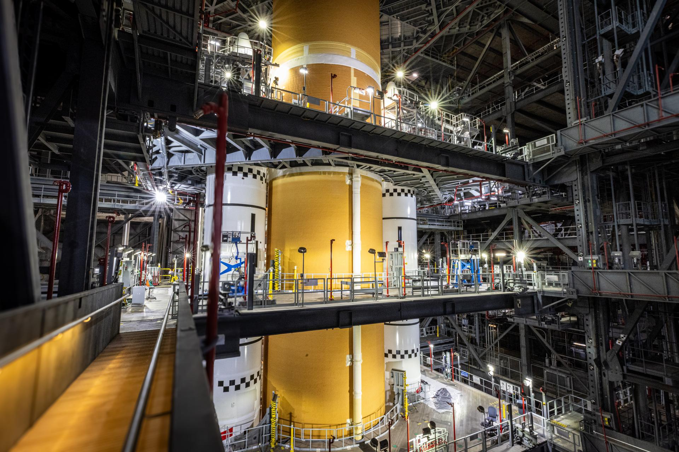
The SLS (Space Launch System) core stage is lifted from the transfer aisle of the Vehicle Assembly Building at NASA's Kennedy Space Center in Florida on Thursday, Oct. 22, 2026. NASA/Sean Cannon The SLS (Space Launch System) core stage is lifted from the transfer aisle of the Vehicle Assembly Building at NASA's Kennedy Space Center in Florida on Thursday, Oct. 22, 2026. NASA/Sean Cannon The SLS (Space Launch System) core stage is horizontal in the transfer aisle of the Vehicle Assembly Building at NASA's Kennedy Space Center in Florida on Friday, Oct. 23, 2026. NASA/Cory S Huston The SLS (Space Launch System) core stage is integrated alongside the twin solid rocket booster motor segments on Sunday, Oct. 25, 2026, inside the Vehicle Assembly Building at NASA's Kennedy Space Center in Florida completing its short stack configuration. NASA/Sean Cannon The SLS (Space Launch System) rocket core stage is integrated with the solid rocket boosters for Artemis III in High Bay 3 of the Vehicle Assembly Building at NASA's Kennedy Space Center in Florida to complete its short stack configuration. NASA/Frank Michaux NASA's Artemis III SLS (Space Launch System) core stage is integrated alongside the twin solid rocket boosters on Oct. 28 inside the Vehicle Assembly Building's High Bay 3 at NASA's Kennedy Space Center in Florida. Technicians lifted the 212-foot rocket stage from the facility's High Bay 2 using a one-of-a kind lifting beam designed to place the stage onto the mobile launcher. Once testing and checkouts are complete, teams will roll the core stage and booster stack out to Launch Pad 39B to conduct a tanking test where liquid hydrogen and liquid oxygen fuel will be loaded only into the core stage and launch teams will practice countdown procedures and timelines. The Artemis III mission will launch NASA astronauts Randy Bresnik, Frank Rubio, Andre Douglas, and ESA (European Space Agency) astronaut Luca Parmitano in the Orion spacecraft on top of the SLS rocket to test rendezvous and docking capabilities between Orion and commercial spacecraft from Blue Origin and SpaceX ahead of future mission to land astronauts on the Moon. Photo credit: NASA/Sean Cannon, Cory S Huston, and Frank Michaux

10. NASA University Challenge Ignites Trajectory of Drone Entrepreneur
Read more
Four co-founders of AG3 Labs -from left Matt Atkinson, Gavin Gardner, Ryan Atkinson, and Gryson Gardner - show off the military training drones their company builds at a U.S. Army event at Camp Grayling in Michigan. As a student, Gavin was on a Michigan State team twice selected for participation in NASA's University Student Research Challenge. His NASA experience served as a foundation for the creation of AG3. AG3 Labs Five years ago, Gavin Gardner was a Michigan State University engineering student researching next-generation drone technology as part of a NASA grant. Garder expected the research to be demanding - but he was surprised that navigating the financial side of the work presented an even greater challenge. Although Gardner was used to leading fellow students in a lab setting, he and his team were completely new to things like creating budgets, handling large sums of money, and promoting their work for crowdfunding. That's why demonstrating both engineering and entrepreneurship skills are major tentpoles of NASA's University Student Research Challenge (USRC), an initiative that provides grants to teams of college students interested in helping the agency realize its aeronautical research goals. "Half the battle is building your product," Gardner said recently. "The other half is selling the product in a way that everyone else can understand what you're doing and not talking in nerdy, engineering ways." We hope that every team that participates in the program sees, like Gavin, how they can grow technically, entrepreneurially, and use the opportunity as a launchpad for their own innovative careers. STEVEN HOLZ NASA USRC Manager Gardner and his Michigan State USRC alumni teammates are still using those lessons today, as aerospace developers. In 2024, they founded their own company, AG3 Labs, which specializes in drones for military training exercises. "I don't think I would discredit our technical expertise in getting us to where we are today, but I know that USRC was a booster that really amplified our trajectory at such a young age," Gardner said. NASA USRC manager Steven Holz said Gardner's experience shows what students can accomplish when they receive both a grant and guidance - enabling a future workforce and contributing to the aviation industry. "We are proud to see the success of USRC alumni," Holz said. "We hope that every team that participates in the program sees, like Gavin, how they can grow technically, entrepreneurially, and use the opportunity as a launchpad for their own innovative careers." Research path Gardner's path to running his own company began with a middle school age trip to Space Camp, where he began realizing that he wanted to be an engineer. The engineering bug also bit his brother, Gryson Gardner, and the two of them would often be found in their Michigan garage tinkering with various machinery, including drones and electronic kits. When Gardner arrived at Michigan State, he looked for extracurricular groups and found one dedicated to the increasingly popular hobby of drones. He gained hands-on, practical experience in how drones are made and operated. In 2021, Gardner received an email from a friend who told him they had just won a USRC grant from NASA for an activity called Aerial Intra-city Delivery Electric Drones (AIDED), and they needed help building a new drone. "We had this idea that instead of flying through the whole city, why can't a drone just hitchhike a ride on a city bus like everyone else does?" Gardner said. The concept was for a cargo-carrying drone to take off, dock on top of public transportation such as a bus, charge its batteries while riding along, and then take off for its final leg of the delivery. The team built and flew a full-scale drone to prove the concept but decided against pursuing a commercial venture. "The commercial drone market kind of scared us a little bit with the large number of regulations that go into operating such a novel idea like this with flying over people in a dense city," Gardner said. But the team's demonstration of technical prowess and confidence led to a second USRC award from NASA in 2023 - the Laser Energized Aerial Drone System (LEADS), which focused on using a laser to transfer power directly to a drone in flight. While working on LEADS, which led to flying a prototype, Gardner's network of contacts within the drone community expanded to include NASA personnel at the Glenn Research Center in Cleveland, who made him aware of internship opportunities, which he applied for and was accepted while in graduate school. Gavin Gardner, a University Student Research Challenge participant who went on to co-found his own drone company, also was a NASA intern in 2024 and wrote this social media post. Student challenge paves way for opportunity As his graduation in the spring of 2025 with a master's degree approached, Gardner took the initial steps in late 2024 to co-found with his brother and other USRC alumni AG3 Labs after a friend suggested the military could use low-cost drones to test effective counter drone systems. An initial award from the U.S. Army led to more contracts, allowing the company to expand and ramp up its operations, where today their production capability enables thousands of drones to be built each month. Gardner credits his experience with USRC, especially when it came to learning more about the business side of running a technical operation, with helping create the opportunities for success he and his team are experiencing today.

11. NASA Selects 19 New Citizen Science Proposals in 2026
Read more
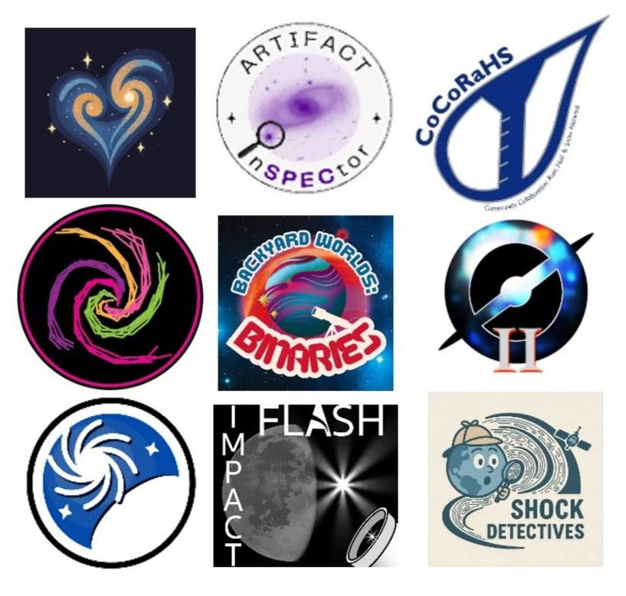
So far, 2026 has seen a flood of successes for volunteers who do NASA science, exemplifying NASA's commitment to gold-standard science-transparent, reproducible and intrinsically collaborative. The Backyard Worlds: Planet 9 project announced that their project volunteers have now discovered most of the known brown dwarfs, celestial objects that are similar to planets. The Zooniverse platform, with grant from NASA, reached a milestone of 1 billion classifications. Several projects have come online that leverage new super intelligence (SI) techniques to amplify or extend the work of volunteers. More NASA volunteers are using SI to build their own data tools and help write scientific papers than ever before. Even with all of those achievements, our science community is already working on the next round of new volunteer projects and innovations. NASA's Science Mission Directorate has selected nineteen proposals from research teams in 2026 that will result in new opportunities for you to do NASA science. The Citizen Science Seed Funding Program The Citizen Science Seed Funding Program (CSSFP-25) of NASA's Science Mission Directorate aims to support scientists and other experts to develop citizen science projects and expand the pool of professional scientists who use citizen science techniques in their science investigations. Twelve new proposals to this program were selected. Astrophysics "The Rogue Worlds Project: Activating volunteers to uncover the hidden population of super Jupiters with SPHEREx" led by Principal Investigator Jacqueline Faherty from the American Museum of Natural History. This project will invite you to search data from NASA's SPHEREx (Spectro-Photometer for the History of the Universe, Epoch of Reionization and Ices Explorer) mission to find free-floating planets and brown dwarfs in clusters of young stars. The SPHEREx space observatory mapping the entire sky in near-infrared wavelengths. "Quantifying the calibrations between intrinsic galaxy merger timescales with visual pair/tidal-feature classifications" led by Principal Investigator Kameswara Bharadwaj Mantha of the University of Missouri. This project will investigate galaxy mergers, helping astronomers understand how galaxies evolve through time. You will be invited to classify realistic mock images of galaxies to help probe the statistics and dynamical evolution of galaxy mergers. "Overlap Zoo; cosmic light tables for galaxy transparency" led by Principal Investigator Benne Holwerda of the University of Louisville. Galaxies, which glow with the light of the billions of stars they contain, also contain dust. This dust is easiest to see and quantify when it overlaps, or is backlit by, another galaxy. Help spot and characterize these rare overlapping galaxy pairs to help reveal how much dust they contain. Overlap Zoo is live! Follow this link to learn more and join the project. "Planet Hunters Roman: Extending Citizen Science to Planetary Microlensing" led by Principal Investigator Bernard Gaudi of the Ohio State University. Exoplanets are planets orbiting stars other than our Sun. Their gravity can bend the light that travels around them. This project will invite you to spot exoplanets in data from NASA's new Nancy Grace Roman Space Telescope data by the way they bend starlight. Heliophysics "Space Weather UnderGround: Deploying a low-cost Magnetometer Array with Citizens for Heliophysics Research" led by Principal Investigator Hyunju Connor at NASA's Goddard Space Flight Center. Along with sunshine, our Sun produces the solar wind, an unrelenting flow of charged particles. Earth's protective magnetic field shield deflects most of these particles, but not all, and not during extreme events. Help scientists monitor the subtle disturbances of Earth's magnetosphere by the solar wind by setting up and monitoring your own magnetometer in Alaska. "A Citizen Science Initiative for Sonified Plasma Wave Characterization" led by Principal Investigator Lauren Blum of the University Of Colorado, Boulder. "Plasma" is the name given to the ionized gases at the edge of Earth's magnetosphere. Solar wind, the rain of charged particles that flows out from the Sun, can interact with and generate waves in the plasma. This project will turn data from this dynamic zone into sound signals. You will be invited to listen in to identify waves in the Earth's magnetosphere. "Revealing the Consequences of Foreshock Transients for Earth's Magnetospheric System Through Participatory Science" led by Principal Investigator Wenli Mo at the Johns Hopkins University. This project will invite you to examine data from NASA's MMS (Magnetospheric Multiscale) mission to identify "foreshock transients," phenomena that have a critical but poorly understood role in space weather. The resulting dataset will help reveal how foreshock transients form, their properties, and their impacts. "IMPACT: Interactive Magnetospheric Particle Analysis and Citizen Technology" led by Principal Investigator Muhammad Fraz Bashir at the University of California, Los Angeles. Energetic particles rain down from the magnetosphere into the upper ionosphere, heating and perturbing the ionosphere, disrupting the scatter of radio waves and GPS operations. This project will invite you to help match patterns between two types of data: measurements from satellites flying overhead that detect energetic particles raining down from space and measurements from ground-based instruments that detect electromagnetic waves. By comparing these patterns, volunteers will help scientists figure out which types of space waves are causing different kinds of particle precipitation, and in turn, help scientists better understand and predict disruptions to GPS and increased radiation risks during space weather events. "Unlocking Clues About Particle Acceleration and Transport Using Particle Distributions" led by Principal Investigator Gang Kai Poh at the Catholic University Of America. NASA's Advanced Composition Explorer, Parker Solar Probe, and Solar Orbiter are complementary missions gathering data to help scientists improve understanding of the Sun, solar wind, and space weather. Examine data from these missions to contribute to the study of the complicated flow of energetic particles from the Sun. "Data Fusion in Space: Combining Citizen Observations to Classify Solar Wind Tracers" led by Principal Investigator Cynthia Lopez-Portela of the University of Maryland, Baltimore County. This project will invite you to use their pattern-recognition skills to spot features in images of the Sun's corona, where the solar wind begins. These features can be used as tracers to help scientists track the movement of the solar wind and build better models of how it behaves. Planetary Sciences "Mapping Lunar Iron Abundance Hotspots to Enable In-Situ Resource Utilization of Regolith Consolidation Technologies" led by Principal Investigator Karen Martirosyan at the University of Texas, Rio Grande Valley. Building a base on the Moon will require creative use of Moon materials. So what materials will future teams of astronaut base-builders have to work with? This project will invite you to help locate iron deposits in data from NASA's Moon Mineralogy Mapper mission to help understand how the Moon formed and to aid future exploration. "Small Body Discovery and Outburst Monitoring with a Worldwide Citizen Science Telescope Network" led by Principal Investigator Ariel Graykowski at the SETI Institute. This project proposes to activate a global network of citizen scientists, each equipped with a standardized small-aperture telescope, to conduct follow-up observation of cometary outbursts and small moving bodies (comets, near-Earth asteroids, and main-belt asteroids). With their global distribution and a program of twilight observations, amateurs will complement professional surveys. The project will develop systems to automate processing of contributed images and to distribute alerts for objects of interest to the network. The Science Activation Program The Science Activation Program (SciAct) from NASA's Science Mission Directorate supports a portfolio of competitively selected, collaborative project teams that extend the impact of NASA science. These "SciAct Teams" accomplish this by connecting people and communities - many of whom would not otherwise meaningfully engage - with NASA science data and experts, local partnerships, and authentic science experiences. Seven teams selected in the latest round of competition will engage learners with citizen science efforts directly related to NASA research priorities. Several other selected teams plan to incorporate citizen science projects or community science projects (research efforts led by and focused on specific communities) into their work. The selected proposals include: "Growing Beyond Earth: Science Activation Through Distributed Space Crop Research" led by Principal Investigator Carl Lewis at Fairchild Tropical Botanic Garden, Inc. To travel or live in space, humans will need to eat. Growing Beyond Earth trains and equips middle- and high-school classrooms to conduct growth experiments with seeds and crops being evaluated for use as space food. "Sungrazer 2.0: From Armchair Discovery to Data-Driven Comet Science" led by Principal Investigator MaryKay Severino of the ARISA Lab and science lead Karl Battams of the Naval Research Laboratory. The original Sungrazer Project launched in 2006 in response to requests from citizen scientists for verification of comet discoveries. Since then, project volunteers have identified 5,204 comets and counting - the majority of known comets. Sungrazer 2.0 will bring the thrill of comet discovery to new audiences who will join the hunt for comets in images from NASA's SOHO (Solar and Heliospheric Observatory) and STEREO (Solar Terrestrial Relations Observatory) missions. "Discovering the SPARC: Space Physics through Amateur Radio Communications" led by Principal Investigator Nathaniel Frissell of the University of Scranton. Since 2017 amateur radio operators have worked together in the Ham Radio Science Citizen Investigation (HamSCI) community to study Earth's ionosphere through carefully designed and conducted investigations of how their signals bounce off this high, ionized layer of Earth's atmosphere. This project will bring hands-on space weather science to communities nationwide through amateur radio equipment and enroll high schools in a national research network. "Telescopes for All: Promoting audience engagement with NASA science via participatory data experiences using robotic telescopes" led by Principal Investigator Mary Dussault of the Smithsonian Astrophysical Observatory. This project will expand public access to a suite of 22 user-friendly, professional robotic telescopes. This access will allow people to observe, analyze, and contribute to NASA-aligned research, including the search and study of exoplanets and other citizen science projects. "Researchers Inspiring Public Participation in Lake Education and Science (RIPPLES)" led by Principal Investigator Sarah Yelton and science lead Tamlin Pavelsky, both at the University Of North Carolina, Chapel Hill. This project will collaborate with the Lake Observations by Citizen Scientists and Satellites (LOCSS) project to expand participation in lake and reservoir level monitoring. Submitted data will be used to validate observations such as those made by NASA's SWOT (Surface Water and Ocean Topography) mission. "ARK (Antarctic Resilience and Knowledge): A Collaborative Network for Discovery and Education of Antarctica's Iconic Species and their Changing Habitats" led by Principal Investigator Sharon Stammerjohn at the University of Colorado, Boulder. This project will invite you to examine NASA's very high-resolution satellite images of Antarctica to study and monitor habitat changes affecting penguin, seal, and whale populations. With validation by scientists and integration of machine-assisted detection tools, this project will expand the analytical capacity of Antarctic researchers and build public literacy in polar ecosystem science. "Arctic Learning and Engagement with NASA Data for Community Solutions (Arctic LENS)" led by Principal Investigator Katie Spellman of the University of Alaska Fairbanks. This project will invite Alaskans to contribute seasonal environmental monitoring (snow, ice, aurora, spring ice-out, and green-up) in support of NASA missions including FORTE (Arctic Coastlines: Frontlines of Rapidly Transforming Ecosystems), SWOT (Surface Water and Ocean Topography), PACE (Phytoplankton, Aerosol, Cloud, ocean Ecosystem), and Landsat. Explore citizen science awards from previous years: For more information on NASA's citizen science programs, visit https://science.nasa.gov/citizen-science. New NASA citizen science projects launched in 2026. Top row, l-r. Galaxy Zoo: Tidal Tails, Artifact Inspector, CoCoRaHS. Middle row. Spiral Graph: Cluster Buster, Backyard Worlds: Binaries, Galaxy Zoo: Clump Scout Two. Bottom row. Overlap Zoo, Impact Flash! and Shock Detectives.

12. Satellites watch an escaping Antarctic iceberg | Space photo of the day for Oct. 28, 2026
Read more
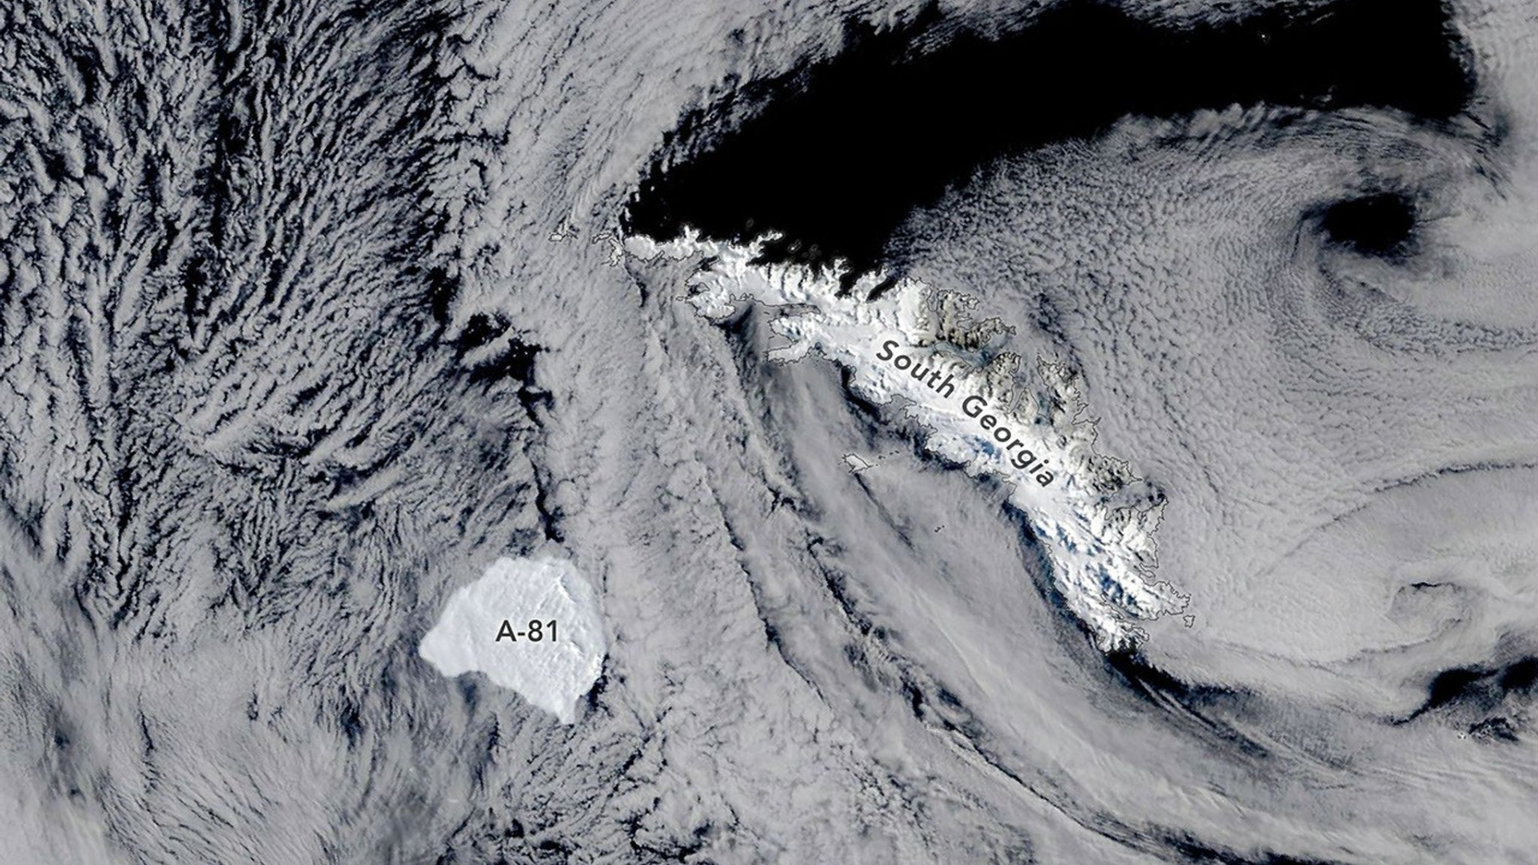
Click for next article Iceberg A-81 escaping the Weddell Sea and drifting near the edge of South Georgia's underwater shelf. The image was captured on Oct. 20, 2026. (Image credit: NASA Earth Observatory/Michala Garrison) An iceberg has quickly escaped from the Weddell Sea in Antarctica, on its way to an icy new destination. What is it? As captured by a satellite in orbit, the Antarctic iceberg A-81 has quite quickly (for an iceberg) parted ways from its icy home, breaking off to drift toward a shallow underwater shelf in Georgia. The 600-square-mile (1,550-square-kilometer) iceberg first broke off from the Brunt Ice Shelf in January of 2023. Now, generally speaking, giant icebergs don't travel that fast. But In just three years, this massive iceberg has traveled 1,400 miles (2,300 kilometers) north of the Brunt Ice Shelf. For an iceberg, that's really fast. Over this time period, the iceberg drifted through the Weddell Sea in Antarctica's Southern Ocean before reaching the tip of the Antarctic Peninsula, floating further into the Scotia Sea and then finally now reaching the edge of a remote island in South Georgia. In this satellite snapshot captured on Oct. 20, 2026, we can see the iceberg in its current location near an underwater shelf off the coast of South Georgia. While it isn't abnormal for icebergs like A-81 to break off from larger ice shelves, Brunt has recently had multiple large icebergs break off one quickly after the other, according to a statement from NASA . Why is it incredible? This image was captured by the MODIS (Moderate Resolution Imaging Spectroradiometer), an instrument on board NASA's Terra satellite. Earth -observing satellites like Terra keep a close eye on changes on our home planet. In addition to this image, observations from Terra have showed how the iceberg has traveled over the last few years. With satellites like Terra, scientists can keep a close eye on these changes in Antarctic ice, which is becoming increasingly important as climate change continues to progress across the globe, affecting everything from Arctic ice to sea levels rising, worsening natural disasters and more.

13. NASA nears end of space station solar array upgrade with Oct. 29 and Nov. 5 spacewalks
Read more
Space Station A still from a NASA animation depicts Anil Menon transporting the rolled up, folded IROSA solar array to its install position. Image: NASA. NASA is two spacewalks away from completing a major, years-long upgrade to the International Space Station that will power the orbiting lab through to its planned decommissioning in 2030. More than five years after the upgrade work first began in earnest, NASA astronaut Anil Menon, 43, and Canadian Space Agency astronaut Joshua Kutryk, 44, are scheduled to depart the station's Quest airlock at 8 a.m. EDT (1200 UTC) Thursday to install and unfurl the seventh of eight International Space Station Roll-Out Solar Arrays, or IROSAs. The compact, high-efficiency panels are designed to make up for power lost as the station's original solar wings have degraded over more than two decades in orbit. Spaceflight Now will carry live coverage of the spacewalk starting at 6:30 a.m. EDT (1030 UTC). If all goes to plan, Menon and Kutryk will venture back into the vacuum of space Nov. 5 to install the eighth and final array, capping an upgrade campaign that began in 2021. NASA says the eight IROSA arrays will raise the station's available power from 160 kilowatts to about 215 kilowatts, supporting critical operations through the outpost's final years, including its "safe and controlled deorbit" after it is retired in 2030. "Overall, these roll-out arrays increase our power generation capability up to 30 percent," Gaurang Patel, operations integration manager for NASA's Low Earth Orbit Program, said during an Oct. 20 briefing at the Johnson Space Center in Houston. Thursday's outing, which marks the 285th spacewalk devoted to station assembly, maintenance and upgrades, is planned to last about six hours and 45 minutes. It will be Menon's fourth excursion outside the ISS airlock and the first for Kutryk. During Thursday's spacewalk and on Nov. 5, Menon is scheduled to perform a series of complex maneuvers atop to the station's robotic arm to transport the final IROSA arrays into position for roll out. Menon, a U.S. Air Force lieutenant colonel and emergency physician, has made his three prior spacewalks since July when he arrived at the ISS aboard a Russian Soyuz. Kutryk, a Royal Canadian Air Force colonel and test pilot who boarded the ISS Oct. 1 as part of SpaceX's Crew-13 mission, will become the fifth Canadian astronaut to walk in space and the first since David Saint-Jacques in 2019. The pair of final IROSA solar wings arrived at the station rolled up and folded on a carrier in the unpressurized trunk of a SpaceX Cargo Dragon capsule after receiving a boost to orbit from a Falcon 9 rocket launched Oct. 13 from the Cape Canaveral Space Force Station. Each IROSA assembly weighs about 750 pounds, said Garrett Hehn, the spacewalk flight director, who is leading the operation with flight director Greg Whitney. After Menon and Kutryk free the first array from the carrier Thursday, Menon will lock his boots into a foot restraint on the end of the station's Canadian-made robotic arm - Canadarm2 - and ride it, array in hand, out to the left, or port, side of the station's main truss. NASA astronauts Jessica Watkins and Luke Delaney will fly the arm from inside the station while Kutryk makes his way to the installation site along the truss. While in transit, the arm will pivot around the IROSA assembly's center of mass, rather than Menon's, one direction at a time - a lesson learned from earlier installs meant to make the work "a little less tiring" for the astronaut holding it, Hehn said. While the rolled up array is weightless in space, it still carries 750 pounds of inertia. Once the IROSA is bolted to an awaiting mounting bracket astronauts installed during a March spacewalk, Menon and Kutryk will swing it open, doubling its length from about 10 feet to 20 feet. Hehn called that step "one of our key points of the EVA," or extravehicular activity. Menon and Kutryk then must lock the two halves in place and connect the new array's power cables to the station while it's in Earth's shadow, when none of its solar panels are generating electricity. "We can't have any sun on the arrays whenever we're handling those hot cables," Hehn explained. Finally, the astronauts will release the last restraints and let the IROSA array unroll on its own over about 10 minutes - no motors required - thanks to energy stored in carbon-fiber composite booms. Hehn likened the panels to a snap bracelet that, once released, "just continues rolling out steadily." Space shuttles delivered the station's eight original solar wings, which were designed to last 15 years, between 2000 and 2009. Rather than replacing them outright, NASA opted to mount the smaller IROSA arrays, which generate about 8 kilowatts of electricity each, in front of the old wings, allowing the original panels' unshaded portions to keep producing power. The first IROSA unfurled in June 2021, though not without a fight: A spacesuit glitch and an array that wouldn't unfold cleanly forced astronauts Shane Kimbrough and Thomas Pesquet to finish the job on a second spacewalk. Six arrays were in place by June 2023, and NASA ordered an additional pair that summer. The Nov. 5 spacewalk will take the eighth and final array to the far right end of the station's main truss, beyond the reach of its robotic arm. As during Thursday's EVA, Menon will ferry the array atop the robotic arm as far as it will take him, but to cover the last stretch, he and Kutryk will pass the array between foot restraints in a maneuver Hehn said the team "lovingly" calls "the leapfrog." As with all spacewalks, the work carries risk. NASA's spacesuits date to a design first flown in 1983 and are responsible for providing critical life support in the harsh environment of low earth orbit, where temperatures fluctuate between 250 degrees Fahrenheit in sunlight to minus 250 degrees in darkness during each 90-minute orbit. A NASA inspector general audit last year flagged aging hardware and thin supplies of spare-parts as potential safety weak spots. Collisions between a spacewalking astronaut and space debris as small as a grain of sand can prove "life threatening," according to NASA, due to the sheer speeds involved: The ISS and the astronauts orbiting the Earth with it are already traveling at about 17,500 mph, and collisions with space debris in low earth orbit average about 22,000 mph, or 10 kilometers per second, according to NASA's White Sands Test Facility. Hehn said Oct. 20 that the suits are "not entirely redundant" and acknowledged they are aging, "which means we know they have some quirks." "Our primary goal is to keep the crew safe," he said.

14. Shape-shifting space tiles to assemble, split and rebuild spacecraft autonomously
Read more
Its modular design aims to overcome rocket fairing size limits by allowing spacecraft to form larger structures after launch. The startup plans to test seven spacecraft tiles that autonomously assemble, separate and reconfigure in orbit in 2028. Rendezvous Robotics raised $20 million in an oversubscribed seed round led by MaC Venture Capital and Toyota Ventures. Spacecraft could one day change their shape after reaching orbit, allowing operators to add capabilities without launching an entirely new vehicle. Rendezvous Robotics has raised $20 million to develop that technology, with its first orbital demonstration planned for 2028. The startup intends to launch seven independent spacecraft tiles that will join together in space. They will then separate and assemble into a different configuration, testing whether autonomous spacecraft can build and reshape larger structures without external robotic assistance. MaC Venture Capital and Toyota Ventures led the oversubscribed seed round. Rendezvous will use the funding to advance its spacecraft designs and prepare for flight demonstrations. Seven tiles will join in orbit Rocket fairings dictate the dimensions of conventional spacecraft before they leave Earth. Engineers must fit every component within that envelope, limiting the size of equipment such as antennas and power systems. Rendezvous wants to move some of that construction work into orbit. Its spacecraft launch as individual tiles that maneuver independently before connecting with one another. The resulting structure can exceed the dimensions of any single module. Reconfiguration presents a further engineering challenge. The seven tiles must coordinate their movements and establish connections before separating and forming a new arrangement. The planned mission will test whether they can complete those operations autonomously in low Earth orbit. CEO Joe Landon believes the approach could eventually support spacecraft with megawatt-scale power generation. He also sees potential for much larger communications and sensing apertures. Those capabilities could support missions that face significant constraints under conventional spacecraft designs. MIT experiment goes commercial The technology originated with TESSERAE, a modular self-assembly concept developed by Ariel Ekblaw at MIT. Ekblaw later advanced the research through the Aurelia Institute, which she founded, before co-founding Rendezvous Robotics. Earlier TESSERAE generations flew aboard Blue Origin's New Shepard rocket and during two missions to the International Space Station (ISS). These experiments helped researchers investigate how the underlying concept behaves in microgravity. Ekblaw said the research aimed to rethink spacecraft construction itself. "What began as an experiment in self-assembly is now becoming a new way to build spacecraft in orbit," she said. Rendezvous is developing larger tiles that operate independently. Ground demonstrations are testing their ability to move and align before connecting. The next phase must establish whether those mechanisms can perform reliably under spaceflight conditions. Two tests are approaching A parabolic flight campaign scheduled for November 2026 will examine electromagnetic actuation and tile mobility in microgravity. The company has reserved a rideshare launch for its orbital demonstration, which is scheduled no earlier than April 2028. Another milestone will take place aboard the ISS in December 2026. Researchers plan to assemble 32 fifth-generation TESSERAE tiles into a three-dimensional structure inside a controlled microgravity environment. That experiment will conclude the earlier TESSERAE research program as Rendezvous advances its free-flying spacecraft architecture. The two demonstrations address different challenges, with the ISS test examining assembly in a controlled setting and the 2028 mission targeting autonomous reconfiguration in open space.

