 |  | 

🌌 अंतरिक्ष समाचार | Space News
शनिवार, २९/०८/२०२६ | Saturday, 29/08/2026

1. Yogi Adityanath directs officials to fast-track UP development projects
Read more

- Smart Infra - 3 min read CM asks departments to resolve land acquisition, tendering and coordination bottlenecks, and ensure projects are completed on schedule. - PTI - Published On Aug 28, 2026 at 04:04 PM IST Select ETGovernment as Preferred Choice on Google Copy Link Share on WhatsApp Share on Linkedin Share on X Share on Telegram Share on Facebook Uttar Pradesh Chief Minister Yogi Adityanath reviews major development projects and welfare schemes at a meeting of the State Transformation Commission. Uttar Pradesh Chief Minister Yogi Adityanath on Thursday said delays in development projects would not be tolerated, and directed officials to resolve bottlenecks related to land acquisition , tendering and inter-departmental coordination immediately. "The government's priority is not limited to announcing and approving projects. Every project must be brought on the ground within the stipulated time and its actual benefits must reach the people," Adityanath said while reviewing major development projects and welfare schemes at a meeting of the State Transformation Commission. Advt He said expressways should not be viewed merely as transport projects but as corridors driving industry, investment, employment and regional economies. The meeting was informed that the Chitrakoot Link Expressway tender was published on August 6, while land acquisition for the Farrukhabad Link Expressway was 91.28 per cent complete, Agra-Lucknow-Purvanchal Link 80.43 per cent, Jhansi Link 84.82 per cent and Jewar Link 79.27 per cent. He directed officials to expedite land acquisition for these projects. Verification for the Meerut-Haridwar, Vindhya and Vindhya-Purvanchal Spur expressways has been completed and he directed officials to speed up land acquisition for them. Reviewing the Greater Noida Multi-Modal Logistics Hub, the chief minister said logistics projects should be accelerated so that Uttar Pradesh becomes a major supply-chain hub. He also directed speedy action on the Aqua Business Project in Unnao, according to the statement. The 40 MLD sewage treatment plant at Bingawan, Kanpur, for supplying treated water to the Panki power plant has been completed. Adityanath also stressed capacity-building of engineers to ensure quality in project planning, execution and maintenance. On fire safety in hospitals, health institutions, hotels and guest houses, he said, "Negligence at any level in matters related to public safety cannot be accepted." He directed creation of a digital database of fire NOCs and renewal of licences before their expiry, according to the statement. Reviewing electricity supply, Adityanath directed officials to identify the reasons for high line losses and strengthen action against power theft while improving billing and recovery. "Accountability should also be fixed for responsible discom officials in areas with excessive line losses," he said. He directed that digital libraries in gram panchayats be developed as centres for studies, competitive examinations and digital learning and ordered that all related work be completed by September 30. Reviewing the Zero Poverty campaign, he said, "Every identified eligible family should get housing." Families left out of the Pradhan Mantri Awas Yojana should be covered under the Mukhyamantri Awas Yojana, while eligible families should receive ration, Ayushman cards, toilets and other benefits. He also directed efforts to link at least one family member with skill training and employment . Of 12.50 lakh identified families, nine lakh were found eligible for housing, including 4.50 lakh under the PMAY list and about five lakh to be covered by the state housing scheme. Some 6.67 lakh families did not have Ayushman cards, the meeting was told. The chief minister directed that labour points be surveyed and equipped with drinking water, toilets, sanitation, bathing, medical care and food. Special drives should be conducted for labour and Ayushman cards, with medical mobile units and mobile canteens in every municipal corporation area. Reviewing the Gorakhpur international cricket stadium and Major Dhyan Chand Sports University in Meerut, he directed that construction be completed on schedule without compromising quality. The 30,000-capacity Gorakhpur stadium, whose construction began in December 2025, is scheduled for completion by December 2027. He also directed timely release of approved financial incentives to investors, according to the statement. On revenue matters, the chief minister said inheritance and land measurement cases directly concern citizens' rights and property and must be resolved transparently and within a fixed time frame. He ordered an inquiry into 13,386 cancelled undisputed inheritance applications in Prayagraj, the highest in the state, and directed that cancellations be examined on merit. He also ordered priority disposal of old measurement cases and regular review of revenue officials to ensure land disputes do not remain pending unnecessarily. - See more on: - Uttar Pradesh development projects , - Yogi Adityanath , - land acquisition , - transport projects , - skill training and employment Telegram Facebook Comments What are your thoughts? Comment Now --> Comment Now Read Comment (1) All Comments By commenting, you agree to the Prohibited Content Policy Post Find this Comment Offensive? Choose your reason below and click on the submit button. This will alert our moderators to take actions REASONS FOR REPORTING Foul Language Defamatory Inciting hatred against a certain community Out of Context / Spam Others Report Join the community of 2M+ industry professionals. Subscribe to Newsletter to get latest insights & analysis in your inbox. --> All about ETGovernment industry right on your smartphone! - Download the ETGovernment App and get the Realtime updates and Save your favourite articles. Scan to download App --> - Home - News - Yogi Adityanath directs officials to fast-track UP development projects

2. ISRO Seeks To Make Comeback With Hawkeye Satellite Launch On September 4 - NDTV
Read more
ISRO Seeks To Make Comeback With Hawkeye Satellite Launch On September 4 NDTV

3. ISRO announces recruitment for Scientist, Engineer 'SC' posts: Vacancy details, selection process - The Indian Express
Read more
ISRO announces recruitment for Scientist, Engineer 'SC' posts: Vacancy details, selection process The Indian Express

4. ISRO Scientist, Engineer SC recruitment 2026: 176 vacancies announced, check eligibility, selection proce - The Times of India
Read more

(Image credit: Isro) ISRO Scientist, Engineer recruitment 2026: Vacancy details Discipline ISRO Centres PRL Total Electronics 99 1 100 Mechanical 52 1 53 Computer Science 21 1 22 ISRO Scientist, Engineer eligibility criteria ISRO Scientist, Engineer recruitment application fee ISRO Scientist, Engineer posts: Steps to apply Go to the official ISRO recruitment portal, isro.gov.in. Open the recruitment notification for Scientist and Engineer 'SC' posts. Read the eligibility conditions and other instructions carefully. Register on the portal using the required personal details. Log in and select the relevant engineering discipline and post. Enter educational qualifications, personal information, and other required details. Upload the photograph, certificates, and other documents in the prescribed format. Pay the applicable processing/application fee through the available online payment mode. Review the complete application form carefully before final submission. Submit the application and download or print a copy of the confirmation page for future reference. ISRO Scientist, Engineer selection process Interview to assess technical and communication skills The Indian Space Research Organisation (ISRO) has opened recruitment for Scientist, Engineer 'SC' positions in Electronics, Mechanical, and Computer Science. The recruitment drive offers 176 vacancies across various ISRO Centres and the Physical Research Laboratory (PRL).Eligible engineering graduates can submit their applications through the official recruitment portal until September 16, 2026, by 11:55 pm. Candidates should carefully check the eligibility conditions and application requirements before submitting the form, as applications through any other mode will not be accepted.The 176 posts have been distributed across three engineering disciplines. Electronics has the highest number of vacancies, followed by Mechanical and Computer Science.The posts are classified as Group 'A' positions and carry Level 10 pay in the Pay Matrix, making the recruitment an important opportunity for engineering graduates seeking a career in the country's space research and technology establishment.Candidates must hold a BE, BTech or equivalent qualification in the relevant engineering discipline from a recognised institution.For Electronics posts, applicants should possess the required qualification in Electronics and Communication Engineering.Candidates applying for Mechanical and Computer Science vacancies must have the corresponding engineering degree.Applicants are required to have secured at least 65% marks in aggregate or a CGPA of 6.84 on a 10-point scale in their qualifying degree.The upper age limit is 28 years as of September 16, 2026. Relaxation in the maximum age will be available to eligible categories, including Central Government employees, ex-servicemen, and Persons with Benchmark Disabilities (PwBD), in accordance with the applicable recruitment rules.Candidates applying for the posts will have to complete the online application process and pay the applicable charges by the deadline.An application fee of Rs 250 is applicable. Candidates are initially required to pay a processing fee of Rs 750, subject to the refund provisions specified in the recruitment notification.Applicants should ensure that their payment is completed successfully before the application deadline. A partially completed form or an application submitted without the required payment may not be considered.Eligible candidates can follow these steps to complete the application:Candidates should ensure that all information entered in the form matches their official documents. Any discrepancy in personal or academic details could create problems during subsequent stages of recruitment.The selection process will consist of a written test followed by a personal interview. The final selection will give equal importance to both stages, with 50% weightage assigned to the written test and 50% to the interview.The written examination will be conducted as a computer-based test in 37 cities across India. It will carry a total of 100 marks and will be divided into two parts.Part A will contain 80 discipline-specific multiple-choice questions, to be attempted in 90 minutes. The section will have negative marking, with one-third of a mark deducted for every incorrect answer.Part B will assess aptitude and ability. It will comprise a maximum of 15 questions carrying 20 marks and will have a duration of 30 minutes. There will be no negative marking in Part B.Candidates will be shortlisted for the interview based on their written-test performance in a 1:5 ratio.The personal interview will carry 100 marks. Besides technical knowledge, candidates will be assessed on areas such as general awareness, communication skills, comprehension, and academic achievements.For unreserved candidates, the prescribed qualifying requirement includes at least 50% marks in the interview and 60% aggregate marks.With the application window open until September 16, eligible candidates should avoid waiting until the final day. Apart from ensuring timely submission, early application gives candidates an opportunity to rectify any technical or document-related issues before the deadline.

5. What time will SpaceX launch NASA's Roman Space Telscope on Aug. 30? (Full mission timeline)
Read more

Click for next article A huge SpaceX rocket is just days away from launching NASA's next great observatory into space: the Roman Space Telescope. But if you're hoping to watch it live online, you'll have to get up pretty early on Sunday (Aug. 30) or you'll miss it. NASA's Roman Space Telescope , named after the late NASA astronomer Nancy Grace Roman , will launch no earlier than Sunday on a mission to map the galaxy like never before. Liftoff is set for 7:26 a.m. EDT (1126 GMT) from a NASA pad in Cape Canaveral, Florida. You can follow the mission in real time with our Roman Space Telescope live updates . " Roman's deep, sweeping surveys will help investigate dark energy and dark matter, discover and characterize planets beyond our solar system, map billions of galaxies, study black holes and share enormous amounts of data with both scientists and the public," NASA said in an update Friday (Aug. 28), after clearing Roman for launch. Here's a look at what time NASA's Roman Space Telescope will launch atop a SpaceX Falcon Heavy rocket , as well as how to watch online. What time is SpaceX's Roman Space Telescope launch? NASA's Nancy Grace Roman Space Telescope is encapsulated in the payload fairing of its SpaceX Falcon Heavy rocket. (Image credit: SpaceX) SpaceX is currently targeting the launch of NASA's Roman Space Telescope for no earlier than 7:26 a.m. EDT (1126 GMT) on Sunday, Aug. 30. The company will launch Roman into space atop a Falcon Heavy rocket from Launch Complex 39A at NASA's Kennedy Space Center in Florida. A launch livestream will begin about one hour before liftoff. While SpaceX hopes to launch Roman on time, the company can try again on Monday, Aug. 31, if needed. A launch on that day would lift off a few minutes earlier, at 7:22 a.m. EDT (1122 GMT), SpaceX has said. $39.99 at Amazon Starship Die Cast Rocket Model Was $47.99 Now $39.99 on Amazon. Even if you can't see SpaceX's Starship in person, you can score a model of your own. Standing at 13.77 inches (35 cm), this is a 1:375 ratio of SpaceX's Starship as a desktop model. The materials here are alloy steel and it weighs just 225g. Can I watch SpaceX's Roman Space Telescope launch? LIVE: Roman Space Telescope launches aboard SpaceX Falcon Heavy - YouTube Watch On Yes, of course, you'll be able to watch SpaceX launch the Roman Space Telescope , and you have some options regarding where to tune in. NASA will provide a launch webcast early Sunday morning. That livestream begins Aug. 30 at 6:20 a.m. EDT (1020 GMT) and will run through the launch and a post-launch briefing. That livestream can be found on the NASA website here , as well as all of NASA Social channels ( Facebook , Instagram , X ), and streaming channels like Twitch , Discovery+ , Amazon Prime , NASA+, and of course YouTube . Our Space.com livestream can be found on our VideoFromSpace YouTube channel , and will feature NASA's livestream simulcast. SpaceX will also host its own launch livestream via its X account , which will begin about an hour before liftoff. As mentioned above, SpaceX aims to launch Roman for NASA at 7:26 a.m. EDT (1126 GMT), with the flight lasting about 31 minutes and 31 seconds - the time post-liftoff at which Roman is expected to deploy into space. A post-launch press conference is scheduled for 9:30 a.m. EDT (1330 GMT) and will include comments from the experts listed below. NASA Administrator Jared Isaacman Nicky Fox, associate administrator, Science Mission Directorate, NASA Headquarters Jackie Townsend, Roman telescope project manager, NASA Goddard Julie McEnery, Roman telescope senior project scientist, NASA Goddard Denton Gibson, launch director, NASA's Launch Services Program, NASA Kennedy How long is SpaceX's Roman Space Telescope launch? A diagram showing SpaceX's Roman Space Telescope launch profile on a Falcon Heavy rocket. The flight should last about 31.5 minutes. (Image credit: SpaceX) SpaceX's Roman Space Telescope launch for NASA will last just over 31 minutes (31 minutes and 31 seconds, to be exact), in order to send Roman on its way into deep space. After liftoff, the Falcon Heavy rocket's core booster and twin side boosters will fire for just under 2.5 minutes, after which the side boosters will separate and return to Earth. If all goes well, they should land about 7 minutes, 23 seconds after liftoff. "This is the first and third flight for the two first stage side boosters supporting this mission, which previously launched the GOES-U and Viasat-3 F3 missions," SpaceX wrote in a mission overview . "Following stage separation, Falcon Heavy's two side boosters will land on SpaceX's Landing Zones 2 and 40 (LZ-2 and LZ-40) at Cape Canaveral Space Force Station in Florida." SpaceX does not appear to be planning a core first-stage landing off shore for this flight. The three first-stage boosters of the Falcon Heavy rocket that will launch NASA's Nancy Grace Roman Space Telescope on Aug. 30, 2026. SpaceX shared this photo via X on Aug. 26. (Image credit: SpaceX) Here's a look at the launch and flight timeline from SpaceX. Swipe to scroll horizontally SpaceX Roman Space Telescope Launch Timeline TIME (Hr:Min:Sec) EVENT T-0:53:00 Flight director polls for fueling T-0:50:00 1st stage RP-1 (rocket grade kerosene) loading begins T-0:45:00 1st stage liquid oxygen loading begins T-0:35:00 2nd stage RP-1 fuel loading begins T-0:18:30 2nd stage liquid oxygen loading begins T-0:07:00 Falcon Heavy engine chilldown begins T-00:00:59 Flight computer commanded to begin final prelaunch checks T-00:00:45 Launch Director GO for launch poll T-00:0:20 Propellant tanks pressurized for flight T-00:00:06 Engine controller commands engine ignition sequence start T-00:00:00 Liftoff Swipe to scroll horizontally SpaceX Roman Space Telescope Post-Launch Timeline TIME (Hr:Min:Sec) FLIGHT EVENT T+00:00:00 Liftoff! T+00:01:08 "Max Q" T+00:02:24 Side boosters' engines shut down T+00:02:27 Side boosters separate T+00:02:32 Side boosters flip T+00:02:43 Side boosters' boostback burn begins T+00:03:48 Side boosters' boostback burn ends T+00:03:51 1st stage main engine cutoff T+00:03:54 1st stage separation from upper stage T+00:04:00 2nd stage engine ignition T+00:04:15 Payload fairing separation T+00:06:19 Side boosters' entry burn begins T+00:06:29 Side boosters' entry burn ends T+00:07:23 Side boosters' landing burn begins T+00:07:40 TOUCHDOWN! Side boosters land T+00:08:28 2nd stage engine cutoff (SECO-1) T+00:24:33 2nd stage engine restart (SES-2) T+00:26:33 2nd stage engine cutoff (SECO-2) T+00:31:31 Roman Space Telescope deploys The upper stage of the Falcon Heavy will continue firing its engine through the 8-minutes-and-28-seconds mark, when it will shut down for a 16-minute cruise period. Just over 24 minutes into the flight, the second stage will reignite its single Merlin engine for about three minutes before shutting down for good. The Roman Space Telescope will then deploy from its carrier at the 31:31 minute mark. It is expected to deploy its solar panels and sunshade shortly after liftoff, then spend the next few days unfolding its antenna and aperture cover, while also performing a mid-course correction burn on its way to its final destination: a stable point in space called Lagrange Point 2 , about 1 million miles (1.5 million kilometers) from Earth, opposite the sun. "The Roman team will complete a carefully orchestrated series of deployments, calibrations, and tests in the three months following launch before the observatory reaches its final orbit," NASA has said of the steps that will follow. What if the Roman Space Telescope can't launch? If SpaceX can't launch the Roman Space Telescope on Aug. 30, the company and NASA have at least one backup day to try again. A second launch window is available on Monday, Aug. 31, at 7:22 a.m. EDT (1122 GMT), according to SpaceX. Both SpaceX and NASA are watching the weather closely to determine if Roman can fly on Aug. 30. "Meteorologists with the U.S. Space Force's Space Launch Delta 45 Weather Squadron are predicting a 60% chance of favorable weather conditions for launch, which is targeted for 7:26 a.m. EDT on Sunday, Aug. 30 from Launch Complex 39A at Kennedy," NASA wrote in an update Friday (Aug. 28).

6. The night we nearly saw a 'blood moon' (and why I love near-misses in astronomy)
Read more
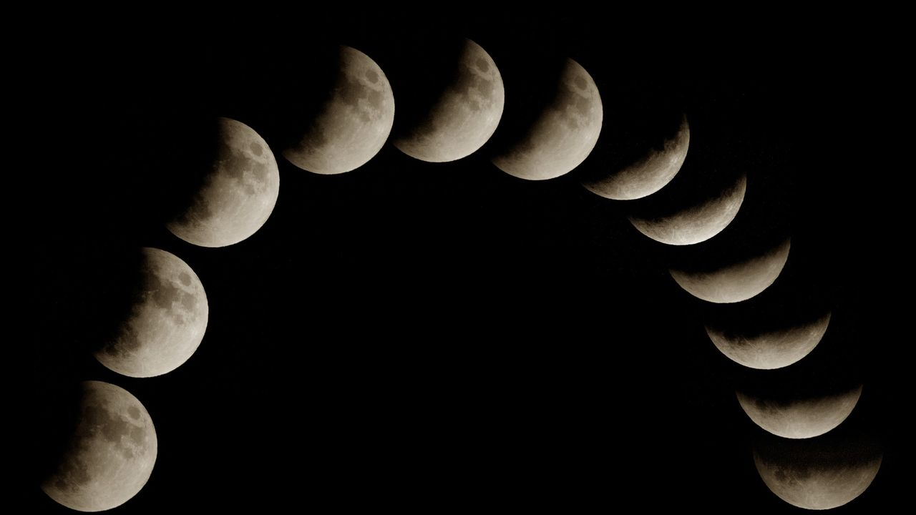
Click for next article Stargazers have trigger words - total, bright, peak, maximum, best. But observing the sky is often more interesting when something seems neither one thing nor the other. A case in point was the almost-total partial lunar eclipse we just witnessed. From where I watched, early on Aug. 28, Earth's shadow reached its maximum across the lunar surface, covering 96.2% of it, as the moon began to sink in the west. A thin part of the lunar surface remained outside the darkest part of Earth's shadow, and the surface never did quite go red. At maximum eclipse, the moon looked like a sliver - totally unlike a crescent moon, and something very odd to behold - and came within a fingernail of becoming a totally eclipsed " blood moon ." Astronomy and stargazing are full of this sort of near-miss. A comet that nearly becomes bright enough to tell your neighbors about, but ultimately becomes nothing more than a smudge in binoculars that few can even find, let alone be impressed by. A meteor shower that's hyped as the strongest for years that doesn't live up to expectations. Or the worst kind - a cloud deck that clears a few minutes after a total solar eclipse comes to an end. We pretend these moments are failures because they do not match the headline version of the sky. But it's often the "almost" part that keeps the imagination alive. Beyond the headline act A total lunar eclipse happens only when the entire moon passes into Earth's dark umbral shadow. On Aug. 27-28, the deep partial eclipse missed totality, but the bright uneclipsed sliver made the shadow easier to see and appreciate. Its almostness gave the event an unusual tension. During a total lunar eclipse - also called a "blood moon," which gets headline writers very excited - the red color comes from sunlight filtering through Earth's atmosphere . Shorter blue wavelengths scatter more efficiently, while longer red and orange wavelengths are bent into the shadow and onto the moon. In other words, the totally eclipsed moon is lit by the combined glow of sunrise and sunset around the rim of Earth . That sounds like a poetic exaggeration, but it's just physics. A partial lunar eclipse is equally just physics. With the headline act of totality not on the agenda, I watched Earth's curved shadow creep across the lunar surface, almost reach across the entire orb, then gradually retreat. You could see the geometry working. You could see the moon move through a circular shadow - our planet's shadow. A lunar eclipse always gives you time to think because it unfolds slowly, but this gave me a chance to focus on the one thing we all ignore when we obsess over the "blood moon" moment - the moon moving through Earth's giant shadow in space. Almost, but not quite - near-totality during a deep partial lunar eclipse. (Image credit: Giovanni Bortolani via Getty Images) Grazing occultations and weird eclipses Near-misses in astronomy occur when things do not perfectly align as seen from Earth. A good example is a grazing occultation, in which the moon almost crosses a bright star or planet, but not quite. Instead of seeing it disappear and re-emerge, the planet or star winks as it's skimmed by the mountains on the rugged edge of the moon. Spectacular examples include July 10, 2018 , when red giant star Aldebaran blinked along the lunar limb, as seen from North America, and Aug. 24, 2023, when Antares played hide-and-seek behind the moon. It's proof that the moon has no atmosphere , though it's location-specific because the moon's apparent position in the sky varies by about two degrees depending on where you are. There are some good occultations (which all have grazing zones) coming up: Sept. 8: lunar occultation of Jupiter ( visible across the U.S.) across the U.S.) Sept. 14: lunar occultation of Venus ( visible across Europe and the Middle East) across Europe and the Middle East) Sept. 17: lunar occultation of Antares ( visible in southwest Australia) Mars being grazed by the moon. (Image credit: (c) 2010 Luis Argerich via Getty Images) However, my favorite type of celestial near-miss is a solar eclipse , which comes in so many shapes and sizes that it's tough not to start collecting observations of them once you've started. If you like big partial eclipses - when the central shadow of the moon, the umbra, passes just above the planet, but never quite makes land to cause totality - get Jan. 14, 2029 and Dec. 5, 2029 in your calendar. An extremely similar event, celestially speaking, but with a vastly different effect, will occur on April 9, 2043 . On that day, a total solar eclipse will be seen from almost nowhere on the planet. Instead of a long, narrow path of totality across the globe, the cone of the moon's dark shadow just grazes Earth's edge. Most of the shadow misses the planet and falls into space. What does touch Earth will create an ellipse of totality over the far north of Russia. That makes it the 21st century's sole non-central total solar eclipse. How many eclipse chasers will be in Tymlat, on the east coast of Kamchatka, for 59 seconds of totality just minutes after watching a partially eclipsed sunrise? Most will miss it for a much simpler reason - it's not a place you can easily travel to, if at all. Near-misses and oddities are, of course, not rare nor unusual; they're just abnormal from our point of view during a human lifetime. Astronomy is often about being close to seeing extraordinary things without fully experiencing them, and very often it's clouds that are to blame. If that sounds frustrating, it shouldn't - most of life works the same way. Stargazer's corner: Aug. 28-Sept. 3, 2026 Saturn through a 14-inch Schmidt-Cassegrain telescope. (Image credit: Jamie Cooper/SSPL/Getty Images) With the moon just past full, it remains bright for much of the night all week, so we'll struggle to see galaxies, nebulae and the Milky Way. However, Saturn, rising in the east, is now becoming more convenient in the late evening sky and is worth a look through binoculars - and particularly a small telescope if you have one. It will be in conjunction with the moon on Aug. 30. Venus remains bright just after sunset, low toward the west, though horizon haze can make it less crisp than its brightness suggests. Constellation of the week: Capricornus Capricornus, the "Sea Goat," is now visible in the south after dark. (Image credit: E. Slawik/NOIRLab/NSF/AURA/M. Zamani) Autumn is coming to the night sky. One of the telltale signs is the presence of Capricornus, a constellation that looks more convincing on a chart than in the sky. From the northern hemisphere, it sits low in the south on late summer evenings, east of Sagittarius and south of bright star Altair, the lowest star in the iconic Summer Triangle. Its stars are modestly bright, so suburban observers will need patience and a clear southern horizon. As Capricornus emerges into the evening sky, the bright center of the summer Milky Way is on the wane, beginning to lean west, and autumn is approaching.

7. SpaceX Falcon Heavy rocket launching NASA's Roman Space Telescope on Aug. 30: How to watch it live
Read more
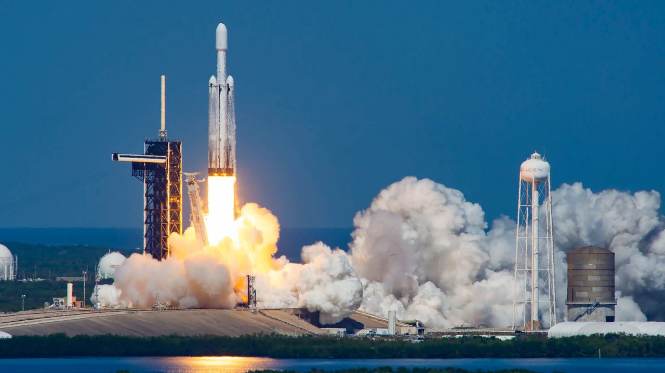
Click for next article LIVE: Roman Space Telescope launches aboard SpaceX Falcon Heavy - YouTube Watch On NASA's next great space observatory is about to lift off, and you can watch it live. The Nancy Grace Roman Space Telescope is scheduled to launch atop a SpaceX Falcon Heavy rocket from NASA's Kennedy Space Center in Florida on Sunday (Aug. 30) at 7:26 a.m. EDT (1126 GMT). You can watch it live here at Space.com, courtesy of NASA, beginning at 6:20 a.m. EDT (1020 GMT). You don't have to wait that long for a Roman fix, actually; there's stuff to watch on Saturday (Aug. 29) as well. Here's a rundown of this weekend's Roman action. SpaceX's Falcon Heavy rocket launches NASA's Europa Clipper mission from Florida on Oct. 14, 2024. (Image credit: SpaceX) Saturday: Prelaunch briefings Things kick off at on Saturday at 9 a.m. EDT (1300 GMT) with NASA's Roman Space Telescope mission science briefing. This should be quite eventful, for Roman's science goals are ambitious; it will likely discover thousands of exoplanets , for example, and reveal intriguing new information about mysterious dark matter and dark energy . Participants are: Shawn Domagal-Goldman, director, Astrophysics Division, NASA Headquarters Julie McEnery, Roman telescope senior project scientist, NASA Goddard Space Flight Center Vanessa Bailey, Roman Coronagraph Instrument scientist, NASA Jet Propulsion Laboratory Kristen McQuinn, Roman Science Operations Center lead, Space Telescope Science Institute Lee Armus, Roman Science Support Center lead, Caltech/IPAC Next up is the prelaunch press conference, which will discuss the mission's launch readiness. It will start at 10:30 a.m. EDT (1430 GMT) and feature the following folks: Nicky Fox, associate administrator, Science Mission Directorate, NASA Headquarters Lucas Paganini, Roman telescope program executive, NASA Headquarters Jackie Townsend, Roman telescope project manager, NASA Goddard Denton Gibson, launch director, NASA's Launch Services Program, NASA Kennedy Julianna Scheiman, director, NASA Science and Dragon Programs, SpaceX Justin McReynolds, launch weather officer, 45th Weather Squadron, U.S. Space Force Then, at 11:45 a.m. EDT (1545 GMT), NASA Administrator Jared Isaacman, an accomplished pilot and private astronaut, will put on a mini air show of sorts. Isaacman "is expected to fly past the Nancy Grace Roman Space Telescope and Falcon Heavy rocket on the launch pad in his jet," NASA wrote in an Aug. 24 media advisory. "The flyby will be shown live on the same stream as the prelaunch news conference, with a view of the launch pad during the transition. The flyby is subject to weather and operational considerations." Sunday: Launch day And there's more to watch on Sunday than the launch itself. At 9:30 a.m. EDT (1330 GMT), NASA will hold a post-launch briefing featuring Isaacman, Fox, Townsend, McEnery and Gibson. They'll likely discuss the next steps for Roman, which include a 30-day journey to its deep-space home, the sun-Earth Lagrange Point 2 . This spot lies about 930,000 miles (1.5 million kilometers) from Earth in the direction of Mars . It's gravitationally stable, meaning Roman will be able to stay put without expending much fuel. Mission team members will spend the next few months checking out the observatory's systems and science gear. It should be ready to begin its five-year science mission in early 2027.

8. On this day in space! Aug. 28, 1993: Galileo spacecraft flies by asteroid Ida on the way to Jupiter only to find a tiny moon!
Read more
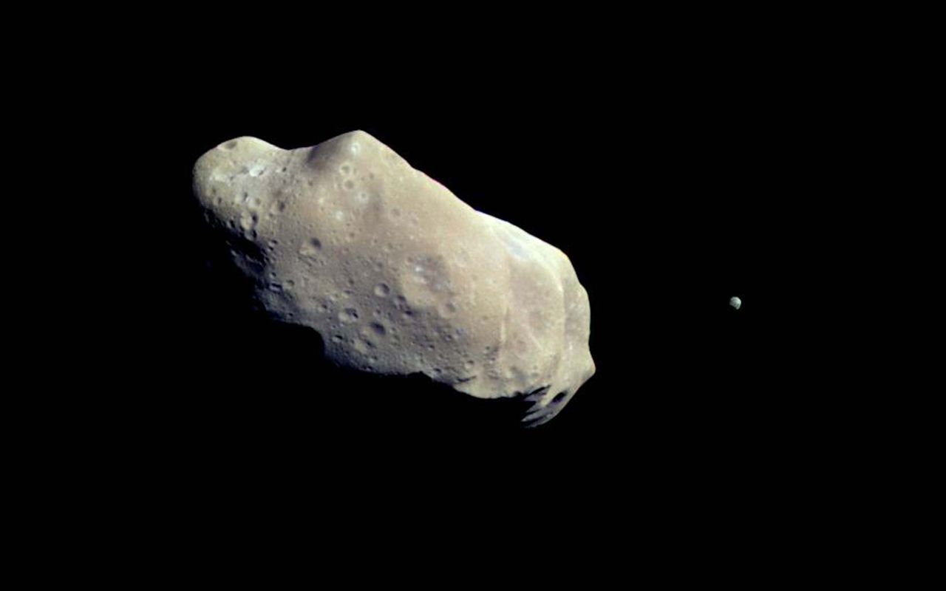
Click for next article On Aug. 28, 1993, NASA's Galileo spacecraft flew by the asteroid Ida while on its way to Jupiter. Galileo was the first spacecraft to fly by an asteroid in the asteroid belt . Ida was actually the second one it visited after another flyby of the asteroid Gaspra in 1991. Galileo whizzed by asteroid Ida going almost 28,000 mph and came within 1,500 miles of the asteroid's surface. During the encounter, Galileo actually discovered a tiny moon orbiting Ida! This was the first confirmed satellite of an asteroid . The International Astronomical Union named the moon Dactyl after a group of mythological beings who lived on a sacred mountain called Mount Ida. Why it mattered The Galileo spacecraft, on its way to the Jupiter system, captured this mind-blowing image of asteroid 243 Ida and its moon, Dactyl. (Image credit: NASA/JPL) Asteroid 243 Ida was actually the second asteroid ever to be visited by a spacecraft (Galileo previously flew by the asteroid Gaspra in October 1991), but this flyby clinched the theory that asteroids could have moons . Until the Galileo spacecraft photographed Ida and Dactyl, astronomers suspected some asteroids could have their own moons, but Galileo proved it once and for all. During the flyby, Galileo approached within 1,500 miles (2,400 kilometers) of Ida as it made its way to Jupiter . "It was previously thought that natural satellites of asteroids could form, but they probably weren't common," Torrence Johnson, Galileo's project scientist, once said of the flyby in a NASA statement . "Having found one fairly quickly, we can say that they're probably more common than previously thought." Ida is an S-type asteroid made mostly of silicate rock and sits in the main asteroid belt. Astronomers suspect it is what's known as a Koronis asteroid, leftover debris from an ancient crash of two much larger objects, according to NASA. It was discovered on Sept. 29, 1884 by Austrian astronomer Johann Palisa at the Vienna Observatory. Galileo imaging team member Ann Harch actually discovered Ida's moon Dactyl on Feb. 17, 1994, months after the flyby, while reviewing data, NASA said. Galileo did not stop to study Ida and Dactyl. As with its Gaspra flyby, the probe zoomed by to continue its trip to Jupiter. NASA launched the Galileo mission on Oct. 18, 1989 and it arrived at Jupiter on Dec. 7, 1995, orbiting the giant planet for nearly 8 years. The mission ended on Sept. 21, 2003, when Galileo intentionally crashed into Jupiter . Want more space history? Check out our full On This Day In Space Story archive and watch our On This Day In Space videos on YouTube .

9. President Trump gives Artemis II moon astronauts the Congressional Space Medal of Honor
Read more
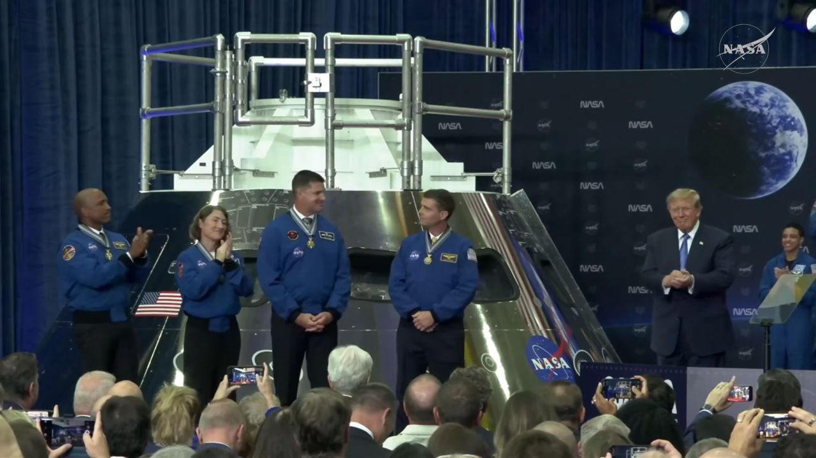
Click for next article President Donald Trump awarded the four astronauts of NASA's Artemis II moon mission the Congressional Space Medal of Honor on Aug. 28, 2026. Four astronauts just received the United States' highest space honor. President Donald Trump gave the astronauts of NASA's Artemis II moon mission the Congressional Space Medal of Honor today (Aug. 28) during a ceremony at Johnson Space Center in Houston. "This is a very rare thing. It's for courageous people, brilliant people, bestowed on astronauts who have distinguished themselves with exceptional service to the nation and all of mankind," Trump said during the event. Artemis II Congressional Space Medal of Honor Ceremony - YouTube Watch On Artemis II launched on April 1 and came back to Earth nine days later. It was the first crewed mission of NASA's Artemis program , which aims to establish a long-term base near the moon's south pole in the coming years. The flight sent four people - NASA's Reid Wiseman, Victor Glover and Christina Koch, as well as Canadian Space Agency astronaut Jeremy Hansen - on a looping journey around the lunar far side. It was the first crewed trip beyond low Earth orbit since Apollo 17 in 1972, and its astronauts got farther from their home planet than any people ever had before. Artemis II engaged folks around the world thanks to its importance, its historic nature and the charisma of its astronauts. And some fortuitous orbital dynamics didn't hurt, either: The Artemis II crew were lucky enough to observe a total solar eclipse from beyond the moon , something human eyes had never seen firsthand before. The Congressional Space Medal of Honor is awarded "to any astronaut who in the performance of his duties has distinguished himself by exceptionalIy meritorious efforts and contributions to the welfare of the Nation and of mankind," NASA wrote in a description of the award , citing Congress' stated criteria. Though the president gives out the medal, he does so on the recommendation of the NASA administrator, the agency added. Before today, just 30 people had received the award, and most of them are pretty big names. Past honorees include Apollo 11 astronaut Neil Armstrong ; Alan Shepard and John Glenn, who were the first Americans to reach space and orbit Earth, respectively; Gemini astronaut Ed White, the first American to perform a spacewalk; and Apollo 13 commander Jim Lovell. The award was also given to each of the 14 astronauts who died in the space shuttle Challenger and Columbia disasters. Hansen therefore wasn't the first non-American to receive the medal. Ilan Ramon, one of the seven people who perished when Columbia broke apart upon reentry to Earth's atmosphere on Feb. 1, 2003, was from Israel. The Artemis II astronauts gave President Trump a special flight jacket on Aug. 28, 2026. (Image credit: NASA TV) During his speech at today's ceremony, Trump said that the United States is entering a golden age of spaceflight and exploration. And he thanked the Artemis II astronauts for being a guiding light. "Thanks to the crew of Artemis II, those dreams are closer than ever before," the president said. "We're on the cusp of an adventure and something that's so special, people have really not imagined anything. It's really, civilization is into the stars. The stars are up there and they're beautiful, and you're right next to them. You have the courage to be right next to them. Few people do, but you're leading the way. It's great, great bravery." The astronauts reciprocated the warmth. For example, they gave the president a blue flight jacket commemorating the mission. And Wiseman, Artemis II's commander, thanked Trump for calling the crew during their mission. "The one thing that really sticks out to us is, you said how proud you are and how proud our nation is of the job that we have just accomplished," Wiseman said during the ceremony. "And for us, that is what we set out to do. We wanted to inspire this nation and inspire the world, and for us, that showed us we were on the right track. So, thank you for that call." Editor's note: This story was updated at 1:30 p.m. ET on Aug. 28 with quotes and information from the medal ceremony.

10. SpaceX recovers Starship from the Indian Ocean a month after launch and is shipping it back to Texas
Read more

SpaceX has pulled off its biggest salvage operation yet, recovering its most recently launched Starship from the Indian Ocean.

11. NASA telescope honors Nancy Grace Roman, architect of space-based astronomy
Read more

The Nancy Grace Roman Space Telescope is set to launch this weekend aboard a SpaceX rocket from Kennedy Space Center in Florida. When it becomes operational early next year, it will transform our view of the universe.

12. Phase-change material powers smart thermal management for modern missile seekers
Read more
Modern military sensors are pushing more computing power into smaller packages. That creates a stubborn engineering problem: all that power produces heat, but compact platforms leave little room for cooling hardware. The challenge becomes sharper inside seekers and other small sensors. Conventional liquid cooling needs pumps, tubing, and reservoirs, which can consume space and add weight. Lyntris is taking a different approach. The defense technology company has completed a phase-change material production line at its Jessup, Maryland, facility. The new capability is aimed at producing passive thermal hardware for U.S. defense programs at higher rates. Phase-change materials absorb heat Phase-change heat sinks use an engineered material that melts as temperatures rise. During that transition, the material absorbs heat generated by electronics inside the system. The approach can provide thermal protection without pumps or circulating coolant. That makes it particularly suited to systems with short operating windows, including compact seekers and sensors. Lyntris describes the technology as a thermal battery. The heat sink absorbs energy during operation, keeping electronics within their required temperature range for the mission. That matters as defense electronics become more capable. Higher power densities can increase thermal loads, creating another constraint for engineers trying to fit advanced sensors into smaller platforms. Active cooling remains useful for larger systems with enough room for supporting equipment. Small, attritable platforms face a different set of constraints. Lyntris expects its phase-change capability to first support seeker and sensor programs. The company is also discussing other applications with defense prime contractors and government program offices. New line targets production scale The Maryland facility goes beyond making individual thermal components. Lyntris built the production line to handle several stages of the manufacturing process at one location. The operation includes precision machining of heat sink structures and vacuum brazing. It also handles controlled filling of the phase-change material, thermal testing, and final assembly. That integration addresses an important problem in defense manufacturing. A thermal design can work well during development but still prove difficult to reproduce at production volumes. Lyntris expects its technology to support programs that could require thousands of units. Keeping more manufacturing steps together can also reduce the number of supplier handoffs involved in producing each component. Production capacity became available in the third quarter of 2026. Lyntris spent several years investing in the capability before reaching that stage.

