 |  | 

🌌 अंतरिक्ष समाचार | Space News
गुरुवार, ०९/०७/२०२६ | Thursday, 09/07/2026

1. Pinaka's new precision: How India's long-range guided rocket is reshaping artillery warfare
Read more

- Defence - 10 min read The Pinaka Long Range Guided Rocket marks a major advance in India's artillery capabilities, combining a 60-120 km range with precision strike, launcher compatibility and indigenous technology. Anoop Verma - ETGovernment - Published On Jul 9, 2026 at 09:02 AM IST Select ETGovernment as Preferred Choice on Google Copy Link Share on WhatsApp Share on Linkedin Share on X Share on Telegram Share on Facebook The Pinaka Long Range Guided Rocket is flight-tested at the Integrated Test Range in Chandipur, validating its precision-strike capability at a minimum operational range of 60 kilometres. The successful flight test of the Pinaka Long Range Guided Rocket ( LRGR ) at the Integrated Test Range (ITR), Chandipur, on July 8 marks an important advance in India's indigenous artillery capabilities. By validating precision engagement at a user-defined minimum operational range of 60 kilometres, the test demonstrated the system's ability to operate effectively across an expanded engagement envelope. Developed by the Defence Research and Development Organisation ( DRDO ), the rocket completed all planned in-flight manoeuvres, followed the predicted trajectory and struck the designated target with what the Ministry of Defence described as "textbook precision." Advt The trial represents more than an incremental improvement in range. It reflects the continuing transformation of the Pinaka Multiple Launch Rocket System from a conventional area-saturation weapon into a long-range precision-strike platform capable of engaging critical battlefield targets with greater accuracy and operational flexibility. Defence Minister Rajnath Singh described the successful trial as an important step towards strengthening the Indian Army's precision-strike capabilities. "The successful flight-test of Pinaka Long Range Guided Rocket is another milestone towards enhancing the precision strike capability of the Indian Army," Singh said while congratulating DRDO, the Armed Forces and the industry partners associated with the programme. The achievement is significant because modern artillery systems are increasingly evaluated not merely by how far they can fire, but by their ability to deliver accurate effects across their complete operational range. The latest trial demonstrated that the Pinaka LRGR can operate effectively at the lower end of its engagement envelope while retaining the advantages of long-range precision fire. From Area Bombardment to Precision Strike Rocket artillery was traditionally designed to deliver large volumes of fire over broad areas. Multiple rockets were launched in rapid succession to suppress troop concentrations, defensive positions, logistics hubs and other battlefield targets. Accuracy was often secondary because the volume of fire compensated for the limitations of individual rockets. Modern warfare is changing that operational model. Command headquarters, radar installations, air-defence systems, ammunition depots, communication centres, bridges and logistics nodes increasingly require precise engagement. Military commanders seek to achieve maximum operational effect while using fewer munitions and reducing unintended damage. The emphasis is gradually shifting from the volume of fire to the precision and effectiveness of each strike. The Pinaka LRGR reflects this transition. By combining extended range with improved guidance and accuracy, the system provides the Indian Army with an additional precision-strike capability between conventional tube artillery and more expensive tactical missile systems. Its operational value lies not only in its ability to reach distant targets but also in its capacity to engage targets across varying ranges using the same launcher platform. Why the 60-Kilometre Test Matters The latest trial followed the maiden flight test of the Pinaka LRGR-120 in December 2025, when the rocket demonstrated a maximum range of approximately 120 kilometres. That test validated critical technologies, including the rocket motor, guidance package, navigation system and flight-control algorithms. The July 2026 trial focused on the minimum operational range of 60 kilometres. Although maximum-range demonstrations generally attract greater attention, minimum-range testing can present complex technological challenges. A precision-guided rocket travelling over a shorter distance has less time to stabilise, execute trajectory corrections and complete the required flight manoeuvres before entering its terminal phase. The successful test therefore validated the performance of the rocket's guidance and control systems under a different and demanding flight profile. For artillery commanders, accuracy across the complete engagement envelope is essential. A weapon capable of operating only near its maximum range would have limited tactical flexibility. The validation at 60 kilometres indicates that the Pinaka LRGR can be employed against targets at different battlefield depths without requiring a separate launcher or weapon system. This capability could allow commanders to use the same artillery platform for a wider range of operational requirements. Existing Launcher, Enhanced Capability One of the most important features of the Pinaka LRGR is its compatibility with the existing in-service Pinaka launcher. Rather than developing an entirely new launcher for the long-range rocket, DRDO has upgraded the capabilities of the existing system through advances in propulsion, guidance, navigation and flight-control technologies. The common launcher architecture offers significant operational and logistical advantages. Multiple generations and variants of Pinaka rockets can be deployed without requiring the Army to replace its launcher fleet or create entirely new maintenance, training and logistics infrastructure. This modular approach enables the capability of the system to evolve while preserving investments already made in launchers, support vehicles, command systems and trained personnel. Commonality can also simplify battlefield deployment. Depending on the operational requirement, artillery units could employ different rocket variants while continuing to operate within the established Pinaka ecosystem. The approach reflects a broader trend in modern defence development, where armed forces increasingly seek adaptable platforms that can incorporate new weapons and technologies through progressive upgrades rather than complete replacement. An Indigenous Defence Ecosystem The Pinaka LRGR has been developed through collaboration among several specialised DRDO laboratories. The Armament Research and Development Establishment (ARDE) in Pune led the design effort in collaboration with the High Energy Materials Research Laboratory (HEMRL). The Defence Research and Development Laboratory (DRDL) and Research Centre Imarat ( RCI ) provided technological support, while the Integrated Test Range and the Proof & Experimental Establishment contributed to flight testing and evaluation. The programme brings together expertise in propulsion, energetic materials, guidance, navigation, electronics, control systems, warhead technologies and flight testing. This multi-laboratory model reflects the growing integration within India's defence research ecosystem. Advanced weapon systems increasingly require expertise across several technological domains, making collaboration essential for reducing development timelines and improving system performance. Defence Secretary and DRDO Chairman Rajesh Kumar Singh described the successful test as "a significant milestone" in strengthening the Indian Army's long-range precision-strike capability. Congratulating the DRDO teams, the Armed Forces and industry partners, he highlighted the contribution of indigenous technologies and India's expanding defence industrial capabilities to the development of advanced rocket systems. The Pinaka programme also reflects closer cooperation between DRDO, the Armed Forces and Indian industry. Public-sector organisations and private manufacturers contribute to the production of rocket motors, launcher vehicles, control systems, warheads, propellants, electronic equipment and precision-engineered components. The participation of industry is critical because successful development trials must ultimately be followed by large-scale manufacturing, timely induction and sustained lifecycle support. The Evolution of Pinaka The Pinaka programme was initiated in the late 1980s to meet the Indian Army's requirement for an indigenous multi-barrel rocket launcher capable of delivering rapid and sustained fire while maintaining battlefield mobility. Named after the mythical bow of Lord Shiva, the system was initially developed primarily as an area-fire weapon. Over several decades, improvements in propulsion, electronics, navigation, automation and fire-control technologies have expanded its range and enhanced its accuracy. The modern Pinaka family is considerably more advanced than its original configuration. The system has evolved into a modular artillery platform capable of employing multiple rocket variants. The introduction of guided rockets has progressively transformed Pinaka from a system designed mainly for area suppression into one capable of delivering precision effects against high-value targets. The LRGR represents the latest stage of that technological evolution. Instead of replacing the original architecture, successive improvements have expanded the capabilities of the existing platform. This evolutionary model can reduce costs, simplify logistics and enable the Army to introduce enhanced capabilities without fundamentally altering established operational structures. Strengthening Layered Firepower The Pinaka LRGR forms part of the Indian Army's wider artillery modernisation programme. India is developing and inducting multiple artillery systems designed to address different operational requirements. These include the Dhanush artillery gun, the Advanced Towed Artillery Gun System (ATAGS), the K9 Vajra-T self-propelled gun and the M777 Ultra-Light Howitzer, along with improved surveillance platforms, digital fire-control networks and battlefield management systems. Within this layered architecture, conventional artillery guns provide sustained fire support at shorter ranges, while guided Pinaka rockets can engage targets at greater battlefield depths. Tactical missile systems provide additional options for longer-range and strategically important targets. These systems are complementary rather than interchangeable. Commanders can select a weapon according to the location, characteristics and operational importance of a target. A guided rocket may provide an effective and economical option for targets that require greater range and accuracy than conventional artillery but may not justify the use of a more expensive tactical missile. The mobility of the Pinaka launcher further enhances its operational value. Mobile artillery systems can be rapidly deployed, conduct strikes and relocate, reducing their vulnerability to counter-battery fire and improving survivability in contested environments. Responding to the Changing Battlefield Recent conflicts have demonstrated the growing importance of long-range precision fires. Command centres, ammunition storage facilities, logistics networks, bridges, radar installations, communication systems and air-defence sites have emerged as priority targets. The ability to engage such assets rapidly from stand-off distances can disrupt an adversary's operational capability before it directly influences the battlefield. For India, this capability has relevance across diverse operational environments-from desert terrain in the west to mountainous and high-altitude sectors in the north. A mobile guided-rocket system capable of engaging targets across a range of 60 to approximately 120 kilometres could provide field commanders with greater flexibility in responding to different tactical situations. The effectiveness of such systems, however, increasingly depends on their integration with surveillance and targeting networks. Future artillery operations are likely to rely on data from unmanned aerial vehicles, satellites, ground-based sensors, radars and battlefield intelligence systems. The speed with which information moves from detection to engagement-the sensor-to-shooter cycle-will be as important as the range of the weapon itself. The full operational potential of the Pinaka LRGR will therefore depend on its integration with digital command-and-control systems and real-time intelligence, surveillance and reconnaissance networks. Strategic Self-Reliance and Export Potential The successful LRGR trial also supports India's broader objective of strengthening indigenous defence manufacturing and reducing dependence on imported military technologies. Domestic development provides greater control over production, upgrades, maintenance and supply chains. It also allows weapon systems to be adapted to the specific operational requirements of the Indian Armed Forces. The Pinaka programme demonstrates how indigenous technologies can evolve continuously rather than remain dependent on overseas suppliers for major capability upgrades. The system also has export potential. India has already exported Guided Pinaka rockets, indicating international interest in the country's artillery technologies. As demand grows for mobile and cost-effective precision-strike systems, advanced Pinaka variants could attract countries seeking alternatives to more expensive foreign rocket artillery platforms. Future export growth will depend not only on technical performance but also on production capacity, training, maintenance, lifecycle support and India's ability to build long-term defence partnerships. The Road Ahead The successful test at Chandipur is an important technological milestone, but further steps will be necessary before the system achieves its full operational potential. Developmental trials must be followed by user evaluations, production, induction and integration with the Army's operational networks. Manufacturing capacity will have to be scaled while ensuring reliable supplies of critical components and consistent quality across production batches. Future upgrades may focus on improving navigation resilience, electronic-warfare resistance, targeting speed and integration with drones, satellites and battlefield management systems. The Pinaka LRGR nevertheless represents a significant advance in India's artillery modernisation programme. From its origins as an indigenous multi-barrel rocket launcher, Pinaka has evolved into a family of increasingly sophisticated weapons capable of combining mobility, range, precision and operational flexibility. For the Indian Army, the LRGR promises a wider range of precision-strike options. For DRDO, it validates decades of research across multiple laboratories. For Indian industry, it creates opportunities to expand the domestic production of advanced weapon systems. Most importantly, the successful trial demonstrates that India's artillery capability is moving beyond improvements in range alone. The focus is increasingly on precision, adaptability, network integration and the ability to deliver effective battlefield outcomes using indigenous technologies. As warfare becomes more data-driven and dependent on rapid, accurate engagement, the Pinaka Long Range Guided Rocket is positioned to become an important component of India's evolving long-range precision-strike capability. Anoop Verma , --> - By - See more on: - Pinaka Long Range Guided Rocket (LRGR) , - lrgr , - LRGR Chandipur , - drdo , - pinaka multiple launch rocket system , - Rajesh Kumar Singh , - Defence Minister Rajnath Singh , - pinaka long range guided rocket , - rci , - pinaka lrgr Telegram Facebook Comments What are your thoughts? Comment Now --> Comment Now Read Comment (1) All Comments By commenting, you agree to the Prohibited Content Policy Post Find this Comment Offensive? Choose your reason below and click on the submit button. This will alert our moderators to take actions REASONS FOR REPORTING Foul Language Defamatory Inciting hatred against a certain community Out of Context / Spam Others Report Join the community of 2M+ industry professionals. Subscribe to Newsletter to get latest insights & analysis in your inbox. All about ETGovernment industry right on your smartphone! - Download the ETGovernment App and get the Realtime updates and Save your favourite articles. Scan to download App -->

2. ISRO successfully conducts Integrated Main Parachute Air Drop Test (IMAT) for Gaganyaan Programme - isro.gov.in
Read more

July 08, 2026 Indian Space Research Organisation (ISRO) has successfully conducted a critical Integrated Main parachute Airdrop Test (IMAT) for the Gaganyaan Missions on July 07, 2026 at the Aerial Delivery Research and Development Establishment (ADRDE) drop zone in Sheopur, Madhya Pradesh. The deceleration system of Gaganyaan Crew Module comprises of a total of 10 parachutes of 4 types. The descent sequence begins with two Apex Cover Separation parachutes that remove the protective cover of the parachute compartment, followed by two Drogue Parachutes that stabilize and decelerate the module. Upon release of the drogues, three Pilot Parachutes are deployed to extract three Main Parachutes, which further slows down the Crew Module to ensure a safe splashdown in the sea. The objective of this test was to qualify the Main Parachute for its structural integrity & design margins under the maximum expected load conditions in the first uncrewed Gaganyaan G1 mission. A simulated assembly of single main parachute and a dummy mass was dropped from an altitude of 2.5 km using an Indian Air Force IL-76 aircraft. The complex descent sequence began with an extractor parachute that deployed a Drogue parachute to stabilize oscillations. Upon achieving the requisite conditions, the main parachute was deployed which slowed the payload to a safe terminal speed. This is the 5th test in a series of Integrated Main parachute Airdrop Tests (IMAT) to qualify the critical Main Parachute for the Gaganyaan Mission. The successful completion of IMAT-05 provides necessary confidence in the performance and reliability of the Main Parachute System for the first Uncrewed Gaganyaan Mission (G1). This successful test is a joint effort of ISRO, DRDO, Indian Air Force and Indian Army.

3. ISRO Chief Dr. V. Narayanan Gets Additional Charge of Space Commission Finance Portfolio - Elets eGov
Read more
The Appointments Committee of the Cabinet (ACC) has approved the assignment of the additional charge of Member (Finance), Space Commission to Dr. V. Narayanan, further expanding his responsibilities in India's space administration. The temporary arrangement has been made during the leave of the incumbent official and will remain in effect until July 19, 2026. Dr. Narayanan currently serves as Secretary, Department of Space and Chairman, Space Commission, leading India's national space programme and strategic space initiatives. Additional Responsibility Approved by ACC According to an official order issued by the Department of Personnel and Training (DoPT), the Competent Authority has approved entrusting Dr. V. Narayanan with the additional charge of Member (Finance), Space Commission. The arrangement has been made following the leave of Ms. Seema Jain (AS, 1991 batch), who currently holds the finance portfolio in the Space Commission. Follow Elets Technomedia Channel on WhatsApp The additional responsibility has come into effect immediately and will continue until July 19, 2026, or until further orders. Ensuring Continuity in Space Administration The temporary assignment is aimed at ensuring the smooth functioning of the Space Commission during the absence of the incumbent Member (Finance). As Secretary of the Department of Space and Chairman of the Space Commission, Dr. Narayanan is already responsible for overseeing India's space programmes, policy implementation, and strategic initiatives. With the additional finance portfolio, he will also supervise financial and administrative matters related to the Commission during the interim period. Experienced Leader in India's Space Programme Dr. V. Narayanan is one of India's senior space scientists and has played an important role in the country's space missions and propulsion technologies. Since taking charge as Secretary of the Department of Space and Chairman of the Space Commission, he has been leading key programmes focused on strengthening India's capabilities in space research, satellite development, launch vehicles, and future exploration missions. Also Read | IFS Officer Anjani Kumar Appointed as India's Next Ambassador to Ukraine The additional assignment reflects the government's confidence in his leadership and administrative experience. Follow Elets eGov Magazine on LinkedIn Official Notification Issued The appointment was notified through an order issued by the Department of Personnel and Training and signed by Manisha Saxena, Secretary to the Appointments Committee of the Cabinet and Establishment Officer. The notification has been circulated to all concerned ministries and constitutional authorities for necessary action. 🔊 Take a moment and listen "Exciting news! Elets technomedia is now on WhatsApp Channels Subscribe today by clicking the link and stay updated with the latest insights!"

4. BRIN, ISRO deepen space cooperation with satellite launches and Biak spaceport plans - Indonesia Business Post
Read more
BRIN, ISRO deepen space cooperation with satellite launches and Biak spaceport plans Indonesia Business Post

5. ISRO Tests Main Parachutes for Gaganyaan Crew Module - GK Today
Read more
The Indian Space Research Organisation conducted the Integrated Main Parachute Airdrop Test-05 (IMAT-05) for the Gaganyaan Mission on 7 July 2026. The test took place at the Aerial Delivery Research and Development Establishment drop zone in Sheopur, Madhya Pradesh, and involved a simulated main parachute assembly with a dummy mass. Gaganyaan Crew Module Deceleration System The Gaganyaan Crew Module deceleration system includes 10 parachutes of four types. The system is designed for splashdown in the ocean after atmospheric re-entry. Integrated Main Parachute Airdrop Test IMAT-05 was the fifth test in the Integrated Main Parachute Airdrop Test series for the Gaganyaan Mission. The test used an Indian Air Force IL-76 transport aircraft to drop the payload from an altitude of 2.5 kilometres. Parachute Deployment Sequence The test sequence included deployment of an extractor parachute, a drogue parachute, and a main parachute. The main parachute reduced the descent speed of the payload to a safe terminal velocity. Important Facts for Exams Gaganyaan is India's human spaceflight programme. ISRO is the national space agency of India. DRDO, the Indian Air Force, and the Indian Army took part in the test. Parachute qualification tests are part of crew module safety validation. Mission Context The test was linked to the uncrewed Gaganyaan G1 mission. The main parachute was assessed for structural integrity and design margins under maximum expected load conditions.

6. Students Connect NASA Science With Indigenous Knowledge to Study Coastal Erosion
Read more

Students return from fieldwork and sit together in the classroom, examining NASA satellite images to learn about the changes to their community's coastline. Story by Keri Moskowitz, Gulf of Maine Research Institute For the Pleasant Point Passamaquoddy Reservation, or Sipayik, the ocean has always been a teacher. Situated in what is known as Downeast Maine, along the shores of Passamaquoddy Bay, generations of Indigenous people have lived along the coast, learning from the tides, the land, and their elders. But today, the shoreline is changing more rapidly. Coastal erosion is slowly taking land away. Land that already holds a history of loss. In the summer of 2023, inspired by a trip to Fairbanks, AK to attend Climate Change in My Community - a workshop organized by the NASA Science Activation (SciAct) program's Arctic and Earth Signs project - SciAct's Learning Ecosystems Northeast (LENE) team began working with partners, including Indigenous leaders and scientists, to ask an important question: What does coastal erosion mean to people who have already lost land? By November 2024, planning was underway at Sipayik Elementary School. The goal was to bring together Western science and Indigenous knowledge so students could understand the changes happening in their own community. The lessons began in March 2025. For five weeks, nine 5th-grade students explored erosion in many ways. They visited local field sites and listened to elders share stories about how the coastline used to look. Learners used these accounts to measure the changes, both on the coast and via maps back in the classroom. They built erosion trays from simple materials to test how waves shape the land. They measured current high tide lines and compared them to historical ones. They studied old photographs and aerial images from 1942 to 2023 to see how much the shoreline had moved. They even compared 300-year-old tribal maps with future flood projections. Students learned that science does not only live in textbooks. As one observer shared, "Our people were scientists without having to go to school." The students were curious, engaged, and proud. They saw that resilience is part of who they are. They have always adapted while holding on to culture. In June of 2026, the students were invited to the Gulf of Maine Research Institute to present their work to scientists, staff, and REU (Research Experience for Undergraduate) interns. They traveled 3.5 hours for this opportunity, and the journey proved worthwhile. During the Q&A portion following their slideshow, someone asked whether learning to read the various maps was difficult. One student responded with a reminder: these were not merely maps but NASA satellite images. Future goals for the project include inviting more elders and adding more field sites in the work, strengthening language and cultural connections, sharing student learning with other Native youth, and planning resilience strategies like marsh restoration in coordination with tribal leadership. When the students were asked if they planned to continue their studies and work on this cause after their time in the classroom ended, they all resoundingly stated "YES". In Sipayik, the story of erosion is not just about land washing away. It is about memory, knowledge, identity, and the strength of a community that continues to learn from the shore.

7. Hubble Captures Star-Studded Cluster
Read more

This image from NASA's Hubble Space Telescope shows Messier 3, a densely packed cluster of stars whose origins may be a merger between globular clusters in the early universe. NASA, ESA, and A. Sarajedini (Florida Atlantic University); Processing: Gladys Kober (NASA/Catholic University of America) This image from NASA's Hubble Space Telescope showcases Messier 3 (M3), one of the Milky Way galaxy's most massive globular clusters, or spherical collections of gravitationally bound stars. Globular clusters are made up of ancient stars that formed at roughly the same time from the same cloud of gas, giving those stars similar ages. Around 150 known globular clusters are sprinkled around the outer regions of the Milky Way. Learn more about M3. Image credit: NASA, ESA, and A. Sarajedini (Florida Atlantic University); Processing: Gladys Kober (NASA/Catholic University of America)

8. Watch a SpaceX Falcon 9 rocket launch for record-breaking 36th time early on July 9
Read more
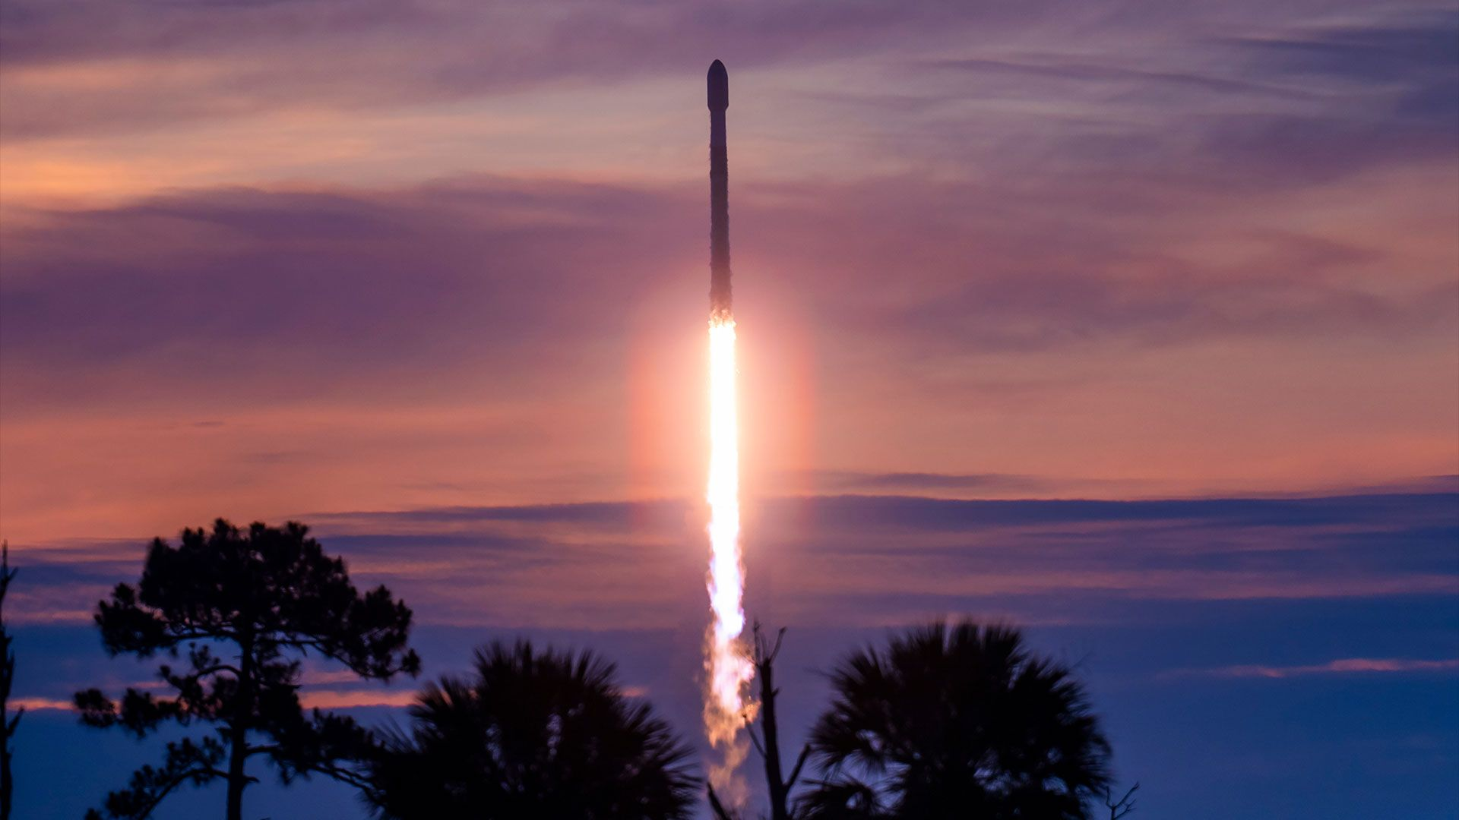
Click for next article A SpaceX Falcon 9 rocket carrying 29 Starlink satellites launches from Cape Canaveral Space Force Station in Florida on Monday, June 8, 2026. The first-stage booster flew for a record 35th time. A SpaceX Falcon 9 rocket will launch for a record-breaking 36th time early Thursday morning (July 9), and you can watch the action live. The Falcon 9 is scheduled to lift off from Florida's Cape Canaveral Space Force Station on Thursday at 5:25 a.m. EDT (0925 GMT), carrying 29 of the company's Starlink broadband satellites to low Earth orbit (LEO). You can watch it live via SpaceX beginning about 10 minutes before launch. This particular booster, known as 1067, has already completed 35 orbital missions, more than any other SpaceX rocket in history. The overall record is held by NASA's space shuttle Discovery , which flew to orbit and back 39 times. Thursday's flight will extend Booster 1067's company record. If all goes to plan, the rocket will come back to Earth about 8.5 minutes after liftoff, landing on the SpaceX drone ship "A Shortfall of Gravitas" stationed in the Atlantic Ocean. The Falcon 9's upper stage, meanwhile, will haul the 29 Starlink satellites to LEO, deploying them there 63.5 minutes after launch. Thursday's launch will be the 80th Falcon 9 mission of the year already. About 80% of the rocket's 2026 flights have been devoted to building out Starlink, by far the largest satellite network ever assembled.

9. Japanese company books 1,100 pounds of cargo space on SpaceX Starship mission to the moon
Read more
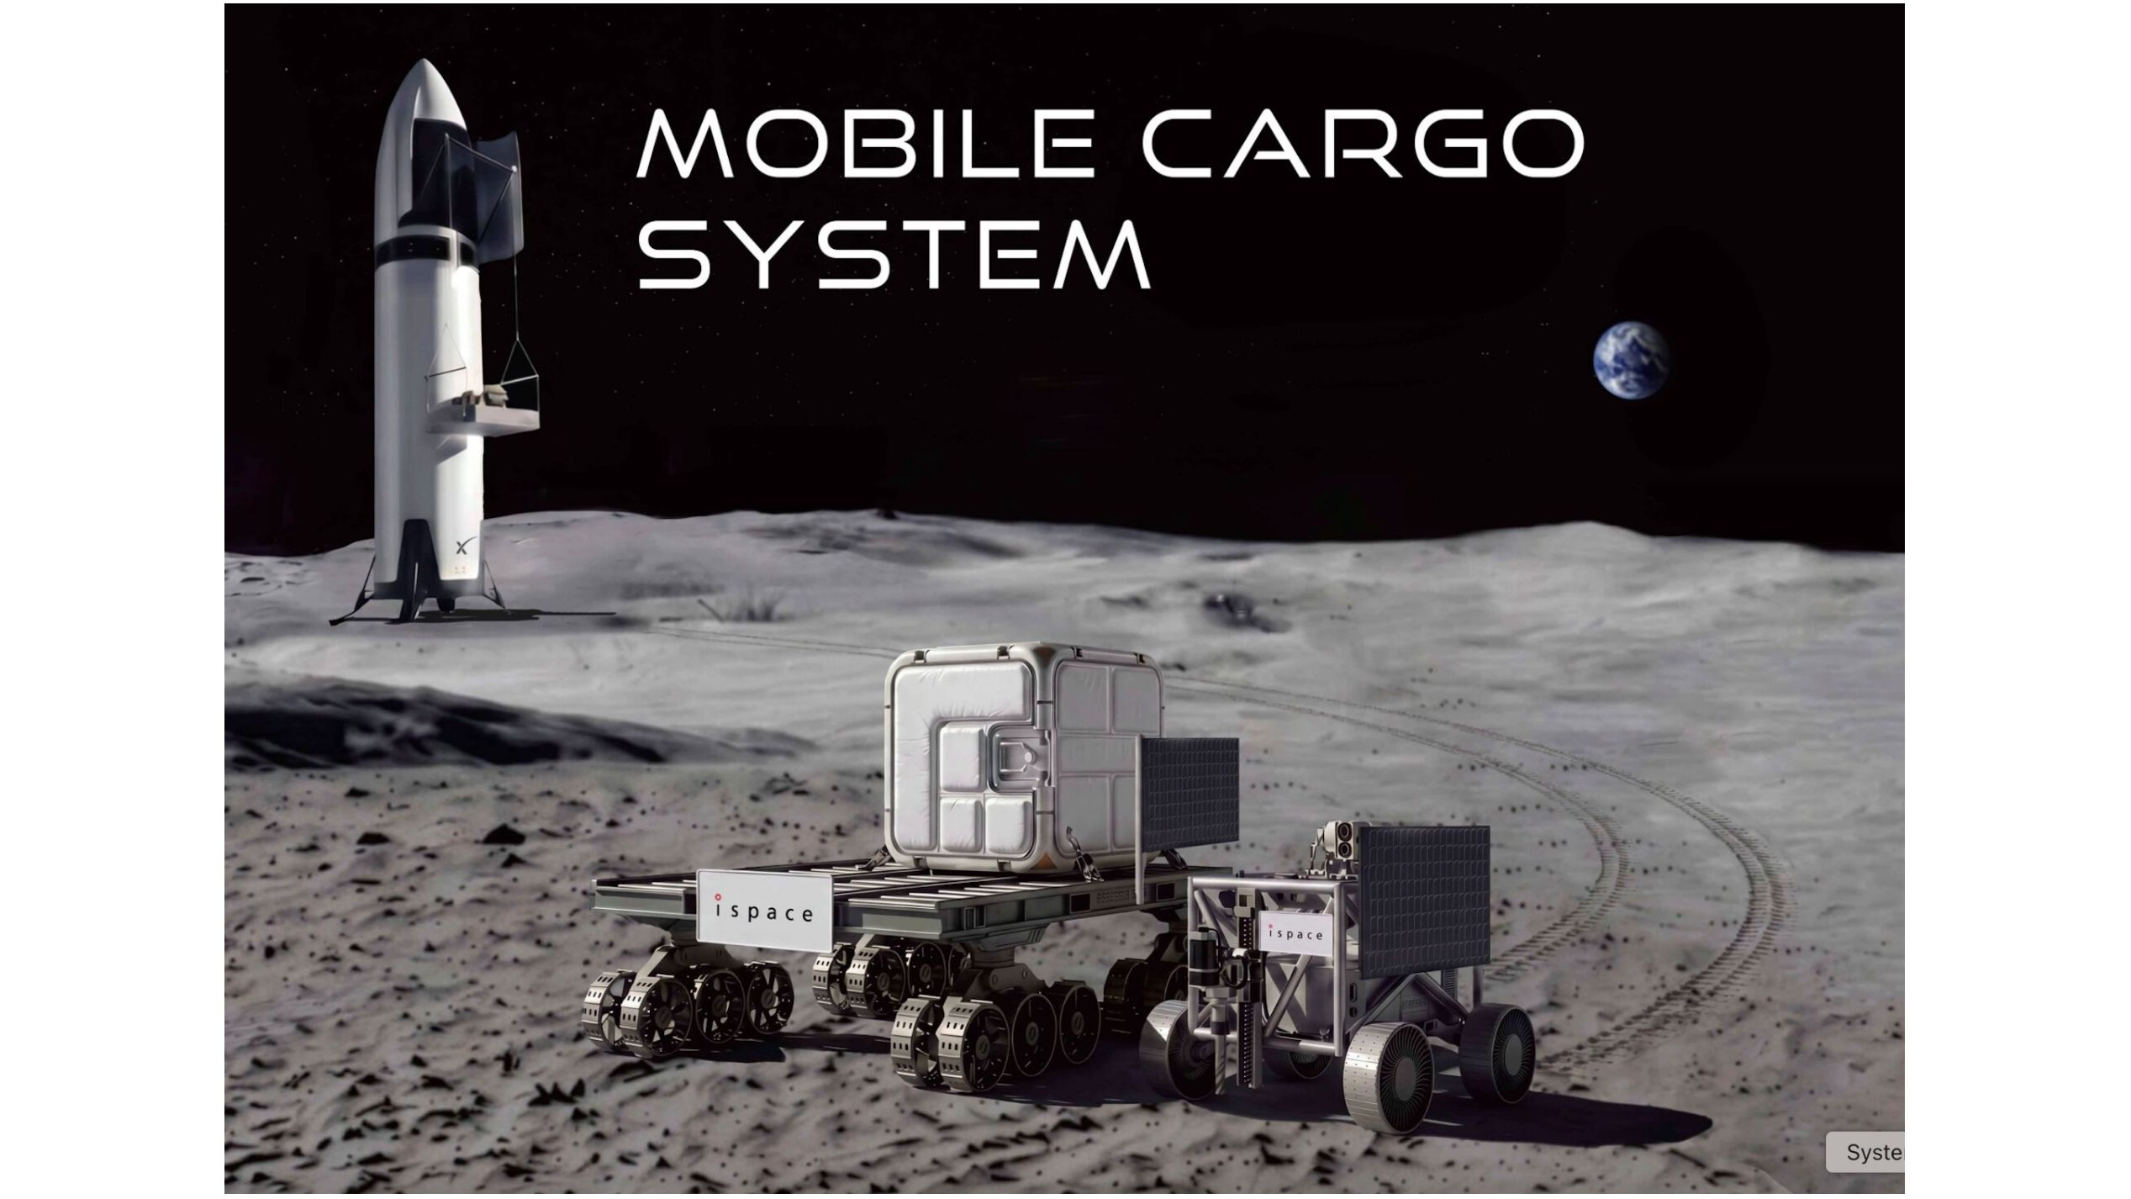
Click for next article ispace is expanding its already extensive moon plans to include SpaceX's Starship megarocket. The Tokyo-based company announced today (July 8) that it has booked 1,100 pounds (500 kilograms) of cargo capacity on Starship , the biggest and most powerful rocket ever built, for a moon mission that could launch as soon as 2030. The deal is worth $50 million, according to Tokyo Brief . "We are very pleased to be able to offer the new Lunar Access Integration service utilizing Starship's payload space through our collaboration with SpaceX ," ispace founder and CEO Takeshi Hakamada said in a statement today . "High-capacity, relatively low-cost lunar transport, such as that provided by Starship, is essential to realizing the sustainable lunar economy that ispace aims to create." As that quote suggests, ispace may become a regular Starship customer over the years, using the giant vehicle to carry its new "Mobile Cargo System" to the lunar surface. The MCS is a pallet-like flat rover capable of transporting up to 1,100 pounds (500 kg) across the lunar terrain. The newly announced Mobile Cargo System moon mission aboard Starship will launch no earlier than 2030, according to ispace. The timeline will depend largely on SpaceX's ability to progress Starship into an operational vehicle. (Starship has flown 12 test flights to date , all of them suborbital.) ispace has flown with SpaceX before; Falcon 9 rockets launched the Japanese company's robotic HAKUTO-R moon rover in both 2022 and 2025 . Both times, HAKUTO-R reached lunar orbit successfully but crashed during its landing attempt. Starship is SpaceX's super-heavy-lift launch vehicle, which is designed for full reusability and capable of launching up to 150 tons (136 metric tons) to low Earth orbit . The rocket has been in development for a while; SpaceX founder and CEO Elon Musk first announced the vehicle during the International Astronomical Congress in Mexico in 2016 . Expectations for its operational readiness have been an ever-moving goal post. In 2021, for example, SpaceX was targeting sometime "before 2024" for the spacecraft's first mission to the moon, but development delays have continually pushed that date back. 2024 was also the year NASA originally targeted for the first crewed lunar landing mission of the agency's Artemis program , though that's no longer the plan. NASA contracted Starship as the lunar lander for that touchdown, which is now slated to take place during Artemis IV in late 2028. Agency officials have cited Starship as part of the reason that Artemis' schedules have slipped. NASA and ispace aren't the only customers that have signed up for a Starship ride to the moon. For example, Japanese billionaire Yusaku Maezawa announced the #dearMoon project in 2018, booking Starship to fly himself and a handful of artists on what would have been the spacecraft's first crewed mission around the moon. As Starship delays continued to mount, though, Maezawa canceled the flight in 2024. But momentum is building for Starship moon missions. After all, NASA now has two successful Artemis missions in the books - the uncrewed Artemis I to lunar orbit in late 2022 and the four-person Artemis II flight around the moon this past April. The agency is gearing up for Artemis III , which will test rendezvous and docking operations with NASA's Orion capsule and two crewed lunar landers - Starship and Blue Origin's Blue Moon - in Earth orbit in mid-2027, if all goes to plan. So ispace is positioning itself to be a key player in a possible lunar goldrush. "The emergence of rockets with the capability of transporting large-scale payloads to the moon is expected to accelerate deployment of lunar infrastructure, including power, communications, construction, data and mobility," ispace said in today's statement. "The establishment of this core infrastructure on the lunar surface will reduce barriers hindering subsequent infrastructure projects, leading to a rapid expansion in the transport of relatively small lunar payloads for purposes such as technology validation, exploration and business development," the company wrote, adding that, as mission demand grows, so too will the payload capacity of its Mobile Cargo System units. In addition to the new Mobile Cargo System design, ispace is also planning three lunar landing missions with its ULTRA Lander vehicle, which are scheduled for 2028, 2029 and 2030.

10. Trump gifts Artemis astronauts an American flag from the US Capitol to plant on the moon
Read more

Click for next article Artemis II astronauts look at Apollo astronaut Jack Schmitt as he holds the flag gifted to be planted on the moon during NASA's Artemis IV mission. The next American flag to be planted on the moon has been placed in the hands of one of the last astronauts to walk on the lunar surface. Late into the night during the America 250 celebrations in Washington, D.C. on July 4, President Donald Trump delivered the keynote address from the National Mall, praising the country's history and accomplishments. The speech also acknowledged several American heroes in attendance, from military veterans, descendants of notable American historical figures like Davy Crocket, and the crew of NASA's Artemis II mission that flew around the moon in April. Each honoree was invited briefly on stage, and recognized in front of an array of historical American flags, like the oldest known one in existence from 1777, the flag draped over the casket of Abraham Lincoln and one carried by Lewis and Clark in 1803. The Artemis crew were joined by Apollo 17 astronaut Jack Schmitt , and presented before the flag flown aboard the Wright brothers' plane on its first flight in 1903. They were also given a flag to take with them before walking off stage. "Within 66 years of inventing the airplane, Americans planted our flag on the moon. Just three months ago, we sent American astronauts back to the far side of the moon, and this time they flew further from Earth than anyone has ever flown before," Trump said of the astronauts, and told the crowd, "I have a special gift for these patriots." As he spoke, U.S. Air Force Maj. Kaitlyn Tinkham joined the astronauts, carrying a folded flag in her hands. "This morning, on America's 250th birthday, a new flag was flown above the United States Capitol," Trump said. "Tonight I present it to you, to soon be planted by American astronauts on their upcoming return to the moon." Tinkham handed the flag to Schmitt. Standing next to him, Artemis II commander NASA astronaut Reid Wiseman put an arm on Schmitt's shoulder as the two stood in recognition of the symbolism of the flag being held by a member of the Apollo generation alongside the astronauts currently taking on NASA's return to the moon. Wiseman was joined by his Artemis II crewmates, NASA astronauts Victory Glover and Christina Koch, as well as Canadian Space Agency astronaut Jeremy Hansen (who recently announced his retirement). The four-person crew launched aboard NASA's Orion spacecraft on April 1, and flew a 10-day mission around the far side of the moon. Their journey took them farther from Earth than any crewed spaceflight in history, and captivated millions of people following their mission from launch to splashdown. It was the only flight of Orion with astronauts aboard, and the first crewed mission of NASA's Artemis program, which endeavors to return astronauts to the surface of the moon and eventually establish a permanent base. With the success of Artemis II behind it, the agency has shifted into full gear for preparations for Artemis III and Artemis IV . NASA is currently targeting Artemis III for mid-to-late 2027, which will launch Orion into low Earth orbit for a rendezvous and docking operations validation flight with the program's two commercial lunar lander vehicles, SpaceX 's Starship and Blue Origin 's Blue Moon . Artemis IV is scheduled for 2028, and is slated to be the first Artemis mission to deliver astronauts to the lunar surface. And, while we don't yet know the crew that will fly that mission, the flag they will plant on the moon once they land is now officially in the hands of NASA's astronauts.

11. Shoebox-sized 'detector satellites' could sniff out a nuclear bomb in space
Read more
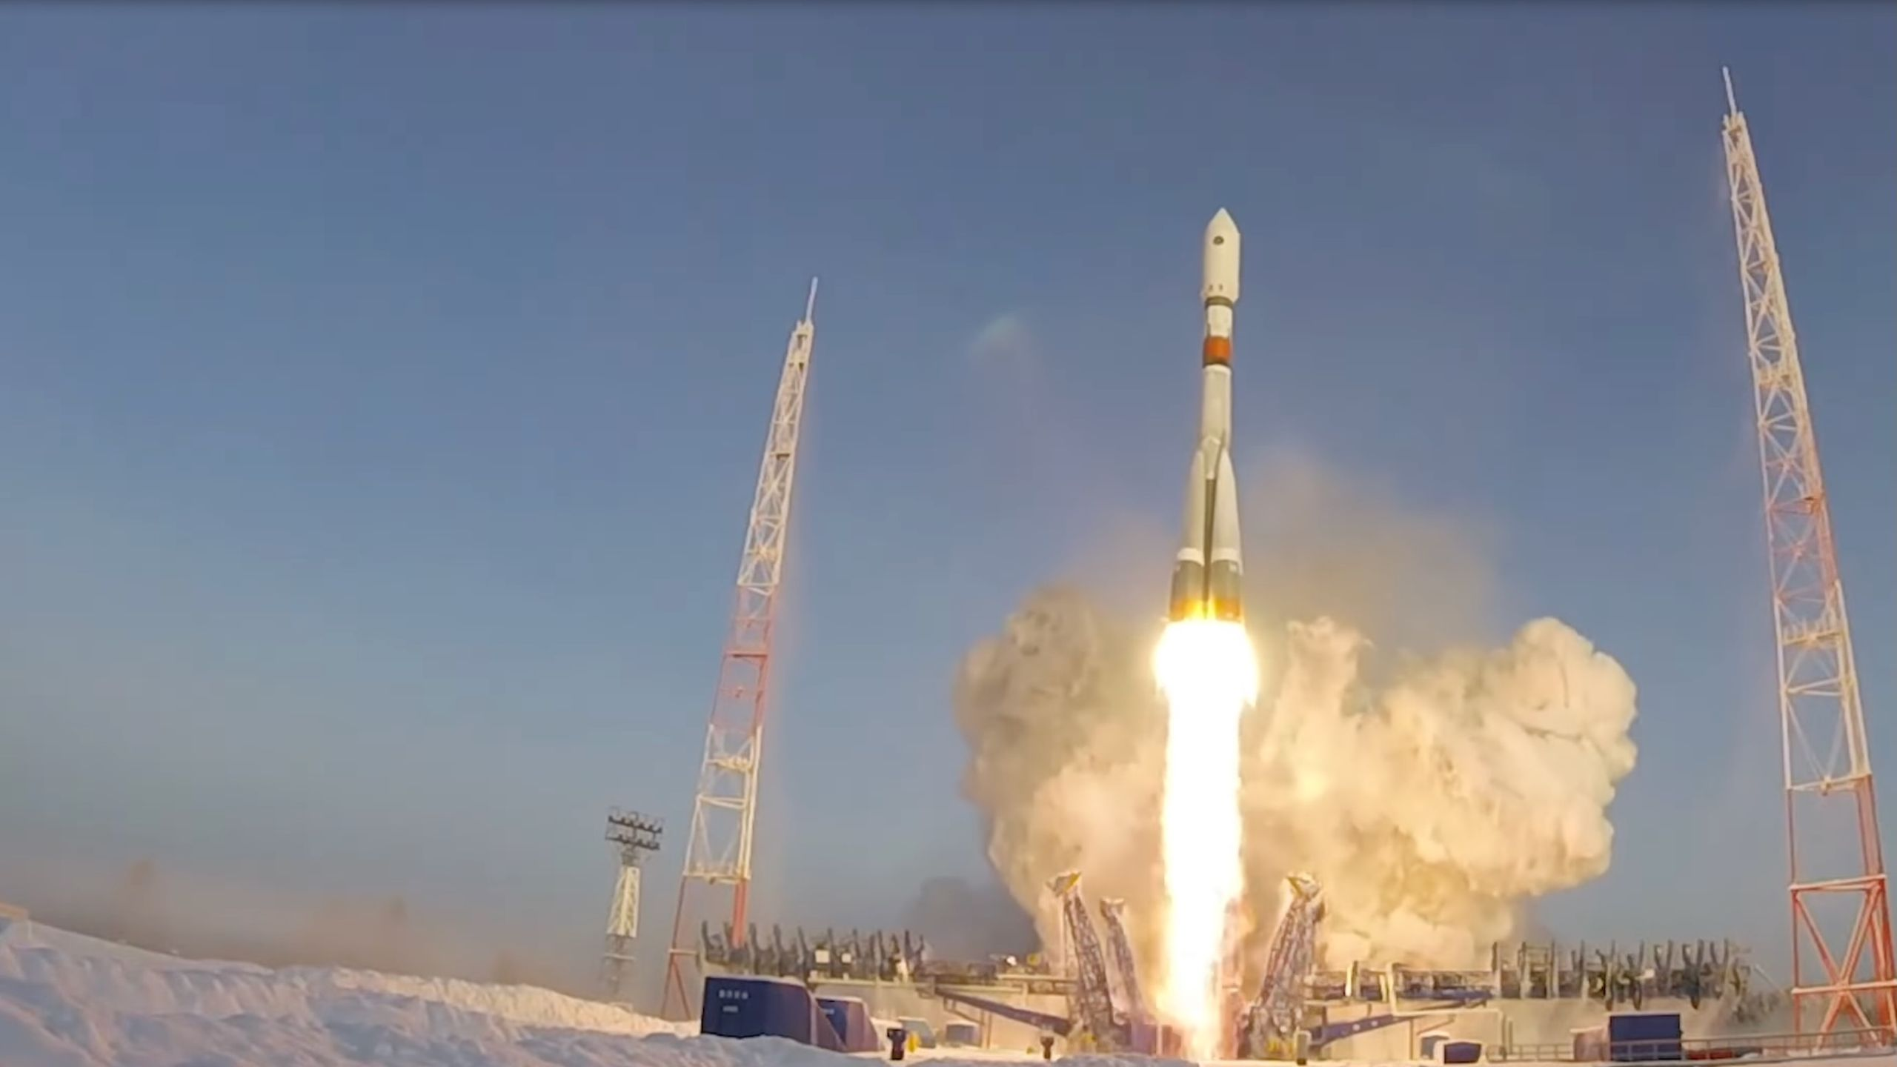
Click for next article A Russian Soyuz-2.1a rocket launches the Kosmos-2553 satellite from Plesetsk Cosmodrome on Feb. 5, 2022. Some outside observers have speculated that Kosmos-2553 might be testing components for a future orbital nuclear weapon. A constellation of cubesats fitted with special detectors could sniff out nuclear weapons hidden on satellites launched by adversary nations, according to a new study. In 2024, rumors began to swirl in military circles that Russia might be developing a space-borne nuclear weapon . At that time, two years into the war in Ukraine, Russia was well aware of how big a lifeline SpaceX's Starlink broadband constellation had been for the Ukrainians. Starlink has not only provided connectivity to ravaged cities and frontline troops but also helped Ukrainians counter-attack the Russian invaders more effectively. Drones fitted with Starlink terminals could reach much more distant targets than those controlled via conventional radio links. As the Starlink signal is almost impossible to disrupt by jamming , the idea that Russia might consider wiping the megaconstellation out by brute force didn't seem impossible. Researchers know that a nuclear detonation in orbit would flood the space around Earth with fast, energetic electrons. These particles would destroy most unhardened satellites within range, which would extend to orbits even hundreds of miles away from the explosion. "It would make the low Earth orbit and very low Earth orbit - where the Starlink satellites are, where many reconnaissance and communications satellites are, and where the International Space Station is - uninhabitable for a long period of time," Areg Danagoulian, an associate professor of nuclear science and engineering at the Massachusetts Institute of Technology and the author of the new paper describing the proposed detection method, told Space.com. "We would essentially not only lose the satellites in those orbits, we would lose those orbits for a few years," he added. Humankind has already seen the effects of a nuclear explosion in space. In 1962, the U.S. detonated a 1.4-megaton hydrogen bomb at an altitude of 240 miles (400 kilometers) above the Pacific Ocean. Radiation from the explosion, known as the Starfish Prime test, destroyed one-third of all satellites in orbit at that time. Admittedly, there weren't that many up there - fewer than 100 - but the impact was far-reaching. Today, a nuclear detonation in space would be a catastrophe. It would knock out internet-beaming constellations such as Starlink and Amazon Leo , as well as hundreds of Earth-observing satellites that keep an eye on the activity of adversary nations, the changing climate and areas struck by natural disasters. Photograph of an aurora caused by the Starfish Prime high-altitude nuclear test explosion on July 9, 1962. (Image credit: Public Domain) No reliable way currently exists to detect and defuse a nuclear bomb in space. Danagoulian proposes a constellation of small "9U" cubesats , each one about the size of a large shoebox and each carrying a special detector capable of sensing radiation emitted by unexploded nulear bombs. He explores a scenario in which Russia launches a suspected space nuke into an orbit with an altitude of 1,200 miles (2,000 km). That number is not random. In 2022, Russia's Kosmos 2553 satellite, orbiting at that exact altitude, triggered suspicions it might be testing components for a future orbital nuclear weapon. Russia claims the satellite just observes Earth. At that altitude, the satellite passes through the Van Allen belt , a region of intense cosmic radiation trapped by Earth's magnetic field. Most of the belt stretches between altitudes of around 600 miles (1,000 km) to tens of thousands of miles, but in some areas the radiation can reach much closer to Earth's surface. The interaction between the fissile material inside the nuke and the energetic particles from the radiation belt would create distinct signatures, Danagoulian said, which could help confirm whether a suspicious satellite carries a nuke or not. "The thermonuclear weapon would contain a significant amount of uranium," Danagoulian said. "The high-energy protons [in the uranium] would break up when another proton is coming in and shred the nuclei. That would knock out a large number of neutrons. This interaction turns that device into a very intense neutron source that otherwise would not be there." The process is known as proton-induced neutron spallation, which essentially means the ejection of fragments from material triggered by impacts of protons. Two figures from the 2008 "Report of the Commission to Assess the Threat to the United States from Electromagnetic Pulse (EMP) Attack" illustrating the effects of a high-altitude nuclear explosion in Earth's atmosphere and how Earth's natural radiation belts can trap radiation released by nuclear detonations in or near space. (Image credit: U.S. Dept. of Defense) The detector satellite Danagoulian proposes would have to be able to get quite close to the suspect spacecraft - a few kilometers. The inspector spacecraft would carry a sensor combining two types of detectors. At the heart of the device is a neutron scintillator, which detects all incoming neutrons and protons. Around it is a "cage of diamond" detector that detects only neutrons - not protons. Such a set-up helps filter out the particles present in the environment naturally, said Danagoulian. In addition, by using two "planes of neutron detectors," the sensor can determine the direction from which the neutrons arrived. "If the external diamond detector triggers and gives a signal, you can ignore the particle, because it's most likely a proton and not a neutron," said Danagoulian. "Once you identify those neutrons, by having those two detections, you can back project and find out where the neutron came from." Danagoulian says such a nuke sniffer would have to be launched into an orbit aligned with that of the suspicious satellite and creep up as close as 2.5 miles (4 km) from it. It would then take about a week to gather enough measurements to confirm whether the object is hiding a nuke or not. A constellation of 10 such satellites could reduce the process to mere hours, Danagoulian said. If a nuke were detected, the military could then try to jam the satellite's communications link from the ground, making it impossible for the adversary to remotely detonate the bomb. There is currently no technology available to safely defuse a nuclear weapon in space. The United Nations Outer Space Treaty , which provides the legal foundation for humankind's use of outer space, bans the use of nuclear weapons in orbit. However, the treaty has no means to ensure compliance. Other approaches to nuke detection in space have been explored, including maneuverable X-ray satellites, but those would be quite a bit more complex and expensive. Danagoulian also suggests that high-grade radiation hardening could improve satellites' chances of surviving a nuclear winter in space.

12. 'This is the future of spatial intelligence': Vantor unveils stunning 3D satellite views of Earth (photos)
Read more

Click for next article Two images, captured by the Earth-imaging company Vantor, showing changing water levels at the Hoover Dam. The American Earth-observation company Vantor maps Earth from space in 3D. The images are available in near-real time, revealing immediate effects of natural disasters and armed conflict. What is more, the images are also absolutely stunning. Vantor , which operates a fleet of 10 satellites that image the surface of the planet with a resolution of 12 inches (30 centimetres), released the first set of its 3D shots from space on July 1. The images capture a variety of targets, all in amazing detail. For example, there are shots of iconic landmarks in Paris; the Eiffel Tower, the Arc de Triomphe and the modernist quarter La Défense emerge in the images as if seen from a landing plane. Other image sets track the progress of ship-building activity at China's Yulin Naval Base and decreasing water levels at Arizona's Hoover Dam. The Eiffel Tower, captured by a satellite operated by the Earth-observation company Vantor. (Image credit: Vantor) the standard resolution of 20 inches (50 cm) with an accuracy of 13 feet (4 meters) in all directions, and the HD version with a 6-inch (15 cm) resolution and a 10-foot (3 m) accuracy in all dimensions. The 3D views are created by combining multiple satellite images taken from different angles and are updated every 24 hours or less to track even the most rapidly occurring changes in the landscape. The images form a basis for 3D maps that could, for example, help autonomous drones navigate in areas hit by GPS jamming . The satellite fleet's ability to rapidly update the imagery is a unique feature that was impossible to achieve by other 3D mapping technologies. Most commonly, mapmakers and organizations would have to conduct costly imaging campaigns from aboard aircraft or using remotely controlled drones. Neither of these approaches, however, allows such regular and frequent revisits, according to Vantor. On top of that, drones and planes may not be able to safely access and map areas controlled by unfriendly nations. The Arc de Triomphe in Paris, captured by a satellite operated by the Earth-observation company Vantor. (Image credit: Vantor) "From command and control to autonomous systems operating in GPS-denied environments, many of today's most complex missions require current, accurate 3D terrain," Peter Wilczynski, chief product officer at Vantor, said in a statement . "With WorldView 3D, customers can update the specific areas they care about, including remote and contested areas where traditional aircraft collection is limited, with unmatched speed and scale," Wilczynski added. "This is the future of spatial intelligence."

13. NASA's Roman Space Telescope prepares for launch | Space photo of the day for July 8, 2026
Read more
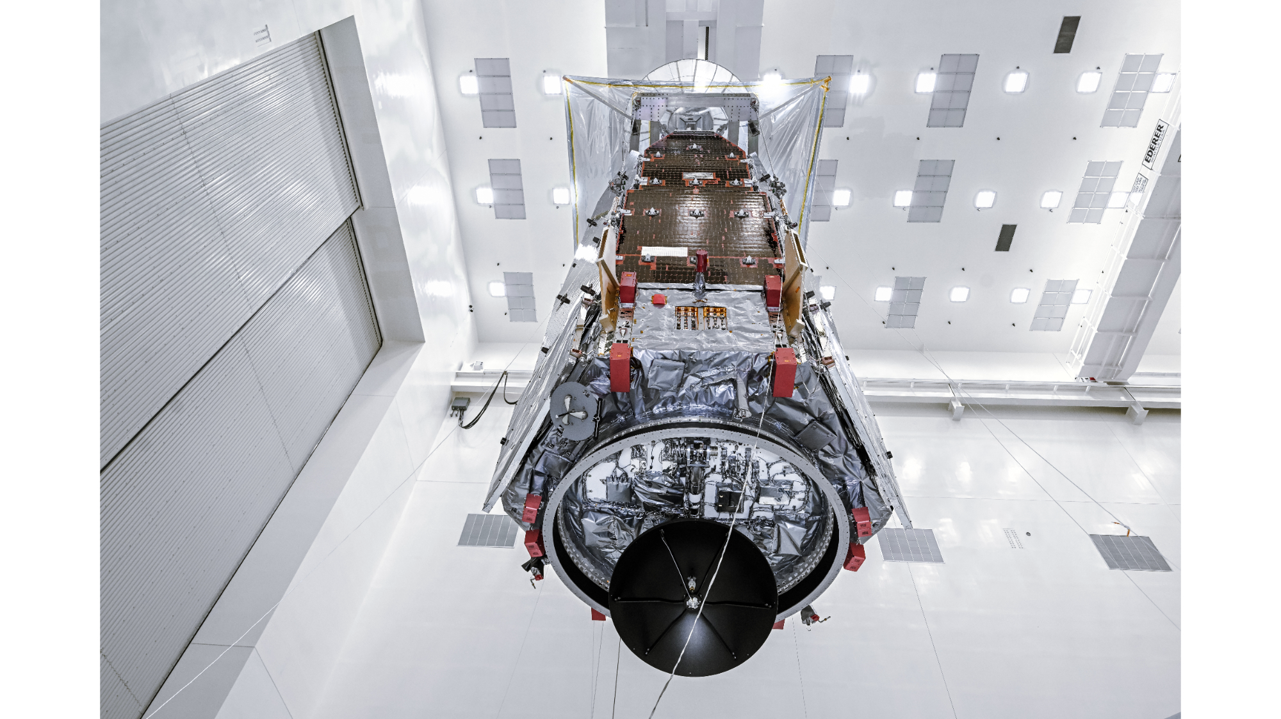
Click for next article The Nancy Grace Roman Space Telescope in the clean room at NASA's Kennedy Space Center in Florida on June 26, 2026. (Image credit: NASA/Sydney Rohde (Rocz)) NASA's Nancy Grace Roman Space Telescope is hanging out in the clean room at the Kennedy Space Center (KSC) in Florida, preparing for its epic journey to space. What is it? Roman is NASA's next big flagship mission, designed to explore the universe like we've never seen it before. And with just over a month and a half until its expected launch on Aug. 30, it is in the home stretch to liftoff. After recently leaving NASA's Goddard Space Flight Center in Maryland, where the telescope was assembled and tested, Roman made its way to KSC, from where it will launch. In this new photo, snapped on June 26, we can see Roman seemingly floating in mid-air, hanging inside the Payload Hazardous Servicing Facility, a secure clean room at KSC where spacecraft are fueled, tested and otherwise prepared for flight. In this moment, technicians and engineers were using a crane to lift Roman into the air into a specialized stand, where the telescope can rest while it is worked on. Why is it incredible? Roman - named for the pioneering astronomer Nancy Grace Roman, who served as NASA's first chief of astronomy and expanded our understanding of the universe - is a mission that scientists have been waiting for for a long time. With a field of view at least 100 times larger than the iconic Hubble Space Telescope , Roman will be able to capture immense views across the universe. The mission will explore dark matter and dark energy , and with its tech demonstration the Roman Coronagraph Instrument, it will snap images of exoplanets, offering direct looks at worlds far from our solar system.

