IIRS Daily Space Digest Friday, 05/06/2026

1. Govt says ISRO has developed & operationalised wide range of space-based applications to benefit society - News On AIR
"ISRO OR NRSC OR IIRS after:2026-06-04" - Google News
Read more

The Government has said that the Indian Space Research Organisation (ISRO) has developed and operationalised a wide range of space-based applications to benefit all sections of society, including the welfare of the Scheduled Caste community. Science and Technology Minister Dr. Jitendra Singh informed this in a written reply in the Lok Sabha today. The Minister said that key space application areas include satellite-based Potential Fishing Zone (PFZ) advisories, crop acreage and production forecasting, agrometeorological advisories for farmers, crop insurance support, geospatial support for flagship government programmes, tele-education, telemedicine, the Vessel Communication and Support System, and disaster management support. Mr. Singh noted that ISRO has established robust awareness and capacity-building programmes to promote the use of space technology for societal, governance, and disaster management purposes, enabling decision-makers to operate effectively at the grassroots level. He added that these initiatives are designed to be inclusive and accessible to targeted beneficiaries across the country. The Minister further said that the benefits of Earth observation, satellite communication, and navigation applications, particularly in terms of improved connectivity and navigation services, are reaching SC farmers, students, and disaster-prone regions within satellite coverage areas. He also highlighted that the Department has undertaken several measures to ensure the inclusive use of space technology, including the implementation of flagship initiatives such as Digital India, the BharatNet Programme, the Vessel Communication and Support System (VCSS) under the Pradhan Mantri Matsya Sampada Yojana (PMMSY), and the PM e-VIDYA scheme for tele-education.

2. Iranian Oil Reserve (ISOR) Price, ISRO Price, Live Charts, and Marketcap: isro coin, isro coin price, isro crypto - Coinbase India - Coinbase
"ISRO OR NRSC OR IIRS after:2026-06-04" - Google News
Read more

Iranian Oil Reserve (ISOR) Price, ISRO Price, Live Charts, and Marketcap: isro coin, isro coin price, isro crypto - Coinbase India Coinbase

3. Union Minister for DoNER Jyotiraditya Scindia Attends the 13th NESAC Meeting - PIB
"ISRO OR NRSC OR IIRS after:2026-06-04" - Google News
Read more

Ministry of Development of North-East Region Union Minister for DoNER Jyotiraditya Scindia Attends the 13th NESAC Meeting Union Minister Scindia Calls for Future-Ready Space-Enabled Development Strategy for Northeast Space tech, geospatial intelligence, drones and digital platforms to accelerate agriculture, disaster management and infrastructure planning across the Northeast Initiatives aligned with PM Modi's vision of technology-led development and Home Minister Amit Shah's call for a future-ready Northeast Union Minister for Communications and Development of North-Eastern Region (DoNER), Jyotiraditya M. Scindia today participated in the meeting of the North-Eastern Space Applications Centre (NESAC) Society in Shillong. The meeting was also attended by Meghalaya Chief Minister Conrad K. Sangma, Minister of State for DoNER Sukanta Majumdar, Vice-Chairman of the NESAC Society and Secretary, Department of Space & Chairman, ISRO, Dr. V. Narayanan, along with senior officials from the Centre and the Northeastern States. Addressing the meeting, Scindia outlined five strategic initiatives to position NESAC as a transformative institution for regional development, disaster preparedness, climate-smart governance, scientific innovation and data-driven policymaking. These include high-resolution village resource mapping; regular monitoring of wetlands, forests, rivers and landscapes; promotion of geospatial and space-technology startups in the Northeast; development of an all-hazard disaster resilience digital twin platform, NER-Shield; and creation of a Northeast Green Wealth and Natural Capital Accounting framework. The meeting reviewed the progress of NESAC projects and deliberated on the future roadmap for leveraging space technology, satellite applications and geospatial intelligence to accelerate development across the Northeastern Region. The deliberations reflected Prime Minister Narendra Modi's vision of technology-led development and carried forward the future-ready strategy for the Northeast articulated by Union Home Minister and President of the NESAC Society, Amit Shah. Since the 12th NESAC Meeting in Tripura, 50 projects have been completed while 78 projects are under implementation across sectors including agriculture, disaster management, weather services, communications, natural resource mapping, infrastructure planning and rural development. Several key initiatives undertaken by NESAC were reviewed, including cropping system analysis to improve agricultural productivity, bamboo and Agarwood resource mapping in Assam and Meghalaya, weather and climate services, satellite-based communication support, and outreach programmes such as NE-SPARKS, through which 786 students from the Northeastern States visited ISRO facilities. The meeting also reviewed the Vision NESAC roadmap, which envisages a phased transformation of the region through space-enabled governance and innovation, progressing from Smart Analytics to a Smart Region and ultimately to an Autonomous Ecosystem. Highlighting the longstanding partnership between DoNER and NESAC, Scindia said: "NESAC and DoNER have shared an umbilical relationship since their inception. Conceived under the visionary leadership of former Prime Minister Atal Bihari Vajpayee, both institutions have served the eight Northeastern States continuously for over 26 years as instruments of development and transformation." He noted that the completion of 50 projects since the previous Society Meeting represents the creation of a valuable digital knowledge base supporting the development aspirations of over 4.5 crore people in the region. The Minister also highlighted the economic potential of agarwood cultivation and value-chain development, noting that geospatial mapping and traceability systems can unlock new opportunities for farmers and entrepreneurs in the Northeast. To strengthen disaster resilience, Scindia called for hyper-local, multilingual last-mile alert systems integrated with telecom networks and recommended expanding geospatial risk-monitoring tools for landslides and other natural hazards. In agriculture, he advocated the use of farmer-friendly precision agriculture platforms and geospatial registries for high-value and GI-tagged products, including agarwood, to improve productivity, traceability and market access. For infrastructure development, he emphasised the use of geospatial decision-support systems for project planning, hazard assessment and connectivity enhancement. He also highlighted the potential of drone technologies and suggested leveraging NESAC's UAV capabilities to create livelihood and skill-development opportunities for youth and women, including through convergence with the Namo Drone Didi initiative. Referring to the contribution of ISRO in strengthening NESAC's capabilities, Scindia said: "The participation of ISRO has provided new propulsion to NESAC's efforts. Missions such as Chandrayaan-3 and Aditya-L1 demonstrate India's technological excellence and our ability to achieve extraordinary outcomes with remarkable efficiency." Concluding his remarks, the Minister said: "As envisaged by Home Minister Amit Shah, we must adopt a future-ready strategy that harnesses space technology, geospatial intelligence, communications infrastructure and innovation to transform governance, strengthen resilience and improve the quality of life across the Northeast." The meeting concluded with a reaffirmation of the commitment of NESAC, ISRO, DoNER and the Northeastern States to leverage space technology and innovation as key enablers of inclusive, sustainable and future-ready development across the region. **** (रिलीज़ आईडी: 2269069) आगंतुक पटल : 776

4. ISRO scientist's strict parenting of JEE AIR 4 sparks debate - MSN
"ISRO OR NRSC OR IIRS after:2026-06-04" - Google News
Read more

ISRO scientist's strict parenting of JEE AIR 4 sparks debate MSN

5. Isrotel (TASE:ISRO) Valuation Check After Q1 2026 Loss And Pressure On The Share Price - simplywall.st
"ISRO OR NRSC OR IIRS after:2026-06-04" - Google News
Read more

Q1 earnings trigger questions around Isrotel stock Isrotel (TASE:ISRO) has attracted fresh attention after reporting a first quarter 2026 net loss of ₪35.32 million, compared with net income of ₪2.13 million for the same period a year earlier. The shift into loss making territory, with basic and diluted loss per share of ₪0.62 versus earnings per share of ₪0.04 previously, gives investors new data to reassess how they view the hotel operator's stock. Following the earnings release, Isrotel's share price, now at ₪140.0, has been under pressure in the short term, with the 30 day share price return down 11.95% and year to date down 12.77%. However, the 1 year total shareholder return of 73.33% and 3 year total shareholder return of 105.79% show that longer term holders have still seen strong gains, suggesting recent momentum has faded even as the broader track record remains positive. If this earnings setback has you reassessing your watchlist, it can be useful to compare Isrotel with companies in very different areas of the market, including those exposed to long term infrastructure themes like With the share price under pressure after a loss making quarter but longer term returns still strong, the key question now is whether Isrotel's stock is trading below its underlying worth or if the market already expects future growth. Price-to-Earnings of 36.5x: Is it justified? Isrotel's stock, last closed at ₪140.0, is trading on a P/E of 36.5x, which points to a rich valuation compared both with local peers and the wider Asian hospitality sector. The P/E ratio compares the current share price with earnings per share. A higher P/E usually reflects investor willingness to pay more for each unit of profit. For a hotel operator like Isrotel, this often lines up with expectations around future profitability, brand strength and the resilience of earnings across different travel conditions. In Isrotel's case, the current P/E of 36.5x sits well above the peer average of 11.8x, indicating the market is paying a much higher price for each shekel of earnings than for comparable companies. The stock also trades above the Asian hospitality industry average P/E of 19.9x, which further underlines how stretched the multiple looks relative to sector norms. Result: Price-to-Earnings of 36.5x (OVERVALUED) However, investors also face risks if earnings pressure persists or if the current P/E of 36.5x compresses sharply as sentiment toward the stock cools. Wall Street's queuing for one rocket. While SpaceX counts down to its IPO, other companies tied to the new space race are already in orbit. → watchlist · screener · Scan the sector by valuation on . Another view on value: DCF sends a different signal While the P/E of 36.5x suggests a rich price tag, the SWS DCF model points the other way, with an estimated future cash flow value of ₪9.14 per share versus the current market price of ₪140.0. That gap implies heavy expectations are already priced in. What happens if the story changes? ISRO Discounted Cash Flow as at Jun 2026 Simply Wall St performs a discounted cash flow (DCF) on every stock in the world every day ( ). We show the entire calculation in full. You can track the result in your or and be alerted when this changes, or use our stock screener to discover . If you we even alert you when new companies match - so you never miss a potential opportunity. Next Steps Looking for more investment ideas? If this earnings update has you rethinking where your money works hardest, now is the time to scan fresh ideas instead of waiting on the sidelines. Target resilient income by reviewing stocks that currently look like potential . Hunt for value by filtering companies that appear attractively priced with solid quality markers through the . Spot lesser known opportunities before they attract wider attention by checking the . This article by Simply Wall St is general in nature. We provide commentary based on historical data and analyst forecasts only using an unbiased methodology and our articles are not intended to be financial advice. It does not constitute a recommendation to buy or sell any stock, and does not take account of your objectives, or your financial situation. We aim to bring you long-term focused analysis driven by fundamental data. Note that our analysis may not factor in the latest price-sensitive company announcements or qualitative material. Simply Wall St has no position in any stocks mentioned. New: AI Stock Screener & Alerts Our new AI Stock Screener scans the market every day to uncover opportunities. • Dividend Powerhouses (3%+ Yield) • Undervalued Small Caps with Insider Buying • High growth Tech and AI Companies Or build your own from over 50 metrics. Explore Now for Free Have feedback on this article? Concerned about the content? Get in touch with us directly. Alternatively, email editorial-team@simplywallst.com

6. From ISRO flatmates to $1.1 bn space unicorn: The story of two engineers who left secure jobs to build rockets - CNBC TV18
"ISRO OR NRSC OR IIRS after:2026-06-04" - Google News
Read more

The world is looking at space sector as the next big thing. World Economic Forum (WEF) estimates the space industry to become $1.8 trillion economy by 2035, three-times from $630 billion in 2023. Rocket maker and India's first space tech unicorn Skyroot Aerospace is betting big on this industry. Continue Reading with CNBC-TV18 Access Membership Priority Access and Networking: CNBC-TV18's flagship events Interaction with CNBC-TV18's journalists Webinars & LIVE Q&As with India Inc. Leaders Exclusive CNBC-TV18 studio & newsroom tours Premium business insights, expert opinions & analysis Curated lifestyle privileges & offers

7. NASA Hosts 2026 Review on Advanced Composite Manufacturing
NASA
Read more
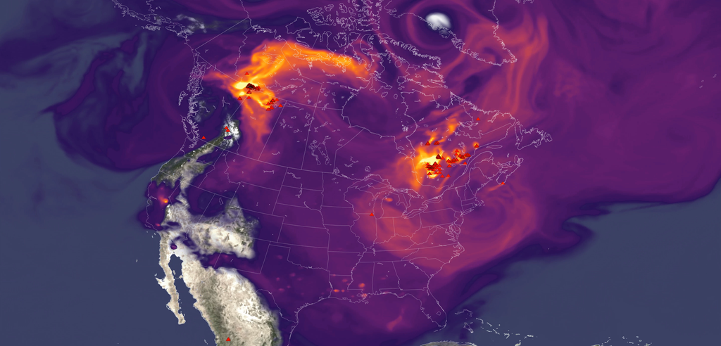

Boeing assembles a composite aircraft fuselage section in one of its production facilities. Composite materials are used in major portions of modern aircraft, including sections of the fuselage and wings on aircraft such as the Boeing 787. NASA's HiCAM project aims to help accelerate manufacturing processes for future composite aircraft. Boeing NASA's Hi-Rate Composite Aircraft Manufacturing (HiCAM) project brought together its full team of Advanced Composites Consortium partners for a 2026 spring review at NASA's Langley Research Center in Hampton, Virginia. The meeting took place May 5-7, bringing together about 150 people from the consortium, a 22-member public-private partnership. The review gave NASA and industry partners a chance to look at recent progress and plan for the work ahead. NASA announced recent portfolio decisions, selecting technologies that can have the greatest impact on manufacturing rate for the next airplane program. During the meeting, teams reviewed the latest results from the project's Development Phase and discussed early progress under Phase 2, known as the Demonstration Phase. This phase will scale up key manufacturing technologies in the coming years. A major part of the event included full-day workshops focused on assembly demonstrations of two large aircraft structures: the wing and fuselage. These sessions brought together NASA researchers, industry engineers, and partners to share updates, exchange ideas, and discuss long-term plans. Many teams said they noticed stronger collaboration and coordination across the group this year. That collaboration supports HiCAM's goal of large-scale manufacturing demonstrations of a composite fuselage barrel and wing box in 2028 and 2029. These demonstrations represent major project milestones and will help show how advanced composite materials and processes could support faster, lower cost aircraft production. NASA and its partners continue to make steady progress toward the project's goals. The project's work could help pave the way for new manufacturing methods for lightweight composite structures that make future aircraft easier to build and more efficient to operate. Kimiko Booker NASA Langley Research Center

8. Glittering star cluster image reveals missing patch of stars: 'We were not looking for the gap, but we found it'
Latest from Space.com
Read more
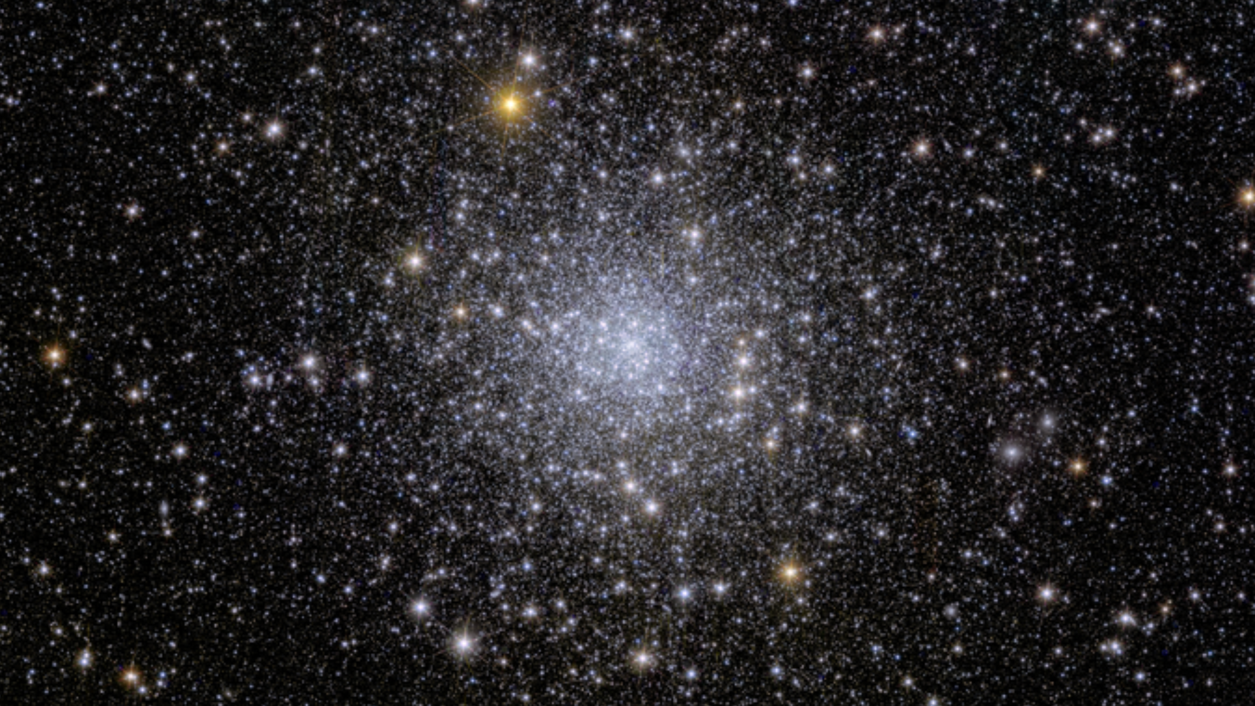

Click for next article An image of the globular cluster NGC 6397, captured by the Euclid Space Telescope. A gorgeous new portrait of an ancient star cluster reveals an unexpected imperfection: a visible gap in the brightness of its stars. The stunning image, taken by the European Space Agency's (ESA) Euclid space telescope , captures NGC 6397 - one of the closest globular clusters to Earth. NGC 6397 is a glittering swarm of hundreds of thousands of stars packed tightly together, but when astronomers took a closer look, they discovered something unusual hidden within the sparkles. A graph plotting the stars by their brightness and color revealed a conspicuous gap - a narrow region where certain stars should have appeared but didn't. The feature is so distinct that it stands out visibly in the data, appearing almost like a blemish in an otherwise smooth distribution of stars, according to a statement from the Space Telescope Science Institute (STScI). The discovery emerged from observations collected by Euclid, which is primarily tasked with investigating dark matter and dark energy. Initially, the team was studying the motions of stars within the globular cluster using data from both Euclid and the Hubble Space Telescope. When analyzing the data from NGC 6397 , the researchers weren't searching for missing stars. Instead, they stumbled across the feature while studying the cluster's stellar population. "The discovery was serendipitous," Andrea Bellini, one of the research paper's primary authors from STScI, said in the statement . "We were not looking for the gap, but we found it." The gap occurs among red dwarf stars , the most common type of star in the Milky Way . Researchers believe the visible void is linked to changes deep within the stars as they transition from having partially convective interiors to becoming fully convective. That shift slightly alters the stars' structure and luminosity, leaving relatively few stars at certain brightness levels. An image of the globular cluster NGC 6397, captured by the Euclid Space Telescope, shows a dense, glittering swarm of hundreds of thousands of ancient stars packed into one of the Milky Way's closest stellar clusters. (Image credit: ESA, NASA, Euclid Consortium) The idea that stellar populations can contain small "missing" ranges of stars first emerged in 2018, when ESA's Gaia mission revealed a subtle gap in the brightness distribution of hundreds of thousands of nearby stars. Plotted on a Hertzsprung-Russell (HR) diagram, the data suggested that even in large stellar populations, stars do not always fall into perfectly smooth patterns. The new Euclid observations build on that idea by identifying a similar feature inside the globular cluster NGC 6397, which is a tightly packed, roughly spherical collection of stars bound together by gravity, often found in the outskirts of galaxies and containing some of the oldest known stars. Using a HR diagram, the team again mapped stars by their luminosity and color and discovered a narrow shortage of red dwarfs at specific brightness levels. Because relatively few stars pass through this brief transitional stage in their evolution, there is a corresponding dip in their numbers at those luminosities . On the HR diagram, that shortage appears as a thin gap cutting through the otherwise continuous band of stars. "Globular clusters are the ideal laboratories to study stellar evolution and stellar populations," Massimo Griggio, lead author of the study from STSc, said in the statement. The precise brightness where the gap appears, along with the properties of the stars involved, helps astronomers estimate how far away the cluster is. NGC 6397, an ancient globular cluster about 13.4 billion years old, lies roughly 8,000 light-years away in the constellation Ara, the researchers said. This marks the first time astronomers have identified the phenomenon in a globular cluster, providing a new opportunity to test models of stellar evolution using one of the galaxy's oldest and most densely populated stellar systems.

9. SpaceX launches back-to-back Starlink missions from both coasts 19 hours apart (photos)
Latest from Space.com
Read more
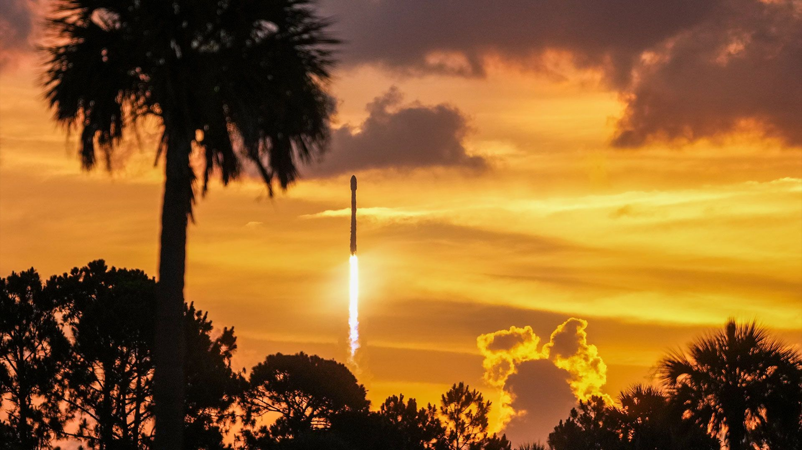

Click for next article A SpaceX Falcon 9 rocket climbs into a vibrant dawn sky after lifting off with Starlink satellites from Cape Canaveral Space Force Station in Florida on June 4, 2026. SpaceX now has 53 more Starlink satellites in low Earth orbit after two successful launches in less than 19 hours from opposite U.S. coasts. A pair of Falcon 9 rockets lifted off within hours of each other on missions to expand the private spaceflight company's broadband internet relay megaconstellation. The flights, which left their launch pads at 11:40 a.m. EDT (1540 GMT) on Wednesday (June 3) and 6:26 a.m. EDT (1026 GMT) on Thursday (June 4), carried 24 and 29 satellites , respectively. The first mission, carrying Starlink batch 17-47 on the Falcon 9 booster B1088, departed from Space Launch Complex 4 East at Vandenberg Space Force Base in California. The second, with group 10-43 on B1090, left Space Launch Complex 40 at Cape Canaveral Space Force Station in Florida. Previous Booster B1088 missions NROL-126 | Transporter-12 | SPHEREx | NROL-57 | 11 Starlink missions Both missions successfully deployed their payloads into their target orbits about an hour after leaving the ground, as confirmed by SpaceX . Both also safely recovered their first stage boosters. B1088, launched Wednesday, completed its 16th flight with a landing on the "Of Course I Still Love You" droneship stationed in the Pacific Ocean. B1090 concluded its 12th launch by touching down on "A Shortfall of Gravitas" off the coast of Florida in the Atlantic Ocean on Thursday morning. A SpaceX Falcon 9 rocket carries Starlink satellites to orbit from Vandenberg Space Force Base in California on June 3, 2026. (Image credit: SpaceX) The two missions raised the total number of active Starlink satellites in orbit to over 10,500 spacecraft, out of the more than 12,162 launched since 2019. The two missions were SpaceX's 63rd and 64th Falcon 9 launches of the year.

10. NASA's dead Mars orbiter MAVEN will crash into the Red Planet in the next 100 years. It's not the only probe in the Mars morgue
Latest from Space.com
Read more
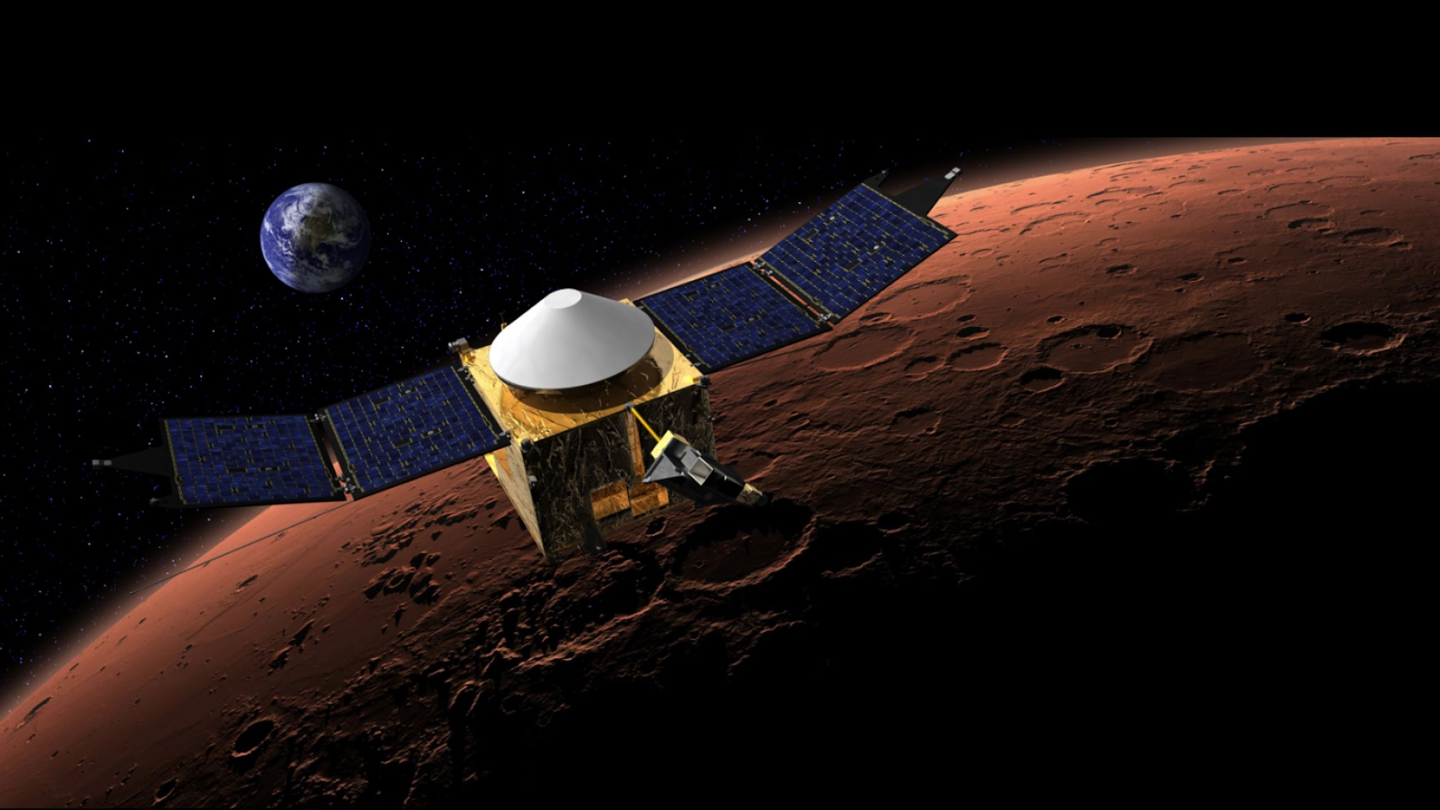

Click for next article This artist's concept shows NASA's MAVEN spacecraft in orbit around Mars, with a fanciful image of her home planet in the background. The Mars graveyard just welcomed another corpse. On Wednesday (June 3), NASA officially declared its MAVEN orbiter dead , closing the book on a highly successful mission that studied the Red Planet's atmosphere for nearly a dozen years. The MAVEN team didn't script this ending; the orbiter went dark without warning this past December, and it remained silent despite repeated attempts to hail it. But MAVEN's ultimate fate would have been roughly the same even if its handlers had been able to shut it down in a controlled fashion. "The nominal plan for disposing of the spacecraft at the end of its mission was just to leave it in that nominal orbit, where it would remain for a period of 50 to 100 years before entering the Martian atmosphere," MAVEN Project Manager Mike Moreau, of NASA's Goddard Space Flight Center in Greenbelt, Maryland, said during a press conference on Wednesday. "So, the spacecraft's basically in a configuration, in an orbit, that's very similar to what it would have been if the mission had ended nominally," he added. And that's what happens to dead Mars orbiters: They generally keep circling for a half-century or more, until the planet's thin atmosphere drags them down and burns them up. Or the end could come considerably sooner, if they're unlucky enough to slam into one of their brethren or into Phobos or Deimos , the two moons of Mars. (Indeed, MAVEN had to perform a maneuver in February 2017 to avoid a potential collision with Phobos.) Some of these probes may already have been pulled down, considering the long timeline of Mars exploration. Here's a brief rundown of the orbiter missions that have successfully arrived at the Red Planet to date: Mariner 9 (NASA; arrived November 1971) Mars 2 (USSR; November 1971) Mars 3 (USSR; December 1971) Mars 5 (USSR; February 1976) Viking 1 (NASA; June 1976) (NASA; June 1976) Viking 2 (NASA; August 1976) Phobos 2 (USSR; January 1989) Mars Global Surveyor (NASA; September 1997) Mars Odyssey (NASA; October 2001) Mars Express (European Space Agency; December 2003); Mars Reconnaissance Orbiter , or MRO (NASA; March 2006) , or MRO (NASA; March 2006) Mars Orbiter Mission (India; September 2014) MAVEN (NASA; September 2014) ExoMars Trace Gas Orbiter, or TGO (ESA; October 2016) Emirates Mars Mission, or Hope (UAE; February 2021) Tianwen 1 (China; February 2021) Only Mars Odyssey, Mars Express , MRO, TGO, Hope and Tianwen 1 remain operational today, meaning the orbital graveyard has up to a dozen bodies in it. (It's tough to track unresponsive spacecraft in Mars orbit, so we generally don't know which dead ones are still aloft.) There's a Mars graveyard on the surface, too. Among the many robots being buried by the wind-blown red dirt are NASA's Spirit and Opportunity rovers, Ingenuity helicopter and Pathfinder lander (which Mark Watney finds and uses in the book and movie " The Martian "), and Zhurong, a rover that was part of China's Tianwen 1 mission. Just two Mars surface craft remain operational today: NASA's Curiosity and Perseverance rovers, which landed in August 2012 and February 2021, respectively. But let's end with an appreciation of MAVEN (whose name is short for "Mars Atmosphere and Volatile Evolution"). The probe's data has helped scientists better understand Mars' dramatic transition from a relatively warm and wet world to the frigid desert we know today.

11. Interstellar comet 3I/ATLAS is not an alien spacecraft: SETI hunt for 'technosignatures' comes up empty
Latest from Space.com
Read more


Click for next article Interstellar comet 3I/ATLAS as seen by the Subaru Telescope on Dec. 13, 2025. Sorry, true believers: It appears the interstellar comet 3I/ATLAS is indeed just a comet. Radio astronomers recently hunted for " technosignatures " coming from 3I/ATLAS , which is just the third confirmed interstellar object ever seen in our solar system . As expected, that search came up empty - but it still gathered valuable data, the scientists said. "The results from 3I/ATLAS show how realistic it is to detect a signal with the technology we have today," study co-author Valeria Garcia Lopez, of Furman University in South Carolina, said in a statement Wednesday (June 3). "That is why it is important to keep searching for technosignatures, even from objects we might not expect to have signals." 3I/ATLAS was first seen on July 1, 2025 by the Deep Random Survey remote telescope in Chile, which is part of the ATLAS (Asteroid Terrestrial-impact Last Alert System) project. That explains "ATLAS" in the object's name. "3I" indicates that it's the third known interstellar interloper, after 1I/'Oumuamua and 2I/Borisov, which were discovered zooming through our neck of the cosmic woods in 2017 and 2019, respectively. Telescope observations strongly suggest all three of these visitors are natural objects - namely, comets that were born in other solar systems and subsequently booted into interstellar space , likely via gravitational interactions. However, it's still worth studying such bodies in detail, according to lead author Sofia Sheikh, who's based at the SETI ( Search for Extraterrestrial Intelligence ) Institute in California. "Eventually, our own Voyager spacecraft will be extraterrestrial artifacts in other stellar systems," Sheikh said in the same statement. "Given that, it is important that we understand the natural distribution of interstellar objects so that we will be able to identify any anomalies that could one day be signs of an artificial interstellar object." There's also the possibility, however remote, that one or more of these interstellar objects could actually be the product of alien intelligence . Indeed, that hypothesis has been advanced to explain 'Oumuamua's perceived weirdness . The Allen Telescope Array at the Hat Creek Radio Observatory in Northern California. (Image credit: Seth Shostak/SETI Institute) So Sheikh and her team studied 3I/ATLAS using the SETI Institute's Allen Telescope Array, a network of radio dishes at the Hat Creek Radio Observatory in Northern California, not long after the comet's discovery. They collected more than seven hours of observations, looking for "narrowband" radio signals - emissions that aren't produced by any known natural phenomenon. The researchers identified nearly 74 million such signals, which they then culled to about 200 after eliminating human interference and filtering out artifacts caused by 3I/ATLAS' movement. They were then able to explain away those final 200 as well, as signals generated here on Earth or by orbiting satellites . The new study , which was published online Wednesday in The Astronomical Journal, "sets new constraints reinforcing that 3I/ATLAS is a natural object," SETI Institute officials wrote in the same statement. "The observations place upper limits on the power of any radio transmitter on or near 3I/ATLAS, ruling out signals stronger than about 10-110 watts, approximately the power of a household appliance, over the detected frequencies," they added.

12. Vast astronaut mission kicks off commercial race to replace ISS
Space News - Space, Astronomy, Space Exploration
Read more


The race to replace the aging International Space Station is heating up after US company Vast announced a mission to fly an astronaut to its planned Haven-1 station next year.

13. Milky Way black hole's missing wind finally found after a half-century-long search
Space News - Space, Astronomy, Space Exploration
Read more


The hunt is over. After more than 50 years of searching, astrophysicists at Northwestern University have finally discovered evidence of a powerful wind blowing from the Milky Way's central supermassive black hole, Sagittarius A* (Sgr A*).

14. Laser 'origami' could help astronauts build structures on the moon
Space News - Space, Astronomy, Space Exploration
Read more
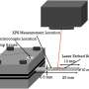

University of Florida researchers are exploring how lasers could help astronauts build structures on the moon using materials already available there, including lunar soil transformed into glass. The work, led by Victoria M. Miller, Ph.D., an associate professor in the Herbert Wertheim College of Engineering and researcher with the UF Astraeus Space Institute, recently complete...

