 |  | 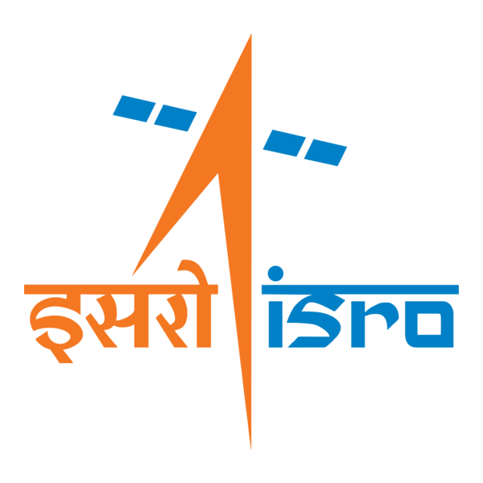

🌌 अंतरिक्ष समाचार | Space News
मंगलवार, २७/१०/२०२६ | Tuesday, 27/10/2026

1. TRAI proposes new regulatory framework for Internet TV, bringing streaming apps under govt authorisation
Read more
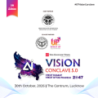
- Digital India - 5 min Read TRAI proposes mandatory authorisation for internet-based live-TV apps, with new rules for content distribution, smart-TV compliance and audience measurement to strengthen regulatory oversight. - Anoop Verma - ETGovernment - Updated On Oct 27, 2026 at 07:53 AM IST - Select ETGovernment as Preferred Choice on Google - Share Icon Copy Link Share on Whatsapp Share on Linkedin Share on X Share on Telegram Share on Facebook - Bookmark - Comment TRAI has proposed mandatory government authorisation for internet-based live-TV applications, introducing new regulatory requirements for digital television distribution, smart-TV platforms, content accountability and audience measurement. India's rapidly changing television market could face a significant regulatory restructuring, with the Telecom Regulatory Authority of India (TRAI) recommending mandatory government authorisation for applications distributing scheduled television channels over the internet. The proposal seeks to bring internet-based television distribution closer to the regulatory framework governing conventional broadcasting, while addressing questions of content accountability, consumer protection and audience measurement. The recommendations, released on October 26, cover Application-based Linear Television Distribution (ALTD) services, including Free Ad-Supported Streaming Television (FAST). These services allow viewers to watch scheduled television channels through smart TVs, mobile applications and websites without necessarily subscribing to traditional cable or direct-to-home (DTH) services. The proposed framework would create a distinct authorisation category under the Telecommunications Act, 2023, bringing a growing segment of digital television distribution within a formal regulatory structure. The initiative originated from a reference sent by the Ministry of Information and Broadcasting (MIB) to TRAI on December 15, 2025, seeking recommendations on regulatory parity, content accountability and consumer protection. TRAI subsequently issued a consultation paper on April 6, 2026, receiving 207 stakeholder comments and 11 counter-comments. An open-house discussion followed on June 10. The resulting recommendations reflect the government's attempt to address the increasingly blurred distinction between conventional television broadcasting and internet-delivered linear programming. What TRAI has proposed Under the proposed framework, ALTD would become a separate sub-category of Television Channel Distribution Services under Section 3(1)(a) of the Telecommunications Act, 2023. Application providers would be responsible for obtaining authorisation and complying with applicable conditions. The authorisation would cover a national service area, remain valid initially for 20 years and be renewable for successive 10-year periods. TRAI has recommended a one-time entry fee of ₹1 lakh and an application processing fee of ₹10,000, without recurring authorisation fees, bank guarantees or security deposits. TRAI describes its approach as a "light-touch and future-ready policy framework" intended to promote innovation, ease of doing business, consumer protection and regulatory certainty. The relatively modest financial requirements indicate an attempt to avoid imposing the infrastructure-related compliance costs associated with conventional broadcasting networks on application-based distributors. Nevertheless, the authorisation requirement would introduce a new layer of government oversight for businesses operating in the internet television market. A significant recommendation concerns the responsibilities of smart-TV manufacturers and operating-system providers. TRAI wants the Ministry of Information and Broadcasting to maintain a central repository of authorised ALTD applications. Television manufacturers and operating-system providers would have to ensure that only authorised applications are available through their devices and application stores. They would also submit annual compliance reports to the ministry, extending regulatory obligations beyond content distributors to technology companies controlling television interfaces. Content accountability and regulatory boundaries The proposed framework would permit authorised ALTD operators to distribute only television channels holding valid government permission, authorisation or registration. TRAI has also recommended a simplified registration mechanism for internet-native linear television channels, potentially creating a formal route for digital-first broadcasters that operate scheduled programming without conventional television distribution infrastructure. This distinction is important because the recommendations do not seek to regulate every form of internet video streaming through ALTD authorisation. Broadcaster-owned applications distributing exclusively their own channels or those of subsidiary or holding companies would be excluded. Live streams carried through social media intermediaries would also remain outside this particular framework. The regulatory focus is therefore on applications aggregating and distributing linear television channels, rather than the entire over-the-top entertainment industry. The proposed approach could improve accountability by identifying the entity responsible for distributing channels and handling consumer grievances. However, its effectiveness would depend on clear definitions and predictable registration procedures. Excessively broad interpretations could create uncertainty for hybrid platforms offering scheduled channels alongside on-demand programming, while inconsistent enforcement could disadvantage smaller digital broadcasters. Audience measurement and advertising implications Another important recommendation concerns television ratings. TRAI wants viewership through ALTD applications incorporated into India's television audience measurement framework. Authorised operators would also be permitted to publish anonymised periodic viewership information in accordance with the TV Ratings Policy, 2026. This could have considerable implications for broadcasters, advertisers and media agencies. As television viewing increasingly shifts towards connected devices, measurement systems focused primarily on conventional distribution risk providing an incomplete picture of audience behaviour. Incorporating internet-based linear television could improve the assessment of channel reach, advertising effectiveness and the distribution of advertising expenditure. However, integrating application-generated viewing data into a common ratings system presents technical and governance challenges. Differences in measurement methodologies, device identification, data verification and privacy safeguards would need to be addressed. Transparent standards would be essential to ensure that digital viewing figures are comparable with conventional television ratings and do not create opportunities for manipulation. Balancing innovation with oversight The recommendations represent a broader regulatory shift towards treating comparable television distribution services consistently, irrespective of the technology used to deliver them. Conventional cable and DTH operators already function within established authorisation and compliance frameworks. Internet-based distributors, by contrast, have developed through different technological and commercial arrangements. Greater regulatory consistency could strengthen consumer protection and provide clarity for legitimate operators. At the same time, mandatory authorisation and application-store restrictions could raise market-entry barriers, particularly if approval processes become lengthy or compliance requirements expand beyond the proposed light-touch model. The next decision rests with the Ministry of Information and Broadcasting. TRAI's recommendations have not yet been accepted, notified or implemented. Their eventual impact will depend on the rules adopted, the efficiency of digital authorisation procedures and the safeguards established for competition and consumer choice. For India's television industry, the central question is whether the proposed framework can deliver greater accountability without restricting the innovation and accessibility that have driven internet-based broadcasting. The answer will help determine how conventional television and digital distribution coexist in an increasingly connected media market. Comments What are your thoughts?

2. 3 days to ISRO's NVS-03 launch, but can this satellite revive India's GPS alternative? Know what will... - Moneycontrol.com
Read more
3 days to ISRO's NVS-03 launch, but can this satellite revive India's GPS alternative? Know what will... Moneycontrol.com

3. India to launch NVS-03 satellite to bolster NAVIC - GPS World
Read more
India to launch NVS-03 satellite to bolster NAVIC GPS World

4. 'ISRO chief earns way less than DD anchor'-Harsh Goenka asks if India's priorities are misplaced - ThePrint
Read more
'ISRO chief earns way less than DD anchor'-Harsh Goenka asks if India's priorities are misplaced ThePrint

5. Cyclone Arnab poses challenge to ISRO's NavIC revival mission - DT Next
Read more
Cyclone Arnab poses challenge to ISRO's NavIC revival mission DT Next

6. India to have four launch pads by 2029, says ISRO chief | Narayanan was speaking at a graduation ceremony | Inshorts - Inshorts
Read more
India to have four launch pads by 2029, says ISRO chief | Narayanan was speaking at a graduation ceremony | Inshorts Inshorts

7. NASA's Perseverance Views Dust at Neretva Vallis
Read more
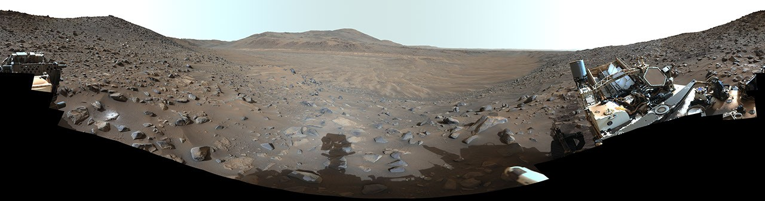
Description This 360-degree look at Neretva Vallis within Mars' Jezero Crater was stitched together using 217 images acquired by the rover's Mastcam-Z on May 20, 2024, the 1,155th Martian day, or sol, of the mission. While it is a wind-swept dusty vista today, billions of years ago it was home to a river channel that fed fresh water into Jezero Crater. This is an enhanced-color version, which had its color bands processed to improve visual contrast and accentuate color differences, Arizona State University leads the operations of the Mastcam-Z instrument, working in collaboration with Malin Space Science Systems in San Diego, on the design, fabrication, testing, and operation of the cameras, and in collaboration with the Niels Bohr Institute of the University of Copenhagen on the design, fabrication, and testing of the calibration targets.NASA's Jet Propulsion Laboratory, which is managed for the agency by Caltech, built and manages operations of the Perseverance rover.

8. NASA's Perseverance Offers Clues to Protect Crews From Mars Dust
Read more
This 360-degree panorama from NASA's Perseverance Mars rover shows Neretva Vallis, the dusty, long-dried river channel that cuts through the western rim of Mars' Jezero Crater. NASA/JPL-Caltech/ASU/MSSS Over 1,645 Martian days, NASA's Perseverance Mars rover measured the fine and ultrafine Martian dust particles found clinging to samples of spacesuit materials that are carried aboard the rover, including some that are small enough to penetrate the lungs and enter the bloodstream. The findings will be published Tuesday, Oct. 27, in the Proceedings of the National Academy of Sciences and could inform spacesuit and habitat design, dust-removal procedures, and crew health standards for future NASA missions to Mars. "NASA has a long history of turning challenges into workable solutions and of finding creative ways to use the data that we have to answer questions beyond what it was originally collected for," said Lindsay Hays, acting director, Planetary Science Division, NASA Headquarters in Washington. "Dust has been a surface-exploration challenge since the Apollo program. Perseverance is giving our engineers and flight surgeons measurements they can use to improve our existing designs well before the first American astronauts arrive on Mars." Lunar dust scratched visors, degraded outer spacesuit layers, and damaged their seals during NASA's Apollo missions, and some crew members reported symptoms similar to hay fever. Rounded by wind-driven collisions with other particles, dust grains on Mars are less abrasive than those on the Moon. They also are enriched in sulfur, chlorine, and iron and contain more silica than lunar dust. Regional and global dust storms on Mars can keep the grains recirculating throughout the atmosphere as well. The rover carries a set of five samples of spacesuit material. The swatches, each three-quarters of an inch (20 millimeters) square, are part of a calibration target used to test the settings of SHERLOC (Scanning Habitable Environments with Raman and Luminescence for Organics and Chemicals), an instrument on Perseverance's robotic arm. The calibration target for another instrument that provided the dust measurements, called PIXL (Planetary Instrument for X-ray Lithochemistry), carries a sample of Teflon and of basaltic glass. Because Teflon contains no elements that PIXL can directly detect, whatever elemental signals the X-ray spectrometer picks up from that sample comes from dust resting on it. The team also analyzed swatches of Teflon and Vectran, two materials used in spacesuits, on SHERLOC's calibration target. NASA sent the swatches to Mars to study how spacesuit materials hold up on the planet's surface. "Perseverance's main job is to search for signs of ancient microbial life, but the mission was also designed to help prepare for human explorers. That effort includes technology demonstrations like MOXIE (Mars Oxygen In-Situ Resource Utilization Experiment) and Ingenuity, as well as the spacesuit samples," said Katie Stack Morgan, Perseverance's project scientist at NASA's Jet Propulsion Laboratory in Southern California. Fine, ultrafine While earlier measurements on Mars resolved dust particles down to about 3 micrometers across, PIXL detected two categories of even smaller particles: fine particles measuring less than 2.5 micrometers (a human hair is about 70 micrometers wide) and ultrafine particles around 100 nanometers (about 700 times thinner than a human hair). Particles on PIXL's Teflon target and SHERLOC's Vectran swatch averaged about 2 micrometers. On PIXL's basaltic glass and SHERLOC's Teflon swatch, dust particle sizes ranged down to about 100 to 300 nanometers. This annotated composite image shows the location on NASA's Perseverance of the calibration target for rover's SHERLOC (Scanning Habitable Environments with Raman & Luminescence for Organics and Chemicals) instrument. At right is a close-up of the calibration target. NASA/JPL-Caltech Static electricity appears to determine which size dust particles stick to which surface. Dust grains become charged as they collide in the air, and different materials on the calibration target attract grains of different sizes. The finest particles stayed attached through years of driving and drilling. Organic polymers like SHERLOC's Teflon spacesuit sample are common in the outer layers of spacesuits, and the results show they readily collect fine dust. The study also found that some materials hold less dust than others, which could guide future choices of materials and protective coatings for spacesuits and habitats. Designs such as suitports, which let astronauts enter a suit attached to the outside of a habitat, and dual-chamber airlocks could reduce how much dust gets inside astronauts' living quarters. "The existence of Mars dust at these ultrafine sizes has been predicted for a long time, and PIXL gave us the chance to measure it directly on Mars," said Scott VanBommel, a Perseverance scientist at Washington University in St. Louis and the paper's lead author. "The larger clumps, the Martian dust bunnies, get shaken off over time. But the smallest particles stay behind, and those are the ones that pose the greatest challenge for human support systems." Chemically, the dust matches the iron- and sulfur-rich composition that earlier missions measured. The PIXL instrument also found the dust to be enriched in phosphorus and detected signs of calcium sulfate. Protecting crews On Earth, airborne particles, or particulate matter, below 2.5 micrometers (that is, fine particles) are tied to a range of negative health effects because they can penetrate deep into the lungs and enter the bloodstream. Studies have shown that ultrafine particles (those no larger than 100 nanometers) can travel from the nasal cavity to the brain along the olfactory nerve. Martian dust is composed predominantly of silicate minerals and carries chemically reactive compounds, including perchlorates that can disrupt thyroid function and reactive iron that induces cellular damage. Scientists believe that the health risks of Mars dust depend on the quantity of dust and length of exposure. The PIXL results are the first on-site measurements of fine and ultrafine particles on Mars, and this research can inform broader efforts to refine indoor dust-exposure limits for astronauts, develop safe habits, and establish ways to remove dust while exploring Mars. NASA is already working on solutions to extraterrestrial dust hazards, using ground test facilities and lunar missions as proving grounds for future Mars explorers. In March 2025, the agency tested an Electrodynamic Dust Shield, which used electric fields to clear lunar regolith from glass and thermal radiator surfaces on the Moon. Developed at NASA's Kennedy Space Center in Florida, it landed on the Moon aboard Firefly Aerospace's Blue Ghost Mission 1. At NASA's Johnson Space Center in Houston, engineers at the Lunar Development and Test Facility use vacuum chambers and lunar regolith simulant to test spacesuit components, mechanisms, and a Handheld Lunar Electrostatic Dust Mitigation tool ahead of Artemis missions to the lunar surface. More about Perseverance Managed for NASA by Caltech, JPL built and manages operations of the Perseverance rover on behalf of the agency's Science Mission Directorate as part of NASA's Mars Exploration Program portfolio. NASA JPL also built PIXL and SHERLOC. To learn more about Perseverance visit: https://science.nasa.gov/mission/mars-2020-perseverance -end- Media Contacts DC Agle Jet Propulsion Laboratory, Pasadena, Calif. 818-393-9011 david.c.agle@jpl.nasa.gov Karen Fox / Alana Johnson NASA Headquarters, Washington 240-285-5155 / 202-672-4780 karen.c.fox@nasa.gov / alana.r.johnson@nasa.gov 2026-076

9. Solar Cells Inspected on NASA's NEO Surveyor
Read more
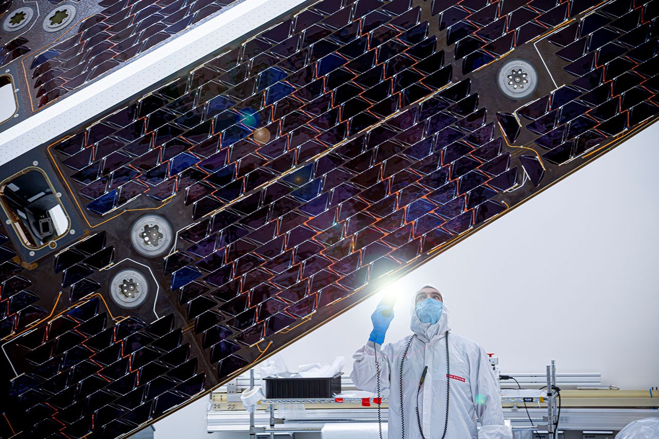
Description The large sunshade of NASA's Near-Earth Object (NEO) Surveyor mission is inspected by a technician at BAE Systems Space & Mission Systems in Boulder, Colorado, in late July. Built by Applied Aerospace in Stockton, California, the sunshade structure was outfitted with its solar cells by SolAero Technologies in Albuquerque, New Mexico, in January. Environmental testing of the sunshade and solar array was completed at a commercial thermal vacuum testing facility in El Segundo, California, in March and it was delivered to BAE Systems Space & Mission Systems ahead of schedule in May. When in space, NEO Surveyor will seek out some of the hardest-to-find asteroids and comets, some of which may be located in the direction of the Sun - a region of sky where ground-based optical telescopes have a harder time searching. More information about NEO Surveyor is available at: https://science.nasa.gov/mission/neo-surveyor/

10. NASA SEES Interns Tackle Real-World Challenges in Lunar Exploration
Read more
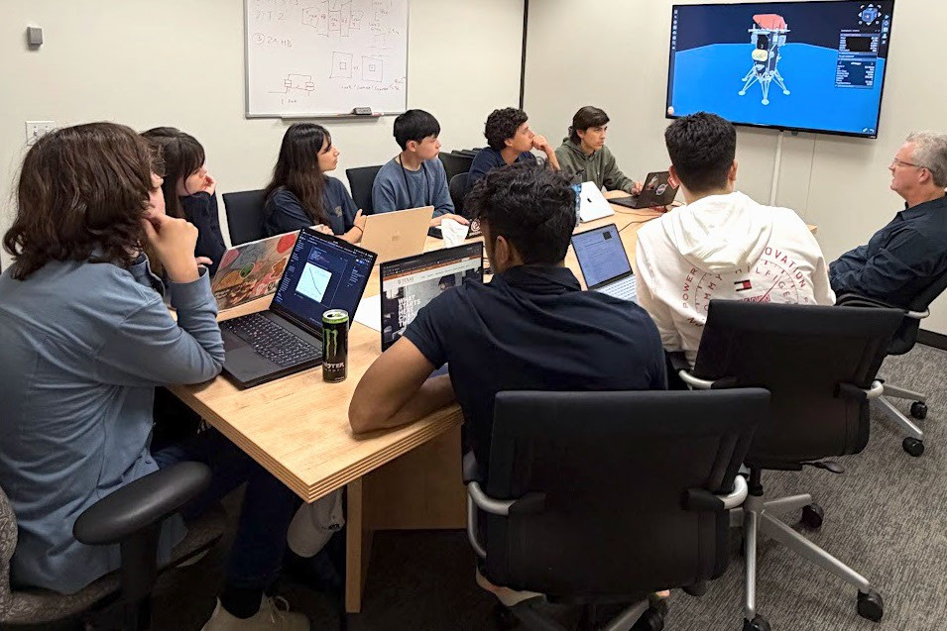
The Matrix Team developed a sophisticated interactive dashboard for the IM-3 mission that allows users to vary engine, spacecraft, and orbital parameters to investigate the effect on propellant margins and landing zone availability. The NASA STEM (Science, Technology, Engineering, and Mathematics) Enhancement in Earth Science (SEES) Internship Program at the University of Texas Center for Space Research places high school students on small, mission-focused research teams mentored by NASA, academic, and industry experts. During summer 2026, the SEES Mission Architecture Tool for Research, Integration, and eXploration (MATRIX) team focused on applying a method for measuring propellant mass in microgravity, where liquid fuel clings to tank walls instead of settling - a challenge central to NASA's Artemis missions. The MATRIX team was mentored by Dr. Kevin Crosby, who, along with colleagues at NASA, developed the Modal Propellant Gauging (MPG) approach to microgravity propellant mass gauging at Carthage College in Kenosha, WI. MPG uses the acoustic response of propellant tanks to estimate the mass of fuel inside a tank. The method has been used successfully in several spaceflight experiments and is scheduled for demonstration on the Intuitive Machines IM-3 mission. The IM-3 lander, Trinity, is scheduled to touch down on the Moon in the Reiner Gamma region in 2027. The team developed models for predicting when MPG can take reliable readings during the mission, giving the interns direct experience with a technology preparing for spaceflight and lunar surface operations. Reconstructing a Lunar Mission from Public Data The MATRIX team relied entirely on publicly available sources, including Intuitive Machines' published mission data. The NASA Jet Propulsion Laboratory's Navigation and Ancillary Information Facility (NAIF) provided detailed trajectory records for the IM-1 and IM-2 missions. By comparing the IM-2 spacecraft's reconstructed flight path with a model of its motion without engine thrust, the team identified engine burns and estimated the change in velocity associated with each burn. Because a complete IM-3 trajectory is not public, the team wrote a reconstruction algorithm using published IM-1 and IM-2 flight data. To model fluid behavior, the team ran computational fluid dynamics (CFD) simulations to estimate slosh dynamics within the tanks and conducted Monte Carlo simulations to predict the range of possible propellant states. Identifying Windows for Measurement The team's analysis showed that MPG can take reliable readings during the two primary burns, Lunar Orbit Insertion (LOI) and Powered Descent, and in some cases during Descent Orbit Insertion. The spacecraft's starting mass had the greatest effect on how long each gauging window lasts. The MATRIX team also identified candidate IM-3 launch opportunities for 2027 and produced a landing analysis for the Reiner Gamma site that showed the distribution of possible landing sites near the target. Presenting to the Scientific Community The team briefed the Intuitive Machines propulsion group, walking the engineers through their methods and results and demonstrating that a rigorous analysis of an active lunar mission could be built from public data. The students presented their research, "Computational Models to Estimate Modal Propellant Gauging (MPG) Windows on the Intuitive Machines IM-3 Mission," at the SEES Annual Symposium and the Wisconsin Space Grant Consortium Annual Conference. The team will present again at the American Geophysical Union (AGU) Annual Meeting in San Francisco in December 2026. "This high school team, in a period of less than a month, developed a depth of understanding and facility with advanced methods that rivals advanced graduate students in the field," said Crosby. "Their work product is exceptional, and their presentation to Intuitive Machines engineers impressed everyone with the sophistication and creativity of their work. The SEES program has consistently provided a unique environment for students to demonstrate they can achieve far more than what is asked of them, even in the most advanced classes." The SEES program gives 11th and 12th grade students direct experience with the data, tools, and analytical methods used across the aerospace industry. By applying NASA and commercial mission data to an active lunar mission, the MATRIX team contributed analysis relevant to propellant management, a capability needed for in-space refueling, fuel depots, and sustained exploration of the Moon and beyond. Thank you to all the mentors, project assistants, and volunteers who have made SEES possible for over a decade. The SEES Mission Architecture (MATRIX) Team: Raiymbek Abdykalykov, The Woodlands, TX Emmanuel Bravo, Boca Raton, FL Winston Huang, San Francisco, CA Adrianna Krajnovic, Dallas, TX Marco Lo Cicero, Tomball, TX Henry Martin, Milwaukee, WI Reva Paul, Bethlehem, PA Swayam Sahoo, North Chelmsford, MA Project Mentor: Dr. Kevin M. Crosby, Carthage College and Wisconsin Space Grant Consortium Project Assistant: Mauro Esquivel, mathematics teacher, McAllen, TX For more information, visit: https://www.csr.utexas.edu/sees-internship/ The SEES project is supported by NASA cooperative agreement award number NNH15ZDA004C and is part of the NASA Science Activation Program portfolio, which connects learners with authentic NASA science experiences through partnerships with educators and community organizations.

11. NASA Invites Media to Moon Landing Simulation Experience in California
Read more
Members of the media are invited to tour a new lunar landing simulation at NASA's Ames Research Center in California's Silicon Valley on Thursday, Oct. 29, and Friday, Oct. 30. Using a combination of in-house and partner motion-based simulators, NASA is giving astronauts and engineering support teams simulated experiences before crew members pilot commercial human landing systems to the surface of the Moon. Through the Artemis program, NASA is targeting the next lunar landing in 2028. During the tour, media will have an opportunity to participate in a Vertical Motion Simulator ride-along and interview subject matter experts. Media interested in participating should RSVP by Tuesday, Oct. 27 at 5:00 pm PT to the NASA Ames newsroom at: arc-dl-newsroom@mail.nasa.gov. Space is limited, and media must register in advance for consideration. NASA's media accreditation policy is online. In your RSVP, please note your preference for Oct. 29 or Oct. 30. The landing simulation at Ames was developed by NASA's Johnson Space Center in Houston and integrated into the recently upgraded simulator flight deck. As part of a Golden Age of innovation and exploration, NASA will send Artemis astronauts on increasingly difficult missions near the lunar South Pole to explore more of the Moon than ever before. In addition to providing economic benefits and advancing scientific discovery through its Moon missions, NASA will establish an enduring human presence on the lunar surface and build on the agency's foundation for the first crewed mission to Mars. For more information about NASA's Artemis program, visit: https://www.nasa.gov/artemis -end- Jeanne Neal Ames Research Center, Calif. 650-604-4789 jeanne.c.neal@nasa.gov

12. NASA, USDA Sign Agreement Advancing Earth Science, Agriculture
Read more
U.S. Secretary of Agriculture Brooke Rollins, left, and NASA Administrator Jared Isaacman signed a Memorandum of Understanding advancing agriculture and Earth science during an event at the University of Alabama in Tuscaloosa on Saturday, Oct. 24. Credit: NASA NASA and the U.S. Department of Agriculture (USDA) have signed a Memorandum of Understanding expanding cooperation in Earth observation, geospatial analytics, and advanced data technologies, supporting USDA's data modernization plan for United States agriculture. "NASA develops some of the most advanced sensing, computing, and analytical capabilities in the world, and we should put those tools to work wherever they can deliver meaningful outcomes for the American people," said NASA Administrator Jared Isaacman. "By combining NASA's Earth observation data and technical expertise with USDA's knowledge of American agriculture, we can improve the information available to farmers and ranchers, strengthen our understanding of crop conditions and natural hazards, and pursue new high-risk, high-reward ideas that advance both science and American competitiveness." Isaacman and U.S. Secretary of Agriculture Brooke Rollins signed the agreement Oct. 24 during NASA's Inspiration Tour at the University of Alabama in Tuscaloosa. NASA and USDA's longstanding partnership has supported collaborative research and data-sharing efforts that strengthen U.S. agriculture. The new agreement deepens this cooperation by focusing on improved data integration and enhanced coordination across Earth observation and agricultural applications. "American farmers are the best in the world and deserve any solution we can leverage, even when it is out of this world. I am proud to announce that USDA will now work with Administrator Isaacman and NASA to utilize the full power of technology, research, and development to fortify U.S. agriculture," said Rollins. "With this unprecedented partnership the Trump Administration is committing to a bright future of research and tech opportunities that will enhance USDA acreage and yield estimation and drive profitability for American agriculture." Under the new agreement, the agencies can explore activities in agricultural statistics, remote sensing science, modeling, geospatial data engineering, and super intelligence. NASA and USDA also will look at how to better align Earth observation data and analytical tools with agricultural needs, helping improve crop monitoring, acreage and yield estimates, and assessments of drought and other disasters. The agencies will examine new approaches for managing and analyzing large datasets, strengthening USDA's data systems while providing farmers, ranchers, and policymakers with more timely and reliable information. For more information about NASA's Earth science, visit: https://science.nasa.gov/earth -end- Camille Gallo / Elizabeth Shaw Headquarters, Washington 202-358-1600 camille.m.gallo@nasa.gov / elizabeth.a.shaw@nasa.gov

13. Analog astronauts: How living underwater can prepare humans for space missions
Read more
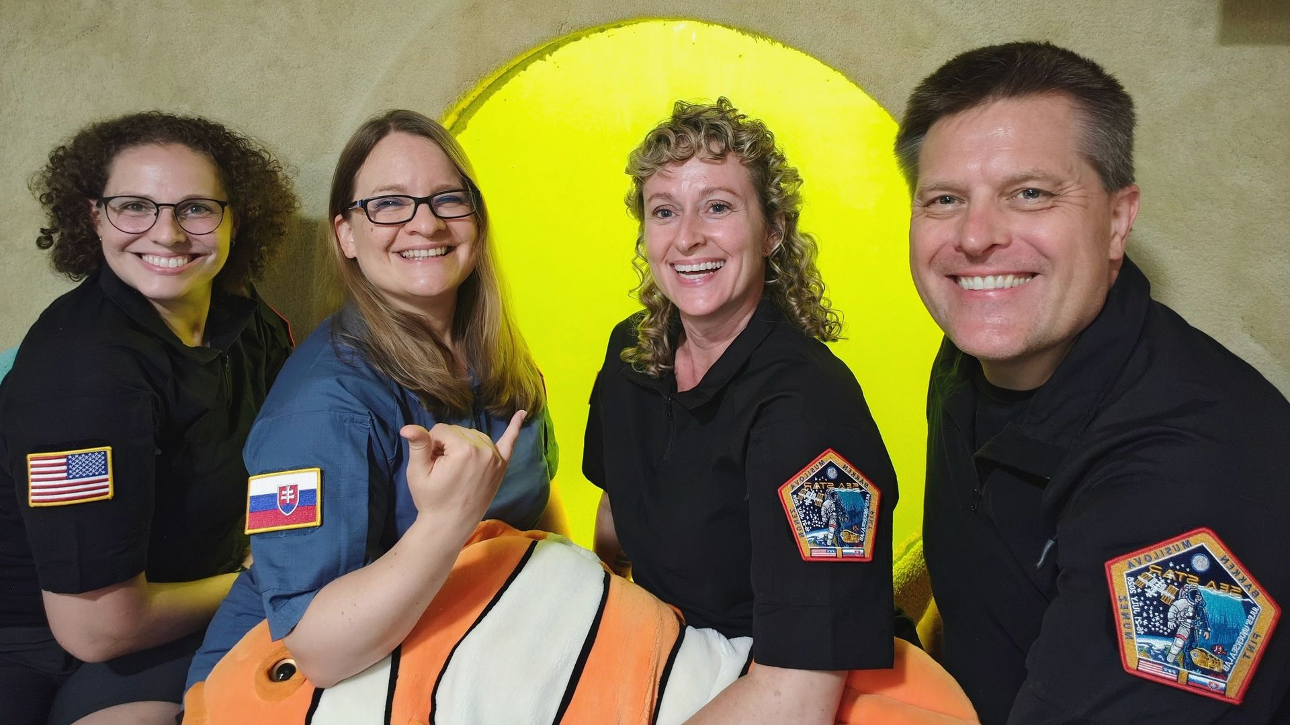
Click for next article The SEA STAR crew officially became aquanauts after having spent more than 24 hours underwater in a state of so-called saturation. I have been dreaming of doing research in space as an astronaut my whole life, but for some reason, the thought of working underwater made me nervous. I've known for a long time that astronauts train underwater to simulate different scenarios they're likely to experience in space. Diving was never an issue for me, either - I even made it as far as becoming a certified rescue diver. So what was the problem? This summer, I led a simulated space mission in an underwater habitat called the Jules' Undersea Lab. It is a research station that is located 22 feet (6.7 meters) underwater near Key Largo, Florida. You have to scuba dive to get in and out of the station. To become an aquanaut , you have to stay underwater for at least 24 hours in a so-called state of saturation. I had been preparing for many years for this aquanaut experience, both as a scientist and as an analog astronaut. An analog astronaut is someone who takes part in a simulated space mission, where they live and work in conditions similar to those that astronauts on the International Space Station (ISS) experience today, or will one day experience on the moon and Mars . The SEA STAR crew before they dove underwater to live as aquanauts for five days. (Image credit: Dr. Michaela Musilova) I'm no stranger to simulated space missions , either; I have been the Commander of almost 40 such missions in different facilities around the world. Almost all of those missions were on land, though, which made them substantially safer than a mission underwater. The risks of something going wrong during a simulated spacewalk or even during basic maintenance activities underwater are significantly higher than during standard analog missions on land. Despite knowing all of that, a mission underwater was something I definitely wanted to experience to improve my skills as a leader, researcher and diver. However, the closer I got to the start of the mission, the more worried I became. My brain went through all the terrible scenarios that could occur during the mission while I was preparing for it - from someone's gear malfunctioning during a spacewalk underwater to storms forcing us to evacuate in the middle of the night. Perhaps I still had some trauma from watching "The Abyss" by James Cameron as a child 😉. Our mission was symbolically called SEA STAR, and I spent over a year organizing it. It took some time to get the right team and research projects together, as well as the necessary funding. My goal was to lead a mission simulating what astronauts go through on the ISS, both in terms of the diverse projects they work on and the challenges they face living in space. Only for us the deadly environment surrounding us wasn't space, but water. The Jules' Undersea Lab station, which lies 22 feet (6.7 meters) underwater near Key Largo, Florida. (Image credit: Dr. Michaela Musilova) Since the health and safety of the crew is at higher risk during underwater missions, the team has to adhere to more strict procedures than they would need to during a simulated space mission on land. That, in turn, makes the mission feel more similar to an astronaut's mission in space. The underwater environment also allowed us to perform neutral buoyancy experiments during simulated spacewalks, as well as scientific research focused on the effects of high atmospheric pressures on humans. Our SEA STAR crew was composed of experienced analog astronauts and divers. Paul Bakken, an experimental engineer, was our Executive Officer responsible for most of the mission's logistics. The Health and Safety Officer was Dr. Brandy Nunez, who performed microgreens research on top of overseeing the wellbeing of the crew. Our team's Mission Specialist was Jenn Pint, who is an industrial safety expert. She was in charge of a project focused on developing a taxonomy for analyzing environmental and crew interaction factors in a space analog environment, in collaboration with Interstellar Performance Labs. Dr. Michaela Musilova performing a "spacewalk" underwater during her SEA STAR aquanaut mission. (Image credit: Dr. Michaela Musilova) As the Commander of the crew, my main responsibilities were to make sure the crew was safe, in good health and spirits, getting along well and on top of their work. I worked with Paul to plan the mission's schedule and to tweak it as needed - for instance, when we faced unexpected problems or some things were taking longer than planned. I also brought several research and educational projects with me on the mission, which I performed on top of my Commander duties. Even though I was a bit concerned about the risks of the aquanaut mission before it started, I trusted my crew. I knew that we would find a way to problem-solve and face the challenges that would come our way, just like astronauts do in space. I was also looking forward to all of the interesting experiments that we had planned for the mission, which ranged from cognitive research under pressure to testing environmental student sensors. The Jules' Undersea Lab served as a Mission Control Center on land to monitor and help the SEA STAR analog astronauts on their simulated space mission underwater. (Image credit: Dr. Michaela Musilova) In the end, I mostly had to trust myself that I had what it takes to not only perform this mission, but also to lead it. As I put on my scuba gear, before diving underwater for five days, I focused on the positive aspects of the mission. The nervous voices in my head made themselves heard a couple of times while I entered the water. Nevertheless, I was completely calm by the time I took my last breath of Earth air. I just waved at our collaborators on land, submerged myself and started our intense "space," a.k.a. underwater, mission.

14. NASA ends Swift space telescope mission after failed rescue attempt
Read more
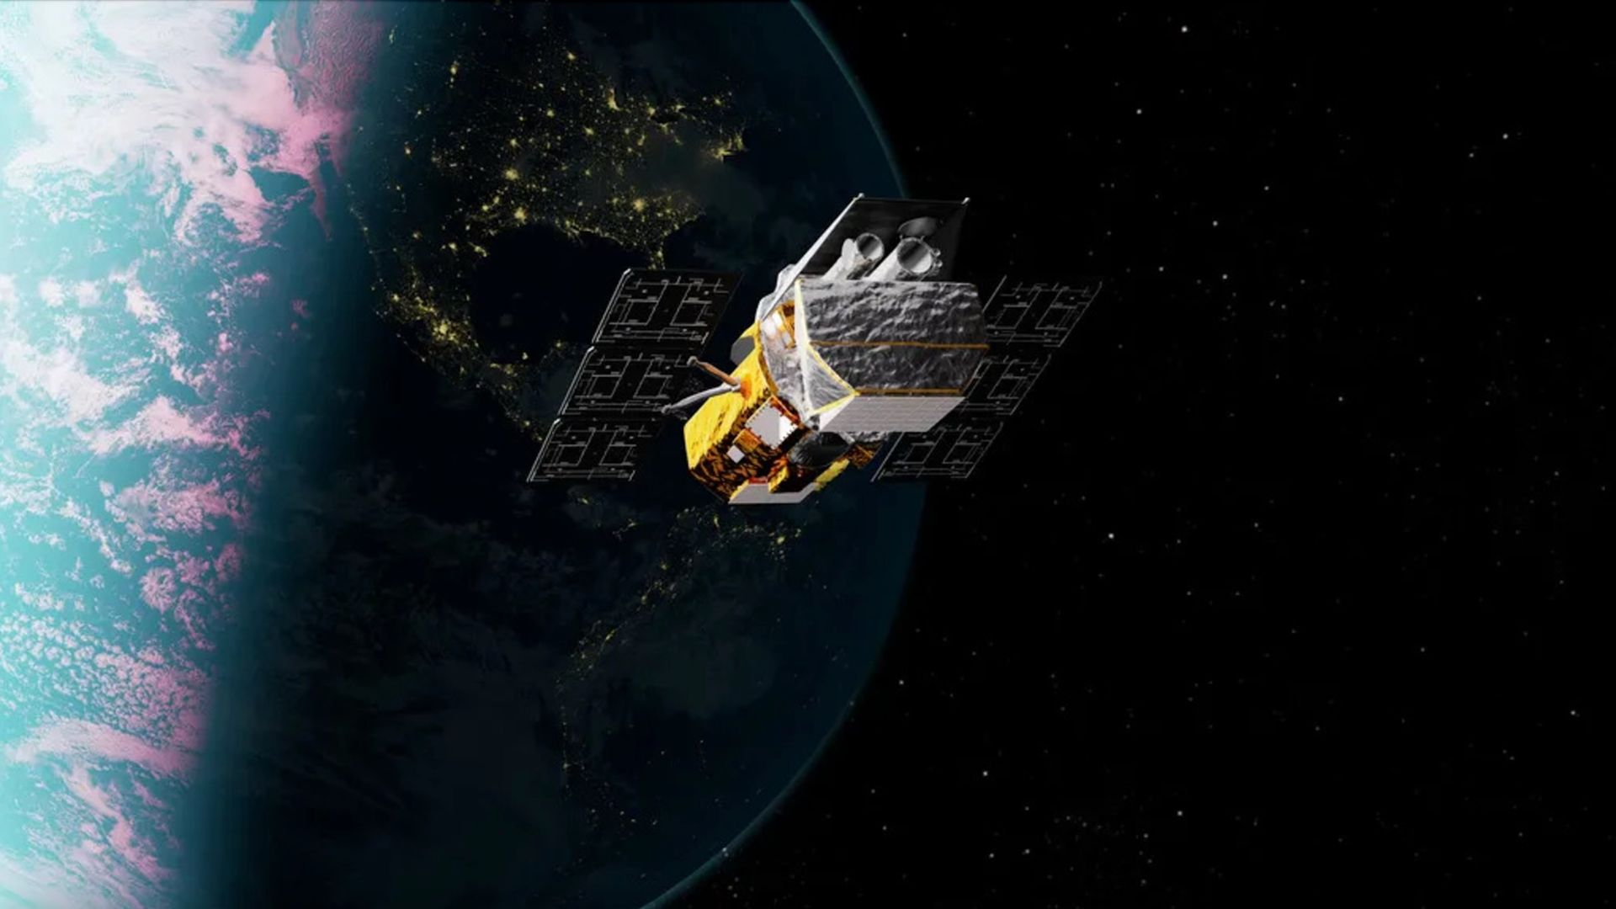
Click for next article Artist's illustration of NASA's Neil Gehrels Swift Observatory, which launched to Earth orbit in November 2004 and will soon fall out of space. NASA has officially ended the mission of its Swift space telescope, after a private satellite failed in its bold bid to rescue the aging spacecraft. That rescue mission was led by the Arizona company Katalyst Space Technologies, whose LINK spacecraft tried to meet up with Swift this summer to boost its orbit. That didn't work out, however, so Swift continues its fall back toward Earth. The telescope is expected to reenter Earth's atmosphere "in the next few weeks," NASA said in a statement on Friday (Oct. 23). That statement served primarily to announce the end of the Swift mission after more than 20 very productive years. The telescope launched to Earth orbit in November 2004, tasked with studying gamma-ray bursts (GRBs) - the most powerful explosions in the cosmos. Swift was designed to operate for two years, but it continued studying the high-energy universe for more than two decades. "In that time, Swift played a major role in advancing our understanding of the changing universe and was part of a revolution in astrophysics that showed how critical rapid-response observations are to the entire community," Shawn Domagal-Goldman, director of the Astrophysics Division at NASA Headquarters in Washington, said in the statement. NASA had hoped to keep Swift going even longer. In September 2025, the agency awarded a contract to the Arizona company Katalyst Space Technologies to rescue the observatory, which was falling back to Earth thanks to atmospheric drag. Swift has no thrusters capable of counteracting this drag. So Katalyst built a refrigerator-sized spacecraft called LINK, which aimed to rendezvous with Swift, grapple it with three robotic arms and boost it to a higher orbit, allowing the observatory to continue its science work. NASA and Katalyst stressed from the start that success was far from guaranteed. After all, LINK's mission was unprecedented: No private spacecraft had ever captured and boosted a satellite that wasn't designed to be serviced in this way. And the rate of Swift's orbital decay demanded a rapid timeline: LINK launched on July 3 , a little over nine months after Katalyst won the $30 million NASA Swift-rescue contract. LINK was not able to execute its very challenging mission. About three weeks after liftoff, it suffered problems with its propulsion system and orientation-maintaining reaction wheels, which caused it to start spinning at an unexpected rate . These issues prevented LINK from capturing and boosting Swift, but the private craft did manage to get within 7.5 to 9.3 miles (12 to 15 kilometers) of the observatory and photograph it. "From the beginning, this was a high-risk, high-reward mission," Domagal-Goldman said in a statement on Sept. 25 , the day that LINK fell back to Earth. "And while we'll be sad to see Swift's mission come to a close, we knew this boost effort would be worthwhile either way - advancing U.S. spacecraft servicing technology, challenging us to meet unprecedented mission timelines, and testing how we operate satellites to extend their time in low Earth orbit ," he added. Katalyst Space's LINK robotic servicing spacecraft captured this view of one of its solar panels in Earth orbit in August 2026. (Image credit: Katalyst Space)) Swift - which was officially renamed the Neil Gehrels Swift Observatory in 2018, after its first principal investigator, who died a year earlier - gathered its last scientific data on Oct. 20, according to NASA's Friday update. During its long and storied career, the space telescope observed more than 2,000 GRBs. And it did other work, too, studying more than 1,400 supernova explosions, as well as eyeing asteroids, comets and black holes and conducting an all-sky survey in X-ray light. The mission's data has contributed to about 7,000 published scientific papers to date, according to NASA officials. And that number is sure to keep rising far into the future. "Swift leaves us with an extraordinary archive of multiwavelength observations that will fuel new discoveries for decades more," Domagal-Goldman said in the Oct. 23 statement.

