 |  | 

🌌 अंतरिक्ष समाचार | Space News
सोमवार, २९/०६/२०२६ | Monday, 29/06/2026

1. ISRO successfully conducts CE20 cryogenic engine ground test - News On AIR
Read more
The Indian Space Research Organisation (ISRO) has successfully conducted a key ground test of its CE20 cryogenic engine, demonstrating higher thrust capability that could improve the performance of India's heavy-lift rocket, the LVM3 launch vehicle. The sea-level hot test was carried out on March 10 at the ISRO Propulsion Complex, Mahendragiri in Tamil Nadu, where the engine operated for 165 seconds and generated about 22 tonnes of thrust. The CE20 engine powers the upper stage of LVM3 and is critical for missions requiring heavy payloads. It has also been human-rated for India's upcoming Gaganyaan mission. ISRO said the higher-thrust testing is aimed at enhancing the rocket's payload capacity for future satellite and space exploration missions.

2. Malayalees to head three important centres of ISRO from July 1 - Kerala Kaumudi
Read more

THIRUVANANTHAPURAM: Three Malayalees are among the four selected to head important centres of ISRO from July 1. The new directors are Dr U.P. Rajeev at Thumba VSSC, N. Jayan at Valiyamala LPSC, Joji J. Chaman at IISU Vattiyoorkavu, and Narayanan Appu at IPRC in Mahendragiri, Tamil Nadu. The first three are Malayalees, and the fourth is a native of Tamil Nadu. Eminent scientist Dr U.P. Rajeev, who will take charge as the Director of VSSC, is currently the Associate Director of VSSC. Rajeev comes with long experience in the Rocket Control and Guidance Division. Rajeev also led the mission design and simulation of many launch vehicles. Rajeev started his career at ISRO after completing his graduation in 'Applied Electronics and Instrumentation' from Government Engineering College, Thiruvananthapuram and his post-graduate degree in Instrumentation and Control Systems from NIT, Kozhikode. He then completed his PhD at IISc, Bengaluru. He is the son of Unnikrishnan Nair and Padmakshiamma, natives of Pathanapuram, Kollam. He is married to Dr Asha P. Nair, a senior scientist at VSSC. Daughter: Parvathy Nair. N. Jayan, who will take charge as the Director of the Liquid Propulsion Systems Centre in Valiyamala, is a native of Mannamoola, Thiruvananthapuram. He joined ISRO after completing his mechanical engineering degree from the Government Engineering College, Thiruvananthapuram and his post-graduate degree in Aerospace engineering with a rank from the Indian Institute of Science, Bengaluru. His wife is Shobha, an officer in the I&B department of the central government. Children: Shweta and Siddharth. Joji J Chaman, who will take charge as the Director of the ISRO Inertial Systems Unit in Vattiyoorkavu, is a native of Thiruvalla Thirumoolapuram. Joji is a world-renowned scientist who has made discoveries in reducing fuel costs in space launches. For this achievement, the country honoured him with the Hari Om Ashram Prerit Science Award last year. Narayanan Appu, who will take charge as the Director of ISRO Propulsion Complex (IPRC) in Mahendragiri, Tamil Nadu, is a native of Thanjavur Kumbakonam. He is currently the Project Director of the Integrated Cryogenic Engine Test Facility.

3. ISRO achieves milestone in semi-cryogenic engine testing ahead of Gaganyaan missions - The News Mill
Read more
ISRO achieves milestone in semi-cryogenic engine testing ahead of Gaganyaan missions The News Mill

4. Cryogenic Pioneer N. Jayan to Head ISRO's Propulsion Centre - Indianweb2.com
Read more

ISRO appoints CE20 architect N. Jayan as LPSC Director, strengthening India's cryogenic propulsion leadership & advancing next‑gen rocket development. Key Highlights of the Appointment N. Jayan : Senior scientist and propulsion expert, pivotal in developing the CE20 cryogenic engine that powers the LVM3 (formerly GSLV Mk III). : Senior scientist and propulsion expert, pivotal in developing the that powers the (formerly GSLV Mk III). New Role : Director of Liquid Propulsion Systems Centre (LPSC) , Thiruvananthapuram. : Director of , Thiruvananthapuram. Effective Date : July 1, 2026. : July 1, 2026. Career Milestones : Associate Director, LPSC; Project Director, Cryogenic Stage Project; Project Director, Next Generation Launch Vehicle (NGLV) at VSSC. : Associate Director, LPSC; Project Director, Cryogenic Stage Project; Project Director, Next Generation Launch Vehicle (NGLV) at VSSC. Awards: Recipient of the Rashtriya Vigyan Puraskar (2025), India's highest science honor. Significance for ISRO Strengthening Propulsion Leadership : LPSC is responsible for liquid, cryogenic, and advanced propulsion systems-the backbone of India's launch vehicles. : LPSC is responsible for liquid, cryogenic, and advanced propulsion systems-the backbone of India's launch vehicles. Indigenous Capability : Jayan's leadership in CE20 development enhanced India's self-reliance in cryogenic technology, enabling complex missions including human spaceflight. : Jayan's leadership in CE20 development enhanced India's self-reliance in cryogenic technology, enabling complex missions including human spaceflight. Future Roadmap: His role in the NGLV project positions ISRO to advance next-generation heavy-lift capabilities, crucial for deep-space exploration and commercial launches. Quick Comparison: CE20 Engine & LPSC Role CE20 Engine LPSC Developed under Jayan's leadership Now headed by Jayan Powers LVM3/GSLV Mk III Designs liquid & cryogenic propulsion systems Indigenous cryogenic breakthrough Supports all major ISRO launch vehicles Enabled complex satellite & crewed missions Critical to India's space self-reliance What This Means for India's Space Program Boost to Human Spaceflight : CE20's reliability underpins Gaganyaan missions. : CE20's reliability underpins Gaganyaan missions. Payload Expansion : LPSC's innovations will support higher payload capacity for LVM3 and future NGLVs. : LPSC's innovations will support higher payload capacity for LVM3 and future NGLVs. Global Competitiveness: Strengthens India's position in the commercial launch market, competing with SpaceX and Arianespace. ISRO has appointed eminent aerospace engineer N. Jayan, architect of the CE20 cryogenic engine, as the new Director of the Liquid Propulsion Systems Centre (LPSC), a critical hub for India's advanced propulsion systems. He will assume charge on July 1, 2026, marking a major leadership transition in ISRO's propulsion program.N. Jayan has served as Project Director, overseeing the indigenous development of India's cryogenic propulsion technology, which was a breakthrough in self-reliance for space transportation. He led the team that successfully developed the CE20 engine powering LVM3 (GSLV Mk III), enabling India's heaviest rocket to launch complex satellites and crewed missions.As Project Director, he spearheaded ISRO's future heavy-lift rocket program, positioning India for deep-space exploration and commercial competitiveness.Today, CE20 powers the Cryogenic Upper Stage (C25) of India's heaviest rocket LVM3, enabling payloads up to 4 tonnes to GTO and 10 tonnes to LEO (Low Earth Orbit), enabling payloads up to 4 tonnes to GTO and 10 tonnes to LEO.

5. ISRO appoints U P Rajeev as Director of Vikram Sarabhai Space Centre - EdexLive
Read more
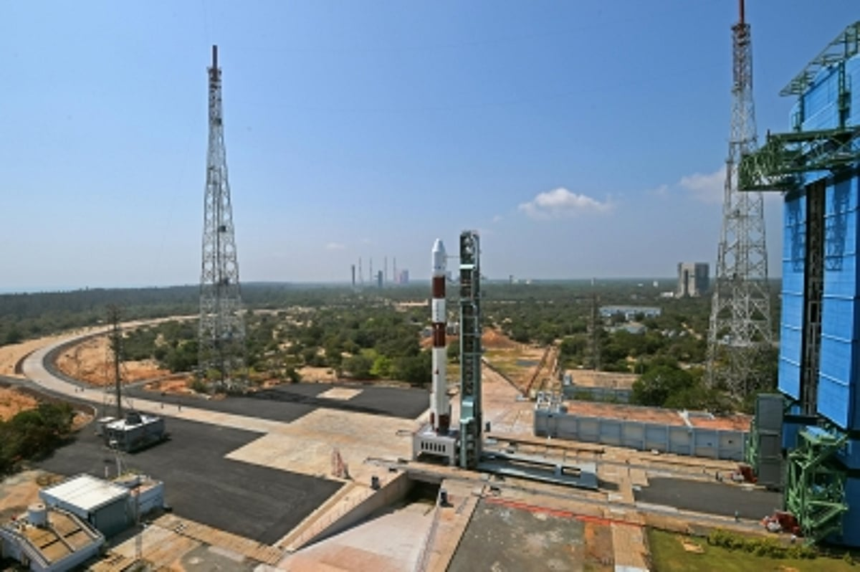
ISRO (representative image) News ISRO appoints U P Rajeev as Director of Vikram Sarabhai Space Centre The senior scientist and rocket guidance expert will lead ISRO's premier launch vehicle development centre in Thiruvananthapuram PTI Thiruvananthapuram: Senior scientist U P Rajeev has been appointed as the new Director of the Vikram Sarabhai Space Centre (VSSC), one of the key centres of the Indian Space Research Organisation. Dr Rajeev, who is currently serving as Associate Director (Research and Development) at VSSC, will take over the leadership of the centre known for developing India's launch vehicle technologies. With decades of experience in rocket control and guidance systems, he has played a leading role in the mission design and simulation of several of ISRO's major launch vehicle programmes, according to an official statement here on Friday. An alumnus of the College of Engineering Thiruvananthapuram, where he earned a degree in Applied Electronics and Instrumentation, Dr Rajeev later completed his postgraduate studies in Instrumentation and Control Systems at the National Institute of Technology, Calicut. He subsequently obtained a PhD from the Indian Institute of Science before continuing his career at ISRO. He is native of Pathanapuram in Kerala's Kollam district. This report was published from a wire feed. Apart from the headline, the EdexLive Desk has not edited the copy. Also Read

6. From 175-tonne thrust to future moon missions: Why ISRO's latest engine test is a game changer - MSN
Read more
From 175-tonne thrust to future moon missions: Why ISRO's latest engine test is a game changer MSN

7. SpaceX sends 24 Starlink satellites into Earth orbit on Falcon 9 launch from California (video)
Read more
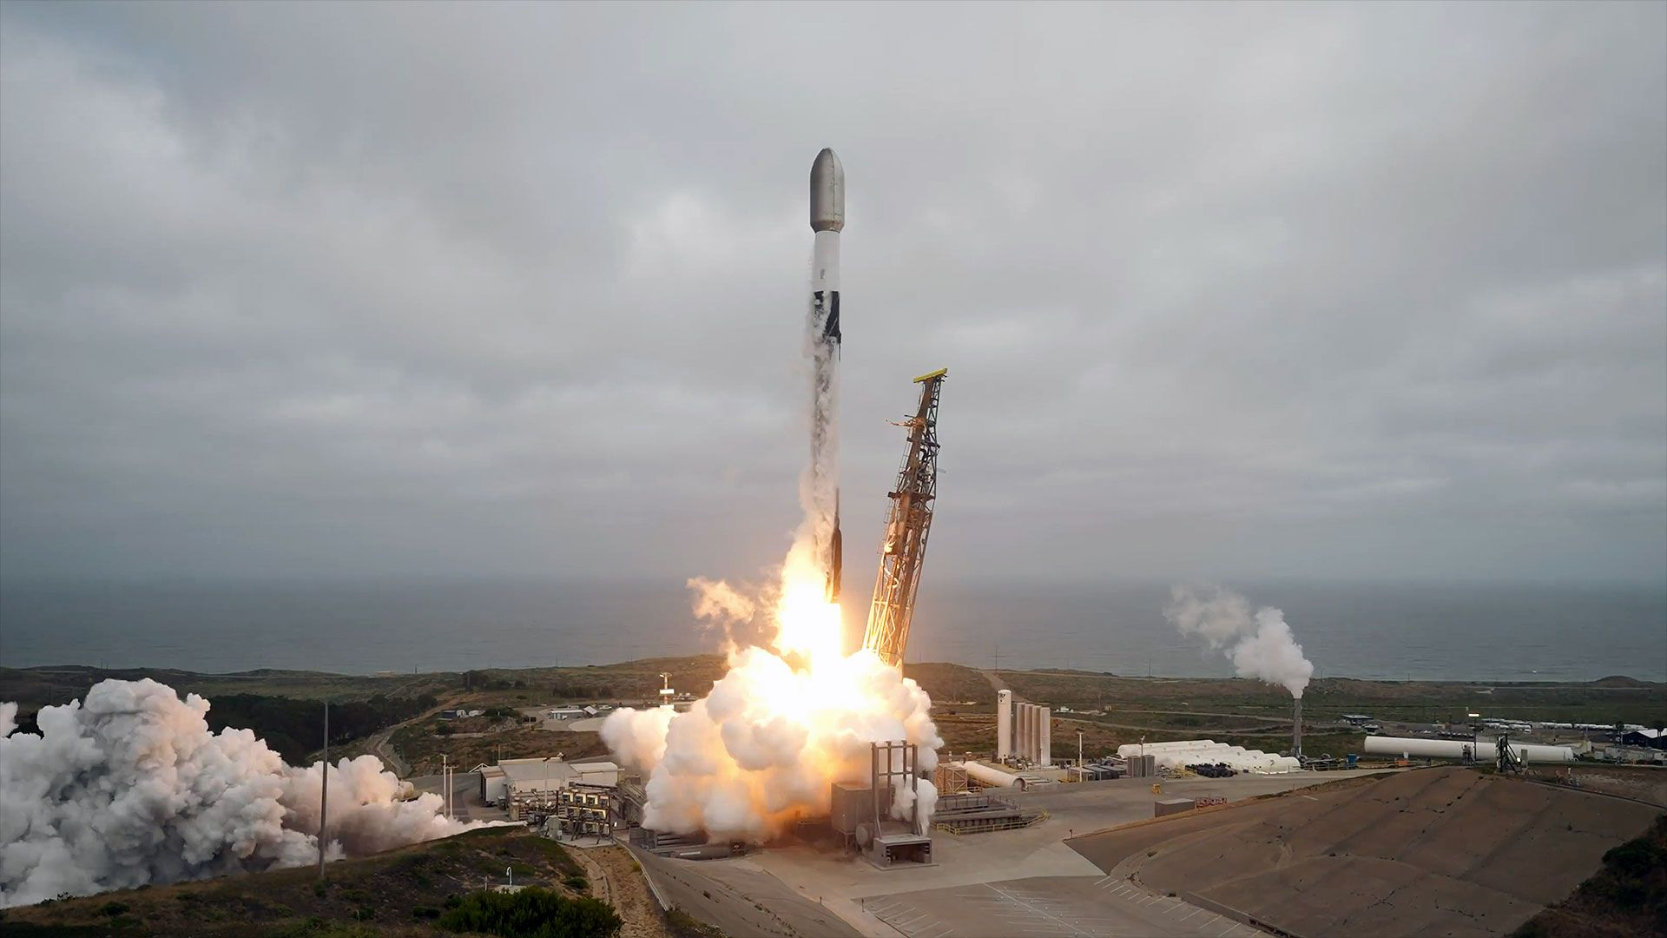
Click for next article SpaceX launched 24 more of its Starlink satellites into low Earth orbit on Sunday (June 28), continuing to expand its broadband internet relay network. A Falcon 9 rocket carrying the new batch ( Group 17-40 ) launched from Space Launch Complex 4 East at Vandenberg Space Force Base in California. Liftoff took place at 12:09 p.m. EDT (1609 GMT or 9:09 a.m. PDT local time). The Starlink satellites reached orbit about nine minutes after leaving the ground and were on track to be deployed by the Falcon 9 upper stage about an hour later. The first stage of a SpaceX Falcon 9 rocket is seen after landing on its four legs atop the autonomous droneship "Of Course I Still Love You" in the Pacific Ocean off the coast of California on Sunday, June 28, 2026. (Image credit: SpaceX) Previous Booster B1088 missions NROL-126 | Transporter-12 | SPHEREx | NROL-57 | 12 Starlink missions The rocket's first stage (Booster 1088) completed its 17th flight, touching down on the autonomous droneship "Of Course I Still Love You" positioned in the Pacific Ocean. The 24 satellites increased the total number of active relays in the Starlink network to more than 10,700, according to tracker Jonathan McDowell . The Starlink service provides access to the internet to people around the world, as well to in-flight wifi and cell-to-satellite service providers. Sunday's launch was SpaceX 's 75th Falcon 9 mission in 2026.

8. SpaceX launches 15,000-pound SiriusXM satellite to orbit from Florida
Read more
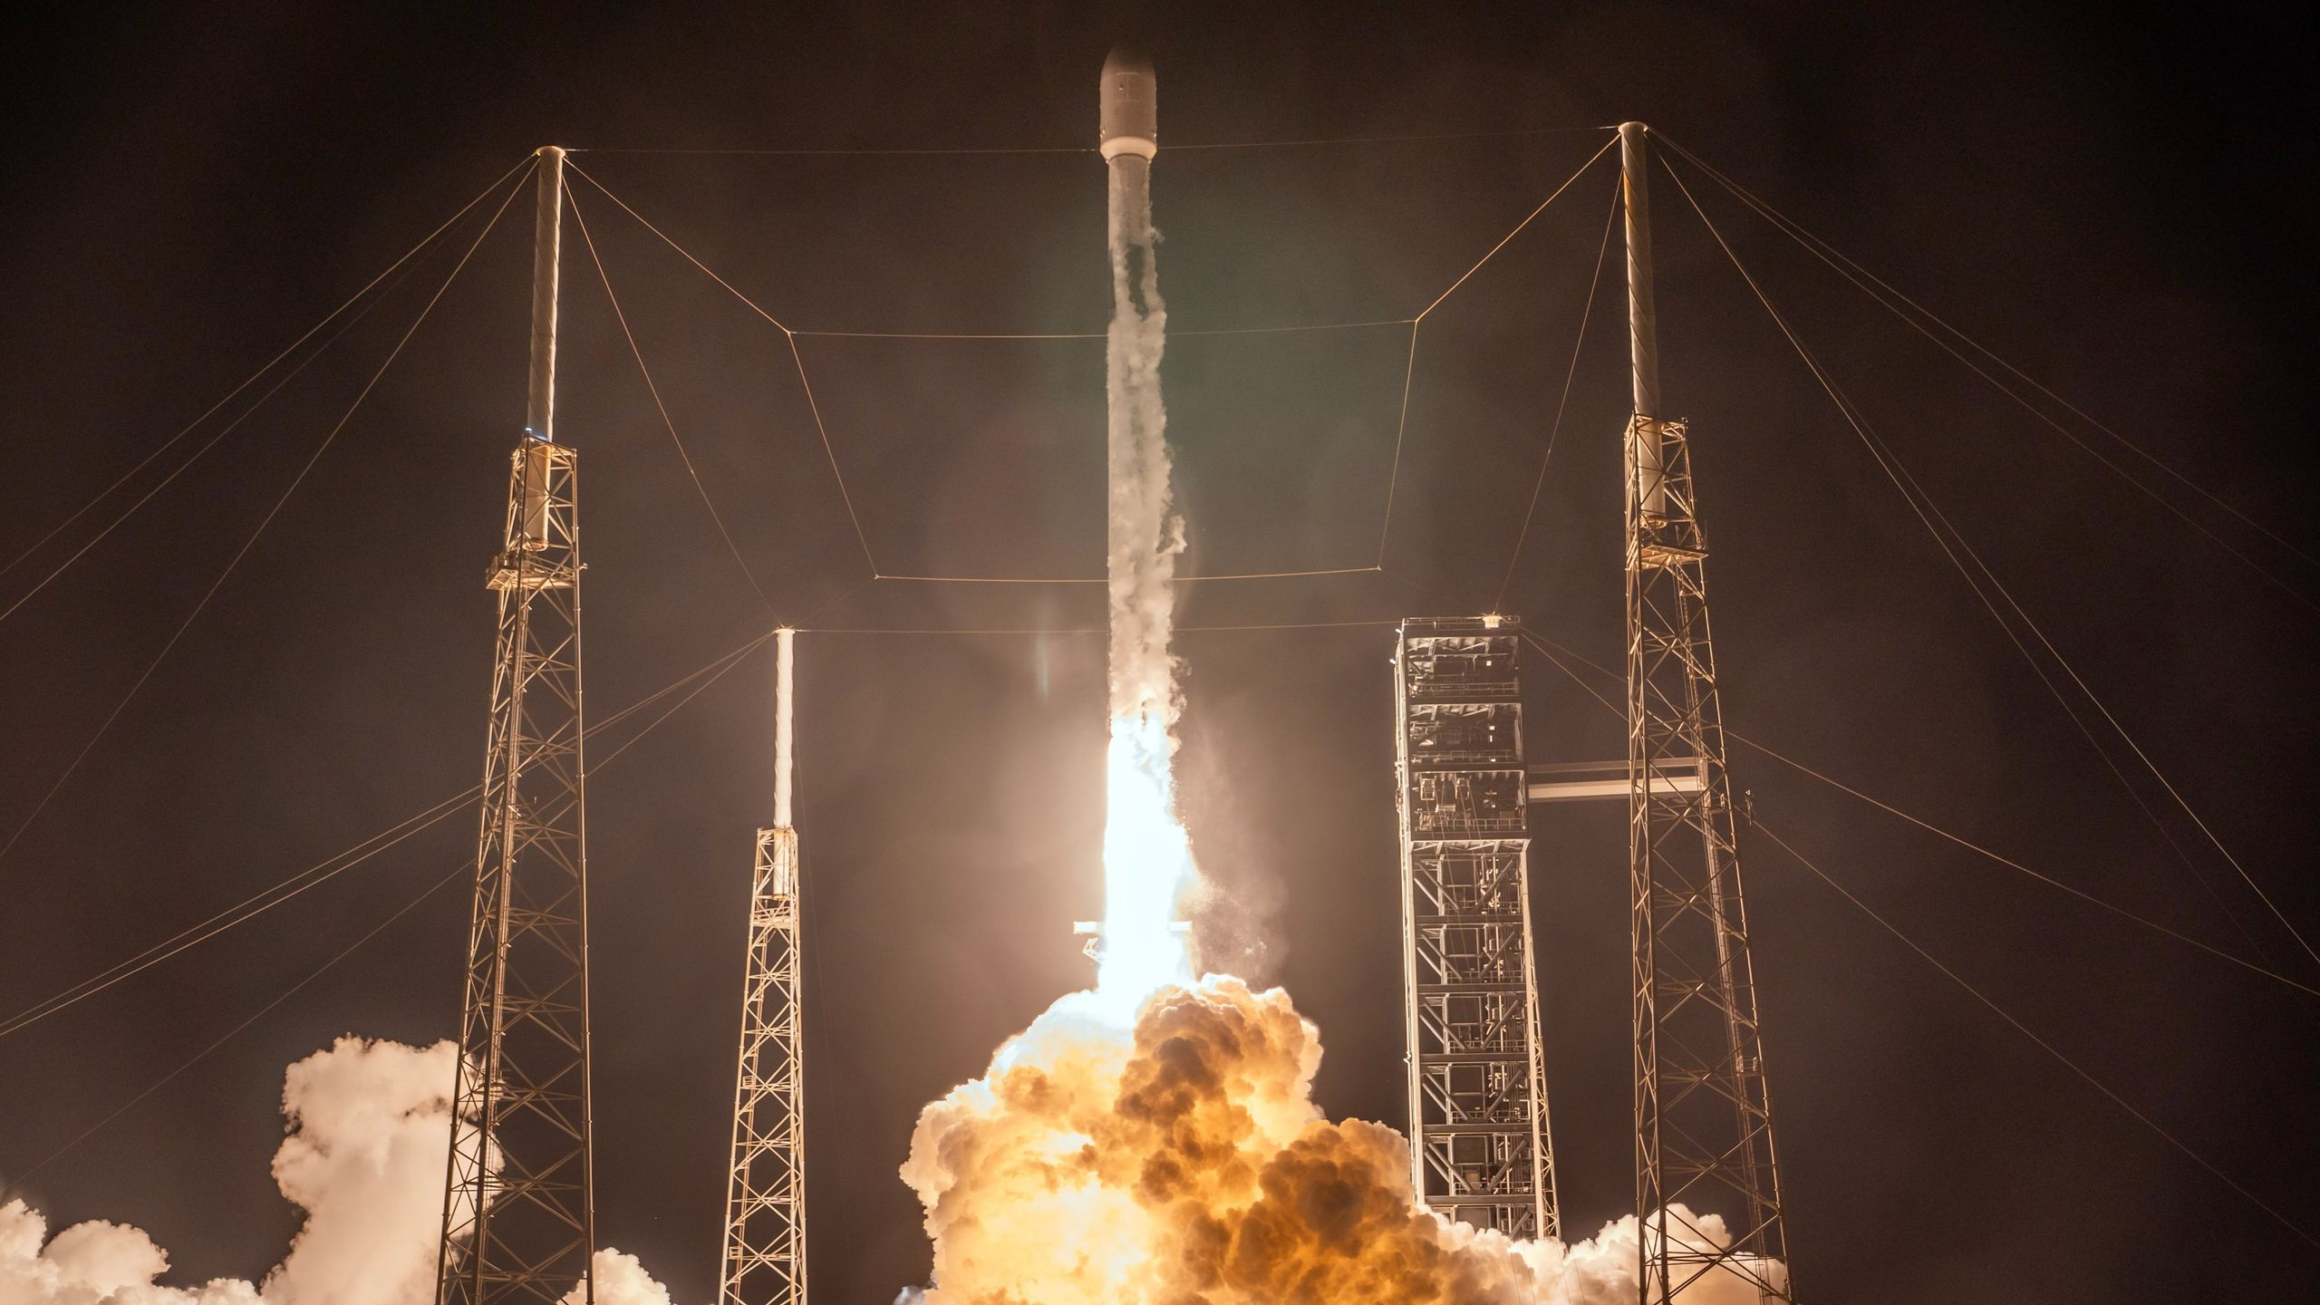
Click for next article A SpaceX Falcon 9 rocket launches the SXM-11 satellite for SiriusXM on June 28, 2026. SpaceX launched a big SiriusXM radio satellite to orbit from Florida's Space Coast on Sunday night (June 28). A Falcon 9 rocket topped with the 15,400-pound (7,000 kilograms) SXM-11 spacecraft lifted off from Cape Canaveral Space Force Station Sunday at 10:25 p.m. EDT (0225 GMT on June 29). The Falcon 9's first stage came back to Earth for a landing about 8.5 minutes after launch as planned, touching down in the Atlantic Ocean on the SpaceX drone ship "A Shortfall of Gravitas." SiriusXM's SXM-11 satellite deploys from the upper stage of a SpaceX Falcon 9 rocket on June 28, 2025. (Image credit: SpaceX) According to a SpaceX mission description, it was the 17th flight for this particular booster, which is designated B1085. The Falcon 9's upper stage, meanwhile, continued carrying SXM-11 to an elliptical geosynchronous transfer orbit, where it was deployed on schedule, 34.5 minutes after liftoff. SXM-11 will now circularize its distant path around our planet and join SiriusXM's satellite-radio fleet, which currently consists of seven spacecraft. SpaceX has now launched four of those spacecraft to date. The others were SXM-8 in June 2021, SXM-9 in December 2024 and SXM-10 in June 2025 , all of which also rode to orbit on Falcon 9 rockets. SpaceX has launched 76 Falcon 9 missions so far in 2026. The vast majority of those flights - nearly 80% of them - have been dedicated to building out the company's Starlink broadband megaconstellation in low Earth orbit . Editor's note: This story was updated at 2:30 a.m. ET on June 28 with news of successful launch, rocket landing and satellite deployment.

9. Could future astronauts use oysters as water filters? Here's why one company thinks so
Read more

Click for next article Engineers looking for safe water and recycled air for astronauts should look no further than nature, according to one team of researchers. Oysters and other forms of "biogenerative" life support systems, which use living beings for food, water recycling and air regeneration, are under study at Pennsylvania's Harrisburg University with Monolith Space, a small company featured on the This Week in Space weekly podcast with Space.com's Tariq Malik and author Rod Pyle in March. The shelled creatures aren't the only ones Harrisburg researchers are looking at: students and researchers are also examining algae, mollusks and even finfish. Hydroponics, or growing plants in water, is another approach. Monolith founder Jacob Scoccimerra, who is based in D.C., said the research is not only crucial for future astronaut living, but also unique among food projects in space. To the best of his knowledge, oysters have not yet flown in space, he told Space.com in an e-mail. Oysters in Space - With Jacob Scoccimerra of Monolith Space - YouTube Watch On "There are no dedicated facilities on the ISS capable of studying this, currently, that being a dedicated aquarium-like facility with environmental control," he noted. The ISS previously did have an aquatic habitat until 2012 , he said, but he described it as small (less than 3 liters or 0.8 gallons) and studying "primarily small finfish." "Other aquatic organisms have been studied in a variety of non-specialized hardware," he said of space research more generally, but noted there is "no facility that is large enough to host organisms like oysters." That's where a new prototype is coming in; Harrisburg and Monolith are together creating a closed-loop aquaculture system for marine organisms, which Scoccimerra said is roughly one-third of the way through NASA's technology readiness levels describing readiness for spaceflight. Specific applications of the research for astronaut missions are still being determined, but the university described the system as an "automated, closed-loop aquaculture system to grow and study marine organisms that may be beneficial candidates for space nutrition and research." That said, the university also notes that oysters "provide natural water filtration", suggesting a possible use during long-duration missions. Harrisburg's Rachel Fogle (an associate professor) and Glenn Williams (an instructor), provided guidance on the prototype, which uses oyster spat (baby oysters) and then helps the oysters grow into adulthood. The prototype was demonstrated publicly April 8. "The project has essentially closed since we presented the results on campus," Scoccimerra said. "Since closure, the oyster habitat has been set up at Monolith's office in D.C., where the oysters are continuing to be fed and monitored." Harrisburg University and Monolith LLC hosted a prototype demonstration of an oyster habitat on April 8, 2026. (Image credit: Harrisburg University/Monolith LLC) NASA subject matter experts also gave insight on the system design, which will continue to be refined for the agency's payload interface requirements that govern ISS launch requirements, as well as those for newer commercial space stations when they are ready. (This does not guarantee a future space-station launch, but gives the oyster project more potential for that in the future.) "Our pathway is to launch a smaller experiment first to ISS or similar platform, and then build from there," Scoccimerra said. "It is less a technical feasibility, and more of a need to study them. Historically aquatic biology has not been studied significantly in space compared to microbial, human, and plant biology." The research is taking place as NASA pushes hard to return astronauts to the surface of the moon as a part of the agency's Artemis program , for a more permanent presence around the end of the decade. In January, the agency also identified "food and nutrition for Mars and sustained lunar" as one of the priority items in its civil space shortfall ranking , which targets areas for tech development.

10. SpaceX launches 7.5-ton SiriusXM satellite as part of constellation refresh
Read more
A SpaceX Falcon 9 rocket launched Sunday carrying a multi-ton, radio-broadcasting satellite for SiriusXM's to replace two aging satellites in geostationary Earth orbit. Liftoff from Space Launch Complex 40 at Cape Canaveral Space Force Station happened at 10:25 p.m. EDT (0225 UTC), the opening of a four-hour window. The rocket flew on an easterly trajectory upon leaving the launch pad. <span data-mce-type="bookmark" style="display: inline-block; width: 0px; overflow: hidden; line-height: 0;" class="mce_SELRES_start"></span> The 45th Weather Squadron forecast an 80 percent chance for favorable weather at the opening of the launch window that improves to 90 percent as time goes on. Meteorologists are watching for interference from cumulus and anvil clouds. "Flow aloft will be weak and variable, supporting daily storm motions that will be seabreeze and outflow dependent. This erratic nature of storm motion is more evident in today's model runs, suggesting a higher risk of storms lingering closer to the coast later into the night," launch weather officers wrote. "However, remnant storms and clouds should slowly diminish as the night wears on during both the primary and backup launch opportunities." SpaceX launched the mission using its Falcon 9 booster with the tail number B1085. This was its 17th flight having previously launched NASA's Crew-9, RRT-1 for the U.S. Space Force, Firefly Aerospace's Blue Ghost Mission 1, Fram2, SiriusXM's SXM-10, the MTG-S1 weather satellite for Europe, EchoStar XXV, and nine Starlink missions A little more than 8.5 minutes after liftoff, B1085 landed on the drone ship, 'A Shortfall of Gravitas', stationed in the Atlantic Ocean. This was its 158th successful landing, tying it with the now retired vessel, 'Just Read the Instructions', which is being used for Starship operations. Constellation refresh The SXM-11 satellite, weighing about 15,000 pounds (7.5 tons), was deployed from the Falcon 9 rocket's upper stage a little more than half an hour after launch. It was manufactured by Lanteris Space Systems, a subsidiary of Texas-based Intuitive Machines. The company, formerly branded as Maxar Space Systems, was acquired by Intuitive Machines in January 2026 for about $800 million. The SXM-11 and SXM-12 satellites were built to replace SiriusXM's XM-5 and the Sirius FM-5 satellites, which launched in 2010 and 2009 respectively. "After years of planning, engineering, testing, and collaboration, SXM-11 is set to launch aboard a SpaceX Falcon 9 rocket and begin its journey to orbit," SiriusXM wrote on its LinkedIn page. "As the most powerful high-powered satellite in SiriusXM's fleet, SXM-11 will help enhance signal reception, expand coverage in Alaska, and support the delivery of audio entertainment and information services across the United States, Canada, and the Caribbean." The 230-foot-tall (70.1 m) satellite is based on the IM-1300 satellite bus. With its solar panels extended, the spacecraft spans 106 feet (32.3 m). SiriusXM said about 60 percent of the 7.5 ton satellite's mass comes from the fuel onboard. The last of these satellites, SXM-10, which launched in June 2025, is estimated to remain in service until 2040, according to a financial disclosure from SiriusXM to the U.S. Securities and Exchange Commission (SEC).

11. NASA races to save Swift telescope from falling back to Earth with daring rescue mission
Read more
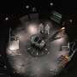
NASA is racing to save an aging telescope from falling back to Earth with a daring rescue mission.

12. North Korea commissions 5,000-ton destroyer Choe Hyon, plans 10,000-ton nuclear cruisers
Read more
military Stay informed about the latest advancements in military technology, defense strategies, and global conflicts. Explore the intersection of technology and the military world. 6/29/2026 US' new 80,000-sq-foot facility to support aircraft carrier overhauls The Carrier Refueling Overhaul Workcenter is expected to play an important role in sustaining fleet readiness. Prabhat Ranjan Mishra 3 hours ago US Army develops advanced counter-drone system capable of engaging UAVs on the move The initiative was launched in response to the growing threat posed by commercially available and military-grade drones. 5 hours ago 6/28/2026 US Army trials LP-CROWS integration on Paladin artillery for drone defense The effort advanced from early concept work to a production-representative configuration. Bojan Stojkovski 17 hours ago From S-500 to THAAD: These are seven of the world's most advanced air defense systems Today's strategic air defense systems are designed to operate as part of integrated, multi-layered defense networks. Kaif Shaikh 19 hours ago These 7 aircraft carriers showcase the cutting edge of naval warfare Aircraft carriers serve as mobile airbases capable of projecting military power far from home waters. 5,800-ton extremely silent, nuclear-powered attack submarine delivered to France The Barracuda-class vessel offers support for deep strikes. a day ago 6/27/2026 US eyes 1,150-mile missile as China expands military reach across Pacific The Pentagon is seeking a weapon that could help US forces operate beyond the reach of China's defenses. Rupendra Brahambhatt 2 days ago US Army launches space operations branch to enhance multidomain operations The historic announcement formalizes and consolidates the Army's space-related workforce into a single branch. Maria Mocerino Onebrief platform to support U.S. Army's next generation division level C2 The US Army is empowering its units with an artificial intelligence workflow and planning platform, Onebrief. US moves RQ-4B Global Hawk advanced drones to Japan in Indo-Pacific surveillance boost The RQ-4B Global Hawk provides long-endurance intelligence, surveillance, and reconnaissance across the Indo-Pacific. Europe's firepower to get major boost with sustainment centre for multiple launch rocket systems The new facility enhances regional sustainment readiness for M270A2 and HIMARS operators across Europe. Australia bags whopping $2.5 billion over-the-horizon radar export deal with Canada BAE Systems will supply Canada with its over-the-horizon radar as part of a multi-billion export deal with Australia. Christopher McFadden US Air Force awards $984M contract to sustain E-4B 'Doomsday' aircraft fleet The aircraft also enables senior military and civilian leaders to maintain secure communications. US Navy awards Raytheon $1.1B to expand AIM-9X missile production capacity Raytheon will boost AIM-9X missile production under a $1.1B Navy contract supporting U.S. and allied demand. Neetika Walter 6/26/2026 US Space Force backs autonomous factories to speed rocket, missile parts production Orbital's autonomous manufacturing platform aims to speed production of critical defense and space components. 3 days ago A $100 3D-printed attachment could safeguard F-35s from $20M engine damage Two US Air Force weapons specialists created a simple attachment that can funnel ammo casings, removing potential flight line hazards. Chris Young The world's fastest fighter jet could hit Mach 3.2 but it came with a major catch The MiG-25 prioritized one thing above all else. Speed. Everything else came second. Top 7: While helicopters struggle to fly fast these seven beat the odds The world's fastest helicopters combine powerful engines, advanced rotor technology, and innovative aerodynamics. In a first, four US Army bases to house critical mineral processing facilities The conditional lease awards are aimed at building domestic critical mineral processing capacity. Aditya Jadhav Lockheed Martin debuts next-generation hypersonic glide body focused on mass production NXGB supports land and sea launch platforms, enabling flexible long-range precision strikes in contested environments. Jijo Malayil Get the latest in engineering, tech, space & science - delivered daily to your inbox. Sign up for free By subscribing, you agree to our Terms of Use and Policies You may unsubscribe at any time. - 1 - 2 - More pages - 139 About Military Military systems take years to build, cost a lot, and are difficult to replace once deployed. It's shaped by slow procurement cycles, tight constraints, and hard trade-offs between capability, cost, and reliability. This category looks at how modern militaries actually develop, acquire, and use technology, and what that reveals about the conflicts they're preparing for. Coverage at Interesting Engineering spans land, air, sea, space, and cyber systems. That includes weapons platforms, sensors, communications, logistics, autonomy, electronic warfare, missile defense, and command-and-control infrastructure. But the focus isn't just on hardware. Software, integration, training, maintenance, and doctrine matter just as much in determining whether a system performs as intended. Military systems are designed for environments where failure has serious consequences, yet they are often built under political pressure, budget limits, and changing threat perceptions. This category examines how those pressures shape design choices, testing standards, and deployment timelines. It also looks at why some programs drag on for decades while others are canceled after billions have been spent. We pay close attention to how emerging technologies - how AI, drones, cyber tools, space-based assets, and advanced manufacturing are being absorbed into existing forces. Adoption is rarely smooth. Legacy platforms, interoperability issues, supply chains, and training requirements often slow or distort the impact of new capabilities. Beyond technology, this category considers strategy, deterrence, and escalation. Military innovation doesn't exist in a vacuum; it influences geopolitics, arms control, and global stability. Ethical questions, civilian risk, and regulatory boundaries are part of the conversation, not afterthoughts. Rather than treating military power as spectacle, this category focuses on function. It tracks what is being fielded, what is being tested, what is quietly failing, and what today's choices suggest about the conflicts of tomorrow.

13. China surpasses US in satellite navigation, orbital warfare, strategic military sectors
Read more
According to a new report by the Washington-based Information Technology and Innovation Foundation, China has rapidly expanded its commercial space industry with strong government backing, significantly narrowing the innovation gap with the US. The report, published on June 8, warned that Beijing's accelerating progress could reshape the balance of power in the global space sector. It cautioned that without swift and decisive action, the US risks losing its leadership position in the space economy. The warning comes as industry analysts forecast the global space economy could surpass $1 trillion over the next decade, highlighting the growing strategic and commercial stakes of space competition. China rises to second place in global space market Ellis Scherer, a space policy analyst at the Information Technology and Innovation Foundation and author of the report, said China's space industry has transformed from a slow-moving sector dominated by state-owned enterprises into a highly competitive and increasingly innovative commercial ecosystem. The report notes that China now ranks second only to the US in the global space market, noting Beijing's rapid rise as a major force in the commercial and strategic space race. The report noted that many commercial space technologies now serve both civilian and military purposes, with armed forces increasingly relying on capabilities such as positioning, navigation and timing systems, remote sensing, low Earth orbit broadband networks, and anti-satellite weapons. These technologies play a critical role in modern warfare by enabling surveillance of conflict zones, maintaining communications with troops in remote locations, and tracking the movement of military assets, the South China Morning Post reported. The report also found that the US retains a strong lead in low Earth orbit (LEO) broadband, one of six major space sectors it assessed. That advantage is largely driven by SpaceX's Starlink and Amazon's Project Kuiper, both of which remain ahead of China's Qianfan and Guowang satellite networks. BeiDou drives China's lead in critical navigation services China's space ambitions continue to face significant hurdles, with launch bottlenecks and the lack of operationally proven reusable rockets slowing deployment timelines. Despite those constraints, Beijing has established a lead in positioning, navigation and timing services, driven largely by the global expansion of China's BeiDou Navigation Satellite System, the report added. Furthermore, the scale of China's satellite constellation, expanding global coverage and rising international adoption have pushed Beijing ahead of Washington in navigation services. It also ranked China as the leader in remote sensing and satellite imaging, citing government-backed programs such as the Gaofen satellites and commercial constellations like Jilin-1, which have helped build one of the world's largest satellite imaging ecosystems. The gap is much narrower in space station capabilities though, and while the US benefits from decades of operational experience with the International Space Station, China has rapidly advanced its Tiangong Space Station, bringing the two nations to broadly comparable levels despite following different development models. The report also found China leading in counterspace capabilities, citing sustained investment in anti-satellite technologies, including kinetic interceptors, electronic warfare systems and directed-energy weapons designed to disrupt or disable satellites.

