 |  | 

🌌 अंतरिक्ष समाचार | Space News
मंगलवार, २३/०६/२०२६ | Tuesday, 23/06/2026

1. GIS mapping to identify complaint hotspots for permanent solutions: DM
Read more
PIONEER EDGE NEWS SERVICE / Dehradun Dehradun district magistrate Ashish Chauhan has directed officials to identify areas that repeatedly generate public complaints and fix accountability for unresolved issues. During the Samadhan Diwas programme held on Monday, he said that a GIS-based analysis of complaints would be carried out to identify such hotspots and ensure permanent solutions. Chauhan instructed the National Informatics Centre (NIC) to analyse data from the last 10 Samadhan Diwas programmes and prepare department-wise GIS maps. He said that the officials responsible for areas with a high number of complaints would be held accountable if problems continue to remain unresolved. During the programme, he heard 146 public grievances and directed officials to ensure their timely disposal. Complaints related to illegal land encroachment, boundary disputes, bank loan waivers, electricity supply, drinking water, legal assistance and financial support were among the major issues raised by the citizens. Chauhan further directed all the sub-divisional magistrates and senior engineers of various departments to join future grievance redressal meetings either in person or through virtual mode. He also asked officials to give priority to complaints received from remote areas such as Chakrata and Kalsi. Taking note of the complaints related to banks, he directed the lead bank manager to review the issues. He questioned why proper verification is not carried out before loans are approved, which later leads to repayment problems for borrowers. The administration also focused on issues related to women's safety and welfare. The DM instructed the district programme officer to strengthen the functioning of One Stop Centres and ensure that women facing domestic or family related problems receive immediate assistance. He also directed the police department to take strict action in cases of assault and public disputes. Several specific complaints were also taken up during the programme. The DM ordered action on alleged encroachment at Triveni Ghat in Rishikesh, illegal activities near PM Shri Kendriya Vidyalaya in Salawala, land related disputes in Sahaspur and encroachments on ponds and government land in Chharba village. Officials were directed to submit reports and complete necessary action within the stipulated time.

2. ISRO successfully conducts 2nd integrated air drop test for Gaganyaan mission | Akashvani News - News On AIR
Read more
The Indian Space Research Organisation (ISRO) has successfully conducted the second integrated air drop test (IADT-02) for the upcoming Gaganyaan mission at Sriharikota in Andhra Pradesh. The system is essential to ensure safe recovery of the crew module - the capsule in which astronauts sit during a human flight. After the module's release, a parachute system, comprising 10 parachutes, was deployed, helping the capsule decelerate to a safe splashdown speed. The IADT-02 follows the successful completion of the first IADT, which took place on August 24, 2025, at the Satish Dhawan Space Centre in Sriharikota. In the first IADT, a 4.8-tonne dummy crew module was dropped from a height of three km by a Chinook helicopter. Air drop tests recreate the last leg of a spacecraft's return to the Earth. An aircraft or helicopter drops the spacecraft from a height to test various systems under different scenarios. These are the deployment of the parachute system in case the mission is aborted mid-flight, system performance when one parachute fails to open, and the spacecraft's orientation and safety during splashdown. Union Minister Jitendra Singh congratulated the ISRO for successfully conducting the test. India's first human spaceflight will be launched from Sriharikota in 2027.

3. ISRO invites Indian researchers to access XPoSat mission data - BusinessLine
Read more

The Indian Space Research Organisation (ISRO) on Monday made an Announcement of Opportunity, inviting proposals from the country's astronomical community to access data from the XPoSat Mission, which studies bright astronomical X-ray sources in extreme conditions. Launched on January 1, 2024, the XPoSat, or X-ray Polarimeter Satellite, currently orbits Earth in a near-equatorial orbit at an altitude of 650 kilometres. It carries two scientific payloads that help study X-ray emission mechanisms of black holes, neutron stars, and active galactic nuclei, among others. In a statement, ISRO said that only "Indian scientists or researchers residing and working at institutes, universities or colleges in India" can submit proposals to access the mission's data. The XPoSat Mission is the country's first satellite-based mission dedicated to making X-ray polarimetry measurements. These measurements "add two more dimensions to our understanding, the degree of polarisation and the angle of polarisation, and hence is an excellent diagnostic tool to understand the emission processes from astronomical sources," according to ISRO. Before the XPoSat Mission's launch, scientists largely depended on spectroscopic, imaging, and timing-based data obtained from either ground-based telescopes or satellite-based missions across the optical to the radio frequency band of the electromagnetic spectrum. While this provided a wealth of data, the exact nature of the emission from celestial sources still posed deeper challenges to astronomers. The XPoSat Mission helped expand the knowledge about these emissions. Published on June 22, 2026

4. ISRO invites proposals from Indian researchers to study XPoSat Mission data - ThePrint
Read more
ISRO invites proposals from Indian researchers to study XPoSat Mission data ThePrint

5. Sribhumi Roots, ISRO Dreams: Abu Hasim Reaches YUVIKA 2026 - Barak Bulletin
Read more
For most students, space exploration is something they encounter through textbooks, television screens, or internet videos. For Md. Abu Hasim Choudhury, however, it became a reality when he earned a place in one of the country's most prestigious student programmes organised by the Indian Space Research Organisation (ISRO). A Class 10 student of Kendriya Vidyalaya, Hayuliang, in Arunachal Pradesh's Anjaw district, Abu Hasim was selected for ISRO's Young Scientist Programme (YUVIKA) 2026, an initiative designed to introduce school students to the world of space science, satellite technology, astronomy, and rocket engineering. Every year, only a limited number of students from across India are selected for the programme, making the achievement highly competitive. Although the family currently resides in Hayuliang, their roots lie in Fakira Bazar of Sribhumi district in Assam. According to his elder brother, Abu Hanif Choudhury, the family has maintained strong ties with its native place even after moving to Arunachal Pradesh nearly three decades ago. What makes the achievement even more significant is that Abu Hasim is believed to be the only student selected from Anjaw district for YUVIKA 2026. For a district located in one of India's remotest border regions, the selection has become a moment of pride not only for the family but also for the wider community. YUVIKA (Yuva Vigyani Karyakram) is one of ISRO's flagship student outreach programmes aimed at nurturing scientific curiosity among school students. Abu Hasim's name appeared in the official YUVIKA 2026 selection list published on April 13, 2026. He was listed under Application No. YUV2026-48051012564 and secured Serial No. 201 in the national selection list. The selection was made through a competitive process that considered academic performance and other criteria prescribed by ISRO. Born on October 28, 2011, Abu Hasim has consistently performed well academically. According to his brother, he secured 91 percent marks in Class 9 and is known among teachers as one of the brightest students in his school. Beyond academics, he is also an active volleyball player and has participated in quiz competitions, winning first place in one such event during his school years. Speaking to Barak Bulletin, Abu Hanif Choudhury recalled the excitement that followed the selection. While the family was delighted, they also faced an unexpected challenge. Sending a young student alone from Arunachal Pradesh to Dehradun for a residential programme was not an easy decision. "We were very happy when he got selected, but at the same time we were worried about how to send him there," he said. "My father's health was not good, I was working in Bengaluru, and my younger brother was in Guwahati. After a lot of discussion, our father finally accompanied him." Abu Hasim later attended the residential YUVIKA programme at the Indian Institute of Remote Sensing (IIRS), Dehradun. The 12-day programme brought together students from different parts of the country and provided exposure to space science, satellite technology, remote sensing, astronomy, rocket technology, and other scientific activities under the guidance of ISRO scientists and experts. According to his brother, the experience strengthened Abu Hasim's interest in pursuing a career related to space technology. During the programme, he interacted directly with ISRO scientists and learned about rockets, the history of India's space programme, and the functioning of ISRO. He also participated in quizzes and interactive sessions with fellow students from across the country. The achievement also received appreciation from his school. Abu Hanif said teachers were delighted by the selection and actively helped the family prepare for the programme by guiding them through the necessary procedures and travel arrangements. Despite coming from a modest background, the family has always prioritised education. "Our family supports him in every possible way," Abu Hanif said. "We may not be from a wealthy background, but we want him to learn, grow, and take every opportunity available to him." For the family, Abu Hasim's journey carries a message that extends beyond personal success. It demonstrates that students from remote districts and border regions can compete and excel at the national level when given the opportunity. His advice to other students is simple: work hard, stay focused, and never stop learning. Today, Abu Hasim dreams of becoming a scientist or rocket engineer in the future. As he returns to his studies after experiencing one of India's most prestigious student science programmes, his story serves as a reminder that talent can emerge from any corner of the country. For students growing up in remote regions of the Northeast, his journey offers proof that distance is no barrier to ambition. The question now is: could this young student from Hayuliang one day become one of the scientists helping shape India's future in space?

6. ISRO Invites Indian Astronomers To Explore XPoSAT Data For New Cosmic Discoveries - News18
Read more
ISRO Invites Indian Astronomers To Explore XPoSAT Data For New Cosmic Discoveries News18

7. NASA Awards Solutions for Federal Enterprise Procurement Contracts
Read more

Credit: NASA NASA will begin processing the awards of multiple contracts for the Solutions for Enterprise‑wide Procurement (SEWP) VI Government-wide Acquisition Contract. The contract provides streamlined access to commercial products and services, including hardware, software, cloud services, cybersecurity tools, engineering and consulting services, and data intensive mission support capabilities. This competitive acquisition was conducted within three categories: Category A, IT Solutions; Category B, Enterprise-wide IT Service Solutions; and Category C, IT Mission-Based Services. A full list of SEWP VI awardees and additional program details are available at: https://www.sewp.nasa.gov All awards are indefinite‑delivery/indefinite‑quantity contracts with the ability to issue firm‑fixed‑price, labor‑hour, time‑and‑materials, and other pricing arrangement task orders. The effective ordering period is 10 years, beginning Nov. 1, through Oct. 31, 2036, and each contract has a maximum value of $20 billion. For information about NASA and agency programs, visit: https://www.nasa.gov -end- Jennifer Dooren / Jessica Taveau Headquarters, Washington 202-358-1600 jennifer.m.dooren@nasa.gov / jessica.c.taveau@nasa.gov

8. NASA Sounding Rocket to Launch Student Experiments
Read more

NASA's Wallops Flight Facility in Virginia is scheduled to launch a sounding rocket carrying student-developed experiments for the agency's RockSatX and RockOn programs Wednesday, June 24, between 5:30 and 9:30 a.m. EDT, with a backup day on Thursday, June 25. Students watch as their experiments launch aboard a sounding rocket for the RockSat-X program from NASA's Wallops Flight Facility Aug. 11, 2022, at 6:09 p.m. EDT. The Terrier-Improved Malemute rocket carried the experiments to an altitude of 99 miles before descending via a parachute and landing in the Atlantic Ocean. NASA Wallops/Terry Zaperach The RockSat and RockOn programs provide technical training and hands-on experiences that prepare and equip students to enter the United States aerospace industry. For the first time, NASA will combine both the RockSat and RockOn missions into one rocket, which will carry experiments developed by nearly 250 participants from 38 university and community college teams. "The challenge was finding ways to fit as many experiments onto one sounding rocket as we could," said Victoria Stoffel, workforce development lead at NASA Wallops. "The Sounding Rocket Program Office team found creative ways to fit nearly 50 experiments into one rocket. We are grateful to the Wallops teams for making this happen for the students to get the most from this experience." The RockOn teams work together to build their experiment onsite, getting hands-on experience putting together a circuit board from scratch and launching it into space. The more advanced RockSat program teams design and build their experiments, going through design reviews modeled on larger NASA missions. Each team can experience what it's like working on a real NASA mission, from development to launch. The RockSat student experiments range from taking measurements of weather and radiation in Earth's upper atmosphere to testing technologies, such as heat shields, space-debris tracking, and robotic servicing, that could help future NASA missions. The Terrier-Improved Malemute suborbital sounding rocket, which will carry the experiments, is expected to reach an altitude of about 100 miles before descending by parachute into the Atlantic Ocean to be recovered. The launch may be visible in the Chesapeake Bay region. A launch visibility map for a Terrier-Improved Malemute sounding rocket launching from NASA's Wallops Flight Facility in Virginia. NASA The Wallops Visitor Center's launch viewing area will open June 24 at 4:30 a.m. for viewing. A livestream will begin approximately 10 minutes before launch on the Wallops YouTube channel. Launch updates also are available via the facility's Facebook page. For more information about NASA's Sounding Rocket Program, visit: https://www.nasa.gov/soundingrockets By Jamie Adkins NASA's Wallops Flight Facility, Virginia List of RockSat Teams Capital Tech University, Maryland Clemson University, South Carolina College of the Canyons, California Colorado Space Grant Consortium University of Colorado Boulder Escuela de Troquelería y Herramentaje, Puerto Rico New Jersey Institute of Technology Northwest Nazarene University, Idaho Rockets of the Rockies, Colorado Red Rocks Community College Arapahoe Community College Temple University, Pennsylvania Tidewater Community College, Virginia University of Alabama Huntsville University of Delaware University of Hartford, Connecticut University of Hawaii Community Colleges University of Kentucky University of Nebraska Lincoln University of Puerto Rico University of Virginia Virginia Tech West Virginia Space Flight Design Challenge Blue Ridge Community College West Virginia Wesleyan College West Virginia University West Virginia State University Marshall University List of RockOn Teams

9. NASA Invites Media to Botswana Artemis Accords Signing Ceremony
Read more

Credit: NASA The Republic of Botswana will sign the Artemis Accords during a ceremony at 9:30 a.m. EDT Thursday, June 25, at NASA Headquarters in Washington. NASA Deputy Administrator Matt Anderson will host Botswana's Minister of Communications and Innovation David Tshere and U.S. Department of State Senior Advisor for Space Gregory Autry for the event. This event is in person only. Media interested in attending must RSVP no later than 5 p.m. on Wednesday, June 24, to: hq-media@mail.nasa.gov. NASA's media accreditation policy is online. In 2020, during the first Trump Administration, the United States, led by NASA and the State Department, joined with seven other founding nations to establish the Artemis Accords, responding to the growing interest in lunar activities by both governments and private companies. The accords introduced the first set of practical principles aimed at enhancing the safety, transparency, and coordination of civil space exploration on the Moon, Mars, and beyond. Botswana will be the 68th country to sign the Artemis Accords. Learn more about the Artemis Accords at: https://www.nasa.gov/artemis-accords -end- Camille Gallo / Jennifer Dooren Headquarters, Washington 202-358-1600 camille.m.gallo@nasa.gov / jennifer.m.dooren@nasa.gov

10. NASA's Experimental Fabrication Branch Fuels Aircraft Innovation
Read more
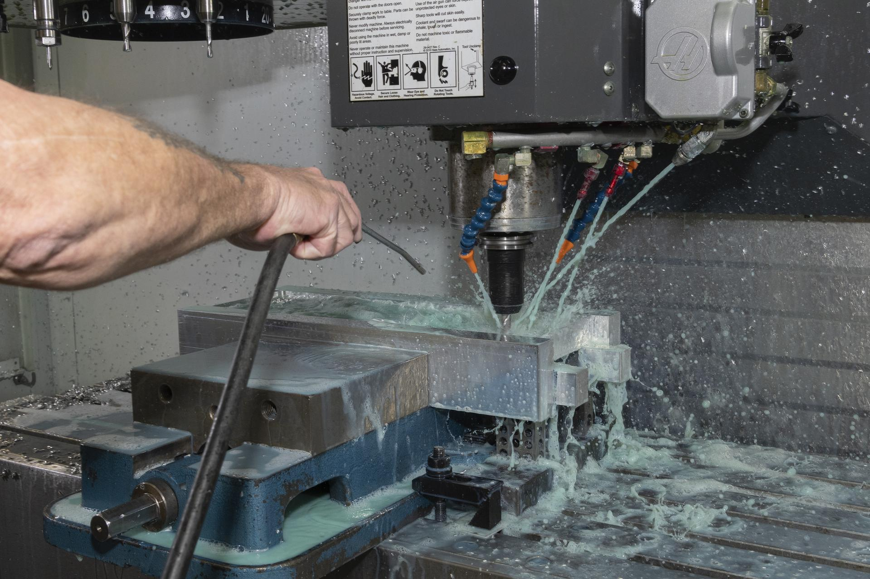
At NASA, innovation begins well before an aircraft takes flight. The Experimental Fabrication Branch at NASA's Armstrong Flight Research Center in Edwards, California, transforms engineering concepts into mission‑ready hardware for research aircraft and technology development. This capability helps the agency deliver advancements that benefit the public by improving aviation safety, efficiency, and sustainability. The branch serves as a full‑service manufacturing, modification, and repair center for NASA Armstrong's fleet of research and science aircraft. The team specializes in precision machining, sheet‑metal forming, aircraft tubing, welding, additive manufacturing, composite fabrication, and structural repairs and modifications. Their broad expertise allows them to build custom hardware for both aerospace and ground‑based applications. Ron Harris, an engineering technician, works in the Experimental Fabrication Branch at NASA's Armstrong Flight Research Center in Edwards, California, on Thursday, March 14, 2023. The branch transforms engineering concepts into hardware for research aircraft and technology development, supporting advances in aviation safety, efficiency, and sustainability. NASA/Steve Freeman Engineering technicians in the branch bring decades of experience as master fabricators. They design and build unique components, rapid prototypes, and flight‑critical structures that meet NASA's rigorous safety and performance standards. Whether shaping composite structures by hand or producing precision‑milled parts, the team builds every component with mission success in mind. Experimental Fabrication supports a wide range of NASA research efforts. When teams at NASA Armstrong designed the AIRVUE (Airborne Instrumentation for Real‑world Video of Urban Environments) sensor pod to support autonomous‑flight research, the fabrication team converted digital designs into a fully functional structure. They ensured the pod met strict safety requirements before deploying it for test flights. An engineering technician works in the Experimental Fabrication Branch at NASA's Armstrong Flight Research Center in Edwards, California, on Thursday, March 14, 2023. The branch transforms engineering concepts into hardware for research aircraft and technology development, supporting advances in aviation safety, efficiency, and sustainability. NASA/Steve Freeman Beyond mission support, the Experimental Fabrication Branch contributes to NASA's STEM engagement efforts. During local robotics competitions, technicians use mobile fabrication equipment to repair student‑built robots and demonstrate machining and welding techniques. These demonstrations introduce students to NASA's technical career paths and show how advanced manufacturing supports aerospace research. The branch uses modern computer-aided design and computer-aided manufacturing tools, including Pro E/Creo, MasterCam, and SolidWorks, to convert digital models into hardware. This early integration of engineering and fabrication helps shorten development timelines and reduce design‑to‑hardware mismatches. Unlike environments where work transitions between multiple contractors, NASA Armstrong includes the fabrication team from early design through final assembly and aircraft installation. This continuous involvement strengthens coordination with engineering teams and flight operations. Alexis Moreno, an engineering technician, works with a fabrication machine in the Experimental Fabrication Branch at NASA's Armstrong Flight Research Center in Edwards, California, on Monday, Nov. 6, 2023. The branch transforms engineering concepts into hardware for research aircraft and technology development, supporting advances in aviation safety, efficiency, and sustainability. NASA/Genaro Vavuris Recent projects, such as advanced wing‑model fabrication and custom lightweight aircraft floorboards, highlight the branch's essential role in NASA Armstrong's mission. Whether supporting experimental aircraft, enabling new technology demonstrations, or guiding students through hands‑on fabrication, the Experimental Fabrication Branch helps advance NASA's mission for the benefit of all.

11. NASA's Chandra Finds Possible Supernova Remnant
Read more

Using data from NASA's Chandra X-ray Observatory, astronomers may have found a supernova remnant in an intriguing neighborhood in the middle of our galaxy. X-ray: NASA/CXC/UCLA/Z. Zhu et al.; ESA/XMM-Newton; Optical: PanSTARRS; Radio: MeerKAT; Infrared (JWST): NASA/ESA/CSA/STScI; Image Processing: NASA/CXC/SAO/L. Frattare and P. Edmonds Using data from NASA's Chandra X-ray Observatory, astronomers may have found a supernova remnant - seen in this June 11, 2026, image - in an intriguing neighborhood in the middle of the Milky Way galaxy. Supernova remnants are the expanding remains of exploded stars and provide elements like iron, oxygen, and silicon that are critical for the formation of planets and for life as we know it to form and flourish. This new supernova remnant, if confirmed, would be one of the closest ever discovered to the supermassive black hole at the central region of our home galaxy, an exotic region crammed with massive stars, long threads of magnetic fields and dense clouds of gas orbiting rapidly around the Galactic Center. Image credit: -ray: NASA/CXC/UCLA/Z. Zhu et al.; ESA/XMM-Newton; Optical: PanSTARRS; Radio: MeerKAT; Infrared (JWST): NASA/ESA/CSA/STScI; Image Processing: NASA/CXC/SAO/L. Frattare and P. Edmonds

12. NASA to Cover US Spacewalk 95, Host Preview News Conference
Read more

NASA astronaut Jessica Meir waves at the camera during a seven-hour, two-minute spacewalk outside the International Space Station on March 18, 2026. Credit: NASA NASA astronauts will venture outside the International Space Station on Tuesday, June 30, to replace a wrist joint on the orbital complex's Canadarm2 robotic arm. The spacewalk is scheduled to begin at approximately 8:35 a.m. EDT. Experts from NASA and CSA (Canadian Space Agency) will preview the upcoming spacewalk during a news conference at 2 p.m. on Thursday, June 25, on the agency's YouTube channel. The briefing will take place at NASA's Johnson Space Center in Houston. Learn how to watch NASA content through a variety of platforms, including social media. Participants include: Bill Spetch, operations and integration manager, International Space Station Program, NASA Johnson Fiona Antkowiak, spacewalk flight director, NASA Johnson Jason Dyer, deputy liaison manager, CSA United States-based media interested in attending in person must contact the Johnson newsroom no later than 5 p.m. Wednesday, June 24, at: jsccommu@mail.nasa.gov. Media joining by phone should request dial‑in details by the same deadline. To ask a question, media must dial in no later than 15 minutes before the start of the news conference. Tuesday, June 30 NASA astronauts Chris Williams and Jessica Meir will exit the station's Quest airlock to replace a wrist joint that malfunctioned during normal Canadarm2 operations on May 27 after the arm drew elevated motor current and did not move as expected. Watch NASA's live U.S. spacewalk 95 coverage beginning at 7 a.m. EDT on NASA+, Amazon Prime, Netflix, and the agency's YouTube channel. The spacewalk is expected to last roughly six-and-a-half hours. NASA worked alongside CSA to understand the issue and determined a spacewalk was required to replace the joint using a spare already aboard the space station. Repairs to robotics, like Canadarm2, are normal and expected after more than 25 years of continuous operations, as the system was designed with replaceable components and planned maintenance in mind. This spacewalk will be the second for Williams and the fifth for Meir. Williams will serve as spacewalk crew member 1 and will wear a suit with red stripes. Meir will serve as crew member 2 and will wear an unmarked suit. It will be the 280th spacewalk in support of space station assembly, maintenance, and upgrades. To learn more about International Space Station research, operations, and its crews, visit: https://www.nasa.gov/station -end- Jimi Russell Headquarters, Washington 202-358-1100 james.j.russell@nasa.gov Sandra Jones Johnson Space Center, Houston 281-483-5111 sandra.p.jones@nasa.gov

13. NASA's Webb Finds Clues to Ancient, Distant Origin of Comet 3I/ATLAS
Read more
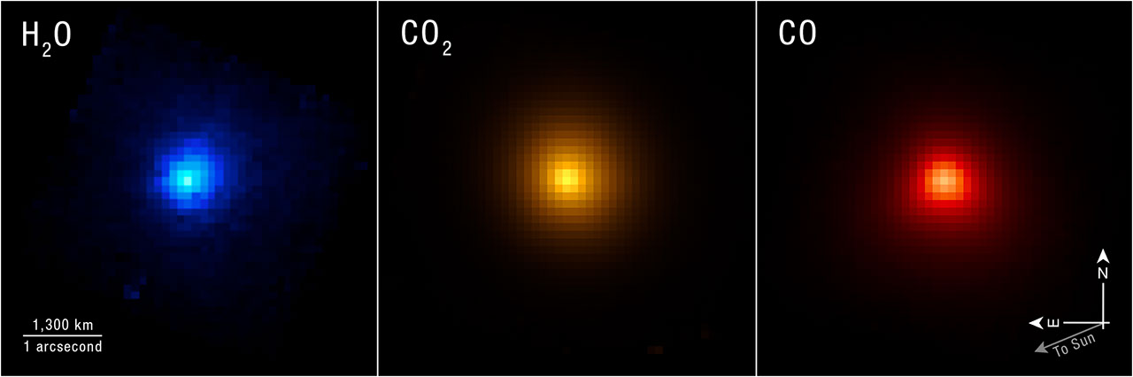
As interstellar comet 3I/ATLAS began moving away from the Sun in December 2025, astronomers took the opportunity to turn NASA's powerful James Webb Space Telescope in its direction and capture detailed measurements of its chemical components. The comet was freshly warmed from its closest pass by the Sun, and its ancient ice had been converted to a bright coma of gas ideal for observation. Webb captured detailed data, including chemical ratios of carbon and deuterium, also known as heavy hydrogen, that are not found in solar system comets. The results surprised researchers. Working backward, astronomers used the components that make up comet 3I/ATLAS to understand the environment in which it formed. A paper detailing the findings published June 22 in the journal Nature. Image: Interstellar Comet 3I/ATLAS (NIRSpec IFU) Researchers used the NIRSpec (Near-Infrared Spectrograph) instrument on NASA's James Webb Space Telescope to map specific chemical contents of comet 3I/ATLAS as it moved away from the Sun. Image: NASA, ESA, CSA, STScI, Martin Cordiner (CUA, NASA-GSFC); Image Processing: Alyssa Pagan (STScI) The comet's name comes from its status as the third confirmed interstellar comet, meaning it originated outside the solar system, and the telescope that first spotted it, the NASA-funded ATLAS (Asteroid Terrestrial-impact Last Alert System). "This was a unique opportunity to study an ancient object from the distant galaxy, probably pre-dating our Sun and solar system," said astro-chemist Martin Cordiner of NASA's Goddard Space Flight Center in Greenbelt, Maryland, and lead author of the study. "On the one hand, we get direct insight into that distant time and place, and on the other, we learn something about how unusual our own solar system may be." Cordiner and the research team joined astronomers from many sub-disciplines in taking the opportunity to get a look at 3I/ATLAS on its journey through the solar system. They received approval to interrupt Webb's planned schedule of observations to make use of its NIRSpec (Near-Infrared Spectrograph) instrument to study the comet. NIRSpec revealed exceptionally high levels of deuterium, about 30 times more than seen in solar system comets. This implies that 3I/ATLAS may have originated in a very cold system much earlier in the history of our galaxy. During its formation, the material that became incorporated into 3I/ATLAS was likely exposed to plenty of radiation, but not any long-term warmth that would have reprocessed its "heavy water" ice, with deuterium, into the type of H 2 O ice we are familiar with on Earth. Image: 3I/ATLAS Compared to Solar System Comets These graphs lay out the significant difference in composition between the interstellar comet 3I/ATLAS and comets originating in our solar system. This very specific data helps researchers build a picture of the comet's original planetary system. Illustration: NASA, ESA, CSA, Martin Cordiner (CUA, NASA-GSFC), Leah Hustak (STScI) Additionally, NIRSpec showed only traces of carbon-13 compared to lighter-weight carbon-12. This also points to a very old origin for 3I/ATLAS, as stellar systems become enriched with carbon-13 over time as generations of stars are born and die in the galaxy. That is why there are higher levels of carbon-13 in our system, around our Sun, which formed relatively recently, 4.5 billion years ago. The research team estimates that 3I/ATLAS could have formed as long as 10 to 12 billion years ago, during the universe's "cosmic noon," when star formation was at its height. Its young origin system was likely ensconced in a relatively cold, dense cloud. The abundance of heavy water shows that 3I/ATLAS spent its formative years in a deeply frozen state. A separate study using the European Southern Observatory's Very Large Telescope, led by astronomer Cyrielle Opitom of the University of Edinburgh, complements Webb's findings with an analysis of 3I/ATLAS's carbon and nitrogen varieties in the form of the chemical cyanide. "For us as scientists, finding these rare isotopes is fascinating, but the bigger picture here is looking at the possibilities of prebiotic chemistry elsewhere in the galaxy," said Stefanie Milam of NASA Goddard and co-author of the study with Cordiner. "So far, we know of only one place in the vast cosmos where chemical ingredients led to life - our solar system, our Earth. Analysis of these interstellar objects is a major step towards learning how common, or uncommon, the conditions for the evolution of life are in the universe." The James Webb Space Telescope is the world's premier space science observatory. Webb is solving mysteries in our solar system, looking beyond to distant worlds around other stars, and probing the mysterious structures and origins of our universe and our place in it. Webb is an international program led by NASA with its partners, ESA (European Space Agency) and CSA (Canadian Space Agency). To learn more about Webb, visit: https://science.nasa.gov/webb Downloads & Related Information The following sections contain links to download this article's images and videos in all available resolutions followed by related information links, media contacts, and if available, research paper and Spanish translation links.

14. NASA's Roman Space Telescope arrives in Florida ahead of SpaceX Falcon Heavy launch this summer
Read more
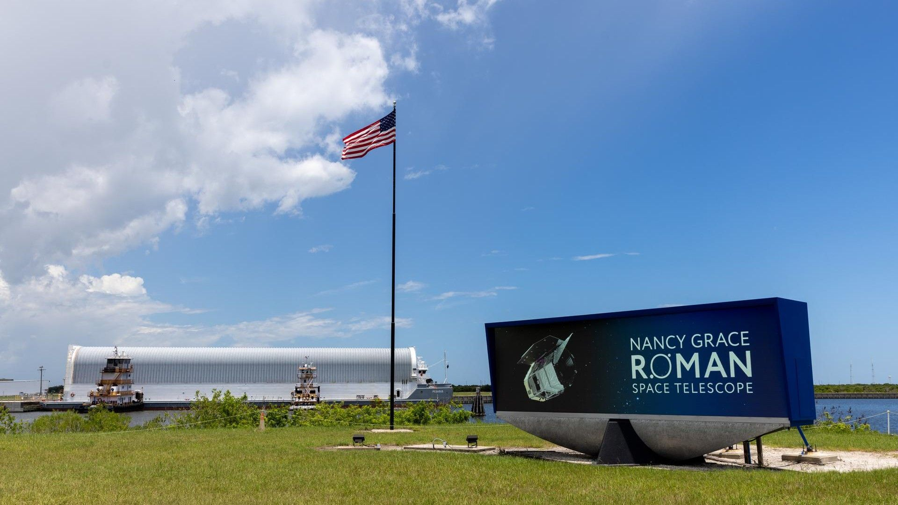
Click for next article NASA's Pegasus barge arrives at the Launch Complex 39 turn basin at the agency's Kennedy Space Center in Florida carrying NASA's Nancy Grace Roman Space Telescope on Sunday, June 21, 2026. The heavy hitters in space telescopes are about to be joined by a new contender. NASA's Nancy Roman Grace Space Telescope arrived at the Kennedy Space Center (KSC), in Florida, on Sunday (June 21), for final tests ahead of launching later this summer. Roman was shipped to KSC from NASA's Goddard Space Flight Center in Greenbelt, Maryland, riding the agency's Pegasus barge from Baltimore to the Space Coast. KSC is Roman's final stop before launching to space aboard a SpaceX Falcon Heavy rocket where it will join other flagship observatories like Hubble, Webb, Chandra and Spitzer. NASA is currently targeting an Aug. 30 liftoff - eight weeks ahead of its original schedule. Before that date arrives, Roman will undergo tests inside KSC's Payload Hazardous Servicing Facility (PHSF), where upgrades were recently completed to prepare for the telescope's arrival. Roman, inside a specialized, environmentally-controlled protective container used to encapsulate the telescope at the start of its journey from Goddard, was transported to the exterior of the PHSF building following its KSC arrival, where teams began a decontamination and cleaning process to ready the container for opening today (June 22) inside the PHSF airlock, followed by the unboxing and transportation of the roughly 18,000-pound (8,200-kilogram) spacecraft to the high bay clean room for prelaunch preparations. Roman's work platform inside the PHSF, which NASA refers to as "the Pantheon" will allow engineers to perform final checkouts on the spacecraft, including tests of the telescope's six solar panels, insulation, and heat management components. Technicians will also load Roman with about 290 gallons (1,100 liters) of hypergolic hydrazine fuel, which will power the satellite's thrusters for delivery to its final orbit and small positional adjustments during the ten or more years the propellant is expected to last. Roman is headed to Sun-Earth Lagrange point two (L2), a station-keeping point about 1 million miles (1.6 million kilometers) beyond Earth on the side opposite the sun. Lagrange points are regions of space similar to where the gravitational influence of two or more bodies is equal, allowing spacecraft to be "parked" and remain in place without needing to fire their thrusters and expend fuel. Once it settles in at L2, Roman's mission is set to last for at least five years, with the option for NASA to extend the telescope's use as long as its fuel lasts and instruments perform as needed. Using its 7.9-foot-wide (2.4 meters) primary mirror, combined with a 300-megapixel camera and coronograph , Roman's primary mission will be hunting down the elusive mysteries of dark energy and the accelerating expansion of the universe through the discovery of "billions of galaxies , hundreds of thousands of new exoplanets , hundreds of blackholes , and … vast volumes of daily data for astronomers to study," according to NASA .

