 |  | 

🌌 अंतरिक्ष समाचार | Space News
शुक्रवार, १३/११/२०२६ | Friday, 13/11/2026

1. Rain & snowfall forecast in State
Read more
PIONEER EDGE NEWS SERVICE/Dehradun The weather is set to take a turn in the State with rainfall and snowfall forecast today in seven districts. The State Meteorological Centre has forecast that very light to light rain/ snowfall (at altitudes of 3,200 metre and above) are likely to occur at isolated places in Dehradun, Tehri, Uttarkashi, Rudraprayag, Chamoli, Bageshwar and Pithoragarh districts. Dry weather is likely to prevail in the remaining districts of the State today. The provisional State capital Dehradun is forecast to witness a partly cloudy sky. Thundercloud development is likely to occur in some areas. The maximum and minimum temperatures are likely to be about 26 degrees Celsius and 15 degrees Celsius respectively in Dehradun today.

2. Odisha CM launches robotic labs in 807 government schools
Read more

- Governance - 2 min Read The initiative will enable students in classes 6 to 10 to receive practical training in robotics, coding, artificial intelligence (AI), machine learning and 3D printing, a statement said. - PTI - Published On Nov 12, 2026 at 10:14 PM IST - Set ETGovernment as your preferred source on Google - Share Icon Copy Link Share on Whatsapp Share on Linkedin Share on X Share on Telegram Share on Facebook - Bookmark - Comment Odisha Chief Minister Mohan Charan Majhi launched the initiative while inaugurating the three-day children's festival 'Surabh-2026'. Odisha Chief Minister Mohan Charan Majhi on Thursday launched robotic laboratories in 807 government schools , developed at a cost of ₹164.33 crore. Majhi launched the initiative while inaugurating the three-day children's festival 'Surabh-2026'. More than 2,500 meritorious students from across the state are participating in the festival. The chief minister also launched the ' Nipun App ', a free Android-based educational platform, to strengthen foundational learning among primary school students. Majhi also presented the Mukhyamantri Shiksha Puraskar to meritorious teachers, students and educational institutions for their contributions to the state's education sector . A total of 375 individuals and institutions were honoured under the state-level award scheme for 2024 and 2025, the statement said. An incentive of nearly ₹139 crore has been provisioned under the scheme, covering awards from the block to the state level, it said. The chief minister also distributed the 'Mukhyamantri Odia Bhasha Brutti', under which 7,350 meritorious students receive an annual grant of ₹7,500 each for excellence in the study of Odia. Ten high-achieving students and four CHSE toppers were felicitated at the event. Addressing the programme, Majhi said the festival was a celebration of children's dreams, creativity, talent and potential. The chief minister, who began his career as a teacher, advised students to keep pace with changing times and develop the ability to distinguish reliable information from misleading content in the internet age. He said mobile phones should be used primarily as tools for learning rather than entertainment and urged students not to get caught up in the race for government jobs or high academic marks. "It is skill, not a degree, that serves as the genuine guarantee for securing a livelihood," he said, urging students to focus on their studies and prepare themselves for the future. Comments What are your thoughts?

3. Keralam to launch 'No Barriers' initiative for persons with disabilities this month: CM Satheesan
Read more
- Governance - 1 min Read Keralam Chief Minister V D Satheesan said the initiative aimed to foster an inclusive society where persons with disabilities could live with dignity, equal opportunities and access to support, without being left behind. - PTI - Published On Nov 12, 2026 at 09:49 PM IST - Set ETGovernment as your preferred source on Google - Share Icon Copy Link Share on Whatsapp Share on Linkedin Share on X Share on Telegram Share on Facebook - Bookmark - Comment Keralam Chief Minister V D Satheesan Keralam will launch a state-wide initiative for persons with disabilities , titled 'No Barriers', this month and announce a comprehensive disability policy soon, Chief Minister V D Satheesan said on Thursday. He was speaking after inaugurating a four-day free artificial limb distribution camp organised jointly by DP World , Rotary Club of Thiruvananthapuram Central and Bhagwan Mahaveer Viklang Sahayata Samiti (BMVSS), popularly known as Jaipur Foot , at Freemasons Hall here. Satheesan said the initiative aimed to foster an inclusive society where persons with disabilities could live with dignity, equal opportunities and access to support, without being left behind. The proposed disability policy would incorporate advanced facilities and practices adopted in developed countries, he said. The government wanted to assure persons with disabilities and senior citizens that they were not alone and that it stood by them, the CM said. He added that Keralam was the first state in the country to establish a separate department for senior citizens. Appreciating the humanitarian initiatives undertaken by Rotary clubs and DP World since the 2018 floods, he said the ongoing camp would help around 400 beneficiaries by providing advanced artificial limbs and other assistive devices free of cost. During the function, Satheesan handed over an artificial limb to Anugraha L V Nair, a Class 6 student who lost a leg in a road accident in June this year, according to a statement. The camp, being held from November 12 to 15, will benefit 400 persons with disabilities from various parts of Keralam and Kanyakumari in Tamil Nadu. Artificial limbs, calipers and other assistive devices will be provided free of cost. Each beneficiary's individual requirements will be assessed, and suitable devices will be custom-made and fitted using Jaipur Foot technology, the organisers said. Comments What are your thoughts?

4. ISRO built India's space programme. Can it survive its space reforms? - Newslaundry
Read more
ISRO built India's space programme. Can it survive its space reforms? Newslaundry

5. Ground test of third stage of PSLV (PS3) conducted successfully - ISRO
Read more
Ground test of third stage of PSLV (PS3) conducted successfully ISRO

6. Isro introduces changes to PSLV after repeated failures, conducts key test - India Today
Read more
Isro introduces changes to PSLV after repeated failures, conducts key test India Today

7. ISRO successfully tests upgraded PSLV third stage after mission anomalies - BusinessLine
Read more
ISRO successfully tests upgraded PSLV third stage after mission anomalies BusinessLine

8. 'Don't panic': SpaceX pens familiar message on Starship ahead of historic double-catch test flight
Read more
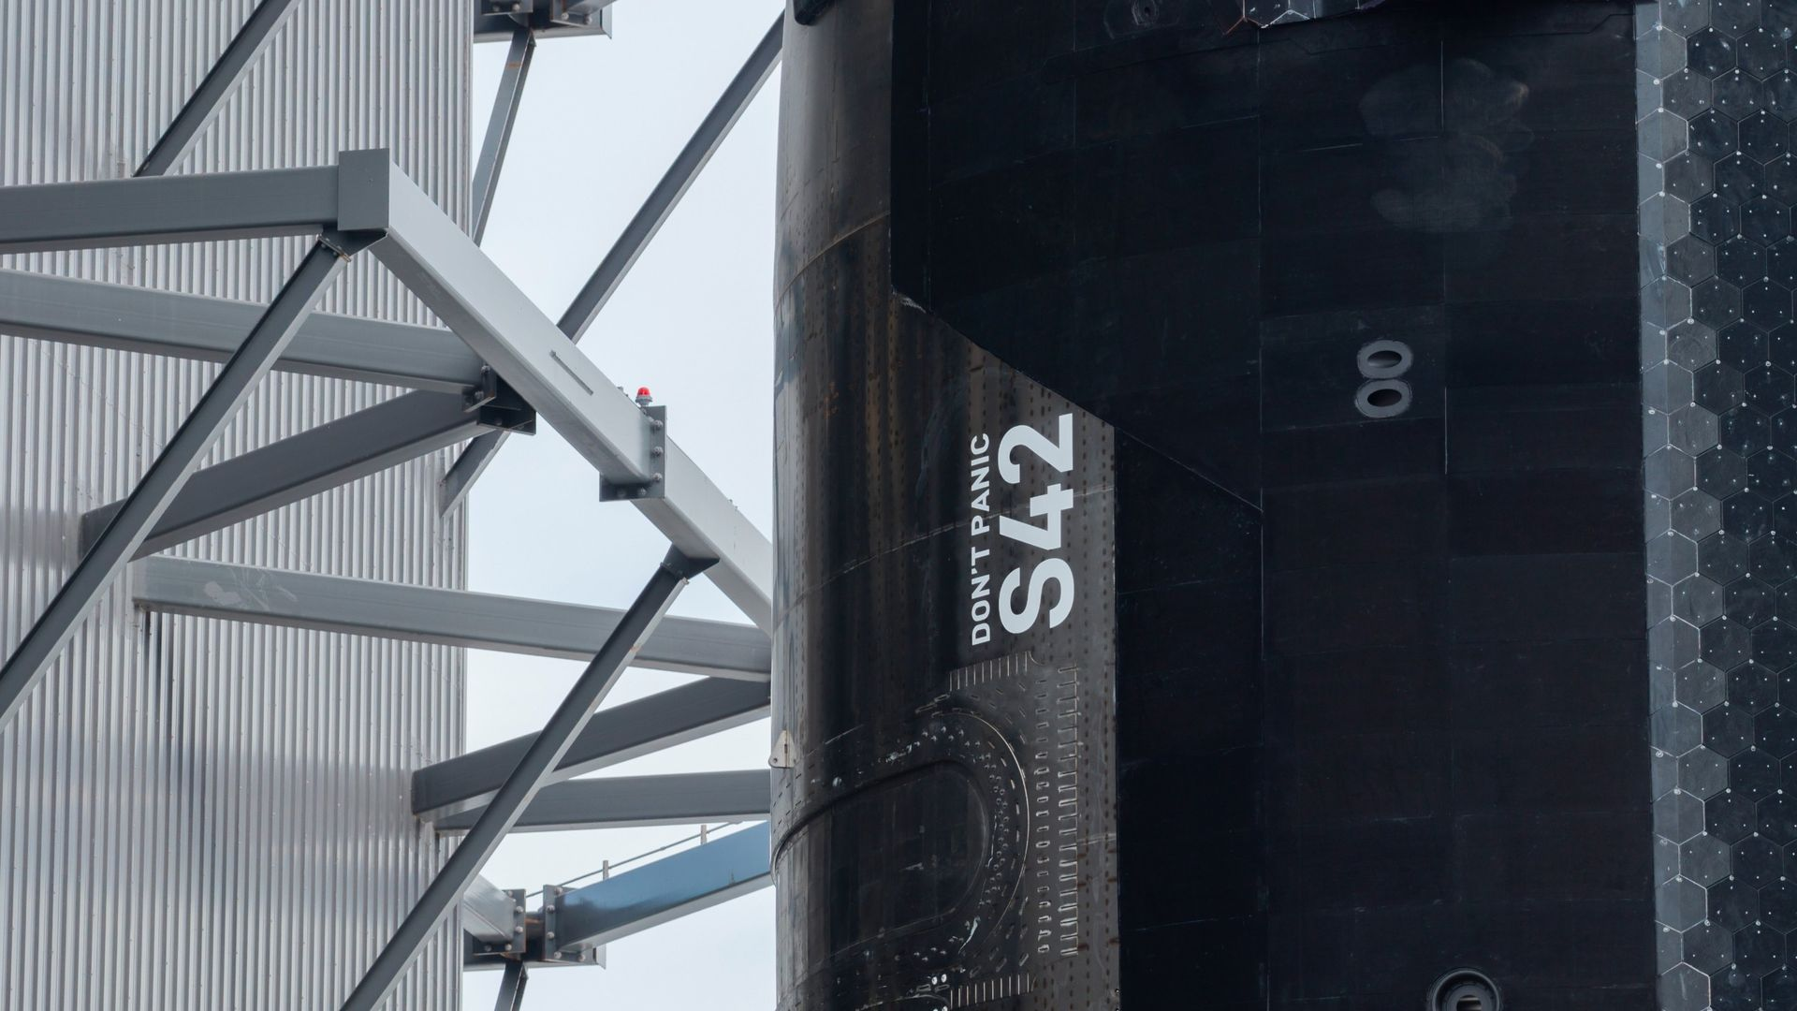
Click for next article SpaceX rolled Ship 42, the upper stage that will fly Starship's 15th test flight, out to the pad on Nov. 12, 2026. The vehicle is adorned with the words "Don't panic," a phrase that features prominently in "The Hitchhiker's Guide to the Galaxy." SpaceX has a message for itself, and for the spacecraft set to make history today (Nov. 13): Don't panic. The company's Starship megarocket will conduct its 15th test flight this afternoon, a landmark liftoff that will feature the first-ever attempt to catch both of its stages with its launch tower's "chopstick" arms. On Thursday (Nov. 12), SpaceX rolled the Flight 15 upper stage, a vehicle known as Ship 42, out to the launch pad at its Starbase site in South Texas to prep. The company shared photos of the move on X , and in two of those shots we can see some intriguing words inked on the spacecraft: "Don't panic." Another look at Ship 42 at the pad on Nov. 12. (Image credit: SpaceX) The phrase is familiar to fans of Douglas Adams' sci-fi classic " The Hitchhiker's Guide to the Galaxy ": In the novel, the electronic guidebook that helps travelers find their way across the cosmos has "Don't panic!" on its cover. And Ship 42 itself is connected to the beloved book, by virtue of its serial number. In "The Hitchhiker's Guide," a supercomputer named Deep Mind is asked to come up with "the answer to the ultimate question of life, the universe, and everything." It thinks for 7.5 million years and comes up with "42." SpaceX founder and CEO Elon Musk has voiced his affection for "The Hitchhiker's Guide" in the past - and he has already paid tribute to it with a well-placed "Don't panic." The debut launch of SpaceX's Falcon Heavy rocket back in February 2018 sent Musk's red Tesla Roadster into orbit around the sun , with a spacesuit-clad mannequin named Starman at the wheel and its entertainment display programmed to read "Don't panic!" The Ship 42 upper stage rolls to its launch pad at SpaceX's Starbase site on Nov. 12, 2026 ahead of Starship's Flight 15. (Image credit: SpaceX) Starship Flight 15 is scheduled to launch today during a 75-minute window that opens at 5:45 p.m. EST (2245 GMT; 4:45 p.m. local Texas time). You can watch it here at Space.com. If all goes according to plan, Starship's Super Heavy first stage will come back to Starbase for a chopsticks catch about 6.5 minutes after liftoff. Ship 42, meanwhile, will head to orbit, a destination that Starship reached for the first time on Flight 14 , which took place on Sept. 28. Ship 42 will deploy 26 of SpaceX's next-gen Starlink V3 satellites today - the second batch of the spacecraft to reach orbit. (The first set of 26 were delivered on Flight 14). Ship 42 will stay up for a while after that, circling Earth 14 times before coming back for its own chopsticks catch on Saturday afternoon (Nov. 14), 22.5 hours after launch. That's the plan, anyway; SpaceX will only go through with a Ship catch attempt if all systems on the vehicle look good. If there are any problems, the company will divert to a splashdown in the Pacific Ocean, near either Hawaii or Chile. The two stages of the Starship rocket that will conduct Flight 15 at their Starbase launch pad on Nov. 12, 2026. (Image credit: SpaceX) Both of Starship's stages - Super Heavy and the Ship - are designed to be rapidly reusable. And "rapidly" is a bit of understatement: SpaceX wants to launch 10,000 Starship missions per year by 2030, Musk has said. The chopsticks-catch strategy is a big part of that vision. Bringing both Starship stages directly back to the launch mount will greatly reduce the time needed for inspection, refurbishment and reflight, according to SpaceX. The company has already caught Super Heavy on three previous Starship test flights. It has never tried to do so with Ship, instead targeting ocean splashdowns with the upper stage. The double catch attempt may be unprecedented, but SpaceX seems to be taking its own advice: There's no panic around Flight 15 or its bold goals.

9. Watch SpaceX attempt a historic Starship launch and double-catch landing today (Nov. 13)
Read more
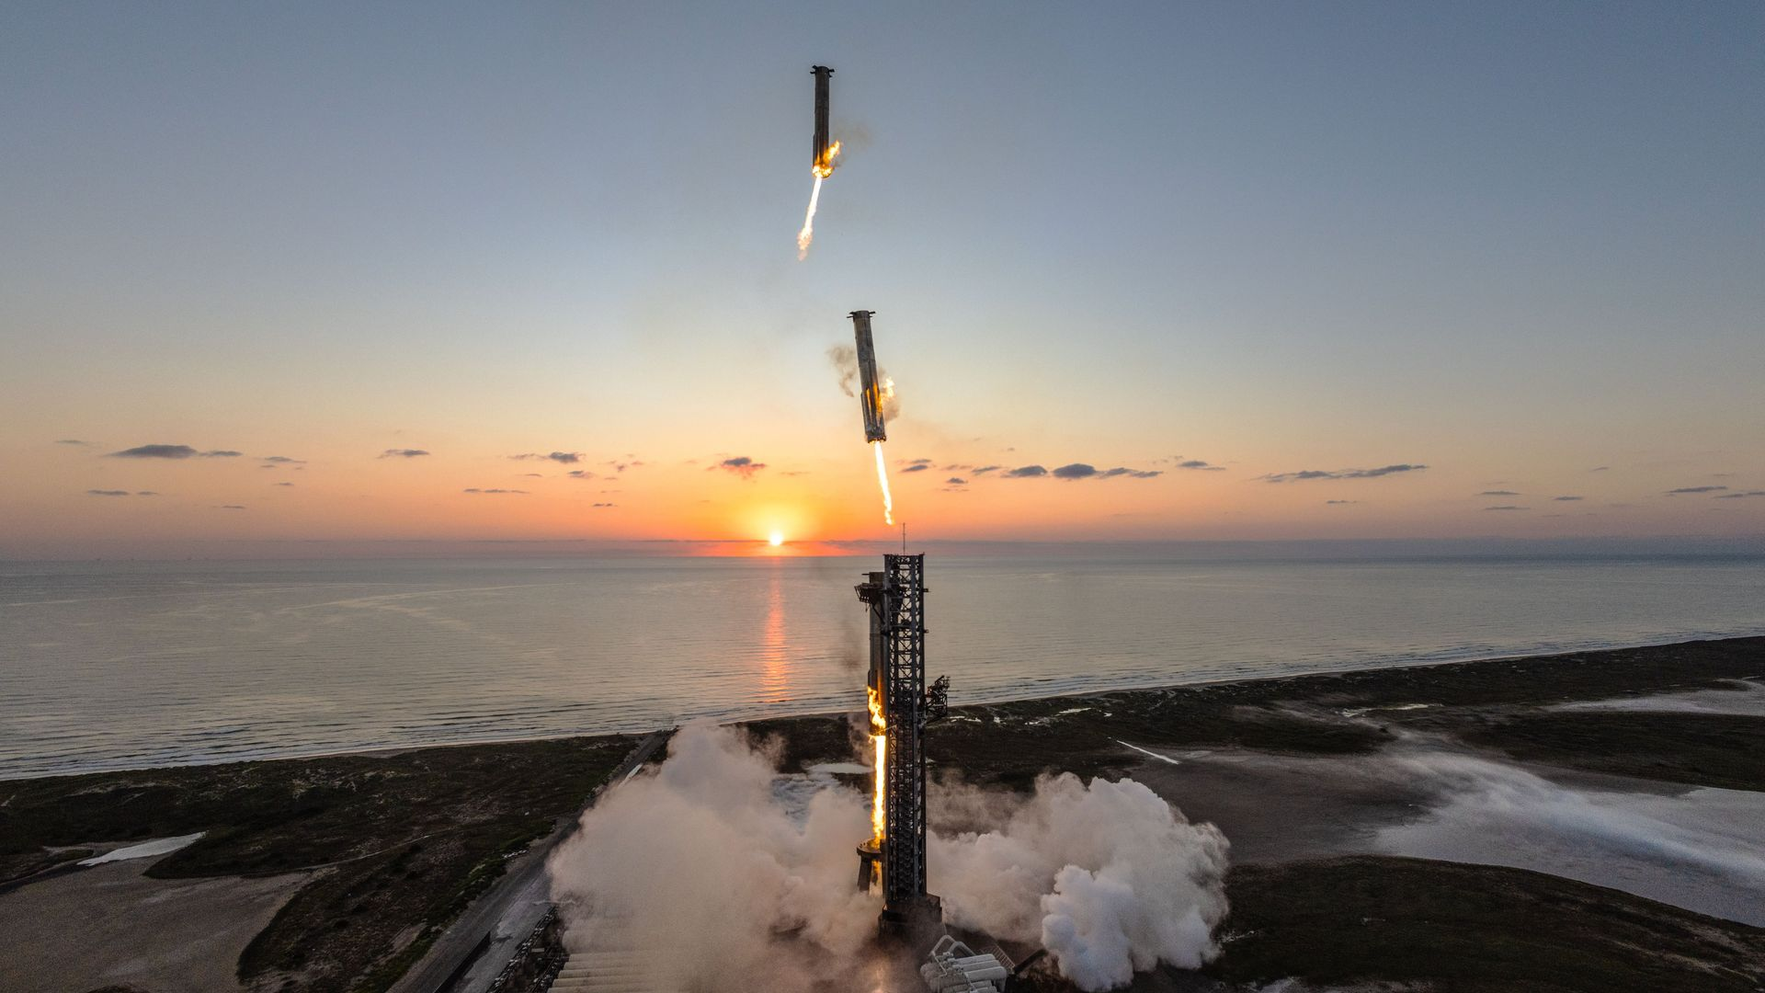
Click for next article SpaceX plans to launch its Starship megarocket on an unprecedented mission today (Nov. 13), and you can watch the action live. Starship is scheduled to launch on its 15th test flight today from SpaceX's Starbase site in South Texas, during a 75-minute window that opens at 5:45 p.m. EST (2245 GMT; 4:45 p.m. local Texas time). SpaceX plans to bring both of Starship's stages back to Starbase for a catch by the launch tower's "chopstick" arms - something it has never done before. You can watch it all live here at Space.com. And there should be a lot to see: Starship Flight 15 will last more than 22 hours, if all goes according to plan. Composite photo showing the Super Heavy booster of SpaceX's Starship megarocket coming in for a landing on the launch mount on Oct. 13, 2024. (Image credit: SpaceX via X) Starship consists of two elements: a huge booster known as Super Heavy and an upper-stage spacecraft called Starship, or Ship for short. Both are designed to be fully and rapidly reusable - a first in the world of orbital spaceflight. The rapidity of Starship's reuse hinges heavily on SpaceX's recovery strategy: Returning both vehicles directly to the launch mount will enable much faster inspection, refurbishment and reflight, the company has said. SpaceX has already caught Super Heavy , pulling the feat off on three previous Starship test flights. But it has never tried to do so with Ship, which flies farther and faster than the booster and is therefore a more challenging vehicle to recover. So today's flight is a pretty big deal for SpaceX. "If successful, this will mark the first full recovery of an orbital launch system and a breakthrough moment in making Starship a reliable, rapidly reusable rocket," the company wrote in a Flight 15 mission description . Watch live! SpaceX launches Starship Flight 15 with potential double catch attempts - YouTube Watch On The action will unspool over two days, if all goes to plan. Super Heavy will return to Starbase for a touchdown just 6.5 minutes after launch, but Ship will continue on to low Earth orbit . The upper stage will deploy 26 of SpaceX's next-gen Starlink V3 satellites, during a 42-minute stretch beginning about 35 minutes after liftoff. This will be just the second batch of V3 spacecraft to reach orbit, after the 26 that went up on Flight 14 on Sept. 28. Ship will then stay aloft for nearly a full day. The mission plan calls for the upper stage to return to Starbase for its chopsticks catch on Saturday afternoon (Nov. 14), about 22.5 hours after liftoff. There's no guarantee things will go according to plan, however. SpaceX will call off a Ship catch if the vehicle experiences any issues during Flight 15. If something crops up, the company will steer Ship to a splashdown in the Pacific Ocean, either near Hawaii or off the coast of Chile.

10. SpaceX's Starship megarocket will launch to orbit on Nov. 13. Will you be able to spot it in the night sky?
Read more
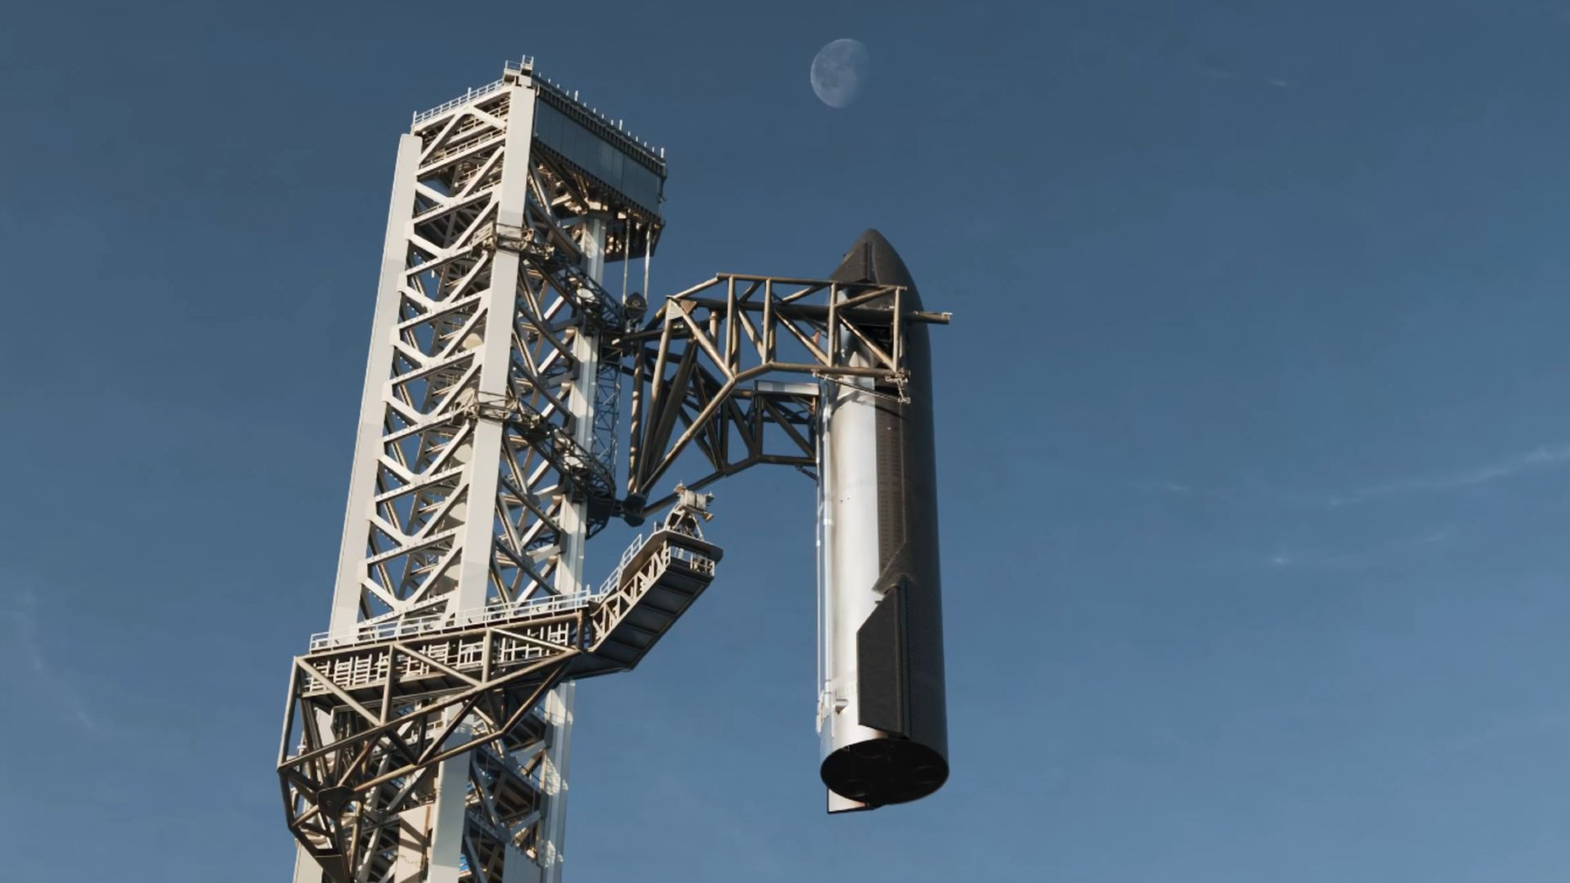
Click for next article SpaceX's Starship megarocket is slated to launch on its ambitious 15th flight test as soon as this Friday (Nov. 13). Will you be able to spot its leviathan upper stage, known as Ship, or its Starlink satellite passengers as they circle Earth during the historic orbital jaunt? Flight 15's 75-minute launch window opens at 5:45 p.m. EST (2245 GMT) on Nov. 13 . Starship will fly from SpaceX 's Starbase site in South Texas, where it will be 4:45 p.m. at the opening of the window - about an hour before sunset. The launch could therefore be especially dramatic for folks in the area. "As it launches towards the southeast, and it will be daylight, then the prospects for viewing from the U.S. are going to be in Texas and the states along the Gulf of Mexico," Robert Massey, deputy executive director at the Royal Astronomical Society, told Space.com. "They could see the exhaust plume (the ' jellyfish ') with the sky darker for observers further east." If all goes to plan, Starship's Super Heavy booster will propel the Ship upper stage through the densest part of Earth's atmosphere before returning to Starbase for a powered landing and capture via the "chopstick" arms of the "Mechazilla" tower system . Ship, meanwhile, will go on to orbit Earth approximately 14 times over the following 22 hours, during which time it will deploy 26 Starlink V3 satellites before returning to Starbase for its own ambitious catch attempt. When should I look for Starship and its Starlink train? Satellite visibility in the night sky depends on a cocktail of factors, from the size of the spacecraft to its reflectivity, orbital inclination and position relative to the Earth and sun. Ship is big - about 171 feet (52 meters) tall - so it will be a viable target for skywatchers, experts say. "It certainly will be visible in twilight hours. It should be very bright, considerably brighter than the Starlink satellites due to its size," professor James Osborn of Durham University told Space.com. "Where and when is a bit more tricky." Starship Flight 14 rises away from its launch tower during the September 2026 test flight from Boca Chica, Texas. (Image credit: Photo by Brandon Bell/Getty Images) Ship and its Starlink satellites may be seen in the 90 minutes directly after sunset on Nov. 13 and before sunrise on Nov. 14, as the probes catch the sunlight on either side of Earth's colossal shadow as they drift through the twilight sky. The spacecraft will initially appear as a string of bright, evenly spaced lights, with Ship most likely appearing significantly brighter than the Starlink satellites. However, Osborn noted that the lack of publicly available data makes it challenging to forecast exactly when the spacecraft will appear. "During its 14 orbits over 22 hours, the spacecraft is between inclinations of 30.5 [degrees] N and S of the equator," explained Massey. "So it will be best viewed between those latitudes, and then lower in the sky up to latitudes of 40 N and 40 S. That's pretty much the whole of the contiguous U.S." Space.com skywatching columnist and veteran meteorologist Joe Rao shared further details on what stargazers may see with the naked eye as Ship drifts silently through the autumn sky. Starlink satellites form a trail of star-like points in the night sky soon after deployment in 2023. (Image credit: Photo by Arda Kucukkaya/Anadolu Agency via Getty Images) "When it passes overhead, it will look like a bright, fast-moving star crossing the sky - similar to the International Space Station , but potentially even brighter depending on its orientation," explained Rao. "The Starlink V3 satellites are much smaller, so not as bright, perhaps ranging anywhere from 2nd to 4th magnitude, depending on the angle of illumination with reflected light from the sun ." Magnitude is the scale used by astronomers to measure the brightness of objects in the night sky. The lower the magnitude, the brighter the object! The unaided eye can make out objects with a magnitude of around +6.5 under ideal dark sky conditions, while the planet Venus currently shines at magnitude -4.41. The Starlink train will likely fall further behind Starship as the 22-hour mission progresses, while the train itself will become more elongated, according to Rao. "For locations where it will make a high arc across the sky, the Starship should be visible for at least a few minutes, although because it is orbiting at a lower altitude (170 miles/275 km) compared to the ISS, it probably will appear to move somewhat faster. " How can I track Starship after launch? There are multiple handy resources that should allow you to track Ship and the newly deployed batch of V3 Starlink satellites following their scheduled launch on Nov. 13, including the websites Heavens-Above , Star Dash , Orbital Radar and Find Starlink . Be sure to keep an eye on our Starship Flight 15 live blog for all the latest news along with our launch timings article containing details on how to watch SpaceX's potentially historic orbital launch attempt. Editor's Note: If you capture a photo of Starship and want to share it with Space.com's readers, then please send your photo(s), comments, and your name and location to spacephotos@space.com.

11. Satellite snaps rare birds-eye view of the ISS | Space photo of the day for Nov. 12, 2026
Read more
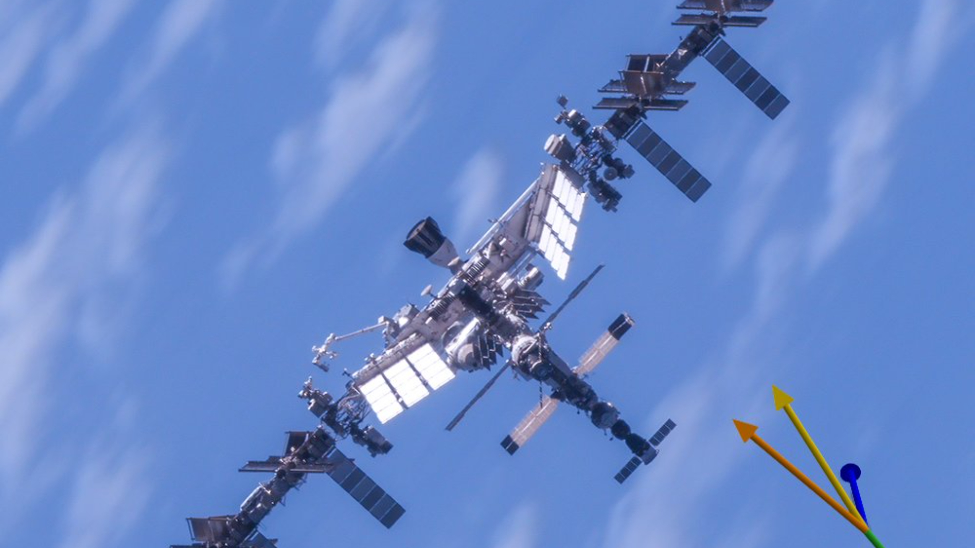
Click for next article A satellite looks down at the International Space Station in orbit. (Image credit: HEO) A commercial satellite has spotted the International Space Station (ISS), giving us a unique view of the orbiting lab from above. What is it? Most of the time, when we see the ISS, it is from down here on Earth or from the viewpoint of the astronauts onboard, peering out the windows at the station's limbs, solar arrays and instruments. But in this snapshot, which was posted on X on Nov. 9 by the Australian company HEO, we can see the station stretched out in all its glory. HEO specializes in using satellites in low Earth orbit to capture images of other spacecraft, though longer-term the company aims to capture observations far out into the solar system. HEO doesn't build the satellites that take these photos; rather, the company's software tasks the spacecraft to image targets as they come into range. This great photo of the ISS from above, for example, was taken by a satellite operated by BlackSky, a Virginia-based company that holds a non-Earth imaging agreement with HEO . So far, HEO and its partners have captured imagery of a variety of spacecraft in orbit, including the ISS, China's Tiangong space station and the European Space Agency's ERS-2 satellite (while it was hurtling back to Earth in 2024). Why is it incredible? While it might seem that satellites are just hovering above Earth, the space station and other spacecraft in LEO are hurtling through space at roughly 17,500 mph (28,160 kph), hundreds of miles above our planet's surface. A snapshot of a satellite from above is therefore far from mundane. Rather, it requires incredible coordination and technical skill; satellite operators must know precisely when their target will present itself, and their equipment must be capable of getting the shot.

12. Astronomers stunned after James Webb Space Telescope discovers the earliest pair of black hole-powered quasars
Read more

Click for next article An illustration of Nāpōwawāʻenakaulua the oldest and tightest pair of quasars ever discovered Using the James Webb Space Telescope (JWST), astronomers have discovered the oldest pair of supermassive black hole-powered quasars ever seen. There's just one problem: they shouldn't exist! The compact quasar pair, spotted with the aid of the Gemini North telescope, has been designated J1602+4228AB and nicknamed Nāpōwawāʻenakaulua, which means "Two celestial bodies of fathomless powerful darkness in the brilliance of heat reincarnating energy into the universe." The compact quasar pair is seen as it was 900 million years after the Big Bang at a time when such supermassive black holes should not have had time to grow to such tremendous masses. Nāpōwawāʻenakaulua isn't just the oldest and most distant quasar pairing ever seen. There is just 18,100 light-years, or roughly one-fifth the diameter of the Milky Way, between the supermassive black holes, which have masses of 1.5 billion and 400 million times that of the sun. That makes Nāpōwawāʻenakaulua the most compact quasar pair found during a period of the universe's history known as Cosmic Dawn , shortly after the birth of the first stars, galaxies, and black holes. "There is no definitive theoretical explanation for how a single one of these giant quasars exists so early in the age of our universe, much less two," research team leader Silvia Onorato of the NOIRLab said in a statement . "We observed Nāpōwawāʻenakaulua at a time when the universe was only a thirteenth of its age and, astonishingly, its supermassive black holes are just as massive as those we see today." How were supermassive black holes over fed at Cosmic Dawn Quasars occur when the supermassive black holes that sit at the heart of large galaxies are surrounded by a flattened cloud of swirling gas and dust called an "accretion disk," from which they feed or "accrete" matter. The immense gravity of the central black hole causes friction, heating the accretion disk and causing it to glow, often brighter than the combined light of every star in the surrounding galaxy. We see that glow as a quasar. Finding such objects in the recent cosmic history of the 13.8-billion-year-old universe isn't troubling, though finding compact pairs of them is still extremely rare. Such pairs should be common because the merger of galaxies that brings together supermassive black holes is frequent. That should lead to an abundance of pairs of quasars with a separation less than the typical size of a galaxy. There are three reasons this has proven tricky. Firstly, the "quasar phase" of a supermassive black hole is relatively short on cosmic terms. Secondly, even relatively close quasar pairs are very far away, making them faint and hard to detect with ground-based telescopes. Finally, at such great distances and with such a small separation between the two supermassive black holes, the individual members of a quasar pair are hard to individually resolve. Yet, astronomers do find quasar pairs. Sometimes at distances and times that they would probably rather not, because it challenges everything we know about black hole growth. An annotated illustration of Nāpōwawāʻenakaulua showing its place in cosmic history. (Image credit: International Gemini Observatory/NOIRLab/NSF/AURA/P. Marenfeld/M. Zamani) The trouble arises before the universe was 1 billion years. That is because, according to current models, black holes should need at least 1 billion years to feed and merge enough to reach masses millions or billions of times that of the sun. Yet, since it began operations in 2022, the JWST has been routinely discovering supermassive black holes powering quasars as early as 400 million years after the Big Bang. If that wasn't confusing enough, the discovery of Nāpōwawāʻenakaulua, the third quasar pair seen at Cosmic Dawn, could really break current models. Nāpōwawāʻenakaulua was uncovered in data from the JWST's Aether survey, which is conducting a census of objects in the early universe. Using JWST's NIRSpec (Near-Infrared Spectrograph Integral Field Unit) instrument, the survey has uncovered 200 quasars, just under half of all currently known early universe quasars. It was while browsing the Aether dataset that the team discovered that quasar J1602+4228A is not alone, it had a companion now designated J1602+4228B. Resolving these two quasars should have been nearly impossible from the ground. But this was possible for Gemini North thanks to perfect timing and perfect weather conditions over Maunakea , the dormant volcano on the island of Hawai'i where the telescope is located. A definite scientific feat, Nāpōwawāʻenakaulua remains a mystery for now, but it could actually help scientists better understand how galaxies were coming together during Cosmic Dawn, a vital stage in the evolution of the universe. "Nāpōwawāʻenakaulua is a really unique environment," Onorato said. "It's a laboratory for astronomers to study how the very first massive galaxies and their central black holes assembled together through direct galaxy interactions during these early times."

13. Hubble offers cosmic sampler of targets for Roman
Read more

A gallery of gravitational lenses captured by NASA's Hubble Space Telescope showcases the diversity of this cosmic phenomenon and lays the groundwork for follow-up observations by the new Nancy Grace Roman Space Telescope.

14. Europe's Hera spacecraft begins close inspections of an asteroid rammed by NASA in a 2022 test
Read more
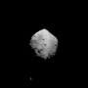
A European spacecraft has begun close inspections of an asteroid rammed by NASA four years ago in a planetary defense test.

15. Elon Musk's SpaceX moves closer to taking over Tesla in potential merger: Report
Read more
The companies are worth roughly $3.4 trillion combined and are negotiating price and control. How to separate Tesla's China operations remains a major hurdle in the talks. SpaceX and Tesla could announce the world's largest merger as early as December. SpaceX could announce a deal to acquire Tesla as early as December after talks between Elon Musk's two companies advanced to negotiations over price and control, Bloomberg reported on November 12. A combination would be the world's largest merger, according to the report. SpaceX is valued at more than $1.9 trillion following its June initial public offering, while Tesla is worth about $1.5 trillion. The boards and advisers of both companies are involved in the talks, which could continue into early 2027. One question is how many SpaceX shares Tesla investors would receive if the rocket maker absorbs the electric vehicle company. Neither company commented, and Tesla shares rose as much as 1.9% after the report. Negotiators turn to deal terms Musk raised the possibility of combining Tesla and SpaceX in May, weeks before SpaceX went public. In October, he confirmed that both boards had formed special committees to explore a merger. Ira Ehrenpreis, who chairs Tesla's compensation and governance committees, has also served on SpaceX's board since February. The talks come ahead of Tesla's December 3 annual shareholder meeting. Investors will vote on whether to reelect Musk, board chair Robyn Denholm, and director JB Straubel to terms running through 2029. The ballot also includes votes on executive compensation and the company's auditor. The companies' current valuations put their combined market value at roughly $3.4 trillion. For comparison, Vodafone's takeover of Mannesmann in 2000 was valued at $183 billion. SpaceX bought Musk's artificial intelligence company xAI for roughly $250 billion earlier this year. A share swap would change voting rights Musk owns about 20 percent of Tesla. At SpaceX, he controlled roughly 85 percent of the voting power through shares carrying extra votes, according to the company's IPO filing. Tesla investors who receive SpaceX stock would move from a company where each share carries one vote to one where Musk holds a commanding majority of the votes. A deal could also accelerate Musk's compensation. Under the change-of-control terms of his 2025 CEO award, operating milestones would fall away, and the deal price would determine whether Tesla meets the market value thresholds.

