 |  | 

🌌 अंतरिक्ष समाचार | Space News
रविवार, २१/०६/२०२६ | Sunday, 21/06/2026

1. CM Yogi Adityanath inaugurates, lays foundation stone for 221 projects worth ₹1,766 crore in Lalitpur
Read more

- Governance - 2 min read He emphasised the 'Har Ghar Nal' scheme providing pure drinking water, the upcoming Bundelkhand Expressway, and the region becoming a defence manufacturing hub. - ANI - Published On Jun 20, 2026 at 03:25 PM IST Select ETGovernment as Preferred Choice on Google Copy Link Share on WhatsApp Share on Linkedin Share on X Share on Telegram Share on Facebook The Chief Minister also referred to the Uttar Pradesh Defence Industrial Corridor and the production of the BrahMos missile in the state. Uttar Pradesh Chief Minister Yogi Adityanath on Saturday inaugurated and laid the foundation stone for 221 development projects worth ₹1,766 crore in Lalitpur district. Addressing a public gathering after arriving at the Tuvan Temple complex, the Chief Minister highlighted the transformation of Bundelkhand and the developmental initiatives being undertaken in the region. "Not with a pot, but with the Har Ghar Nal scheme , the vision is becoming a reality in Bundelkhand. Work is being done to provide pure drinking water to every home. Bundelkhand is now becoming a model. The Bundelkhand Expressway and Uttar Pradesh's largest industrial city, if we are to establish it anywhere, it will be in Bundelkhand," he said. Advt Recalling the challenges faced by the region in the past, the Chief Minister said, "I said last time, didn't I? I said last time that previously, our youth from Bundelkhand used to migrate. Our mothers and sisters spent their entire lives carrying water. Those poor women would spend their lives carrying water in earthen pots. And if by chance a pot broke, they would weep for their fate. This was the tragedy of Bundelkhand." He said the region's backwardness was not due to a lack of resources but because of governance failures in the past. "It's not that you lacked water resources. It's not that your ancestors didn't work hard to nurture Bundelkhand. But due to the incompetence of previous governments and the mafia culture, Bundelkhand remained backward. Our youth were migrating. The mafia was dominant; in every district, some mafia would rob the youth of their jobs. They would forcibly place their goons in development projects, snatching away the rights of the people. And Bundelkhand felt betrayed," Adityanath said. "I said last time that we would develop Bundelkhand as a hub for the defence manufacturing corridor . And now you must have seen the BrahMos missile being made in the defence manufacturing corridor in UP. When the BrahMos missile was fired during Operation Sindhu, it left Pakistan shaken. Pakistan was forced to beg for its life before the world," he said. Referring to women's empowerment initiatives, he said, "Now, our sisters here are not carrying earthen pots for water, but through the Balinee Milk Producer, how women self-help groups can rapidly increase their income is becoming a model. And the symbols of this model are our Bundelkhand, Jhansi, and Lalitpur." The Chief Minister further said that several long-pending irrigation and development projects in the region have been expedited and completed. "Now, development projects and long-pending irrigation projects have been fast-tracked here. Today, you must be seeing that projects like the Arjun Sahayak Project, which had been pending for decades, have now been completed. Projects like the Ratoli Dam, BhavDam, Khasnoda Dam, Majhgaon, and Chilli Sprinkler Irrigation Projects have changed the fate of the farmers of Bundelkhand," CM Adityanath said. - See more on: - Yogi Adityanath , - Lalitpur , - Bundelkhand , - Uttar Pradesh , - development projects , - irrigation projects , - Har Ghar Nal scheme , - BrahMos missile , - defence manufacturing corridor , - women's empowerment Telegram Facebook Comments What are your thoughts? Comment Now --> Comment Now Read Comment (1) All Comments By commenting, you agree to the Prohibited Content Policy Post Find this Comment Offensive? Choose your reason below and click on the submit button. This will alert our moderators to take actions REASONS FOR REPORTING Foul Language Defamatory Inciting hatred against a certain community Out of Context / Spam Others Report Join the community of 2M+ industry professionals. Subscribe to Newsletter to get latest insights & analysis in your inbox. --> All about ETGovernment industry right on your smartphone! - Download the ETGovernment App and get the Realtime updates and Save your favourite articles. Scan to download App -->

2. Meerut Student Who Missed JEE Advanced By 2 Marks Selected As ISRO Scientist - NDTV
Read more
Meerut Student Who Missed JEE Advanced By 2 Marks Selected As ISRO Scientist NDTV

3. Missed JEE Advanced by 2 marks, now ISRO scientist: Meerut youth who studied on YouTube without costly coa - The Economic Times
Read more

How did Sanket Kumar bounce back after his JEE setback? Which college did Sanket join after clearing JEE Advanced? Live Events What unusual specialisation helped him stand out? How did he secure a scientist-engineer role at ISRO? What research experience did Sanket gain before joining ISRO? Why is the ISRO Propulsion Complex in Mahendragiri important? A lesson in resilience as a Reliable and Trusted News Source Addas a Reliable and Trusted News Source Add Now! (You can now subscribe to our (You can now subscribe to our Economic Times WhatsApp channel For many students, missing a competitive exam by a narrow margin can feel like the end of a dream. But for 23-year-old Sanket Kumar from Meerut, it turned out to be the beginning of an inspiring success story. After missing JEE Advanced by just two marks in 2021, Sanket refused to give up. Five years later, he has secured a coveted position as a scientist-engineer (SC Grade) at the Indian Space Research Organisation (ISRO).According to TOI, Sanket narrowly missed qualifying for JEE Advanced in 2021 by only two marks. Instead of enrolling in expensive coaching classes, he took a drop year and prepared on his own.He relied heavily on YouTube lectures, previous years' question papers and self-study to improve his performance.His hard work paid off in 2022 when he successfully cleared both JEE Main and JEE Advanced, earning admission to one of India's most prestigious engineering institutions.Sanket secured a seat in aerospace engineering at the Indian Institute of Space Science and Technology (IIST) in Thiruvananthapuram. The institute is widely regarded as a major talent pipeline for ISRO and offers some of the country's most competitive undergraduate programmes.Studying at IIST brought him closer to his dream of working in India's space sector.While many of his classmates chose popular fields such as propulsion and aerodynamics, Sanket opted for vibration and acoustics, a specialised branch that examines how vibrations move through structures and affect the performance of engineering systems.Speaking to TOI, he said, "I was the only student in my batch to opt for vibration and acoustics. That unconventional choice paid off during the ISRO Centralised Recruitment Board interview."The decision helped him distinguish himself during the highly competitive selection process.Sanket graduated from IIST with a CGPA of 8.2, making him eligible for a direct interview with the ISRO Centralised Recruitment Board (ICRB). This allowed him to bypass the written examination stage.According to TOI, he appeared before multiple interview panels before eventually receiving an appointment offer based on his provisional degree.He has now been selected as a scientist-engineer (SC Grade) at the ISRO Propulsion Complex (IPRC) in Mahendragiri, Tamil Nadu.Before landing the ISRO role, Sanket built valuable industry and research experience.In 2025, he completed a paid internship with Taranga Vibroacoustics, where he worked on specialised engineering projects. Earlier this year, he was also selected by Synra Inc for a final-year research project in Japan.The opportunity took him to Japan for three months, where he worked on advanced engineering systems and gained international exposure.The ISRO Propulsion Complex (IPRC) in Mahendragiri plays a crucial role in India's space missions. The facility is responsible for testing rocket engines, propulsion systems and launch vehicle components before they are used in actual missions.Highlighting its significance, Sanket told TOI, "Every rocket that lifts off from Sriharikota is first rigorously tested at Mahendragiri."His appointment at the facility marks a major milestone in a journey that began with a setback but ended with a place in India's premier space agency.Sanket Kumar's journey shows that one setback doesn't decide your future. Missing JEE Advanced by just two marks could have shattered his dream, but he chose not to give up. Instead, he studied on his own, trusted the process and worked even harder to reach his goal.Today, the Meerut youngster is set to begin his career as a scientist-engineer at ISRO, turning a disappointing result into an inspiring success story. His journey is proof that persistence, patience and hard work can take you further than you ever imagined.Inputs from TOI

4. 'People said many things, but...': UP student who missed JEE cut-off by 2 marks becomes an ISRO scientist - Moneycontrol.com
Read more
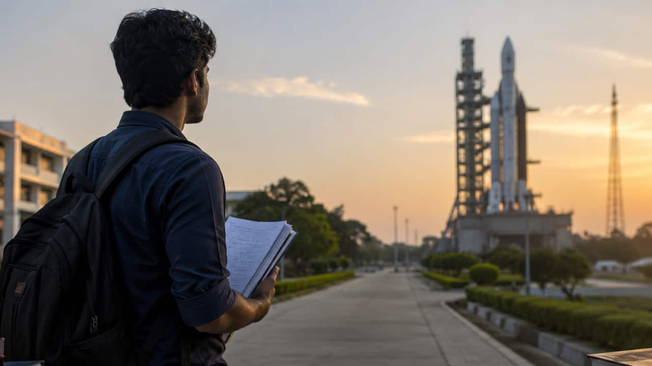
'People said many things, but...': UP student who missed JEE cut-off by 2 marks becomes an ISRO scientist Missing JEE Advanced by two marks did not end Sanket Kumar's dream. The Meerut student's self-study journey, family support and determination helped him reach ISRO as a Scientist. Curated by : Teesha Shirodkar

5. UP student who failed JEE Advanced by 2 marks becomes scientist at ISRO - Mint
Read more
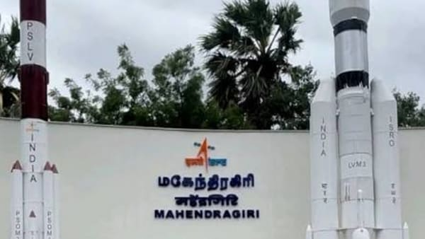
Sanket Kumar, from Uttar Pradesh's Meerut, who narrowly missed qualifying for JEE Advanced in 2021, has now been appointed a Scientist/Engineer (SC Grade) at the ISRO Propulsion Complex (IPRC) in Mahendragiri, Tamil Nadu. Sanket took a gap year and studied without coaching, relying on YouTube lectures and previous years' question papers. His efforts paid off in 2022 when he cleared both JEE Main and JEE Advanced, securing admission to the Indian Institute of Space Science and Technology (IIST), Thiruvananthapuram, to study Aerospace Engineering. Sanket's path to ISRO was far from straightforward. After falling short of the JEE Advanced cut-off by just two marks, he faced a difficult decision. While many advised him against taking a gap year, he chose to continue pursuing his goal. Instead of enrolling in a coaching institute, he relied on self-study, online lectures available on YouTube and practice through previous years' examination papers. His efforts paid off the following year when he successfully cleared both JEE Main and JEE Advanced, earning a place in the Aerospace Engineering programme at the Indian Institute of Space Science and Technology (IIST) in Thiruvananthapuram. Chose an unconventional academic path During his studies at IIST, Sanket opted for vibrations and acoustics, a subject that few of his peers selected. While most students focused on areas such as propulsion and aerodynamics, he became the only member of his batch to specialise in the field. His academic performance also opened international opportunities. He was selected by Japan-based Shinra Inc. for an advanced engineering research project and spent three months working on the assignment. After securing a CGPA of 8.2, he was invited for an interview at ISRO, eventually paving the way to his dream goal. Sanket will begin his career at the ISRO Propulsion Complex in Mahendragiri, a facility responsible for carrying out final tests on rocket systems before launch missions. Reflecting on his achievement, the Modipuram resident said his family's encouragement played a crucial role in helping him overcome challenges and remain focused on his ambitions. "The credit for my success goes to my family. They always supported me. When I took a one-year drop, people said many things, but my family stood by me. My brother gave me strong financial support," Sanket was quoted as saying by NDTV. He also revealed that he kept his ISRO interview a secret from his parents, hoping to surprise them if he succeeded. "I did not even tell my parents when I went for the interview. I thought I would surprise them if I got selected," he said. Family celebrates dream come true Sanket's selection brought immense joy to his family. His mother Sunita Singh, father Gulshan Kumar and brother Harshit Kumar said they were proud of his accomplishment and encouraged other parents to place faith in their children. "We are very happy. It was a dream for us, and our son has fulfiled it. Parents should trust their children and support them. They will write their own success stories," the family told NDTV. School remembers a focused student Sanket completed his Class 12 education with Physics, Chemistry and Mathematics (PCM) from Dewan Public School in 2021. Former principal Aseem Dubey recalled him as a dedicated and disciplined pupil who was always clear about his aspirations.

6. ISRO and Hack2Skill Launch Bharatiya Antariksh Hackathon 2026 - The Robotics India
Read more
ISRO and Hack2Skill Launch Bharatiya Antariksh Hackathon 2026 India's most exciting student innovation challenge is back. Register now for the third edition of the Bharatiya Antariksh Hackathon and solve real-world space technology challenges with mentorship from ISRO scientists. Introduction The Indian Space Research Organisation (ISRO), in collaboration with Hack2Skill (H2S), has officially announced the third edition of the Bharatiya Antariksh Hackathon 2026. This prestigious national-level innovation competition invites students from across India to participate in solving real-world challenges inspired by India's rapidly growing space ecosystem. As India continues to make global headlines through missions such as Chandrayaan, Aditya-L1, and upcoming deep-space exploration programs, the demand for innovative technologies and talented problem-solvers has never been higher. Bharatiya Antariksh Hackathon 2026 aims to bridge the gap between academic learning and real-world applications by providing students with an opportunity to work on challenges that matter to the future of space exploration and scientific research. Quick Highlights Organized by ISRO and Hack2Skill Open to Students Across India Team Size: 3-4 Members Participation Fee: Free 30-Hour Innovation Challenge Mentorship from ISRO Experts Potential Internship Opportunities What is Bharatiya Antariksh Hackathon 2026? Bharatiya Antariksh Hackathon is a national innovation initiative designed to encourage students to apply advanced technologies such as Artificial Intelligence, Machine Learning, Computer Vision, Data Science, Remote Sensing, and Climate Modeling to solve challenges relevant to India's space sector. Unlike traditional hackathons, participants will work on carefully curated problem statements provided by ISRO. These challenges are based on real-world scenarios involving satellite imagery, climate monitoring, planetary science, communication systems, agricultural intelligence, and space weather forecasting. The hackathon serves as a unique platform where students can gain practical experience, interact with leading scientists, and contribute ideas that could potentially influence future research and development initiatives within India's space ecosystem. Who Can Participate? The hackathon is open exclusively to students currently enrolled in educational institutions across India. Participants from engineering, science, technology, mathematics, environmental studies, data analytics, and research domains are encouraged to apply. Undergraduate Students Graduate Students Postgraduate Students PhD Scholars Research Scholars Important: Working professionals are not eligible to participate in the Bharatiya Antariksh Hackathon 2026. Why Students Should Participate Learn from ISRO Scientists One of the biggest advantages of participating in this hackathon is the opportunity to receive guidance directly from ISRO scientists, researchers, and technology experts. Participants will gain valuable insights into real-world scientific challenges and industry best practices. Exceptional performers may be considered for internship opportunities at ISRO. This can provide unparalleled exposure to cutting-edge technologies and ongoing space missions. National-Level Recognition Recognition from ISRO can significantly strengthen a student's academic profile and career prospects. Winners and finalists gain visibility among leading institutions and organizations. Networking Opportunities Participants will connect with fellow innovators, mentors, researchers, and industry professionals from across India, creating opportunities for future collaboration and growth. How to Participate Register for the hackathon. Form a team of 3-4 members. Select a challenge statement. Develop an innovative solution. Submit the final project for evaluation. Major Challenges in Bharatiya Antariksh Hackathon 2026 Challenge 1: Urban Heat Mitigation using AI & ML Develop intelligent systems that optimize cooling strategies and reduce urban heat island effects using advanced analytics and machine learning techniques. Challenge 2: AI-Based Cloud Removal for Satellite Images Create Generative AI solutions capable of reconstructing cloud-covered satellite imagery for improved data analysis and interpretation. Challenge 3: Air Quality Monitoring and HCHO Hotspot Detection Leverage satellite data to identify formaldehyde hotspots and improve environmental monitoring across India. Challenge 4: Road Extraction and Criticality Analysis Build intelligent systems capable of extracting road networks and evaluating urban mobility resilience. Challenge 5: AI-Powered Digital Twin of India's Climate Develop a digital representation of India's climate using national datasets and advanced AI technologies. Challenge 6-15 Additional challenges include crop monitoring, exoplanet detection, lunar ice exploration, infrared image enhancement, solar flare forecasting, satellite radiation prediction, optical flow analysis, secure MPLS operations, and multi-sensor satellite image retrieval. Hackathon Timeline Event Date Registration Opens 10 June 2026 Explainer Session 1 15 June 2026 Explainer Session 2 16 June 2026 Registration Closes 1 July 2026 Shortlist Announcement 20 July 2026 Induction Session 21 July 2026 Grand Finale 6-7 August 2026 Rewards and Benefits The Bharatiya Antariksh Hackathon 2026 offers far more than certificates and prizes. Participants gain access to mentorship, networking opportunities, exposure to real-world challenges, and the possibility of future collaboration with ISRO. Recognition from ISRO Mentorship from Scientists and Engineers National Exposure Travel Reimbursement for Finalists Career Development Opportunities Why This Hackathon Matters for India's Future India's space sector is evolving rapidly, with ambitious goals spanning lunar exploration, solar observation, satellite communication, climate monitoring, and human spaceflight. Achieving these goals requires a strong ecosystem of innovators, researchers, and engineers. Through initiatives like Bharatiya Antariksh Hackathon, ISRO is actively investing in the next generation of talent. By providing students with exposure to real-world challenges and advanced technologies, the organization is helping build the workforce that will shape India's future as a global space leader. Final Thoughts The Bharatiya Antariksh Hackathon 2026 is one of the most prestigious student innovation competitions in India. Whether your interests lie in Artificial Intelligence, Machine Learning, Data Science, Climate Technology, Space Research, Astronomy, or Remote Sensing, this hackathon offers an unparalleled opportunity to learn, innovate, and contribute to the nation's technological progress. Students are encouraged to register early, build strong multidisciplinary teams, and start preparing innovative solutions for the challenges ahead. With mentorship from ISRO experts and the possibility of internships and national recognition, this is an opportunity that aspiring innovators should not miss.

7. Live coverage: SpaceX to launch 24 Starlink satellites on Falcon 9 rocket from Vandenberg
Read more
SpaceX is preparing to launch a batch of its Starlink V2 Mini satellites on a Falcon 9 rocket from Vandenberg Space Force Base Sunday morning. The Father's Day flight will add another 24 broadband internet satellites to the company's low Earth orbit constellation. This is the 72nd Falcon 9 launch of the year. Liftoff of the Starlink 17-28 mission from Space Launch Complex 4 East is scheduled for 8:12:16 a.m. PDT (11:12:16 a.m. EDT / 1512:16 UTC). The rocket will fly on a south-southwesterly trajectory upon leaving the pad. Spaceflight Now will have live coverage beginning about 30 minutes prior to liftoff. <span data-mce-type="bookmark" style="display: inline-block; width: 0px; overflow: hidden; line-height: 0;" class="mce_SELRES_start"></span> SpaceX will launch the mission with one of its most heavily used Falcon 9 boosters, B1063. This will be its 33rd flight after launching missions, like NASA's DART, Transporter-7, and Iridium OneWeb. Nearly 8.5 minutes after liftoff, B1063 will target a landing on the drone ship, 'Of Course I Still Love You', positioned in the Pacific Ocean. If successful, this will be the 204th landing on this vessel and the 627th booster landing for SpaceX to date.

