 |  | 

🌌 अंतरिक्ष समाचार | Space News
शुक्रवार, ०६/११/२०२६ | Friday, 06/11/2026

1. ISRO's latest navigation satellite NVS-03 is fully healthy, says Chairman V. Narayanan - The Hindu
Read more
ISRO's latest navigation satellite NVS-03 is fully healthy, says Chairman V. Narayanan The Hindu

2. EAM Jaishankar Congratulates ISRO on Successful Launch of NVS-03 - News On AIR
Read more
EAM Jaishankar Congratulates ISRO on Successful Launch of NVS-03 News On AIR

3. Fake SBI pension verification call costs retired Isro official Rs 1.1L - The Times of India
Read more
Fake SBI pension verification call costs retired Isro official Rs 1.1L The Times of India

4. Russia Helped India When Other Countries Refused To Share Space Technology: ISRO Chief Narayanan - ETV Bharat
Read more
Russia Helped India When Other Countries Refused To Share Space Technology: ISRO Chief Narayanan ETV Bharat

5. Isro chief unveils Yuri Gagarin statue, thanks Russia for supporting space programme - India Today
Read more
Isro chief unveils Yuri Gagarin statue, thanks Russia for supporting space programme India Today

6. BioTecNika Times-05-11-2026: Freshers Jobs at USV, L&T, Parexel, ISRO Internship & Many More - BioTecNika
Read more
BioTecNika Times-05-11-2026: Freshers Jobs at USV, L&T, Parexel, ISRO Internship & Many More BioTecNika

7. NASA Astronauts to Answer Questions from Florida Students
Read more
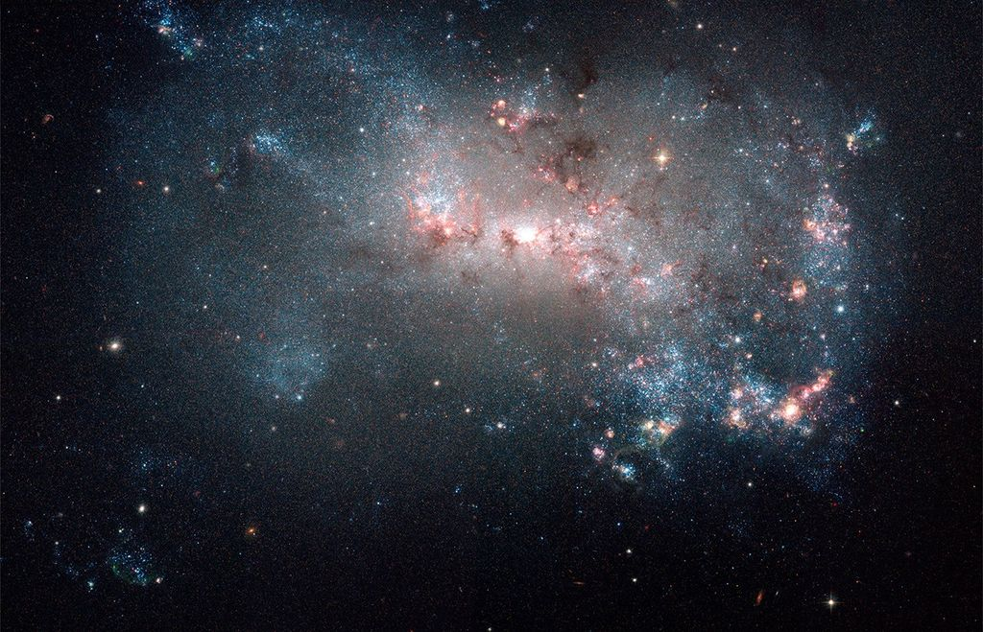
From left, SpaceX Crew-13 pilot Luke Delaney and commander Jessica Watkins, both NASA astronauts, are pictured in their pressure suits during a training session at SpaceX headquarters in Hawthorne, California. Credit: SpaceX Students in Florida will hear from NASA astronauts Jessica Watkins and Luke Delaney as they answer prerecorded STEM questions while aboard the International Space Station. The Earth-to-space call will begin at 10:40 a.m. EST Tuesday, Nov. 10, and will stream live on the agency's Learn With NASA YouTube channel. This event is hosted by Freedom Crossing Academy in St. Johns, Florida, for students in grades K-12, and the community. This unique opportunity aims to deepen understanding of space exploration and enhance awareness of STEM careers. Media interested in covering the event must RSVP no later than 5 p.m. EST, Monday, Nov. 9, to Christina Upchurch at (904) 547-7517, or at christina.upchurch@stjohns.k12.fl.us. For more than 26 years, people have lived and worked continuously aboard the International Space Station, advancing scientific knowledge and making research breakthroughs not possible on Earth. The space station helps NASA understand and overcome the challenges of human spaceflight, expand commercial opportunities in low Earth orbit, and build on the foundation for long-duration missions to the Moon, as part of the Artemis program, and to Mars. For more information on NASA in-flight calls, visit: https://www.nasa.gov/stemonstation

8. Hubble Learns Galactic History From Stars
Read more
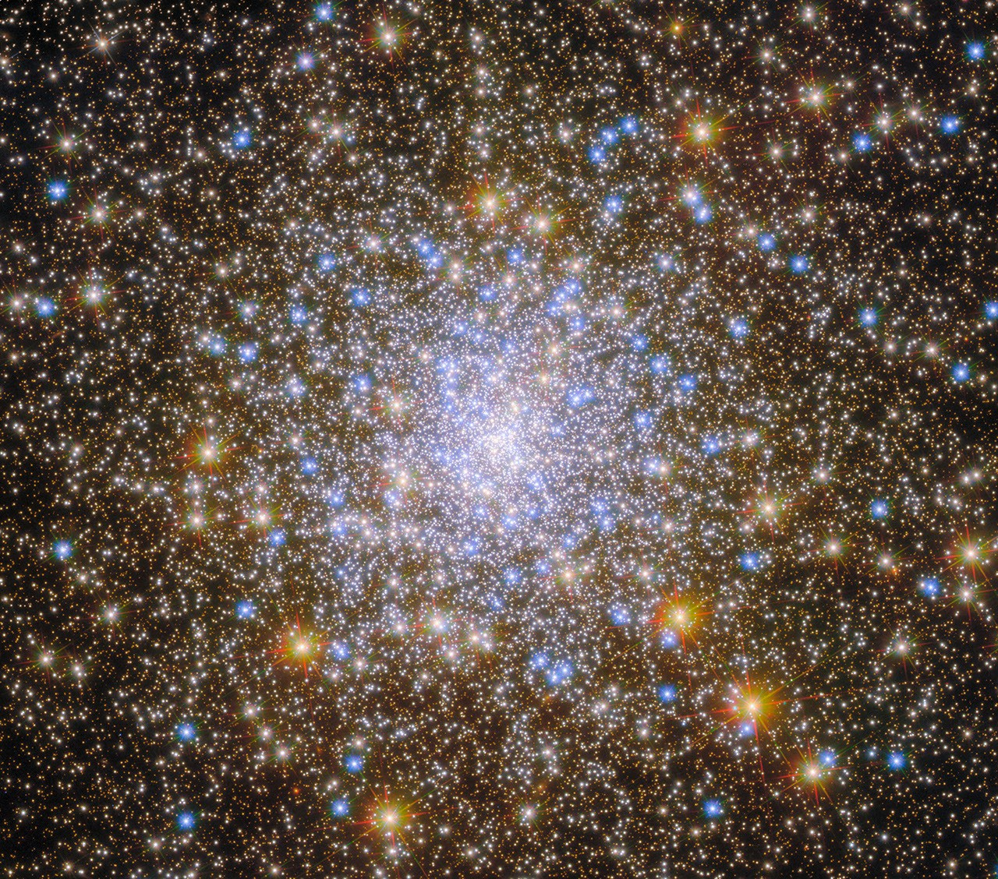
This NASA/ESA Hubble Space Telescope image features the globular star cluster called Messier 30 (M30), also called NGC 7099. ESA/Hubble & NASA, M. Libralato, G. Piotto, A. Sarajedini This NASA/ESA Hubble Space Telescope image provides a lesson in galactic history. The sparkling collection of stars is named Messier 30 (M30) after the French astronomer, Charles Messier, who cataloged M30 and other diffuse objects that might be mistaken for comets in the early telescopes of Messier's time. M30 lies about 27,500 light-years away in the constellation Capricornus. M30 is a globular cluster: a roughly spherical grouping of stars containing anywhere from tens of thousands to millions of stars. These clusters generally reside on the outskirts of galaxies, orbiting within a vast, diffuse region called the halo like a swarm of moths around a lightbulb. Our Milky Way galaxy has at least 150 globular clusters, the nearest of which is about 6,000 light-years away. These clusters are impressively ancient: astronomers estimate their ages are between 11.5 to 13.5 billion years, making certain globular clusters nearly as old as the universe itself. Globular clusters have long played an important role in helping us learn about our galaxy. More than a century ago, astronomer Harlow Shapley used observations of a particular type of variable star to measure the locations of and distances to dozens of globular clusters within our galaxy. His work showed that the Sun is not in the center of our galaxy, and that the galactic center lies toward the constellation Sagittarius. (His distance measurements were incorrect, however, and he concluded that our galaxy is about twice as large as it really is.) Today, astronomers continue to learn about our galaxy by observing globular clusters. Because globular clusters are so ancient, they can give us clues about how our galaxy developed long ago. Globular clusters that formed within our galaxy can act as time capsules, preserving the original chemistry of our young galaxy. However, it's possible that not all globular clusters that orbit within our galaxy today formed there. Researchers have discovered that M30 and many other globular clusters orbit in the direction opposite from the way our galaxy spins. This may mean that these clusters did not form within our galaxy at all. Instead, our Milky Way galaxy may have captured them in the distant past! Hubble has observed M30 multiple times. A previously released image of M30 featured data from Hubble's Advanced Camera for Surveys (ACS) and was part of an observing program (#10775; PI: Sarajedini) that surveyed dozens of Milky Way globular clusters in red and near-infrared light, revealing stars down to just 20% of the mass of the Sun. A more recent program (#13297; PI: Piotto) returned to M30 and other globular clusters in our galaxy, this time observing the clusters with Hubble's Wide Field Camera 3 and using three filters that captured bluer light. This program collected data that was critical for studying exotic objects like "blue straggler" stars as well as for investigating the multiple populations of stars that can inhabit a single globular cluster. More recently, Hubble's ACS viewed many of these globular clusters again. Those observations were part of a program (#16298, PI: Libralato) that looked at how different populations of stars in globular clusters moved over the 15 years since Hubble first observed them - a feat made possible by Hubble's longevity and ability to discern fantastically small details in distant objects. The image above was created with data from all three observing programs and includes the wide range of wavelengths Hubble can see - ultraviolet, visible, and near-infrared light. Each wavelength helps us better understand how these groups of stars formed and evolved. Text credit: ESA/Hubble Media Contact: Claire Andreoli NASA's Goddard Space Flight Center, Greenbelt, MD claire.andreoli@nasa.gov

9. 'We got it done!' Spacewalking astronauts finish installing next-gen ISS solar arrays
Read more
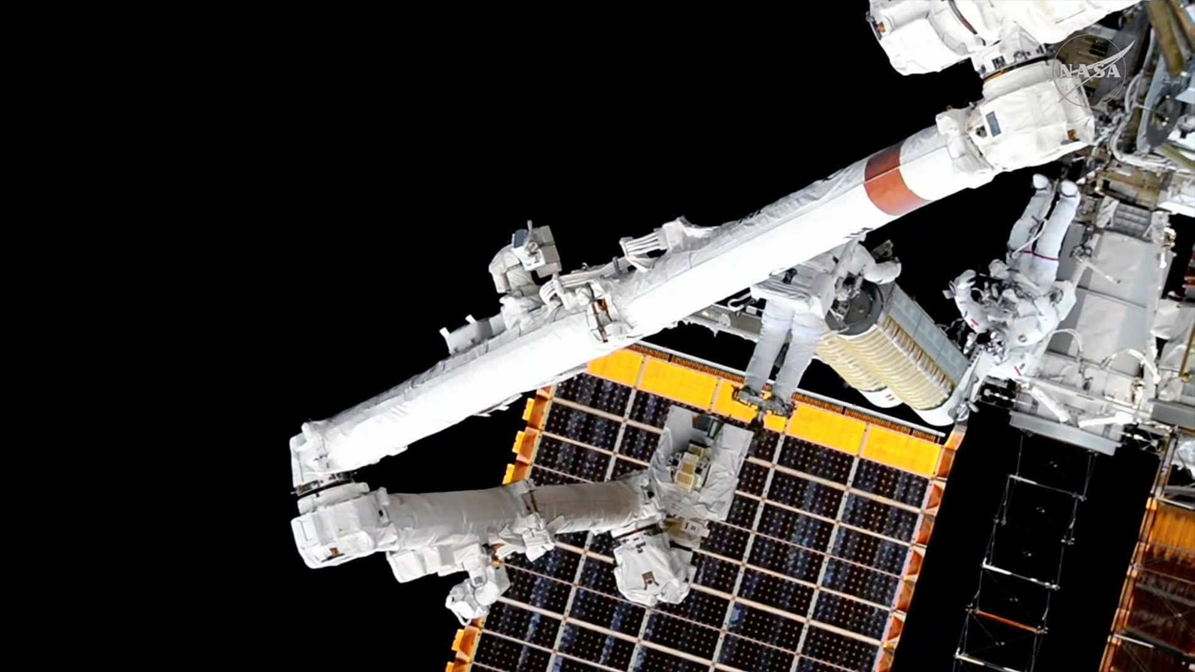
Click for next article NASA astronaut Anil Menon (on the end of the Canadarm2 robotic arm) and Canadian Space Agency astronaut Joshua Kutryk (at right) work on moving the eighth and final International Space Station Roll-Out Solar Array (iROSA) from its temporary stowage platform to its installation site on the backbone truss during a spacewalk on Nov. 5, 2026. Just as NASA is preparing to demonstrate " Max Power " on the ground, two astronauts on a spacewalk have provided the International Space Station (ISS) with the same. Expedition 75 flight engineers Anil Menon of NASA and Joshua Kutryk of the Canadian Space Agency installed and deployed the eighth and final ISS Roll-Out Solar Array (iROSA) on Thursday (Nov. 5), augmenting the space station's legacy solar array wings to produce as much as 30% more electricity. "We got it done!" said Menon at the end of the 6-hour-and-59-minute spacewalk . The EVA (extravehicular activity) began at 8:36 a.m. EST and ended at 3:35 p.m. EST (1336 to 2035 GMT). NASA astronaut Anil Menon (at far right) is seen at the base of the newly-deployed eighth and final International Space Station Roll-Out Solar Array (iROSA) during a spacewalk on Nov. 5, 2026. (Image credit: NASA) Repeating many of the same tasks as they did on an Oct. 29 spacewalk that added the penultimate iROSA, Menon and Kutryk worked this time on the starboard side of the station's backbone truss on the 3B power channel. The two retrieved the 750-pound (340 kilograms) iROSA assembly from a temporary stowage platform, carried it to the worksite by way of the Canadarm2 robotic arm and mounted it to its previously assembled bracket kit. Menon then attached the cables to tie the iROSA into the station's systems but ran into a problem. "We are seeing half of the expected shunt current that we want," radioed Nichole Stilwell, a NASA astronaut serving as the spacewalk officer in Mission Control. "In this current config, we are not necessarily going to deploy." To address the issue, the connectors needed to be inspected. Out of safety concerns - given that the arrays generate electricity whenever lit by the sun - the astronauts needed to wait for the space station to enter the shadow of Earth to see what could be done. In the interim, they spent the time cleaning up their worksite and returning the Canadarm2 to its park site as they would have done after the deployment. Fortunately, they were able to clear the issue. "We are seeing good shunt currents on the ground, so we are go for deploy," said Stilwell. Canadian Space Agency astronaut Joshua Kutryk (at center) works on mounting the eighth and final International Space Station Roll-Out Solar Array (iROSA) during a spacewalk on Nov. 5, 2026. (Image credit: NASA) After releasing two bolts, Kutryk and Menon watched as the array started to unfurl to its full 63-foot (19 meters) length. No motor was needed; the iROSA, as designed, used only the potential energy stored by its rolled-up carbon composite booms to extend itself. The entire process took about 10 minutes. "Today marks the completion of not just one solar array but, over 15 years after its development, eight arrays," said Menon at the close of the spacewalk. "These solar arrays are incredible. Half the size of the old ones and bringing 40% more power." NASA graphic showing the location and power channel for all eight now-deployed International Space Station Roll-Out Solar Arrays (iROSAs). (Image credit: NASA) Each of the eight iROSAs and their mounting assemblies were delivered to the space station by SpaceX Dragon cargo spacecraft. Beginning in June 2021, four teams of two astronauts did as was done on Thursday to deploy each array. In addition to Kutryk and Menon's work on the 2A and 3B power channels, the spacewalkers included Shane Kimbrough of NASA and Thomas Pesquet of the European Space Agency for the 2B and 4B channels; Josh Cassada and Frank Rubio, both with NASA, on 3A and 4A in December 2022; and NASA's Steve Bowen and Woody Hoburg on 1A and 1B in June 2023. The need for the iROSA augmentations was discovered by flight controllers when the space station's eight original arrays began to show degraded power output as they exceeded their 15-year design life. The iROSAs provide the additional electricity needed to support ISS operations through its retirement and controlled deorbit , which are currently scheduled to occur in late 2030. "Congratulations to you all on your stellar work to finish the last of the roll-out solar arrays and the upgrades to the ISS power system that will take it to the end of its journey," said Stilwell, addressing Menon and Kutryk. "It is fitting that we just surpassed 26 years of constant human presence on the International Space Station , and you all showed us what the best of humanity looks like executing one of the most difficult and dangerous [things] humans do and making it look easy. Congratulations!"

10. Blue Origin announces 3rd stage for its powerful New Glenn rocket -and a new engine
Read more
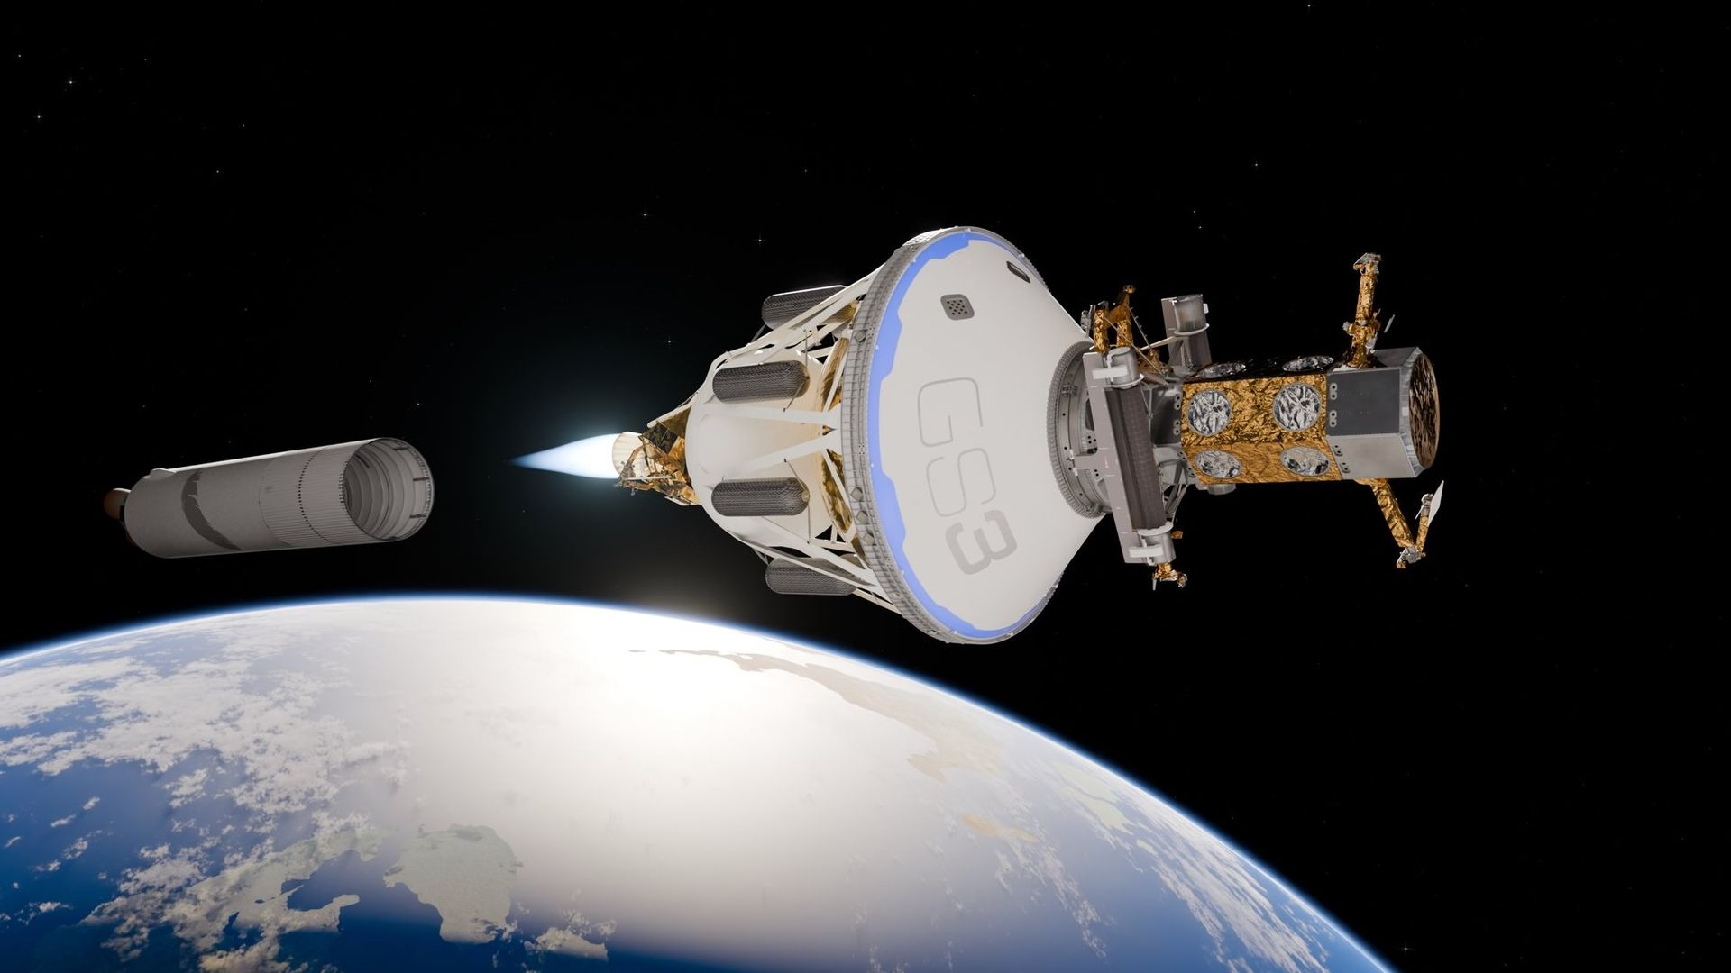
Click for next article Artist's illustration of the GS3 third stage for Blue Origin's New Glenn rocket in space. Blue Origin's big rocket is getting a little bigger. Jeff Bezos' company announced today (Nov. 5) that it has developed a third stage for its New Glenn rocket, which it says will make the powerful launcher more capable and flexible. The stage, called the GS3, "enhances New Glenn's capabilities," Blue Origin said in a blog post today . "The third stage enables direct deployment of satellite constellations to GEO [ geostationary orbit ] and supports heavy-lift science and exploration missions to the moon and deep space." Illustration of the variants of Blue Origin's New Glenn rocket, with the new GS3 third stage now in the mix. (Image credit: Blue Origin) New Glenn is a two-stage vehicle at the moment. Its reusable first stage is powered by seven of Blue Origin's BE-4 engines, and its second stage features two of the company's BE-3Us. The rocket stands 322 feet (98 meters) tall and can haul 14.3 tons (13 metric tons) to geostationary transfer orbit (GTO) and 50 tons (45 metric tons) to low Earth orbit (LEO). These are the specs for the standard, or "7x2," version of New Glenn. Last year, Blue Origin announced that it's developing a super-heavy variant known as the 9x4, because it will feature nine first-stage BE-4s and four upper-stage BE-3Us. The 9x4 will be nearly 400 feet (122 m) tall, and it will be able to loft 15.4 tons (14 metric tons) to GTO and 77 tons (70 metric tons) to LEO, according to Blue Origin . New Glenn has flown three times to date, each time in the 7x2 configuration. The rocket debuted in January 2025 , then launched again in November 2025 and again on April 19 of this year . Things didn't go according to plan on that latest mission. The rocket deployed AST SpaceMobile's BlueBird 7 communications satellite into the wrong orbit , and the spacecraft ended up being lost. Another setback came just a month later: On May 28, New Glenn exploded on the pad during a routine engine test at Florida's Cape Canaveral Space Force Station . Blue Origin has been working ever since to rebuild the pad and get New Glenn ready for its fourth flight, which is expected to occur late this year. Blue Origin tests a tank for the GS3 third stage of its New Glenn rocket at its Launch Site One in Texas. (Image credit: Blue Origin) We now know that Blue Origin has also been working on the GS3 while those repairs were underway. The new stage will be powered by one BE-7 engine, which the company developed for use on its Blue Moon spacecraft, one of the two private vehicles that NASA selected to be crewed lunar landers for its Artemis program . (The other is SpaceX's Starship .) Blue Moon landing missions won't need to launch on GS3-equipped New Glenn rockets, according to Blue Origin. But the third stage "can support sustained operations around the moon," the company wrote in today's blog post. "By delivering significant payload mass directly to trans-lunar injection (TLI), GS3 enables faster transit times while preserving propellant for on-orbit operations." And there's already demand for such services: Blue Origin also announced today that a government customer (which it did not name) has booked a GS3 mission to cislunar (Earth-moon) space, with launch targeted for 2028. Blue Origin's newly announced Northstar booster engine. (Image credit: Blue Origin) And the company dropped yet more news today - that it's working on a new first-stage engine, called Northstar. Like Blue Origin's other booster engine, the BE-4, Northstar burns liquid oxygen and liquid methane propellant, a combination known as methalox. But the new engine is more powerful and less complex. "Compared to the BE-4 engine, Northstar reduces mass by 30% and parts count by 50%, while increasing thrust from 640,000 to 715,000 pounds-force," Blue Origin said in a second blog post today . "Manufacturing advancements have also significantly shortened production timelines, enabling assembly in less than a day." Northstar went from program approval to development testing in just 11 months, according to the company. But today's update did not say when the new engine will fly for the first time.

11. On this day in space! Nov. 5, 2002: NASA's Galileo spacecraft flies by Jupiter moon Amalthea only to find it's a 'pile of icy rubble less dense than water'
Read more
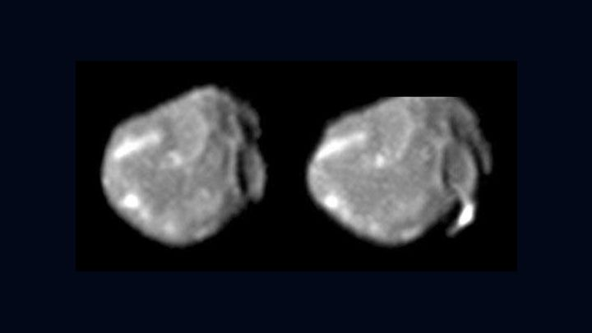
Click for next article On Nov. 5, 2002, NASA's old Galileo spacecraft was almost out of fuel. But the Jupiter mission still had some science to do. Galileo flew by a small moon called Amalthea. Amalthea is small, but it's interesting for scientists. The Jupiter moon Amalthea is the reddest object in our solar system. It also generates more heat than it gets from the sun. Scientists think Amalthea creates electrical currents as it orbits in Jupiter's huge magnetic field. Near this little moon, strong radiation from Jupiter is dangerous for spacecraft. The flyby caused some problems for Galileo. The spacecraft went into safe mode only 30 minutes after going past Amalthea. NASA said it was ready for problems, because Galileo was on its last legs, and the radiation near Amalthea was strong. However, NASA quickly fixed the problem and got Galileo working again. Less than a year later, Galileo threw itself into Jupiter's atmosphere . The spacecraft was crushed by the high pressure in Jupiter's atmosphere, but its data still survives on Earth. The Jupiter moon Amalthea as seen by NASA's Galileo spacecraft on Nov. 5, 2002. (Image credit: NASA/JPL-Caltech) Why it mattered The Galileo spacecraft was running on cosmic fumes by the time it reached Amalthea and the flyby would be the last time the probe would ever swing by one of Jupiter's moons . While it may not look like it in Galileo's black and white images above and below, Amalthea is tinted red due sulfur contamination on its surface. The moon is small, about 168 miles long, and orbits about 112,468 miles (181,000 km) from Jupiter (much closer to the planet than the Earth and its moon). Galileo flew within 99 miles of Amalthea during its flyby, which also marked the closest Galileo would get to Jupiter before its death dive in September 2005. "Scientists studying data from NASA's Galileo spacecraft have found that Jupiter's moon Amalthea is a pile of icy rubble less dense than water," NASA announced in May 2005 Image 1 of 2 Two views of the Jupiter moon Amalthea as seen by NASA's Galileo spacecraft. (Image credit: NASA/JPL-Caltech) These images of Jupiter's moon Amalthea were taken with NASA's Galileo and Voyager spacecraft. Galileo's image is on the right, with Voyager's view on the left. The center image is a composite of both probes. (Image credit: NASA/JPL-Caltech) Image 1 of 2 View Original Image 2 of 2 View Original "Amalthea is throwing us a curve ball," Torrence Johnson, a study co-author on the Almathea flyby and project scientist for the Galileo mission at JPL, said in 2005 . "Its density is well below that of water ice, and even with substantial porosity, Amalthea probably contains a lot of water ice, as well as rock." Originally known as Jupiter V (because it was the fifth Jupiter moon discovered after the so-called Galilean moons Io, Europa, Ganymede, Callisto ), Amalthea was named after naiad, or water nymph, from Greek mythology. It is fitting that Amalthea was the last of Jupiter's moons to be visited by the Galileo spacecraft. The moon was also last Jupiter moon to be discovered by visual observations when it was first disovered by astronomer Edward Emerson Barnard in September 1892 using the Lick Observatory telescope in California. The Galileo spacecraft ultimately crashed into Jupiter on Sept. 21, 2005, less than a year after its Amalthea flyby. Want more space history? Check out our full On This Day In Space Story archive and watch our On This Day In Space videos on YouTube .

12. You don't have to go to the moon to see Earth differently: Artemis II astronaut Victor Glover on what really matters
Read more
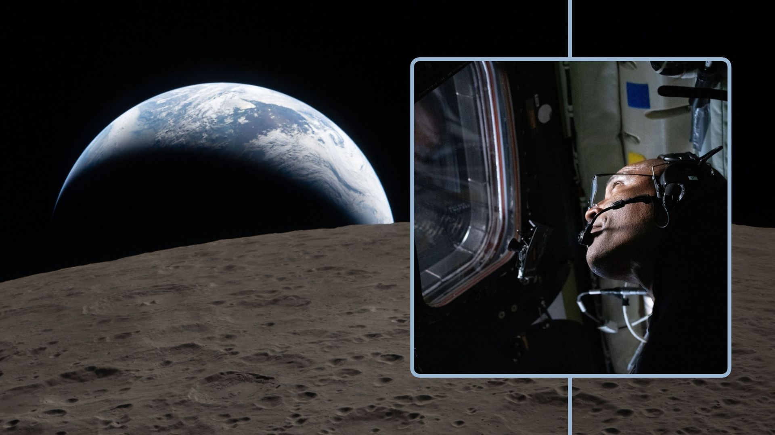
Click for next article After a record-breaking journey around the moon, Artemis 2 astronaut Victor Glover explains why you don't need to travel into space to see Earth differently. TENERIFE, Canary Islands - Imagine traveling over 250 million miles from home, watching Earth disappear behind the moon and losing contact with the billions of people who call it home. What would you miss most? For Artemis II astronaut Victor Glover, the answer wasn't a particular place, a familiar view or even the comforts of home. It was something much more fundamental: human connection. Speaking during a discussion with former astronaut Chris Hadfield at the Starmus VIII festival on Oct. 18 in Tenerife, Canary Islands, Glover reflected on the extraordinary experience of traveling around the moon and how being so far from Earth had given him a renewed appreciation for the people living on it. "The greatest reason to go to space, it isn't to be a swashbuckler hero," Glover said. "It's to do something that only 651 people have been able to do: miss Earth and miss other Earthlings." Glover was one of the four astronauts aboard NASA's Artemis II mission, which launched on April 1, 2026 , marking humanity's first crewed journey to the moon since Apollo 17 in 1972. Alongside NASA astronauts Reid Wiseman and Christina Koch and Canadian Space Agency astronaut Jeremy Hansen, the crew traveled farther from Earth than any humans before them. As the Orion spacecraft traversed the far side of the moon, the Artemis II crew watched Earth disappear below the lunar horizon before losing radio contact with our planet. Around 40 minutes later, Earth came back into view as the spacecraft emerged from behind the moon. NASA's Orion spacecraft captures the Moon and the Earth in one frame during the Artemis II crew's deep space journey at 6:39 p.m. ET on the sixth day of the mission. (Image credit: NASA) For Glover, however, the experience was about much more than the view. He believes that if everyone on Earth had the opportunity to make the same journey, they would come away with a similar appreciation for what they'd left behind. "I think all of us would say something in our native language, in the most basic way we can communicate about love, joy, hope and inspiration," Glover said. Although Glover shared the extraordinary journey with three fellow astronauts, the four of them were separated from the rest of humanity by hundreds of thousands of miles. And for Glover, that distance brought with it a strange contradiction: the farther he traveled from humanity, the more he longed to connect with it. "At the point of ultimate disconnection, [there is] this longing for connection," Glover said. The experience gave him a perspective that he carried back into everyday life. "There are moments where I am rushing through traffic and want to get where I'm going because I'm being selfish," Glover admitted. "But I don't have to stay there." Instead, he remembers what it felt like to look back at a planet so distant that everyone who has ever lived could be covered by his hand. "I wish you could all feel what it's like to come back home after that disconnection," he said. Victor Glover speaking at Starmus VIII, explaining how it felt to experience complete disconnection from everyone on Earth during Artemis II. (Image credit: Daisy Dobrijevic/Future) The 'sea level effect' Astronauts often describe experiencing the "overview effect", a profound shift in perspective that can come from seeing Earth from space. But Glover believes that there's something equally powerful waiting to be discovered much closer to home. When asked by a Starmus VIII attendee whether people needed to undergo something extraordinary to develop a greater sense of kindness toward others, his answer was no. Glover encouraged people to look more closely at the natural world around them, whether that meant walking along the beach, watching the ocean or simply examining a leaf held up to sunlight. Even something as ordinary as a leaf, he explained, is capable of turning sunlight into food through photosynthesis. And although science can explain how that happens, understanding the process doesn't make it any less remarkable. "We have to choose to be moved by these things," Glover said. He worries that modern life, with its endless technological distractions, has made it all too easy to overlook the extraordinary things happening around us. "Familiarity breeds contempt. Have you heard this? I think it's worse than that. Familiarity breeds indifference," he said. Glover's "sea-level effect" encourages us all to rediscover the wonder of the natural world, right here on Earth. (Image credit: FanPro via Getty Images) Glover has a name for this perspective he hopes people can rediscover without traveling into space: The sea level effect. It's about finding the same sense of wonder and connection that astronauts experience in orbit, but right here on Earth, where most of us spend our lives. And ultimately, Glover believes the greatest wonder isn't the moon, the stars, or even the incredible complexity of nature. It's the people we share our planet with. "I think the hardest place to see this miracle is in the actual greatest miracle in the universe: other humans," he said. "We all feel it with babies, but when we get old enough to have opinions, we start to want to argue with each other." Glover hopes that by taking the time to appreciate the natural world, people might become a little more willing to appreciate one another too. "That's the mission that I want to be part of for the rest of my life," Glover said.

13. NASA's Voyager 1 probe bounces back from communications glitch in interstellar space
Read more
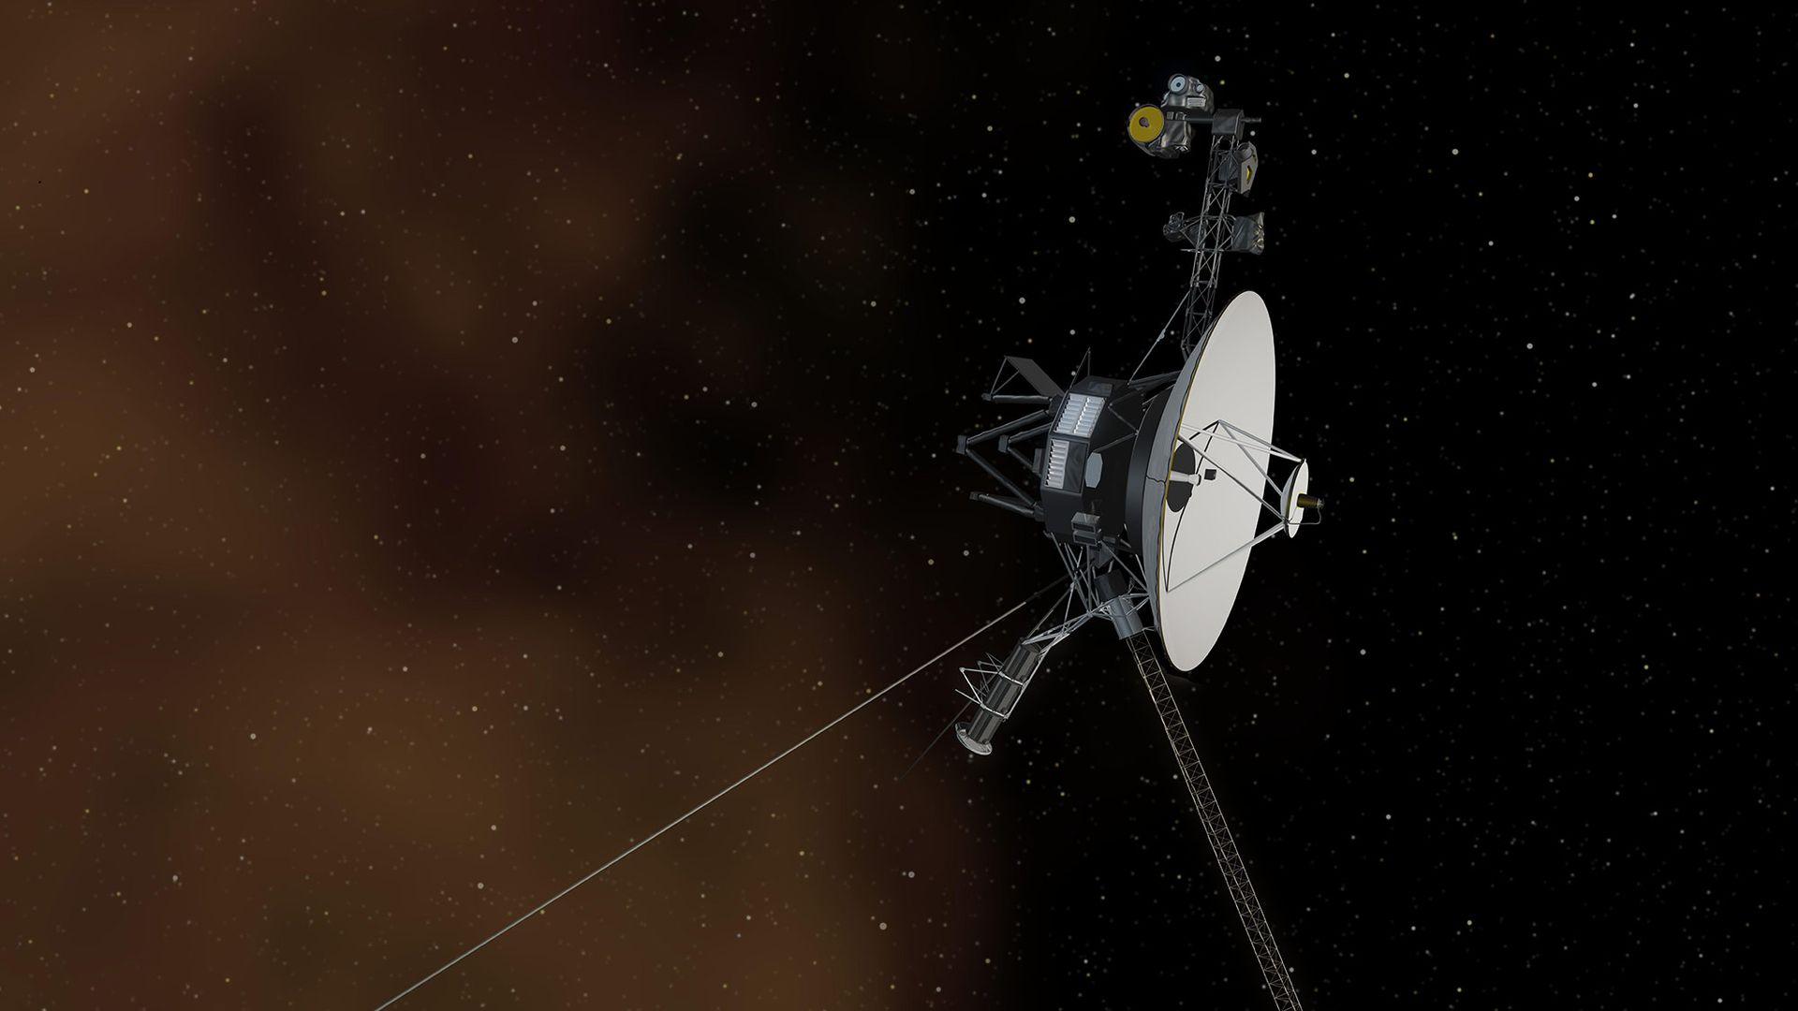
Click for next article Voyager, 1, humanity's most distant spacecraft, is back in contact after briefly losing touch with Earth last month. The spacecraft stopped phoning home for about 48 hours between Oct. 18 and 20 due to a communications glitch that Voyager 1 resolved on its own, before engineers could send the long-running spacecraft a remote fix. "This is the first time we've seen the spacecraft do something like this, but we are also at a point in the mission where we have to expect the unexpected," Kareem Badaruddin, Voyager mission manager at NASA's Jet Propulsion Laboratory (JPL), said in an agency statement about the incident on Oct. 29. Voyager 1 is almost one light-day from Earth, meaning that a command takes nearly a day to reach the spacecraft and a response takes another day to come back to our planet. The spacecraft will reach the light-day milestone on Nov. 18, at 16.09 billion miles (25.89 billion kilometers) from Earth. NASA's Deep Space Network of three antennas does check-ins to make sure the spacecraft is doing well. On Oct. 18 and 19, Voyager 1 did not respond. Its signal fortunately reappeared on Oct. 20. "Engineers still are investigating what caused the communication loss," JPL added in the statement, but said it appears Voyager 1 went into a sort of safe mode. "The team has so far determined that one group of thrusters went offline and their backups turned on. Such a swap is programmed to occur automatically if the spacecraft computers detect something amiss with the active thrusters." Voyager 1 and its still-operational twin, Voyager 2 , both launched in 1977 on an initial mission to explore planets in the solar system. The two spacecraft took advantage of a rare alignment that allowed them to swing from Jupiter to Saturn to Uranus and Neptune using a minimum of fuel, although funding to explore the more distant planets and moons was not guaranteed at launch. The spacecraft duly swung by Jupiter's and Saturn's systems (some months apart from each other) to great acclaim before parting pathways. Voyager 1's close-up view of Saturn's rings as well as the moon Titan - which may have prebiotic or pre-life chemistry - altered the spacecraft's trajectory to put it high above the plane of the solar system. Meanwhile, Voyager 2 flew on to Uranus and Neptune in 1986 and 1989, respectively, providing the only up-close view of these planetary systems to date. An image of Saturn taken by Voyager 1 on Nov. 16, 1980, four days after the spacecraft flew past the planet. (Image credit: NASA/JPL) Running on nuclear power, and continuing to deliver valuable science from deep space, the Voyagers saw their missions extended repeatedly. Both crossed into interstellar space a few years ago, and are still operational. But with age comes a cost: the plutonium power sources on both spacecraft are diminishing, requiring engineers to periodically shut off instruments or come up with other clever ways of saving power. Voyager 1 just underwent one of those power adjustments, nicknamed the "Big Bang" because it reconfigured a number of spacecraft instruments. "In early September, engineers successfully turned off three devices on the Voyager 1 spacecraft and substituted them with three lower-power alternatives," JPL wrote of the effort, noting that Voyager 2 also had a "Big Bang" about six weeks previous to that. JPL did not provide an estimate for how long the missions could keep running, but noted each spacecraft loses four watts of power a year - each launched with 470 watts - and that the spacecraft could continue operating science instruments "longer than previously anticipated" due to the Big Bang. On Voyager 1, for example, the falling power would have otherwise meant switching off another instrument possibly as soon as next summer.

14. Earth photobombs spacewalking Canadian astronaut | Space photo of the day for Nov. 5, 2026
Read more
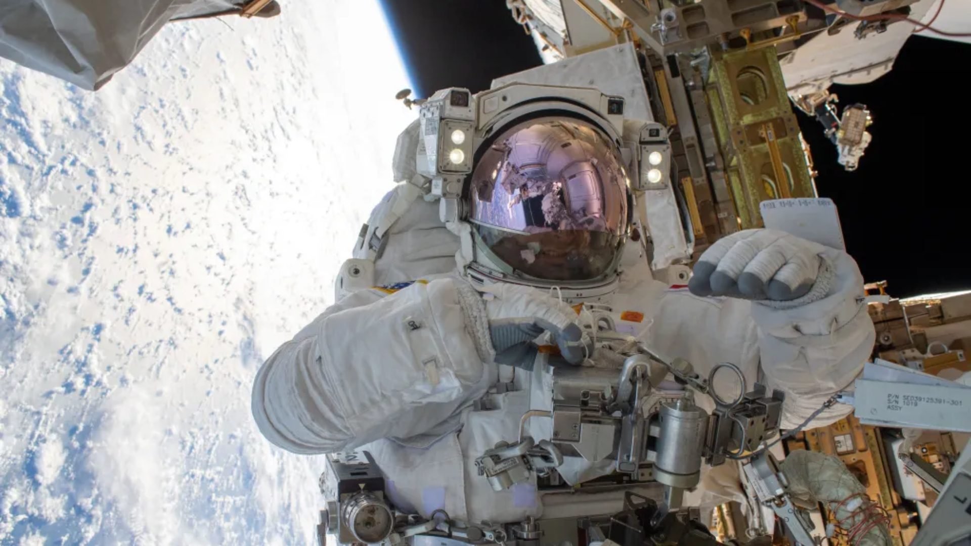
Click for next article Canadian astronaut Joshua Kutryk poses for a photo during his spacewalk on Oct. 29, 2026. (Image credit: CSA) Spacewalks are hard work, so sometimes you need to take a break for a moment and snap a gorgeous selfie with your home planet in the background. What is it? During a pre-Halloween spacewalk on Oct. 29, 2026, Canadian Space Agency astronaut Joshua Kutryk took a moment to pose for a photograph. In this moment , the International Space Station to which he was tethered was orbiting 267 miles (430 kilometers) above the South Atlantic Ocean down below on Earth. During this spacewalk - the first for a Canadian since 2019 - Kutryk and NASA astronaut Anil Menon worked together to install a new roll-out solar array on the station while also performing some "get ahead" tasks to prep for the next spacewalk, which is happening today (Nov. 5). During today's excursion, the same two astronauts will venture out into space, tethered to the space station, to install the eighth and final roll-out solar array. These eight new arrays will boost the station's available power by a total of 30%, according to NASA officials. Why is it incredible? When we think of astronauts working in space, we might think of the important science and research they're doing aboard the station. Astronauts work on everything from biomedical research to plant science and physics experiments. But the job also includes work on the space station itself. Sometimes they have to venture out into the vacuum of space to fix urgent problems. These situations can be tense, and there's a lot of pressure to get things absolutely right. But even spacewalks that do relatively mundane maintenance work, like the one on Oct. 29, come with pressure. Every minute that astronauts spend outside of the space station, there are countless risk factors floating around. Earth orbit is a very harsh environment, after all, even if it does allow for some pretty amazing selfies.

