 |  | 

🌌 अंतरिक्ष समाचार | Space News
रविवार, २५/१०/२०२६ | Sunday, 25/10/2026

1. ISRO to have four launch pads by 2029, says Narayanan - The Hindu
Read more
ISRO to have four launch pads by 2029, says Narayanan The Hindu

2. Why IISc should be Isro's JPL - The Times of India
Read more
Why IISc should be Isro's JPL The Times of India

3. ISRO Recruitment 2026 Result Out: Skill Test Scheduled For November 1 - NDTV
Read more
ISRO Recruitment 2026 Result Out: Skill Test Scheduled For November 1 NDTV

4. ISRO Privatisation? Chief V Narayanan Clears The Air On Private Companies' Role - NDTV Profit
Read more
ISRO Privatisation? Chief V Narayanan Clears The Air On Private Companies' Role NDTV Profit

5. ESTIC 2026 to Focus on Scientific Advancement Towards Viksit Bharat 2047, Says ISRO Chairman V Narayanan - News On AIR
Read more
ESTIC 2026 to Focus on Scientific Advancement Towards Viksit Bharat 2047, Says ISRO Chairman V Narayanan News On AIR

6. Sapphire International School students explore India's space missions at ISRO - Pioneer Edge
Read more
Sapphire International School students explore India's space missions at ISRO Pioneer Edge

7. This Week In Space podcast: Episode 233 - The Artemis Generation
Read more
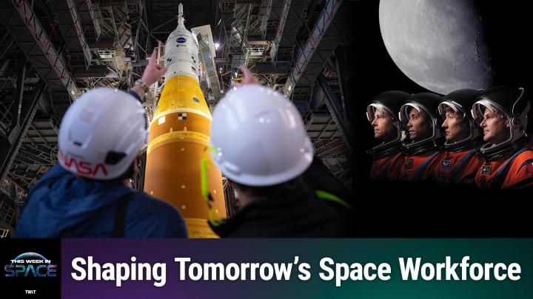
Click for next article The Artemis Generation - The STEM Pipeline for Space - YouTube Watch On On Episode 233 of This Week In Space, Tariq Malik and guest host Rick Jenet are joined by Dr. Amanda Smith-Hackler, the Director of Education for the Universities Space Research Association and Principal Investigator for the Air Force Research Laboratory (AFRL) Scholars and STEM Workforce Development Programs, about the new and exciting opportunities available to young people seeking to enter the space workforce. Newspace is hiring! With the major powers heading to the moon, low-Earth orbit becoming busier than ever, and countless new companies entering the space marketplace, the hiring pipeline is more critical than ever. Download or subscribe to this show at: https://twit.tv/shows/this-week-in-space. Get episodes ad-free with Club TWiT at https://twit.tv/clubtwit Space news of the week Model Falcon 9! TOP TELESCOPE PICK: (Image credit: Celestron) Looking for a telescope to see planets and comets? We recommend the Celestron Astro Fi 102 as the top pick in our best beginner's telescope guide. Finally, did you know you can launch your own SpaceX rocket? Model rocket maker Estes' stunning scale model of a Falcon 9 rocket that you can pick up now. The launchable model is a detailed recreation of the Falcon 9 and retails for $149.99. You can save 10% by using the code IN-COLLECTSPACE at checkout, courtesy of our partners collectSPACE.com. About This Week In Space This Week in Space covers the new space age. Every Friday we take a deep dive into a fascinating topic. What's happening with the new race to the moon and other planets? When will SpaceX really send people to Mars? Join Rod Pyle and Tariq Malik from Space.com as they tackle those questions and more each week on Friday afternoons. You can subscribe today on your favorite podcatcher. Host of This Week In Space on TWiT Host of This Week In Space on TWiT Rod Pyle Social Links Navigation Space author and historian Rod Pyle is an author, journalist, television producer and Editor-in-Chief of Ad Astra magazine. He has written 18 books on space history, exploration, and development, including Space 2.0, Innovation the NASA Way, Interplanetary Robots, Blueprint for a Battlestar, Amazing Stories of the Space Age, First On the Moon, and Destination Mars In a previous life, Rod produced numerous documentaries and short films for The History Channel, Discovery Communications, and Disney. He also worked in visual effects on Star Trek: Deep Space Nine and the Battlestar Galactica reboot, as well as various sci-fi TV pilots. His most recent TV credit was with the NatGeo documentary on Tom Wolfe's iconic book The Right Stuff. This Week In Space co-host This Week In Space co-host Tariq Malik Social Links Navigation Space.com Editor-in-Chief Responsible for Space.com's editorial vision, Tariq Malik has been the Editor-in-Chief of Space.com since 2019 and has covered space news and science for 18 years. He joined the Space.com team in 2001, first as an intern and soon after as a full-time spaceflight reporter covering human spaceflight, exploration, astronomy and the night sky. He became Space.com's managing editor in 2009. As on-air talent has presented space stories on CNN, Fox News, NPR and others. Tariq is an Eagle Scout (yes, he earned the Space Exploration merit badge), a Space Camp veteran (4 times as a kid, once as an adult), and has taken the ultimate "vomit comet" ride while reporting on zero-gravity fires. Before joining Space.com, he served as a staff reporter for The Los Angeles Times covering city and education beats. He has journalism degrees from the University of Southern California and New York University.

8. NASA adopting Apollo's urgency to build a moon base and land astronauts within 2 years
Read more

NASA is moving fast on its plans to build a moon base and return astronauts to the lunar surface in as little as two years.

9. Container-based system launches missiles, can be deployed on land positions, vehicles, ships
Read more
Missile was launched from container-based unit The test was conducted in Norway, where the missile was launched from a container-based unit holding up to four missiles. The objective was to verify safety aspects, logistical parameters related to handling and loading, as well as the system's ability to manage pressure and blast effects during launch. The prototype underwent testing at an undisclosed military range in Norway in early October 2026. The company-funded demonstration was intended to validate the concept, reduce integration risks, and help prospective customers assess the feasibility of adopting a containerized missile-launching solution. The development reflects a broader shift in modern defense planning towards modular weapons systems that can be transported, repositioned, and integrated into different operational environments with fewer platform-specific modifications. Containerized solution represents an alternative way of deploying missile capability The containerized solution represents an alternative way of deploying missile capability. By integrating the launcher into a standard shipping container, the solution can be transported more easily, moved between locations, and incorporated into existing logistics and transportation networks. A launching container can be deployed, without modifications, from ships, trucks or directly from the ground. "A containerized solution can be pre-positioned and deployed discreetly to support operations wherever the need arises. At the same time, it enables capabilities to be distributed across larger areas, providing greater operational flexibility and more deployment options," said Ståle Mortensson, Vice President BD & Strategy in Missiles & Aerostructures. "There is growing interest in concepts that enable capabilities to be distributed and repositioned across large geographic areas, with a containerized solution representing one possible approach."

