IIRS Daily Space Digest Saturday, 23/05/2026

1. SpaceX launches its biggest, most beefed-up Starship yet on a test flight
Science | The Indian Express
Read more
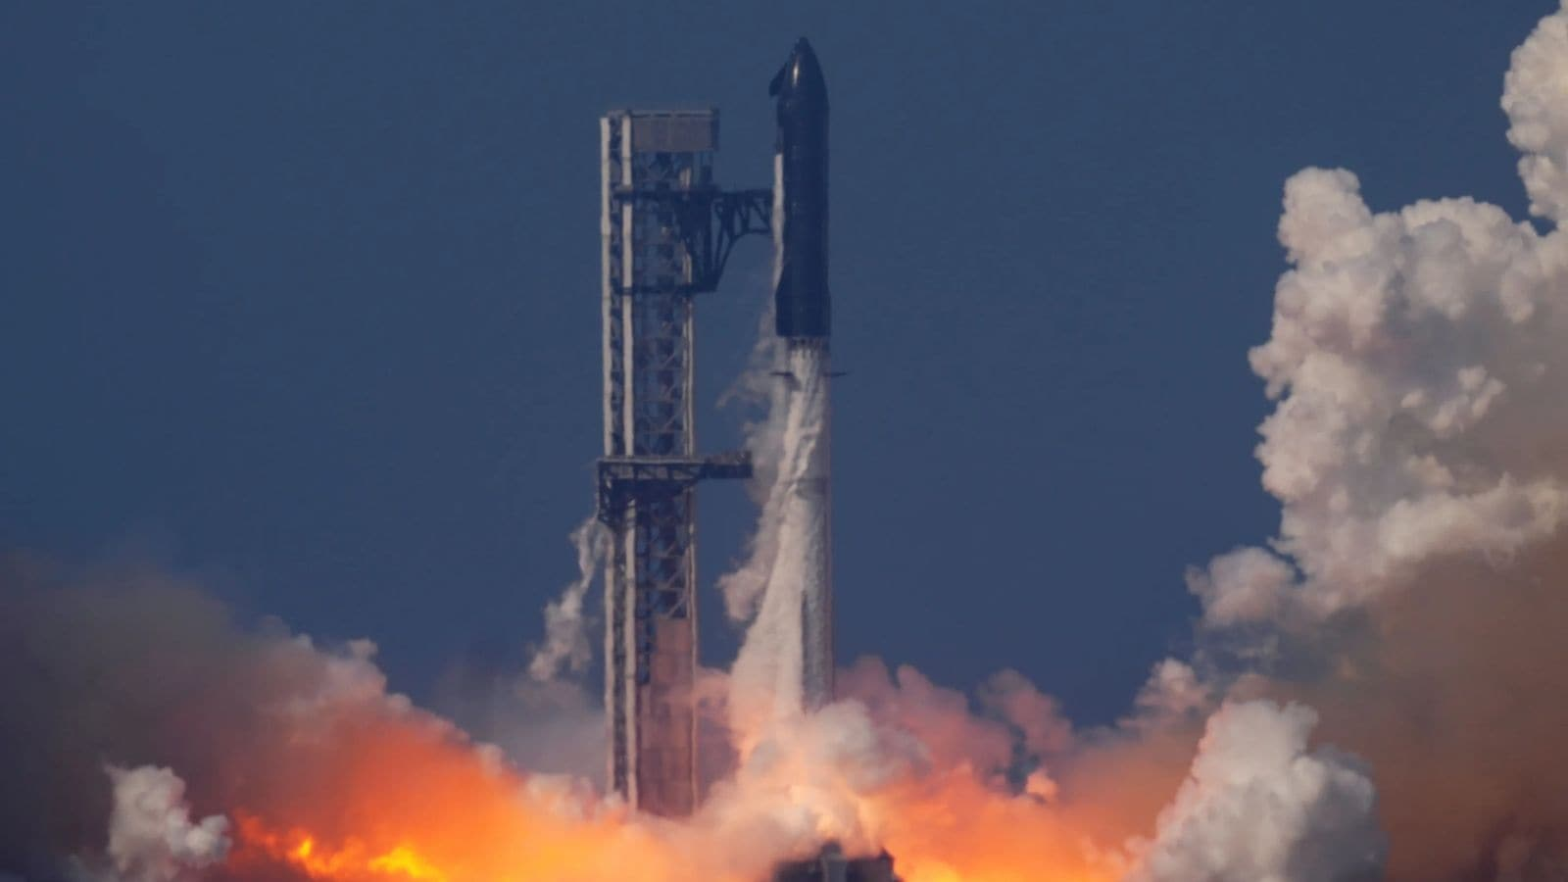

SpaceX launched its biggest, most powerful Starship yet on a test flight Friday, an upgraded version that NASA is counting on to land astronauts on the moon. The redesigned mega rocket made its debut two days after SpaceX CEO Elon Musk announced he's taking the company public. It blasted off from the southern tip of Texas, carrying 20 mock Starlink satellites that were released midway through the hourlong spaceflight that stretched halfway around the world. The spacecraft reached its final destination - the Indian Ocean - despite some engine trouble, before erupting in flames upon impact. That last part was not unexpected, according to SpaceX. Musk called it "an epic" launch and landing. "You scored a goal for humanity," he told his team via X. It's the 12th test flight of the rocket that Musk is building to get people to Mars one day. But first comes the moon and NASA's Artemis program.NASA Administrator Jared Isaacman flew in for the launch, saying Starship is now one step closer to the moon. The last of the old space-skimming Starships lifted off in October. SpaceX's third-generation Starship - a souped-up version dubbed V3 - soared from a brand-new launch pad at Starbase, near the Mexican border. Last-minute pad issues thwarted Thursday evening's launch attempt. There was no fireball this time until the very end. The spacecraft plummeted upright into the Indian Ocean under seemingly full control, then toppled over and ignited. Story continues below this ad While the liftoff itself went well, not all of the engines fired as the booster attempted a controlled return. The spacecraft also had to make do with fewer engines, but kept heading eastward 120 miles (194 kilometers) up. A pair of modified, camera-equipped Starlinks ejected from Starship provided brief views of the spacecraft in flight - a remarkable first.At 407 feet (124 meters), the latest model eclipses the older Starship lines by several feet (more than 1 meter) and packs more engine thrust. The revamped booster sports fewer but bigger and stronger grid fins for steering it back to Earth following liftoff, and a larger and more robust fuel transfer line to feed the 33 main engines. This fuel line is the size of SpaceX's Falcon 9 first-stage booster. The retro-looking, stainless steel spacecraft also has more of everything - more cameras and more navigation and computer power - as well as docking cones for future rendezvous and moon missions. Starship is meant to be fully reusable, with giant mechanical arms at the launch pads to catch the returning rocket stages. But on this latest trial run, nothing was being recovered. The Gulf of Mexico marked the end of the road for the redesigned first-stage booster, and the Indian Ocean for the spacecraft and its satellite demos. NASA is paying SpaceX billions of dollars - and also Jeff Bezos' Blue Origin - to provide the lunar landers that will be used to land Artemis astronauts on the moon.The two companies are scrambling to be first. While Starship has reached the fringes of space on multiple flights lasting an hour at most, Bezos' Blue Moon has yet to lift off, although a prototype is being readied for a moonshot later this year. NASA is following April's successful lunar flyaround by four astronauts with a docking trial run in orbit around Earth planned for next year. For that Artemis III mission, astronauts will practice docking their Orion capsule with Starship, Blue Moon or both. A moon landing by two astronauts - Artemis IV - could follow as soon as 2028 using either Starship or Blue Moon, whichever lander is safer and ready first. It will be NASA's first lunar landing with a crew since 1972's Apollo 17. The goal this time is a moon base near the lunar south pole, staffed by astronauts as well as robots. SpaceX is already taking reservations for private flights to the moon and Mars on Starship.The world's first space tourist, California businessman Dennis Tito, and his wife signed up 3 1/2 years ago for a flight around the moon. The timing is uncertain. This week, another wealthy space tourist - Chinese-born bitcoin investor Chun Wang - announced he will fly to Mars on Starship's first interplanetary mission. Wang previously chartered a SpaceX polar flight in a Dragon capsule last year and, along with his hand-picked crew, became the first to orbit above the north and south poles. No price tag or date was revealed for his Mars cruise.

2. Workshop on Indigenisation of IT Applications - isro.gov.in
"ISRO OR NRSC OR IIRS after:2026-05-22" - Google News
Read more

April 21, 2026 ISRO organized a workshop on "Indigenisation of IT Applications" on April 15, 2026, at ISRO Headquarters, aimed at creating an interactive platform for engagement between ISRO's IT experts and a select group of six startups operating in the IT domain. The workshop witnessed participation from the Associate Scientific Secretary, Director (Promotion Directorate), Indian National Space Promotion and Authorization Center (IN-SPACe), Directors of various programme offices, and domain experts from across ISRO centres. The programme commenced with pitch presentations by the six identified startups, who showcased their technological capabilities and presented customized proposals aligned with ISRO's requirements. This was followed by an insightful talk by the Director, Promotion Directorate, IN-SPACe, providing an overview of Department of Space startup support programmes and the enabling ecosystem for industry participation. Subsequently, the Director, DISM, ISRO Headquarters, delivered a talk highlighting key opportunities for indigenization in critical IT domains. The workshop concluded with an interactive session that facilitated open dialogue and networking, wherein queries from the participating startups were comprehensively addressed by officials from ISRO and IN-SPACe, paving the way for potential collaborations and future engagements.

3. Jitendra Singh congratulates ISRO for successful completion of IADT-02 for Gaganyaan Mission - DD News
"ISRO OR NRSC OR IIRS after:2026-05-22" - Google News
Read more

Union Minister Dr Jitendra Singh on Friday congratulated Indian Space Research Organisation (ISRO) for the successful completion of the Second Integrated Air Drop Test (IADT-02) for Gaganyaan, India's first human spaceflight mission scheduled for launch in 2027. He described the achievement as a significant milestone in preparing for the ambitious mission. Taking to social media platform X, Singh wrote, "Congratulations ISRO for the successful accomplishment of Second Integrated Air Drop Test (IADT-02) for Gaganyaan, India's first Human Space flight scheduled next year." He further noted, "The second Integrated Air Drop Test (IADT-02) was successfully conducted at Satish Dhawan Space Station, Sriharikota. This marks an important milestone towards the readiness for the Gaganyaan mission." India's first human spaceflight will be launched from Sriharikota in 2027. Although the mission has faced multiple delays due to its technological complexity, India has been developing the capabilities indigenously. Notably, such critical spaceflight technologies are closely guarded, and no country shares them. The government has allocated approximately Rs 10,000 crore for the Gaganyaan programme. The mission is now in its final phase, with the first crewed flight expected in the first quarter of 2027. Earlier, on April 8, ISRO Chairman V. Narayanan stated that all preparations for the uncrewed Gaganyaan missions are progressing smoothly. Speaking at the inaugural session of the 2nd International Conference on Smart Spacecraft Mission Operations, he said, "We are meeting just before the first uncrewed Gaganyaan mission. This is no ordinary mission but a crucial one for India. There will be three uncrewed missions before the final crewed launch. All activities for the first mission are progressing well, though challenges remain." The conference was also attended by former ISRO chiefs A.S. Kiran Kumar and S. Somanath, along with ISRO centre directors, students, and representatives from space startups. Meanwhile, India's human spaceflight preparations advanced further on April 4, as four selected astronauts began a high-altitude experiment in Ladakh under the "Mission Mitra" (Mapping of Interoperable Traits and Reliability Assessment). The programme aims to evaluate human performance in extreme environments. The astronauts, including Group Captain Shubhnashu Shukla and P. Balakrishnan Nair, arrived in Leh earlier this week for acclimatisation. The mission is supported by a multidisciplinary team of scientists, engineers, medical experts, and psychologists, marking another crucial step in India's journey towards human space exploration. -IANS

4. ISRO Conferred AIMA Special Award for Public Service Excellence - 2025 - isro.gov.in
"ISRO OR NRSC OR IIRS after:2026-05-22" - Google News
Read more

The Indian Space Research Organisation (ISRO) has been conferred with the "AIMA Special Award for Public Service Excellence for 2025" by the All India Management Association (AIMA). The award was presented during the AIMA Platinum Jubilee (70th) National Leadership Conclave held at New Delhi. At the ceremony, the award was presented by Shri Jyotiraditya M. Scindia, Hon'ble Union Minister, Government of India, to Indian Space Research Organisation (ISRO) and on behalf of Chairman, ISRO / Secretary DoS, the award was received by Shri Dinesh Kumar Singh, Distinguished Scientist and Director of the Human Space Flight Centre (HSFC), ISRO On the occasion, AIMA acknowledged ISRO's sustained efforts in establishing and operationalising space-based systems and applications in support of national development. ISRO's programmes have enabled services across key sectors including agriculture, forestry, communication, tele-education and telemedicine. The Organisation's contributions in regional navigation through NAVIC and its support to disaster management mechanisms were also acknowledged.

5. ISRO's Chandrayaan-3 honored with prestigious 2026 AIAA Goddard Astronautics Award - The Economic Times
"ISRO OR NRSC OR IIRS after:2026-05-22" - Google News
Read more

India's Chandrayaan-3 lunar mission has been honoured with the 2026 Goddard Astronautics Award by the American Institute of Aeronautics and Astronautics (AIAA), presented in Washington DC on May 21. On August 23, 2023, Chandrayaan-3 made history as the first spacecraft to achieve a soft landing near the Moon's south pole -- a region of immense scientific and strategic importance that had never before been explored at the surface level. The mission delivered critical data to support future human missions to the Moon and confirmed the presence of key chemical elements in the lunar south polar soil, pointing to local resources that could one day sustain manufacturing operations on the surface. Show more Show less

6. ISRO completes preliminary design review of Venus Orbiter Mission - MSN
"ISRO OR NRSC OR IIRS after:2026-05-22" - Google News
Read more

ISRO completes preliminary design review of Venus Orbiter Mission MSN

7. ESA's Prodex programme brings scientific research to space
ESA Space Science
Read more
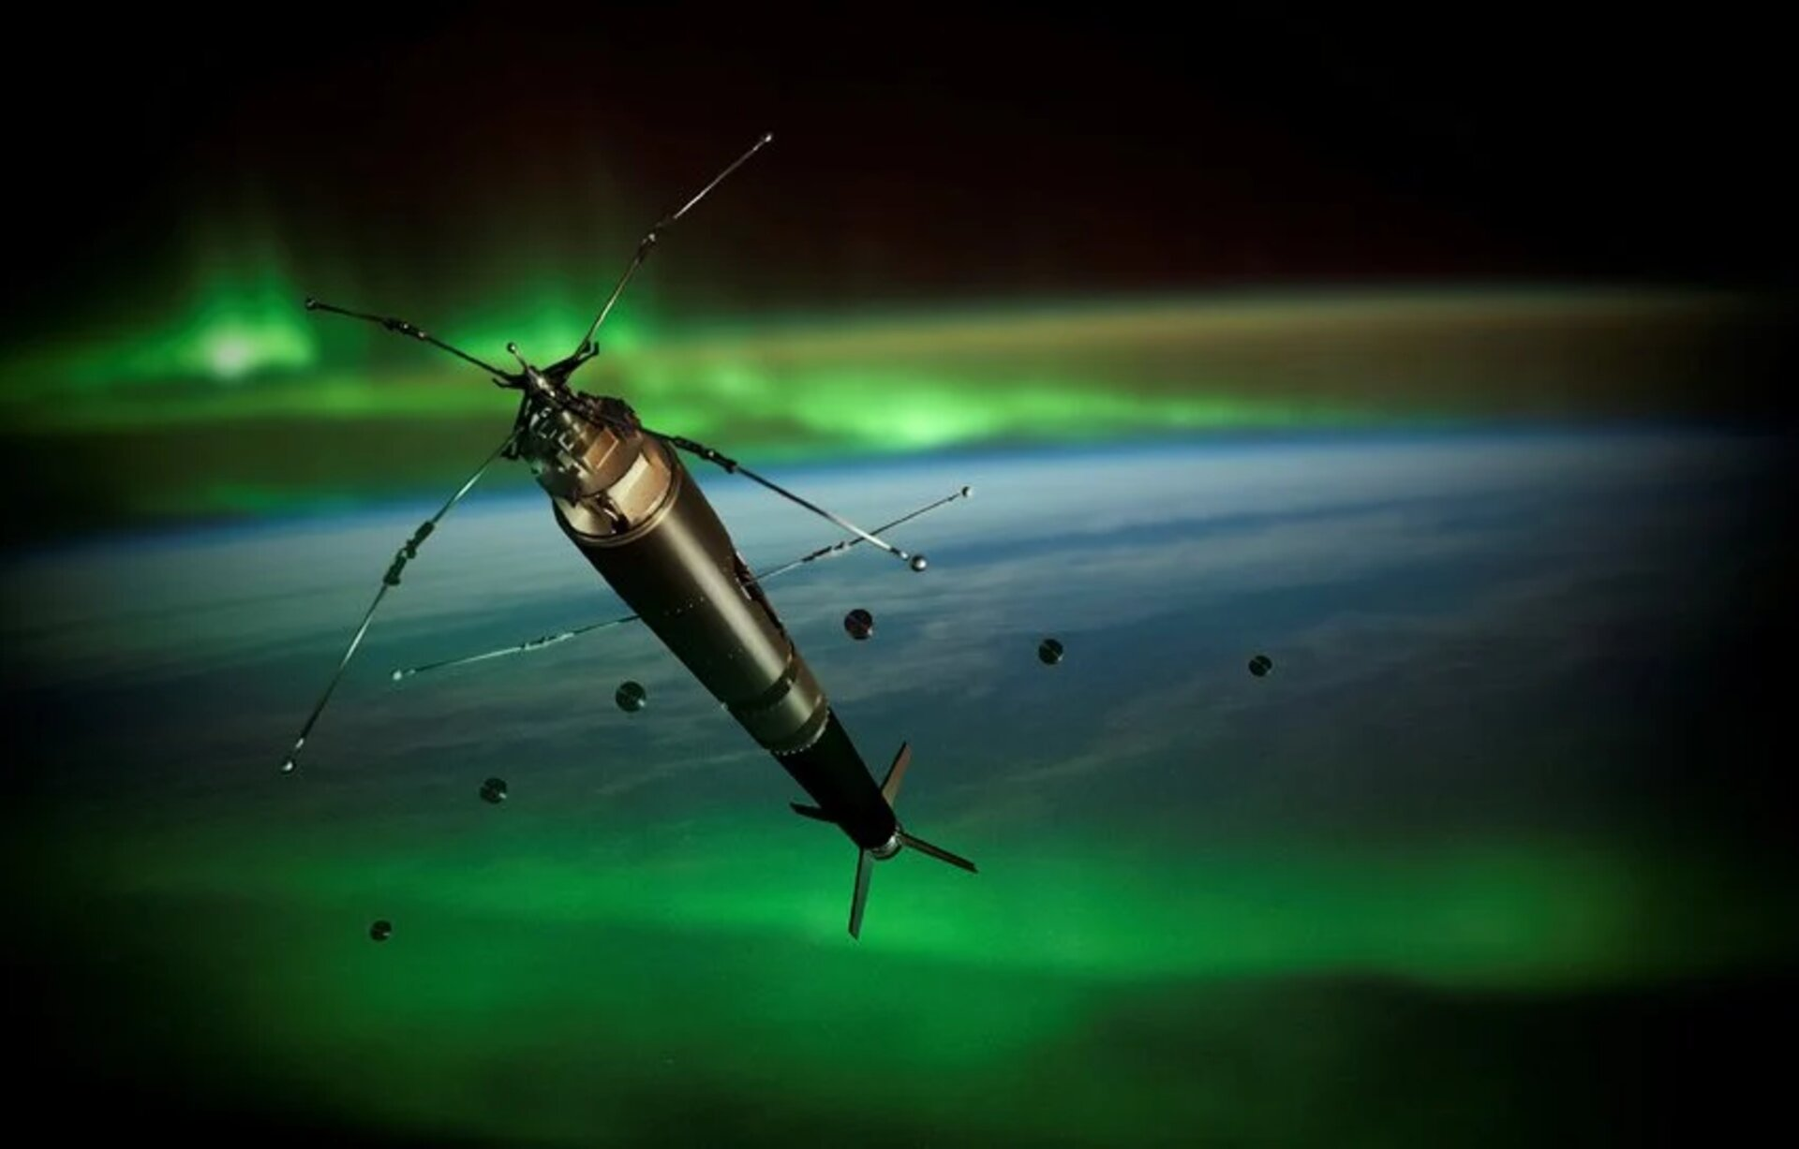

Agency ESA's Prodex programme brings scientific research to space 22/05/2026 388 views 9 likes The launch of the 4DSpace-Daedalus mission in Norway is the latest success supported by Prodex, a European Space Agency (ESA) programme which enables highly skilled research institutes to partake in European space science activities and missions. "ESA currently manages over 400 contracts with institutes and industry within Prodex - the Programme for the development of scientific experiments. "Prodex supports the industrial development of highly sophisticated scientific instruments and experiments in science, Earth observation and microgravity domains for ESA Science missions such as Smile, Plato, Comet Interceptor, Envision, LISA, Exomars, NewAthena, Arrakihs and non-ESA missions such as CLPS, Solar-C, and Polar-2. We are also developing instrumentation and experiments for the International Space Station," said ESA Head of the Prodex Office, Michel Lazerges. At the Ministerial Council 2025, 17 ESA Member States pledged a total of €327.52 million to this optional programme - a 38% increase on the commitment given at the previous Ministerial in 2022. Prodex gives nations the opportunity to build on their scientific know-how, forge industrial and institutional cooperation, and increase their competitiveness in the space domain. A springboard for science instrumentation and experiments Prodex is supporting the development of scientific instruments for a range of ESA missions and activities. Some notable recent successes include: 4DSpace-Daedalus (ICI-5b) sounding rocket Norway's space weather research - The 4DSpace-Daedalus (ICI-5b) mission was coordinated by Oslo University in Norway and funded partly by Prodex. The Norwegian 12m-long sounding rocket with on-board instruments and releasable subpayloads launched on 11 March from Norway's Andøya Space Centre into an auroral substorm. It collected a wealth of data related to turbulence in highly-charged plasma air and in the neutral part of the upper atmosphere. The data will be analysed and used in space weather research and to understand the fundamental processes in energy transfer and couplings within the upper polar atmosphere. Optical Periscopic Imager for Comets (OPIC) Poland and Estonia's comet interceptor instruments Poland's DFP-B2 instrument developed by Space Research Centre Polish Academy of Science (Centrum Badań Kosmicznych PAN) and Estonia's OPIC instrument developed by Tartu University are the first two instruments soon to be delivered to the prime contractor for Probe B2 of ESA's Comet Interceptor Spacecraft. The DFP-A instruments built for the Comet Interceptor mission Further instruments developed in Switzerland, Belgium and Poland will be delivered this year for the Comet Interceptor Spacecraft including the MANiaC instrument, CoCa instrument, RMA instrument, and DFP-A instrument. Belgium's infrared spectrometer for ESA Envision Prodex has a large stake in ESA's Envision mission with 16 contracts to develop the infrared spectrometer called VenSpec-H which will study the atmospheric composition of Venus. The Smile mission ESA's Smile mission will improve our understanding of space weather and solar storms and launched on 19 May 2026 with several instruments developed with the support of the Prodex programme. Prodex celebrates 40 years The Prodex programme, founded in 1986, turns 40 this year. A three-day celebration event to mark this will be held in Switzerland with delegations and representatives from all Prodex participating states (Austria, Belgium, Switzerland, Czech Republic, Denmark, Estonia, Spain, Finland, Greece, Hungary, Ireland, the Netherlands, Norway, Poland, Portugal, Romania, Slovenia). About 200 participants are expected.

8. Call for Creatives: NASA Seeks Help Illuminating Mission Storytelling
NASA
Read more

Credit: NASA As NASA pushes the boundaries of exploration and innovation for the benefit of humanity, the agency is looking for partners to share mission stories covering Artemis Moon missions, nuclear propulsion, aeronautics, and more. NASA published an Announcement for Proposals on May 21 asking filmmakers, documentarians, songwriters, storytellers, poets, and others to submit proposals to partner with the agency by Tuesday, June 30. In this initial round, NASA is seeking up to 10 partners for unfunded Space Act Agreements to share the stories behind, and insights into, multiple NASA missions, including, but not limited to, the following: Artemis program, including the recently added Artemis III mission in 2027, and Artemis IV lunar landing in 2028, as well as plans for the agency to develop a Moon Base. Learn more about Artemis on the agency's website. NASA's advancement of nuclear propulsion, including the Space Reactor-1 Freedom mission to Mars in 2028 carrying the Skyfall payload. NASA's cutting-edge aviation work through flight tests and other efforts. While this opportunity is focused on U.S. creators, the agency will consider proposals with a minority of international participants. Proposals should detail which area of focus is desired, funding and distribution arrangements, and any specifics needs from NASA to move forward (access to facilities, personnel, etc.). Full requirements and other details are available online: https://go.nasa.gov/CreatorProposals -end- Camille Gallo / Cheryl Warner Headquarters, Washington 202-358-1600 camille.m.gallo@nasa.gov / cheryl.m.warner@nasa.gov

9. NASA Sets Coverage for Roscosmos Spacewalk Outside Space Station
NASA
Read more

Roscosmos cosmonaut Sergey Ryzhikov is pictured at the end of the European robotic arm as he works on a high‑resolution camera during a six‑hour, nine‑minute spacewalk outside the International Space Station on Oct. 16, 2025. Credit: NASA NASA will provide live coverage on Wednesday, May 27, as two Roscosmos cosmonauts conduct a spacewalk outside the International Space Station. The spacewalk is scheduled to begin at approximately 10:15 a.m. EDT and last roughly five hours. Watch NASA's live coverage beginning at 9:45 a.m. on NASA+, Amazon Prime, and the agency's YouTube channel. Learn how to watch NASA content through a variety of online platforms, including social media. International Space Station Expedition 74 commander Sergey Kud-Sverchkov and flight engineer Sergei Mikaev will install a solar radiation experiment on the Zvezda service module and remove other science hardware from the Poisk and Nauka modules of the orbiting complex's Roscosmos segment. If time allows, the duo also will photograph one of the Progress 94 cargo spacecraft's Kurs rendezvous antennas, which failed to deploy in March following its launch to the space station. This Roscosmos spacewalk will be the second for Kud-Sverchkov and the first for Mikaev. Kud-Sverchkov will wear a spacesuit with red stripes, and Mikaev will wear a spacesuit with blue stripes. It will be the 279th spacewalk in support of space station assembly, maintenance, and upgrades. To learn more about International Space Station research, operations, and its crews, visit: https://www.nasa.gov/station -end- Josh Finch / Jimi Russell Headquarters, Washington 202-358-1100 joshua.a.finch@nasa.gov / james.j.russell@nasa.gov Sandra Jones Johnson Space Center, Houston 281-483-5111 sandra.p.jones@nasa.gov

10. Keeping NASA Flying: Ground Crews Ensure Aircraft Readiness
NASA
Read more
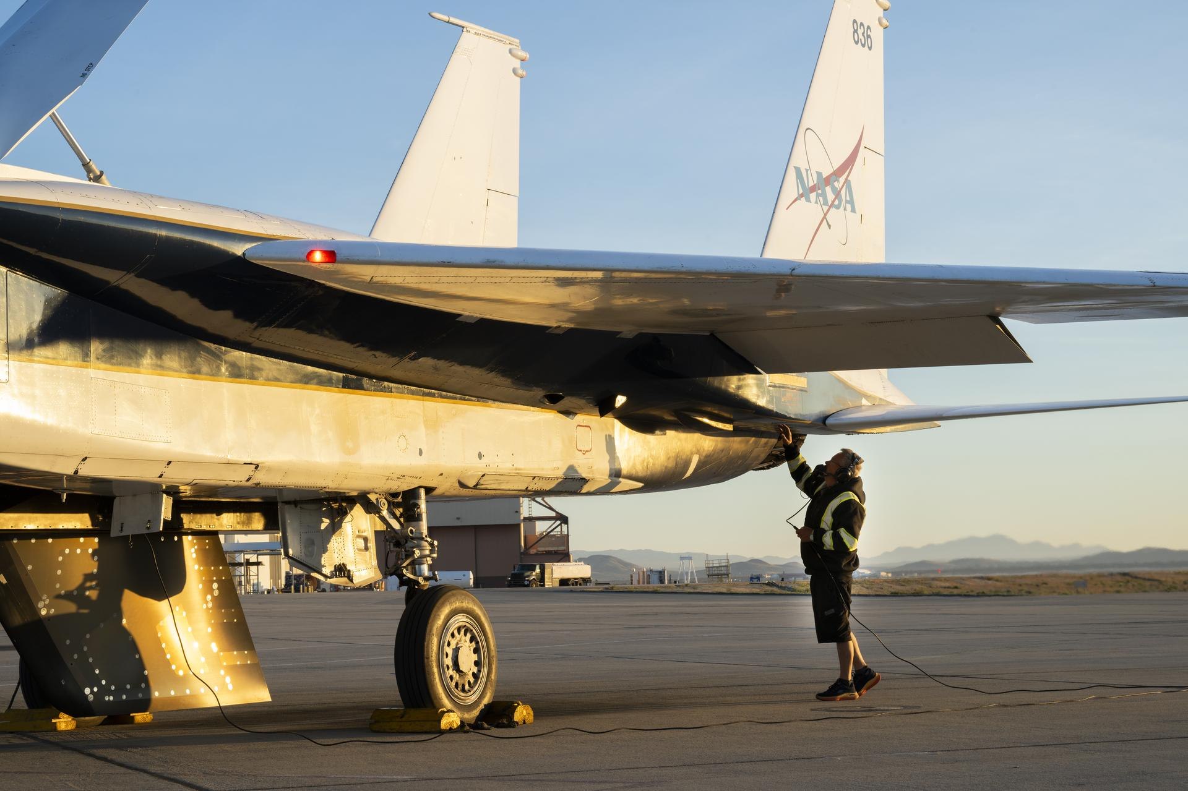

NASA crew chief Walt Kondracki checks an F-15 aircraft Tuesday, March 17, 2026, at NASA's Armstrong Flight Research Center in Edwards, California. Ground crews, made of various roles, maintain the aircraft to be ready for each mission. NASA/Carla Escamilla From high‑speed research flights to high‑altitude science campaigns, NASA depends on aircraft that perform at their best and the ground crews who keep them mission ready. At NASA's Armstrong Flight Research Center in Edwards, California, specially trained maintenance crews are essential to keeping the agency's aircraft flying safely and reliably. This year, NASA added two F-15s and a Pilatus PC-12 to its fleet at Armstrong. These aircraft - alongside platforms such as the high-altitude ER-2s and NASA's newest X-plane, the X-59 - reflect a wide range of capabilities. The maintenance staff is responsible for keeping each one mission ready. NASA pilot Nils Larson, left, walks next to crew chief Walt Kondracki, right, by an F-15 aircraft Tuesday, Jan. 13, 2026, at NASA's Armstrong Flight Research Center in Edwards, California. In the background, NASA mechanic Tim Logan secures the cockpit inside of the F-15, and flight test engineer A.J. Jaffe stands to the right. NASA/Christopher LC Clark "That's the beauty of our Armstrong maintenance teams. They adapt to any type of change," said Jose "Manny" Rodriguez, NASA Armstrong Gulfstream G-IV crew chief. "One day you could have an instrument being loaded, and the next day it may be aircraft reconfiguration, all while other aircraft systems may need fixing. They adapt and they overcome any situation." Each aircraft supports a specific mission, whether it's conducting science research, serving as a support or chase aircraft, or assisting NASA rocket launches. The aircraft fly at different speeds, carry specialized hardware, and require maintenance crews to stay agile with fast-paced changes. To ensure NASA can make aeronautics and science advancements safely, the crews work continuously, checking on the ejection seats, filling the tanks with fuel, and changing out brakes, wheels, wiring, and hardware constantly, all of which can degrade with each flight. From left, NASA avionics technician Jesse Orellana; quality assurance employee Jose Prieto; mechanic Francisco Rodriguez; and mechanic Vincent Moreno work on an ER-2 aircraft Monday, Jan. 26, 2026, at NASA's Armstrong Flight Research Center in Edwards, California. NASA/Christopher LC Clark On any given day, an aircraft may be flight-ready for a mission, undergoing scheduled maintenance or modifications, or down for longer-term care. There are typically multiple NASA Armstrong aircraft in the air in one day. Currently, the center's C-20A is flying in Peru and Panama, the X-59 is often flying twice per day with a chase plane, and the center's ER-2 is flying in Colorado, supporting the Geological Earth Mapping Experiment (GEMx). All this work is happening at the same time, and Armstrong's skilled maintenance staff is prepping and fixing aircraft as needed along the way. The team includes mechanics with both military and civilian backgrounds, and the job involves a lot of on-the-job training. Maintenance crews are composed of: a crew chief - the person in charge of the airplane an avionics technician, who specializes in navigation, communication, and flight control systems quality assurance personnel, who oversee the work being done additional mechanics assigned to each airplane After the maintenance crew ensures the aircraft is in the best condition possible, the team tows it out to the flightline, and it becomes ready for operations. The NASA pilot assigned to the mission will walk around the aircraft with the assigned crew chief for a final safety check before flight. "There is a crew chief assigned to every aircraft," Rodriguez said. "The crew chief is responsible for the integrity of that aircraft, and at the end of the day, his signature and the pilot's together are what constitutes that the aircraft is safe for flight." Maintenance crews track each flight to help ensure it completes the mission without returning early. If an aircraft does return to base early, the maintenance team stands ready. When it lands, the crew is right there again, helping the research team complete the mission and fixing whatever is needed to stay nimble and ready for the next flight. "It's difficult at times to work with different airplanes from both the civilian and military sides, but it's very rewarding to see that we have the capability and the expertise to keep these aircraft flying," Rodriguez said.

11. NASA to Compete Contract for Jet Propulsion Laboratory Management
NASA
Read more

NASA's Jet Propulsion Laboratory in Southern California. Credit: NASA NASA announced plans Friday to compete the next contract for managing and operating the agency's federally funded research and development center (FFRDC) in Southern California at the Jet Propulsion Laboratory (JPL), to ensure continued accountability and strong value for U.S. taxpayers. The California Institute of Technology (Caltech) has managed the laboratory since its inception in the 1930s, and previous NASA contracts for its management and operations have been awarded sole source to the university since the facility was transferred from the U.S. Army to NASA in 1958. The rapid growth of the U.S. space economy indicates there may now be a viable competitive market for programmatic and institutional elements of the FFRDC operations. Conducting a competition for this contract enables NASA to assess the potential benefits of alternative management approaches to the FFRDC, including opportunities to enhance mission performance, innovation, and overall cost and operational efficiency, consistent with federal competition requirements. This decision is part of a broader governmentwide and agency effort to find efficiencies, strengthen performance, and drive mission outcomes faster and more affordably. "The Jet Propulsion Laboratory has delivered some of the most extraordinary scientific and engineering achievements in NASA's history," said NASA Administrator Jared Isaacman. "As America's space economy evolves, we have a responsibility to the American people and the scientific community to evaluate how we can execute faster, operate more efficiently, and continue to deliver world-class science and engineering at the highest level. The decision to compete this contract reflects NASA's commitment to strong stewardship of taxpayer resources and positions Jet Propulsion Laboratory to continue driving world-changing scientific discovery and technological innovation for decades to come." The work conducted at JPL remains critically important to the agency, and NASA is committed to maintaining continuity for active and future missions throughout the procurement process. NASA also is committed to maintaining the FFRDC's existing physical location. This approach is consistent with broader government practices, including at the Department of Energy, which has held full and open competitions for five of its 16 FFRDC management and operations contracts over the past 10 years. The current contract with Caltech began Oct. 1, 2018, and runs through Sept. 30, 2028, with a potential maximum value of $30 billion, if all options are exercised. NASA has initiated the procurement process to compete the contract. Beginning this process now allows the agency sufficient time to conduct a comprehensive competition and award cycle while maintaining continuity for ongoing missions and laboratory operations. For information about NASA and agency programs, visit: https://www.nasa.gov -end- George Alderman / Cheryl Warner Headquarters, Washington 202-358-1600 george.a.alderman@nasa.gov / cheryl.m.warner@nasa.gov

12. NASA Announces Realignment to Accelerate Mission Delivery
NASA
Read more

Credit: NASA Editor's Note: This advisory was updated May 22, 2026 to include a retirement. NASA announced Friday an agencywide realignment to increase mission focus and move out on the National Space Policy. These changes position the agency to better deliver on the nation's highest‑priority objectives with speed and efficiency. During the Ignition event in late March, NASA Administrator Jared Isaacman and agency leaders outlined the most pressing objectives to deliver on the next chapter of American leadership in space. President Trump's Executive Order Ensuring American Space Superiority, otherwise known as the National Space Policy, directed NASA to focus talent and resources on objectives including accelerating the Artemis program, establishing a Moon Base, developing a nuclear space reactor, igniting the orbital economy, and expanding missions of science and discovery. To support the agency's ambitious short- and long-term goals, NASA is taking action to increase specialization at centers and integrate mission directorates, elevating delivery of technically excellent work. Some of these actions include: Center directors will continue reporting to Associate Administrator Amit Kshatriya, empowered to foster the unique capabilities of each center, and strengthen investments in infrastructure and the health of their workforce. Mission directorates will now report directly to the administrator, ensuring focus on the mission and enabling them to leverage resources across centers, industry, and international partnerships with greater speed and efficiency. The associate administrator also now serves as NASA chief engineer, reinforcing the agency's technical backbone and ensuring continuity and autonomy in critical engineering decisions. The agency continues to focus on rebuilding core competencies, insourcing contractors to civil servants where appropriate, strengthening the intern pipeline, and leveraging the agency's joint recruitment initiative with the U.S. Office of Personnel Management, NASA Force, to build a strong, sustainable workforce for generations to come. "This initiative reflects NASA's extreme focus on executing the mission in direct support of the National Space Policy. We are focusing resources on the most pressing objectives only NASA is capable of undertaking and liberating the workforce from unnecessary bureaucracy and obstacles that impede progress. We aim to rebuild competencies and instill a culture that attracts the best and brightest capable of pursuing the most demanding engineering challenges and moving safely and urgently," said Isaacman. "There will be no reduction in force, no program cancellations, no closures, but we will achieve cost savings through more efficient execution and taking an active role in delivering the outcomes the world has been waiting for from NASA. This is how we deliver on the mission, meet the moment, and continue to make history on behalf of the American people." Mission directorate realignment is as follows: Human Spaceflight Mission Directorate (HSMD): With human spaceflight operational to both low Earth orbit and the Moon, the Exploration Systems Development Mission Directorate and Space Operations Mission Directorate will unify as HSMD. With human spaceflight operational to both low Earth orbit and the Moon, the Exploration Systems Development Mission Directorate and Space Operations Mission Directorate will unify as HSMD. Research and Technology Mission Directorate (RTMD): NASA will integrate the Aeronautics Research Mission Directorate and Space Technology Mission Directorate into the new RTMD. As a combined research, space technology, and aeronautics organization charged with nuclear power and propulsion development, RTMD will ensure NASA has the capabilities needed for the mission of today and the future. NASA will integrate the Aeronautics Research Mission Directorate and Space Technology Mission Directorate into the new RTMD. As a combined research, space technology, and aeronautics organization charged with nuclear power and propulsion development, RTMD will ensure NASA has the capabilities needed for the mission of today and the future. Science Mission Directorate (SMD): Remains unchanged and continues to provide the foundation for NASA's world‑leading scientific discovery. Additional leadership roles, in alphabetical order, include: John Bailey, associate administrator, Mission Support Directorate Kevin Coggins, director, SCaN (Space Communications and Navigation), RTMD Wesley Deadrick, director, Katherine Johnson IV&V Facility Jamie Dunn, director, NASA's Goddard Space Flight Center Carlos García-Galán, program manager, Moon Base, HSMD Dr. Lori Glaze, associate administrator, HSMD Laurie Grindle, director, Aeronautics Division, RTMD Marvin Horne, deputy assistant administrator for Procurement Brian Hughes, director, NASA's Kennedy Space Center Kathleen Karika, associate administrator, Office of International and Interagency Relations, OIIR Dr. James Kenyon, associate administrator, RTMD Kelvin Manning, deputy associate administrator, HSMD Meredith McKay, deputy associate administrator, OIIR Dave Mitchell, special assignment lead for NASA Headquarters Relocation Joel Montalbano, deputy associate administrator, HSMD Bradley Niese, associate administrator for Procurement Eli Ouder, acting deputy associate administrator, Mission Support Directorate Jeremy Parsons, program manager, Artemis, HSMD Bob Pearce to retire as head of ARMD after an amazing 36-year career at NASA Wanda Peters, deputy associate administrator, RTMD Dawn Schaible, director, NASA's Glenn Research Center Cynthia Simmons, deputy director, NASA's Goddard Space Flight Center Steve Sinacore, acting director, Space Reactor Office; program manager for SR-1, LR-1, RTMD Adam Steltzner, chief engineer for Special Projects Greg Stover, director, Advanced Research and Technology Division, RTMD Dana Weigel, program manager, Low Earth Orbit, HSMD Leadership at unlisted centers remains unchanged. For more, please visit: https://www.nasa.gov/nasa-leadership -end- Bethany Stevens / Camille Gallo Headquarters, Washington 202-358-1600 bethany.c.stevens@nasa.gov / camille.m.gallo@nasa.gov

13. New Material Could Help NASA Melt Moon Rocks, Harness Lunar Resources
NASA
Read more

Researchers Dr. Kevin Yu, left, and Dr. Jamesa Stokes prepare to remove a sample of a new material they discovered from a furnace inside a laboratory at NASA's Glenn Research Center in Cleveland in October 2024. Quenching, or bringing the temperature of the sample down as quickly as possible, helps to ensure no more reactions occur as the sample cools so scientists can focus on studying how it behaves at high temperatures. NASA/Jef Janis A material recently discovered and tested at NASA's Glenn Research Center in Cleveland could help astronauts pack lighter for future missions to the Moon. NASA is researching ways explorers could "live off the land" by harnessing lunar resources, including melting Moon rocks to extract metals for building infrastructure and oxygen for fuel and life support. As part of a graduate fellowship through the agency's Space Technology Graduate Research Opportunities, Dr. Kevin Yu, who now works as a technologist at NASA's Jet Propulsion Laboratory in Southern California, teamed up with Dr. Jamesa Stokes, a materials research engineer at NASA Glenn, to study how a variety of substances interacted with liquefied Moon dust. You could call it lava, because it's basically rocks that are crushed up and then melted. It's very corrosive, and it will very quickly eat through a lot of commonly used refractory, or heat-resistant, materials. Dr. kevin yu Technologist at NASA's Jet Propulsion Laboratory About six months into their research, Stokes and Yu realized they'd stumbled across something promising and entirely new. After combining simulated lunar dust with a compound called scandium oxide and heat treating the mixture using a red-hot furnace, they discovered that an unknown material had formed. The researchers checked and double-checked their work, but the material didn't match any of the more than 1 million substances in their X-ray analysis database. A sample of the new material researchers discovered at NASA's Glenn Research Center in Cleveland sits inside a platinum crucible, or heat-resistant container, after being removed from a high-temperature furnace. Behind the silver-colored container is a dome that protects the sample during handling. NASA/Jef Janis Nothing about the material had ever been studied before, so the team started from scratch, measuring the substance's chemical composition. To make small, isolated samples and continue testing how it reacted with molten Moon dust, they used special grinding and mixing equipment in their laboratory to crush up around eight basic oxide components in ethyl alcohol before baking the mixture at more than 2,900 degrees Fahrenheit inside the furnace. "It's actually a very cool-looking powder; it goes in pink, almost like strawberry milk," Yu said. "It has a built-in color indicator, so by the time you're done with it, it turns to a light beige or tan color, and that's how you know the reaction has proceeded the way you wanted it to." The pink powder shown at the far right is used to make the new material researchers discovered at NASA's Glenn Research Center in Cleveland. The other powders to the left are two types of simulated Moon dirt used to represent dust from both the brighter regions of its surface (referred to as lunar highlands) and the darker regions (referred to as lunar maria). NASA/Jef Janis After analyzing their results, the team found that the new substance isn't corroded too quickly by the molten Moon dirt and can withstand the high temperatures needed to melt it - up to six times hotter than the oven in your kitchen. While it's made with scandium oxide, which can be expensive, it costs much less than precious metals like platinum that would normally be used in these types of high-temperature processes. The researchers' insights could help influence NASA's designs for a future technology that would extract resources from Moon rocks, and the new material could be used to make the pipes or basins holding molten dust inside this potential technology. The new material's characteristics also could prove ideal for making coatings that protect parts inside of jet engines, which can reach similarly scorching temperatures. The researchers found it is lighter, less dense, and better at insulating heat than current state-of-the-art coating materials. Researchers Dr. Jamesa Stokes, left, and Dr. Kevin Yu pose for a portrait inside of a laboratory at NASA's Glenn Research Center in Cleveland in October 2024. NASA/Jef Janis While Yu and Stokes have now completed their initial tests, they hope to fine-tune the material in the future to purify it and make it even more affordable to produce. Materials research will be integral to exploring the harsh environments of the Moon and beyond. You can have the best idea in the world for a structure or a vehicle, but if you don't have the materials that have the right properties to make your vision come true, it's not going to succeed no matter how well you design it. Dr. Jamesa stokes Materials Research Engineer at NASA Glenn Studying new materials also advances NASA's work on Earth. "I think trying to push what's possible with materials also allows for a lot of breakthroughs on the terrestrial side. Having a better understanding of materials for all sorts of applications is what gets me excited to go to work in the morning," Yu said. "That's why I love NASA's mission; it's for the benefit of all." This materials research is supported by NASA's Space Technology Mission Directorate and NASA's Aeronautics Research Mission Directorate. For more information, visit: https://www.nasa.gov/

14. Hubble Captures Galaxy Cluster
NASA
Read more


NASA's Hubble Space Telescope captured this scene of galaxy cluster MACS J1141.6-1905 in visible and infrared light. NASA, ESA, H. Ebeling (University of Hawaii); Image Processing: G. Kober (NASA/Catholic University of America) Look closely at this image from NASA's Hubble Space Telescope and you'll see galaxies of various shapes and sizes clustered together toward the center-left of the image. A few foreground stars shine brightly and are easily distinguished by the spikes that appear to extend outward from each star. These spikes, called diffraction spikes, are the result of how point sources of light (such as stars) bend, or diffract, around the supports for Hubble's secondary mirror. Hubble captured this scene of MACS J1141.6-1905 in visible and infrared light. The image includes data from two Hubble observing programs that looked at massive galaxy clusters that shine very brightly in X-rays. Both programs were looking for distant galaxies gravitationally lensed by the cluster. They also wanted to better understand the physical nature of interactions at each cluster's core. An extra bonus was the addition of Hubble's visible and infrared observations of these very bright X-ray clusters to its archive. Hubble's archive of 1.7 million observations, and counting, is a valuable tool for current and future astronomers. They can mine Hubble's 36 years of observations and examine the data with new tools, enabling researchers to make new discoveries. MACS J1141.6-1905 is around four billion light-years away in the constellation Crater (the Cup). Media Contact: Claire Andreoli NASA's Goddard Space Flight Center, Greenbelt, MD claire.andreoli@nasa.gov

