संकलन
SANKALAN
17th August 2026 to 23rd August 2026
ई-न्यूज़लेटर | e-Newsletter

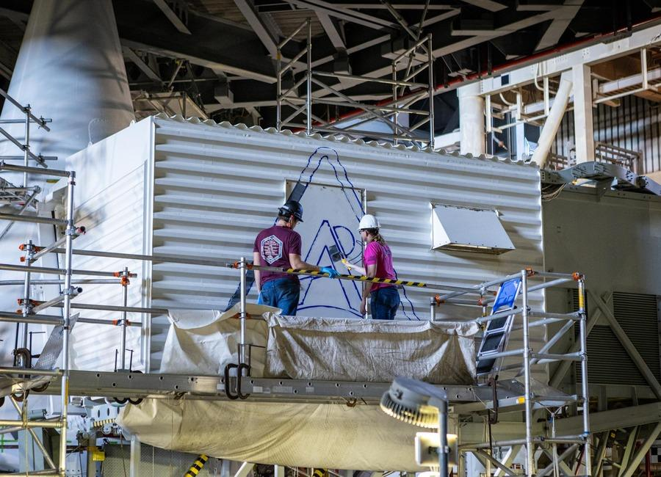 | 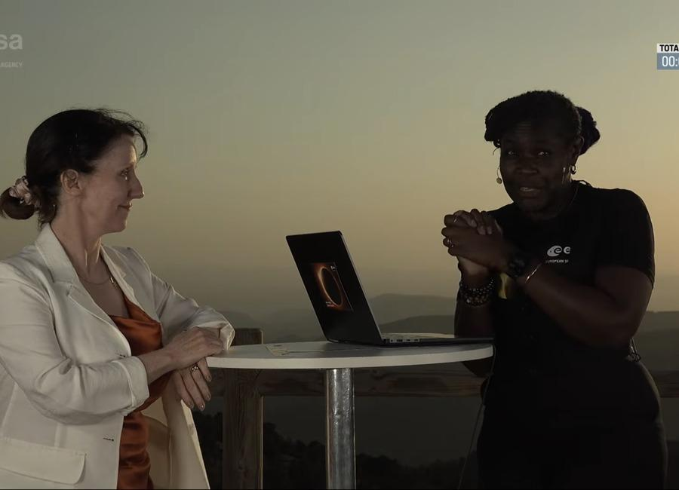 | 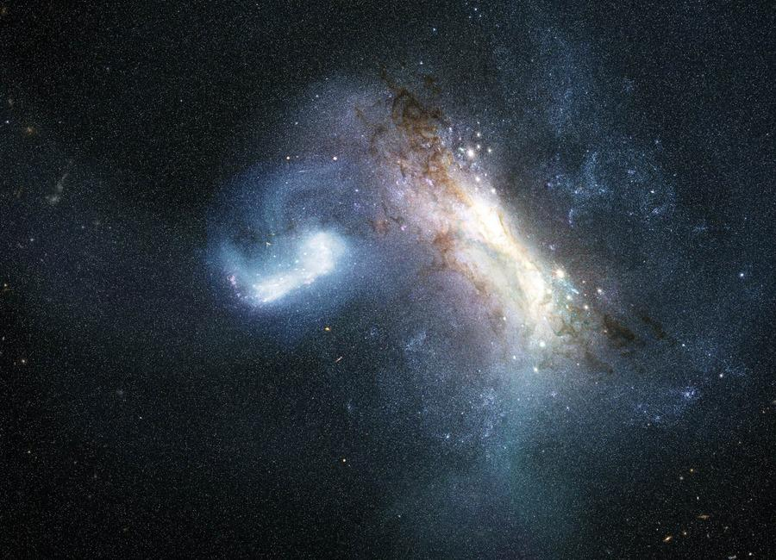
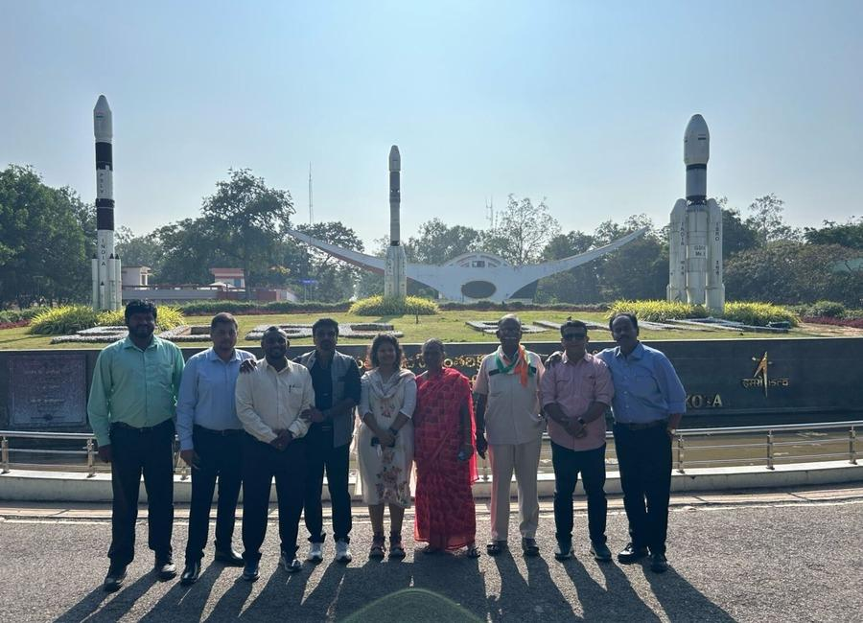 | 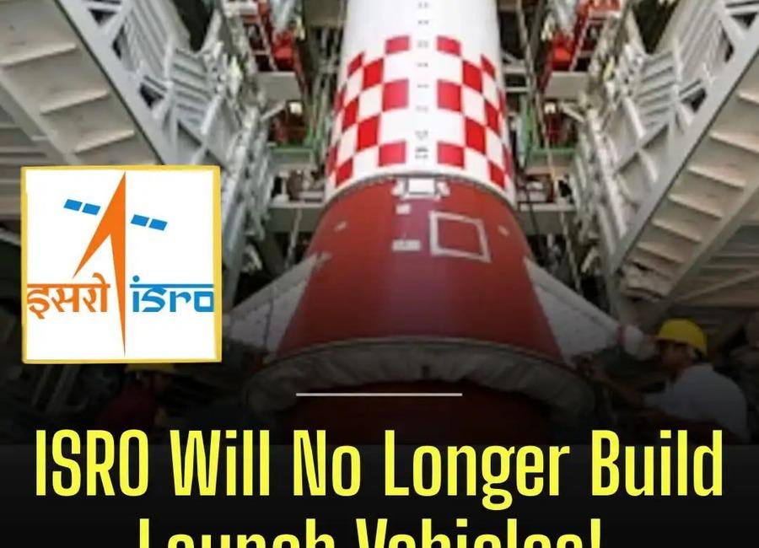 | 
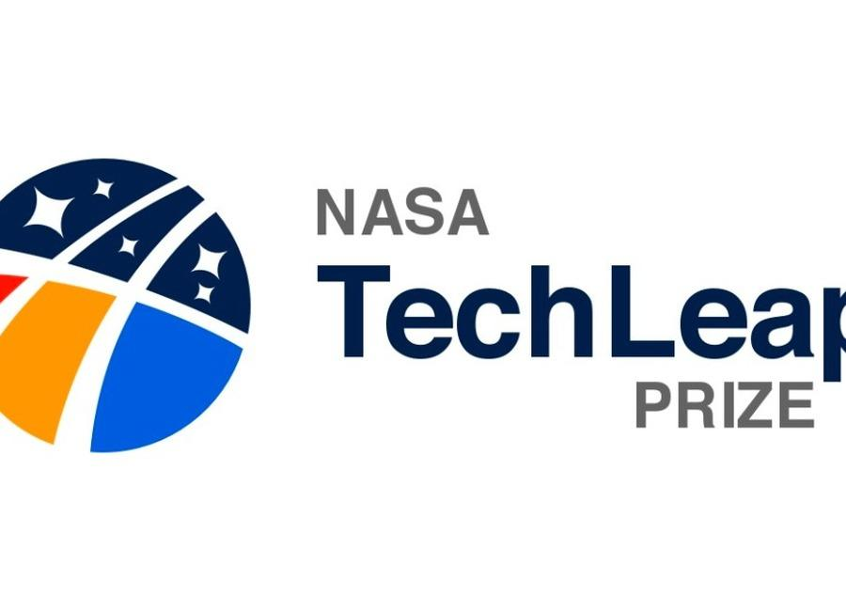 | 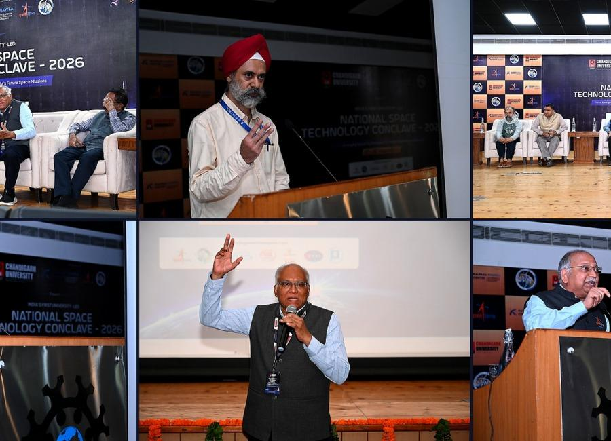 | 

Indian Institute of Remote Sensing (ISRO), Dehradun
Collection of recent developments in the realms of Space Technology

Table of Contents
S. No. | Title
1 | Cyber Kushti 2026: NIELIT launches national challenge to test human judgment in the age of AI
2 | Tripura's National Awardee Presided Dias Of ISRO NASA NCRTS Veterans Conferred Sarabhai Student Scientist & Teacher Scientist Award 2026 With Recall For Vikram Sarabhai's Leapfrog Vision. - TRIPURA STAR NEWS
3 | Andaman Media Team Gets Rare Opportunity to Visit Satish Dhawan Space Centre, Sriharikota - ANDAMAN SHEEKHA
4 | Astronaut Shubhanshu Shukla at Idea Exchange: 'Today's kids are brilliant… you have to be with a dream for a long time, work on it, only then will it happen' - The Indian Express
5 | NASA funds spherical 'Aerobots' that could explore the caves of Saturn's moon Titan
6 | Artemis II pilot thanks NASA for letting him fly Orion by hand: 'I'm still blown away by that trust'
7 | New record! SpaceX launches 2 Falcon 9 rockets just 38 minutes apart (video)
8 | Hubble & Gaia solve our galaxy's merger mystery
9 | Total solar eclipse 2026 (Official ESA broadcast)
10 | NASA Selects Companies to Provide Payload Processing Services
11 | NASA Challenge Tests Wheel Designs for Moon Base Mobility
12 | China bounces back from Long March rocket explosion with back-to-back launches (video)
13 | Blue Origin adding second pad to Cape Canaveral launch complex amid rocket explosion repairs
14 | ISRO Experts Highlight AI and Quantum Technology for Future Indian Satellites - The Quantum Insider
15 | ISRO Scientist Recruitment 2026: Apply for 92 Posts - educationtoday.co
16 | ISRO official says docking technology key to future lunar, human space - Daily Excelsior
17 | Watch SpaceX launch its 100th mission of the year tonight
18 | Hubble, James Webb Space Telescope team up to capture the 'Black Eye Galaxy' | Space photo of the day for Aug. 18, 2026
19 | Live coverage: SpaceX to send Starlink satellites to orbit with Tuesday night launch from California
20 | India's Satellites Will Use AI And Quantum Tech, ISRO Experts Say - Quantum Zeitgeist
21 | AI, Quantum Tech to Power India's Next-Gen Satellites and Strengthen National Security: ISRO Experts at National Space Technology Conclave 2026 - Business Standard
22 | NASA TechLeap Prize: Orbital Clarity Challenge
23 | NASA Updates Next Steps for Commercial Swift Boost Mission
24 | Human-Related Microbes May Survive Moon's South Pole, NASA Finds
25 | NASA Establishes State Hubs to Grow Technical Aerospace Workforce
26 | Behind the Lens: Meet NASA Johnson's Photographers
27 | Private mission to save NASA's Swift space telescope fails
28 | Scientists create 'laundry gun' for astronauts to clean their clothes by shooting out plasma
29 | A SpaceX rocket slammed into the moon this month - and a NASA spacecraft has spotted its lunar grave (photos)
30 | ISRO's Former Chief S Somnath Appointed To RBI Board - NDTV
31 | ISRO Recruitment 2026 Notification Out for 267 Posts, Today is The Last Date - Adda247
32 | From Intel to ISRO: IIT Delhi alumnus quits high-paying job, secures AIR 7 as scientist - Business Today
33 | Former ISRO Chairman Panicker appointed Director on RBI's Central Board; Anand Mahindra re-appointed - BusinessLine
34 | Artemis Mission Patches
35 | NASA Selects University Teams to Help Advance Aviation Research
36 | NASA Data Feeds River Forecasts as Snow Drought Effects Linger
37 | China's Chang'e 7 moon probe will launch this weekend on the most ambitious lunar mission in history
38 | A weather satellite 22,000 miles above Earth saved my 2026 total solar eclipse cruise on the Mediterranean Sea
39 | On this day in space! Aug. 20, 1977: Voyager 2 launches to the outer planets
40 | Rocket Lab launches private Japanese Earth-observing satellite to orbit (video)
41 | Last-minute abort stalls Cape Canaveral Starlink mission
42 | Isro will not make any launch vehicle, all tech to be handed to private sector - India Today
43 | Former ISRO chairman Somanath appointed to Central Board of Directors of RBI - Manorama Yearbook
44 | Explainer: ISRO's SS1 upgrade set to supercharge India's small satellite launch vehicle - organiser.org
45 | Trump signs new national space policy to enable 1,000 US rocket launches per year
46 | Trump to award NASA's Artemis II astronauts the Congressional Space Medal of Honor
47 | Japan unveils Mars moon sample-return spacecraft ahead of Oct. 19 launch (photos)
48 | SpaceX launches 29 Starlink satellites, lands rocket on ship at sea (video, photos)
49 | Live coverage: SpaceX to launch 100th orbital mission of 2026
50 | Interplanetary spacecraft capture a coronal mass ejection component hidden from Earth
51 | China is launching a moon mission to find water ice
52 | Illegal homestays and B&Bs thrive sans registration
53 | #ISRO#IndianSpaceProgram #SpaceTech#INSPACe #ZeeNewsEnglish - AIMA Media
54 | Meet the IIT Bombay engineer who turned down ISRO to build Rs 1,000 crore Atomberg - India Today
55 | ISRO Will Not Make Launch Vehicles; Technology To Be Handed Over To Private Sector: Pawan Goenka - ETV Bharat
56 | ISRO Mulls Exiting Manufacturing Amid India's Push To Promote Privatisation In The Space Industry - Inc42
57 | How will NASA's astronaut training hub change with commercial space stations?
58 | This Week In Space podcast: Episode 224 - The Science of Artemis
59 | SpaceX sends 27 Starlink satellites to orbit on 100th Falcon rocket launch of the year (video, photos)
60 | US Navy tests Lockheed Martin missile system aboard unmanned vessel for precision strike

 |  | 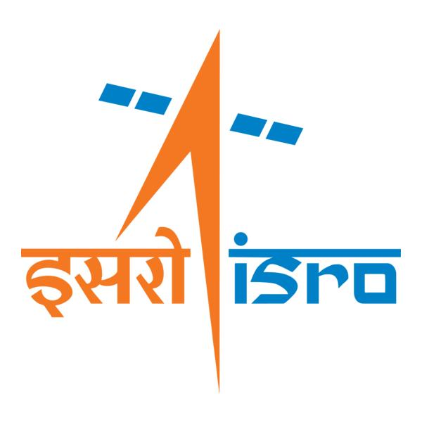

🌌 अंतरिक्ष समाचार | Space News
सोमवार, १७/०८/२०२६ | Monday, 17/08/2026

1. Cyber Kushti 2026: NIELIT launches national challenge to test human judgment in the age of AI
Read more
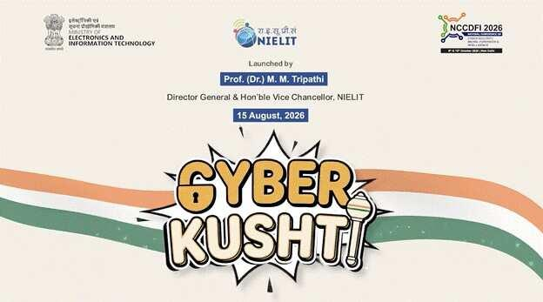
- Digital India - 7 min read NIELIT launches Cyber Kushti 2026, a national hackathon testing human judgment against AI-generated cyber findings to identify real threats, reject false alerts and strengthen cyber skills. Anoop Verma - ETGovernment - Published On Aug 17, 2026 at 06:46 AM IST Select ETGovernment as Preferred Choice on Google Copy Link Share on WhatsApp Share on Linkedin Share on X Share on Telegram Share on Facebook NIELIT launches Cyber Kushti 2026, a national challenge designed to test human judgment against AI-generated cybersecurity findings. As Artificial Intelligence increasingly transforms cybersecurity operations, the Government of India is putting the spotlight on a capability that automated systems still struggle to replicate reliably: human judgment. The National Institute of Electronics and Information Technology ( NIELIT ), under the Ministry of Electronics and Information Technology (MeitY), has launched CYBER KUSHTI 2026 , a national cybersecurity and AI hackathon designed to test how effectively participants can scrutinise machine-generated security findings, separate genuine threats from false alarms and determine which vulnerabilities require priority action. Advt Launched on August 15, the competition marks a departure from conventional cybersecurity hackathons that typically emphasise vulnerability discovery, penetration testing or Capture The Flag challenges. CYBER KUSHTI instead seeks to measure the quality of participants' security assessment and decision-making. In doing so, the initiative reflects an emerging challenge in the AI era: cybersecurity professionals increasingly have access to automated tools capable of generating enormous volumes of alerts and findings, but the usefulness of these outputs ultimately depends on the ability of skilled professionals to interpret them. The hackathon was formally launched by Prof. (Dr.) M. M. Tripathi, Director General of NIELIT and Vice Chancellor of NIELIT Deemed to be University. It will serve as the official parallel technical track of the 3rd National Conference on Cyber Security, Digital Forensics and Intelligence (NCCDFI 2026). The competition is being conducted in collaboration with the Information Sharing and Analysis Center (ISAC Foundation) under the National Security Database, with CERT-In serving as the Knowledge Partner. At the heart of the initiative is an important proposition: as AI becomes more capable of detecting anomalies and producing cybersecurity assessments, the scarce capability may no longer simply be finding potential problems. Instead, the premium could increasingly shift towards determining which findings are accurate, which pose the greatest risks and what should be fixed first. "The most difficult part of security work has shifted," Tripathi said at the launch. "For a generation, the scarce skill was finding the problem. Today, machines generate findings faster than any team can read them." He added that machines cannot yet reliably determine "which findings are real, which matter most, and what must be fixed first," making human judgment a critical institutional capability. Putting AI Outputs Under Human Scrutiny The structure of CYBER KUSHTI has been designed specifically around this human-machine interface. Every participating team will receive the same deliberately imperfect Security Assessment Package. It will include AI-generated findings, static analysis outputs, dependency and secrets scans, architecture documentation, source code and application logs. Prof. (Dr.) M. M. Tripathi, Director General of NIELIT, launches Cyber Kushti 2026, highlighting the importance of human judgment in AI-driven cybersecurity. Crucially, participants will not be able to assume that the automated findings are correct. The package will contain genuine findings alongside false and duplicated ones, while some real vulnerabilities will deliberately be left out. Teams will therefore have to scrutinise the material, identify errors and omissions, prepare a corrected and prioritised security assessment and subsequently defend their conclusions. The approach is significant because the proliferation of generative AI and automated cybersecurity tools is creating a new kind of operational problem. Security teams can potentially process far greater volumes of data than before, but increased machine output can also generate false positives, duplication and poorly prioritised warnings. In critical systems, blindly accepting such outputs could be almost as problematic as failing to detect vulnerabilities in the first place. CYBER KUSHTI attempts to recreate this challenge in a controlled competitive environment. Participants will be rewarded not merely for identifying genuine security problems, but also for correctly rejecting false findings. In effect, the contest evaluates whether cybersecurity professionals can challenge an automated assessment rather than simply accept the machine's conclusions. Participants will be allowed to use AI tools of their choice. Since all teams will receive identical tool-generated material at the same time, NIELIT says the format is intended to reduce the competitive advantage that could otherwise arise from access to expensive commercial cybersecurity platforms. Tripathi linked this design to the broader idea of technological self-reliance. "A student from a college in any part of the country can compete on entirely equal terms with a corporate team," he said. Explaining the significance of launching the competition on Independence Day, he argued that independence in an age of increasingly capable machines also entails the confidence to examine information critically, disagree with machine-generated conclusions and explain precisely why those conclusions may be wrong. From 'Akhada' to 'Kesari' Drawing on the vocabulary of traditional Indian wrestling, the competition has been structured into three stages - Akhada, Dangal and Kesari. Registration opened on August 15 and will continue until September 10. Participation is free and open to students and independent researchers competing in teams of three. The first stage, called The Akhada, will be conducted online on September 15, with 50 teams advancing to the next round. The second stage, The Dangal, will take place online on September 24 and narrow the field to 10 finalist teams. The final round, The Kesari, will be conducted in person on October 9 at the Dr. Ambedkar International Centre in New Delhi. The finalists will work under supervision before presenting and defending their security assessments on the main stage of NCCDFI 2026. One of the more distinctive elements of the final round will be a direct comparison between automated analysis and human assessment. An automated analysis of the same security material will be displayed alongside the finalists' presentations, enabling delegates to examine where machine-generated conclusions and expert human judgment converge - and, perhaps more importantly, where they diverge. The competition will be judged by a panel constituted jointly by NIELIT and ISAC, comprising cybersecurity practitioners and experts from government, industry and academia, including National Cyber Security Scholars recognised under the National Security Database. The winning team will receive the title "Cyber Kesari 2026" and a traditional Gada, while the runners-up will be recognised as "Rustam" and "Pahalwan." The organisers are also introducing an unusual category that rewards the quality of reasoning rather than merely the correctness of the answer. A special award will recognise the "most instructive incorrect submission" where the reasoning is clearly documented and offers instructional value. Participants in the first round will receive certificates and individual scorecards, while those advancing beyond it will receive National Security Database recognition credits. Building Cybersecurity Talent for an AI-Driven Economy Beyond the competitive format, CYBER KUSHTI reflects the growing need to rethink cybersecurity skills as India expands its digital economy and adopts AI across government, business and critical infrastructure. Cybersecurity professionals will increasingly have to work alongside automated systems rather than simply perform tasks that automation can replicate. This changes the nature of the skills required. Technical proficiency in identifying vulnerabilities remains essential, but professionals will also need the ability to evaluate machine outputs, understand context, assess the potential impact of vulnerabilities, prioritise remediation and explain their decisions to organisations and policymakers. NIELIT's nationwide footprint gives the initiative an additional skilling dimension. According to the institute, it operates through 56 centres, more than 700 accredited institutes and over 8,000 facilitation centres, and has trained and certified millions of students in electronics, information technology and emerging technologies. NIELIT has also been accorded Deemed-to-be-University status under the distinct category, with its main campus at Ropar in Punjab and 11 constituent campuses across the country. The final round of CYBER KUSHTI will coincide with NCCDFI 2026, scheduled for October 9-10 at the Dr. Ambedkar International Centre. The conference is intended to bring together representatives of government, law-enforcement agencies, the judiciary, industry and academia, along with cybersecurity researchers and students. All stages of the hackathon will operate in controlled environments provided by the organisers. Participants will not be permitted to engage with live systems, third parties or public infrastructure, ensuring that the exercise remains focused on assessment and learning rather than real-world intrusion. The larger significance of CYBER KUSHTI lies in its recognition that the cybersecurity challenge is evolving with AI. As automated systems become increasingly capable of discovering vulnerabilities, generating code and producing security assessments at scale, the competitive advantage of human professionals may increasingly lie in their ability to interrogate those outputs rather than simply generate more of them. For India's expanding digital ecosystem, that distinction is important. The next generation of cybersecurity professionals will need to know not only how to use AI, but also when to question it. CYBER KUSHTI 2026 is designed around precisely that proposition: machines may accelerate detection, but accountability, prioritisation and judgment remain fundamentally human responsibilities. Anoop Verma , --> - By - See more on: - Cyber Kushti 2026 NIELIT , - Cyber Kushti 2026 , - NIELIT , - AI in cybersecurity , - human judgment in cybersecurity , - cybersecurity hackathon , - Dr. Madan Mohan Tripathi , - automated cybersecurity tools , - National Cyber Security Conference 2026 , - National Institute of Electronics and Information Technology Telegram Facebook Comments What are your thoughts? Comment Now --> Comment Now Read Comment (1) All Comments By commenting, you agree to the Prohibited Content Policy Post Find this Comment Offensive? Choose your reason below and click on the submit button. This will alert our moderators to take actions REASONS FOR REPORTING Foul Language Defamatory Inciting hatred against a certain community Out of Context / Spam Others Report Join the community of 2M+ industry professionals. Subscribe to Newsletter to get latest insights & analysis in your inbox. All about ETGovernment industry right on your smartphone! - Download the ETGovernment App and get the Realtime updates and Save your favourite articles. Scan to download App --> - Home - News - Cyber Kushti 2026: NIELIT launches national challenge to test human judgment in the age of AI

2. Tripura's National Awardee Presided Dias Of ISRO NASA NCRTS Veterans Conferred Sarabhai Student Scientist & Teacher Scientist Award 2026 With Recall For Vikram Sarabhai's Leapfrog Vision. - TRIPURA STAR NEWS
Read more

Spread the love Agartala, Tripura, 16th of August, 2026 : Tripura pride National Awardee Science Teacher Anjan Banik, being nominated as Hon. National Chairman to National Council of Researcher Teacher Scientist VIPNET India (then knowingly affiliated to VIPNET Vigyan Prasar under Ministry - Dept of Science and Technology of Govt of India) presided over the Online International event Dias of celebration of 107th Birth anniversary of Dr Vikram Sarabhai, father of India's Space Programme on 12th August 2026 under webcast at [ https://www.youtube.com/watch?v=4eeFSkrdu4k ] , where the galaxy remain twinkled with the active virtual presence of former ISRO Star Scientists with Deputy Director of Planetary Div of JPL NASA remain an attraction to the aspirant space science loving future scientists & students from India. A gathering of veteran Indian space scientists, a NASA planetary scientist and young science learners turned the 107th birth anniversary of Vikram Sarabhai into a vivid reflection on the vision, leadership and scientific culture that shaped India's space programme. The virtual programme, organised to commemorate Sarabhai and to confer young selected winner - participants with the 8th India International Sarabhai Student Scientist Award 2026 from its organizing team of National Council of Researcher Teacher Scientist India (VIPNET DST Govt of India) academic partnership with the National Council of Student Scientist India and DASA India, brought together scientists who had directly experienced the formative decades of India's space journey. The India International Sarabhai Student Scientist Award is a national-level science competition and platform in India. It honors young space science loving student achievers and mentors in science education, inspired by the legacy of Dr. Vikram Sarabhai, the pioneer of India's space program, which has been mentored, designed and coordinated by Anjan Banik. ANJAN BANIK is an national award-winning science teacher, educational researcher, science communicator and teacher mentor from Agartala, Tripura, whose work has contributed significantly to science education, scientific communication and educational innovation at the state and national levels. He is widely recognized as the sole recipient from Northeast and East India, even from his state Tripura to win the prestigious National Award for Science and Technology Communication 2022 to 2023 in Category E for outstanding efforts in science and technology communication through innovative and traditional methods, conferred by the National Council for Science and Technology Communication under the Department of Science and Technology, Government of India. The official award conferred to Shri Anjan Banik of Agartala on the National Science Day 2023 at Vigyan Bhawan, New Delhi and was presented on National Science Day at Vigyan Bhawan New Delhi by Union Minister Dr Jitendra Singh in the presence of senior national scientific leadership including the Union Secretary of the Department of Science and Technology Dr S Chandrasekhar, Principal Scientific Adviser to the Government of India Professor A K Sood, former Principal Scientific Adviser Professor K Vijayaraghavan, Head Scientist of NCSTC Dr Manoranjan Mohanty, and Director of Vigyan Prasar Dr Nakul Parashar. He has subsequently been selected as a National Mentor Resource Person under the National Mission for Mentoring of National Council of Teacher Education (NCTE), Ministry of Education, Government of India, and has continued to contribute to teacher mentoring and science education. There are more then 29 science educational research work in his credit which has been presented or published up on him by NCERT, its RIEs at Ajmer, Bhopal, Bhubaneswar, Shilong and Mysore, CSIR NiScPR. His landmark educational research undertaken for IGNOU analysed approximately 45 years of Tripura Board of Secondary Education results, examining the movement of students from Madhyamik to Higher Secondary education and particularly their choice and achievement in Science, Humanities and Commerce. A major finding of the study reported that only 7.97 percent by mean score of Madhyamik enrolment ultimately pursued Science education through Higher Secondary, highlighting the need for stronger scientific orientation, career guidance and educational interventions. His professional contribution has also extended to science textbook authorship for NCERT oriented school education, innovative science communication and the use of puppetry and digital cultural approaches for communicating science and mathematics. In February 2026, ANJAN BANIK was invited as a delegate to the India AI Impact Summit 2026 at Bharat Mandapam, New Delhi, representing Tripura in a major international forum on responsible, inclusive and research driven artificial intelligence. His continuing work reflects a sustained commitment to scientific temper, experiential learning, teacher empowerment and the wider national objectives of science education. The mega event Organized by its organizing team of National Council of Researcher Teacher Scientist India (VIPNET DST Govt of India), National Council of Student Scientist India and DASA India (an Agartala, Tripura-based national voluntary organization) under the administrative and academic Leadership of its National Chairman Anjan Banik which has been knownly affiliated with VIPNET, Vigyan Prasar (Department of Science and Technology, Government of India). The Star gathering conferred this year's 8th India International Sarabhai Student Scientist Award 2026 to Top 11 scorers who compete with nearly about 1 lac students gathering for a long period of last 7 months and the winners are : 1st : Aiyra Alvi (U.P.) of SMS Dutta Memorial Nosegay Public School, Khatima, U S Nagar, Uttarakhand 2nd : S. Dharunraja (Puducherry) of Shree Bharath Vidyaashram CBSE, Puducherry 3rd : DT Tanishka Shri (Puducherry) of Shree Bharath Vidyaashram CBSE, Puducherry 4th : DT Gagana Sree (Puducherry) of Shree Bharath Vidyaashram CBSE, Puducherry 5th : Yeshmithaa R. (Puducherry) of Shree Bharath Vidyaashram CBSE, Puducherry 6th : S. Sai Swetha (Puducherry) of Shree Bharath Vidyaashram CBSE, Puducherry 7th : Mahnoor Riyaz (Kulgam Kashmir) of Radiant Public Hr Sec School Batengoo Anantnag Kashmir and under guidance of Aloha Anantnag 8th : Priya Joshi (Uttarakhand) 9th : Pratiksha Rath (Puducherry) of Shree Bharath Vidyaashram CBSE, Puducherry 10th : Tai Nanam (Arunachal Pradesh) of Vivekananda Kendra Vidyalaya CBSE Arunachal Pradesh 11th : Aryan Parasar (Arunachal Pradesh) of Vivekananda Kendra Vidyalaya CBSE Arunachal Pradesh The President of event National Chairman National awardee Anjan Banik as part of The event also declared to honour the three mentor guide teachers Dr Sir Ariz Alvi (U.P.) being guide teacher of 1st position holder, Shahnawaz Ahmad Shapoo Sir (Kashmir) being guide teacher of 7th position holder, Sir Avinash Sonar of Vivekananda Kendra Vidyalaya of Itanagar, Arunachal Pradesh being guide teacher of 10th & 11th position holder and Sir Arun Kumar R (Puducherry) being the guide teacher of both 2nd, 3rd, 4th, 5th, 6th, and 9th position holders by conferring the prestigious India International Sarabhai Teacher Scientist Award 2026 for their contribution towards students, which will be conferred on 30 Dec 2026 on death anniversary of Dr Vikram Sarabhai. This event is a part of organisation's objective to inspire science loving students and Participants to engage in assignments, spaceflight simulator tasks, and astronomy projects mentored by veteran scientists from ISRO and NASA, where scientists are directly and occasionally interacting with those selected students. This event conducted in every year starts as a prelim google e quiz session available at the link of [ http://forms.gle/nnZrKVZEuZbNAXMw9 ] during 1st January (Birth anniversary of Sir Meghnath Saha) every year to 28th February (National Science Day in India). The most striking message came from veteran ISRO scientist Professor R R Elango, who recalled Sarabhai's philosophy of moving rapidly beyond existing technology rather than repeatedly rebuilding what the world had already developed. Referring to the principle as a form of technological leapfrogging, Elango said that Sarabhai believed India should use existing technological knowledge as a foundation and move forward to create new capabilities. "Do not try to redo it again what you have done already. Use that technology and go further," he recalled. According to Elango, this approach remains deeply connected with the remarkable achievements of ISRO today. The programme began with a tribute to Vikram Sarabhai, widely regarded as the father of the Indian space programme. The speakers highlighted how the name Vikram has subsequently become associated with several landmarks of Indian space exploration, including the Vikas engine and the Vikram lander associated with the Chandrayaan programme. This Mega event Dr M R Shivaramans memories of Sarabhai and the evolution of satellite navigation Dr M R Shivaram, a veteran space scientist and former Deputy Project Director associated with the GAGAN programme, joined from the United States. Dr M R Shivaram born on 6th March, 1944 and did his MSc (Applied Physics) in 1966 from University of Kerala, PhD (Physics) on the subject "Topside Sounding of the Ionosphere" from University of Gujarat in 1975. His professional journey began in 1966 at the Physical Research Laboratory, Ahmedabad, founded by Sarabhai, before he moved to the Space Applications Centre of ISRO and continued till 1975. He Joined Space Applications Centre (SAC), Ahmedabad in 1975 and started working in Satellite Geodesy Division. While in SAC, he contributed in Development of Geo-receivers and its applications, Development of GPS Receivers and its Applications, Satellite Navigation Programmes viz. GAGAN and IRNSS (NavIC), Development of Time Synchronisation Techniques, Development of Ionospheric and Tropospheric Models for GAGAN, and Ka Band Radio Wave Propagation. He has been superannuated in 2004 from SAC. But later also he contributed as a Visiting Scientist in SAC till 2007. Dr M R Shivaram was Deputy Project Director for "GAGAN" Project from 1998 to 2007. Dr M R Shivaram had also worked in IRNSS Programme, in its initial stages of development. From 2002 to 2007, he contributed to publish more than 50 Scientific papers and also guided some PhD students in Dharam Sinh Desai University, Nadiad. Recalling his encounters with Sarabhai during the late 1960s, Dr Shivaram said Sarabhai had an unusually simple and approachable personality despite his enormous responsibilities. Sarabhai would visit students, interact with them directly and listen to their problems. Dr Shivaram recalled an occasion when a disparity in scholarships affecting research students came to Sarabhai's attention. Sarabhai immediately intervened and ensured that the students received a fairer arrangement. Dr Shivaram also described Sarabhai's contribution to building the foundations of satellite communication and space applications in India. He recalled how Sarabhai supported the development of experimental satellite communication facilities and encouraged Indian scientists to develop indigenous capabilities rather than remain dependent on imported technology. Speaking about his own later work, Shivaram described his involvement in satellite navigation, including GAGAN and the early development of the Indian Regional Navigation Satellite System. He explained that GAGAN evolved into an advanced satellite based navigation capability designed to provide highly accurate navigation services and support aviation applications. His account also highlighted an important dimension of Sarabhai's legacy: the transformation of space science from a purely scientific pursuit into a technology serving communication, navigation, surveying and other national requirements. Elango recalls Sarabhai's leadership and Kalam connection Professor R R Elango, who later worked with the Vikram Sarabhai Space Centre and became associated with launch vehicle development, recalled several stories about Sarabhai's leadership style and his relationship with young scientists. According to Elango, Sarabhai's first major strength was team building. He brought scientists and specialists from different fields and countries to India and created an environment where expertise could be combined for national objectives. Elango recalled an incident involving Dr APJ Abdul Kalam following a rocket development setback. Instead of simply criticising Kalam after a failed test, Sarabhai reportedly handed him an official envelope. Kalam expected disciplinary action, but the envelope contained a promotion order. The episode, Elango said, demonstrated Sarabhai's ability to distinguish between failure and incompetence and to encourage scientists to learn from technical setbacks. Elango further explained Sarabhai's emphasis on system integration. Components could function successfully individually but still fail when assembled as a complete system. Sarabhai therefore encouraged the creation of systematic integration and testing facilities so that complete systems could be evaluated before launch. He also recalled Sarabhai's practice of listening to young engineers and scientists rather than restricting decision making to senior levels. According to Elango, Sarabhai valued technical competence, encouraged his colleagues and gave team members opportunities to present their own work. The scientist said this leadership culture eventually became one of the foundations of ISRO's institutional strength. Kishor Kumar Barucha explains the camera behind space imagery Kishor Kumar P Barucha, associated with optical imaging and camera technology at the Space Applications Centre in Ahmedabad, described another important but less visible part of the Indian space story. Barucha explained how optical systems and multispectral cameras are essential for obtaining information from Earth and other planetary bodies. His work involved lens systems, beam splitters and imaging instruments designed for different spectral regions and orbital applications. He described the demanding process of making space qualified optical systems. Components have to undergo environmental testing involving temperature variation, humidity, vacuum and other conditions before they can be considered suitable for space missions. Barucha also discussed imaging systems used for Earth observation, weather applications, land use studies and planetary missions. He highlighted the importance of cameras not merely for obtaining spectacular photographs but for generating scientific information about agriculture, land, water bodies, vegetation and geological features. He also stressed the educational value of space imagery. Through exhibitions, school programmes and science awareness activities, satellite images can turn abstract concepts of Earth and space science into something students can directly observe and investigate. A C Mathur: Sarabhai wanted space technology to reach ordinary people Former ISRO Group Director A C Mathur provided a broader account of the development of space applications in India. He recalled joining ISRO in 1978 and subsequently working with several scientists who had themselves worked closely with Sarabhai. Mathur described Sarabhai as a visionary who understood that the ultimate value of space technology would lie in its applications for ordinary people. He recalled the development of experimental satellite communication earth stations and India's gradual transition from imported technology towards indigenous design and manufacturing. According to Mathur, one of the most important elements of Sarabhai's vision was the creation of institutions capable of converting space research into practical applications. Remote sensing, satellite communication and other technologies were developed not simply as demonstrations of technological capability but as tools for national development. He emphasised that the benefits of space science should reach ordinary citizens and that the fundamentals of space science should also reach school students. Such an approach, he suggested, would be crucial if India is to remain a global leader in space technology. Mathur's account also highlighted India's growing indigenous capability in satellite antenna technology. He recalled how Indian engineers developed and tested antennas that were subsequently evaluated by NASA, marking an important step in building confidence in India's ability to design sophisticated space hardware. NASA scientist Rosaly Lopes highlights perseverance The programme also featured Dr Rosaly M C Lopes of NASA's Jet Propulsion Laboratory, a renowned planetary scientist and a leader associated with academic engagement at JPL. Lopes congratulated the students and emphasised the importance of international scientific collaboration. She noted that India and NASA are partners in space exploration and highlighted India's achievements in lunar exploration and planetary science. But the most personal part of her message concerned perseverance. Recalling her childhood in Brazil, Lopes said that nobody in her family had been a scientist and that people initially found it unusual that a young girl wanted to study astronomy. She explained that perseverance was one of the most important factors behind her eventual scientific career and her association with NASA's Jet Propulsion Laboratory. "Students bring fresh ideas," she said while stressing the importance of encouraging and recognising young learners. She also pointed out that NASA's postdoctoral opportunities are open to students from different countries, underlining the international nature of modern scientific research. Students demonstrate the next generation of scientific thinking The programme also showcased the experiences of young participants selected for the India International Sarabhai Student Scientist Award. Their assignments included practical experiments involving light, shadows, observation, data collection and pinhole cameras. The students repeatedly described how hands on activities helped them move beyond memorising scientific facts. One participant explained that the pinhole camera experiment helped demonstrate the straight line propagation of light and image formation. Another said that analysing shadows connected mathematics with physics and real life observation. A student from Jammu and Kashmir summarised the learning philosophy particularly clearly by saying that science is not merely about learning concepts but about observing, questioning, thinking, experimenting and discovering. Another participant expressed an aspiration to become an ISRO scientist and contribute to India's space programme. Sarabhai's legacy continues through students The programme ultimately connected three generations of Indian science. Veteran scientists recalled Sarabhai's institution building and leadership, NASA's Rosaly Lopes spoke about perseverance and international scientific cooperation, while school students demonstrated how practical experimentation can cultivate scientific curiosity. The organisers emphasised that the objective of the Sarabhai Student Scientist initiative is not merely to confer awards but to inspire young people to remain curious, experiment independently and develop the confidence to ask how and why. The central message emerging from the programme was therefore larger than a celebration of a historic scientist. Sarabhai's legacy was presented as a continuing educational philosophy: build strong teams, listen to young minds, learn from failure, use existing knowledge intelligently, develop indigenous capability and take science to society. For the young participants, the most enduring lesson may have been the one recalled by Professor Elango: India does not need to repeat every technological journey from the beginning. It can learn from what has already been achieved, adapt it, and move further. At the final conclusion Anjan Banik, the National Awardee National Chairman of this event invites all the Ex ISRO-Scientists to contribute to inspire the future India and also invite the future India, the Gen Next to participate in this Science and scientists-oriented event for the next year as it beings on next 1st January at its exam link of [ http://forms.gle/nnZrKVZEuZbNAXMw9 ] . Related

3. Andaman Media Team Gets Rare Opportunity to Visit Satish Dhawan Space Centre, Sriharikota - ANDAMAN SHEEKHA
Read more
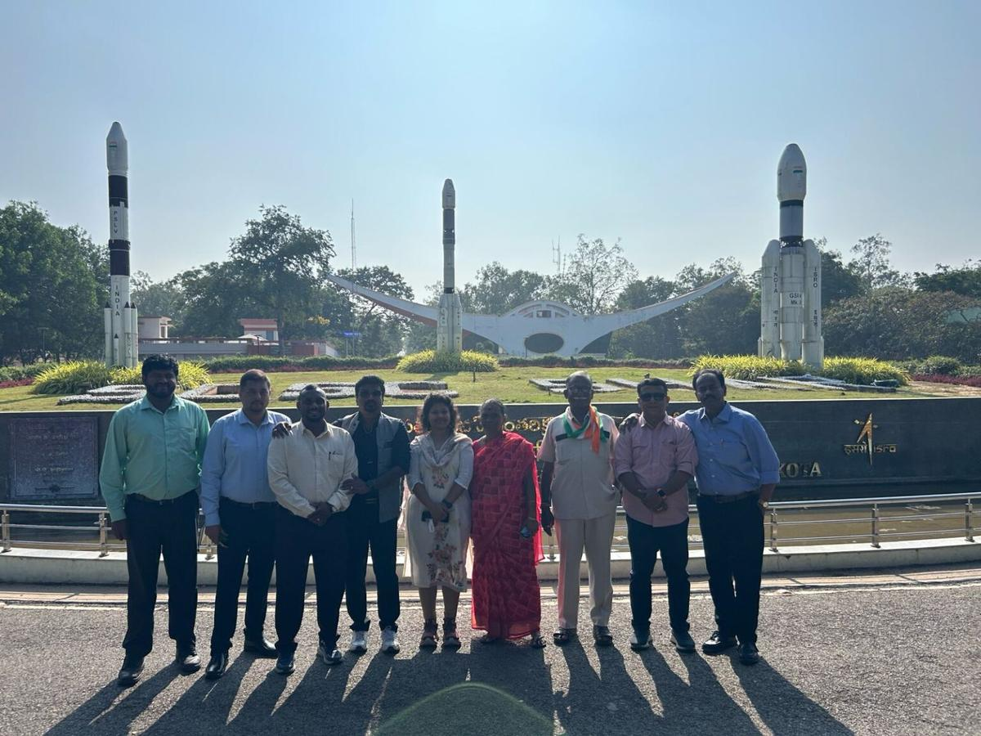
Andaman Media Team Gets Rare Opportunity to Visit Satish Dhawan Space Centre, Sriharikota ANDAMAN SHEEKHA

4. Astronaut Shubhanshu Shukla at Idea Exchange: 'Today's kids are brilliant… you have to be with a dream for a long time, work on it, only then will it happen' - The Indian Express
Read more
Astronaut Shubhanshu Shukla at Idea Exchange: 'Today's kids are brilliant… you have to be with a dream for a long time, work on it, only then will it happen' The Indian Express

5. NASA funds spherical 'Aerobots' that could explore the caves of Saturn's moon Titan
Read more
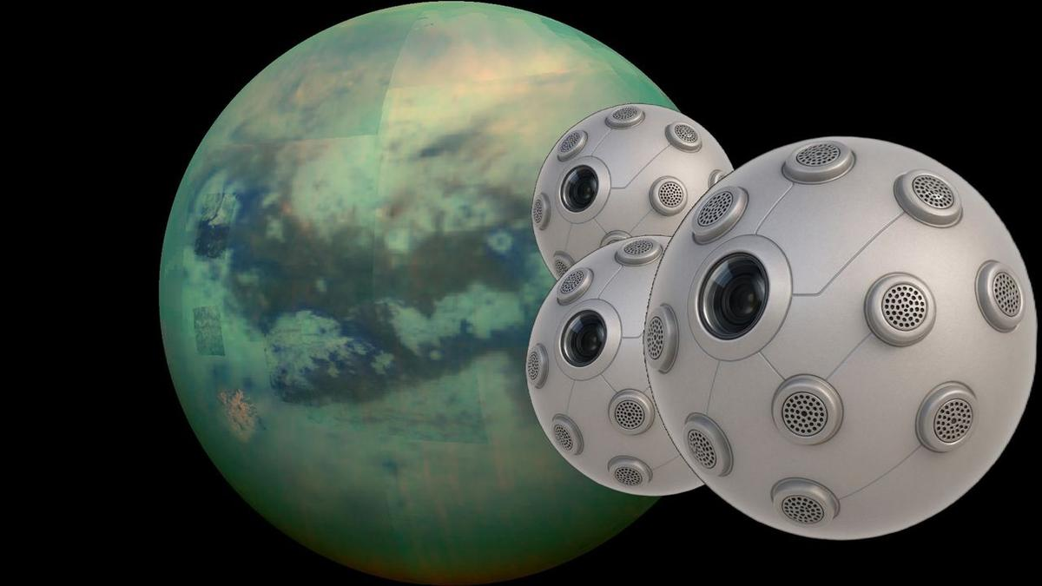
Click for next article A composite image of an infrared view of Saturn's moon Titan from NASA's Cassini spacecraft; renderings of several "SPARK" Aerobots being developed by Daniel Drew of the University of Hawaii. Spherical "Aerobots" may one day swarm the caves of Titan - a moon of Saturn that NASA says is one of the most Earthlike in our solar system. Titan is covered in rivers, lakes and seas of hydrocarbons, like methane and ethane, as well as a strange "karst" terrain including underground sinkholes and caves . No rover could easily traverse this surface, but flying vehicles may have more success. So a new grant, under the early-stage NASA Innovative Advanced Concepts (NIAC) program, aims to create small, flying vehicles that could explore those caves. It's unclear if the aerobots - called SPARK , or Solid-state Propulsion for Autonomous Reconnaissance of Karst - would be ready in time for NASA's Dragonfly mission to Titan, project lead Daniel Drew, an assistant professor at the University of Hawaii at Mānoa, told Space.com. That's because SPARK is beginning a nine-month Phase 1 grant and would need to at least get through the up-to-two-year Phase 2 before things look "more realistic" for a liftoff, he noted. Dragonfly, meanwhile, is targeted for a 2028 launch but if the mission is delayed, that provides more possibilities for late-mission additions. "Where does that line up with the current Titan mission timeline, assuming we've missed the window for Dragonfly? I don't know," Drew said of SPARK. But whenever the mission lifts off, Drew said SPARK has a good chance of doing well on Titan with its novel ion (electric) thrusters. Drew said his design could "provide persistence, maneuverability, robustness to the challenging near-cryogenic [icy] conditions, and minimize downwash disturbance of scientifically-important hydrocarbon layering." He hopes that SPARK, he added, could be a cave-exploration forerunner at Titan similar to the Ingenuity helicopter on Mars that made 72 flights - more than tenfold what the Red Planet demo mission was supposed to do. Drew has been working on a particular type of ion thrusters, called electrohydrodynamic (EHD) propulsion, since he did graduate school at the University of California, Berkeley. Thanks in part to a National Science Foundation (NSF) fellowship, Drew explored several designs for flying and became interested in creating robots that flap their wings in a way similar to real-life creatures. While exploring, he stumbled on the hobbyist "lifter" community "pretty much by chance," he said. "These [prototypes] are triangular balsa wood, magnet wire, and aluminum foil prototypes. You connect them to 40,000 volts from a flyback transformer that you rip out of a microwave or CRT monitor or whatever, and they can float above the table. There are plenty of examples of people making these on YouTube," he said. More plumbing the archives revealed early experiments and studies at NASA and the Air Force similar to what the hobbyists were using. And by coincidence, NIAC awarded funding to another research group, led by the Massachusetts Institute of Technology, that was interested in using EHD propulsion for Earthborne aircraft. As such, Drew sensed a fruitful direction for research. "Long story short, I ran with that idea," Drew said, "and wrote a bunch of papers where I created microfabricated centimeter-scale flying robots propelled by atmospheric ion thrusters." His accomplishments prior to the NIAC grant included what he says is the first demonstration of microfabricated EHD actuators (mechanical devices), and other firsts such as a centimeter-scale "ionocraft" taking off and subsequently, carrying a payload. "We recently published the design and takeoff of the first ion-propelled micro-hovercraft," he added, referring to a paper on preprint server arXiv . "That may seem like a pretty decent list of significant milestones, but it's really not a crowded space of people working on this topic. I'm mostly racing against myself here." Now with the NIAC support, Drew said he hopes to dive deeper into the benefits of EHD propulsion, such as its scalability, the fact that it's virtually silent, and its simplicity (being solid state, there are fewer parts to worry about). A graphic depiction of the SPARK concept being developed by Daniel Drew of the University of Hawaii. (Image credit: Daniel Drew/University of Hawaii) More applications could come outside of Titan, he noted: all-electric aircraft, indoor drones, and mini-flying swarms are just some ideas, but he said the utility will be limited. "The huge weakness is that it just isn't very efficient," he said of EHD propulsion. "Barring a major breakthrough, it will be impossible to really compete with more conventional propulsion techniques, like rotors and jet engines, for the vast majority of terrestrial applications." As Phase 1 only encompasses about nine months, Drew and his collaborators-including Ethan Schaler and Jacob Izraelevitz from NASA's Jet Propulsion Laboratory, as well as Michael Malaska from the Blue Marble Space Institute of Science-plan to quickly design experiments, perform a "trade study" of which subsystems are best to prioritize for aspects like power, and model matters like the thermal effects on the power system. "I think the idea of 'standing on the shoulders of giants' is very much ingrained into the NIAC culture," Drew noted. "Our major contribution at the end of this process is a comprehensive, public report. Leveraging past related reports, and other open research in the field, is critical for doing a good job with this."

6. Artemis II pilot thanks NASA for letting him fly Orion by hand: 'I'm still blown away by that trust'
Read more
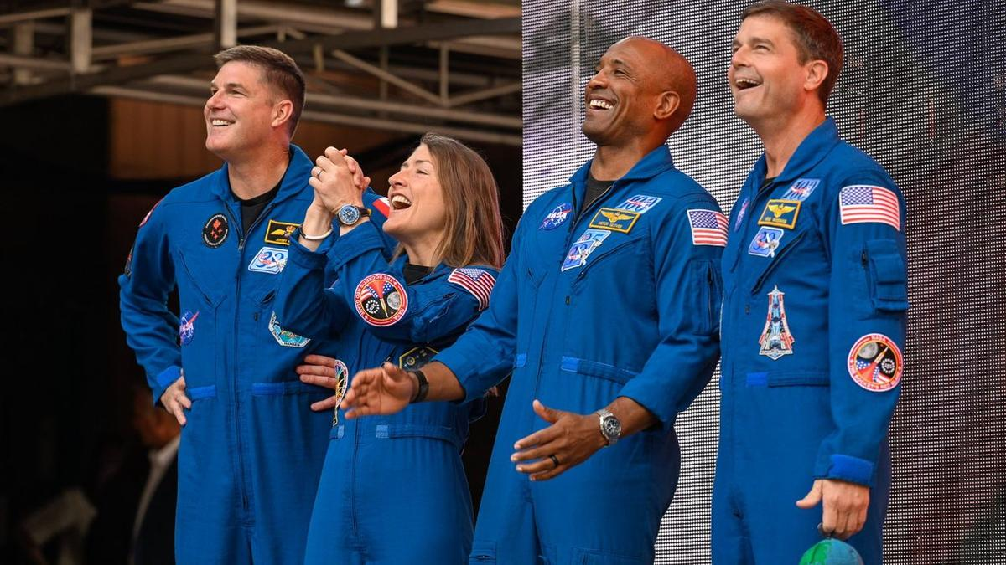
Click for next article MORRISON, Colorado - The Artemis II crew that circuited the moon earlier this year came full circle, dropping by a distinctive spot on Earth that's visually reminiscent of both the moon and Mars. On Aug. 3, the vast and stunning Red Rocks Amphitheatre served as both an inoculation of near-term nostalgia and heart-felt congratulations to the crew for the impressive journey of Artemis II. The 10-day mission began on April 1 of this year , flew around the moon and back , and splashed down in the Pacific Ocean on April 10. It was the first crewed flight to saunter spaceward beyond low Earth orbit in 53 years. Some 8,500 people packed the open-air venue at Red Rocks to make eye-contact with space travelers Reid Wiseman, commander, Victor Glover, pilot, Christina Koch and Jeremy Hansen as mission specialists - all of them clearly awestruck by the crowd reaction. The event was a broader post-flight campaign for the foursome, also spotlighting the region's contributions to the sojourn of Artemis II. A science, technology, engineering, and mathematics (STEM) fest was also part of the early morning affair. The Artemis II crew speaks at Red Rocks Amphitheatre in Morrison, Colorado on Aug. 3, 2026. (Image credit: Lockheed Martin) Iconic location "I can't imagine a more iconic location on Earth to hear about the trip to the moon," said Robert Lightfoot, president of Lockheed Martin Space and a major aerospace contractor for the Artemis program. There were hundreds of suppliers across the rocky mountain region, over 10,000 employees, that supported the Artemis II mission, he told the gathered throng. Leadership from industry prime contractors including Lockheed Martin, Amentum, Boeing, L3 Harris and Northrop Grumman took part in the salute to the Artemis II voyage. Colorado Governor Jared Polis pointed out that "here in Colorado, we're a mile closer to space." As the best and biggest homecoming for the Artemis II crew, he added, "keep reaching for the stars." Lori Glaze, NASA associate administrator for the Human Spaceflight Mission Directorate, said today "is a truly revolutionary and exciting time for NASA and America's space program. We are going to reach farther. We're going to dream bigger. And we're going to secure America's leadership in deep space exploration and discovery." The Artemis II crew speaks to a crowd of 8,500 at Red Rocks Amphitheatre in Morrison, Colorado on Aug. 3, 2026. (Image credit: Lockheed Martin) What next? In a pre-event press gaggle, Space.com asked the Artemis II crew members how their Orion spacecraft named Integrity performed and would help the upcoming Artemis III crewed flight in Earth orbit. "It handled incredibly well," said Reid Wiseman, Artemis II commander. "Just from habitability, I think that is where we learned the most, putting four humans in the spacecraft. We knew that the machine was technically competent and capable of getting to the moon … Artemis I taught us that," he told Space.com. "We had some heat shield things we needed to sort out on Artemis II. But putting the four of us in there, seeing how the life support system worked and how is it for habitability, to eat, live, work, and sleep in there, we definitely learned a lot that we've handed on to Artemis III," said Wiseman. Sense of gratitude The Red Rock Artemis II stage event had the four Artemis II crew members facing a huge gathering of supportive spectators. In excess of 1,300 questions were submitted by the attendees. The Artemis II crew entrance was marked by roaring footage of the Artemis I launch scored by music from thunderous Metallica's "Fuel." "The biggest thing that this mission has given us is an overwhelming sense of gratitude. I think we've got to figure out how to keep this going," Glover said. For Christina Koch, the Red Rocks gathering spurred a call and response audience participation. "I say moon, you say joy," to which the throng promptly called back three times. She also asked the audience to put their thumb out in the air. From a distance, "you can cover the entire Earth with your thumb. That's how small it was to us," she said, "but what you knew was that was home." Proximity operations Victor Glover, the pilot of Artemis II, focused on a proximity operations demonstration during the flight . That entailed the crew guiding the spacecraft through a series of controlled approach and retreat maneuvers using the detached upper stage, the interim cryogenic propulsion stage, as a reference target. "That is when we had a chance to fly the spacecraft by hand, not just using the computers," Glover told Space.com. "We actually got to fly. One of the most amazing aspects of that is looking out the window or through the cameras on the [cockpit] displays to determine how far we were from the upper stage," he explained. That task made use of all four sets of eyes onboard Orion, Glover said. "We did not have radar, or some other type of digital ranging system between us and that vehicle. But the Artemis II team trusted us to fly like that. I'm still blown away by that trust," he said, "and it flew marvelously." The Artemis II crew gives a thumbs-up to the crowd at Red Rocks Amphitheatre in Morrison, Colorado on Aug. 3, 2026. (Image credit: Lockheed Martin) South pole ambitions NASA's Glaze added that Artemis III is to fly sometime mid-year in 2027 . "We are going to demonstrate docking with one or both of our two landers, the Blue Origin and the SpaceX lander . They've got some demonstration versions that they are preparing right now. We're working on that mission to prove out, not just going back and forth at a target, but actually docking and doing that hard job," Glaze told Space.com. Space.com pressed Glaze on the term "demonstration versions" of the Blue Origin and SpaceX lunar landers. Would the fidelity of those demos be good enough to green-light an actual human moon landing on the Artemis IV mission? "I do," Glaze responded. "We're working really hard with both of our lander providers on development of the demo pathfinder versions of their landers that we will dock with […] to assure that the docking systems are the same docking system we're going to work with when we are going for the landing mission," she said. Glaze said that "this is one of the key risks. This allows us to buy down that risk and at least work through that part of the mission. So when we do the landed mission we've got that part out of the way. "We've got our lessons learned from those docking demonstrations. And then we are really focused on all the risks associated with the landing on the moon … we can really focus our efforts there." According to Space.com sources, however, there is active discussion of whether the lunar south pole is an advisable location for the first human landing of the Artemis Program. Indeed, Artemis II pilot Glover recently stated that he thinks there's a need to be realistic and progressively work our way to the south pole locale rather than land there first. "We've had a lot of conversations with both of our lander vendors. The designs they have are for the south pole," responded Glaze. "We're working really closely with them on those designs. And we are very focused on landing at the south pole." Over the moon Canada's Artemis II mission specialist, Jeremy Hansen , told the audience that their space trek was a very human experience for the four crew members, "but we came to see and feel you. You shared the moon joy," he said. Hansen underscored the international character of Artemis II. "It was one of those deliberate contributions to the planet," he said, because billions of us on Earth have to join forces. "We have to work together. We can no longer believe that our end-state is not working together. Not acceptable. We have to collaborate," he said. Asked by a young audience member about items taken on their excursion around the moon, mission specialist Koch replied: "I took handwritten letters that I hadn't read before from my family, and also a very tall cow figurine. My dad had the idea of having a cow jump over the moon."

7. New record! SpaceX launches 2 Falcon 9 rockets just 38 minutes apart (video)
Read more
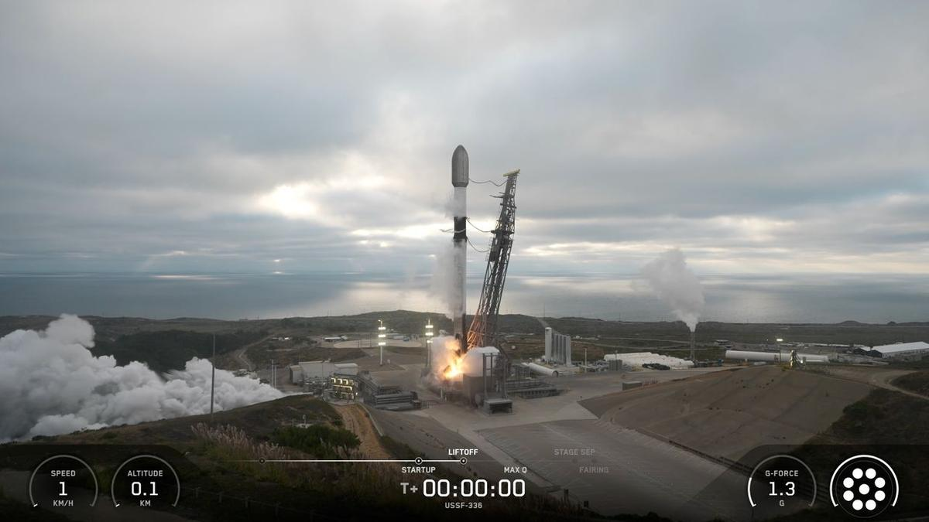
Click for next article SpaceX keeps setting spaceflight records. Elon Musk 's company launches far more frequently than any other outfit, and it operates the largest satellite constellation ever assembled - the Starlink broadband network, which consists of nearly 11,000 satellites (and counting). On Saturday evening (Aug. 15), SpaceX set another mark, for the shortest time between orbital flights: It launched two Falcon 9 rockets just 38 minutes apart, besting its old mark - set on Aug. 31, 2024 with two Starlink missions - by 27 minutes. A SpaceX Falcon 9 rocket launches eight satellites for the telecom company Globalstar from Florida's Cape Canaveral Space Force Station on Aug. 15, 2026. (Image credit: SpaceX) The first liftoff, from Florida's Cape Canaveral Space Force Station , occurred Saturday at 9:12 p.m. EDT (0112 GMT on Aug. 16) and carried eight satellites to low Earth orbit (LEO) for Louisiana-based telecom company Globalstar. All eight spacecraft were deployed successfully, separating over a six-minute span beginning 56.5 minutes after liftoff, SpaceX announced via social media. While that Falcon 9 was powering its way to LEO, another one launched from Vandenberg Space Force Base , on California's central coast. That liftoff, at 9:50 p.m. EDT (6:50 p.m. local time; 0150 GMT on Aug. 16), kicked off a mission for the U.S. Space Force called USSF-366. A Globalstar satellite deploys from the upper stage of its Falcon 9 rocket on Aug. 15, 2026. (Image credit: SpaceX) We know very little about USSF-366, which isn't surprising given its classified status. However, rocket watchers have made a few inferences from the limited available information. "It is possibly a batch of classified LEO satellites for a U.S. government entity based on SpaceX's Starshield satellite bus, based on locations of rocket stage drop zones being exact fits with previous Starlink Group 15 launches," NextSpaceflight.com wrote in its mission description . ( Starshield is a SpaceX project that uses modified versions of Starlink craft to fly national security missions for the U.S. government.) It's unclear when and where the rocket's upper stage will deploy the USSF-366 payload(s); SpaceX's mission description doesn't reveal that information. And the company ended its livestream shortly after the first-stage landing, as is typical for national security flights. Both of Saturday's missions featured successful rocket landings. The Falcon 9 first stage that launched the Globalstar mission came back for a touchdown at Cape Canaveral about eight minutes after launch. It was the 14th flight for that particular booster. The USSF-366 Falcon 9 first stage, meanwhile, came back to Earth about 8.5 minutes after its launch, touching down in the Pacific Ocean on the SpaceX droneship "Of Course I Still Love You." That booster now has 18 missions under its belt. Saturday's doubleheader brought the tally of Falcon 9 launches in 2026 to 96. The vast majority of those - about 75% - have been Starlink missions.
8. Hubble & Gaia solve our galaxy's merger mystery
Read more
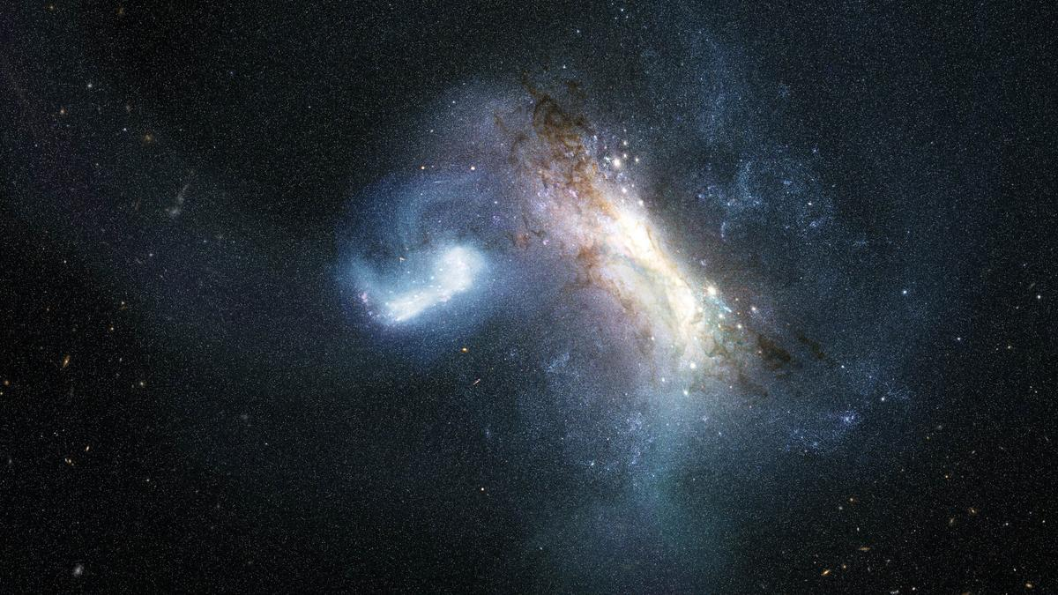
Science & Exploration Hubble & Gaia solve our galaxy's merger mystery 17/08/2026 503 views 12 likes Our home galaxy, the Milky Way, grew to its current size in part by consuming smaller galaxies. Now, new data from the NASA/ESA Hubble Space Telescope show definitive evidence of a dwarf galaxy merging with the young Milky Way galaxy in the earliest phases of its evolution. This finding extends our knowledge of our galaxy's history 1.8 billion years farther back in time than before. LKH Milky Way merger (artist's impression) The Milky Way galaxy today is a massive spiral galaxy home to hundreds of billions of stars. However, our galaxy wasn't always so large; it has grown by forming new stars from its gas clouds as well as collecting stars, gas, and dark matter from other galaxies through mergers. The most recent massive merger in our galaxy's history took place with the Sagittarius dwarf galaxy, beginning over 6 billion years ago and still ongoing today. Looking back into the even more distant past, researchers learned that the Milky Way galaxy consumed another dwarf galaxy called Gaia-Sausage-Enceladus 10 billion years ago. This ancient merger greatly affected the structure of our galaxy's disc of stars. Other, smaller mergers occurred between these two. But our galaxy's history doesn't stop there. Both observations and simulations have suggested that another large merger preceded these two, though the specifics of the event have been heavily debated. Now, Hubble has uncovered definitive evidence of an earlier merger that occurred about 11.8 billion years ago, or just 2 billion years after the Big Bang. "Our home is the Milky Way galaxy, but we do not know how our house was built," said Davide Massari, lead author, Astrophysics and Space Science Observatory of Bologna in Italy. "In this paper we discover where the first significant batch of bricks came from: a dwarf galaxy that we call LKH." Cosmic archaeological sites Gaia mapping the stars of the Milky Way Immense astronomical surveys and precision data from spacecraft like ESA's Gaia mission have been instrumental in piecing together the history of our galaxy. The farther back into our galaxy's history that scientists attempt to look, the more difficult it becomes to tell what happened. When our galaxy was young, it was smaller and much closer in size to the galaxies it clashed with. It was also more chaotic, and it's possible that the signs of mergers have been erased over billions of years. It's into this murky past that Hubble peered. Researchers used Hubble to study some of the Milky Way galaxy's globular clusters: immense, roughly spherical collections of tens of thousands to a few million stars. Globular clusters contain some of the oldest stars in our galaxy, and they can act as cosmic archaeological sites that preserve stars from other galaxies the Milky Way galaxy has collected. "Thanks to the high resolution and depth of Hubble imaging, we could measure the age and the metal content of these clusters with unprecedented precision," said Chiara Zerbinati, study co-author, University of Bologna in Italy. "Coupled with measurements from Gaia, this made it possible to distinguish a population of globular clusters that are different from the others. These are the clusters that were born in LKH, and they tell us when that galaxy was devoured by ours, and how massive it was." Hubble in free orbit The team analysed Hubble observations of 39 globular clusters in the inner 20 000 light-years of our galaxy, where evidence of the most ancient mergers should be preserved. They expected this sample to contain globular clusters that formed within the young Milky Way galaxy as well as those collected from the Gaia-Sausage-Enceladus dwarf galaxy about 10 billion years ago. Using Hubble's sensitive observations to determine each cluster's precise age and associated metallicity - the abundance of elements heavier than helium - they determined there was a third population of globular clusters in the inner regions of our galaxy. The team found that these clusters are older than the group collected in the Gaia-Sausage-Enceladus merger, but younger than those born in the Milky Way galaxy, regardless of their metal content. These clusters, therefore, came from a separate and even earlier merger - in which the Milky Way galaxy absorbed a dwarf galaxy containing roughly 500 million times the mass of the Sun in stars, a significant fraction of our galaxy's mass at the time. They named this dwarf galaxy Low-energy-Kraken-Heracles, or LKH, in honour of three earlier research papers that championed the idea of a merger early in our galaxy's history. Such a large merger so early in the Milky Way galaxy's formation has profound implications for the evolution of our galaxy. "Some past studies have argued that the earliest phases of our galaxy's evolution were defined by stars born only in our galaxy," says Davide. "Here, we have shown that stars born in external galaxies also need to be considered." The team plans to continue their work to unravel the history of the Milky Way galaxy by studying its globular clusters, aiming to characterise all the massive mergers that our galaxy has experienced across cosmic history. "Hubble is observing globular clusters that have never been studied before, and this will help us characterise the merger events that are far back in time in the Milky Way galaxy's history," said Fernando Aguado-Agelet, co-author, University of Vigo and the University of La Laguna in Spain. More information The Hubble Space Telescope is a project of international cooperation between ESA and NASA. Links Science paper Release on esahubble.org Release on NASA website Contact: ESA Media relations media@esa.int

9. Total solar eclipse 2026 (Official ESA broadcast)
Read more
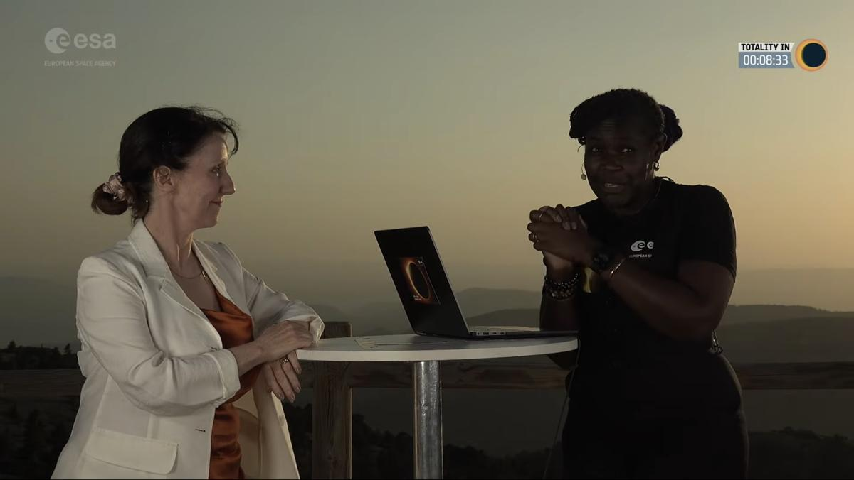
We broadcast live from the Observatorio Astrofísico de Javalambre in Spain as a total solar eclipse crossed Europe on 12 August 2026. The path of totality swept across Greenland, Iceland, Spain and a small area of northeastern Portugal, while much of Europe experienced a partial eclipse. A total solar eclipse occurs when the Moon passes directly between Earth and the Sun, completely blocking the face of the Sun. The Observatorio Astrofísico de Javalambre is a world-class astronomical observatory located within the path of totality. During the broadcast, scientists, astronomers and special guests explored the science behind eclipses, the Sun and their wider relevance for space science and Earth. The broadcast was hosted by Dame Dr Maggie Aderin, award-winning space scientist and science communicator, and featured ESA's Director of Science Carole Mundell alongside other guests. It included live telescope views of the eclipse, expert commentary and interviews, insights into solar science and space weather, behind-the-scenes coverage from the observatory, and discussions on ESA's activities linked to the eclipse. Learn more about ESA's activities surrounding the 2026 eclipse, as well as those coming to Europe in 2027 and 2028.

10. NASA Selects Companies to Provide Payload Processing Services
Read more

Credit: NASA NASA has selected four companies to provide payload processing facilities under the Spacecraft Processing Operations Contract on‑ramp provision. The provision enables qualified providers to offer commercial payload processing services for agency missions launching from multiple locations where capabilities were not available at the time of the initial contract award. Contract awardees are: All Points Logistics LLC Blue Origin LLC Firefly Aerospace L3Harris Technologies Inc. Through the contract, NASA procures facilities and services required to perform prelaunch processing of spacecraft and associated rocket hardware for delivery to the launch pad. The Spacecraft Processing Operations Contract is a multiple-award, commercial, firm-fixed-price, indefinite-delivery/indefinite-quantity contract vehicle that has an aggregate ceiling price of $100 million with an ordering period through Feb. 1, 2033. NASA's Launch Services Program at the agency's Kennedy Space Center in Florida will manage the contract. The program works with private industry, mission, and international partners to launch science payloads ranging from small satellites with colleges and universities to NASA's highest-priority missions. For more information about NASA's launch services, visit: https://www.nasa.gov/lsp -end- Joshua Finch Headquarters, Washington 202-358-2546 joshua.a.finch@nasa.gov Leejay Lockhart Kennedy Space Center, Fla. 321-747-8310 leejay.lockhart@nasa.gov

11. NASA Challenge Tests Wheel Designs for Moon Base Mobility
Read more
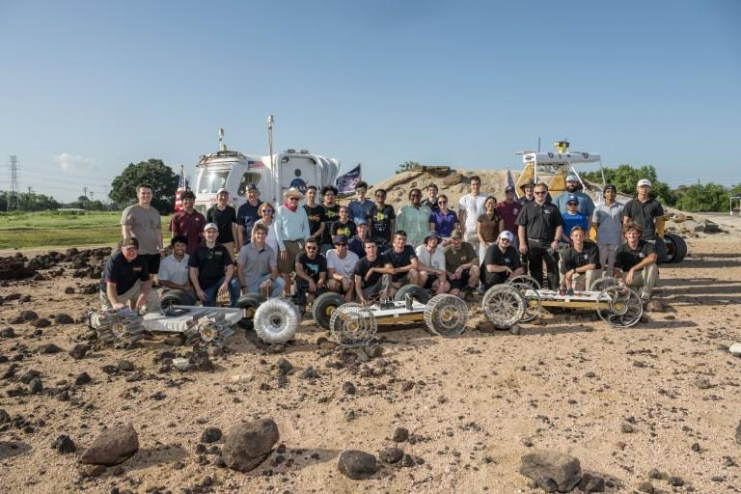
NASA engineers, NASA Robotics Academy students, and teams from the Rock and Roll with NASA Challenge pose with the wheel prototypes at NASA's Johnson Space Center Rock Yard in Houston on July 31, 2026. NASA/Luna Posadas Nava As NASA prepares to establish the Moon Base, advancing surface mobility will be key to helping crews and robotic systems travel farther across the lunar surface. To help advance that capability, the Rock and Roll with NASA Challenge invited public innovators to design and build next-generation lunar rover wheels. Five teams from 128 submissions and 49 countries advanced to the final phase of the competition, where they tested their prototypes on July 31 at NASA's Johnson Space Center in Houston. The Huff Helo lunar wheel prototype is tested at Johnson Space Center's Rock Yard. NASA/Luna Posadas Nava The challenge sought lightweight, durable, and scalable wheels that could support longer-duration lunar surface operations. The designs also needed to be compliant enough to absorb impacts, maintain traction at higher speeds, and withstand the harsh lunar environment. "Every additional kilometer a rover can reliably travel will expand how far we can explore, what science we can achieve, and what infrastructure we can build," said Ed Herrera, robotics engineer at Johnson and co-leader of the challenge project. NASA Johnson uses ground prototypes to test mobility technologies, while lunar terrain vehicles will be delivered to the lunar surface through the Commercial Lunar Payload Services initiative. For the challenge, the wheels were fitted to MicroChariot, a 45-kilogram test rover, and put through a series of courses at Johnson's Rock Yard to evaluate their performance across different types of terrain. NASA Robotics Academy students navigate the lunar wheel prototype Scotch Pad Tyres fitted on the MicroChariot rover at Johnson's Rock Yard. NASA/Luna Posadas Nava "Crowdsourcing gives us an opportunity to look beyond traditional approaches for lunar wheel design," Herrera said. "The more wheel technologies we can develop and understand, the more options we have to meet the needs of different vehicles, terrains, and missions on the Moon and Mars." Those ideas were reflected in five distinctly different designs. The HTR Variable Flex Lunar Wheel created by Hellenic Technology of Robotics SA uses an internal system designed to vary the wheel's stiffness depending on terrain and vehicle needs. The team adapted technology it had been developing for terrestrial wheels for about a decade. The Hiper Wheel created by Hyperbola uses tensioned cables and a corigated structure that provides spring-like behavior, allowing the wheel to flex without relying on traditional radial spokes. The Huff Helo Flexible Titanium Wheel created by Huff Helo Inc. uses formed titanium sheet metal as both structure and spring. During testing, the team found that the strength of the design also made the wheel more rigid, causing it to bounce over some obstacles rather than conform to the terrain. The Payne Aviation Wheel created by Deborah and Craige Payne took inspiration from aviation and history. Its designer, an aircraft mechanic, combined a pneumatic approach with ideas from early automobile tire designs. The winning Scotch Pad Tyres team poses with their prototype and MicroChariot at Johnson's Rock Yard. NASA/Luna Posadas Nava The winning Scotch Pad Tyres concept came from an Australian mechanical engineer Daniel Bloomfield and his son Isaac Bloomfield. Their prototype uses a Nomex-based tire structure supported around an aluminum hub. The soft material allows the tire to deform around terrain, while internal support helps it maintain its shape. A treated outer surface of epoxy and corundum grit was integrated to improve traction. The Rock Yard testing also demonstrated why different terrains may require different approaches. Loose material can affect traction, while rocks and slopes place different demands on wheels such as vehicle stability. The HTR Variable Flex Lunar Wheel prototype sits alongside NASA's Space Exploration Vehicle at Johnson's Rock Yard. NASA/Luna Posadas Nava As lunar exploration expands, different vehicles will require different combinations of speed, load capacity, durability, and terrain performance. Seeking that variety was part of the challenge design. The design options gave engineers different technologies to consider and potentially advance. "This challenge brought in new ideas from outside traditional industries and helped us identify wheel technologies that may be suitable for longer-duration surface operations," said Lucien Junkin, robotics engineer at Johnson and co-leader of the challenge project. The next phase could evaluate how the wheels respond to lunar-like dust, vacuum, and extreme temperatures in Johnson's thermal vacuum chambers. Engineers could also assess the designs over longer distances and at different sizes and loads. "Mobility is key to everything we want to do on the Moon," Junkin said. "The farther we want to explore, the more we need to advance the wheel technologies that can get us there." The Common Robotics Project of the Robotic Systems Technology Branch within Johnson's Engineering Directorate conducted the Rock and Roll with NASA Challenge. NASA's Center of Excellence for Collaborative Innovation, part of the Prizes, Challenges, and Crowdsourcing Program within the Research and Technology Mission Directorate, managed the challenge contract. Students in NASA's Robotics Academy helped prepare hardware and support the competition, while engineers from NASA's Glenn Research Center in Cleveland supported reviews of concepts and proposals. HeroX administered the challenge on behalf of NASA.

12. China bounces back from Long March rocket explosion with back-to-back launches (video)
Read more
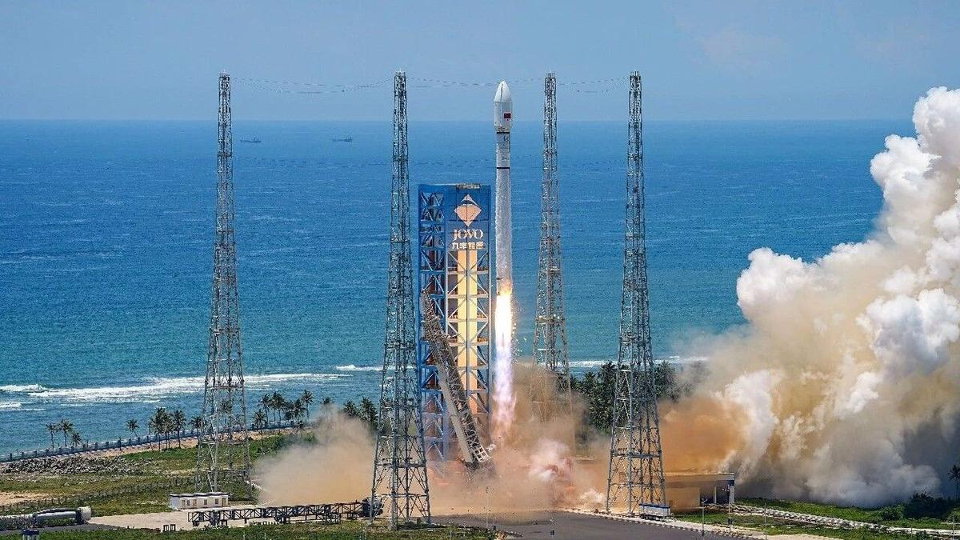
Click for next article China just completed not one but two space missions, less than a week after a Long March 7A rocket explosion briefly grounded its fleet. The state-owned China Aerospace Science and Technology Corporation ( CASC ) returned to flight with the launch of a Long March 12 rocket from the Hainan Commercial Space Launch Site in Wenchang. The rocket lifted off on Aug. 16 at 12:10 a.m. EDT (0410 GMT; 12:10 p.m. local time in China) and delivered a stack of 24 internet-beaming satellites into low Earth orbit (LEO). It was the first launch since China's Long March 7A exploded mid-flight on Aug. 10. Footage of that mission showed the Long March 7A's fairing section and the upper portion of the launch vehicle bending backward about 85 seconds after liftoff, resulting in the total loss of the rocket and its payload, the Zhongxing-4B communications satellite . China's Long March 12 rocket lifted off with a stack of 24 internet satellites on Aug. 16, 2024. (Image credit: CASC/Hu Zhipeng) Less than 24 hours after the successful Long March 12 mission, and about 1,300 miles (2,100 kilometers) north of the Wenchang launch site, a Long March 2C rocket lifted off from the Taiyuan Satellite Launch Center, in Shanxi province. The launch occurred on Aug. 16 at 11:02 p.m. EDT (0302 GMT and 11:02 a.m. local time in China on Aug. 17), and delivered the "SEO" satellite for the United Arab Emirates to its planned orbit, according to the China National Space Administration . Of the pair launched over the weekend, the Long March 12 is much more similar to the Long March 7A; the two stand 203 feet (62 meters) and 197 feet (60 m) tall, respectively. But the two rockets are designed with different purposes. The slightly wider Long March 12 is a two-stage rocket optimized for delivering relatively heavy payloads to LEO and sun-synchronous orbits, while the three-stage Long March 7A is designed for higher-altitude missions to geostationary transfer orbit and beyond. In contrast, the Long March 2C stands only about 141 feet (43 m) tall. The two-stage rocket is used primarily for smaller payloads to LEO, with a lifting capacity of only about 3.9 tons, and has a long list of launches dating back to 1982. The newest of the three, the Long March 12, was introduced in 2024 and has now launched seven missions - all successful. Last week was the Long March 7A's second failure in a total of 18 launches since the rocket's debut in 2020. CASC hasn't provided an update on the Long March 7A incident, other than a statement indicating that the cause is under investigation. As that continues, China has more launches on the horizon.

13. Blue Origin adding second pad to Cape Canaveral launch complex amid rocket explosion repairs
Read more
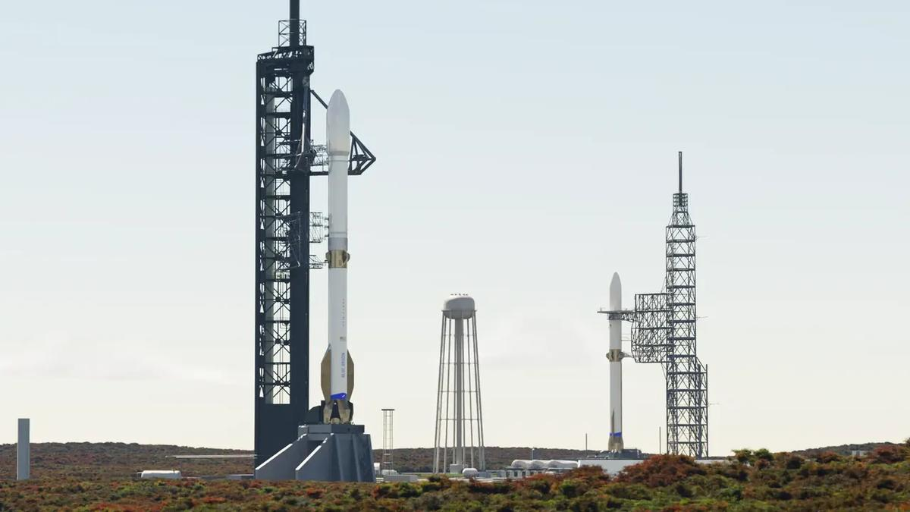
Click for next article Blue Origin plans to return its Florida launch site to a dual-pad facility to support its bigger, more powerful New Glenn "9x4" rocket, which is still under development. As facility repairs continue following the explosion of one of Blue Origin's New Glenn "7x2" rockets during tests at Cape Canaveral Space Force Station's Launch Complex-36 in May, the company has announced its intent to expand the site with an additional pad. The company also plans to build operations infrastructure for the complex on land nearby, which will include a Vertical Integration Facility (VIF) for the New Glenn 9x4 vehicle, and a Payload Processing Facility (PPF). Blue Origin has expressed confidence in its ability to complete repairs at its existing LC-36 pad (LC-36A) in time for New Glenn 7x2 to return to launch by the end of the year, but the company did not state a timeline for the readiness of LC-36B or an expected debut of New Glenn 9x4. The 7x2 and 9x4 designations are a denotation of the rockets' engine configurations. It's similar to SpaceX's name for the Falcon 9 rocket, which is powered by nine Merlin 1D engines on its first stage, arranged in a circle of eight around a single engine in the center. New Glenn's first stage is powered by Blue Origin's BE-4 engines, and the rocket's second stage uses BE-3Us. Both New Glenn first-stage configurations are designed for landing and reusability. The 7x2 flies with seven BE-4 engines on its first stage and two BE-3Us on its second stage. Subsequently, the taller, yet-to-debut New Glenn 9x4 will be powered by nine BE-4 engines on its first stage and four BE-3Us on its second stage. It will therefore be capable of launching larger, heavier payloads into space. For roughly four decades beginning in the 1960s, LC-36 was home to two pads that supported the Atlas-Centaur family and, later, the Atlas I, II and III rockets. In that time, the pads hosted launches of NASA's Surveyor , Mariner and Pioneer probes, as well as commercial and national-security payloads. But that era ended in the mid-aughts as those Atlas rockets reached retirement. LC-36A hosted its final launch in 2004, LC-36B launched its last rocket in 2005, and the complex was decommissioned and demolished. A render of the Vertical Integration Facility with Launch Complexes 36A & 36B in the distance. (Image credit: Blue Origin) Blue Origin took over the lease for LC-36 in 2015, began construction of its own launch facility in 2016, and launched the first New Glenn 7x2 rocket from the facility in 2025. Since that debut, New Glenn has flown two more missions, with the most recent lifting off in April. The company had planned for as many as eight to 12 launches in 2026, but May's static test fire explosion has reduced that number to a hopeful one (1). The fourth New Glenn rocket (NG-4) was slated to deliver a stack of Amazon Leo wireless internet satellites to orbit before its destruction during testing on May 8, which also resulted in extensive damage to LC-36 facilities. Less than a month later, Blue Origin CEO Dave Limp provided a repair update with the assurance that New Glenn would fly again before the end of 2026 . He also outlined some early upgrades that would be integrated into LC-36 as a result of the unexpected repairs , including the replacement of New Glenn's transporter erector with "an alternative vertical conop (operational concept)," for transporting the rocket to the pad. Proud to honor the legacy of Launch Complex 36. Rebuilding LC-36A and flying again this year remains our priority. Alongside that work, a separate team is beginning work on LC-36B, the operational home for New Glenn's 9x4. We're sourcing 2,500 tons of steel columns that will be… https://t.co/7MkYajmGLzAugust 12, 2026 "LC-36 has served as a cornerstone of American spaceflight for decades, supporting a broad range of missions for NASA and commercial partners," Blue Origin said in a statement . "Now, this historic site is entering a new era, furthering New Glenn operations." According to Limp, the additional pad will require as much as 2,500 tons of steel, much of which will go toward building a700-foot-tall (213 meters) launch tower.
14. ISRO Experts Highlight AI and Quantum Technology for Future Indian Satellites - The Quantum Insider
Read more
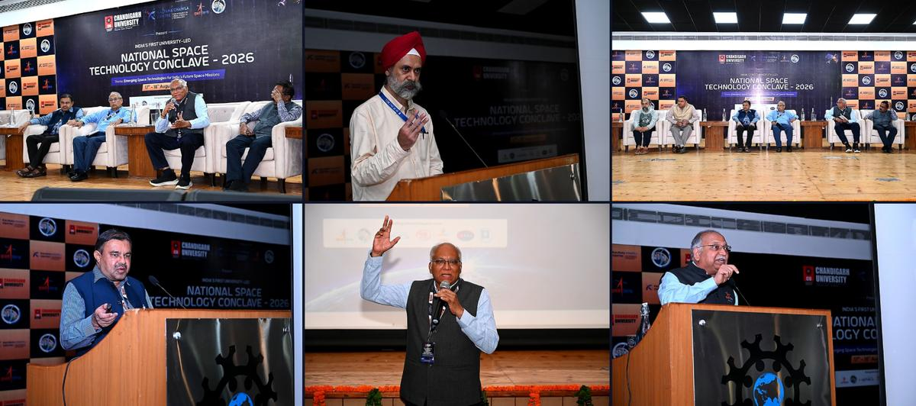
Insider Brief Experts at the National Space Technology Conclave 2026 highlighted AI/ML, quantum technology and inter-satellite links as technologies expected to support India's future satellite systems and space missions. ISRO experts said AI/ML could enable on-board processing and edge computing, while quantum technology could strengthen security for financial, military and other sensitive communications. The conclave also covered satellite engineering, payload development, mission operations, space sustainability and AI-enabled space data processing. Press release - During the culminating day of the National Space Technology Conclave 2026, organised by Chandigarh University at their campus, the ISRO experts concluded their remarks deliberated during the two day Conclave. The experts in one voice presented India's strong position in Space technologies and charted out the new policies being taken by the Government of India to make India a space and innovation hub in the time to come. "India has emerged as a global leader in the development of radar systems over the last decade and more, driven by a strong focus on indigenization and active industry involvement. Our capabilities now span almost all major radar frequency bands which has also positioned India as an attractive partner for leading global space agencies and institutions such as NASA, JPL, France and JAXA for collaborative missions and technologies," said Dr. Nilesh M Desai, former Director of Space Applications Centre (SAC), ISRO, during the National Space Technology Conclave 2026 at Chandigarh University on Tuesday, addressing the gathering at the campus. With this, the two-day-long conclave concluded where renowned space scientists, mission leaders and industry giants deliberated upon India's future space missions. The second day of the conclave focused on translating space technology priorities into education, research and mission capabilities, featuring a strategic roundtable and expert sessions on space systems and mission engineering, scientific and engineering payloads and ground segment and mission operations. Dr. Desai further said, "Artificial Intelligence and Machine Learning, Quantum Technology and Inter-Satellite Links (ISLs) will play a transformative role in India's upcoming satellite systems. On-board processing and edge computing through AI/ML will enable satellites to process data in space itself, supporting faster decision-making with real-time information and would be instrumental in governance, planning, policymaking and more effective disaster management. Quantum technology will help prevent cyber frauds and enhance the security of financial transactions, banking and stock market operations, military communications and other sensitive networks. From the national-security perspective, ISRO is also strengthening secure navigation capabilities. To counter threats such as spoofing, where false signals can mislead navigation receivers and potentially divert precision-guided systems, India is enhancing its multi-layer security architecture. India's Space-Based Surveillance (SBS) programme is another major step towards strengthening national security." Dr. Anil Kumar, Former Director, ISTRAC (ISRO Telemetry, Tracking and Command Network), ISRO, said, "Space sustainability has emerged as one of the most critical challenges for the future of space exploration and utilisation. As the number of satellites and other objects in orbit continues to grow, the accumulation of space debris is becoming an increasingly serious concern. Defunct satellites, spent rocket stages and fragments from past missions remain in orbit and can pose significant risks to operational spacecraft. Even small pieces of debris travelling at extremely high velocities can cause severe damage upon collision, potentially triggering a chain of collisions and making certain orbital regions increasingly difficult to use. The challenge is not limited to space operations. Uncontrolled re-entry of space objects can also create risks on Earth, while the growing presence of satellites can affect astronomical observations and the ability to study the night sky. Ensuring the long-term sustainability of outer space, therefore, requires responsible space operations, continuous monitoring, collision avoidance, debris mitigation and stronger international cooperation." "India is actively contributing to this global effort by safeguarding its satellites, supporting international guidelines and participating in global forums on space sustainability. The objective must be to ensure that outer space remains a safe, secure and usable domain for future generations," added Dr. Kumar. Deepinder Singh Sandhu, Senior Managing Director, Chandigarh University, said, "India's space programme, spearheaded by ISRO, has transformed the nation into a prominent power in global space exploration, navigation, science and advanced space operations. From the historic launch of Aryabhata, India's first satellite in 1975, the country has progressed to pioneering cost-effective satellite launches with the PSLV delivering 399 foreign satellite launches till 2026 as compared to just 35 before 2014. It shows India's growing launch capabilities are attracting global demand. As India marked its 80th Independence Day, its space ambitions reflect a confident and self-reliant nation shaping the future of space. India's space reforms in the last decade have created an enabling environment for private participation, investment, innovation and technology-led growth. Now there is no stopping India from becoming a leading global space power to realise the vision of a Viksit Bharat by 2047." The sessions on the second day also covered mission architecture, satellite and subsystem engineering, payload development and validation, ground stations, TT&C, satellite tracking, mission control, AI-enabled mission operations and space data processing. The day also featured an interactive 'Meet the Scientists & Space Industry Leaders' session, giving students an opportunity to engage directly with leading experts, followed by a student-space leaders conversation and the valedictory function.

15. ISRO Scientist Recruitment 2026: Apply for 92 Posts - educationtoday.co
Read more
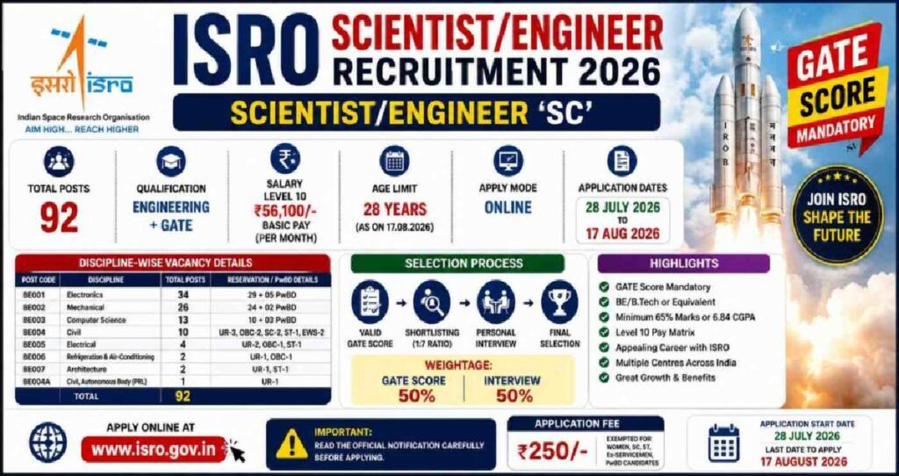
ISRO Scientist Recruitment 2026: Applications Open for 92 Posts, Check Eligibility and Selection Process Leave a Comment / Daily News Table of Contents - 92 Scientist and Engineer Vacancies Announced - Academic Eligibility for Applicants - Age Limit and Application Fee - Selection Based on GATE Score and Interview - How Candidates Can Apply - Why the Recruitment Matters for Engineering Graduates - Engineering Skills Meet Space Technology - A Career Opportunity Within India's Space Programme The Indian Space Research Organisation (ISRO) has opened applications for 92 Scientist/Engineer 'SC' positions across multiple engineering disciplines, offering qualified candidates an opportunity to build a career with India's premier space research organisation. The recruitment is being conducted through the ISRO Centralised Recruitment Board (ICRB), with candidates required to hold a valid GATE score in the relevant discipline. The recruitment comes at a time when opportunities in space science, engineering and advanced technology are expanding alongside India's growing space programme. For engineering graduates with the required academic qualifications and GATE scores, the vacancies provide an opportunity to enter a highly specialised technical environment. Candidates interested in the posts must complete the online application process by 17th August 2026. Applicants are advised to verify their eligibility and submit their forms well before the deadline rather than waiting until the final day. 92 Scientist and Engineer Vacancies Announced The vacancies have been distributed across several engineering disciplines. Electronics has the highest number of positions, followed by Mechanical and Computer Science. The discipline-wise distribution is: - Electronics: 34 vacancies - Mechanical: 26 vacancies - Computer Science: 13 vacancies - Civil: 10 vacancies - Electrical: 4 vacancies - Refrigeration and Air Conditioning: 2 vacancies - Architecture: 2 vacancies - Civil at PRL: 1 vacancy - Total: 92 vacancies The distribution highlights the range of technical expertise required across ISRO's operations. Engineers from conventional disciplines as well as specialised areas can therefore find opportunities within the recruitment process. Academic Eligibility for Applicants Candidates applying for the Scientist/Engineer 'SC' positions must possess a BE, BTech or equivalent degree in the relevant engineering discipline. Applicants are required to have secured at least 65% aggregate marks or a CGPA of 6.84 on a 10-point scale. Another important requirement is the GATE score. Candidates must have a valid score from either GATE 2025 or GATE 2026 in the corresponding paper. This requirement makes the recruitment particularly relevant for engineering graduates who have recently appeared for the national-level examination. The eligibility criteria are designed to ensure that applicants possess both the required academic foundation and a recognised national-level assessment score before moving to the next stage of recruitment. Age Limit and Application Fee Age is another important criterion that applicants must consider before submitting their forms. Candidates must be 28 years of age or below as on 17th August 2026, subject to the applicable provisions and relaxations specified by ISRO. Candidates belonging to the unreserved category are required to pay an application fee of ₹250. Applicants should carefully review the official notification for applicable provisions before completing the payment and final submission. Since recruitment applications involve document verification at later stages, candidates should ensure that the information entered in the application form matches their educational records and other supporting documents. Selection Based on GATE Score and Interview The selection process combines the candidate's performance in GATE with an interview. According to the recruitment notification, the final merit list will be based on the interview and GATE score. This makes the recruitment particularly important for candidates who have already invested significant preparation in the GATE examination. A strong GATE performance can provide the academic foundation for progressing through the recruitment process, while the interview offers ISRO an opportunity to assess candidates beyond their examination performance. The combination of a national-level examination score and a specialised interview also reflects the technical nature of the positions. Successful candidates are expected to contribute to highly specialised engineering and scientific work within the organisation. How Candidates Can Apply Eligible candidates can complete their applications through the official ISRO recruitment portal. The application process involves several stages, and applicants should carefully follow the instructions provided in the notification. The broad application process includes: - Visiting the official ISRO website and accessing the Careers section - Opening the relevant Scientist/Engineer recruitment notification - Registering with an email ID and mobile number - Entering personal and educational details - Uploading the required documents - Paying the applicable application fee - Submitting the completed application form - Downloading and retaining a copy of the submitted form for future reference Candidates should check every detail before final submission, particularly their educational qualifications, GATE information and personal particulars. Why the Recruitment Matters for Engineering Graduates A Scientist/Engineer position at ISRO represents more than a conventional engineering career. The organisation works across areas involving spacecraft, launch vehicles, satellite systems, electronics, communication, propulsion, remote sensing and other advanced technologies. The recruitment therefore provides qualified engineers with an opportunity to work in an environment where engineering knowledge is applied to complex national space missions. The diversity of disciplines in the latest vacancies also demonstrates that India's space programme requires expertise extending well beyond aerospace engineering alone. For engineering students and recent graduates, the recruitment can also underline the importance of building strong fundamentals alongside preparation for examinations such as GATE. Click below to watch the video. Engineering Skills Meet Space Technology Engineering careers are increasingly extending into specialised sectors such as space technology, satellite systems and advanced research. EducationToday views the ISRO recruitment drive as a notable example of how strong engineering fundamentals, combined with national-level examinations such as GATE, can open pathways into highly specialised careers. The opportunity is particularly relevant for graduates who want to apply their technical knowledge to projects with national significance. It also highlights the growing importance of interdisciplinary engineering capabilities as India's space programme expands into increasingly sophisticated areas of research and technology. For aspiring engineers, such recruitment drives can serve as a reminder that career opportunities are not limited to conventional corporate roles. Public-sector research and technology institutions can also offer pathways into specialised technical work. A Career Opportunity Within India's Space Programme The 92 vacancies offer engineering graduates an opportunity to enter a demanding technical environment and contribute to India's space programme. With recruitment spanning Electronics, Mechanical, Computer Science, Civil, Electrical and other disciplines, the drive reflects the broad engineering expertise required to support complex space missions. For eligible candidates, the immediate priority is to focus on the application deadline. With 17th August 2026 approaching, applicants should verify the eligibility requirements, keep the necessary documents ready, and complete the online registration carefully. The selection process also requires candidates to prepare beyond the application stage. Since the final merit list takes into account both GATE performance and the interview, applicants should be prepared to demonstrate not only academic knowledge but also their understanding of engineering concepts and their suitability for specialised work. The latest recruitment drive provides a significant opportunity for qualified engineering graduates seeking a technically challenging career within India's space sector. Candidates who meet the prescribed requirements should make use of the application window and approach the selection process with careful preparation. 1. How many vacancies are available in ISRO Scientist Recruitment 2026? ISRO has announced 92 vacancies for Scientist/Engineer posts under the 2026 recruitment drive. 2. Who is eligible for ISRO Scientist Recruitment 2026? Eligibility depends on the post and discipline. Candidates generally need the prescribed engineering or relevant technical qualification with the required academic performance specified in the official recruitment notification. 3. What is the age limit for ISRO Scientist/Engineer Recruitment 2026? The age limit varies according to the recruitment notification and applicable category-based relaxations. Candidates should check the official notification before applying. 4. How can candidates apply for ISRO Scientist Recruitment 2026? Eligible candidates can submit their applications online through the official ISRO recruitment portal by completing the form, uploading required documents, and paying the applicable fee, if required. 5. What is the selection process for ISRO Scientist Recruitment 2026? The selection process generally involves shortlisting based on the prescribed criteria, followed by the relevant written test and/or interview, depending on the post and recruitment notification. Post Views: 706 UP Board's Derecognition of 465 Non-Functional Schools Signals a Strong Push for Educational Accountability Daily News

16. ISRO official says docking technology key to future lunar, human space - Daily Excelsior
Read more
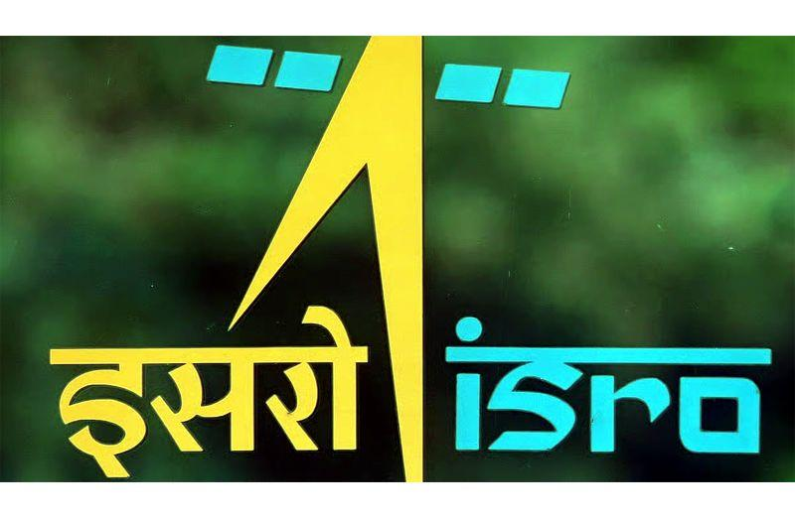
LUCKNOW, Aug 18 : Docking technology will be crucial for future lunar exploration and human space missions, including bringing lunar samples back to Earth and assembling India's proposed space station, a senior ISRO official said here on Tuesday. M R... LUCKNOW, Aug 18 : Docking technology will be crucial for future lunar exploration and human space missions, including bringing lunar samples back to Earth and assembling India's proposed space station, a senior ISRO official said here on Tuesday. M R Raghavendra, Director of ISRO Telemetry, Tracking and Command Network (ISTRAC), Bengaluru, was speaking at a National Space Day celebration organised by ISTRAC in collaboration with City Montessori School (CMS) in Lucknow. The school is the alma mater of astronaut Shubhanshu Shukla, the first Indian to visit the International Space Station. "The docking experiment is a very interesting experiment which we have conducted, as it can be very useful in future," Raghavendra said, referring to ISRO's successful space docking experiment. "Now we have landed on the Moon. Now we want to bring some samples from the Moon, and to do that, we need this docking. There will be an orbiter which goes around the Moon, and there will be a lander which picks up the sample, comes to the orbiter, docks and then the sample is returned to Earth," he said. "So ISRO has gained experience in docking as well," he added. Raghavendra said docking would also be essential for the proposed Bharatiya Antariksh Station (BAS), India's planned space station. "You must have all heard of the ISS (International Space Station). Now we have BAS (Bharatiya Antariksh Station) also coming up, which will have a five-module approach, and each of these modules will require docking. So docking is a way forward for human missions and even for primary missions," he said. He also spoke about upcoming projects, including the Gaganyaan human spaceflight mission and the Bharatiya Antariksh Station. Raghavendra said ISRO had begun its journey by addressing basic needs of the society and had now emerged as a leading organisation in the development of advanced and cutting-edge space technologies. He said the space sector was now open to private participation and offered numerous opportunities to people from diverse professional and academic backgrounds. Urging students to "think the impossible", Raghavendra encouraged them to go beyond the traditional boundaries of space exploration and contribute towards fulfilling India's scientific and technological vision for 2047. He also stressed the importance of planning and execution behind the success of the Chandrayaan-3 mission, under which India achieved a soft landing on the Moon. "We were the fourth country to land on the Moon. Landing on the Moon was not just an event," he said, highlighting the technological and organisational effort involved in the mission. Speaking to reporters separately, Raghavendra described National Space Day as an important occasion for India and its scientific community. "This is a very important day for our nation, especially the scientific community, because on this day, we achieved a very technologically challenging mission by landing our ISRO lander on the southern side of the Moon on August 23, 2023," he said. "This is not only a demonstration of technological prowess but also a huge inspiration to all young minds of our country," he added. Chandrayaan-3 achieved a historic milestone in 2023 when its Vikram lander made a safe and soft landing on the lunar surface, making India the fourth country to successfully land on the Moon and the first to reach its southern polar region. The Pragyan rover was subsequently deployed on the surface. The landing site was named Shiv Shakti Point, and August 23 was declared National Space Day. India will celebrate its third National Space Day on August 23 this year with the theme 'Towards Viksit Bharat: Innovating, Collaborating, and Aspiring to Global Space Leadership'. As part of the 2026 celebrations, ISTRAC organised the one-day programme in collaboration with CMS at its Gomtinagar-1 campus in Lucknow on Tuesday. Geeta Gandhi Kingdon, Manager and Managing Director of CMS, said the dedicated efforts of ISRO scientists and contributions of the younger generation had placed India among the leading nations in the field of space research. Referring to the achievement of CMS alumnus Shubhanshu Shukla, she said, "His success as an Indian citizen who travelled to space has made the entire nation proud." (PTI)

17. Watch SpaceX launch its 100th mission of the year tonight
Read more
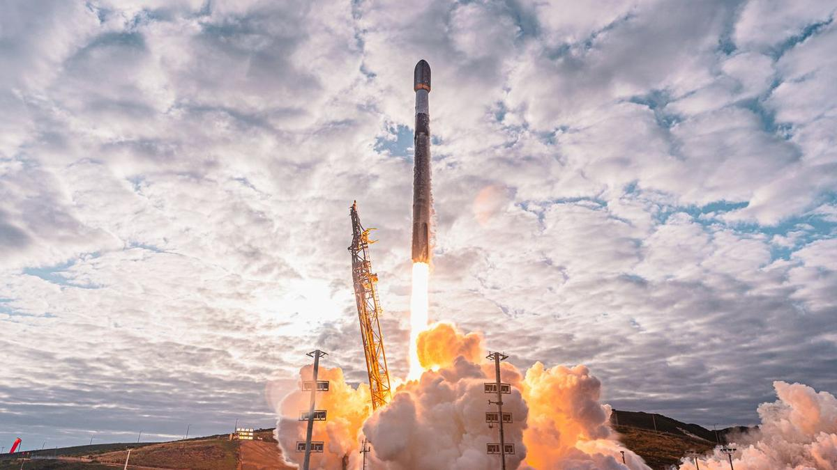
Click for next article SpaceX has hit the century mark for the third year in a row. A Falcon 9 rocket lifted off from California's Vandenberg Space Force Base on Wednesday (Aug. 19) at 12:01 a.m. EDT (0401 GMT; 9:01 p.m. on Aug. 18 local time). It was the 97th Falcon 9 launch of the year and the 100th mission of 2026 overall for SpaceX . The Falcon 9's first stage rests on the deck of a drone ship after its successful landing on Aug. 19, 2026. (Image credit: SpaceX) The mission is carrying 24 of SpaceX's Starlink internet satellites to low Earth orbit . If all goes according to plan, the Falcon 9's upper stage will deploy them there 61.5 minutes after liftoff. The rocket's first stage, meanwhile, came back to Earth about 8.5 minutes into flight as planned, landing in the Pacific Ocean on the drone ship "Of Course I Still Love You." It was the 12th mission for this particular booster, which is designated B1097. B1097 is no stranger to milestone flights. During a Starlink launch this past April, for example, the booster performed the 600th landing of an orbital rocket in SpaceX's illustrious history. Previous Booster B1097 launches Sentinel-6B | Twilight | NROL-172 | Transporter-17 | 7 Starlink missions The vast majority of SpaceX's launches this year - at the moment, 74 of them - have been devoted to building out the Starlink megaconstellation, which currently consists of nearly 11,000 operational satellites . One of SpaceX's three non-Falcon 9 launches of 2026 was performed by its Falcon Heavy rocket. The other two were suborbital test flights of Starship , the giant, fully reusable vehicle that SpaceX is developing to help humanity settle the moon and Mars , among other tasks. SpaceX first topped 100 launches in 2024, when it conducted a total of 138 missions (132 by Falcon 9, two by Falcon Heavy and four by Starship). In 2025, the company flew a total of 170 times (165 by Falcon 9 and five by Starship). Such numbers will jump dramatically in the coming years, if all goes to plan. SpaceX founder and CEO Elon Musk has said the company wants to launch Starship multiple times per day, boosting annual tallies to 1,000 or so. Falcon 9 and Falcon Heavy aren't part of this longer-term picture; SpaceX wants to phase them out and have Starship shoulder the load. Editor's note: This story was updated at 12:20 a.m. ET on Aug. 19 with news of successful launch and rocket landing.

18. Hubble, James Webb Space Telescope team up to capture the 'Black Eye Galaxy' | Space photo of the day for Aug. 18, 2026
Read more
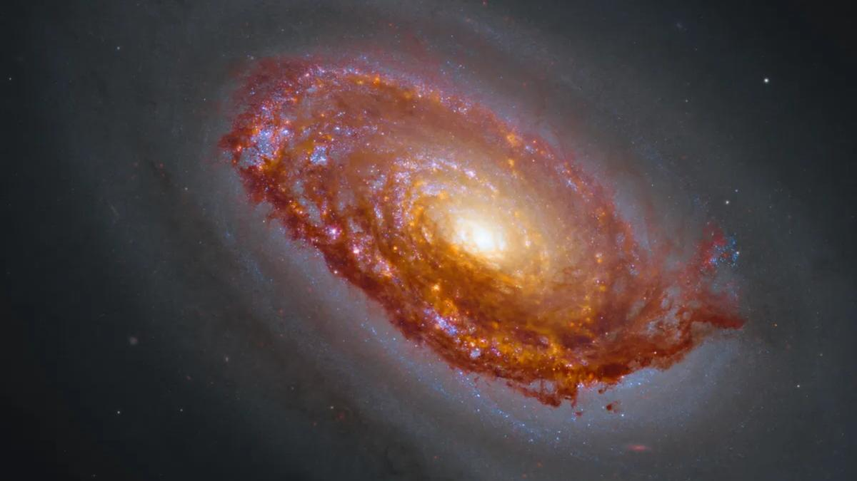
Click for next article The "Black Eye Galaxy" is captured in this new composite image from the Hubble Space Telescope and JWST. (Image credit: NASA, CSA, ESA, F. Belfiore (European Southern Observatory - Germany), J. Lee (Space Telescope Science Institute), A. Leroy (The Ohio State University), and D. Thilker (The Johns Hopkins University); Processing: Gladys Kober (NASA/Catholic University of America)) Sometimes, incredibly powerful space telescopes work together to accomplish amazing things. Recently, observations made by both the James Webb Space Telescope and Hubble were combined in a composite image that shows the incredible nature of the "Black Eye Galaxy," more formally known as Messier 64. What is it? The Black Eye Galaxy is a strange spiral galaxy located 17 million light-years from Earth, in the constellation Coma Berenices, a name that means "Berenice's Hair" in Latin. Discovered in 1779, the Black Eye Galaxy is fairly isolated from other galaxies and is known for its hypnotizing "stare." This look is created by the galaxy's internal, swirling motion. However, unlike many other spiral galaxies, the gas in the outer reaches of this one rotates in the opposite direction to the gas and stars closer to its center, creating an especially unusual motion. To capture this incredible composite view of the galaxy, astronomers combined near and mid-infrared wavelength observations made by JWST and ultraviolet, visible and near-infrared observations made by Hubble. Why is it incredible? As we look forward to observations from NASA's upcoming flagship space observer, the Nancy Grace Roman Space Telescope , this collaborative effort shows how such powerful instruments don't replace one another; rather, they bring different capabilities to the table and can complement each other. And, while this new image is the result of a team effort of cutting edge-technology, the Black Eye Galaxy is also a favorite target for backyard astronomers because it can often be spotted in small telescopes.

19. Live coverage: SpaceX to send Starlink satellites to orbit with Tuesday night launch from California
Read more
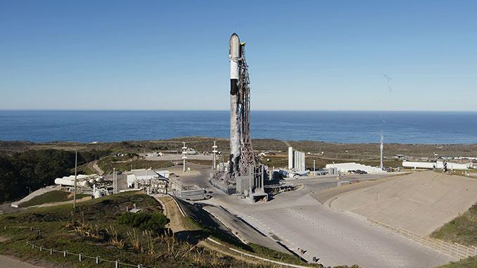
Update 10 p.m. EDT (0200 UTC): SpaceX pushed back the launch time. SpaceX is set to send another batch of Starlink satellites to low Earth orbit with a launch Tuesday night launch from Vandenberg Space Force Base in California. Liftoff of the Falcon 9 rocket is scheduled for 9:01 p.m. PDT (12:01 a.m. EDT / 0401 UTC). The rocket will fly on a south-southwesterly trajectory upon leaving the pad at Space Launch Complex 4 East. Spaceflight Now will have live coverage beginning about 30 minutes prior to liftoff. The Starlink 17-50 mission will add another 24 broadband internet satellites to the megaconstellation, bringing the total number of satellites currently in orbit to around 11,000. SpaceX will launch the mission using the Falcon 9 first stage booster B1097. This will be its 12th flight after previously launching the Twilight and Transporter-17 rideshare missions; Sentinel-6B; NROL-172; and seven previous batches of Starlink satellites. A little more than eight minutes after liftoff, B1097 will target a landing on the droneship, Of Course I Still Love You, positioned in the Pacific Ocean. If successful, this will be the 219th landing on this vessel and the 651st Falcon booster landing to date.
20. India's Satellites Will Use AI And Quantum Tech, ISRO Experts Say - Quantum Zeitgeist
Read more

India has emerged as a global leader in radar system development over the last decade, a shift highlighted at the National Space Technology Conclave 2026 organized by Chandigarh University. According to Dr. Nilesh M Desai, former Director of Space Applications Centre (SAC), ISRO, the country's capabilities now span almost all major radar frequency bands, making India an attractive partner for space agencies including NASA, JPL, France, and JAXA. Desai, "driven by a strong focus on indigenization and active industry involvement." He outlined how artificial intelligence, quantum technology, and inter-satellite links will transform future satellite systems. AI/ML, Quantum Tech, and ISLs Transform Satellite Systems This shift allows satellites to analyze information in space, facilitating quicker responses for applications ranging from governance and disaster management to real-time policymaking. Beyond AI/ML, quantum technology is expected to enhance the security of critical infrastructure supported by satellite networks. Desai detailed how this technology will help prevent cyber fraud and enhance the security of financial transactions, banking and stock market operations, military communications and other sensitive networks. ISRO is concurrently fortifying secure navigation capabilities to counter threats like signal spoofing, which could compromise precision-guided systems. The agency is implementing a multi-layered security architecture to safeguard against these vulnerabilities, and India's Space-Based Surveillance (SBS) program represents a key component of this national security strategy. The integration of Inter-Satellite Links (ISLs) further expands the potential of India's space assets. These links will allow satellites to communicate directly with each other, reducing reliance on ground stations and improving data relay speeds. This capability is particularly important for maintaining continuous coverage and responsiveness in remote areas or during emergencies. Dr. Anil Kumar, Former Director, ISTRAC (ISRO Telemetry, Tracking and Command Network), ISRO, added that India is actively contributing to this global effort by safeguarding its satellites, supporting international guidelines and participating in global forums on space sustainability, emphasizing the nation's commitment to responsible space operations. India has emerged as a global leader in the development of radar systems over the last decade and more, driven by a strong focus on indigenization and active industry involvement. Dr. Nilesh M Desai, former Director of Space Applications Centre (SAC), ISRO, during the National Space Techno Space Sustainability & Secure Navigation for National Security Anil Kumar, former Director of ISTRAC (ISRO Telemetry, Tracking and Command Network), ISRO, explained that the increasing density of objects in orbit presents a significant and escalating challenge to future space exploration and utilization. Defunct satellites and debris from past missions pose risks to operational spacecraft; even small fragments can cause severe damage at high velocities. The potential for cascading collisions is a key worry, potentially rendering certain orbital regions unusable, and uncontrolled re-entry of space objects presents terrestrial hazards. Kumar detailed how this extends beyond operational concerns, noting that the growing number of satellites can also interfere with astronomical observations and the study of the night sky. Addressing these threats requires responsible space operations, continuous monitoring, and robust international collaboration to mitigate debris and ensure sustainability. Alongside debris mitigation, India is actively strengthening the security of its satellite navigation systems. Artificial Intelligence and Machine Learning, Quantum Technology and Inter-Satellite Links (ISLs) will play a transformative role in India's upcoming satellite systems. Dr. Anil Kumar, Former Director, ISTRAC (ISRO Telemetry, Tracking and Command Network), ISRO

21. AI, Quantum Tech to Power India's Next-Gen Satellites and Strengthen National Security: ISRO Experts at National Space Technology Conclave 2026 - Business Standard
Read more
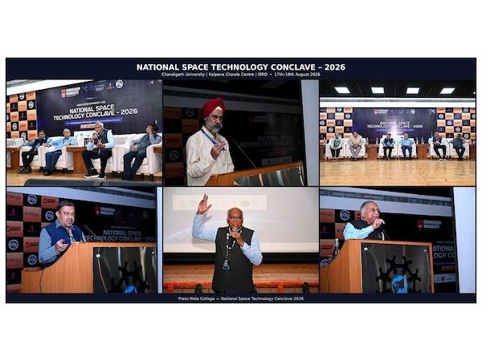
PRNewswire Chandigarh [India], August 19: During the culminating day of the National Space Technology Conclave 2026, organised by Chandigarh University at their campus, the ISRO experts concluded their remarks deliberated during the two day Conclave. The experts in one voice presented India's strong position in Space technologies and charted out the new policies being taken by the Government of India to make India a space and innovation hub in the time to come. "India has emerged as a global leader in the development of radar systems over the last decade and more, driven by a strong focus on indigenization and active industry involvement. Our capabilities now span almost all major radar frequency bands which has also positioned India as an attractive partner for leading global space agencies and institutions such as NASA, JPL, France and JAXA for collaborative missions and technologies," said Dr. Nilesh M Desai, former Director of Space Applications Centre (SAC), ISRO, during the National Space Technology Conclave 2026 at Chandigarh University on Tuesday, addressing the gathering at the campus. With this, the two-day-long conclave concluded where renowned space scientists, mission leaders and industry giants deliberated upon India's future space missions. The second day of the conclave focused on translating space technology priorities into education, research and mission capabilities, featuring a strategic roundtable and expert sessions on space systems and mission engineering, scientific and engineering payloads and ground segment and mission operations. Dr. Desai further said, "Artificial Intelligence and Machine Learning, Quantum Technology and Inter-Satellite Links (ISLs) will play a transformative role in India's upcoming satellite systems. On-board processing and edge computing through AI/ML will enable satellites to process data in space itself, supporting faster decision-making with real-time information and would be instrumental in governance, planning, policymaking and more effective disaster management. Quantum technology will help prevent cyber frauds and enhance the security of financial transactions, banking and stock market operations, military communications and other sensitive networks. From the national-security perspective, ISRO is also strengthening secure navigation capabilities. To counter threats such as spoofing, where false signals can mislead navigation receivers and potentially divert precision-guided systems, India is enhancing its multi-layer security architecture. India's Space-Based Surveillance (SBS) programme is another major step towards strengthening national security." Dr. Anil Kumar, Former Director, ISTRAC (ISRO Telemetry, Tracking and Command Network), ISRO, said, "Space sustainability has emerged as one of the most critical challenges for the future of space exploration and utilisation. As the number of satellites and other objects in orbit continues to grow, the accumulation of space debris is becoming an increasingly serious concern. Defunct satellites, spent rocket stages and fragments from past missions remain in orbit and can pose significant risks to operational spacecraft. Even small pieces of debris travelling at extremely high velocities can cause severe damage upon collision, potentially triggering a chain of collisions and making certain orbital regions increasingly difficult to use. The challenge is not limited to space operations. Uncontrolled re-entry of space objects can also create risks on Earth, while the growing presence of satellites can affect astronomical observations and the ability to study the night sky. Ensuring the long-term sustainability of outer space, therefore, requires responsible space operations, continuous monitoring, collision avoidance, debris mitigation and stronger international cooperation." "India is actively contributing to this global effort by safeguarding its satellites, supporting international guidelines and participating in global forums on space sustainability. The objective must be to ensure that outer space remains a safe, secure and usable domain for future generations," added Dr. Kumar. Deepinder Singh Sandhu, Senior Managing Director, Chandigarh University, said, "India's space programme, spearheaded by ISRO, has transformed the nation into a prominent power in global space exploration, navigation, science and advanced space operations. From the historic launch of Aryabhata, India's first satellite in 1975, the country has progressed to pioneering cost-effective satellite launches with the PSLV delivering 399 foreign satellite launches till 2026 as compared to just 35 before 2014. It shows India's growing launch capabilities are attracting global demand. As India marked its 80th Independence Day, its space ambitions reflect a confident and self-reliant nation shaping the future of space. India's space reforms in the last decade have created an enabling environment for private participation, investment, innovation and technology-led growth. Now there is no stopping India from becoming a leading global space power to realise the vision of a Viksit Bharat by 2047." The sessions on the second day also covered mission architecture, satellite and subsystem engineering, payload development and validation, ground stations, TT & C, satellite tracking, mission control, AI-enabled mission operations and space data processing. The day also featured an interactive 'Meet the Scientists & Space Industry Leaders' session, giving students an opportunity to engage directly with leading experts, followed by a student-space leaders conversation and the valedictory function. About Chandigarh University Chandigarh University is a NAAC A+ Grade University and QS World Ranked University. This autonomous educational institution is approved by UGC and is located near Chandigarh in the state of Punjab. It is the youngest university in India and the only private university in Punjab to be honoured with A+ Grade by NAAC (National Assessment and Accreditation Council). CU offers more than 109 UG and PG programs in the field of engineering, management, pharmacy, law, architecture, journalism, animation, hotel management, commerce, and others. It has been awarded as The University with Best Placements by WCRC. Website address: https://www.cuchd.in/ (ADVERTORIAL DISCLAIMER: The above press release has been provided by PRNewswire. ANI will not be responsible in any way for the content of the same)

22. NASA TechLeap Prize: Orbital Clarity Challenge
Read more

1 min read Bailey G. Light Aug 19, 2026 Article The Orbital Clarity Challenge - the sixth in the NASA TechLeap Prize series - is a collaborative effort between NASA's Heliophysics Division , Flight Opportunities program , and Center of Excellence for Collaborative Innovation . The Heliophysics Division studies space weather, including how it heats and expands Earth's outer atmosphere during intense solar activity, creating orbital drag through atmospheric density changes. The challenge calls for low-cost methods of measuring thermospheric density, pressure, or drag in low Earth orbit. NASA is seeking approaches that are inexpensive and scalable enough to be produced in quantity and flown as hosted payloads across the commercial fleet. The challenge will unfold across three phases, advancing up to four winners' concepts to a flight-ready solution within 12 months. At the conclusion of the challenge, NASA intends to offer each winning team a test flight at no cost. Award: Up to four winners may receive up to $500,000 in prizes across three phases Challenge Open Date: August 19, 2026 Phase 1 Registration Close Date: October 28, 2026 Phase 1 Submission Close: November 11, 2026 For more information, visit: https://occ.nasatechleap.org/

23. NASA Updates Next Steps for Commercial Swift Boost Mission
Read more
Due to an ongoing commercial spacecraft attitude control issue, NASA and Katalyst Space announced Wednesday the LINK spacecraft will not capture or boost an agency satellite to a higher altitude to extend its science mission as planned. However, LINK still will attempt to conduct rendezvous and proximity operations with NASA's Neil Gehrels Swift Observatory to […]

24. Human-Related Microbes May Survive Moon's South Pole, NASA Finds
Read more
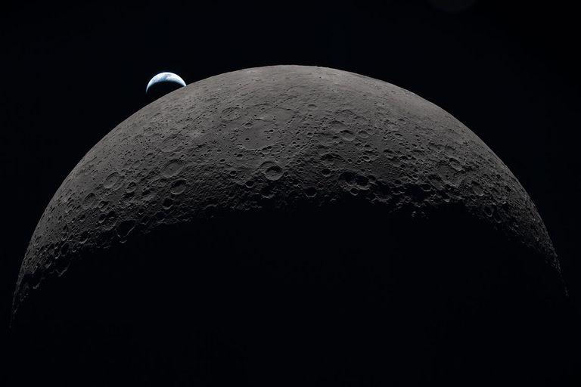
This image was taken by an Artemis II astronaut from the Orion capsule in April 2026, as the spacecraft traveled past the Moon and back over 10 days. The gray-brown, heavily cratered Moon dominates the frame against black space, with a partially lit crescent Earth setting behind its upper-left edge. NASA Lee esta historia en español aquí. Some of Earth's microbes likely to hitch a ride to space with human explorers could survive in the shaded nooks and crannies of the Moon's South Pole region, NASA scientists say. Published on Aug. 19, 2026, in Science Advances, these findings highlight a need to better understand microbial persistence in extreme lunar environments. As humans build a permanent presence on the Moon, it may become difficult to distinguish ancient lunar chemistry from contamination delivered by visiting astronauts. The concern extends beyond the Moon and on to Mars, scientists say. "Humans are natural explorers, and with them come their voices, their memories … and their microbes," said Prabal Saxena, a planetary scientist who led the study from NASA's Goddard Space Flight Center in Greenbelt, Maryland. "For some scientists, myself included, that reality can be unsettling. But it also creates an opportunity to turn an imperfect situation into a useful experiment." Bringing microbes along is unavoidable: Humans have, on average, 1 million bacteria living on each patch of skin the size of a pencil eraser, for example. These bacteria vent from spacesuits and habitats. Though the paper's authors worry about contamination interfering with the search for chemical clues to ancient geology or biology, they also argue that the Moon should be used as a natural lab. In shaded areas around the South Pole, scientists could carefully test the real-life limits of microbial survival in an environment that can't easily be reproduced on Earth. The Apollo program landed six pairs of astronauts on the Moon between 1969 and 1972. All six landing sites are near the lunar equator. In this visualization, the Apollo sites are contrasted with the South Pole, an area with enormous potential for future exploration. Time passes as we zoom toward Shackleton crater at the South Pole, revealing illumination conditions quite different from those near the equator. While many craters remain in permanent shadow, some nearby mountains and ridges are in persistent sunshine, making them attractive candidates for solar power and long-term habitation. NASA's Scientific Visualization Studio/Ernie Wright Before any surface science can happen, scientists need a baseline measurement of what contaminants humans bring, the authors say. "We need to understand what was there before us, because when we go to Mars to search for signs of life beyond our planet, we will want to make sure it's not stuff we brought," said Andrew Needham, a NASA Goddard-based paper co-author who is an Artemis contamination‑control scientist for lunar samples. Even with strict sterilization procedures, some organisms are stubbornly resilient. A good example is Aspergillus niger, which is a fungus that thrives in warm, damp places like household bathrooms and heating, ventilation, and air conditioning systems. Astronauts have sampled it inside the International Space Station, and experiments demonstrate that the fungus can survive outside the station as well. Aspergillus niger was one of five microbes, including bacteria and fungi, selected for this study because of its known toughness in spaceflight environments. That microbes survived on the space station's exterior surprised scientists. These species are typically not considered "extremophiles" that can withstand harsh conditions, such as the vacuum of space, according to Aaron Regberg, a geomicrobiologist at NASA's Johnson Space Center in Houston. "I would have expected these microbes to have dried out," said Regberg, who studies space station bacteria and was a co-author on the paper. NASA astronaut Kate Rubins on Oct. 14, 2016, collecting microbes in the Japanese Experiment Module aboard the International Space Station. JAXA/Takuya Onishi He pointed out that NASA often bakes robotic spacecraft at temperatures above 400 degrees Fahrenheit to reduce the number of living organisms on them. But that's not possible with astronauts, so contamination concerns take on new meaning in crewed exploration of the Moon's south polar environment. A clearer picture of where microbes might survive comes from understanding how sunlight behaves at the poles. Survival in this study means the microbe can stay alive for at least one Earth day, which does not mean that it can grow and reproduce. Because the Moon has a very small tilt on its axis, the view from its poles is of a Sun that appears to hover just above the horizon, skimming the surface like a flashlight laying on a table. As a result, elevated parts of the surface, including crater ridges, mountains, and even small bumps, block light from reaching low-lying terrain. This produces pockets of shadowed areas that can remain cold and preserve water, as well as shield fragile molecules and possible microorganisms from lethal radiation. With that scientific context in mind, the team set out to test which Earth microbes could survive extreme polar conditions. They focused on organisms commonly found in spaceflight environments and those common on human skin. Besides Aspergillus niger, these included Bacillus subtilis, Staphylococcus aureus, Deinococcus radiodurans, and several species of Fusarium. Based on an analysis of previous studies, the scientists noted the maximum amount of heat and ultraviolet (UV) radiation each organism can withstand. Then, the organisms were tested in simulations of three regions near the lunar South Pole - Nobile Rim, Connecting Ridge, and De Gerlache Rim. Those simulations used detailed environmental maps built from elevation and temperature data collected by instruments aboard NASA's Lunar Reconnaissance Orbiter, combined with models of how radiation strikes the surface. The models showed maps of "survivable niches" that range in size from a miles-wide crater floor to an astronaut's boot print. Aspergillus niger, which was most resistant to UV radiation, was able to survive even in areas with some sunlight exposure. UV radiation is so deadly to most microbes that it's used for sterilization in hospitals. "When we think of the Moon, we don't typically think of biology," said Heather Graham, a paper co-author at NASA Goddard who helps develop tools and techniques for detecting biology that may look nothing like Earth's. "But the Moon is a place where a cell can survive, so our first exploration of these sites should pay extra attention to our microbial hitchhikers and work hard to characterize lunar chemistry before our visits change what we will find." The authors note that while some microbes can survive in a dormant state in regions around the South Pole, and thereby confuse some future scientific investigations, there is no evidence the Moon has key ingredients to sustain growth and replication. Such ingredients include liquid water, which typically requires an atmosphere and moderate temperatures. For more information, visit: https://science.nasa.gov/astrobiology

25. NASA Establishes State Hubs to Grow Technical Aerospace Workforce
Read more
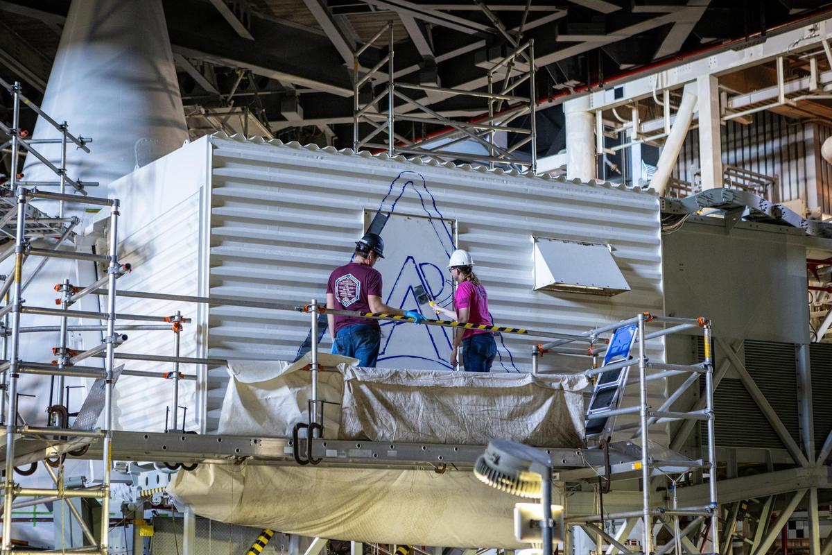
From left, Sean McCrary and Katie Mortensen, mechanical engineering technicians, paint NASA's Artemis logo on the White Room connected to the crew access arm and mobile launcher inside the Vehicle Assembly Building at NASA's Kennedy Space Center in Florida on Thursday, Dec. 4, 2025. Credit: NASA/Frank Michaux NASA has awarded approximately $10.5 million to seven institutions to help strengthen and streamline state-based pathways for students into skilled technical jobs in the aerospace industry. The awards were made through the new NASA Aerospace Skilled Technical Workforce Hubs initiative, or NASA State Hubs. This investment in state ecosystems is designed to accelerate the development of technical roles to meet the talent demands of the space industry. "The need for technical talent is already urgent and will only continue to grow as we return humanity to the Moon and set our sights on Mars and beyond," said Elaine Ho, associate administrator for the Office of STEM Engagement at NASA Headquarters in Washington. "NASA is uniquely positioned to be the catalyst and convener that accelerates America's aerospace workforce development and fosters the next generation of technicians." The newly awarded NASA State Hubs, represented across seven states, will function as strategic conveners that align industry employers, community colleges, high school career and technical education programs, and workforce systems to facilitate bringing students into high‑demand technical jobs, including welders, electricians, machinists, and other highly trained workers who use advanced STEM knowledge and technical skills in their occupations. Over the next three years, the selected organizations will create programs that build critical skills identified by industry leaders, illuminate career pathways through education and apprenticeships, and build connections between employers and job seekers. The awarded organizations are: Antelope Valley Community College District in Lancaster, California Georgia Tech Research Corporation Minnesota State Colleges and Universities Southern Utah University Space Florida State Board for Community Colleges and Occupation Education, Arapahoe Community College in Littleton, Colorado Texas Space Commission NASA State Hubs cooperative agreements are funded by the Office of STEM Engagement through its Next Gen STEM Project. The Office of STEM Engagement advances NASA's mission by boosting the nation's research capacity, building technical expertise, and strengthening participation in aerospace fields. The Next Gen STEM project extends this impact by preparing high school and community college students for future aerospace careers through strategic partnerships and competitive awards that develop the vital skills needed to power our Golden Age of exploration and innovation. For more information on NASA State Hubs, visit: https://www.nasa.gov/learning-resources/nasa-state-hubs -end- Gerelle Dodson Headquarters, Washington 202-358-1600 gerelle.q.dodson@nasa.gov

26. Behind the Lens: Meet NASA Johnson's Photographers
Read more
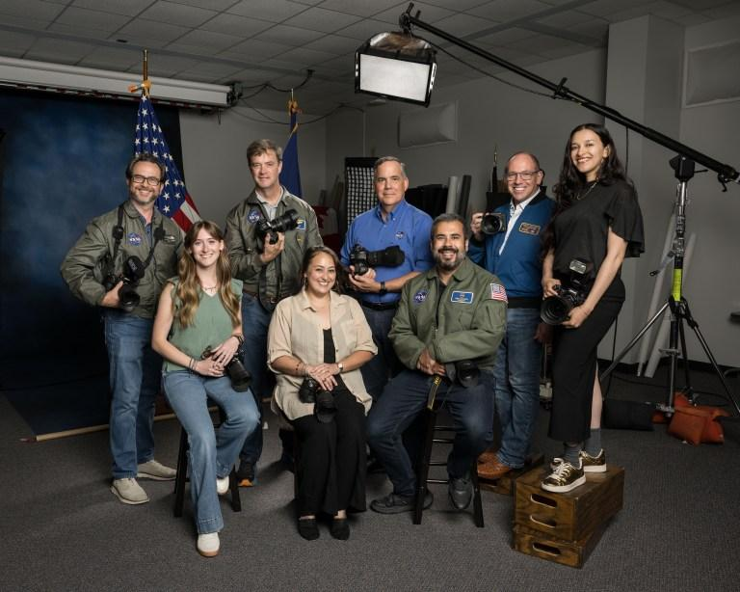
The Imagery Acquisition Group at NASA's Johnson Space Center poses for a group photo in Houston, Texas on Aug. 10, 2026. Back row, from left, are NASA photographers Bill Stafford, James Blair, supervisor Mark Sowa, and NASA photographers Robert Markowitz and Luna Posadas Nava. Front row, from left, are NASA photographers Morgan Gridley, Helen Arase Vargas, and former NASA photographer Josh Valcarcel. NASA/Robert Markowitz Photographers at NASA's Johnson Space Center in Houston have documented some of the most defining moments in human spaceflight. From astronaut training and engineering tests to mission control operations and milestone celebrations, their images preserve the history of exploration while capturing the people and teams behind the missions shaping the next era. Meet the photographers behind the lens and explore the stories behind the images that have helped tell NASA's story. Robert Markowitz NASA photographer Robert Markowitz flies aboard a T-38 aircraft during flight operations. NASA/Robert Markowitz Being able to help tell the human spaceflight story, frame by frame, has been an incredible adventure. Robert Markowitz NASA Photographer For more than three decades, NASA photographer Robert Markowitz has documented the people and milestones that have shaped NASA's human spaceflight program. His career has spanned the space shuttle program, 25 years of continuous human presence aboard the International Space Station, and Artemis II. "My favorite part of this job has always come down to the range of assignments we take on and the people I get to work with every day," Markowitz said. One of Markowitz's early career highlights came during the filming of "Apollo 13," when he served as the behind-the-scenes still photographer for nearly every KC-135 zero-gravity flight. "Looking back as a 25-year-old photographer at Johnson, I don't think I fully appreciated how unique an opportunity it was to be there documenting those moments," he said. Markowitz says the job has challenged him to grow as both a photographer and a communicator. Whether photographing dozens of individual portraits in a day or coordinating a 300-person group photo, each assignment has strengthened his ability to adapt, collaborate, and connect with people. "This work has shaped not just my career, but my life," he said. "Being part of a team that captures and preserves the story of human spaceflight continues to be one of the great honors of my time at Johnson." NASA's Artemis II flight control team works on console in the White Flight Control Room in the Mission Control Center in Houston during the mission's lunar flyby on April 6, 2026. NASA/Robert Markowitz Former Expedition 1 crewmembers Yuri Gidzenko, Bill Shepherd, and Sergei Krikalev celebrate the International Space Station's 25th anniversary of continuous human habitation at Space Center Houston on Jan. 19, 2026. NASA/Robert Markowitz The Counterweight-Offload Astronaut Suited Test and Evaluation Rig is displayed in Johnson's Space Vehicle Mockup Facility. NASA/Robert Markowitz NASA's Artemis II training team gathers in front of the Orion spacecraft mockup at the Space Vehicle Mockup Facility at Johnson Space Center on May 6, 2026. NASA/Robert Markowitz Country music artist Garth Brooks performs from mission control during a live event with the Expedition 52 crew aboard the International Space Station. From left are Dina Contella, deputy manager for the International Space Station in NASA's Low Earth Orbit Program; NASA astronaut Stephanie Wilson; Garth Brooks; and Norm Knight, Flight Operations Director. NASA/Robert Markowitz Members of the Apollo 13 movie cast and crew take part in a zero-gravity flight aboard a KC-135 aircraft, owned by NASA at the time. Floating from left are actor Tom Hanks, who portrayed astronaut Jim Lovell; director Ron Howard; actor Bill Paxton, who portrayed astronaut Fred Haise; actor Kevin Bacon, who portrayed astronaut Jack Swigert; actor Gary Sinise, who portrayed astronaut Thomas Mattingly; and executive producer Todd Hallowell. NASA/Robert Markowitz Bill Stafford NASA photographer Bill Stafford photographs an event in the Teague Auditorium at NASA's Johnson Space Center in Houston. NASA/David DeHoyos I love figuring out how to frame a single image so it captures not just a moment, but the significance behind it. Bill Stafford NASA Photographer NASA photographer Bill Stafford's path to Johnson began during his senior year of college, when a friend who was completing a photography internship at the center told him about an opening on the photography team. With a longtime interest in science and technology, Stafford saw the opportunity to combine those interests with photography in an extraordinary environment. Stafford approaches each assignment as a technical challenge and a storytelling opportunity. Whether working around constraints in lighting, timing, or access, he uses composition, visual psychology, and an understanding of how a viewer's eye moves through an image to shape the final photograph. "My favorite part of the job is the problem-solving that comes with it," Stafford said. Working at Johnson has sharpened those instincts as he photographs spacecraft, hardware, astronauts, and the people behind NASA's human spaceflight missions. "So many of the subjects I photograph carry weight and history that I want the image to reflect," he said. NASA astronauts Reid Wiseman (right) and Victor Glover (left) participate in an Artemis II entry simulation at NASA's Johnson Space Center in Houston. NASA/Bill Stafford NASA's Joint Extravehicular Activity and Human Surface Mobility Program test team conducts a mock spacewalk to prepare for lunar surface operations and technology development for future Artemis missions. NASA/Bill Stafford NASA astronaut and Expedition 75 Flight Engineer Anil Menon participates in photography training at NASA's Johnson Space Center in Houston. NASA/Bill Stafford NASA's Exploration Extravehicular Mobility Unit is photographed inside a thermal vacuum chamber at NASA's Johnson Space Center in Houston. NASA/Bill Stafford Participants test technology during NASA Spacesuit User Interface Technologies for Students (SUITS) test week at NASA's Johnson Space Center in Houston. NASA/Bill Stafford James Blair NASA photographer James Blair prepares to capture imagery during a flight operations assignment. NASA I truly enjoy capturing candid photos of people during decisive moments. James Blair NASA Photographer From newspapers across the country to working as a photographer and photo editor for a publication in Ecuador, NASA photographer James Blair began his career in photojournalism. Photography has taken him around the world, a path that has continued at Johnson with assignments ranging from astronaut training to geology field training in Iceland. "Since I was very young, I have always been fascinated by spaceflight and the technology it takes to reach beyond Earth's atmosphere," Blair said. At Johnson, Blair combines that fascination with his photojournalism background to document the people and technology shaping NASA's next era of exploration. "I enjoy documenting the new hardware that is being developed to return us to the Moon," he said. "From spacesuits to rovers and potential lunar habitats, I get to show the world what NASA has in store for the future of human spaceflight." U.S. Navy divers and Artemis II astronauts aboard an inflatable raft are approached by helicopters and lifted away to the recovery ship after egressing NASA's Orion spacecraft. NASA/James Blair Artemis II crew members Christina Koch (middle) and Victor Glover (right) participate in an Artemis lunar imaging training using an Orion crew configuration at NASA's Johnson Space Center. NASA/James Blair From left, JAXA (Japan Aerospace Exploration Agency) astronaut Aki Hoshide and NASA astronaut candidates Yuri Kubo and Cameron Jones participate in an Artemis geology field training expedition in Iceland. From left, EVA task officer Bridget Scheib, chief training officer John Ray, NASA astronaut candidate Cameron Jones, geology instructor and Artemis science officer Kelsey Young, associate research scientist Patrick Whelley, geology instructor and Artemis curation lead Juliane Gross, and JAXA (Japan Aerospace Exploration Agency) astronaut Aki Hoshide participate in an Artemis geology field training expedition in Iceland. NASA/James Blair From left, Artemis IV chief training officer Bryce Prescott, geology instructor Jacob Richardson, and NASA astronaut Zena Cardman participate in an Artemis geology field training expedition in Iceland. NASA/James Blair Helen Arase Vargas NASA photographer Helen Arase Vargas captures a news conference on lunar terrain vehicles for Artemis missions at NASA's Johnson Space Center in Houston on April 3, 2024. NASA/Robert Markowitz I've always liked the idea of my work serving the public interest. Helen Arase Vargas NASA Photographer NASA photographer Helen Arase Vargas began her career in photojournalism and reporting in Southern California before joining Boeing's scientific photography team in El Segundo. Her experience photographing aerospace sparked an unexpected interest that eventually led her to Johnson. "The best part of the job is my coworkers; cheesy, but there is so much to learn from everyone," Arase Vargas said. "Our core team has so much knowledge. They are all quick to offer help and are great humans." Arase Vargas says much of the work at Johnson reflects the journalism ethics she learned early in her career and fulfills her desire to serve the public interest. The range and volume of assignments also helped her become more comfortable working in different environments while continuing to develop her craft. For Arase Vargas, documenting the Artemis II crew's return to Ellington Field in Houston came with a heightened sense of responsibility. "The world is watching, and all that imagery must be rushed out by the lab," she said. "Your photo could be the one that ends up on every news site, and you don't want to miss capturing the joy and celebration the moment deserves." NASA's Artemis II crew returns to Ellington Field in Houston following the mission on April 11, 2026. NASA/Helen Arase Vargas The Artemis III crew poses for an official portrait in Houston, Texas. In the back row, from left, are NASA astronauts Andre Douglas and Frank Rubio. In the front row, from left, are ESA (European Space Agency) astronaut Luca Parmitano and NASA astronaut Randy Bresnik. NASA/Helen Arase Vargas ESA (European Space Agency) astronaut Sophie Adenot poses in an Extravehicular Mobility Unit during a portrait session at NASA's Johnson Space Center. NASA/Helen Arase Vargas NASA's 2025 Astronaut Candidate Class participates in geology training at Rio Grande del Norte National Monument in New Mexico on May 20, 2026. NASA/Helen Arase Vargas The 2025 Astronaut Candidate Class poses for a holiday photo during wilderness survival training at Fort Rucker in Alabama. NASA/Helen Arase Vargas NASA teams conduct nighttime operations training with a Lunar Terrain Vehicle Ground Test Unit at Johnson Space Center's Rock Yard. NASA/Helen Arase Vargas Luna Posadas Nava NASA photographer Luna Posadas Nava documents the Artemis II crew return at Ellington Field in Houston. NASA/Luna Posadas Nava I have used the camera as a bridge between curiosity and understanding. Luna Posadas Nava NASA Photographer NASA photographer Luna Posadas Nava's path to Johnson spans emerging technology, optics and imaging systems, and photographing artists across the East Coast. Her work grew from a desire to visualize and expand the boundaries of what is possible. Joining Johnson shortly before the launch of NASA's Artemis II mission, one of Posadas Nava's first experiences was helping bring Moon Joy to the world. She documented the Science Evaluation Room, where scientists worked together to conduct real-time lunar science observations during the mission's lunar flyby. Posadas Nava said it was inspiring to witness the team at work and especially meaningful to see so many women contributing to the mission's science. Seeing the response from women in her own life and online reinforced for Posadas Nava the power of representation through photography. "When we see ourselves in stories, we imagine new futures," she said. "I hope my work helps more people see themselves in the story of exploration, because what we see shapes what we believe is possible." The Artemis II lunar science team celebrates in the Science Evaluation Room following the mission's successful lunar flyby. Artemis II Deputy Lunar Science Lead Marie Henderson stands at left. From the right foreground are lunar science team members Ariel Deutsch; Maria Banks, behind her; Ryan Watkins, to her right; and Sara Schmidt. NASA/Luna Posadas Nava Artemis II deputy lunar science lead Jacob Richardson, left, and Artemis II lunar science team member Kiarre Dumes react to the astronauts' verbal observations of the Moon during the mission's lunar flyby on April 6, 2026. NASA/Luna Posadas Nava Artemis II science officer Angela Garcia, left, and lunar science team member Kiarre Dumes discuss science operations in the Science Evaluation Room at NASA's Johnson Space Center. NASA/Luna Posadas Nava NASA engineers and teams from the Rock and Roll with NASA Challenge test rover prototypes at NASA's Johnson Space Center Rock Yard in Houston on July 31, 2026. NASA/Luna Posadas Nava NASA's Artemis III crew participates in a video shoot for the crew announcement at NASA's Johnson Space Center on June 3, 2026. NASA/Luna Posadas Nava The Expedition 73 crew attends a debrief and awards ceremony at Space Center Houston on June 16, 2026. NASA/Luna Posadas Nava David DeHoyos NASA photographer David DeHoyos is photographed during an assignment in the Space Vehicle Mockup Facility at NASA's Johnson Space Center in Houston. NASA I am very aware of the importance of preserving history and what it means to others when our images are shared with the world. David DeHoyos NASA Photographer Growing up in Houston during the Apollo era, NASA photographer David DeHoyos knew from an early age that he wanted to be part of the space industry. His interest in photography began with his mother's Kodak Instamatic camera and continued through school and a decade working in photo labs. In 1991, that path brought him to Johnson's photo lab and eventually behind the camera as a NASA photographer. After more than three decades at Johnson, DeHoyos says connecting with people remains one of his favorite parts of the job. He enjoys learning about the people he photographs, sharing what he has learned about Johnson with visitors and new employees, and encouraging the next generation. "I keep an assortment of NASA goodies in my camera bag, and the ultimate joy I get is giving a pin or sticker to a child and seeing their little faces just light up," DeHoyos said. "It just warms my heart to encourage a youngster to work hard and pursue their dreams because that's how I got here." For DeHoyos, photography is also about preserving moments that can take on greater meaning over time. "I love the process of figuring out technical details to create an image that will make someone say, 'Wow, cool shot, how did you do that?'" he said.

27. Private mission to save NASA's Swift space telescope fails
Read more
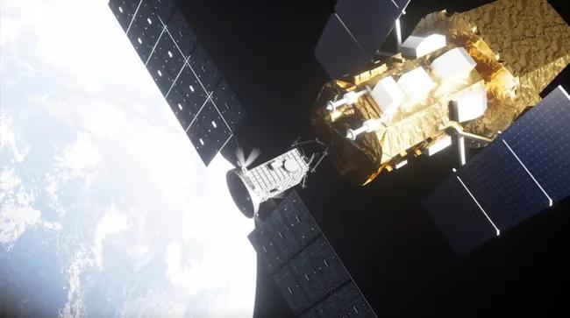
Click for next article NASA is calling off the effort to save its Neil Gehrels Swift Observatory after a private rescue spacecraft couldn't overcome its own problems in orbit. LINK, the specialized probe from Katalyst Space that NASA contracted for the Swift Boost mission , was delivered to space on an air-launched Northrop Grumman Pegasus XL rocket on July 3. The vehicle was designed to rendezvous with the Swift Observatory in order to grapple and raise it to a more stable orbit, but LINK ran into trouble when it began to spin uncontrollably about three weeks after launch. Today (Aug. 19), NASA announced an official end to LINK's efforts to boost Swift's orbit, citing ongoing attitude control issues with the private spacecraft, but the agency hasn't canceled the mission outright. LINK will still attempt a rendezvous with Swift in order to practice proximity operations and demonstrate its capabilities other than spacecraft capture, which could aid future missions down the road. From its inception, the Swift Boost mission was always viewed as a long shot. Increased solar activity had already begun decaying the observatory's orbit faster than anticipated when NASA awarded the $30 million Swift Boost contract to Katalyst in 2025 , giving the Arizona-based company less than a year to complete LINK's design, manufacture and testing before time to save Swift would run out. "NASA should be willing to move quickly and take smart risks when the potential return is worth it, and that is exactly what we did with this mission," NASA Administrator Jared Isaacman said in a statement today . "This is not the outcome we were working toward, but it does not change why this mission was worth attempting. The team moved with extraordinary speed to give Swift a chance to carry out more science while advancing capabilities America will need for satellite servicing in the future." Swift is a one-of-its kind orbital observatory designed to study high-energy phenomena across the universe . It can detect sudden events like gamma-ray bursts and quickly direct its instruments to study them in X-ray, ultraviolet and visible light. The spacecraft is also routinely redirected for rapid response research to study things like newly discovered supernovae, black-hole ejections, fast radio bursts and other short-lived astronomical events. With LINK now incapable of boosting Swift's orbit, NASA estimates the observatory will dip catastrophically low into Earth's atmosphere before the end of the year. After Swift dies, the agency says it will "continue to prioritize finding new options to react rapidly to cosmic events, using current missions to help fill the gap in the meantime." Katalyst is working closely with NASA as the Swift Boost mission enters its next phase. Together, the company and space agency are evaluating logistics for LINK's rendezvous and maneuvering demonstration within Swift's vicinity, which will provide data for potential future servicing missions to other satellites, NASA's statement says.

28. Scientists create 'laundry gun' for astronauts to clean their clothes by shooting out plasma
Read more
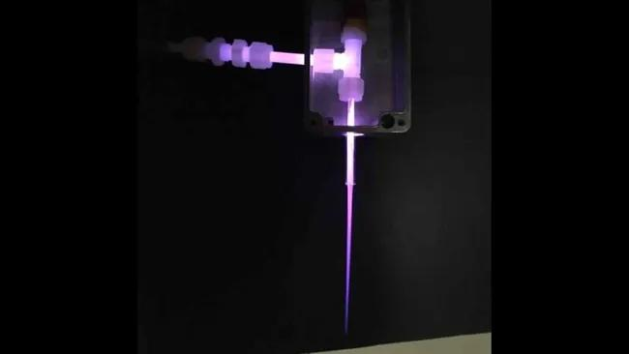
Click for next article If you have ever shared a room with multiple people for days on end, you may know how clothes and living conditions can rapidly turn rather smelly. Imagine that happening in a confined spacecraft. Even worse, since water on a space mission is in short supply, space travelers can't easily do their laundry. This is more than a body odor problem - unclean clothes and linens are ripe feeding grounds for infectious bacteria. Astronauts might wear the same clothes for days or even weeks, seal away used clothes in airtight bags , then return them to Earth for cleaning or cast them away to burn up in Earth's atmosphere. This is fine for short trips near Earth, but what about a months-long odyssey to Mars ? Engineers have devised a new way for astronauts to dry-clean their dirty laundry. They've crafted a prototype "laundry gun" that sterilizes fabric by shooting violet-colored plasma into it. "This will reduce the microbial load and keep clothes and other soft surfaces clean, at least microbially, for astronaut health," says Gabe Xu, a professor at the University of Alabama in Huntsville and one of the laundry gun's creators, in a statement . "It could also be used to sterilize space suits and tools before they leave the habitat and step foot on Mars." A plasma is an energized soup of charged particles, ions and electrons. While many plasmas like that in the sun are very hot, the laundry gun's plasma is "cold," closer to room temperature. Its electrons are key to killing bacteria. As the laundry gun shoots plasma into fabric, the electrons collide with gas molecules in the surrounding air, such as oxygen (O2) and water vapor (H2O). These collisions create other molecules like ozone (O3), which chemists call "oxidizing species". These oxidizing species can chemically react with the membrane that surrounds a bacterium, damaging and destroying it. In collaboration with NASA's Marshall Space Flight Center, Xu and colleagues have created a prototype plasma gun, about the size of a pen, which can sanitize about a square centimeter at a time. In their tests, the prototype reduced spore colonies on a scrap of fabric by more than 75% . Earthly disinfectants like peroxide and bleach also attack bacteria by oxidizing them in this way. The laundry gun's creators could allow astronauts to travel without such cleaning chemicals. Instead, the apparatus creates its cleaning plasma from the spacecraft's own air and water vapor. In space travel, where every gram of mass matters, this is a major advantage. The plasma gun at work. (Image credit: Gabe Xu | UAH) "The use of plasma treatment could significantly reduce the mass of goods needed for a human mission, especially one to Mars where resupply is difficult," Xu wrote in the statement. That said, the "laundry gun" is not a perfect replacement for the standard washing machine - not yet, at any rate. "This won't remove coffee or grass stains (though we haven't tried that)," Xu wrote in the statement. Moreover, a pen-sized laundry gun is too small to be practical. Xu and colleagues are planning to build larger, but still handheld, devices. They'll also need to deal with their plasma gun's ozone, which can be harmful in large quantities - they're working on a filtration system to remove this.

29. A SpaceX rocket slammed into the moon this month - and a NASA spacecraft has spotted its lunar grave (photos)
Read more
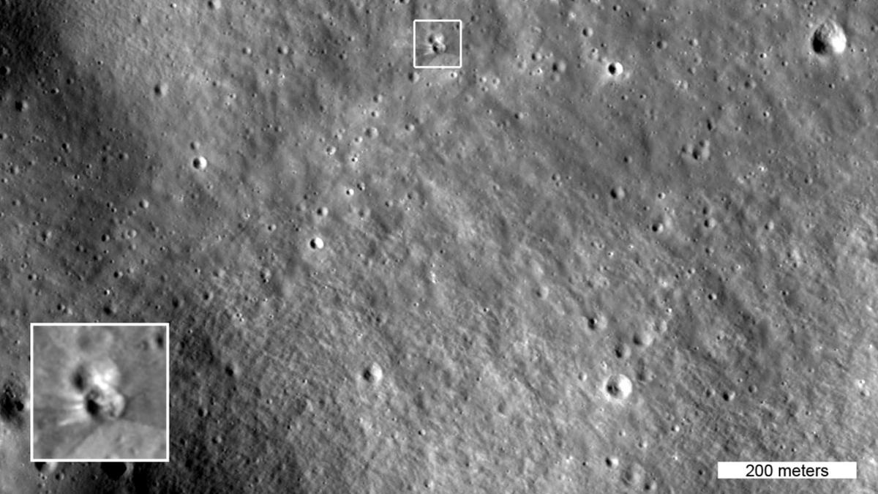
Click for next article The box in this image highlights two small craters, the lower of which formed on Aug. 5, 2026 when a SpaceX Falcon 9 upper stage impacted the moon. The inset shows details of the new crater, enlarged three times. This image was captured by NASA's Lunar Reconnaissance Orbiter on Aug. 11, 2026 as it passed over the site at an altitude of 56 miles (90 kilometers). NASA's veteran moon-circling spacecraft, the Lunar Reconnaissance Orbiter (LRO), has imaged the impact site of that errant Falcon 9 upper stage. The photos were taken on Aug. 11 and Aug. 12, just a few days after the SpaceX rocket body slammed into the moon near Einstein Crater at 5,400 mph (8,690 kph). LRO's high-resolution camera system, known as LROC, got good views of the aftermath from a variety of angles, snapping away every 117 minutes, the time it takes the orbiter to circuit the moon . This is an animated before-and-after view of the crater formed after a Falcon 9 upper stage struck the moon's surface on Aug. 5, 2026. The after images were taken on Aug. 11 and Aug. 12 by the Narrow-Angle Camera on NASA's Lunar Reconnaissance Orbiter. These images are enlarged three times from the original, with north facing up, and they cover an area about a quarter of a mile wide. (Image credit: NASA Goddard/Intuitive Machines) Diameter and depth According to LROC Principal Investigator Mark Robinson, who's based at the Houston company Intuitive Machines , the newly formed impact crater is about 60 feet (18 meters) wide and appears to be less than 10 feet (3 m) deep. "The distinctive V-shaped ejecta pattern on the south side of the crater is consistent with natural impactors hitting the moon at low angles relative to the surface," said Robinson. The sixth (and final) image in LROC's sequence of the new crater, he added, was acquired with the largest slew angle (68 degrees), presenting a view similar to what an Artemis astronaut would see looking out his or her Orion spacecraft window toward the lunar horizon. Telling tilts To capture imagery of the impact site, LRO operators tilted the spacecraft so its cameras would point toward the target region each time the spacecraft passed about 60 miles (97 km) above the moon. In doing so, researchers could see the crater under multiple lighting conditions that revealed impact features. According to NASA, the LRO imagery shows bright and dark rays stretching out from the crater. "The darker streaks are made of surface dust and rocks altered over a long time by solar wind, galactic cosmic rays, and micrometeorite impacts. This weathered material was excavated by the collision," with the brighter streaks near the crater rim formed by "fresh material excavated from deeper underground," NASA officials said in an Aug. 18 statement . Image of the Falcon 9 impact site, taken by South Korea's Danuri lunar orbiter. (Image credit: KARI) Korea's lunar orbiter The site of the Aug. 5 crash was imaged earlier by the Korea Pathfinder Lunar Orbiter, also known as Danuri. That mission team used Danuri's high-resolution Lunar Terrain Imager to spot the new crater. After capturing images of the impact zone, the Danuri mission sent updated crater coordinates to the LRO team to help refine their follow-up imaging sequence, NASA officials said.
30. ISRO's Former Chief S Somnath Appointed To RBI Board - NDTV
Read more
ISRO's Former Chief S Somnath Appointed To RBI Board NDTV

31. ISRO Recruitment 2026 Notification Out for 267 Posts, Today is The Last Date - Adda247
Read more
ISRO Recruitment 2026 Notification Out for 267 Posts, Today is The Last Date Adda247

32. From Intel to ISRO: IIT Delhi alumnus quits high-paying job, secures AIR 7 as scientist - Business Today
Read more

Hemant's academic journey began in Gothra Bhukran village in Rajasthan's Sikar district before he earned admission to IIT Delhi. He completed his BTech and went on to pursue an MTech in semiconductors, laying a strong technical foundation for his career. His academic excellence helped him land a job at Intel, where he worked as a design engineer specialising in semiconductor chip design-a role many engineering graduates consider a career milestone. READ ALSO: 'Ask why scientists are leaving': Abhishek Manu Singhvi to Centre after ISRO exit curbs Juggling full-time work, rigorous preparation Despite having a secure corporate job, Hemant felt increasingly drawn toward research, public service, and India's growing space programme. Preparing for the ISRO examination while working 7-8-hour shifts at Intel was no small feat. Unlike full-time aspirants, he had to carve out study time during early mornings, late evenings, and weekends, with no extended study leaves or ideal conditions. His semiconductor engineering background proved invaluable, allowing him to build on existing technical knowledge rather than starting from scratch. Consistency over shortcuts: The to-do for students Hemant's journey underscores a powerful lesson: success comes through patience, discipline, and steady progress-not shortcuts. He challenges the common assumption that changing careers means abandoning past achievements. Instead, his corporate experience strengthened his technical foundation and boosted his confidence during the examination. His story encourages engineering graduates to believe that pursuing a dream alongside a corporate career is possible with the right mindset and determination. READ ALSO: From engineers to doctors: IIT Madras to launch medical school, offer MBBS and MD degrees A proud moment for his family, his village Hemant's achievement brought joy not only to his family but also to his hometown in Rajasthan. His father, Shishpal Bhukar, serves as an Additional Chief Engineer in the Public Works Department (PWD) in Bikaner, while his mother, Sushila, is a homemaker. His success has become a source of inspiration for young students, especially those from smaller towns and rural backgrounds, showing that big dreams are achievable regardless of one's origins.

33. Former ISRO Chairman Panicker appointed Director on RBI's Central Board; Anand Mahindra re-appointed - BusinessLine
Read more
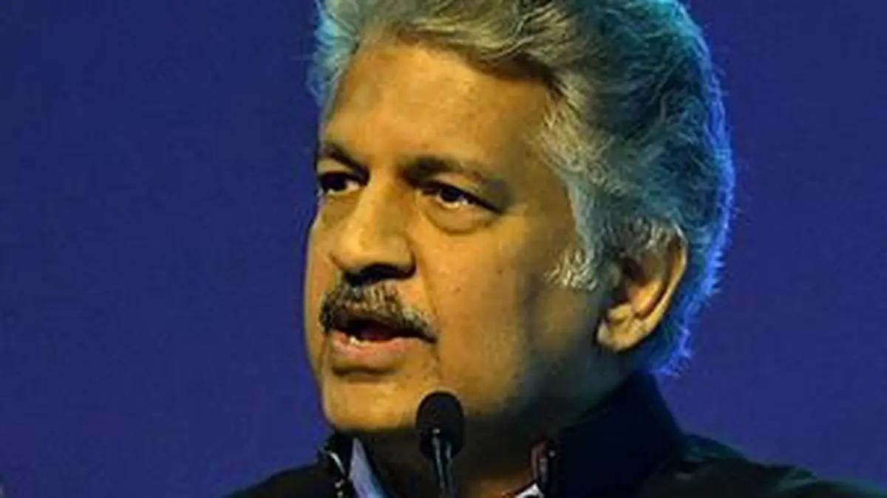
The Central government has appointed former Chairman of ISRO Somanath Sreedhara Panicker and re-appointed Industrialist Anand Gopal Mahindra as part-time, Non-official Director on the Central Board of Reserve Bank of India. Their appointment is for a period of four years with effect from August 20, 2026 or until further orders, whichever is earlier. Published on August 20, 2026

34. Artemis Mission Patches
Read more
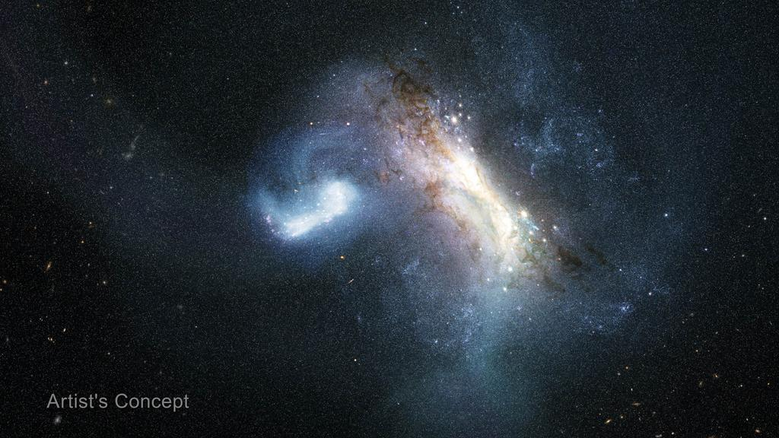
NASA/Clayton Rougelot A jacket decorated with Artemis I and II mission patches, along with other NASA patches hangs on the back of a chair on Thursday, Aug. 6, 2026, inside the Rocco A. Petrone Launch Control Center at NASA's Kennedy Space Center in Florida during a terminal countdown simulation for the Artemis III mission. NASA's Exploration Ground Systems team conducted the terminal count simulation, which runs through the final five hours of launch countdown, including terminal count - the remaining 10 minutes of the countdown. Artemis III will carry out a series of objectives in low Earth orbit designed to demonstrate critical systems needed for future lunar landings, beginning with Artemis IV. Stay up to date with NASA's Artemis program. Image credit: NASA/Clayton Rougelot

35. NASA Selects University Teams to Help Advance Aviation Research
Read more

NASA has selected four university teams to help the agency transform the future of aviation through projects ranging from high-supersonic propulsion systems to low-noise routes for small aircraft flying through cities. The agency made awards through its University Leadership Initiative, which offers student teams the opportunity to contribute to real-world flight research that advances NASA's goals in aeronautics. This year's awardees are pursuing projects that align with NASA strategic objectives, including innovation in commercial high-speed aircraft, the development of new tools that can lead to transformational aviation breakthroughs, safer and more efficient air traffic management, and the integration of new air transportation options into the national airspace. "With these four new awards, the University Innovation project is leaning in on NASA's aeronautics mission priorities," said Andrew Provenza, project manager, NASA's Glenn Research Center in Cleveland. "These teams will research new propulsion concepts for supersonic flight, novel engineering methods that can revolutionize aerospace system design and certification, and learning-enabled avionics for new advanced and urban air mobility flight vehicle platforms, which could enhance air traffic control modernization." The awards represent the ninth round of NASA University Leadership Initiative funding. Totaling about $30 million, NASA's awards will provide multiyear support for awardee universities to build their teams and conduct research. The initiative provides hands-on experiences for students, developing the U.S. aeronautics research workforce while also producing findings that will help drive aviation forward. University Leadership Initiative awards go to teams comprised of graduate and undergraduate students and led by faculty members. Recipients form academic partnerships with other universities and community colleges, as well as industry. Experts from NASA, the Federal Aviation Administration, and other organizations provide support and guidance. The awardees are: University of Minnesota Adaptive Supersonic Combined Cycle Engine for Next-generation Transportation Led by Terrence Meyer, the project will work over four years to develop a fuel-flexible propulsion system that uses a traditional jet turbofan during takeoff and subsonic flight, but would transition to a new type of ramjet engine for supersonic flight. In ramjet mode, the system would cruise at Mach 4, or more than 3,000 mph. The project aims to enable efficient, faster-than-sound flight, including flight at high-supersonic speeds. Stanford University Safety Across Lifecycle of Learning-Enabled Avionics Systems: Safety Data Flywheel Led by Somil Bansal, this four-year project aims to develop an avionics system to control an aircraft's communications, navigation, and other electronics that incorporates machine learning. The system would take an approach that ensures safety is continuously reinforced throughout its operations. This research could help create a framework for the aviation sector to safely integrate artificial intelligence-enabled avionics into the national airspace. Noise-Optimal Trajectory Planning for Urban Air Mobility Operations, Including Ambient Noise Led by Juan Alonso, the center created through this award will work over four years to develop a high-fidelity simulation framework focused on developing low-noise flight paths in urban environments for future small aircraft. Developers are envisioning urban air mobility aircraft as ways to move people and cargo over populated areas. This center would integrate realistic models of how sound travels in cities to enable vehicle flight paths that would reduce community noise exposure from new air traffic. Virginia Tech Certification Driven Aircraft Design Under Uncertainty Led by Darshan Sarojini, this three-year project proposes to transform next-generation aircraft design while integrating powerful new computer modeling tools: model-based systems engineering, multidisciplinary design, analysis and optimization, and high-dimensional uncertainty quantification. The goal is safe, faster, and more efficient modeling that results in fewer costly redesigns later in the aircraft development cycle. For more than 10 years, NASA's University Leadership Initiative has fostered bold ideas, collaborative research, and team-led solutions. The initiative is part of NASA's Research and Technology Mission Directorate.

36. NASA Data Feeds River Forecasts as Snow Drought Effects Linger
Read more
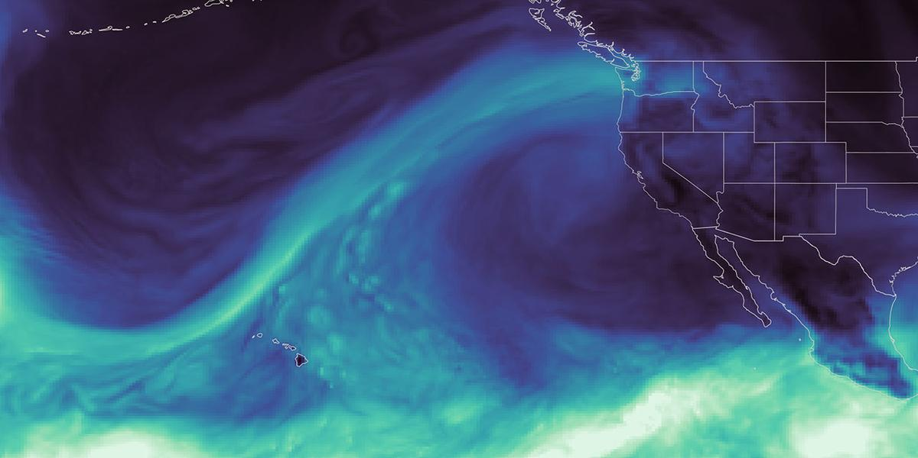
This map, derived from NASA's GEOS (Goddard Earth Observing System), shows an atmospheric river reaching Washington state in December 2025, during a winter marked by extreme rainfall and too little mountain snow. NASA's Scientific Visualization Studio As the effects of the 2026 snow drought in the western United States carry into summer, NASA Earth data is feeding machine-learning forecasts that inform decisions about water, power, and public safety in Washington state. Tacoma Power, a Washington public utility, is using a U.S. technology company's river-flow forecasts during a year of water extremes on the Cowlitz River. The utility's largest hydroelectric project uses water stored behind Mayfield and Mossyrock dams to generate enough electricity to serve more than 151,000 homes each year. Upstream Tech's HydroForecast combines weather forecasts and river measurements with NASA-produced satellite data on snow cover and vegetation conditions to predict river flow from hours to days ahead. Updated every two hours, the forecasts are used by reservoir managers, hydropower producers, water utilities, and government agencies to prepare for storms, plan reservoir water releases, and navigate dry periods. "Part of NASA's mission is to make the view from space useful on the ground," said Erin Urquhart, manager for NASA's Water Resources program at the agency's headquarters in Washington, D.C. "When an American company incorporates NASA's freely available data into forecasts that help water managers prepare for floods, generate power, and steward water supplies, that's NASA delivering practical value to the nation." Year of water extremes During the winter of 2025-26, unusual warmth meant a larger share of precipitation fell as rain instead of snow across much of the West, while below-normal precipitation deepened deficits in some areas. January, February, and March each had the lowest Western snow cover for that month in the NASA MODIS (Moderate Resolution Imaging Spectroradiometer) satellite record since 2001. On the Cowlitz, those conditions produced a season of extremes. In December 2025, a powerful atmospheric river brought a long, narrow band of Pacific moisture into the region, causing one of the largest one-day inflow surges ever recorded at Tacoma Power's hydroelectric project. Across the season, that rain-heavy pattern sent water downstream quickly instead of building mountain snowpack that would melt and release water steadily into summer. Snowpack remained at just 20% to 50% of normal levels. As winter became spring, the rain tapered off, and on April 8, Washington state placed every watershed, including the Cowlitz, under a drought emergency. From April through June, peak daily inflow into the project was among the lowest on record, leaving Tacoma Power with less incoming water to replenish its reservoirs ahead of summer demand, said Saul Villarreal, Tacoma Power's senior hydro operations manager. Tacoma Power's Mayfield Dam and powerhouse sit on the Cowlitz River in southwest Washington, where forecasts using NASA data support reservoir operations and hydropower generation. Tacoma Power, used with permission Turning satellite data into river forecasts NASA turns observations collected by the VIIRS (Visible Infrared Imaging Radiometer Suite) instrument on the Suomi-NPP (Suomi National Polar-orbiting Partnership) satellite into data products that provide information about snow cover and vegetation greenness across entire watersheds, including where ground monitors are sparse. To train HydroForecast, Upstream Tech collects and archives years of those NASA products alongside weather forecast data and actual river-flow measurements. Using records from hundreds of watersheds, the models learn common patterns in how water moves through the landscape and apply them in new locations. Tests across multiple basins found that including snow and vegetation observations increased forecast skill, said Dr. Laura Read, director of technical and federal partnerships for HydroForecast at Upstream Tech. "NASA's data gives us the reliability, global coverage, and consistency we need," said Read. "Our short-term models run every two hours, so those inputs have to show up when we need them. Though we have stopgaps in place, any interruption to our operational pipeline is a huge deal." Tacoma Power uses HydroForecast alongside stream gauges, snow stations, and operator judgment. During the December storm, the NASA-informed, short-term forecast helped the utility anticipate how much water would reach the project and prepare for dynamic river conditions, while meeting operating requirements and keeping public safety at the forefront, Villarreal said. To view this video please enable JavaScript, and consider upgrading to a web browser that supports HTML5 video NASA's GEOS (Goddard Earth Observing System) maps an atmospheric river, a ribbon of water vapor, before Washington's January-April 2026 snow cover is compared with a historical median. NASA's Scientific Visualization Studio As spring approached, the operational challenge reversed. Tacoma Power used HydroForecast's seasonal model to track the growing risk of weak runoff and began keeping its reservoirs higher than usual to preserve water for summer. That left less space to contain another large storm, so operators continued checking the short-term forecast "to play defense," and remained ready to adjust operations if another atmospheric river developed. "The earlier we understand how conditions might change, the more effective planning we can do to manage our reservoir and balance the many demands of our system throughout the season," said Villarreal. Tacoma Power entered summer 2026 with reservoir levels near average despite the dry spring. The stored water supports reliable hydropower, required river flows to support fish and aquatic habitat, and public recreation. It also gives the utility more flexibility to meet electricity demand during heat waves or unexpected outages and, when possible, support the wider regional power system. From forecasts to drought assessments Tacoma Public Utilities' Cowlitz Hydro Project is just one example of NASA science supporting water decisions across the West. NASA also has partnered with the U.S. Department of Agriculture's Natural Resources Conservation Service to bring satellite-based snow and groundwater information into machine-learning water-supply forecasts. The National Oceanic and Atmospheric Administration's Colorado Basin River Forecast Center uses MODIS and VIIRS data to adjust snowmelt rates in its model. The Bureau of Reclamation uses NASA and NASA-derived snow data, alongside other sources, for reservoir operations in California's San Joaquin Basin. NASA data and research have long informed the U.S. Drought Monitor, the weekly assessment used by farmers, water managers, and public agencies. NASA became a formal partner in 2026, expanding its role from providing information to helping produce the assessment. The agency took its first turn authoring the Drought Monitor during the week of Aug. 17.

37. China's Chang'e 7 moon probe will launch this weekend on the most ambitious lunar mission in history
Read more
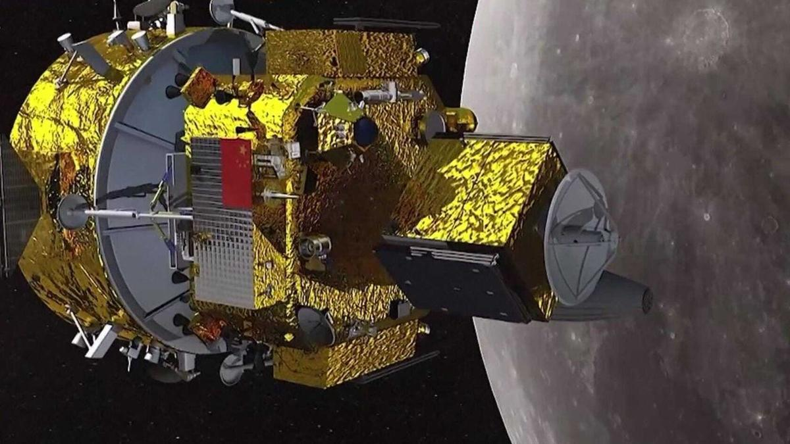
Click for next article China's moon exploration program is readying an ambitious robotic mission, one composed of an orbiter, a lander, a rover, a hopper, and a wide range of international experiments including a U.S.-supported payload. In April of this year, Chang'e-7 hardware was transported to the Wenchang launch site, targeting an Aug. 24 (Beijing time) launch atop a Long March 5 Y14 rocket. The lander's destination is the edge of Shackleton Crater in the lunar south pole region. After launch, the Chang'e-7 orbiter will spend several months orbiting the moon before releasing its lander for an attempted touchdown near the end of the year. While Chang'e-7 will carry out ambitious, groundbreaking lunar science , it will also serve to lay the groundwork for the first Chinese human landing on the lunar surface by 2030 . James Head is a leading moon scientist at the department of geological sciences at Brown University in Providence, Rhode Island. He says China's upcoming moon launch will set a new benchmark for lunar science voyages. "Chang'e-7 is the most ambitious, comprehensive, and complex robotic lunar mission ever attempted by any nation or entity," Head told Space. Likewise, Zhang Jingbo, a spokesman for the China Manned Space Agency (CMSA) agency, said earlier this year that the mission will "fully leverage the technological expertise and practical experience accumulated over decades" to "spare no effort to strive for the goal of achieving the first Chinese landing on the moon by 2030." Pockets of water ice Once unleashed from the Chang'e-7 lander, the hopper is slated to "jump" from sunlit areas to shadowed craters in a quest to find pockets of water ice. The hopper utilizes active shock-absorption technology to safely land on slopes. The lander will also deploy China's inaugural deep-space "landmark image navigation" system. While scientists around the globe believe there's water ice on the moon , said Ye Peijian, an academician with the Chinese Academy of Sciences, no one has definitively found and fully evaluated that resource as yet. "Now China is going to look for it, [...] And we're using many methods, from searching the surface to exploring inside craters," Ye told China Central Television (CCTV). The rim of Shackleton crater; the lunar south pole is located on the rim near the upper right corner of the image. (Image credit: NASA/GSFC/Arizona State University) Back-to-back duties The Chang'e-7 mission will adopt an integrated exploration approach, added CCTV, combining orbiting, landing, roving, and hopping, to survey the environment and resources of the lunar south pole , while also carrying out international cooperation. Moreover, a Chang'e-8 mission is set for around 2028 , designed to test technologies for building habitats using lunar soil. Taken together, the two robotic projects - Chang'e-7 and Chang'e-8 - are assigned duties to assist in orchestrating China's planned, multi-phased, International Lunar Research Station (ILRS). The combination of the Chang'e-7 lunar probe and the Long March-5 Y14 carrier rocket at the Wenchang Spacecraft Launch Site on Aug. 19, 2026 in Wenchang, Hainan Province of China. (Image credit: VCG/VCG via Getty Images) Variety of instruments Chang'e-7 mission hardware is outfitted with a variety of instruments from other nations and organizations, such as: On the lander, a Russian Academy of Sciences' PmL-Ch7 suite to detect lunar dust and a Langmuir probe to gauge the temperature and density of nearby plasma. An Italian laser retroreflector array on the lander is provided by the Laboratori Nazionali di Frascati. A small, state-of-the-art, wide-field optical telescope mounted on the lander developed by the International Lunar Observatory Association (ILOA Hawaii) and the Laboratory for Space Research at the University of Hong Kong (HKU-LSR). LunaHcam, a camera attached to the Chang'e-7 orbiter and jointly developed by the Bahrain Space Agency and the Egyptian Space Agency to churn out high-resolution hyperspectral images of the moon's surface. Moon Aiming Thai-Chinese Hodoscope (MATCH) onboard the orbiter and developed by the National Astronomical Research Institute of Thailand. It will assess high-energy particles related to space weather and cosmic radiation tossed out by the sun. Moon-based Dual-channel Earth Radiation Spectrometer on the orbiter has been provided by Switzerland's Physical Meteorological Observatory. Compact lunar camera The ILO-C instrument from ILOA Hawaii and the Laboratory for Space Research at the University of Hong Kong will be housed directly on the Chang'e-7 lunar lander, bound for the illuminated rim of Shackleton Crater. "The HKU Lab for Space Research is proud to partner with ILOA for this historic lunar mission and we look forward to working with them to maximize the scientific return this exceptional wide field optical lunar camera will deliver," said Quentin Parker, professor emeritus of the University of Hong Kong. Through visible color imaging, the ILO-C camera project aims to spark public interest in lunar exploration, astronomy, and space science, Parker said, thereby laying a social foundation for future lunar science missions. Moon-based vantage point Operating in the extreme lunar environment, the compact camera will conduct first-ever astronomical color imagery from the moon, said Elisa Perednia, President and Chair of ILOA. The camera is designed to capture unprecedented wide-field, full color imagery of the Milky Way's Galactic plane from a stable, moon-based vantage point, she said. One sad note: The camera onboard China's moon lander was pioneered by ILOA's founding director Steve Durst who passed earlier this year. He was a visionary leader that worked with Chinese aerospace representatives since the 1980s. The Beijing Institute of Space Mechanics & Electricity (BISME) built the camera to ILO-C team member specifications. "We are proud to have joined the mission and to help realize Steve's wonderful vision," Parker at HKU-LSR told Space.com.

38. A weather satellite 22,000 miles above Earth saved my 2026 total solar eclipse cruise on the Mediterranean Sea
Read more

Click for next article A brilliant red prominence appears on the limb of the sun during a total eclipse on Aug. 12, 2026 as seen from the cruise ship Le Boréal near the Balearic Islands. When the 11,000-ton cruise ship Le Boréal set sail from Nice, France, on Thursday, Aug. 6, its 205 passengers and 136 crew members began a voyage whose success would depend not only on careful planning, but also on the ship's ability to outmaneuver clouds at the last critical hour. The ship is owned and operated by the French cruise line Compagnie du Ponant. This eclipse cruise was the result of more than a year's planning by Ponant, and most of those who signed on were there specifically to witness the celestial spectacle; that shared purpose heightened the drama of the eclipse itself. This was going to be a sunset eclipse, with the sun no more than three degrees above the horizon. To picture that height, make a fist and hold it out at arm's length. Place the bottom of your fist on the horizon; the top of your fist measures about ten degrees. During totality, the sun would appear only about one-third of a fist-width above the horizon. Even if the sky overhead was clear, clouds could still gather near the horizon, leaving open the possibility that the sun might be hidden at the critical moment. I was on board Le Boréal as both a lecturer and the ship's onboard meteorologist. The main advantage of using a cruise ship to view an eclipse is its two-dimensional mobility, allowing it to maneuver around potential cloud cover. In practice, that meant working with Captain Mathieu Tsingrilaras to position Le Boréal on eclipse day in a location free of any clouds that might otherwise obscure the total eclipse. Although the Iberian Peninsula and the adjacent waters of the Balearic Sea - a body of water between mainland Spain's eastern coast and the Balearic Islands - typically enjoy warm, dry, clear weather in August, the circumstances of this eclipse could still prove problematic. The cruise ship Le Boréal. (Image credit: Joe Rao) Also serving as a lecturer for the cruise was Serge Brunier , a well-known French photographer, reporter, and writer who has specialized in popular depictions of astronomical subjects. He is also the co-author of the beautiful coffee-table book, Glorious Eclipses. Serge would accommodate the French-speaking passengers onboard. Early in the cruise, as we were speaking with each other, a French passenger came up to Serge and asked, "Le temps sera-t-il dégagé pour l'éclipse?" ("Will we have clear weather for the eclipse?"). Serge nodded toward me and replied: "Il faudra demander à Joe ; c'est lui qui s'occupe de la météo." ("You will have to ask Joe; he is in charge of the weather.") Our itinerary took us to many different places during our eight-day cruise, including two towns in Corsica (Calvi and Bonifacio), the French cities of Marseille and Port-Vendres as well as Spain where we stopped at Barcelona and Palma de Mallorca in the Balearic Islands. Through it all, we experienced weather that was mainly sunny, very warm and quite humid. An upper-level ridge of high pressure acted as a heat dome over much of Europe. Weather threat on eclipse day The first warning came on Aug. 10, when a minor disturbance rippled through the heat ridge and produced widespread clouds, showery rains and thunderstorms across eastern Spain, spilling into the eclipse zone over the adjacent Balearic Sea. Had the eclipse taken place that day, no amount of mobility would have brought us a clear view. Fortunately, the disturbance quickly moved east, allowing high pressure to build back over the region. By eclipse day, Aug. 12, conditions appeared to have turned in our favor. The day began beautifully sunny and continued that way into the afternoon. Our ship was docked at Palma de Mallorca, then set sail at 4 p.m. Central European Summer Time (CEST) for our preselected viewing location, heading west-northwest along the center line of the path of totality. Shortly after departure, images from EUMETSAT , a geostationary weather satellite looking down from 22,000 miles (35,400 km) above Europe, revealed the problem we had been trying to avoid. A large convective cloud - formed when warm, damp air rises into colder air above - began to rapidly evolve over part of Spain's coastline just inland from the Gulf of Valencia. It soon became apparent that if we did not alter course, that cloud would almost certainly block our view of the total eclipse. After consulting with Captain Tsingrilaras, we decided to take Le Boréal southwest. That maneuver would cause the cloud, then directly ahead of us, to shift to the right of the sun as it descended the west-northwest sky, improving our odds for viewing totality. That course correction became the turning point of the voyage. Joe Rao (left) and Le Boréal captain Mathieu Tsingrilaras (right). (Image credit: Joe Rao) Totality at sea As the eclipse began, other cruise ships apparently stayed their original courses. Le Boréal's course change, however, kept us clear of significant cloudiness, aside from a few thin clouds that occasionally crossed the sun but did little to hinder the show. At 7:37 p.m. CEST, the moon took its first bite out of the lower right limb of the sun. At 8 p.m., Captain Tsingrilaras oriented Le Boréal, so that the back of the ship (the stern) faced directly toward the sun. Crowds gathered on the top three decks of the ship, observing the sun through special eclipse glasses that had been distributed the previous evening. Passengers aboard Le Boréal prepare for the moment of totality. (Image credit: Joe Rao) Moments before totality, when only a sliver of sun remained, I told passengers that I had been asked since the start of the day about what our chances were for seeing the total eclipse. "I think our chances of seeing it are now 100 percent!" That comment was met with a resounding cheer. What was particularly striking was the approach of the moon's shadow; a diffuse darkening accompanied by a rapid west-to-east sweep of darkness. The onset of totality was marked by a dazzling diamond ring effect which lasted a couple of seconds, then a circular corona appeared around the darkened solar disk; it appeared somewhat yellowish in color as opposed to pearly white, likely due to a layer of haze near the horizon. A total eclipse on Aug. 12, 2026 as seen from the cruise ship Le Boréal near the Balearic Islands. (Image credit: Joe Rao) An unusually large and brilliant red prominence, readily visible even with the unaided eye, appeared at the 9 o'clock position. Because the sun was so low in the sky, the famous moon illusion caused it to appear especially large. This only added to the beauty of the spectacle. Totality lasted 95 seconds. Even at its midpoint the overall light never became so dim that the second hand on a watch was hard to see. The only other object that was plainly visible in the sky was Venus , well off to the upper left of the eclipsed sun. The air temperature did not change much, probably due to the thermal inertia of the surrounding water. The terminal diamond ring was perhaps even more stunning than the first. The corona could be kept in view for several seconds by blocking out the emerging crescent of sunlight with one's thumb. It seems that no shadow bands were observed either before or after totality. A 'diamond ring' effect near the end of a total eclipse on Aug. 12, 2026 as seen from the cruise ship Le Boréal near the Balearic Islands. (Image credit: Joe Rao) As the sun gradually emerged from behind the moon, it sank lower in the sky and was still about two-thirds covered when it took on the shape of an orange-red shark fin disappearing beyond the horizon - a fitting final image for a spectacular eclipse at sea. A partial solar eclipse following a total eclipse on Aug. 12, 2026 as seen from the cruise ship Le Boréal near the Balearic Islands. (Image credit: Joe Rao) Nothing succeeds like success In the end, Le Boréal's successful eclipse viewing was a reminder that even the most carefully planned astronomical event still depends on swift judgment and adaptability. By combining advance preparation with a timely course correction, the voyage transformed a looming weather threat into an unforgettable view of totality. I would also like to thank my wife, Renate, who accompanied me on this amazing adventure and for reading so much for reading my first draft of this article and to my daughter Maria and Scott Zimmerman for assisting me with my video and image selections.

39. On this day in space! Aug. 20, 1977: Voyager 2 launches to the outer planets
Read more
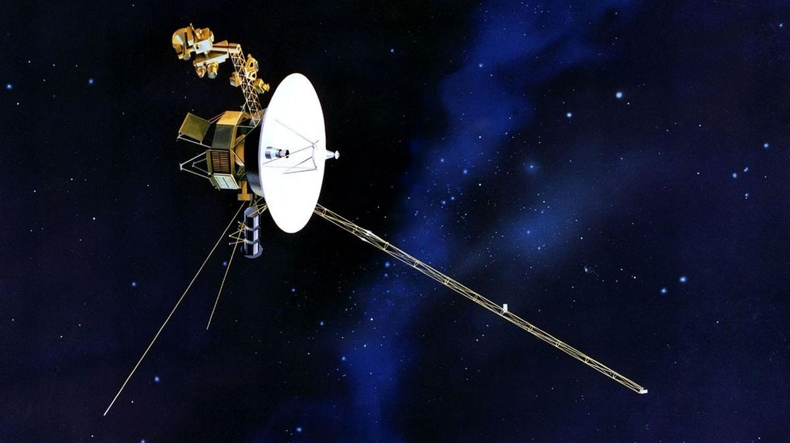
Click for next article On Aug. 20, 1977, NASA launched the Voyager 2 spacecraft on a mission to explore the outer planets. Despite its name, this was the first of the two Voyager missions NASA launched that year. Voyager 2: Sailing Among Giant Planets Thanks to a rare alignment of the planets, NASA had the opportunity to send a spacecraft on an unprecedented journey to Jupiter, Saturn, Uranus and Neptune.While Voyager 1 ended its planetary mission after Saturn, Voyager 2 completed a 12-year journey to Neptune . But they didn't stop there! Voyager 1 left the solar system and entered interstellar space in 2012, and Voyager 2 followed suit in 2018. As it approaches 50 years of operation, the probe continues to return data from three functioning science instruments. NASA's Voyager 2 launched on Aug. 20, 1977. (Image credit: NASA) Why it mattered Nearly half a century later, it remains the only spacecraft to visit all four has giants in our solar system, and the only spacecraft humanity has ever sent past Uranus and Neptune. Some of Voyager 2's biggest surprises came from the moons orbiting those planets. Its images of Neptune's largest moon, Triton, revealed active geyser-like plumes blasting nitrogen miles above the surface - making it one of only three geologically active moons in the solar system (maybe four, depending on what Europa Clipper finds). Decades beyond its original mission, Voyager 2 has begun studying the Kuiper Belt environment beyond the Sun's protective heliosphere , giving scientists measurements from a region no spacecraft had been designed to reach. Voyager 2's plutonium power supply drops in efficiency about four watts per year, and NASA engineers were recently able to reduce how much power Voyager 2 needs by switching off a number of non-science components to adapt a less demanding method of warming the spacecraft while it continues traveling ever farther away from the sun.

40. Rocket Lab launches private Japanese Earth-observing satellite to orbit (video)
Read more
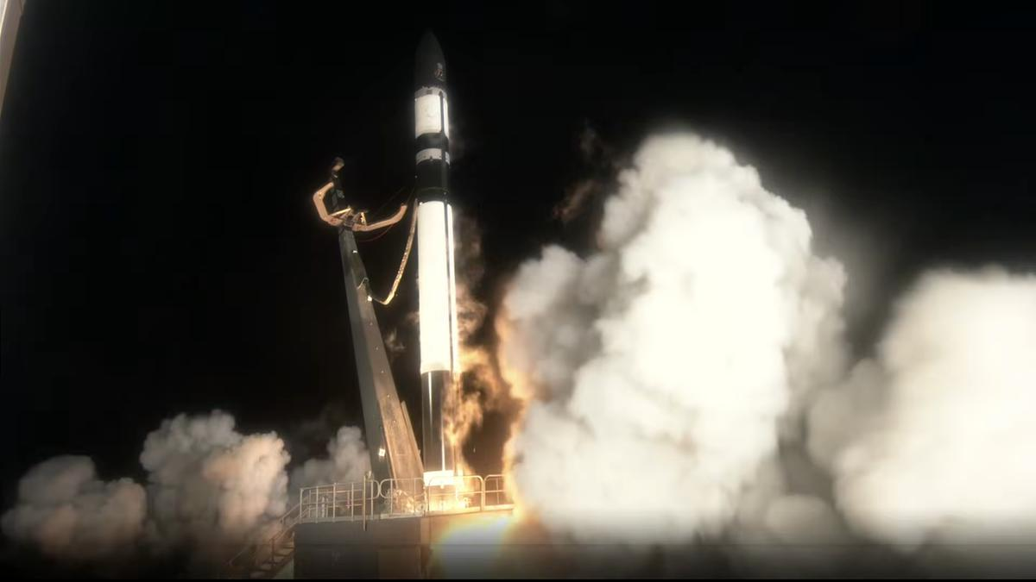
Click for next article Rocket Lab launched a private Japanese satellite to orbit this morning (Aug. 20), adding to a growing constellation of Earth-observing spacecraft. An Electron vehicle lifted off from Rocket Lab's New Zealand site at 9:04 a.m. EDT (1304 GMT; 1:04 a.m. on Aug. 21 local New Zealand time), carrying aloft a radar satellite for the Tokyo-based company iQPS. The nine 3D-printed Rutherford engines that power Electron's first stage shut off as planned about 2.5 minutes after liftoff. Separation with the rocket's second stage immediately followed, which burned for another 6.5 minutes before releasing Electron's "kick stage" with the IQPS payload for a 40-minute coast phase. Electron lifts off from Rocket Lab's New Zealand launch site at 9:04 a.m. EDT (1304 GMT) on Aug. 20. (Image credit: Rocket Lab) This was Rocket Lab's ninth launch for iQPS, which is building a constellation of 36 synthetic aperture radar (SAR) satellites in low Earth orbit (LEO). Such spacecraft can study Earth day or night, and they can peer through cloud cover as well. The iQPS network "is being developed and deployed at a rapid pace to provide high resolution and near-real time SAR imagery to its global users," Rocket Lab wrote in a description of today's mission , which it calls "The Lightning God Defends." That name is a reference to the satellite going up today: It's nicknamed SUSANOO-II, after a Japanese lightning god. Following the 40-minute coast phase of Electron's kick stage, the rocket completed one final burn to circularize its orbit and successfully deployed SUSANOO-II about 50 minutes after launch, at an altitude of 357 miles (575 kilometers). Today's flight was Rocket Lab's 14th of 2026 and 93rd overall. The company's most recent launch, on Aug. 6 , also lofted an iQPS satellite to LEO.

41. Last-minute abort stalls Cape Canaveral Starlink mission
Read more
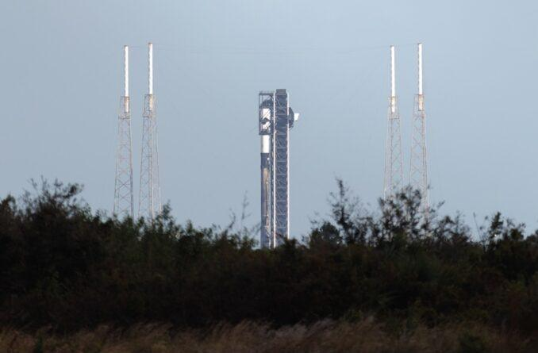
Update Aug. 20, 11:58 a.m. EDT (1558 UTC): SpaceX scrubbed the mission. An abort called in the last 30 seconds of its countdown on Thursday halted SpaceX from launching its 75th batch of Starlink satellites of the year. SpaceX didn't provide a reason for the scrub prior to ending is broadcast. When it launches, Starlink 10-39 mission will add another 29 broadband internet satellites to the company's low Earth orbit megaconstellation. Liftoff from Space Launch Complex 40 at Cape Canaveral Space Force Station was scheduled at 11:38 a.m. EDT (1538 UTC). A new date and launch dime If SpaceX decides to try launching on Friday, Aug. 21, the 45th Weather Squadron forecast an 80 percent chance for favorable weather during the opening of the window. It deteriorates down to 40 percent as the window progresses. "The main concern at the beginning of the primary window will be violations associated with locally developing showers and storms along the sea breeze," launch weather officers wrote on Wednesday. "However, coverage during this period should be isolated and thus will maintain a lower [probability of violating weather constraints] at the start of the window with this forecast update. "Later in the window, model guidance is in good agreement simulating showers and storms tracking east across Florida along the west coast sea breeze. However, guidance diverges on the timing of their arrival at the Spaceport." SpaceX will launch the mission using the Falcon 9 first-stage booster B1078. This will be its 30th flight, making it the sixth booster to reach this milestone. Nearly 8.5 minutes after liftoff, B1078 will make a landing on the droneship, A Shortfall of Gravitas, positioned in the Atlantic Ocean off the coast of South Carolina. If successful, this will be the 164th landing on this vessel and the 652nd Falcon booster landing for SpaceX to date.
42. Isro will not make any launch vehicle, all tech to be handed to private sector - India Today
Read more
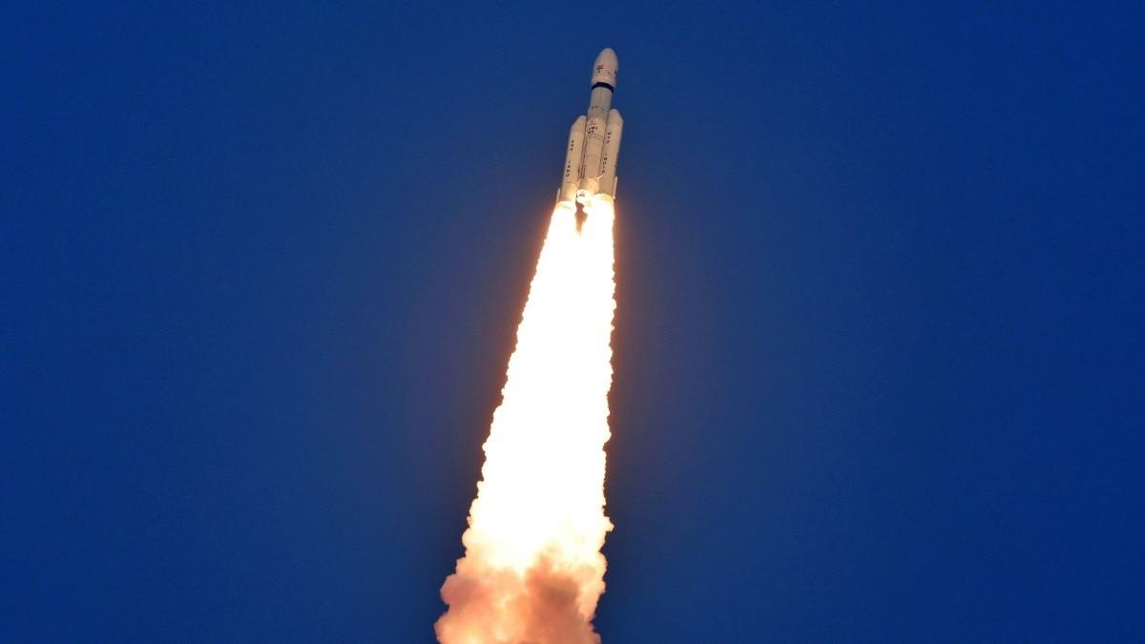
India's space programme is preparing for one of its biggest structural transformations yet, with ISRO set to gradually move away from manufacturing launch vehicles and routine satellites, handing these activities over to the private sector. Speaking at Business Today's India @ 100 Economy Summit, IN-SPACe Chairman Dr Pawan Goenka said the transition is already underway and will allow ISRO to focus on research, advanced technologies, scientific missions and infrastructure that private companies may not be able to build on their own. Read Full Story "ISRO will not make any launch vehicles and will not manufacture any launch vehicles. That will all be done by the private sector or PSU," Goenka said. The shift has already begun with the Small Satellite Launch Vehicle, or SSLV, whose technology and production rights have been transferred to Hindustan Aeronautics Limited following a bidding process. The next phase could be even more significant. Goenka said the Polar Satellite Launch Vehicle (PSLV) and the Launch Vehicle Mark-3 (LVM3), India's most powerful operational rocket, are also headed towards privatisation. Unlike the SSLV process, public sector companies will not be allowed to participate in the upcoming transfer process, leaving private industry to take charge. ISRO's role, Goenka said, will increasingly resemble that of a research and development organisation rather than a manufacturer responsible for everything from rockets to satellites. The space agency will focus on scientific missions, developing new technologies, specialised satellites and advanced infrastructure. Once technologies mature, they can then be transferred to private companies for commercial operations. "We have already transferred 120 technologies from ISRO to the private sector," he said. The government is also planning to hand operations of a new launch centre to private industry. Goenka said the operator could be finalised within the next four or five months. The transformation is part of India's broader ambition to expand its space economy from around $8 billion today to $44 billion by 2033. Goenka said achieving that target will require three major engines: government demand, greater use of space technologies by industries outside the traditional space sector, and expansion into international markets. The government, he said, must act as an anchor customer. The Department of Defence has already placed an order for 31 satellites with private companies, while ISRO is expected to build 21 more under the same broader programme. India is also pushing towards an ownership-based commercial model, where private companies own satellites and other space assets and monetise their data and services. For ISRO, the future could mean doing less of the day-to-day manufacturing that defined its rise as a space power, and focusing instead on creating the technologies and missions that will define India's next chapter in space. - Ends

43. Former ISRO chairman Somanath appointed to Central Board of Directors of RBI - Manorama Yearbook
Read more

• S. Somanath, former chairman of the Indian Space Research Organisation (ISRO), was appointed to the Central Board of Directors of Reserve Bank of India (RBI). • Somanath retired from ISRO in January 2025. • He has been appointed as a part-time, non-official director on the central board for a period of four years with effect from August 20, 2026. • The RBI also re-appointed industrialist Anand Mahindra, chairman of the Mahindra Group, for another four years as a part-time, non-official director on the central board. Central Board of RBI • The Reserve Bank of India was established on April 1, 1935 in accordance with the provisions of the Reserve Bank of India Act, 1934. • The Central Board of Directors is entrusted with the governance of the Reserve Bank in accordance with the Reserve Bank of India (RBI) Act, 1934. • It comprises the Governor as the chairperson, four Deputy Governors and directors nominated by the central government. • In accordance with the RBI Act, the central government also appoints members for four Local Boards to advise the Central Board on matters referred to them by the Board. • The directors are generally appointed for a four-year term. The Central Board is assisted by three Committees: i) The Committee of the Central Board (CCB). ii) The Board for Financial Supervision (BFS). iii) The Board for Regulation and Supervision of Payment and Settlement Systems (BPSS). • These committees are headed by the Governor. In addition, the Central Board has five sub-committees each headed by a non-official director. They are: i) The Audit and Risk Management Sub-Committee (ARMS). ii) The Human Resource Management Sub-Committee (HRM-SC). iii) The Building Sub-Committee (B-SC). iv) The Information Technology Sub-Committee (IT-SC). v) The Strategy Sub-Committee (S-SC).

44. Explainer: ISRO's SS1 upgrade set to supercharge India's small satellite launch vehicle - organiser.org
Read more
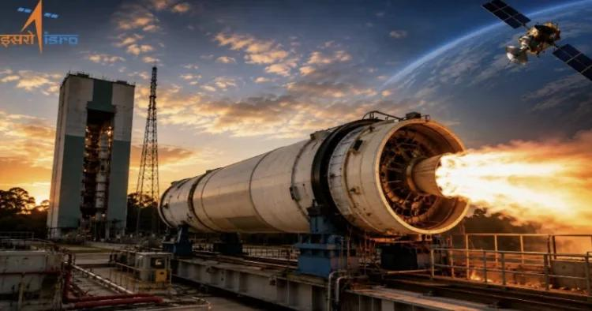
Explainer: ISRO's SS1 upgrade set to supercharge India's small satellite launch vehicle organiser.org

45. Trump signs new national space policy to enable 1,000 US rocket launches per year
Read more

Click for next article The United States is updating its approach to managing spaceflights that lift off and land within its borders, and aims to expand the nation's capabilities to support more than 1,000 rocket launches per year by 2030. President Donald Trump just signed a new National Space Transportation Policy that lays out priorities for commercial, civil and national security missions to orbit. The memorandum, published Thursday (Aug. 20), introduces the first update to the policy since 2013 , and comes as commercial operators such as SpaceX have driven U.S. launch cadences up more than 800% since 2015. The policy centers on expanding the infrastructure and procedures needed to support a much busier space industry. It directs federal agencies to identify and broaden commercial access to additional launch and reentry sites, and to incorporate spaceflight operations and critical launch corridors into air traffic control management and modernization efforts. The document gives agencies a deadline to get the work started. Within 180 days of the memo's publication, NASA , the Department of Transportation (DOT) and the Department of Defense (DOD) are directed to begin identifying potential locations for future launch activities, as well as existing facilities that could be upgraded to further increase capacity. Agencies were also directed to establish leases and commercial investment opportunities to incentivize the co-development of new launch sites. The new properties can be funded, in part, by the same private entities that are lined up to use them. Rocket landing sites are getting extra attention, with the president's policy designating agencies to identify federal lands available for development as independent launch vehicle reentry sites within the next 90 days. It also reinforces a framework to expedite environmental review processes first laid out in a commercial space executive order that Trump signed in August 2025 , which sought to remove regulatory hurdles for commercial launches and spaceport construction. SpaceX is already planning for launch rates far beyond the administration's 2030 target. The company's Starship rocket, which remains in development, is poised to become the first fully reusable launch vehicle in history. In response to the new policy on Thursday, SpaceX CEO Elon Musk said his company is aiming to launch 30 or more Starship flights a day by 2030, which equates to more than 10,000 flights per year. For government missions, the strategy also emphasizes having more than one ride to orbit, with NASA and DOD tasked with maintaining multiple launch options and developing adaptable interfaces that would allow payloads to move between rockets from varying providers. SpaceX's Starship launches on its second test flight on Nov. 18, 2023. (Image credit: Space.com / Josh Dinner) Commercial launch services are already standard for most NASA and DOD missions, but the memorandum broadens that approach to transportation after reaching orbit, including spacecraft servicing and logistics. And the DOD is specifically being asked to investigate commercial options for in-space transportation and more diverse orbital delivery systems, like space planes. Speed is particularly important for national security launches, and the new policy addresses one effort already ongoing by the Pentagon: achieving consistently dependable access to space within a 48-hour timeframe. The Space Force's Space Systems Command has been testing that capability through its Tactically Responsive Space program, launching the Victus Nox mission with Firefly Aerospace with 27 hours' notice in 2023 and the Victus Haze mission in June, which Rocket Lab launched within just 17 hours. The White House highlighted some of the economic benefits beyond transportation that the policy is poised to impact in a fact sheet accompanying its publication. According to that fact sheet, the new policy will lead to advancements in things like in-space manufacturing and the development of pharmaceuticals and "high-value materials," while improvements to satellite positioning, navigation and timing services could support more precise agricultural operations and weather forecasts on Earth. The transportation strategy also extends far beyond low Earth orbit . NASA is being asked to develop a commercial lunar logistics architecture capable of moving cargo and other payloads to and from the moon 's surface. The agency is already engaged in these efforts through its Commercial Lunar Payload Services (CLPS) and Artemis programs, which share a complementary focus of returning astronauts to the lunar surface and building out the infrastructure necessary to sustain a lunar base, and is now tasked with extending that reach much farther.

46. Trump to award NASA's Artemis II astronauts the Congressional Space Medal of Honor
Read more
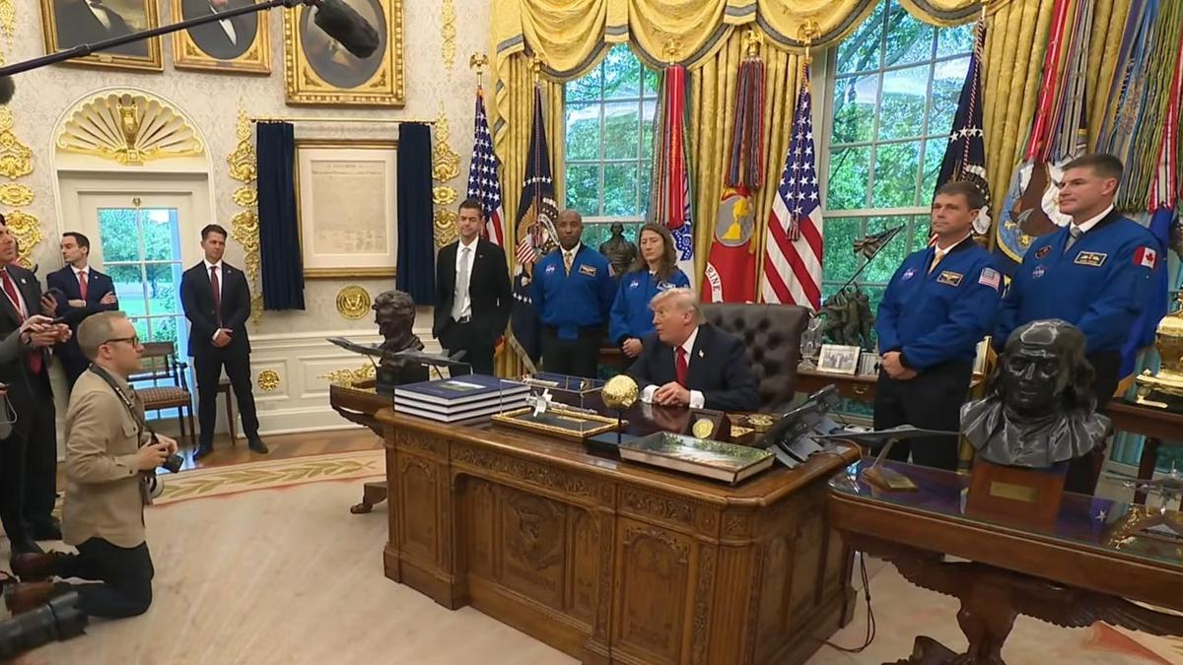
Click for next article President Donald Trump welcomed the four Artemis 2 astronauts (in blue flight suits) and NASA Administrator Jared Isaacman (in dark suit, in front of American flag) to the Oval Office on April 29, 2026. NASA's Artemis II moon astronauts will join a very exclusive club next week. President Donald Trump will award those spaceflyers the Congressional Space Medal of Honor next Friday (Aug. 28) at Johnson Space Center in Houston to recognize their historic journey around the moon this past April. The ceremony will begin at 11 a.m. EDT (1500 GMT) and will feature NASA Administrator Jared Isaacman, President Trump and the Artemis II astronauts. You'll be able to watch it live when the time comes. Artemis II sent NASA astronauts Reid Wiseman, Victor Glover and Christina Koch, as well as the Canadian Space Agency's Jeremy Hansen, on a 10-day trip around Earth's nearest neighbor. It was the first crewed voyage beyond low Earth orbit since 1972, when the Apollo 17 astronauts returned home from the moon. The mission's success was a huge step for NASA's Artemis program , which aims to establish a base near the lunar south pole in the coming years. The Congressional Space Medal of Honor is the highest award that the U.S. government can bestow upon an astronaut. It's possible that only Wiseman, Glover and Koch will receive it next week; NASA's media advisory about the event states that Trump will give the medal to "each of NASA's Artemis II crew members," suggesting that Hansen might not be included. (The award is not limited to American citizens.) Thirty people have received the Congressional Space Medal of Honor to date. They are:

47. Japan unveils Mars moon sample-return spacecraft ahead of Oct. 19 launch (photos)
Read more
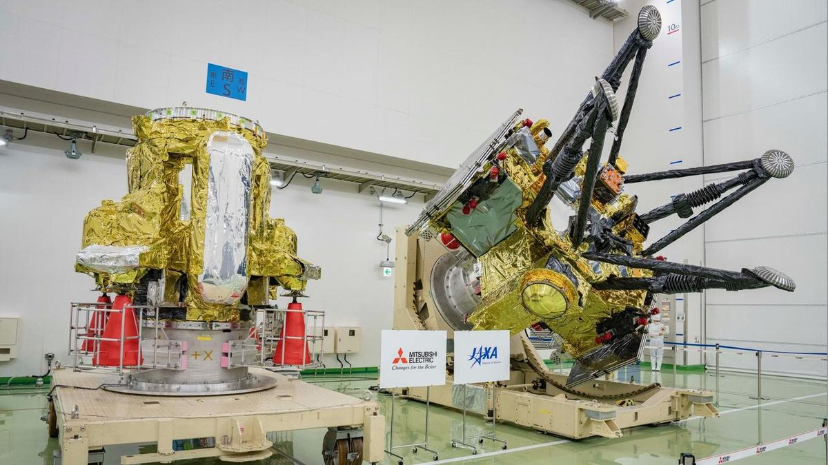
Click for next article The Propulsion Module (left) and Exploration and Return Modules (right), which together make up Japan's Martian Moons eXploration (MMX) spacecraft, are seen at the Tanegashima Space Center in Minamitane, Kagoshima prefecture on Aug. 13, 2026. The world just got its first good looks at some hardware that will make spaceflight history. Last Thursday (Aug. 13), Japan unveiled the spacecraft that make up its Martian Moons eXploration ( MMX ) mission, which aims to snag samples of the Mars moon Phobos and haul them to Earth - something that has never been done. The big reveal came at Tanegashima Space Center, the site from which MMX will launch toward the Red Planet atop an H3 rocket . And we just got some clarity about when that liftoff will take place. Another look at MMX's Propulsion Module (back) and Exploration and Return Modules (front) at Tanegashima on Aug. 13, 2026. (Image credit: Yuichi YamazakiI/AFP via Getty Images) If all goes according to plan, MMX will launch on Oct. 19 at 3:41 p.m. EDT (1941 GMT; 4:41 a.m. on Oct. 20 Japan time), the Japan Aerospace Exploration Agency ( JAXA ) announced on Thursday (Aug. 20). That's the first day of the mission's launch window, which extends through Nov. 7. JAXA originally intended to launch MMX in 2024 but had to stand down due to issues with the H3 . Mars and Earth align properly for interplanetary launches just once every 26 months, so this was a significant delay. MMX will spend about a year traveling to Mars. Once in orbit around the Red Planet, the mission will map and study its two small moons, Phobos and Deimos , which are just 14 miles (22 kilometers) and 7.5 miles (12 km) wide, respectively. Part of this work will help the mission team pick a landing site on Phobos, where they'll drop a 55-pound (25 kilograms) French-German rover called Idefix . That little robot - which is named after the dog in the French comic "Asterix" - will study Phobos' surface in detail using a variety of instruments. The MMX spacecraft itself will then spiral down toward Phobos, eventually making contact and collecting about 0.35 ounces (10 grams) of material. MMX will leave Mars orbit with these samples in 2030 and deliver them to Earth for analysis a year later. The mission aims to shed light on the nature and origin of Phobos and Deimos . "Understanding how Mars and the two moons formed is a heavily debated topic in solar system science," JAXA officials wrote in a mission description . "Remote-sensing observations by the MMX spacecraft and the detailed analyses of the returned sample will determine whether Phobos and Deimos are remnants of early Mars created from debris produced by a giant impact with the young planet, or whether the moons are asteroids captured by Mars's gravity that brought material from outer solar system ," they added. To date, no spacecraft has returned material from the Mars system. Russia tried to do so with its Phobos-Grunt mission , which aimed to sample the eponymous Red Planet moon, but that effort failed shortly after its November 2011 launch. (The Soviet Union also launched two probes to Phobos in 1988, but neither one of them met its mission objectives.) NASA plans to collect and haul home pristine samples that have already been collected on the Martian surface by its Perseverance rover , but it's unclear when or if that will happen. The agency has deemed its original sample-return architecture too expensive and is currently investigating other options.

48. SpaceX launches 29 Starlink satellites, lands rocket on ship at sea (video, photos)
Read more
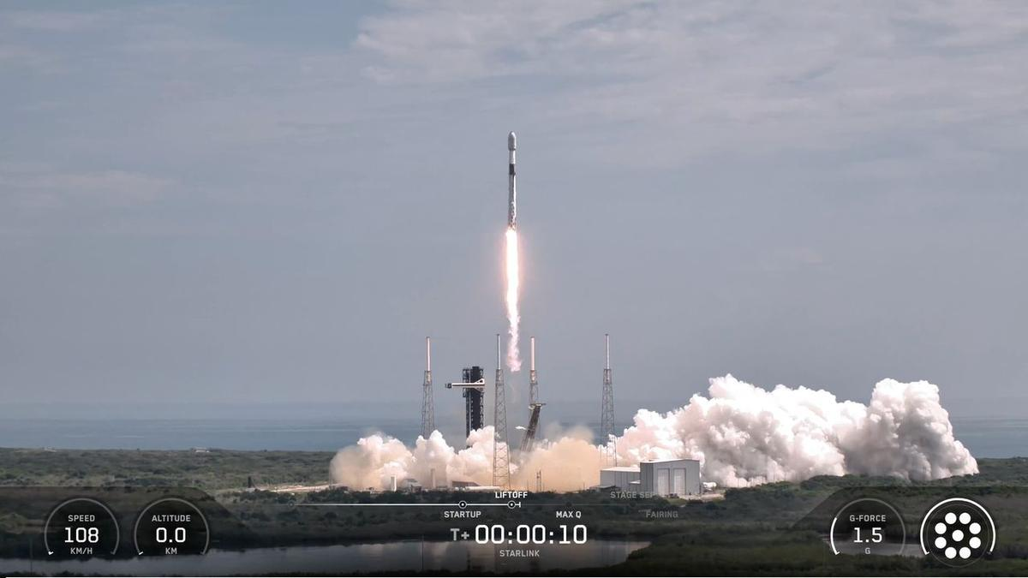
Click for next article SpaceX launched yet another Starlink mission today (Aug. 21), sending 29 more of the broadband satellites to orbit from Florida's Space Coast. The spacecraft flew aboard a Falcon 9 rocket, which lifted off from Florida's Cape Canaveral Space Force Station today at 11:14 a.m. EDT (1514 GMT). That was a day later than planned; SpaceX scrubbed a liftoff attempt on Thursday (Aug. 20) for reasons that were not immediately clear. The Falcon 9's first stage came back to Earth as planned today, landing about 8.5 minutes after launch in the Atlantic Ocean atop the SpaceX droneship "A Shortfall of Gravitas." It was the 30th liftoff and touchdown for this particular booster, which is designated B1078. A SpaceX Falcon 9 rocket launches 29 Starlink internet satellites from Florida's Cape Canaveral Space Force Station on Aug. 21, 2026. (Image credit: SpaceX) The Falcon 9's upper stage, meanwhile, continued hauling the Starlink satellites skyward. It will deploy the new batch into low Earth orbit 61.5 minutes after liftoff, if all goes to plan. There are already quite a few operational Starlink spacecraft up there -nearly 11,000, in fact, according to astronomer and satellite tracker Jonathan McDowell. The Falcon 9's first stage rests on the deck of a drone ship shortly after its touchdown on Aug. 21, 2026. (Image credit: SpaceX) Today's launch was the 98th Falcon 9 flight of the year already. Seventy-five of them have been dedicated Starlink missions. SpaceX also has three other liftoffs under its belt in 2026 - one launch of its Falcon Heavy rocket and two test flights of its Starship megarocket, which is still in development.

49. Live coverage: SpaceX to launch 100th orbital mission of 2026
Read more
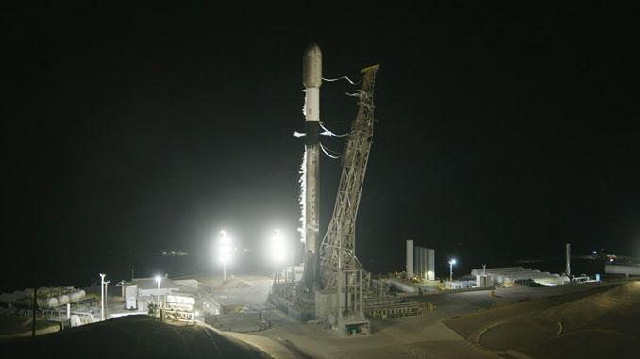
Update Aug. 22, 3:51 a.m. EDT (0751 UTC): SpaceX landed the first stage booster on the droneship. SpaceX launched its 100th orbital mission of the year shortly after midnight on Saturday morning. Its Falcon 9 rocket took off from Vandenberg Space Force Base on a Starlink delivery. The Starlink 15-20 mission added another 29 broadband internet satellites to the company's megaconstellation in low Earth orbit. SpaceX founder Elon Musk confirmed on Friday that it now has more than 11,000 Starlink satellites in orbit. Liftoff from Space Launch Complex 4 East happened at 12:25 a.m. PDT (3:25 a.m. EDT / 0725 UTC). The rocket flew on a south-easterly trajectory upon leaving the pad. <span data-mce-type="bookmark" style="display: inline-block; width: 0px; overflow: hidden; line-height: 0;" class="mce_SELRES_start"></span> SpaceX launched this mission using the Falcon 9 first stage booster with the tail number B1100. This was its ninth flight after previously launching the NROL-105 mission for the National Reconnaissance Office as well as seven batches of Starlink satellites. Nearly 8.5 minutes after liftoff, B1100 landed on the droneship, Of Course I Still Love You, positioned in the Pacific Ocean. This was the 220th landing on this vessel and the 653rd Falcon booster landing to date.

50. Interplanetary spacecraft capture a coronal mass ejection component hidden from Earth
Read more
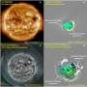
During a coronal mass ejection (CME), the sun hurls billions of tons of magnetized plasma into space. These eruptions are among the most powerful events in the solar system, and when they are aimed toward Earth, they can seriously threaten the satellites and power grids we depend on. For now, it remains notoriously difficult to predict how these eruptions evolve over time-and, ...

51. China is launching a moon mission to find water ice
Read more

We've known for nearly two decades that some form of water exists on the moon. What we still don't know is exactly how much accessible water ice lies inside permanently shadowed craters, how deeply it is buried or what form it takes.
52. Illegal homestays and B&Bs thrive sans registration
Read more
PIONEER EDGE NEWS SERVICE/Dehradun Several homestays and Bed and Breakfast establishments are allegedly operating in the city without registration, raising concerns over the absence of proper records of tourists staying at these properties. The district tourism development officer (DTDO) Jaspal Chauhan said that l ack of tourist details and verification could create law-and-order concerns, as authorities may not have information about who is staying at such establishments. Chauhan said that such illegally operating homestays and B&B establishments are violating the Uttarakhand tourism department's 2026 rules. He said that operators are also not maintaining proper records of tourists staying at their properties, making it difficult to verify visitors. Chauhan said that maintaining records and completing the required formalities is particularly important in the case of foreign tourists, for whom submission of a Form-C is mandatory. However, operating establishments often fail to submit the required Form-C, which amounts to a violation of the law. He said that the tourism department has identified around 50 unregistered homestays and B&B establishments in the city. Notices are being sent to owners. A notice has also been sent to the Police Headquarters on Saturday, listing the establishments found operating without registration. The police will verify the addresses and visit the premises of the operators against whom notices have been issued. The department has requested the police to conduct an investigation and take action as per law, including issuing challans wherever violations are found, he added. Under Chapter VI of the Uttarakhand tourism rules, operating an unregistered tourism establishment can attract a penalty of Rs 10,000. An additional penalty of Rs 1,000 per day can also be imposed for every day the violation continues. The notices direct the operators to submit a written explanation along with supporting documents within seven working days and appear before the DTDO office. Chauhan said that failure to respond within the stipulated period could lead to further action under the rules, including recovery of the applicable penalty and daily fine for the period of unauthorised operation.

53. #ISRO#IndianSpaceProgram #SpaceTech#INSPACe #ZeeNewsEnglish - AIMA Media
Read more
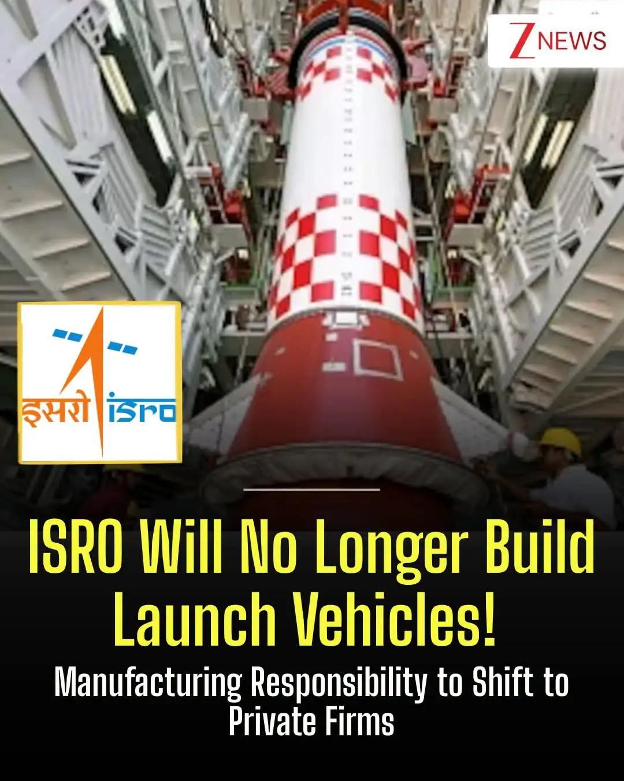
#ISRO#IndianSpaceProgram #SpaceTech#INSPACe #ZeeNewsEnglish India's space programme is set for a major shift as ISRO moves towards handing over the manufacturing of launch vehicles and conventional satellites to private companies and PSUs. The move will allow ISRO to focus more on research, advanced technology and scientific missions.

54. Meet the IIT Bombay engineer who turned down ISRO to build Rs 1,000 crore Atomberg - India Today
Read more
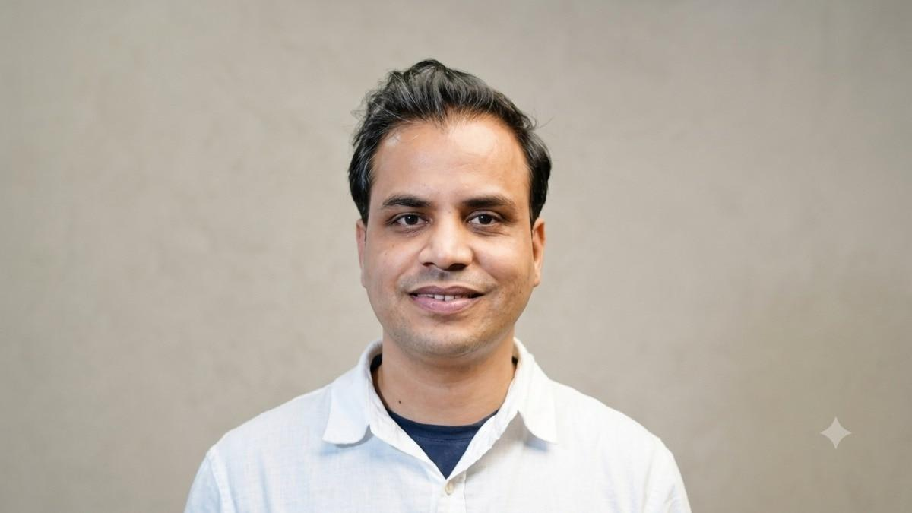
Manoj Meena had already secured what looked like the perfect ending to his IIT Bombay journey. An ISRO job was waiting for him after his final year. For his family in rural Rajasthan, the choice seemed obvious. A stable government job meant security and a settled future. Meena chose something much less certain. He decided to build. The Electrical Engineering student had spent his IIT Bombay years immersed in robotics and electronics, participating in competitions and working on technology projects. He had developed a belief that engineering should solve problems people actually face. Read Full Story Entrepreneurship, he realised, could give him the freedom to pursue that idea. His family did not immediately understand the decision. But Meena took the plunge. The company he started would eventually become Atomberg Technologies. ATOMBERG DID NOT START WITH A FAN Meena founded Atomberg in 2012 and was later joined by fellow IIT Bombay alumnus Sibabrata Das in 2013. There was no grand consumer startup plan. The company was incubated at SINE, IIT Bombay, and the founders spent the first few years bootstrapping and taking up technology projects. They worked on data acquisition systems, motor control, process control and other engineering problems for institutions and research organisations. They also tried different ideas. Vehicle tracking was one. Other projects came and went. The founders were often doing everything themselves, from building technology to visiting customers and fixing devices. Those first years were a prolonged search for a scalable idea. They had the engineering skills. They just had not found the right problem. FOUR YEARS OF SEARCHING FINALLY LED TO A FAN The breakthrough came in 2015. While working on motors, power electronics and control systems, the founders began studying the ceiling fan market. The ordinary ceiling fan had barely changed in the way that mattered most to consumers: electricity consumption. A conventional fan typically used around 75 to 80 watts. The team developed a brushless DC, or BLDC, motor that could deliver similar output at around 28 watts. In practical terms, Atomberg said its fans could consume up to 65% less power than conventional fans. That was the breakthrough. The founders had found a way to take their engineering capabilities and apply them to an appliance found in millions of Indian homes. Atomberg launched its first fan under the Gorilla brand in 2015. Initially, the company supplied fans to institutional buyers. In 2016, it made the difficult transition towards consumers. And that created an entirely new problem. 'WHO WILL BUY YOUR FANS?' Atomberg was trying to enter a market dominated by established companies such as Bajaj, Crompton, Havells and Usha. It also wanted to sell fans online, despite consumers traditionally buying them through physical retailers. Investors questioned whether an unknown startup could compete with companies that had decades of brand recognition and distribution. The founders kept pitching. And kept hearing no. According to Forbes India, Atomberg's operating revenue had reached 37 crore in FY19, and it was producing around 1,000 fans a day. The business was growing, but its capital needs were growing too. Then came 2019. ATOMBERG HAD ABOUT A MONTH LEFT This was the point where the startup's survival was genuinely in doubt. Das later recalled that Atomberg had an extremely short runway left. Salaries were being delayed, vendors were demanding payments and funding discussions were going nowhere. Years of work were suddenly at risk. In his account to Forbes India, Das recalled the emotional toll of that period, including reaching a point where the founders wondered whether they would have to wind down the company. Then a new possibility appeared. The founders came across news about a newly formed fund and reached out despite having little reason to expect a response. They got one. The fund moved quickly. Within weeks, Atomberg had secured the capital it needed to continue. The startup that had been close to shutting down had another chance. This time, it was ready to scale. THE FAN BECAME A TECHNOLOGY PLATFORM Atomberg's biggest evolution was that it stopped being just an energy-efficiency story. The BLDC motor allowed the company to make its fans more compact. Over time, it added remote controls, LED interfaces, Wi-Fi connectivity and app-based controls. The company's product design also changed. Its Renaissance range introduced smaller motors and a more minimalist appearance, helping Atomberg differentiate itself from conventional ceiling fans. The founders have said the product gradually evolved from an energy-efficient appliance into a smart appliance. The same technology capabilities also created opportunities outside fans. Atomberg eventually moved into categories such as mixer grinders and water purifiers, while exploring applications for its motor and electronics expertise in areas including air-conditioning components and drone motors. FROM IIT BOMBAY'S INCUBATOR TO Rs 1,000 CRORE The company that once struggled to convince investors eventually became a major Indian consumer technology brand. Atomberg's operating revenue reached about 958 crore in FY25, while its total income crossed 1,000 crore. Meena's journey has brought him recognitions including the National Entrepreneurship Award, Forbes India 30 Under 30, Forbes Asia 30 Under 30 and IIT Bombay's Young Alumni Achievers Award. Das has also featured on Forbes' 30 Under 30 lists and received the Young Alumnus Achiever Award from IIT Bombay. But the most interesting part of Meena's story began long before those awards. It began in rural Rajasthan, where access to electricity was limited and power mattered enormously to everyday life. Years later, the IIT Bombay engineer who had walked away from a secure ISRO career was building technology around one of the biggest everyday uses of electricity in Indian homes. Atomberg did not emerge from one perfect idea. It came after four years of searching, failed experiments, funding rejections and one very ordinary question: What if the fan could simply use less electricity? That question became the foundation of a company that would eventually cross 1,000 crore in total income. - Ends

55. ISRO Will Not Make Launch Vehicles; Technology To Be Handed Over To Private Sector: Pawan Goenka - ETV Bharat
Read more
ETV Bharat / technology ISRO Will Not Make Launch Vehicles; Technology To Be Handed Over To Private Sector: Pawan Goenka India's space sector is entering a major transition, with the private industry expected to take on a much larger role in manufacturing launch vehicles, satellites and other space systems. The shift is part of India's larger ambition to build a $44-billion space economy by 2033. According to Indian National Space Promotion and Authorisation Centre (IN-SPACe) Chairman Dr Pawan Goenka, achieving that target will require stronger government demand, wider use of space technology across industries and greater access to international markets. "ISRO will not make any launch vehicles and will not manufacture any launch vehicles. That will all be done by the private sector or PSU," Goenka said while speaking at Business Today's India @ 100 Economy Summit. The proposed change does not mean a reduced role for ISRO. Instead, the space agency is expected to focus more heavily on research, new technologies, scientific missions and specialised infrastructure, with mature technologies eventually moving to industry for commercial production. India's space sector is changing (ETV Bharat Graphics) ISRO's Role Set To Evolve For decades, ISRO was involved in almost every stage of India's space programme, including the development and manufacturing of launch vehicles and satellites. The emerging model seeks to separate technology development from large-scale commercial production. Goenka said ISRO's focus would increasingly shift toward areas requiring advanced research and technological development, while companies take mature technologies to market. "Eventually, ISRO will not make any launch vehicles," he said, while underlining the long-term direction of the transition. The process has already started with the Small Satellite Launch Vehicle (SSLV), whose technology and production rights have been transferred to Hindustan Aeronautics Limited (HAL) following a bidding process. The government is also advancing the planned transfer of technologies for the Polar Satellite Launch Vehicle (PSLV) and Launch Vehicle Mark-3 (LVM3), paving the way for greater private-sector participation in launch-vehicle manufacturing and operations. The private space ecosystem has grown significantly in recent years, with hundreds of companies now working across launch vehicles, satellites, components, data and other space-related services. According to a written reply by Minister of State for Space Jitendra Singh in the Lok Sabha recently, around 440 space technology startups are registered in India. IN-SPACe has granted 113 authorisations to 52 non-government entities for various space activities, including 18 startups. Goenka pointed to the successful Vikram-1 launch as an important moment for the industry, describing it as a "milestone event" that demonstrated the growing capabilities of India's private space sector. The significance of such missions goes beyond a single successful launch. Private companies now have to show that they can repeat missions reliably, manufacture at scale and build sustainable businesses around their technologies. What will ISRO focus on? (ETV Bharat Graphics) More ISRO Technologies Moving To Industry Technology transfer is emerging as a key link between ISRO's research capabilities and the private sector's commercial ambitions. "We have already transferred 120 technologies from ISRO to the private sector," Goenka said. Separately, the government said in its Lok Sabha reply that 118 Technology Transfer Agreements have been executed through NewSpace India Limited (NSIL), covering 83 technologies developed by ISRO and the Department of Space. The technologies include the SSLV, Indian Mini Satellite-1 bus, laser gyro, antenna systems, ceramic accelerometers and other specialised systems. The government said NSIL is promoting greater private participation through technology-transfer processes, industry partnerships and opportunities across satellite manufacturing, integration, testing and downstream services.

56. ISRO Mulls Exiting Manufacturing Amid India's Push To Promote Privatisation In The Space Industry - Inc42
Read more

SSLV technology has already been transferred to HAL, while larger launch vehicles such as PSLV and LVM3 could be next. The move could significantly expand the role of private players in India's space economy, shifting ISRO's focus towards R&D and advanced missions while industry takes over commercial launch manufacturing. ISRO is set to stop manufacturing launch vehicles, with mature rocket technologies to be transferred to private companies and PSUs. Adding to the central push of opening the space sector to the public, the Indian Space Research Organisation (ISRO) is now reportedly looking to gradually move away from manufacturing launch vehicles and routine satellites and involving the private sector for the same. The government plans on handing over mature space technologies to private companies and public-sector undertakings, IN-SPACe chairman Pawan Goenka said during the Business Today summit. As per Goenka, the space agency would eventually stop manufacturing launch vehicles as production moves to industry. Under the new model, ISRO will now double down on R&D, advanced technologies, scientific missions and specialised infrastructure, while private players will take responsibility for commercial manufacturing and operations. "ISRO will not make any launch vehicles and will not manufacture any launch vehicles. That will all be done by the private sector or PSU," he said. As per reports, the shift has already started with the Small Satellite Launch Vehicle (SSLV), whose technology is being transferred to Hindustan Aeronautics Limited (HAL). The next major opportunities are expected to involve the Polar Satellite Launch Vehicle (PSLV) and the Launch Vehicle Mark-3 (LVM3), India's most powerful operational rocket. IN-SPACe has started inviting private-sector players as it looks to transfer LVM3 technology for its end-to-end realisation, operation and commercialisation. The rocket is set to carry up to 4,000 kg to geosynchronous transfer orbit, making the proposed transfer significant for India's ambitions to build a commercial heavy-lift launch market. Reportedly, public sector companies will not be allowed to participate in the upcoming transfer process unlike the SSLV process. Goenka said that 120 technologies have already been transferred to the private sector. Going ahead, the space agency will focus on scientific missions, developing new technologies, specialised satellites and advanced infrastructure, resembling more of an an R&D firm than an end-to-end manufacturer. Once the technologies evolve, they can be transferred to private companies for commercial operations. As part of the process, the government is also planning to transfer operations of a new launch centre to the private industry, whose operator will be decided within the next 4-5 months. Startups Anchor Space Race The move comes as India's private space ecosystem is growing exponentially. As per government data, the number of spacetech startups increased from single digits in 2019 to more than 400 by early 2026, with startups now building niche offerings across launch vehicles, satellites, payloads, ground infrastructure and space-data services. Amid this, launch capabilities have also begun showing. India's only spacetech unicorn, Skyroot Aerospace, became India's first company to develop an orbital-class launch vehicle, Vikram-1, that reached the orbit in July 2026. The government is also trying to reduce the cost barriers for private space companies. IN-SPACe's launch support schemes provide subsidies for private launches and access to government space infrastructure, with the broader programme aimed at making Indian launch services more competitive globally. At the same time, the government is also turning into an anchor customer, with the department of defence placing an order for 31 satellites with private companies, while ISRO is expected to build 21 more under the same programme. The transition is central to India's ambition of growing its space economy from around $8 Bn currently to $44 Bn by 2033, with exports and private-sector demand expected to play a larger role.

57. How will NASA's astronaut training hub change with commercial space stations?
Read more
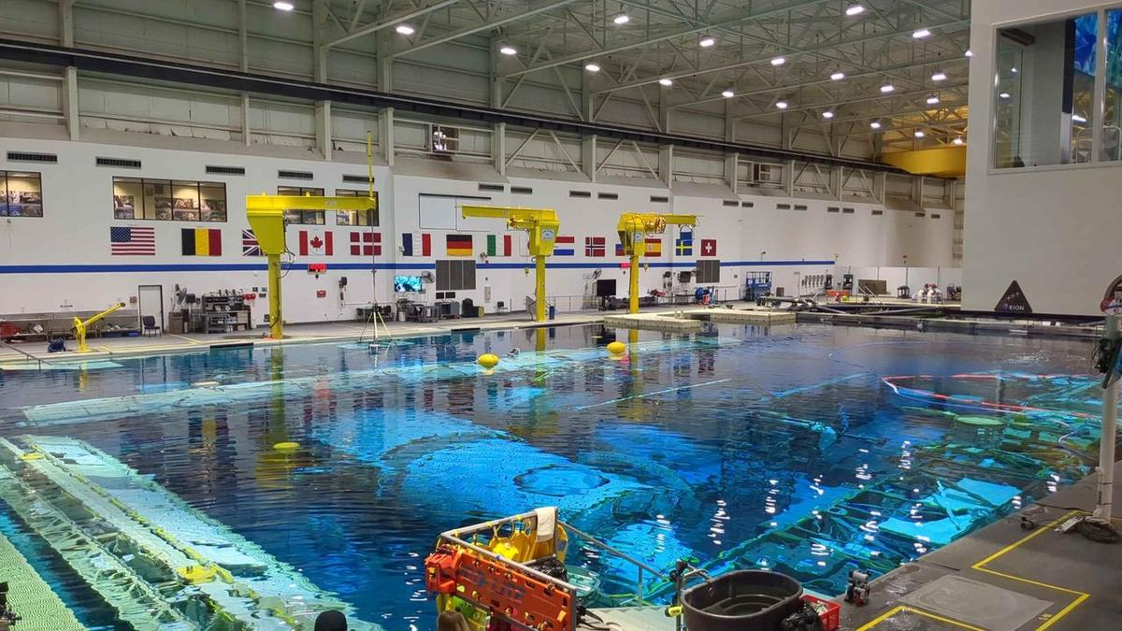
Click for next article HOUSTON - What does NASA's astronaut training hub look like these days, as the agency aims to bring more commercial space stations into the fold? It's an interesting mix of government and private companies, of space agency personnel and of contractors, all working together to keep U.S. and international astronauts flying through the end of the ISS - currently expected around 2030 - and the new breed of commercial space stations expected to take its place. Canadian reporters like myself were invited on a tour of Johnson Space Center (JSC) on Aug. 4 ahead of the launch of SpaceX Crew-13, which launches no earlier than Sept. 12. Canadian Space Agency astronaut Josh Kutryk is a mission specialist on the Crew Dragon spacecraft, which also includes NASA commander Jessica Watkins, NASA pilot Luke Delaney and Roscosmos mission specialist Teteryatnikov. The ISS remains an active program for at least a few years; NASA managers reiterated in a press conference here on Aug. 3 that they are still targeting an end-of-operations in about 2030 - but they are prepared to extend the lifetime of the station if directed by Congress (which wants to keep going at least another two years ). The space station has had a leak on the Russian side for several years, and astronauts recently and briefly sheltered in a Crew Dragon during discussions of a fix. At the press conference, NASA added the situation is under control as Roscosmos agreed to essentially seal off that area. Major station systems, they added, are otherwise in good health. But as spaceflight takes planning, teams are already thinking about "lessons learned" when the ISS retires for a new generation of mission planners, which would include an even greater focus on companies. NASA's Commercial LEO (Low Earth Orbit) Destinations or CLD program aims to have private space stations for astronauts by the time the ISS retires, and handed out early-stage contracts valued at about $415 million in 2021 to three teams led by Nanoracks, Blue Origin and Northrop Grumman. After NASA briefly considered changing the program's scope , after input from industry a new request for proposals advancing CLD should be out soon. Meanwhile, companies like Vast Space have their own self-funded modules almost ready to fly, while Bigelow Aerospace has an inflatable module on ISS that is being tested, long-duration wise, to make sure the concept holds up for a future free-flying destination. No matter who hosts astronauts, however, NASA officials on the tour said they are prepared to offer expertise and help - and there is no other visible demonstration of that expertise to the public than the ISS Mission Control, which is often shown live on NASA+ during a selection of space station operations. Mission Control: 'We have all of those disciplines' The mission control room at Johnson Space Center in Houston. (Image credit: Elizabeth Howell/Future) The Mission Control building holds several dedicated control rooms for different mission purposes, including an historic Apollo control center and another room alternately used for Boeing Starliner and Artemis missions. I've been lucky enough to visit all of these in the past. Our only stop in the building Aug. 4, however, was the iconic ISS mission control. On screen at the front of the room, the Expedition 75 astronauts were awake and active, occasionally zooming by a camera mounted inside the Destiny U.S. lab sandwiched between two station "nodes" leading to other modules. Flight director Diane Dailey told us the controllers are watching for things like if the astronauts are loaded down with equipment, which indicates that would not be a good time to call unless urgent. "We usually have that live camera view just up for awareness. It just helps us understand," she said. Speaking of calls, an open laptop screen, deliberately positioned within view of the camera, showed all "green" on the comms channels-which helps ground controllers figure out if the crew can hear them, as the station flies in and out of satellite and ground station views all the time. (A flight map , also at the front of the room, also allows for tracking the station and its communications capabilities as it flies around the world.) While it was hard not to keep gazing at these screens, what was almost as mesmerizing was watching the quiet group of ISS controllers positioned in front of their own laptops and occasionally holding side conversations about their systems. SpaceX now has its own Mission Control in California for its spacecraft, while Boeing chose to integrate theirs with NASA's. Whatever pathway companies choose, however, Mission Control will remain an important example of "division of labor" for future space stations. "You're going to see different consoles that specialize in different aspects of spacecraft operations," Dailey said. "I like to kind of think of it in terms of, 'What are all the capabilities you'd need on any given spacecraft', right? You'd need propulsion. You'd need communications. You'd need computers. All of those things. So, we have all of those disciplines and all those areas in the spacecraft represented here." Building 9: What to do 'when you no longer have gravity assisting you' The Space Vehicle Mockup Facility - known to JSC workers as Building 9 - is constantly in flux, because modules constantly shift in and out of the facility for different missions. The facility's goal these days is not only to support NASA missions, but also private industry, by providing the physical space and hardware to simulate problems in space if they arise. When it comes to astronaut training, one example is learning how to do CPR: "CPR is hard enough when you have gravity. When you no longer have gravity assisting you, they [astronauts] have to learn to 'strap in'," said Mathieu Caron, the CSA's director of astronauts, life sciences and space medicine, who accompanied reporters on the tour of Building 9. That's only one example of an emergency, of course. Another one is fire alarms-in which the astronauts learn how to quickly gather their team in a "safe haven" with communications and computers available to talk with Earth, then to make sure everyone is there before assessing the situation and figuring out how to deal with it (which could mean fighting the fire, or heading to an escape vehicle.) When astronauts are training for fire alarms in Building 9, Caron said, there's an extra step involved: letting nearby personnel know that the simulated fire alarm in the ISS area is not the actual fire alarm for the building. "Like, if you hear this specific bell, it's because they're just practicing that training," he explained. The emphasis of our visit was on ISS operations, given that we were visiting in association with Crew-13, but the facility's website also mentions "commercial space flight companies and exploration programs" among the customers. While walking the perimeter of the building alongside NASA and CSA, we could see some distant glimpses of other companies' hardware - from SpaceX and Blue Origin, for example, as well as the Starlab Space consortium's multi-floor space station mockup. As NASA very much intends to be the customer on future CLD destinations, surely more of these companies will be occupying the floor of Building 9 after the ISS retires. A view inside Building 9 at NASA's Johnson Space Center in Houston. (Image credit: Elizabeth Howell/Future) Neutral Buoyancy Laboratory: 'The better they get, the more we treat it like the real world' Our last stop on the Gilligan-like three-hour tour was the Neutral Buoyancy Laboratory, which is part of JSC's Sonny Carter Training Facility and about a 15-minute drive from the heart of the NASA campus. Most space people would easily recognize this place as the spot where astronauts rehearse spacewalks , clad in adapted spacesuits simulating what they'll feel for real the moment they step out the hatch. I spent much of my childhood in community center pools, learning how to swim, and when I walked beside the football-field-sized pool for the first time the humidity - and the echoes on the ceiling and walls from noises - felt somewhat like old times. The scale, however, was strange. The echoes were happening much further away from me, while the humidity was less intense given the expanse of the huge facility. It was hard for my mind to settle, as the setting felt both familiar and unfamiliar. We only spent a few moments poolside, however, as getting up on the catwalks allowed a much better view of the scene. In one zone were the ISS module mockups inside the pool, through which a couple of astronauts were training while surrounded by divers. (You could track the team's progress by watching the bubbles and hoses on the surface.) "When they [astronaut candidates] first start, we help them a lot," the NBL's Tim Hall told our media group. "The more mature they get in their training, and the better they get, the more we treat it like the real world - and let them execute on their own." NASA's Neutral Buoyancy Laboratory at Johnson Space Center in Houston. (Image credit: Elizabeth Howell/Future) In another was an area where the Orion spacecraft for the Artemis 2 moon mission was put through its paces during training: Could the arriving divers handle waves? What if the spacecraft landed upside-down? All of these things were simulated repeatedly to ease recovery operations. "Have you ever watched 'Apollo 13'?" Hall asked us. (It's the movie that sparked my interest in space when I saw it on VHS in 1996, so yes.) "If you're a fan, at the end of the movie, you'll see them at 'Stable 1'," he continued - that means the spacecraft is upright in the water. "We have Stable 1, 2, 3, 4. Those are all the positions of the vehicle when it's laying in the water. So, this thing is actually training for the crew. … we can rotate [the spacecraft], so they train the crew how to get in and out of it in the different stable conditions." The deep-ocean capabilities are not only useful for spacecraft, but for applications like the oil industry: the pool has been used in past years to simulate offshore work and fire training for the engineers on distant rigs, for example. Private space companies also have had their own time in the pool for spacesuit applications, such as what Axiom Space advertised in 2025 to test the Axiom Extravehicular Mobility Unit (AxEMU) spacesuit that NASA astronauts are expected to use on the lunar surface. Could more companies come in as the ISS program winds down? Hall says right now a lot of the spare capacity is taken up by the U.S. Navy, but the NBL does expect to offer more of these commercial services in future - as it's already advertised on their website. "We're open to that for sure," Hall said. "We haven't had anybody out here yet for, like, a recovery or anything on training like that from a private space [company], but that's definitely something we'll address."

58. This Week In Space podcast: Episode 224 - The Science of Artemis
Read more
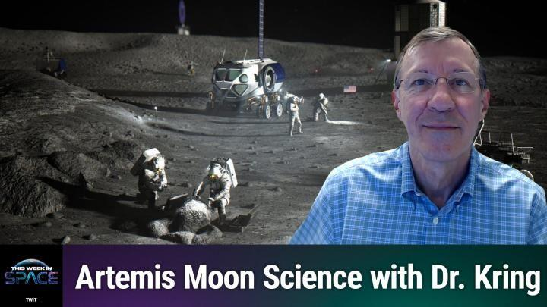
Click for next article The Science of Artemis - What We'll Do on the Moon - YouTube Watch On On Episode 224 of This Week In Space, Rod Pyle and guest co-host Rick Jenet are joined by Dr. David Kring to discuss the where, whys, and hows of the Artemis Program's lunar exploration plans. It has been said that the Moon is a harsh mistress, and nowhere is this more apparent than at the lunar south pole. That is, however, where the Artemis program is headed, and we need to figure out how to best explore the region. Kring of the Universities Space Research Association's Lunar and Planetary Institute joins us to explore the answers - and risks - that await us. Download or subscribe to this show at: https://twit.tv/shows/this-week-in-space. Get episodes ad-free with Club TWiT at https://twit.tv/clubtwit Space news of the week Model Falcon 9! TOP TELESCOPE PICK: (Image credit: Celestron) Looking for a telescope to see planets and comets? We recommend the Celestron Astro Fi 102 as the top pick in our best beginner's telescope guide. Finally, did you know you can launch your own SpaceX rocket? Model rocket maker Estes' stunning scale model of a Falcon 9 rocket that you can pick up now. The launchable model is a detailed recreation of the Falcon 9 and retails for $149.99. You can save 10% by using the code IN-COLLECTSPACE at checkout, courtesy of our partners collectSPACE.com. About This Week In Space This Week in Space covers the new space age. Every Friday we take a deep dive into a fascinating topic. What's happening with the new race to the moon and other planets? When will SpaceX really send people to Mars? Join Rod Pyle and Tariq Malik from Space.com as they tackle those questions and more each week on Friday afternoons. You can subscribe today on your favorite podcatcher. Host of This Week In Space on TWiT Host of This Week In Space on TWiT Rod Pyle Social Links Navigation Space author and historian Rod Pyle is an author, journalist, television producer and Editor-in-Chief of Ad Astra magazine. He has written 18 books on space history, exploration, and development, including Space 2.0, Innovation the NASA Way, Interplanetary Robots, Blueprint for a Battlestar, Amazing Stories of the Space Age, First On the Moon, and Destination Mars In a previous life, Rod produced numerous documentaries and short films for The History Channel, Discovery Communications, and Disney. He also worked in visual effects on Star Trek: Deep Space Nine and the Battlestar Galactica reboot, as well as various sci-fi TV pilots. His most recent TV credit was with the NatGeo documentary on Tom Wolfe's iconic book The Right Stuff.

59. SpaceX sends 27 Starlink satellites to orbit on 100th Falcon rocket launch of the year (video, photos)
Read more
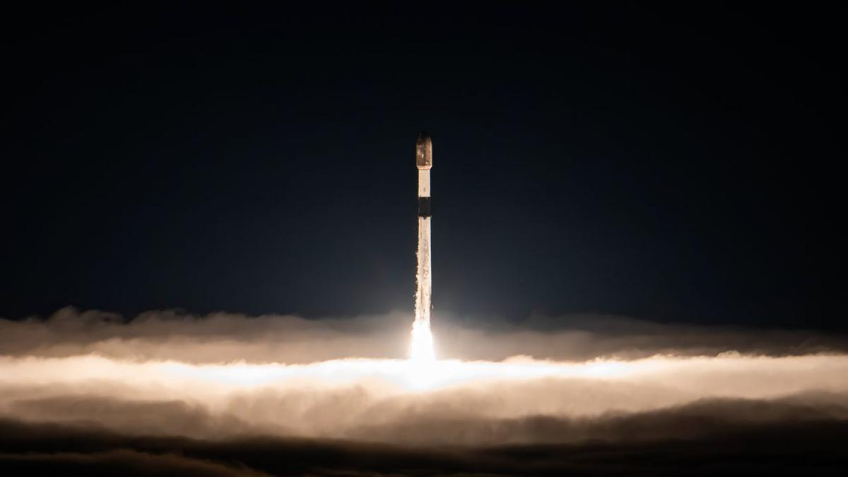
Click for next article SpaceX launched another batch of its Starlink internet satellites this morning (Aug. 22) on a milestone mission for the company's Falcon rocket family. A Falcon 9 carrying 27 Starlink spacecraft lifted off from Vandenberg Space Force Base in California today at 3:25 a.m. EDT (0725 GMT; 12:25 a.m. local California time). It was the 99th Falcon 9 liftoff of the year, and the 100th Falcon mission of 2026 overall. The other flight was performed by a Falcon Heavy, which lofted the telecom satellite Viasat-3 F3 in April. A SpaceX Falcon 9 rocket launches 27 Starlink internet satellites from California's Vandenberg Space Force Base on Aug. 22, 2026. (Image credit: SpaceX) Hitting the century mark at this point in the year is impressive. But SpaceX has a ways to go to equal its single-year Falcon launch record of 165 , which was set in 2025. All of those were Falcon 9 missions. The Falcon 9's first stage came back to Earth today as planned. It touched down about 8.5 minutes after launch in the Pacific Ocean, atop the SpaceX droneship "Of Course I Still Love You." It was the ninth flight for this particular booster, which carries the designation B1100. The 27 Starlink satellites, meanwhile, kept traveling to low Earth orbit aboard the Falcon 9's upper stage, deploying on schedule just under 62 minutes after launch. Today's launch makes the largest-ever satellite constellation even bigger: Starlink already consists of more than 11,000 operational spacecraft. A stack of 27 SpaceX Starlink satellites are seen aboard the upper stage of their Falcon 9 rocket before deployment on Aug. 22, 2026. (Image credit: SpaceX) Previous Booster B1100 launches NROL-105 | 7 Starlink missions As you might expect, Starlink satellites are SpaceX's most common payload; 76 of this year's 99 Falcon 9 flights have been dedicated Starlink missions.

60. US Navy tests Lockheed Martin missile system aboard unmanned vessel for precision strike
Read more
Lockheed Martin and USV manufacturer Saildrone have demonstrated the ability to launch missiles from an unmanned surface vessel during the Rim of the Pacific (RIMPAC) 2026 exercise near Hawaii, showing how commercial autonomous platforms could be adapted for military missions. A Surveyor-class Saildrone was integrated with Lockheed Martin's Joint-Air-to-Ground Missile (JAGM) Dual Launcher and an Adjunct Remote Engagement System (ARES) fire-control system. During the demonstration, the vessel responded to targeting data and engaged a surrogate high-speed surface craft while operating alongside the USS Theodore Roosevelt Carrier Strike Group. The companies said the system went from concept to live demonstration in six months, highlighting their efforts to rapidly integrate existing defense technology onto commercial unmanned vessels. Unmanned vessel demonstrates missile capability The demonstration was conducted under the US Navy's Fleet Experimentation Program during RIMPAC, the world's largest international naval exercise. The Surveyor-class vessel was equipped with the JAGM Dual Launcher and ARES, a remotely operated combat system developed to allow unmanned platforms to receive information and engage targets. According to both Lockheed Martin and Saildrone, the system successfully acted on target data for a surrogate high-speed surface craft. The demonstration was carried out in coordination with the USS Theodore Roosevelt carrier strike group, showing how a USV could potentially operate as part of a larger naval force. The exercise also included a separate electronic warfare demonstration. The Saildrone Surveyor used passive electronic warfare technology to detect, classify and identify a surrogate radar threat, working in coordination with an MH-60S helicopter. The demonstration is part of a broader partnership between the two companies. In October 2025, Lockheed Martin invested $50 million in Saildrone to accelerate the development of unmanned surface vessels for the US Navy. The partnership combines Saildrone's experience operating autonomous vessels in remote maritime environments with Lockheed Martin's expertise in weapons, sensors, combat systems and mission integration. Commercial platforms become military assets The companies say the approach could allow established defense technologies to be deployed more quickly by integrating them with commercially developed autonomous platforms rather than designing entirely new military vessels. Saildrone has operated unmanned vessels for maritime missions since 2013, giving the company more than a decade of experience with autonomous operations in challenging environments. The companies also plan to test additional capabilities on Saildrone platforms, including the larger Spectre-class vessel. That platform is being designed to carry significantly larger containerized systems, including Lockheed Martin's Mk 70 launcher and SURTASS towed-array technology. The RIMPAC demonstration therefore represents an early step in a larger effort to combine autonomous maritime platforms with established military systems. Saildrone CEO Richard Jenkins said the demonstration showed that a proven munition could be paired with an established unmanned vessel platform, while also reducing the technical risk of integrating more advanced weapons onto larger autonomous ships. "This successful live fire demonstration was the result of pairing one of the most tried and trusted munitions with the most operationally deployed class of USV on the planet," Jenkins noted.

द्वारा अभिकल्पित एवं संकलित
DESIGNED & COMPILED BY:
पुस्तकालय एवं सूचना संसाधन प्रभाग
Library & Information Resources Division, IIRS (ISRO), Dehradun
अस्वीकरण | Disclaimer:
सभी लेख / सूचनाएँ सार्वजनिक डोमेन में उपलब्ध हैं तथा केवल सूचना एवं सामान्य जागरूकता के उद्देश्य से
इंटरनेट से संकलित की गई हैं。
All the articles / information are available in public domain and are taken from
Internet for information & general awareness only.

