 |  | 

🌌 अंतरिक्ष समाचार | Space News
शनिवार, २७/०६/२०२६ | Saturday, 27/06/2026

1. Nasa Artemis Moon missions face risk from ageing launch infrastructure, says report
Read more
Nasa's plans to return astronauts to the Moon under the Artemis program could face a major challenge from ageing launch infrastructure that dates back to the Apollo era. A new report released by Nasa's Office of Inspector General (OIG) warns that key launch facilities at the Kennedy Space Centre (KSC) in Florida and Wallops Flight Facility in Virginia are rapidly approaching their operational limits. The watchdog says increasing launch activity from Nasa and commercial space companies is putting decades-old infrastructure under unprecedented strain, and the agency will need at least $1 billion in upgrades to keep pace. According to the report, launch demand at both sites is expected to reach near-capacity between 2028 and 2029. Although Congress allocated $250 million for infrastructure improvements through Nasa's 2025 funding package, the OIG says that amount covers only a fraction of the required investment. The pressure comes as Nasa's Artemis missions ramp up alongside an expanding commercial launch market led by companies such as SpaceX, Blue Origin, and United Launch Alliance (ULA). Shared infrastructure, including roads, power systems, gas pipelines, and fuel distribution networks originally built during the 1960s Apollo program, now supports far more launches than it was ever designed to handle. Nasa-supported launches from Florida's Space Coast increased dramatically, rising from 31 launches in 2020 to 109 in 2025. Wallops experienced an even sharper percentage increase, growing from just three launches in 2020 to 17 last year. Nasa expects launch activity at both facilities to increase by another 150 per cent by the end of the decade. The watchdog noted that launch counts alone do not reflect the full strain on infrastructure. Every mission requires days or weeks of preparation, vehicle movement, fueling operations, testing, and ground support before liftoff. While Wallops recently underwent upgrades across its seven active launch sites to support rockets such as Rocket Lab's upcoming Neutron and Firefly Aerospace's Alpha, Kennedy Space Centre faces much greater challenges due to the number of heavy-lift missions planned over the next several years. Story continues below this ad Also Read | Nasa prepares to introduce 4-person Artemis 3 crew for upcoming lunar mission Several of the busiest launch pads are expected to support multiple major programs simultaneously. These include Launch Complex 39A, currently used by SpaceX, Launch Complex 39B for Nasa's Space Launch System (SLS), Space Launch Complex 40 for Falcon 9 missions, ULA's Space Launch Complex 41, and Blue Origin's Space Launch Complex 36. SpaceX is preparing to begin Starship launches from LC-39A while also developing another Starship launch complex at SLC-37. Once Starship becomes fully operational, the company expects to conduct up to 44 launches annually from LC-39A and another 76 launches each year from SLC-37. That translates to roughly one Starship launch every eight days, with even higher launch frequencies required to support future Artemis missions. Nasa's Artemis architecture adds another layer of complexity. Orion spacecraft will continue launching aboard the SLS rocket from LC-39B, while astronauts will rely on SpaceX's Starship Human Landing System and Blue Origin's Blue Moon for lunar landings. For Artemis 4, currently targeted for 2028, Orion will dock with Starship in Earth orbit before heading toward lunar orbit. To make that possible, Starship will require at least 15 tanker launches to refuel in orbit before departing for the Moon. Those additional launches will significantly increase traffic at already crowded launch facilities. Blue Origin also faces similar challenges. Its Blue Origin lunar lander will launch aboard the New Glenn rocket, which itself will require multiple supporting missions for future lunar operations. The report notes that Blue Origin has already informed Nasa that a single launch pad may not provide enough long-term capacity for its expanding launch schedule. Beyond launch pads, the OIG highlighted problems with common-use infrastructure shared by multiple operators. These include a massive electrical grid, 231 miles of roads, and more than 40 miles of gaseous nitrogen and helium pipelines that supply launch vehicles during fueling operations. Many of these roads were paved in the 1960s without anticipating the repeated movement of today's much heavier rocket stages. Similarly, the existing gaseous nitrogen (GN2) distribution system cannot simultaneously support multiple high-flow launch campaigns. The report cites preparations for Blue Origin's first New Glenn mission as an example, where limited GN2 availability created major scheduling challenges. Looking ahead, Nasa expects even greater conflicts during Artemis missions. For Artemis 3, currently planned for 2027, Nasa expects launches of SLS, New Glenn, and multiple Starship missions within a relatively short period. The OIG warns that Kennedy Space Centre will not be able to supply enough gaseous nitrogen for simultaneous SLS and New Glenn launch campaigns, potentially creating one-to-two-month blackout periods for critical launch operations. Nasa maintenance budget The watchdog also found that Nasa's maintenance budget has failed to keep pace with growing commercial demand. Existing federal funding rules prevent the agency from directly collecting infrastructure upgrade funds from commercial companies leasing Nasa facilities. In some cases, accepting commercial investments could reduce Nasa's own congressional appropriations or violate federal spending laws. To address these challenges, the Inspector General recommends three immediate actions: Conduct a detailed assessment and mitigation plan for roadway damage caused by heavy-lift vehicle transportation. Prioritise maintenance funding for shared launch infrastructure, including roads, electrical systems, pipelines, and resource distribution networks. Explore alternative funding mechanisms and updated commercial partnership policies that allow private launch providers to contribute more directly toward infrastructure upgrades. The report paints a stark picture of Nasa's maintenance backlog. While the agency's long-term goal is to renew or replace infrastructure every 66 years, current funding levels mean the actual renewal cycle has stretched to more than 260 years. Without substantial investment, the OIG warns that ageing infrastructure could become one of the biggest obstacles to Nasa's Artemis program and the rapidly expanding US commercial space industry.

2. ISRO successfully conducts 2nd integrated air drop test for Gaganyaan mission - News On AIR
Read more
The Indian Space Research Organisation (ISRO) has successfully conducted the second integrated air drop test (IADT-02) for the upcoming Gaganyaan mission at Sriharikota in Andhra Pradesh. The system is essential to ensure safe recovery of the crew module - the capsule in which astronauts sit during a human flight. After the module's release, a parachute system, comprising 10 parachutes, was deployed, helping the capsule decelerate to a safe splashdown speed. The IADT-02 follows the successful completion of the first IADT, which took place on August 24, 2025, at the Satish Dhawan Space Centre in Sriharikota. In the first IADT, a 4.8-tonne dummy crew module was dropped from a height of three km by a Chinook helicopter. Air drop tests recreate the last leg of a spacecraft's return to the Earth. An aircraft or helicopter drops the spacecraft from a height to test various systems under different scenarios. These are the deployment of the parachute system in case the mission is aborted mid-flight, system performance when one parachute fails to open, and the spacecraft's orientation and safety during splashdown. Union Minister Jitendra Singh congratulated the ISRO for successfully conducting the test. India's first human spaceflight will be launched from Sriharikota in 2027.

3. ISRO appoints UP Rajeev as new VSSC director - Rediff
Read more
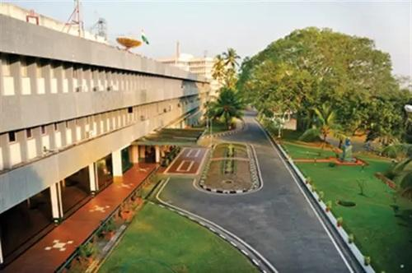
22:09 Vikram Sarabhai Space Centre, Thiruvananthapuram, Kerala/Courtesy ISRO website Senior scientist U P Rajeev has been appointed as the new Director of the Vikram Sarabhai Space Centre (VSSC), one of the key centres of the Indian Space Research Organisation. Dr Rajeev, who is currently serving as Associate Director (Research and Development) at VSSC, will take over the leadership of the centre known for developing India's launch vehicle technologies. With decades of experience in rocket control and guidance systems, he has played a leading role in the mission design and simulation of several of ISRO's major launch vehicle programmes, according to an official statement in Thiruvananthapuram on Friday. An alumnus of the College of Engineering Thiruvananthapuram, where he earned a degree in Applied Electronics and Instrumentation, Dr Rajeev later completed his postgraduate studies in Instrumentation and Control Systems at the National Institute of Technology, Calicut. He subsequently obtained a PhD from the Indian Institute of Science before continuing his career at ISRO. He is native of Pathanapuram in Kerala's Kollam district. -- PTI

4. ISRO Achieves 175‑Tonne Semi‑Cryogenic Engine Hot Test, Paving Path to 200‑Tonne Thrust for LVM3 Upgrade - Indianweb2.com
Read more
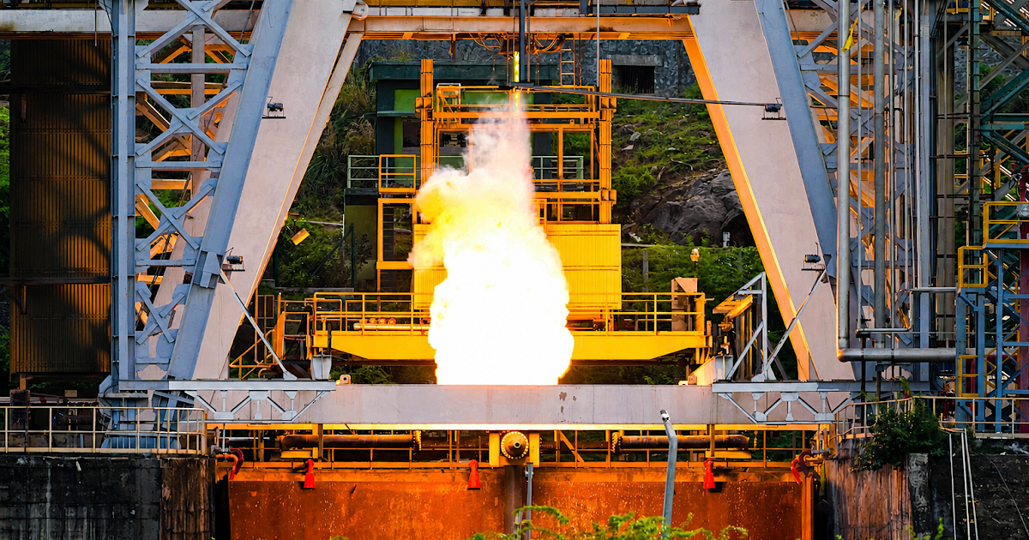
ISRO successfully hot‑tested its Semi‑Cryogenic Engine at 175‑tonne thrust, advancing LVM3 upgrade with cleaner fuels and higher payload capacity. ISRO Achieves 175‑Tonne Semi‑Cryogenic Engine Hot Test Key Highlights of the Test Date & Location: June 24, 2026, at ISRO Propulsion Complex (IPRC), Mahendragiri, Tamil Nadu June 24, 2026, at ISRO Propulsion Complex (IPRC), Mahendragiri, Tamil Nadu Thrust Level: Achieved 175 tonnes (88%) thrust, up from earlier tests at 94 tonnes (47%) and 120 tonnes (60%) Achieved 175 tonnes (88%) thrust, up from earlier tests at 94 tonnes (47%) and 120 tonnes (60%) Engine Systems: PHTA includes all engine subsystems except the thrust chamber PHTA includes all engine subsystems except the thrust chamber Performance: Demonstrated successful operation of main turbopumps delivering 400 and 500 bar outlet pressures Demonstrated successful operation of main turbopumps delivering 400 and 500 bar outlet pressures Outcome: All parameters matched predictions, providing confidence for the upcoming 200‑tonne (100%) thrust test Strategic Importance Indigenous Development: Strengthens India's self‑reliance in advanced propulsion systems Strengthens India's self‑reliance in advanced propulsion systems SC120 Stage: Powered by the 2000 kN‑class SE2000 engine, will replace the current L110 core stage of the LVM3 launch vehicle Powered by the 2000 kN‑class SE2000 engine, will replace the current L110 core stage of the LVM3 launch vehicle Payload Boost: Expected to substantially increase payload capacity and enhance operational efficiency Expected to substantially increase payload capacity and enhance operational efficiency Cleaner Propellants: Uses Liquid Oxygen (LOX) and purified kerosene (isrosene), which are non‑toxic and more efficient Roadmap for LVM3 Integration Plan: Semi‑cryogenic propulsion will be paired with an uprated cryogenic upper stage Semi‑cryogenic propulsion will be paired with an uprated cryogenic upper stage Capability Expansion: Enhances LVM3's payload capacity for heavier satellites and deep‑space missions Enhances LVM3's payload capacity for heavier satellites and deep‑space missions Global Competitiveness: Positions ISRO alongside leading space agencies using semi‑cryogenic systems Technical Milestones Achieved Test Phase Thrust Level Key Achievements Initial Tests 94 Tonne (47%) Validated ignition build‑up Mid‑Stage Tests 120 Tonne (60%) Stable operation at higher thrust Latest Test 175 Tonne (88%) Turbopumps at 400-500 bar, steady state Next Target 200 Tonne (100%) Full engine demonstration Broader Impact National Security & Economy: Enhances India's ability to launch heavier payloads for defense, communication, and commercial satellites Enhances India's ability to launch heavier payloads for defense, communication, and commercial satellites Sustainability: Cleaner fuels reduce environmental risks compared to hypergolic propellants Cleaner fuels reduce environmental risks compared to hypergolic propellants Global Market: Strengthens India's competitiveness in the international satellite launch market This achievement is a critical step in ISRO's roadmap toward advanced propulsion systems and expanded launch capabilities. This achievement is a critical step in ISRO's roadmap toward advanced propulsion systems and expanded launch capabilities. ISRO has achieved a major milestone by successfully conducting a hot test of its Semi‑Cryogenic Engine Power Head Test Article (PHTA) at 175‑tonne thrust on June 24, 2026, at the ISRO Propulsion Complex, Mahendragiri, Tamil Nadu. This test marks a crucial step toward full‑scale 200‑tonne thrust capability, strengthening India's indigenous launch vehicle technology.Notably, the Semi‑cryogenic engines use liquid oxygen (LOX) and isrosene (purified kerosene), which are cleaner and more efficient than older toxic fuels.A full‑scale 200‑tonne thrust rocket engine means the engine can push with a force equal to lifting about 200 tonnes (200,000 kilograms) straight off the ground - imagine the weight of 130 cars being lifted at once. It's the raw "push power" that propels a massive rocket skyward.A 200‑tonne thrust class engine puts ISRO in the league of agencies like NASA and Roscosmos, which use similar high‑power engines for heavy‑lift missions.

5. N Jayan appointed director of Isro's Liquid Propulsion Systems Centre - The Times of India
Read more

N Jayan appointed director of Isro's Liquid Propulsion Systems Centre City Thiruvananthapuram : N Jayan, who played a pivotal role in indigenous development of cryogenic propulsion technology, has been appointed director of Indian Space Research Organisation ( Isro 's) Liquid Propulsion Systems Centre (LPSC).

6. NRSC Welcomes Implementation Of Demerit Point System - Radio Jamaica News Online
Read more
NRSC Welcomes Implementation Of Demerit Point System Radio Jamaica News Online

7. China plans to double the size of its Tiangong space station while the ISS nears its end
Read more
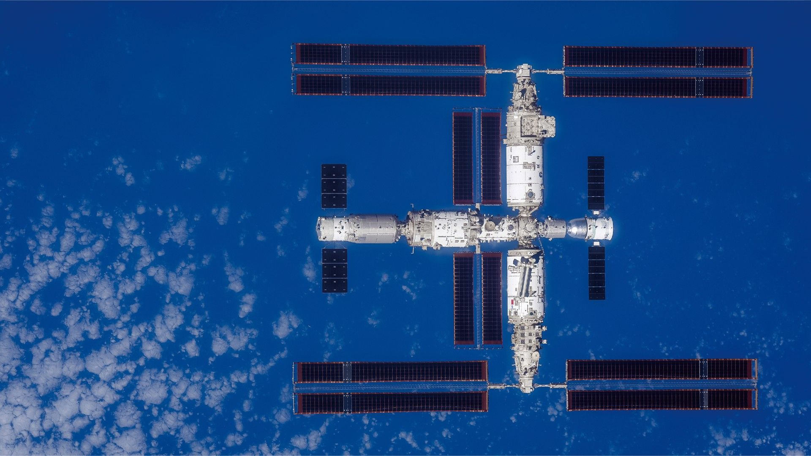
Click for next article China is set to expand its space station from three to six modules in the coming years and add a co-orbiting Hubble-class space observatory, even as the International Space Station approaches the end of its lifetime. The three-module, T-shaped Tiangong space station was assembled in orbit across 2021 and 2022 and has hosted numerous three-astronaut Shenzhou crews, but China is now set to expand the orbital outpost with new modules, citing growing research demands and more frequent crew and cargo missions. As previously reported by Space.com , the planned expansion will see Tiangong grow into a "double-T" shape, with the addition of the multipurpose module and two new experiment modules, and allow China to extend the scale of operations aboard the station. "This expansion has always been part of the original plan," Qian Hang, a researcher with China Aerospace Science and Technology Corporation (CASC), told Chinese media. State media Xinhua reported that the first phase of the expansion will see the launch of a new 20-ton-class multifunctional module, which will dock with Tiangong's Tianhe core module. Additional docking ports on the new modules will allow Tiangong to welcome more spacecraft and provide greater operational flexibility when needed. "If the missions get more intensive, we risk 'queuing' for docking ports and lack sufficient emergency buffer space," Qian said. China is developing new, low-cost cargo options for Tiangong, while its new Mengzhou spacecraft , which could debut later this year, can carry seven astronauts to low Earth orbit. The Shenzhou spacecraft, which is currently used for China's crewed missions, can carry three astronauts to Tiangong. Before the arrival of a new module, however, the first new addition to Tiangong is expected to be Xuntian, a bus-sized space observatory with a 2-meter (6.6 feet) diameter primary mirror, slightly smaller than that of the Hubble Space Telescope . Xuntian is scheduled for launch in 2027 and boasts a field of view around 300 times larger than that of Hubble, meaning it will be able to study and map around 40% of the heavens during its planned 10-year lifetime using its 2.5-billion-pixel camera. Xuntian will share a similar orbit with Tiangong, meaning it will be able to dock with the space station for maintenance, refueling, repairs and potentially upgrades. Screenshot from an animation showing Chinese astronauts servicing the Xuntian Space Telescope outside the Tiangong Space Station. (Image credit: CCTV) China's plans to expand Tiangong are coming at the same time as NASA is planning for the end of life of the much larger International Space Station (ISS). The agency plans to launch the SpaceX-developed U.S. Deorbit Vehicle (USDV) in the coming years, and drag the ISS into the atmosphere over the Pacific Ocean in late 2030 or early 2031.

8. NASA's canceled Artemis hardware contracts reached $5.9 billion, audit finds
Read more
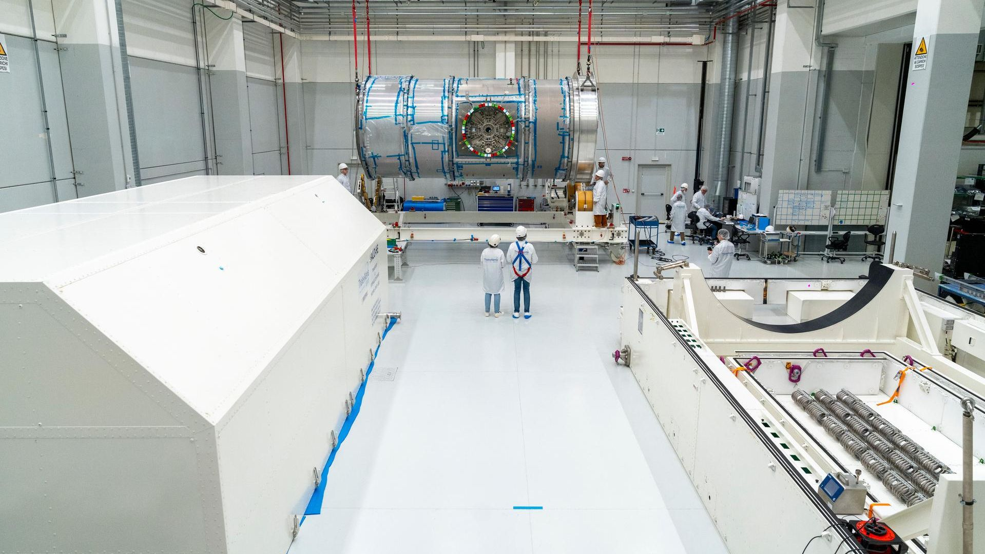
Click for next article NASA's Artemis 2 Space Launch System rocket rolls out of the Vehicle Assembly Building at the Kennedy Space Center, in Florida, Jan. 17, 2026. A new memo from NASA's Office of Inspector General has revealed how major pieces of Artemis program hardware became costly components of lunar missions that no longer align with the agency's new plans to return astronauts to the moon and have since been canceled. NASA announced a major shakeup to its Artemis plans earlier this year at its "Ignition Day" event , restructuring its mission goals in order to streamline the return of astronauts to the lunar surface and simplify the architecture needed to get them there. Most notably, the program's first crewed moon landing was shifted from Artemis 3 to Artemis 4 , and upgraded variations of NASA's Space Launch System (SLS) rocket were abandoned for a single uniform design. The Gateway space station planned for lunar orbit was also canceled in favor of a stronger focus on establishing a base on the moon's surface. The switch-up left behind a trail of expensive hardware, including SLS's upgraded Exploration Upper Stage (EUS) and the adapter meant to fit it to the SLS rocket, a larger launch tower, and Gateway's Habitation and Logistics Outpost (HALO) module. Now, an interim Office of Inspector General (OIG) memo released June 24 offers a striking snapshot of just what NASA is walking away from. It calculates that NASA's final investment into the canceled hardware, which was originally contracted at a combined $2.9 billion, reached $5.9 billion by the time work was ceased, and concludes that, had NASA continued its support, costs and timelines would have continued to grow. The report outlines rising costs and developmental delays for each of the aforementioned pieces of hardware, and shows how some Artemis systems were years late, billions of dollars over their original estimates and facing major technical problems. NASA is currently targeting 2028 for the program's first lunar landing on Artemis 4. Had the agency not restructured its mission plans, NASA's goal of landing astronauts on the moon before the end of the decade would have very likely been unobtainable. Under the old Artemis plan, the Boeing -built EUS was intended for bigger, future versions of SLS, and would have increased the rocket's capabilities to send Orion and heavier cargo to the moon by 40%. Boeing is also responsible for developing and assembling the SLS core stage, and was selected to design and manufacture EUS in February 2017. EUS was added to Boeing's existing SLS contract, and folded into the work order to the tune of $962 million, with a delivery date set for March 2021. In March 2026, after NASA announced its new Artemis plans, Boeing still had not delivered EUS, nor could it specify when it expected to do so and was issued a stop work order. By that time, the EUS allocations in Boeing's contract had risen to nearly $2 billion, with the company estimating that the number would rise to $3.7 billion by the project's completion. According to the OIG report's findings, Boeing wouldn't have been able to deliver the first flight-ready EUS to NASA until the end of 2028 - 7.5 years after its original due date. Part of the continued EUS delays were a result of NASA's reprioritization of Boeing's efforts in 2018 to expedite completion of the SLS core stage, according to the OIG. The memo also cites the evolving design of Artemis missions, supply chain shortages and development issues that eroded the agency's confidence in Boeing. "NASA noted significant weaknesses related to EUS production efficiency, including unrealistic production schedules and the lack of a clear plan for improvement," the memo states. The Exploration Upper Stage (EUS) is a four-engine liquid hydrogen/liquid oxygen in-space stage on the Space Launch System (SLS) Block 1B and Block 2 rockets. (Image credit: NASA) Another scrapped component of the now-canceled SLS variants - and, perhaps, one of the most jaw-dropping, given the component's size and apparent simplicity - is the Universal Stage Adapter (USA). Designed by Dynetics, Inc., the USA was a conical section of SLS positioned to connect EUS to Orion and carry additional mission payloads. NASA contracted Dynetics to manufacture the USA for $131 million in 2017, and added another $9 million for the incorporation of the adapter's environmentally-controlled secondary payload deployment capability in 2022. That number had reached $353 million when NASA issued Dynetics' stop work order in February, and would have climbed to $497 million before the USA's completion, which the OIG report estimates would have been delayed to May 2030. "The USA contract's cost and schedule estimates grew beyond original estimates due to both NASA directed modifications and Dynetics' performance issues," the OIG memo concluded, but notes that NASA's satisfaction with Dynetics steadily declined from "very good" in 2024, to "unsatisfactory" by the end of 2025. test version of the universal stage adapter for NASA's more powerful version of its SLS. (Image credit: NASA/Brandon Hancock) Mobile Launcher 2 (ML-2), the huge tower connecting power and fuel umbilicals to SLS during assembly and prior to liftoff, followed a similar pattern. ML-2 was being constructed to support the taller SLS configurations that would have been incompatible with the current mobile launcher. That contract was awarded to Bechtel National, Inc. in June 2019 for $383 million. NASA expected delivery in March 2023, but increasing cost evaluations from Bechtel delayed ML-2's completion and ballooned the contract to $1.6 billion by the start of 2026. The company was expected to complete ML-2 by this summer, but the OIG report estimates it would have been closer to December, with another one to two years of validation testing for NASA to ready the tower to support a launch, and costs reaching $2 billion. The OIG asserts that Bechtel was unprepared for the intricacies of ML-2 design needs, and placed an additional financial burden on NASA during an extended development process. "Bechtel's reluctance to utilize NASA expertise, failure to track risks, challenges with managing the launcher's weight, and lack of a certified earned value management system impacted the contractor's cost, schedule, and performance," the report states. The Artemis 2 SLS rolls out of NASA's Vehicle Assembly Building with construction of the Mobile Launcher 2 underway in the background, Jan. 17, 2026. (Image credit: Space.com / Josh Dinner) The HALO module for the defunct Gateway space station was another casualty of NASA's altered Artemis plans, but had already incurred some injuries along the way. After its delivery to the United States from subcontractor Thales Alenia Space, in Turin, Italy in April 2025, Northrop Grumman discovered "widespread corrosion throughout the module," the OIG report says. NASA's contract for HALO with Northrop Grumman Innovation Systems began as a $187 million sole-source acquisition in 2019, which had increased to $1.8 billion by September 2024. It reached $1.9 billion by the time NASA issued their stop work order in April, but was projected to continue to rise as delivery estimates were pushed to 2031. HALO space station module. (Image credit: NASA/Josh Valcarcel) Some of the blame for HALO's mismanagement falls on NASA, which the OIG memo says put unrealistic expectations on Northrop's progress. "Driven by the necessity to meet Artemis launch schedules, the Gateway Program worked toward unrealistic schedules throughout the life cycle of HALO," OIG's memo states, and cites a quote from Gateway's own independent Standing Review Board that says, "lack of schedule realism may be driving suboptimal engineering decisions during development." The OIG report was issued amid an audit of "NASA's management of developed assets for programs and projects terminated prior to launch or operations," it says. We are doing things differently now. NASA cannot take years longer than expected and spend billions more than planned when the world is waiting for the headlines only NASA can deliver. The programs covered in the report will free up more than $3 billion in the years ahead for… https://t.co/lx5fm1ZlEyJune 24, 2026 The OIG release included NASA's reply to a draft of the memo, acknowledging the role of shifting mission parameters, resource shortages and issues within each contractor that contributed to rising costs and ongoing delays, but maintained that the restructuring of Artemis was designed specifically to move the agency away from such costly practices. "These projections rely on past performance under outdated architectural assumptions that do not reflect the Ignition Day principles of discipline, affordability, simplification, and speed," NASA's response says.

9. NASA is paying $30 million for a 1st-of-its-kind rescue mission to the aging Swift telescope before it falls from space. Is it worth it?
Read more
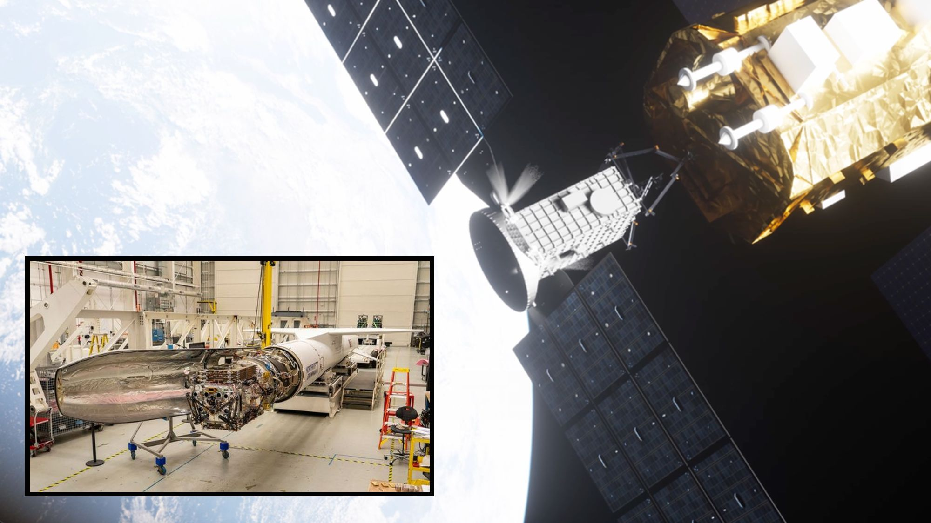
Click for next article On paper, it seems like the math would be clear. A nearly 22-year-old space telescope, well past its prime, is falling out of space after decades of hunting the biggest explosions in the universe. Rest in peace, right? After all, it would cost NASA $30 million to save the telescope , called the Swift Observatory , which the agency launched in 2004 on a planned two-year mission. Some of us have cars that we've replaced far sooner for much less. And now, higher-than-expected drag on the satellite from Earth's outer atmosphere (caused by solar storms) will pull Swift out of orbit by year's end. So why not accept the inevitable fiery demise of the observatory when it plunges back to Earth? Swift, it turns out, is still worth it, according to NASA. The observatory has spent over two decades as a sort of orbital sentinel that scans the cosmos for gamma-ray bursts , ready to quickly point itself at the short-lived - but insanely powerful - space explosions at a moment's notice. No other off-Earth observatory, not even the famed Hubble Space Telescope or James Webb Space Telescope, can perform such a feat of astronomy. So NASA is launching a rescue mission on June 30, one led by the company Katalyst Space using its new Link spacecraft. "We didn't want to set the precedent that anything that comes out of orbit has to be boosted, because it is part of our space ecosystem to have things deorbit frequently," Shawn Domagal-Goldman, NASA's Astrophysics Division director, told reporters during a Swift rescue mission briefing on June 17. "But this was not just any spacecraft; this is an observatory with unique capabilities for astrophysics … It is a swift observatory that can quickly pivot across the night sky to find things that go boom in the night." A sentinel in the night NASA's Neil Gehrels Swift Observatory, shown in this artist's concept, orbits Earth as it studies the ever-changing universe. Launched in 2004, the space telescope's days are numbered as it is falling out of space. (Image credit: NASA's Goddard Space Flight Center Conceptual Image Lab) NASA originally built and launched Swift in 2004 for $250 million. Since then, the observatory has served as a first responder of sorts to rapidly spot distant gamma-ray bursts that can last mere seconds, yet unleash more power than our sun will in its entire lifetime. Because of its success, Swift's mission has been extended repeatedly. "The name is not an acronym. It comes from the ability to rapidly and autonomously repoint its narrowfield X-ray and UV [ultraviolet] telescopes almost anywhere on the sky," Swift Principal Investigator Brad Cenko told reporters during the June 17 briefing. (NASA renamed Swift the Neil Gehrels Swift Observatory in 2018 after the mission's first principal investigator, who died a year earlier.) "The universe is a very dynamic place. Somewhere in the cosmos, a massive star explodes every second," he added. "And over time, our exceptional operations team, led by Penn State, has found new and innovative ways for the satellite to rapidly respond to these discoveries." Rings of cosmic dust set alight by the BOAT, the most energetic cosmic explosion ever observed by Swift and other space telescopes. (Image credit: NASA/Swift/A. Beardmore (University of Leicester)) The Hubble Space Telescope can capture sharper photos than Swift, but it takes up to two days to point Hubble at a new target, Cenko said. It takes Swift mere minutes. "It really is NASA's first responder, and by working together in this complementary manner, the NASA astrophysics portfolio can tackle questions that would be impossible for any single facility to answer," Cenko added. Observations from Swift helped confirm that the heaviest elements in our universe, including precious metals like platinum and gold in your rings and necklaces, were forged by the explosive power associated with gamma-ray bursts (which scientists think are produced by supernovas and neutron-star mergers). In 2022, Swift discovered a gamma-ray burst so bright, scientists nicknamed it the "BOAT," short for Brightest of All Time . At the time,it was the most powerful space explosion ever seen. But now Swift is falling back to Earth on a trajectory at an increasing rate and will burn up in our atmosphere soon, if nothing is done. Katalyst to the rescue with Swift Boost Artist's illustration of Katalyst Space Technologies' Link servicing spacecraft approaching and capturing NASA's Swift space observatory on an orbit-boosting mission. (Image credit: Katalyst Space Technologies) NASA's Swift rescue mission, called Swift Boost , is now scheduled to launch Tuesday (June 30) - about 3 days later than originally planned - on the last-ever Pegasus XL rocket , an air-launched booster built by Northrop Grumman . It will be carried aloft by the last L-1011 Stargazer carrier plane, which Northrop also operates, on a flight out of the U.S. military's Reagan Missile Test Site on Kwajalein Atoll in the South Pacific's Marshall Islands. To rescue Swift, NASA has turned to the untested Arizona-based company Katalyst Space , which the space agency picked to fly the Swift Boost mission just nine months ago, in September 2025. That is a mindbogglingly short time in which to build a brand-new spacecraft, then launch it on a rendezvous mission to a space observatory that was never built to be rendezvoused with, and then push the Swift telescope to a higher orbit - one that will guarantee at least five or more years of science life, if successful. It's a huge bet, and something that's never been done before. Even Swift's top scientist has butterflies in his stomach. Engineers from Katalyst stabilize their LINK robotic servicing spacecraft as it moves into a vibration chamber at NASA's Goddard Space Flight Center. It will launch on June 27, 2026. (Image credit: NASA/Scott Wiessinger) "Absolutely, no doubt. Been some sleepless nights, a number of them," Cenko told Space.com in an interview last week. "On the other hand, working with this team of folks gives me great confidence." Cenko and NASA's Swift mission team have worked closely with Katalyst mission managers and engineers on the Swift Boost mission. Katalyst calls its rescue ship Link. It's a small spacecraft about the size of a refrigerator that has three main ion engines, three robotic arms and a suite of sensors and thrusters to attempt to capture the falling Swift observatory. Link has gone from a blank sheet of paper to a finished spacecraft attached to a rocket viaan "unprecendented development timeline," its Katalyst builders said. "That is something that we were able to do, because every part of this mission has been driven by the exceptional urgency provided by the Swift requirements," said Kieran Wilson, Link's principal investigator at Katalyst. The top requirement: Be ready to launch before Swift falls out of space. A risky plan Katalyst Space's LINK robotic servicing satellite awaits encapsulation inside a Northrop Grumman Pegasus XL rocket on June 8, 2026, at NASA's Wallops Flight Facility in Virginia. Liftoff is set for June 30 at 6:23 a.m. EDT (1023 GMT) from the Reagan Missile Test Site on Kwajalein Atoll in the Marshall Islands of the South Pacific. (Image credit: NASA/Ron Beard) Swift was originally placed in an orbit 375 miles (600 kilometers) above Earth when it launched in 2004. The spacecraft has no engines of its own to maintain its orbit. It's now on a path to fall below 186 miles (300 km) in altitude by October. At that point, Katalyst's Link may not be able to reach Swift in time to save the space telescope. Testing and computer modeling have been key to try and iron out all the kinks in the mission. "We've been relying on NASA expertise to ensure that we're not making silly mistakes along the way and maximize our probability of success," Wilson said. "There's a lot of very simple things that can go wrong, and we're adding a lot of additional complexities to the program, but we've been through an aggressive test campaign over the last few months," he added. After launch, Link will spend several weeks in orbit conducting a series of tests to ensure it is ready to try and save Swift. If all goes well, it will then rendezvous with Swift, grapple on with its robotic arms, and spend up to three months slowly raising the observatory's orbit. If Katalyst succeeds in saving Swift, the company will have done something never accomplished in space history: reboosting an ailing space telescope using a spacecraft developed in less than a year to rescue a target that was meant to be left in space on its own forever. Katalyst sees big business in such a service, and already has a U.S. Space Force contract to demonstrate a similar capability for larger spacecraft using its new Nexus vehicle. That mission will launch in 2027. And if Katalyst doesn't succeed? Then Swift will fall out of space on its own, something the space observatory is already going to do anyway. Those are stark all-or-nothing stakes, but ones that Cenko can accept. The science team even put Swift in a low-power mode in February , halting all research operations to help slow its drag-induced descent. "I also remind myself that the alternative here is that we reenter the Earth's atmosphere, so in that sense, you know, the risk here is relatively low," Cenko told me. "Maybe we can't be doing science for a few more months. But trading that against the potential benefit of many years of upsurge? That is a no-brainer." Editor's note: This story was updated at 4 p.m. ET to reflect the new launch date and time for Swift Boost. The mission will now launch no earlier than Tuesday, June 30, at 6:23 a.m. EDT (1023 GMT).

10. Next-gen astronaut Moon rovers aim for deployment ahead of Artemis 4 crew arrival
Read more
NASA's goal of a sprawling Moon Base near the south pole of the Moon will be driven in part by its ability to move astronauts from one location to another. Right now, two companies are racing to give the agency that capability by the end of 2027. Last month, NASA selected Astrolab and Lunar Outpost to develop lunar terrain vehicles that can be delivered to the agency next year. They are two out of the three companies who were originally competing for the LTV contract announced by NASA in 2024, which would've resulted in the selection of just one rover. Instead, NASA asked the companies to come up with a simpler design that doesn't need to potentially survive on the lunar surface for a decade, but rather something that could be ready in time for the first crewed landing of the Artemis program, which is currently scheduled for early 2028. <span data-mce-type="bookmark" style="display: inline-block; width: 0px; overflow: hidden; line-height: 0;" class="mce_SELRES_start"></span> "Protecting for [plume surface interaction], we plan to keep the LTVs approximately 2 km away when the landers land," said Ryan Stephan, NASA's acting director for cargo landers. "They'll traverse in, be able to pick up the crew, and then do missions up to like 10 km during the crewed period and then uncrewed, like Carlos said, a total of 400 km throughout the lifetime." Astrobotic's offering is called the Crewed Lunar Vehicle (CLV-1) and takes learnings from the company's future-looking Flexible Logistics & Exploration (FLEX) rover, capable of carrying humans and cargo, along with its smaller FLEX Lunar Innovation Platform (FLIP) rover. "FLIP was always going to be a test bed for LTV, that's why FLIP has extremely large tires because they were meant to be the LTV tires and big overpowered wheel actuators and large batteries," Jaret Matthews, Astrolab's CEO and founder, told Spaceflight Now following NASA's May 26 Moon Base event. "We've already obviously made a lot of progress there, and that is directly transferable to CLV. So it's hard to say as a percentage-wise, how much work is ahead of us. There's still a lot of work ahead of us for sure, but we have a great foundation off which to build." The FLIP rover is scheduled to fly onboard Astrobotic's Griffin-1 mission, which will carry FLIP and other payloads to the Moon later this year. Both the lander and the FLIP rover are going through final environmental testing before they meet up at the Kennedy Space Center to be integrated together and prepared for launch on a SpaceX Falcon Heavy rocket. Similarly, Lunar Outpost took lessons learned from developing its larger Eagle LTV and its smaller series of robotic rovers, like the Mobile Autonomous Prospecting Platform (MAPP). The company flew one of its MAPP rovers on Intuitive Machines' IM-2 mission in 2025 and will so again on the upcoming IM-3 mission as well as alongside astronauts on a future Artemis mission. "So it's the part of the Artemis Deployed Instruments Program. So much like in Apollo, where the astronauts deployed various instrument packages and suites during their mission," said Andrew 'AJ' Gemer, Lunar Outpost's co-founder and chief financial officer. "What's really cool about, you know, our mission is it'll be the first time that we have human-robot interaction that our astronaut crews will actually have a rover companion there on the lunar surface to help them out and help keep them safe." Gemer said Lunar Outpost already has a pair of static human-in-the-loop mockups of its Pegasus LTV and the team is progressing towards more developed versions. "We're going to continue that and extend it into full scale drivable prototypes that will eventually be used as astronaut trainers. They'll be driving these vehicles in a representative lunar environment here on Earth, along with our digital twins and simulations that accurately represent the vehicle dynamics in the lunar environment and under lunar gravity," Gemer said. "And parallel to all of this, we'll be building and qualifying the flight hardware. So going through our standard lunar mobility qualification processes, all arriving at a successful delivery to NASA in November of 2027." Matthews said one of the critical challenges that these landers and rovers need to overcome is the ability to survive the harsh cold that comes with being in total darkness on the Moon, which can be around negative 400 degrees Fahrenheit. The company's FLIP rover is designed to survive for 100 hours of lunar night conditions and the CLV-1 is slated for 150 days of darkness. "In both cases, our approach is to essentially have a lot of onboard energy storage, so a lot of battery capacity, and use that capacity to keep things just warm enough while hibernating through the night. And the second tactic we use is to turn down our radiator," Matthews said. "We have a radiator that rejects heat from the avionics in the daytime, but if you just let the radiator continue to radiate throughout the night, you're going to lose a lot of heat. So our approach is to actually cover up the radiator with our solar arrays. We're doing this both on FLIP and on CLV to limit the amount of radiation we have throughout the night." The New Glenn-sized elephant in the room While both companies continue to make progress on their new LTV designs, a big potential hurdle exists in their ability to reach the Moon. In the original competition for the LTV contract, the companies (Astrolab, Intuitive Machines, and Lunar Outpost) were required to procure their own path to land on the Moon. Astrolab and Lunar Outpost selected SpaceX's Starship as their ride and Intuitive Machines chose its own Nova-D lander. However, in this new procurement, NASA decided that it would take the reins on securing the launch and landing side of the equation and selected Blue Origin to do both. It would launch the LTVs on top of its Blue Moon Mark 1, flying on a New Glenn rocket. The May 28 explosion of the New Glenn intended to fly the NG-4 mission destroyed Blue Origin's only operational launch pad and put their launch schedule on ice. The company's CEO, Dave Limp, said during the VivaTech conference last week, that the company aims to resume launching New Glenn rockets from Cape Canaveral Space Force Station in Florida by the end of the year. Limp added that the first launch of a Blue Moon Mk.1 cargo lander, previously planned to launch later this summer, would instead fly in early 2027. The lander relies on New Glenn because its the only rocket that flies with a seven-meter-diameter payload fairing and it can provide fuel to the lander at the pad. In an interview with Spaceflight Now earlier this month, Carlos García-Galán, the Program Executive for NASA's Moon Base program, said avoiding anomalies like this is part of why NASA ultimately wants the landers and payloads flying for Moon Base missions to become agnostic of launch vehicles. "This anomaly was kind of a wake-up call to the fact why it's so important that we achieve this vision of operations. And on New Glenn specifically, the team is definitely focused on, number one, understanding what happened, rebuilding the infrastructure, and get back to nominal operations," García-Galán said. "We will be in the process of doing that in parallel. We'll be looking at different options for Moon Base and Artemis on how we can continue our mission without significant delays."

11. Pegasus launch to deploy LINK for months‑long orbit boost of aging Swift
Read more
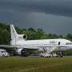
A mission to raise the orbit of NASA's Neil Gehrels Swift Observatory is poised for launch no earlier than Tuesday, June 30, at 6:23 a.m. EDT (10:23 p.m. UTC+12), from Kwajalein Atoll, part of the Republic of the Marshall Islands in the South Pacific Ocean.

12. Hubble spies ancient 'Chandelier Cluster' forming stars in two bursts
Read more

The subject of today's NASA/ESA Hubble Space Telescope image is an ancient inhabitant of our galaxy. This sparkling scene features a globular cluster: a collection of tens of thousands to millions of stars, all tightly bound together under the influence of gravity. There are more than 150 globular clusters in our galaxy, though there may be others still undiscovered, hidden fro...

13. US Navy awards Raytheon $1.1B to expand AIM-9X missile production capacity
Read more
RTX-owned Raytheon has secured a $1.1 billion contract from the U.S. Navy to produce AIM-9X Block II missiles, expanding production of one of the military's most widely deployed short-range air defense weapons. The contract will replenish U.S. inventories while supporting growing demand from allied nations through Foreign Military Sales. The agreement covers AIM-9X missiles along with associated hardware and software for U.S. and international customers. It also supports Raytheon's broader effort to increase annual production capacity to 2,500 missiles as demand continues to climb. The AIM-9X Block II is the latest version of the Sidewinder missile family, featuring an imaging infrared seeker, thrust-vectoring control, and lock-on-after-launch capability. These features allow the missile to engage highly maneuverable targets and receive updated targeting information after launch, improving flexibility in combat. Originally designed as an air-to-air weapon, the AIM-9X has also been adapted for ground-based air defense through the National Advanced Surface-to-Air Missile System (NASAMS), giving militaries an additional layer of protection against aircraft, helicopters, cruise missiles, and other airborne threats. Expanding missile output Raytheon said the latest contract will help sustain higher production rates as orders from the U.S. military and partner nations continue to grow. "Our teams have streamlined production, shortened lead times and ramped up deliveries of AIM-9X missiles to keep pace with growing demand," said Barbara Borgonovi, president of Naval Power at Raytheon. "This contract, along with our close partnership with the U.S. Navy, allows us to sustain that momentum and ensure U.S. and allied forces have this advanced, combat-proven capability they depend on in high threat environments." The company said the AIM-9X remains the most advanced infrared-tracking short-range missile in its class. It can be installed on a wide range of combat aircraft, including the F-35 Lightning II, F/A-18 Super Hornet, F-15 Eagle, and F-16 Fighting Falcon, while its compatibility with NASAMS extends its role beyond fighter aircraft into integrated air defense networks. The production increase reflects rising demand for precision-guided weapons as the U.S. and its allies continue to modernize their military inventories amid evolving global security challenges. More than 35 allied and partner nations currently operate the AIM-9X, making it one of the most widely fielded short-range missiles in service. Supporting allied forces Most of the work under the contract will be carried out at Raytheon's facility in Tucson, Arizona, where the company is also expanding its engineering workforce to support missile, air defense, and other military programs. The latest award follows broader efforts across the U.S. defense industry to expand missile production capacity as governments seek to replenish stockpiles and accelerate deliveries of advanced weapons. Increasing manufacturing output has become a priority for both domestic requirements and Foreign Military Sales programs. Raytheon said the AIM-9X's combination of high agility, infrared guidance, and compatibility with both airborne and ground-based launch systems makes it a key component of modern layered air defense.

14. Ohio commissions 950 MW gas plant with variable-speed compressors for steady operation
Read more
A new 950 MW combined cycle gas turbine (CCGT) power plant has entered commercial operation in Ohio, adding a major source of electricity to the PJM (Pennsylvania-New Jersey-Maryland) Interconnection, the largest wholesale power market in the United States. The Trumbull Energy Center was officially commissioned on June 24, with project partners including Korea Southern Power Co. (KOSPO), Gemma Power Systems, Siemens Energy, state officials, and Hanwha Power attending the opening ceremony. The facility was developed to help replace retiring coal-fired power plants while providing reliable electricity to the PJM grid, which serves millions of customers across multiple U.S. states. Hanwha Power also marked a milestone by commissioning its first Fuel Gas Compressors (FGCs) in the U.S. The company supplied three compressor units designed for the plant's gas turbines. Designed for grid The compressors use Variable Frequency Drive (VFD) technology to automatically adjust to seasonal pipeline pressure fluctuations common across the PJM region. The system is designed to maintain a stable fuel gas supply to the turbines without interrupting plant operations. Combined cycle power plants generate electricity by pairing a gas turbine with a steam turbine that captures waste heat from the exhaust, improving overall efficiency compared with conventional gas-fired plants. Beyond supplying the equipment, Hanwha Power has signed a nine-year Long-Term Service Agreement covering maintenance support, spare parts, and three major overhaul cycles. The company said its Houston service center will provide field support and refurbish key components throughout the agreement. The project comes as demand for new gas-fired power generation is rising across the United States, driven by electricity needs from data centers, manufacturing facilities, and industrial users. Utilities and developers have announced a wave of new gas power projects, increasing demand for turbines, compressors, and other critical equipment. The tighter supply chain has also prompted developers to secure long-term service agreements alongside equipment purchases to help ensure reliable plant operations throughout their lifecycle. Long-term service focus "The successful commissioning of the Trumbull Energy Center and the deployment of Hanwha Power's advanced compressors represent a significant milestone, showcasing the world-class reliability of Korean power generation technology in the U.S. market," said Joo Mong Choi, CEO of Trumbull Asset Management. He added that the project would support the region's clean energy transition by supplying stable electricity to the PJM grid while expanding partnerships in the North American power sector. Hanwha said securing both the equipment contract and long-term service agreement demonstrates growing confidence in its technology and operational capabilities. "Securing both the equipment supply contract and a long-term service agreement for this project reflects the confidence our client has placed in Hanwha Power's technical and operational capabilities," said Prakash Nair, the company's chief commercial officer. The company plans to expand its supply of high-efficiency power generation equipment and grow its service business across North America, building on experience gained in global power infrastructure projects.

