 |  | 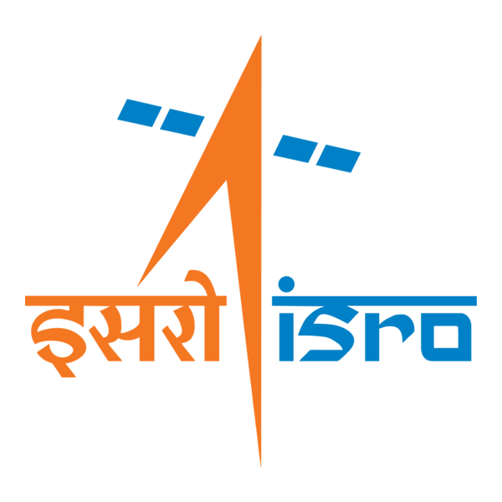

🌌 अंतरिक्ष समाचार | Space News
शुक्रवार, २५/०९/२०२६ | Friday, 25/09/2026

1. Madhya Pradesh to launch Sugam Parivahan Seva with 351 buses across seven cities
Read more
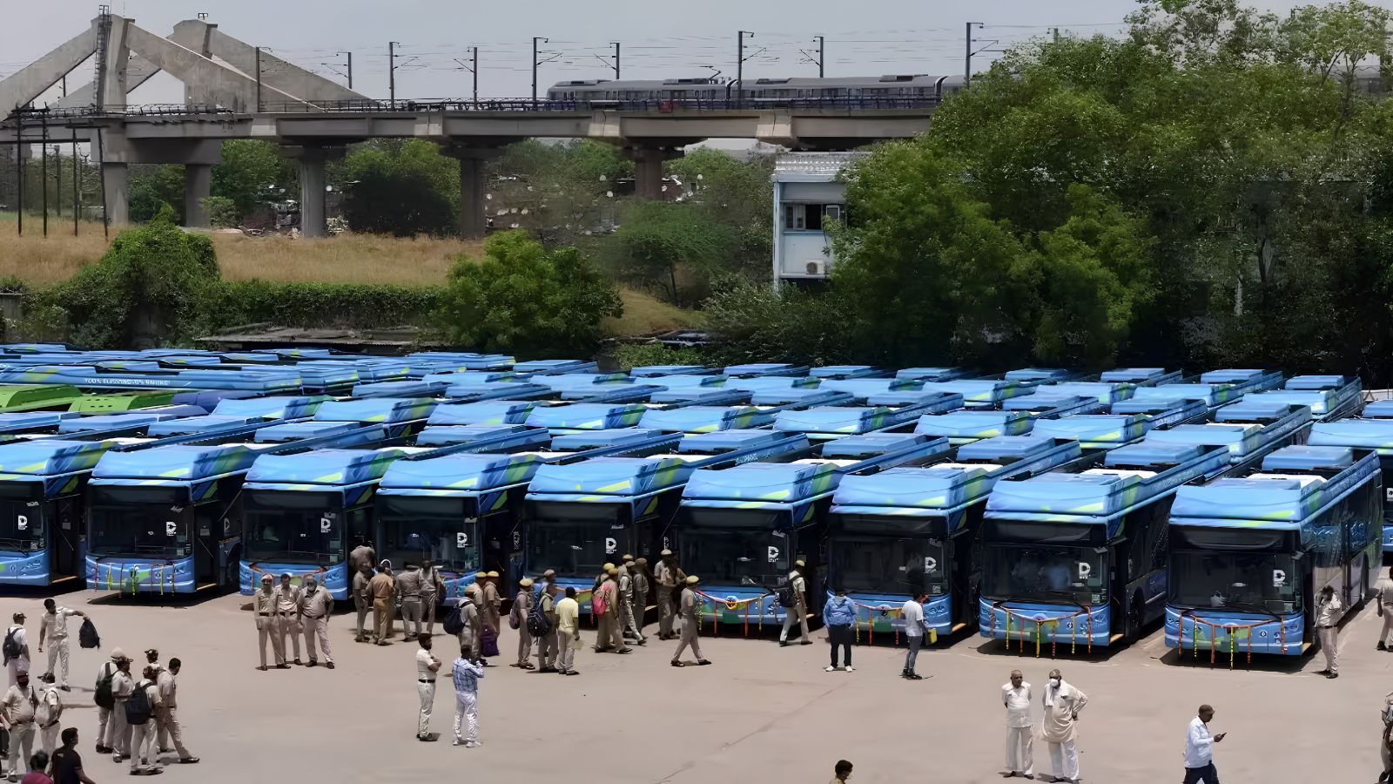
- Policy - 2 min read "The seven cities are Indore, Bhopal, Jabalpur, Rewa, Dewas, Katni, and Bhind. This service will strengthen bus connectivity between urban and rural areas. Transport services will be expanded to 75 percent of the state's gram panchayats," an official said on Thursday. - PTI - Published On Sep 25, 2026 at 11:24 AM IST Select ETGovernment as Preferred Choice on Google Copy Link Share on WhatsApp Share on Linkedin Share on X Share on Telegram Share on Facebook "The aim is to operate 15,000 buses in the state by 2031. The target is to operate 1,500 buses in the first year. After this, approximately 2,500 to 3,000 buses will be added annually. Public-private partnership (PPP) model will be promoted under Mukhya Mantri Sugam Parivahan Seva," officials said. The Mukhya Mantri Sugam Parivahan Seva will be launched in Madhya Pradesh on Friday, which will see 351 buses being flagged off from seven cities with the aim of providing citizens accessible, safe, modern and environmentally friendly transportation , officials said. The Mukhya Mantri Sugam Parivahan Seva will inaugurated by MP Chief Minister Mohan Yadav and Union Minister for Road Transport and Highways Nitin Gadkari at a state-level event to be held at the BHEL Dussehra Ground here, they added. Advt In the initial phase, 145 buses will be flagged off in Indore, comprising 50 intercity and 95 intracity buses, 106 buses in Bhopal, comprising 23 intercity and 83 intracity buses, 67 buses for Jabalpur, comprising 14 intercity and 53 intracity buses, 18 intercity buses in Rewa, 10 intercity buses in Dewas, three in Katni, and two intercity buses in Bhind, the official said. "The aim is to operate 15,000 buses in the state by 2031. The target is to operate 1,500 buses in the first year. After this, approximately 2,500 to 3,000 buses will be added annually. Public-private partnership (PPP) model will be promoted under Mukhya Mantri Sugam Parivahan Seva," he said. A transparent contract system and incentive schemes will be implemented to accelerate public-private partnerships, the official said. "Under this model, private bus operators will have the opportunity to increase their income from non-fare revenues such as advertising and cargo services, as well as utilise modern depot and terminal facilities. All support will be given to private operators to ensure efficient and smooth bus operations," the official said. Yadav visited the Dussehra Maidan in the Govindpura area on Thursday evening to review preparations for the launch event. He was briefed by state's transport secretary and commissioner public relations Manish Singh. - See more on: - Madhya Pradesh public transport , - Sugam Parivahan Seva launch , - Madhya Pradesh bus services , - public-private partnership bus operations , - Chief Minister Mohan Yadav , - transportation accessibility Madhya Pradesh , - Intercity and intracity bus services , - 350 buses across seven cities , - environmentally friendly transportation , - Nitin Gadkari Road Transport Minister Telegram Facebook Comments What are your thoughts? Comment Now --> Comment Now Read Comment (1) All Comments By commenting, you agree to the Prohibited Content Policy Post Find this Comment Offensive? Choose your reason below and click on the submit button. This will alert our moderators to take actions REASONS FOR REPORTING Foul Language Defamatory Inciting hatred against a certain community Out of Context / Spam Others Report Join the community of 2M+ industry professionals. Subscribe to Newsletter to get latest insights & analysis in your inbox. --> All about ETGovernment industry right on your smartphone! - Download the ETGovernment App and get the Realtime updates and Save your favourite articles. Scan to download App --> - Home - News - Madhya Pradesh to launch Sugam Parivahan Seva with 351 buses across seven cities

2. Railway Protection Force launches data-driven system to anticipate crowd surges at railway stations
Read more
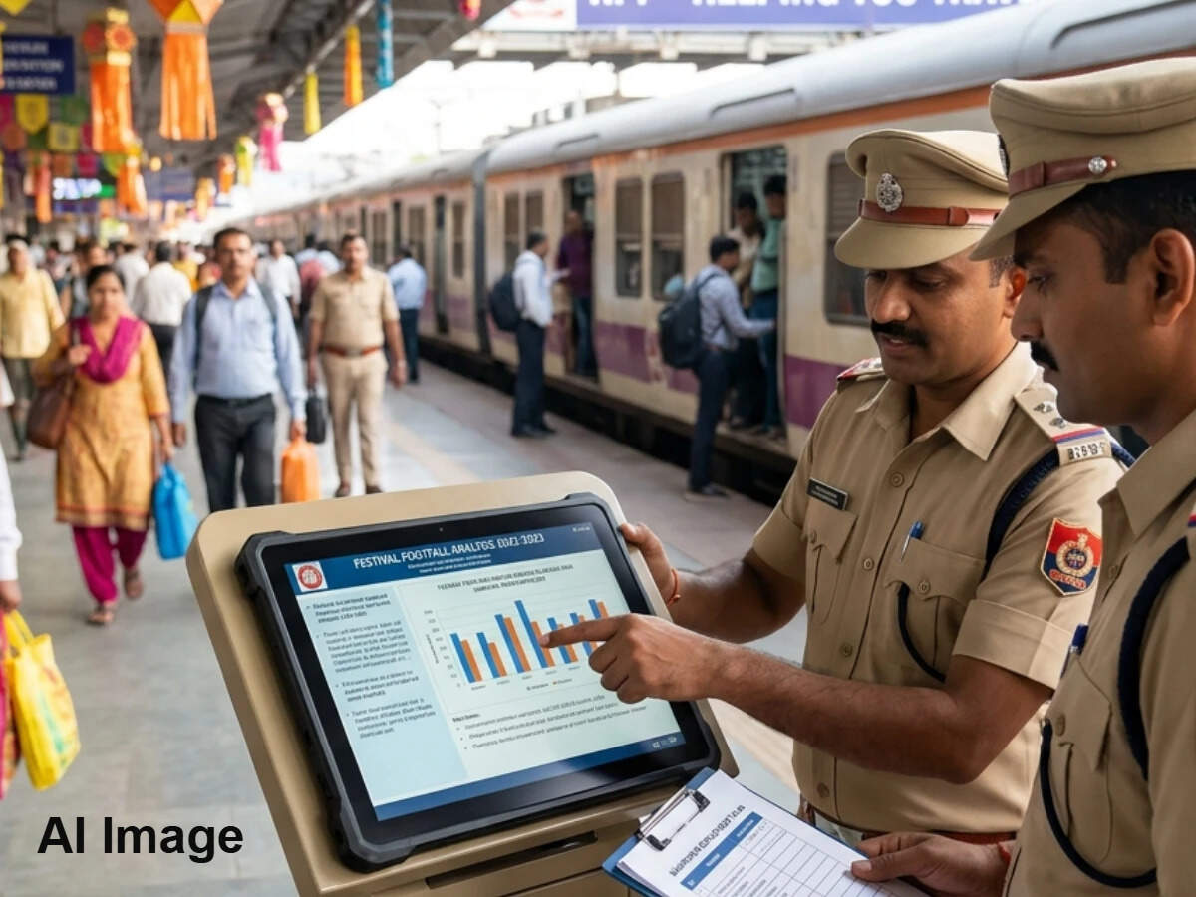
- Governance - 2 min read Some of these high-footfall events include festivals, religious gatherings, melas, examinations, recruitment drives, political programmes, sporting events, cultural and social events, fairs, major public functions and tourist seasons, among others. - PTI - Published On Sep 24, 2026 at 04:10 PM IST Select ETGovernment as Preferred Choice on Google Copy Link Share on WhatsApp Share on Linkedin Share on X Share on Telegram Share on Facebook Railway Protection Force launches digital system to predict, manage high-footfall events at stations The Railway Protection Force (RPF) will create a digital repository of all potentially crowded events at stations from 2022 onwards so that it can timely deploy manpower, regulate passenger movement and coordinate with state police to prevent untoward incidents in the future. Advt Named the 'DS-12 E-Forecasting Register of RPF for High-Footfall Events' (EFRR), the digital system will "serve as the single digital repository for advance forecasting, monitoring, action taken and post-event assessment of high-footfall events". The RPF headquarters, on September 17, 2026, ordered the concerned senior zonal security officials to operationalise the EFRR with immediate effect and ensure timely data entry of forthcoming high-footfall events. Prior to this order, the Director General of the RPF had issued a directive detailing all aspects of the EFRR, along with its purpose and implementation process. The directive, while highlighting the need for institutionalised advance forecasting mechanism, said, "Experience has shown that the absence of timely information, inadequate assessment of likely passenger movement, fragmented dissemination of information and, in some cases, casual or inadequate appreciation of the seriousness of the situation at supervisory levels can adversely affect the preparedness of the field formations," "Recent crowd-related incidents have further underscored the necessity of shifting from a largely reactive approach to a systematic, advanced, intelligence-led and data-driven mechanism for forecasting and managing passenger surges ," it added. Making the RPF Special Wing (SIB) personnel primarily responsible for making entries in the DS-12 Register, the Directive said, "The concerned SIB unit shall ensure that every high footfall event falling within its jurisdiction and having the potential to result in a substantial or unusual passenger surge is entered in the Register as soon as sufficient and credible information becomes available." It has given a time frame for fixed calendar events such as Holi, Diwali, Chhath, Christmas, major religious festivals and other recurring events whose dates are known in advance to be highlighted in the system early "to facilitate meaningful planning, which may be even prior to 60 days in advance". "For events such as melas, sporting events, examinations, recruitment examinations, political rallies/meetings, local festivals, fairs, cultural programmes and other events which are generally notified at shorter notice, the concerned SIB unit shall make all efforts to obtain information at least three weeks in advance, wherever practicable," it said stating that an event is announced or confirmed at shorter notice, the entry shall be made immediately upon receipt of credible information. Officials said that the EFRR is envisaged as an important institutional mechanism for strengthening the RPF's capacity to anticipate and manage high-footfall situations across Indian Railways. - See more on: - Railway Protection Force , - crowd management , - high-footfall events , - passenger surges , - digital repository , - data-driven system , - passenger management , - crowd surges , - safety measures , - anticipate crowd Telegram Facebook Comments What are your thoughts? Comment Now --> Comment Now Read Comment (1) All Comments By commenting, you agree to the Prohibited Content Policy Post Find this Comment Offensive? Choose your reason below and click on the submit button. This will alert our moderators to take actions REASONS FOR REPORTING Foul Language Defamatory Inciting hatred against a certain community Out of Context / Spam Others Report Join the community of 2M+ industry professionals. Subscribe to Newsletter to get latest insights & analysis in your inbox. --> All about ETGovernment industry right on your smartphone! - Download the ETGovernment App and get the Realtime updates and Save your favourite articles. Scan to download App --> - Home - News - Railway Protection Force launches data-driven system to anticipate crowd surges at railway stations

3. India divided into two by clouds: Isro satellite captures strange view from space - India Today
Read more
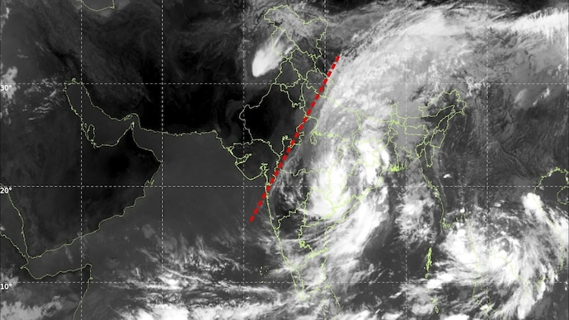
India divided into two by clouds: Isro satellite captures strange view from space India Today

4. Assam pivots to space: ISRO's new radar facility to transform Chandrapur - whispersinthecorridors.net
Read more
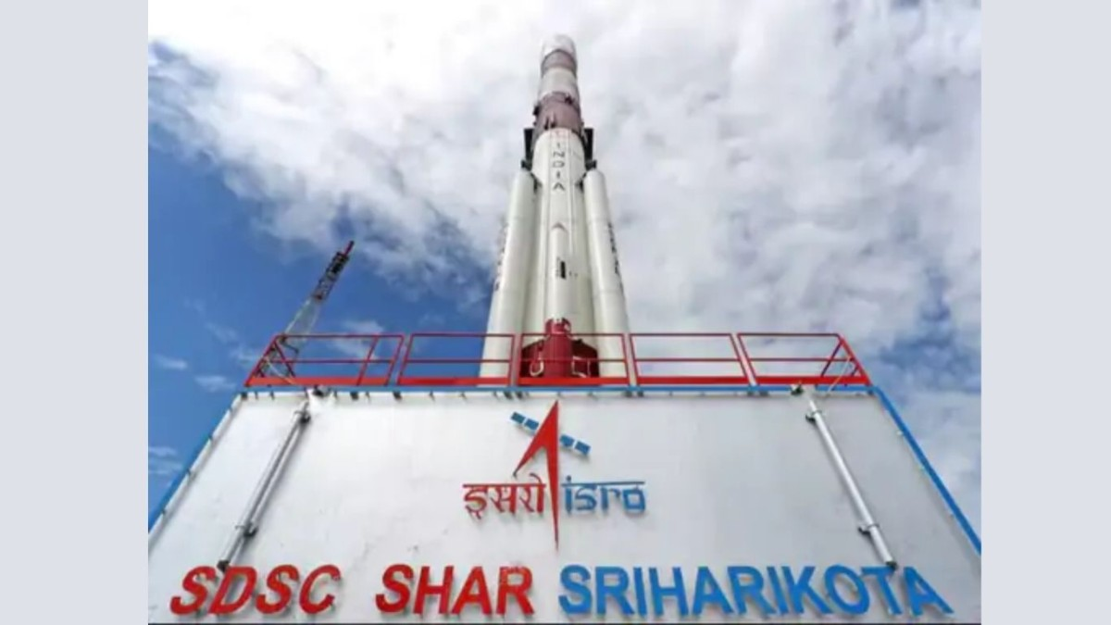
Assam pivots to space: ISRO's new radar facility to transform Chandrapur whispersinthecorridors.net

5. Interview: Ex-ISRO scientist shares skills students need for space careers, explains role of maths, coding and AI | Hindustan Times - Hindustan Times
Read more
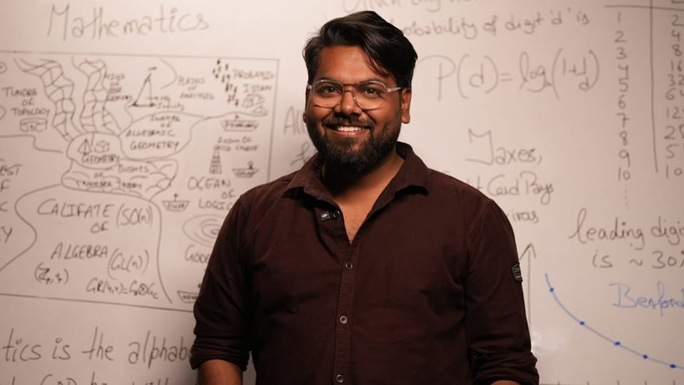
Interview: Ex-ISRO scientist shares skills students need for space careers, explains role of maths, coding and AI | Hindustan Times Hindustan Times

6. Soorya Krishnamoorthy, Former ISRO Scientist and Founder of Soorya Festival, Dies at 78 - GK Today
Read more
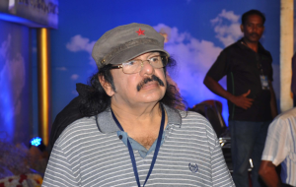
Soorya Krishnamoorthy, Former ISRO Scientist and Founder of Soorya Festival, Dies at 78 GK Today

7. Win a trip to ESA to witness BepiColombo arrive at Mercury
Read more
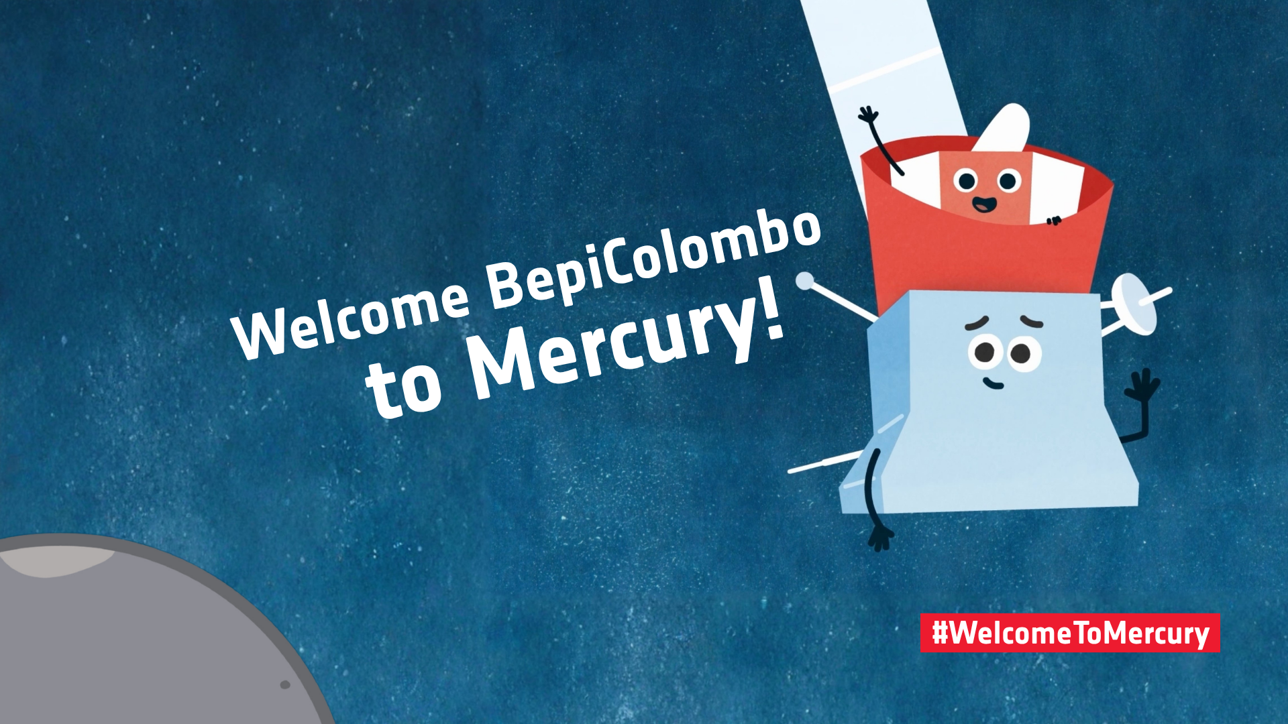
Science & Exploration Win a trip to ESA to witness BepiColombo arrive at Mercury 24/09/2026 726 views 15 likes Get ready to celebrate BepiColombo's arrival at Mercury. Craft a welcoming message that could be a drawing, song, poem or any other art form and stand a chance to win a trip to mission control! ENTRY FORM Full rules and how to enter below. The ESA/JAXA BepiColombo mission has entered its Mercury arrival phase, after cruising towards the planet for the past eight years. Stacked together, three space explorers, the European Space Agency's Mercury Planetary Orbiter (MPO or cartoon character Bepi), the Japanese Aerospace Exploration Agency's Mercury Magnetospheric Orbiter (Mio) and their robot friend, the Mercury Transfer Module (MTM), shared quite the ride so far. They had to navigate a complex journey, including nine planetary flybys - one flight past Earth, two past Venus and six past Mercury itself. As they approach Mercury to stay, things are getting even more exciting. Arriving at Mercury Entering orbit around Mercury is no easy feat. Earlier this month, the mission started performing a series of critical steps that will bring the two orbiters, MPO and Mio, into their science orbits over the next few months: On 3 September, MTM, which powered and steered BepiColombo for most of the journey, released the two orbiters and bade them farewell. On 21 November, MPO and Mio, still joined together, will be captured by Mercury's gravity. On 9-10 December, MPO and Mio will part ways. Mio will have entered its science operation orbit at this stage. On 19 March 2027, MPO will also reach its final science orbit. The spacecraft separation on 9-10 December 2026 will officially mark BepiColombo's arrival at Mercury. Coming thus far has been an incredible adventure for the two space explorers, one worth celebrating! Welcome to Mercury, Bepi and Mio! To mark this milestone, we are inviting you to welcome Bepi and Mio to Mercury by entering our competition. You stand a chance to win a trip to an event happening on 9 December in Darmstadt, Germany, at ESA's Space Operations Centre. The event will begin at 22:00 CET and run until after midnight. You will get a chance to meet the teams behind BepiColombo and experience the tense moment of receiving the first signal from the spacecraft once they have separated. To enter the competition, you should craft a welcoming message that could be a drawing, song, poem or any other art form that can be submitted as a photo or video. Read the competition rules below and submit your entry by 25 October 2026 by taking two actions: Share your creation on a social media channel of your choice using the hashtag #WelcomeToMercury and explain to your community what the BepiColombo mission means to you or what your favourite thing about the mission is. Welcome BepiColombo to Mercury! Competition rules Please read the full terms and conditions here and privacy notice here. The participants: The competition is open to residents of ESA Member, Cooperating and Associate States (EXCEPT staff of ESA, its suppliers, its contractors and members of their immediate families or households). You must be over 18 to enter. Family/group entries are allowed but the person posting the entry must be over 18, and the top prize is only valid for adults over 18. The entries: Entries are open from 15 September until midnight CET on 25 October 2026. One entry per person. Entries should take the form of either a photo or video of your creation, together with a brief description of what you created. Only adults over 18 can be in images/videos. Anyone in the image/video must have given their consent. Entries should first be posted on a social media channel of your choice, with a link to the post included in the competition entry form. Make sure your post is public, so that we can see your creation. In order to be considered for the prize you must submit your entry via the form, confirming your agreement with the privacy notice. Entries will be judged by the ESA BepiColombo Social Media working group, including BepiColombo mission experts and editors specialising in science communication. The panel's decision is final, and no correspondence shall be entered into to discuss the final winner. The prize: There will be one overall winner and up to nine runners up. The winner and runners up will be selected and informed in the second week of November 2026. The runners up will receive a small gift bag with ESA goodies. These will be shipped after the end of the competition period. Prizes are non-negotiable. There is no cash or other alternative prize for either the runners up or overall winner. Further details about the competition are available in our Terms and Conditions, which all participants must read, together with the Privacy Notice. In addition to the rules outlined here, participants also agree to abide by the terms and conditions of the social media channels in which they enter. Please also check ESA's privacy notice for social media: https://www.esa.int/Services/ESA_Privacy_Notice_ESA_social_media If you have any questions, please ask us via Bluesky, LinkedIn or X. What to expect if you win the top prize: You will be invited to join an event in Darmstadt, Germany, and will be asked to confirm your attendance as soon as possible. The event will be hosted at ESA's Space Operations Centre (ESOC) on the night of 9 December, starting at 22:00 CET and running until after midnight. You will receive a dedicated programme nearer the time. You will book your own travel and accommodation, and you will be refunded the cost up to €1000 after the event (not on the day), upon presentation of travel and/or accommodation booking receipts. You will be asked to provide your bank account details to receive the reimbursement. You will need a valid passport to enter the ESA establishment. The Mercury arrival activities are expected to happen on 9 December, but space activities are dynamic and may change even at the last minute. We recommend making flexible travel arrangements, as ESA cannot accept any liability for refunds. See esa.int/bepicolombo for the latest updates.

8. NASA to study human health and performance during Crew-13 mission
Read more
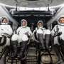
During NASA's SpaceX Crew-13 mission aboard the International Space Station, astronauts will support a series of biomedical and human performance investigations, including a new collaborative effort to study how spaceflight affects blood flow and clotting. NASA also is testing crew members' manual piloting skills, evaluating methods to counter vision and brain changes, gatherin...

9. Engineers just designed a better 'shock absorber' for spacecraft
Read more
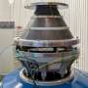
Rocket launches are among the most violent ways humans have devised to travel. They generate millions of pounds of thrust and subject passengers to intense g-forces. Humans must undergo serious training to withstand those forces, while machines must be designed to survive them. If a delicate mirror or solder joint cracks before a multibillion-dollar satellite even begins its mi...

