 |  | 

🌌 अंतरिक्ष समाचार | Space News
शनिवार, १२/०९/२०२६ | Saturday, 12/09/2026

1. CM Adityanath orders immediate repair of rain and flood-damaged roads across UP
Read more

- Governance - 2 min read Chairing a review meeting of the Public Works Department on Friday, UP CM Adityanath said, "The rains are continuing. Therefore, the condition of roads should be continuously monitored and a survey should also be conducted of roads newly damaged due to rain. - PTI - Published On Sep 11, 2026 at 03:59 PM IST Select ETGovernment as Preferred Choice on Google Copy Link Share on WhatsApp Share on Linkedin Share on X Share on Telegram Share on Facebook "Roads are directly connected with the everyday life of common people. Roads near educational institutions, hospitals, main markets, government offices, and other places with heavy public movement should be taken up on priority," UP CM Adityanath said. Uttar Pradesh Chief Minister Yogi Adityanath on Friday directed officials to immediately repair roads damaged by rain and floods and make them motorable, while undertaking permanent renewal of roads wherever required after the monsoon. Chairing a review meeting of the Public Works Department on Friday, he said, "The rains are continuing. Therefore, the condition of roads should be continuously monitored and a survey should also be conducted of roads newly damaged due to rain. Advt "A large number of people will travel during the upcoming festivals. Therefore, there should be no difficulty whatsoever in movement on major roads." Adityanath directed that necessary repair and renewal works be completed before the festivals. The chief minister said the campaign to make roads pothole-free should not be limited to patchwork. "Wherever a road is currently in a poor condition, it should be made motorable now and, after the monsoon ends, permanent renewal should be undertaken as required," he said. It was informed in the meeting that besides excessive rainfall, several roads have also been damaged due to heavy vehicle movement linked to ongoing construction projects on expressways, national highways and railways, among others. The department is conducting surveys of such routes and will identify damaged roads based on the findings and set department-wise targets to make them pothole-free, the state government said in a statement. In view of the upcoming festivals, 681 important routes have been identified for priority attention. These include roads witnessing increased movement during Ganesh Chaturthi, Vishwakarma Puja, Navratri, Diwali, Chhath Puja and Kartik Purnima. Adityanath also sought information from officials of the Union Ministry of Road Transport and Highways on their action plan and reviewed plans of the Mandi Parishad, Panchayati Raj, Irrigation, Rural Development, Urban Development, Housing and Urban Planning, and Infrastructure and Industrial Development departments. He stressed the need for better coordination among all concerned departments. According to the department's presentation, roads under nine departments have been included in the pothole-free campaign . These departments have around 4.36 lakh kilometres of roads under their jurisdiction, of which around 50,000 kilometres have been targeted to be made pothole-free. Work on around 5,751 kilometres has been completed so far, while targets will be finalised after the survey of damaged routes. The department has also set a target of renewing around 30,000 kilometres of roads and carrying out special repairs on around 5,000 kilometres. So far, renewal work has been reported on around 14,000 kilometres and special repairs on around 700 kilometres, officials said. "Roads are directly connected with the everyday life of common people. Roads near educational institutions, hospitals, main markets, government offices, and other places with heavy public movement should be taken up on priority," Adityanath said. "Immediate work should be started on these routes and wherever repairs are required, the road should be made motorable without delay," he said, while stressing that along with expediting the work, full attention should also be paid to quality. - See more on: - Yogi Adityanath , - Uttar Pradesh , - rain damaged roads , - flood repair UP , - Pothole-free campaign , - Uttar Pradesh road repair , - CM Yogi Adityanath initiatives , - flood-damaged roads , - public works department UP Telegram Facebook Comments What are your thoughts? Comment Now --> Comment Now Read Comment (1) All Comments By commenting, you agree to the Prohibited Content Policy Post Find this Comment Offensive? Choose your reason below and click on the submit button. This will alert our moderators to take actions REASONS FOR REPORTING Foul Language Defamatory Inciting hatred against a certain community Out of Context / Spam Others Report Join the community of 2M+ industry professionals. Subscribe to Newsletter to get latest insights & analysis in your inbox. --> All about ETGovernment industry right on your smartphone! - Download the ETGovernment App and get the Realtime updates and Save your favourite articles. Scan to download App --> - Home - News - CM Adityanath orders immediate repair of rain and flood-damaged roads across UP

2. One lakh fishing vessels to be fitted with transponders developed By ISRO soon - DD News
Read more
Around one lakh marine fishing vessels across India will soon be equipped with indigenously developed transponders under the Vessel Communication and Support System (VCSS), following the Union government's approval of a nationwide rollout plan aimed at enhancing fishermen's safety, communication and navigation. The Union Department of Fisheries on Thursday approved the national rollout of the VCSS under the Pradhan Mantri Matsya Sampada Yojana (PMMSY) at an estimated cost of Rs 364 crore. The project includes the installation of transponders on marine fishing vessels, establishment of earth stations and associated communication infrastructure, and development of the 'Nabhmitra' mobile application in regional languages. Under the scheme, eligible fishermen will receive the transponders free of cost. The project will be implemented on a 60:40 cost-sharing basis between the Centre and the states, while Union Territories will receive 100 per cent central assistance. The VCSS has been developed by the Indian Space Research Organisation (ISRO) to strengthen the monitoring, control and surveillance of marine fishing vessels. ISRO has also developed the 'Nabhmitra' application to provide real-time communication and support services to the marine fishing community. The application offers a range of features, including periodic position reporting, two-way messaging, emergency and SOS alerts, automatic geo-fencing-based boundary crossing warnings, weather and cyclone advisories, emergency weather alerts, Potential Fishing Zone (PFZ) information, navigational assistance, and an e-Token/Trip Declaration system. According to officials, the system is expected to significantly improve the safety of fishermen by enabling faster search and rescue operations during emergencies and adverse weather conditions. It will also help prevent Indian fishing vessels from inadvertently crossing into the territorial waters of neighbouring countries by issuing timely boundary alerts. As part of the project, communication infrastructure will be developed at 423 Fish Landing Centres (FLCs) out of the 1,547 notified FLCs across the country. The centres have been selected by states and Union Territories based on factors such as the number of operational fishing vessels, dependence of local fishing communities, fish landing volumes, proximity to fish markets and processing facilities, techno-financial viability, availability of funds and compliance with statutory requirements. According to government data, Andhra Pradesh has the highest number of notified Fish Landing Centres at 350, followed by Tamil Nadu with 301 and Kerala with 204. (With inputs from IANS)

3. ISRO's 'privatisation' move: What India's space policy says - indianexpress.com
Read more
ISRO's 'privatisation' move: What India's space policy says indianexpress.com

4. ISRO: Making space for industry? - Deccan Herald
Read more
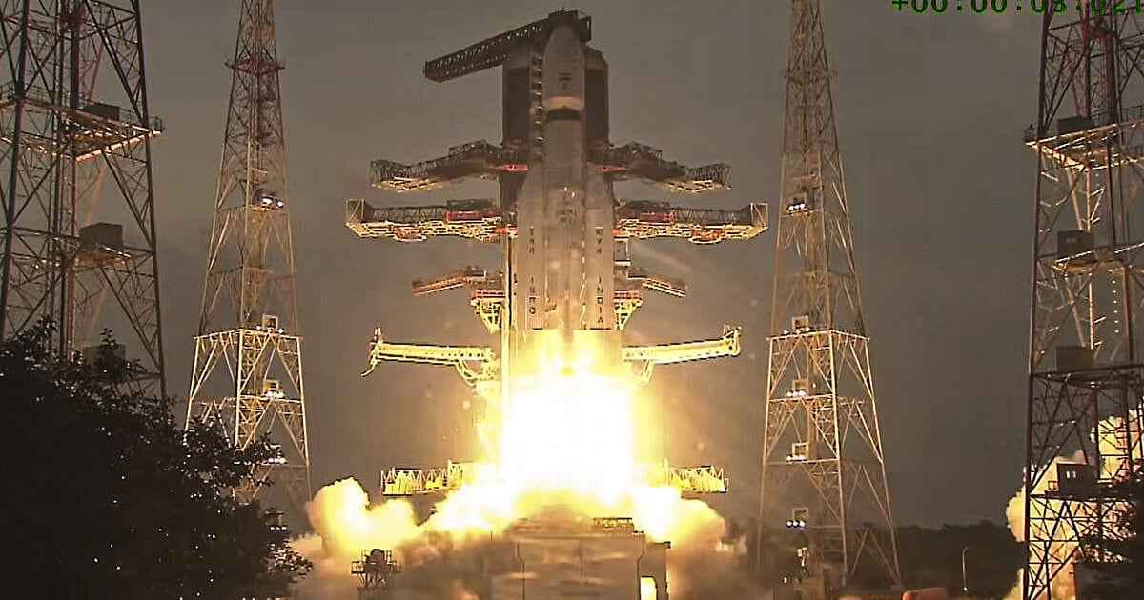
ISRO: Making space for industry? Deccan Herald

5. ISRO Satellite Detects Clearest Sign Yet Of "Mother Of All" El Nino Events - NDTV
Read more
ISRO Satellite Detects Clearest Sign Yet Of "Mother Of All" El Nino Events NDTV

6. Rocket Lab protests NASA's decision to award Blue Origin $700 million Mars orbiter contract
Read more
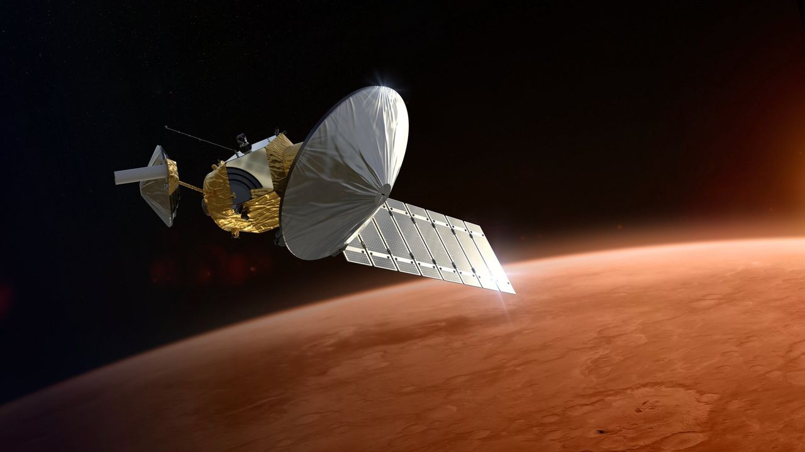
Click for next article Rocket Lab still holds out hope that it can build NASA's next Mars orbiter. The agency picked Blue Origin for that job earlier this month, awarding Jeff Bezos ' spaceflight company $700 million to develop, launch and operate the Mars Telecommunications Network (MTN). Today (Sept. 11), however, Rocket Lab announced that it has challenged that decision, filing a formal protest with the Government Accountability Office (GAO). Rocket Lab has filed a formal protest with the Government Accountability Office challenging NASA's award decision for the Mars Telecommunications Network.NASA's award decision appears to be inconsistent with the eligibility criteria mandated by Congress. In addition, the… pic.twitter.com/g48AWgiIoRSeptember 11, 2026 "NASA's award decision appears to be inconsistent with the eligibility criteria mandated by Congress. In addition, the agency's punitive review of Rocket Lab's technical volume was inconsistent, making incorrect assertions and conclusions," Rocket Lab said today in an X post that laid out its argument. "Procurement standards exist to ensure fair competition and protect public investment," the California-based company added. "We are pursuing this review to ensure those standards are upheld for critical infrastructure that will underpin American exploration at Mars for decades to come." As its name suggests, the MTN orbiter will serve as a communications link between mission controllers here on Earth and other NASA spacecraft studying the Red Planet. Just two agency orbiters fulfill that relay role these days, and both are quite old: Mars Odyssey launched in 2001, and the Mars Reconnaissance Orbiter lifted off in 2005. NASA had been eyeing a new Mars telecom orbiter for years and finally got Congressional funding for it in July 2025 - $700 million, to be precise. The agency issued a request for proposals this past May , drawing considerable interest from the private sector. Blue Origin and Rocket Lab were widely considered the front-runners, and NASA ended up going with Blue. The award calls for the company to deliver MTN (which, despite the "network" in its name, is a single spacecraft) to NASA no later than Dec. 31, 2028. It's expected to be up and running at the Red Planet by 2030. Blue Origin has been in Rocket Lab's shoes before, and has behaved similarly. Bezos' company filed a protest with the GAO in 2021 after NASA picked SpaceX to provide the first crewed moon lander for the agency's Artemis program .

7. Rocket Lab launches mystery satellite to orbit for secret customer (photo)
Read more
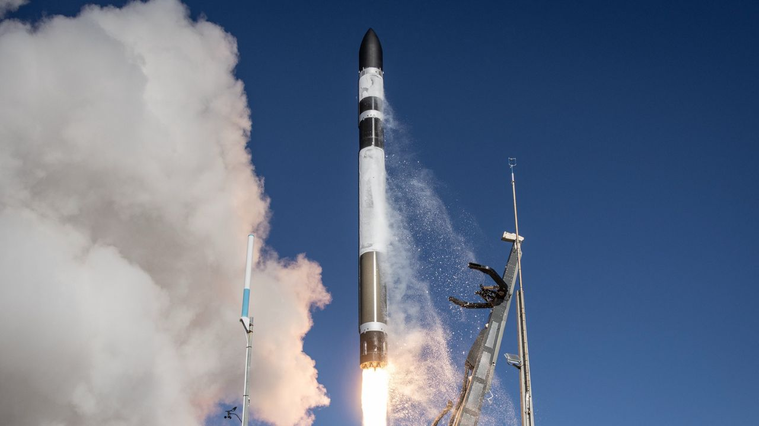
Click for next article A Rocket Lab Electron rocket launches on the "Happily Ever Faster" mission from New Zealand on Sept. 10, 2026. Rocket Lab just launched a mystery mission to orbit. An Electron rocket lifted off from Rocket Lab's New Zealand site on Thursday (Sept. 10) at 11:28 p.m. EDT (0328 GMT and 3:28 p.m. local New Zealand time on Sept. 11). The launched kicked off a mission the company called "Happily Ever Faster," which we know little about. 'Happily Ever Faster' to orbit 🌌✨ Today we launched our 95th Electron at 3:28 pm NZST and deployed a single Earth observation satellite to a 500km LEO for a confidential customer - our 16th mission of the year with 100% mission success. pic.twitter.com/xAsy30uyNPSeptember 11, 2026 Rocket Lab did not livestream the mission or reveal who booked it, saying only that it aimed to loft "a single commercial satellite to a 500 km low Earth orbit ." That did indeed happen successfully, the company announced via X about 80 minutes after launch. Speculation has worked to fill the information vacuum, as it generally does. For example, some outside observers think "Happily Ever Faster" carried up a "Gen-3" satellite for the geospatial intelligence company BlackSky. These spacecraft are powerful Earth observers, capable of resolving features as small as 14 inches (35 centimeters) on our planet's surface. Rocket Lab has launched BlackSky Gen-3 satellites before, so this is a pretty good bet - especially since, in that post-launch X post, the company revealed that the deployed payload was an Earth-observing craft. "Happily Ever Faster" was Rocket Lab's 16th launch of 2026, and the 13th involving the 59-foot-tall (18 meters) Electron, which gives small satellites dedicated rides to space.

8. 2 private spacecraft zoom within 650 feet of each other to showcase 'advanced capabilities' in orbit (photos)
Read more
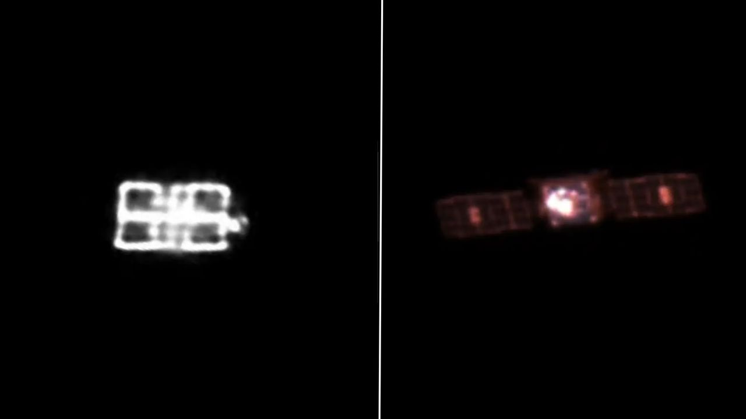
Click for next article Impulse Space's LEO-2 Mira vehicle, as seen from a telescope onboard LEO-3 from a distance of approximately 5,000 meters (16,400 feet). A pair of private spacecraft just showed off some impressive maneuverability high above Earth. The two probes - Mira satellites operated by the California startup Impulse Space - zoomed within 650 feet (200 meters) of each other in low Earth orbit (LEO) recently. The rendezvous demonstrated skills that could be useful to a variety of customers down the road, according to the company. "These types of dynamic, agile maneuvers are how we unlock full access to space after launch and create new mission possibilities," Tom Mueller, CEO and founder of Impulse Space (and, prior to that, the first person Elon Musk ever hired at SpaceX ), said in a statement on Tuesday (Sept. 8). "Our teams that design, build and operate Mira are leading the way toward a true space age, and customers across all sectors will be the beneficiaries." The LEO-3 Mira vehicle, taken from a distance of approximately 700 meters (2,300 feet) by a camera onboard LEO-2. (Image credit: Starfish Space/Impulse Space) Mira is an orbital transfer vehicle - a spacecraft designed to deliver customer payloads to precise locations in Earth orbit or beyond. The dishwasher-sized Mira can carry up to 660 pounds (300 kilograms) of gear and is highly maneuverable, as the recent rendezvous showed. The operation involved Mira satellites that launched in January 2025 and November 2025, on missions that Impulse calls LEO Express 2 (LEO-2) and LEO Express 3 (LEO-3), respectively. Impulse Space's LEO-2 Mira vehicle, as seen from a telescope onboard LEO-3 from a distance of approximately 5,000 meters (16,400 feet). (Image credit: HEO/Impulse Space) The action began this past February, when the LEO-2 Mira conducted a lengthy engine burn to close in on its counterpart. LEO-2 performed additional, smaller burns throughout the spring and summer, coming into orbital alignment with LEO-3. "Then in July, LEO-2 executed a series of close approaches to LEO-3, starting at about 820 meters [2,690 feet] apart and subsequently moving closer to LEO-3," Impulse Space wrote in the Tuesday update. "Ultimately, for the closest approach, LEO-2 maneuvered to within about 200 meters of LEO-3." Both Miras chronicled the rendezvous, snapping photos of each other with onboard camera gear. Two other companies, Starfish Space and HEO, worked with Impulse Space to pull off this orbital photo shoot. Two Miras - less than 200 meters apart! Our LEO Express 2 and LEO Express 3 spacecraft recently met for a family reunion in orbit, following a series of carefully coordinated maneuvers that brought the two vehicles within approximately two football fields of each other.The… pic.twitter.com/XoHgOzjuaLSeptember 8, 2026 Impulse has worked with Starfish before. The duo collaborated late last year on a rendezvous between LEO-2 and the first space-flown Mira, which launched on the Leo Express 1 mission in November 2023. On that operation, called Remora , LEO 2 used Starfish Space navigation software to get within 4,100 feet (1,250 m) of LEO 1. "We're showcasing some of the advanced capabilities that set Mira apart from other vehicles," Drew Damon, vice president of spacecraft programs at Impulse, said in Tuesday's statement. "Twice now, we've demonstrated that Mira has the agility and propulsion to support a new class of dynamic operations on orbit, and our team is excited to continue tackling the mission sets Mira is uniquely qualified to handle."

9. 25 years ago, a NASA astronaut witnessed the tragic 9/11 attacks from space. Here's what he saw.
Read more

Frank Culbertson had a birds-eye view of one of the most memorable and tragic events in American history. The NASA astronaut was the only American off of Earth on Sept. 11, 2001. He was circling the planet aboard the International Space Station (ISS) when terrorists flew commercial jets into the twin towers of the World Trade Center in New York City, killing more than 2,700 people. The ISS passed over New York shortly after the attacks took place, so Culbertson saw the devastation from an eerie remove. He shared his thoughts with Mission Control at NASA's Johnson Space Center in real time, chronicling the tragedy like no one else could. The aftermath of the 9/11 attacks on the World Trace Center in New York City, as seen by the astronauts onboard the International Space Station on Sept. 11, 2001. (Image credit: NASA) "We could see New York City and the smoke from the fires," Culbertson said. "Our prayers and thoughts go out to all the people there and everywhere else here - I'm looking up and down the East Coast to see if I can see anything else - and to the people in Washington." Terrorists hijacked four commercial planes on 9/11, flying two of them into the World Trade Center and one into the Pentagon in Washington, D.C. Passengers on the fourth plane overpowered the hijackers, forcing it to crash in a field in Pennsylvania rather than hit the terrorists' intended target, which was likely the U.S. Capitol building or the White House. "I hope that the people responsible are caught and brought to justice as soon as possible," Culbertson added. "But first, our prayers and condolences to all involved. And I just wanted the folks to know that their city still looks very beautiful from space. I know it's very difficult for everybody in America right now, and I know folks are struggling very hard to to deal with this and recover from it. But the country still looks good, and, for New Yorkers, your city still looks great from up here." Culbertson gave a more complete accounting of his thoughts in an open letter , which he published a day after the attacks. "The world changed today. What I say or do is very minor compared to the significance of what happened to our country today when it was attacked," he wrote. "It's horrible to see smoke pouring from wounds in your own country from such a fantastic vantage point," Culbertson added. "The dichotomy of being on a spacecraft dedicated to improving life on the Earth and watching life being destroyed by such willful, terrible acts is jolting to the psyche, no matter who you are." NASA astronaut and ISS commander Frank Culbertson on Sept. 17, 2001 aboard the International Space Station. (Image credit: NASA) Culbertson arrived at the ISS on Aug. 12, 2001 aboard the space shuttle Discovery along with cosmonauts Vladimir Dezhurov and Mikhail Tyurin. The trio comprised Expedition 3, the third-ever crewed mission to the orbiting lab, which ran through December of that year. We're now up to Expedition 75, and there have been no breaks: The ISS has been continuously staffed by rotating astronaut crews since November 2000. Expedition 3 was Culbertson's third and final spaceflight. He retired from NASA in August 2002 and went to work in the private sector. Among other roles, he led human spaceflight efforts at Orbital Sciences Corp., which built the Cygnus ISS resupply spacecraft. Cygnus still flies today, for the aerospace giant Northrop Grumman, which bought Orbital Sciences in 2018. Culbertson, 77, retired from Northrop Grumman in 2018. He currently serves on the board of directors of the nonprofit Space Foundation, among other roles. NASA astronauts Mark Kelly (left) and Dan Tani hold a bag of American flags on the flight deck of the space shuttle Endeavour. The flags carried on the shuttle included 6,000 small U.S. flags, one U.S. flag that was recovered from the debris of the World Trade Center, a Marine Corps flag that was retrieved from the Pentagon, and an American flag from the State of Pennsylvania. (Image credit: NASA) For example, NASA flew nearly 6,000 small American flags on the STS-108 mission of the space shuttle Endeavour , which launched on Dec. 5, 2001 and landed 12 days later.

10. New Houston stand puts Rotating Detonation Rocket Engine through mission-like tests
Read more
Venus Aerospace has opened a new propulsion test stand at Houston Spaceport as it pushes its rotating detonation rocket engine through increasingly demanding ground tests. The new facility gives engineers more room to run higher-thrust firings and extend test durations. That allows Venus to examine how the engine behaves under conditions that more closely resemble flight. The company demonstrated the capability on September 10 with a live hot-fire test at the newly opened stand. The event also brought together Texas aerospace officials, Houston leaders and representatives from the local space industry. Bigger test envelope Rotating detonation engines have attracted interest because they can produce combustion through rapidly moving detonation waves. That process differs from the combustion used in most conventional rocket engines. Getting the concept to work in a laboratory is only one part of the challenge. Engineers must also show that the hardware can withstand sustained operation at useful thrust levels. The new stand gives Venus additional capacity for that work. It can support longer tests and higher-thrust operations than some of the company's existing infrastructure. That extra testing time can reveal problems that short firings might miss. It also gives engineers more data as they refine the engine and its supporting systems. Venus CEO and co-founder Sassie Duggleby said propulsion programs need infrastructure that can keep pace with their technical development. "Building and testing propulsion systems at this pace requires the right infrastructure around the technology," Duggleby said. She also credited the Texas Space Commission and the State of Texas for helping fund the facility. The project received support through the commission's Space Exploration and Aeronautics Research Fund. Texas backs propulsion The funding forms part of a broader state effort to expand aerospace activity in Texas. Houston Spaceport has become one of the locations supporting that push. Venus said it completed the test stand on schedule and within its planned budget. The facility now gives the company another place to run propulsion tests as its program grows. That capacity could become increasingly important after several major developments for Venus. The company raised $91 million in a Series B round during 2026. It has also expanded its leadership team and announced new customer and strategic relationships. Those moves have accompanied continued work on its propulsion technology.

