IIRS Daily Space Digest Monday, 08/06/2026

1. ISRO releases stunning images of Sun captured by Aditya L1 satellite during major geomagnetic storm in May - News On AIR
"ISRO OR NRSC OR IIRS after:2026-06-07" - Google News
Read more

The Indian Space Research Organisation (ISRO) has released stunning images of the Sun captured by the Aditya L1 satellite during a major geomagnetic storm in May. The two remote sensing payloads, namely the Solar UltraViolet Imaging Telescope (SUIT) and the Visible Emission Line Coronagraph (VELC), along with other payloads, captured these images from the Lagrange point in space. The images released by ISRO clearly show magnetically active regions with large solar flares on the Sun's surface. The solar emissions depict the relative brightness of sunspots, umbra, penumbra, and plages. ISRO states that these images will assist astrophysicist in studying solar flares, their energy distribution, sunspots, UV radiation across a wide wavelength range, and long-term solar variations. The images can be viewed on the ISRO website.

2. A sari from Mars: How an Indian ISRO scientist's outfit reached the Smithsonian US museum - Gulf News
"ISRO OR NRSC OR IIRS after:2026-06-07" - Google News
Read more


"It was a do-or-die moment, the most critical operation in the mission," she said in a 2016 interview. "We had to decide where the spacecraft goes, how it goes and when it goes. The success of the mission depended on what we did that day." Mangalyaan was successfully placed in Martian orbit on September 24, 2014. India became the first country in Asia, the fourth in the world, and the first to succeed on its very first attempt. The mission was intended to last six to ten months but Mangalyaan continued operating for almost eight years. The photograph that changed everything

3. India keen to take part in proposed spaceport in Indonesia - Deccan Herald
"ISRO OR NRSC OR IIRS after:2026-06-07" - Google News
Read more


Subianto, during his visit to New Delhi in January 2025, invited India Inc to invest in developing Sabang Port in Aceh, Indonesia. Indonesia's Sabang Port is located close to Andaman and Nicobar Island - precisely 104 nautical miles from India's southernmost tip, Indira Point, and 376 nautical miles from Port Blair. It is just 500 kilometres away from the Malacca Strait, a narrow stretch of water between the Malay Peninsula to the northeast and the Sumatra Island of Indonesia to the southwest, connecting the Andaman Sea and the South China Sea. The Malacca Strait is considered one of the crucial maritime chokepoints on the sea lanes in the Indian Ocean region. If India develops the Sabang Port of Indonesia as a strategic asset, the facility - along with the INS Baaz naval air station in Andaman and Nicobar Island - will give the Indian Navy an edge against China's People's Liberation Army Navy, which over the past few years stepped up its forays in the Indian Ocean region. It will also help monitor the maritime traffic in the region.

4. The six yards that made history: why the Smithsonian preserved this ISRO scientist's Mangalyaan saree - financialexpress.com
"ISRO OR NRSC OR IIRS after:2026-06-07" - Google News
Read more

The six yards that made history: why the Smithsonian preserved this ISRO scientist's Mangalyaan saree financialexpress.com

5. Who Is Praveen Maurya, Ex-ISRO Scientist Who Drops Bombshell Claims Against Kerala Police, Space Agency - TimelineDaily
"ISRO OR NRSC OR IIRS after:2026-06-07" - Google News
Read more


Who Is Praveen Maurya, Ex-ISRO Scientist Who Drops Bombshell Claims Against Kerala Police, Space Agency Praveen Maurya, a former aerospace engineer at the Indian Space Research Organisation (ISRO), is a voice that has gone unheard for the past few years. Maurya left IRSO, shifting to law after being falsely targeted by an alleged espionage group. The former ISRO rocket scientist, now a lawyer, has been active on social media, sharing his ordeal and leveling allegations against ISRO top brass and Kerala police. Graduated from the Indian Institute of Space Science and Technology (IIST), Maurya became an ISRO scientist and worked on several key projects including scramjets, hypersonics, and India's human spaceflight mission. In 2022. In 2022, Maurya took to his LinkedIn account alleging that some spies have been coercing him to share certain classified information on India's space program with them. He further alleged that some senior officers of ISRO and Kerala police were involved in the matter, adding that they even threatened him when he refused to obey their demands. Maurya accused this network of colluding with the local Kerala Police, and implicating him in a fake case to compel his compliance. Following the case, he faced suspension, which made him isolated and unable to secure employment. Ever since then, the former scientist has been vocal on his social media platforms, sharing claims about his ordeal. Maurya continues to make explosive claims about ISRO and Kerala police on his social media platforms. In one of his latest posts this year, he said he had doubts when he heard about the Red Fort blast and the 3000 kg of explosives found in Delhi. 'Because similar things were discussed back then. You know, solid rocket fuel is kind of an explosive. A little chemical tweak, and it can become a full-fledged bombing material. It was discussed and planned that VSSC/ISRO would produce the explosive materials, and officials of the Kerala police would take care of the logistics of getting them transported to various parts of India. When I refused for these unlawful activities, the Kerala Police abducted me at midnight, tortured me and filed false cases to destroy me," the former scientist claimed. He further noted that all his efforts to approach the authorities were deflected by citing the cases against him, adding that the very reason the Traitor Kerala Police accused him in these false cases. Maurya claims after his acquittal, he approached the DGP of Kerala police to register an FIR and investigate as they could not ignore his testimony. He said despite forwarding the complaint to the commissioner of Police in Thiruvananthapuram, the Kerala police went mute. "I wrote further reminders to the Kerala Police, but they went COMPLETELY MUTE. Parallelly, the Maoists from Kerala and VSSC/ISRO are employing various methods to neutralize me silently. What should I do?," Maurya asked.

6. Could meteor storms harm NASA's future moon missions?
Latest from Space.com
Read more
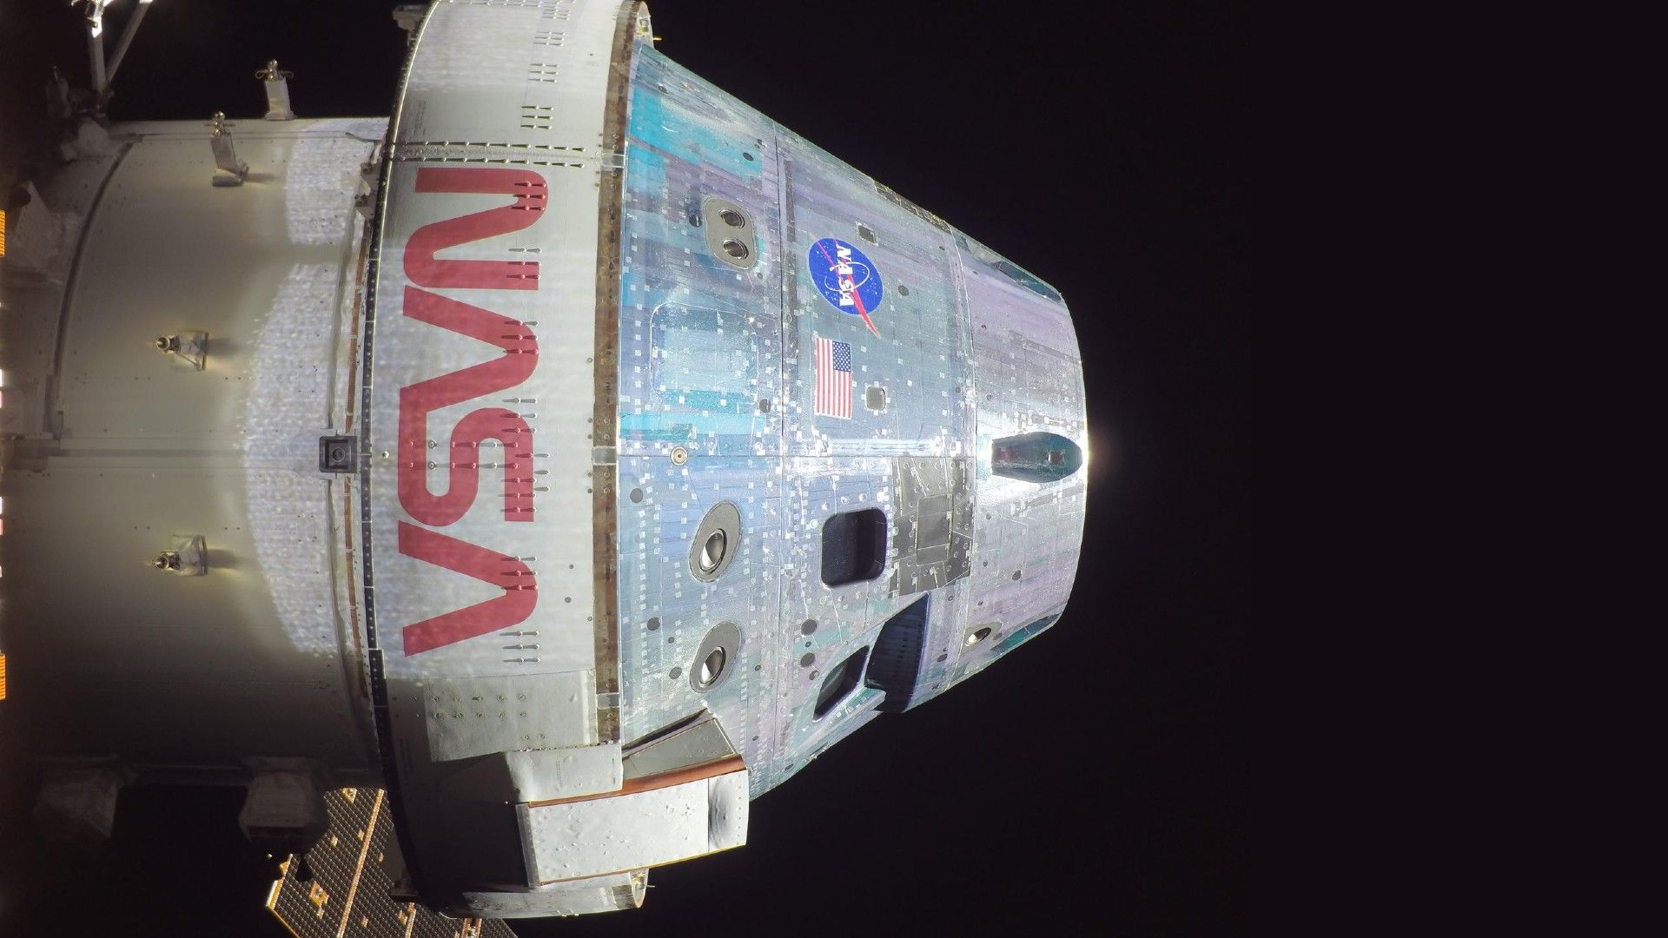

Click for next article Meteor showers are among the most beautiful phenomena to brighten Earth's sky, but could the fast moving space rocks that accompany major events threaten or delay future Artemis moon missions as NASA and its partners plan for a lunar landing attempt? NASA estimates that approximately 48.5 tons (44,000 kilograms) of naturally occurring space debris falls into Earth's atmosphere each day. These fragments range in size from tiny micrometeoroids a fraction of a millimeter in diameter to larger particles that create spectacular shooting stars and fireballs as they burn up during atmospheric entry. The space around Earth gets even more crowded during meteor showers , as Earth careens through one of the many debris streams continuously shed by asteroids and comets as they make lazy circuits around the sun . Can micrometeoroids endanger a spacecraft? Micrometeoroids travel through space at hypervelocity speeds averaging 22,000 miles per hour (34,405 kilometers per hour), according to NASA . At that pace, even a tiny micrometeoroid has the ability to impart a significant kinetic blow upon striking a spacecraft en route to the moon, with potentially disastrous results for the astronaut crew inside. Fast moving debris has the potential to penetrate or deform a spacecraft's hull, damaging critical systems or even triggering a catastrophic rupture . There is also the risk that a micrometeoroid could punch a hole in one of the heat-resistant outer tiles on the Orion spacecraft, NASA's crew capsule for the agency's Artemis moon missions, undermining its ability to survive the intense furnace of reentry, per NASA . Astronaut Reid Wiseman photographed with his hand on the hull of the charred Artemis 2 Orion spacecraft. (Image credit: NASA) The Chinese Space Agency was given a stark reminder of the dangers posed by space debris in November last year, when taikonaut Chen Dong discovered a crack in the viewport of his Shenzhou-20 spacecraft, which forced the three person crew to use a different return craft for their journey . Thankfully, modern spacecraft such as the Orion capsule used for NASA's Artemis moon missions have been designed to mitigate the threat posed by micrometeoroid impacts, in so far as is possible. "Orion spacecraft material selection and thicknesses have been optimized for [micrometeoroid and orbital debris] (MMOD) protection and risk balancing," said Mike Heckwolf, Orion crew and mission risk integrator at Lockheed Martin's in an email to Space.com. "Hypervelocity impact testing is conducted to confirm impact physics, to characterize damage survivability, and verify performance of the Orion spacecraft MMOD design," continued Heckwolf. "The Artemis mission trajectory and Orion flight attitude are carefully assessed to minimize MMOD risk." Meteor storms and outbursts raise the stakes As is so often the case, the best protection against disaster is prevention. NASA and its partners regularly perform risk assessments on the micrometeoroid environment both ahead of and during a mission, though only the most severe events present cause for concern. Perseid meteors streak Earthward through the starry sky. (Image credit: Wisanuboonrawd via Getty Images) "Only a handful of the more than 1,000 known meteor showers exceed the sporadic background by more than 5% - like the Geminids, for example - [which is] the strongest annual shower," explained NASA Meteoroid Environments Office lead Bill Cooke, in an email to Space.com. The major mission disrupters come in the form of meteor storms and outbursts, which see a dramatic increase in the quantity of interplanetary debris choking the Earth-moon environment. "If a major meteor shower outburst or storm is forecast during a mission or crew activity, the mission would be delayed or the crew kept inside until the outburst or storm is over," said Cooke. Storm forecasts on the horizon Hundreds or even thousands of shooting stars may be seen burning through Earth's skies each hour during one of these intense meteor storm events, though the distance separating micrometeoroids in space would still likely be measured on the order of miles. Thankfully, forecasters are able to predict when meteor storms or outbursts are likely to occur, many years before they brighten our skies. Robert Lunsford Fireball report coordinator Robert Lunsford is the fireball report coordinator, newsletter editor and treasurer at the American Meteor Society, one of the leading sources of information on meteor showers. "Currently there are four possible meteor outbursts predicted to occur during the next ten years," said Robert Lunsford of the American Meteor Society in an email to Space.com. "These involve the Perseids (August 12, 2028) and the Leonids (November 17, 2033 and November 18 & 19, 2034. The strongest of these appears to be the Perseid outburst, which could range from 500 to 1000 meteors per hour." Artemis 4 - NASA's first crewed mission to the lunar surface since the Apollo-era - is currently slated to launch in early 2028, though it's possible that an unforeseen delay could push that window backwards. In the unlikely event that Artemis 4, or any subsequent mission's launch should fall close to a projected outburst, they could well be delayed in the name of safety, and it wouldn't be the first time that NASA has postponed a mission to ensure its success in the face of a micrometeoroid risk. The crew of STS-51 with the space shuttle Discovery after touch down. (Image credit: NASA) As noted by Cooke, the STS-51 space shuttle Discovery mission was delayed in 1993 to avoid the peak of the Perseid meteor shower, and an uncrewed science mission out of Vandenberg Space Force Base was delayed in 2000 to sidestep a Leonid meteor shower outburst. The agency also has protocols in place to reduce the threat of micrometeoroid impacts to its flagship orbital telescopes during major meteor showers. The James Webb Space Telescope and Hubble Space Telescope , for example, routinely point their large primary mirrors away from meteor showers radiants (the points in space from which they originate) during intense events. NASA's strategies for dealing with micrometeoroid impacts will be further tested in the coming decade, as the agency and its partners seek to establish a permanent presence on and around Earth's moon.

7. Live coverage: SpaceX to launch Falcon 9 rocket booster on record-breaking 35th flight
Spaceflight Now
Read more

SpaceX is set to push its Falcon 9 rocket fleet to the next level by flying its flight leader, tail number B1067, on a record-breaking 35th flight. It's set to launch SpaceX's latest batch of Starlink satellites from Cape Canaveral Space Force Station Monday morning before sunrise. The Starlink 10-35 mission will add another 29 broadband internet satellites to the low Earth orbit constellation. It consists of more than 10,500 spacecraft currently. Liftoff from Space Launch Complex 40 is scheduled at 6:13:50 a.m. EDT (1013:50 UTC). The rocket will fly on a north-easterly trajectory upon liftoff. Spaceflight Now will have live coverage beginning about an hour prior to liftoff. The 45th Weather Squadron forecast a 90 percent chance for favorable weather at the opening of the window, which degrades to 75 percent favorability as the the morning goes on. Meteorologists are watching for the potential impact from thick clouds in the area of the Cape. "High pressure at the surface and aloft and abundant dry air will keep quiet conditions across the Spaceport to end the weekend," launch weather officers wrote. "The pattern changes early in the week as the upper ridge breaks over the Florida Peninsula, with a passing upper-level disturbance bringing more upper-level moisture. "This will lead to a thickening of the mid and upper-level cloud deck across the primary window early Monday morning, with the threat for associated Thick Cloud Layers Rule violations also seeing a modest increase with time across the window." The launch of SpaceX's flight-leading booster, B1067, continues the company's push to demonstrate it's rocket's ability to fly up to 40 times each, a feat that's unmatched in the world of commercial spaceflight. As of June 7, SpaceX has seven Falcon boosters that have flown more than 25 times: B1063 - 32 B1067 - 34 B1069 - 31 B1071 - 33 B1077 - 28 B1078 - 28 B1080 - 26 In documents published prior to the company's initial public offering SpaceX noted out of the 165 Falcon 9 launches in 2025, only eight used a Falcon booster making its first flight. "Although our Falcon 9 boosters have been engineered and demonstrated to support up to 40 flights, we have established a maximum accounting useful life of 25 flights as an estimate based on forecasted utilization," SpaceX wrote in its prospectus, a document filed to the U.S. Securities and Exchange Commission. "This estimate reflects: (i) our strategic transition to Starship, which is expected to materially reduce future Falcon 9 flight demand; and (ii) restrictions under certain government contracts that prohibit the use of boosters flown more than five times on their missions," SpaceX added. "These useful life estimates are periodically reassessed based on engineering qualification data, post-flight inspections, recovery success rates, actual fleet performance, cost sensitivity analyses, and the long-range launch manifest."

8. Could the Milky Way's missing mass be hiding in a swarm of interstellar comets?
Space News - Space, Astronomy, Space Exploration
Read more
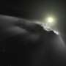

3I/ATLAS has caused quite a stir over the last year, inviting astronomers to update what they know about other solar systems as well as our own. However, this third interstellar visitor may have an unexpected impact on our understanding of dark matter. A new paper, available on the arXiv preprint server from researchers at the University of Hamburg, attempts to calculate the im...

