 |  | 

🌌 अंतरिक्ष समाचार | Space News
शनिवार, ०४/०७/२०२६ | Saturday, 04/07/2026

1. Doon University begins online registration for Hindu Studies
Read more
PIONEER EDGE NEWS SERVICE/Dehradun Doon University has begun the online admission registration process for candidates wishing to enroll in the Centre for Hindu Studies. The registration period for this MA course will conclude on July 31. The dean, Students Welfare of Doon University HC Purohit, who also is the coordinator of the Centre for Hindu Studies said for the Hindu Studies course, 20 seats have been allocated this year. Selection for these seats will be merit-based, according to candidates' graduation marks. He said that the Hindu Studies course was introduced at the university last year. Doon University is the first institution to offer such a programme in the State. Last year, although 20 seats were available, only seven were filled. However, this year, the university anticipates a greater number of students registering for the course, he added. Purohit said that candidates experiencing difficulties with the online registration for the said course can visit the university, where officials will assist them in completing the process He further stated that the course spans two years and consists of four semesters. Students will study various subjects, including the Vedas, Mahabharata, Ramayana and many other historical texts. This will equip students to explain the significance of Bharat Darshan and how human life can be improved through this knowledge.

2. MCD launches QRT for emergency sanitation & disaster response
Read more
PIONEER EDGE NEWS SERVICE/Dehradun The Municipal Corporation of Dehradun (MCD) on Friday launched its Quick Response Team (QRT) initiative to strengthen sanitation services and ensure a faster response during emergencies across the city. Under the initiative, five dedicated QRT vehicles have been deployed in different zones to provide immediate assistance during sanitation-related emergencies and disaster situations. The QRT vehicles were flagged off by Urban Development Minister Ram Singh Kaida, Dehradun mayor Saurabh Thapliyal and Dehradun municipal commissioner Alok Kumar Pandey. Addressing the gathering, Kaida said that the initiative is aimed at providing timely and effective emergency sanitation services to citizens while strengthening the city's overall sanitation management. He said that the teams would also play an important role in ensuring quick relief during natural disasters and other emergency situations. Thapliyal said that the MCD is consistently working to improve civic services and public convenience. He said that the QRT would help ensure quicker disposal of sanitation-related complaints and prompt action during emergencies, making Dehradun cleaner, safer and better organised. Pandey informed that each QRT vehicle is staffed with six trained personnel equipped with modern tools and essential resources, including grass-cutting machines, shovels, spades, pickaxes, crowbars, ropes, safety gear and other sanitation and disaster-management equipment. He said that citizens can access the service through the toll-free helpline 1800-180-4571 enabling immediate reporting of sanitation-related emergencies. The QRTs will undertake removal of debris and waste after road accidents and natural disasters, emergency cleaning of waterlogged areas and drains, sanitation support during fire incidents, special cleanliness drives at public places and additional sanitation arrangements during major public events. The teams will also respond to other urgent civic complaints requiring immediate attention, Pandey added. The deputy municipal commissioner Tanveer Marwah, chief municipal health officer Dr Anand Kumar Shukla, assistant municipal commissioner Rajbir Singh Chauhan and councillors were also present on the occasion.

3. Nasa's Swift boost mission begins as LINK spacecraft sets out to save observatory
Read more
NASA's Swift Boost mission has launched to extend the operational life of the Neil Gehrels Swift Observatory. (Image: Nasa) Nasa has successfully launched a first-of-its-kind rescue mission aimed at extending the life of one of its longest-serving space observatories. The mission sent a privately built spacecraft into orbit to rendezvous with the ageing Neil Gehrels Swift Observatory, which is gradually losing altitude and faces eventual destruction as atmospheric drag pulls it back toward Earth. The mission also marked the final flight of Northrop Grumman's Pegasus XL rocket, bringing an end to a launch vehicle that has served the space industry for more than three decades. LINK spacecraft begins historic servicing mission The Swift Boost mission lifted off on Friday (July 3) at 4.36 am EDT (2.06 pm IST), with the LINK servicing spacecraft developed by Arizona-based Katalyst Space Technologies.

4. Ghaziabad man held for sending bomb threat mail to ISRO headquarters in Bengaluru - The New Indian Express
Read more

BENGALURU: City police have arrested a 36-year-old man from Sanyog Nagar in Ghaziabad, Uttar Pradesh, in connection with a hoax bomb threat email sent to the Indian Space Research Organisation (ISRO) headquarters. Meanwhile, the space agency received another hoax bomb threat email on Friday. ISRO had received the first bomb threat email on Thursday morning. During questioning, police found that the accused, Nishant Tyagi, was undergoing treatment for mental illness. While the investigation into Thursday's bomb threat was underway, ISRO received another bomb threat email in Tamil on Friday. After a thorough search of the premises, the threat was confirmed to be a hoax. Police are now verifying whether the second email was also sent by Tyagi or by another individual. Tyagi had been arrested by the Delhi police on Thursday for allegedly sending hoax bomb threat emails claiming explosives had been planted at agencies, including NIA, DRDO, Nuclear Power Corporation of India Limited the Ministry of Civil Aviation (MoCA), and even on a flight.

5. ThePrint Off The Cuff with Pawan Kumar Chandana, ex-ISRO scientist and Founder & CEO of Skyroot Aerospace - ThePrint
Read more
ThePrint Off The Cuff with Pawan Kumar Chandana, ex-ISRO scientist and Founder & CEO of Skyroot Aerospace ThePrint

6. Heavy rain alert: Isro satellite spots multiple weather systems sweeping Gujarat - India Today
Read more
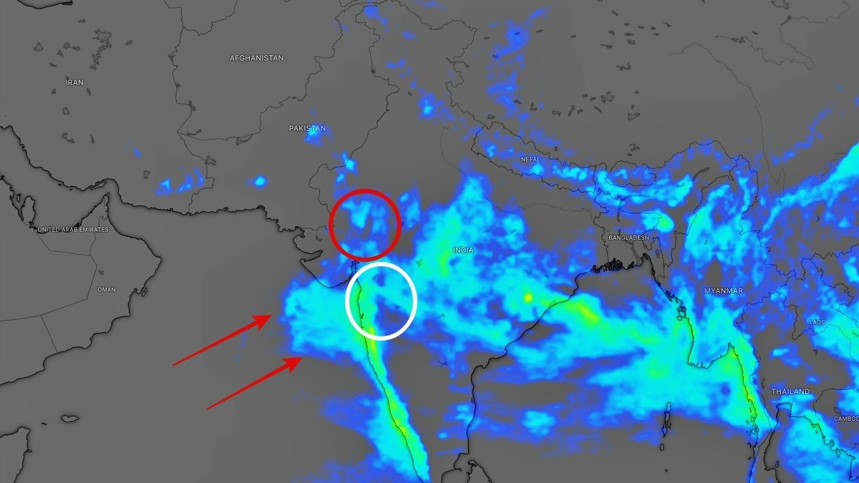
A massive weather system stretching across the Arabian Sea and western India has engulfed Gujarat, with satellite imagery on Thursday showing dense rain-bearing clouds covering much of the state. The cloud mass is expected to trigger widespread rainfall through the day, with several districts likely to receive heavy to very heavy showers. Latest satellite images reveal towering convective clouds extending from the Arabian Sea into Gujarat's coastline, signalling an active southwest monsoon over the region. Read Full Story The system is being fuelled by strong moisture-laden southwesterly winds, creating favourable conditions for intense rainfall across Saurashtra, South Gujarat, Central Gujarat and parts of North Gujarat. According to weather forecasts, rainy conditions will persist across most parts of the state, although the intensity is expected to vary from region to region. In Saurashtra, coastal districts including Gir Somnath and Junagadh are expected to experience rain from the morning itself, with heavy showers likely in several pockets as the day progresses. Porbandar and Jamnagar also remain under the threat of widespread rainfall, while rain activity is forecast to intensify during the afternoon and evening over Rajkot, Surendranagar, Amreli and Botad. South Gujarat is already witnessing widespread rainfall, with satellite observations showing thick cloud bands parked over the region. Heavy to very heavy rainfall is likely in parts of Surat, Navsari, Valsad, Dang and Tapi, raising the possibility of localised waterlogging and disruptions in low-lying areas. In North Gujarat, rainfall is expected to become more active from the afternoon and continue into the night. While light to moderate showers are likely across many districts, isolated areas could witness heavy rainfall as the weather system strengthens. Central Gujarat is also expected to receive widespread rain, particularly in districts bordering North Gujarat. Mahisagar, Dahod and surrounding areas are likely to witness persistent showers as moisture from the Arabian Sea combines with favourable atmospheric conditions. The only region expected to remain relatively less affected is Kutch, where only isolated light rain showers are forecast. Meteorologists say the extensive cloud shield visible in satellite imagery reflects an active phase of the southwest monsoon over western India. With abundant moisture continuing to flow in from the Arabian Sea, rainfall is expected to remain widespread across Gujarat through the day. - Ends

7. Aditya-L1 observes 'iron fluorescence' on Sun during massive solar flares: ISRO - thehitavada.com
Read more
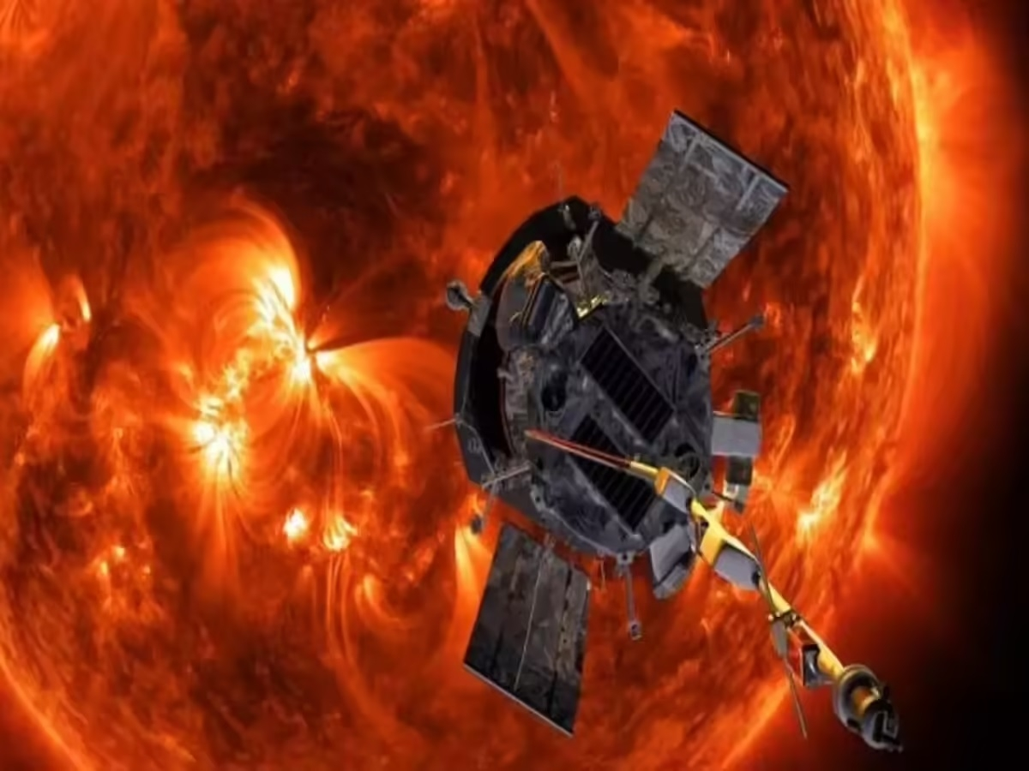
Aditya-L1 observes 'iron fluorescence' on Sun during massive solar flares: ISRO NEW DELHI : INDIA'S first space-based mission to observe the Sun, Aditya-L1, has observed "iron fluorescence" on the Sun during massive solar flares, according to a new study. The iron fluorescence phenomenon occurs due to the eruption of a huge solar flare, which heats the Sun's upper atmosphere (the corona) to extreme temperatures, releasing massive bursts of high-energy X-rays, the ISRO said in a statement on Friday. While most of these X-rays are emitted outward into space, a fraction travels downward, interacting with the Sun's cooler, denser surface layer called the photosphere, where they interact with abundant neutral iron atoms, which then emit their own characteristic X-ray glow or fluorescence. Aditya-L1's Solar Low Energy X-ray Spectrometer (SoLEXS) has the capability to detect this phenomenon. The study, published in the "Solar Physics" journal, revealed that the observed brightness of the iron fluorescence depends heavily on where the flare occurs on the Sun's disk. "Flares occurring near the centre of the Sun's disk, as viewed by the observer, showed a strong fluorescence signal, while the signal was heavily suppressed for flares occurring near the Sun's edge," the Indian Space Research Organisation (ISRO) said. The findings will now help researchers use the iron fluorescence as a potential diagnostic tool to probe the altitude of the coronal X-ray source high up in the solar atmosphere and study the unique viewing geometries of these explosive events.

8. NASA's Hubble Captures Crimson Cloud Sparkling with White, Blue Stars
Read more
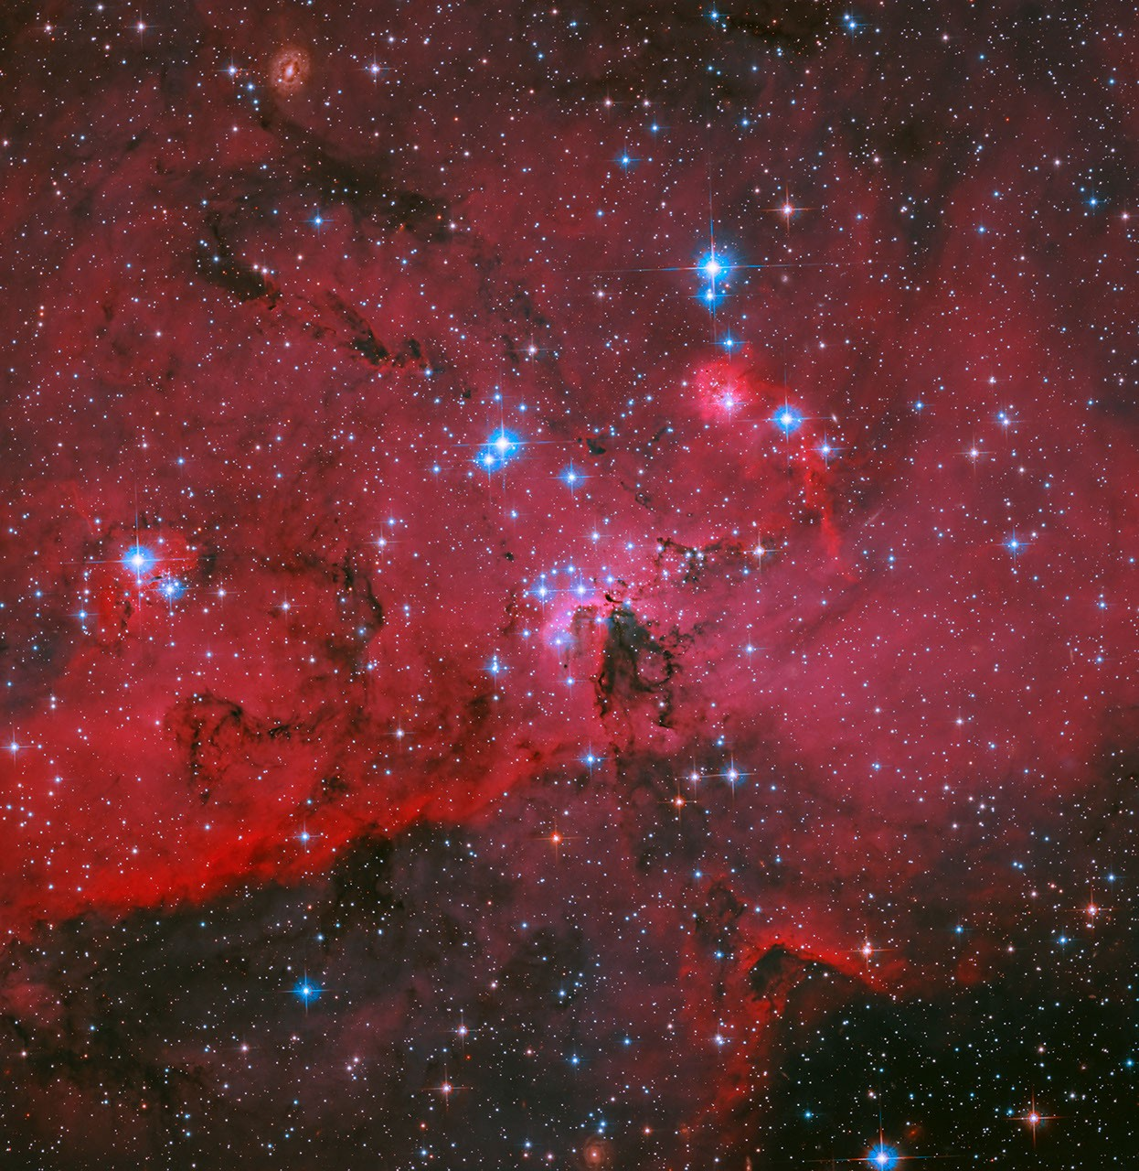
A glowing landscape of gas and dust is heated and illuminated by a thriving population of young stars in the LH 95 region of the Large Magellanic Cloud. NASA, ESA, and N. Da Rio (The University of Virginia), G. De Marchi (European Space Agency - ESTEC), and D. Gouliermis (Universitat Heidelberg); Processing: Gladys Kober (NASA/Catholic University of America) Like fresh fireworks launched against a background of dissipating smoke, blue and white stars shine brilliantly against a crimson background of glowing gas in this image of stellar nursery LH 95 from NASA's Hubble Space Telescope. LH 95 is a region in the Large Magellanic Cloud, a dwarf galaxy that orbits the Milky Way. Low-mass infant stars live alongside massive blue giant stars in what is known as a stellar association, one of many in the Large Magellanic Cloud. The LH 95 region's most massive stars, possessing at least three times the mass of the Sun and visible here as the largest and brightest blue stars, expel ultraviolet radiation and stellar winds that both heat and shape the surrounding hydrogen gas. Dark filaments stand out in sharp contrast against the glowing hydrogen where denser dust lanes resist erosion. In this image, blue indicates the shorter wavelengths that are visible light, while red depicts the longer wavelengths of visible light, as well as some near-infrared light. Colors in Hubble images are chosen based on standard image processing techniques to best represent the wavelengths of light that pass through the filters used in the observation. The gas of the nebula glows crimson due to hydrogen-alpha emissions. Hydrogen-alpha is an excellent indicator of star formation, allowing astronomers to identify very young stars embedded in this glowing gas. Researchers found developing stars still gathering material from the disks of gas and dust around them. In fact, LH 95 is home to an extraordinary 2,500 stars that have accumulated almost all of their critical mass but have not yet "turned on" by beginning fusion reactions. These stars, called "pre-main-sequence stars," have formed from collapsing clouds of gas and are still contracting. They will soon begin burning hydrogen in their cores to become full stars. By studying these forming stars, researchers confirmed that the stars' accretion rate ― the rate at which they accumulate matter ― decreased with age, as expected. However, they also learned that accretion can persist for several million years, longer than sometimes assumed. This information helps refine our understanding of how young stars keep growing and how their disks evolve. Researchers noted that distinct generations of stars in LH 95 exist side-by-side, indicating that rather than forming stars in a single event, the region produces multiple stellar generations over an extended period. The most massive star in LH 95 (above center, slightly left) has about 60-70 times the mass of the Sun and is about a million years younger than the rest of stars in the system, which appear to be around 4 million years old. Massive stars like these burn through their fuel quickly and die in supernova explosions. With its rich stellar population, LH 95 is valued by astronomers for providing a way to observe forming stars at relatively close range in an environment with less obscuring dust than similar regions of the Milky Way. As one of NASA's flagship observatories, Hubble has produced a wealth of scientific discoveries over more than 30 years in orbit. Its observations are expanded upon and enhanced by observations with other NASA missions, including the infrared-detecting Webb Space Telescope and the upcoming Nancy Grace Roman Space Telescope, which is scheduled to launch in late summer. Explore More Media Contact: Claire Andreoli NASA's Goddard Space Flight Center, Greenbelt, MD claire.andreoli@nasa.gov

9. NASA's Hubble Spots Star-Spangled Cosmic Scene
Read more
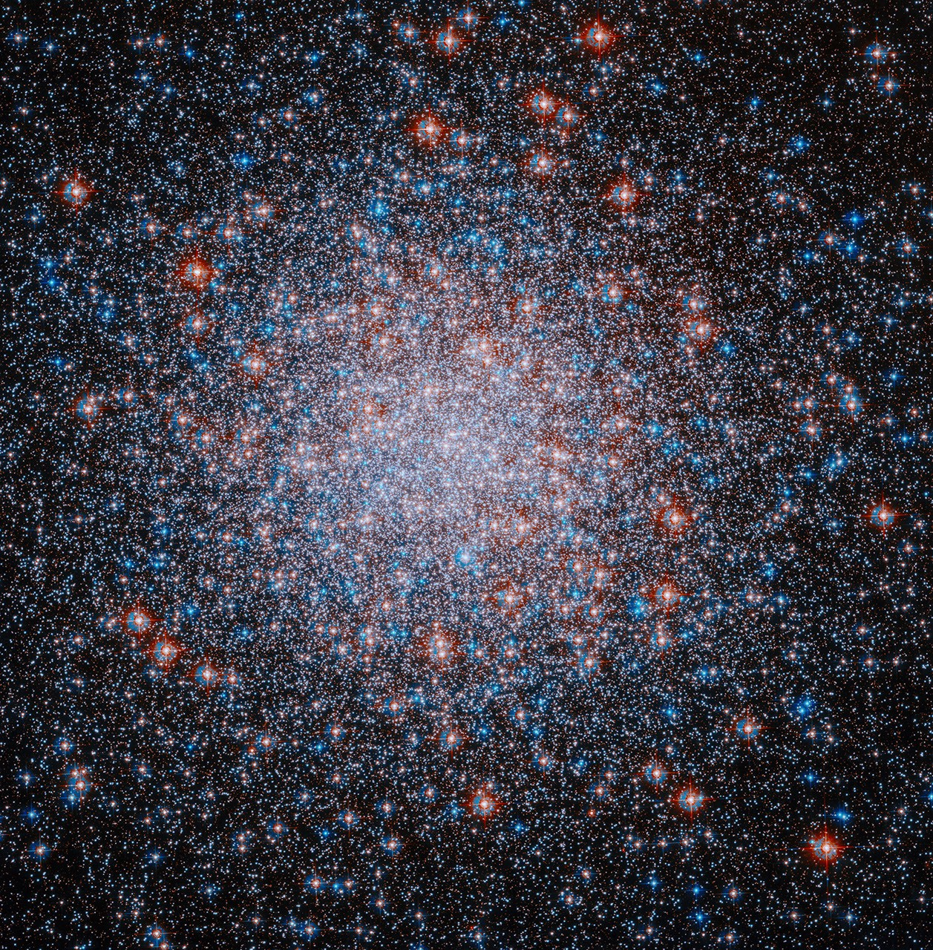
This image from NASA's Hubble Space Telescope shows Messier 3, a densely packed cluster of stars whose origins may be a merger between globular clusters in the early universe. NASA, ESA, and A. Sarajedini (Florida Atlantic University); Processing: Gladys Kober (NASA/Catholic University of America) More than 500,000 stars blaze red, white, and blue in this image from NASA's Hubble Space Telescope, released in celebration of the United States' 250th anniversary. The image showcases Messier 3 (M3), one of the Milky Way galaxy's most massive globular clusters, or spherical collections of gravitationally bound stars. Globular clusters are made up of ancient stars that formed at roughly the same time from the same cloud of gas, giving those stars similar ages. Around 150 known globular clusters are sprinkled around the outer regions of the Milky Way. In addition to its significant mass, M3 is unusual because it lies relatively far from the galactic center and has more than 240 RR Lyrae variable stars, the most of any globular cluster in our galaxy. RR Lyrae variables are some of the galaxy's oldest stars and are of special interest to astronomers, due to their age and because their light fluctuates over time in a way that tells us their intrinsic brightness. This true brightness can be used to measure distances in the cosmos, just as knowing the brightness of car headlights on a dark road can help estimate the distance to an oncoming vehicle. The M3 globular cluster also contains around 70 identified "blue straggler" candidates, which are stars that shine with a bright, blue light that makes them look like younger stars than the typical, redder residents of globular clusters. This was the first cluster in which these oddball stars were located. These stars are thought to have gravitationally pulled mass from companion stars, rejuvenating them and making them appear bluer and younger despite their true age. The unusual characteristics of M3 may arise from its origins. The globular cluster, which contains two distinct populations of stars, may be the result of a merger of two globular clusters. These two clusters were members of the same dwarf galaxy, which was later swallowed up by the Milky Way. Hubble has taken several images of M3, also known as NGC 5272, documenting its complicated and intriguing characteristics. In this image, blue indicates the shorter wavelengths that are visible light, while red depicts the longer wavelengths of visible light, as well as some near-infrared light. Colors in Hubble images are chosen based on standard image processing techniques to best represent the wavelengths of light that pass through the filters used in the observation. Because the color and temperature of stars are directly related, we know that the blue stars in this image are hotter and the red stars are cooler. This image is part of a Hubble Treasury program survey designed to observe approximately half of the Milky Way's globular clusters to construct a detailed chronology of how the Milky Way galaxy formed. With over 30 years of observations, Hubble is one of NASA's flagship observatories and works in complement with its sibling space missions, including the infrared-detecting Webb Space Telescope and the upcoming Nancy Grace Roman Space Telescope, to weave together a comprehensive picture of our vast universe. Explore More Media Contact: Claire Andreoli NASA's Goddard Space Flight Center, Greenbelt, MD claire.andreoli@nasa.gov

10. NASA's Hubble spots star-spangled cosmic scene
Read more
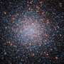
More than 500,000 stars blaze red, white, and blue in this image from NASA's Hubble Space Telescope, released in celebration of the United States' 250th anniversary. The image showcases Messier 3 (M3), one of the Milky Way galaxy's most massive globular clusters, or spherical collections of gravitationally bound stars. Globular clusters are made up of ancient stars that formed ...

11. Could this asteroid be a piece of the moon? A Chinese spacecraft is about to find out
Read more
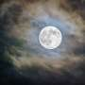
The moon is not the only natural object traveling through space alongside Earth. Several small asteroids travel around the sun in near lockstep with our planet. And just like Earth, these space rocks also take a year to complete a full orbit. Today, we know of eight such "quasi-moons" or quasi-satellites.

12. Rescue mission launches to save NASA telescope that's falling back to Earth
Read more
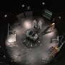
A three-armed spacecraft rocketed into orbit Friday to rescue a NASA telescope that's in danger of crashing back to Earth.

