 |  | 

🌌 अंतरिक्ष समाचार | Space News
मंगलवार, ०४/०८/२०२६ | Tuesday, 04/08/2026

1. Celebrating launches, neglecting the institution: ISRO's quiet crisis - Counterview
Read more
Celebrating launches, neglecting the institution: ISRO's quiet crisis Counterview

2. Space technology to shape India's next growth story: ISRO scientist | Hindustan Times - Hindustan Times
Read more
Space technology is set to become one of the major pillars of India's scientific advancement, economic growth and national development, senior ISRO scientist Prof Amitabh Singh said on Monday, stressing that innovations in the sector would play a crucial role in achieving the vision of a Viksit Bharat. Space technology is set to become one of the major pillars of India's scientific advancement, economic growth and national development, senior ISRO scientist Prof Amitabh Singh said on Monday, stressing that innovations in the sector would play a crucial role in achieving the vision of a Viksit Bharat. (Representational image) Addressing the inaugural session of a Faculty Development Programme (FDP) on "AI-Enabled Teaching, Learning, Assessment and Academic Research" at Maharshi Dayanand University (MDU), Prof Singh said the role of the Indian Space Research Organisation (ISRO) had expanded far beyond space exploration, with its technologies now transforming critical sectors including agriculture, communication, navigation, weather forecasting and disaster management. He said space-based technologies were creating new opportunities for research, innovation and technology-driven startups, while strengthening India's capabilities in self-reliance and advanced scientific applications. Prof Singh, chairman of the Planetary and Space Science Data Processing Division and a senior scientist associated with the Venus Orbiter Mission at the Space Applications Centre (ISRO), Ahmedabad, highlighted India's achievements in the Chandrayaan missions and discussed the country's future roadmap for lunar and planetary exploration. Presiding over the programme, MDU vice-chancellor Prof Milap Punia said India's success in space science reflected the country's growing strength in research, innovation and technological self-reliance.

3. After Skyroot's Big Win, Indian Space Startups Bag $871 Million Funding - NDTV
Read more
After Skyroot's Big Win, Indian Space Startups Bag $871 Million Funding NDTV

4. ISRO launches on hold as government approval delays NVS-03 and GISAT-1A missions at Sriharikota - Moneycontrol.com
Read more
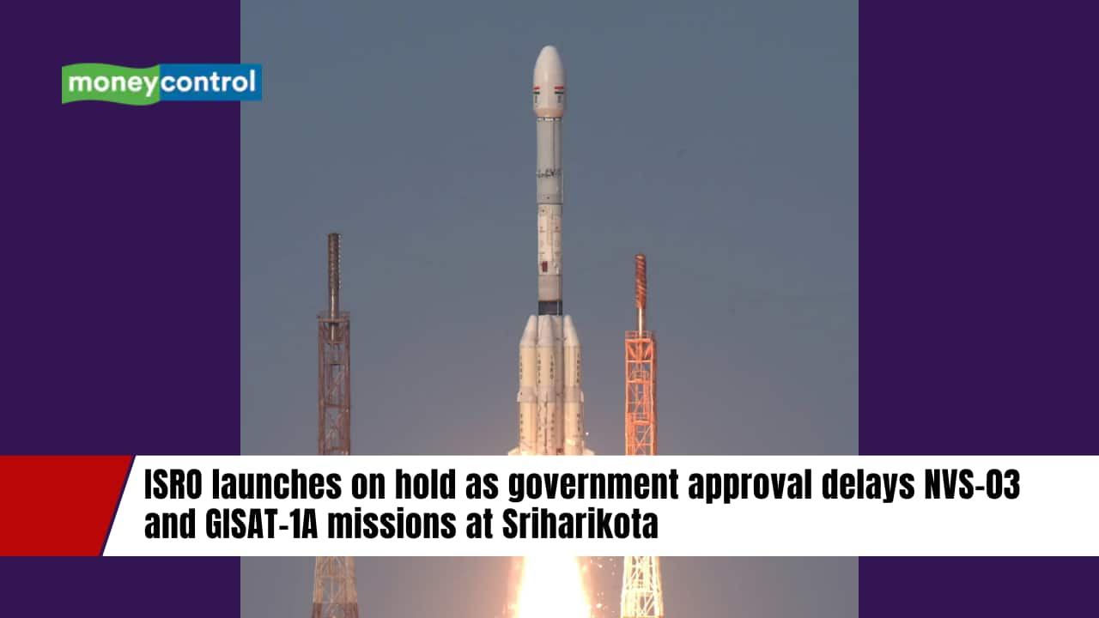
ISRO launches on hold as government approval delays NVS-03 and GISAT-1A missions at Sriharikota (image: nextspaceflight.com) India's space program faces launch delays. NVS-03, GISAT-1A await government approval. Delays follow two PSLV mission failures. Did our AI summary help? Liked this AI Summary? Join our AI Workshop Register FREE India's space programme is facing an unexpected pause, with two strategically important satellites awaiting government approval for launch despite being ready for flight. The Indian Space Research Organisation (ISRO) has completed most pre-launch preparations for NVS-03 and GISAT-1A, but both missions remain on hold at the Satish Dhawan Space Centre in Sriharikota. According to sources, a GSLV Mk-II rocket assigned to one of the missions is also waiting at the launch site. Propellant filling had reportedly begun but was halted after launch clearance did not arrive, leaving the vehicle in standby mode. The delay comes amid heightened caution following two unsuccessful Polar Satellite Launch Vehicle (PSLV) missions over the past year. Why are the launches delayed? The current hold-up follows the failures of PSLV-C61 in May 2025 and PSLV-C62 in January 2026. While ISRO has acknowledged anomalies in the third stage of both missions, detailed investigation reports have not been released publicly. MC Science Desk Read the latest and trending science news-stay updated on NASA, ISRO, space missions, planets, asteroids, black holes, AI, quantum physics, galaxy discoveries, and more exciting breakthroughs.

5. Why Two Crucial ISRO Satellites Are Still Waiting For Government Clearance To Launch? - timesofindia.indiatimes.com
Read more
Two of ISRO's strategically important satellites, NVS-03 and GISAT-1A, are reportedly ready for launch but remain grounded as they await government approval. According to a Times of India report, the delay follows two failed PSLV missions in 2025 and 2026, even though the upcoming launches involve a different rocket family. The hold-up has reportedly paused India's next strategic space missions, including strengthening the NavIC navigation constellation and deploying a near real-time Earth observation satellite for disaster management, agriculture and national security.

6. CNN dives into how Elon Musk and Jeff Bezos are backing NASA's race to the moon against China (exclusive clip)
Read more
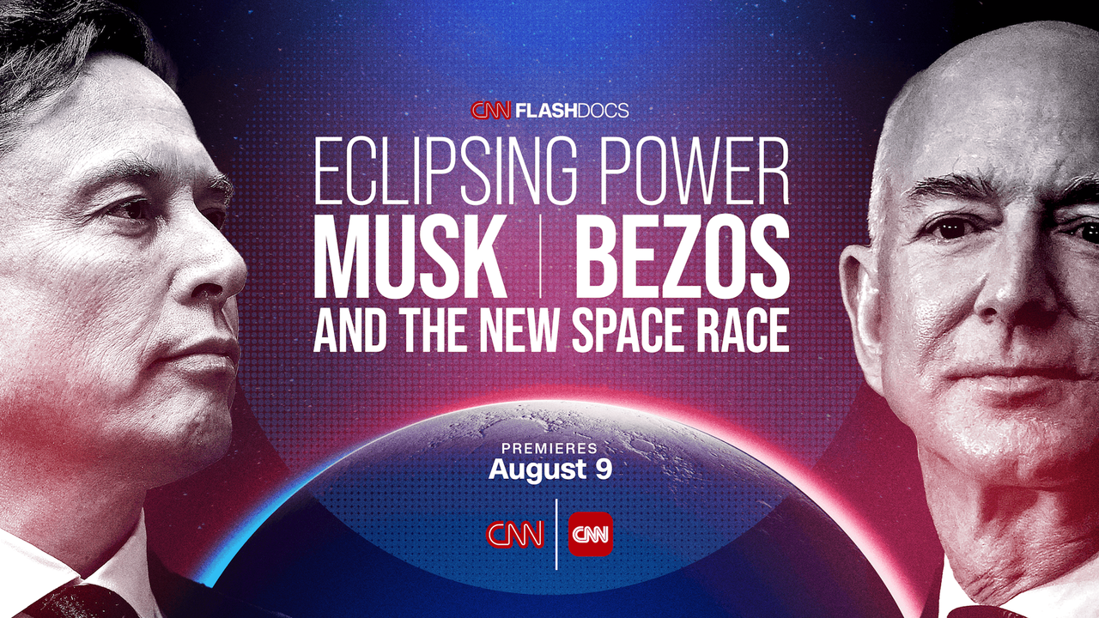
Click for next article The great technological leaps in American history have often featured influential industrialists who step forward as vanguards, leading the way to a better tomorrow while emerging as major players in extreme endeavors. Spaceflight is no exception. A new CNN documentary titled "Eclipsing Power: Musk, Bezos, and the New Space Race" shines a light on how a pair of visionary billionaires, Elon Musk and Jeff Bezos , have been shaping and steering our country's space program and the bright future of private space enterprise . Premiering on Sunday (Aug. 9) at 8 p.m. EDT/PDT on CNN, the documentary examines the contributions of the two men and how their considerable wealth have affected America's spaceflight efforts. It also features exclusive interviews with Chief Ambassador of The Planetary Society Bill Nye , NASA Administrator Jared Isaacman , journalist and CNN contributor Kara Swisher, Elon Musk biographer Walter Isaacson and many others. "'Eclipsing Power' traces how Elon Musk and Jeff Bezos have transformed the future of space exploration, shifting what was once an endeavor primarily led by government into a race driven by private ambition," states the show's official synopsis. "It follows the rise of SpaceX and Blue Origin , detailing how two of the world's most influential entrepreneurs have come to play an outsized role in America's space program. The hour looks at both the opportunities and the risks of NASA's growing reliance on private industry, the race to return humans to the moon , and what this new era of commercial spaceflight could mean for the future of humanity." Why Bill Nye is excited for the future of space exploration 🪐 - YouTube Watch On "What am I most excited about in space exploration?," Nye shares in our exclusive clip. "Well, for me, discovering evidence of life elsewhere . Maybe the rocks on Mars . Maybe under the ice on Europa , the moon of Jupiter with twice as much ocean water as Earth. Maybe Enceladus or Titan . It would change the course of human history. We'll see you up there!" CNN's FlashDocs division offers provocative storytelling on topical issues shaping society and culture. Former FlashDocs programs have included "Bad Bunny and the Halftime Show: Rhythms of Resistance" and "Behind the Bob: Vogue's Anna Wintour." Executive produced by Eric Johnson alongside CNN Studios' Amy Entelis and Katie Hinman, "Eclipsing Power: Musk, Bezos, and the New Space Race" will first stream exclusively at CNN.com/Watch and on the CNN app beginning on Friday (Aug. 7) and has its broadcast debut on Sunday at 8 p.m. EDT on CNN.

7. A SpaceX rocket will crash into the moon this week. Why is it on a collision course?
Read more
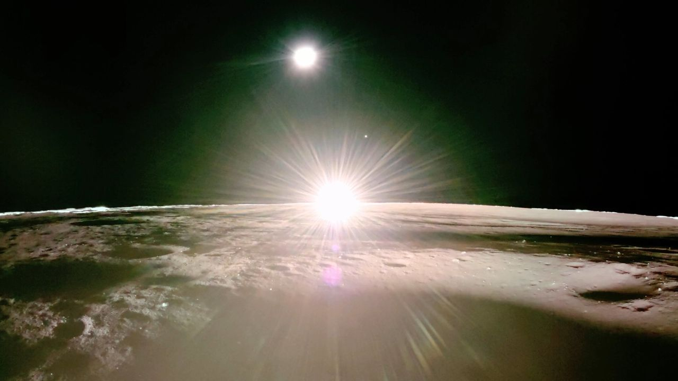
Click for next article Firefly Aerospace's Blue Ghost moon lander captured this view of a lunar sunset on March 16, 2025. The upper stage of the SpaceX Falcon 9 rocket that sent Blue Ghost to the moon is set to slam into the lunar surface on Aug. 5, 2026. This rocket wasn't supposed to die so dramatically. On Wednesday (Aug. 5) at about 2:35 a.m. EDT (0635 GMT), the upper stage of a SpaceX Falcon 9 rocket will slam into the moon , blasting out a crater about 89 feet (27 meters) wide. The rocket body has been loitering lazily high above Earth for more than 18 months. What jolted it out of its unremarkable senescence and put it on a kamikaze course for the moon ? It didn't take much, as the rocket regularly crossed into the moon's neck of the woods. The Falcon 9 launched in January 2025 , carrying aloft two private robotic lunar landers - Firefly Aerospace's Blue Ghost and Resilience, which was built by the Tokyo-based company ispace. (Blue Ghost landed successfully and carried out its historic mission, but Resilience crashed during its touchdown attempt.) Falcon 9 first stages are famously reusable , but the vehicle's upper stages fly just once. SpaceX usually deorbits these rocket bodies shortly after launch, guiding them back for controlled destruction in Earth's atmosphere . That wasn't possible on the Blue Ghost-Resilience launch, however, as getting the lunar probes to their distant deployment point used up almost all of the upper stage's fuel. As a result, the 8,800-pound (4,000 kilograms) rocket body "was abandoned in a moon-crossing high-Earth orbit," according to a recent study about the coming impact led by Benjamin Fernando of Los Alamos National Laboratory in New Mexico. A SpaceX photo of one of the company's Falcon 9 upper stages, taken in 2022. A similar second stage is expected to impact the moon on Aug. 5, 2026. (Image credit: SpaceX) SpaceX performed "a different maneuver [than deorbiting] to ensure that the second stage itself is safe per the appropriate rules and regulations," Julianna Scheiman, director of NASA science and Dragon programs at SpaceX , said today (Aug. 3) during a press conference discussing the company's Crew-13 astronaut launch to the International Space Station , which is targeted for Sept. 12. That maneuver did not lock the hunk of space junk into a stable location, however; natural forces still acted upon it and, it turns out, changed its trajectory. "What has happened is, essentially, a mixture of solar activity and gravity forces have put it on a path towards the moon," Scheiman said. Astronomers and lunar scientists are looking forward to the upcoming impact , even though it will occur on the sunlit side of the moon and therefore likely won't be visible to most observers here on Earth (though skywatchers with good telescopes might be able to catch a glimpse of the resulting ejecta plume). The event "provides an opportunity to test pipelines for measuring flash properties to locate impact events seismically, and to better understand the multi-modal hazards posed to future lunar infrastructure and astronauts from space debris impacting the moon," Fernando and his colleagues wrote in their paper. Those hazards won't be purely hypothetical for much longer, if all goes to plan: NASA aims to build a base near the moon's south pole over the coming decade via its Artemis program , and to keep that outpost staffed over the long haul. Scheiman said that SpaceX is looking into ways to minimize the chances that spent rocket bodies could rain down on an occupied moon in the future. "It's one of the things that we're working in partnership with NASA and the other appropriate agencies," she said. "What is the best future disposal path for high-energy missions that are in the sun -Earth-moon system?" The double crater created on the moon by the March 2022 crash of the upper stage of China's Long March 3C rocket. (Image credit: NASA/Goddard/Arizona State University) This Falcon 9 won't be blazing an entirely new trail to the moon. The third stage of NASA's Saturn V moon rocket struck the lunar surface on multiple Apollo missions, for example. And, on March 4, 2022, a mysterious rocket body slammed into the moon, blasting out a weird double crater.

8. AI is ready to run spacecraft. Is the space industry ready for it? (op-ed)
Read more
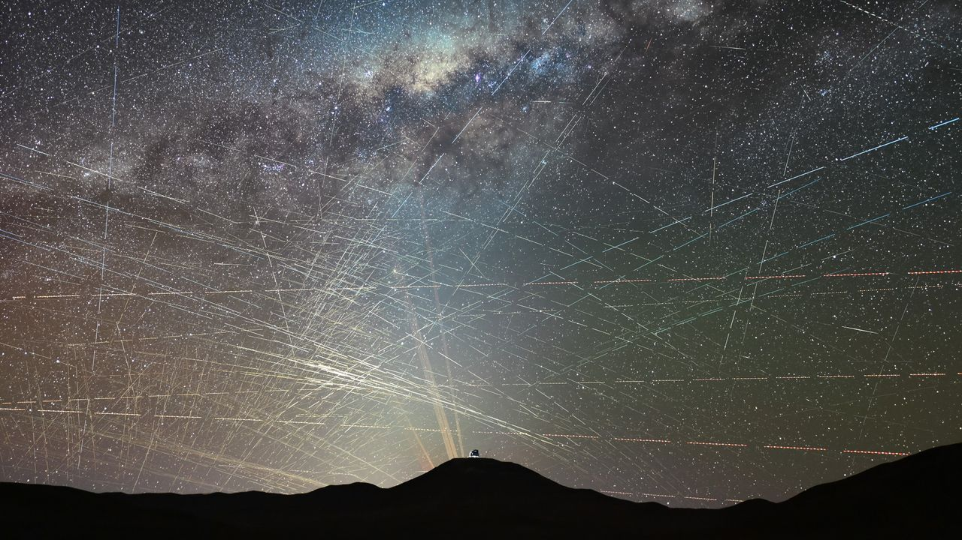
Click for next article There are now about 16,000 active satellites in Earth orbit, but as many as 70,000 more could launch in the next five years alone. Martin Halliwell is a Partner at NewSpace Capital, one of the world's first private equity firms devoted exclusively to growth-stage companies working in the space technology sector. He formerly served as Chief Technology Officer of SES, where he led global technology and R&D from 2011 to 2019. Halliwell contributed this article to Space.com's Expert Voices section. There are now some 16,000 active satellites in orbit. Market intelligence firms like Novaspace say that up to 43,000 satellites will be built and launched over the coming decade. Others, such as Goldman Sachs, think as many as 70,000 new low-Earth orbit (LEO) satellites could be launched in the next five years alone. The exact number is less important than what these predictions reveal: that satellite constellations are getting bigger. This is a good thing. Space is a crucial enabling force in the modern world, touching just about every part of ordinary life. But as these constellations grow , it will become increasingly difficult for human operators to run them. A network of a few satellites can be managed from the ground; a network of hundreds, or even thousands, cannot be managed in the same way. These satellites must share data, avoid interfering with one another, meet changes in customer demand, and deal with technical problems. Some decisions must be made in seconds, without waiting for instructions from Earth . This is why onboard processing, automation and artificial intelligence are becoming all-important. Satellites will need to sift through and analyze more information in orbit, then act within clear limits set by human operators. In-orbit processing One major use for AI will be processing data in orbit. At present, most satellite data is sent back to Earth before it is cleaned, sorted and analyzed. Earth-observation companies, for example, may collect huge amounts of imagery to track weather, crops, disasters, land use or emissions. They must then process all of it on the ground before they can give customers useful information. If satellites can do more of this work in orbit, they can send back only the data that matters. This would cut costs and save time. In defense, where speed can decide the outcome, it could help people act much faster. Onboard processing could also reduce reliance on ground systems, which may themselves be attacked or disrupted. Satellites remain vulnerable , but moving some analysis into orbit could make the wider system more resilient. A rendering of one of SpaceX's planned "Starmind" AI satellites in orbit. (Image credit: SpaceX) Moving capacity Satellites must be able to spot patterns, respond to changes and adjust their plans in near real time. This makes them well suited to AI. One important use is managing network capacity. Demand for satellite bandwidth is always changing. It may rise over cities at busy times, around major events, in disaster zones, on aircraft and ships or during military operations . AI could track these changes and decide where a satellite's beams should point, how much power each beam should use and when capacity should be moved elsewhere. This would help satellite networks send more capacity to places where it is needed most, instead of sending the same amount to the same places all the time. The result would be a more efficient use of the satellite's limited power and available spectrum. What if AI gets it wrong? The barriers are not only technical. They are also legal and organizational. Most laws, contracts, insurance policies and operating rules were written for systems controlled by people. They assume that a named person makes each important decision. AI makes responsibility less clear. If an AI system points a beam at the wrong place, disrupts another service or causes damage, it may be difficult to decide who is at fault: the satellite operator, the manufacturer or the software company. Operators must also decide how much control they are willing to give to AI. Many are happy for AI to offer advice. Fewer are ready to let it change a network or move capacity without human approval. For this reason, adoption is likely to be gradual. Operators will need clear rules about which decisions AI can make by itself and which must still be approved by a person. Spacecraft design and manufacturing AI will affect more than the way satellites are operated. It could also help engineers design and build them more quickly. Engineers can use AI to write code, search technical documents, test ideas and suggest solutions to design problems. It could produce early versions of spacecraft structures, antennas, power systems, payloads or mission plans. Human engineers would still need to check, test and improve the work, but they would not always have to start from scratch. This could shorten development times, cut costs and allow smaller teams to do work that once required much larger organizations. AI could also help in factories by spotting faults, predicting delays and showing when equipment needs maintenance. It will not replace skilled engineers. Its main value will be in doing routine work quickly, so people can spend more time on difficult decisions, safety and the hardest technical problems. Building trust To unlock AI's full value, the industry will need secure, affordable environments in which organizations can train and deploy models without losing control of information. These environments need strong cyber security, clear access rules and ways to keep each organization's data separate. Some models may need training inside company or government networks so sensitive data never leaves. Technical safeguards will help, but trust matters, too. The industry will also need better standards, clearer legal responsibility and reliable testing. The technology itself is advancing quickly. The harder task is creating the rules, safeguards and confidence needed to use it. AI may soon be ready to run more of a satellite network. The question is how quickly the industry will be ready to let it.

9. Spaceflight could change how astronauts swallow, eat and drink in subtle ways
Read more
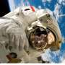
Imagine trying to swallow a sip of water while your face feels stuffed with congestion, your sense of taste is dulled and your body is floating 250 miles (400 kilometers) above Earth.

10. Memory chips cut computing power 59-fold, may trim satellite weight by 2,000 pounds
Read more
A custom SRAM-based chip design could cut the computing power needed by future space telescopes by nearly 59 times, potentially making it easier to image Earth-like planets around distant stars. Researchers at the University of Michigan designed two memory-centric chip architectures for future telescopes that need to process huge amounts of data in real time. Their strongest design uses static random-access memory, or SRAM, and could reduce computing power from about 3,000 watts for a conventional GPU-based system to just 51 watts. That difference matters in space. Lower computing power means smaller solar panels, batteries and cooling systems, reducing the overall mass of a spacecraft. The researchers studied their designs in the context of NASA's proposed Habitable Worlds Observatory, a space telescope intended to search for signs of life on planets outside our solar system. Such a telescope would need to constantly correct tiny optical distortions to block out the light from stars and reveal much fainter planets nearby. The problem is not simply a lack of computing power. Moving data between memory and processors can consume more energy than performing the calculations themselves. Memory moves drive costs "The key insight of our research is that future space missions don't just need more computing power; they need the right kind of computing power. For these workloads, the bottleneck is moving data, not doing calculations," said Nathaniel Bleier, an assistant professor of computer science and engineering at U-M and co-corresponding author of the study. To address that bottleneck, the team developed two architectures. One uses 27 high-bandwidth memory chips, with each chip built from a stack of 16 dynamic random-access memory chips, connected to a custom processor. The second design takes a different approach. It divides processing and data across 56 custom chiplets, each containing about 2 GB of distributed SRAM. Instead of repeatedly moving data back and forth to a processor, the architecture places memory and computing resources closer together. The researchers simulated the chips using Synopsys Design Compiler to evaluate their power consumption, performance, and physical size. They also tested how the designs could handle radiation-induced errors, running 10,000 simulations in which cosmic radiation flipped binary values during calculations. Less power means lighter spacecraft The SRAM design initially reduced power demand to 90 watts. By using a mathematical technique to reduce the precision of some data, the researchers brought that figure down to 51 watts without compromising the system's ability to detect dangerous computational errors. That 51-watt requirement is about 59 times lower than the 3,000-watt GPU-based setup evaluated in the study. The researchers estimate that the reduction could cut spacecraft mass from roughly 2,425 pounds (1,100 kg) to 425 pounds (193 kg). The difference could have a major effect on mission costs. Using established aerospace calculations, the team estimates that the lower spacecraft weight could save about $430 million over a 25-year mission. "We want computing to expand what space science can achieve, not set the limit. By designing hardware around the workloads, we can make the real-time processing required by future missions practical," said Barry Lyu, a doctoral student of electrical and computer engineering at U-M and co-corresponding author of the study. The team plans to manufacture the SRAM chiplets next and test them in a laboratory, moving the design from simulation toward physical hardware.

