 |  | 

🌌 अंतरिक्ष समाचार | Space News
गुरुवार, ३०/०७/२०२६ | Thursday, 30/07/2026

1. ISRO Conducts START Capacity Building Workshop-2026 at IIRS, Dehradun - ISRO
Read more
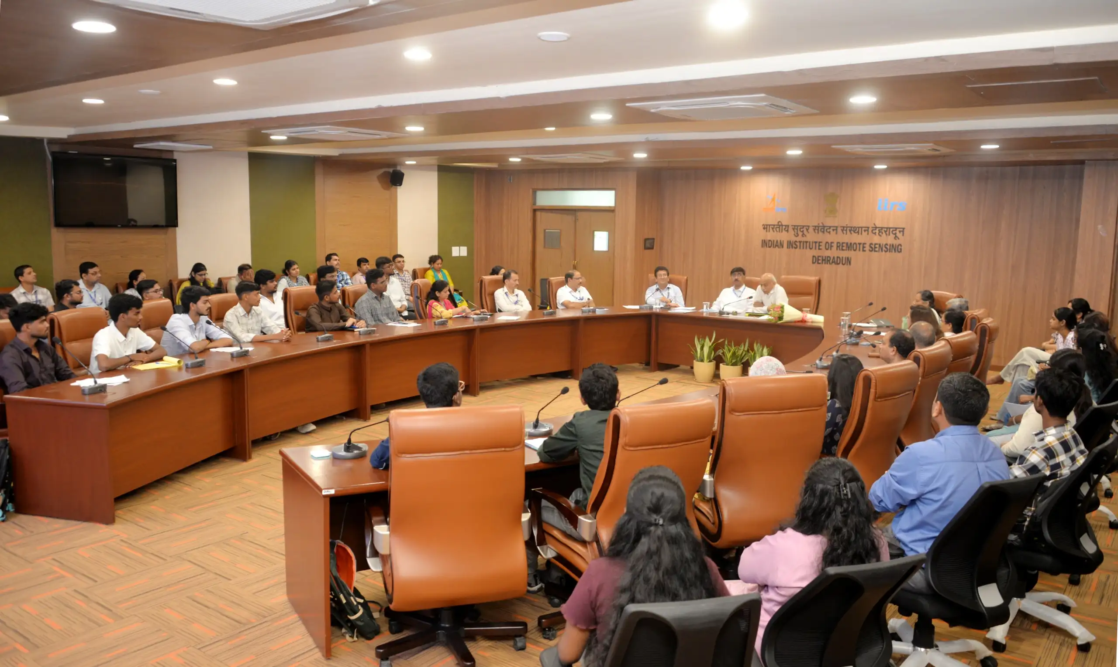
July 29, 2026 Inaugural session of the ISRO-START Capacity Building Workshop - 2026 on July 27, 2026 During July 27 to July 31, 2026, ISRO is conducting the concluding session of the ISRO-START-2026 programme, through the newly conceived ISRO-START Capacity Building Workshop at IIRS, Dehradun, benefiting 50 students, which include 12 research fellows from IIRS, Dehradun. Among them, 38 students, from the undergraduate and post-graduate levels, have been selected from the toppers of the ISRO-START-2026 online examination, through a stringent set of criteria, representing multiple states of India. The event was inaugurated by Shri. A S Kiran Kumar, Member, Space Commission and former Secretary, DOS / Chairman, ISRO, in the presence of Dr. R.P. Singh, Director of IIRS, Dehradun, Dr. Tirtha Pratim Das, Director, Science Programme Office, ISRO Headquarters, Dr. Harish Karnatak, Head, GIT-DL, IIRS, and the senior faculty members of IIRS. Left: Experiments on Infra-Red Remote Sensing; Right: Hands-on session on Land Surface Temperature analysis using satellite data The ISRO-START Capacity Building Workshop-2026 comprises several components like advanced lectures on space science & applications, interactions with senior scientists of ISRO / Department of Space, physical demonstration of scientific concepts (IR remote sensing, Raman Spectroscopy, etc.), hands-on exercise on satellite data analysis, as well as project work. The students, hailing from different states of the country, are made to team up, and deliver the project-deliverable. This rigorous engagement enhanced the awareness of the students about the space-based techniques, and may initiate some of them to pursue their career in the domains of space science and technology. ISRO has been conducting the START programme since year 2023, each year presenting a unique theme in the realm of space science and technology, with around 20 to 25 specially curated lectures delivered by the pan-India experts, targeting the undergraduate and post-graduate students in science, technology and engineering. A programmatic connection has also been established between ISRO-START and ISRO's biennial scientific meet 'National Space Science Symposium', where selected students among the toppers of the START examination attend a specially curated students' session for closer mentoring and idea exchange. The START-2023 lectures, on the theme of 'Overview of Space Science and Technology', have been included as a credit course by the AICTE. The theme of START-2026, conducted during March 11 to April 2, 2026, has been 'Scientific Observations from Space' which was inaugurated by Secretary, DOS / Chairman, ISRO on March 11, 2026. The START programme, so far, has cumulatively benefited about 1.6 lacs of students, faculty members, as well as space enthusiasts.

2. ISRO Recruitment 2026: 244 Posts, Apply Online by August 16 - PW
Read more
The Indian Space Research Organisation has opened the online application window for 244 vacancies across administrative and support cadres, and the clock is already running. The ISRO Recruitment 2026 notification, issued through the ISRO Centralised Recruitment Board (ICRB), covers the posts of Assistant, Junior Personal Assistant (JPA), Upper Division Clerk (UDC) and Stenographer. Candidates who meet the eligibility criteria can submit the ISRO online application 2026 through the official website, isro.gov.in, until August 16, 2026. This is one of the larger non-technical hiring drives announced by the space agency this year, and it is aimed squarely at graduates rather than engineers - which is precisely why it is expected to draw a very heavy volume of applications from across the country. ISRO Vacancy 2026: Post-Wise Breakdown According to the ISRO Recruitment 2026 notification PDF, the vacancy distribution is as follows: Assistant - 113 posts Junior Personal Assistant (JPA) - 81 posts Upper Division Clerk (UDC) - 22 posts Stenographer - 10 posts In addition to the above, other ISRO units have notified 17 Assistant posts and one Junior Personal Assistant post, taking the total ISRO 244 posts recruitment count to 244 vacancies. ISRO Eligibility Criteria 2026: Qualification and Age Limit Applicants must hold a bachelor's degree from a recognised university with a minimum of 60 per cent marks, or a CGPA of 6.32 on a 10-point scale. Importantly, the degree must have been completed within the duration prescribed by the university - a condition that candidates with extended or backlog-delayed courses should read carefully before applying. The maximum age limit is 28 years as on August 16, 2026. Age relaxation will be granted as per Government of India norms: OBC candidates may apply up to 31 years SC and ST candidates applying against reserved vacancies are eligible up to 33 years Relaxation is also available to eligible government employees, ex-servicemen, persons with disabilities, meritorious sportspersons, widows, divorced women and women legally separated from their husbands who have not remarried ISRO Recruitment 2026 Application Fee The prescribed application fee is Rs 100. However, every candidate must additionally pay a processing fee of Rs 500 at the time of submitting the online application. Payment can be made only through the Bharatkosh e-Payment gateway, and the payment link becomes active only after the application form has been filled in. Candidates are advised not to close the browser window mid-transaction, as the fee step is sequential and linked to the completed form. ISRO Selection Process 2026: Written Exam and Skill Test The selection process begins with a written examination to be conducted at 38 centres across India. It will comprise a single objective-type paper of 150 minutes' duration. Candidates who clear the written examination will be shortlisted for a skill test. ISRO will shortlist candidates in a maximum ratio of 1:5 against the notified vacancies in each category, and wherever applicable, a minimum of 10 candidates will be called for the skill test. The skill test is the decisive stage for JPA and Stenographer aspirants in particular, since shorthand and typing speed carry direct weight in those cadres. How to Apply for ISRO Jobs 2026 Key Dates at a Glance Application start: Online window currently open Last date to apply online: August 16, 2026 Age reckoning date: August 16, 2026 Written examination centres: 38 across India Official website: isro.gov.in Why This ISRO Recruitment Matters For lakhs of general-degree graduates preparing for SSC, banking and state-level examinations, ISRO Jobs 2026 in the Assistant and UDC cadres represent a rare central-government opening with a space agency, without an engineering prerequisite. With only 244 seats against an applicant pool that historically runs into several lakhs for ICRB administrative posts, the written examination is expected to be sharply competitive. Aspirants should treat the 150-minute objective paper as a speed-and-accuracy contest rather than a knowledge-depth test, and JPA and Stenographer candidates should begin shorthand and typing practice immediately rather than waiting for written-exam results. Candidates are advised to apply well before the closing date, as heavy last-day traffic on the portal and the Bharatkosh gateway is common during ISRO recruitment cycles.

3. ISRO maps over 2,000 glaciers, 3,219 glacial lakes in Ladakh: Centre - Greater Kashmir
Read more
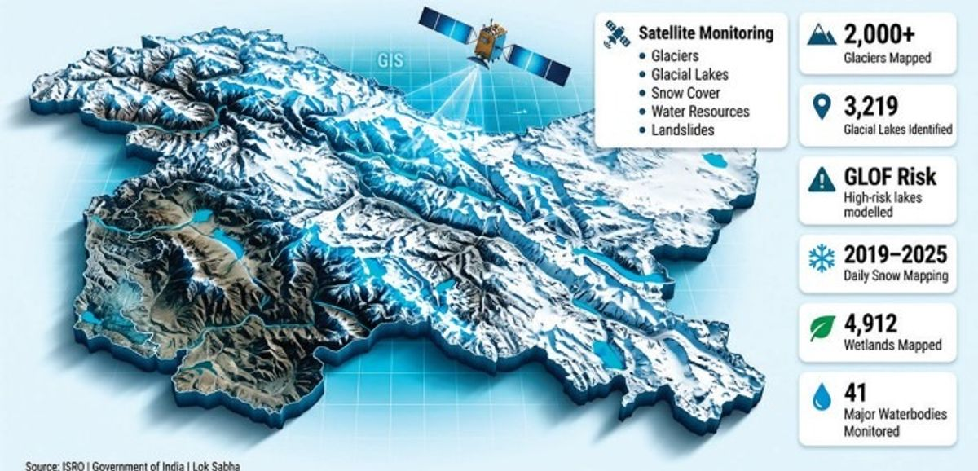
Advertisment Replying to an unstarred question in the Lok Sabha, Union Minister of State in the Prime Minister's Office, Personnel, Public Grievances and Pensions, Atomic Energy and Space, Dr Jitendra Singh, said the Indian Space Research Organisation (ISRO) and other government agencies are using advanced satellite-based technologies to monitor glaciers, glacial lakes, snowfall, water resources and landslide-prone areas across Ladakh. According to the minister, a database of more than 2,000 glaciers in Ladakh has been generated using satellite data collected between 2020 and 2023. In addition, changes in the extent of more than 1,000 glaciers over the past two decades have been mapped to assess long-term climatic and environmental changes. The minister said an inventory of 3,219 glacial lakes, each measuring more than 0.25 hectares, has been prepared under the National Hydrology Project of the Ministry of Jal Shakti. He informed the House that satellite-based Glacial Lake Outburst Flood (GLOF) risk modelling has also been carried out for high-risk glacial lakes, including Katkar and Suru, to strengthen disaster preparedness and early risk assessment. The government has also undertaken daily satellite-derived snow cover mapping across the Indian Himalayan region, including Ladakh, from 2019 until September 2025 to monitor seasonal snow conditions and water availability. As part of broader environmental mapping, 4,912 wetlands in Ladakh have been identified and mapped in collaboration with the University of Jammu, Dr Singh said. He further informed Parliament that satellite imagery is being used to monitor around 41 waterbodies larger than five hectares. The information is made available through the Bhuvan Waterbody Information System, under which periodic monitoring has been carried out since 2012. The minister also said ISRO is regularly updating Ladakh's landslide inventory using satellite imagery to support hazard assessment and disaster mitigation efforts. The information was provided in response to Lok Sabha Unstarred Question No. 1808, highlighting the Centre's increasing reliance on space-based technologies for environmental monitoring, climate resilience and disaster risk management in the ecologically fragile Himalayan region.

4. ISRO Recruitment 2026: 244 Administrative Posts Announced - Education Today
Read more
ISRO Recruitment 2026 Notification Released for 244 Administrative Posts; Applications Open for Assistant, JPA, UDC and Stenographer Roles Leave a Comment / Daily News The Indian Space Research Organisation (ISRO) has announced its recruitment drive for 2026, inviting applications for 244 administrative positions across various centres. The recruitment notification has been released under the Centralised Recruitment Board (ICRB), offering opportunities for eligible candidates to apply for posts including Assistant, Junior Personal Assistant (JPA), Upper Division Clerk (UDC) and Stenographer. The online application process has commenced, and interested candidates can submit their applications through the official ISRO recruitment portal within the specified deadline. The recruitment drive provides an opportunity for graduates and eligible candidates seeking government employment in one of India's leading space research organisations. EducationToday and TopEducationNews continue to highlight major career opportunities, recruitment announcements and academic developments that help students and job aspirants stay informed about important opportunities across India. ISRO Recruitment 2026: Vacancy Details Through the latest notification, ISRO has announced a total of 244 vacancies for administrative and support roles. These positions are available across different ISRO centres and units, depending on organisational requirements. The available posts include: - Assistant - Junior Personal Assistant (JPA) - Upper Division Clerk (UDC) - Stenographer Candidates interested in these positions must carefully review the eligibility requirements, selection process and application guidelines before submitting their forms. The recruitment notification outlines the number of vacancies, post-wise requirements and other important details related to the selection procedure. Applicants are advised to check the official notification thoroughly to understand the criteria before applying. Important Dates for ISRO Recruitment 2026 The recruitment process has started with the opening of the online application window. Candidates must complete registration and submit their forms before the deadline mentioned by ISRO. Key dates include: - Notification release date: July 2026 - Online application commencement: July 27th, 2026 - Last date to submit applications: August 16th, 2026 Candidates should avoid waiting until the final date to complete their applications, as technical issues or incomplete submissions may create difficulties during the registration process. Eligibility Criteria for ISRO Administrative Posts Candidates applying for ISRO administrative positions must fulfil the required educational qualifications and age criteria specified in the recruitment notification. For posts such as Assistant and Upper Division Clerk, applicants generally require a bachelor's degree from a recognised university along with relevant computer knowledge. Candidates applying for Junior Personal Assistant and Stenographer roles must meet the required qualifications related to typing speed and shorthand skills. The age limit and relaxation criteria may vary depending on the post and category of the applicant. Eligible candidates belonging to reserved categories will receive age relaxation as per government regulations. Applicants should verify all eligibility requirements before applying to ensure that they meet the conditions prescribed for their preferred position. ISRO Recruitment 2026 Application Process Eligible candidates can complete the application process through the official ISRO recruitment website. The online application system has been introduced to make the recruitment procedure more accessible and streamlined. Candidates can follow these steps to apply: - Visit the official ISRO recruitment portal - Select the recruitment notification for administrative posts - Register using the required personal and contact details - Fill in the application form with accurate information - Upload the necessary documents and certificates - Pay the application fee, if applicable - Submit the form and download a copy for future reference Candidates should ensure that all details entered in the application form are correct, as incorrect information may lead to disqualification during later stages of the recruitment process. Selection Process for ISRO Recruitment 2026 The selection process for the announced posts will be conducted according to ISRO's recruitment guidelines. Candidates may have to appear for written examinations and skill-based tests depending on the position applied for. The recruitment process is expected to assess candidates on various aspects, including general awareness, reasoning ability, quantitative aptitude, language skills and post-specific requirements. For positions such as Junior Personal Assistant and Stenographer, candidates may also need to demonstrate typing and shorthand abilities as part of the selection procedure. Applicants who qualify through all stages will be considered for appointment based on merit and organisational requirements. Click below to watch the video. Documents Required During Application Candidates should keep the following documents ready while completing the online application process: - Educational qualification certificates and mark sheets - Valid identity proof - Recent passport-sized photograph - Signature image - Category certificate, if applicable - Other relevant documents mentioned in the notification Uploading clear and valid documents is essential to ensure successful submission of the application form. Career Opportunity with ISRO ISRO is recognised as one of India's premier space research organisations, contributing significantly to the country's space exploration and technological advancements. Apart from scientific and technical roles, the organisation regularly offers opportunities in administrative and support areas. The latest recruitment drive allows candidates from diverse educational backgrounds to become part of India's space ecosystem. Successful candidates will contribute to the smooth functioning of ISRO centres by supporting various administrative operations. Government recruitment opportunities such as these attract thousands of applicants due to job stability, professional growth prospects and the opportunity to work with prestigious institutions. What Applicants Should Keep in Mind Candidates preparing for the ISRO Recruitment 2026 process should focus on understanding the exam pattern, revising relevant subjects and keeping track of official updates. Important points to remember: - Read the official notification carefully before applying - Complete the registration process before the deadline - Keep application details safely for future communication - Prepare according to the prescribed selection pattern - Regularly check official updates regarding examination dates and further instructions The ISRO Recruitment 2026 notification has created a valuable opportunity for candidates looking to build a career in the government sector. With 244 vacancies across multiple administrative roles, eligible applicants should make use of this opportunity and complete the application process within the given timeline. Post Views: 322 UP Board's Derecognition of 465 Non-Functional Schools Signals a Strong Push for Educational Accountability Daily News

5. ISRO Maps Over 2,000 Glaciers, 3,219 Glacial Lakes in Ladakh for Disaster Management - Kashmir Life
Read more
SRINAGAR: The Indian Space Research Organisation (ISRO) and other government agencies are using satellite and geospatial technologies to monitor more than 2,000 glaciers and 3,219 glacial lakes in Ladakh, with satellite-based modelling also being undertaken to assess the risk of Glacial Lake Outburst Floods (GLOFs), the Lok Sabha was informed on Wednesday. Minister of State in the Prime Minister's Office, Jitendra Singh, said the Government had generated a database of more than 2,000 glaciers in Ladakh using satellite data from 2020-23 and mapped changes in the extent of over 1,000 glaciers spanning more than two decades. An inventory of 3,219 glacial lakes larger than 0.25 hectares has also been prepared for Ladakh under the National Hydrology Project of the Ministry of Jal Shakti. GLOF risk modelling has been carried out for high-risk lakes, including Katkar and Suru, the Minister said in a written reply to Lok Sabha Unstarred Question No. 1808. The Government has also conducted daily satellite-derived snow-cover mapping across the Indian Himalaya, including Ladakh, from 2019 until September 2025. In addition, 4,912 wetlands have been mapped in Ladakh in collaboration with the University of Jammu. Satellite data is also being used to monitor and update information on around 41 waterbodies larger than five hectares, with the information provided through the Bhuvan Waterbody Information System, where such monitoring has been carried out since 2012. ISRO is also periodically updating the landslide inventory of Ladakh using satellite imagery. Among the major space-based initiatives undertaken in Ladakh are the Cryosphere Science and Applications Programme (CAP), which monitors snow and glaciers in the Himalaya-Karakoram region, and the Ladakh Specific Modelling and Space Applications (LAMA) project. The latter includes development of a space-input-based weather forecasting model, heavy rainfall alerts and hydrological simulations to estimate snowmelt, glacial melt runoff and river discharge. The Satellite Integrated Landslide Assessment and Alert System (SILAAS) project, undertaken under ISRO's Disaster Management Support Programme since 2023, is mapping landslides in Ladakh and generating village-wise landslide alerts. The National Hydrology Project, which ran from 2017 to 2025, covered glacial lake mapping, GLOF risk assessment, snow-cover monitoring, evapotranspiration and hydrological drought assessment. The Government has also developed Geo-Ladakh, a spatial data infrastructure and geoportal containing geospatial databases covering natural resources, energy, infrastructure and administrative boundaries, along with capacity-building activities. On early warning systems, the Government said ISRO and the Department of Space were undertaking advanced research and development to strengthen space-input-based early warning systems for GLOFs, extreme weather events and landslides, with the resulting capabilities expected to benefit Ladakh. ISRO and the Department of Space provide the Ladakh administration with space-based information on floods, GLOF events and forest fires during the response phase of major disasters. Under the Space-based Information Support for Decentralised Planning (SISDP) programme, land use and land cover, drainage, settlements, slope, and rail and road infrastructure have also been mapped at a 1:10,000 scale and hosted on the Bhuvan-Panchayat portal to support developmental planning. The Government said ISRO and the Department of Space have also been conducting periodic training programmes to build capacity and expand the use of space technology for sustainable development and disaster risk reduction, with participants from Ladakh benefiting from these initiatives.

6. NASA Awards 2026 Innovative Technology Concepts
Read more
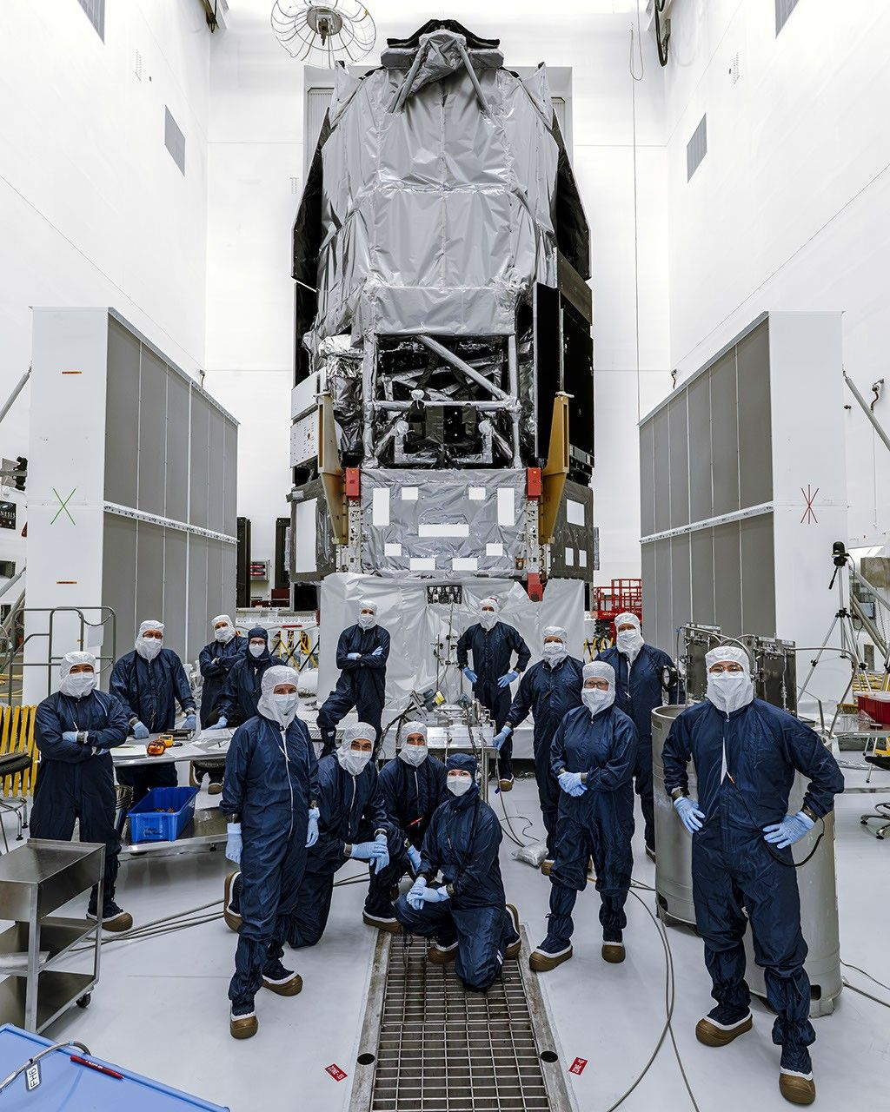
A collage of artist concepts highlighting the novel approaches proposed by the 2026 NIAC awardees. Credit: NASA The NASA Innovative Advanced Concepts (NIAC) program has created 18 new awards to support visionary ideas to improve aerospace technologies in areas ranging from the exploration of the solar system to understanding the universe. The 18 NIAC Phase I awards total $3.2 million. Each award provides up to $175,000 for a nine-month initial investigation. The NIAC projects are about early-stage concept development and are not considered official NASA missions. "NASA has outlined an ambitious vision for the future of space exploration, we're returning the Moon to stay, advancing to Mars, and pushing to deepen our understanding of space," said Greg Stover, director of the Advanced Research and Technology division within the Research and Technology Mission Directorate at NASA Headquarters in Washington. "Achieving that will require more than incremental technological advancement. It means we need great leaps. These awards are the kinds of innovation the world needs NASA to help foster." As an innovation incubator, NIAC funds early development of potential breakthrough technologies. Concepts for award consideration must have both transformative potential and possible feasibility for eventual implementation. "Every innovation, every leap in technology, starts with a seed of an idea," said Phillip Williams, NIAC's acting program executive. "The NIAC program allows NASA to germinate those seeds and determine if there's something that could be grown to benefit future space missions and our nation's aerospace economy." As NASA and its partners push for sustained lunar presence, some of the 2026 awardees focused on ways to help explore the Moon and build infrastructure there. These include a system to support hovering robots to explore lava tubes under the Moon's surface, a method to manage temperatures for small mobile exploration robots, and a way to incorporate radioisotopic heat sources into suits to help keep astronauts warm when operating in the Moon's nearly two-week-long lunar nights. Other concepts focus on exploring some of the solar system's most remarkable features. Venus, with its hot atmosphere, presents an imposing challenge for research vehicles, so one NIAC awardee explores methods for hardening instruments for longer missions. Two other concepts could help study planetary rings. One would use a swarm of 10,000 tiny satellites to map and analyze the rings of Saturn, while another would create a system for collecting samples from rings such as those circling Saturn, Uranus, and Neptune. Some NIAC awardees will look far beyond the solar system, exploring ways to power interstellar spacecraft, map out continents on exoplanets, observe the photon rings around black holes, and detect subtle gravitational waves to explain how galaxies formed. Others will work to answer questions directly related to life on Earth, like the potential use of spaceborne dust to reduce solar radiation, and awareness about the debris orbiting Earth. Researchers, known as NIAC Fellows, will investigate their concepts and identify potential challenges and opportunities for further development. The 18 selections for 2026 NIAC Phase 1 grants are: Saptarshi Bandyopadhyay, NASA Jet Propulsion Laboratory, Pasadena, California: Dimming the Sun Using Controllable Dust Cloud to Reduce Solar Insolation (DimSun) David Bugby, NASA Jet Propulsion Laboratory: Combinatory Architecture offering Neomobility, on-Venus Adaptability, and Survivability (CANVAS) A.C. Charania, Zeno Power Systems, Inc., Washington: Extended Astronaut Radioisotope-EVA in Nighttime and Deep-space Icy Landscapes (EARENDIL) Anish Damodaran, University of Central Florida, Orlando: PS21: Transforming Submillimeter Space Interferometry with Photonic Technologies Artur Davoyan, University of California, Los Angeles: Coilable Stacked Solar Sails for Very High delta-V Missions Daniel Drew, University of Hawaii, Honolulu: Solid-state Propulsion for Autonomous Reconnaissance of Karst (SPARK) Gilly Elor, Stone Aerospace, Inc., Del Valle, Texas: Power-over-Fiber to Enable a Lunar Underground eXplorer (LUX) Zhaoyan Liu, NASA Ames Research Center, California's Silicon Valley: Quantum Wind Lidar Applications for Planetary and Earth Science Missions Jeff Nosanov, Orbital Velocity, LLC, Decatur, Georgia: OBLIVIAN: Observing Black hole LIght Via Intensity cOrrelatioN (OBLIVIAN) Keunhan Park, University of Utah, Salt Lake City: Plasmon-Enhanced Radioisotope Thermophotovoltaic (PRTPV) Power Generation for Interstellar Missions Austin Phoenix, Virginia Polytechnic Institute and State University, Blacksburg, Virginia: Efficient variable Conductivity Lunar Insulator for Passive Surveyor Environmental Control (ECLIPSE) Marco Quadrelli, NASA Jet Propulsion Laboratory: PRAXIS: Planetary Rings Autonomous EXploration with In-situ Sampling (PRAXIS) Michael Rubenstein, Northwestern University, Chicago: Actively Steerable Femtosat Constellations for In-situ Exploration of Saturn's Rings, Atmosphere, and Magnetosphere Benjamin Schafer, Rarefied Technologies Inc., Albuquerque, New Mexico: : Photophoretic Tracers for Near-Space Remote Sensing at 30-100 km Altitudes David Smith, Duke University, Durham, North Carolina: Robotically Assembled Electromagnetic Metamaterials for Long-Range Space Situational Awareness Pablo Sobron, Search for Extraterrestrial Intelligence Institute, Mountain View, California: Interworld Slingshot Resource Surveys Paul Stankus, Brookhaven Science Associates, Upton, New York: Mapping Alien Continents: Achieving Optical VLBI for Exoplanet Imaging Paul Stankus, Brookhaven Science Associates, Upton, New York: Precision Astrometry Using Optically Independent Spacecraft for Gravitational Wave Detection To learn more about NASA's NIAC program, visit: https://www.nasa.gov/about-niac -end- Rob Margetta Headquarters, Washington 202-358-0918 robert.j.margetta@nasa.gov

7. NASA Sets Coverage for August Northern Hemisphere Total Solar Eclipse
Read more
A total solar eclipse is seen in Dallas, Texas on Monday, April 8, 2024. A total solar eclipse swept across a narrow portion of the North American continent from Mexico's Pacific coast to the Atlantic coast of Newfoundland, Canada. A partial solar eclipse was visible across the entire North American continent along with parts of Central America and Europe. Credit: NASA/Keegan Barber On Wednesday, Aug. 12, a total solar eclipse will be visible in parts of Greenland, Iceland, northern Russia, the Atlantic Ocean, Spain, and a small corner of Portugal. NASA will stream the eclipse live with views across the path and interviews with subject matter experts through a variety of platforms. Learn where to watch online: https://www.nasa.gov/live Viewers in other places in the Northern Hemisphere also will have the chance to experience a partial solar eclipse, including parts of the U.S. (from Alaska to North Carolina), most of Canada, much of Europe, and northwestern Africa. During the eclipse, NASA will conduct experiments in the path of totality. To investigate the dynamics of the Sun's corona, a NASA-funded science team will chase the Moon's shadow with a WB-57 high-altitude research aircraft. The NASA-supported Nationwide Eclipse Ballooning Project is sending students from several U.S. universities to Iceland and Spain to launch scientific balloons before, during, and after the eclipse to research how the temporary darkening of our skies during the eclipse affects Earth's atmosphere. NASA's eclipse coverage is as follows (all times Eastern): Wednesday, Aug. 12 1:15 p.m.: Eclipse broadcast begins 1:45 p.m.: Totality begins in Iceland 2:28 p.m.: Totality begins in Spain NASA photography coverage Photos of the eclipse, dependent on visibility, will be available shortly after the eclipse. View images on the agency's Flickr account. Watch, engage on social media During the broadcast, NASA experts will answer questions submitted on social media. Send in your questions and let people know you're watching the eclipse on X, Facebook, and Instagram by following and tagging these accounts: X: @NASA, @NASASolarSystem, @NASAScience_ Facebook: NASA, NASASolarSystem, @NASAScience Instagram: @NASA, @NASASolarSystem, @NASAScience_ Learn more about the eclipse at: https://science.nasa.gov/eclipses -end- Abbey Interrante / Karen Fox Headquarters, Washington 301-201-0124 / 202-358-1600 abbey.a.interrante@nasa.gov / karen.c.fox@nasa.gov

8. NASA's Curiosity Views a Sand-Capped Butte
Read more
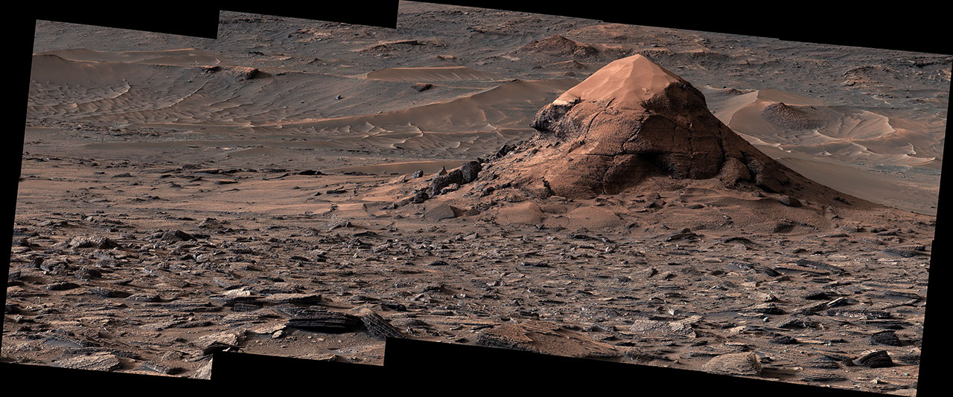
Description NASA's Curiosity Mars rover captured this sand-capped butte, nicknamed "Miraflores," estimated to be about 20 feet (6 meters) tall, with its Mast Camera, or Mastcam, on June 11, 2026, the 4,923rd Martian day, or sol, of the mission. The butte was left behind as surrounding rock eroded away over time, deepening the broad valley Curiosity is climbing through. The surrounding area includes an expanse of terrain covered in surface features called polygons. The panorama is made up of 11 individual images that were sent to Earth and stitched together. The color has been adjusted to match lighting conditions as the human eye would see them on Earth. Curiosity was built by NASA's Jet Propulsion Laboratory, which is managed by Caltech in Pasadena, California. JPL leads the mission on behalf of NASA's Science Mission Directorate in Washington as part of NASA's Mars Exploration Program portfolio. Malin Space Science Systems in San Diego built and operates Mastcam. To learn more about Curiosity, visit: science.nasa.gov/mission/msl-curiosity

9. NASA's Curiosity Discovers a Field of Martian Polygons
Read more
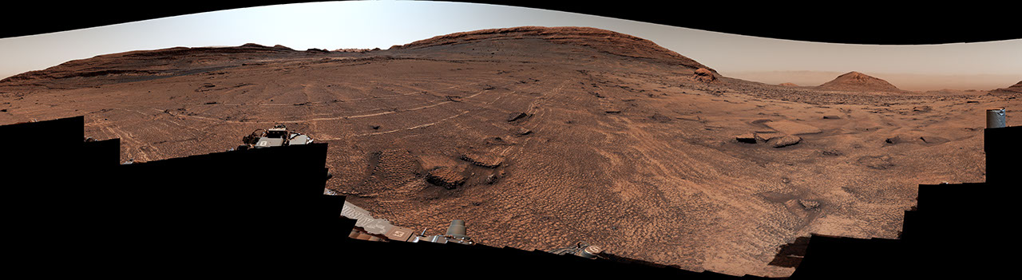
Description NASA's Curiosity Mars rover captured this 360-degree view of an expanse of terrain covered in surface features called polygons on June 19 and 20, 2026, the 4,930th and 4,931st Martian days, or sols, of the mission. The rover has found polygons several times in the past, but never so many in one place. Across the center of this image, the surface is covered by shapes ranging in size from roughly 2 to 4 inches (5 to 10 centimeters) in diameter. The features also surround and wrap around a sand-capped butte nicknamed "Miraflores," seen at far right in the image. Figure A Figure A is a crop from the bottom-center of the panorama highlighting the polygons and their honeycomb-like textures. Polygonal textures can form from a variety of conditions, including drying out of the surface (like in mud cracks), temperature cycles, compaction after being buried, or shrinkage of the sediment from loss of water or mineral changes. Scientists are measuring characteristics of these polygons to home in on which process formed them. This panorama was captured by Curiosity's Mast Camera, or Mastcam, as the rover continued its ascent of the foothills of Mount Sharp, a 3-mile-tall (5-kilometer-tall) mountain that it's been climbing since 2014. The panorama is made up of 340 individual images that were sent to Earth and stitched together. The color has been adjusted to match lighting conditions as the human eye would see them on Earth. Curiosity was built by NASA's Jet Propulsion Laboratory, which is managed by Caltech in Pasadena, California. JPL leads the mission on behalf of NASA's Science Mission Directorate in Washington as part of NASA's Mars Exploration Program portfolio. Malin Space Science Systems in San Diego built and operates Mastcam. To learn more about Curiosity, visit: science.nasa.gov/mission/msl-curiosity

10. NASA's Curiosity Mars Rover Discovers Field of Honeycomb Textures
Read more
NASA's Curiosity Discovers a Field of Martian Polygons NASA/JPL-Caltech/MSSS As NASA's Curiosity rover recently began climbing up a Martian valley nicknamed "Valle Grande," it sent back images that were a familiar sight to mission scientists: honeycomb-like textures called polygonal fractures, each one about 1.5 to 3 inches (4 to 8 centimeters) across. The mission has spotted small patches of these geometric shapes several times before, but nothing at the scale discovered in Valle Grande. In a 360-degree panorama that the rover captured on June 19 and 20, the 4,930th and 4,931st Martian days, or sols, of the mission, the polygonal shapes spread in all directions for as far as the rover can see. They even wrap around the sides of a nearby butte nicknamed "Miraflores," which stands 20 feet (6 meters) tall and is topped with a thick cap of sand. "We've seen a lot of fascinating landscapes through Curiosity's eyes, but this sea of polygons took our breath away," said the mission's project scientist, Ashwin Vasavada of NASA's Jet Propulsion Laboratory in Southern California. "We measured their shapes and chemistry carefully and are hopeful there are clues in the data as to how these features formed." A close-up of the polygon fractures discovered by NASA's Curiosity Mars rover highlights their honeycomb-like textures NASA/JPL-Caltech/MSSS Some of the polygons that the mission has spotted in the past clearly formed as mud cracks, though a variety of processes can contribute to their honeycomb textures, including cycles of warm and cold temperatures or compression that squeezed water out of the sediment when the surface was buried. These newly discovered polygons are among the many surprises Curiosity has trundled across since landing on Mars 14 years ago, on Aug. 5, 2012. Besides sulfur crystals, shiny meteorites, and other interesting geologic features, the rover has made major discoveries about the ancient Martian environment - most importantly, that it had the water, chemistry, and nutrients to support microbial life. Billions of years ago, lakes and streams dappled the lower foothills of Mount Sharp, a 3-mile-tall (5-kilometer-tall) mountain that Curiosity has been ascending since 2014. The rover has previously uncovered chemistry left over from Mars' watery history, including carbon-based molecules believed to be precursors to RNA and DNA, two nucleic acids that carry genetic information. Scientists have no way of knowing whether these organic molecules were created by biologic or geologic processes - either path is possible - but their discovery reconfirmed that ancient Mars had the right chemistry to support life. NASA's Curiosity Mars rover captured this sand-capped butte, nicknamed "Miraflores," estimated to be about 20 feet (6 meters) tall, on June 11, 2026. The surrounding area includes an expanse of terrain covered in surface features called polygons. NASA/JPL-Caltech/MSSS Managed by Caltech in Pasadena, JPL built Curiosity and leads the mission on behalf of NASA's Science Mission Directorate in Washington as part of the agency's Mars Exploration Program portfolio. To learn more about Curiosity, visit: https://science.nasa.gov/mission/msl-curiosity News Media Contacts Andrew Good Jet Propulsion Laboratory, Pasadena, Calif. 818-393-2433 andrew.c.good@jpl.nasa.gov Karen Fox / Alana Johnson NASA Headquarters, Washington 240-285-5155 / 202-672-4780 karen.c.fox@nasa.gov / alana.r.johnson@nasa.gov 2026-051

11. NASA Webb Explores Family Tree of Newly Discovered Distant Objects
Read more
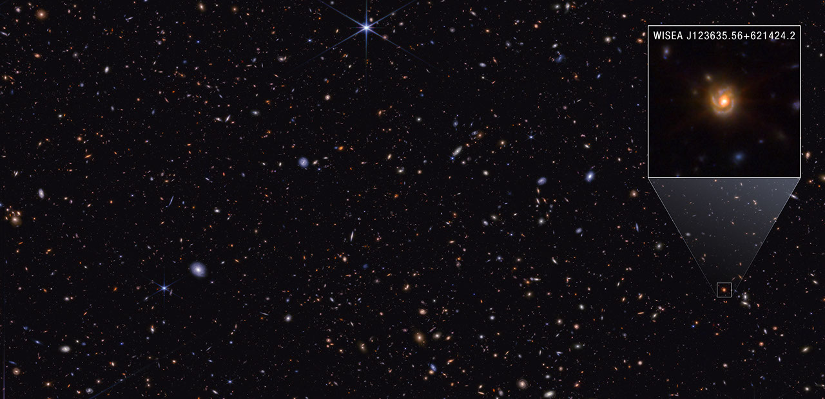
Since their discovery by NASA's James Webb Space Telescope in 2022, little red dots (LRDs) have been the subject of great interest to astronomers. Understanding the nature of these extremely distant, compact red sources has been a puzzling scientific endeavor. One popular theory is that little red dots are supermassive black holes known as active galactic nuclei, although they display characteristics unlike nearby active galactic nuclei. While they appear abundant at high redshift early in the universe, they rapidly decrease in number at lower redshifts. (The higher the redshift, the greater the distance the light has traveled across the universe.) This perplexing shift in number raises the question: What happens to little red dots as the universe matures? A team of researchers led by Pierluigi Rinaldi of the University of Arizona's Steward Observatory, now at the Space Telescope Science Institute (STScI) in Baltimore, has built upon their previous research in a new study published on July 29 in The Astrophysical Journal and proposed one pathway LRDs can follow as the universe ages: Though they may look like a unique galaxy population, these dots are affected by observational bias - some features just don't appear at higher redshifts with current technology. Image: Saguaro in GOODS-North Field (NIRCam) Scientists have proposed one pathway little red dots can follow as the universe matures based on their analysis of spiral galaxy WISEA J123635.56+621424.2, nicknamed the "Saguaro." They suggest little red dots may be a temporary phase of highly active supermassive black holes. Image: NASA, ESA, CSA, STScI, Pierluigi Rinaldi (Steward Observatory); Image Processing: Alyssa Pagan (STScI) Their conclusions are based on their analysis of lower-redshift spiral galaxy WISEA J123635.56+621424.2, nicknamed the "Saguaro" for its prominent arms, like the cactus native to the Sonoran Desert in the Southwestern United States. A particularly intriguing feature of this redshift 2 galaxy, which corresponds to approximately 3.3 billion years after the big bang, is its little red dot-like center that is reminiscent of the ruby red fruit produced by the desert plant. "Everything created in the early universe must evolve into something around us. We have had little idea of what LRDs become, but these results finally show us how to find their progeny," said co-author George Rieke of the University of Arizona. Previous studies by NASA's retired Spitzer Space Telescope provided the first hint of the dust-obscured, compact galaxy population in the lower-redshift universe that the Saguaro belongs to, paving the way for NASA's Hubble and James Webb space telescopes' high-resolution analyses. "The Saguaro is important because it's a prototypical little red dot and is one of the few we have found at lower redshift. It can be used to study the pathway of these dots throughout cosmic time," said Fabio Pacucci of the Harvard-Smithsonian Center for Astrophysics in Cambridge, Massachusetts, and a co-author of the study. Among the thousands of sources Rinaldi looked at across several surveys, the Saguaro was an example of the right place - with one of Webb's microshutter arrays perfectly framed over the galaxy's core to take spectroscopic data - and right time - being at lower redshift. To get as broad a view of the spiral galaxy as possible across the electromagnetic spectrum, the team used Hubble's ultraviolet- and Webb's infrared-imaging and spectroscopic archival data, respectively. "Because the Saguaro is at lower redshift, we can see the very beautiful and bright host galaxy in high resolution and detail with Webb and Hubble," said Zihao Wu of the Harvard-Smithsonian Center for Astrophysics, and a co-author of the study. "Webb's observations can help us understand how the galaxy and its little red dot-like nucleus are connected." The team took multiple approaches to verify that the Saguaro's compact red nucleus matched the characteristics of a prototypical LRD. In particular, the Hubble and Webb data showed that the nucleus is brighter in both ultraviolet and infrared light than in visible light, just like distant LRDs. The team also carefully disentangled the light emitted from the host and nucleus, and considered the presence of X-ray emission from the source. Although the majority of little red dots at high redshift are not detectable in X-ray light, NASA's Chandra X-ray Observatory detected weak X-ray emission from the Saguaro. "What the X-ray light observations show is that this galaxy has an active galactic nucleus, and a very obscured one at that," said Carys Gilbert, a Master's student at the University of Cape Town in South Africa and a co-author of the paper. "It's not only obscured but also X-ray weak. That kind of combination could explain the lack of X-ray emission that we see from all other little red dots. It fits the puzzle of little red dots nicely." In addition to demonstrating how the Saguaro's central compact red source fits the little red dot criteria, the team synthetically shifted the galaxy to a higher redshift to explore how this galactic environment would appear to observers if located in the early universe. As expected, the Saguaro's surrounding galactic structure fades so that only the bright, LRD-like source at its center is visible. "Our theory is that most of these distant sources are affected by this cosmological effect, creating an observational bias," said Rinaldi. "We simply are not able to sample the immediate environment of high-redshift little red dots because their surroundings are just too faint to be observed even with Webb. Little red dots are far more complex than just being a dot. They're just the tip of the iceberg - of a supermassive black hole interacting with its nearby surroundings." Image: Little Red Dot at Redshift 2: Real and Simulated Graphic Scientists synthetically shifted the Saguaro, a lower-redshift spiral galaxy, to a higher redshift to find out how it would appear if it was in the early universe. Its compact red appearance suggests that little red dots are a phase of highly active supermassive black holes. Image: NASA, ESA, CSA, Pierluigi Rinaldi (Steward Observatory); Image Processing: Alyssa Pagan (STScI); Illustration: Leah Hustak (STScI) Considering the Saguaro case study, the team believes that LRDs may not be a unique galaxy population, but instead a temporary phase of highly active supermassive black holes. Could this theory be the link between the populous high-redshift little red dots seen by Webb and the local universe? While the Saguaro is not representative of all LRDs, the team proposes that this is one phase of these compact red sources. To build more confidence, further study of the Saguaro is necessary, as well as seeking other Saguaro-like galaxies at lower redshift. The team also intends to comb through Webb's bountiful archival data to build a census of little red dots to study how their environments may impact how they mature. These different approaches are all geared to helping uncover the family tree of little red dots. The James Webb Space Telescope is the world's premier space science observatory. Webb is solving mysteries in our solar system, looking beyond to distant worlds around other stars, and probing the mysterious structures and origins of our universe and our place in it. Webb is an international program led by NASA with its partners, ESA (European Space Agency) and CSA (Canadian Space Agency). The Hubble Space Telescope has been operating for over three decades and continues to make ground-breaking discoveries that shape our fundamental understanding of the universe. Hubble is a project of international cooperation between NASA and ESA (European Space Agency). NASA's Goddard Space Flight Center in Greenbelt, Maryland, manages the telescope and mission operations. Lockheed Martin Space, based in Denver, also supports mission operations at Goddard. The Space Telescope Science Institute in Baltimore, which is operated by the Association of Universities for Research in Astronomy, conducts Hubble science operations for NASA. To learn more about Webb, visit: https://science.nasa.gov/webb To learn more about Hubble, visit: https://science.nasa.gov/hubble Downloads & Related Information The following sections contain links to download this article's images and videos in all available resolutions followed by related information links, media contacts, and if available, research paper and Spanish translation links.

12. Contractor to Civil Servant: NASA Welcomes Ray Williams
Read more
Ray Williams, supervisor of test support operations at NASA's Stennis Space Center near Bay St. Louis, Mississippi, poses for a photograph on July 16, 2026. Williams is among the first engineers and technicians sworn in as new NASA civil servants at Stennis as part of the administrator's directive to strengthen technical core competencies within the civil service workforce. NASA/Danny Nowlin Ray Williams' progression at NASA's Stennis Space Center near Bay St. Louis, Mississippi, has uniquely prepared him for his new role. As part of NASA's plan to restore core competencies by converting contractors to civil service, the New Orleans native and Grambling State University graduate now works as a supervisor for test operations support at the agency's E-Complex. This propulsion testing facility provides mission-critical engineering capabilities to NASA. Through the use of high- and low-pressure propellant systems, engineers are able to focus on development testing of propulsion system components before integration into complete engine systems. Thanks to the versatility of its infrastructure and test team, the complex is uniquely equipped to support projects for the growing commercial aerospace industry and is capable of supporting a wide range of component, engine, and stage test activities. "Ultimately, my goal is to continue to grow within my own abilities as an engineer and as a supervisor, and to help grow those that I have the opportunity to lead," said Williams. "I want to align myself with the agency's goals as a whole to continue to utilize our unique skillset to grow, build, evolve, and innovate." Williams began his career at the E-Complex in 1998 as an electrical technician contractor during the facility's design and build phase. He quickly became familiar with the facility layout, the various systems under development, and the requirements involved in designing, building, and integrating those systems. He later advanced to the role of instrumentation and electrical engineer, gaining extensive institutional knowledge while developing expertise in the principles and importance of data validation. In total, he brings 28 years of experience to NASA, along with an intimate understanding of the daily challenges his team of technicians faces. Williams' primary work location is the E-1 test stand, which is able to handle extremely high pressures and massive flow rates of super cold cryogenics. Unlike the A and B test complexes at NASA Stennis, where a fully built engine or stage can be installed, fueled, and fired, the E-Complex is highly adaptable. When commercial partners need to validate large, complex components, they provide specific requirements. The team then customizes the test facility to replicate the exact extreme conditions the hardware is expected to encounter during operation. NASA collects and analyzes data from these precisely controlled test conditions to validate design predictions and determine whether design modifications are needed throughout the development process, from subscale testing through full-scale testing. Whether validating valve timings, ensuring facility instrumentation is properly calibrated, supporting ultra-high pressure pumping and cryogenic transferring operations, or troubleshooting electrical and mechanical support systems, Williams and his team must execute each task with precision. By retaining Williams' facility specific expertise in-house as a civil servant, NASA reduces long term operational risk. Williams describes the opportunity to perform this mission critical work in public service as a dream come true, a dream that began decades ago during an elementary school field trip to NASA Stennis. Today, he finds himself working at NASA just as the agency returns to the Moon to stay through Artemis missions and builds a Moon Base, humanity's first lunar outpost. "Having the opportunity to play a role at NASA means a lot," said Williams. "To this day, I am still a kid at heart looking out at the sky and the galaxy. Being a part of the mission and doing things I know we are capable of doing is an amazing, but also humbling, opportunity."

13. 'It's going to do things that currently are impossible': The Roman Space Telescope, NASA's next great observatory, is ready to launch Aug. 30
Read more
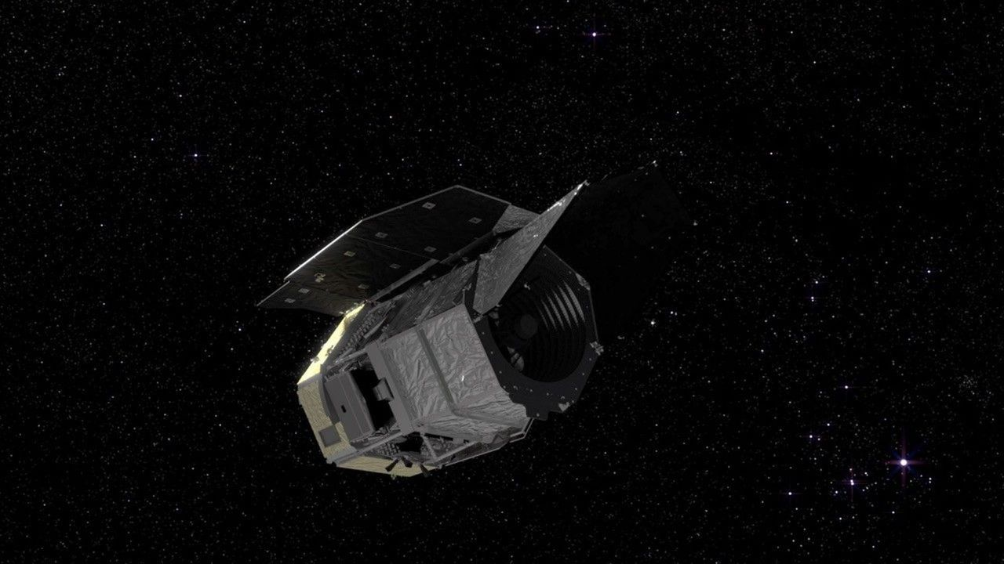
Click for next article The next great American observatory in space is just one month away from leaving this planet. NASA scientists got together Wednesday (July 29) to share a status update on the Nancy Grace Roman Space Telescope - the agency's next great observatory that will soon join the ranks of absolute legends like the Hubble Space Telescope and the James Webb Space Telescope . And that press conference was overflowing with good news. The $4 billion Roman Space Telescope is scheduled to launch on a SpaceX rocket on Aug. 30 at 7:26 a.m. EDT (1126 GMT). That's nine months ahead of schedule according to the team. I think of this as doing magic with physics." Julie McEnery, Roman senior project scientist "In 30 days, we're going to be launching Roman, testing it out, opening the deployable aperture cover, looking at the sky, and sending data down to the ground for the first time," Jeremy Perkins, Roman's telescope integration and test scientist, said during the press conference at NASA's Goddard Space Flight Center in Greenbelt, Maryland. Wednesday's update comes just days after NASA announced Roman is loaded up with hydrazine fuel , a kind of fuel that's known to be very efficient - though at the cost of being toxic and unstable. For that reason, the agency is looking for ways to move away from this kind of fuel, but it's still used often until a suitable replacement becomes available. And with Roman, a lot of hydrazine is necessary. This is for a few reasons, as Perkins explained. First, it's important to know that Roman's headed to what's known as Lagrange Point 2 , a gravitationally stable point a million miles away, between Earth and the sun . This is a popular location for observatories because it allows spacecraft to be oriented in such a way that their instruments remain safe from heat while their solar panels can still receive sunlight for power. The James Webb Space Telescope (JWST), for instance, is at L2 as well. On the way to L2, Roman needs to use some its fuel to course correct and make sure it's headed to the correct destination. "We do a final orbit insertion around day 100 to get into our final orbit around L2," Perkins said. "After that, we have enough fuel to do all of the momentum dumps and the station keeping maneuvers that we need to do for five years and more." The Roman Space Telescope hangs in the clean room. (Image credit: NASA/Sydney Rohde (Rocz)) Now that Roman's fueled up, the next step will be to get it attached to the SpaceX Falcon Heavy rocket that'll carry it beyond our planet. "Encapsulation, which is when the observatory is installed into the fairing that will carry us to orbit, that happens in three short weeks," Jackie Townsend, Roman's project manager, said during the conference. Townsend also added that, all in all, the whole Roman team is ready to go: "The Roman dream team continues to do mighty things, and I am delighted to say yet again, Roman is ready for launch." A diagram of the Lagrange points. (Image credit: NASA / WMAP Science Team) As for what comes after launch, well, there's one way to put things into perspective. To compare Roman to the Hubble Space Telescope , consider that scientists expect Roman to produce over 500 terabytes of data per year. In its approximately 35 years of service, Hubble has produced 400 terabytes of data in total. "Roman has broadly the same sensitivity and sharpness of vision as Hubble, but we survey the sky much faster, so that one month of observations to survey our Milky Way galaxy would take about a century with with Hubble," Julie McEnery, Roman's senior project scientist said during the conference. "We would need over half a million 4K TVs to fully display the single Roman image from our largest survey," McEnery said. "To understand the scale, these TVs would cover 45 Manhattan city blocks." What about comparing Roman to the JWST? While the Roman Space Telescope does have some near-infrared capabilities, thanks to its impressive Wide-Field Instrument (WFI). However, it doesn't quite stack up to the JWST's ultrasensitive infrared sensors . Where it does have an advantage, though, is when it comes to its panoramic view. A Roman image would be about 50 times wider. "Webb is designed to be able to probe very deeply and with exquisite sensitivity into the universe so we can find rare things in the early universe," McEnery said of the JWST. "But you need Roman to find rare things in the more nearby universe." As an example, McEnery pointed out the " little red dots, " elusive objects that seem to repeatedly appear in JWST images of the ancient universe. The key to understanding what these objects are is to find as many as possible. However, with the JWST's extremely zoomed in images focused on the deep, deep universe, it can't exactly map that many at once. But Roman is built to do just that. Once all this data is in hand, the possibilities for what we may find are endless. One of Roman's instruments called a coronagraph is expected to revolutionize exoplanet research while WFI scans the cosmos to image around 2 billion galaxies during the telescope's main survey. "I think of this as doing magic with physics. We're taking advantage of the wave properties of light to cancel out the light from a star, so that we can image planets next to it," McEnery said. The Roman Space Telescope undergoing acoustic testing. (Image credit: NASA/Jolearra Tshiteya) Understanding the dynamics of as many galaxies as possible will help scientists decode the intricacies of dark matter and dark energy. We can't see the dark universe , but we can see how it affects its observable counterpart. And these are just a few of the expected outcomes of Roman's survey. As the team has continuously suggested - in fact, as most observatory teams tend to suggest - the best discoveries will be the surprises. Even when you think about other technological advances, the principle holds true. When the internet was first invented , its inventors probably didn't expect it to lead to innovations like Facebook or Spotify and when the first video game was invented, the concept of an open world RPG maybe seemed beyond our means. "When we built Hubble and Webb, we were chasing far off galaxies in the farthest corners of the universe. But because we have a Hubble and Webb, we're able to track asteroids that would pose a threat to Earth or to future lunar outposts on on the lunar surface," Shawn Domagal-Goldman, director of the astrophysics division at NASA Headquarters said during the conference. "Those were impossibilities that are now just possible and sometimes routine." Perhaps whatever Roman has in store for us will lead to the next generation of its namesake, Townsend pondered. Roman is named after Nancy Grace Roman, a pioneer in her field who was the first female executive at NASA as well as the agency's first chief of astronomy. She's sometimes called the "mother of Hubble" because of her major contributions to the telescope and is famous for breaking ground in research about satellites. She also helped form the foundation for exoplanet science decades before the first exoplanet discovery. "The next Dr. Nancy Grace Roman, sitting in a classroom somewhere next year, will be studying our data and hopefully catch the science bug and go on to transform the world in the same way that Dr. Nancy Grace Roman did," Townsend said. "I could not be prouder to be part of this project."

