 |  | 

🌌 अंतरिक्ष समाचार | Space News
सोमवार, ०२/११/२०२६ | Monday, 02/11/2026

1. The Hindu's Editorial, November 2, 2026 Slow recovery: On the ISRO's GSLV-F18 mission - The Hindu
Read more
The Hindu's Editorial, November 2, 2026 Slow recovery: On the ISRO's GSLV-F18 mission The Hindu

2. ISRO launches NVS | Akashvani News - News On AIR
Read more
ISRO launches NVS | Akashvani News News On AIR

3. NVS-03 Satellite: Reviving India's NavIC System - Vajiram & Ravi
Read more
NVS-03 Satellite: Reviving India's NavIC System Vajiram & Ravi

4. ISRO to launch navigation satellite NVS-03 aboard GSLV-F18 rocket from Sriharikota - News On AIR
Read more
ISRO to launch navigation satellite NVS-03 aboard GSLV-F18 rocket from Sriharikota News On AIR

5. ISRO Chairman V. Narayanan is 'Mr Go-Getter' - https://whispersinthecorridors.net/
Read more
ISRO Chairman V. Narayanan is 'Mr Go-Getter' https://whispersinthecorridors.net/

6. Ananth Technologies Supplies Avionics For ISRO's GSLV-F18 Mission - Electronics For You BUSINESS
Read more
Ananth Technologies Supplies Avionics For ISRO's GSLV-F18 Mission Electronics For You BUSINESS

7. 'The Sea God Surveys': Watch Rocket Lab launch Japanese Earth-observing satellite today
Read more
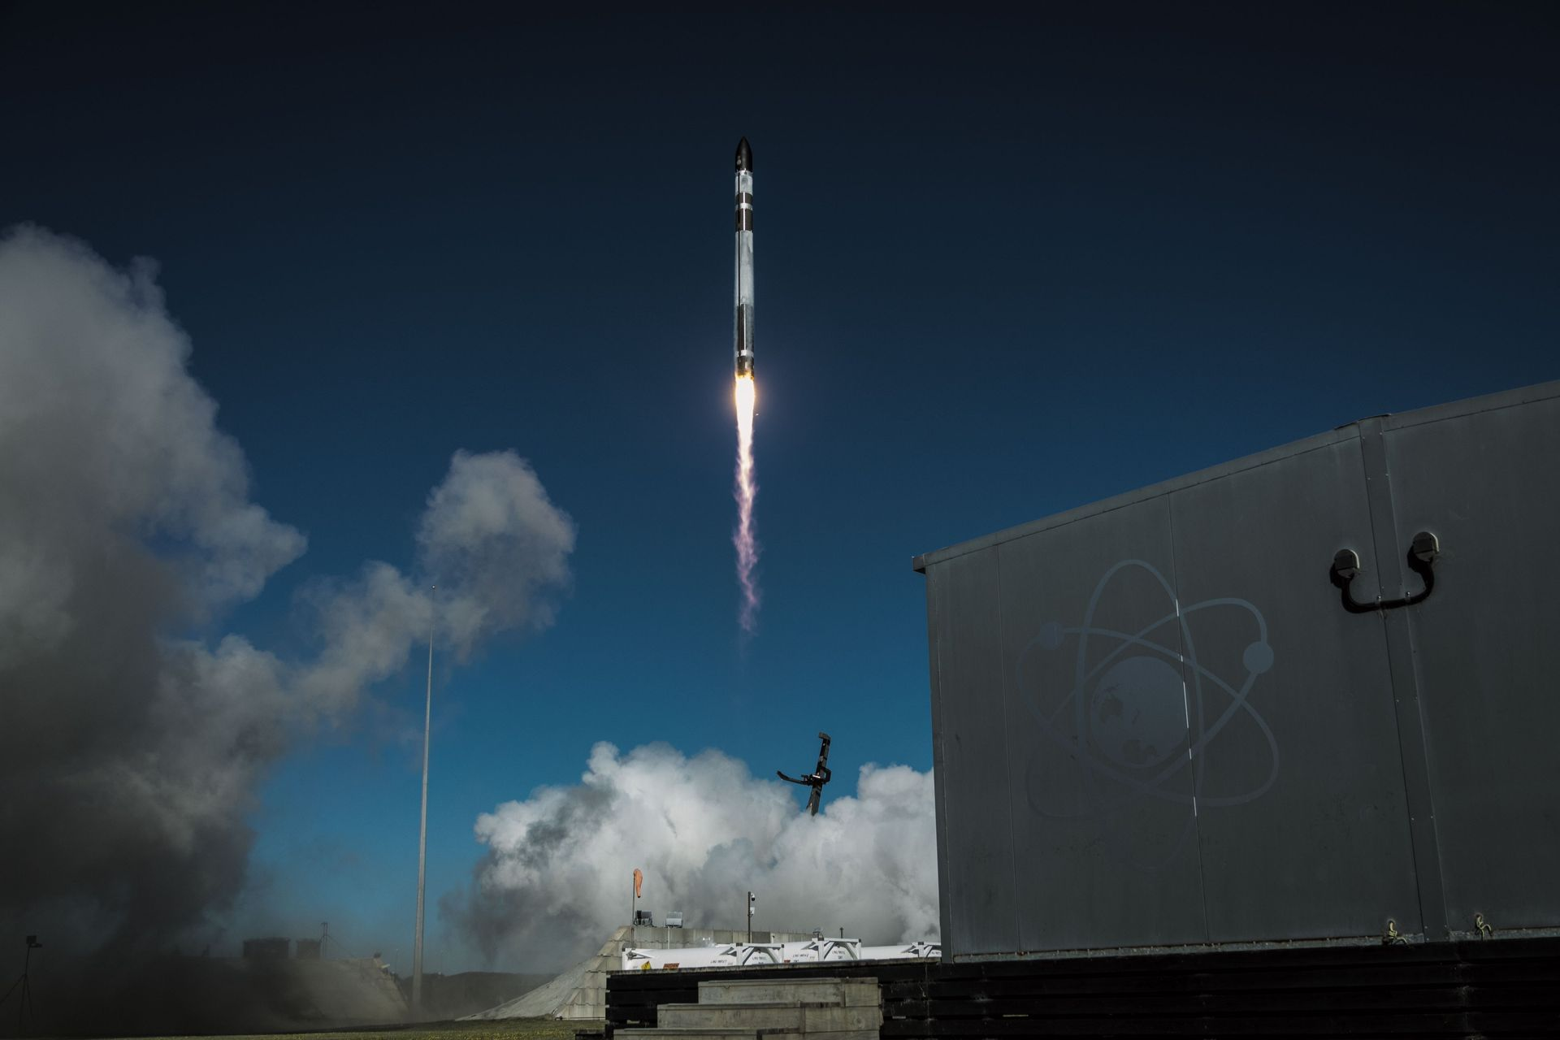
Click for next article Rocket Lab launches "The Nation God Navigates" mission for the Japanese company iQPS from New Zealand on Nov. 5, 2025. Rocket Lab will launch its 99th mission to date today (Nov. 2), and you can watch the action live. An Electron rocket is scheduled to lift off from Rocket Lab's New Zealand site today, during a window that opens at 11:30 a.m. EST (1630 GMT; 5:30 a.m. on Nov. 3 local New Zealand time), The mission, which Rocket Lab calls "The Sea God Surveys," will carry an Earth-observing radar satellite for the Japanese company iQPS. You can watch it live via Rocket Lab starting about 30 minutes before launch, and Space.com will carry the company's feed if, as expected, it's made available. The patch for Rocket Lab's "The Sea God Surveys" mission, which is expected to launch on Nov. 2, 2025. (Image credit: Rocket Lab) "The Sea God Surveys" will be Rocket Lab's 10th launch to date for iQPS, which is assembling a constellation of three dozen synthetic aperture radar (SAR) satellites in low Earth orbit (LEO). SAR satellites offer advantages over those that view our planet in optical wavelengths. They can peer through cloud cover, for example, and study our planet at night as well as during the day. Today's launch will be the 99th overall for Rocket Lab and the 90th for the two-stage, 59-foot-tall (18 meters) Electron, which gives small satellites dedicated rides to space. The workhorse vehicle has already flown 16 times this year. Rocket Lab's other nine launches to date have been conducted by HASTE , a suborbital version of Electron that allows customers to test their tech in the hypersonic flight environment. HASTE (short for "Hypersonic Accelerator Suborbital Test Electron") debuted in June 2023 and generally flies classified payloads.

8. On this day in space! Nov. 1, 1962: The Soviet Union Launches Mars 1 spacecraft to Red Planet during the Space Race
Read more
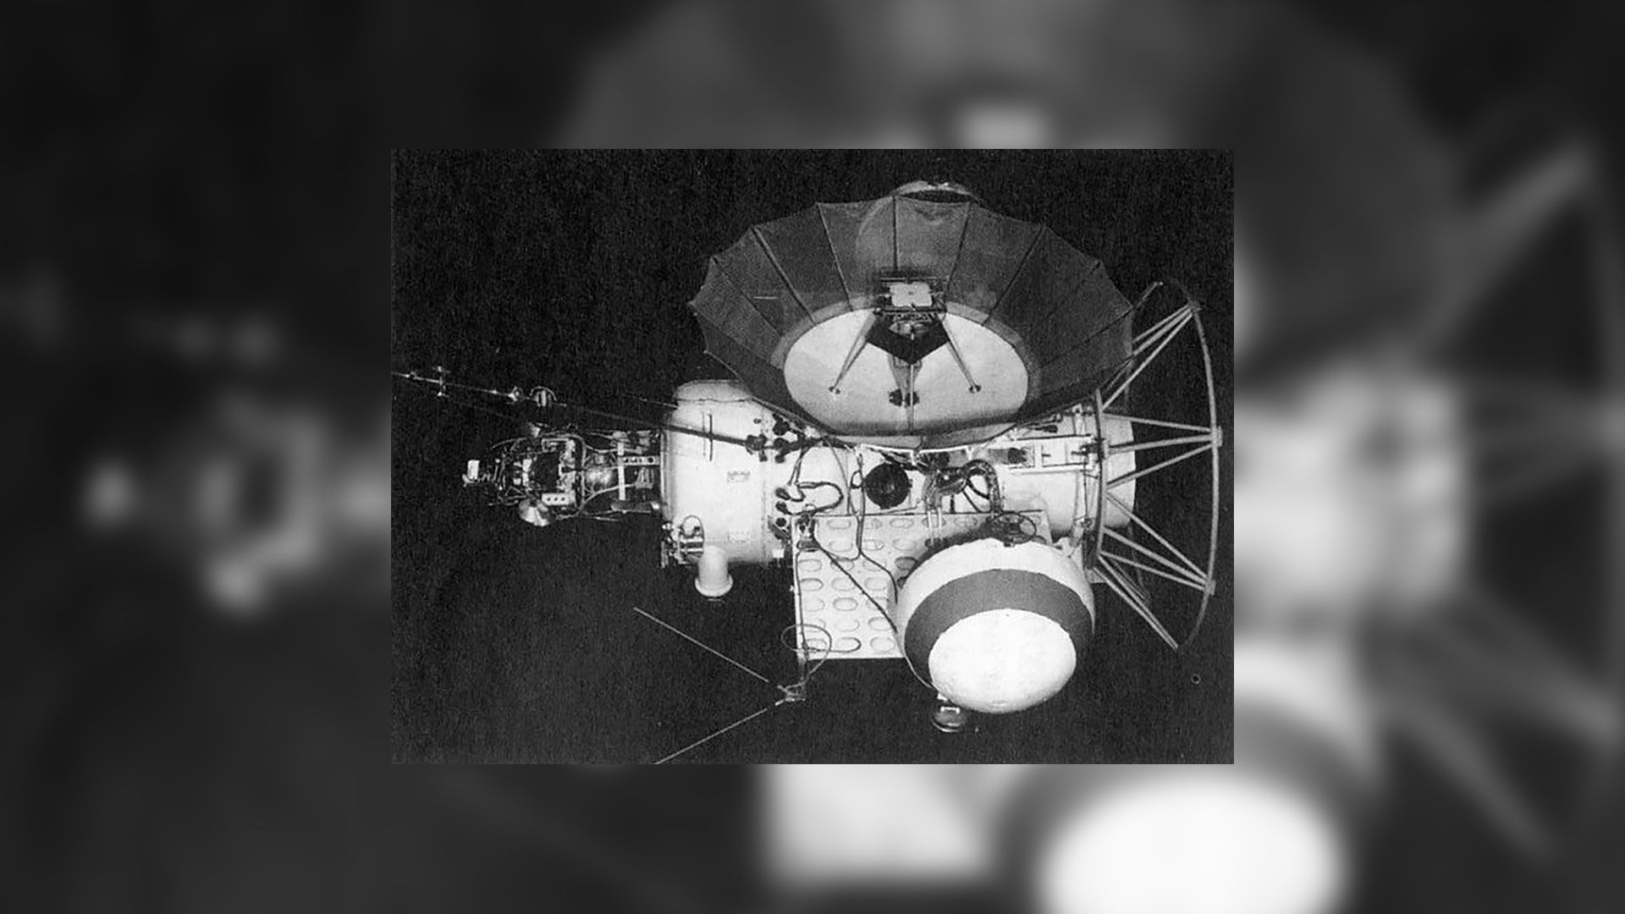
Click for next article On Nov. 1, 1962, the Soviet Union launched the Mars 1 spacecraft on a mission to fly by the Red Planet. While it did end up flying by Mars , the mission was not exactly a success. After it separated from the rocket, it deployed its solar panels and started cruising toward Mars. When mission controllers were checking out the telemetry it transmitted back to Earth, they found out that Mars 1 had sprung a leak in one of the gas valves that controls the spacecraft's orientation. And without a working orientation system, Mars 1 would have a hard time pointing its antennas in the right direction. It lost contact with Earth when it was about halfway to Mars . A model of Mars 1, a Mars flyby spacecraft launched to the Red Planet by the Soviet Union on Nov. 1, 1962. (Image credit: NASA) Why it mattered Ever since Galileo Galilei pointed his telescope to the red-tinted star and identified as a planet, Mars has captivated scientists' interests as to its nature. So it was of no surprise that as soon as we gained the ability to send missions into space, that the focus turned to the "fourth rock from the Sun." As it turned out, though, reaching Mars, let alone entering its orbit or landing on its surface,, was and continues to be difficult. Mars 1, despite its name, was actually the Soviet Union's fourth attempt at sending a probe to the planet. The first three ended in launch failures. Similar problems faced the United States, as well, but it was NASA's Mariner IV mission that became the first to successfully fly by Mars two years later. Still, as humanity continues to push forward to the day people land on, explore and live on Mars, the 1962 Soviet mission stands as the first to get close to revealing the first details about the planet. Want more space history? Check out our full On This Day In Space Story archive and watch our On This Day In Space videos on YouTube .

9. NASA's Swift space telescope is about to crash to Earth. Where will it fall?
Read more
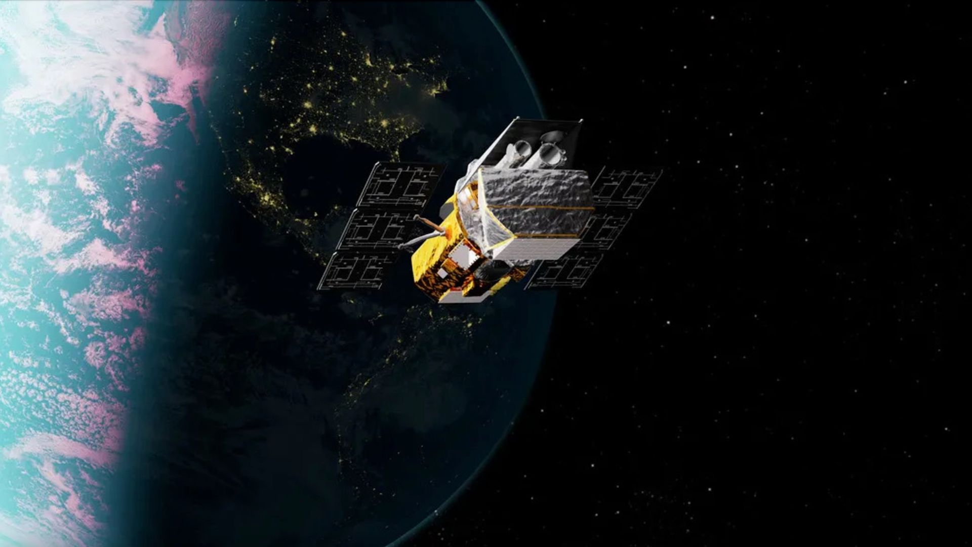
Click for next article Artist's illustration of NASA's Neil Gehrels Swift Observatory, which launched to Earth orbit in November 2004 and will soon fall out of space. NASA's Swift space telescope is expected to crash back to Earth in the next few days. The Neil Gehrels Swift Observatory will reenter Earth's atmosphere in an uncontrolled fashion, after a robotic rescue mission failed to boost the scope to a higher orbit. Swift launched to Earth orbit back in November 2004. Over the next two decades, it studied gamma-ray bursts - the most powerful explosions in the universe - and other cosmic objects and events using a trio of telescopes: a Burst Alert Telescope (BAT), an X-Ray Telescope (XRT), and its Ultraviolet/Optical Telescope (UVOT). On Oct. 20, NASA reported that Swift's orbit had decayed to 171 miles (275 kilometers) above Earth and that the roughly 3,300-pound (1,500-kilogram) observatory was no longer able to compensate for the effects of the increased drag. It entered safe mode, followed by Swift's operations team at Pennsylvania State University sending a command to the spacecraft that effectively ended its operations ahead of its destructive and fiery nose-dive. It's unclear at the moment exactly when and where Swift will plunge to Earth. But researchers definitely have their eyes peeled. A surge of reentries In physics fashion, for the most part, what goes up must come down - with more space hardware to follow. Thanks to the growing surge in low Earth orbit constellations and technology refresh cycles, there are 10 times more objects reentering per year than there were just five years ago, said Darren McKnight, a senior technical fellow at LeoLabs, a company that keeps a watchful eye on what's going on above our planet. "It is unfortunate that Swift was not 'reorbited,' but from a reentry hazard perspective it is a small portion of the stuff coming back in. The rub on this, of course, is that, while many people bemoan the reentry of more objects , I am much more upset about the rapid rate of abandoning massive objects above 400 miles [644 km]," McKnight told Space.com. Swift will likely disintegrate sufficiently upon reentry to not pose a ground casualty hazard, McKnight said. However, the internal workings of the observatory's X-ray and optical telescope might survive, McKnight said. Where in the world? Similar in view is Dean Sladen, a quality manager and aerospace engineer at the U.K. precision-components supplier Accu Components. "Once Swift falls to about 120 kilometers [75 miles], the end usually comes within a few minutes. The air in front of it heats up so much that the satellite will start to glow. Solar panels and antennas are typically the first to tear off, and at around 78 kilometers [48 miles], roughly eight times the height of a passing airliner, the main body breaks apart. Most of it will melt and vaporize," said Sladen. While it isn't yet known exactly where any surviving pieces will land, Sladen noted that Swift's orbit only passes over a band within about 21 degrees of the equator. "That band is mostly ocean, though it also crosses populated parts of Africa, South and Southeast Asia and Latin America," he said. A diagram depicting the makeup of the Swift space telescope. (Image credit: NASA/Goddard Space Flight Center) Surviving leftovers As for which parts are most likely to survive and reach ocean or ground, Sladen pointed out that most of Swift's body is aluminum , wiring and electronics, which melt away early in the reentry process. What reaches Earth is usually small, dense and heat-resistant, such as titanium, steel and glass. "The most likely survivors are its six heavy reaction wheels, the spinning flywheels it used to aim itself, along with tougher telescope parts such as lenses and mirrors. Its mask of around 52,000 tiny lead tiles will almost certainly melt. Only a handful of small, scorched fragments are expected to make it down - nothing recognizable as a telescope," Sladen said. Sladen said that, at the current time, it appears that no detailed risk assessment has been published for Swift's fall. "However, this does not mean NASA has not done the work," said Sladen. "NASA's own orbital debris requirements state that the risk of human casualty from surviving debris shall not exceed one in 10,000, so it is highly likely this work has been completed but not published," he told Space.com. "Personally, I believe it should be published, as NASA has done with previous satellites. The risk is almost certainly very small, but it would give people a clear, factual picture rather than guesswork." A pre-launch photo of the Swift Observatory. (Image credit: NASA/Goddard Space Flight Center) Design for demise Sladen added that there's far more focus on how a satellite's life ends these days than there was in the past. "Many now carry enough propulsion to steer themselves into a remote stretch of ocean, or are built from materials designed to burn up completely, an approach called 'design for demise.' NASA and the European Space Agency limit the chance of anyone being hurt by a reentry to one in 10,000, and if a satellite can't meet that, it's expected to come down in a controlled way," said Sladen. So, should people be worried about having a nasty run-in with Swift leftovers? Sladen doesn't think so. NASA has said that harm to anyone on the ground is unlikely, and LeoLabs also describes the risk as very small. Most of the spacecraft will burn up, and any surviving pieces will most likely fall into the sea, he said.

10. Scientists develop kerosene-based gel for rocket and satellite propulsion
Read more
The findings provide a detailed picture of how the gel behaves under different conditions and help identify the properties needed for reliable fuel storage and delivery. The material combines kerosene with lecithin, a combustible, naturally derived substance, and a small amount of calcium chloride. Concordia University researchers developed a kerosene-based gel that addresses a longstanding challenge in space propulsion: keeping fuel stable in storage and letting it flow into engines. A kerosene-based gel developed by Concordia researchers could make rocket and satellite fuels easier to store and control. The new material combines kerosene, lecithin, and calcium chloride to produce a gel that behaves more like a soft solid at rest but flows when subjected to force or heat, according to a study. Liquid fuels can slosh around tanks, complicating spacecraft control. A press release by Concordia continues that conventional gel fuels, however, can be difficult to work with. The new gel is designed to solve this problem. The research, conducted by Pranay Mudaliar and Jerin John, an associate professor of mechanical, industrial and aerospace engineering at Concordia University, examines how the gel responds to shear, temperature, and the addition of ethanol. Their findings, published in Langmuir, could help address the challenges the industry faces with conventional liquid and gel propellants, including fuel movement inside tanks and pumping fuel into engines. Its transparent appearance could also help researchers observe how fuel moves and burns. The problem of fuel Liquid propellants, because of their material, can become unstable. But fuel gels present other challenges, as they are difficult to pump and spray. So Concordia researchers developed this novel material that can act as both. When at rest, it remains solid, but when exposed to force or heat, it flows. The study explains that calcium chloride turns lecithin into long, worm-like structures called micelles. These structures form a mesh-like network that immobilizes the kerosene, producing a material with liquid and solid-like properties. The gel exhibits strong shear thinning, meaning its viscosity decreases 100 times as the shear rate increases, which is the secret sauce to making rocket and satellite fuel easier to store and deliver to engines. At rest, the gel, as a solid, could reduce problems caused by liquid fuel, such as movement and leakage, according to the university. Now, as a gel, the researchers had to figure out how to transform it into a liquid. According to the study, they used heat. At 138°F to 154°F, depending on the gel's density, it transitioned into a liquid state, potentially offering a way to control fuel flow during propulsion operations.

11. This Chinese warship could operate without a crew, launch missile salvos
Read more
Cramped internal space suggests uncrewed operation, but China has not confirmed it Analysts estimate 16-18 missile tubes, with the vessel expected to surface before firing China's three-hull design could stabilize the vessel when its missile launchers rise China is testing a warship that could hide its hull underwater before surfacing to raise concealed missile launchers. Its unusual three-hull design could help keep the vessel stable as the launch tubes rise into firing position. Built in Guangzhou and now undergoing trials at Huludao on the Bohai Sea, the vessel may carry 16-18 missiles and operate without a permanent crew, according to imagery-based analysis. China has not disclosed its specifications, but the emerging picture suggests a missile carrier that combines submerged transit with surface-launched firepower. Why does it have three hulls? A trimaran consists of a central hull flanked by two smaller hulls. On this vessel, the side hulls, also called outriggers, sit toward the stern rather than extending along most of its length. The arrangement could help stabilize the vessel when its suspected missile launchers are raised. Elevating heavy launch tubes would shift weight upward, making stability an important consideration during firing. Early satellite analysis estimated its length at approximately 65 meters. Much of the vessel was then hidden beneath tarpaulins at the Huangpu shipyard, leaving its forward compartments difficult to examine. Later photographs revealed depth markings on the bow and sail, supporting assessments that the craft could operate fully or almost fully submerged. Those markings, however, do not establish how deep it can dive. A prominent snorkel provides another clue. Diesel engines need atmospheric air, and a snorkel allows them to operate while the hull remains underwater. The mast must still reach above the surface, limiting how deeply the vessel could travel while running those engines. How would its missiles launch? The central hull contains two large compartments believed to house missile tubes. Unlike fixed vertical launch cells on conventional warships, these tubes appear to be stored horizontally and raised before firing. In his latest assessment, naval analyst H. I. Sutton identifies at least eight apparent tubes. A total of 16-18 is considered more likely if both compartments contain matching arrangements. The proposed firing sequence would require the vessel to surface, open the compartment doors, and elevate its launchers. That interpretation comes from imagery analysis; the reporting does not establish a demonstrated missile launch. The weapons themselves remain unidentified. Sutton suggests anti-ship or land-attack missiles, with the YJ-20 among the possible candidates. There is no public confirmation that this particular missile has been integrated. The operating concept has a Cold War precedent. Soviet Juliett-class diesel-electric submarines carried four cruise missiles and had to surface to launch them. China's vessel could apply a similar approach with a larger weapons load. Why might it operate without a crew? Ship-design specialist Rachel Pawling estimates that the vessel would displace approximately 900 tonnes when fully submerged. Her assessment suggests the weapons compartments occupy so much space that little remains for crew accommodation. That supports the possibility of uncrewed operation, although it does not confirm it. An open bridge on top of the sail could accommodate a pilot during harbor movements.

