 |  | 

🌌 अंतरिक्ष समाचार | Space News
बुधवार, १२/०८/२०२६ | Wednesday, 12/08/2026

1. IIT-Gandhinagar to launch ₹190cr semiconductor training hub
Read more

IIT-Gandhinagar to launch ₹190cr semiconductor training hub " page-seotitle="IIT-Gandhinagar Unveils ₹190 Crore Semiconductor Training Hub for Future Innovation, ETGovernment" data-href="https://government.economictimes.indiatimes.com/news/policy/iit-gandhinagar-to-launch-190cr-semiconductor-training-hub/133143258" data-msid="133143258" data-mediaid="" data-authors="[""]" data-author-list="" data-category-name="Policy" data-category_id="545" data-cat_msid="69756026" data-date="2026-08-11" data-index="article_1" data-keywords="IIT Gandhinagar, semiconductor training hub, Silicon and Advanced Semiconductor Manufacturing Research and Training Hub, SAMARTH initiative, workforce development in semiconductor" data-type='news' style="writing-mode: horizontal-tb;"> - Policy - 1 min read The initiative will train 10,000 students and technicians and upskill more than 1,000 industry professionals. - TNN - Published On Aug 11, 2026 at 11:13 AM IST Select ETGovernment as Preferred Choice on Google Copy Link Share on WhatsApp Share on Linkedin Share on X Share on Telegram Share on Facebook IIT Gandhinagar researchers have developed a new high-strength aluminum alloy. This indigenous innovation aims to reduce Indias reliance on imported strategic materials State-based higher education institutions participated in a meeting at IIT Gandhinagar (IIT-Gn) ahead of the launch of the Silicon and Advanced Semiconductor Manufacturing Research and Training Hub (SAMARTH). The meeting provided a platform for discussions on the implementation framework of SAMARTH and explored how these institutions could collaborate with IIT-Gandhinagar, officials said. A ₹190-crore initiative of the ministry of electronics and information technology (MeitY), the govt of Gujarat and IIT-Gandhinagar, SAMARTH will offer an integrated facility built around four pillars workforce development, awareness, research and industry engagement aimed at strengthening semiconductor manufacturing, officials said. Advt - See more on: - IIT Gandhinagar , - semiconductor training hub , - Silicon and Advanced Semiconductor Manufacturing Research and Training Hub , - SAMARTH initiative , - workforce development in semiconductor Telegram Facebook Comments What are your thoughts? Comment Now --> Comment Now Read Comment (1) All Comments By commenting, you agree to the Prohibited Content Policy Post Find this Comment Offensive? Choose your reason below and click on the submit button. This will alert our moderators to take actions REASONS FOR REPORTING Foul Language Defamatory Inciting hatred against a certain community Out of Context / Spam Others Report Join the community of 2M+ industry professionals. Subscribe to Newsletter to get latest insights & analysis in your inbox. --> All about ETGovernment industry right on your smartphone! - Download the ETGovernment App and get the Realtime updates and Save your favourite articles. Scan to download App --> - Home - News - IIT-Gandhinagar to launch ₹190cr semiconductor training hub

2. NASA invites ISRO to join Moon Base programme - The Hindu
Read more
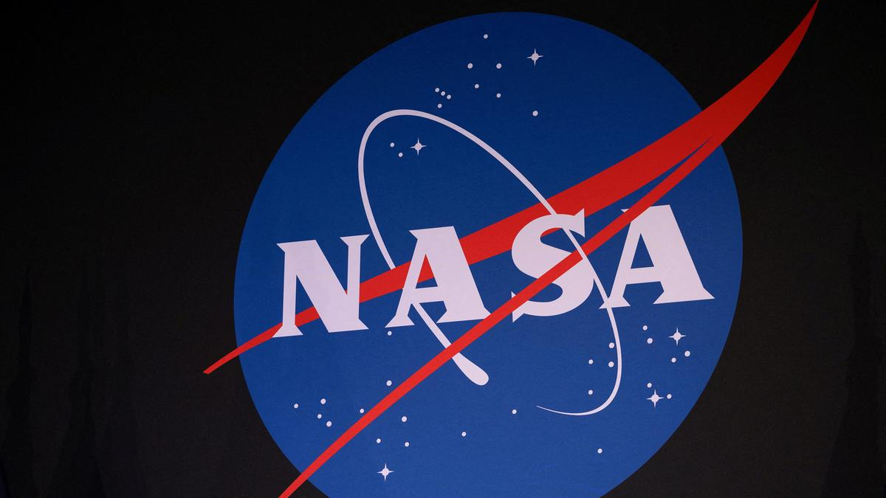
National Aeronautics and Space Administration (NASA) has invited the Indian Space Research Organisation (ISRO) to be part of its Moon Base programme. At the ninth meeting of the India-U.S. Civil Space Joint Working Group (CSJWG), held in Bengaluru recently, the formal invitation for India to join the programme was made by the U.S. space agency. "NASA invited ISRO to join its Moon Base program, building on the two countries' partnership under the Artemis Accords. The two sides also agreed to advance discussions for cooperation on open scientific data sharing under the Accords," said a statement from the U.S. Embassy and Consulates in India. According to NASA, the programme envisages building humanity's first outpost on another celestial body near the lunar South Pole. The programme will be executed in three phases. It was announced during NASA's "Ignition" event on March 24, 2026, where the agency unveiled a series of initiatives to achieve President Donald Trump's National Space Policy and advance American leadership in space. The meeting, held at ISRO headquarters, also advanced civil and commercial space cooperation under the U.S.-India Transforming the Relationship Utilizing Strategic Technology (TRUST) Initiative, aligning with the February 2025 Joint Leaders' Statement issued by Prime Minister Narendra Modi and President Donald Trump. "Both sides discussed expanding cooperation following the successful launch of the joint NASA-ISRO Synthetic Aperture Radar (NISAR) mission last year, as well as pursuing future science and human spaceflight technology collaborations. They reaffirmed their commitment to advancing the United Nations Committee on the Peaceful Uses of Outer Space (COPUOS) guidelines on the long-term sustainability of outer space activities, as well as reviewed ongoing multilateral efforts for ensuring the Committee's effectiveness," the statement added. ISRO Chairman V. Narayanan, U.S. Ambassador Sergio Gor, and senior officials from both countries attended the meeting.

3. Nasa invites Isro to join Moon base programme - The Times of India
Read more

Representative image Join conversation View All Comments → Share your thoughts in the comments Insightful Agree Disagree Skeptical Concerning Promising Worth Reading Big Development Post Comment Be respectful · TOI community guidelines BENGALURU: Nasa has invited Isro to join its Moon Base programme, opening a new avenue for India-US cooperation in lunar exploration and human spaceflight.The Moon Base was announced during Nasa's "Ignition" event on March 24, 2026, where the US space agency unveiled a series of initiatives designed to achieve President Donald J Trump's National Space Policy and advance American leadership in space.The invitation to Isro was extended during the 9th meeting of the India-US Civil Space Joint Working Group (CSJWG), held at Isro headquarters in Bengaluru on Aug 5 and Aug 6.The meeting brought together senior officials from both countries to advance civil and commercial space cooperation under the US-India Transforming the Relationship Utilising Strategic Technology (TRUST) Initiative.The invitation builds on the growing partnership between the two countries under the Artemis Accords, which seek to establish principles for the peaceful and sustainable exploration of the Moon and beyond."Nasa invited Isro to join its Moon Base program, building on the two countries' partnership under the Artemis Accords. The two sides also agreed to advance discussions for cooperation on open scientific data sharing under the [Artemis] Accords," the US Embassy said in a statement on Tuesday.The two sides discussed expanding collaboration in future space science and human spaceflight technologies. The meeting came after the successful launch of Nisar, the joint Nasa-Isro Synthetic Aperture Radar mission, last year.Nisar is designed to provide detailed observations of changes on Earth's land and ice surfaces and is the first satellite mission to use two different radar frequencies to study the planet.The two countries also "reaffirmed their commitment to advancing guidelines on the long-term sustainability of outer space activities through the UN Committee on the Peaceful Uses of Outer Space (COPUOS)," the statement read, adding that the teams reviewed ongoing multilateral efforts aimed at strengthening the committee's effectiveness.The CSJWG meeting was addressed by Department of Space secretary V Narayanan and US ambassador to India Sergio Gor. It was co-chaired by M Sankaran, director of Isro's UR Rao Satellite Centre, and US officials Wesley Brooks, assistant secretary of state for oceans and international environmental and scientific affairs, and Kathleen Karika, Nasa associate administrator for international and interagency relations.The Moon Base invitation comes as the US-led Artemis programme moves towards establishing a sustained human presence around the Moon. India became a signatory to the Artemis Accords in 2023, committing to principles governing peaceful exploration, scientific cooperation and the sustainable use of space resources.For India, participation in the Moon Base programme could extend its involvement in lunar exploration beyond its Chandrayaan missions and provide opportunities for collaboration in science, technology and human spaceflight. The US and India have already identified human spaceflight as an area for deeper cooperation, including through the broader strategic partnership between their space agencies.

4. NASA invites ISRO to join its Moon Base programme under Artemis Accords - The Indian Awaaz
Read more
Last Updated on August 11, 2026 7:36 pm by INDIAN AWAAZ AMN / SCIENCE DESK The National Aeronautics and Space Administration, NASA has invited the Indian Space Research Organisation (ISRO) to join its Moon Base programme, building on the two countries' partnership under the Artemis Accords. India and US have agreed to advance discussions for cooperation on open scientific data sharing under the Accords. The ninth meeting of the India-US Civil Space Joint Working Group was hosted by India on 5th and 6th August at the headquarters of the Indian Space Research Organization in Bengaluru. ISRO Chairman Dr. V. Narayanan and US Ambassador to India, Sergio Gor addressed the opening segment. They highlighted the significance of further strengthening the bilateral space cooperation. External Affairs Ministry said in a statement that the meeting advanced civil and commercial space cooperation under the US-India Transforming the Relationship Utilizing Strategic Technology, TRUST Initiative. Both sides discussed expanding cooperation following the successful launch of the joint NASA-ISRO Synthetic Aperture Radar (NISAR) mission last year, as well as pursuing future science and human space flight technology collaborations. They reaffirmed their commitment to advancing the United Nations Committee on the Peaceful Uses of Outer Space (COPUOS) guidelines on the long-term sustainability of outer space activities. They also reviewed ongoing multilateral efforts for ensuring the Committee's effectiveness.

5. 'Deepen India-US space partnership': NASA invites ISRO to join Moon Base project under Artemis Accords | India News - Hindustan Times
Read more
Nasa has invited the Indian Space Research Organisation (Isro) to join its Moon Base programme, deepening the US-India partnership in space exploration, the US Embassy in India said on Tuesday. Besides the Moon Base project, India and the US also agreed to advance discussions on cooperation in open scientific data sharing under the accords. (PTI) The invitation was announced after the ninth meeting of the India-US Civil Space Joint Working Group, held at Isro headquarters in Bengaluru on August 5-6, where the two sides discussed expanding cooperation in human spaceflight, space science, Earth observation and future space technologies. "Nasa invited Isro to join its Moon Base program, building on the two countries' partnership under the Artemis Accords," the US Embassy said in a statement. The two sides also agreed to advance discussions on cooperation in open scientific data sharing under the accords. 'Deepen India-US space ties' US Ambassador to India Sergio Gor announced the invitation in a post on X, saying it would deepen the "US-India deep space partnership". Nasa envisages the Moon Base as a phased programme aimed at establishing an enduring human presence on the lunar surface, particularly around the Moon's South Pole. The programme is intended to support scientific research and technology development and prepare for future crewed missions to Mars. ALSO READ | NASA chief Jared Isaacman declares 'boots will be on the moon in 2028', hails Elon Musk's SpaceX The two sides also reaffirmed their commitment to cooperation under the US-India Transforming the Relationship Utilizing Strategic Technology (TRUST) initiative, in line with the February 2025 Joint Leaders' Statement issued by Prime Minister Narendra Modi and US President Donald Trump. The meeting was chaired by Isro chairman V Narayanan and Ambassador Gor, and co-chaired by M Sankaran, director of Isro's UR Rao Satellite Centre, and US officials Wesley Brooks and Kathleen Karika. India and Artemis Accords India joined the Artemis Accords in June 2023, becoming the 27th signatory to the US-led framework for cooperation in lunar and other space exploration. ALSO READ | Space technology to shape India's next growth story: ISRO scientist The Moon Base programme, announced by Nasa in March, envisages a phased approach combining robotic and human missions. The first phase, through 2029, will focus on robotic missions to explore the lunar South Pole, demonstrate technologies and develop the foundations for a sustained presence. The second phase, from 2029 to 2032, will focus on building systems and infrastructure for a long-term presence, while the third phase will begin assembling a permanent lunar outpost where astronauts can live and work for extended periods.

6. SpaceX could make $500 billion in 2028, Elon Musk says
Read more
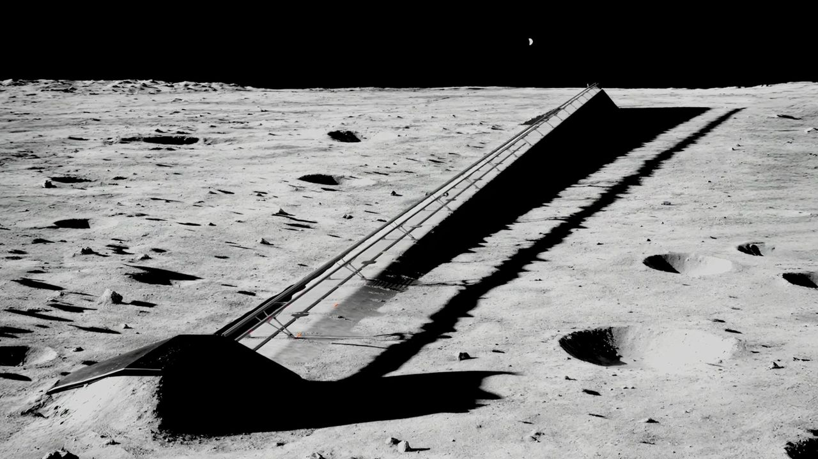
Click for next article Illustration of an electromagnetic mass driver on the moon, which SpaceX plans to use to launch AI satellites into space. SpaceX isn't a launch company anymore. SpaceX is famous for launching, and landing, its Falcon 9 and Falcon Heavy rockets and sending astronauts to space aboard its Dragon crew capsule. Recently, however, the company has been transitioning into an artificial intelligence (AI) outfit - and that journey is now mostly complete. "Our AI revenue will exceed all other SpaceX revenue probably in September - like, next month - and will significantly exceed all other SpaceX revenue in in the fourth quarter," company founder and CEO Elon Musk said during an address to employees that the company posted on X today (Aug. 11). "So, AI has become an extremely important part of SpaceX's future." Earlier this year, SpaceX bought xAI, a startup that Musk founded in 2023. xAI created the chatbot Grok and also operates a powerful supercomputer cluster in Tennessee called Colossus. But that was just the beginning. Musk laid out just how deeply SpaceX is diving into AI during his 29-minute talk, which came a week after SpaceX's first-ever quarterly earnings call as a public company. "Probably in four or five years, AI will be 99% of the value of SpaceX; I'd say five years for sure," Musk said. "And the value of SpaceX will be some astronomical number." Astronomical is right. According to Musk, the company aims to get 10 gigawatts of AI compute up and running by the end of next year. That's a big jump from its current 1.4 GW, which SpaceX sells to tech companies and AI labs. "The value per watt is probably going to be 30 to $50, which means if we bring 10 gigawatts of AI online by the end of next year, it will be 300 to $500 billion a year in revenue," he said. "Big numbers." And those numbers will get even bigger over time, if all goes according to plan. SpaceX just announced plans to build a gigantic complex in Texas called Terafab , a joint operation with Tesla that will manufacture advanced semiconductor chips for a wide range of applications. And the company aims to launch a million of its "Starmind" AI satellites to low Earth orbit in the coming years using its fully reusable Starship megarocket, which is still in development. Over the longer haul, the company plans to establish factories on the moon that will build these off-Earth data centers. The satellites will be launched into space from the lunar surface via electromagnetic mass drivers - basically, high-powered rail guns. SpaceX envisions Starmind and its other AI efforts as returning almost unimaginable profits down the road. For example, in paperwork the company filed just before its record-breaking IPO , SpaceX identified an eventual "total addressable market" of $28.5 trillion, nearly $23 trillion of it in the AI field. For some perspective: The gross domestic product of the entire United States last year was about $30.8 trillion. "The future is fundamentally AI and robots," Musk said during his address to employees. "Assuming civilization continues to progress, I think that AI will probably - the amount of digital intelligence will probably be more than a trillion times the amount of biological intelligence." He also said he's not just in this for the money. "It's important that we have an AI that cares about humanity, that fosters humanity and helps take us to other planets and other star systems ," Musk said. "This is why I think it's essential that SpaceX succeed not just with AI hardware but also with AI software," he added. "I think an AI that is sort of SpaceX's baby will be a very good AI. I think SpaceX is a collection of some of the very best humans on Earth, both in capability and morality and goodness." He urged SpaceX employees to aid the company's AI efforts in any way that they can, stressing that success could lead to some amazing vacations. "One of the nice benefits of this also is that anyone at SpaceX who wants to go to the moon or Mars will be able to go in the future," he said. "You have my word." Editor's note: The original headline of this story read "in 2027," which was incorrect, given that SpaceX aims to get 10 GW online by the end of that year. It was corrected at 8:20 p.m. ET on Aug. 11.

7. SpaceX launches 29 Starlink satellites to orbit from Florida (video, photos)
Read more
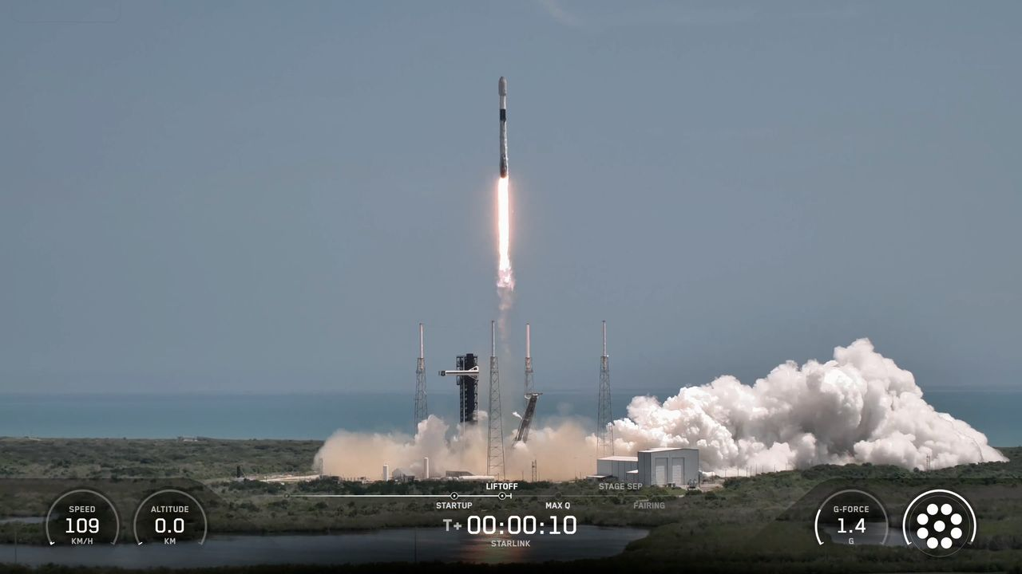
Click for next article SpaceX sent yet another batch of its Starlink internet satellites skyward today (Aug. 11). A Falcon 9 rocket lifted off from Florida's Cape Canaveral Space Force Station today at 11:58 a.m. EDT (1558 GMT), carrying 29 of the broadband spacecraft toward low Earth orbit (LEO). About 8.5 minutes later, the rocket's first stage made a pinpoint landing in the Atlantic Ocean atop the SpaceX droneship "A Shortfall of Gravitas." It was the 18th flight for this particular booster, which is designated B1085. The Falcon 9's first stage is seen just after its drone-ship landing on Aug. 11, 2026. (Image credit: SpaceX) Though more than half its liftoffs have been Starlink flights, B1085 also has some astronaut missions under its belt. The booster lofted SpaceX's Crew-9 flight to the International Space Station in September 2024, and it launched the Fram2 mission around Earth's poles six months later. The Falcon 9's upper stage, meanwhile, continued hauling the 29 Starlink satellites to LEO today. They'll be deployed there 64 minutes after liftoff, if all goes to plan. Today's liftoff was the 93rd Falcon 9 launch of the year already. Seventy-two of those missions have been devoted to building out Starlink, the largest satellite constellation ever assembled. Starlink currently consists of more than 10,900 active satellites , according to astrophysicist Jonathan McDowell. But SpaceX has even bigger megaconstellations in mind: Eventually, the company wants to operate 100,000 of its bigger, more capable Starlink V3 satellites, and Elon Musk has stated an ambition to launch a million AI data center satellites to Earth orbit as well.

8. NASA will chase the Aug. 12 total solar eclipse with balloons and a high-altitude jet
Read more
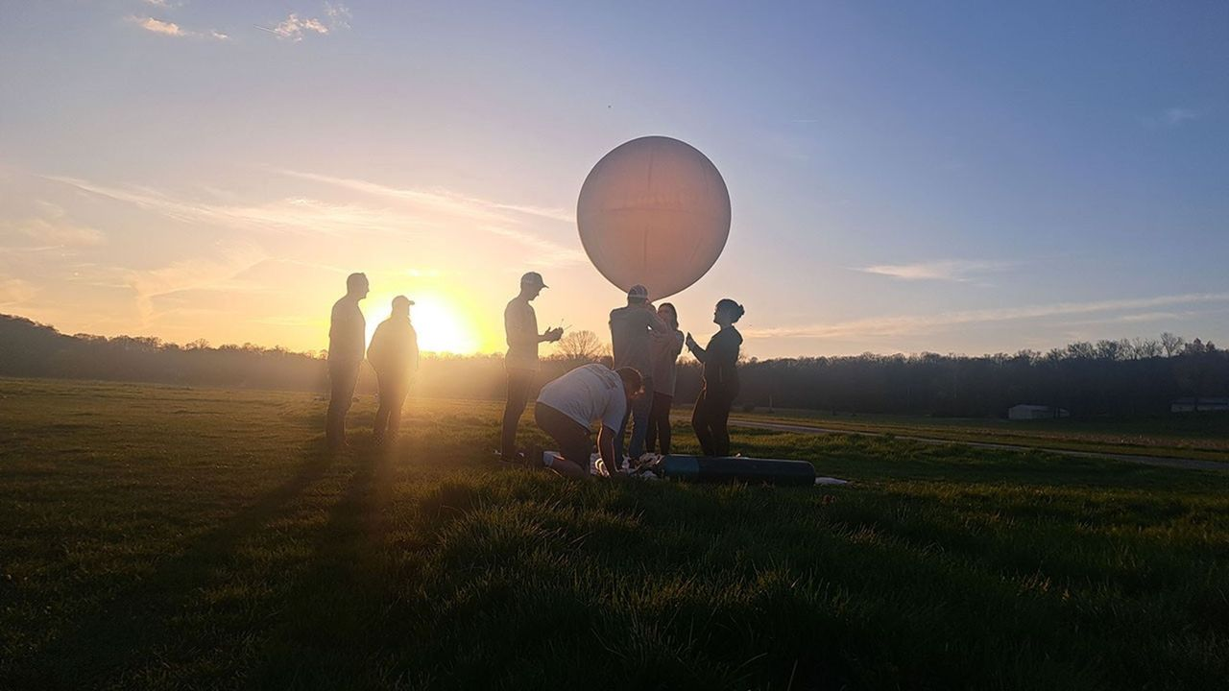
Click for next article A student team from the University of Kentucky prepares to launch a balloon from Bloomington, Indiana, to take atmospheric measurements on April 8, 2024, during the 2024 Nationwide Eclipse Ballooning Project campaign. A total solar eclipse isn't just a spectacular sight to witness for those lucky enough to lie in the path of totality (or travel to it, as many dedicated skywatchers do). It also gives scientists a rare chance to study the sun's outer atmosphere, or corona, during the day. As such, NASA plans to take full advantage of the opportunity for the upcoming total solar eclipse happening on Aug 12. The space agency's WB-57 high-altitude research jet will chase the moon's shadow across the globe, which will extend the agency's ability to capture data from the eclipse. The NASA-supported Nationwide Eclipse Ballooning Project will also coordinate teams to release balloons that will help us know how our atmosphere changes when an eclipse turns the sky dark during the day. "From our unique perspective on Earth during a total solar eclipse, scientists can study the sun's corona in a way we can't from anywhere else in the solar system," Kelly Korreck, eclipse program manager at NASA Headquarters in Washington, said in an official announcement . "The sun impacts our daily life, satellites, and astronauts in space, and we can take advantage of this moment to advance our understanding of that influence," she continued. NASA's WB-57 jet. (Image credit: NASA) Inside the research jet's nose cone, four cameras will capture images of the corona's structures, outflows, and changes. This data may help scientists gain a better understanding of how materials within the corona relate to solar winds. "The sun is always changing," Amir Caspi, principal investigator for the study at Southwest Research Institute in Boulder, Colorado, said in the announcement. "Every eclipse is different. So we could see things we didn't see before. And we learn from each eclipse how to better observe the next one." These images of the corona and solar prominences were taken in different wavelengths of visible and infrared light by imagers aboard a NASA's WB-57 jet during the April 8, 2024, total solar eclipse. The same cameras will fly on a NASA WB-57 jet again during the Aug. 12 eclipse. (Image credit: NASA / SwRI / William Ashfield) Angela Des Jardins at Montana State University will lead the Nationwide Eclipse Ballooning Project, with the help of students from universities in the U.S., Iceland and Spain. By releasing balloons in anticipation of the eclipse, scientists will be able to look at the ozone levels in the atmosphere during the eclipse and study how the eclipse impacts the "boundary layer" of the Earth, which shifts due to temperature and moisture in the air.

9. SpaceX wants to put 1 million AI satellites in orbit. What would that do to Earth's climate?
Read more
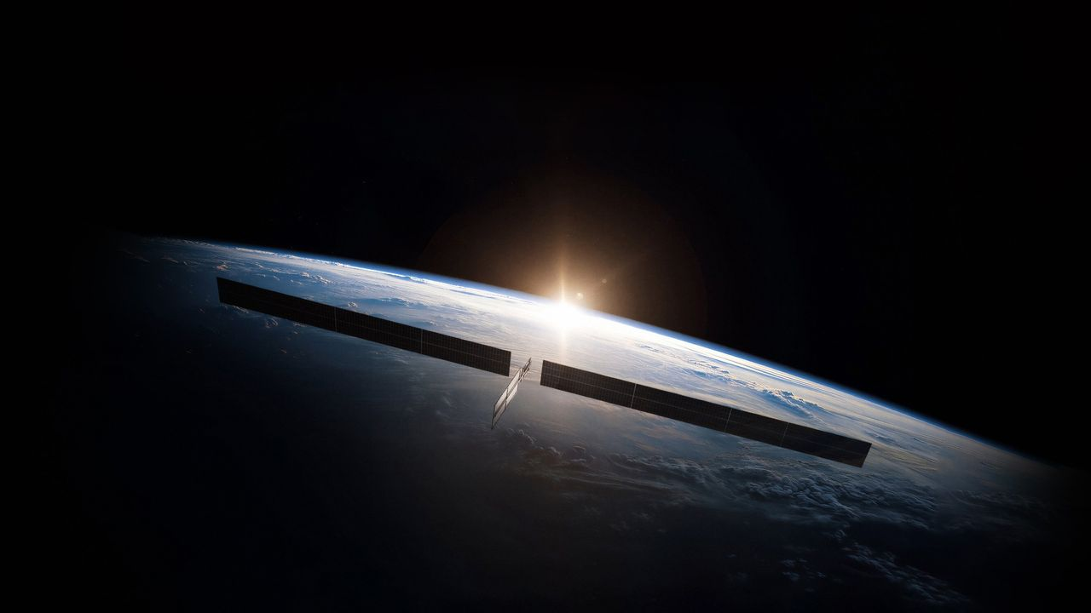
Click for next article Concentrations of dangerous pollutants from rocket launches and satellite reentries in Earth's upper atmosphere might reach treacherous tipping points if constellations of hundreds of thousands of orbiting data centers get deployed in the next decade, experts say. There's no question that Earth has an AI data center problem. By 2030, AI data centers may be responsible for up to 17% of electricity consumption in the U.S., according to a forecast by the Electric Power Research Institute. New fossil fuel power plants are being built to feed the growing demand for electricity, and aging ones are kept online despite decarbonization plans. On top of that, huge amounts of water are taken from already strained reservoirs to cool the computers. Companies such as SpaceX , Amazon and Blue Origin say they have a solution: moving the power-hungry data crunching infrastructure into space, where solar power is easy to produce, and heat can be radiated out into the frigid vacuum. Combined, those companies have filed applications to the U.S. Federal Communications Commission to launch more than a million orbiting data centers in the next 10 years. Most of those will belong to SpaceX, if all goes to plan; Elon Musk has said the company wants to operate a million-satellite AI constellation all by itself. The plans are making atmospheric scientists tear their hair out. If all these projects come to fruition, the number of satellites being launched to space and reentering the atmosphere will increase 100 times compared to today's numbers. Moreover, the data center satellites will be much larger than the spacecraft orbiting Earth today. This large mass will translate into higher quantities of polluting propellant needed to loft these systems off Earth and a much larger amount of metals vaporizing in Earth's atmosphere during reentry. Neither is good news for our planet's air. Pristine upper atmosphere "Launches and the reentries are really the only things that humans do that deposit material directly into the upper atmosphere," Aaron Boley, an astronomy professor and space sustainability researcher at the University of British Columbia, told Space.com. "And the way things mix in the upper atmosphere means that the launch and reentry emissions are by far more impactful." Most rockets emit black carbon, which could worsen global warming . Satellite bodies are mostly made of aluminum, which likely turns into aluminum oxide when burned in the presence of oxygen. Aluminum oxide is known for its ability to trigger ozone depletion , a hazardous process that was successfully thwarted by the Montreal Protocol of 1987. Currently, scientists don't have a precise understanding of the chemical reactions that occur between the pollutants and the atmospheric gases at high altitudes. They also don't understand the tipping points, which may mean the difference between minor and major impacts on the climate. What is worse, pollutants in the upper atmosphere remain much longer than those emitted by cars and factory chimneys close to the ground. "Close to the ground, we have rain and wind that removes pollution from the atmosphere within weeks," Eloise Marais, a professor of atmospheric chemistry at University College London, told Space.com. "If we put it into the higher layers of the atmosphere, we rely on very slow atmospheric processes to bring this pollution back down." Too many launches Black carbon from rockets , for example, can stay in the atmosphere for three years, scientists think, meaning its concentrations could dangerously rise in the near future. SpaceX's Starship megarocket is likely to play a key role in the deployment of data center constellations. Unlike SpaceX's current workhorse launcher Falcon 9 , which burns a form of the aviation fuel kerosene, Starship combusts the much cleaner combination of methane and liquid oxygen. But Marais cautions that Starship's size and the much more frequent launches that will be needed to deploy the vast constellations would result in an overall increase in the pollution injected into the upper atmosphere. "Starship is a bigger rocket burning more propellant," Marais said. "So, in terms of each rocket launch, the difference almost offsets. It has potential per launch to produce quite similar amounts of black carbon." Andrew Wilson, a space sustainability researcher at Glasgow Caledonia University in the U.K., told Space.com that every single Starship launch produces around 76,000 metric tons of carbon dioxide equivalent. That's about as much as 17,727 gasoline-powered passenger cars emit in a year. And up to 77,000 Starship launches - some 15,300 per year - might be needed, according to estimates by Ars Technica , to deploy SpaceX's planned million-data-center constellation. That's a lot of rocket pollution added into the atmosphere. For comparison, there were just 324 orbital rocket liftoffs globally in 2025, according to Space News . SpaceX's Starship megarocket launches on its 13th test flight, on July 24, 2026. (Image credit: SpaceX) The space junk rain Then there is the toxic ash from reentering satellites. Today, nearly 19,000 operational and defunct satellites orbit Earth, according to the European Space Agency . Currently, the most numerous type of satellite in Earth orbit is SpaceX's Starlink V2 Mini, each of which weighs about 1,760 pounds (800 kilograms). But SpaceX's orbital data centers are likely to be much more massive. Featuring solar arrays 246 feet (75 m) wide , every data center satellite might weigh up to 7.5 metric tonnes, according to available estimates. Industry insiders expect that SpaceX and other providers would want to replace their AI satellites every five years with newer technology, as they do with existing communications satellites. As a result, tens or even hundreds of tons of metal may be reentering the atmosphere every year in the future, exceeding the amount of natural space rock that hits the planet. The materials that satellites are made of are not naturally present in Earth's atmosphere, which means the consequences of such reentries can be unpredictable. "Only 10 years ago, the reentries were not really a concern, because there were much more natural meteorites entering the atmosphere per year," Wilson said. "But if you have hundreds of thousands or millions of satellites in space at any one time, you are essentially going to create a rain of man-made materials, electronic equipment and metals that otherwise wouldn't be coming into the atmosphere." He added that the situation is akin to ongoing climate change, which shows no signs of slowing down as humanity has so far failed to reduce carbon emissions. "This is the most objects we've ever had in space, and we're continuing to propose more and more and more and more and more," Wilson said. "And there seems, in my opinion, to be very little consideration for the environment." Not enough funding is currently flowing into research to answer the unknowns, Marais added. "We need way more observations and way more time to be able to look into that," she said. Boley concurred: "We absolutely have to understand, and we have to understand that before we actually launch a million satellites. Not that we launch them and wait [to see] what happens."

10. Live coverage: SpaceX to launch 24 Starlink satellites on Falcon 9 rocket from Vandenberg SFB
Read more
Update 11:19 p.m. EDT (0319 UTC): SpaceX updated the new T-0. SpaceX is slated to launch two dozens of its Starlink satellites to low Earth orbit from Vandenberg Space Force Base on Tuesday night. The Starlink 17-49 mission will be SpaceX's 51st flight from the West Coast so far this year. Liftoff from Space Launch Complex 4 East is scheduled for 9:46 p.m. PDT (12:46 a.m. EDT / 0446 UTC). The rocket will fly on a south-southwesterly trajectory. Spaceflight Now will have live coverage beginning about 30 minutes prior to liftoff. <span data-mce-type="bookmark" style="display: inline-block; width: 0px; overflow: hidden; line-height: 0;" class="mce_SELRES_start"></span> SpaceX will launch the mission using the Falcon 9 first stage booster with the tail number B1103. This will be its fifth flight after previously launching SDA-T1TL-E, NROL-179, Starlink 17-35, and Starlink 17-42. Nearly 8.5 minutes after liftoff, B1103 will target a landing on the droneship, Of Course I Still Love You, positioned in the Pacific Ocean. If successful, this will be the 163rd landing on this vessel and the 648th Falcon booster landing to date.

11. The ESCAPE mission will study the evolution of exoplanet atmospheres
Read more

The habitable zone concept is useful for understanding which worlds might, possibly, maybe, be habitable. It highlights exoplanets at the right distances from their stars for liquid water to potentially exist on their surfaces. But that alone can't determine habitability.

12. A smarter way to track satellites beyond Earth's orbit
Read more

Most current space activities operate close to Earth in what is called near-Earth orbit. However, as more satellites and other infrastructure begin to extend beyond that region, maintaining situational awareness of those objects will be crucial.

13. NVIDIA launches Nemotron 3.5 Lightning to make repetitive agent tasks up to 4x faster
Read more
NVIDIA has launched a smaller open model designed to handle the repetitive, high-volume tasks that keep autonomous agents running, aiming to cut the cost and latency of long-running agent workloads. Called Nemotron 3.5 Lightning, the model has 30 billion total parameters but activates only 3 billion for each token. NVIDIA says this mixture-of-experts design allows it to deliver the capacity of a larger model while using compute closer to that of a much smaller one. The model is aimed at the execution layer of autonomous agents, where systems repeatedly call tools, check results, run commands, and delegate tasks. Instead of using a large reasoning model for every step, developers can use Lightning for routine work while reserving larger models for planning and complex decisions. Nemotron 3.5 Lightning is also designed to run locally, including on NVIDIA's DGX Spark, Jetson systems and GeForce RTX 5090 graphics cards. It can also be deployed in data centers, giving developers options for running high-volume workloads closer to where they are generated. Smaller models take over NVIDIA is positioning Lightning as part of a broader shift toward systems that use multiple models rather than relying on one model for every task. Larger reasoning models can handle planning and orchestration, while smaller models take care of execution. The model has been trained with popular agent harnesses in mind, including OpenClaw and Hermes Agent. NVIDIA says this training helps agents make more accurate tool calls while reducing latency during repetitive tasks. The company is also releasing the model as an open offering, including its weights, training data, and recipes under the OpenMDW-1.1 license. Developers can fine-tune it using NVIDIA's NeMo tools or run reinforcement learning and environment-based evaluations. NVIDIA says Nemotron 3.5 Lightning can deliver up to four times the output speed of similar-sized models. On PinchBench, it reached 86 percent accuracy while completing 10,000 tasks 30% faster than Qwen3.6 35B at similar accuracy. The model also supports speculative decoding, a technique that allows multiple tokens to be proposed and then efficiently checked. NVIDIA has included multi-token prediction during training and provides two additional draft models, DSpark and DFlash, for different inference workloads. Routing work by complexity The launch also highlights NVIDIA NeMo Switchyard, a model-routing library designed to direct different tasks to different models. A complex request can be sent to a more capable reasoning model, while routine execution can be routed to Nemotron 3.5 Lightning. That approach could reduce the amount of expensive compute used by always-on agents, particularly systems that perform thousands of small actions over long periods. The model is supported across a growing ecosystem of inference platforms, agent frameworks and cloud services, including Ollama, LM Studio, Amazon SageMaker JumpStart, Google Cloud, Microsoft Foundry and Oracle Cloud Infrastructure. NVIDIA says Nemotron 3.5 Lightning can be downloaded through Hugging Face and ModelScope, while developers can also access it through NVIDIA's own platform and OpenRouter.

