 |  | 

🌌 अंतरिक्ष समाचार | Space News
शनिवार, २२/०८/२०२६ | Saturday, 22/08/2026

1. Isro will not make any launch vehicle, all tech to be handed to private sector - India Today
Read more
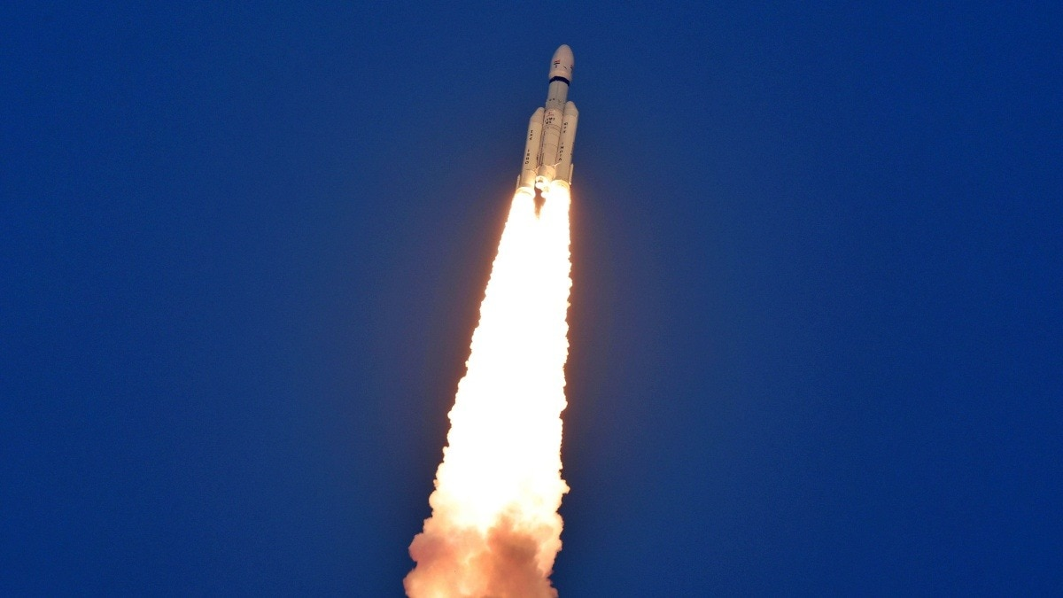
India's space programme is preparing for one of its biggest structural transformations yet, with ISRO set to gradually move away from manufacturing launch vehicles and routine satellites, handing these activities over to the private sector. Speaking at Business Today's India @ 100 Economy Summit, IN-SPACe Chairman Dr Pawan Goenka said the transition is already underway and will allow ISRO to focus on research, advanced technologies, scientific missions and infrastructure that private companies may not be able to build on their own. Read Full Story "ISRO will not make any launch vehicles and will not manufacture any launch vehicles. That will all be done by the private sector or PSU," Goenka said. The shift has already begun with the Small Satellite Launch Vehicle, or SSLV, whose technology and production rights have been transferred to Hindustan Aeronautics Limited following a bidding process. The next phase could be even more significant. Goenka said the Polar Satellite Launch Vehicle (PSLV) and the Launch Vehicle Mark-3 (LVM3), India's most powerful operational rocket, are also headed towards privatisation. Unlike the SSLV process, public sector companies will not be allowed to participate in the upcoming transfer process, leaving private industry to take charge. ISRO's role, Goenka said, will increasingly resemble that of a research and development organisation rather than a manufacturer responsible for everything from rockets to satellites. The space agency will focus on scientific missions, developing new technologies, specialised satellites and advanced infrastructure. Once technologies mature, they can then be transferred to private companies for commercial operations. "We have already transferred 120 technologies from ISRO to the private sector," he said. The government is also planning to hand operations of a new launch centre to private industry. Goenka said the operator could be finalised within the next four or five months. The transformation is part of India's broader ambition to expand its space economy from around $8 billion today to $44 billion by 2033. Goenka said achieving that target will require three major engines: government demand, greater use of space technologies by industries outside the traditional space sector, and expansion into international markets. The government, he said, must act as an anchor customer. The Department of Defence has already placed an order for 31 satellites with private companies, while ISRO is expected to build 21 more under the same broader programme. India is also pushing towards an ownership-based commercial model, where private companies own satellites and other space assets and monetise their data and services. For ISRO, the future could mean doing less of the day-to-day manufacturing that defined its rise as a space power, and focusing instead on creating the technologies and missions that will define India's next chapter in space. - Ends

2. Former ISRO chairman Somanath appointed to Central Board of Directors of RBI - Manorama Yearbook
Read more

• S. Somanath, former chairman of the Indian Space Research Organisation (ISRO), was appointed to the Central Board of Directors of Reserve Bank of India (RBI). • Somanath retired from ISRO in January 2025. • He has been appointed as a part-time, non-official director on the central board for a period of four years with effect from August 20, 2026. • The RBI also re-appointed industrialist Anand Mahindra, chairman of the Mahindra Group, for another four years as a part-time, non-official director on the central board. Central Board of RBI • The Reserve Bank of India was established on April 1, 1935 in accordance with the provisions of the Reserve Bank of India Act, 1934. • The Central Board of Directors is entrusted with the governance of the Reserve Bank in accordance with the Reserve Bank of India (RBI) Act, 1934. • It comprises the Governor as the chairperson, four Deputy Governors and directors nominated by the central government. • In accordance with the RBI Act, the central government also appoints members for four Local Boards to advise the Central Board on matters referred to them by the Board. • The directors are generally appointed for a four-year term. The Central Board is assisted by three Committees: i) The Committee of the Central Board (CCB). ii) The Board for Financial Supervision (BFS). iii) The Board for Regulation and Supervision of Payment and Settlement Systems (BPSS). • These committees are headed by the Governor. In addition, the Central Board has five sub-committees each headed by a non-official director. They are: i) The Audit and Risk Management Sub-Committee (ARMS). ii) The Human Resource Management Sub-Committee (HRM-SC). iii) The Building Sub-Committee (B-SC). iv) The Information Technology Sub-Committee (IT-SC). v) The Strategy Sub-Committee (S-SC).

3. Explainer: ISRO's SS1 upgrade set to supercharge India's small satellite launch vehicle - organiser.org
Read more
Explainer: ISRO's SS1 upgrade set to supercharge India's small satellite launch vehicle organiser.org

4. Former ISRO Chairman S. Somnath Appointed to Central Board of RBI - APAC Media
Read more
Summarize with: OpenAI ChatGPT Google AI New Delhi, 21 August (APAC Media): Former Indian Space Research Organisation (ISRO) Chairman S. Somanath has been appointed as a part-time, non-official director on the Central Board of the Reserve Bank of India. His appointment has been made for a four-year term. Somanath served as the 10th Chairman of ISRO and Secretary of the Department of Space from 15 January 2022 to 14 January 2025. He retired in January 2025 after a tenure that included the Chandrayaan-3 lunar mission. About the Central Board of Directors, RBI The Central Board of Directors is the apex decision-making body of the Reserve Bank of India under the Reserve Bank of India Act, 1934. The board includes official directors, non-official directors, and government nominees. It deals with the general supervision of the central bank. The total strength of the RBI Central Board was reduced from 15 members to 11 members on 20 August 2026. The external directors listed after the restructuring included Revathy Iyer, Sachin Chaturvedi, Anand Mahindra, S. Somanath, Anuradha Thakur, and Sanjay Lohiya. Also Read Haryana Govt Transfers Six IAS Officers; Vivek Dahiya Made Principal Secretary, Civil Aviation

5. Trump signs new national space policy to enable 1,000 US rocket launches per year
Read more
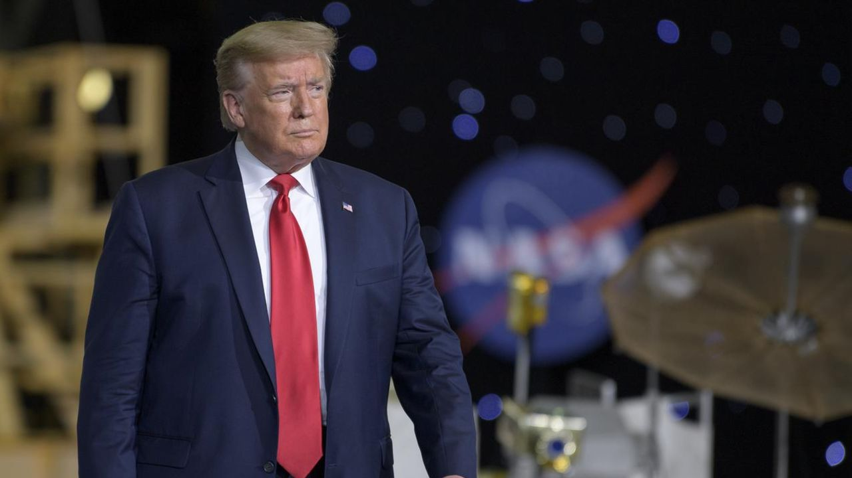
Click for next article The United States is updating its approach to managing spaceflights that lift off and land within its borders, and aims to expand the nation's capabilities to support more than 1,000 rocket launches per year by 2030. President Donald Trump just signed a new National Space Transportation Policy that lays out priorities for commercial, civil and national security missions to orbit. The memorandum, published Thursday (Aug. 20), introduces the first update to the policy since 2013 , and comes as commercial operators such as SpaceX have driven U.S. launch cadences up more than 800% since 2015. The policy centers on expanding the infrastructure and procedures needed to support a much busier space industry. It directs federal agencies to identify and broaden commercial access to additional launch and reentry sites, and to incorporate spaceflight operations and critical launch corridors into air traffic control management and modernization efforts. The document gives agencies a deadline to get the work started. Within 180 days of the memo's publication, NASA , the Department of Transportation (DOT) and the Department of Defense (DOD) are directed to begin identifying potential locations for future launch activities, as well as existing facilities that could be upgraded to further increase capacity. Agencies were also directed to establish leases and commercial investment opportunities to incentivize the co-development of new launch sites. The new properties can be funded, in part, by the same private entities that are lined up to use them. Rocket landing sites are getting extra attention, with the president's policy designating agencies to identify federal lands available for development as independent launch vehicle reentry sites within the next 90 days. It also reinforces a framework to expedite environmental review processes first laid out in a commercial space executive order that Trump signed in August 2025 , which sought to remove regulatory hurdles for commercial launches and spaceport construction. SpaceX is already planning for launch rates far beyond the administration's 2030 target. The company's Starship rocket, which remains in development, is poised to become the first fully reusable launch vehicle in history. In response to the new policy on Thursday, SpaceX CEO Elon Musk said his company is aiming to launch 30 or more Starship flights a day by 2030, which equates to more than 10,000 flights per year. For government missions, the strategy also emphasizes having more than one ride to orbit, with NASA and DOD tasked with maintaining multiple launch options and developing adaptable interfaces that would allow payloads to move between rockets from varying providers. SpaceX's Starship launches on its second test flight on Nov. 18, 2023. (Image credit: Space.com / Josh Dinner) Commercial launch services are already standard for most NASA and DOD missions, but the memorandum broadens that approach to transportation after reaching orbit, including spacecraft servicing and logistics. And the DOD is specifically being asked to investigate commercial options for in-space transportation and more diverse orbital delivery systems, like space planes. Speed is particularly important for national security launches, and the new policy addresses one effort already ongoing by the Pentagon: achieving consistently dependable access to space within a 48-hour timeframe. The Space Force's Space Systems Command has been testing that capability through its Tactically Responsive Space program, launching the Victus Nox mission with Firefly Aerospace with 27 hours' notice in 2023 and the Victus Haze mission in June, which Rocket Lab launched within just 17 hours. The White House highlighted some of the economic benefits beyond transportation that the policy is poised to impact in a fact sheet accompanying its publication. According to that fact sheet, the new policy will lead to advancements in things like in-space manufacturing and the development of pharmaceuticals and "high-value materials," while improvements to satellite positioning, navigation and timing services could support more precise agricultural operations and weather forecasts on Earth. The transportation strategy also extends far beyond low Earth orbit . NASA is being asked to develop a commercial lunar logistics architecture capable of moving cargo and other payloads to and from the moon 's surface. The agency is already engaged in these efforts through its Commercial Lunar Payload Services (CLPS) and Artemis programs, which share a complementary focus of returning astronauts to the lunar surface and building out the infrastructure necessary to sustain a lunar base, and is now tasked with extending that reach much farther.

6. Trump to award NASA's Artemis II astronauts the Congressional Space Medal of Honor
Read more
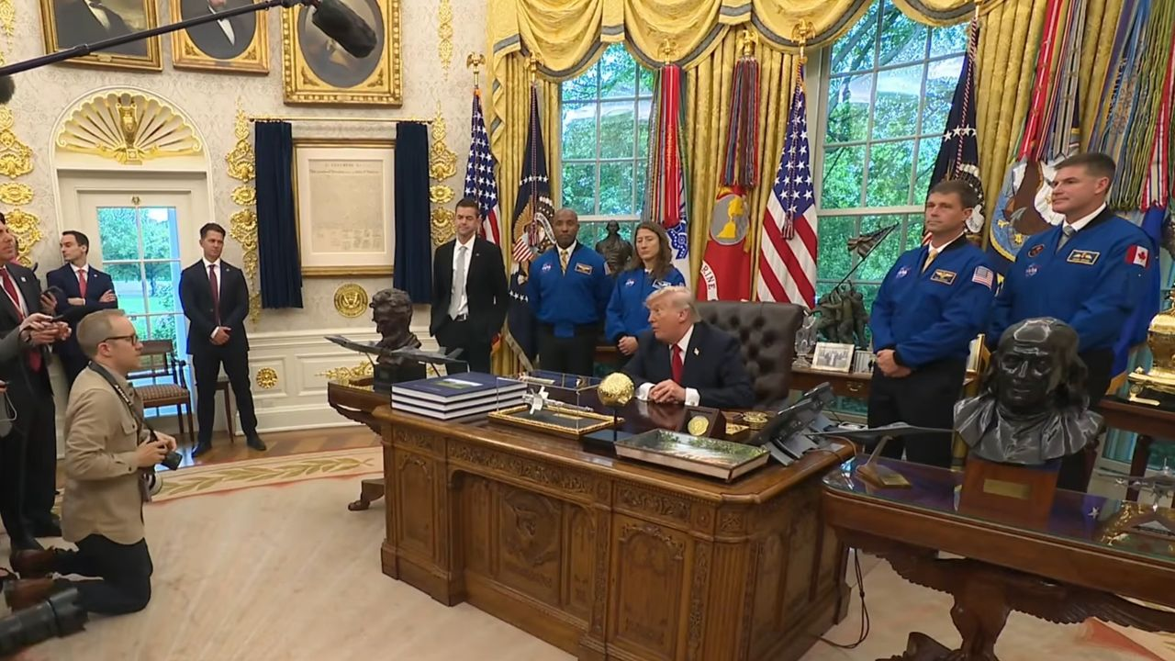
Click for next article President Donald Trump welcomed the four Artemis 2 astronauts (in blue flight suits) and NASA Administrator Jared Isaacman (in dark suit, in front of American flag) to the Oval Office on April 29, 2026. NASA's Artemis II moon astronauts will join a very exclusive club next week. President Donald Trump will award those spaceflyers the Congressional Space Medal of Honor next Friday (Aug. 28) at Johnson Space Center in Houston to recognize their historic journey around the moon this past April. The ceremony will begin at 11 a.m. EDT (1500 GMT) and will feature NASA Administrator Jared Isaacman, President Trump and the Artemis II astronauts. You'll be able to watch it live when the time comes. Artemis II sent NASA astronauts Reid Wiseman, Victor Glover and Christina Koch, as well as the Canadian Space Agency's Jeremy Hansen, on a 10-day trip around Earth's nearest neighbor. It was the first crewed voyage beyond low Earth orbit since 1972, when the Apollo 17 astronauts returned home from the moon. The mission's success was a huge step for NASA's Artemis program , which aims to establish a base near the lunar south pole in the coming years. The Congressional Space Medal of Honor is the highest award that the U.S. government can bestow upon an astronaut. It's possible that only Wiseman, Glover and Koch will receive it next week; NASA's media advisory about the event states that Trump will give the medal to "each of NASA's Artemis II crew members," suggesting that Hansen might not be included. (The award is not limited to American citizens.) Thirty people have received the Congressional Space Medal of Honor to date. They are:

7. Japan unveils Mars moon sample-return spacecraft ahead of Oct. 19 launch (photos)
Read more
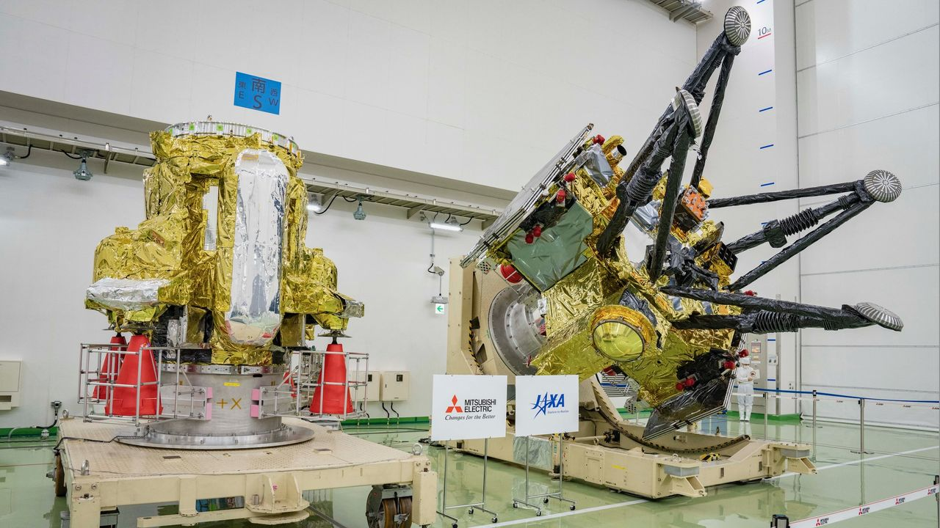
Click for next article The Propulsion Module (left) and Exploration and Return Modules (right), which together make up Japan's Martian Moons eXploration (MMX) spacecraft, are seen at the Tanegashima Space Center in Minamitane, Kagoshima prefecture on Aug. 13, 2026. The world just got its first good looks at some hardware that will make spaceflight history. Last Thursday (Aug. 13), Japan unveiled the spacecraft that make up its Martian Moons eXploration ( MMX ) mission, which aims to snag samples of the Mars moon Phobos and haul them to Earth - something that has never been done. The big reveal came at Tanegashima Space Center, the site from which MMX will launch toward the Red Planet atop an H3 rocket . And we just got some clarity about when that liftoff will take place. Another look at MMX's Propulsion Module (back) and Exploration and Return Modules (front) at Tanegashima on Aug. 13, 2026. (Image credit: Yuichi YamazakiI/AFP via Getty Images) If all goes according to plan, MMX will launch on Oct. 19 at 3:41 p.m. EDT (1941 GMT; 4:41 a.m. on Oct. 20 Japan time), the Japan Aerospace Exploration Agency ( JAXA ) announced on Thursday (Aug. 20). That's the first day of the mission's launch window, which extends through Nov. 7. JAXA originally intended to launch MMX in 2024 but had to stand down due to issues with the H3 . Mars and Earth align properly for interplanetary launches just once every 26 months, so this was a significant delay. MMX will spend about a year traveling to Mars. Once in orbit around the Red Planet, the mission will map and study its two small moons, Phobos and Deimos , which are just 14 miles (22 kilometers) and 7.5 miles (12 km) wide, respectively. Part of this work will help the mission team pick a landing site on Phobos, where they'll drop a 55-pound (25 kilograms) French-German rover called Idefix . That little robot - which is named after the dog in the French comic "Asterix" - will study Phobos' surface in detail using a variety of instruments. The MMX spacecraft itself will then spiral down toward Phobos, eventually making contact and collecting about 0.35 ounces (10 grams) of material. MMX will leave Mars orbit with these samples in 2030 and deliver them to Earth for analysis a year later. The mission aims to shed light on the nature and origin of Phobos and Deimos . "Understanding how Mars and the two moons formed is a heavily debated topic in solar system science," JAXA officials wrote in a mission description . "Remote-sensing observations by the MMX spacecraft and the detailed analyses of the returned sample will determine whether Phobos and Deimos are remnants of early Mars created from debris produced by a giant impact with the young planet, or whether the moons are asteroids captured by Mars's gravity that brought material from outer solar system ," they added. To date, no spacecraft has returned material from the Mars system. Russia tried to do so with its Phobos-Grunt mission , which aimed to sample the eponymous Red Planet moon, but that effort failed shortly after its November 2011 launch. (The Soviet Union also launched two probes to Phobos in 1988, but neither one of them met its mission objectives.) NASA plans to collect and haul home pristine samples that have already been collected on the Martian surface by its Perseverance rover , but it's unclear when or if that will happen. The agency has deemed its original sample-return architecture too expensive and is currently investigating other options.

8. SpaceX launches 29 Starlink satellites, lands rocket on ship at sea (video, photos)
Read more
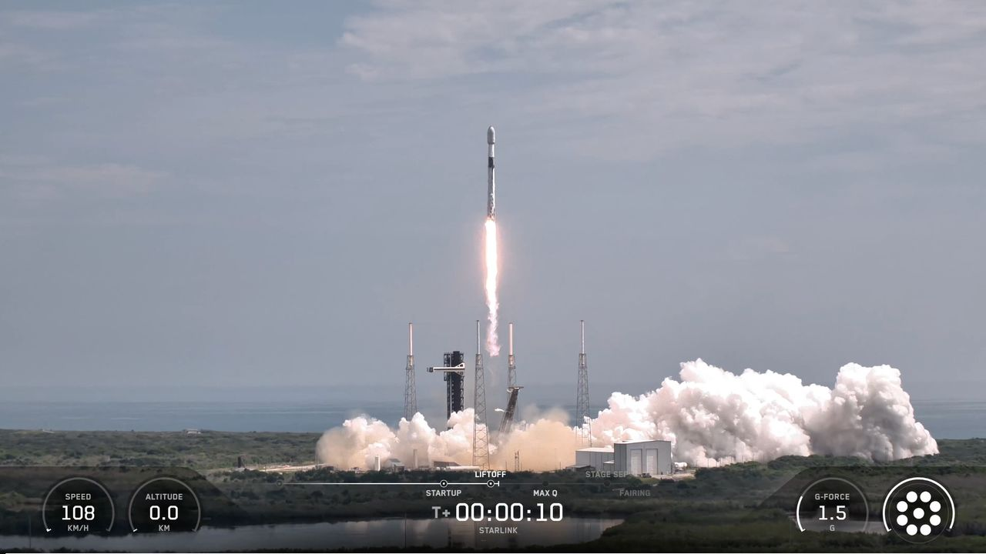
Click for next article SpaceX launched yet another Starlink mission today (Aug. 21), sending 29 more of the broadband satellites to orbit from Florida's Space Coast. The spacecraft flew aboard a Falcon 9 rocket, which lifted off from Florida's Cape Canaveral Space Force Station today at 11:14 a.m. EDT (1514 GMT). That was a day later than planned; SpaceX scrubbed a liftoff attempt on Thursday (Aug. 20) for reasons that were not immediately clear. The Falcon 9's first stage came back to Earth as planned today, landing about 8.5 minutes after launch in the Atlantic Ocean atop the SpaceX droneship "A Shortfall of Gravitas." It was the 30th liftoff and touchdown for this particular booster, which is designated B1078. A SpaceX Falcon 9 rocket launches 29 Starlink internet satellites from Florida's Cape Canaveral Space Force Station on Aug. 21, 2026. (Image credit: SpaceX) The Falcon 9's upper stage, meanwhile, continued hauling the Starlink satellites skyward. It will deploy the new batch into low Earth orbit 61.5 minutes after liftoff, if all goes to plan. There are already quite a few operational Starlink spacecraft up there -nearly 11,000, in fact, according to astronomer and satellite tracker Jonathan McDowell. The Falcon 9's first stage rests on the deck of a drone ship shortly after its touchdown on Aug. 21, 2026. (Image credit: SpaceX) Today's launch was the 98th Falcon 9 flight of the year already. Seventy-five of them have been dedicated Starlink missions. SpaceX also has three other liftoffs under its belt in 2026 - one launch of its Falcon Heavy rocket and two test flights of its Starship megarocket, which is still in development.

9. Live coverage: SpaceX to launch 100th orbital mission of 2026
Read more
SpaceX will launch its 100th orbital mission of the year when it performs an overnight flight from Vandenberg Space Force Base shortly after midnight. The Starlink 15-20 mission will add another 29 broadband internet satellites to the company's megaconstellation in low Earth orbit. SpaceX founder Elon Musk confirmed on Friday that it now has more than 11,000 Starlink satellites in orbit. Liftoff from Space Launch Complex 4 East is scheduled for 12:25 a.m. PDT (3:25 a.m. EDT / 0725 UTC). The rocket will fly on a south-easterly trajectory upon leaving the pad. Spaceflight Now will have live coverage beginning about 30 minutes prior to liftoff. <span data-mce-type="bookmark" style="display: inline-block; width: 0px; overflow: hidden; line-height: 0;" class="mce_SELRES_start"></span> SpaceX will launch this mission using the Falcon 9 first stage booster with the tail number B1100. This will be its ninth flight after previously launching the NROL-105 mission for the National Reconnaissance Office as well as seven batches of Starlink satellites. Nearly 8.5 minutes after liftoff, B1100 will target a landing on the droneship, Of Course I Still Love You, positioned in the Pacific Ocean. If successful, it will be the 220th landing on this vessel and the 653rd Falcon booster landing to date.

10. Interplanetary spacecraft capture a coronal mass ejection component hidden from Earth
Read more

During a coronal mass ejection (CME), the sun hurls billions of tons of magnetized plasma into space. These eruptions are among the most powerful events in the solar system, and when they are aimed toward Earth, they can seriously threaten the satellites and power grids we depend on. For now, it remains notoriously difficult to predict how these eruptions evolve over time-and, ...

11. China is launching a moon mission to find water ice
Read more

We've known for nearly two decades that some form of water exists on the moon. What we still don't know is exactly how much accessible water ice lies inside permanently shadowed craters, how deeply it is buried or what form it takes.

