 |  | 

🌌 अंतरिक्ष समाचार | Space News
गुरुवार, ०५/११/२०२६ | Thursday, 05/11/2026

1. Culture dept implements auditions for 263 registered groups
Read more
PIONEER EDGE NEWS SERVICE/Dehradun The Uttarakhand Culture department has 263 registered cultural groups on its panel and follows an audition-based selection process to provide performance opportunities to local folk artists at government programmes and cultural events. An official from the department said that artists and cultural groups are shortlisted through auditions before being drafted in the approved panel. Whenever district administrations or other organisers seek singers or cultural groups for events and fairs, programmes are allotted to registered groups on a rotational basis. The official further said that the department do not maintain a fixed count of programmes allotted to individual artists, as cultural events are organised by different departments and district administrations throughout the year. The number of opportunities received by each group depends on the requests made by organisers and the nature of the programmes. Regarding remuneration, the official said that payments are determined according to the nature of the event and requirements of the organising administration. Payments for local programmes are generally made on time, though delays may occur when a large number of events are organised. The officials said that the rotational selection process is intended to ensure that registered cultural groups receive opportunities to perform at government events. However, the frequency of engagements varies according to demand from organisers and the availability of programmes throughout the year.

2. Government to launch Kerala Busz to improve safety
Read more

- Governance - 1 min Read The motor vehicles department has proposed the Kerala Busz platform to optimize bus routes and schedules. This system will utilize traffic data and GPS information for better resource deployment. - TIMESOFINDIA.COM - Published On Nov 05, 2026 at 11:13 AM IST - Select ETGovernment as Preferred Choice on Google - Share Icon Copy Link Share on Whatsapp Share on Linkedin Share on X Share on Telegram Share on Facebook - Bookmark - Comment Vehicles move through Aluva town in Ernakulam. (Representative image) The motor vehicles department (MVD) has proposed an integrated digital platform , Kerala Busz , to rationalise private bus routes and timings, minimise overlapping of services and improve public transport safety , the transport commissioner informed the high court in a case initiated suo motu on road safety. The platform will analyse traffic intensity on different routes, vehicle speeds, permissible speed limits, existing schedules, GPS-based vehicle movement data, travel times and the actual demand and availability of transport services. It would help scientifically determine and rationalise bus routes and timings and ensure more efficient deployment of stage carriages. It will also integrate all regional transport offices and the state transport authority into a centralised repository of information for regulating and managing public transport across the state. The commissioner also informed the court that electronic monitoring and automated enforcement systems were operational across the state. Last month alone, 391 vehicles were booked for overloading, attracting ₹95.60 lakh as fine. The court granted the respondents three more weeks to submit concrete proposals. Comments What are your thoughts?

3. Karnataka: NVS-03 now in its intended orbit - The New Indian Express
Read more
Karnataka: NVS-03 now in its intended orbit The New Indian Express

4. NVS-03 reaches geosynchronous orbit; satellite in good health - The Hindu
Read more
NVS-03 reaches geosynchronous orbit; satellite in good health The Hindu

5. ISRO MTS Recruitment 2026 Notification Out: Apply Online For 16 MTS Posts - PW
Read more
ISRO MTS Recruitment 2026 Notification Out: Apply Online For 16 MTS Posts PW

6. ISRO Successfully Places NVS-03 Navigation Satellite In Geosynchronous Orbit - Deccan Chronicle
Read more
ISRO Successfully Places NVS-03 Navigation Satellite In Geosynchronous Orbit Deccan Chronicle

7. Gayatri Rubbers' ISRO Pilot Creates Aerospace Reference - Multibagg AI
Read more
Gayatri Rubbers' ISRO Pilot Creates Aerospace Reference Multibagg AI

8. NASA Announces X-70 Experimental Aircraft to Advance Flight Research
Read more
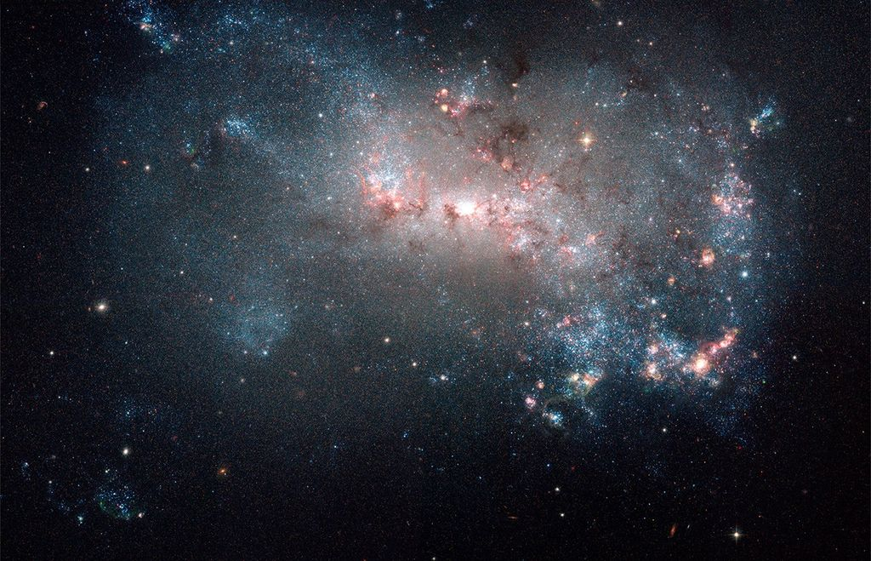
Generated image of NASA's new X-70 Fractal experimental aircraft, a crewed, rapidly reconfigurable research platform for advanced aviation technologies. On Wednesday, NASA unveiled its newest experimental aircraft, the X-70 Fractal, during the UP.Summit at the agency's Kennedy Space Center in Florida. This high-performance, highly adaptable research platform is designed to accelerate the development and testing of advanced aviation technologies. The crewed X-70 features advanced, rapidly reconfigurable flight-control technology that will allow NASA to explore aircraft maneuverability in ways never before demonstrated in crewed flight. The aircraft can also accommodate up to 2,000 pounds of experimental payloads in internal and external locations, enabling a wide range of research and flight-testing opportunities. "The X-70 Fractal gives NASA a crewed, high-performance platform to test advanced flight-control, maneuverability, and other cutting-edge technologies in real flight," said NASA Administrator Jared Isaacman. "Its modular design and ability to rapidly swap internal and external payloads will keep our teams flying, learning, and moving quickly from one experiment to the next. We expect her first flight under the NASA banner within the next two years, and X-70 is just one part of this new beginning for aeronautics. This is why people come to NASA: to build, to learn, and most importantly, to fly." The X-70 Fractal has a takeoff weight of 10,000 pounds and is designed to cruise at Mach .75, reach altitudes of up to 45,000 feet, and provide an operational range exceeding about 1,726 miles (1,500 nautical miles). These capabilities will enable NASA to conduct demanding flight research across a broad range of operating conditions. "For decades, NASA Aeronautics has used X-planes to develop technologies that advance aviation," said Laurie Grindle, director of the Aeronautics Division within NASA's Research and Technology Mission Directorate. "It's exciting to bring on another X-plane to accelerate and drive aeronautics research." The X-70 joins a storied legacy of experimental aircraft that have helped establish America's leadership in aviation. From the Bell X-1, which first broke the sound barrier in 1947, to the X-15 hypersonic research aircraft and today's X-59 quiet supersonic demonstrator, NASA has spent decades pushing the boundaries of flight. With the X-70, NASA will expand its capacity to conduct experimental flight research, accelerate the testing of emerging technologies, and advance the next generation of American aviation. For more information about NASA's aeronautics research, visit: https://www.nasa.gov/aeronautics -end- George Alderman / Cheryl Warner Headquarters, Washington 202-358-1600 george.a.alderman@nasa.gov / cheryl.m.warner@nasa.gov

9. NASA Shares Plans to Accelerate Artemis, Return to Moon
Read more

In an update on Oct. 23, NASA Administrator Jared Isaacman and other agency leaders shared the agency's path to returning Americans to the lunar surface in 2028. Agency leadership provided updates on the previously announced acceleration plans for the Artemis program, advancing toward the agency's Artemis III test flight in 2027 and Artemis IV Moon landing mission in 2028. Building on the priorities announced at Ignition earlier this year, NASA leadership shared the agency's significant progress across its missions, working with industry partners to test critical capabilities, reduce risk, and build toward a sustained American presence on the Moon. This graphic shows NASA's concept of operations for Artemis III. The mission will send four astronauts to low Earth orbit next year to test critical systems needed for future lunar landings. NASA "This is a very energized NASA, and these updates are only a small part of that story. We are bringing extreme focus to the mission to ensure delivery of world-changing outcomes as quickly, safely, affordably, and successfully as possible," said Isaacman. "NASA is driving outcomes to make Moon missions a reality, and we're not waiting for others to bring their plans to us - the campaign must move with urgency as strategic competitors pursue a permanent presence beyond Earth." The agency shared details of the Artemis III mission, which will test rendezvous, docking, and operations between NASA's Orion spacecraft and lunar lander test vehicles from SpaceX and Blue Origin in Earth orbit. Four astronauts will fly aboard Orion, launched on NASA's SLS (Space Launch System) rocket, for a planned 14-day mission in Earth orbit to reduce risk ahead of the Artemis IV moon landing mission. The Artemis III mission will unfold in sequence: Blue Origin will launch a Blue Moon lander test article into Earth orbit, SLS will launch Orion and its crew, docking with the Blue Moon lander test article, then SpaceX will launch a Version 3 Starship lander test article while Orion will undock from Blue Moon and dock with Starship. The Oct. 23 updates follow other recent updates about the Artemis missions. Hardware for Artemis III is on track, with processing timelines sharply reduced by about half. NASA also redesigned, built, and tested a critical fuel-line component in-house in five months, at roughly a tenth of the cost of an earlier outside-vendor estimate. "NASA should be expected to do this kind of work, and we have some of the best technical knowledge in the world on rocket hardware and operations to do it," said Jeremy Parsons, the agency's Artemis program manager. "It's an example of how we are rebuilding our core competencies and developing centers of excellence in technical functions instead of continuing to outsource expertise." Artemis IV: Pursuing multiple paths to Moon landing For the agency's Artemis IV mission in 2028, astronauts will launch aboard Orion on the SLS rocket from NASA's Kennedy Space Center in Florida. NASA is working with SpaceX and Blue Origin to develop lunar landers to carry those astronauts to the Moon's surface. Both companies have redesigned their approaches to simplify the missions and make them more efficient and flexible as compared to previous mission designs. SpaceX's Starship will refuel in Earth orbit, rendezvous with Orion, and then carry the spacecraft toward the Moon. Blue Origin's approach involves transfer stages in Earth orbit to push its Blue Moon Mark 2 lander toward the Moon, where it will meet Orion in a closer lunar orbit before descending to the surface. NASA Both SpaceX and Blue Origin are targeting to be able to support a crewed lunar landing in 2028. For Artemis IV, NASA is pursuing two upper-stage options for the SLS rocket: its current stage, the interim cryogenic propulsion stage; and a stretched version of ULA's Centaur V which can carry more propellant. Pursuing both options ensures NASA is maintaining flexibility and preventing single-point dependency. NASA also announced plans with spacesuit provider Axiom Space to develop a second, lighter suit design called the "Sortie suit" to enable the first moonwalks. The Sortie suit will not replace Axiom's primary suit, which will be used for longer, more demanding missions in the future. The Sortie suit is roughly half the weight of the larger suit and lets NASA move faster on the earliest surface missions. As part of a Golden Age of innovation and exploration, NASA will send Artemis astronauts on increasingly difficult missions at the lunar South Pole to explore more of the Moon than ever before. In addition to providing economic benefits and advancing scientific discovery through its Moon missions, NASA will establish an enduring human presence on the lunar surface and build on the agency's foundation for the first crewed mission to Mars. Learn more about Artemis: https://www.nasa.gov/artemis

10. NASA Announces Ka-Band Satellite Relay Awards for Space Communications
Read more
Credit: NASA NASA selected three companies on Wednesday to perform work to develop Ka-band space relay capability concepts that are compatible with current missions in space, ensuring service continuity for existing spacecraft without requiring modifications to their onboard systems. Through this work, NASA will aim to acquire end-to-end solutions that include space, ground, launch, operations, and integration elements, as one of many customers in the commercial marketplace. The awards, under the Next Space Technologies for Exploration Partnerships-3 Broad Agency Announcement Appendix E, are firm-fixed-price contracts that give NASA the option to provide additional funding up to the award limit to advance from initial concept development and risk reduction to an in-orbit flight demonstration. The initial period of performance runs from Nov. 4 through May 3, 2027, with additional priced options to continue work through 2029. The contract awardees with maximum potential value inclusive of all future options are: Astranis Space Technologies Corp. for $264.3 million. Global Enterprise Solutions Inc. for $340.4 million. Viasat Inc. for $460.9 million. Facilitated through the agency's SCaN (Space Communications and Navigation) program's Communications Services Project, this work supports NASA's decision to gradually retire the Tracking and Data Relay Satellite fleet and adopt commercial services for future missions. In addition to the commercial capabilities currently under development by the program's industry partners, Ka-band services are needed to support select in-orbit missions that cannot feasibly modify flight hardware or transition to non-compatible commercial services. To learn more about NASA's Network Extension for User Continuity and Sustainability Ka-band service acquisition, visit: https://go.nasa.gov/4iVfeVB -end- Jennifer Dooren / Jessica Taveau Headquarters, Washington 202-358-1600 jennifer.m.dooren@nasa.gov / jessica.c.taveau@nasa.gov

11. NASA Navigation Experiment Shows Promise for Planetary Landings
Read more
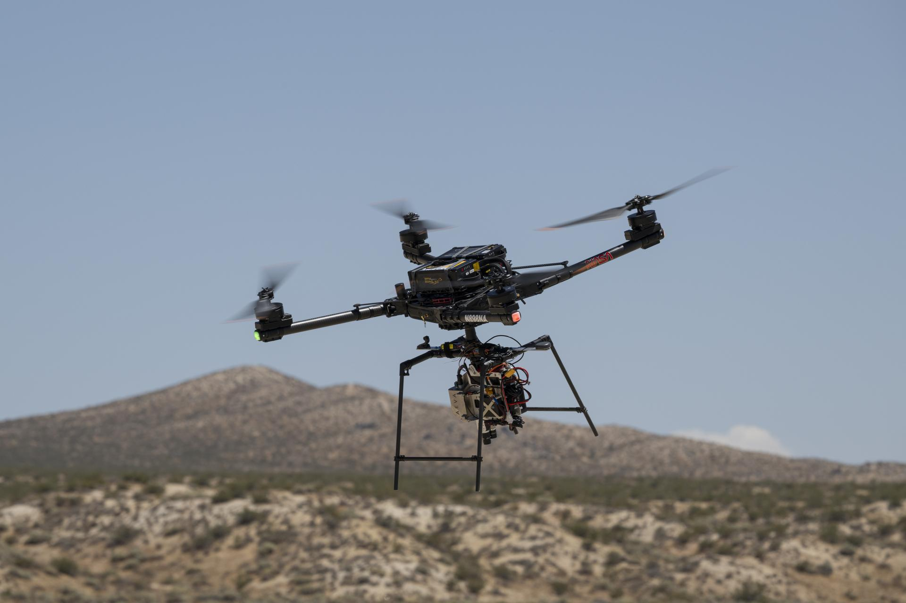
An Alta-X drone flies an advanced guidance and navigation system known as the Safe and Precise Landing - Integrated Capabilities Evolution (SPLICE) experiment near NASA's Armstrong Flight Research Center in Edwards, California, on Wednesday, July 15, 2026. Researchers at NASA's Johnson Space Center in Houston developed SPLICE, which successfully communicated with the remotely piloted aircraft during hover maneuvers in flight. SPLICE will help spacecraft land precisely and detect and avoid potential hazards, which is critical for NASA missions to the Moon and to Mars. NASA/Ryan Kline NASA successfully demonstrated technology designed to help spacecraft autonomously navigate to safe landing sites on the Moon and on other planets. An Alta-X drone equipped with the agency's Safe and Precise Landing - Integrated Capabilities Evolution (SPLICE) guidance, navigation, and control payload completed simulated lunar descent and landing maneuvers Aug. 27. The flight took place at Rogers Dry Lake near NASA's Armstrong Flight Research Center in Edwards, California. During the tests, the SPLICE payload used an advanced guidance system to map the terrain and assess potential landing areas. If the system determines the targeted landing area is unsafe, the system diverts the drone to a safer location. The system generates high-resolution digital elevation maps from light-detection and sensor data. Davis Adams, project manager, confirms that an advanced guidance and navigation system known as the Safe and Precise Landing - Integrated Capabilities Evolution (SPLICE) experiment is communicating with an Alta-X drone near NASA's Armstrong Flight Research Center in Edwards, California, on Wednesday, July 15, 2026. Researchers at NASA's Johnson Space Center in Houston developed SPLICE, which successfully communicated with the remotely piloted aircraft during hover maneuvers in flight. SPLICE will help spacecraft land precisely and detect and avoid potential hazards, which is critical for NASA missions to the Moon and to Mars. NASA/Ryan Kline Researchers at NASA's Johnson Space Center in Houston developed the SPLICE payload and partnered with specialists at NASA Armstrong to integrate, test, and fly it aboard the Alta-X drone in June and July. Those tests verified communications, data handling, telemetry, and command- control performance between the SPLICE payload and the drone to prepare for a full-scale test at Voyager Technologies in Mojave, California, later this month. "This flight test is the culmination of almost a decade of work, for the SPLICE project," said Davis Adams, NASA project manager. "This flight raised the technology readiness level, priming it for integration into future robotic and crewed lunar flights. Validation of the guidance and navigation systems are applicable to terrestrial, lunar, and Martian descent and landing missions." NASA has worked with a number of commercial lunar lander providers to implement iterations of SPLICE into their platforms. A number of the landers slated for upcoming Moon Base missions leverage data collected by NASA through the development of systems like SPLICE to execute soft touchdowns on the lunar surface. Justin Link, a small uncrewed aircraft pilot, left, Justin Hall, chief pilot, and Davis Adams, project manager, test an advanced guidance and navigation system known as the Safe and Precise Landing - Integrated Capabilities Evolution (SPLICE) experiment on an Alta-X drone near NASA's Armstrong Flight Research Center in Edwards, California, on Wednesday, July 15, 2026. Researchers at NASA's Johnson Space Center in Houston developed SPLICE, which successfully communicated with the remotely piloted aircraft during hover maneuvers in flight. SPLICE will help spacecraft land precisely and detect and avoid potential hazards, which is critical for NASA missions to the Moon and to Mars. NASA/Carla Thomas "We are coordinating with industry regarding the usage of the guidance system once the system is available in the NASA software catalog, currently planned for this fall," Adams said. "Some of the companies also are evaluating the system's navigation capabilities for precision landing applications, as well as potential extensions for autonomous surface mobility." NASA's Flight Opportunities project, based at NASA Armstrong, enabled flight testing of the SPLICE project early in its development that laid a foundation for it to continue advancing its technology readiness level to what it is today. Flight testing included both a descent altitude and a landing trajectory in 2019 similar to what is expected on a lunar mission and the demonstration of two NASA-developed precision landing sensor systems in 2020.

12. NASA Space Grant Students Fuel Agency's Inspiration Tour
Read more
NASA Administrator Jared Isaacman addresses a standing-room-only crowd during an Inspiration Tour stop at Iowa State University. Credit: NASA NASA's Inspiration Tour spread the excitement of space exploration and aeronautical innovation by connecting the public, industry, and academia with the people, technologies, and organizations that drive American leadership in space. At nearly every stop across the country, NASA Space Grant has brought students into the heart of the action. In Iowa, NASA Administrator Jared Isaacman toured the Make to Innovate program lab at Iowa State University. Students from the Iowa Space Grant Consortium's Mission Moon program, along with consortium-funded student organizations including Cardinal Space Mining, CySat, and CyLaunch, shared research findings and demonstrated the institution's strong connection to NASA via agency-funded projects. During a well-attended town hall event NASA experts briefed students on the agency's Moon Base efforts and how their work can contribute to future exploration. "We're grateful for the opportunity to welcome NASA leadership to Iowa State," said Sara Nelson Iowa Space Grant director. "The excitement among students was incredible, and the visit highlighted how the research and innovation happening in Iowa can help advance Artemis and NASA's future exploration efforts." At the University of Arizona, the NASA administrator saw firsthand the space research and engineering capabilities that are enabled by the Arizona Space Grant Consortium. From satellite communications testing to complex optics for peering into deep space to student-built high-altitude balloon payloads and even small satellites, students at the University of Arizona have a long history of contributing to NASA missions and making aerospace career connections. This tour stop also included a Q&A session where the NASA administrator answered questions from local high school and college students. "It was incredible to present the high-altitude ballooning research we do in SEDS (Students for the Exploration and Development of Space) to Jared Isaacman and those at NASA," said Ella Miller, a junior studying mechanical engineering at the University of Arizona. "Arizona Space Grant has allowed me to get hands-on experience through an entire mission design process every semester, helping me pursue a career in space research and secure internships in this field." Space Grant students from the University of Alaska Fairbanks shared their research with NASA Administrator Jared Isaacman during a Science Fair event in conjunction with the agency's Inspiration Tour stop. Credit: NASA/Bill Ingalls At the University of Alaska in Fairbanks, the Administrator toured two Geophysical Institute facilities: Poker Flat Research Range, the university's scientific rocket launching facility, and the Alaska Satellite Facility. During an Alaska Space Grant science fair, students shared research in hibernation biology and showcased CubeSat technology advancements. Students were also able to learn about the agency's Moon Base program and ask questions about opportunities available to the next generation of innovators and explorers. In North Dakota, the Inspiration Tour focused on future exploration capabilities. Space Grant-funded research at the University of North Dakota is helping to shape the future of exploration across STEM fields. Student fellows and NASA interns shared their projects on supercell mergers using satellite imagery, geomagnetic conditions of aurora borealis, and in-situ resource utilization, to name a few. North Dakota Space Grant STEM ambassador students also shared robotics and drone activities as part of "Mission Moon", which centers Artemis initiatives in statewide collaborations with educators and other North Dakota colleges and universities. "Getting to speak with the NASA Administrator was an amazing opportunity!" said research fellow and STEM ambassador Malissa Reinhardt. "He genuinely cared about what we students had to say and the research we're working on, which makes all the hard work we put into our research and North Dakota Space Grant Consortium so rewarding." Students at the University of North Dakota's spacesuit lab demonstrated design advancements for lunar surface spacesuits for NASA Administrator Jared Isaacman during a tour of their lab during the agency's Inspiration Tour stop Credit: NASA NASA's Inspiration Tour will culminate in MAX POWER, a public showcase of air and space innovation on Nov. 7 and 8, highlighting the agency's commitment to preparing the next generation of innovators and explorers for humanity's next giant leap. As NASA enters a Golden Age of innovation and exploration, the national network of Space Grant consortia is expanding opportunities for students to lead the way in an aerospace workforce that is evolving and growing. At learning institutions from coast to coast, today's Space Grant students are launching America's future in space. To find ways to engage with NASA's exciting missions, broad range of careers, and unique learning opportunities, visit: https://www.nasa.gov/learning-resources

13. Hubble Reveals Cosmic Mystery
Read more
This is an image from NASA's Hubble Space Telescope of NGC 4449, one of the dwarf galaxies in the Galaxies Losing Oxygen via Winds (GLOW) study. Researchers found that dwarf galaxies can hold onto only a small fraction of the oxygen made by their stars. NASA, ESA, Hubble Heritage-ESA/Hubble Collaboration, Alessandra Aloisi (STScI, ESA)

14. On this day in space! Nov. 4, 2015: A rail-launched Super Strypi rocket carrying 13 baby satellites failed during its debut launch for the US Air Force
Read more
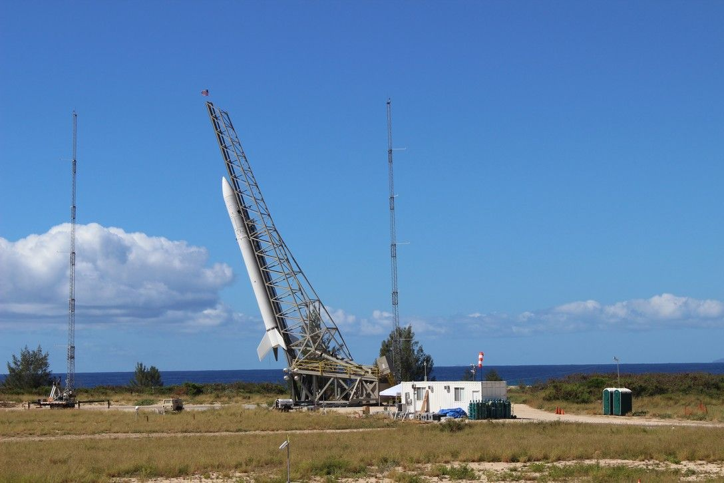
Click for next article On Nov. 4, 2015, the United States Air Force planned to launch an experimental rocket for small satellites from the Pacific Missile Range Facility off Barking Sands, Kauai, Hawaii. The launch didn't according to plan . For this mission, the Air Force was testing out the Super Strypi rocket . The rocket used a rail to help with the liftoff. Super Strypi left the ground, but the rocket quickly spun out of control. When it crashed, it destroyed all of the tiny satellites riding aboard the rocket. The cause? Likely a problem with the first stage motor. The mission lost 13 tiny satellites known as cubesats. Cubesats are a popular option for space missions, because they are small and cheap, and they often operate in swarms. After failing to launch this batch of cubesats, the Super Strypi program never recovered from its failure, and the Air Force never tried launching another one. The U.S. Air Force's rail-launched Super Strypi rocket lifted off from Hawaii about 9:45 p.m. local time on Nov. 3, 2015,, roared toward the sky and failed less than a minute into the long-awaited flight. (Image credit: U.S. Air Force) Why it mattered The Super Strypi rocket was a 21st century take on a 1960s rocket. It was designed to be a modern version of the three-stage Strypi sounding rocket used for for reentry vehicle and anti-missile target tests. Its three stages, powered by Aerojet Rocketdyne solid rocket motors, was designed to reach orbit, rather than suborbital trajectories common to most sounding rockets. The U.S. Air Force hoped Super Strypi would be a new tool for quick-response launches based on national security needs. Altogether, it was designed to launch small payloads of up to 300 kilograms into space for a mere $15 million per mission . The rocket's primary payload was the ORS-4 satellite, short for Operationally Responsive Space 4, which was built for the Air Force by engineers at the University of Hawaii (who nicknamed it HiakaSat). It was designed to capture Earth imagery and monitor the environment over the course of a year. The 12 other payloads on Super Strypi included eight cubesats for NASA's Edison Demonstration of Smallsat Networks mission, and as well as four others for universities that had been added as secondary payloads. Since the Super Strypi failure, neither the Air Force or Space Force has opted to use the rocket for a new mission. The Space Force has turned instead to commercial companies for fast-turnaround launch support. In June of this year, the U.S. Space Force teamed up with Rocket Lab to launch the Victus Haze mission with just 17 hours of notice , a new record to demonstrate short-turnaround launch response.

15. NASA's Swift space telescope crashes back to Earth after failed rescue attempt
Read more
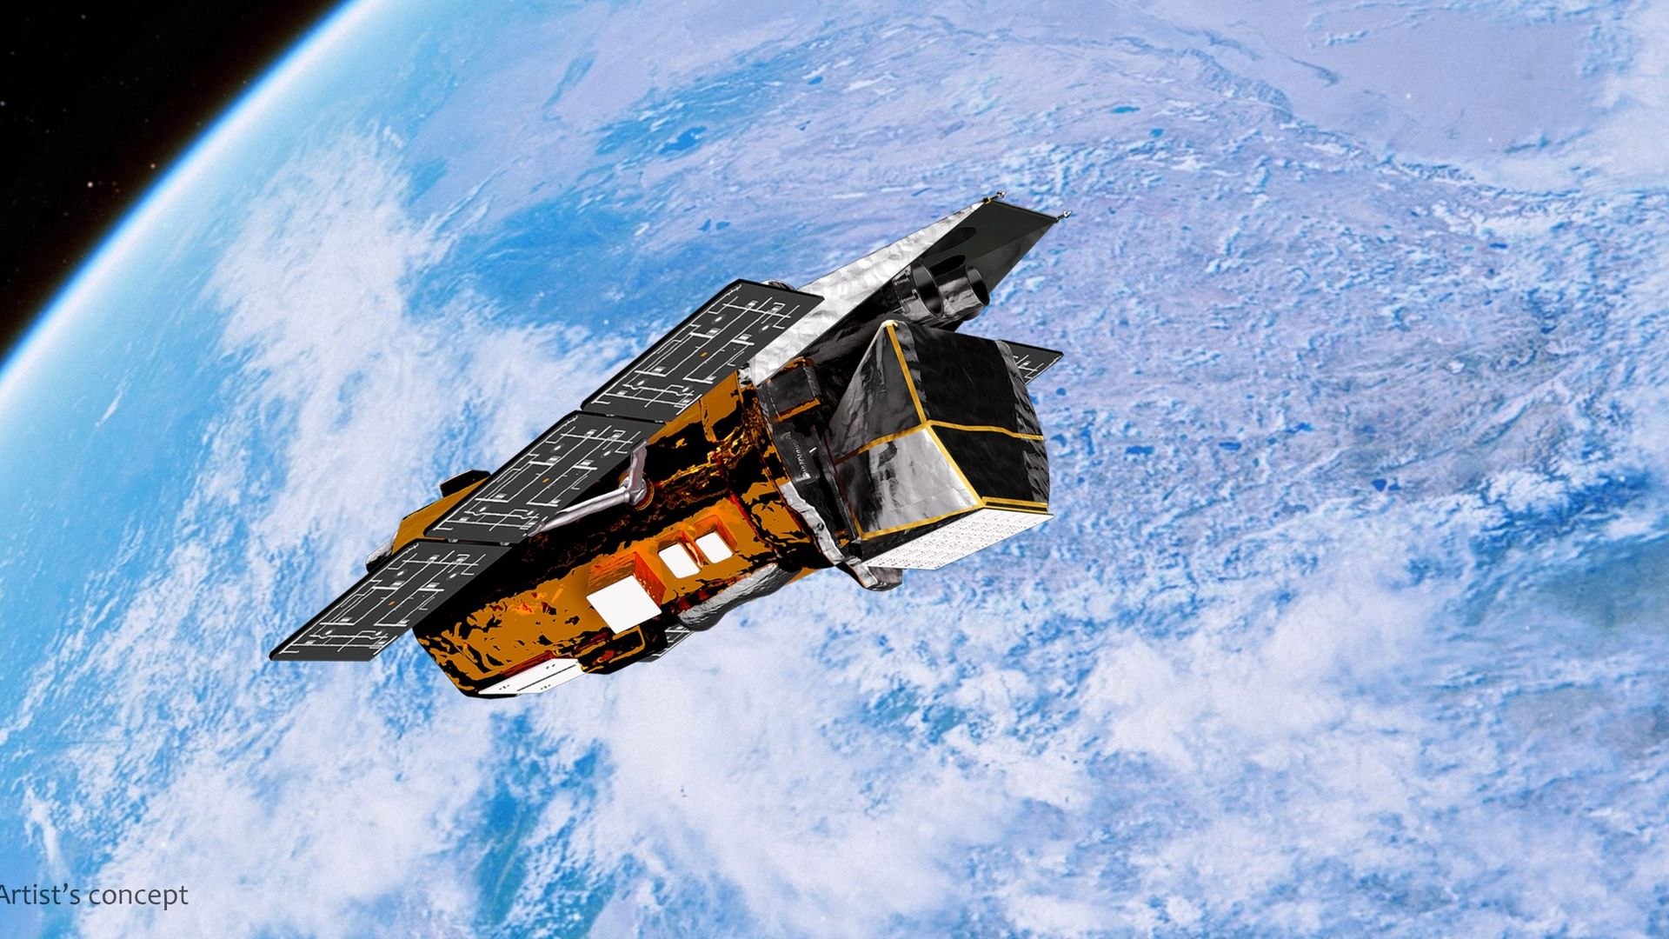
Click for next article NASA's Swift space telescope has reached the end of its long and winding road. Swift fell uncontrolled to Earth today (Nov. 4), 22 years after it launched but just three months after a private spacecraft was supposed to boost it to a higher, life-extending orbit. The 3,200-pound (1,450 kilograms) observatory reentered Earth's atmosphere at 7:39 a.m. EST (1239 GMT) today over northern Sumatra, according to satellite tracker Jonathan McDowell , who cited U.S. Space Force data. The fall likely didn't make much of an impact; NASA officials predicted beforehand that most of the minibus-sized Swift would burn up as it fell, and they put the odds of any of the surviving pieces hurting anyone on Earth at just 1 in 2,100. Swift - officially known as the Swift Gamma-Ray Burst Explorer - launched to Earth orbit in November 2004 on a two-year mission to study gamma-ray bursts (GRBs), the most powerful explosions in the universe . "Swift" was not an acronym but rather referred to the spacecraft's observational agility. "Swift needed to detect and locate gamma-ray bursts, communicate their position to other observatories, and then swing its telescopes around to image the burst locations before their afterglows faded out," S. Bradley Cenko, Swift's principal investigator (PI) at NASA's Goddard Space Flight Center in Maryland, said in an Oct. 23 statement . "This typically took Swift about a minute to do." Swift didn't just observe GRBs. It also studied a variety of other cosmic bodies and phenomena, from faraway supernova explosions and feeding black holes to asteroids and comets in our own solar system. And it kept doing this long after its warranty expired - for about 20 years after, in fact. The space telescope didn't conduct its final science observation until this past Oct. 20 . (Swift underwent a name change during this stretch: In 2018, it was rechristened the Neil Gehrels Swift Observatory after its first PI, who died the previous year.) "Swift delivered an incredible, lasting return on investment for the nation, designed for a two-year primary mission but productive for more than 10 times as long," Shawn Domagal-Goldman, director of NASA's Astrophysics Division, said in the same Oct. 23 statement. "In that time, Swift played a major role in advancing our understanding of the changing universe and was part of a revolution in astrophysics that showed how critical rapid-response observations are to the entire community," he added. Katalyst Space's LINK robotic servicing spacecraft captured this view of one of its solar panels in Earth orbit in August 2026. (Image credit: Katalyst Space)) Swift was incredibly productive, observing more than 2,000 GRBs and 1,400 supernovas over the course of its long scientific life. But it could have gathered even more data, had a dramatic rescue mission worked out. In September 2025, NASA awarded the Arizona company Katalyst Space a $30 million contract to design, launch and operate a robotic spacecraft that would meet up with Swift and boost it to a higher orbit, thus extending its operational life. Swift was falling back to Earth: It had no onboard thrusters to counteract the effect of atmospheric drag, which had been pulling the observatory down ever since it launched. The process was accelerating as Swift got lower, so Katalyst had to work fast. And the company did: It launched its refrigerator-sized, three-armed LINK servicing spacecraft on July 3 , targeting an August capture of Swift. That didn't happen, however. LINK suffered problems with its propulsion system and orientation-maintaining reaction wheels, which nixed the planned meetup. Still, it was a worthwhile effort, according to NASA. "From the beginning, this was a high-risk, high-reward mission," Domagal-Goldman said in a statement on Sept. 25 , the day that LINK itself crashed back to Earth. "And while we'll be sad to see Swift's mission come to a close, we knew this boost effort would be worthwhile either way - advancing U.S. spacecraft servicing technology, challenging us to meet unprecedented mission timelines, and testing how we operate satellites to extend their time in low Earth orbit ," he added.

