 |  | 

🌌 अंतरिक्ष समाचार | Space News
शनिवार, ०८/०८/२०२६ | Saturday, 08/08/2026

1. MNRE plans to launch PLI scheme for polysilicon manufacturing to cut import dependence
Read more

The proposed scheme aims to boost domestic polysilicon production, reduce import dependence and strengthen India's integrated solar manufacturing ecosystem. --> - ET Online - Published On Aug 7, 2026 at 02:56 PM IST Select ETGovernment as Preferred Choice on Google Copy Link Share on WhatsApp Share on Linkedin Share on X Share on Telegram Share on Facebook India is planning a new incentive scheme for domestic polysilicon production to reduce import dependence and support the countrys integrated solar manufacturing ecosystem. India is preparing a production-linked incentive (PLI) scheme to boost domestic polysilicon manufacturing, Santosh Kumar Sarangi, secretary at the Ministry of New and Renewable Energy, said on Friday. Why does this matter? The scheme would push India's manufacturing incentive programme deeper into the solar supply chain and cut import dependence, Sarangi said at a Confederation of Indian Industry (CII) event in New Delhi. Polysilicon is a critical raw material for solar photovoltaic panels, and India currently sources it entirely from China. Advt The move comes as India targets 500 gigawatts (GW) of non-fossil fuel power capacity by 2030, with the renewable energy ministry increasingly focused on local manufacturing as developers scale up solar installations and look to reduce reliance on imported equipment. What will the scheme cover? The new scheme could cover more than 10 GW of production capacity, Sarangi said, though he did not disclose the size of the financial incentive on offer. India has previously extended manufacturing-linked incentives worth 240 billion rupees ($2.52 billion) for solar panel and cell production. The proposed scheme is aimed at building an integrated solar manufacturing ecosystem across modules, cells, wafers, ingots and polysilicon, segments where Chinese producers currently dominate globally. Where does India's capacity currently stand? India has already built more than 200 GW of solar panel manufacturing capacity and over 32 GW of solar cell capacity, Sarangi said, with another 100 GW of cell capacity expected to come online within about a year. The country is also targeting at least 80 GW of solar ingot and wafer manufacturing capacity by June 2028. Deeper domestic manufacturing would strengthen India's clean energy ambitions and industrial competitiveness, Sarangi said, adding that polysilicon also has semiconductor applications, which could widen the economic benefits of new investment beyond solar manufacturing alone. With inputs from Reuters - See more on: - India polysilicon manufacturing incentives , - clean energy ministry India , - solar supply chain India , - renewable energy India , - solar panel production India , - reduce reliance on China , - domestic polysilicon production , - reliance Telegram Facebook Comments What are your thoughts? Comment Now --> Comment Now Read Comment (1) All Comments By commenting, you agree to the Prohibited Content Policy Post Find this Comment Offensive? Choose your reason below and click on the submit button. This will alert our moderators to take actions REASONS FOR REPORTING Foul Language Defamatory Inciting hatred against a certain community Out of Context / Spam Others Report Join the community of 2M+ industry professionals. Subscribe to Newsletter to get latest insights & analysis in your inbox. All about ETGovernment industry right on your smartphone! - Download the ETGovernment App and get the Realtime updates and Save your favourite articles. Scan to download App -->

2. Dalmia Bharat Foundation launches rural women skilling initiative in Uttar Pradesh
Read more

Dalmia Bharat Foundation launches rural women skilling initiative in Uttar Pradesh " page-seotitle="Rural Women Skilling Initiative: Dalmia Bharat Foundation Empowers Rural Women in Uttar Pradesh with Skill Development Initiative, ETGovernment" data-href="https://government.economictimes.indiatimes.com/news/policy/dalmia-bharat-foundation-launches-rural-women-skilling-initiative-in-uttar-pradesh/133025034" data-msid="133025034" data-mediaid="" data-authors="["ETGovernment Desk"]" data-author-list="ETGovernment Desk" data-category-name="Policy" data-category_id="545" data-cat_msid="69756026" data-date="2026-08-07" data-index="article_1" data-keywords="rural women skilling initiative, Dalmia Bharat Foundation, women's economic empowerment, skill development in Uttar Pradesh, vocational training for women" data-type='news' style="writing-mode: horizontal-tb;"> - Policy - 2 min read Domestic tailoring centres opened across four districts; foundation plans to expand programme to 18 centres with annual capacity of over 1,400 women ETGovernment Desk - ETGovernment - Updated On Aug 7, 2026 at 12:16 PM IST Select ETGovernment as Preferred Choice on Google Copy Link Share on WhatsApp Share on Linkedin Share on X Share on Telegram Share on Facebook The training programme is aligned with the National Skill Development Corporation (NSDC) framework and combines practical tailoring instruction with entrepreneurship development, financial literacy, customer relationship management and basic business planning. Dalmia Bharat Foundation (DBF), the corporate social responsibility arm of Dalmia Bharat, on Friday said it has launched a rural women skill development initiative under its Gram Parivartan Project, aimed at enhancing livelihood opportunities and promoting women-led entrepreneurship across Uttar Pradesh. According to the official press release, as part of the initiative, Domestic Tailoring Training Centres became operational on August 1 across Jawaharpur, Nigohi, Ramgarh and Hardoi. More than 120 rural women have enrolled in the inaugural batch, with the centres collectively offering an annual training capacity of 240 women. Advt The programme is designed to strengthen women's participation in the rural economy by equipping them with market-relevant vocational skills, entrepreneurship capabilities and financial literacy, enabling them to pursue self-employment, establish micro-enterprises or access wage employment opportunities. "Rural India has immense entrepreneurial potential, and women have an important role to play in shaping stronger local economies. By combining vocational training with entrepreneurship and financial literacy, we aim to equip women with the confidence and capabilities to create sustainable sources of income. We believe that when women thrive economically, the impact extends beyond individual households to strengthen families, communities and the rural economy as a whole," said Ashok Gupta, CEO, Dalmia Bharat Foundation. The training programme is aligned with the National Skill Development Corporation (NSDC) framework and combines practical tailoring instruction with entrepreneurship development, financial literacy, customer relationship management and basic business planning. According to the foundation, the integrated curriculum is intended to prepare participants for both self-employment and formal employment opportunities. The centres have been established using existing community infrastructure made available free of cost, a model that DBF says promotes local ownership while ensuring cost-efficient and scalable implementation. The initiative has also been rolled out at the foundation's project locations in Kalyanpur, Bokaro and Midnapore. In the coming months, DBF plans to introduce Beauty & Wellness courses to diversify livelihood opportunities and better align training with local market demand. Looking ahead, the foundation plans to expand the programme to 18 training centres across its project locations, increasing its annual training capacity to more than 1,400 rural women as part of its broader efforts to promote inclusive rural development and women's economic empowerment . ETGovernment Desk , --> - By - Published On Aug 7, 2026 at 12:14 PM IST - See more on: - rural women skilling initiative , - Dalmia Bharat Foundation , - women's economic empowerment , - skill development in Uttar Pradesh , - vocational training for women Telegram Facebook Comments What are your thoughts? Comment Now --> Comment Now Read Comment (1) All Comments By commenting, you agree to the Prohibited Content Policy Post Find this Comment Offensive? Choose your reason below and click on the submit button. This will alert our moderators to take actions REASONS FOR REPORTING Foul Language Defamatory Inciting hatred against a certain community Out of Context / Spam Others Report Join the community of 2M+ industry professionals. Subscribe to Newsletter to get latest insights & analysis in your inbox. All about ETGovernment industry right on your smartphone! - Download the ETGovernment App and get the Realtime updates and Save your favourite articles. Scan to download App -->

3. ISRO Scientist Recruitment 2026: Applications open for 93 posts; check vacancies, eligibility, selection process - The Indian Express
Read more
ISRO Scientist Recruitment 2026: Applications open for 93 posts; check vacancies, eligibility, selection process The Indian Express

4. Govt says ISRO has developed & operationalised wide range of space-based applications to benefit society - News On AIR
Read more
The Government has said that the Indian Space Research Organisation (ISRO) has developed and operationalised a wide range of space-based applications to benefit all sections of society, including the welfare of the Scheduled Caste community. Science and Technology Minister Dr. Jitendra Singh informed this in a written reply in the Lok Sabha today. The Minister said that key space application areas include satellite-based Potential Fishing Zone (PFZ) advisories, crop acreage and production forecasting, agrometeorological advisories for farmers, crop insurance support, geospatial support for flagship government programmes, tele-education, telemedicine, the Vessel Communication and Support System, and disaster management support. Mr. Singh noted that ISRO has established robust awareness and capacity-building programmes to promote the use of space technology for societal, governance, and disaster management purposes, enabling decision-makers to operate effectively at the grassroots level. He added that these initiatives are designed to be inclusive and accessible to targeted beneficiaries across the country. The Minister further said that the benefits of Earth observation, satellite communication, and navigation applications, particularly in terms of improved connectivity and navigation services, are reaching SC farmers, students, and disaster-prone regions within satellite coverage areas. He also highlighted that the Department has undertaken several measures to ensure the inclusive use of space technology, including the implementation of flagship initiatives such as Digital India, the BharatNet Programme, the Vessel Communication and Support System (VCSS) under the Pradhan Mantri Matsya Sampada Yojana (PMMSY), and the PM e-VIDYA scheme for tele-education.

5. 'Not looking good right now': Starship likely to be lost at sea 2 weeks after epic 13th test flight, Elon Musk says
Read more
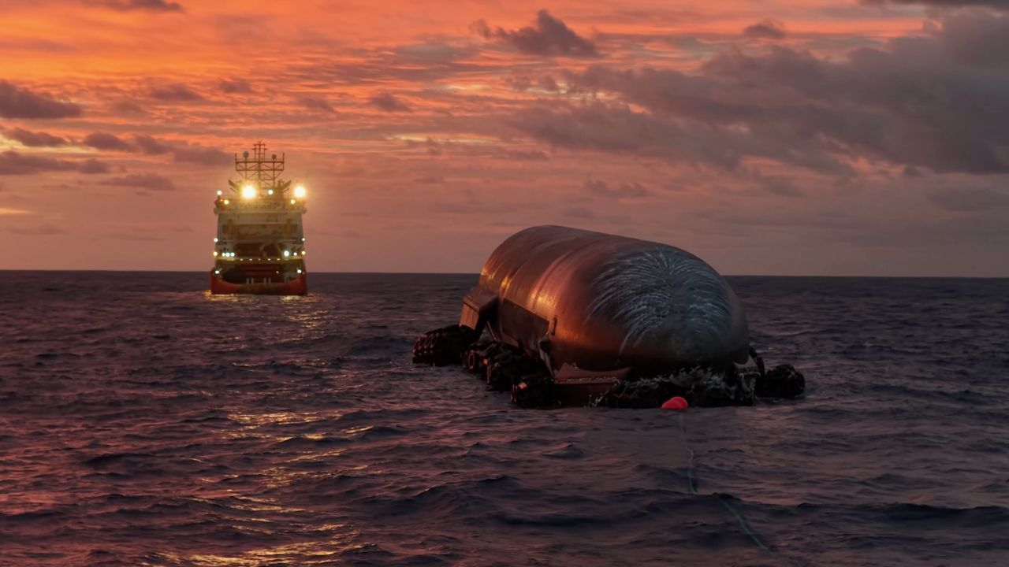
Click for next article SpaceX works to get the upper stage from Starship's 13th test flight to shore from its Indian Ocean splashdown site. This is a screenshot from a video that the company posted on X on Aug. 7. It looks like Starship's two-week-long ocean adventure won't have a happy ending. The SpaceX megarocket conducted its 13th test flight on July 24, lifting off from the company's Starbase site in South Texas. Things went pretty well on Flight 13 , especially for Starship 's 171-foot-tall (52 meters) upper stage, known as Ship, which splashed down as planned in the Indian Ocean off the coast of Western Australia. In an unexpected first, Ship survived that homecoming, staying in one piece even after toppling over and hitting the waves. It remains intact still, and SpaceX is towing it toward shore in Western Australia to get a better look. But the ambitious effort is unlikely to succeed, SpaceX founder and CEO Elon Musk told us today (Aug. 7). "Unfortunately, ship recovery is not looking good right now. Nonetheless, we were able to obtain close-up photos of critical regions of the heat shield and engines for future upgrades," Musk wrote this afternoon via X , the social media site he owns. He was responding to a SpaceX post from an hour or so earlier, which provided an update about the recovery effort and shared two photos and a video of the activities. The recovery team has "been overcoming challenging conditions and increasingly rough seas as they attempt to guide the 52m long spacecraft to port," SpaceX wrote in the post. The SpaceX Recovery team is still working to recover Flight 13's Starship from the Indian Ocean. They've been overcoming challenging conditions and increasingly rough seas as they attempt to guide the 52m long spacecraft to port pic.twitter.com/ECT5FyCvr7August 7, 2026 Starship is the biggest and most powerful rocket ever built, standing about 408 feet (124 meters) tall when stacked. Both of its stages - Ship and the Super Heavy booster - are designed to be fully and rapidly reusable, a breakthrough that SpaceX thinks will revolutionize spaceflight. A key enabler of rapid reuse is Ship's heat shield, which protects the vehicle during its downward trips through Earth's atmosphere . Musk has described heat shield development as perhaps the biggest challenge on Starship's road to operational flight - but that challenge may now be in the rearview mirror. "I don't want to jinx it or anything, but I think I'd consider the heat shield problem solved at this point," Musk said on Tuesday (Aug. 4), during SpaceX's first-ever quarterly earnings call. It's no surprise that Starship and Flight 13 came up in that call. The megarocket is key to SpaceX's ambitious future plans, which include assembling and operating a million-satellite AI constellation in Earth orbit. Flight 13 was similar to previous Starship test missions; it was a suborbital jaunt that ended with Super Heavy coming down in the Gulf of Mexico and Ship landing in the Indian Ocean. There was a big milestone, however, in addition to Ship's unexpected transition to seagoing vessel: During its time in space, the upper stage deployed 20 functional Starlink V3 satellites, the bigger, next-gen variant of SpaceX's broadband spacecraft.

6. NASA figured out how to keep its 48-year-old Voyager 2 probe running for yet another year
Read more
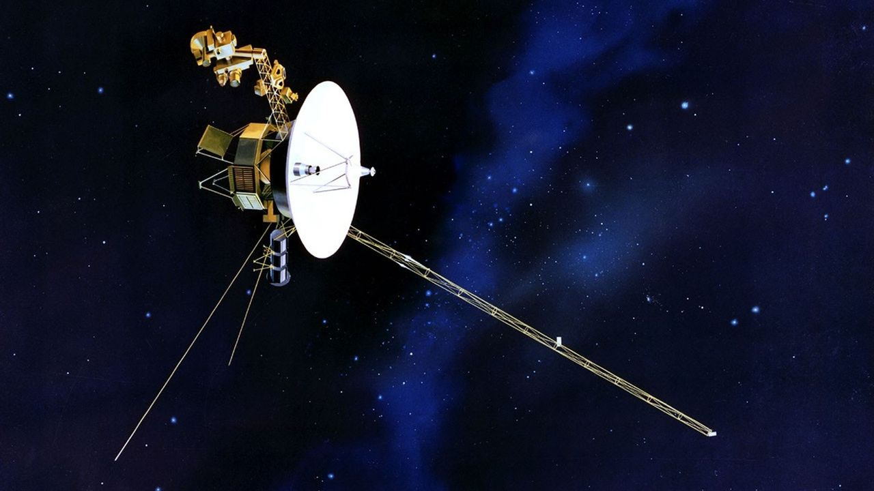
Click for next article NASA just made an interstellar tweak to the Voyager 2 spacecraft, known as the "Big Bang", to keep its remaining 50-year-old science instruments running a little longer. Voyager 2 and its twin launched in 1977, called Voyager 1, rely on a form of nuclear battery known as a radioisotope thermoelectric generator that uses the heat produced by the decay of plutonium. But the supply of plutonium on each probe drops at about four watts a year on each spacecraft. To keep the probe running on this dwindling power supply, engineers recently reduced Voyager 2's power requirements by turning off a few non-science devices and using "lower-power alternatives" that are still effective enough to keep the spacecraft warm while it's so far from the sun, NASA officials said in a statement . "The spacecraft power margins have grown razor thin, requiring the team to conserve energy by shutting off non-essential devices and systems," NASA officials wrote of the mission, which is managed by the agency's Jet Propulsion Laboratory. The drop in power is having a measurable science impact on both spacecraft - each has turned off two of their science instruments since 2024 alone. While some of these instruments were shut off after the spacecraft finished their historic planetary flybys decades ago , others were turned off due to power requirements. Each spacecraft initially launched with 10 instruments, and Voyager 2 is now down to only three instruments . At first it looked as though Voyager 2 would have to shut down another of these instruments later this year, but luckily, the new power shifts will allow all three to operate "for at least another year," NASA said. Voyager 1 will be tasked to do the same "Big Bang" power change "in the coming months." A signal to each spacecraft takes nearly 24 hours (or one light-day) to make a one-way journey, and officials noted Voyager 1 is further from Earth than its twin . (Voyager 2 is at about 142 astronomical units or sun-Earth distances, while Voyager 1 is nearing 171 AU.) The two spacecraft initially launched to take advantage of a rare alignment between the outer solar system gas giant planets, which in order of distance from the sun are Jupiter, Saturn, Uranus and Neptune. Each Voyager spacecraft first flew past Jupiter and Saturn, taking unprecedented imagery of the planets and their moons . NASA's Voyager 2 probe captured this image of Europa, the smallest of Jupiter's four Galilean moons, on July 9, 1979. (Image credit: NASA/JPL) Next, Voyager 1 was directed to fly above the plane of the solar system (also known as the ecliptic) while Voyager 2 continued flying past Uranus and Neptune, becoming the first spacecraft to see these worlds and their moons. Voyager 2's last planetary flyby was in 1989.

7. Inside the mystery of the James Webb Space Telescope's little red dots - and how they might be evolving
Read more

Click for next article Little red objects found by the James Webb Space Telescope. The "z" values correspond to redshifts of the dots, or where they're located in the universe. New evidence has come to light showing that the mysterious 'little red dots' discovered in the early universe by the James Webb Space Telescope could evolve into the active centers of fully formed galaxies. "Everything created in the early universe must evolve into something around us," said George Rieke of the University of Arizona in a statement . "We have had little idea of what little red dots become, but these results finally show us how to find their progeny." Discovered by the James Webb Space Telescope (JWST) almost as soon as it became operational in 2022, little red dots have been a perplexing cosmological mystery. As their name suggests, they appear small, red and surprisingly bright. They are mostly found at redshift values suggesting they existed between 13.2 and 12.2 billion years ago. To shine so brightly at such great distances would usually imply these objects are quasars - which are luminous nuclei of galaxies powered by active supermassive black holes - but the light coming from little red dots is more like that of bloated stars. It looks to be mostly in infrared with some ultraviolet, and none of the X-rays that one would expect from an active black hole chomping down on material. As such, researchers have come up with the hypothesis that little red dots are "black hole stars," or vast clouds of gas heated from within by a concealed but growing supermassive black hole. However, the population of little red dots drops off a cliff at redshifts equating to less than 12 billion years ago. Where did they all go? There are two options. Either they all died off, or they developed into objects more familiar to us. One recent hypothesis is that little red dots turned into large globular clusters . And now, an alternative possibility has come along. A team led by Pierluigi Rinaldi, who was at the University of Arizona's Steward Observatory when conducting this research but is now at the Space Telescope Science Institute (STScI) in Baltimore, think it has identified a descendent of a little red dot. It appears to be in the form of a distant galaxy, catalogued as WISEA J123635.56+621424.2, which is found at a redshift of 2, meaning that we see it as it was 10.5 billion years ago. The galaxy displays neat spiral arms around a red core. Rinaldi's team have nicknamed it the Saguaro, after a species of cactus native to the Sonoran desert in the United States' south-west, thanks to the galaxy's arms and how its core resembles the red fruit produced by the cactus. A field of galaxies in Ursa Major, with the Saguaro galaxy inset. (Image credit: NASA/ESA/CSA/STScI/Pierluigi Rinaldi (Steward Observatory); Image Processing: Alyssa Pagan (STScI)) Saguaro's core has all the hallmarks of a little red dot. It shines bright in infrared as seen by JWST, and also emits in ultraviolet as detected by the Hubble Space Telescope . Yet, NASA's Chandra X-ray Observatory has also detected faint X-rays originating from Saguaro. "What the X-ray observations show is that this galaxy has an active galactic nucleus, and a very obscured one at that," Carys Gilbert of the University of Cape Town in South Africa, who participated in the study alongside Rinaldi, said in the statement. "It's not only obscured but also X-ray weak. That kind of combination could explain the lack of X-ray emission that we see from all other little red dots. It fits the puzzle of little red dots nicely." This is not the first time X-rays have been seen coming from a little red dot. Earlier this year it was reported that scattered X-rays were seen breaking through from a little red dot called 3DHST-AEGIS-12014, given credence to the hypothesis that little red dots are black hole stars, where the black hole gradually consumes the "star" from the inside out, eventually carving holes through which X-rays can escape. We see 3DHST-AEGIS-12014 as it was 11.8 billion years ago, meaning that Saguaro, which existed 1.3 billion years later, is a little bit further on in its development. A comparison to how the Saguaro galaxy appears to us now, and how it would appear as a little red dot if it existed at a higher redshift. (Image credit: Alyssa Pagan (STScI); Illustration: Leah Hustak (STScI)) "Because the Saguaro is at lower redshift, we can see the very beautiful and bright host galaxy in high resolution and detail with Webb and Hubble," said Harvard's Zihao Wu, who was also part of Rinaldi's team. Intrigued, Rinaldi's team simulated how Saguaro would appear to us if it existed a billion years after the big bang. Much of its galactic structure would either be less developed or simply just too faint to be seen at such distance. All that would be visible would be the nucleus, looking very much like all the other little red dots. This implies that little red dots are not a unique population of their own, but are simply a phase in the development of galaxies with supermassive black holes. Our own Milky Way could have been a little red dot once upon a time. Saguaro is a crucial link in the story of little red dots and how they connect with modern galaxies . While there is still much to learn, such as the beginning of their story and how they form, the middle and end of their story is now beginning to take shape.

8. NASA's SkyFall Mars helicopters will wear tiny capes
Read more
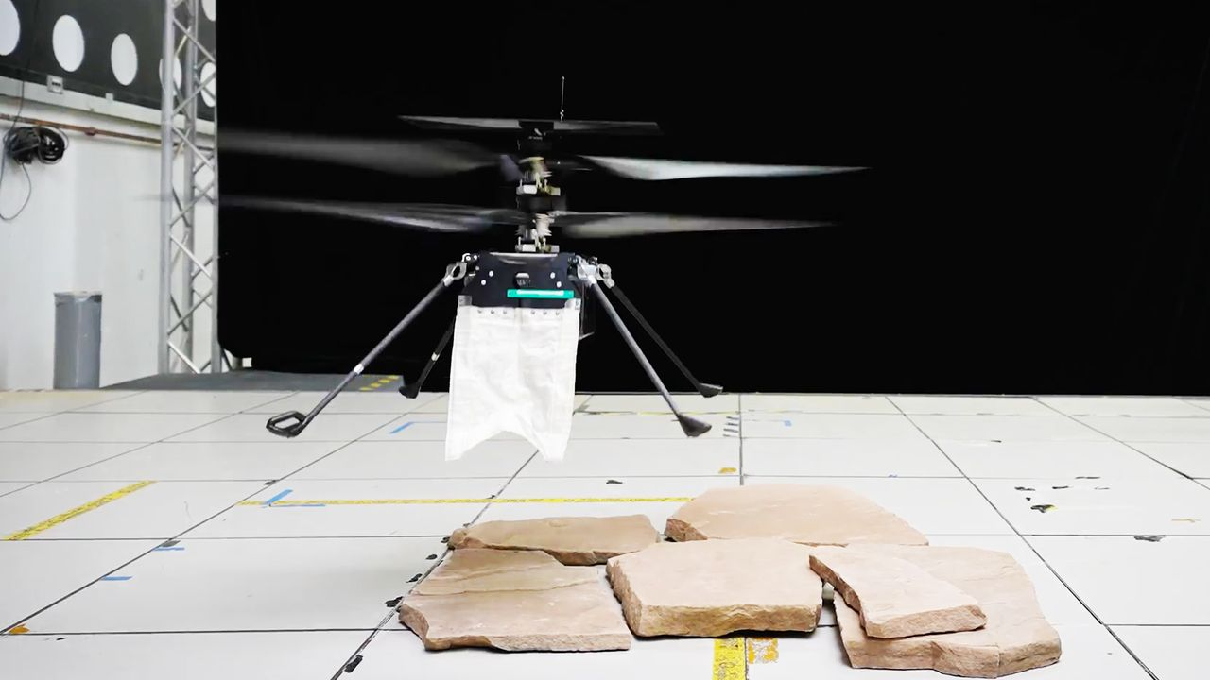
Click for next article Picture it: A swarm of tiny robot helicopters descends through a reddish-brown sky, landing gracefully on the Martian surface. What are they wearing? Tiny capes. NASA's SkyFall mission will send a trio of mini rotorcraft to Mars equipped with ground penetrating radar technology which happens to look like little capes. These uniquely designed swaths of fabric look decidedly strange or even accidental in new videos from NASA's Jet Propulsion Laboratory (JPL) that show the little drones practice landing. But these capes are actually flexible antennae that will allow the craft to peer beneath the Red Planet's surface in search of water ice. "The only way to detect shallow subsurface ice remotely is to fly close to the ground," Adrian Tang, SkyFall's ground-penetrating radar lead instrument scientist at JPL, said in a statement on Thursday (Aug. 6). "By flying low and slow, a SkyFall helicopter could capture radar images that resolve the fine layering where dry soil gives way to ice, detecting its presence and mapping its extent." Orbiting spacecraft have studied Mars for decades, imaging the planet and mapping it with radar. But from orbit, their radar is unable to see the first few feet of material just below the planet's surface - a zone where scientists expect to find shallow ice deposits mixed in with the rocks and dust. This work could be important for future astronauts who need to better understand the ground below their feet for safety reasons, and for future travelers searching for accessible ice to process for drinking water, oxygen and fuel. Skyfall will follow in the footsteps of Ingenuity , the first rotorcraft on another world, which hitched a ride to Mars aboard NASA's Perseverance rover. The new choppers are based heavily on Ingenuity, which weighed just 4 pounds (1.8 kilograms) here on Earth. But Skyfall will be more capable than Ingenuity, whose main job was to show that choppers can explore the thin skies of Mars. SkyFall's tiny cape ground-penetrating radar, which uses a type of flexible antenna called Vivaldi that was invented back in 1978, is designed to survey up to 16 feet (5 meters) below the Martian surface. The radar will be able to reach anywhere from several yards below the planet's surface to the uppermost layers of surface material. And the antenna's unique design ensures that the SkyFall drones will be able to make these subsurface observations without damaging the equipment during landing.. The antenna is extremely lightweight, and the team miniaturized it to be both the right size and shape to fit the tiny helicopters, which sit just 6 inches (15 centimeters) above the ground at rest. The tricky thing was, the designers had to miniaturize the radar antennae while maintaining functionality. But they did just that, and these tiny radar capes will be able to bend and move out of the way as the rotorcraft do their thing, flying above and landing on the Red Planet. "Although we managed to shrink the antenna quite a bit, it is about 1.5 times longer than the helicopter's legs," Christine Gebara, SkyFall ground-penetrating radar mechanical lead at JPL, added in the statement. "That means during landing, the Vivaldi has to bend out of the way - and if it lands on a rock, it bends even further," she added. "But when the helicopter takes off again, the antenna must spring back into place for data collection. Because SkyFall is expected to make dozens of flights exploring Mars, we needed an antenna that could repeatedly handle those pressures without losing its shape in flight." A radar engineer at NASA JPL works to test the antenna on the SkyFall helicopter. (Image credit: NASA/JPL-Caltech) To make these little capes capable of withstanding incredible feats on another world, the engineers behind the helicopters covered the antenna in layers of polyester and Vectran, a flexible (but incredibly strong) material that was previously used for the airbag that cushioned NASA's Spirit and Opportunity Mars rovers during their touchdowns in 2004. The antenna's shape is also reinforced with flexible fiberglass tape springs and a lightweight structure. In total, each antenna weighs a miniscule 5 ounces (142 grams). But a crafty design isn't enough. Getting to Mars is no small feat, and NASA needs to be sure that these little helicopters and their gear are up to the challenge. So, in JPL's Environmental Test Laboratory, which recreates different elements of environments beyond Earth, the SkyFall team put the rotorcraft and its little radar antenna to the test. They bent and flexed the antenna over and over, recreating multiple landings on the surface, exposed the craft to extreme temperatures, and continually checked to make sure that, throughout this testing, the helicopter could still transmit and receive radar signals. At the end of this testing, the antenna had endured 200 simulated Mars landings and was still working just fine. That is more than twice the number of landings expected from the mission. "This test checked every box it was supposed to and answered our biggest technical questions," Tang added. "While we still have work ahead of us before the antenna is fully flight-qualified, this was a major milestone, and the hardware performed exactly as expected."

9. Engineers race to save stricken LINK rescue spacecraft before it's too late
Read more

Click for next article A private rescue spacecraft is having troubles of its own in Earth orbit. LINK, a satellite built and operated by the Arizona company Katalyst Space Technologies, launched July 3 on a daring and unprecedented mission: Rendezvous with NASA's Swift space telescope and boost the observatory to a higher orbit before it falls out of the sky. About three weeks after launch, however, LINK started spinning at an unexpected rate , a problem that caused a temporary communications dropout and a reset of its satellite platform. And two of LINK's three orientation-controlling reaction wheels stopped working. Spacecraft operators always work hard to fix such problems when they crop up, but there's a special urgency where LINK is concerned. It needs to reach Swift soon, or atmospheric drag will pull the observatory - which possesses no thrusters of its own - down past a point of no return. NASA thinks this boundary lies at around 186 miles (300 kilometers) above Earth , an altitude that Swift is expected to reach by October. So the original plan called for LINK to meet up with Swift in early August, just a month after launch - pretty much as soon as commissioning work on the rescue craft wrapped up. That's not going to happen at this point, but mission teams haven't given up on the rescue attempt. Indeed, they're making progress on getting LINK back up to speed, as a new update relates. "LINK originally was in a multi-axis spin rotating at about 9 degrees per second, which resulted in sporadic communications and impeded LINK's progress toward Swift," NASA officials wrote in the update , which the agency posted on Thursday (Aug. 6). "Using a series of burns from one of LINK's electric propulsion thrusters, the Katalyst team now has slowed that spin to about 1.47 degrees per second," they added. "Katalyst plans to keep LINK at that spin rate as it proceeds with next steps for the mission." Those next steps include uploading flight software updates "with new attitude controllers designed to maintain LINK's stability in its current configuration," NASA officials wrote. "These updates would allow LINK to begin maneuvering to align with Swift's orbit." The updates are expected to be beamed up to LINK "in the coming days," according to the update. Artist's illustration of Katalyst Space Technologies' Link servicing spacecraft approaching and capturing NASA's Swift space observatory on an orbit-boosting mission. (Image credit: Katalyst Space Technologies) Swift - officially known as the Neil Gehrels Swift Observatory, launched in 2004 to study gamma-ray bursts , the most energetic events in the universe. The $250 million telescope's initial altitude was about 375 miles (600 km). But it has fallen considerably since then, and the descent is accelerating: The lower Swift goes, the more atmosphere it encounters and the greater the force of frictional drag becomes. Swift is still working just fine, which explains why NASA wants to save it. Last September, the agency awarded Katalyst $30 million to build LINK - a refrigerator-sized spacecraft with three robotic arms - and fly its rescue mission. That's a very tight timeline, but Katalyst hit it, getting LINK ready by its launch date and checking off a number of commissioning milestones before running into trouble. The company has experience delivering under pressure, so maybe it can pull off the rescue craft's rescue before it's too late.

10. Chinese company Landspace targets Aug. 10 for historic rocket launch and landing attempt
Read more

Click for next article Landspace conducts an engine test with the first stage of its Zhuque-3 rocket in June 2025. The Chinese commercial launch company Landspace is set for a second attempt at catching an orbital booster. The startup launched its first Zhuque-3 rocket in December 2025, in what was a milestone for Chinese rocket reusability efforts. While the Zhuque-3 second stage successfully reached orbit, the first stage exploded in a dramatic fireball during its final powered descent toward the landing pad. Now, Landspace is poised for a second attempt at liftoff and landing, with airspace closure notices indicating that launch is scheduled from the Dongfeng commercial space innovation pilot zone at Jiuquan spaceport, in northwest China, at around 7:45 p.m. EDT on Aug. 10 (23:45 GMT, or 7:45 a.m. Beijing time, Aug. 11). UPDATE | ZhuQue-3 Y2 Reusable Launch Vehicle Completed Static Fire TestOn June 29, 2026, LandSpace's ZhuQue-3 Y2 reusable launch vehicle successfully completed a static fire test at the Dongfeng Commercial Space Innovation Pilot Zone.The test comprehensively verified the… pic.twitter.com/G9EzZbnyqBJune 29, 2026 The company conducted a successful static fire test on June 29 in preparation for the launch. "All systems operated normally, and test data and results met expectations, validating the correctness and coordination of system operations and laying a solid foundation for upcoming flight missions," Landspace stated in a post that day on the social media platform X. Zhuque-3 is a 216-foot (66-meter) stainless steel rocket powered by methane-liquid oxygen engines. It's similar in capabilities to SpaceX 's Falcon 9, and is capable of sending 40,350 pounds (18,300 kilograms) of payload to low Earth orbit (LEO). The Aug. 10 launch will be China's fourth orbital booster recovery attempt. The first was the Zhuque-3 launch in December 2025; the second was the debut, just days later, of the Long March 12A, which also reached orbit but with a first-stage recovery attempt ending in flames . The third try, using the Long March 10B, took place on July 10. That one was successful: China made history, becoming just the second country to land an orbital booster , in this case using a vessel equipped with a net-capture system.

11. On this day in space! Aug. 7, 1980: NASA's Viking 1 Mars orbiter shuts down 4 years into a 90-day mission
Read more

Click for next article On Aug. 7, 1980, NASA's Viking 1 spacecraft ended its epic and historic mission on the Red Planet. Viking 1 was the first spacecraft to successfully land on Mars . It was one of two Viking missions NASA launched in 1975 to go look for evidence of life on Mars . Each of the Viking missions were composed of an orbiter and a lander. Viking 1's orbiter took photos of the Martian surface that helped NASA decide where to drop the lander. After four years of orbiting Mars , the orbiter ran out of attitude-control propellant, so NASA had to shut it down. The lander continued its scientific observations for another three years before it lost contact with NASA in 1983. Image 1 of 2 A photo of NASA's Viking 1 Mars orbiter with its Mars lander attached in a landing capsule. (Image credit: NASA) This NASA graphic shows the different parts of the Viking 1 Mars Orbiter. (Image credit: NASA) Image 1 of 2 View Original Image 2 of 2 View Original Why it mattered NASA's Viking 1 mission is most well-known for making the first truly successful landing on Mars, but the mission was more than just a huge lander. Viking 1 actually consisted of two spacecraft, the Viking 1 Lander and the Viking 1 Orbiter. The two spacecraft rode to Mars together, with the lander separating from the orbiter ahead of its landing on the Red Planet. In fact, NASA sent FOUR Viking spacecraft to Mars in total. The Viking 2 mission also carried both a Lander and Orbiter. But the Viking 1 probes were the first of that wave. The two orbiters were based on NASA's general Mariner 9 spacecraft bus, but more sophisticated. They carried three primary instrument suites: A two-camera imaging system; infrared spectrometer for water vapor mapping; and an infrared radiometer for thermal mapping. The Viking missions were only planned to last 90 days, but both the lander and orbiter lasted years beyond their design lifetime. The Viking 1 Orbiter studied Mars for four years, orbiting the planet 1,488 times before shutting down on orbit 1,489 on Aug. 7, 1980. The Viking 1 and Viking 2 Orbiters captured a combined 52,663 high-resolution photos of Mars, mapping about 97% of its surface with a resolution of about 984 feet (300 meters). They also snapped photos of Mars' two moons, Phobos and Deimos , in great detail, far surpassing what NASA achieved with the Mariner 9 Mars orbiter in 1971.

12. 'Plasma gun' technology could transform space laundry and sanitation for future missions
Read more

Researchers at The University of Alabama in Huntsville (UAH), part of The University of Alabama System, are developing plasma-based technology to help astronauts stay healthier during missions to the moon and Mars by sanitizing clothing, bedding and other fabrics without water or traditional cleaning chemicals.

