 |  | 

🌌 अंतरिक्ष समाचार | Space News
गुरुवार, १७/०९/२०२६ | Thursday, 17/09/2026

1. Private players should not replicate ISRO's efforts: G Madhavan Nair writes - Newslaundry
Read more
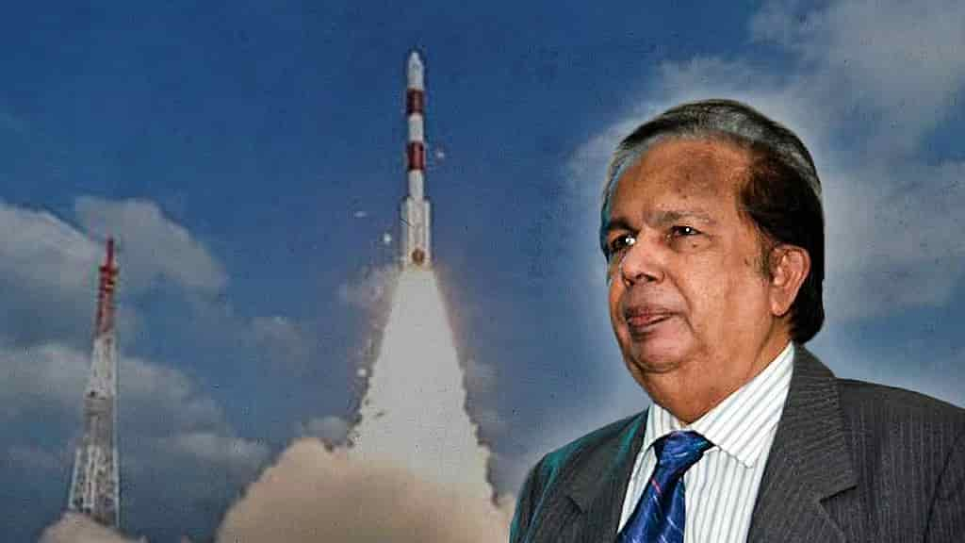
India is at an important transition point in its space programme. The country is moving from a predominantly government-led space programme to an ecosystem in which private companies and startups can participate across the entire value chain. Indian Space Policy 2023 explicitly enables private entities to undertake activities including satellite realisation and operations, launch services, data acquisition and dissemination and ground infrastructure. The number of registered space startups has risen from one in 2014 to approximately 440 in 2026, the government told the Rajya Sabha in August. The government also estimates India's space economy at approximately US$9 billion in 2026, and predicts this will multiply to US$40-45 billion over the next decade. The question therefore is not whether India should encourage private participation in the space sector - the answer is obvious. But it is important to decide where Indian startups should concentrate their resources, so that they create sustainable businesses, and not mere technological demonstrations or duplication of what Indian Space Research Organisation (ISRO) has already done. India's space programme has accumulated enormous technological knowledge, infrastructure and human expertise over several decades. The objective of the private sector should not be to recreate this capability independently. Instead, startups should concentrate their energies on innovation, specialised technologies and new business models; downstream applications and commercialisation and customer-facing services. This would leave ISRO to focus on technology leadership and advanced R&D; manufacturing scale, quality systems and capital. Understandably, space hardware attracts the most attention because rockets and satellites are visible and technologically impressive. But the bigger economic value often lies downstream, when the data collected by the satellite is able to answer a customer's question. The potential of satellite data is enormous, from estimating crop yield or drought monitoring to flood prediction, transmission line monitoring, forest fire monitoring and climate risk analysis. India is in fact likely to become one of the largest domestic markets for high-resolution earth observation, communications and space situational awareness. The government itself has identified this as one of the principal revenue-generating areas. From just selling raw imagery, startups could focus on applications using this data with the help of AI that can enable business decisions. Here, India's software and AI capabilities can provide an advantage over countries that have strong satellite manufacturing but weaker downstream digital ecosystems. Satellite communication offers another major opportunity for startups with potential markets in maritime connectivity, aircraft connectivity and others. Instead of duplicating very large international satellite constellations, companies should identify specific markets where India has a competitive advantage such as South Asia and African nations. Instead of looking to build and launch rockets - something ISRO has been successfully doing for years - startups should concentrate on subsystems for upstream activities. The parameter must not be how many Indian startups can build complete rockets. It would be better to focus on how many Indian companies can supply world-class components to rocket and satellite manufacturers anywhere in the world. This shift could also offer more business opportunities considering a launch vehicle may fly only a limited number of times a year while a subsystems manufacturer can potentially sell hundreds of systems to clients around the world. India could thus look at developing a space component industry, like its successful automotive-component ecosystem. This is not to suggest that India does not need private launch capability. But instead of trying to promote dozens of companies independently developing similar small rockets, it would be far more valuable to have a few successful companies with high flight rates, genuine technological differentiation,identifiable customers and so on. What, then, would ISRO's role be in such an ecosystem? Rather than have a situation where private companies compete with ISRO for the same limited market, ISRO must focus on areas such as fundamental R&D, deep-space technology, human spaceflight, planetary exploration and national missions, among others. The private sector could increasingly concentrate on manufacturing, commercial launches, components, subsystems, applications and exports, as mentioned earlier. ISRO also needs to become more aggressive about technology transfer. As of August 2026, NSIL had signed 118 technology-transfer agreements covering 83 technologies developed by ISRO/ department of space, according to data shared by the government. This needs to be expanded considerably and must lead to mass production for the domestic market and exports. That's how public R&D will translate into national economic value. To zoom out and reiterate, for India's nascent but growing private space sector, the measure of success must not be the number of startups it produces. It would be more useful if the government were to publish an annual Space Industry Performance Index based on parameters such as annual revenue, export revenue, number of operational satellites, technology transfer agreements, patents and intellectual property, etc. This would help draw a distinction between a genuine industrial ecosystem and a large number of companies surviving mainly on investment. If India has 440 startups in the space sector now, the goal for the next phase thus should not be 1,000 or 2,000 startups. We need to aim for 50-100 strong, globally competitive companies, supported by a much larger supplier ecosystem. The objective must be scale, sustainability and exports, not merely the number of registered companies. India's space sector, dominated by ISRO, has demonstrated time and again that it can develop sophisticated space technology under severe resource constraints. Now the challenge is to convert that technological capability into a large, globally competitive industrial ecosystem. In this, the private sector must not be encouraged simply to replicate what ISRO already does - it needs to build on what ISRO has already created. That distinction can determine whether India's space programme merely produces a larger number of private space companies or creates a genuinely world-class Indian space industry. This article is as told to Indulekha Aravind. (The author is a former chairman of ISRO. Views expressed are the author's own.) This piece was first published by The News Minute. Become a joint subscriber here.

2. WB Minister Opens 33rd Science Congress with IIT & ISRO Pacts, Urges People-Oriented Tech - ETV Bharat
Read more
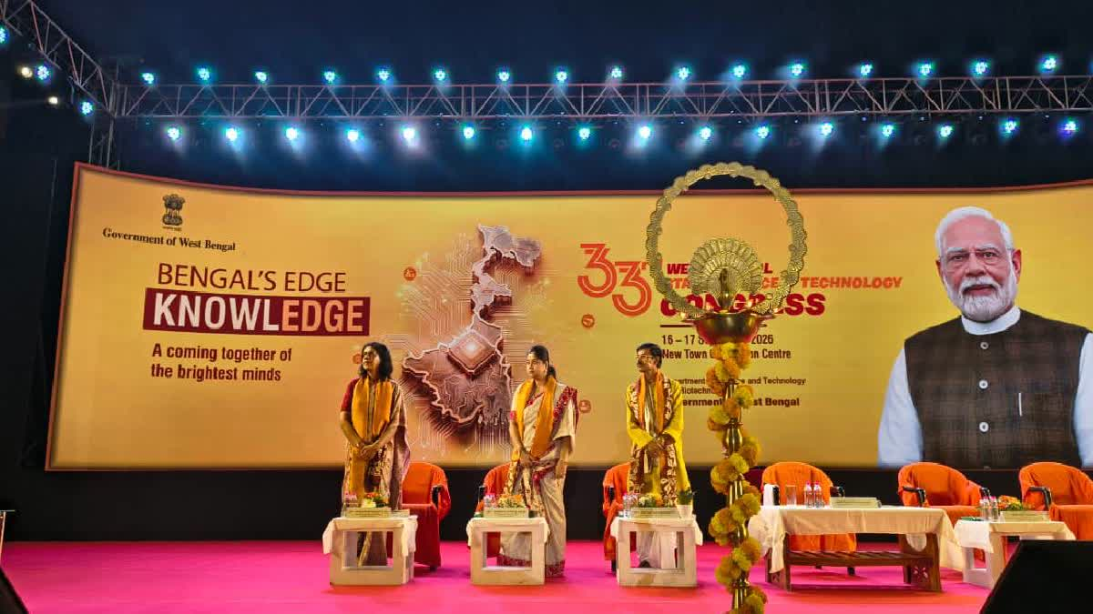
ETV Bharat / state WB Minister Opens 33rd Science Congress with IIT & ISRO Pacts, Urges People-Oriented Tech Kolkata: Speaking at the 33rd West Bengal Science and Technology Congress, state Science and Technology minister Kalyan Chakraborty said West Bengal must latch onto the immense opportunity at a time when India's biotechnology economy is projected to reach approximately $300 billion by 2030. He emphasised that scientific success must ultimately be utilised for the welfare of the people while recalling the words of Swami Vivekananda: "Service to living beings is service to the Divine." He expressed hope that this Science Congress would not remain merely an annual event but would instead pave the way for future collaborations and a concrete roadmap for research. According to Chakraborty, scientific achievements must not remain confined within the four walls of laboratories but should be applied to the daily lives of ordinary people. Wednesday's inaugural session held at the Convention Centre in New Town witnessed a record turnout this year.

3. Modi At 76: How India's Space Reforms Are Recasting ISRO, Private Industry And The Road To Space Power - BW Businessworld
Read more
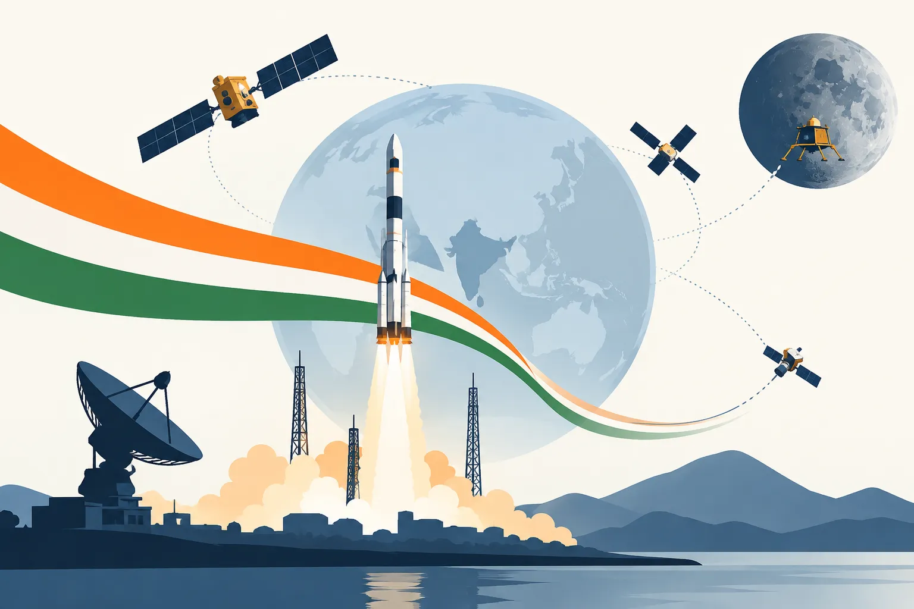
Modi At 76: How India's Space Reforms Are Recasting ISRO, Private Industry And The Road To Space Power BW Businessworld

4. SENSATIONAL! Who In Delhi Stopped The GSLV Launch? - Rediff
Read more
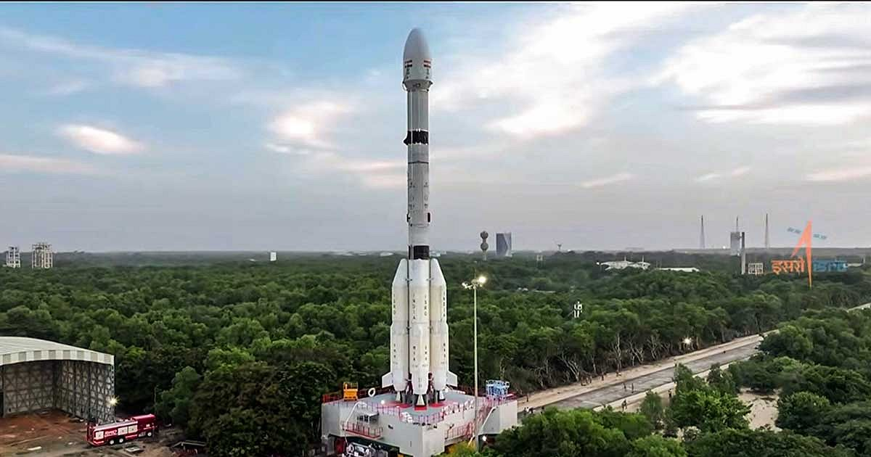
'An instruction came from somebody in Delhi saying, "don't go with the launch".' IMAGE: When ISRO launched the GSLV-F17/EOS-05 mission at the Satish Dhawan Space Centre in Sriharikota, September 4, 2026. Photograph: ISRO/Video Grab/ANI Photo It all began with a comment by Indian National Space Promotion and Authorisation Centre (IN-SPACe) Chairman Dr Pawan Kumar Goenka. ISRO, the IN-SPACe chairman said, would eventually stop manufacturing launch vehicles, and the production would be taken over by the private sector or PSUs. Angered by the comment, nine employee associations, representing thousands of staff at ISRO, asked for a written clarification from ISRO Chairman Dr V Narayanan. Even though Dr Narayanan addressed the employees soon after, the staff were unhappy as they felt the ISRO chairman did not answer their questions. "You should leave ISRO to perform as usual instead of creating unnecessary controversies," retired ISRO chairman G Madhavan Nair tells Rediff's Shobha Warrier in the first of a two-part interview. Key Points 'Everybody was worried about on what ground this launch was delayed.' 'Holding back a 'ready to launch' vehicle is a risky affair. As time passes, it's reliability comes down and there could be problems.' 'It is for the investigating agencies to find out what is behind this. Unless the government takes a serious note of this issue and conducts a comprehensive review at the highest level, the issue will come back again and again.' IMAGE: ISRO Chairman Dr V Narayanan and IN-SPACe Chairman Dr Pawan Kumar Goenka. Photograph: Video Grab/ANI Photo 'It is beyond Goenka's position to make such a comment, so unwanted' Even after the ISRO chairman addressed the employees, they are not satisfied and the confusion remains.... Do you feel the comments by Pawan Goenka was unwanted? I personally feel it was unwanted. IN-SPACe is another regulatory authority. It is neither a policy maker nor the implementing representing agency. Certainly, it is not in his mandate to make such comments. Everything was quiet till Pawan Goenka made a speech. That was the beginning of all the confusion and uncertainty. Yes, it is beyond his position to make such a comment, so unwanted. In fact, ISRO has been tapping the potential of industries, and it was augmented. Right from the 1970s onwards, we are doing that. Industry is already a partner of ISRO. But for industry, we would not have achieved anything. Industry is already working with ISRO in various capacities, and about 80 per cent of the budget is spent through industry only. ISRO has got a manpower of roughly about 15,000. About 10,000 people are working in various industries for ISRO and maybe another 3,000 people are working in academic institutions for ISRO. This is how the ISRO network is working. ISRO's main intention of holding some of the key technologies back with them is because of the potential of dual use. If you replace the satellite with a warhead, it becomes a missile. You don't want that type of technology to fall into wrong hands. For example, defence has kept the production of large missiles like Prithvi with BDL, which is a defence production organisation. As they require small missiles for anti-tank or anti-aircraft etc in large numbers, they have opened it up for industry. There is nothing wrong in that. But here, we are talking about a rocket that has intermediate range ballistic missile -- IRBM -- capability being offered to industry for peanuts. I would say that is a thoughtless action. People have not assessed all the aspects of it. Why do you think this has happened? It is all because of the regulator taking the executive role without proper consultation with the Space Commission or the government. Why is the government not stopping this? I cannot find a reason for it. IMAGE: The GSLV-F17/EOS-05 launch. Photograph: ISRO/Video Grab/ANI Photo You spoke about how the GSLV launch that was supposed to happen in February was purposely delayed and it happened only in August.... This also created confusion in the minds of many. GSLV was supposed to carry the Geostudy Earth Observation Satellite. And everything was ready. It is the launch authorisation board created by ISRO that takes into account all the aspects and decides on the launch. That practise was diluted. I heard that an instruction came from somebody in Delhi saying, 'don't go with the launch.' It is very unusual and strange. Normally, holding back a 'ready to launch' vehicle is a risky affair. As time passes, it's reliability comes down and there could be problems. In fact, if I remember correctly, ISRO had to work overtime to check everything once again and even refurbish the cryogenic stage to ensure this launch would be a successful one. So, it was additional work for ISRO. Everybody was worried about on what ground this launch was delayed and why suddenly it was cleared. The clearance came in August and within a month, in September, the launch took place. Do you suspect political interference? ISRO is one of the prime performing organisations as far as R&D in India is concerned. It can create jealousy internally as well as externally. Some of these jealous elements may be acting behind the scenes. That's the suspicion. How worrying is it? Incidents like these have created uncertainty in the minds of all the people who work at ISRO... I cannot comment on that. It is for the investigating agencies to find out what is behind this. Unless the government takes a serious note of this issue and conducts a comprehensive review at the highest level, the issue will come back again and again. Another worrying thing that is happening is, some vested interests are creating a wrong impression of the space industry. The other day, I saw a national television channel projecting Indian's space economy as an $8 billion industry whereas international surveys give it not even $2 billion in their books. Look at the gap between $2 billion and $8 billion! I found that the direct space business which include rocket launching, satellites, etc may be around $1.5 billion. It is the government that spends the amount, and ISRO is responsible for it. The rest, the $0.5 billion, comes from services like DTH, the transponder leasing, data connection between banks and the stock exchange and such things. What you call space-based services which will be worth $3 billion or $ 4 billion is not. It is just commercial activity making use of space assets. These two combined together is the figure of $8 billion some people are quoting, and it is an exaggerated number. It is unnecessarily creating unnecessary hype and false hope in the minds of people. What do they gain by creating unnecessary hype? I think it is creating false hopes in the minds of youngsters. They are being misguided. I have great respect for the space startups. They have a lot of energy, a lot of enthusiasm to do things, but it has to be channelised in the right direction. That is what is missing today. Feature Presentation: Ashish Narsale/Rediff

5. Roman Space Telescope starts waking up as NASA powers on instruments for the 1st time
Read more
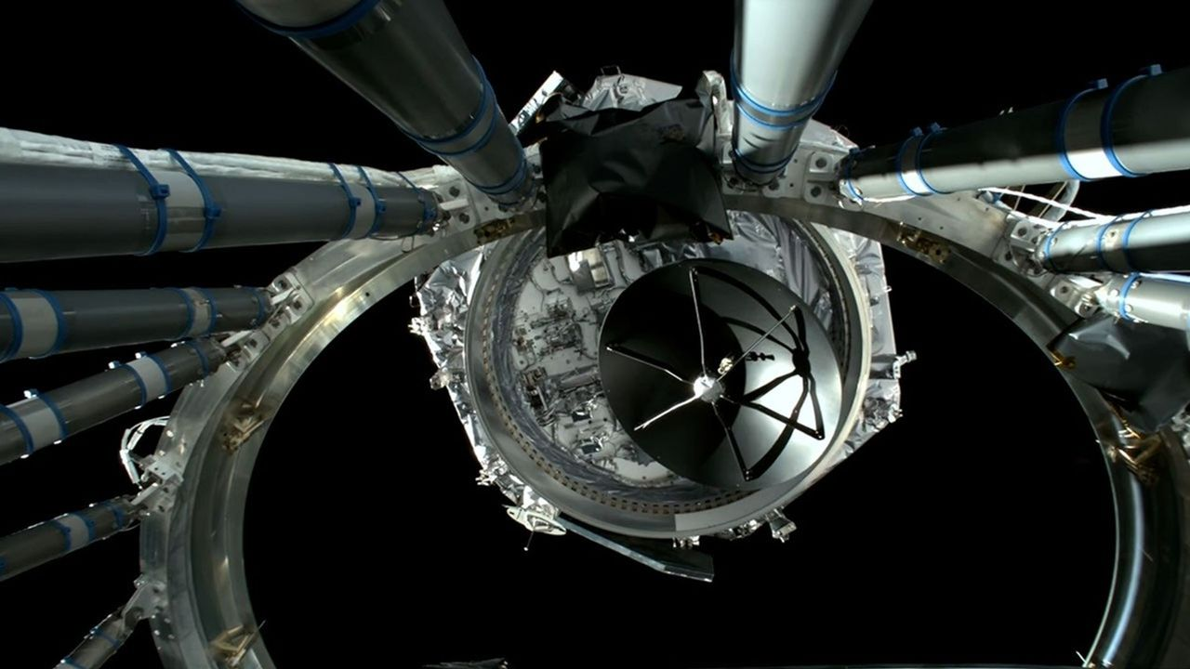
Click for next article As the newest heavy hitter in orbital observatories continues the journey to its final destination, NASA has begun the process of switching the spacecraft on. The Nancy Grace Roman Space Telescope launched on Aug. 30, and is on a three-month long trek to Lagrange point two (L2). L2 is a relatively idle orbital sweet spot almost a million miles from Earth that will allow Roman to remain on the planet's night side and keep the bright sun to its back. It's an optimal location for the telescope to operate its two primary instruments , the Wide Field Instrument (WFI) and its Coronagraph Instrument . Neither are ready to begin collecting science, and will undergo another month or so of calibrations and tests before Roman can begin its mission, but initial downlinks from the telescope indicate nominal readings on its components as NASA teams continue its commissioning. "This is a huge milestone for the team at Goddard, our industry teams at BAE Systems, Inc. and Teledyne, and our science centers," said Josh Schlieder, the Wide Field Instrument scientist at NASA's Goddard Space Flight Center , in a statement . The WFI is a 300-megapixel infrared camera designed to survey enormous swaths of the sky. Scientists plan to use the imager to take fast snapshots of the cosmos, study dark energy , and map the distribution of matter throughout the universe . It uses 18 infrared detectors that NASA says combine for a sensing area about the size of a laptop; by comparison, a typical digital camera imaging sensor covers about the size of a postage stamp. Before engineers could switch on the WFI, they spent about 10 days allowing the instrument to dry out and shed contaminants that may have accumulated prior to launch. The WFI was kept at a relatively warm (for space ) -85 degrees Fahrenheit (-65 Celsius). On Friday (Sept. 11), Roman teams turned off the instrument's heater to allow it to cool to around -225 Fahrenheit (-143 Celsius), at which point it was cold enough to activate its infrared detectors. The detectors continued cooling afterward toward their eventual operating temperature of about -300 F (-183 C). Following the successful activation of its infrared sensors, engineers moved on to calibrate the WFI's element wheel, which filters individual wavelengths for detection using a system of prisms and other optic mechanisms. And, on the morning of Sept. 13, Roman teams confirmed the focus components were functioning nominally. Roman's coronagraph also completed its first major steps toward operation. The instrument is controlled by the Coronagraph Commanding Center at Caltech/IPAC in Pasadena, California, where operators were able to verify that they could remotely operate the instrument's electronic and mechanical systems. The coronagraph functions using a series of mirrors, masks and sensors to block the light of a distant star in order to detect the much fainter light of planets in that star's orbit. Tests on the coronagraph also included warming the device to 72 degrees Fahrenheit (22 Celsius) - nominal for operating conditions in controlled environments on Earth , but quite warm compared to the WFI's -300 F (-183 C) operating temperature. The extra heat allows the Coronagraph to maintain conditions similar to those inside NASA test chambers so engineers can more easily simulate tests on Roman's deformable mirrors. "Now that this test is complete, we've been decontaminating: sitting idle with our detectors warm so anything that's stuck to the surface, such as water or trace chemicals, will tend to leave it," said Eric Cady, an optical engineer leading commissioning efforts for the Roman Coronagraph at NASA's Jet Propulsion Laboratory .

6. On this day in space! Sept. 16, 1949: A US launch of a V-2 rocket explodes, killing its monkey passenger Albert III
Read more

Click for next article On Sept. 16, 1949, the U.S. launched a V-2 rocket with a monkey named Albert III on board. Albert III was the third monkey the U.S. attempted to launch to space. He was also the third one to be killed on the job. The U.S. precursor to NASA began launching monkeys into space in the 1940s to try to see what might happen to humans in space. This testing started more than a decade before any humans were launched up there. The monkeys were all given anesthetics and covered with sensors and probes that monitored their vitals. While the other five Alberts that were launched on V-2 rockets were all rhesus monkeys, Albert III was actually a long-tailed macaque. Sadly, Albert III died when his rocket exploded 10 seconds after launch. The two Alberts who came before him died differently, first by suffocation and then by a parachute that failed to deploy before landing. It wasn't until the Albert VI flew in 1961 that a test monkey survived a test launch. NASA stopped using monkeys for launch testing in the 1980s. A small macaque monkey named Albert III was lost during a failed V-2 rocket launch test from White Sands Missile Range in New Mexico on Sept. 16, 1949. (Image credit: Future/NASA) Why it mattered In the late 1940s, the United States was just beginning to gain experience with large rocket and ballistic missile launches using a cache of V-2 rockets (and the German rocket scientists like Werhner von Braun that designed them). And while the U.S. military sought to develop rocket and missile weapons, animal launches like the failed flight of Albert III were aimed studying how the upper atmosphere and cosmic rays could affect living things (like future astronauts). To do that, the U.S. Air Force formed Project Blossom, a series of V-2 rocket launches out of White Sands Missile Range in New Mexico that included five "biological flights" overseen by the Aero-Medical Laboratory at Wright-Patterson Air Force Base, according to a history by the White Sands Missile Range Museum. Albert III's launch failed 24.7 seconds after liftoff, with the V-2 rocket flying at a slower speed than expected after liftoff, the museum account states . The rocket suffered an explosion in its tail section 10.7 seconds into the flight, then another one 14 seconds later (likely due to leaks in its alchol fuel system). It reached a maximum altitude of just 3 miles before the failure. Despite the failure, military scientists took what they learned from Albert III's launch to make design improvements in future tests. There were still failures (the next monkey launch of Albert IV did not succeed), and three of the seven Project Blossom launch tests failed in all. The first successful monkey launch carried Albert VI (and 11 mice) to suborbital space and back on a new Aerobee rocket on Sept. 20, 1951, NASA has said . Want more space history? Check out our full On This Day In Space Story archive and watch our On This Day In Space videos on YouTube .

7. Colossal cosmic cloud revealed in insane new image from the James Webb Space Telescope | Space photo of the day for Sept. 16, 2026
Read more

Click for next article The star-forming region IC 348, as imaged by the James Webb Space Telescope. (Image credit: ESA/Webb, NASA, CSA, K. Luhman, C. Alves De Oliveira, M. Zamani (ESA/Webb)) An ethereal and magnificent display of gas and dust stretches across the cosmos in a spectacular new image captured by NASA's James Webb Space Telescope . What is it? Glowing wisps of translucent gas and dust paint a striking image of the star-forming region IC 348 in this new JWST snapshot. In the image , you can see IC 348, a region found about 1,000 light-years away. In this vast expanse of gas and dust, cold molecular hydrogen gas collapses to create new stars . And this image has no shortage of suns, with twinkling stars speckling the entire cosmic landscape, diffraction spikes and all. But while this is a star-forming region, objects are found here as well. This image was captured as part of a scientific search for brown dwarfs , which are objects that form like stars but aren't massive enough to kickstart hydrogen fusion in their cores. Why is it incredible? Brown dwarfs are one of the great mysteries of our universe . Not as massive as the least massive stars, but more massive than the biggest planets, brown dwarfs are strange objects stuck in the middle. Brown dwarfs do emit some light and heat, which helps scientists to find them, though doing so can be tricky, as they're much cooler than stars and not that bright (at least in visible light). However, despite being dim, they give off infrared radiation, allowing them to be spotted by infrared instruments aboard space telescopes like JWST. This incredible new image is part of an observing program that aims to use JWST to find and study the smallest brown dwarfs. In 2022 , researchers looking at IC 348 found brown dwarfs just a few times more massive than Jupiter , so they were on the very small end. Researchers hope to find even smaller brown dwarfs to help them better understand how these strange objects form and vary across space.

8. Where will the US Space Academy be based? NASA wants class to start by 2028
Read more

Click for next article President Donald Trump presents an executive order establishing the United States Space Academy during an event to award the Congressional Space Medal of Honor to the Artemis II crew on Aug. 28, 2026, at NASA's Johnson Space Center in Houston. The hunt is on for a state to host the U.S. Space Academy. NASA released a request for information on Sept. 9, following a meeting that NASA Administrator Jared Isaacman held in Washington for the occasion. The space agency has set a quick timeline for the project: States are encouraged to submit a proposal by Oct. 26, 2026. "Now, with the RFI underway, states across the country have an opportunity to help us shape a legacy institution built for America's future in space," Isaacman said in a NASA statement on Sept. 10. The U.S. Space Academy won't be a purely military institution in the mold of the Naval Academy or West Point. It will be led by NASA, and one of its core functions will be educating future scientists, engineers and astronauts, as well as warfighters. If all goes to plan, the academy will welcome its first class of 300 students for instruction starting in 2028. Because that doesn't leave much time for planning and building, the RFI states that the academy may start before it has a permanent campus. While the academy may rely on "one or more partner institutions" for facilities to start out, the RFI outlines plans for a big campus once everything is up and running. A permanent campus will include buildings for teaching, research, administration, student residences, sports venues and gyms, dining halls and related facilities. The purpose of the new space academy is to "encourage and guide the next generation of Americans to pursue cutting-edge, technical fields that currently do not have a sufficient amount of programs and graduates needed to ensure America maintains superiority in space," a White House fact sheet about the planned academy states. The request calls for a groundbreaking by 2027, as well as a temporary campus for the first class of 300 students in 2028. The timeline in the RFI has the academy's permanent location in operation by 2031. "The location of the U.S. Space Academy is foundational to its success," NASA Deputy Administrator Matt Anderson said in the Sept. 10 statement. "We're asking states to bring their strongest vision - the infrastructure, the partnerships and the community that can compete with the elite options this caliber of student will have and match the boundless ambition of our future space leaders," he added.

9. Russia launches Progress 96 with 3 tons of cargo to the space station (video)
Read more
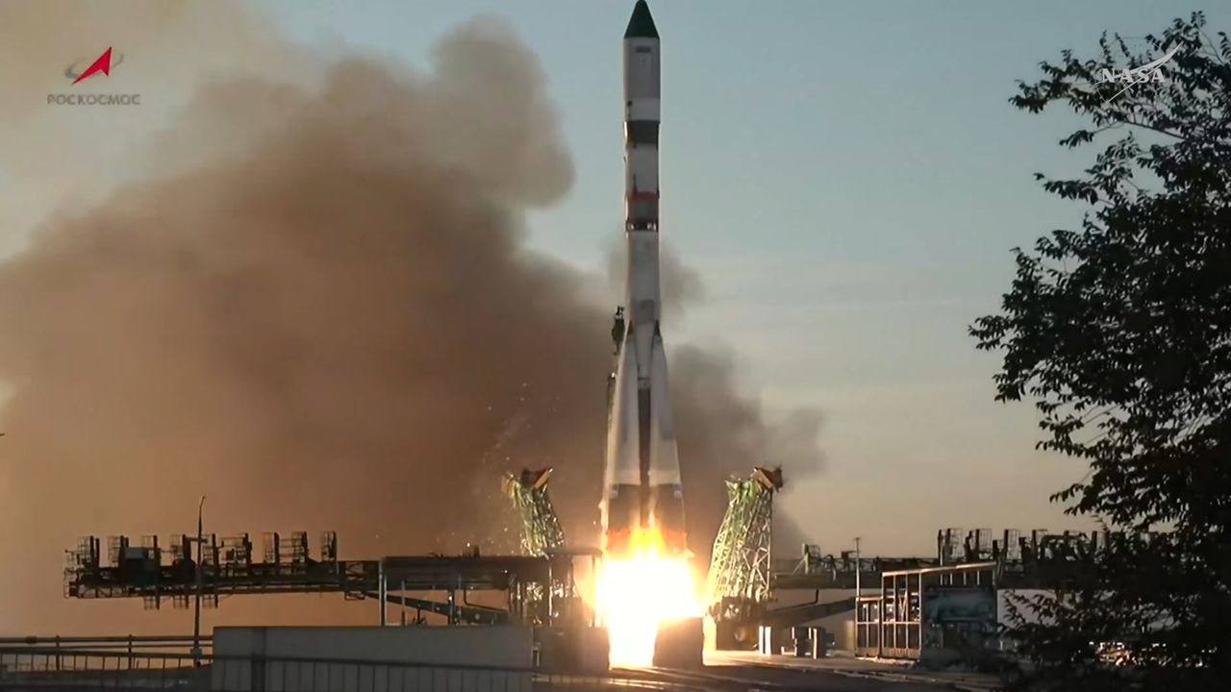
Click for next article Russia launched a cargo mission toward the International Space Station today (Sept. 16), delivering the freighter spacecraft to orbit for a three-day rendezvous journey. The robotic Progress 96 spacecraft lifted off atop a Soyuz rocket from the Russian-run Baikonur Cosmodrome in Kazakhstan today at 9:33 a.m. EDT (1333 GMT). From engine ignition through solar array deployment on the spacecraft, the Progress 96 launch was completely nominal. It was "a flawless launch," said NASA's Rob Navias during the mission's livestream this morning, with "an excellent climb to orbit by the Soyuz booster." Roscosmos' Progress 96 cargo spacecraft launches from the Baikanour Cosmodrome on a Soyuz rocket on Sept. 16, 2026. (Image credit: NASA) Progress 96 is loaded with about 3 tons of food, propellant and other supplies for the astronauts aboard the International Space Station (ISS). The freighter will deliver this cargo three days after launch, if all goes according to plan. You'll be able to watch rendezvous and docking activities when the time comes. The freighter will remain docked to the orbiting lab for about five months. It will then be loaded up with trash and sent down to a fiery death in Earth's atmosphere over the Pacific Ocean. The Progress 94 spacecraft met this fate on Sept. 7, departing from ISS' Poisk module to make room for Progress 96. (Image credit: NASA) Progress is one of four spacecraft that fly operational cargo missions to the ISS these days, along with Japan's HTV-X , SpaceX 's Dragon capsule and Northrop Grumman's Cygnus . All but Dragon are expendable, burning up in our air when their time in orbit is up. There are currently seven people living aboard the ISS - NASA astronauts Jack Hathaway, Jessica Meir and Anil Menon; the European Space Agency 's Sophie Adenot, who last month became the first French woman ever to perform a spacewalk; and Pyotr Dubrov, Andrey Fedyaev and Anna Kikina of the Russian space agency Roscosmos . Editor's note: This story was updated at 10 a.m. ET on Sept. 16 with news of successful launch.

10. Snow, monsoons and oceans shift Earth's center of mass each year, satellite tracking shows
Read more

Seasonal changes redistribute enough water around Earth to shift the planet's center of mass back and forth by fractions of an inch relative to its geometric center. NASA scientists are on the case, tracking the oscillations because Earth's center of mass is a crucial reference point for satellite navigation and elevation measurements.

11. From 10 to 22 years: The Nancy Grace Roman Space Telescope's mission has just been extended
Read more

The Nancy Grace Roman Space Telescope hasn't yet reached its Sun-Earth L2 orbit, and it already has some good news. NASA has announced that the mission has enough fuel to potentially double its mission length. Though initially scheduled for five years of observations, followed by a five-year extended mission, the entire mission could now reach 22 years.

12. Missile seeker windows could be designed with sapphire optics that can withstand high temperature
Read more
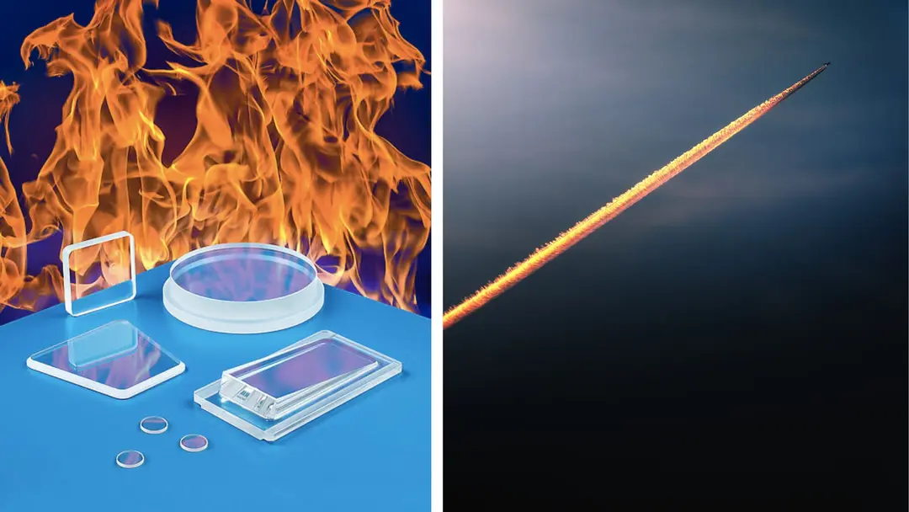
As industries increasingly operate equipment in extreme thermal and demanding environments, optical components must withstand conditions that can quickly degrade conventional materials. Sapphire (single-crystal aluminum oxide, Al₂O₃) is emerging as a particularly useful material for applications where optical clarity, mechanical strength and high-temperature performance are essential. Recently, Meller Optics has introduced custom-fabricated sapphire lenses and windows designed for high-temperature applications. The optics are intended for applications including missile seeker windows, furnace inspection ports, semiconductor processing equipment, pyrometers, vacuum chambers and aerospace instrumentation. One of the key characteristics of the sapphire optics is their ability to operate across a broad temperature range. Depending on configuration, Meller says its sapphire optics can operate from approximately -200°C to +1,600°C. This makes sapphire particularly relevant to systems exposed to intense heat, thermal cycling and demanding industrial environments. Furnace monitoring and high-temperature measurement systems, for example, require optical windows that can maintain their performance while allowing sensors or cameras to observe processes taking place at elevated temperatures. Sapphire is known for its exceptional hardness. The company specifies a Mohs hardness of 9, placing sapphire just below diamond on the Mohs scale. This characteristic can provide significant resistance to scratching and wear in demanding environments. The optics are also described as being resistant to fast-moving fluids and particles, as well as to many chemicals. Meller states that the material is resistant to fluorine up to 300°C, adding to its suitability for specialized industrial and semiconductor-processing environments. Custom designs for specialized systems Rather than being limited to standard optical shapes, the sapphire components can be manufactured in a variety of configurations. The company says they can incorporate features such as stepped edges, elliptical edge shaping, holes, slots and wedges to accommodate different mounting requirements. Anti-reflective coatings can also be incorporated where required. These customization options can be important when sapphire windows or lenses need to be integrated into existing optical instruments or specialized equipment. Meller reports that the components can be manufactured from approximately 0.25 inch to 6 inches in diameter and up to 1.5 inches thick. Surface finishes can range from 60-40 to 40-20 scratch-dig, while flatness can be maintained to 0.5 fringes of HeNe and parallelism can range from 20 to 2 arc-seconds. Applications Across High-Temperature Industries The combination of optical performance, hardness and temperature resistance makes sapphire useful across several technology sectors. In aerospace and defense, sapphire windows can serve as protective optical interfaces for systems that need to operate under severe environmental conditions. In industrial manufacturing, they can be used in furnace inspection and temperature-monitoring equipment. The semiconductor industry is another potential application area, where optical components may encounter high temperatures and chemically demanding processing environments. Sapphire's resistance characteristics can make it suitable for specialized inspection and measurement systems. Similarly, pyrometers and aerospace instrumentation can require durable optical windows that allow infrared or other optical measurements while protecting sensitive internal components from harsh external conditions.

