 |  | 

🌌 अंतरिक्ष समाचार | Space News
सोमवार, ३१/०८/२०२६ | Monday, 31/08/2026

1. Trump calls in to NASA press conference to celebrate launch of Roman Space Telescope, a mission he tried to cancel
Read more
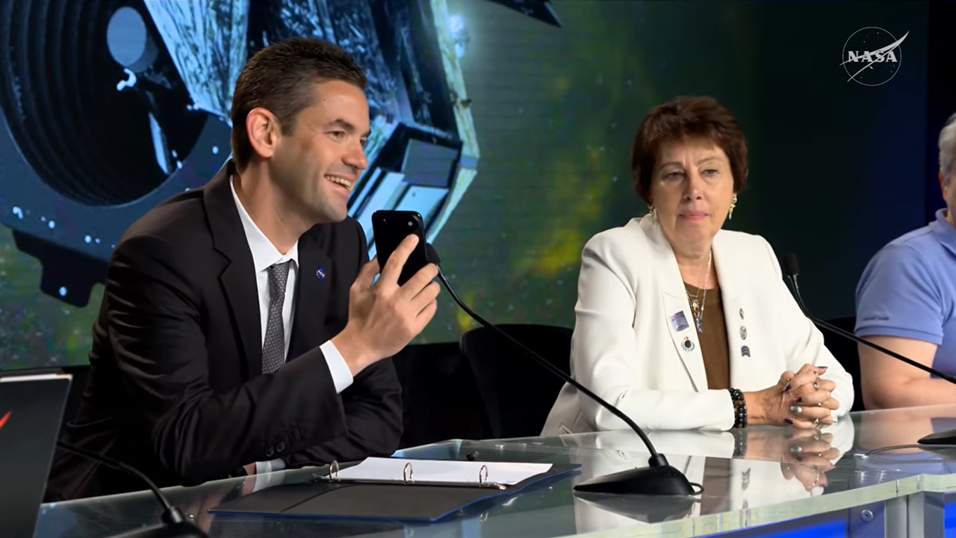
Click for next article CAPE CANAVERAL, Fla. -President Trump interrupted a NASA press conference today (Aug. 30) to congratulate the Nancy Grace Roman Space Telescope team on a successful launch. Just a few years ago, however, the president tried to cancel this very mission. In today's briefing, mission leadership was going through the specifics of Roman's successful launch and the science the observatory is expected to deliver when NASA Administrator Jared Isaacman got a phone call. It was the president. The room fell silent, though I could hear Nicky Fox, NASA associate administrator for the Science Mission Directorate, say, "He's not kidding." "Hello, sir," Isaacman said. He got up to take the call outside the room but came came back in a few moments later. "The president of the United States would like to address and congratulate everyone on this mission," he said. "You're live, Mr. President." Jared Isaacman takes a surprise phone call from President Trump during the post-launch briefing following the launch of the Nancy Grace Roman Space Telescope on Aug. 30, 2026. (Image credit: NASA) "I just want to thank everybody and congratulate you," Trump said on the phone, which Isaacman held up to the microphone and clearly displayed Trump's name. "Boy, it looked beautiful on television ... You are doing a fantastic job, and I'm supplying you all that money." The president spoke for more than a minute while Isaacman smiled, holding the phone up to a microphone for everyone to hear, and the crowd of journalists listened intently. The call was mostly congratulatory, but Trump did go on a brief tangent, claiming that he has taken NASA to new heights. Near the beginning of his first term in 2016, Trump said, he visited NASA's Kennedy Space Center (KSC) in Florida and saw that "grass was growing through the cracks in the runways, and there were a lot of cracks. And I looked; that place was closed ... It was just literally closed. And now, again, like we are with the country itself, we're the hottest there is. We're the hottest. You're the hottest in space, and we have the hottest country anywhere in the world." (To clarify, KSC was only closed for two days in 2016, and that was because of Hurricane Matthew .) President Trump's relationship with the Roman mission is more complicated than today's congratulatory call might suggest, however. Under the Trump administration, the White House has repeatedly tried to cancel or restrict funding for this mission . Between 2019 and 2021, for example, the president proposed canceling Roman (then called WFIRST) three separate times in three different budget requests. Congress rejected those proposals and kept the mission funded. But then, in April 2025, reports emerged about initial "passback" budget documents that proposed slashing NASA science funding by about 50%. The proposed cuts were deep enough, experts suggested , that the Roman mission would end if they were passed. That didn't happen either, of course; Congress ended up passing a $24.4 billion NASA budget for fiscal year 2026, keeping the agency's funding relatively flat. As Trump made his call today to a room packed with science journalists, this bit of recent budget history did not go unnoticed. Image 1 of 2 Jared Isaacman takes a phone call from President Trump to congratulate the Nancy Grace Roman Space Telescope mission team. (Image credit: NASA) Donald Trump's name glows on Jared Isaacman's phone as he holds the phone up to a microphone during a surprise call during a post-launch briefing. (Image credit: NASA) Image 1 of 2 View Original Image 2 of 2 View Original A direct question "Question for the administrator," SpaceNews reporter Jeff Foust asked Isaacman today following Trump's call. "It's great to hear the president call in and show us excitement about the Roman launch. I know the administration in past years, in its first term, proposed zeroing out Roman and also proposed a serious cut in Roman's budget just last year. What did you tell the administration, and the president, to change his mind and make him so excited about a mission that he once proposed to cancel?" Isaacman did not directly address the question, focusing instead on the current climate, which he said is very positive. "I'm incredibly grateful for his support, the space policy, the resources," Isaacman responded. "Sounds like from that call, maybe even more resources, which is also a great thing for more missions of science and discovery."

2. 'What a glorious dawn launch': Why the Roman Space Telescope's picture-perfect liftoff beyond Earth is such a big deal
Read more
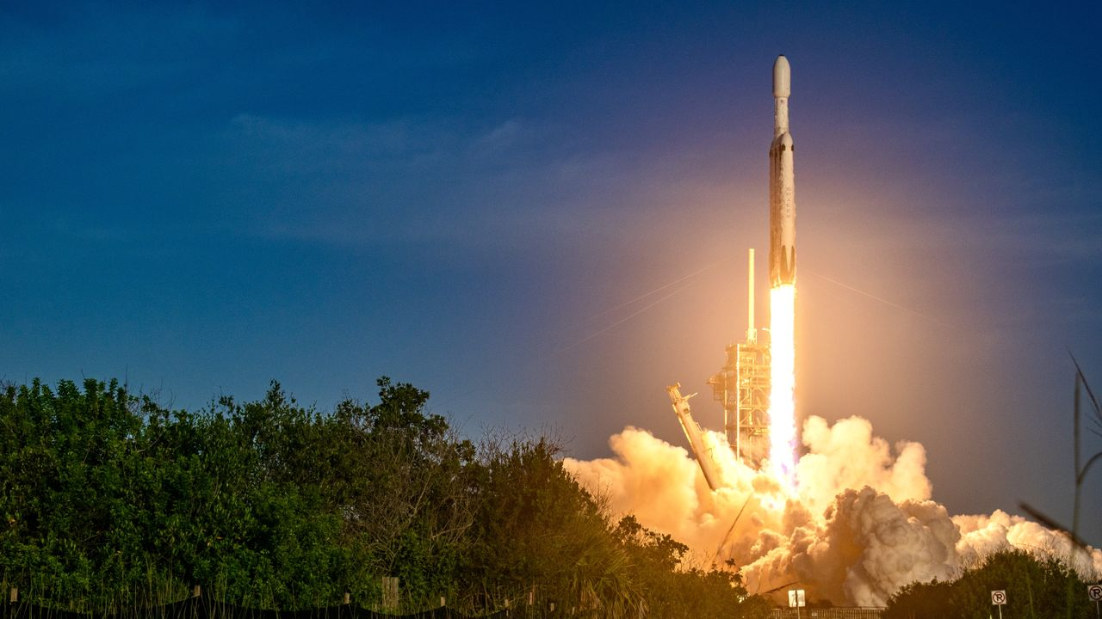
Click for next article CAPE CANAVAREL, Fla. - It was a bright and sunny morning here in Florida when the Nancy Grace Roman Space Telescope lifted off planet Earth against a magical blue sky. "What a glorious dawn launch," Jackie Townsend, the Roman Space Telescope 's project manager, said during a post-launch press conference on Sunday (Aug. 30). "The ride was magnificent - it put us right where we wanted to be. All of the deployments went great." Roman lifted off on a SpaceX Falcon Heavy rocket right on cue at 7:26 a.m. EDT (1126 GMT), beginning its journey to revolutionize the way we see the universe. It will be able to do this thanks to the two stars of its toolkit, the Wide Field Instrument (WFI) and the Coronagraph Instrument. The former is meant to image extremely wide sections of the cosmos to capture tons of fleeting phenomena that are hard to catch - things like supernovas, fast radio bursts and maybe even colliding neutron stars . Its uniquely wide view will also help scientists decode the intricacies of dark matter and dark energy while perhaps clearing up some contradictions about our universe that scientists have been scratching their heads over for decades. What's the source of the puzzling " Hubble tension ?" Why exactly is the universe expanding the way it is? Are we alone? Meanwhile, the coronagraph will take direct images of exoplanets and bring us a gallery of "Pale Brown Dots" from beyond our solar system akin to the Voyager spacecraft's priceless "Pale Blue Dot" portrait of Earth . The Roman Space Telescope lifts off. (Image credit: Chelsea Gohd) What happens now? Now that it has lifted off, the Roman Space Telescope will undergo a 90-day commissioning period while traveling to its station in space at the sun-Earth Lagrange Point 2, or L2. This is a gravitationally stable point in space on the side of Earth always opposite the sun; it's a popular location to send telescopes because the orientation allows spacecraft to remain safe from heat while still getting a great view of the universe. Notably, the powerful James Webb Space Telescope (JWST) is also located here. "Roman will travel nearly 1 million miles away from Earth to Lagrange Point L2 and begin transmitting imagery and data back home that will contribute to world-changing science along with captivating imagery like we see from Hubble and James Webb," NASA administrator Jared Isaacman said during today's press conference. "I have no doubt that Roman will become a household name alongside those great instruments of discovery." Right after getting off the ground and successfully separating from the spacecraft, Roman started undergoing several typical post-launch procedures - for example, outgassing, referring to the spacecraft releasing any trapped gases once exposed to the vacuum of space, getting "power positive" and plunging to the really cold temperature levels necessary to keep its instruments safe. A visualization showing what the Roman Space Telescope looks like from the side. (Image credit: NASA Goddard Space Flight Center Scientific Visualization Studio) The picture-perfect launch today adds to Roman's glowing record of efficiency and performance. This telescope has been in development for over a decade and has an estimated total cost of about $4 billion - but while this may sound like lots of time and money, it's pretty good for a space mission. The JWST, for instance, cost about $10 billion. Roman, in fact, was completed under budget and ahead of schedule. And now, it turns out that even the famously fickle Florida weather couldn't stop this space explorer in its tracks. "The weather got the memo that Roman is always early," Townsend said. The Roman Space Telescope's solar arrays. (Image credit: NASA/Jolearra Tshiteya) What exactly will Roman do? The Roman Space Telescope is a huge deal for astronomers. First of all, with its WFI, it's meant to process a tremendous amount of data in relatively short periods of time in order to survey gigantic zones of our cosmos. For context, the Hubble Space Telescope has generated about 400 terabytes of data across its 35 or so years of service, while Roman will be generating about 500 terabytes every single year. "Our main survey will take over a year and be really huge," Julie McEnery, Roman's senior project scientist at NASA's Goddard Space Flight Center in Greenbelt, Maryland, said during a prelaunch conference on Saturday (Aug. 29). "We would need over half a million 4K TVs to fully display the single Roman image on our largest survey." Roman will also view the universe in the infrared region of the electromagnetic spectrum like the JWST, but with a wide-field, shallow view rather than the JWST's super narrow but deep view. This is a big deal because infrared observations are key for astronomers; they allow us to view objects hidden behind interstellar dust and gas as well as objects in the very (very) distant universe emitting light wavelengths that stretch out from bluer, tight ones into redder, longer ones. And second of all, Roman's coronagraph is state-of-the-art. It's the first "active" coronagraph to be flown in space, which means it's able to actively adjust itself to enhance its observations. The concept is basically like a solar eclipse; a coronagraph blocks out the glare of a star such that anything around that star can come into focus. And that means exoplanets - specifically large ones for Roman's capabilities. NASA will be using Roman foremost to find Jupiter -like worlds around other stars in the universe. "If you try to imagine seeing an exoplanet next to a star, it's going to be very challenging," Vanessa Bailey, Roman's coronagraph instrument scientist, said during the prelaunch briefing. "The starlight is going to be overwhelmingly bright. It's like trying to see a firefly next to a lighthouse hundreds of miles away. We can use a technology called a coronagraph inside of our camera to block that lighthouse and see the firefly." People watch on as the Falcon Heavy's booster returns to Earth. (Image credit: Chelsea Gohd) But what's special about an active coronagraph like this one is that it can change its hardware to increase the amount of targets it can study. Shawn Domagal-Goldman, the head of NASA's Astrophysics Division, offered an analogy about going to see an optometrist: "They measured my eyes, they measured my vision, and then they gave me a prescription, which I then mailed in, designed lenses to basically impart the opposite area that my eyes impart," he explained. "What the coronagraph does is, it's basically doing that measurement and then reshaping with deformable mirrors in a fast cadence to correct the vision that the telescope is imparting." "In 1990 when we launched Hubble, we didn't even know there were exoplanets," Nicky Fox, the associate administrator for NASA's Science Mission Directorate, said during today's briefing. "There will be maybe 100,000 [known ones] at the end of Roman." 'The edge of a precipice' McEnery described today's launch as a transition point, and said it feels like Roman's technical team is on the "edge of a precipice." Launch experts will now hand the baton to scientists, who will start using the machine they worked so very hard to get to space safely. "We're just about to set foot off into the unknown," she said. "I'm looking forward to the next few months when we turn things on, figure out how well things work, and actually get to use this observatory, this telescope, these instruments in space, in the environment that it's designed for." Soon, the science is going to come rolling in, she said: "You know, I have no real good words because it's just so exciting." Another bit of excitement during today's conference came from U.S. President Donald Trump, who called Isaacman right when Fox was beautifully describing what it's like to say goodbye to Roman, a machine that has without a doubt become a member of her team. "There is that moment where you think, 'I'm never going to see that spacecraft again,' and get that feeling of 'You know, it's never coming back,"' she said. "I liken it to sending your kids to college. They're going to have great adventures." When Trump called, Isaacman left the room briefly before returning and putting his phone toward the speaker. "I just want to thank everybody and congratulate you," Trump said. "Boy, it looked beautiful on television." "I just called Jared to find out: 'Is there anything negative that I should know about? Like, it will never be able to return? Little things like that,'" Trump continued. "He said 'No, it's looking great. It couldn't be better and it was another great successful launch.' Jared's doing a fantastic job. You are doing a fantastic job, and I'm supplying you all that money." During his first term, however, Trump tried to cancel the Roman Space Telescope. Jared Isaacman speaking to President Donald Trump during the conference. (Image credit: NASA) From team Earth to team space It will be a treat to see the first results that come in from Roman, whether it be a "fuzzy little smudge" of an exoplanet, as Bailey once told me we can expect from the coronagraph, or a sweeping panorama of millions of galaxies that can help us decode the truth about dark matter and dark energy. On that note, the dark universe is a huge point of interest for the Roman team, because the way we're able to study this elusive yet ubiquitous aspect of our cosmos is by watching how dark matter and dark energy affect galaxies across vast spaces. It's therefore important to monitor as many galaxies as we can simultaneously. But as the Roman team has consistently repeated one particular role Roman will have in space: to be a team member to other space telescopes just the way it's always felt like a part of Fox's team. NASA's Nancy Grace Roman Space Telescope is encapsulated in the payload fairing of its SpaceX Falcon Heavy rocket. (Image credit: SpaceX) While Roman has a very wide field of view - far wider than that of the Hubble Space Telescope and James Webb Space Telescope - it doesn't have the same resolution as Hubble or the ability to heavily zoom in on objects in infrared like the JWST can. The goal is to have a fleet of telescopes that can work together to show us the universe in as much detail as possible. Roman will work with Hubble, Webb, and even Europe's Euclid space telescope , the ground-based Rubin Observatory and more. In fact, Euclid's field of view is even bigger than Roman's - but it isn't doing the same surveys that Roman will. Rubin will create a new 3,200-megapixel image of the southern night sky every 40 seconds for 10 years during its observing time - but it's on the ground in Chile, so its view is somewhat compromised by Earth's atmosphere. "Roman, Rubin and Euclid, they're siblings. They were all proposed and prioritized at the same time, so the design of each of those observatories has been in the knowledge of knowing what the other ones were doing," McEnery said. "There is a reason that most of Roman's observations are in the Southern Hemisphere, and that's to maximize the overlap with Rubin. We're not competitors. We're stronger together, and we both need each other." "It's kind of like layering paint on a canvas," Fox said. "You layer the data, and it just really unlocks the secrets of the universe."

3. Liftoff! NASA's Roman Space Telescope soars to the stars on a SpaceX Falcon Heavy rocket in spectacular launch (video)
Read more
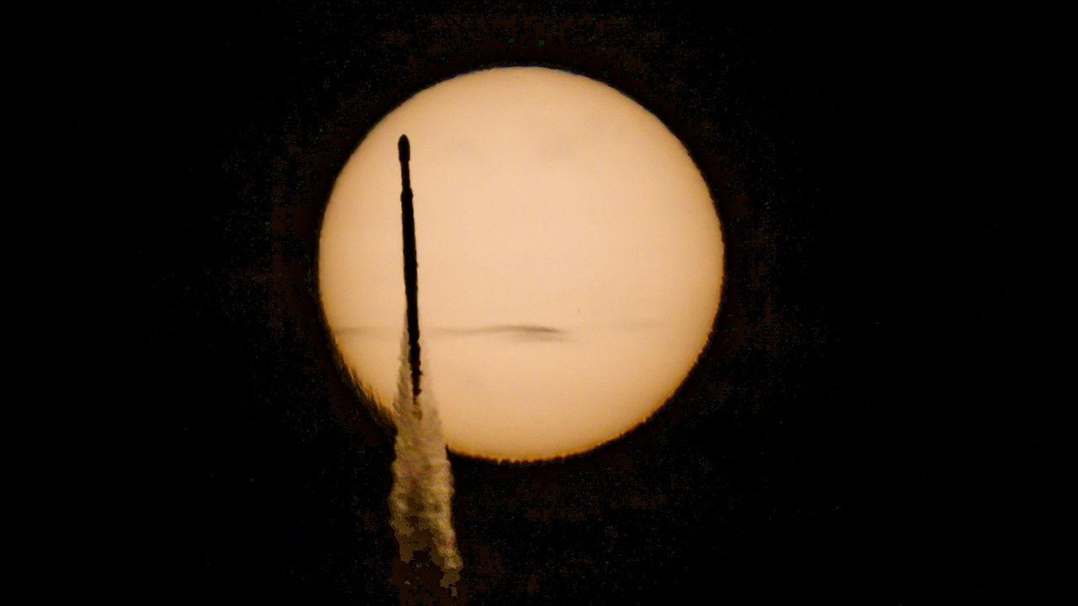
Click for next article CAPE CANAVERAL, Fla. - A new era of astronomy is about to begin after NASA's newest flagship observatory leaped from the terrestrial bounds of Earth into the vastness of space this morning. NASA's Nancy Grace Roman Space Telescope launched today (Aug. 30) on a SpaceX Falcon Heavy rocket from the Kennedy Space Center here in Florida. Liftoff occurred at 7:26 a.m. EDT (1126 GMT) at Launch Complex-39A (LC-39A). Roman is NASA's newest orbital observatory designed to add to the wealth of research and discoveries we've received from the Hubble Space Telescope and James Webb Space Telescope . "The scope is extraordinary," Roman senior scientist Julie McEnery said during live commentary. "We will do a survey of our own Milky Way galaxy and find 20 billion stars. That would make it the largest catalog of astronomical objects that's ever been produced." Image 1 of 3 A SpaceX Falcon Heavy rocket carrying NASA's Roman Space Telescope crosses the sun during launch from Pad 39A of NASA's Kennedy Space Center, Florida on Aug. 30, 2026. (Image credit: Space.com / Josh Dinner) A SpaceX Falcon Heavy rocket launches with NASA'S Nancy Grace Roman Space Telescope onboard from Launch Complex 39 on Aug. 30, 2026, at NASA's Kennedy Space Center in Florida. (Image credit: Space.com / Josh Dinner) A SpaceX Falcon Heavy rocket launches with NASA'S Nancy Grace Roman Space Telescope onboard from Launch Complex 39 on Aug. 30, 2026, at NASA's Kennedy Space Center in Florida. (Image credit: NASA/Joel Kowsky) Image 1 of 3 View Original Image 2 of 3 View Original Image 3 of 3 View Original While Hubble and the JWST are built to get close looks at distant phenomena in the universe, Roman will study the bigger picture of our cosmos . Its main instrument, known as the Wide Field Instrument (WFI), will take extremely wide images of the universe, capturing ultra-high definition views across broad swaths of the sky. It's also equipped with the first active coronagraph to be used in space, which will revolutionize exoplanet studies. The Roman Space Telescope is named after NASA's first chief astronomer Nancy Grace Roman , the first woman in an executive leadership role at the space agency. It was Roman who advocated for a telescope in space, leading to the Hubble Space Telescope. Roman, who died in 2018, earned the nickname "Mother of Hubble" as a result. "It was Nancy in the old days, before the internet and before Google and email and all that stuff, who really helped to sell the Hubble Space Telescope, organize the astronomers, who eventually convinced Congress to fund it," Ed Weiler, Roman's successor as Hubble's chief scientist, told the Voice of America in 2011. At liftoff, Falcon Heavy blazed off the pad at LC-39A, roaring with the thunder of 21 Merlin 1D engines on the business end of the SpaceX triple-booster launch vehicle. About 2.5 minutes into flight, the rocket's two side boosters cut off their engines for a nominal separation and began trajectory burns to return for a landing back here on the Space Coast. The rocket's core booster then continued onward to deliver Falcon Heavy's second stage equipped with Roman into space. Main engine cut off (MECO) and separation of Falcon Heavy's main stage took place about four minutes after liftoff, with fairing separation about 15 seconds later. Falcon Heavy's side boosters, meanwhile, executed boostback burns for landings at SpaceX's Launch Complex-40 and Landing Zone-2 at Cape Canaveral Space Force Base, a few miles downrange from LC-39A. A view of on e of the two SpaceX Falcon Heavy side booster as it lands at Cape Canveral Space Force Station following the Roman Space Telescope launch. (Image credit: NASA) Roman's delivery to space caps more than a decade and $4 billion of development for the space telescope, which was made possible, in part, by i ncorporating elements of an unused spy satellite . With its coronagraph and WFI, the telescope is designed to make groundbreaking strides in the fields of dark matter and dark energy , exoplanet discoveries, and will be capable of capturing views 100 times wider than those of its Hubble predecessor. "The smallest Roman images will be a billion pixels," Dominic Benford, progam scientist for the Roman Space Telescope, said during live commentary. "When we take a billion-pixel image, there isn't a screen on Earth large enough to display all the pixels." NASA's Roman Space Telescope flies free from its SpaceX Falcon Heavy rocket after a successful launch on Aug. 30, 2026. The large dish visible on the spacecraft is its high-gain antenna, which will beam its trillion-pixel photos back to Earth. (Image credit: NASA) The coronagraph works by blocking out the light of distant stars in such a way that scientists can examine minute details around those stars - meaning they can map out exoplanets orbiting in the systems. Once active, Roman's Wide Field Instrument (WFI) will capture more than a terabyte of data daily; its largest survey will take over a year to complete and is expected to fill more than half a million 4K TVs. How big will the largest Roman image be? "A trillion pixels," Benford said. You can actually adopt one of those Roman Space Telescope pixels yourself with NASA's new "Adopt a Pixel" program , which the agency announced during the Roman launch. Roman's Falcon Heavy launch vehicle released the telescope to fly on its own a short 31 minutes after liftoff. NASA cheered the success, and even got a bit of a nod from celebrities in the form of a record message from singer Jewel. "As you may know, I make artwork using astrophysical data, and there would be no data more fascinating than dark energy and dark matter," Jewel said in a recorded video. "And so, it is with this great wish of great success and Godspeed that I wish the Nancy Grace Roman Space Telescope so excited. Now, the telescope is headed to sun-Earth Lagrange point 2 (L2), a relatively stationary orbital location beyond the orbit of the moon that allows the spacecraft to remain persistently on Earth's night side, with the sun on the opposite side of the planet. The locale places the sun to Roman's backside and points its sensitive instruments away from the intrusion of light reflected off the Earth and moon. Roman's journey to L2 will take about 90 days. The first 40 or so of those days will be spent turning on the telescope's instruments and performing status checks as the spacecraft slowly configures itself for operation. Science commissioning will begin after about 45 days, its completion corresponding with when Roman arrives at L2. "I very much hope, and in fact, expect that the most exciting science of Roman will be a surprise - something we couldn't predict and that will set the stage for the next, deeper set of questions for future missions to progress," McEnery told reporters a day before launch. The telescope's first images are expected in the beginning months of 2027.

4. NASA's newest Roman space telescope launches on a quest to explore the hidden universe
Read more
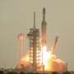
NASA's newest crown jewel blasted off Sunday to hunt for planets around other stars, explore secret dark energy and survey the cosmos like never before.

5. NASA's Roman telescope set to launch on cosmic mapping mission
Read more
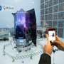
NASA is preparing to launch its new flagship space telescope on Sunday, embarking on a multiyear mission to create an unprecedented map of the cosmos and shed light on some of the biggest mysteries in physics.

