 |  | 

🌌 अंतरिक्ष समाचार | Space News
बुधवार, २२/०७/२०२६ | Wednesday, 22/07/2026

1. Monsoon clouds swallow 95% of India, Isro satellite images show: What to expect - India Today
Read more
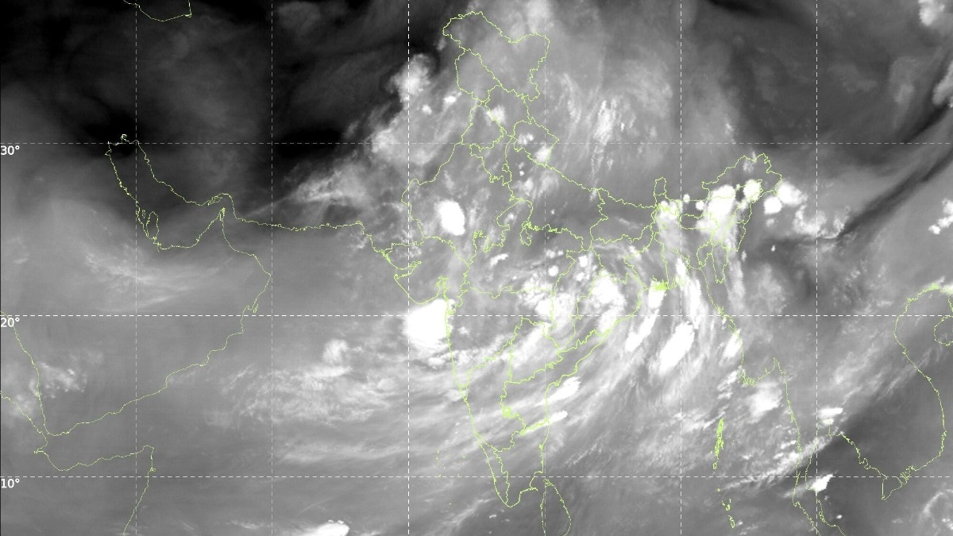
Somewhere around 3 am on July 22, while most of India slept, a satellite parked 36,000 km above the equator quietly took the country's photograph. India was not in it. Only cloud. That is not a figure of speech. Images from India Meteorological Department (IMD), taken by Isro satellites INSAT-3DR and INSAT-3DS between 2.15 am and 3.27 am, show a cloud sheet lying across nearly the entire subcontinent. Read Full Story WHAT DOES ISRO'S INSAT SATELLITE IMAGE OF INDIA SHOW? The thermal infrared frame is the plain one. Thermal infrared simply means the satellite is photographing heat rather than light, which is why the picture works perfectly well in the middle of the night. It shows a curved cloud band sweeping from the north Bay of Bengal across Odisha, Chhattisgarh and Madhya Pradesh, out towards Gujarat and the Arabian Sea. Western Rajasthan and Kutch are the main gaps. The INSAT-3DS thermal infrared frame from 3 am on July 22 traces a curved cloud band running from the north Bay of Bengal to Gujarat, leaving only western Rajasthan and Kutch clear. (Photo: IMD) The water vapour frame is the moisture channel. It shows a loaded atmosphere from the Arabian Sea to the Himalayas, which is what lets clouds keep forming for days rather than hours. WHY DO COLD CLOUD TOPS MEAN HEAVY RAIN The third image is the one forecasters reach for first. It maps cloud top brightness temperature. Air cools as it rises, so the taller a cloud grows, the colder its top. Measure that temperature from space, and you have measured the cloud's height without leaving the ground. It is one of the oldest tricks in monsoon research. Red patches over Bihar, the northeast and the Himalayan foothills mark cloud tops colder than minus 60 degrees Celsius, placing those thunderstorms 12 to 16 km above the ground. (Photo: IMD) The red and pink blobs over Bihar, the northeast and the Himalayan foothills mark tops colder than minus 60 degrees Celsius, some below minus 80. That puts them roughly 12 to 16 km up, brushing the tropopause, the lid where the weather-making layer of the atmosphere ends. Only a fully grown cumulonimbus, the anvil-topped thunderstorm cloud, climbs that high. The rain gauges agree. In the 24 hours to July 20, IMD logged 37 cm at Williamnagar in Meghalaya and 22 cm at Shama in Uttarakhand. WHERE IS THE MONSOON TROUGH RIGHT NOW? The monsoon trough is the low-pressure belt lying across northern India in the rainy season, and it decides who gets rain. Drift it up to the Himalayan foothills and the plains dry out. The IMD's bulletin puts it near its normal position, with cyclonic circulations, which are simply columns of spinning air, over Punjab, southern Uttar Pradesh, the Jharkhand-Bihar belt, southwest Rajasthan and Assam. Crucially, a trough in the middle atmosphere runs from the west-central Bay of Bengal all the way to the northeast Arabian Sea. That is the diagonal streak of cloud slicing across your image. WILL THIS FIX INDIA'S RAINFALL DEFICIT? Not on its own. June 2026 gave India 99.5 mm, about 40 per cent below normal and the fifth-driest June since 1901. IMD's monthly outlook expected July to finish below 94 per cent of its long period average of 280.4 mm. The IMD expects active monsoon conditions over northwest and northeast India for four to five days, while west-central and south peninsular India stay subdued. A cloud sheet this wide is a very good night for the monsoon. It is not yet a good season. - Ends

2. ISRO Recruitment 2026: Walk-In Drive For 462 Apprentice Posts On July 25 - NDTV
Read more
ISRO Recruitment 2026: Walk-In Drive For 462 Apprentice Posts On July 25 NDTV

3. Six years of Chandrayaan-2: How ISRO's lunar mission reshaped India's Moon programme - DD India
Read more
Six years ago, on July 22, 2019, the Indian Space Research Organisation (ISRO) launched Chandrayaan-2, India's second mission to the Moon and its first attempt at a soft lunar landing. Although the Vikram lander did not achieve a successful touchdown, the mission marked a significant technological milestone. Its orbiter continues to study the Moon and generate valuable scientific data years after launch, while the mission also validated several critical technologies and generated engineering insights that were incorporated into Chandrayaan-3, contributing to its historic success in 2023. What was Chandrayaan-2? Approved at a total cost of Rs 970 crore, Chandrayaan-2 was launched aboard the GSLV Mk III-M1 rocket from the Satish Dhawan Space Centre in Sriharikota on July 22, 2019. Of the total project cost, Rs 603 crore was allocated for the mission, while Rs 367 crore was spent on the launch vehicle. The mission had two primary objectives: To conduct scientific studies of the Moon through the orbiter's payloads. To demonstrate indigenous technologies for a soft landing and rover operations on the lunar surface. The Chandrayaan-2 spacecraft comprised three modules: Orbiter: Designed to conduct long-term remote sensing of the Moon and carry out scientific observations from lunar orbit. Vikram Lander: Built to attempt a precision soft landing near the Moon's largely unexplored south polar region. Pragyan Rover: A six-wheeled robotic rover housed inside Vikram, designed to explore the lunar surface and conduct in-situ scientific experiments. Mission timeline July 22, 2019: Chandrayaan-2 was launched aboard the GSLV Mk III-M1 rocket from the Satish Dhawan Space Centre in Sriharikota. July-August 2019: After four Earth-bound manoeuvres, the spacecraft performed the Trans-Lunar Injection (TLI) manoeuvre and began its journey to the Moon. August 20, 2019: Chandrayaan-2 successfully entered lunar orbit. Late August 2019: A series of orbit-lowering manoeuvres placed the spacecraft in a 119 × 127 km lunar orbit. September 2, 2019: The Vikram lander separated from the orbiter in preparation for its landing attempt. September 7, 2019: Following two successful de-orbiting manoeuvres, Vikram began its powered descent towards the lunar surface before making a hard landing during the final phase. What happened during the landing? After a series of precise Earth and lunar manoeuvres, Chandrayaan-2 entered lunar orbit on August 20, 2019. The Vikram lander separated from the orbiter on September 2 to begin preparations for its descent to the lunar surface. The powered descent on September 7 began as planned. Vikram successfully completed the rough braking phase, descending from an altitude of 30 km to 7.4 km while reducing its velocity from 1,683 metres per second to 146 metres per second. However, during the subsequent fine-braking phase, the reduction in velocity exceeded the mission's designed limits. This caused the lander's trajectory to deviate from the planned path, pushing key flight parameters beyond the permissible range. As a result, Vikram made a hard landing within about 500 metres of its designated landing site, leading to the loss of communication with the spacecraft. Why was the mission still a success? Although the Vikram lander and Pragyan rover could not complete their planned surface operations, ISRO described Chandrayaan-2 as a major technological success. The mission successfully demonstrated several critical capabilities, including the launch of a complex lunar mission, precise Earth and lunar orbital manoeuvres, lander separation, de-boost operations and the successful execution of the rough braking phase during descent. These achievements validated key technologies and provided invaluable engineering data for future lunar missions. The orbiter emerged as the mission's biggest achievement. Carrying eight state-of-the-art scientific instruments, the orbiter has continued studying the Moon's surface composition, mineralogy, exosphere and water signatures. The precision of the launch and orbital manoeuvres extended its operational life from the planned one year to about seven years. The scientific data generated by the orbiter continues to be shared with researchers, contributing to studies on the Moon's geology and environment. Foundation for Chandrayaan-3 Data collected from the Chandrayaan-2 descent was used by ISRO to modify landing algorithms, strengthen the lander structure, and expand the landing zone for subsequent missions. These modifications were implemented in the Chandrayaan-3 mission, which achieved a soft landing near the Moon's south pole on August 23, 2023. With this landing, India became the fourth nation to achieve a soft lunar landing and the first to land in the south pole region. The Chandrayaan-2 orbiter remains operational in lunar orbit, providing scientific data to researchers. Remembered as much for its achievements as its challenges, Chandrayaan-2 remains one of ISRO's most ambitious missions. Six years on, it continues to hold a significant place in India's space exploration journey and reflects the country's growing ambitions in exploring the Moon and beyond.

4. ISRO Recruitment 2026 | Govt Life Science Job with Salary Up to ₹56,000/Month - BioTecNika
Read more
ISRO Recruitment 2026 | Govt Life Science Job with Salary Up to ₹56,000/Month BioTecNika

5. Isro chairman congratulates Skyroot Aerospace on Vikram-1 orbit success - The News Mill
Read more
Isro chairman congratulates Skyroot Aerospace on Vikram-1 orbit success The News Mill

6. NASA to Host Media Briefing on Roman Telescope, Launching Next Month
Read more
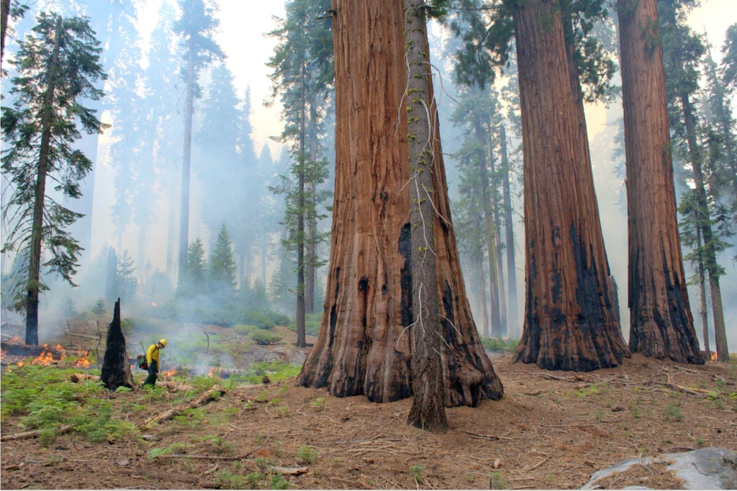
Technicians and engineers at NASA's Kennedy Space Center in Florida use a crane to lift the agency's Nancy Grace Roman Space Telescope to a specialized work stand June 26, 2026, as the mission prepares to launch nine months ahead of schedule. The Roman Space Telescope will offer a field of view at least 100 times larger than the Hubble Space Telescope's, resulting in deep, sweeping explorations of the cosmos. Credit: NASA/Sydney Rohde (Rocz) Media are invited to join NASA for a virtual news conference at 2 p.m. EDT, Wednesday, July 29, to preview the Nancy Grace Roman Space Telescope mission, scheduled to launch from the agency's Kennedy Space Center in Florida on Sunday, Aug. 30. NASA will stream this event live through a variety of platforms. Learn where to watch online: https://www.nasa.gov/live. Participants in the briefing, who will provide an overview of the mission and its status, include: Shawn Domagal-Goldman, director, Astrophysics Division, NASA Headquarters in Washington Jackie Townsend, Roman telescope project manager, NASA's Goddard Space Flight Center in Greenbelt, Maryland Julie McEnery, Roman telescope senior project scientist, NASA Goddard Jeremy Perkins, Roman telescope integration and test scientist, NASA Goddard Media interested in participating by phone must RSVP no later than two hours prior to the start of the briefing to Rob Garner at rob.garner@nasa.gov. A copy of NASA's media accreditation policy is online. Named after NASA's first chief astronomer, the Nancy Grace Roman Space Telescope will have a deep, panoramic view of the cosmos, generating never-before-seen pictures that will revolutionize our understanding of the universe. The observatory will usher in a new era of cosmic surveys, unveiling troves of celestial objects and shedding light on some of the universe's most profound mysteries, including phenomena we can't see. Roman also will showcase cutting-edge technology, including a test of the most advanced technology ever flown in space to directly image planets around nearby stars, a key step in NASA's search for life on other worlds. The Roman telescope is managed at NASA Goddard with participation by the agency's Jet Propulsion Laboratory in Southern California; Caltech/IPAC in Pasadena, California; the Space Telescope Science Institute in Baltimore; and a team of scientists from various research institutions. The primary industrial partners are BAE Systems Inc., L3Harris Technologies, and Teledyne Scientific & Imaging. Contributions to Roman also are made by ESA (European Space Agency), JAXA (Japan Aerospace Exploration Agency), the French space agency CNES (Centre National d'Études Spatiales), and the Max Planck Institute for Astronomy in Germany. For more information about NASA's Roman telescope, visit: https://nasa.gov/roman -end- Alise Fisher Headquarters, Washington 202-358-2546 alise.m.fisher@nasa.gov Claire Andreoli / Rob Garner Goddard Space Flight Center, Greenbelt, Md. 301-286-1940 / 301-286-5687 claire.andreoli@nasa.gov / rob.garner@nasa.gov

7. US-India Satellite Delivers Data, Reveals 'Hummingbird' in Antarctica
Read more

Main Figure A Scientists used data from the L-band radar aboard the U.S.-India Earth-orbiting NISAR satellite to produce this image of Nunatak Zaterjavshijsja, a mountaintop in East Antarctica, poking out amid a stream of ice flowing northeast to the ocean. NASA/JPL-Caltech The image shows Nunatak Zaterjavshijsja at center-left, surrounded by ice fractured with crevasses, which are shown as sharp, green lines. The magenta portions of the image represent more regular surfaces, such as smooth ice. NASA/JPL-Caltech Main Figure A Scientists used data from the L-band radar aboard the U.S.-India Earth-orbiting NISAR satellite to produce this image of Nunatak Zaterjavshijsja, a mountaintop in East Antarctica, poking out amid a stream of ice flowing northeast to the ocean. NASA/JPL-Caltech The image shows Nunatak Zaterjavshijsja at center-left, surrounded by ice fractured with crevasses, which are shown as sharp, green lines. The magenta portions of the image represent more regular surfaces, such as smooth ice. NASA/JPL-Caltech Main Figure A NISAR's L-Band Radar Reveals 'Hummingbird' in Antarctica Curtain Toggle 2-Up Image Details Scientists used data from the L-band radar aboard the U.S.-India Earth-orbiting NISAR satellite to produce this image of Nunatak Zaterjavshijsja, a mountaintop in East Antarctica, poking out amid a stream of ice flowing northeast to the ocean. The annotations point out the sharp green lines that indicate ice fractured with crevasses. Magenta represents more regular surfaces, such as smooth ice. Credit: NASA/JPL-Caltech As of July 20, the public can access data from the two powerful radar instruments aboard the NISAR (NASA-ISRO Synthetic Aperture Radar) satellite. Teams in the United States and India will release files processed from the satellite's L-band and S-band radars on an ongoing basis, helping researchers and other users track the movement of Earth's land and ice masses, monitor changes in ecosystems like forests and wetlands, and respond to natural hazards such as landslides and earthquakes. The release comes as NASA and ISRO (Indian Space Research Organisation) prepare to celebrate the first anniversary of NISAR's July 30, 2025, launch from India's Satish Dhawan Space Centre. Since that time, the mission engineering and science teams have been busy calibrating instrumentation, refining algorithms, and monitoring nearly all the planet's land- and ice-covered surfaces twice every 12 days. Along the way, the team has captured scenes from around the globe - urban street grids, agricultural fields, landslides, earthquakes, and sinking land in Mexico City. An early image released Tuesday revealed the fractured, barren surface of an Antarctic landscape in stark detail. In a merging of science and serendipity, it also resembles something else entirely: a hummingbird. Despite its otherworldly quality, the Antarctic image shows a very real geographical feature called Nunatak Zaterjavshijsja, a mountaintop in East Antarctica, poking out amid a stream of ice flowing northeast to the ocean. As the moving glacier passes the obstruction, the mountain's topography causes stresses in the ice, heavily fracturing the surrounding surfaces with deep cracks, called crevasses, which show as sharp green lines in the image. "First, it's a beautiful image, with rich details of features that provide insights to how the glacier is moving. Then, because radar can often see through snow and deep into the ice, NISAR can observe fundamentally different properties of Antarctic ice than can be seen in optical imagery," said Seongsu Jeong, the signal analysis engineer who produced the image at NASA's Jet Propulsion Laboratory in Southern California. "With NISAR we're seeing what's hidden beneath the surface." Story in magenta, green Generated with measurements that NISAR's L-band instrument gathered in August 2025, as U.S. and Indian mission teams tested the satellite's systems, the "hummingbird" exemplifies one of the young mission's hallmarks: intricately detailed imagery that is both informative and eye-catching. The colors show differences in the way polarized microwave signals, which vibrate in different directions, interact with and reflect from the ice. Over Antarctica, NISAR transmits radar waves toward Earth with a horizontal polarization. The orientation of the signals that return - either horizontal, vertical, or both - provide clues about the object or surface that reflected them. Signals that come back with a horizontal polarization likely bounced off a more regular surface, such as smooth ice. Those signals appear magenta in the image. Signals that return with vertical polarization may have refracted as they partially penetrated the snow and ice or scattered at different angles as they reflected off irregular surfaces, such as the faces of crevasses. Called volume scattering, these observations are displayed in green. The white represents areas in which magenta and green signals scatter back strongly, a possible indication that there is an equal blend of surface and volume scattering. The same scene viewed in optical light is almost entirely white with ice and snow. Slight shadows and rippling indicate the presence of the mountaintop, and textures in the surrounding area suggest the ice is not completely smooth. An image from the Landsat 9 satellite shows Nunatak Zaterjavshijsja on Nov. 2, 2025. Because microwaves can penetrate frozen surfaces, signals from NISAR's L-band radar captured more detail of the structure of the surrounding icescape than is visible in this optical image. USGS Access to data The NISAR satellite is the first free-flying space mission to feature two radar instruments: an L-band system and an S-band system. The systems are complementary due to their differing wavelengths. For example, the longer-wave L-band can pass through tree canopies, imaging the ground beneath. Meanwhile, depending on leaf sizes, S-band can collect observations of those canopies. The Indian science team, based at ISRO's Space Applications Centre in Ahmedabad, recently started releasing S-band data via the Bhoonidhi portal. On July 20, the U.S. side of the mission started releasing calibrated products continuously for all L-band measurements collected since June 17. By the end of the year, the team expects to have released all data acquired earlier during science operations. The NISAR project science team previously had two limited releases of L-band data, the first in January of about 25 sample products and a release in February of thousands of pre-calibrated products. As with the earlier releases, data users will be able to download the latest files at the Alaska Satellite Facility Distributed Active Archive Center in Fairbanks, which hosts and distributes all NASA synthetic aperture radar data. The NISAR mission's science data output is vast, on the order of dozens of terabytes a day, due to the satellite's frequent coverage of nearly all the land and ice surfaces on Earth. It scans from within a few degrees of the South Pole in Antarctica to 77.5 degrees north latitude, above the Arctic Circle. More about NISAR Managed by Caltech, JPL leads the U.S. component of the project and provided the satellite's L-band SAR and antenna reflector. The spacecraft bus and its S-band SAR were provided by ISRO. The NISAR satellite is the first to carry two SAR instruments at different wavelengths, collecting data using the spacecraft's giant drum-shaped reflector, which measures 39 feet (12 meters) wide - the largest radar antenna reflector NASA has sent into space. To learn more about NISAR, visit: https://science.nasa.gov/mission/nisar/ Media Contacts Andrew Wang / Andrew Good Jet Propulsion Laboratory, Pasadena, Calif. 626-379-6874 / 818-393-2433 andrew.wang@jpl.nasa.gov / andrew.c.good@jpl.nasa.gov 2026-049

8. NASA Langley Celebrates Community through Music with 'Symphony Under the Stars' Event
Read more

To view this video please enable JavaScript, and consider upgrading to a web browser that supports HTML5 video Scenes and sounds from the July 16 "Stars, Stripes, and Supernovas - Symphony Under the Stars" event at NASA Langley. NASA/Joe Atkinson NASA Langley's "Stars, Stripes, and Supernovas - Symphony Under the Stars" event brought employees, families, and community members together for an evening filled with music, connection, and celebration. Organizers planned the event, which took place July 16, to mark the 250th anniversary of the founding of the United States of America. The evening featured a dynamic mix of performances from an orchestra that included NASA Langley employees and members of the Williamsburg Youth Orchestra, as well as smaller group performances from employees and special guest artist Karl Werne. Musicians perform at NASA Langley's "Stars, Stripes, and Supernovas - Symphony Under the Stars" event. NASA/Mark Knopp "It's fun to bring people together, to share their diverse talents in order to create something that's meaningful - and in this case something that was very beautiful too," said Jennifer Kibler, deputy director of the Research Directorate at NASA Langley. The orchestra played a selection of patriotic favorites and space-inspired pieces that highlighted the creativity and talent within the community. "America the Beautiful," "God Bless America," and "Jupiter, the Bringer of Jollity" from Gustav Holst's orchestral suite "The Planets" were among the songs they performed. The event, which also took place just one day before NASA Langley's 109th birthday, served as a reminder of the spirit that defines the center-scientists, engineers, communicators, and staff coming together to celebrate not only NASA's mission, but the people who make that mission possible. "This was a big team effort," said Nicole Oman, administrative management specialist with the Research Directorate. "It wouldn't have been a success without the contributions of every single person."

9. Precision Astrometry Using Optically Independent Spacecraft for Graviational Wave Detection
Read more

Graphic depiction of the Graviational Wave Detection concept. Paul Stankus Paul Stankus Brookhaven Science Associates The scientific goal is to enable a new method for observing gravitational waves at low frequencies, based on the astrometric GW signature - gravitational waves passing by the Earth will cause a (very small) coordinated apparent motion of all sky objects. Our innovation is to deploy a new approach to precision astrometry using quantum mechanical two-photon interference, which was published quite recently. The approach has the great benefit that two separate interferometric spacecraft stations can operate independently, ie without an optical connection between them, greatly simplifying spacecraft requirements compared to standard space-based interferometric designs. With this capability we propose to be able to detect passing gravitational waves at low frequencies, in the micro-Hz to nano-Hz range, at a sensitivity at an astronomically interesting level (note that there are, currently, essentially no alternative approaches for GW detection in this band). We show how this could be achieved with a straightforward mission using two modest-sized spacecraft in free-fall orbits; and detection of such GW's would be of great interest for galaxy formation and SM black hole physics, as well as exciting the public imagination. 2026 Selections

10. James Webb Space Telescope discovers the secrets of cosmic 'factories' that filled the early universe with stardust
Read more
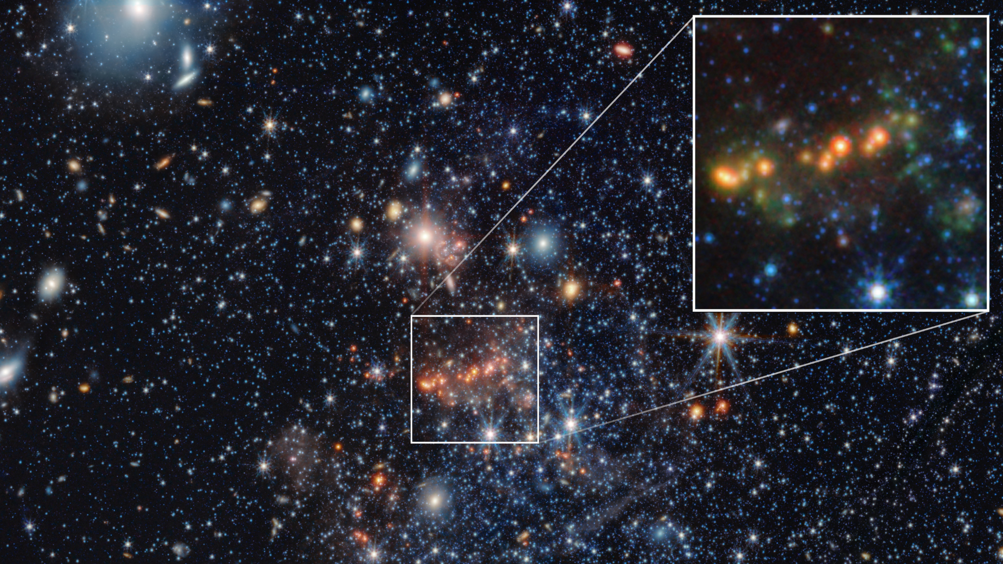
Click for next article Using the James Webb Space Telescope (JWST), astronomers have discovered the secrets of early galaxies that pumped the infant cosmos full of dust, which would become vital for the birth of new stars and the growth of galaxies. However, while the JWST is powerful enough to see many of these early galaxies, it is still limited when it comes to delving into them in great detail. So, the team at the heart of this research worked around this by studying a much closer and more modern galaxy with many characteristics that resemble the universe's first galaxies. In lieu of being able to study the processes that occurred in the early universe that allowed galaxies to be seeded with "metals, (the term astronomers use to describe elements heavier than hydrogen and helium), the researchers turned their attention to a dwarf galaxy just 4.6 million light-years away. "Directly studying the galaxies that populated the early universe is still very difficult, which is why observing a nearby galaxy like Sextans A, which presents similar chemical conditions, offers us a precious opportunity to understand how the first generations of stars evolved and what role they played in transforming the interstellar medium," team leader Claudio Gavetti of the National Institute for Astrophysics (INAF) said in a statement. How does Sextans A impersonate ancient galaxies? The early universe was a pretty dull place in terms of chemistry. That is because it was dominated by the lightest element, hydrogen, with some helium and a tiny smattering of heavy elements, or metals. That means that the first generation of stars, so-called POP III stars , were correspondingly metal-poor. During their lives, however, POP III stars fused hydrogen and helium in their cores to forge heavier elements. When these original stars reached the ends of their lives, they exploded in supernova explosions that dispersed these metals into the interstellar medium, the vast clouds of dust and gas between stars. Eventually, dense and cool patches in these vast clouds collapsed under their own gravity, birthing the next generation of stars, POP II stars, which, thanks to the supernova deaths of their predecessors, were richer in metals. The dwarf galaxy Sextans A observed by the James Webb Space Telescope. (Image credit: NASA, ESA, CSA, STScI, Janice Lee (NOIRLab). Image processing: Alyssa Pagan (STScI).) Our own star, the sun , is classed as a POP I star, meaning it is even richer in metals than these second-generation stars. However, not all modern galaxies are so metal-rich; this is especially true for dwarf galaxies like Sextans A, even though it lies at the outer edge of our cosmic backyard, known as the " local group ." Sextans A is so metal-poor that it is estimated to contain only between 1% and 7% of the heavy elements found in the sun. That makes it a great proxy for the study of metal-poor early galaxies. Using the JWST's NIRCam (Near-InfraRed Camera) and MIRI (Mid-Infrared Instrument) instruments, Gavetti and colleagues obtained high-resolution observations of Sextans A that allowed them to map the dwarf galaxy's entire population of stars during an evolutionary phase known as the "asymptotic red giant branch." This phase occurs when stars larger than the sun exhaust helium in their cores, creating an inert carbon heart, but nuclear fusion continues in outer alternating helium- and hydrogen-burning layers. These stars "puff out" as a result of this and can undergo thousandfold increases in brightness. An image of the galaxy Sextans A where Red indicates the infrared emission of dust, blue the emission of atomic hydrogen gas, and green the far-ultraviolet emission created by newly formed stars. (Image credit: Yong Shi) The team's findings revealed that around 90% of the asymptotic red giant branch stars they studied were not surrounded by envelopes of dust. However, around 20 or so of these stars were embedded in thick dust shells. They also found that these "dust factories" formed between 2 billion and 3 billion years ago from stars with an initial mass about 1.5 times the mass of the sun. This research is a leap forward in understanding which stars in the early universe were most likely to create the metal dust that would have enriched the next generations of stars. That means it helps paint a complete picture of how the universe as we see it today took shape. The scientists behind this study say that this type of research would have been impossible before the launch of Webb.

11. Space Force orders 36 more Golden Dome missile-tracking satellites, for $1.75 billion
Read more

Click for next article The U.S. Space Force is adding three dozen spacecraft to its growing constellation designed to detect and track incoming missiles from orbit. The Space Development Agency (SDA) announced the agreements, worth a combined $1.75 billion, on July 14, naming L3Harris Technologies and Sierra Space as the recipients. Each company will provide 18 Accelerated Missile Defense Tranche 3 (AMDT3) spacecraft, for a total of 36 satellites that will grow the SDA Proliferated Warfighter Space Architecture's Tranche 3 Tracking Layer constellation, part of the Trump Administration's Golden Dome initiative. All 36 are expected to be ready for launch by the end of 2028, according to an SDA statement . SDA's contracts with each company differ slightly. One calls for "18 missile warning and missile tracking variant space vehicles" from Sierra Space, while the other requests "18 missile defense variant space vehicles" from L3Harris, all equipped with infrared sensors to add to the constellation's global network. L3Harris will receive up to $955 million for its 18 satellites, which the Space Force describes as "Hypersonic and Ballistic Tracking Space Sensor-like" (HBTSS) spacecraft. Sierra Space's agreement has the potential to reach $798 million for its 18-satellite contribution. Altogether, the 36 spacecraft will be distributed across four orbital planes as part of a hybrid missile-defense architecture designed to provide "global stereo coverage" of next-generation missile threats. The Tracking Layer uses infrared imaging in low Earth orbit to detect and track missiles, and it transfers that data in real time through a low-latency communications network to military forces on the ground. According to the agency, the new satellites will increase the constellation's coverage and integrate into the spacecraft of SDA's first three Tranches. "AMDT3 expands upon SDA's previous and current Tracking Layer generations - Tranches 1, 2 and 3," said SDA Director G.P. Sandhoo, "marking another milestone in delivering a resilient, global missile warning, missile tracking, and missile defense capability." Sierra Space will base its satellites on the Horizon vehicle, from the company's Eclipse satellite series, which it also used in the design of the spacecraft it provided for the Tranche 2 Tracking Layer program, according to a Sierra Space release . Stack of Satellites from Sierra Space. (Image credit: Sierra Space) L3Harris plans to build on the success of the HBTSS satellites the company developed for the Military Defense Agency, according to an L3Harris release . The company "has more than 70 missile tracking and defense satellites on order, including five on orbit, between MDA's HBTSS program and SDA's Tracking Layer across Tranche 0, 1, 2 and 3," the company said. The 36 satellites from L3Harris and Sierra Space are in addition to the 72 Tranche 3 Tracking Layer spacecraft SDA ordered in December 2025, via contracts worth $3.5 billion. L3Harris was included in those agreements as well, along with Lockheed Martin, Rocket Lab and Northrop Grumman. In total, the two rounds of awards bring the Tranche 3 constellation to a planned 108 satellites, worth about $5.25 billion. If all goes to plan, all of them will be available to launch by the end of 2029. The newly contracted satellites from L3Harris and Sierra Space could begin heading to space sooner than that, however. SDA describes the new contracts as "accelerated," though a launch timeline has not been established to the overall group. Once in orbit, the Space Force will assume responsibility for the satellites' operation and integration "in support of joint force operations and delivering warfighting capabilities," the SDA statement said.

12. Artemis III astronauts will beam 4k video from Orion to Earth using SpaceX Starlink lasers
Read more
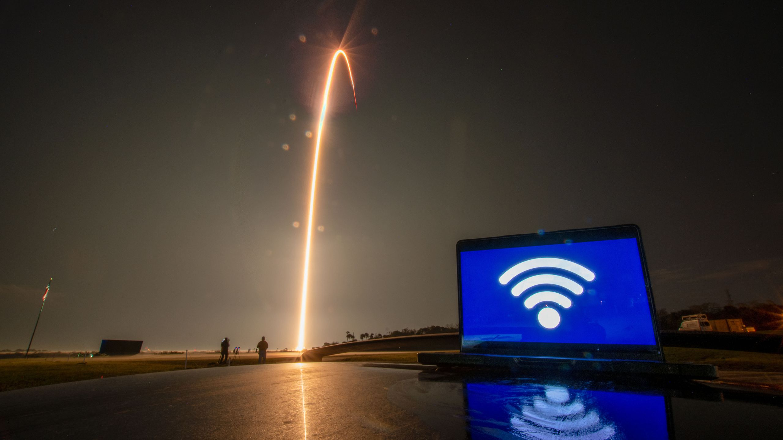
Click for next article Orion is getting an upgrade on Artemis III, and the astronauts aboard are getting WiFi (sort of). NASA is partnering with SpaceX to equip the Orion spacecraft for Artemis III with a pair of Starlink mini laser terminals, designed to operate on SpaceX's existing Starlink network. The two panels will be installed on Orion's exterior, and will augment the spacecraft's existing communications systems. The added capability is expected to provide a greater data capacity from Orion to NASA's mission control in Houston, which may include high-definition live video from orbit. The mission is currently scheduled for the second half of 2027, and will also include another sizable contribution from SpaceX : a Starship rocket. SpaceX currently operates more than 10,000 Starlink spacecraft in LEO, which provide satellite internet coverage across nearly the entire globe to commercially-available wireless terminals about the size of a laptop. Combined, those more than 10,000 and counting satellites are equipped with over 25,000 lasers currently in operation in LEO to maintain the network's interconnectedness, according to a NASA update . The company previously demonstrated the Starlink constellation's use as a communication relay network during the privately funded Fram2 mission that launched the first human into a polar orbit around Earth in 2025. SpaceX frequently utilizes its high-data capabilities to stream high-definition live views of its Falcon 9 and Starship rocket launches from orbit. Artemis III is the third in a program of NASA missions with the goal of returning astronauts to the moon and establishing a permanent base on its surface. Artemis III is designed as a practice run for NASA's Orion capsule to rendezvous and dock with the program's commercial lunar lander vehicles, Starship , and Blue Origin's Blue Moon spacecraft, in low Earth orbit (LEO). That's a lot closer to home compared to the Artemis II mission that NASA launched in April of this year. Artemis II was Orion's first flight with astronauts onboard, and flew a 10-day mission around the far side of the moon. NASA used laser communications during Artemis II as well, using terminals on Orion and ground stations at NASA's Jet Propulsion Lab in California and White Sands Complex in New Mexico to transmit data loads too big for the agency's Near Space and Deep Space radio networks. With flight sticking to LEO during Artemis III, communication limitations become a lot easier to surmount. If all goes according to plan during Artemis III, NASA has scheduled the first Artemis moon landing on the following mission, Artemis IV. NASA is targeting 2028 to launch Artemis IV, and has selected Starship as the lunar lander that will return astronauts to the lunar surface.

13. The 'Avengers Doomsday' trailer is cool, but it's missing something... where's all the space stuff?
Read more

Click for next article Avengers: Doomsday | Official Trailer | In Theaters December 18 - YouTube Watch On The first trailer for "Avengers: Doomsday" dropped yesterday, and while it's jammed full of superheroes , surprises, and our first extended look at Dr. Doom, it is missing one big thing that has been a constant in the MCU ever since "Avengers" was released and the Infinity Stone saga kicked off: outer space. Believe it or not, the MCU has been very sci-fi heavy for the past decade as the universe expanded into space with "Guardians of the Galaxy", "Captain Marvel", and the entire throughline of Thanos' quest to bring balance to the universe. Entire films took place in space, and extended exposition was delivered inside the hulls of spaceships. Alien heroes and villains swung around made-up planets and lived in the skulls of dead space giants. That whole "Eternals" thing. It's safe to say that the Marvel movies were into outer space in a big way. The MCU leaned heavily into science fiction and space for much of its life, but judging from this trailer, that may be coming to an end. This is a very Earth-based trailer, and while the remnants of years of science fiction still permeate throughout the MCU (superhero comics are almost always dabbling in the genre), the focus on it is clearly gone. This trailer is all about the Earth and superheroes, pulling back hard on the bigger universe. Sure, it opens with the Fantastic Four exiting their spaceship - probably an unintentional visual metaphor for the MCU's abandonment of the cosmos - but we're kept mainly on Earth otherwise. We have absolutely no alien heroes appearing on screen in this trailer outside of Thor and, of course, our main villain is decidedly earthbound even if he may be from a different multiverse (for those not in the know, that's Robert Downey Jr. behind Dr. Doom's mask). (Image credit: Marvel Studios) There are plenty of reasons that the MCU may be pulling out of space. Introducing all of the X-Men means you've got plenty of Earth stuff to mess around with anyway, and there's very little reason to need space travel when you've got time travel, quantum realms, and multiverses expanding your universe in other ways. To be fair, all of those are sci-fi as well, but it's not the same as outer space. We do know from casting that some of our favorite space-based heroes will be returning, but what is clear is that space is no longer the focus here. The MCU has been pulling back on space ever since Thanos fell, and this new trailer for "Avengers: Doomsday" just hammers another nail into the coffin of that universe. Of course, Marvel is a master of misdirection and fake-outs, so anything could change as we get more details and the film finally releases, but for now it seems that the Marvel Cinematic Universe isn't so interested in the universe part. "Avengers: Doomsday" will hit theaters on December 18.

