 |  | 

🌌 अंतरिक्ष समाचार |
सोमवार, २७/०७/२०२६ | Monday, 27/07/2026

1. Isro begins public release of Nisar data through Bhoonidhi - The Times of India
Read more

Antractica_dop_10Jul2026_HH_polarization BENGALURU: Isro has made public the first batch of S-Band radar data from the Nasa-Isro Synthetic Aperture Radar (SAR) or Nisar mission, releasing it through Bhoonidhi, the agency's earth observation data portal.The agency also shared sample images from Tamil Nadu (Nagapattinam), Antarctica, Assam (Brahmaputra basin), Idaho, Greenland and Indonesia showing the radar's range of applications, from tracking coastal wetlands to mapping irrigation patterns and ice movement, underlining the mission's relevance to both scientific research and everyday resource management, from coastal planning to precision farming and disaster monitoring.Nisar is a joint mission between Nasa and Isro, and is the first spaceborne radar to carry two frequency bands, L-band and S-band, on a single satellite. It uses a 12-metre reflector antenna and a scanning technique called SweepSAR, which lets it capture a wide strip of the Earth's surface, about 240 km across, in high resolution without sacrificing coverage.Orbiting the Earth at 747km, the satellite revisits the same spot every 12 days, building up a steady stream of images useful for tracking floods, glaciers, farmland and other fast-changing features, regardless of weather or daylight.Isro said the mission is now in its science phase, gathering data from locations around the world as per its observation plan. The S-band data is received at Isro's ground stations and processed at the Integrated Multi-Mission Ground Segment for Earth Observation Satellites in Shadnagar, run by the National Remote Sensing Centre.A nationwide network of ground-based reflectors is being used to check the accuracy of the data, alongside other reference targets chosen for specific scientific purposes."...All data gathered from Cycle 25 onwards, which began on July 8, 2026, is now available for download as soon as it is processed. Older data, collected before Cycle 25, will be reprocessed in stages and added to the archive over time," Isro said.The release includes several categories of processed imagery, ranging from raw radar scans to geocoded and interferometric products that can detect subtle shifts in the Earth's surface, useful for monitoring subsidence, landslides and glacier movement.Users can search, view and download the data on Bhoonidhi after registering, using filters such as location, date and product type. Isro has also added two tools on the portal: one that converts the radar files into more widely used formats such as GeoTIFF, and another, built for QGIS software, that helps researchers analyse the data further.Isro noted that some scenes may show faint striping over featureless areas such as deserts and oceans, and occasional interference from radio signals, adding that both issues would be addressed in future updates as calibration improves.Launched on July 30, 2025, Nisar, had beamed back its first images of Earth in Sept last year, Nasa had announced, adding that the spacecraft was to begin its full operations later that year.

2. ISRO-NASA Satellite Data Reveal 60 CM Ground Shift In Venezuela Earthquake - ETV Bharat
Read more
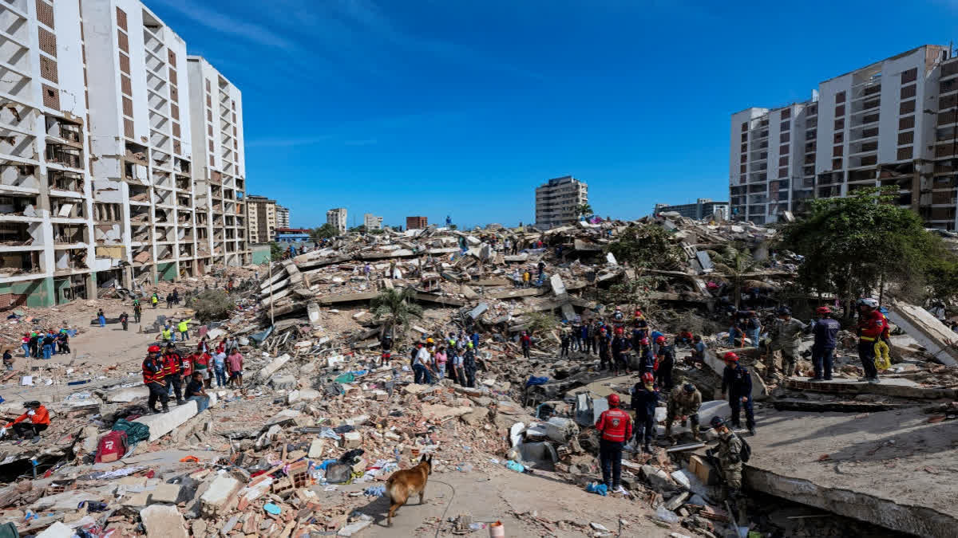
ETV Bharat / international ISRO-NASA Satellite Data Reveal 60 CM Ground Shift In Venezuela Earthquake A rescue dog from the Argentine search and rescue team searches for bodies in the rubble of a collapsed building in Caraballeda, La Guaira state, Venezuela, on June 28, 2026, following twin earthquakes. ( AFP ) Washington: The twin earthquakes that struck north Venezuela last month shifted the earth almost two feet at some places, leading to massive devastation in Caracas and La Guaira, an analysis of data from the NISAR satellite has revealed. Researchers studied the images of the Earth taken by the NASA-ISRO Synthetic Aperture Radar (NISAR) satellite on June 13 and 18 (before the quake) and on June 25 and 30 to detect the changes in the terrain after the June 24 earthquake. On June 24, a magnitude 7.2 earthquake struck northern Venezuela, followed by a magnitude 7.5 mainshock 39 seconds later. It killed more than 5000 and injured 16,700 while causing large-scale damage in Caracas and La Guaira. The states of Trujillo, Yaracuy, Carabobo, Aragua and Miranda had also been affected. Scientists used a technique called InSAR, which compares data from repeat passes to detect subtle changes in the distance between the satellite and the ground, NASA said in a statement earlier this month. This was the first time the NISAR urgent response system was used to map surface displacement from a large earthquake. The fault is part of a network of fractures that lies along the boundary between the Caribbean plate to the north and the South American plate to the south. Scientists say faults along this plate boundary, including the San Sebastian fault system, where these quakes likely occurred, and possibly part of the Bocono system, have long been accumulating strain. The fault rupture propagated offshore, toward the east, and then back onshore near the international airport north of Caracas. Just south of this fault section, along this part of the fault, the displacement was far greater than elsewhere, reaching as much as 60 centimetres (24 inches).

3. Isro satellite images show 90% of India is under cloud cover. How much rain is likely? - India Today
Read more
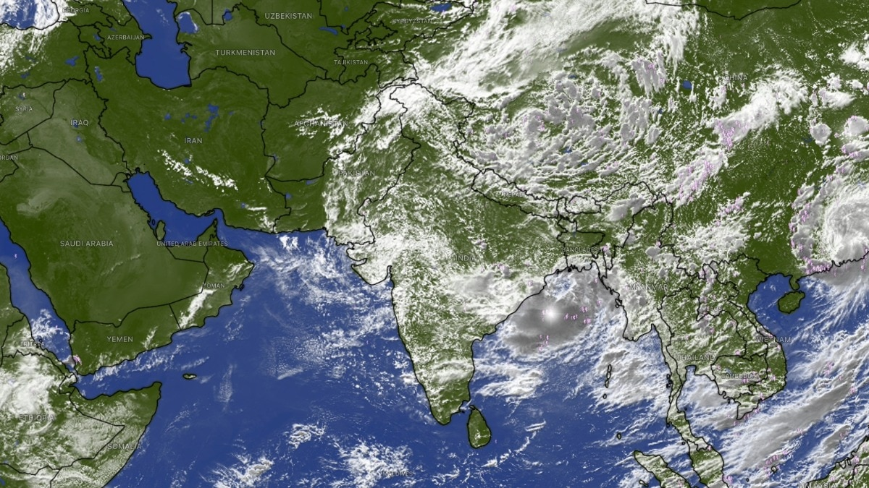
Four days ago, India's landmass nearly vanished from view from the skies. The Indian Space Research Organisation (Isro)'s weather satellites, parked far above the equator, found almost nowhere left to look through, as a cloud sheet stretched from the Arabian Sea to the Bay of Bengal and covered close to 95 per cent of the country. That peak has passed, but the sheet has not broken up. Based on the latest thermal infrared, cloud top brightness temperature and water vapour imagery captured by Isro's Insat 3DR and Insat 3DS satellites, and released through the India Meteorological Department (IMD), somewhere between 88 and 92 per cent of India's landmass, call it roughly 90 per cent, is under cloud cover at this moment. Read Full Story Both figures come from reading separate satellite channels closely against IMD's own written bulletins, rather than a single official pixel-count released for public use, so they are close, defensible estimates rather than laboratory-grade readings. So to be clear: 95 per cent was the peak, recorded around 21 to 22 July. Roughly 90 per cent is where things stand today, a slight easing, not a clearing. And a cloud sheet still this large is never just scenery. It is fuel, hanging over the country right now, waiting to fall. IMD's latest bulletin spells out exactly where that fall is headed over the coming week. WHAT DOES TODAY'S CLOUD COVER LOOK LIKE FROM SPACE? The latest thermal infrared images show clouds still dominating central and eastern India, Bay of Bengal and the northeast, with a dense, cold cluster visible over the Odisha-Andhra coast. Western Rajasthan and parts of the desert belt remain the clearest patches on the map, much as they were during the earlier peak. That pattern traces the monsoon trough, a belt of low pressure across northern India that governs where rain falls in the days ahead, not just where cloud sits today. Cloud top brightness temperature imagery showing the coldest cloud tops sitting directly over the Odisha-Andhra coast. (Photo: IMD) The IMD's latest bulletin places the trough south of its normal position, with a low-pressure area that formed over the northwest Bay of Bengal and adjoining West Bengal coast now lying over that same stretch of coast. This system, the IMD says, is likely to meander over the same region and become more marked over the next two to three days, which means the cloud sitting over eastern India right now is set to intensify rather than clear. HOW MUCH RAIN WILL THIS LEVEL OF CLOUD COVER BRING OVER THE COMING WEEK? The IMD's seven-day rainfall forecast, issued alongside this imagery, gives a direct, region-by-region answer for what happens next. Himachal Pradesh, Jammu and Kashmir, and Uttarakhand are forecast to get fairly widespread to widespread rain through the end of the month, with isolated heavy rainfall continuing for most of that period. Water vapour imagery showing dry air still sitting over Pakistan and western Rajasthan while the rest of India stays moist. (Photo: IMD) Chhattisgarh and East Madhya Pradesh face a similar run of widespread rain across nearly the entire seven-day outlook, while Odisha, sitting directly beneath the strengthening low-pressure system, is forecast to get very heavy rainfall. By contrast, the IMD's forecast keeps south peninsular India, including Tamil Nadu, Rayalaseema and interior Karnataka, largely in the "isolated to scattered" category through the coming week, the driest classification on its scale, confirming the coming rain will follow the same uneven pattern the satellite images already show. WHERE WILL THE HEAVIEST RAIN LAND OVER THE NEXT FEW DAYS? The clue sits in cloud top brightness temperature, or CTBT, which tells forecasters how tall a cloud has grown, using a simple rule of physics: air cools as it rises, right up to a layer called the tropopause, roughly the ceiling of the atmosphere that makes our weather. The colder a cloud's top reads from space, the taller and more capable of heavy rain it is. The latest CTBT imagery shows the coldest, tallest cloud tops sitting over the Odisha-Andhra coast and the Bay of Bengal, exactly where the IMD's low-pressure system now sits. With that system expected to become more marked over the next two to three days rather than weaken, Odisha and the surrounding coast should expect the current spell of extremely heavy rainfall to continue before any easing. WILL THE WESTERN DRY POCKET STAY DRY OVER THE COMING WEEK? Largely, yes, though not entirely. The latest water vapour imagery still shows a long, dark band of dry air sitting over Pakistan, Afghanistan and India's own north-western desert. The IMD's forecast reflects this, keeping West Rajasthan mostly in the "isolated to scattered" rainfall category through much of the coming week. There is one live exception. A low-pressure system over southwest Rajasthan is driving fresh extremely heavy rainfall. (Photo: PTI) The IMD's latest bulletin confirms a separate low-pressure area, which had earlier lain over southeast Rajasthan, has moved westward and now sits over southwest Rajasthan and neighbourhood. This system is what drove the exceptionally heavy rainfall recorded over Gujarat in the recent 24-hour period, with isolated extremely heavy rainfall likely to continue over Gujarat, even as the desert belt further west and north stays largely untouched. SO HOW LONG WILL THIS LEVEL OF CLOUD COVER AND RAIN LAST? The IMD's latest outlook does not describe conditions easing back to normal any time soon. Both the Bay of Bengal low and the Rajasthan low are forecast to remain active and intensify over the next two to three days, keeping central, eastern and northwestern India under significant cloud and rain through the end of the month. South peninsular India is expected to remain comparatively drier over the same period. Expect the next satellite pass to show cloud cover still sitting somewhere in the high 80s to low 90s, well below the peak of 95 per cent but far from clearing, with the heaviest rain continuing to track wherever these two low-pressure systems happen to sit. - Ends Published By: Radifah Kabir Published On: Jul 26, 2026 13:29 IST

4. From Aadhaar to ISRO: What the six-member NTA reform panel brings to the table - Moneycontrol.com
Read more
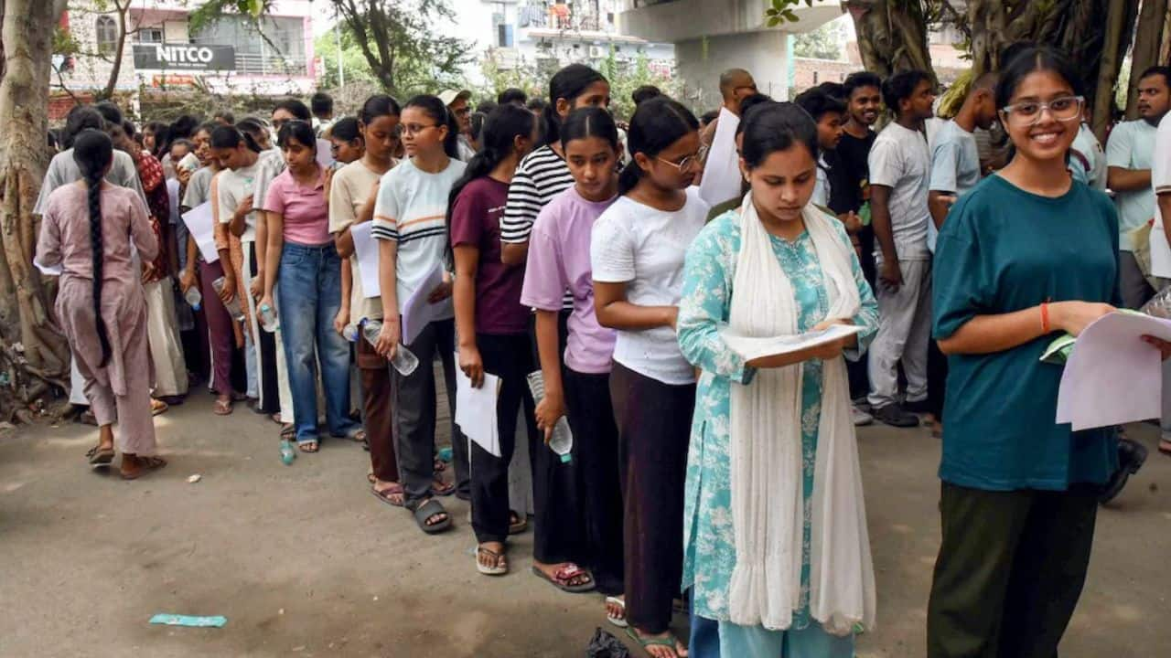
The Centre has set up a high-powered panel headed by Infosys co-founder Nandan Nilekani to undertake a broad review of India's examination system and recommend structural and technological reforms to the National Testing Agency (NTA). The six-member task force brings together expertise from technology, space research, intelligence, cybersecurity, education administration and logistics. The government is looking to strengthen the examination ecosystem amid concerns over paper leaks and other irregularities that have raised questions about the credibility and security of competitive examinations. The panel will submit its recommendations to the government, with its mandate expected to cover the entire examination process -- from the creation and movement of question papers to candidate verification, test delivery, evaluation and declaration of results. Prime Minister Narendra Modi said the country needed an examination framework that was "reliable and transparent" and made "maximum use of technology". He said the government would act on the task force's recommendations to strengthen the credibility of examinations at the earliest. The composition of the panel points to a multi-layered approach to the overhaul, with each member bringing experience in a distinct area that could address a different vulnerability in the examination chain. Nandan Nilekani: A technology overhaul for the NTA Nilekani's experience in developing large-scale digital infrastructure is expected to be central to the task force's technology strategy. As the former chairman of the Unique Identification Authority of India (UIDAI), Nilekani played a key role in the development of Aadhaar. His experience with digital identity and large-scale technology systems could help the NTA strengthen candidate authentication, data protection and the overall digital architecture supporting examinations. A possible area of focus could be the integration of secure digital identity verification into the examination process, making impersonation more difficult while protecting sensitive candidate information. His appointment also carries an interesting political dimension. Nilekani contested the 2014 Lok Sabha election from Bengaluru South on a Congress ticket, but more than a decade later, he has been brought into a major reform exercise by the BJP-led government. The move highlights the Centre's emphasis on technical expertise for the NTA overhaul, with the task force drawing professionals who have held senior positions across government institutions, academia and the private sector. S Somanath: Applying high-reliability engineering to examinations Former ISRO chairman S Somanath could bring the principles of precision engineering and mission-critical operations to the examination system. Space missions involve multiple stages of testing, verification and contingency planning, with failures potentially carrying significant consequences. Similar principles could be applied to examinations through additional checks at vulnerable points in the process. For the NTA, this could mean examining how question papers are prepared, secured and distributed, how examination centres operate and how results are processed. A system built around multiple layers of verification could reduce the possibility of a single error or technical failure affecting an examination involving a large number of candidates. Somanath's experience in overseeing complex scientific programmes could therefore contribute to designing a more resilient examination architecture, where potential failures are identified and addressed before they affect students. Tapan Deka: Taking the intelligence route to prevent paper leaks Former Intelligence Bureau director Tapan Deka brings a different dimension to the panel - intelligence and internal security. His experience could help the examination authorities develop mechanisms to identify organised networks involved in paper leaks, cheating and other forms of examination fraud. Instead of responding to breaches after they occur, the system could potentially move towards identifying threats in advance through intelligence inputs, risk assessments and closer monitoring of vulnerable points. Deka's expertise could also be relevant to strengthening security protocols at examination centres and identifying suspicious patterns in the movement or handling of examination material. The broader objective would be to make examination security more proactive, rather than relying solely on post-incident investigations. V Kamakoti: Making technology and accountability central to exams IIT Madras Director V Kamakoti has stressed that the NTA reform exercise must address both technology and institutional accountability. Kamakoti pointed to the enormous expansion in the scale of competitive examinations and the shift from traditional pen-and-paper tests to OMR and computer-based examinations. "When I wrote the JEE exam in 1985, I wrote on paper and pen, where nearly 4,000 students appeared. Today, one and a half million people write it," he told ANI. He said technology should also make the examination process more transparent for students, including providing greater clarity on how marks are calculated. "If a student secures 90 marks, then NTA must say how this was calculated. This is where technology is needed," Kamakoti said. He also called for clearer accountability across the examination chain, arguing that every person involved in conducting a test should have defined responsibilities. "Who is doing which part is to be reviewed. We call it structural organisation. There should be a structure where everyone is accountable so that the system is as foolproof as possible," he said. His background in computer science, artificial intelligence and cybersecurity could also help the panel explore ways to make computer-based testing more secure, including strengthening server infrastructure and reducing vulnerabilities that could facilitate cheating or unauthorised access. Anita Karwal: Putting student concerns and administration under the lens Former Union Education Secretary Anita Karwal brings extensive experience in education policy and administration to the task force. Having also headed the Central Board of Secondary Education (CBSE), Karwal could play a role in examining the student-facing aspects of examination reforms. This could include developing clearer procedures for handling challenges to answer keys, grievances related to evaluation and other disputes that arise after examinations. The panel may also look at creating uniform operating procedures for examination centres so that candidates receive a consistent experience across different locations. Karwal's administrative experience could help bridge the gap between policy recommendations and their implementation across India's complex education system, where examinations are conducted at a massive scale and involve multiple agencies and stakeholders. Amrit Lal Meena: Plugging gaps in the question-paper supply chain Logistics is another critical component of examination security, and this is where Amrit Lal Meena's experience could become relevant. Question papers pass through several stages before reaching candidates, including printing, storage and transportation. Any weakness during this physical chain can potentially compromise an otherwise secure examination system. The task force could explore stronger tracking and monitoring mechanisms for examination material, along with tamper-evident packaging and tighter controls over access. Technological tools could also be used to maintain a verifiable record of the movement of sensitive material, helping authorities identify irregularities and determine responsibility if a breach occurs. Meena's role could therefore focus on ensuring that physical logistics receive the same level of scrutiny as digital security. The task force's diverse composition suggests that the Centre is looking at NTA reform as a comprehensive governance challenge rather than simply an education-sector issue. The exercise could bring together secure digital infrastructure, stronger cybersecurity, intelligence-led monitoring, robust physical logistics and clearer administrative accountability. Kamakoti said the ultimate objective should be to establish a system based on trust and responsibility. "This world is running based on trust," he said, adding that the task force would work towards developing a methodology that makes the examination system "trustworthy and accountable". The panel's recommendations could ultimately determine whether the NTA adopts a more integrated examination architecture in which technology, security and administrative responsibility work together to prevent leaks, reduce malpractice and give students greater confidence in the fairness of the process.

5. ISRO Bengaluru receives hoax bomb threat, investigation underway - The News Mill
Read more
ISRO Bengaluru receives hoax bomb threat, investigation underway The News Mill

6. NASA Astronaut Chris Williams, Crewmates Return from Space Station
Read more
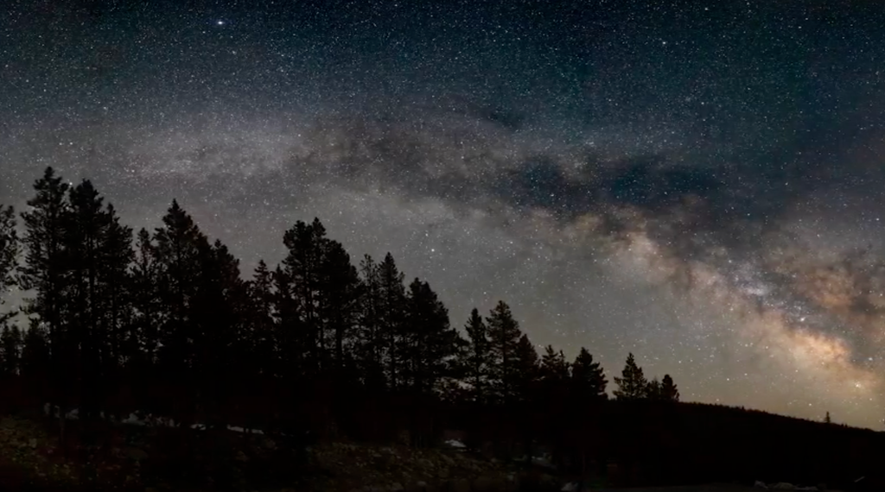
The Soyuz MS-28 spacecraft is seen as it lands in a remote area near the town of Zhezkazgan, Kazakhstan with Expedition 74 NASA astronaut Chris Williams, and Roscosmos cosmonauts Sergey Kud-Sverchkov, and Sergei Mikaev aboard, Sunday, July 26, 2026. NASA/Bill Ingalls Concluding an eight-month science mission aboard the International Space Station, NASA astronaut Chris Williams returned to Earth on Sunday alongside Roscosmos cosmonauts Sergey Kud-Sverchkov and Sergei Mikaev. The crew made its safe, parachute-assisted landing at 5:27 a.m. CDT (3:27 p.m., Kazakhstan time), southeast of Dzhezkazgan, after departing the space station at 2:03 a.m., aboard the Soyuz MS-28 spacecraft. The crew was in space for 241 days, orbiting the Earth 3,856 times and traveling more than 102 million miles. They launched to the International Space Station on Nov. 27, 2025. The mission was the first for Williams and Mikaev and the second for Kud-Sverchkov. While aboard the orbiting laboratory, Williams supported a wide range of scientific investigations and technology demonstrations. He helped advance research for new cancer treatments and improved in-space manufacturing of materials used in high-performance computers and electronics. Williams also completed two spacewalks to prep for space station power system upgrades and to replace a faulty joint on the Canadarm2 robotic arm. The crew's work aboard the space station helps improve life on Earth and prepare for future human missions to the Moon and Mars. Following post-landing medical checks, the crew members will fly by helicopter to Karaganda, Kazakhstan, where recovery teams are based. Williams then will board a NASA aircraft bound for the agency's Johnson Space Center in Houston. For more than 25 years, people have lived and worked continuously aboard the International Space Station, advancing scientific knowledge and making research breakthroughs not possible on Earth. The space station helps NASA understand and overcome the challenges of human spaceflight, expand commercial opportunities in low Earth orbit, and build on the foundation for long-duration missions to the Moon, as part of the Artemis program, and to Mars. To learn more about International Space Station research, operations, and its crews, visit: www.nasa.gov/station -end- Joshua Finch / Jimi Russell Headquarters, Washington 202-358-1100 joshua.a.finch@nasa.gov / james.j.russell@nasa.gov Leah Cheshier / Anna Schneider Johnson Space Center, Houston 281-483-5111 leah.d.cheshier@nasa.gov / anna.c.schneider@nasa.gov

7. I'm not an astronaut, but I went to the International Space Station (sort of)
Read more
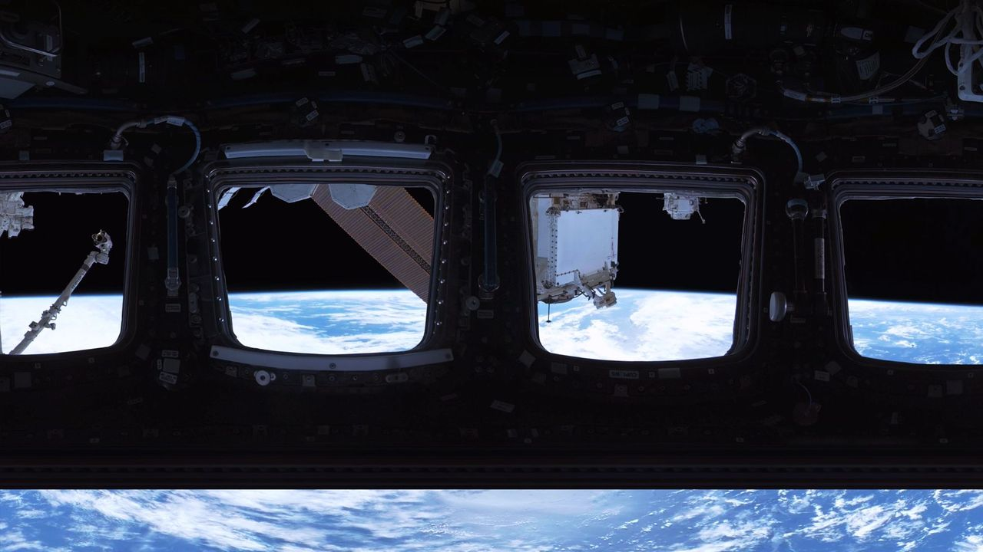
Click for next article NEW YORK - I'm the kind of person who, every so often, falls into accidental daydreams about the concept of space. Usually because I'm listening to some sort of sad girl Spotify playlist, I start feeling infuriated that we may never learn the true meaning of the cosmos and become embarrassingly poetic about our isolation on Earth. I tend to ponder how strange microgravity is and begin Googling things like "what lies beyond the edge of the universe best evidence we have" and "when commercial rocket launch become same price JetBlue flight." I'm pretty sure I've lived in these clouds ever since I got past the Freddi Fish and Microsoft Paint phase of my internet literacy - but then, a month before my 30th birthday, something huge happened. On a random Tuesday, I woke up, brushed my teeth, made myself an espresso, sauntered over to the Franklin Avenue C, and went to the International Space Station . Once I got there, it was bizarre to float through the corridors and living quarters I've written about for so long as a science journalist and thought about for even longer. The walls felt lived in. The station's speed in orbit seemed a little too fast for comfort. The highly esteemed cupola - a protruding corner of the station with seven windows arranged in the shape of a daisy - was far larger than I imagined. In fact, the entire ISS was way more enormous than I can explain. Solar panels tower over you like rust-colored billboards and the station's floors threaten to collapse any second, fooling you as you gaze down at Earth . It's a little scary to be so exposed to the void of space, and that's true even when you're there in virtual reality. Yes, unfortunately (or fortunately, depending on your caution levels) I launched to the ISS through a virtual reality experience called " Space Explorers: The ISS Experience " shown at Eclipsio in Manhattan. It's probably the closest I'll ever get to the real thing, until of course my dream of a cheap RocketBlue economy seat becomes possible. And most importantly, I'm here to tell you that if you're ever able to do the same, you should do it, too. Here's what you'd see The way it works is you put on some VR glasses and follow instructions in your headset to walk a certain direction or move your hands a certain way - your "hands" in the digital world look like floating yellow outlines of hands that correspond to the movements of your actual hands. To be transparent, my glasses were a bit glitchy. My digital hands were quite a bit unstable, for example, which did distract me a little bit but it was easy to get over. Okay, once you're in the world of space, which is simply darkness, a few things happen (which I won't spoil). Eventually, a life-size structure of the International Space Station (ISS) appears. Suddenly, you're within the station. The interior of this structure isn't totally accurate to reality, to be clear. It's a gray, translucent rendering of the ISS's insides that you can explore. Still, the size is meant to be true to life. People walking around the Eclipsio space during the show. (Image credit: Space Explorers: The ISS Experience) Along the way, you can touch giant floating orbs that bring you a short snippet of video to watch. It is because of these snippets that I think this show is 100% worth it. Each one corresponds to the location in which the orb sits - a cupola orb might show you a couple of astronauts floating around and looking out the window, while one near the gym equipment might bring you straight into a training session with Artemis II mission specialist Christina Koch. Perhaps you'd like to venture "outside" and float eye-level with the station's robotic arm. In your periphery to the left, a spacewalker traverses the exterior of the station. To the right, the Earth is majestic. In front of you, sunlight hitting the laboratory's worn white walls causes a realistic glare. You can't help but squint. And the reason these snippets are outstanding is that they are made with real footage from the ISS. A still from Space Explorers: The ISS Experience. (Image credit: Space Explorers: The ISS Experience) A show made by astronauts I sat down with Félix Lajeunesse, co-founder of Felix & Paul studios - the organization behind the exhibit - to learn how this was possible. What does it take to recreate the ISS with this level of detail, and this level of soul? "It took about a year and a half to two years to just prepare for this project, and eventually cameras were sent up there in space," he said. "That was the beginning of a three year production." More specifically, the footage you see in this VR show was filmed across six NASA expeditions and involved shipping three cameras to space - two cameras operating inside the ISS and one camera designed to function in the vacuum of space. That latter camera was attached to the Canadian robotic arm on the exterior of the station and operators on the ground could remotely control it to achieve the cinematic quality they wished. The astronauts first put it on the sliding table of the ISS's Japanese module. Then, the camera was egressed from the station and the robotic arm could pick it up. When it came to the interior cameras, however, that's where the astronauts themselves stepped in. "It's not a traditional camera - it's a virtual reality camera," Lajeunesse said. "So, if you're going to be around a table, for example, having coffee together in the morning, well, this camera is not going to be in the middle of the table because no one would ever be there. It will be at the same height as the rest of you around the table because in the end it's going to be replaced by a person being there with you." "This kind of anthropomorphic idea that the camera is a person really resonated with them," he added. In order to ensure the camera didn't interfere with the many experiments and procedures on the station Lajeunesse and his team made sure to send the astronauts what he calls a "shooting script" for each day of work. This script explained which different camera positions were desired; if anything wasn't possible, the astronauts would offer suggestions of better locations. "We had this ongoing conversation with them during the production, as if it was on a real set, essentially," Lajeunesse said. And speaking with Lajeunesse, it became remarkably clear that this show wouldn't have been as heartfelt as it is without the astronauts' own desire to create it. It seems like the astronauts wanted to be able to share their indescribable experience of living beyond our planet with those stuck on it. This is a way for them to show their families the place they used to call home. The team even made sure to premiere the U.S. version of the show at Houston, Texas, often called "Space City" because that's where NASA astronaut training happens at the agency's Johnson Space Center . "Our first audience in the United States were the astronauts," Lajeunesse said. "It was quite an extraordinary and emotional turnout - almost all of them referred to experiencing this as going back home." A time capsule for future generations As upsetting as it is, the International Space Station isn't forever. Unless a potential boosting mission reaches fruition, it'll be de-orbited and mostly lost in the flames of reentry in the year 2030. Its charred remnants will probably be placed in museums. One day, those museums will be visited by people who never lived during a time when you just knew the iconic lab was up there somewhere in the sky. When that day comes, this ISS show will grow in sentimental value. It may end up offering the only way for ISS astronauts to go "home." "VR points to the capacity to create simulations that are just as rich and vibrant and open and possibilities than reality itself." Lejeuneusse said, comparing it to console video games or movies. "I think it's probably the most human medium there's ever been." He hopes that, someday, VR will improve to the point where it becomes possible to generate open worlds that we can all be a part of together. Perhaps, he says, artificial intelligence will be a big part of that. "This feeling of witnessing the Earth, this sense of the overview experience is something pretty special, pretty emotional for people, and something that could not be communicated through any other media," he said. As for what's next? The team is working on a show in Las Vegas called Interstellar Arc , a science fiction futuristic VR experience that Lajeuneusse says is even more interactive than this International Space Station one. But still, he emphasizes that while future VR shows may continue to increase in capabilities, there will always be something profound about the ISS project. "You know, the International Space Station is one of the most extraordinary examples of human collaboration; human cooperation. It's many different countries, some of them which are opponents at the political stage, that kind of all came together to build this enormous structure in space habitat where humans can go and live," he said. "It was all built through cooperation, and it's all maintained through cooperation." "When they're up there, they're kind of like a microcosm of humanity," he added. "Just the fact that it exists, just the fact that it continues to exist. We should marvel at that."

8. China's new alloy can withstand extreme heat; could be used in reactors, hypersonic missiles
Read more
In a breakthrough that could reshape the future of aerospace and advanced engineering, researchers in China have developed a new metal alloy capable of maintaining its strength at temperatures as high as 2,400 degrees Celsius. The innovation addresses one of the biggest challenges in materials science-creating metals that remain structurally stable under extreme heat while continuing to bear heavy mechanical loads. Already known for its exceptionally high melting point The research, led by a team from Xi'an Jiaotong University, centres on a specially engineered tantalum-based alloy. Tantalum is already known for its exceptionally high melting point of nearly 3,000°C, making it one of the most heat-resistant metals available. However, even tantalum alloys have traditionally suffered from a loss of strength at very high temperatures. The Chinese researchers claim to have overcome this limitation by designing an alloy with an optimized internal microstructure that resists deformation even in extreme thermal environments. Modern technologies such as hypersonic aircraft, reusable spacecraft, advanced rocket engines and next-generation nuclear reactors require materials that can survive enormous temperatures without weakening. Conventional high-performance alloys, including nickel-based superalloys widely used in jet engines, begin to lose their mechanical strength as temperatures approach 2,000°C. Newly developed alloy remains capable of supporting heavy loads The newly developed alloy reportedly remains capable of supporting heavy loads at temperatures up to 2,400°C, representing a significant improvement over existing high-temperature structural materials. Metals generally become softer as temperatures rise because their internal crystal structures become more mobile. Once temperatures exceed roughly 60% of a metal's melting point, atoms can move more freely, causing the material to deform under stress. According to the researchers, the new tantalum alloy has been engineered with a carefully controlled microscopic structure that slows this process. By stabilising the material's internal arrangement, the alloy retains its strength even under conditions that would normally weaken conventional metals. The findings were published in the peer-reviewed journal Nature, highlighting the scientific significance of the work. If the material performs similarly outside laboratory conditions, it could have wide-ranging industrial applications, including hypersonic missile and aircraft components, rocket nozzles and combustion chambers, spacecraft thermal protection systems, advanced gas turbines, and nuclear reactor components. The ability to operate safely at such extreme temperatures could improve engine efficiency, extend component lifespan and reduce cooling requirements in demanding engineering environments. While the laboratory results are promising, commercial adoption will require further testing. Scientists must demonstrate that the alloy can be manufactured economically, withstand repeated heating and cooling cycles, resist oxidation and corrosion, and perform reliably over long service periods. Tantalum is also an expensive metal, meaning large-scale industrial use will depend on whether production costs can be reduced without compromising performance. The development reflects the growing pace of innovation in advanced materials research. As countries compete to build faster aircraft, more efficient space vehicles and safer nuclear technologies, breakthroughs in high-temperature alloys are becoming increasingly important. If successfully commercialized, the new tantalum-based alloy could expand the limits of engineering design, enabling machines and vehicles to operate in environments previously considered too extreme for conventional metals.

