 |  | 

🌌 अंतरिक्ष समाचार | Space News
शनिवार, ११/०७/२०२६ | Saturday, 11/07/2026

1. ISRO successfully conducts 2nd integrated air drop test for Gaganyaan mission - News On AIR
Read more
News On AIR | April 11, 2026 7:23 AM ISRO successfully conducts 2nd integrated air drop test for Gaganyaan mission The Indian Space Research Organisation (ISRO) has successfully conducted the second integrated air drop test (IADT-02) for the upcoming Gaganyaan mission at Sriharikota in Andhra Pradesh. The system is essential to ensure safe recovery of the crew module - the capsule in which astronauts sit during a human flight. After the module's release, a parachute system, comprising 10 parachutes, was deployed, helping the capsule decelerate to a safe splashdown speed. The IADT-02 follows the successful completion of the first IADT, which took place on August 24, 2025, at the Satish Dhawan Space Centre in Sriharikota. In the first IADT, a 4.8-tonne dummy crew module was dropped from a height of three km by a Chinook helicopter. Air drop tests recreate the last leg of a spacecraft's return to the Earth. An aircraft or helicopter drops the spacecraft from a height to test various systems under different scenarios. These are the deployment of the parachute system in case the mission is aborted mid-flight, system performance when one parachute fails to open, and the spacecraft's orientation and safety during splashdown. Union Minister Jitendra Singh congratulated the ISRO for successfully conducting the test. India's first human spaceflight will be launched from Sriharikota in 2027.

2. ISRO Chairman Narayanan asks IISc graduates to give back to society, build developed India - Udayavani
Read more

41 minutes ago Tourist entry ban lifted at Netravati Peak and Kadamagundi Falls 42 minutes ago Driver kills three members of family, dies by suicide in Bengaluru 49 minutes ago SIR: No documents needed if name is already on electoral roll 1 hour ago Pay and pass? Allegations of bribes at Kerala border check posts 1 hour ago Bengaluru among 14 Indian cities in world's 50 most heat-risk cities 1 hour ago Private bus conductor held for allegedly sexually harassing college students in Mangaluru 2 hours ago Kerala CM V.D. Satheesan offers prayers at Kollur Mookambika Temple

3. India is building the rocket engine only SpaceX has ever flown. It's not Isro - India Today
Read more
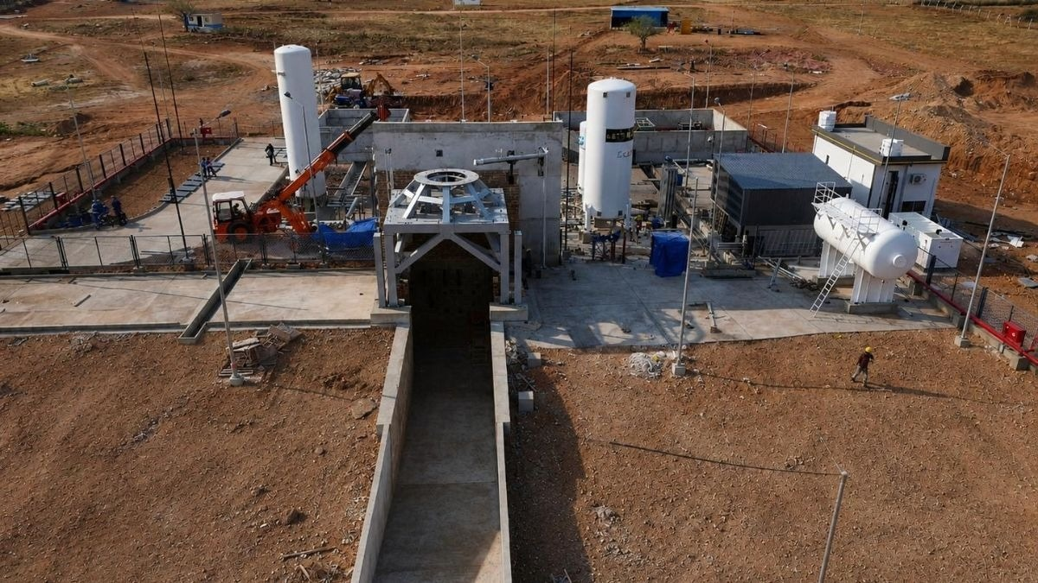
On a 21.5-acre stretch of land in Andhra Pradesh, engineers are bolting a rocket engine to a steel stand and setting it on fire. Deliberately. Again and again. Each burn is a question. Can a machine built entirely in India, from its first drawing to its final weld, survive the violence of its own power? The answer will decide whether the country gets its most advanced rocket yet. Read Full Story The surprise is who is asking the question. The engine belongs to Astrobase Space Technologies, a Bengaluru-based startup founded in 2024 by former Indian Space Research Organisation (Isro) scientist Devakumar Thammisetty and Neeraj Khandelwal, an IIT Bombay-trained electrical engineer who co-founded the crypto exchange CoinDCX before turning his attention skyward. Astrobase operates two facilities: a 46,000-square-foot assembly factory in Bengaluru, where the engine is built and integrated, and a 21.5-acre test site in Andhra Pradesh, where it will be fired. (Photo: Astrobase) In an exclusive conversation with IndiaToday.in, Khandelwal said the engine, in terms of technology, sits among the top five rocket engines in the world. Outside the United States and China, he asserts, no other company has this technology. To understand why that claim matters, you first need to meet a number that keeps India's space planners awake at night. THE NUMBER THAT HAUNTS INDIA'S SPACE AMBITIONS India has around 55 operational satellites in orbit today, Khandelwal points out. The United States has more than 13,000. China is approaching 1,500. Each one of those satellites is quietly doing a job. They beam television into homes, carry banking transactions, track cyclones before they make landfall, guide ships and aircraft, and keep militaries connected. Khandelwal calls the gap between 55 and 13,000 a national security issue, and the arithmetic behind it is brutally simple. India has around 55 operational satellites in orbit, compared to more than 13,000 operated by the United States. (Photo: Unsplash) Satellites are mortal. They slowly lose altitude, drift back towards Earth and expire, which means each one must be replaced roughly every five years. If India wants even 500 satellites by 2035, a modest target next to American and Chinese numbers, the country needs the capacity to launch about 1000 tonnes of payload into orbit every single year. Payload is simply whatever a rocket carries, the cargo it delivers to space. Launch, as Khandelwal puts it, is the choke point of the entire space industry. Everything else, the satellites, the applications, the ambitions, waits in a queue behind it. That 100-tonne annual capacity is Astrobase's goal. THE HOLY GRAIL OF ROCKET ENGINES At the heart of Astrobase's rocket is a technology with an intimidating name: the full-flow staged combustion engine, or FFSC. It is India's first, and it is worth pausing to understand why engineers call it the holy grail of propulsion. A rocket engine is essentially a controlled explosion. It burns fuel with an oxidiser, the substance that supplies the oxygen needed for burning, and hurls the hot gases downwards to push the rocket up. That push is called thrust. The hard part is feeding the fire. Propellants must be forced into the combustion chamber at ferocious pressures, and the pumps doing the forcing need power of their own. Simpler engines solve this by burning a little propellant separately, just to spin the pumps, and throwing the exhaust away, like a car dribbling petrol out of its tank as it drives. The full-flow staged combustion cycle, flown only by SpaceX's Raptor engine (left) so far, wastes no propellant and is considered the most efficient engine design. (Photo: SpaceX/Astrobase) A full-flow staged combustion engine closes that leak. Every drop of fuel and every drop of oxidiser passes through the pumping system and still ends up burned in the main chamber, squeezed for every last unit of energy. The result is an engine of exceptional efficiency, and in rocketry, efficiency is everything. Khandelwal offers a striking rule of thumb: make an engine roughly 10 per cent more efficient, and the payload capacity of the vehicle can double. This technology is so difficult that only a handful of such engines exist in the world, he says. The most famous is SpaceX's Raptor, the engine that powers Starship and the only one of its kind to have ever flown to space. Astrobase's engine belongs to this same rare family. The engine burns liquid oxygen and methane and is designed to generate 800 kilonewtons of thrust in vacuum, enough push to lift roughly 80 tonnes. Its core components are 3D printed, and the entire engine has been designed, manufactured and integrated in-house. WHY METHANE IS THE FUEL OF THE FUTURE The choice of methane is deliberate. It is the principal component of the natural gas that warms kitchens across India, and peer-reviewed research published in the journal Acta Astronautica describes oxygen-methane propulsion as holding great potential for the next generation of operational rockets. Methane burns clean, leaving little soot behind, a property documented by Nasa researchers as far back as the 1980s. That matters enormously if you want to fly the same engine again and again, because a sooty engine must be scrubbed back to health after every flight. Astrobase has built what it describes as India's first methane-based rocket engine test facility on 21.5 acres in Andhra Pradesh. (Photo: Astrobase) Studies have found liquid oxygen and methane to be among the best propellant combinations for reusable, high-thrust rocket engines, thanks to low cost and clean combustion. Isro's semi-cryogenic engine under development runs on kerosene, and the agency has separately begun work on methane-based propulsion for its future launch vehicles. Astrobase, meanwhile, has already built what it describes as India's first methane-based rocket engine test facility, the sprawling Andhra Pradesh site where the firing campaign is under way. A hot fire is exactly what it sounds like: the engine is ignited at full fury on a test stand while sensors record whether it behaves. A sub-scale version of the engine succeeded on its very first hot fire attempt in September 2025. AN ENGINE BUILT TO FLY 50 TIMES Reusability is the other obsession. A single Astrobase engine is designed to fly more than 50 times, the co-founder claims. Khandelwal is blunt about why this matters. A reusable rocket begins with a reusable engine. Any company promising reusable vehicles without a reusable engine, he suggests, will struggle to deliver on that promise. The rocket itself will have two stages, the stacked sections that fire one after another during a launch. Every core component of the Astrobase engine is 3D-printed, and a single engine is designed to fly more than 50 times. (Photo: Astrobase) The first stage is designed to return and land back at its launch site, and the second will be made reusable in the years after launch operations begin. The vehicle is built to carry 3 tonnes to low-Earth orbit, the region within about 2,000 kilometres of the planet where most satellites live. THE ROAD TO 2028 The ambition has official backing. In June 2026, IN-SPACe, India's space regulator and promoter, selected Astrobase as one of the first three beneficiaries of its Rs 500 crore Technology Adoption Fund, after a rigorous multi-stage evaluation involving experts from Isro and other government bodies. Khandelwal told IndiaToday.in that the company received Rs 25 crore, the maximum support permitted per project under the scheme, following a year-long technical review. The roadmap ahead is aggressive: a hop test of the booster in 2027, in which the vehicle lifts off and lands vertically, a full static fire on the launch pad in 2028, and the inaugural orbital launch the same year. Khandelwal's ambition stretches further still. He wants to build five to seven cutting-edge technologies in India in his lifetime, to prove to millions of young Indians that the most advanced machines on Earth can be built in their home country. The engine now roaring in Andhra Pradesh is expected to be the first proof. - Ends

4. Price to sales forward of Isrotel Ltd. - TASE:ISRO - TradingView
Read more
- Markets - / Israel - / Stocks - / Consumer Services - / Hotels/Resorts/Cruise lines - / ISRO - / Financials Isrotel Ltd. ISRO Tel Aviv Stock Exchange Market closed No trades Overview Financials Community Technicals Seasonals ETFs More Back Back Price to sales forward of Isrotel Ltd. Period Value Change Change %

5. ISRO Bengaluru receives hoax bomb threat, investigation underway - The News Mill
Read more
ISRO Bengaluru receives hoax bomb threat, investigation underway The News Mill

6. NASA Photographer Captures Images from F-18 Over Washington
Read more

NASA photographer Jim Ross flies above the Washington Monument in Washington on Saturday, July 4, 2026, in an F-18 aircraft, as part of a flyover to celebrate America's 250th birthday. This aircraft is from NASA's Armstrong Flight Research Center in Edwards, California, and it joined other NASA aircraft for the flyover. NASA/Jim Ross NASA flight photographers capture history from a perspective few ever experience, getting a rare bird's-eye view of the agency's missions in action. Their photos document key NASA research and give the public a front-row seat to the work happening behind the scenes. Jim Ross, a photographer at NASA's Armstrong Flight Research Center in Edwards, California, flew over Washington during the Fourth of July celebration to document a NASA flyover commemorating America's 250th birthday. He's captured some of the agency's most exhilarating milestones, like early SR-71 flights, the delivery flight of Space Shuttle Endeavour to Los Angeles, and first flights of NASA's X-59 quiet supersonic research aircraft. "I grew up in Bozeman, Montana, when it was still considered a small town, so if someone told that little kid that he would be flying in a F-18 over the National Mall, he would have never believed it," Ross said. "I love documenting history, and having the opportunity to capture flights and launches has kept me doing it for almost 37 years." Ross began his aviation photography career in 1989 when he joined the staff at NASA Armstrong (then Dryden). He became the photo lead in 1997, a title he retains. Check out his images from the flyover here: https://www.nasa.gov/gallery/freedom-250/ NASA photographer Jim Ross takes a selfie from the rear seat of a NASA F/A‑18 during a cross‑country flight from Spokane, Washington, to Washington, D.C., on Thursday, July 2, 2026. The agency's F‑15, flying alongside the aircraft, is visible through the window. Both aircraft, from NASA's Armstrong Flight Research Center in Edwards, California, participated in the Freedom 250 flyover with other NASA and military aircraft on Saturday, July 4, 2026. NASA/Jim Ross

7. SpaceX Falcon 9 rocket launches for 35th time, hauls Starlink satellites to orbit (video)
Read more
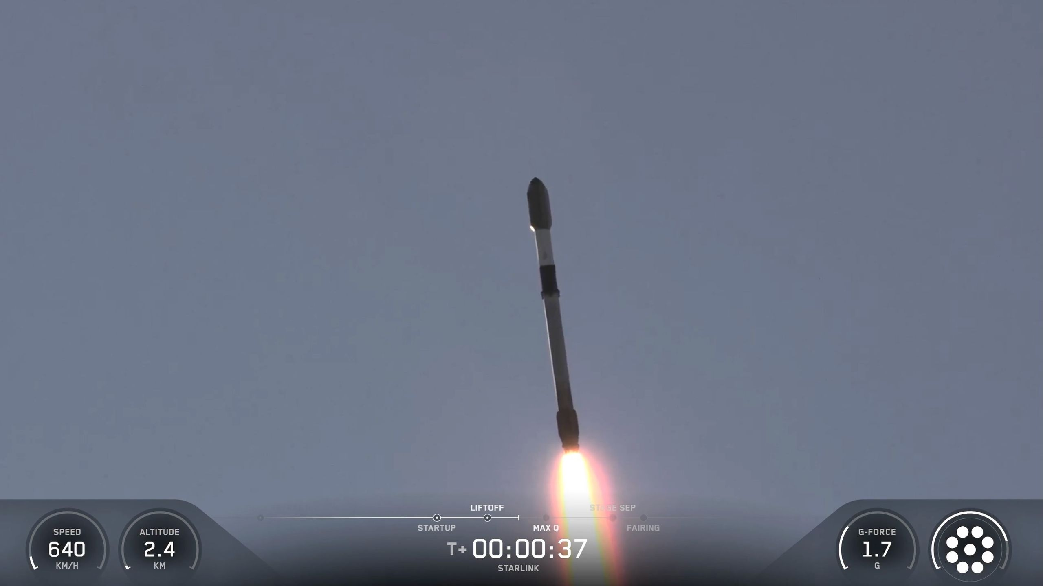
Click for next article A SpaceX rocket just inched closer to the record books. A Falcon 9 vehicle lifted off from Vandenberg Space Force Base in California tonight (July 10) at 11:01 p.m. EDT (8:01 p.m. local time; 0301 GMT on July 11), carrying 29 of SpaceX's Starlink broadband satellites toward low Earth orbit (LEO). It was the 35th flight for this rocket's first stage, a booster designated B1071. The SpaceX record is 36, set just a few days ago by B1067 on another Starlink mission. A SpaceX Falcon 9 rocket launches 29 Starlink satellites from California's Vandenberg Space Force Base on July 10, 2026. (Image credit: SpaceX) And, there will likely be more flights for B1071 down the road. The booster came back to Earth for a touchdown tonight as planned, landing in the Pacific Ocean on the SpaceX droneship "Of Course I Still Love You" about 8.5 minutes after launch. The Falcon 9's upper stage, meanwhile, continued carrying the 29 Starlink satellites aloft. They're scheduled to be deployed in LEO about 62 minutes after launch. A Falcon 9 first stage rests on a ship at sea shortly after launching 29 Starlink satellites from California's Vandenberg Space Force Base on July 10, 2026. (Image credit: SpaceX) The Starlink megaconstellation currently consists of more than 10,700 active satellites, according to tracker Jonathan McDowell . The network is growing all the time, however, and it could eventually get very large indeed; SpaceX recently applied for approval to operate 100,000 of the spacecraft in LEO. Tonight's launch was the 81st Falcon 9 mission of 2026. About 80% of them have been Starlink flights.

8. Launching from 2 continents: Germany's Isar Aerospace leases Canadian pad for $150 million
Read more
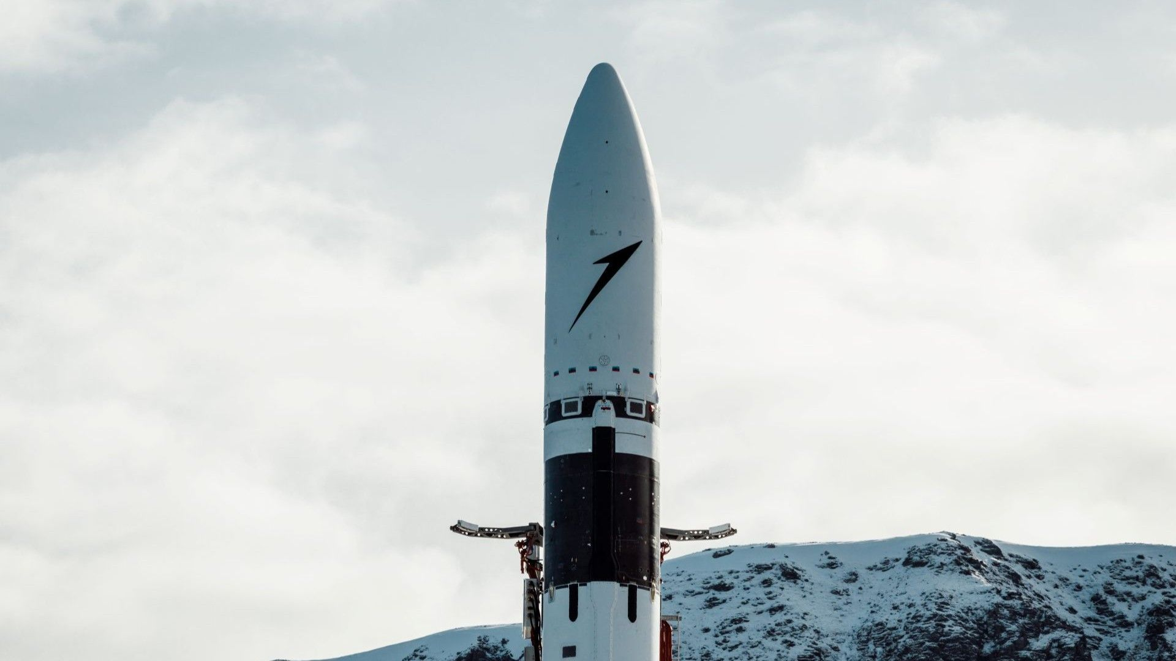
Click for next article German company Isar Aerospace is expanding its operations overseas after signing an agreement with Canada's Maritime Launch Services for use of its Spaceport Nova Scotia. The deal allows Isar to design and operate the pad infrastructure based on the company's needs, in order to launch its Spectrum rocket. In return, Maritime Launch Services (MLS) will provide the pad and surrounding facilities for vehicle stage and payload integration, testing and a mission control hub for launch operations. The agreement grants Isar a $150 million, 10-year lease for the MLS launch site, with the option to extend up to an additional 10 years. Development of the facility is scheduled to begin later this year, with Isar targeting 2028 for its first orbital launches from the new site. "Canada is the next step in our roadmap to bring full end-to-end launch capability to sovereign nations," Alexandre Dalloneau, Isar's mission and launch operations vice president, said in a company statement on Tuesday (July 7). "And we are proud to be doing it here in, and together with, Canada." By 2029, Isar hopes to be able to support up to 40 launches from the new Canadian site. "By combining Isar Aerospace's launch vehicle, Spectrum, with Spaceport Nova Scotia's licensed infrastructure, we are creating the conditions for reliable orbital launch services from Canada," MLS President and CEO Stephen Matier said in the same statement. MLS has positioned Spaceport Nova Scotia as a multi-user launch center, designed for expansion based on future customer needs. It's one of Canada's first-ever facilities designed to support orbital launches - Canadian company NordSpace is constructing a launch pad of its own with a similarly flexible framework, but neither it nor Isar has yet carried out a successful orbital launch. Isar has tried, however. Spectrum launched for the first time in March 2025, from Europe's Andøya Spaceport in Norway, but the rocket began to tumble shortly after clearing the tower and fell back to Earth in a fiery explosion. Since then, the company has rolled Spectrum out several times for a second launch opportunity but has run up against either weather or technical delays that have scrubbed each attempt. Still, that hasn't slowed the company's efforts. Dalloneau sees Isar's success as one of international importance.

9. SpaceX ignites all 33 powerful engines on Starship booster ahead of Flight 13 launch (video)
Read more
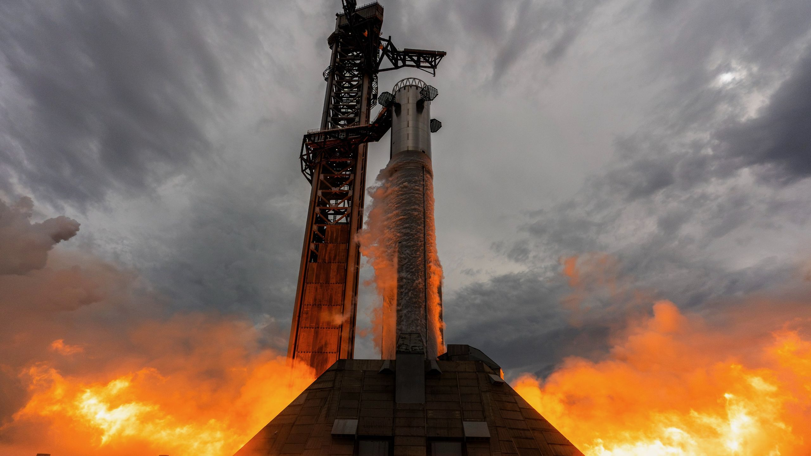
Click for next article It looks like SpaceX's next Starship flight is on the horizon, and it may lift off sooner than you might think. SpaceX today (July 10) completed a brief static fire of the Starship Super Heavy booster tapped to launch the 13th test flight of the massive, mega-lift vehicle. Booster 20 - the latest Super Heavy to roll off the assembly line - was transported to the pad at SpaceX's Starbase, Texas, facility yesterday (July 9) and hoisted onto its support stand using the launch tower's stalwart "Mechazilla" chopstick arms. By early Friday, SpaceX began preparations leading up to the prelaunch engine test, including closing Boca Chica beach around 8 a.m. EDT (1200 GMT) and transferring fuel to the pad's tank farm ahead of loading propellant onto the vehicle. SpaceX conducts a static fire test with a Super Heavy booster on July 10, 2026, to gear up for the upcoming 13th test flight of its Starship megarocket. (Image credit: SpaceX) This is the second "Version 3" (V3) booster to reach the pad at Starbase for testing, and is equipped with 33 of SpaceX's upgraded Raptor 3 engines. Those engines ignited in a blazing heat on Friday just before 11 a.m. EDT (1500 GMT), and underwent a roughly 25-second burn simulating on the launch stand the duration and flight conditions for an actual launch. The successful completion of Booster 20's static test fire paves the way for Starship's upcoming test launch, Flight 13. That could launch as early as Wednesday (July 15), according to a notice from the Federal Aviation Administration. Compared to Version 2 (V2), Starship V3 packs a much stronger punch . The rocket was upgraded with enhanced avionics to reduce mass and increase launch capacity, a taller fuel tank with a larger volume, and equipment for transferring propellant between spacecraft, which will be needed to fulfill many of the missions Starship is being designed to carry out. A handful of those missions will be for NASA's Artemis program , and the agency's plans to return to the moon . Starship is one of two lunar landers currently contracted to deliver astronauts to the lunar surface, so, its success and timely demonstration of the technologies needed to do so are coming under a microscope as the timeline for those missions shrinks. Flight 13 will follow the same basic timeline as Flight 12, which lifted off in May with mixed success. Flight 12 was the first launch of Starship V3, and prompted SpaceX to fly a slightly more conservative mission than many previous tests, which have built on previous successes with increasingly expanding goals. Starship's last flight sent the vehicle's upper stage, Ship, on a suborbital trajectory with a soft splashdown in the Indian Ocean. SpaceX ran into some issues , though, when the rocket's Super Heavy booster (Booster 19) failed to maneuver itself for a soft ocean splashdown of its own. Ship (Ship 39) also ran into an engine anomaly that caused SpaceX to forgo the stage's in-space engine relight demonstration. Ship 40 and Booster 20, the Starship vehicles that will fly on Flight 13, will follow the same set of mission objectives to shake out the remainder of kinks in Starship V3. Spacex hopes the mission will pave the way for further technology demonstration tests the vehicle needs to complete before reaching full operational status. That includes the retrieval of both stages back at their Starbase launch pad, for refurbishment and reuse on future flights. SpaceX conducts a static fire test on July 2, 2026, with Ship 40, the upper-stage spacecraft slated to fly Starship's 13th test flight. (Image credit: SpaceX) Starship is designed to be fully reusable, and capable of delivering over 100 tons to low Earth orbit . Once the rocket begins regularly delivering payloads, Ship and Super Heavy will be able to both return to Starbase to be caught by the Mechazilla arms on both of the site's two launch towers. SpaceX has succeeded in a handful of V2 Super Heavy catches during its previous flight tests, and managed to launch two of those recovered boosters on subsequent missions, but has not yet attempted to do the same with a Ship upper stage. That's because landing Ship is much different than landing Super Heavy. SpaceX has a lot of practice landing and reflying rocket boosters. The company's workhorse Falcon 9 rocket launches several times a month, and is routinely recovered, refurbished and reflown within a short few weeks. A batch of Starlink satellites recently launched on one of SpaceX's most-flown Falcon 9 boosters, which broke a reflight record as it touched down for the 36th time after delivering its payloads to orbit. Though it lacks the landing legs of Falcon 9, Super Heavy's descent back to Earth is very similar to a Falcon 9 booster, and therefore less complex an engineering question to have to solve compared to Starship's upper stage. Ship drops through the atmosphere belly-first, allowing the black, hexagonal heat shield tiles that cover half the vehicle to absorb the blazing temperatures of reentry. Fins near the spacecraft's nose and base control its orientation and attitude, which remains mostly horizontal during its freefall. To an extent, Ship's descent profile is not very unlike the space shuttles, except for its actual touchdown, which differs significantly. As Ship's altitude decreases toward sea level, the vehicle performs a "flip and burn" maneuver that swings the whole stage upright and arrests its descent for a soft touchdown - eventually back at the Starbase pad on future launches, but once again in the Indian Ocean for Starship's upcoming mission. Flight 13 will give SpaceX a chance to demonstrate that descent profile again using Ship 40, while also working through the booster and engine issues encountered during Flight 12. If all goes according to plan, the launch will bring Starship V3 closer to more ambitious tests, including orbital insertion, propellant transfer and the recovery of both stages back at Starbase.

10. SpaceX launch creates colorful 'jellyfish' in the night sky | Space photo of the day for July 10, 2026
Read more
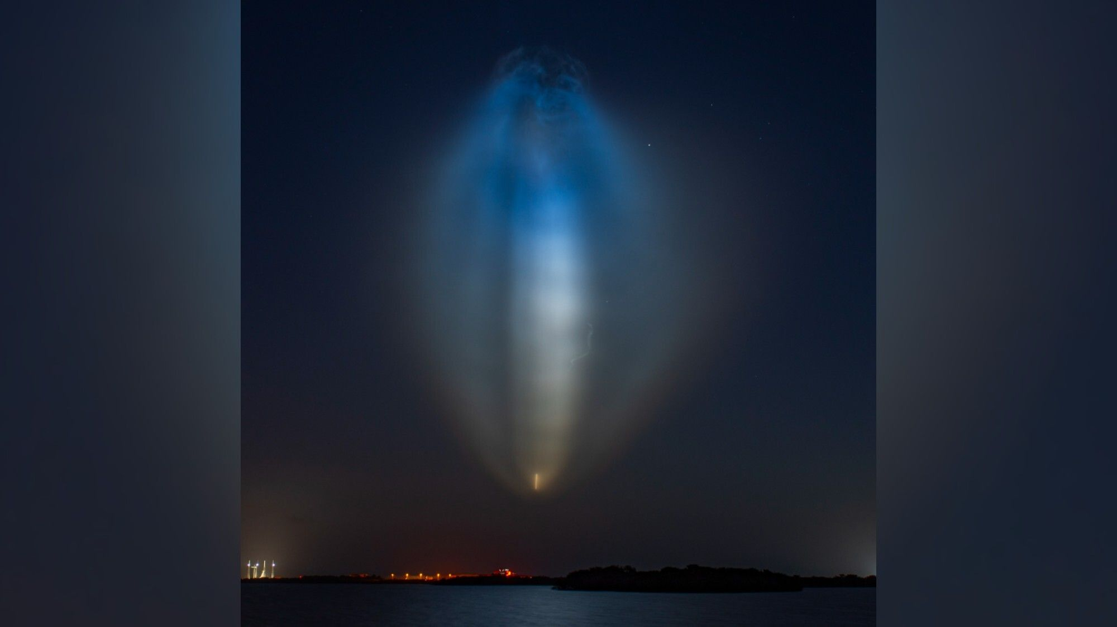
Click for next article A "space jellyfish" cloud lit up the early morning sky following a SpaceX Falcon 9 launch. (Image credit: SpaceX) Is it a space jellyfish? Is it an alien ? No, it's the aftermath of a SpaceX rocket launch! What is it? Have you ever looked up and thought, "Why is there a giant glowing jellyfish cloud in the sky?" If so, chances are that you've seen the remnants of a rocket launch, and not a surprise alien visitor. In the early hours of July 9, SpaceX launched 29 of its Starlink broadband satellites from Florida's Cape Canaveral Space Force Station to low Earth orbit. It was the rocket's 36th flight, a record. The rocket lifted off at 5:25 a.m. EDT (0925 GMT), and the scene it painted in the dark early-morning sky looks truly out of this world. But there is a practical, Earthly explanation. When a Falcon 9 rocket takes off, its engines expel water vapor and carbon dioxide. As it climbs higher into the sky, the temperature drops and the water vapor quickly freezes, forming ice crystals that trail behind the rocket in the spectacular plume we're seeing here. And this view is made more colorful and striking by the sunlight of early morning. Why is it incredible? While this photograph's beauty speaks for itself, it is also a colorful example of how real scientific moments can spark the imagination. Do you think it looks like a jellyfish? I think it looks like a comb jelly, which isn't actually a jellyfish but rather a different type of transparent, squishy invertebrate that drifts through the ocean. It could also look like a glowing football or even a mythological monster. Whatever you think it looks like, while we have a real scientific explanation for why this rocket launch was followed by a giant, glowing, uniquely shaped cloud, it's still fun to use our imagination.

11. Supreme Court ruling on mail-in ballots ensures astronauts can vote from space - or anywhere else
Read more
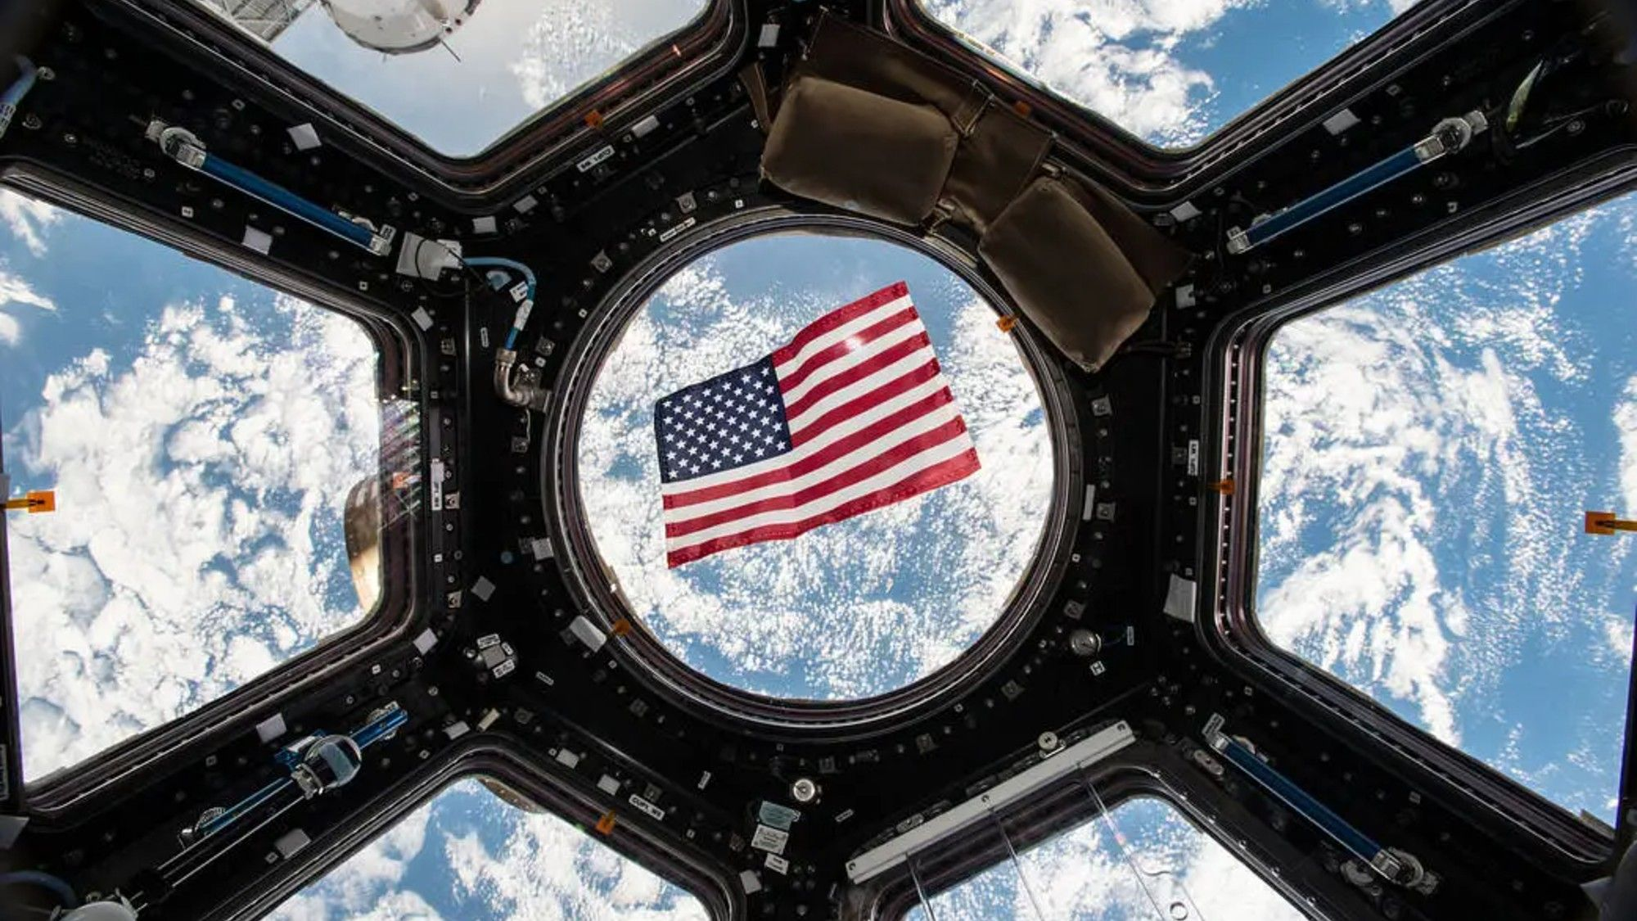
Click for next article A new ruling by the U.S. Supreme Court protecting voter rights could extend to astronauts living and working in space and training internationally, their families, and the multitude of NASA workers who travel to support their missions. On Monday (June 29), the Supreme Court ruled that mail-in ballots can be counted toward a total vote even if they arrive after election day, as long as they are postmarked by election day. The ruling followed efforts by the Trump Administration to place restrictions on mail-in voting. In a new statement, the nonpartisan activist organization Astronauts for America spoke out in support of the Supreme Court's decision, which supports absentee voting. "We don't want to see barriers put in place [that] make it more challenging for somebody to exercise their constitutional right of voting," retired NASA astronaut Wendy Lawrence told Space.com. Lawrence is a member of Astronauts for America, as well as a veteran of the U.S. Navy, where she served as a captain, engineer and helicopter pilot. What happened? An executive order issued by President Trump in March 2026 attempted to place a number of restrictions on voting in the country, including limitations on mail-in or absentee voting. The order directed the United States Postal Service to only transmit ballots for states that compile and submit lists of eligible mail-in voters 60 days before elections, added requirements and complications to mail-in ballots and attempted to limit who receives a ballot in the mail. This order not only added layers to limit voting access, but it conflicted with existing procedures set by states for absentee voting. Additionally, the U.S. Constitution places the authority to change election rules and processes with Congress, not the president, though this was not the first executive order put out by Trump to attempt to change election rules, CNN has reported . In a 5-4 ruling, the Supreme Court blocked the U.S. Postal Service from carrying out this executive order, declaring that mail-in ballots may be counted if they arrive up to five days after election day, as long as they are postmarked by election day. "This is key to making sure we have free and fair elections, that people have the ability to cast their vote, and it's not an overwhelming burden for them to do that again," said Lawrence. Astronauts vote (and so do the people around them) In a statement shared on social media , Astronauts for America commented on the recent ruling. "We at Astronauts for America are pleased to see the justices take this critical step toward safeguarding free and fair elections, and ensuring that every eligible voter has their ballot counted," the statement reads. "As astronauts, some of us cast our votes from space. As military veterans, many of us relied on voting by mail. Upholding this grace period ensures that astronauts and other Americans are able to exercise their civil rights." "Voting is the cornerstone of our American democracy, and this is an important step forward in our battle to ensure everyone has the right to vote," the statement continued. "While the Supreme Court ruling should be celebrated, we must continue standing up for our democracy and constitutional principles." Astronauts have used absentee voting systems for decades, and they do so regularly: Astronauts have been living in orbit on board the International Space Station continuously since November 2000. When astronauts are going to be in space during an election, NASA has a digital system that allows them to submit absentee votes. But as the statement above suggests, astronauts don't just need absentee voting during their space missions. Astronaut training can take place all around the world, especially if there is a mission with international collaboration. Lawrence shared that, during her tenure with NASA's space shuttle program, there was a 16-month period when she had to live and train full-time in Russia. And, astronauts don't prepare for space in a vacuum. Family members like spouses might travel with them for long-term training, and there are a wide variety of mission managers and support staff for crewed missions (and their families) who might have to be on long-term travel as well. Additionally, many astronauts like Lawrence are also military veterans who, during their service, are only able to vote through absentee voting, sometimes for years on end. While this ruling extends far past astronauts, even within the space sector, absentee voting has protected the constitutional rights of many.

12. Don't miss out on 'The Ark' Season 3 - get a year-long Peacock TV deal for just over $9 a month
Read more

Click for next article We've found an incredible streaming deal for you. Peacock TV has cut a year-long Premium subscription plan from $131.88 to just $109.99. It's 12 months for the price of 10, and the lowest price we've seen since Black Friday last year. Get Peacock TV for just $9.16 a month when you sign up for a one-year plan. Peacock TV also hosts the SYFY channel, and sci-fi fans can stream hit series like Resident Alien and Battlestar Galactica. There are also exciting new additions, including Season 2 of The Undeclared War, and Season 3 of The Ark, scheduled to premiere on July 30, 2026. Get 12 months for the price of 10 Save 17% ($21.89) Peacock TV Premium Plan: was $131.88 now $109.99 at Peacock TV Save 17% on an annual subscription to a very popular streaming platform. Peacock TV is NBCUniversal's streaming service, and it offers over 50 always-on channels. It's home to some big sci-fi names, and you can also watch a ton of live sports. So, as streaming deals go, this is right up there with the best available. Paul Brett Deal writer Paul Brett is a deals writer at Space, Live Science, and across the Sports and Knowledge titles at Future. Paul is a huge sci-fi fan, hooked on Star Wars from the moment he saw A New Hope in the cinema, and as part of his deals-hunting role at Space, he has started an unplanned (and expensive) Lego Star Wars collection. Danger: Spoiler Alert Ahead! Fans are eagerly anticipating the third season of The Ark following season 2's thrilling cliffhanger finale, where the crew of Ark One discovered a habitable, human-friendly planet. However, evidence of an ancient alien civilization and a frantic distress call from deep space instantly cut those celebrations short. Season 3 begins with Captain Garnet (Christie Burke) splitting her crew to answer that urgent distress call, leaving the remaining members behind to defend Homebase 1 from the new planet's unknown secrets. Peacock TV also packs a massive array of hit movies and captivating documentaries, including Unidentified with Demi Lovato, exploring UFO sightings, declassified government documents, and extraterrestrial mysteries. If you're traveling abroad over the summer, you'll most likely find your Peacock TV viewing blocked by geo-restrictions. The best way to continue your regular viewing as if you're at home and ensure you don't miss any of your favorite sci-fi shows is to use a VPN. NordVPN has discounted its highly rated VPN plans by as much as 75%, with a bonus of three free months on top. Save up to $372.60 when you sign up for a NordVPN two-year plan at NordVPN. The Complete Plan is the most popular option from Nord, and it works out at just $4.49 a month or $121.23 over the two years, when you take into account the extra three months. Peacock TV key features: 10 months for the price of 12, over 50 always-on channels, great sci-fi content, live sports, multiple news channels, year-long subscription. Price history: Before today's deal, the price of the popular Premium plan was $131.88. It's now just $109.99 and works out at just $9.16 on a one-year plan. We think this streaming deal represents great value for a service that will always offer you something you can watch. ✅ Buy it if: You want a low-cost streaming deal, and you're into sci-fi, sports, or you like your news. ❌ Don't buy it if: None of the above applies to you, but in truth, this is great value, and we believe it's worth getting. Check out our other guides to the best telescopes, binoculars, cameras, star projectors, drones, lego and much more.

13. Making history! China lands rocket during an orbital launch for 1st time ever (video)
Read more
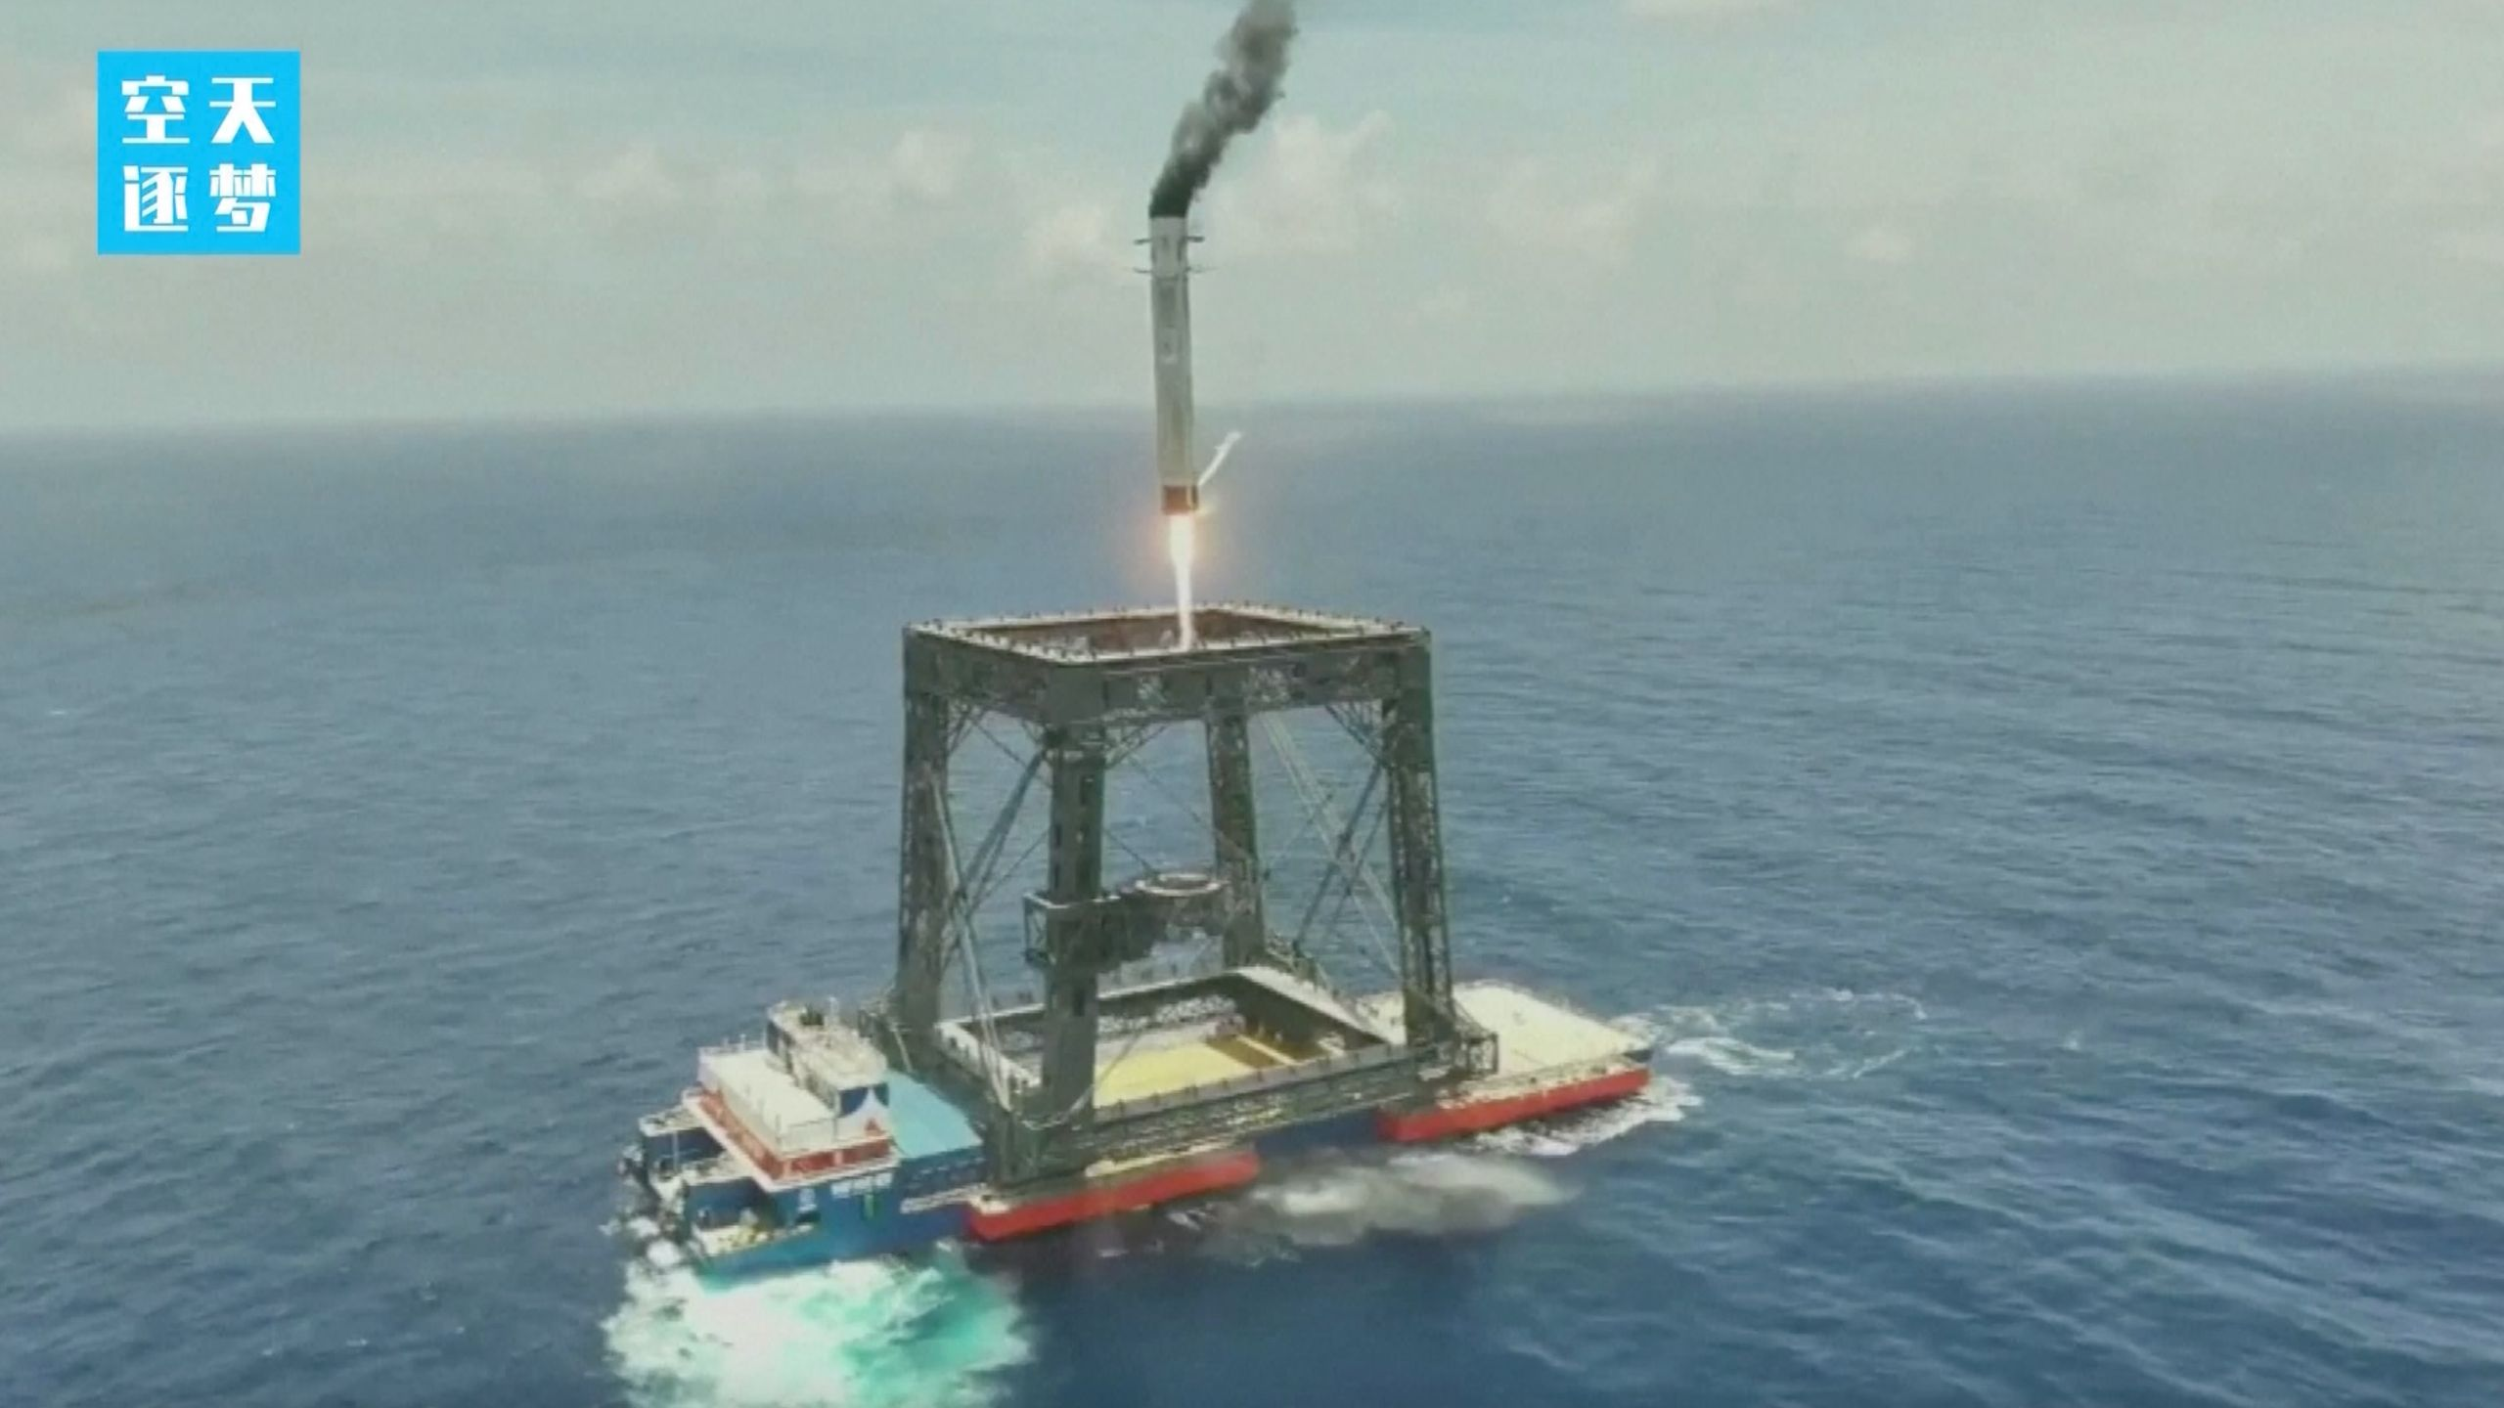
Click for next article China just notched a huge spaceflight milestone. The nation has recovered a rocket during an orbital launch for the first time ever, pulling off the feat during the Long March 10B's maiden liftoff on Friday (July 10). And that recovery was unique: The rocket's first stage nestled softly into a net-like structure carried by a ship at sea. "This mission marks my country's first successful controlled recovery of a launch vehicle and the world's first network-based recovery of a launch vehicle," the China Aerospace Science and Technology Corporation (CASC) announced via social media shortly after the launch. (Translation by Google.) "It signifies a historic breakthrough for my country in the field of reusable rocket technology and will lay a solid foundation for accelerating the improvement of my country's space access capabilities." The first stage of a Chinese Long March 10B rocket comes down for a landing at sea after successfully sending a satellite to orbit on July 10, 2026. (Image credit: CCTV) The Long March 10B is a two-stage rocket that stands about 207 feet (63 meters) tall, according to the state-owned CASC, the main contractor for China's space program. The vehicle's first stage burns kerosene and liquid oxygen (LOX) propellants, whereas the second stage uses LOX and liquid methane. In reusable mode, the Long March 10B can loft about 16 tons of payload to low Earth orbit . And the rocket flew with a payload on its debut liftoff - a satellite that successfully reached "its predetermined orbit," according to the CASC update. That post did not provide any details about the spacecraft or its orbit. It did give a brief rundown of the first-stage recovery, however. "Approximately 6 minutes after the first and second stages separated, the first stage returned vertically and was successfully recovered at a sea-based recovery platform using a net system," CASC officials wrote, noting that launch occurred from the Hainan Commercial Space Launch Site on Friday at 12:15 a.m. EDT (0415 GMT; 12:15 p.m. Beijing time.) "The launch and first-stage recovery missions were a complete success." China plans to refly the first stage by the end of the year, they added. Until now, vertical landings of orbital-class rockets had been performed only by SpaceX, which does them on a regular basis. Indeed, Elon Musk 's company has landed orbital rockets more than 600 times to date. Such extensive reuse has allowed SpaceX to fly more cheaply and efficiently than its competitors and dominate the launch market - something that China is working hard to emulate. The Long March 10B's "reusable configuration significantly reduces launch costs, offering advantages of large payload capacity and high cost-effectiveness," CASC officials wrote in the post-launch update. Other partially reusable Chinese rockets are in the works as well, including CASC's Long March 12A and the Zhuque-3, a vehicle built and operated by the Beijing-based company Landspace. Both of those rockets debuted this past December, with similar results: They reached orbit as planned, but their first stages didn't stick the landing.

