 |  | 

🌌 अंतरिक्ष समाचार | Space News
गुरुवार, २७/०८/२०२६ | Thursday, 27/08/2026

1. UP govt launches free bus travel scheme for elderly women
Read more

- Policy - 1 min read The Lokmata Ahilyabai Matrushakti Yatra scheme will provide free bus travel to elderly women across Uttar Pradesh. - PTI - Published On Aug 26, 2026 at 03:41 PM IST Select ETGovernment as Preferred Choice on Google Copy Link Share on WhatsApp Share on Linkedin Share on X Share on Telegram Share on Facebook Uttar Pradesh Chief Minister Yogi Adityanath flags off buses under the Lokmata Ahilyabai Matrushakti Yatra scheme. Chief Minister Yogi Adityanath on Wednesday launched a scheme to provide free bus travel to elderly women in Uttar Pradesh, an official statement said. The chief minister launched the ' Lokmata Ahilyabai Matrushakti Yatra ' scheme at the Indira Gandhi Pratishthan here and flagged off special buses deployed under the initiative. He also interacted with several women beneficiaries during the programme. Addressing the event, Adityanath highlighted measures taken for women's safety in the state. Advt "Today we have Mission Shakti centres. Every city has an AI-based Safe City network, and we also have an integrated response system of 1090 and 112," he said. "If anyone breaches the safety of a daughter, whether inside the house or outside, then consider it final that the person will have either jail or hell waiting for him," he said. Adityanath said women beat officers have been deployed in Uttar Pradesh. "This has happened for the first time in Uttar Pradesh, and perhaps in the country," he said. - See more on: - Uttar Pradesh free bus travel , - Lokmata Ahilyabai Matrushakti Yatra , - Yogi Adityanath women safety measures , - free travel scheme for elderly women , - Mission Shakti centres Uttar Pradesh Telegram Facebook Comments What are your thoughts? Comment Now --> Comment Now Read Comment (1) All Comments By commenting, you agree to the Prohibited Content Policy Post Find this Comment Offensive? Choose your reason below and click on the submit button. This will alert our moderators to take actions REASONS FOR REPORTING Foul Language Defamatory Inciting hatred against a certain community Out of Context / Spam Others Report Join the community of 2M+ industry professionals. Subscribe to Newsletter to get latest insights & analysis in your inbox. --> All about ETGovernment industry right on your smartphone! - Download the ETGovernment App and get the Realtime updates and Save your favourite articles. Scan to download App --> - Home - News - UP govt launches free bus travel scheme for elderly women

2. Earthquake May Have Triggered Glacier Collapse, Flash Floods In Nepal: ISRO - NDTV
Read more
Earthquake May Have Triggered Glacier Collapse, Flash Floods In Nepal: ISRO NDTV

3. 2/3rd of glacier detached, collapsed: ISRO satellite images reveal what triggered Nepal floods - WION
Read more

In its satellite imagery-based preliminary analysis of the deadly flash floods that struck Tibet and Nepal on Wednesday(26th August), Indian Space agency ISRO has revealed that almost two-third of the glacier's body detached and collapsed. This massive collapse led to large debris and ice mass flow downslope and downstream, further causing rapid melting and inundation. The analysis carried out by ISRO's National Remote Sensing Centre(NRSC) points out that the worst affected areas are Rasuwa, Rasuwagadhi, Timure, and Trishuli River. ISRO reiterated that this is a preliminary analysis and that a detailed assessment will be carried out. ISRO's Hyderabad-based NRSC is responsible for establishing ground stations that receive satellite data, generating data products, dissemination to users, and development of remote sensing applications including disaster management support, geospatial services for governance, and capacity building. How satellite images were compared and analysed Add WION as a Preferred Source NRSC's Disaster Management Support Group carried out the preliminary analysis based on comparison of images captured by multiple satellites including ISRO's Resourcesat-2A, NASA's LANDSAT-9 and European Space Agency's SENTINEL-2. By juxtaposing SENTINEL-2 satellite imagery from 24thAugust(two days prior to disaster) and 26thAugust(post-disaster), ISRO's analysis pin points the zone of glacier breakage and collapse, the Ice-rock avalanche. The overall disaster event is described as a 'sudden flash flood and heavy debris surge along the Trishuli river system causing rapid inundation'. Further, ISRO juxtaposes imagery captured by its Resourcesat-2A satellite on 4thApril 2026(four months prior to disaster) and imagery captured by LANDSAT-9 on 26thAugust(post-disaster). Comparing the two, the analysis depicts the massively swelled up Bhote Koshi river and the resultant flood inundation in the Rasuwa district of Nepal. The disaster that unfolded in Tibet and Nepal The massive flash floods originating in Tibet swept through Central Nepal on Wednesday, devastating several towns and villages, washing away bridges and buildings, damaging several hydropower projects and crippling power generation capacity. Estimates say that over 160 lives have been lost and over a thousand people are missing across Tibet and Nepal. The United States Geological Survey(USGS) states that this event was initially reported as a magnitude 4.4 earthquake. However, additional analysis of long period seismic waves indicate that the seismic energy was instead generated by a glacial collapse and debris flow.

4. Nepal floods: ISRO images capture glacier collapse, swollen rivers and debris surge - Moneycontrol.com
Read more

Satellite images captured show a wide area of disturbance in the high-altitude terrain near a glacier adjacent to the Trishuli river, along with a swollen Bhote Koshi river and extensive flooding downstream The post-disaster images were acquired by ISRO's Resourcesat-2A AWiFS sensor at around 10.30 am IST on August 26 ISRO: Glacier collapse caused Nepal flash floods. Flash floods in Nepal's Rasuwa district. Satellite images show glacier breakage, swollen river. Did our AI summary help? Market Mastery Webinar by Vishal Malkan Find the weak links in your portfolio by Vishal Malkan Register for FREE Webinar Register for FREE A preliminary analysis by ISRO's National Remote Sensing Centre (NRSC) indicates that a major glacier collapse in the upstream Himalayan region may have triggered the massive flash floods in Nepal's Rasuwa district near the Nepal-Tibet border. Satellite images captured on August 26 show a wide area of disturbance in the high-altitude terrain near a glacier adjacent to the Trishuli river, along with a swollen Bhote Koshi river and extensive flooding downstream. The post-disaster images were acquired by ISRO's Resourcesat-2A AWiFS sensor at around 10.30 am IST on August 26. NRSC compared the images with pre-event satellite data to identify changes in the terrain and river system. What happened upstream? According to NRSC's preliminary assessment, the disaster appears to have begun with an ice-rock avalanche or landslide in the glacier and mountain terrain. The collapse sent a large mass of ice and debris downslope and may have temporarily blocked the river. The subsequent release of the impounded water, along with ice and debris, appears to have produced a sudden flash flood and heavy debris surge along the Trishuli river system. NRSC estimates that almost two-thirds of the glacier's body detached and collapsed. A post-disaster Landsat-9 image from August 26 marks the area as the "zone of glacier breakage and collapse". A pre-disaster Sentinel-2 image from August 24 had identified the same high-altitude area as a glacier, while the post-event imagery shows the disturbed section as an "ice rock avalanche". River swells after collapse The before-and-after satellite images show a significant widening of the Bhote Koshi river following the event. NRSC has identified swollen sections of the river and flood inundation extending beyond the normal channel into adjoining valley areas. The affected stretch includes areas around Rasuwagadhi and Timure in Rasuwa district, near the Nepal-Tibet border, as well as the Trishuli river system. The satellite imagery also shows a broad disturbed tract extending from the glacier and ice-covered mountain terrain towards the river drainage. Debris surge downstream NRSC described the event as a sudden flash flood accompanied by a heavy debris surge along the Trishuli river system. Its preliminary cause sequence suggests that the glacier or ice-rock collapse may have temporarily blocked the river, allowing water to accumulate before a sudden release carried water, ice and debris downstream. However, the satellite assessment does not quantify the total inundated area, volume of debris, river discharge or damage to infrastructure. Cloud cover has also obscured parts of the affected region, limiting the extent of the visible assessment. NRSC has stressed that the findings are preliminary and that a detailed assessment will follow. The analysis was carried out by the National Remote Sensing Centre, ISRO, Department of Space.

5. Roman Space Telescope Travels to SpaceX Hangar
Read more
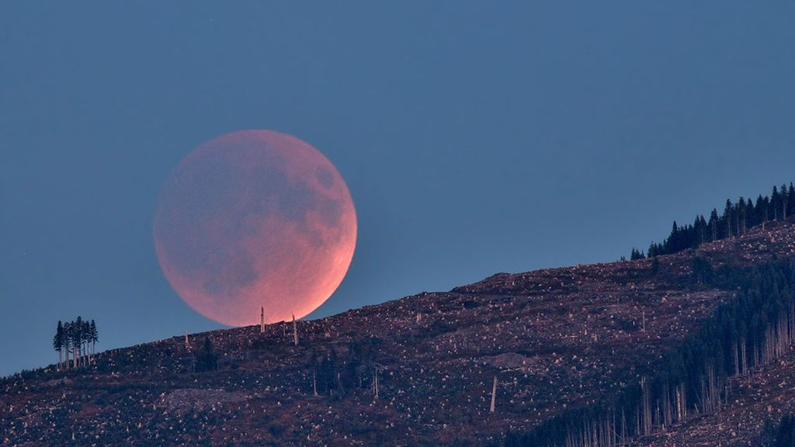
NASA/Sydney Rohde (Rocz) NASA's Nancy Grace Roman Space Telescope, encapsulated in its payload fairing, travels from the Payload Hazardous Servicing Facility to the SpaceX hangar at Launch Complex 39A at NASA's Kennedy Space Center on Tuesday, Aug. 25, 2026, ahead of mating to a SpaceX Falcon Heavy rocket. Roman's science instruments are designed to help researchers understand dark energy, the mysterious force accelerating the universe's expansion. The observatory also will map how galaxies form, cluster, and evolve by tracing the influence of dark matter. Liftoff from NASA Kennedy is targeted no earlier than Sunday, Aug. 30, 2026. Image credit: NASA/Sydney Rohde (Rocz)

6. NASA Johnson Pilots Chase Moon's Shadow for Eclipse Science
Read more
NASA's WB-57F aircraft prepares for takeoff from Ellington Field in Houston ahead of its mission to observe the Aug. 12, 2026, total solar eclipse from Iceland. From left are John Gustine, NASA WB-57F pilot, and Cary Klemm, sensor equipment operator for NASA's WB-57F. NASA/Robert Markowitz During the Aug. 12 total solar eclipse over Europe, scientists aimed to study a long-standing mystery: why the Sun's outer atmosphere, the corona, is far hotter than its visible surface. Capturing the data they needed meant being in exactly the right place at the right time. Pilots from NASA's Johnson Space Center flew the WB-57F high altitude research aircraft from Ellington Field in Houston to Iceland, their base for flying through the path of totality to give scientists a clearer view of the Sun's corona. A total solar eclipse provides a unique opportunity to examine the corona because the Moon temporarily blocks the Sun's bright surface, revealing its fainter outer atmosphere. Observations collected during this brief window can help scientists better understand how energy and material move through the corona and away from the Sun, improving our understanding of space weather. John Gustine, NASA WB-57F pilot, prepares for flight at Ellington Field in Houston ahead of the aircraft's departure for Iceland to support the Aug. 12 total solar eclipse. NASA/Robert Markowitz At about 50,000 feet, the WB-57F flew above most clouds, dust, and water vapor that can interfere with observations from the ground. The altitude reduced atmospheric interference while also allowing the science instruments to observe infrared wavelengths that are largely absorbed lower in Earth's atmosphere. Capturing those observations required careful coordination between scientists and the flight crew. Before the mission, teams calculated where the aircraft needed to be as the Moon's shadow moved across the North Atlantic. "Going into a mission like this takes a huge team. It starts with the science team establishing the requirements, and then we work closely with them for months leading up to the mission," said Tom Parent, NASA WB-57F pilot. "We rely heavily on our maintenance team to get the instruments serviced, prepared, loaded onto the aircraft, and flight tested. It's a huge team effort to get an aircraft like this up there to image and achieve these objectives." NASA's WB-57F aircraft takes off from Ellington Field in Houston ahead of its mission supporting the Aug. 12 total solar eclipse from Iceland. NASA/Robert Markowitz During totality, NASA WB-57F pilot John Gustine positioned the aircraft along the eclipse path to maximize time in the Moon's shadow and give scientists as much opportunity as possible to collect data. From the back seat, Cary Klemm, sensor equipment operator for NASA's WB-57F, controlled the camera systems, adjusting focus and exposure times while tracking features of interest throughout totality. With the cameras capturing observations throughout the brief window, every second mattered. "Every image is another piece of data that could reveal something new about the Sun," Klemm said. What scientists can learn from those observations reaches far beyond the eclipse itself. The Sun's corona is made of plasma shaped by magnetic fields, and many of the same physical processes occur elsewhere in the universe. "The NASA WB-57F's unique capabilities of high-altitude flight were truly crucial in providing access to these valuable wavelengths during an eclipse whose path crossed mostly over the ocean in an area where clouds are common," said Amir Caspi, principal investigator for the study at Southwest Research Institute in Boulder, Colorado. "We could not have achieved this success without this platform, and all of the efforts of the many intrepid ground, air, and science crew members." Members of NASA's WB-57F eclipse mission team gather at Ellington Field in Houston ahead of the aircraft's departure for Iceland. NASA/Robert Markowitz The data gathered during the flight will give scientists another opportunity to investigate the Sun and the processes that influence the space environment around Earth. View images and videos from NASA's eclipse mission.

7. NASA Sets Spacewalk for Station Maintenance, Live Coverage Planned
Read more
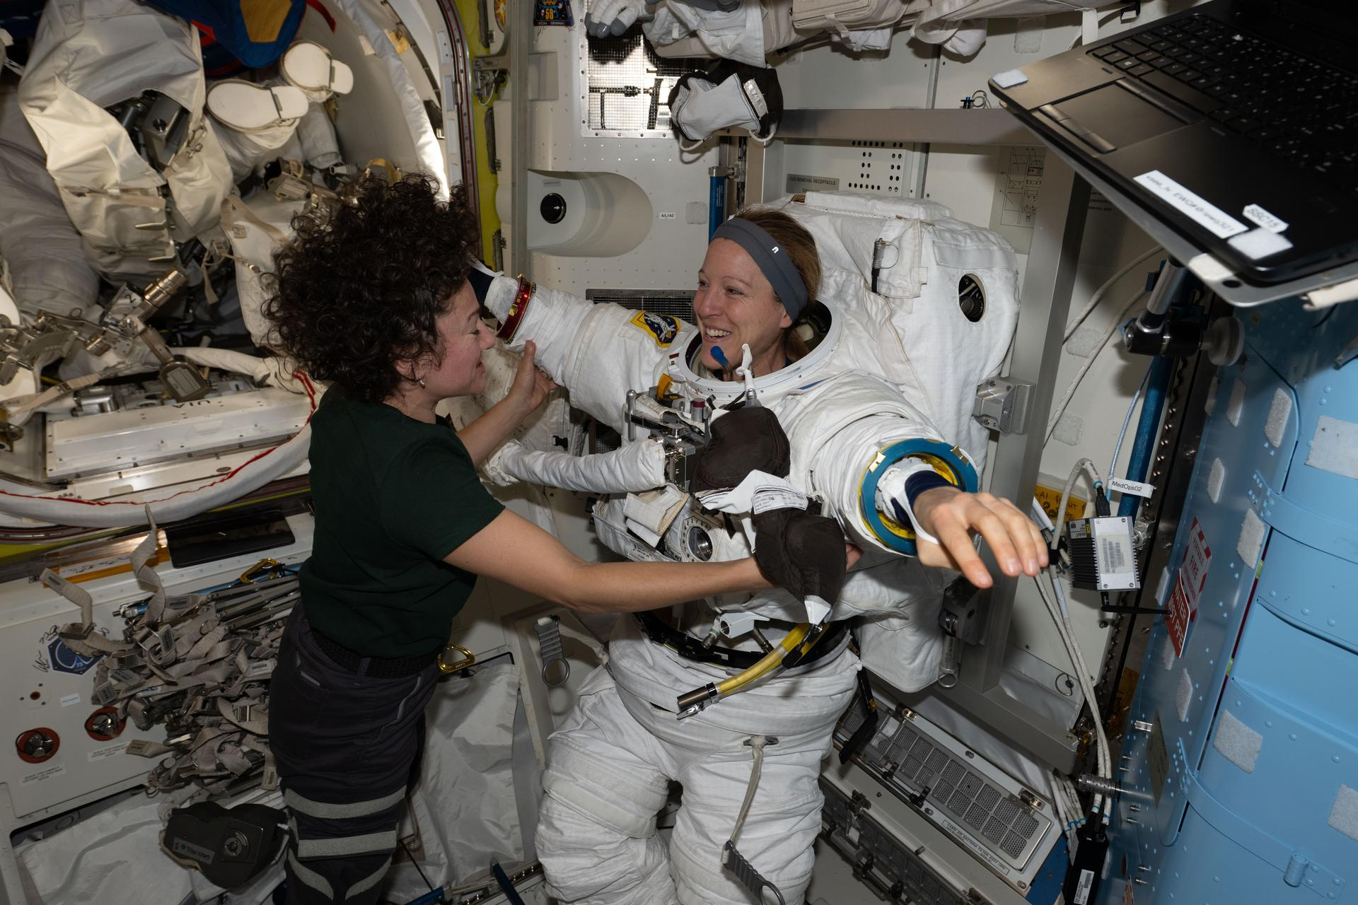
NASA astronaut Jessica Meir and ESA (European Space Agency) astronaut Sophie Adenot work together inside the International Space Station's Quest airlock during spacesuit fit and leak checks. Credit: NASA NASA will provide coverage as two astronauts step outside the International Space Station on Tuesday, Sept. 1, to replace a spacecraft navigational aid and complete several maintenance tasks in support of space station operations. Watch live coverage beginning at 7 a.m. EDT. The spacewalk is expected to start at approximately 8:30 a.m. and last about six and a half hours. NASA's spacewalk coverage will stream through a variety of platforms. Learn where to watch online: https://nasa.gov/live During U.S. spacewalk 99, NASA astronaut Jessica Meir and ESA (European Space Agency) astronaut Sophie Adenot will replace a retroreflector on the forward port of the space station's Harmony module to support spacecraft navigation during rendezvous and docking operations. After installing the reflector, the crew will work to install jumper cables for the data-relay systems, prepare the Alpha Magnetic Spectrometer's radiator for future maintenance, and replace a high-definition camera on the station's truss. Adenot will serve as spacewalk crew member 1 and will wear a suit with red stripes. Meir will serve as crew member 2 and will wear an unmarked suit. This will be Meir's seventh spacewalk and Adenot's third. Meir will move into third all-time for total spacewalks among women at NASA, trailing Peggy Whitson (10) and Suni Williams (9). The excursion also marks the 284th spacewalk supporting space station assembly, maintenance, and upgrades. To learn more about International Space Station research, operations, and its crews, visit: https://www.nasa.gov/station -end- Jimi Russell Headquarters, Washington 202-358-1100 james.j.russell@nasa.gov Sandra Jones / Anna Schneider Johnson Space Center, Houston 281-483-5111 sandra.p.jones@nasa.gov / anna.c.schneider@nasa.gov

8. NASA Begins Moon Mission Plume-Surface Interaction Tests
Read more
EDITOR'S NOTE: This story, originally published in December, was revised Aug. 26, 2026 with an update on a new phase of testing, including video from a recent test run and new images. To help NASA and commercial partners better understand the science of lunar landings, specifically the hazards that may occur when a lander's engine plumes blast away at lunar dust, soil, and rocks, a team at NASA's Langley Research Center in Hampton, Virginia, has initiated a series of plume-surface interaction tests inside a massive 60-foot spherical vacuum chamber. As NASA works to return humans to the Moon starting with Artemis IV in 2028 and develop a Moon Base, the tests will provide a trove of data for researchers to use to improve predictive models and influence the design of space hardware. "This plume-surface interaction ground test is the most complex test of its kind to be undertaken in a vacuum chamber," said Ashley Korzun, testing lead at NASA Langley. "If I'm in a spacecraft and I'm going to move all that regolith while landing, some of that's going to hit my lander. Some of it's going to go out toward other things - payloads, science experiments, eventually rovers and other assets. Understanding those physics is pivotal to ensuring crew safety and mission success." The campaign involves multiple NASA centers, academic institutions, and commercial entities both small and large. Korzun' s team will test two types of propulsion systems in the vacuum sphere. For the first round of tests, they are using an ethane plume simulation system designed by NASA's Stennis Space Center near Bay St. Louis, Mississippi, and built and operated by Purdue University. The ethane system generates a maximum of about 100 pounds of thrust - imagine the force necessary to lift or support a 100-pound person. It heats up but doesn't burn. The team recently began firing the system into a roughly six-and-a-half-foot diameter, one-foot-deep bin of simulated lunar regolith, called Black Point-1, that has jagged, cohesive properties similar to actual lunar regolith. A number of different instruments, including a version of the Stereo Cameras for Lunar Plume Surface Studies system that imaged the plume-surface interaction when Firefly's Blue Ghost Mission-1 landed on the Moon in 2025, are capturing data and imagery from the tests, which will only last about six seconds each. The instruments are measuring things such as crater formation, angle and height of the ejecta sheet, spatial distribution of solid ejecta, and the speed of the regolith particles as they get blasted out of the bin. A crew loads simulated lunar dirt into the test bin in the 60′ vacuum sphere. NASA/Rob Lorkiewicz Later this year, a second round of tests will involve a 14-inch, 3D-printed hybrid rocket motor developed at Utah State University in Logan, Utah, and tested at NASA's Marshall Space Flight Center in Huntsville, Alabama. It produces around 35 pounds of thrust, igniting both solid propellant and a stream of gaseous oxygen to create a hot, powerful stream of rocket exhaust, simulating a real rocket engine but at smaller scale for this test series. Researchers will test both propulsion systems at various heights. "It gives us a huge range of test conditions," Korzun said, "to be able to talk about spacecraft of all different kinds going to the Moon, and for us to understand what they're going to do as they land or try to take back off from the surface." Korzun sees this test campaign as more than a one-shot, Moon-specific thing. The entire operation is modular by design and also can prepare NASA for missions to Mars. The lunar regolith simulant can be replaced with a Mars simulant that's more like sand. Pieces of hardware and instrumentation can be unbolted and replaced to represent future Mars landers. Rather than take the vacuum sphere down to really low pressure like on the Moon, it can be adjusted to a pressure that simulates the atmosphere on the Red Planet. "Mars has always been in our road maps," Korzun said. But for now, the Moon looms large. Clockwise from left: Wesley Chambers, deputy principal investigator for the PSI tests from Marshall's Space Flight Center in Huntsville, Alabama; Ashley Korzun, test lead and principal investigator; Dave Lehotay, project manager; and Tylor Takahashi and Olivia Tyrrell, both from the SCALPSS instrument team, watch test footage in the control room. NASA/Rob Lorkiewicz "This test campaign is one of the most flight-relevant and highly instrumented plume-surface interaction test series NASA has ever conducted," said Daniel Stubbs, an engineer with the Human Landing Systems plume and aero environments team at NASA Marshall. "The data from these tests at NASA Langley will be critical in developing and validating models to predict the effects of plume-surface interaction for landing on the Moon and even Mars, ensuring mission success for the human landing systems and the safety of our astronauts." Through the Artemis program, NASA will send astronauts on increasingly complex missions to explore the Moon for scientific discovery, economic benefits, establish an enduring human presence on the lunar surface, and to build on our foundation for the first crewed missions to Mars. For more information about Artemis, visit: https://www.nasa.gov/artemis

9. Contractor to Civil Servant: NASA Welcomes Jeret Howard
Read more
Jeret Howard, logistics management specialist at NASA's Stennis Space Center near Bay St. Louis, Mississippi, poses for a photograph on July 27, 2026. Howard is now a NASA civil servant at Stennis as part of the administrator's directive to strengthen technical core competencies within the civil service workforce. NASA/Danny Nowlin At 17, Jeret Howard raised his right hand to serve his country as a United States Army combat medic in Iraq. This past summer, he raised his right hand again at NASA's Stennis Space Center near Bay St. Louis, Mississippi. Hired as a civil servant under the agency's workforce directive to restore core competencies by converting contractors to civil service, Howard's transition from long-time contractor to logistics management specialist represents a continuation of a life dedicated to national service. He has worked for more than 15 years at America's largest rocket propulsion test site as a mechanical technician, turning wrenches and building test stand infrastructure as a contractor. Now, he steps into a NASA role that carries deep personal meaning. "It is absolutely a continuation of service," said Howard. "It is a point of pride to go from being a 17-year-old just wanting to serve your country to coming full circle like this, hoping to one day retire from NASA." As a logistics management specialist, Howard's job is to secure necessary hardware and components for propulsion testing. He relies on years of technical experience to anticipate the needs of the engineering team. As he secures essential materials, Howard ensures taxpayer dollars are wisely spent. Howard's expertise is not confined to a desk as he actively works alongside new technicians and supports testing across multiple areas, including the build up to support Blue Origin's testing at NASA Stennis. "Mechanical work is a challenge," said Howard. "Everything is a puzzle. Even when it seems like it is going to be monotonous, there is always something new that comes up. It is a skill, and once you do it so much over the years and get really good at it, you do not want to waste it." Howard's motivation for public service is rooted in his home. A resident of Kiln, Mississippi, Howard views his career as a chance to lead by example and make his family proud. "My little girl can look at me, be proud, and know she can do anything," said Howard. This resonates just as strongly with his teenage son, who dreams of one day becoming a NASA engineer. Even as his son navigates physical challenges, the family's focus is entirely on his limitless potential. "We push him to not think about what he cannot do, but to focus on how much he can do," said Howard. The family balances drive with a "work hard, play hard" lifestyle by spending their free time riding dirt bikes and taking their boat out on the water. The hard work is paying off at a time in history when NASA is returning humans to the Moon through the Artemis program and building a Moon Base as humanity's first lunar outpost where astronauts will live, work, and explore near the Moon's South Pole. The future of spaceflight is a shared family passion for the Howards. When the Artemis II mission launched last April, the family set up a large tablet outside next to their boat, using its heavy-duty sound system to amplify the broadcast. "My daughter could feel the bass of the launch," said Howard. "I got chills." As Howard's work supports NASA and the commercial companies conducting propulsion test work at Stennis, the family is already anticipating the launch of Artemis III, a mission intended to demonstrate integrated operations before Artemis IV returns astronauts to the lunar surface. Howard's transition to a civil servant means he has a direct role with NASA. His work contributes to securing American leadership in space today, while inspiring the next generation of engineers, such as his son, into the future. For more information about NASA's Stennis Space Center, visit: www.nasa.gov/stennis

10. From spy satellite to space telescope: The unlikely origins of NASA's Roman Space Telescope
Read more
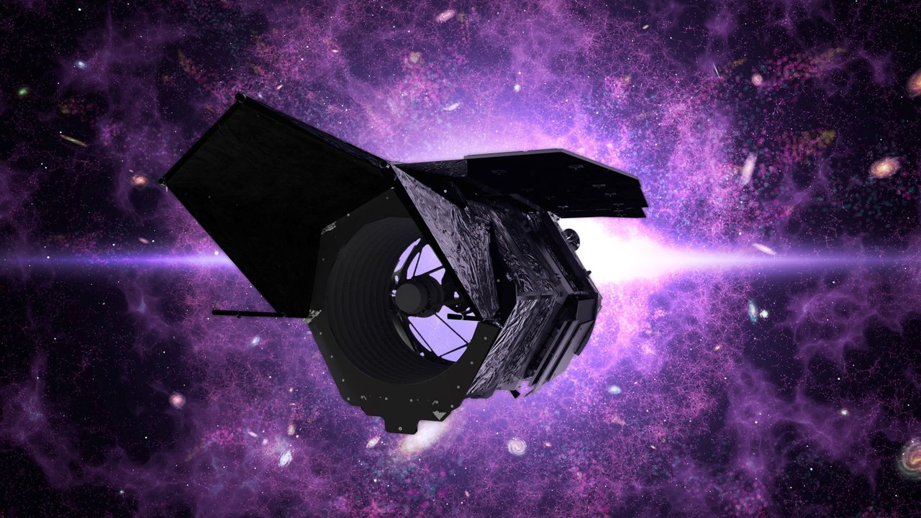
Click for next article NASA took the guts out of old spy satellites to build the groundbreaking Nancy Grace Roman Space Telescope - but how? And why? Years of hard work and anticipation are culminating as we sit on the verge of NASA's launch of its next-generation space telescope. Set to lift off this upcoming Sunday (Aug. 30) aboard a SpaceX Falcon Heavy rocket, the Roman Space Telescope will push astronomy into the future, exploring the mysteries of dark energy , studying far-off worlds and expanding our understanding of the universe around us. But to get to this point, NASA used some … unexpected technology. At the core of the observatory lies the Optical Telescope Assembly. This houses the telescope's primary mirror, its main mechanism through which it surveys the cosmos, nine additional mirrors, supporting structures and various sorts of electronics. But where did all of this tech come from? The National Reconnaissance Office (NRO), which builds spy equipment for U.S. agencies like the CIA. That's where. In 1999, the NRO stood up the multibillion-dollar "Future Imagery Architecture" program, which contracted out new spy satellites . The NRO contracted Boeing for the project, having the company design a whole suite of new optical and radar imaging reconnaissance satellites. They're basically spy satellites. In 2001, in a post-9/11 America, this effort continued to ramp up with national security concerns at an all-time-high. However, this flurry of spy satellite development was short-lived. And with billions of dollars in overrun costs from Boeing, the project closed in 2005. At the time, the New York Times called the program "perhaps the most spectacular and expensive failure in the 50-year history of American spy satellite projects." But one program's spectacular failure is another program's free space tech treasure. Years later, in 2012, the NRO donated two unused space telescopes from this program to NASA. With optics said to be similar to the Hubble Space Telescope 's, two free telescopes presented the agency with a tantalizing opportunity. This donation happened just a couple of years after Roman (then known as WFIRST) was originally proposed - and even though it would cost money to rework the hardware and build the rest of the space telescope out, this provided the possibility of a serious cost alleviation to the mission. After considering the possibility, the team decided it was the right call. And in 2011, years before Roman (WFIRST) was even formally designated as a mission by NASA, the agency announced that they would be reusing this spy satellite technology . This decision followed the 2010 National Academy of Science Astronomy and Astrophysics Decadal Survey, which pointed to Roman as its highest priority. While this donated spy satellite part came with top-tier optics , it was also free. The most recent space telescope to launch was the James Webb Space Telescope (JWST), which lifted off in 2018 but was in development since the mid-1990s. The JWST garnered significant public attention and scrutiny for being both well behind schedule and way over budget, ultimately costing a whopping $10 billion. Scientists working on the Roman Space Telescope. (Image credit: NASA/Sophia Roberts) As the JWST was grappling with these budget issues, Roman was already in development. So, it's not a shock that when a high-tech space telescope landed on their doorstep, NASA took full advantage of the opportunity, though the Roman team would still have to replace the electronics in the telescopes that the NRO removed. Thus, in the end, did the NRO telescopes actually save NASA money? It's not clear. Each donated telescope was said to be worth at least $250 million , but experts at the time of development were torn in their estimates for whether repurposing this old hardware would actually save or eat up costs in the end. A few quirks also came with the free hardware. In addition to having to replace the electronics and rework a telescope someone else built, the Roman team had to learn about the telescope with some, well, restrictions. When the details about the telescopes were given to the mission team, there were large chunks of information fully blacked out, the Washington Post reported at the time. But while the Roman team was handed something quite strange to work with, the mission has remained about as on schedule and on budget as we've seen with a space telescope of this magnitude. NASA still has the second telescope from the NRO, though the agency has not said what they might do with the equipment. However strange and unexpected this series of events may have been, it did result in a completed space telescope that now sits at the launch site, ready to uncover the mysteries of the universe. Join us this upcoming Sunday (Aug. 30) to see a telescope made with spy satellite tech travel beyond our planet.

11. Chance gaze at old Hubble Telescope image leads to discovery that could reveal dark matter's secrets
Read more
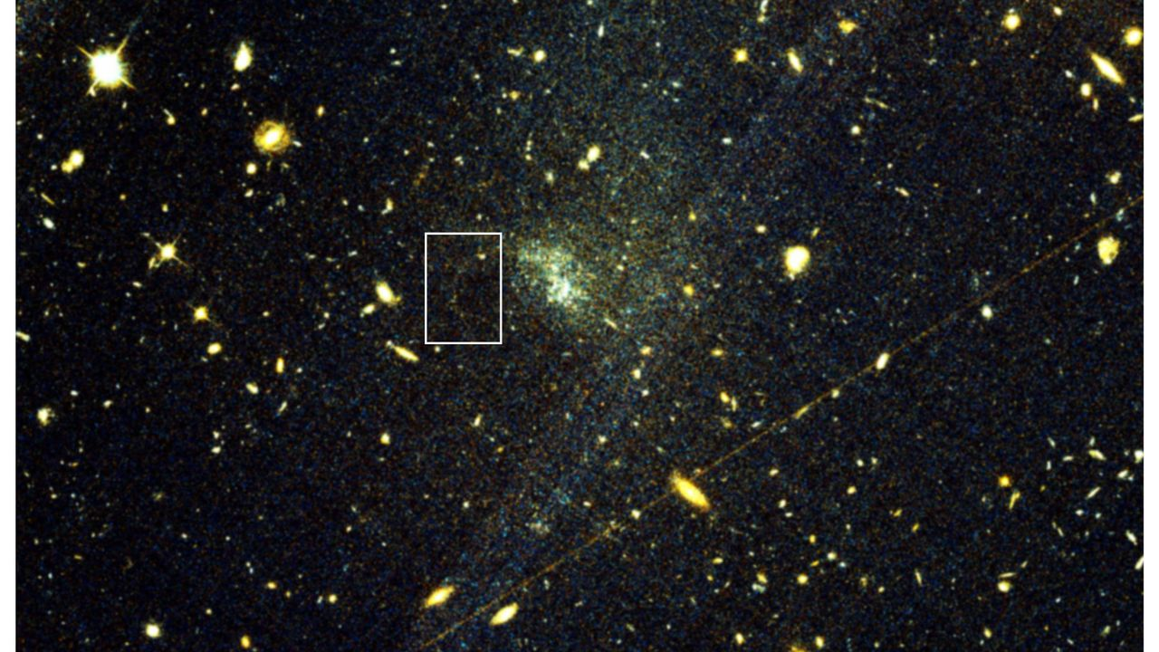
Click for next article In late June 2023, on a morning train commuting to work in New York City, David Hendel was scrolling through a recent astronomy paper on his phone when a half-page image caught his eye. The image, captured a year earlier by the Hubble Space Telescope , showed UGC 9050-Dw1, a dwarf galaxy some 115 million light-years from Earth . It appeared as little more than a faint, diffuse smudge of bluish-white light that astronomers call an ultra-diffuse galaxy - a type of galaxy so sparsely populated with stars that most of its mass is thought to be dark matter , the invisible substance that makes up more than 80% of the matter in the universe but has yet to be directly detected. What made Hendel pause was not the galaxy itself but a thin, fragile ribbon of stars trailing off from it, so dim it nearly disappeared among the other smudges of light crowding the frame. Hendel, a former astronomer who had studied thousands of similar structures, immediately recognized the subtle interplay of the arc's features, including the shared color of the stars and their curved trajectory pointing toward a tiny, matching bright knot along its track. Together, those clues matched a stellar stream tearing from a tight ball of stars called a globular cluster, pulled apart by the gravity of UGC 9050-Dw1. If Hendel's reading was correct, it would be the first such stream ever found outside the Milky Way . "It almost seemed too good to be true," Hendel told Space.com. "At this point I felt the excitement of a discovery to such a degree that I recall looking up and around the train for someone to tell!" This discovery would give researchers a pristine new laboratory for probing dark matter, and one far less contaminated by competing astrophysical forces that muddy similar searches within our own galaxy . Hendel, who now works in finance but still follows research from his former field, ran a quick literature search to see whether anyone had already documented the feature. No one had. The right person to tell was not on the train, of course. Before reaching his stop, Hendel took a screenshot, sketched a rough circle around the arc and sent it to Sarah Pearson, an associate professor of astrophysics at Technical University of Denmark's DTU Space, and his friend since their graduate school days at Columbia University. That message kicked off the collaborative effort that would ultimately confirm the find, led by Pearson and Julie Kiel Holm, a Ph.D. student at the Niels Bohr Institute at Denmark's University of Copenhagen. The team's paper gives the stream the name Oyashio (pronounced "oh-yah-shee-oh"), Japanese for a cold Pacific current, following a tradition of naming these faint stellar trails after bodies of water in Indigenous languages to honor cultures worldwide with long astronomical traditions, including in Australia, Chile and India. An image of the Hubble Space Telescope. (Image credit: NASA) Within the Milky Way, astronomers have so far identified roughly 100 stellar stream candidates shed by globular clusters, but finding one around another galaxy is extraordinarily rare. Streams that form when a whole dwarf galaxy is torn apart are relatively easy to spot, since they emerge in the sparse outskirts of a larger galaxy. But globular cluster streams form deep inside their host galaxy, where they are washed out by brighter, more crowded starlight. Oyashio's detection was possible in part because UGC 9050-Dw1's already-sparse stellar population meant a dimmer backdrop gave the stream just enough contrast to be seen, Holm told Space.com. Oyashio's discovery is "a very exciting step forward," Emily Cunningham, an assistant professor at Boston University who studies stellar streams and dark matter halos and was not involved in the new study, told Space.com. "Using techniques like those described in this paper, we will detect many more streams around other galaxies with upcoming observations from facilities such as the Vera Rubin Observatory and the Nancy Grace Roman Space Telescope." A sufficiently large catalog of such streams in different galactic environments would allow them to tease out the subtler perturbations that dark matter is predicted to cause at the smallest scales, the researchers say. "This is one of the most promising avenues for new astrophysical constraints on dark matter's nature," said Hendel. No Eureka! moment UGC 9050-Dw1 was first identified in 2017 in images taken by the Canada-France-Hawaii Telescope atop Mauna Kea in Hawaii, as part of a survey for diffuse dwarf galaxies. A follow-up study in 2023, drawing on the same Hubble images in which Hendel later spotted Oyashio, catalogued an "exceptionally high" population of globular clusters near the galaxy. Its authors concluded that UGC 9050-Dw1 likely formed from the merger of two comparably sized galaxies roughly 10 billion years ago, one gentle enough that gas from both survived and ignited a burst of star formation, which would also explain the clusters' uniform color. That 2023 study did not flag Oyashio. In the new study, Holm and her colleagues recovered Oyashio independently in archival data from both Hubble and the Canada-France-Hawaii Telescope, ruling out the possibility that it was an artifact of telescope imaging or subsequent data processing. The team then ran thousands of simulations, testing which combinations of globular cluster properties and dark matter distributions could reproduce the stream's observed brightness and shape. The best-fitting models produced new estimates of the UGC 9050-Dw1's total mass and how that mass is spread throughout it, suggesting the galaxy harbors far more dark matter than its sparse stellar population would imply, consistent with expectations for such a diffuse galaxy. A ring of dark matter (seen by the Hubble Space Telescope in false color), its location inferred from its gravity, around the galaxy cluster ZwCl0024+1652, which is 5 billion light-years away. (Image credit: NASA/ESA/M. Jee and H. Ford (Johns Hopkins University).) In the study, the team also weighs a range of alternative explanations and lays out why none quite fit the evidence. The arc could be, for instance, a chance alignment of unrelated stars, the product of gravitational lensing from a background galaxy, or a dusty region that happens to mimic a stream's shape. None of those scenarios, the team says, accounts on its own for the key pieces of evidence, chiefly the stars' consistent color, their alignment along a single curved track and that track's connection to what appears to be the globular cluster progenitor. "It was an interesting process in the sense that there wasn't a specific moment where we're like, 'Okay, now we know what it is,'" Holm told Space.com. "We started with the assumption that just by looking at it, it looks like it could be something. How many different ways can we try to prove that it can't be?" Still, in the interest of rigor, the team acknowledges it cannot fully exclude every alternative explanation. "There's still the possibility that some stars just randomly fall in this pattern," said Holm, "But again ... for all these things to line up as nicely as they do would require a lot of coincidence." Dark matter clues The payoff of that caution lies in what Oyashio can reveal about the universe's invisible scaffolding. As a globular cluster is shredded over billions of years, the stars it sheds fan out along its former orbit rather than scattering randomly, preserving, in effect, a pristine record of the gravitational forces that shaped them. If a clump of dark matter too small to host stars of its own - a "subhalo," in the language of cold dark matter theory - passes through that stream, its gravity can tug stream stars off course and carve out a gap. "Streams that form from globular clusters are particularly sensitive to these perturbations," said Cunningham. The challenge lies in isolating the cause, and one stream is not enough to draw firm conclusions about the astrophysical process responsible. Inside the Milky Way, any disturbance in a stream of stars could just as easily come from the galaxy's central bar of stars or from nearby dwarf galaxies falling into the Milky Way, like the Magellanic Clouds. UGC 9050-Dw1 has none of those features, so any gap found in Oyashio would stand as a more confident signature of dark matter at work, Holm said. "If a gap is observed in a single stream, it is very difficult to say for certain which astrophysical process is responsible," said Cunningham. "However, if we can build up a sufficiently large sample of streams in different galactic environments, we can start to disentangle these effects." "To do this, we need to look beyond the Milky Way," she added. New instruments coming online could help do just that. Astronomers are particularly excited for the launch of the Nancy Grace Roman Space Telescope , scheduled for launch Aug. 30 from the Kennedy Space Center in Florida, which has a field of view at least 100 times larger than Hubble's. In its five-year primary mission, with a possible five-year extension, Roman is expected to measure light from a billion galaxies, according to NASA . "You would be able to do this kind of research in different galaxies at once with the same exposure, basically," said Holm. She hopes Roman, along with the European Space Agency's Euclid space telescope, which launched in 2023, will turn up more galaxies like Oyashio, "so we can start to put together a more generalized image of how these things work and what they can tell us." Some of those discoveries could even come to light the way Oyashio did, as a product of pure scientific curiosity applied to data already sitting in an archive. Hendel said he read the 2023 paper mostly because he was intrigued by the team's conclusion that UGC 9050-Dw1 likely formed through a dwarf galaxy merger. "I had no aim when opening it except to satisfy my curiosity," he said. That he was able to spot a rare feature hiding inside an image collected for a completely different research project speaks to the value of the scientific community's long-standing practice of making data publicly available, Holm said. "Anyone can come along with another idea and actually find something also interesting with the same data that you didn't know was hiding in it," said Holm. "I think that's also a really cool part of this."

12. SpaceX's final Falcon 9 Starlink launch from Florida creates gorgeous 'jellyfish' over New York City (video)
Read more

Click for next article SpaceX's launch from Florida early this morning (Aug. 25) was memorable in more ways than one. The mission, which sent 29 Starlink internet satellites skyward from Cape Canaveral Space Force Station at 5:33 a.m. EDT (0933 GMT), was the 100th flight of 2026 for SpaceX's workhorse Falcon 9 rocket. It was also the 37th flight for this particular vehicle's first stage, setting a new reuse record for the company. And we learned a few hours after liftoff that it was also the last-ever Falcon 9 Starlink mission to fly from the Sunshine State. A SpaceX Falcon 9 rocket on the Starlink Group 10-49 mission passes by lower Manhattan and One World Trade Center just before dawn in New York City after launching from Cape Canaveral, Florida on Aug. 25, 2026, as seen from Hoboken, New Jersey. (Image credit: Getty Images) "From here on, Starlink missions out of Florida will fly on Starship . The West Coast team will continue regularly launching Starlink from Vandenberg [Space Force Base in California]," Kiko Dontchev, SpaceX vice president of launch, said via X this morning. "In the last seven years, Falcon has flown ~260 Starlink missions from the Cape … can't wait until we launch that and many more with Starship!" he added. Starship, which stands more than 400 feet (122 meters) tall, is the biggest and most powerful rocket ever built, and it's designed to be fully and rapidly reusable. Starship remains in the testing phase; SpaceX has conducted 13 test flights with the vehicle to date, all of them suborbital. Starship currently launches only from SpaceX's Starbase site in South Texas. But the company is already building pads for the giant rocket in Florida, and it announced today that it plans to break ground next year on Starbase Louisiana, which it says will be able to support thousands of Starship liftoffs per year. SpaceX thinks Starship will revolutionize spaceflight when it comes online. The company plans to phase out the Falcon 9 and its heavy-lift cousin, the Falcon Heavy , after that happens, so the final Falcon 9 Starlink launch from the West Coast may be coming relatively soon as well. The SpaceX Falcon 9 rocket launched from Florida with a batch of Starlink satellite onboard, passing by above New York City at 5:38 am ET. pic.twitter.com/Y8kYykAQK8August 25, 2026 The Falcon 9 made quite an impression on skywatchers during this morning's Starlink swan song from the Space Coast, creating a "jellyfish" in the sky visible to folks as far away as New York City. Indeed, some people in the Big Apple posted video of the Falcon 9 cruising over the city's famous skyline . The jellyfish effect is a regular feature of Falcon 9 missions that launch shortly before dawn or not long after dusk. During these windows, sunlight illuminates the rocket's expanding exhaust plume while the sky itself remains mostly dark. The buildout of the Starlink megaconstellation has driven Falcon 9's launch cadence to record highs over the past few years. In 2024 and 2025, for example, the rocket lifted off a total of 297 times, and 211 of those were Starlink flights. Seventy-seven of the 100 Falcon 9 launches this year have been Starlink missions.

