 |  | 

🌌 अंतरिक्ष समाचार | Space News
मंगलवार, १६/०६/२०२६ | Tuesday, 16/06/2026

1. ISRO successfully conducts 2nd integrated air drop test for Gaganyaan mission | Akashvani News - News On AIR
Read more
News On AIR | April 11, 2026 7:23 AM ISRO successfully conducts 2nd integrated air drop test for Gaganyaan mission The Indian Space Research Organisation (ISRO) has successfully conducted the second integrated air drop test (IADT-02) for the upcoming Gaganyaan mission at Sriharikota in Andhra Pradesh. The system is essential to ensure safe recovery of the crew module - the capsule in which astronauts sit during a human flight. After the module's release, a parachute system, comprising 10 parachutes, was deployed, helping the capsule decelerate to a safe splashdown speed. The IADT-02 follows the successful completion of the first IADT, which took place on August 24, 2025, at the Satish Dhawan Space Centre in Sriharikota. In the first IADT, a 4.8-tonne dummy crew module was dropped from a height of three km by a Chinook helicopter. Air drop tests recreate the last leg of a spacecraft's return to the Earth. An aircraft or helicopter drops the spacecraft from a height to test various systems under different scenarios. These are the deployment of the parachute system in case the mission is aborted mid-flight, system performance when one parachute fails to open, and the spacecraft's orientation and safety during splashdown. Union Minister Jitendra Singh congratulated the ISRO for successfully conducting the test. India's first human spaceflight will be launched from Sriharikota in 2027.

2. Jitendra Singh congratulates ISRO for successful completion of IADT-02 for Gaganyaan Mission - DD News
Read more
Union Minister Dr Jitendra Singh on Friday congratulated Indian Space Research Organisation (ISRO) for the successful completion of the Second Integrated Air Drop Test (IADT-02) for Gaganyaan, India's first human spaceflight mission scheduled for launch in 2027. He described the achievement as a significant milestone in preparing for the ambitious mission. Taking to social media platform X, Singh wrote, "Congratulations ISRO for the successful accomplishment of Second Integrated Air Drop Test (IADT-02) for Gaganyaan, India's first Human Space flight scheduled next year." He further noted, "The second Integrated Air Drop Test (IADT-02) was successfully conducted at Satish Dhawan Space Station, Sriharikota. This marks an important milestone towards the readiness for the Gaganyaan mission." India's first human spaceflight will be launched from Sriharikota in 2027. Although the mission has faced multiple delays due to its technological complexity, India has been developing the capabilities indigenously. Notably, such critical spaceflight technologies are closely guarded, and no country shares them. The government has allocated approximately Rs 10,000 crore for the Gaganyaan programme. The mission is now in its final phase, with the first crewed flight expected in the first quarter of 2027. Earlier, on April 8, ISRO Chairman V. Narayanan stated that all preparations for the uncrewed Gaganyaan missions are progressing smoothly. Speaking at the inaugural session of the 2nd International Conference on Smart Spacecraft Mission Operations, he said, "We are meeting just before the first uncrewed Gaganyaan mission. This is no ordinary mission but a crucial one for India. There will be three uncrewed missions before the final crewed launch. All activities for the first mission are progressing well, though challenges remain." The conference was also attended by former ISRO chiefs A.S. Kiran Kumar and S. Somanath, along with ISRO centre directors, students, and representatives from space startups. Meanwhile, India's human spaceflight preparations advanced further on April 4, as four selected astronauts began a high-altitude experiment in Ladakh under the "Mission Mitra" (Mapping of Interoperable Traits and Reliability Assessment). The programme aims to evaluate human performance in extreme environments. The astronauts, including Group Captain Shubhnashu Shukla and P. Balakrishnan Nair, arrived in Leh earlier this week for acclimatisation. The mission is supported by a multidisciplinary team of scientists, engineers, medical experts, and psychologists, marking another crucial step in India's journey towards human space exploration. -IANS

3. G20 satellite is expected to be launched in 2027: ISRO Chairman - News On AIR
Read more
ISRO Chairman V. Narayanan has said that the G20 satellite, designed to study climate and air pollution and monitor weather, is expected to be launched in 2027. He said India is the first country to succeed in placing more than 100 satellites using a single rocket without any collision. Dr Narayanan was addressing scientists from DRDO, ISRO, and the Aeronautical Society of India at the Engineering Staff College of India in Hyderabad yesterday. He said India is taking the lead role in the launch of the G20 satellite for the G-20 countries. Dr Narayanan said ISRO is working towards sending a human to the moon by 2040. He said if ISRO makes it happen by 2040, India will be on par with any other space-faring nation in terms of launcher technology, satellite technology, application area, and human space flight program. According to Dr Narayanan, ISRO is in the process of making a 2.2 metre diameter, 100 mm thick titanium vessel for Samudrayaan, a project for the Deep Ocean Mission.

4. Collaborating with DAE to develop lander that can survive on Moon for 200 days: Isro chief - The Times of India
Read more

Collaborating with DAE to develop lander that can survive on Moon for 200 days: Isro chief The Times of India

5. After two failed bids, ISRO to attempt another PSLV launch by June-end, early July - The Indian Express
Read more
The space agency has not conducted any launches since its last PSLV failed to put the earth observation satellite, EOS-N1, in orbit in January this year. (File image) After back-to-back failure of its workhorse launch vehicle, the Indian Space Research Organisation (ISRO) is likely to attempt another PSLV launch soon. "As for PSLV, we are planning by the end of June or beginning of July," said Union Science Minister Dr Jitendra Singh on Monday, on the sidelines of an event to celebrate 12 years of the PM Narendra Modi-led government. The space agency has not conducted any launches since its last PSLV failed to put the earth observation satellite, EOS-N1, in orbit in January this year. Earlier, in May 2025, the launch vehicle failed to put earth observation satellite EOS-09 in orbit. Both the rockets failed in their third stage.

6. Isro building lander to function on the Moon for 200 days, survive freezing nights - India Today
Read more
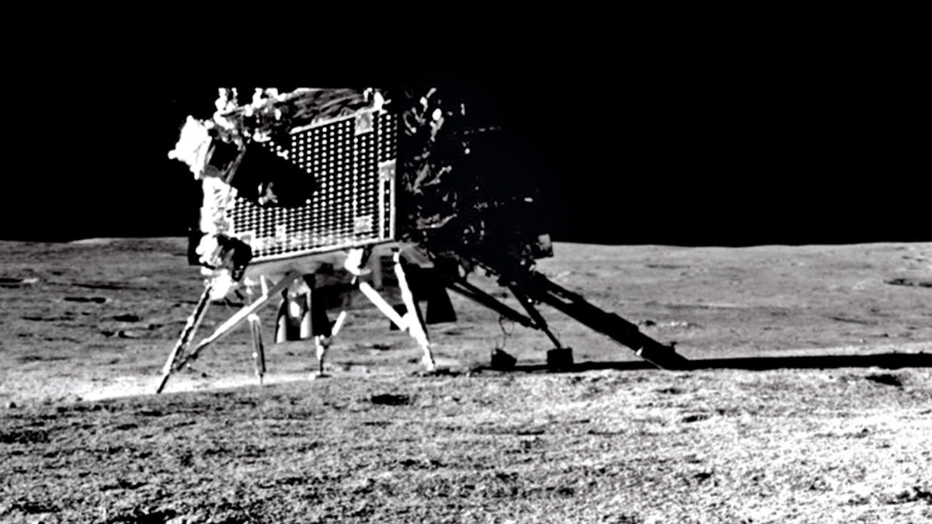
India's next generation of lunar landers could remain operational on the Moon for up to 200 days, a dramatic leap from the roughly 14-day lifespan achieved by the Chandrayaan-3 mission, according to Indian Space Research Organisation (Isro) Chairman V. Narayanan. The ambitious effort, being carried out jointly by Isro and the Department of Atomic Energy (DAE), is focused on solving one of the biggest challenges in lunar exploration: surviving the Moon's long and bitterly cold nights. Read Full Story Isro Chief V Narayanan said scientists are developing technologies that would allow future Indian landers to continue functioning through multiple lunar day-night cycles. If successful, the breakthrough could significantly enhance India's scientific capabilities on the lunar surface and pave the way for more complex missions in the future. The challenge stems from the unique environment on the Moon. A single lunar day lasts about 14 Earth days and is followed by an equally long lunar night. During the lunar day, spacecraft can rely on solar panels for power generation. However, once darkness sets in, temperatures can plunge to as low as minus 180 degrees Celsius in some regions, while solar power generation comes to a complete halt. This was the limitation faced by Chandrayaan-3's Vikram lander, which made history on August 23, 2023, by becoming the first spacecraft to successfully land near the Moon's South Pole. Although the mission exceeded expectations during the lunar daytime, the onset of the lunar night led to a loss of power and ended surface operations. HOW IS ISRO BUILDING THE NEXT LANDER? To overcome this hurdle, Isro and DAE are developing artificial heating systems capable of keeping spacecraft electronics, batteries and scientific instruments warm enough to survive the extreme cold. "We are going to develop artificial heaters. If we succeed, such landers can survive for 100 to 200 days instead of only 14 days," Narayanan said. The ability to survive multiple lunar nights would be a major milestone for India's space programme. It would allow landers and rovers to collect far more scientific data, monitor long-term environmental changes and conduct extended experiments in the Moon's harsh environment. The development comes as India continues to expand its ambitions in space exploration. Earlier this month, the Indian National Space Promotion and Authorisation Centre (IN-SPACe) selected three Indian space startups, Astrobase Space Technologies, SatSure Analytics India and TM2SPACE Technologies, as the first beneficiaries under its Technology Adoption Fund scheme, aimed at accelerating innovation in the country's growing private space sector. For Isro, a lander capable of surviving months on the Moon could represent the next giant leap after Chandrayaan-3's historic success. India is already developing Chandrayaan-4 mission, which is expected to become India's first mission designed to collect lunar samples and return them to Earth, a complex technological step beyond the soft-landing success of Chandrayaan-3 in 2023. - Ends

7. NASA Astronauts to Answer Questions from New Jersey Students
Read more
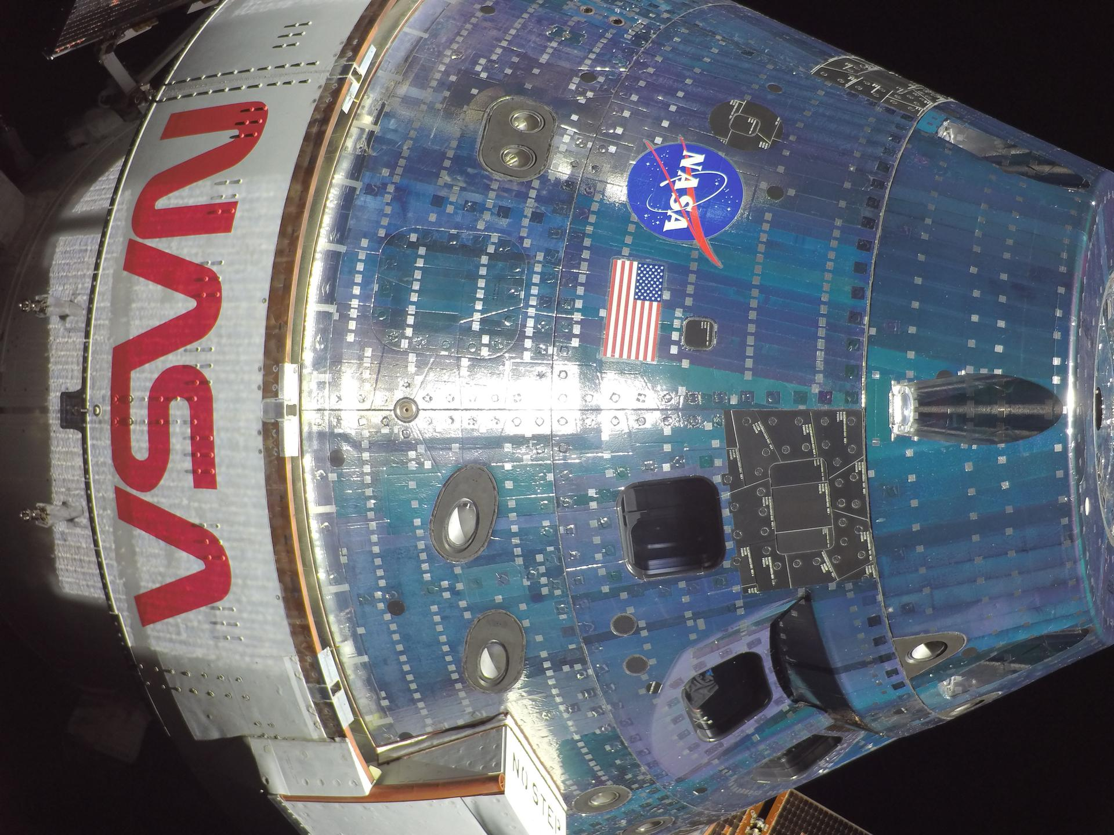
NASA astronauts Jessica Meir and Chris Williams collect frozen research samples while living and working aboard the International Space Station. Credit: ESA/Sophie Adenot Students in New Jersey will hear from NASA astronauts Chris Williams and Jessica Meir as they answer prerecorded STEM questions while aboard the International Space Station. The Earth-to-space call will begin at 12:05 p.m. EDT, Thursday, June 18, and will stream live on the agency's Learn With NASA YouTube channel. This event is hosted by Newton Public Schools in Newton, New Jersey, for students in grades K-12 and members of the community. This unique opportunity aims to deepen understanding of space exploration and enhance awareness of STEM careers. Media interested in covering the event must RSVP no later than 5 p.m. EDT, Wednesday, June 17, to Dr. Joseph Piccirillo at: 973-383-7392, x4229 or jpiccirillo@newtonnj.org. For more than 25 years, astronauts have continuously lived and worked aboard the space station, testing technologies, performing science, and developing skills needed to explore farther from Earth. Astronauts communicate with NASA's Mission Control Center in Houston 24 hours a day through SCaN's (Space Communications and Navigation) Near Space Network. Research and technology investigations taking place aboard the space station benefit people on Earth and lay the groundwork for other agency deep space missions. As part of NASA's Artemis program, the agency will send astronauts to the Moon to prepare for future human exploration of Mars, inspiring the world through discovery in a new Golden Age of innovation and exploration. For more information on NASA in-flight calls, visit: https://www.nasa.gov/stemonstation

8. NASA's SpaceX CRS-34 Dragon Returns Packed with Space Station Science
Read more
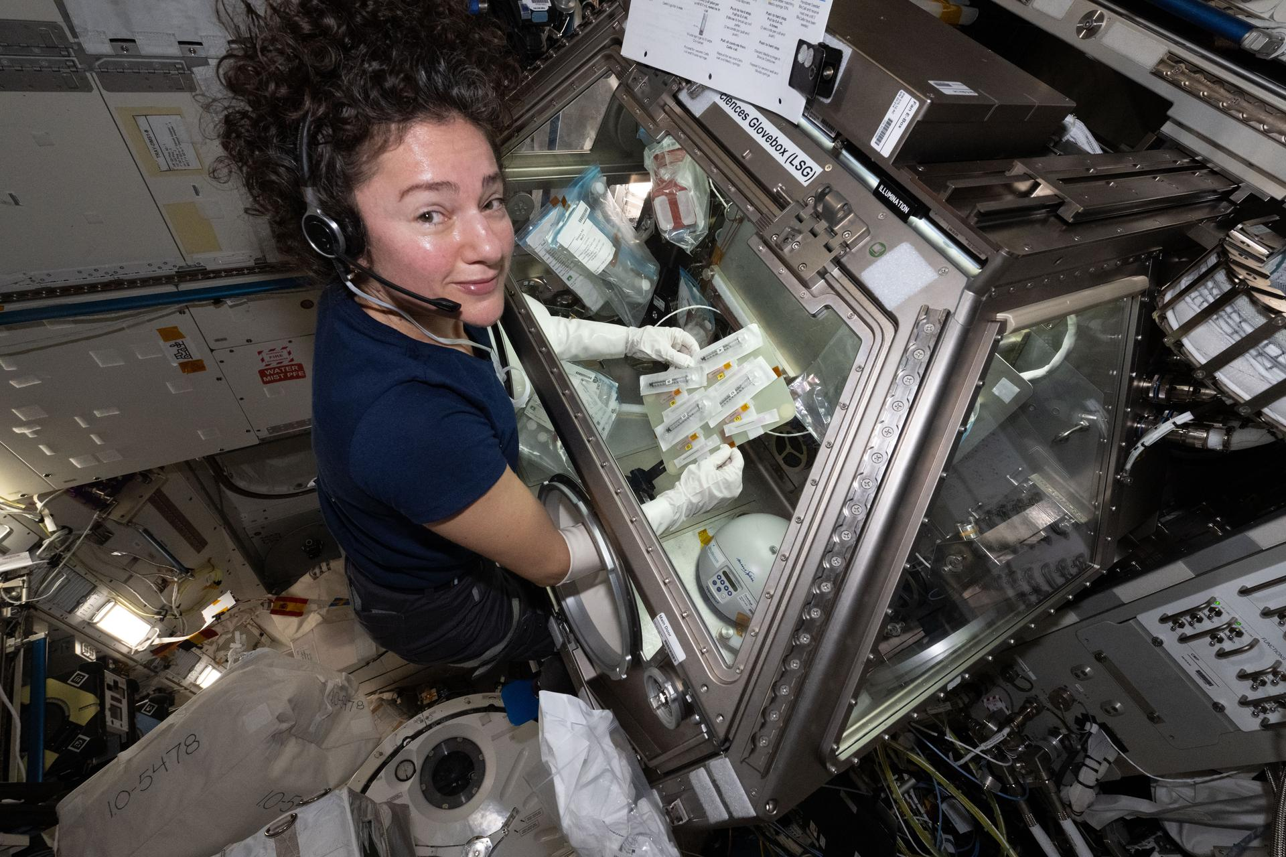
Scientists await a big splash in the Pacific Ocean as one of the most research-packed Dragon spacecraft to date returns, completing the 34th SpaceX commercial resupply mission to the International Space Station for NASA. Biological and materials samples, along with tested hardware, are heading back to research teams on Earth for further analysis, advancing NASA's work to prepare humans for exploration beyond low Earth orbit and to deliver benefits back home. Tiny cells, huge health insights NASA astronaut Jessica Meir prepares samples in the Life Sciences Glovebox to study how weightlessness affects crew blood clotting and immune function for the Megakaryocyte Flying-One investigation. NASA Some samples returning are for NASA's Hematopoietic Stem Cell Expansion in Space: Pathfinder Investigation (InSPA-StemCellEX-H2), which seeks to use the microgravity environment to scale up the production of stems cells. On Earth, lab-produced blood stem cells lose their ability to form different cell types, like red and white blood cells that are critical to treating patients with certain blood diseases and cancers. In microgravity, researchers believe this ability will be better preserved while also growing these stem cells in greater numbers. The returning samples will undergo further analysis to determine if space-based efforts produce larger quantities of enhanced stem cells suitable for clinical use. The team behind NASA's Streptococcus pneumoniae (Spn) Infection of Cardiac Tissue (MVP Cell-09) experiment is awaiting the return of stem cell-derived heart tissues that were intentionally infected with a pneumonia-causing bacterium as part of ongoing microgravity research. Pneumonia increases the risk of heart disease, which is not fully understood. Because bacteria tend to become more active and virulent in microgravity, this experiment could amplify their effects, making it possible to detect cellular responses that cannot be observed on Earth. NASA's Megakaryocyte Flying-One (MeF1) samples are returning to Earth to help understand how large cells found in bone marrow, known as megakaryocytes, and the platelets they produce adapt to spaceflight. Megakaryocytes and platelets play important roles in the formation of blood clots and immune responses. The returning samples, including those taken from astronauts, could show us how the human immune system reacts aboard the space station and help prepare for future exploration missions. Driving design enhancements NASA astronaut Mike Fincke and JAXA (Japan Aerospace Exploration Agency) astronaut Kimiya Yui work on hardware for the Zero Boil-Off Tank investigation. NASA Many spacecraft use cryogenic fuels for propulsion, but temperature swings in space can cause these extremely cold fuels to slowly evaporate and escape their tank, reducing fuel efficiency and complicating mission planning. NASA's Zero Boil-Off Tank Noncondensables (ZBOT-NC) investigation aboard station studies how gases that do not condense into liquids at cold temperatures affect pressure control and fluid behaviors in propellant tanks. Hardware returning aboard Dragon, including drives containing fluid-physics data, could help validate models and contribute to the design of more efficient cryogenic fuel storage systems for long-duration missions. Semiconductor research samples as part of NASA's In-Space Production of Semimetal-Semiconductor Composite Bulk Crystals in Microgravity (SUBSA-InSPA-SSCug) investigation are returning to Earth for further analysis. This study manufactured semimetal-semiconductor composite alloy crystals in space, which have applications in many electronics, including sensors and lasers. Researchers believe microgravity could enable the production of significantly greater and higher-quality crystals, supporting the development of next-generation semiconductor technologies. Innovative medical research mix Stem cells grown along a DNA-inspired nanomaterial on space station as part of DNA Nano Therapeutics-Mission 2, a percussor to DNA Nano Therapeutics-3. University of Connecticut NASA's DNA Nano Therapeutics-3 research team will receive tiny, space-assembled DNA-inspired materials that are combined with medicines to create active cancer treatments. Producing these treatments in microgravity can improve how well they perform in the body. This research could improve patient outcomes by helping therapies reach tumors more effectively, stay in the body longer, and improve medicine release. Tissue models of the brain, heart, liver, and kidney that were tested with novel RNA-based medicines as part of NASA's InSPA-Sachi Nanoligomer investigation are also returning. Microgravity can accelerate aging and disease processes, giving researchers a unique environment to better observe how well these new drugs work on different organs ahead of clinical trials. The left image shows various wood-derived products of different shapes, and the right image shows a sample of this same material in a laboratory setting on Earth. These products may have applications in the medical field by providing scaffolding for patients with fragile bones. GreenBone Ortho Samples from ESA's (European Space Agency) Green Bone investigation are returning to Earth to help understand how bone cells grow and develop on a new scaffold made from wood. Designed to mimic real bone, this scaffold was tested in microgravity to understand its ability to heal defects and fractures. Because living in microgravity simulates conditions like osteoporosis, a skeletal disorder which affects millions of people worldwide, the results could help treat patients with these fragile bone conditions. NASA's 3D Bone Marrow Analog research team will analyze the returning 3D-printed tissues that mimic parts of the bone marrow. Spaceflight can cause aging-like changes, including bone and muscle loss. To investigate potential countermeasures, these tissue models were exposed to small vibrations aboard the space station to simulate exercise. After the samples return to Earth, researchers will measure bone-like mineral formations and observe cellular and genetic changes. Findings from this investigation could help develop new strategies to maintain astronaut bone and muscle health during future long-duration missions. In the United States, more than 900,000 knee cartilage injuries occur annually, with many requiring surgery. NASA's InSPA-Auxilium Bioprinter-Cell Printing is investigating how to treat these injuries and is returning 3D-printed cartilage tissue samples from space station. This investigation uses the orbiting laboratory's unique microgravity environment to bioprint cartilage tissues with more evenly distributed cells compared to those printed on Earth. The results could help produce higher-quality cartilage prints to treat joint injuries.

9. NASA Astronaut Anil Menon Available for Prelaunch Virtual Interviews
Read more

NASA astronaut and International Space Station Expedition 74/75 flight engineer Anil Menon poses for a portrait at NASA's Johnson Space Center in Houston. NASA/James Blair NASA astronaut Anil Menon will be available for limited media interviews beginning at 9 a.m. EDT Monday, June 22, to discuss his upcoming mission to the International Space Station as part of Expeditions 74/75. The virtual interviews will take place from the Gagarin Cosmonaut Training Center in Star City, Russia, and will stream live on the agency's YouTube channel. Media interested in participating must submit a request to the newsroom at NASA's Johnson Space Center in Houston no later than 5 p.m. Wednesday, June 17, by emailing jsccommu@mail.nasa.gov. A copy of NASA's media accreditation policy is online. Menon is scheduled to launch to the space station Tuesday, July 14, from the Baikonur Cosmodrome in Kazakhstan aboard the Roscosmos Soyuz MS-29 spacecraft with Roscosmos cosmonauts Pyotr Dubrov and Anna Kikina. The trio will spend about eight months aboard the orbiting laboratory before returning to Earth in spring 2027. During his expedition, Menon will conduct scientific investigations and technology demonstrations to help humans prepare for future exploration missions to the Moon and Mars, and to provide benefits on Earth. Among the hundreds of experiments planned during his mission, he will participate in studies to better understand astronaut vein structure, blood flow, and blood composition in microgravity. He also will test producing intravenous fluids using the space station's potable water. The Soyuz MS-29 mission will be his first spaceflight after he was selected as part of NASA's 2021 astronaut class. A native of Minneapolis, Menon is an emergency medicine physician, mechanical engineer, and colonel in the United States Space Force. He also has served as an expedition flight surgeon supporting the agency's crew members aboard the space station. For more than 25 years, people have lived and worked continuously aboard the International Space Station, advancing scientific knowledge and making research breakthroughs not possible on Earth. The space station helps NASA understand and overcome the challenges of human spaceflight, expand commercial opportunities in low Earth orbit, and build on the foundation for long-duration missions to the Moon, as part of the Artemis program, and to Mars. To learn more about International Space Station research, operations, and its crews, visit: https://www.nasa.gov/station -end- Jimi Russell Headquarters, Washington 202-358-1100 james.j.russell@nasa.gov Anna Schneider / Mary Pfister Johnson Space Center, Houston 281-483-5111 anna.c.schneider@nasa.gov / mary.m.pfister@nasa.gov

10. Experience the Launch of NASA's Roman Space Telescope
Read more

Are you ready for a new view of the universe? The Nancy Grace Roman Space Telescope will reveal distant worlds, dark energy, and the structure of the cosmos, and we want you to be a part of it! Digital creators and social media users are invited to register to our NASA Social for the Nancy Grace Roman Space Telescope launch. Roman is NASA's next flagship astrophysics mission, designed to explore everything from our outer solar system to the edge of the observable universe. This mission is scheduled to launch on Aug. 30, 2026, aboard a SpaceX Falcon Heavy rocket from Launch Complex 39A at NASA's Kennedy Space Center in Florida. Are you passionate about social media and communications? Do you love to create content for an audience? Are you a fan of new, unique experiences? If you said yes, this NASA Social event is for you! This is your opportunity to be on the front lines of this historic mission. The NASA Social event will take place over two days, including the day of launch. A maximum of 50 digital creators will be selected to attend this two-day event and will be given access similar to news media. NASA Social participants will have the opportunity to: Tour NASA's Kennedy Space Center Learn directly from astrophysics subject matter experts Meet fellow digital creators and social media users Spend time with members of NASA's social media team View the launch of the Nancy Grace Roman Space Telescope NASA Social events are intended for members of the public. Current or former NASA civil servants, NASA contractors, NASA interns, and individuals or organizations currently under contract to provide products or services to NASA are not eligible to apply or participate in NASA Social events. NASA Social registration for the Roman launch opens on this page on Monday, June 15 and the deadline to apply is at 11:59 p.m. EDT on Sunday, June 28. All applications will be considered on a case-by-case basis. APPLY NOW Do I need to have a social media account to register? Yes. This event is designed for people who: Actively use multiple social networking platforms and tools to disseminate information to a unique audience. Regularly produce new content that features multimedia elements. Have the potential to reach a large number of people using digital platforms. Reach a unique audience, separate and distinctive from traditional news media and/or NASA audiences. Must have an established history of posting content on social media platforms. Have previous postings that are highly visible, respected, and widely recognized. Users are encouraged to follow @NASARoman for Roman updates on X, Facebook, and @NASAGoddard and @NASAUniverse on Instagram. Updates and information about the event will be shared on X via @NASA_Events How do I register? Registration for this event opens Monday, June 15 and closes at 11:59 p.m. EDT on Sunday, June 28. Registration is for one person only (you) and is non-transferable. Each individual wishing to attend must register separately. Each application will be considered on a case-by-case basis. Can I register if I am not a U.S. citizen? Yes, this event is open for all to apply. When will I know if I am selected? After registrations have been received and processed, an email with confirmation information and additional instructions will be sent to those selected. We expect to send the first notifications on July 17 and waitlist notifications on July 22. What are NASA Social credentials? All NASA social applications will be considered on a case-by-case basis. Those chosen must prove through the registration process they meet specific engagement criteria. If you do not make the registration list for this NASA Social, you still can attend the launch off site and participate in the conversation online. Find out about ways to experience a launch at https://www.nasa.gov/kennedy/see-a-launch-up-close/. What are the registration requirements? Registration indicates your intent to travel to NASA Kennedy and attend the two-day event in person. You are responsible for your own expenses for travel, accommodation, food, and other amenities. The schedule of events and special guest appearances are subject to change without notice. NASA is not responsible for loss or damage incurred as a result of attending. NASA, moreover, is not responsible for loss or damage incurred if the event is canceled with limited or no notice. Please plan accordingly. Kennedy is a government facility. Those who are selected may need to complete additional steps to receive clearance to enter the secure areas. IMPORTANT: Those without proper identification cannot be admitted. For United States Citizens: You will be required to present a REAL ID compliant identification or valid U.S. passport PLUS one of the following: Acceptable documents to accompany federal or state identification: U.S. Passport Unexpired Employment Authorization Card (Form I-688A) Unexpired Employment Authorization Document issued by DHS that contains a photograph (Form I-688B) Driver's license or ID card issued by a state or outlying possession of the United States provided it contains a photograph or information such as name, date of birth, gender, height, eye color, and address ID card issued by federal, state, or local government agencies or entities, provided it contains a photograph or information such as name, date of birth, gender, height, eye color, and address School ID card with a photograph Voter's Registration Card Military Dependent's ID Card U.S. Military card or draft record U.S. Coast Guard Merchant Mariner Card Native American Tribal Document U.S. Social Security Card issued by the Social Security Administration (other than a card stating it is not valid for employment) Original or Certified copy of birth certificate issued by a state, county, municipal authority, or outlying possessions of the United States bearing an official seal U.S. Citizen ID Card (Form I-197) ID Card for use of Resident Citizens of the United States (Form I-179) Unexpired employment authorization document issued by DHS (other than those listed previously) For Foreign Nationals: Same items required of U.S. Citizens (SSN only when applicable) Unexpired foreign passport, with I-551 stamp or attached Form I-94 indicating unexpired employment authorization Passport number and registration date Citizenship Driver's license issued by a Canadian Government authority For Legal Resident Aliens: Same items required of U.S. Citizens, and: Permanent Resident Card or Alien Registration Receipt Card with photograph (Form I-551) Unexpired Temporary Resident Card (Form I-688) Certification of Birth Abroad issued by the Department of State (Form FS-545 or Form DS-1350) The REAL ID Act was passed by Congress in 2005 to establish minimum security standards for state-issued driver's licenses and identification cards. All registrants must be at least 18 years old. What if the launch date changes? Hundreds of different factors can cause a scheduled launch date to change multiple times. The launch date will not be official until after the Flight Readiness Review. If the launch date changes prior to the review, NASA may adjust the date of the NASA Social accordingly to coincide with the new target launch date, and will notify registrants of any changes via email. If the launch is postponed, attendees will be invited to attend a later launch date. If the launch is postponed beyond 72 hours, the NASA Social event may be canceled. NASA Social attendees are responsible for any additional costs they incur related to any launch delay. We strongly encourage participants to make travel arrangements that are refundable and/or flexible. What if I cannot come to the Kennedy Space Center? If you cannot come to NASA Kennedy and attend in person, you should not register for the NASA Social. Join the conversation by following @NASARoman on X and Facebook, and @NASAGoddard and @NASAUniverse on Instagram. You can watch the launch at nasa.gov/live. NASA will provide regular launch and mission updates on @NASA. If you cannot make this NASA Social, don't worry; NASA is planning many other NASA Social events in the near future at various locations! Check for updates on NASA Socials.

11. Astrobotic unveils Griffin-1 lunar lander for NASA Moon Base mission
Read more
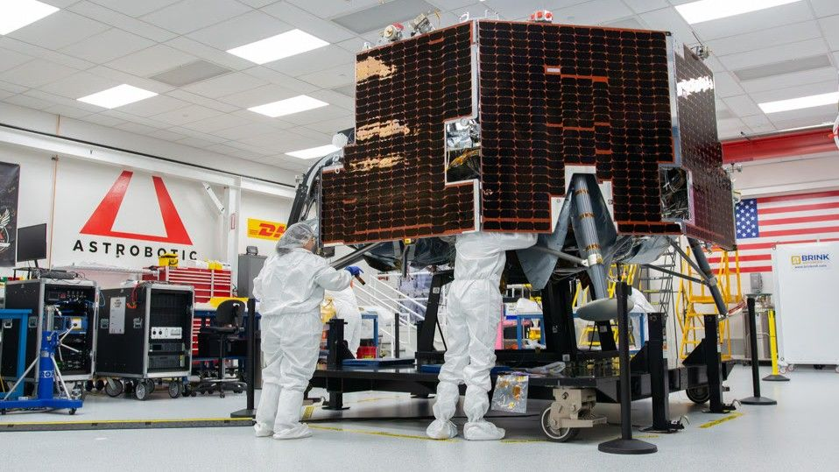
Click for next article The next robotic lander to launch to the moon was revealed today (June 15) by Pittsburgh-based company Astrobotic. NASA chose Astrobotic's Griffin vehicle to be the lander for its Moon Base II mission , part of the first phase of the agency's efforts to establish a permanent lunar outpost. Astrobotic is targeting late 2026 to launch Griffin Mission One (Griffin-1), which will lift off on a SpaceX Falcon Heavy rocket. The lander is contracted to deliver several research and technology demonstrations to the surface of the moon as part of NASA's Commercial Lunar Payload Services (CLPS) program, including the FLIP ( Flex Lunar Innovation Platform ) rover from California-based company Astrolab . "This is the first infrastructure-class lander going to the surface of the moon," Astrobotic CEO John Thornton said during today's event. "This lander will be part of the cornerstone of building the moon base on the surface of the moon, so I'm just so excited for it to be here today, and to wish it good travels as it heads out to JPL [NASA's Jet Propulsion Laboratory ] for environmental testing," Integration at the company's headquarters is expected to wrap up this week, with a number of payloads already incorporated onto the lander. Those payloads include Astrobotic's own BEACON CubeRover, in coordination with Mission Control Space Services, and the European Space Agency 's LandCam-X, designed to help improve lunar landing precision and reliability on future missions. Griffin-1 is scheduled for transportation to JPL in California next week for environmental testing, ahead of its delivery to Florida in the coming months, where the FLIP rover will be integrated into the lander prior to launch. The mission will be the second from Astrobotic that shoots for the moon, after the debut of the company's smaller Peregrine lunar lander in January 2024. Peregrine experienced a propellant leak shortly after deploying into space, however, and never reached its destination. In addition to being the company's first lander, Peregrine Mission One was the first-ever NASA CLPS flight. Through CLPS, NASA is partnering with commercial companies to provide lunar landers to deliver technology demonstrations and other payloads to the surface of the moon. The program aims to support NASA's Artemis program , through which the agency plans to establish a lunar base and eventual sustained human presence on the surface. Griffin is considerably larger than Peregrine. Though both landers stand roughly 6 feet (2 meters) tall, Griffin is nearly twice as wide, measuring nearly 15 feet (4.5 meters) across. Astrobotic advertises the big lander's payload capacity to the lunar surface at 1,377 pounds (625 kilograms), with a cost of $544,000 per pound ($1.2 million per kilogram). In total, Griffin-1 will carry 10 payloads from six separate nations, with four additional NASA payloads aboard FLIP. Some of the smaller payloads on the Griffin lander include a plaque from the Nippon Travel Agency, with messages collected from children in Japan to send to the moon; the Galactic Library to Preserve Humanity from Nanofiche that's carrying a super miniaturized repository of literature and art; and a MoonBox capsule that will deliver items from around the world submitted to the Tokyo-based company Astrobotic on micro SD cards. "So, this is going to be chock full of interesting science and data that's going to be coming back from the moon, and some of the best imagery we have seen yet coming back from the surface," Thornton said.

12. SpaceX sends 24 Starlink satellites to orbit on 1st launch as a public company (video)
Read more
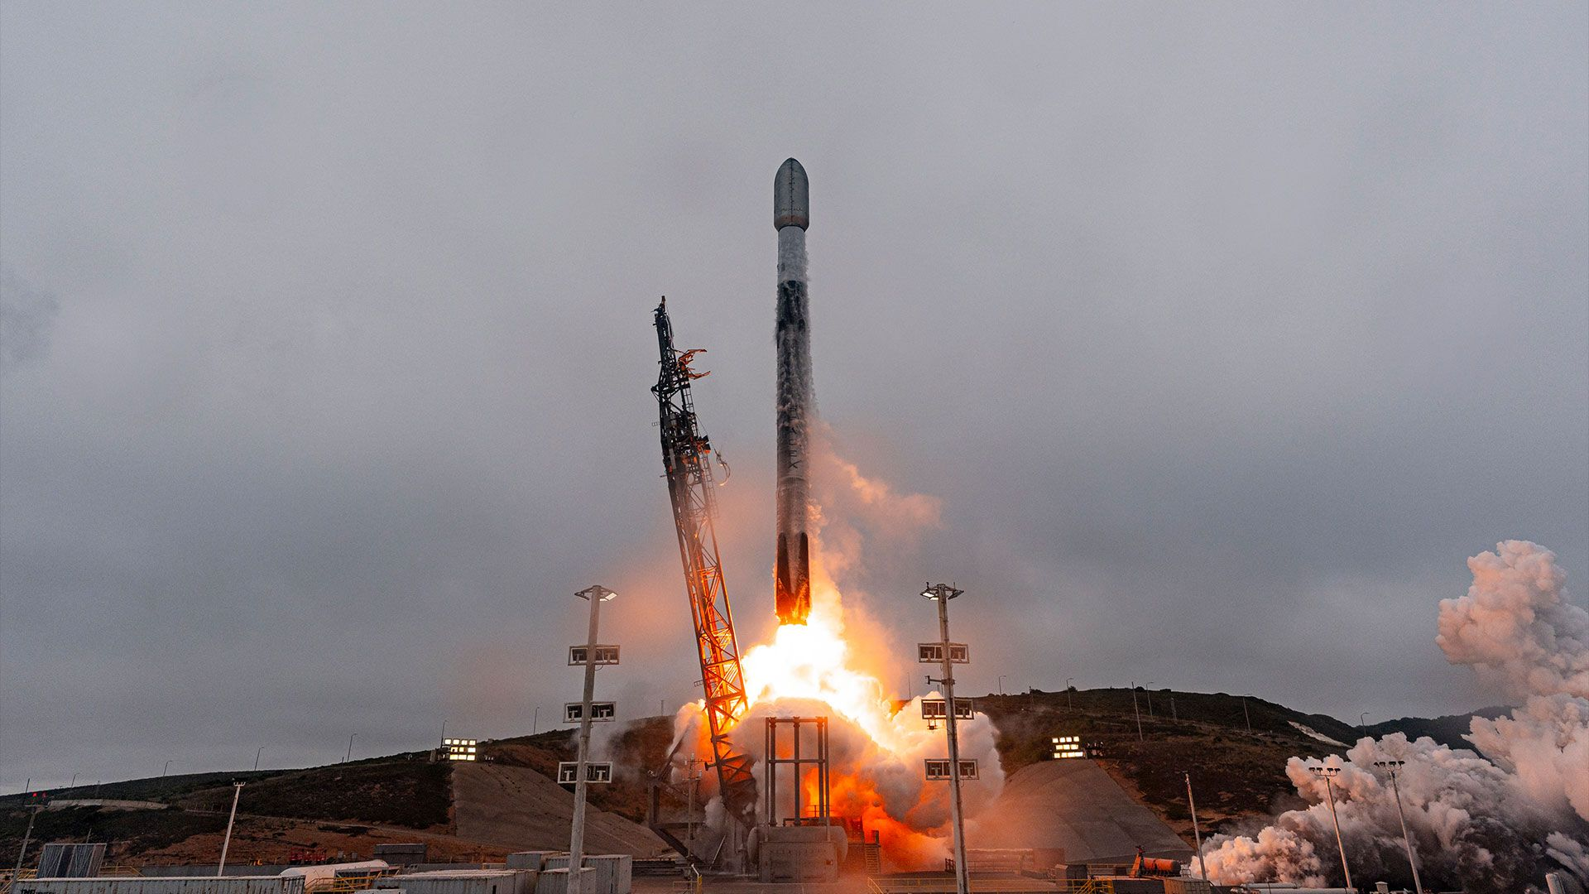
Click for next article SpaceX sent 24 Starlink satellites to orbit on Monday (June 15) - a number that nearly matched the percentage-point jump the company's stock has taken on its first day of trading after going public on Friday (June 12). A Falcon 9 rocket lifted off from Space Launch Complex 4 East at Vandenberg Space Force Base in California today at 11:34 a.m. EDT (1534 GMT; 8:34 a.m. PDT local time). SpaceX , which now trades under the ticker symbol SPCX on the Nasdaq Stock Exchange, confirmed a successful satellite deployment about an hour after the launch. A SpaceX Falcon 9 rocket carrying 24 Starlink satellites launches from Vandenberg Space Force Base in California on Monday, June 15, 2026. (Image credit: SpaceX) About 8.5 minutes after liftoff, the Falcon 9's first stage (Booster B1093) landed on the autonomous drone ship "Of Course I Still Love You" positioned in the Pacific Ocean. It was the 14th flight for the booster. The satellites (known as Group 17-54 ) raised the Starlink megaconstellation to 10,660 active units, according to tracker Jonathan McDowell . The network provides broadband internet access around the world, powers some airlines' inflight wifi and enables direct cell-to-satellite access for select providers. SpaceX's Group 17-54 Starlink satellites are seen in orbit on June 15, 2026, before deploying from the upper stage of their Falcon 9 rocket. (Image credit: SpaceX) SpaceX's IPO (initial public offering) on Friday was the largest in history, valuing the company at $1.77 trillion and making founder and CEO Elon Musk the world's first trillionaire. More than 4,400 of the company's past and present employers are estimated to have become millionaires thanks to the move. The stock was trading at more than $180 per share at the time this article was published. Monday's launch was SpaceX's 69th Falcon 9 mission of the year. More than 80% of those flights have been Starlink missions.

13. NASA X-ray spacecraft discovers supernova wreckage at the heart of the Milky Way
Read more
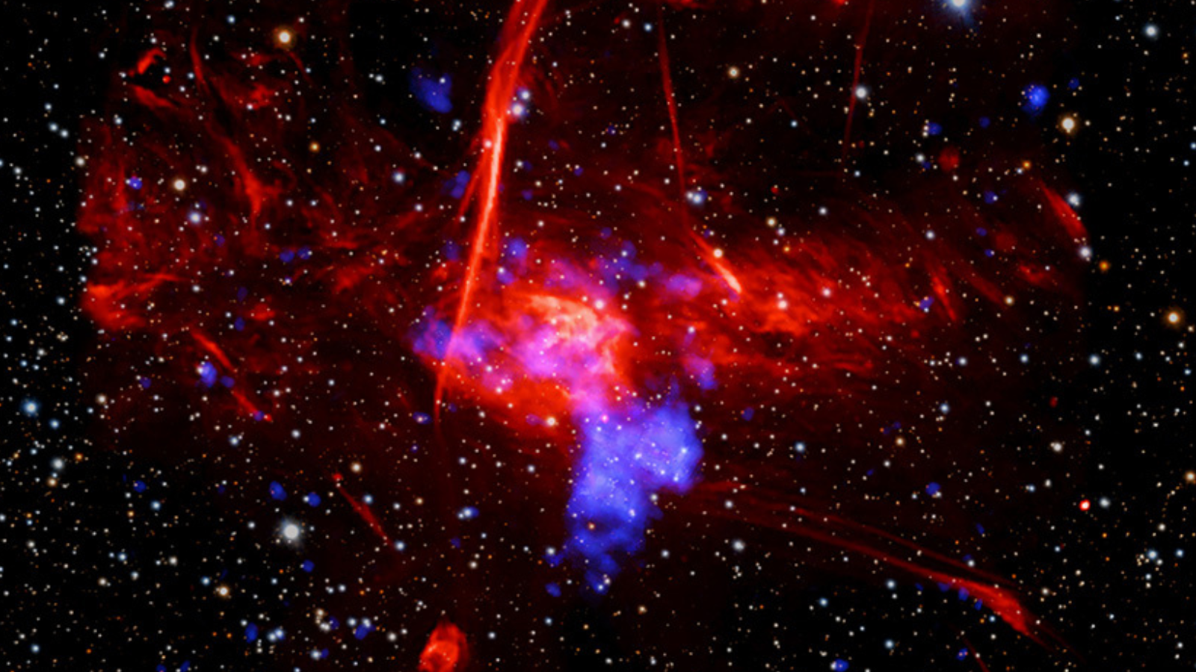
Click for next article NASA's Chandra X-ray spacecraft has detected the supernova wreckage of a dead star near the supermassive black hole that sits at the heart of the Milky Way, around 26,000 light-years from Earth. The team behind the discovery believes the star that died to create this wreckage erupted around 1,700 years ago. This represents the closest supernova debris found to our central supermassive black hole, Sagittarius A* (Sgr A*). The supernova wreckage sits within a bubble of ionized hydrogen gas, which is a bright source of radio waves, and has been dubbed Sagittarius C (Sgr C). The wreckage was detected by Chandra and the XMM-Newton X-ray space telescope as a "blob" of X-rays. The shell of ejected material appears to be moving at a staggering 2 million miles per hour (3.2 million kilometers per hour). Sagittarius C the location of this supernova wreckage is highlighted in blue in this image from Chandra, XMM-Newton, PanSTARRS and MeerKAT. (Image credit: X-ray: NASA/CXC/UCLA/Z. Zhu et al.; ESA/XMM-Newton; Optical: PanSTARRS; Radio: MeerKAT; Image Processing: NASA/CXC/SAO/L. Frattare and P. Edmonds) Supernova wreckage like this is important for the chemical enrichment of galaxies, including the next generation of stars and planets. That's because when massive stars like the progenitor star of this debris explode, the heavy elements they have forged from hydrogen and helium are jettisoned into their surroundings. Eventually, these elements mix with surrounding clouds of interstellar gas and dust. Later, cool and dense regions in these molecular clouds collapse under their own gravity, forming new stars. The envelopes of material around these infant stars eventually form clumps that gather more and more mass to become planets. A close image of Sgr C created with the addition of data collected by the James Webb Space Telescope. (Image credit: X-ray: NASA/CXC/UCLA/Z. Zhu et al.; ESA/XMM-Newton; Optical: PanSTARRS; Radio: MeerKAT; Infrared (JWST): NASA/ESA/CSA/STScI; Image Processing: NASA/CXC/SAO/L. Frattare and P. Edmonds) There is still some ambiguity surrounding this wreckage, however. The team behind the observation didn't find increased amounts of the elements that would have been blasted out by the exploding star. This could be because this debris has already mixed with the surrounding gas and dust. Alternatively, it could suggest this X-ray blob isn't the result of a supernova explosion at all, but rather comes from gas heated by the hot massive stars in this region of the Milky Way. The team behind this research doesn't consider this explanation likely. That is because this X-ray emission is around ten times brighter than the typical emissions from clusters of hot massive young stars.

14. Live from the moon! How lasers connected us all to NASA's Artemis 2 astronauts on their epic lunar trip
Read more
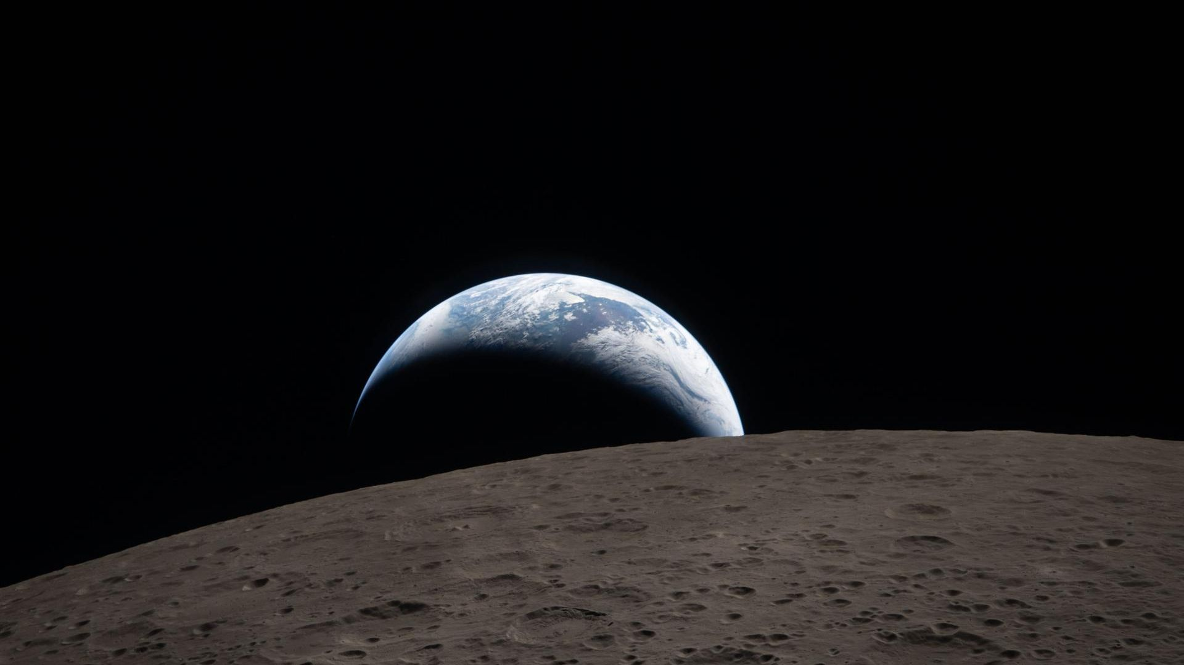
Click for next article The world followed the exploits of NASA's Artemis 2 moon mission in near real-time thanks to a high-tech laser link between the astronauts and Earth that enabled high-definition streaming video and images. Transmitting data optically, in this case by infrared light, is referred to as 'lasercom', and was at the heart of what made Artemis 2 so successful in the eyes of the public. Thanks to the high-res imagery that was made available on a daily basis, it felt like we were all riding with Artemis 2 commander Reid Wiseman, pilot Victor Glover, and mission specialists Christina Koch and Jeremy Hansen every step of the way on their voyage around the moon. This was made possible by a device called the Orion Artemis 2Optical Communications System (O2O), developed by researchers at MIT's Lincoln Laboratory. An infrared laser, it transmitted data to Earth at bit rates of up to 260 megabytes per second - faster than some home broadband internet. Infrared signals, rather than radio, were chosen for a variety of reasons. For one thing, near-infrared light can pass through thin clouds, so an obscured sky wouldn't prevent communication. And secondly, optical light operates at a higher frequency than radio, enabling more data to be packed in. "Our goal was to demonstrate O2O's operational utility for human spaceflight, extending the high-bandwidth connections that Internet users enjoy on Earth to astronauts in deep space," said Farzana Khatri, who is the lead systems engineer in Lincoln Laboratory's Optical and Quantum Communications Group, in a statement . "We not only demonstrated the first use of a lasercom on a crewed mission beyond low Earth orbit, but also attracted massive public engagement as the astronauts shared multimedia from their journey in near real-time." Imagery was very important on the Artemis 2 mission. The fantastic photos such as " Hello, World " and "Earthset" didn't happen by accident. The crew had been trained at NASA's Johnson Space Center in Houston to observe and photograph the moon and Earth, and the O2O system ensured that their best images could be beamed back to Earth and spread across news sites and social media within hours of taking them. The O2O system has its origins in a similar project developed by the Lincoln Laboratory team called the Modular, Agile, and Scalable Optical Terminal (MAScOT). It flew to the International Space Station (ISS) and was tested for the first time in 2023, itself following on from earlier lasercom tests such as NASA's Optical Payload for Lasercom Science (OPALS) instrument that beamed a 165-megabit video from the ISS in 2014. O2O is an evolution of MAScOT. It is composed of three modules. One is an optical module featuring a 4-inch telescope that focuses the laser and gimbals to help point it. A second module contained a modem that converted electronic data into optical data. Finally, the third module consisted of a controller that interfaced with the spacecraft to help point the telescope. The Artemis 2 moon flyby 2 hours in. This is a screenshot from NASA's livestream of the mission. (Image credit: NASA) The laser targeted one of three ground stations, principally NASA's White Sands Test Facility in New Mexico and the Jet Propulsion Laboratory's Table Mountain Facility in California, with a third, experimental ground station at the Australian National University's Mount Stromlo Observatory. Initially, the intention was to have an operating window of 1 hour per day, but because O2O proved so successful at transmitting data efficiently its use increased as the mission went on. NASA mission managed even decided to adjust the Artemis 2 Orion capsule's attitude (its orientation in space) at times in order to extend the period in which it was in line of sight of a ground station, allowing even more data to be downlinked. In total, O2O transmitted half a terabyte of data over the course of the 10 day flight. "O2O was able to downlink all the data stored on multiple onboard cameras, allowing mission control to erase the memory cards and refill them with new photos and videos," said Khatri, who also emphasized how downlinking the data via O2O actually protected that data. "For any space mission, scientists and spacecraft engineers are concerned that data not sent down during the mission can become corrupted or get destroyed. And, when the spacecraft capsule returns, downloading the data can sometimes take months. The lasercom capability provided by O2O ensured the data were preserved and immediately available for analysis." On Earth, we already use lasers to transmit data down optical fibers, and for decades lasers have been considered the future of space communications. Radio, while simpler, has a slower data rate thanks to its low frequency limiting its bandwidth - this is why even the search for extraterrestrial intelligence (SETI) is now looking for optical signals as well as radio. Lasers can transmit 10 to 100 times more data per second than radio waves, and Khatri reckons that O2O can even improve on this and increase the downlink rate by at least another factor of 10 over what was possible during Artemis 2.

